Permutations and combinations
Students discuss the differences between permutations and combinations, then categorise problems based on these concepts. They create a flow chart to determine which strategy to use and test its effectiveness with a range of problems.

Learning intention
- To understand when to use permutations or combinations when solving a problem.

Success criteria
- I can identify when to use a permutation.
- I can identify when to use a combination.
- I can explain what components of a question indicate a certain strategy.
- I can find the probability of an outcome using permutations or combinations.

Outcomes
A student:
- develops understanding and fluency in mathematics through exploring and connecting mathematical concepts, choosing and applying mathematical techniques to solve problems, and communicating their thinking and reasoning coherently and clearly MAO-WM-01
- uses permutations and combinations to solve problems involving counting, ordering and probability ME1-11-04

Content

Permutations and combinations
- Solve problems involving both permutations and combinations, including problems which require consideration of cases
- Solve probability problems involving permutations and combinations
Mathematics Extension 1 11–12 Syllabus © NSW Education Standards Authority (NESA) for and on behalf of the Crown in right of the State of New South Wales, 2024.

Table 1: lesson summary
Section | Summary of activity | Teaching strategies | Teaching points
Activating prior knowledge | Use slide 4 of the PowerPoint to discuss where permutations and combinations exist within the game of Wordle. | Think-Pair-Share | Gauge student’s ability to recognise where permutations and combinations exist in the real world.
Connecting learning | Use slide 6 to discuss the difference between permutations and combinations.  Display slide 7 to show the ‘Approaching questions scaffold’ and refer to the ‘Understand’ section and identify key terms.  Use Appendix A for students to classify the cards, discussing when groups disagree. | Visibly random groups  Vertical non-permanent surfaces | Students summarise the topic by deciphering which strategy to use to approach each type of question and what words in questions lead them to use that strategy.
Releasing responsibility | Have students then create a flow chart to help identify which mathematical concept they would use to solve the problem. Students test their flow chart using  Appendix A again and solve the problems. | Flow chart  Visibly random groups  Vertical non-permanent surfaces  TAG feedback | Students document their thinking to be able to use in the future.
Independent practice | Students use their flow chart to solve harder problems in Appendix B, and adjust their flow chart accordingly. | Visibly random groups  Vertical non-permanent surfaces  Pose-Pause-Pounce-Bounce | Students apply their knowledge to problems that may involve both permutations and combinations to solve.

Activity structure
Please use the associated PowerPoint Permutations and combinations to display images in this lesson.

Activating prior knowledge
- Gather information by asking students if anyone has ever played Wordle and if they know how it is played.
- Display slide 4 from the PowerPoint, which shows a screenshot of the game Wordle. A description of the game is given below.
Wordle is a word puzzle game where the goal is to guess a hidden 5-letter word within 6 attempts. After a word is guessed, feedback is given with the following colours:
- Green indicates the letter is correct and in the right position.
- Yellow indicates the letter is correct but in the wrong position.
- Gray indicates the letter is not in the word at all.
- As a class, play a game of Wordle from the NY Times website ‘Wordle’ (nytimes.com/games/wordle/).
- In a Think-Pair-Share (bit.ly/thinkpairsharestrategy) check for understanding by asking students:
- Is the number of possible 5 letter words an example of a permutation or a combination?
- How do the yellow and green letters relate to permutations and combinations?

Students may realise that the number of arrangements of letters in the unknown word is a permutation, as the order does matter, to make a word.
The letters in yellow indicate if the letter is part of the combination needed to create the word, whereas the green is where the letter exists in the permutation and once found may be considered as a restriction.

Connecting learning
- Activate prior knowledge of the definitions of a permutation and combination by having students review their notes or by displaying slide 6 of the PowerPoint.
- In a Think-Pair-Share, ask students what phrases or key words in a question might align to each of these definitions.
During the class discussion, highlight key terms to help students distinguish between concepts – for example, with permutations: emphasise ‘arrangement’, ‘order matters’, ‘line’, and ‘circle’; for combinations: emphasise ‘order doesn't matter’, ’choose’, and ‘groups.’
- Assign students to visibly random groups of 3 (bit.ly/visiblegroups) on vertical non-permanent surfaces (bit.ly/VNPSstrategy).
- Explain to students that the purpose of the following activity is to break down the ‘Understand’ phase of the ‘Approaching questions scaffold’, found on slide 7, by identifying key terms.
- Distribute adhesive putty and Appendix A ‘Past HSC Questions’ to each group and have them cut the questions into cards.
- Ask groups to write the category headings, ‘permutations’ and ‘combinations’ on their vertical non-permanent surfaces. To check for understanding, ask students to sort the questions into the appropriate category.
- Have students view another group’s work and note any questions that are categorised differently. Groups should come to a consensus as to the correct answer.
- Bring students back together and gather information by discussing any questions that have been categorised differently, clarifying the correct category and discussing why.
- Have students return to their vertical non-permanent surfaces and ask them to label if there are restrictions or repetition in any of the questions and highlight the keywords to show where this is evident.
- Have students again look at another groups' work, noting the similarities and differences between groups' responses.
- Check for understanding by asking students to separate the questions further by putting a P next to the questions asking for a probability.

Releasing responsibility
- Explain to students that they are going to create a flow chart to help them make sense of which strategy to use to solve a problem.
A flow chart example has been provided in the sample solutions.
- Using the Pose-Pause-Pounce-Bounce questioning strategy (PDF 557 KB) (bit.ly/posepausepouncebounce), ask students what prompts they should use and what terms would be beneficial in the creation of their flow chart.
Students should suggest words such as permutation, combination, order, group, restriction, no restriction, circle, probability, and number of arrangements.
- In their groups, on the vertical non-permanent surfaces, have students construct a flow chart using concepts from this unit, including:
- Multiplication principle
- Factorials
- Permutations, including those with restrictions, repeated objects and in a circle
- Combinations, including those with restrictions.
Students should be encouraged to use their notes to remind them of previous concepts.
- Have students view other group’s work, giving feedback using the TAG feedback proforma (bit.ly/DLSpeerfeedback).
- Allow students to use the work of any of the groups to create a personal flow chart for their own notes.
- Distribute another copy of Appendix A and have students answer the questions, testing their flow chart and making changes if necessary.

Independent practice
- Display slide 9 from the PowerPoint to show an HSC style question for students to test their flow chart.
- Use the Pose-Pause-Pounce-Bounce questioning strategy to gather information from students about how well their flow chart worked for the provided questions. Some suggested prompts include:
- Were there any times your flow chart didn’t work? Why?
- What made it difficult to identify whether you were using a permutation or combination?
- What adjustments did you make to your flow chart to cater for these types of questions?
- Have students return to their visibly random groups of 3 on vertical non-permanent surfaces and distribute Appendix B ‘Mixed questions’ which contains questions from past HSC examinations.

Assessment and differentiation

Suggested opportunities for differentiation
Connecting learning
- Challenge students to justify their choices when classifying the questions.
- Students can be encouraged to use concrete materials to help decipher what the questions are asking, to help classify them.
Releasing responsibility
- Students could be encouraged to make a summary page of the topic before constructing their flow charts.
- Students may need to be shown examples of flowcharts before attempting to create their own.
- The flow chart could be constructed as a class.
- Students could be given the flow chart in the solutions and give feedback using 2 stars and a wish before modifying it using their notes.
- A basic flow chart scaffold can be given to students for them to complete. See the sample solution as a guide.
Independent practice
- Challenge students to identify when they would need to use both permutations and combinations to solve a problem and how to differentiate these problems from ones that involve one or the other.

Suggested opportunities for assessment
Activating prior knowledge
- Monitor responses in class discussions to check for student understanding of the definitions of permutations and combinations.
- Students give each other peer feedback before sharing with the class in a Think-Pair-Share.
Connecting learning
- Review how students classify questions from Appendix A as evidence of Working mathematically skills, such as problem solving, understanding and fluency.
- When placed in groups of 3, students provide and receive peer feedback on their understanding.
Releasing responsibility
- Collect student’s flow charts and responses to questions in Appendix B as evidence of learning for the permutations and combinations unit.
- Students provide peer feedback using the TAG proforma and can adjust their flow charts accordingly.
Independent practice
- Students working at vertical non-permanent surfaces allows the teacher to assess student progress and provide support where appropriate.

Appendix A

HSC questions
1 | 2006 HSC Extension 1 Exam (NESA 2006)  How many arrangements of the letters in the word ALGEBRAIC are possible?
2 | 2006 HSC Extension 1 Exam (NESA 2006)  How many arrangements of the letters in the word ALGEBRAIC are possible if the vowels must occupy the 2nd, 3rd, 5th and 8th positions?  The letters A, E, I, O, U are vowels.
3 | 2011 HSC Extension 1 Exam (NESA 2011)  Alex’s playlist consists of 40 different songs that can be arranged in any order.  How many arrangements are there for the 40 songs?
4 | 2004 HSC Extension 1 Exam (NESA 2004)  A four-person team is to be chosen at random from nine women and seven men.  In how many ways can this team be chosen?
5 | 2004 HSC Extension 1 Exam (NESA 2004)  A four-person team is to be chosen at random from nine women and seven men.  What is the probability that the team consists of four women?
6 | 2003 HSC Extension 1 Exam (NESA 2003)  How many nine-letter arrangements can be made using the letters of the word ISOSCELES?
7 | 2002 HSC Extension 1 Exam (NESA 2002)  Seven people are to be seated at a round table.  How many seating arrangements are possible?
8 | 2010 HSC Extension 1 Exam (NESA 2010)  At the front of a building, there are five garage doors. Two of the doors are to be painted red, one is to be painted green, one blue and one orange.  How many possible arrangements are there for the colours on the doors?

9 | 2002 HSC Extension 1 Exam (NESA 2002)  Seven people are to be seated at a round table. Two people, Keven and Jill, refuse to sit next to each other. How many seating arrangements are possible?
10 | 2010 HSC Extension 1 Exam (NESA 2010)  At the front of a building, there are five garage doors. Two of the doors are to be painted red, one is to be painted green, one blue and one orange. How many possible arrangements are there for the colours on the doors if the 2 red doors are next to each other?
11 | 2003 HSC Extension 1 Exam (NESA 2003)  A committee of 6 is to be chosen from 14 candidates. In how many different ways can this be done?
12 | 2008 HSC Extension 1 Exam (NESA 2008)  Barbara and John and six other people go through a doorway one at a time. In how many ways can the eight people go through the doorway if John goes through the doorway after Barbara with no one in between?
13 | 2008 HSC Extension 1 Exam (NESA 2008)  Barbara and John and six other people go through a doorway one at a time. In how many ways can the eight people go through the doorway if John goes through the doorway before Barbara?
14 | 2002 HSC Extension 1 Exam (NESA 2002)  From a pack of nine cards numbered 1,2,3, … 9, three cards are drawn at random and laid on a table from left to right.  What is the probability that the number formed exceeds 400?
15 | 2010 HSC Extension 1 Exam (NESA 2010)  A group of 12 people is to be divided into discussion groups.  In how many ways can the discussion groups be formed if there are 8 people in one group and 4 people in another?
16 | 2010 HSC Extension 1 Exam (NESA 2010)  A group of 12 people is to be divided into discussion groups. In how many ways can the discussion groups be formed if there are 3 groups containing 4 people each?

Appendix B

Mixed questions
- From a group of 12 athletes, a coach selects 5 athletes to run a relay. Then, the coach orders the athletes to assign running positions (1st leg, 2nd leg, and so on). How many different team line-ups are possible?
- Out of 20 teams, 8 qualify for finals. From those 8 teams, the top 4 are drawn randomly and ranked 1st to 4th. How many outcomes are there for the top 4 teams?
- Danielle chose 3 men from 6 and 2 women from 4 to form a 5-person team. She then arranged the team in a line for a photo. How many arrangements are there?
- From a group of 30 students, select 2 to be school captain and vice-captain, then 3 more to be prefects (unordered). What’s the probability that John and Jan will be prefects?

Sample solutions

Appendix A – HSC questions
1 | Permutation, with repetition, asking for the number  $$\frac{9!}{2!}=181400$$
2 | Permutation, with repetition and restrictions, asking for the number  Number of ways of arranging the vowels $=\frac{4!}{2!}$  Number of ways of arranging the consonants $=5!$  Total arrangements $=\frac{4!}{2!}×5!=1440$
3 | Permutation, asking for the number  40!
4 | Combination, no restrictions, asking for the number  $$\left(\begin{matrix}16 \\ 4\end{matrix}\right)=1820$$
5 | Combination, with restrictions, asking for probability  Total teams = $\left(\begin{matrix}16 \\ 4\end{matrix}\right)=1820$  Teams with 4 women $=\left(\begin{matrix}9 \\ 4\end{matrix}\right)=126$  Probability = $=\frac{126}{1820}=\frac{9}{130}$
6 | Permutation, with repetition, asking for the number  $$\frac{9!}{2!3!}=30240$$
7 | Permutation, circle, asking for the number  $$6!=720$$
8 | Permutation, with repetition, asking for the number  $$\frac{5!}{2!}=60$$
9 | Permutation, circle, with restriction, asking for the number  Total number $=6!$  Total of way Kevin and Jill sit together $=2×5!$  Arrangements with Kevn and Jill are separate $=6!-2×5!=480$
10 | Permutation, with restriction, asking for the number  Treat the 2 red doors as 1.  $$4!=24$$
11 | Combination, no restrictions, asking for the number  $$=\left(\begin{matrix}14 \\ 6\end{matrix}\right)=3003$$
12 | Permutation, with restriction, asking for the number  Treat Barbara and John as 1.  $7!=5040$
13 | Permutation, with restriction, asking for the number  John would be in front of Barbara ½ the time.  $$∴\frac{1}{2}×8!=20160$$
14 | Permutations, with restriction, probability  Total number of arrangements $=9×8×7$  Arrangements greater than 400 $=6×8×7$  P (number greater than 400) = $\frac{6×8×7}{9×8×7}=\frac{2}{3}$
15 | Combinations, no restrictions, asking for the number  $$\left(\begin{matrix}12 \\ 8\end{matrix}\right)×\left(\begin{matrix}4 \\ 4\end{matrix}\right)=495$$
16 | Combination, with restrictions and repetition, asking for the number  $$\frac{1}{3!}×\left(\begin{matrix}12 \\ 4\end{matrix}\right)×\left(\begin{matrix}8 \\ 4\end{matrix}\right)×\left(\begin{matrix}4 \\ 4\end{matrix}\right)=11550$$

Releasing responsibility – flow chart
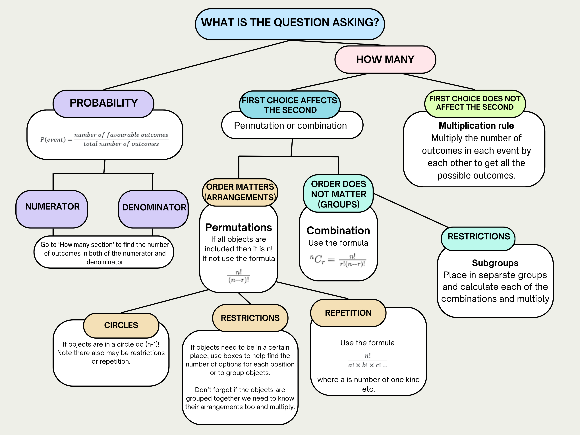

Independent practice problems
- $\left(\begin{matrix}5 \\ 3\end{matrix}\right)=10$
- $5×4×3=60$
- $\left(\begin{matrix}5 \\ 1\end{matrix}\right)+\left(\begin{matrix}5 \\ 2\end{matrix}\right)+\left(\begin{matrix}5 \\ 3\end{matrix}\right)+\left(\begin{matrix}5 \\ 4\end{matrix}\right)+\left(\begin{matrix}5 \\ 5\end{matrix}\right)=31$
- $5+\left(5×4\right)+\left(5×4×3\right)+\left(5×4×3×2\right)+5!=325$

Appendix B – mixed questions
- $\left({12 \atop 5}\right)×5!$
- $\left({20 \atop 8}\right)×$ ⁸P₄
- $\left({6 \atop 3}\right)×\left({4 \atop 2}\right)×5!$
- Total outcomes: ³⁰P₂ $×\left({28 \atop 3}\right)=2 854 800$
Favourable outcomes:
We want to count the number of selections where:
- John and Jan are among the 3 prefects, not the captain or vice-captain.
- Choose 2 captains (from remaining 28, excluding John and Jan)
- ²⁸P₂
John and Jan are in the prefect group, so we need to choose 1 more prefect from the remaining 28 − 2 = 26 students (excluding John, Jan, and the 2 captains).
$$\left({26 \atop 1}\right)$$
- Favourable outcomes = ²⁸P₂ $×$ $\left({26 \atop 1}\right)=19 656$
- $P=\frac{19 656}{2 854 800}=\frac{819}{119 950}$

References
This resource contains NSW Curriculum and syllabus content. The NSW Curriculum is developed by the NSW Education Standards Authority. This content is prepared by NESA for and on behalf of the Crown in right of the State of New South Wales. The material is protected by Crown copyright.
Please refer to the NESA Copyright Disclaimer for more information https://educationstandards.nsw.edu.au/wps/portal/nesa/mini-footer/copyright.
NESA holds the only official and up-to-date versions of the NSW Curriculum and syllabus documents. Please visit the NSW Education Standards Authority (NESA) website https://educationstandards.nsw.edu.au/ and the NSW Curriculum website https://curriculum.nsw.edu.au/.
Mathematics Extension 1 11–12 Syllabus © NSW Education Standards Authority (NESA) for and on behalf of the Crown in right of the State of New South Wales, 2024.
NSW Education Standards Authority (NESA) (2002) ‘Mathematics Extension 1 HSC exam paper 2002’, HSC exam papers archive, NESA website, accessed 22 May 2025.
——(2003) ‘Mathematics Extension 1 HSC exam paper 2003’, HSC exam papers archive, NESA website, accessed 22 May 2025.
——(2004) ‘Mathematics Extension 1 HSC exam paper 2004’, HSC exam papers archive, NESA website, accessed 22 May 2025.
——(2006) ‘Mathematics Extension 1 HSC exam paper 2006’, HSC exam papers archive, NESA website, accessed 22 May 2025.
——(2008) ‘Mathematics Extension 1 HSC exam paper 2008’, HSC exam papers archive, NESA website, accessed 22 May 2025.
——(2010) ‘Mathematics Extension 1 HSC exam paper 2010’, HSC exam papers archive, NESA website, accessed 22 May 2025.
——(2011) ‘Mathematics Extension 1 HSC exam paper 2011’, HSC exam papers archive, NESA website, accessed 22 May 2025.

© State of New South Wales (Department of Education), 2025
The copyright material published in this resource is subject to the Copyright Act 1968 (Cth) and is owned by the NSW Department of Education or, where indicated, by a party other than the NSW Department of Education (third-party material).
Copyright material available in this resource and owned by the NSW Department of Education is licensed under a Creative Commons Attribution 4.0 International (CC BY 4.0) license.

This license allows you to share and adapt the material for any purpose, even commercially.
Attribution should be given to © State of New South Wales (Department of Education), 2025.
Material in this resource not available under a Creative Commons license:
- the NSW Department of Education logo, other logos and trademark-protected material
- material owned by a third party that has been reproduced with permission. You will need to obtain permission from the third party to reuse its material.
Links to third-party material and websites
Please note that the provided (reading/viewing material/list/links/texts) are a suggestion only and implies no endorsement, by the New South Wales Department of Education, of any author, publisher, or book title. School principals and teachers are best placed to assess the suitability of resources that would complement the curriculum and reflect the needs and interests of their students.
If you use the links provided in this document to access a third-party's website, you acknowledge that the terms of use, including licence terms set out on the third-party's website apply to the use which may be made of the materials on that third-party website or where permitted by the Copyright Act 1968 (Cth). The department accepts no responsibility for content on third-party websites.

