Finding the power
Students develop an understanding of the need for logarithms to solve for the power of an equation before learning how to convert between index and logarithmic equation forms. Through exploration, logarithms are introduced as a powerful tool for rewriting exponential relationships and solving equations.

Learning intentions
- To understand what logarithms are.
- To be able to convert between logarithmic and index form of an equation.

Success criteria
- I can explain what logarithms are.
- I can rewrite an exponential equation as a logarithmic equation.
- I can evaluate logarithms with simple bases and powers.

Outcomes
A student:
- develops understanding and fluency in mathematics through exploring and connecting mathematical concepts, choosing and applying mathematical techniques to solve problems, and communicating their thinking and reasoning coherently and clearly MAO-WM-01
- applies exponential and logarithmic laws to simplify expressions, solve equations and prove results MAV-11-07
- analyses graphs of exponential and logarithmic functions MAV-11-08

Content

Logarithmic functions
- Define the logarithm of a number $y$, where $y>0$, to any positive base $a$ as the index to which $a$ is raised to give $y$
- Use the notation $\log_{a}{y}$ for the logarithm of $y$ to the base $a$
- Use digital tools to determine rational and irrational values of exponential and logarithmic expressions
- Explain that $y=a^{x}$ is equivalent to $x=\log_{a}{y}$ for $a>0$ and $a≠1$, and use the equivalence to solve equations of the form $a^{x}=b$, for $a>0$
Mathematics Advanced 11–12 Syllabus © NSW Education Standards Authority (NESA) for and on behalf of the Crown in right of the State of New South Wales, 2024.

Table 1: lesson summary
Section | Summary of activity | Teaching strategies | Teaching points
Activating prior knowledge | Students consider a compound interest scenario from slide 4 of the PowerPoint Finding the power and attempt to determine how long it will take an investment to reach a target value. They attempt to solve the problem using graphs or the compound interest formula and discuss the difficulty of finding the unknown power. | Pose-Pause-Pounce-Bounce | Recognise the need for a method to determine the unknown power in exponential equations.
Connecting learning | Display slide 6 for students to complete a table of powers of 2 and plot the points using Appendix A. They compare the exponential function with the new function and identify the inverse relationship between the 2 graphs. | Notice and wonder  Pose-Pause-Pounce-Bounce | Identify logarithms as the power to which a base is raised.
Releasing responsibility | The logarithm function, notation and terminology are introduced on slides 8–9, and students learn to evaluate base 10 logarithms using a calculator. The teacher models converting between exponential and logarithmic equations and evaluating base-10 logarithms using slides 10–13. Students practise these conversions using Appendix B and compare logarithms using Appendix C. Students revisit the initial scenario using logarithms in slide 14 and record notes summarising key ideas. | Worked examples (Your turn)  Variation theory  Notes to future forgetful selves | Reinforce correct use of notation and the relationship between exponential and logarithmic functions.
Independent practice | Students complete Appendix D in pairs, matching logarithmic expressions with their equivalent forms and values. |  | Reinforce the idea that a log can help solve an exponential equation.

Activity structure
Please use the associated PowerPoint Finding the power to display images in this lesson.

Activating prior knowledge
- Display slide 4 of the PowerPoint and ask students to consider the below scenario:
Jordan decides to invest $200 000 into a high-growth managed fund that earns an annual interest rate of 6.5%, compounded annually. How long does Jordan need to invest his money before he becomes a millionaire?
- Lead a class discussion about how the students think they could solve the problem using the Pose-Pause-Pounce-Bounce questioning strategy (PDF 557KB) (bit.ly/posepausepouncebounce).
- Students may suggest using the graph or the compound interest formula with guess and check.
- Animate the slide to show the graph and the compound interest formula. Give students some time to find the answer to the nearest day.
These methods can be inefficient and inaccurate, so end this activity after an appropriate amount of time and effort.
The answer is 25 years and 204 days, to the nearest day.
- Lead a class discussion about the results using the Pose-Pause-Pounce-Bounce questioning strategy, highlighting the difficulties with these methods. Suggested prompts include:
- Was the graph accurate enough to find the answer to the nearest day? Why / why not?
- Were you able to find the answer using the compound interest formula? What made it challenging?
- Conclude with students that we need a function which will give us the power. Explain to students that today they will be introduced to logarithms, which will help them solve equations where the power is the unknown.

Connecting learning
- Distribute a copy of Appendix A ‘A new function’ to each student and have them complete part A.
- Display slide 6 and ask students to check their graph of the new function.
- Ask students to complete part B of the appendix.
- Lead a class discussion using the Pose-Pause-Pounce-Bounce questioning strategy, using the questions from the appendix.
- Conclude that this new function outputs the power and reveal that it is called a logarithm.

Releasing responsibility
- Display slide 8 to introduce the logarithm function, its notation and the language used to communicate it. Animate the slide to show connections between the 2 forms and animate again to show the self-explanation prompts.
- Display slide 9 and explain to students the base 10 convention, that $\log{x}=\log_{10}{x}$ on many calculators.
- Explicitly teach students how to evaluate $\log{x}$ in base 10 on their calculators.
Note, evaluating $\ln{x}$ and $\log_{a}{x}$ will be taught in future lessons.
- Use slides 10–13 to model worked examples of converting exponential equations to logarithmic equations and evaluating in base 10 using the Worked examples (your turn) method (bit.ly/supportingstrategies). Animate the slides to reveal self-explanations prompts and solutions.
- Distribute a copy of Appendix B ‘Exponential and logarithmic equations’ to each student for them to practise converting between equation types, using variation theory (variationtheory.com/introduction).
- Distribute Appendix C ‘Less, same, more’ to each student and have students complete the table by comparing the effect of the base and the value. Encourage students to convert to exponential equations if they are unsure.
- Display slide 14 which shows the scenario from slide 4 and ask students to find a logarithm for $n$. Animate to show the solution.
The students do not yet know how to evaluate the answer, which comes out as 25.5569, or 25 years and 204 days, to the nearest day.
- Have students create notes to their future forgetful self in pairs (bit.ly/notestofutureself) by annotating their graph from Appendix A, correcting the graph if necessary, and including an example of a conversion between exponential and logarithmic equations.

Independent practice
- Distribute a copy of Appendix D ‘Tarsia puzzle’ to pairs of students. Have students cut up, shuffle and then reassemble the puzzle.

Assessment and differentiation

Suggested opportunities for differentiation
Activating prior knowledge
- Support students by explicitly linking the terms in the compound interest formula and $f\left(x\right)=k(a^{x})$.
- Students could be offered the opportunity to use a spreadsheet to calculate the number of days required.
Connecting learning
- Extend students by asking them to consider other inverse relationships that they can think of, such as addition and subtraction or $x^{2}$ and $\sqrt{x}$.
Releasing responsibility
- Provide step-by-step calculator instructions for evaluating $log(x)$ for students less familiar with their calculators.
- Encourage proficient students to explore and compare the values of $\log{(x)}$ for different powers of 10.
- Support students by providing the solutions to the first few lines of Appendix B on converting between exponential and logarithmic equations and asking them to highlight specific components in both forms, such as the base or exponent.
- Extend students by asking them in pairs to each create questions for the other to solve.
Independent practice
- Support students by giving them the option to use an online calculator to evaluate terms when they are unsure.

Suggested opportunities for assessment
Activating prior knowledge
- Use responses in the discussion to check for understanding of:
- compound interest as an exponential function
- the links between growth, exponential functions and the role of the exponent.
Connecting learning
- Use student responses to check for their ability to plot points and graph curves.
Releasing responsibility
- Use student responses to check for their ability to mentally calculate small powers of low integers.
- Review student notes and their responses to Appendix C to check for attainment of the success criteria.
Independent practice
- Monitor students using the calculator during the tarsia puzzle to check for correct usage.
- Monitor students completing the tarsia puzzle to check for understanding of how to mentally evaluate logarithms.

Appendix A

A new function
Part A
Use the graph to find the power of 2 required to generate the value and complete the table.
Value | Power of 2
8
4
2
1
$$\frac{1}{2}$$
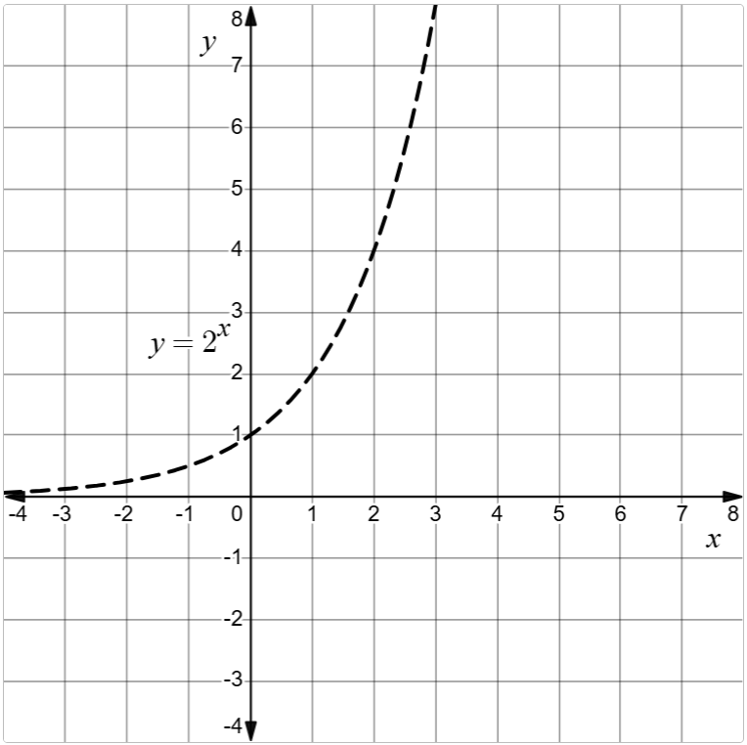
Using the value column as the $x$-coordinate and the power of 2 as the $y$-coordinate, plot the coordinates from the table on the same axes. Connect the new points using a smooth line.

Part B
Consider the new function and the function $y=2^{x}$.
- What is the domain and range of each function and how do they compare?
- How does each function grow as $x→∞$?
- What are the asymptotes and intercepts of each function?
- How are the inputs and outputs of each function related?
- What other features of each graph did you notice?

Appendix B

Exponential and logarithmic equations
Complete the table by filling in the blanks so that each row contains equivalent equations with one in exponential form and one in logarithmic form as well as the value of $x$ in the equations.
$$y=a^{x}$$ | $$x=\log_{a}{y}$$ | $$x$$
$$4=2^{x}$$
$$9=3^{x}$$
 | $$x=\log_{4}{16}$$
 | $$x=\log_{5}{25}$$
$$27=3^{x}$$
$$3=3^{x}$$
 | $$x=\log_{3}{\frac{1}{3}}$$
$$1=3^{x}$$
$$1=4^{x}$$
 | $$x=\log_{5}{1}$$
$$125=5^{x}$$
$$0.2=5^{x}$$
 | $$x=\log_{5}{\frac{1}{25}}$$

Appendix C

Less, same, more
Complete the below ‘Less, same, more’ table without the aid of a calculator by writing a logarithm and its solution in each cell.
 | Base is smaller | Base is the same | Base is larger
Result is smaller
Result is the same |  | $$\log_{3}{27}=3$$
Result is larger

Appendix D

Tarsia puzzle
Cut up, shuffle and then reassemble the puzzle so that the adjacent edges are equivalent.
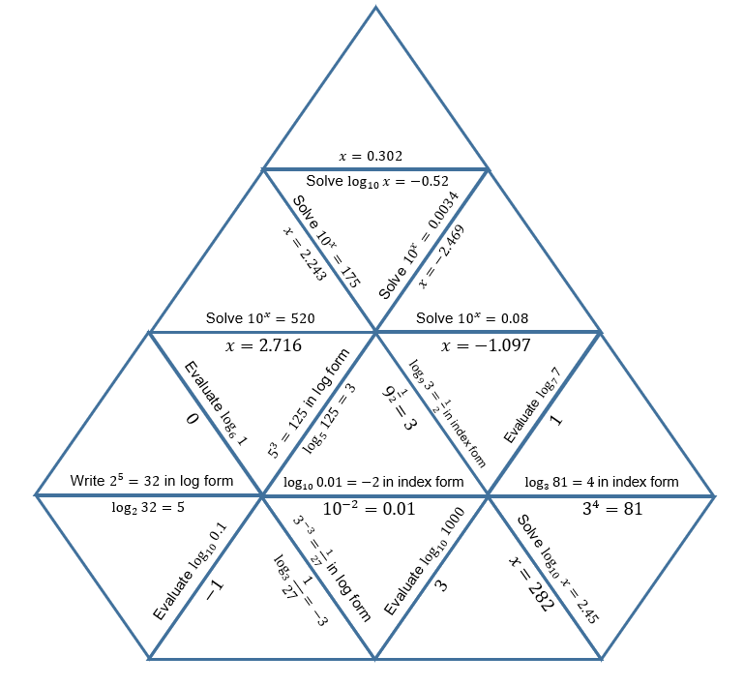

Sample solutions

Appendix A – a new function
Part A
Value | Power of 2
8 | 3
4 | 2
2 | 1
1 | 0
$$\frac{1}{2}$$ | -1
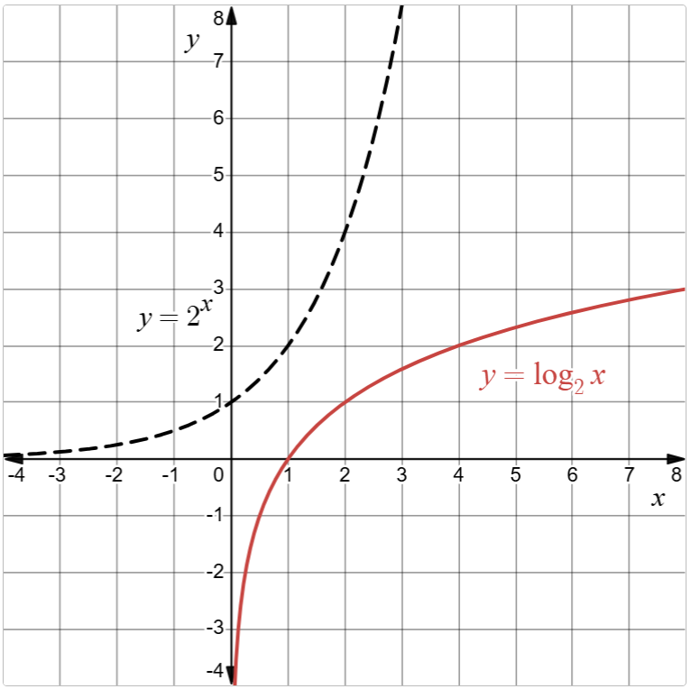

Part B
- The domain of one function is the range of the other and vice versa.
$$y=2^{x}$$ | New function
Domain: all real $x$ | Domain: $x>0$
Range: $y>0$ | Range: all real $y$
- As $x→∞$, $y=2^{x}$ grows quickly and the new function grows slowly.

$$y=2^{x}$$ | New function
Horizontal asymptote: $y=0$ | Vertical asymptote: $x=0$
$y$-intercept: 1 | $x$-intercept: 1
- The inputs and outputs of the 2 functions are swapped, meaning they are the reverse of each other.
- As $x→0$, the new function quickly approaches $-∞$.

Appendix B - Exponential and logarithmic equations
$$y=a^{x}$$ | $$x=\log_{a}{y}$$ | $$x$$
$$4=2^{x}$$ | $$x=\log_{2}{4}$$ | $$2$$
$$9=3^{x}$$ | $$x=\log_{3}{9}$$ | $$2$$
$$16=4^{x}$$ | $$x=\log_{4}{16}$$ | $$2$$
$$25=5^{x}$$ | $$x=\log_{5}{25}$$ | $$2$$
$$27=3^{x}$$ | $$x=\log_{3}{27}$$ | $$3$$
$$3=3^{x}$$ | $$x=\log_{3}{3}$$ | $$1$$
$$\frac{1}{3}=3^{x}$$ | $$x=\log_{3}{\frac{1}{3}}$$ | $$-1$$
$$1=3^{x}$$ | $$x=\log_{3}{1}$$ | $$0$$
$$1=4^{x}$$ | $$x=\log_{4}{1}$$ | $$0$$
$$1=5^{x}$$ | $$x=\log_{5}{1}$$ | $$0$$
$$125=5^{x}$$ | $$x=\log_{5}{125}$$ | $$3$$
$$0.2=5^{x}$$ | $$x=\log_{5}{0.2}$$ | $$-1$$
$$\frac{1}{25}=5^{x}$$ | $$x=\log_{5}{\frac{1}{25}}$$ | $$-2$$

Appendix C – Less, same, more
There are many options, for example:
 | Base is smaller | Base is the same | Base is larger
Result is smaller | $$\log_{2}{4}=2$$ | $$\log_{3}{9}=2$$ | $$\log_{5}{25}=2$$
Result is the same | $$\log_{2}{8}=3$$ | $$\log_{3}{27}=3$$ | $$\log_{5}{125}=3$$
Result is larger | $$\log_{2}{16}=4$$ | $$\log_{3}{81}=4$$ | $$\log_{5}{625}=4$$

References
This resource contains NSW Curriculum and syllabus content. The NSW Curriculum is developed by the NSW Education Standards Authority (NESA). This content is prepared by NESA for and on behalf of the Crown in right of the State of New South Wales. The material is protected by Crown copyright.
Please refer to the NESA Copyright Disclaimer for more information https://www.nsw.gov.au/education-and-training/nesa/copyright.
NESA holds the only official and up-to-date versions of the NSW Curriculum and syllabus documents. Please visit NESA https://www.nsw.gov.au/education-and-training/nesa and NSW Curriculum https://curriculum.nsw.edu.au.
Mathematics Advanced 11–12 Syllabus © NSW Education Standards Authority (NESA) for and on behalf of the Crown in right of the State of New South Wales, 2024.

© State of New South Wales (Department of Education), 2026
The copyright material published in this resource is subject to the Copyright Act 1968 (Cth) and is owned by the NSW Department of Education or, where indicated, by a party other than the NSW Department of Education (third-party material).
Copyright material available in this resource and owned by the NSW Department of Education is licensed under a Creative Commons Attribution 4.0 International (CC BY 4.0) license.

This license allows you to share and adapt the material for any purpose, even commercially. Attribution should be given to © State of New South Wales (Department of Education), 2025.
Material in this resource not available under a Creative Commons license:
- the NSW Department of Education logo, other logos and trademark-protected material
- material owned by a third party that has been reproduced with permission. You will need to obtain permission from the third party to reuse its material.
Links to third-party material and websites
Please note that the provided (reading/viewing material/list/links/texts) are a suggestion only and implies no endorsement, by the New South Wales Department of Education, of any author, publisher, or book title. School principals and teachers are best placed to assess the suitability of resources that would complement the curriculum and reflect the needs and interests of their students.
If you use the links provided in this document to access a third-party's website, you acknowledge that the terms of use, including licence terms set out on the third-party's website apply to the use which may be made of the materials on that third-party website or where permitted by the Copyright Act 1968 (Cth). The department accepts no responsibility for content on third-party websites.

