Euler’s number
Students learn that the derivative of an exponential function is proportional to the original function. They are introduced to Euler’s number, $e$, and the properties of the function $y=e^{x}$. Students practise with transformations of the function $y=e^{x}$.
Students will need at least one digital device per pair to interact with Amplify Classroom during this lesson.
Learning intentions and success criteria should be shared with students later in the learning episode.

Learning intentions
- To understand why $e$ is the unique base whose exponential function is its own derivative.
- To be able to describe and graph transformations of $f\left(x\right)=e^{x}$.

Success criteria
- I can identify that the derivative of $f\left(x\right)=a^{x}$ is proportional to the original function.
- I can explain why $e$ is the unique number such that $f\left(x\right)=e^{x}$ is its own derivative.
- I can apply transformations to the function $f\left(x\right)=e^{x}$.

Outcomes
A student:
- develops understanding and fluency in mathematics through exploring and connecting mathematical concepts, choosing and applying mathematical techniques to solve problems, and communicating their thinking and reasoning coherently and clearly MAO-WM-01
- applies exponential and logarithmic laws to simplify expressions, solve equations and prove results MAV-11-07
- analyses graphs of exponential and logarithmic functions MAV-11-08

Content

Exponential functions
- Examine the gradient of the tangent to the curve $y=a^{x}$ at its $y$-intercept for varying values of $a$, and verify using graphing applications that there is a unique number $e≈2.71828182845$..., such that the gradient of the tangent to $y=e^{x}$ at $x=0$ is 1, and call this number $e$ Euler’s number
- Examine the gradient function of $y=a^{x}$ with graphing applications and identify that the gradient function is $\frac{d}{dx}\left(a^{x}\right)=ka^{x}$, for some constant $k$ depending only on $a$
- Conclude that Euler’s number, $e$, is a unique number such that $\frac{d}{dx}\left(e^{x}\right)=e^{x}$, that is, $e^{x}$ is its own derivative
Mathematics Advanced 11–12 Syllabus © NSW Education Standards Authority (NESA) for and on behalf of the Crown in right of the State of New South Wales, 2024.

Table 1: lesson summary
Section | Summary of activity | Teaching strategies | Teaching points
Activating prior knowledge | Use slides 3-4 of the PowerPoint Euler’s number for students to complete questions about the tangents and derivative of $y=x^{2}$. |  | Recall knowledge of tangents and derivatives.
Connecting learning | Students investigate exponential growth and compound interest using slides 6–9. They complete screens 1–3 of the Amplify Classroom activity (bit.ly/findingeulersnumber) investigating the gradient of exponential functions. Reveal the learning intentions and success criteria on slide 10 and discuss the results of the activity on slide 11. Use slide 12 to discuss the $y$-intercept of $y=a^{x}$. Use screens 4–7 from the Amplify Classroom activity for students to find a function that is its own derivative and introduce Euler’s number $e$ and properties of $e^{x}$ using slide 13. | Pose-Pause-Pounce-Bounce Think-Pair-Share | Recognise that the derivative of an exponential function is proportional to the function and that Euler’s number $e$ is the unique number such that $\frac{d}{dx}\left(e^{x}\right)=e^{x}$.
Releasing responsibility | Students learn how to evaluate $e^{x}$using their calculator. They complete Appendix A by calculating values and graphing $e^{x}$, then summarising its properties using slide 15 and recording notes. | Notes to future forgetful selves | Identify and describe features of the graph of $e^{x}$.
Independent practice | Students complete screens 8–10 of the Amplify Classroom activity as a card-match linking transformations, graphs and equations. They then attempt an HSC-style question on slide 17 and review the solution. |  | Apply transformations to the function $e^{x}$.

Activity structure
Please use the associated PowerPoint Euler’s number to display images in this lesson.

Activating prior knowledge
- Display slide 3 of the PowerPoint and ask students to complete the questions about the derivative of $y=x^{2}$ to recall knowledge about tangents and derivatives.
- Display slide 4 for students to check their solutions.

Connecting learning
- Display slide 6 and have students compute compound interest over 3 periods using the table provided on the slide.
- Animate the slide to show the solutions and a graph of the amount and the interest.
- Animate the slide again to show self-explanation prompts and use the Pose-Pause-Pounce-Bounce questioning strategy (PDF 557KB) (bit.ly/posepausepouncebounce) to discuss them.
- Why can we say that the interest paid at each step is proportional to the amount?
- What does the change between each step represent?
The interest paid at each step is proportional to the amount: $I=0.1×A$. If necessary, remind students about compound interest using Stage 5 – unit 11 learning episode 1 – simple and compound interest.
Students should recognise that the change between each step represents the added interest.
- Display slide 7 which shows the graph of the same investment compounding over 15 years and use a Think-Pair-Share (bit.ly/thinkpairsharestrategy) for students to consider the question on the slide.
- Animate the slide to show the solution and a dashed line on the graph showing the exponential function the points lie on.
Students may benefit from the teacher explaining that the line is dashed because compound interest points lie on an exponential function given by the compound interest formula. However, they are discrete points and do not form a continuous curve.
- Display slide 8 and ask students to find the equation of the exponential function passing through the interest points.
- Animate the slide to show the solution.
- Display slide 9 which summarises the results from slides 6–8.
- Tell students that this was for individual points lying on an exponential function and they will now investigate the rate of change of continuous exponential functions.
- Assign the Amplify Classroom activity ‘Euler’s number’ (bit.ly/findingeulersnumber) for students to attempt in pairs using devices. Restrict students to screens 1–3.
Before completing this activity, you will need to set up an Amplify Classroom (bit.ly/createamplifyclassroom) and use the pacing feature to restrict students to screens 1–3.
Amplify Classroom provides the opportunity for immediate feedback as well as tailored feedback from the teacher as students’ progress.
- Discuss the results of screen 3 using the Pose-Pause-Pounce-Bounce questioning strategy. The following questions may be used:
- How can we summarise what we found in the activity?
- For each value of $a$, what was happening to $k?$
Students should understand that:
- The derivative of an exponential function is proportional to the original function.
- For each value of $a$, there is a unique value of $k$.
- As $a$ increases, the value of $k$ is increasing.
- Display slide 10 and reveal the learning intentions and success criteria for the lesson.
- Display slide 11 summarising what was learnt about the derivative of an exponential.
- The teacher should introduce the goal of finding a function which is its own derivative and justify its importance in mathematics.
When it comes to growth, the function that is its own derivative is the basic building block that allows us to do many things in mathematics. Students will learn more about this in future lessons.
- Return students to the Amplify Classroom activity and extend the pacing to include screen 4 for students to complete.
- Students should find that the function and its derivative overlap when $a≈2.7.$ Inform students that this value is close, but not exact.
- Display slide 12 and ask students in a Think-Pair-Share (bit.ly/thinkpairsharestrategy) to consider what is the same about all graphs of the form $y=a^{x}$.
- Animate the slide to show the solution.
They all have a common point which is the $y$-intercept of 1.
- Ask students in a Think-Pair-Share to consider:
- For the exponential function that is its own derivative, what is the value at $x=0$?
- What is the value of the derivative at $x=0$?
Lead students to conclude that for the function that is its own derivative: $f\left(0\right)=1$ and therefore $f^{'}\left(0\right)=1$.
This is the only point on the graph for which we know the derivative.
- Return students to the Amplify Classroom activity. Adjust the pacing up to screen 7 for students to complete.
- Display slide 13 with a summary of some of the properties of $e$ and state that this is one of the most important numbers in Mathematics, like $π$.

Releasing responsibility
- Explicitly teach students how to evaluate expressions on their calculator that include the value $e$.
- Distribute a copy of Appendix A ‘The exponential function’ to each student and have them complete the table and use it to plot the graph of $f\left(x\right)=e^{x}$ on the first page.
- Display slide 15 and ask students to summarise the properties of $f\left(x\right)=e^{x}$ on the second page of the appendix using their knowledge of exponential functions. Animate the slide to show the solutions.

Independent practice
- Return students to the Amplify Classroom activity and remove the pacing for students to complete screens 8–10, which contain card-matching activities linking transformations, graphs and equations.
Alternatively, you may wish to provide students with a printed copy of the card-sort questions using Appendix B ‘Transformations of $f(x)=e^{x}$.’
- Display slide 17 for students to attempt an HSC-style question. Animate the slide to show in order:
- suggested working prompts
- solutions to the prompts
- the final graph.

Assessment and differentiation

Suggested opportunities for differentiation
Activating prior knowledge
- Extend students by asking them to complete the same question for higher powers of $x$ and explain the patterns between the number of solutions and the power of $x$.
Connecting learning
- Before working with compound interest, briefly revisit or scaffold the concept of simple interest and direct variation.
- Some students may be interested in seeing other mathematical definitions of $e$:
- $e=\lim_{n→∞}{{\left(1+\frac{1}{n}\right)}^{n}}$
- $e=\sum_{n=0}^{∞}{\frac{1}{n!}}$
Releasing responsibility
- Provide step-by-step calculator instructions for evaluating $e$ for students less familiar with their calculators.
- Encourage proficient students to explore and compare the values of $e^{x}$ for negative and fractional values of $x$.
- Teachers may wish to provide students with the graph of $y=e^{x}$ and ask students to make notes to their future forgetful selves by annotating around the graph.
Independent practice
- Some students may require extra practice working with the function $f\left(x\right)=e^{x}$ and should be given questions from an existing resource.
- Extend students by removing the graph or equation and asking them to complete the missing items from the card sort.

Suggested opportunities for assessment
Activating prior knowledge
- Use student responses to check for understanding of basic differentiation.
- Use the solution check on slide 4 as an opportunity for students to self-assess and explain their reasoning aloud.
Connecting learning
- Monitor Think-Pair-Share and Pose-Pause-Pounce-Bounce discussions for understanding of exponential growth in the compound interest context.
- Use student responses to the Amplify Classroom activity to check for understanding of the derivative of an exponential function and pause for further discussion as required.
- Use the post-activity discussion to assess students’ conceptual grasp of derivatives of exponential functions and their connection to Euler’s number.
Releasing responsibility
- Use the post-activity discussion to assess students’ conceptual grasp of derivatives of exponential functions and their connection to Euler’s number.
- Review student notes to check for attainment of the success criteria.
Independent practice
- Review card match activity responses using the teacher dashboard to assess understanding of transformations of $e^{x}$.
- The HSC-style question could be used as an exit ticket (bit.ly/exitticketstrategy), to check for understanding of the transformations and properties of the exponential function.

Appendix A

The exponential function
Complete the table. Use your calculator to approximate the following values, correct to 1 decimal place.
$$x$$ | $$-2$$ | $$-1$$ | $$0$$ | $$1$$ | $$2$$ | $$3$$
$$f\left(x\right)=e^{x}$$ | $$\frac{1}{e^{2}}$$ |  |  |  | $$e^{2}$$
Approximate value
Use the values from the table to help you graph the function $f\left(x\right)=e^{x}$.
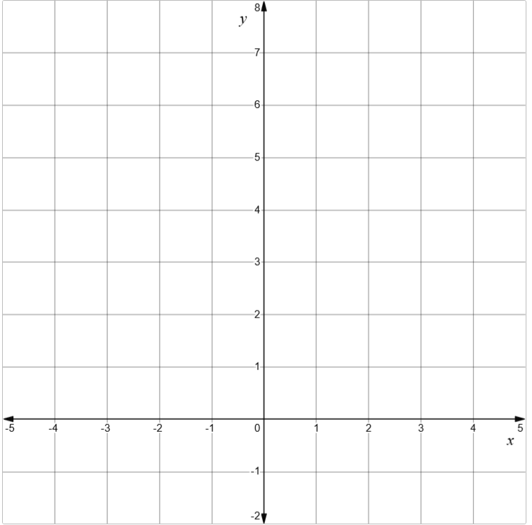

Properties of $f(x)=e^{x}$
What do we know about $f\left(x\right)=e^{x}$?
Intercepts:
Domain:
Range:
Symmetry (is it an odd or even function?):
Behaviour as $x→∞:$
Behaviour as $x→-∞:$
Derivative:
Any other information:

Appendix B

Transformations of $f\left(x\right)=e^{x}$
A transformation has been applied to $f\left(x\right)=e^{x}$. Match each description with the graph and the new equation.
Reflection across the $y$-axis: | 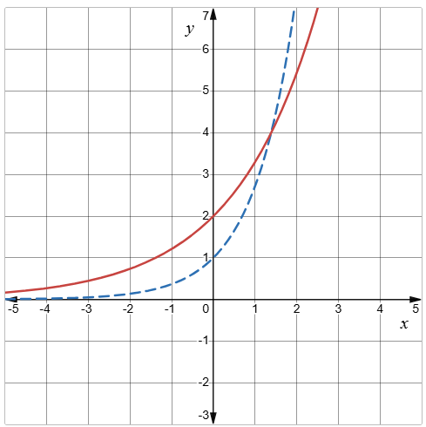 | $$y=2e^{x}$$
Reflection across the $x$-axis: | 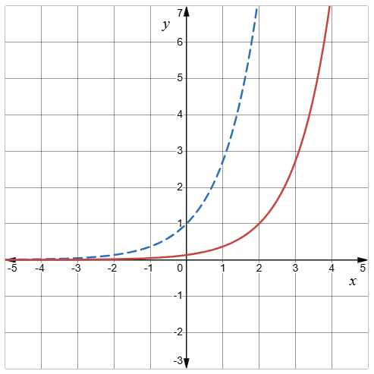 | $$y=e^{x+2}$$
Translate up 2 units: | 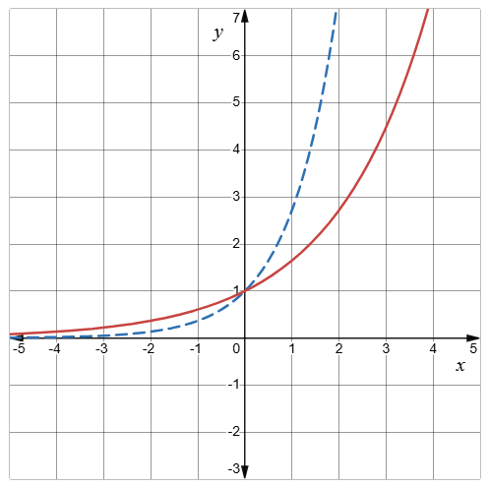 | $$y=\frac{1}{2}e^{2x}$$
Translate down by 2 units: | 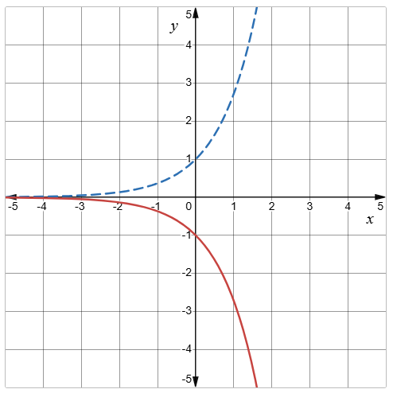 | $$y=e^{x}-2$$
Translate left by 2 units: | 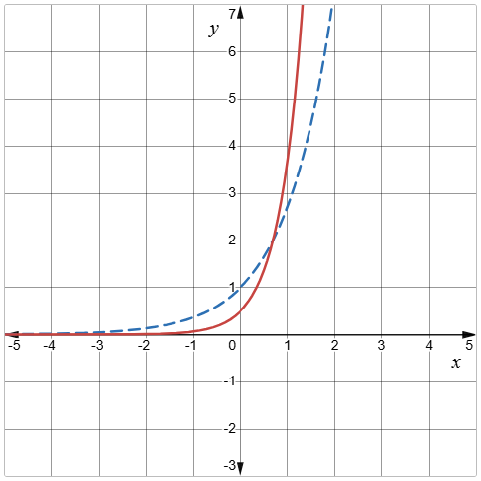 | $$y=e^{\frac{x}{2}}$$
Translate right by 2 units: | 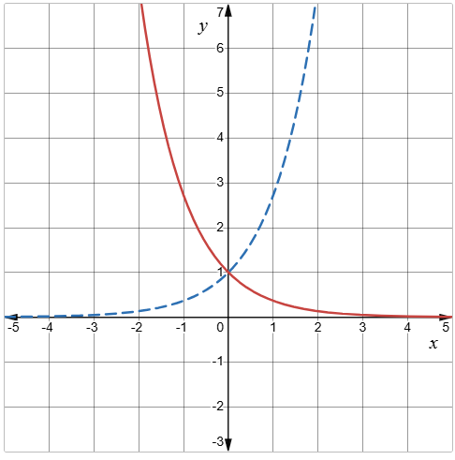 | $$y=e^{-x}$$
Enlarge by a factor of $2$:  Replace $x$ and y with $\frac{x}{2}$ and $\frac{y}{2}$. | 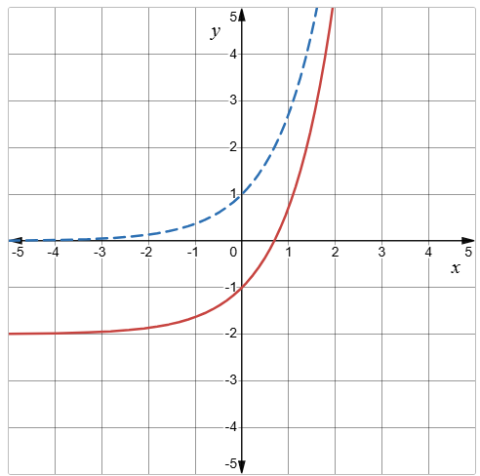 | $$y=2e^{\frac{x}{2}}$$
Reduce by a factor of $\frac{1}{2}$:  Replace $x$ with $\frac{x}{\left(\frac{1}{2}\right)}=2x$ and $y$ with $\frac{y}{\left(\frac{1}{2}\right)}=2y$. | 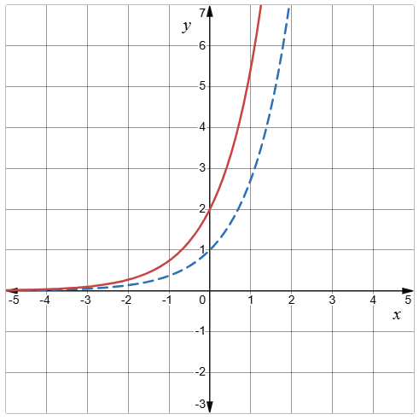 | $$y=e^{x}+2$$
Dilate horizontally by 2: | 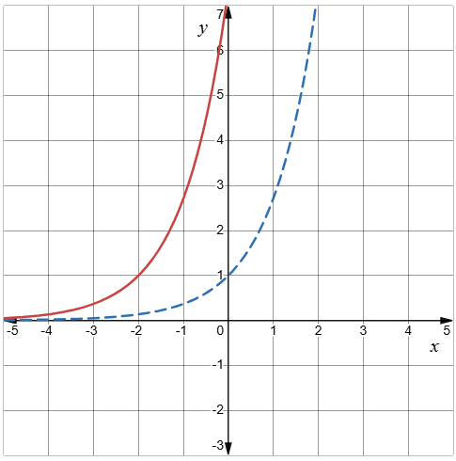 | $$y=e^{x-2}$$
Dilate vertically by 2: | 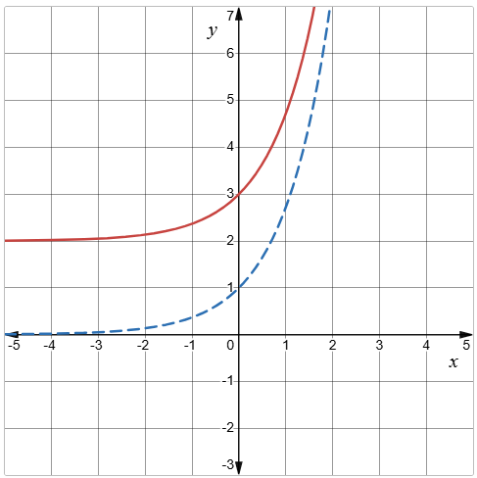 | $$y=-e^{x}$$

Sample solutions

Appendix A - the exponential function
$$x$$ | $$-2$$ | $$-1$$ | $$0$$ | $$1$$ | $$2$$ | $$3$$
$$f\left(x\right)=e^{x}$$ | $$\frac{1}{e^{2}}$$ | $$\frac{1}{e}$$ | $$e^{0}$$ | $$e$$ | $$e^{2}$$ | $$e^{3}$$
Approximate value | $$0.1$$ | $$0.4$$ | $$1$$ | $$2.7$$ | $$7.4$$ | $$20.1$$
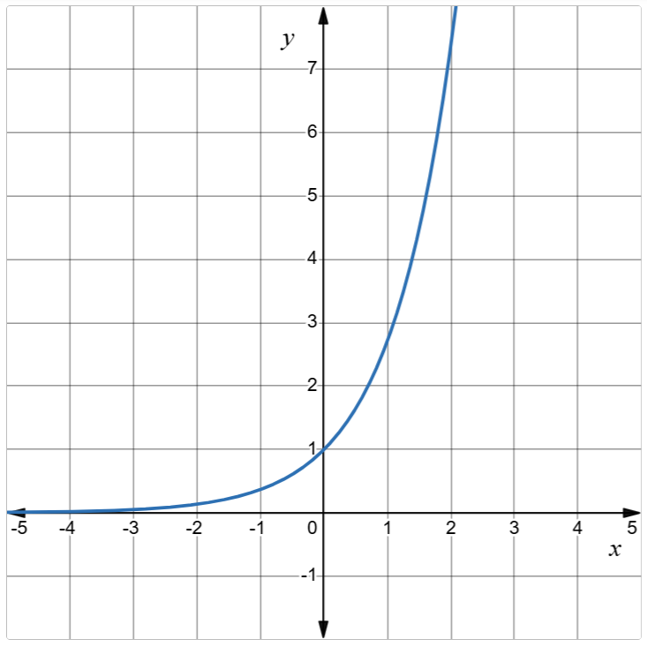

Properties of $f(x)=e^{x}$
What do we know about $f\left(x\right)=e^{x}$?
Intercepts: $y=0$, no $x$-intercepts.
Domain: All real $x$.
Range: $y>0$.
Symmetry (odd or even function?): neither odd nor even.
Behaviour as $x→∞:$ $y→∞$.
Behaviour as $x→-∞:$ $y→0$.
Derivative: $f'(x)$: $\frac{d}{dx}\left(e^{x}\right)=e^{x}$.
Any other information: the function is always increasing.

Appendix B – transformations of $f\left(x\right)=e^{x}$
Reflect across the $y$-axis: |  | $$y=e^{-x}$$
Reflect across the $x$-axis: |  | $$y=-e^{x}$$
Translate up 2 units: |  | $$y=e^{x}+2$$
Translate down by 2 units: |  | $$y=e^{x}-2$$
Translate left by 2 units: |  | $$y=e^{x+2}$$
Translate right by 2 units: |  | $$y=e^{x-2}$$
Enlarge by a factor of $2$:  Replace $x$ and y with $\frac{x}{2}$ and $\frac{y}{2}$. |  | $$y=2e^{\frac{x}{2}}$$
Reduce by a factor of $\frac{1}{2}$:  Replace $x$ with $\frac{x}{\left(\frac{1}{2}\right)}=2x$ and $y$ with $\frac{y}{\left(\frac{1}{2}\right)}=2y$. |  | $$y=\frac{1}{2}e^{2x}$$
Dilate horizontally by 2. |  | $$y=e^{\frac{x}{2}}$$
Dilate vertically by 2. |  | $$y=2e^{x}$$

References
This resource contains NSW Curriculum and syllabus content. The NSW Curriculum is developed by the NSW Education Standards Authority (NESA). This content is prepared by NESA for and on behalf of the Crown in right of the State of New South Wales. The material is protected by Crown copyright.
Please refer to the NESA Copyright Disclaimer for more information https://www.nsw.gov.au/education-and-training/nesa/copyright.
NESA holds the only official and up-to-date versions of the NSW Curriculum and syllabus documents. Please visit NESA https://www.nsw.gov.au/education-and-training/nesa and NSW Curriculum https://curriculum.nsw.edu.au.
Mathematics Advanced 11–12 Syllabus © NSW Education Standards Authority (NESA) for and on behalf of the Crown in right of the State of New South Wales, 2024.

© State of New South Wales (Department of Education), 2026
The copyright material published in this resource is subject to the Copyright Act 1968 (Cth) and is owned by the NSW Department of Education or, where indicated, by a party other than the NSW Department of Education (third-party material).
Copyright material available in this resource and owned by the NSW Department of Education is licensed under a Creative Commons Attribution 4.0 International (CC BY 4.0) license.

This license allows you to share and adapt the material for any purpose, even commercially. Attribution should be given to © State of New South Wales (Department of Education), 2026.
Material in this resource not available under a Creative Commons license:
- the NSW Department of Education logo, other logos and trademark-protected material
- material owned by a third party that has been reproduced with permission. You will need to obtain permission from the third party to reuse its material.
Links to third-party material and websites
Please note that the provided (reading/viewing material/list/links/texts) are a suggestion only and implies no endorsement, by the New South Wales Department of Education, of any author, publisher, or book title. School principals and teachers are best placed to assess the suitability of resources that would complement the curriculum and reflect the needs and interests of their students.
If you use the links provided in this document to access a third-party's website, you acknowledge that the terms of use, including licence terms set out on the third-party's website apply to the use which may be made of the materials on that third-party website or where permitted by the Copyright Act 1968 (Cth). The department accepts no responsibility for content on third-party websites.

