Transformations of exponential functions
Students are reminded about the properties of exponential functions of the form $y=a^{x}$ before extending this knowledge to transform functions of the form $f\left(x\right)=k\left(a^{x}\right)$ and $f\left(x\right)=k\left(a^{-x}\right)$.
Students will need at least one digital device per pair to interact with Amplify Classroom during this lesson.

Learning intentions
- To be able to describe the features and behaviour of the graphs $y=k\left(a^{x}\right)$and$y=k\left(a^{-x}\right).$
- To understand the transformations of exponential functions.

Success criteria
- I can explain the relationship between $y=a^{x}$ and $y=a^{-x}$.
- I can identify the asymptote,$y$-intercept, domain and range of the graphs $y=k\left(a^{x}\right)$and $y=k\left(a^{-x}\right)$.
- I can describe the behaviour of $y=k\left(a^{x}\right) and y=k\left(a^{-x}\right)$ as $x→∞$ and $x→-∞$.
- I can sketch transformations of the graphs $y=k\left(a^{x}\right) and y=k\left(a^{-x}\right)$.

Outcomes
A student:
- develops understanding and fluency in mathematics through exploring and connecting mathematical concepts, choosing and applying mathematical techniques to solve problems, and communicating their thinking and reasoning coherently and clearly MAO-WM-01
- applies exponential and logarithmic laws to simplify expressions, solve equations and prove results MAV-11-07
- analyses graphs of exponential and logarithmic functions MAV-11-08

Content

Exponential functions
- Graph the exponential functions $y=k\left(a^{x}\right)$ and $y=k\left(a^{-x}\right)$ for constants $a$ and $k$ where $a>0$, $a≠1$ and $k≠0$, and identify its asymptote, $y$-intercept, domain and range
- Describe the behaviour of $y=k\left(a^{x}\right)$ and $y=k\left(a^{-x}\right)$ as $x→∞$ and $x→-∞$
Mathematics Advanced 11–12 Syllabus © NSW Education Standards Authority (NESA) for and on behalf of the Crown in right of the State of New South Wales, 2024.

Table 1: lesson summary
Section | Summary of activity | Teaching strategies | Teaching points
Retrieval practice | Students identify and correct errors in exponential expressions using slide 4 of the PowerPoint Transformations of exponential functions. They then use questions on slide 5 to review writing expressions with and without a negative index. | Incorrect worked examples  Mini whiteboards | Recall and apply index laws to simplify exponential expressions.  Reinforce accurate conversion between fractional and negative index forms.
Activating prior knowledge | Students complete an Amplify Classroom activity (bit.ly/exponential_transformations) to investigate transformations of exponential functions. | Pose-Pause-Pounce-Bounce | Identify different types of transformations and how they affect the graph of an exponential function.
Connecting learning | Display slide 7 for students to identify features of an exponential graph when it is reflected in the $y$-axis. Students return to the Amplify Classroom activity, pausing to discuss the reflective behaviour of the negative index and an index between 0 and 1. Students then return to the Amplify Classroom activity before discussing the features and behaviour of $y=k\left(a^{x}\right) and y=k\left(a^{-x}\right)$ as $k$ changes, for $a>0$. | Think-Pair-Share  Pose-Pause-Pounce-Bounce | Consider how changing the value of the index and changing the value of $k$ for $y=k\left(a^{x}\right) and y=k\left(a^{-x}\right)$ impacts the graph of the exponential function.
Releasing responsibility | Students complete worked examples using slides 9–12. Students practise similar questions and create notes using Appendix A. | Worked examples (Your turn)  Four quadrant notes | Identify features of an equation to justify the transformation of a graph.
Independent practice | Students complete Appendix B in pairs and verify solutions using the Desmos graphing calculator (desmos.com/calculator). Strategies are discussed as a class. | Pose-Pause-Pounce-Bounce | Identify successful strategies to sketch a graph using a description of a transformation.

Activity structure
Please use the associated PowerPoint Transformations of exponential functions to display images in this lesson.

Retrieval practice
- Display slide 4 of the PowerPoint and ask students to identify the errors in each of the incorrect worked examples (bit.ly/incorrectworkedexamples).
Students should recognise that the power of $-3$ only applies to the $x$ and not the coefficient.
Linda incorrectly placed the coefficient in the denominator and Scott incorrectly cubed the coefficient.
- Ask students to write down the correct solution using mini whiteboards (bit.ly/miniwhiteboards) and hold up their answers. Animate the slide to display the correct answer.
- Display slide 5 and, using mini whiteboards, ask students to write the first 3 expressions without fractions. Check for understanding by having students display their answers and animate to confirm their solutions.
- Animate slide 5 to display a second set of questions that require students to write expressions on their mini whiteboards without a negative index. Check for understanding by having students display their answers on their mini whiteboards and animate the slide to confirm their solutions.

Activating prior knowledge
- Assign the Amplify Classroom activity ‘Transformations of exponential functions’ (bit.ly/exponential_transformations) for students to attempt in pairs using devices. Restrict students to screens 1–5.
Students were introduced to translations and dilations of graphs of the form $y=a^{x}$ in Unit 4 – graphing transformations.
Before completing this activity, you will need to set up an Amplify Classroom (bit.ly/createamplifyclassroom) and use the pacing feature to restrict students to screens 1–5.
Amplify provides the opportunity for immediate feedback as well as tailored feedback from the teacher as students’ progress.
- Use the Pose-Pause-Pounce-Bounce questioning strategy (PDF 557KB) (bit.ly/posepausepouncebounce) to remind students of the effect that translating and dilation has on the graphs. Possible questions include:
- What effect does adding or subtracting a constant have on an exponential function?
- What effect does multiplying the base by a number have on the exponential function?
- What effect does changing the index have on the exponential function?
Students should recognise that:
- Adding or subtracting a constant to a function results in a vertical translation of the graph.
- Multiplying the base by a constant produces a dilation and changes the$y$-intercept.
- Adding a constant to the index causes a horizontal translation.
- Multiplying the index by a constant results in a dilation.
If students do not recall these transformations, it may be beneficial to revisit them before proceeding.

Connecting learning
- Display slide 7 and use a Think-Pair-Share for students to discuss what features of the graph of $y=2^{x}$ change with reflection in the $y$-axis.
The domain, range, $y$-intercept and asymptote are all unchanged.
The behaviour as $x→∞$ and $x→-∞$ are swapped.
- Return students to the Amplify Classroom activity and extend the pacing to include screens 6–11 for students to complete.
- Use the Pose-Pause-Pounce-Bounce questioning strategy to discuss the results, drawing attention to the reflective behaviour of the negative index and index between 0 and 1. Useful question prompts may include:
- Why doesn’t a negative index produce a negative value?
- How do the graphs of $y={\left(\frac{1}{a}\right)}^{x}$ and $y=a^{-x}$ compare? Why?
A negative exponent does not control the sign of a number, but how many times you multiply or divide.
It can be shown using index laws that ${\left(\frac{1}{a}\right)}^{x}=a^{-x}$.
- Return students to the Amplify Classroom activity and remove the pacing for students to complete the remaining screens.
- Use the Pose-Pause-Pounce-Bounce questioning strategy to discuss the features and behaviour of $y=k\left(a^{x}\right) and y=k\left(a^{-x}\right)$ as $k$ changes, for $a>0$. Useful question prompts may include:
- How does the value of $k$ influence the features of $y=k\left(a^{x}\right) and y=k\left(a^{-x}\right)$?
- How does varying the constant $k$ compare with varying the base?
When $k$ is positive, increasing $k$ increases the distance from the $x$-axis, including for the $y$-intercept. When $k$ is negative, the function is reflected in the line $y=0$ and increasing the magnitude of $k$ increases the distance from the $x$-axis.
When $a>1$, the curve flattens as $a$ decreases and steepens as $a$ increases. When $0<a<1$, the behaviour as $x→∞$ and $x→-∞$ is swapped and decreasing the base steepens the curve.

Releasing responsibility
- Use slides 9–12 to model worked examples of vertical translations and dilations using the Worked examples (Your turn) method (bit.ly/supportingstrategies).
- Students should practise questions from an existing resource.
- Ask students to work in pairs to complete four quadrant notes to their future forgetful self (bit.ly/supportingstrategies) from Appendix A ‘Four quadrant notes’.

Independent practice
- Distribute a copy of Appendix B ‘Challenge questions’ to pairs of students.
- Instruct students to complete each question and then verify their solutions using the Desmos graphing calculator (desmos.com/calculator).
- Use the Pose-Pause-Pounce-Bounce questioning strategy to discuss strategies and encourage justification. The following are some suggested prompts:
- What features in the description helped to determine the equation?
- Were there any descriptions that could only be done one way? How do you know?

Assessment and differentiation

Suggested opportunities for differentiation
Activating prior knowledge
- Support students by providing a checklist of properties to consider, including domain, range, the $y$-intercept, behaviour as $x→∞$, behaviour as $x→-∞$ and asymptote(s).
- Provide students with a summary of different types of transformations and their equations.
Connecting learning
- Use the following questions to draw attention to features of the graph of $y={\left(\frac{1}{2}\right)}^{x}$ and how it can be compared with the graph of $y=2^{x}$.
- What do you notice about the $y$-intercept?
- What do you notice about the shape of the graphs?
- How would you describe what is happening to each graph as $x→∞$ and $x→-∞$?
- What do you notice about the equation of each graph?
- How would you explain the symmetry between the graphs?
- Extend students by asking them to consider the equivalences of horizontal translations and vertical dilations of exponentials using index laws, either here or in Independent practice. For example, $2^{x+2}=2^{2}×2^{x}$.
- Support students by modelling converting between negative index and fraction forms.
- Use the Amplify Classroom teacher dashboard to identify students requiring extra support and provide them with further explanations of the effect of each transformation.
Releasing responsibility
- Support students by considering horizontal and vertical dilations separately.
Independent practice
- Extend students by asking them to consider the equivalences of horizontal translations and vertical dilations of exponentials using index laws. For example, $2^{x+2}=2^{2}×2^{x}$.
- Support students by asking them to consider the effect of specific translations or dilations.
- Support students by asking them to consider what transformations are required for each part of multi-part descriptions.

Suggested opportunities for assessment
Retrieval practice
- Observe student responses on mini whiteboards to assess student understanding of converting between fractions and negative indices.
Activating prior knowledge
- Use the Amplify teacher dashboard to monitor student responses for accuracy and understanding translation and dilation of graphs.
- Listen to student explanations in the Pose-Pause-Pounce-Bounce strategy to assess student understanding of the properties of exponential graphs.
- Challenge students to compare the horizontal translation and the vertical dilation and justify what they find using index laws. Students should recognise that for horizontal translations and vertical translations of exponential functions, they are equivalent. For example, $y=2^{x+3}=2^{3}×2^{x}=8×2^{x}$
Connecting learning
- Use the Amplify teacher dashboard to monitor student responses for understanding of different representations of $a^{-x}$.
- Listen to student explanations in the Think-Pair-Share strategy to assess student understanding of the properties of exponential graphs.
- Use the Amplify Classroom teacher dashboard to check for understanding of the effect of transformations of exponential functions.
Releasing responsibility
- Observe student responses to the Your turn questions to check for understanding of the transformations.
- Monitor completion of the Four quadrant notes to identify students who may need further support in understanding transformations of exponential functions.
Independent practice
- Observe student responses to the challenge questions to check for understanding of the effect of transformations of exponential functions.
- Monitor responses during the discussion of the challenge questions for accuracy in interpreting the descriptions of the transformations.

Appendix A

Four quadrant notes
Example 1  Sketch the graph of $y=2×3^{-x},$ on the same axes as the graph of $y=3^{-x}$.  $y$-intercept:  Choose another point: At $x= , y=$  Asymptote:  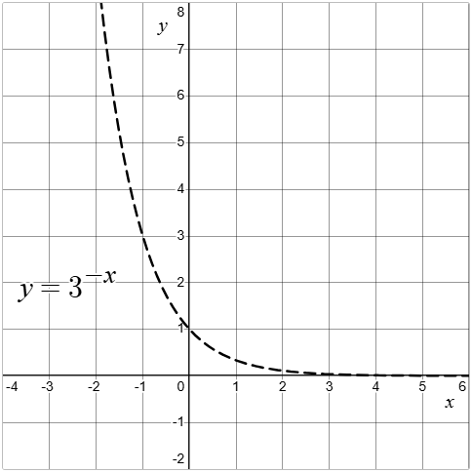 | Example 2  Sketch the graph of $y=2^{-x}-1$ on the same graph as $y=2^{x}$.  $y$-intercept:  Choose another point: At $x= , y=$  Asymptote:  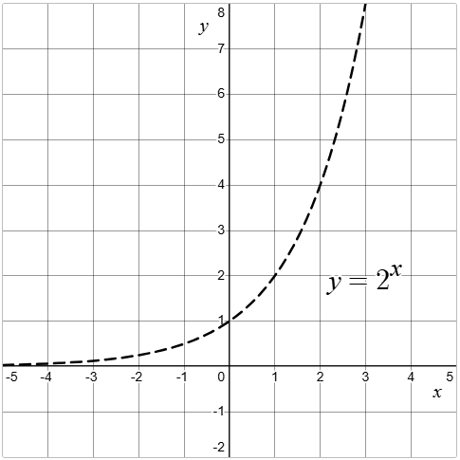
Things to remember | Example 3

Appendix B

Challenge questions
For each description, find an appropriate transformation, the new equation and sketch the graph.
Description:
- Transform $f\left(x\right)=2^{x}$ so that the $y$-intercept is 2.
- Transform $f\left(x\right)=3^{-x}$ so that the range is $y<2$.
- Transform $f\left(x\right)={\left(\frac{1}{2}\right)}^{x}$ so that it passes through the point $\left(1, 1\right).$
- Transform $f\left(x\right)=2^{x}$ so that the $y$-intercept is at $-3$, and $y→0$ as $x→∞$.
- Transform $f(x)=2^{-x}$ so that the range is $y>3$, and the $y$-intercept is 5.
- Transform $f\left(x\right)={\left(\frac{1}{5}\right)}^{x}$ so that $y→-∞$ as $x→∞$.
- Transform $f\left(x\right)=5^{-x}$ so that the asymptote is $y=-1$, and $y->-1$ as $x→-∞$.
- Find 2 ways to transform $f\left(x\right)=2^{x}$ so that the $y$-intercept is 2.

Sample solutions

Appendix A – four quadrant notes
Example 1  Sketch the graph of $y=2×3^{-x}$ on the same axes as the graph of $y=3^{-x}$.  $y$-intercept: when $x=0, y=2×3^{0}$$$=2$$  Choose another point: $x=1,$$$y=2×3^{-1} \\ =\frac{2}{3}$$  Asymptote: $y=1$  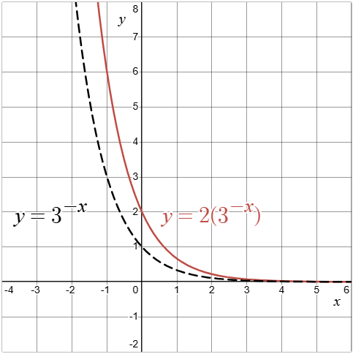 | Example 2  Sketch the graph of $y=2^{-x}-1$ on the same graph as $y=2^{x}$.  $y$-intercept: when $x=0, y=2^{0}-1$$$=0$$  Choose another point: $x=-2$,  $$y=2^{-(-2)}-1 \\ =3$$  Asymptote: $y=-1$  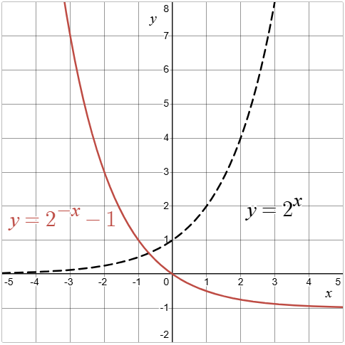

Appendix B – challenge questions
- Transform $f\left(x\right)=2^{x}$ so that the $y$-intercept is 2. | 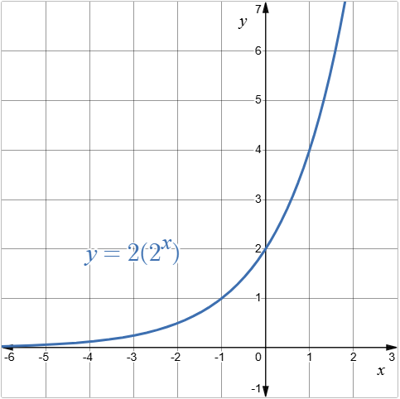
- Transform $f\left(x\right)=3^{-x}$ so that the range is $y<2$. | 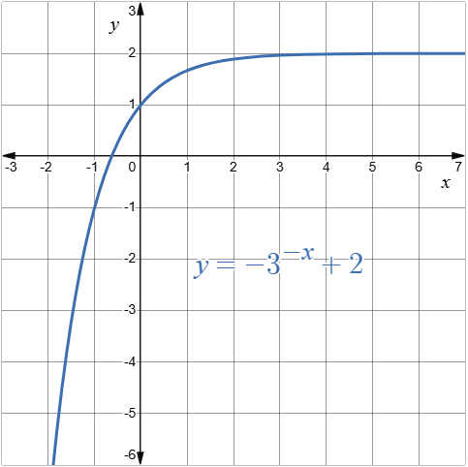
- Transform $f\left(x\right)={\left(\frac{1}{2}\right)}^{x}$ so that it passes through the point $\left(1, 1\right).$ | 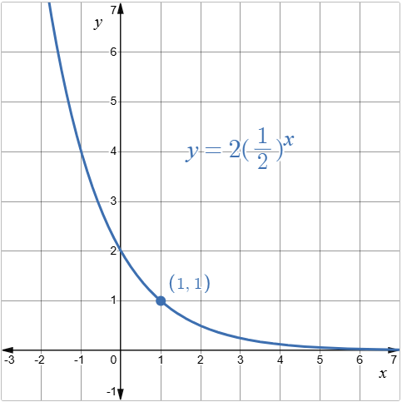
- Transform $f\left(x\right)=2^{x}$ so that the $y$-intercept is at $-3$, and $y→0$ as $x→∞$. | 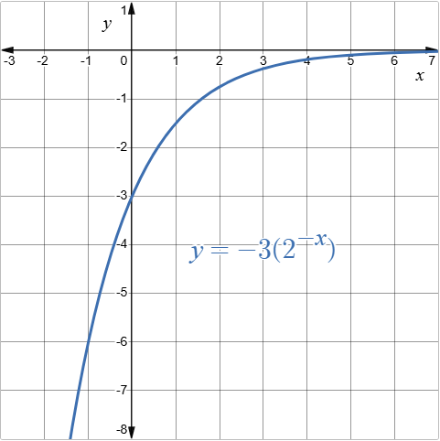
- Transform $f(x)=2^{-x}$ so that the range is $y>3$, and the $y$-intercept is 5. | 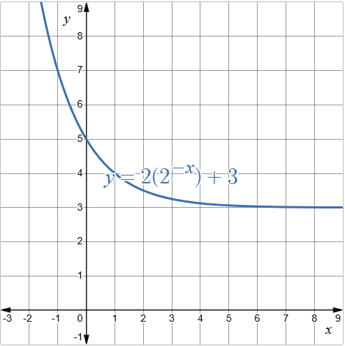
- Transform $f\left(x\right)={\left(\frac{1}{5}\right)}^{x}$ so that $y→-∞$ as $x→∞$. | 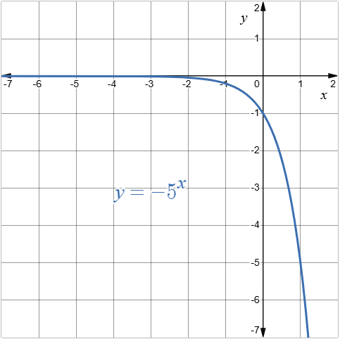
- Transform $f\left(x\right)=5^{-x}$ so that the asymptote is $y=-1$, and $y->0$ as $x→-∞$. | 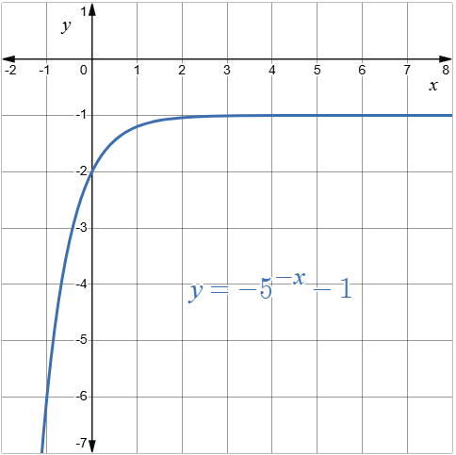
- Find 2 ways to transform $f\left(x\right)=2^{x}$ so that the $y$-intercept is 2. | 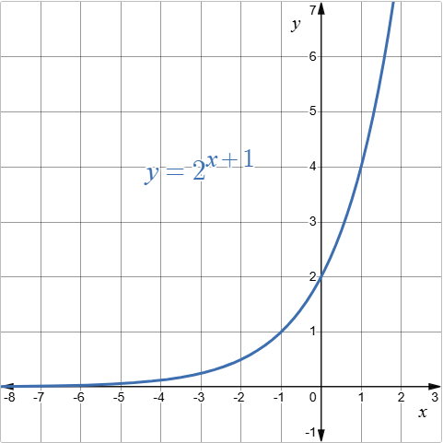  or  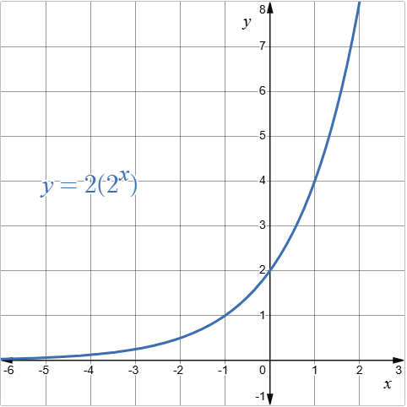

References
This resource contains NSW Curriculum and syllabus content. The NSW Curriculum is developed by the NSW Education Standards Authority (NESA). This content is prepared by NESA for and on behalf of the Crown in right of the State of New South Wales. The material is protected by Crown copyright.
Please refer to the NESA Copyright Disclaimer for more information https://www.nsw.gov.au/education-and-training/nesa/copyright.
NESA holds the only official and up-to-date versions of the NSW Curriculum and syllabus documents. Please visit NESA https://www.nsw.gov.au/education-and-training/nesa and NSW Curriculum https://curriculum.nsw.edu.au.
Mathematics Advanced 11–12 Syllabus © NSW Education Standards Authority (NESA) for and on behalf of the Crown in right of the State of New South Wales, 2024.

© State of New South Wales (Department of Education), 2026
The copyright material published in this resource is subject to the Copyright Act 1968 (Cth) and is owned by the NSW Department of Education or, where indicated, by a party other than the NSW Department of Education (third-party material).
Copyright material available in this resource and owned by the NSW Department of Education is licensed under a Creative Commons Attribution 4.0 International (CC BY 4.0) license.

This license allows you to share and adapt the material for any purpose, even commercially. Attribution should be given to © State of New South Wales (Department of Education), 2026.
Material in this resource not available under a Creative Commons license:
- the NSW Department of Education logo, other logos and trademark-protected material
- material owned by a third party that has been reproduced with permission. You will need to obtain permission from the third party to reuse its material.
Links to third-party material and websites
Please note that the provided (reading/viewing material/list/links/texts) are a suggestion only and implies no endorsement, by the New South Wales Department of Education, of any author, publisher, or book title. School principals and teachers are best placed to assess the suitability of resources that would complement the curriculum and reflect the needs and interests of their students.
If you use the links provided in this document to access a third-party's website, you acknowledge that the terms of use, including licence terms set out on the third-party's website apply to the use which may be made of the materials on that third-party website or where permitted by the Copyright Act 1968 (Cth). The department accepts no responsibility for content on third-party websites.

