Displacement and velocity
Students study a variety of different distance time graphs to learn about displacement and velocity before linking it to calculus and graphing derivatives.

Learning intentions
- To be able to explain the difference between distance and displacement as well as velocity and speed.
- To be able to calculate the displacement and velocity of a moving object.

Success criteria
- I can define displacement and velocity as having both size and direction.
- I can find the velocity equation from the displacement equation.
- I can find when velocity and displacement are zero and interpret the value.
- I can interpret displacement and velocity graphs with respect to time.

Outcomes
A student:
- develops understanding and fluency in mathematics through exploring and connecting mathematical concepts, choosing and applying mathematical techniques to solve problems, and communicating their thinking and reasoning coherently and clearly MAO-WM-01
- interprets the meaning of the derivative and determines the derivative of functions to solve problems MAV-11-06

Content

The derivative as a rate of change
- Interpret 𝑓'(𝑐) as the instantaneous rate of change of the function 𝑓(𝑥) at 𝑥 = 𝑐.
- Define and distinguish between displacement and distance and between velocity and speed.
- Use graphs of functions and their derivatives, without the use of algebraic techniques, to describe and interpret physical phenomena.
- Use the notation $\frac{dx}{dt}$ or $\dot{x}$ to represent the velocity of a particle with displacement 𝑥 from a point as a function of time 𝑡.
- Solve problems by determining the velocity of a particle moving in a straight line, given its displacement from a point as a function of time.
Mathematics Advanced 11–12 Syllabus © NSW Education Standards Authority (NESA) for and on behalf of the Crown in right of the State of New South Wales, 2024.

Table 1: lesson summary
Section | Summary of activity | Teaching strategies | Teaching points
Activating prior knowledge | Students write as much information as possible about a distance time graph (Appendix A) before discussing their findings. | Visibly random groups of 3  Vertical non-permanent surfaces  Gallery walk  Pose-Pause-Pounce-Bounce | Students have studied distance- time graphs in Stages 4 and 5.
Connecting learning | Define displacement using slide 4 and have students find the displacement of the journey from Appendix A. Students use a second graph (Appendix B) to compare displacement and distance (slide 5) before moving to speed and velocity. Students watch a video ‘The Difference Between Speed & Velocity’ (from 0:08 to 1:56) (/bit.ly/velocity_speed) before defining velocity using slide 6. Students use a non-linear graph (Appendix C) to link the derivative and velocity before matching other graphs (Appendix D). | Visibly random groups of 3  Vertical non-permanent surfaces  Gallery walk  Pose-Pause-Pounce-Bounce | This section puts together concepts learned in the previous 2 units to graph and interpret displacement and velocity.
Releasing responsibility | Show the worked example from slides 8–13 before introducing a new notation using slide 14. Students consolidate their learning using Appendix E and Appendix F. Slide 15 can be used to display the questions for the banner task. | Worked examples (Your turn)  Banner task  Four quadrant notes  Visibly random groups of 3  Vertical non-permanent surfaces | Students consider worked examples before consolidating their learning.
Independent practice | Students discuss scenarios before they complete an exit ticket on slide 17. | Pose-Pause-Pounce-Bounce  Exit ticket | Students demonstrate their understanding.

Activity structure
Please use the associated PowerPoint Displacement and velocity to display images in this lesson.

Activating prior knowledge
- Assign students to visibly random groups of 3 (bit.ly/visiblegroups) at vertical non-permanent surfaces (bit.ly/VNPSstrategy).
- Distribute Appendix A ‘Graph 1’ and have students write as much information as they can about the graph or the journey on their vertical non-permanent surface.
- Have groups do a gallery walk (bit.ly/DLSgallerywalk) observing what other students have written about the graph.
- Bring students back together and use a Pose-Pause-Pounce-Bounce questioning strategy (PDF 557 KB) (bit.ly/posepausepouncebounce) to discuss key features of the graph. Possible questions include:
- How far has the person travelled?
- What speeds did the person travel? How did you know?
- What does the gradient represent?

Connecting learning

Distance versus displacement
- Have students consider where the person ends the journey.
Students should recognise that the person ends at the same place as they started.
- Display slide 4 showing the definition of displacement and distance.
Distance – the length between 2 points, magnitude (size) only.
Displacement – the change in position of an object, after a period of time, from its original position. It has both magnitude and direction.
- Ask students in their group to determine the displacement for the journey. Use slide 5 to display the graph and the values for both distance and displacement.
- Distribute Appendix B ‘Graph 2’ to each group and have students again write as much information as possible about the graph.
- Allow students time to do a gallery walk observing what other groups have written about the graph, particularly paying attention to the distance travelled compared to the displacement.
The total distance travelled is 54 m and the displacement is 0.
- Ask students to find the displacement at t = 0, 3, 6, 9, 12, 15 and 18.
- Using the Pose-Pause-Pounce-Bounce questioning strategy, unpack the different displacements.
- What does a negative displacement mean and how is it represented?
- How do you know when displacement is the same?
Students should conclude that the displacement is the distance from the $x$-axis. A negative displacement means ‘in the opposite direction’ and is represented by a negative $y$value.

Speed versus velocity
- Ask students to consider the speed of the moving object in Appendix B and have them calculate the speed of the different segments of the journey.
Students should calculate the gradient of the line segments. The gradients are 3 and −3.
- In a class discussion, have students consider if speeds of 3 and −3 are different.
Speed is how fast an object is moving, that is the number of metres travelled per second. The negative is not relevant when we are discussing speed because it shows the object is travelling backwards, not slowing down.
- Tell students that speed only has magnitude, like distance and introduce the concept of velocity by showing students the video ‘Difference between velocity and speed’ (from 0:08 to 1:56) (//bit.ly/velocity_speed).
- Use slide 6 to define speed and velocity.
Speed – the absolute value of an object’s velocity. It represents how fast the object is moving.
Velocity – the rate of change of an object's position with respect to time. It has both magnitude and direction.
- In a class discussion, unpack the different velocities of the journey in Appendix B. Possible questions include:
- What is the velocity of the journey? How do we know?
- What is the difference between a velocity of $3m/s$ and $-3m/s$?
- Reiterate to students that the negative velocity or a negative gradient means moving in the opposite direction.
- Distribute Appendix C ‘Graph 3’ to each group and, using the Pose-Pause-Pounce-Bounce question strategy, ask students to consider how they might graph a velocity time graph using the displacement time graph.
Students should connect velocity to the first derivative as they have previously with speed.
- Have groups graph the function for the velocity of the graph in Appendix C.
- Distribute Appendix D ‘Card sort’ to each group and have students connect the scenario to the graphs for both displacement and the velocity. Ask students to group the matching cards by using adhesive putty on the vertical surface.
As the cards are shown in order, they should be cut up and shuffled prior to the lesson.
- Have students complete a gallery walk and give feedback using sticky notes. Have students return to their work and re-evaluate their groupings.

Releasing responsibility
- Use slides 8–13 to model worked examples of displacement and velocity using the Worked examples (Your turn) method (bit.ly/supportingstrategies).
- Display slide 14 showing an alternate notation for differentiation. In a class discussion, ask students when they believe this notation could be useful and why you might choose to use it.
Students may say that it is a shorter version.
- Inform students that Newtonian notation is often used in physics and motion-related problems and keeps the equations for velocity and acceleration neat and readable, avoiding clutter as the equations get more detailed.
- In visibly random groups of 3, students are to complete the banner task (bit.ly/supportingstrategies) from Appendix E ‘Banner task’.
Use slide 15 to display the question and animate the slide to reveal the second question.
- Continuing in visibly random groups of 3, ask students to complete Four quadrant notes to their future forgetful selves (bit.ly/supportingstrategies) from Appendix F ‘Four quadrant notes’.

Independent practice
- Use the Pose-Pause-Pounce-Bounce questioning strategy to check for understanding of velocity and displacement. Possible questions could include.
- At $t=3$ seconds, a displacement-time graph is flat. What does this mean for the particle’s motion?
- Is the initial velocity (at t=0) of a particle always 0? Why/why not?
- Consolidate learning by using the exit ticket (bit.ly/exitticketstrategy) on slide 17.

Assessment and differentiation

Suggested opportunities for differentiation
Activating prior knowledge
- Students many need to be reminded of the features of a distance time graph or how to calculate speed given a distance time graph.
Connecting learning
- Provide sentence starters, such as:
- ‘Distance measures …, while displacement measures …’
- ‘Velocity is zero when …’
- Offer a partially completed card sort (for example, one correct pairing) to model expectations.
- Remind students that speed is the gradient of the line.
- Students may need reminding how to graph the derivative function.
- Challenge confident students to explain where the gradient is positive, zero or negative and what this means physically.
Releasing responsibility
- Challenge students to design their own banner task scenario showing both positive and negative velocity.
- Encourage students to annotate where instantaneous velocity = 0 and interpret what that means physically.

Suggested opportunities for assessment
Activating prior knowledge
- Use Pose-Pause-Pounce-Bounce to evaluate students’ understanding of distance time graphs and how to find speed given a distance time graph.
Connecting learning
- During the card-sort gallery walk, assess reasoning through peer feedback comments.
- Look for justification statements such as ‘These graphs match because the velocity crosses zero when the displacement is at its maximum’.
Releasing responsibility
- Question prompts for assessment:
- What does the sign of the velocity tell us about the motion?
- How would you describe the displacement if the object returns to its starting point?
- Teachers should look for use of mathematical language (for example, rate of change, direction, gradient) and correct application of units in written or verbal responses.
- Teachers can evaluate the Four quadrant notes from the groups for understanding of displacement and velocity.
Independent practice
- During the class discussion, teachers can gauge student understanding of displacement and velocity.
- The exit ticket can be used as evidence of learning.

Appendix A

Graph 1
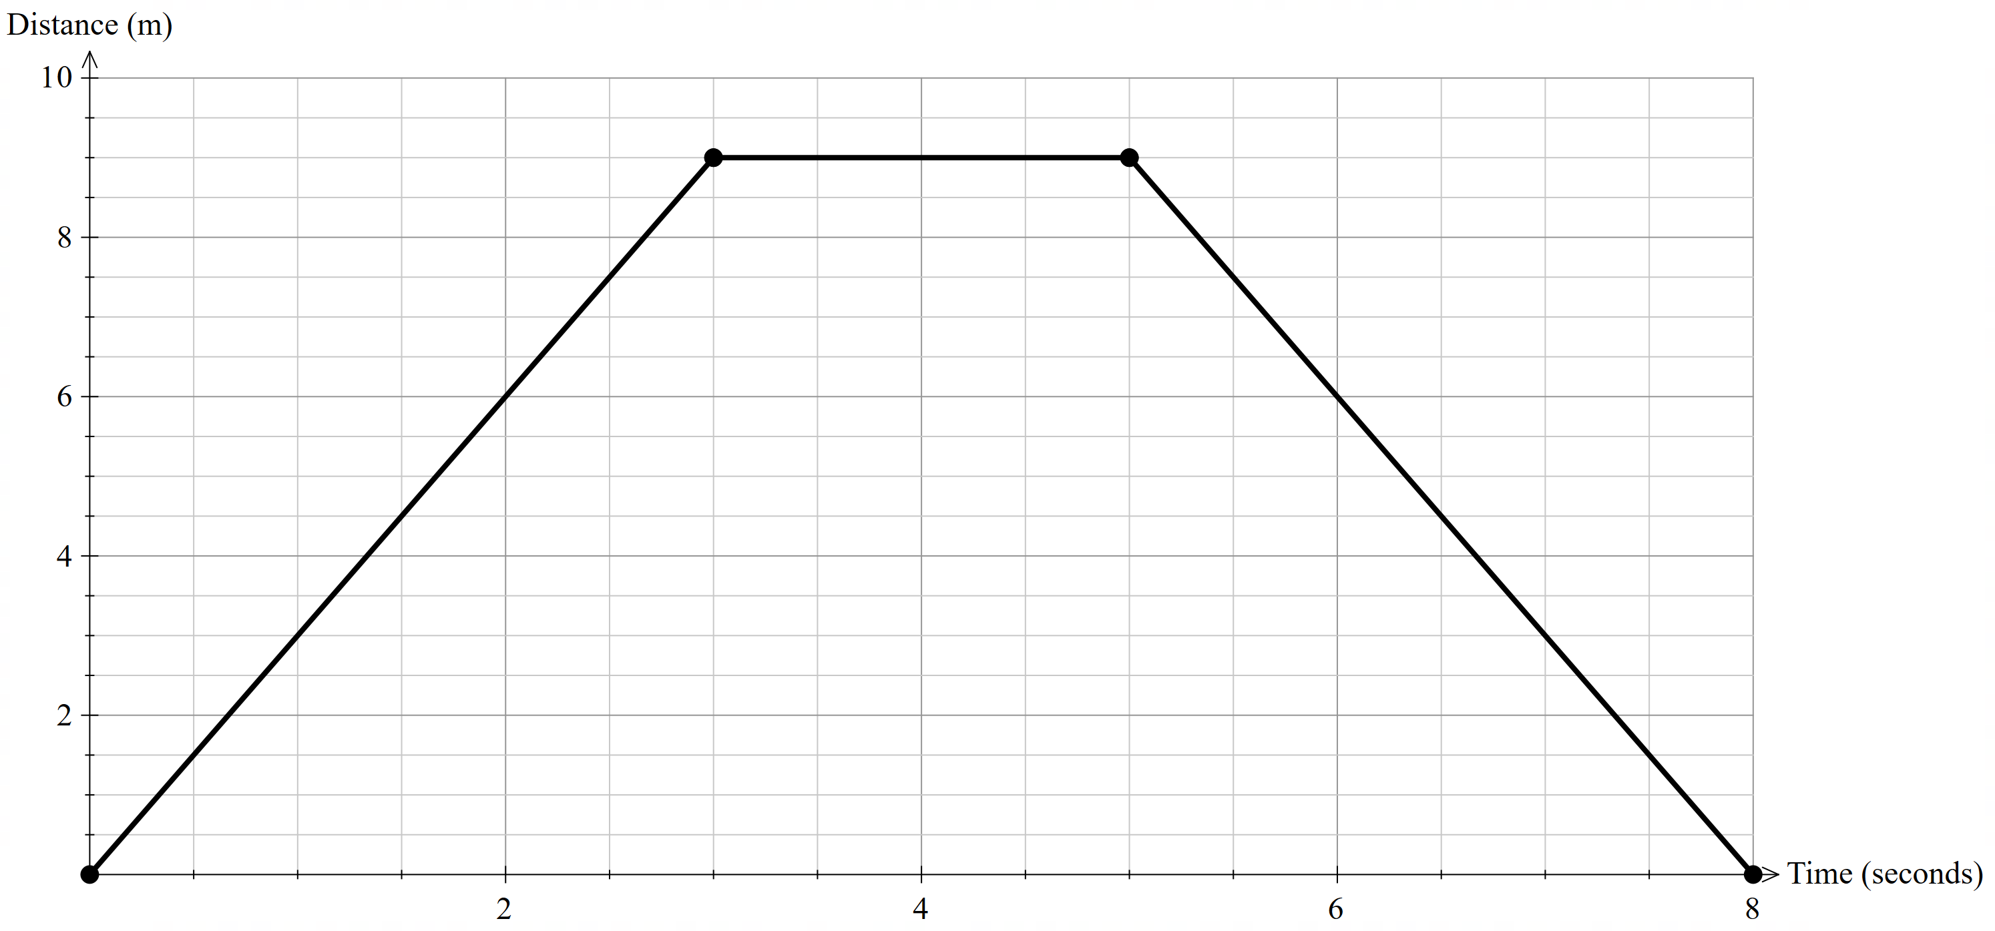

Appendix B

Graph 2
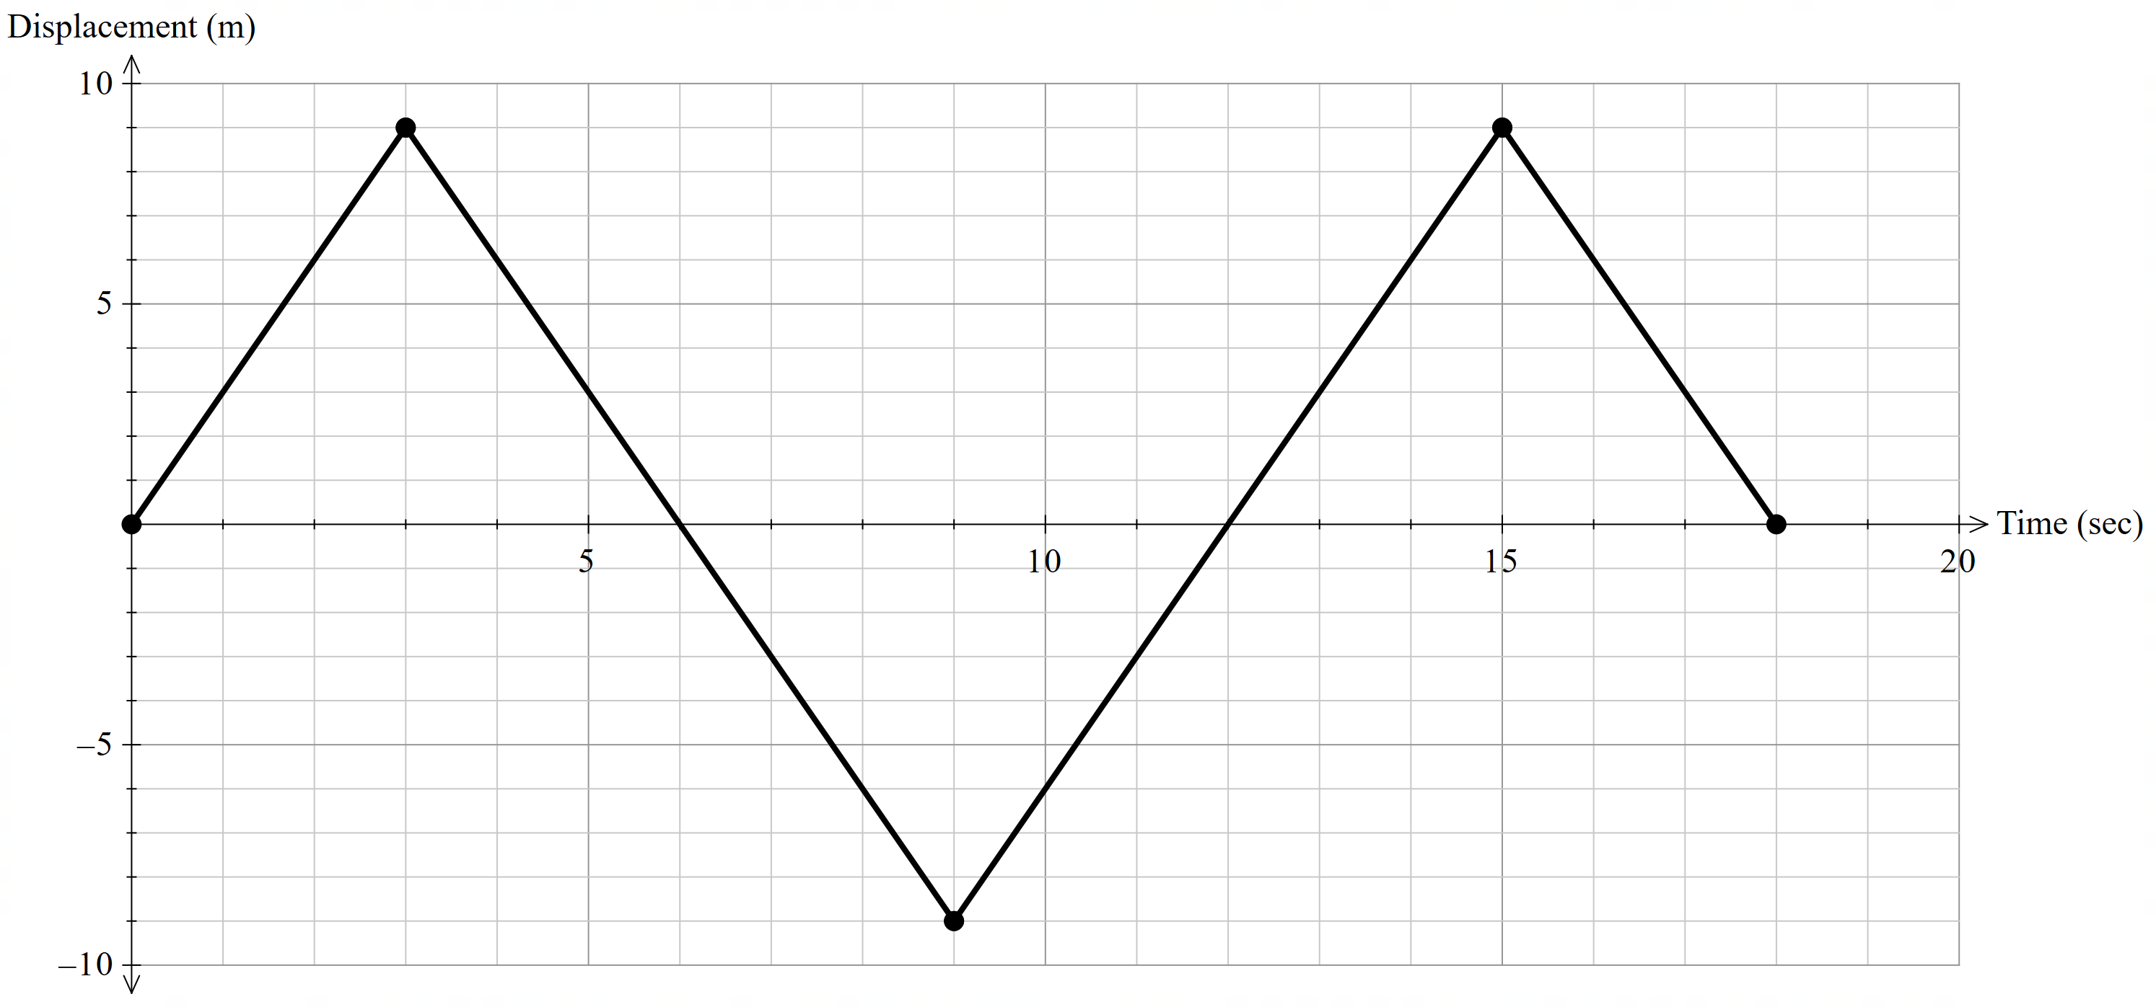

Appendix C

Graph 3
$$f\left(x\right)=2x^{3}+14x^{2}-20x$$
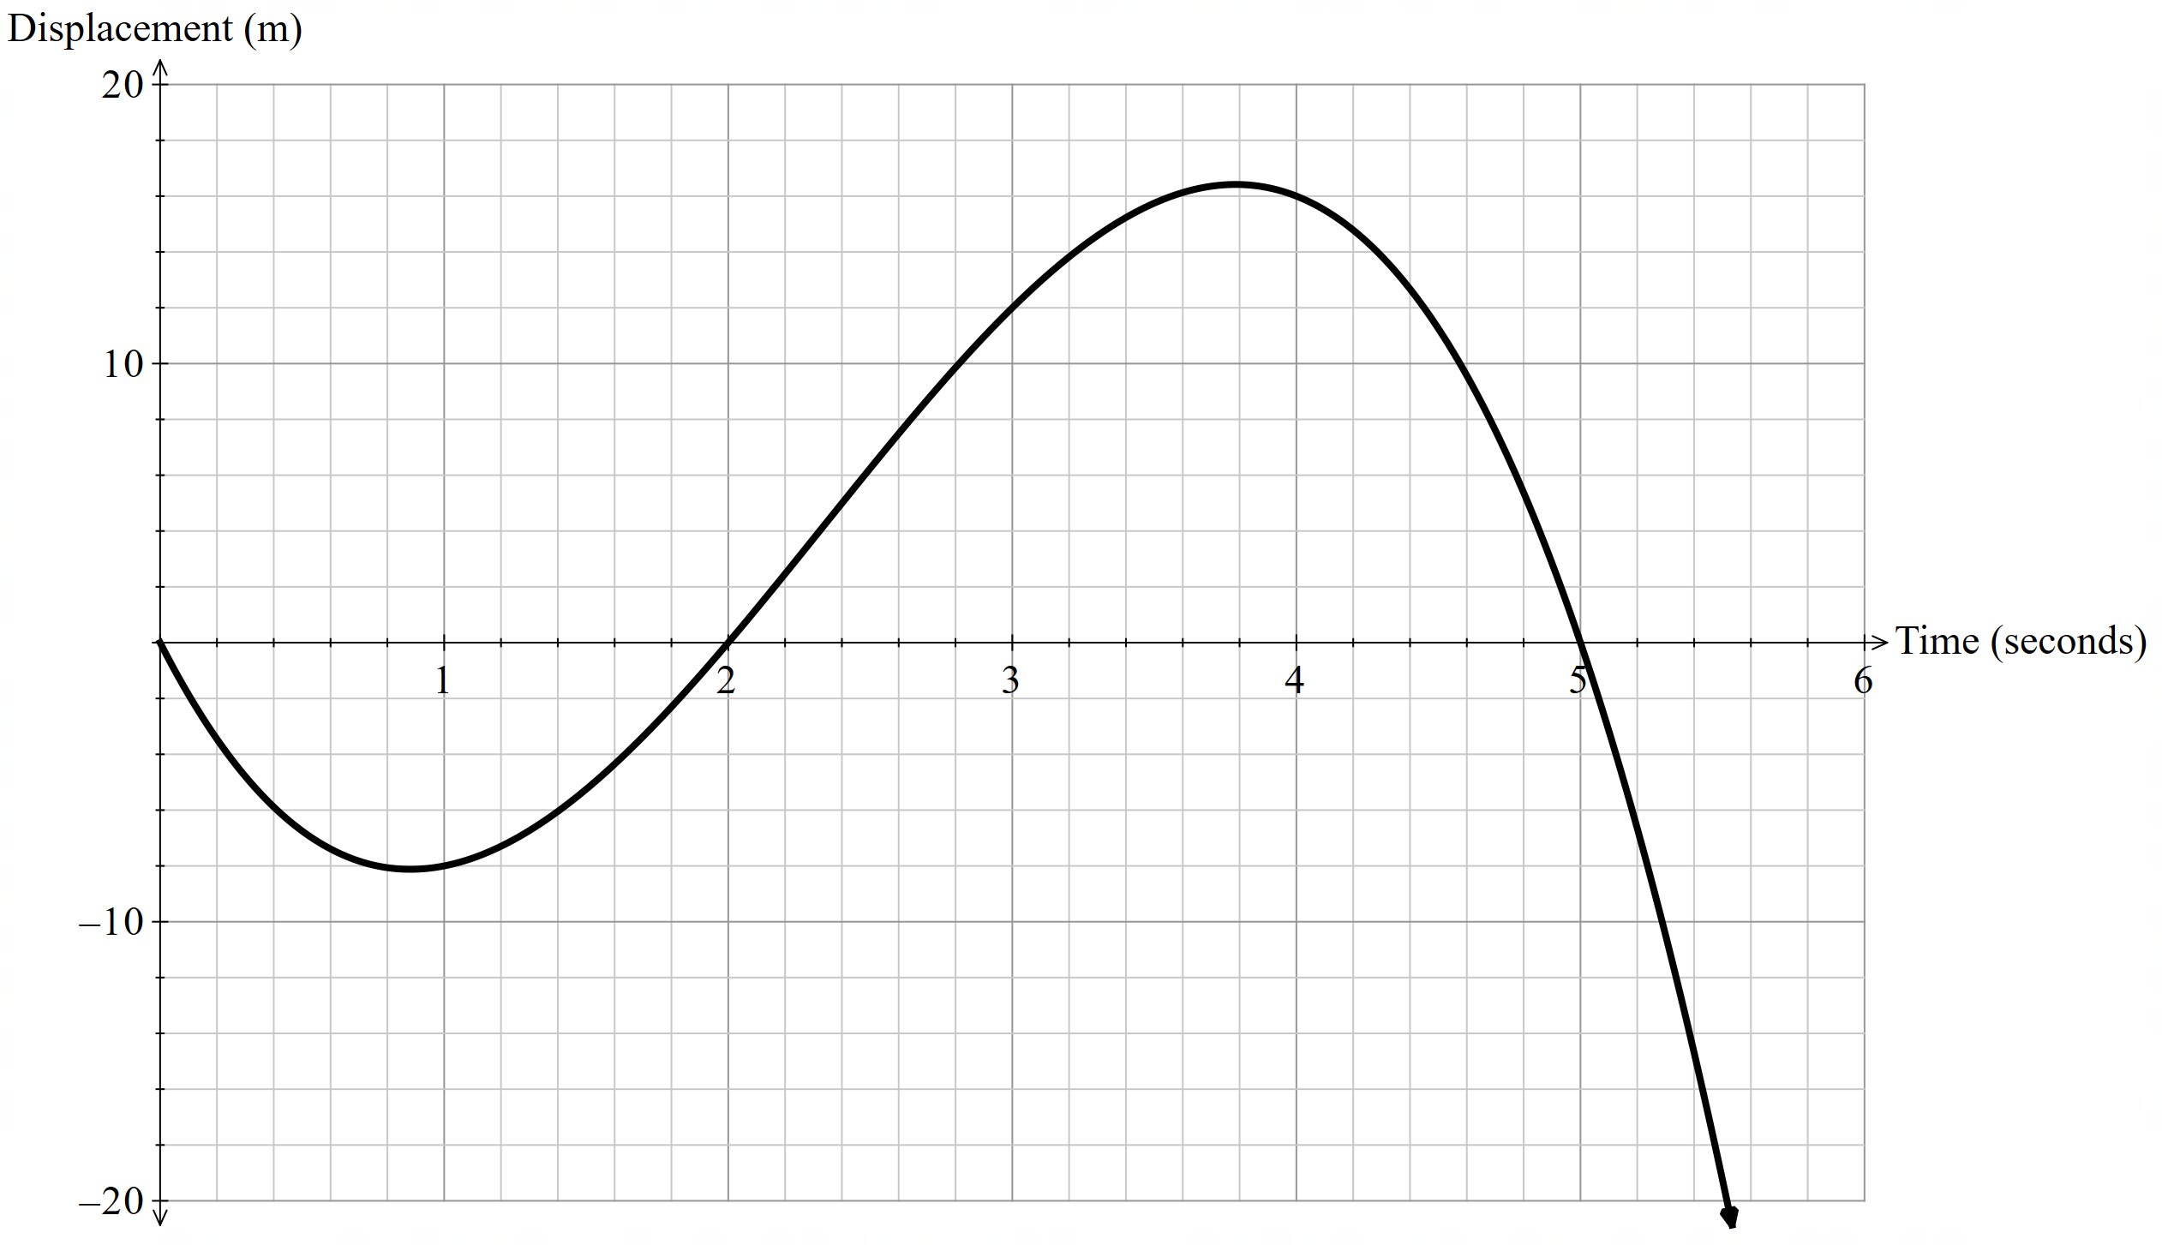

Appendix D

Card sort
Description | Displacement – time | Velocity – time
A car moving forwards with velocity increasing at a constant rate. | Displacement - time  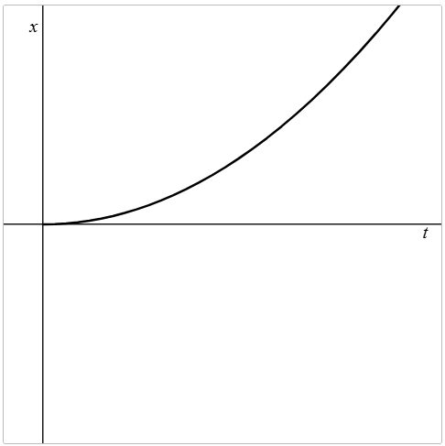 | Velocity - time  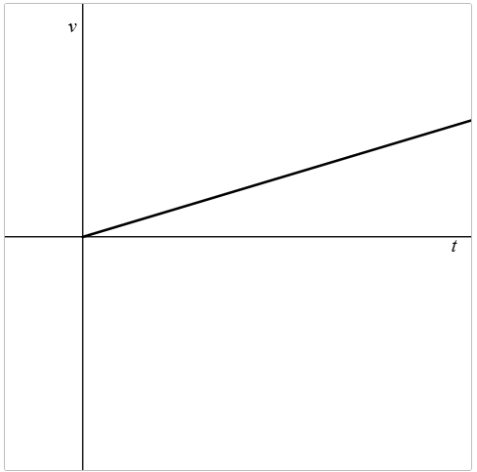
A train moving forwards with constant velocity. | Displacement - time  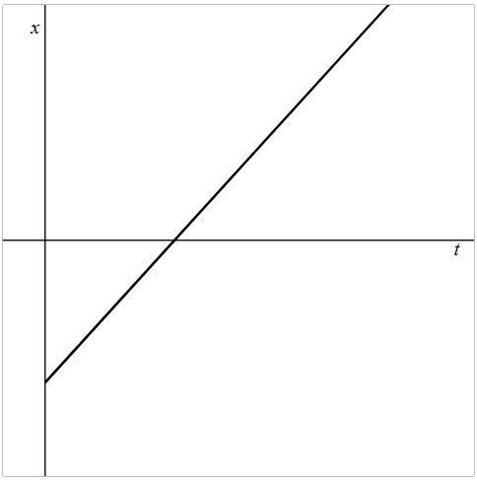 | Velocity - time  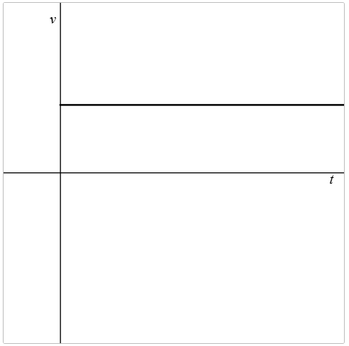
The height of an object thrown upwards off the top of a cliff. | Displacement - time  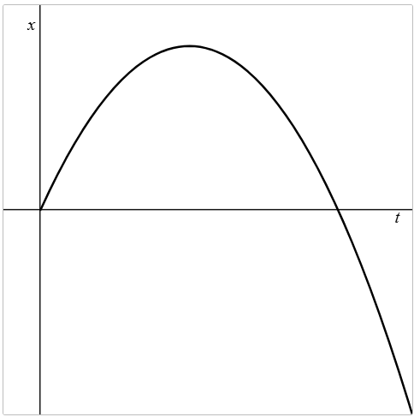 | Velocity - time  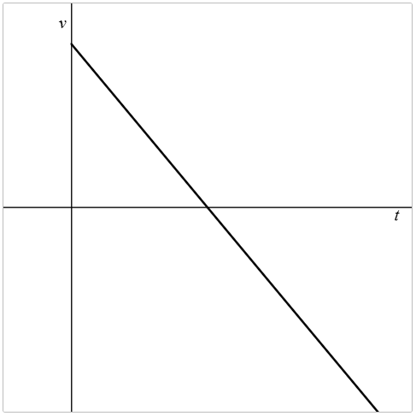
The height of a yo-yo after it’s been released until it is caught again. | Displacement - time  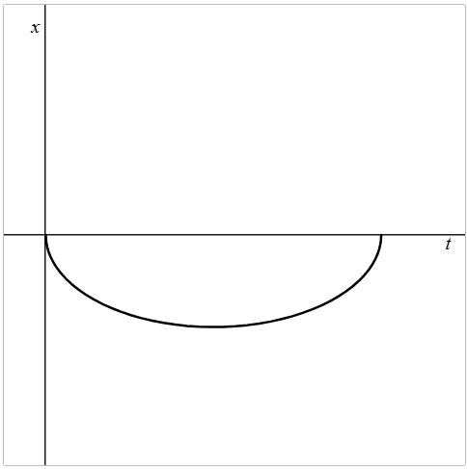 | Velocity - time  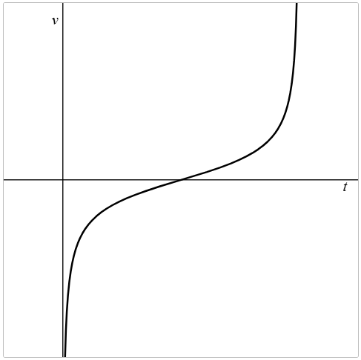
A train moving backwards with constant velocity. | Displacement - time  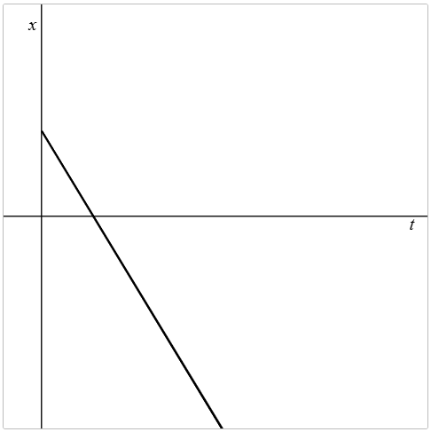 | Velocity - time  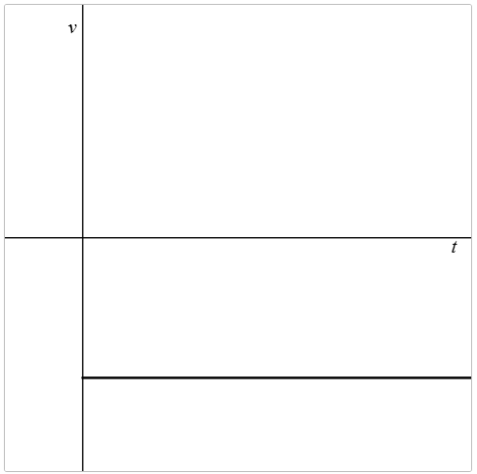
A car traveling backwards, before turning around and moving forwards. | Displacement - time  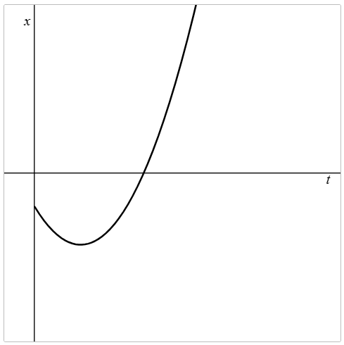 | Velocity - time  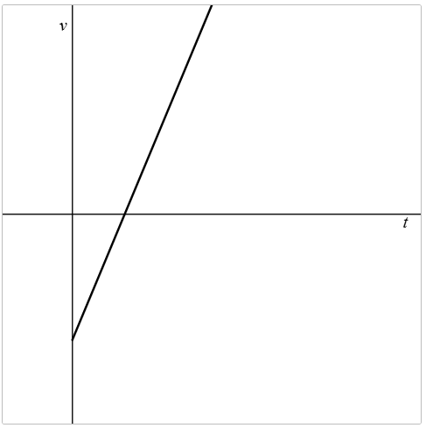
The height of a person jumping on to a trampoline and bouncing. | Displacement - time  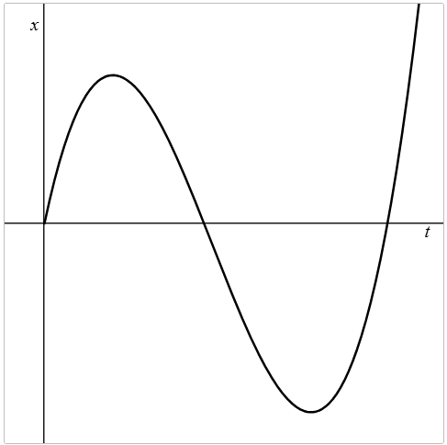 | Velocity - time  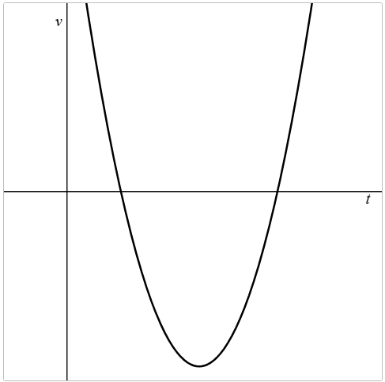

Appendix E

Banner task
Determine the expression for the velocity of a particle at time $t$ $seconds$ given the straight-line displacement $x metres$and find the displacement and velocity at the given times.
$x\left(t\right)=t^{2}$when$t=3$
$x\left(t\right)=t^{3}$ when$t=1$
$x\left(t\right)=t^{2}+2t$when$t=3$
$x\left(t\right)=-2t^{3}+t^{2}-4t$when$t=3$
$x\left(t\right)=2t^{3}-t^{2}+4t$ when$t=4$
$x\left(t\right)=-t^{4}+4t^{3}-2t$ when$t=2$
Determine the expression for the velocity of a particle at time $t$ $seconds$ given the displacement $x$ $metres$ and find the times when the particle is at rest.
$$x\left(t\right)=3t^{2}$$
$$x\left(t\right)=-t^{3}$$
$$x\left(t\right)=-t^{2}+4t$$
$$x\left(t\right)=2t^{2}-4t+7$$
$$x\left(t\right)=t^{3}-6t^{2}+9t$$
$x\left(t\right)=-t^{2}+3t$

Appendix F

Four quadrant notes
Example 1  A particle moves with displacement given by the function $x$ $=t^{2}-6t+5$.  What is the displacement and velocity when $t=3$?  $$x\left(3\right)=⎕^{2}-6×⎕+5 \\ =⎕ m \\ x^{'}\left(t\right)=\dot{x}=⎕t-⎕ \\ x^{'}\left(3\right)=2×⎕-6 \\ =⎕$$ | Example 2  A particle moves with displacement given by the function $x$ $=t^{2}+2t-5$.  What is the displacement and velocity when $t=3$?
Things to remember | Example 3

Sample solutions

Appendix E – banner task
Determine the expression for the velocity of a particle at time $t$ $seconds$ given the straight-line displacement $x metres$and find the displacement and velocity at the given times.
Function | Displacement | Velocity
$$x\left(t\right)=t^{2} when t=3$$ | $$x\left(3\right)=3^{2} \\ =9$$ | $$x\left(t\right)=t^{2} \\ x^{'}\left(t\right)=\dot{x}=2t \\ x^{'}\left(3\right)=2×3 \\ =6$$
$x\left(t\right)=t^{3}$ $when t=1$ | $$x\left(1\right)=1^{3} \\ =1$$ | $$x\left(t\right)=t^{3} \\ x^{'}\left(t\right)=\dot{x}=3t^{2} \\ x^{'}\left(1\right)=3×1^{2} \\ =3$$
$$x\left(t\right)=t^{2}+2t when t=3$$ | $$x\left(3\right)=3^{2}+2×3 \\ =15$$ | $$x\left(t\right)=t^{2}+2t \\ x^{'}\left(t\right)=\dot{x}=2t+2 \\ x^{'}\left(3\right)=2×3+2 \\ =8$$
$$x\left(t\right)=-2t^{3}+t^{2}-4t when$$  $$t=3$$ | $$x\left(3\right)=-2{×3}^{3}+3^{2}-4×3 \\ =-21$$ | $$x\left(t\right)=-2t^{3}+t^{2}-4t \\ x^{'}\left(t\right)=\dot{x}=-6t^{2}+2t-4 \\ x^{'}\left(3\right)=6×3^{2}+2×3-4 \\ =56$$
$x\left(t\right)=2t^{3}-t^{2}+4t$ $when$  $$t=4$$ | $$x\left(4\right)=2×4^{3}-4^{2}+4×4 \\ =128$$ | $$x\left(t\right)=2t^{3}-t^{2}+4t \\ x^{'}\left(t\right)=\dot{x}=6t^{2}-2t+4 \\ x^{'}\left(4\right)=6{×4}^{2}-2×4+4 \\ =92$$
$x\left(t\right)=-t^{4}+4t^{3}-2t$ $when t=2$ | $$x\left(2\right)=-2^{4}+4{×2}^{3}-2×2 \\ =12$$ | $$x\left(t\right)=-t^{4}+4t^{3}-2t \\ x^{'}\left(t\right)=\dot{x}=-4t^{3}+12t^{2}-2 \\ x^{'}\left(2\right)=-4{× 2}^{3}+12×2^{2}-2 \\ =14$$

Determine the expression for the velocity of a particle at time $t$ $seconds$ given the straight line displacement $x$ $metres$ and find the times when the particle is at rest.
Displacement | Velocity and particle at rest
$$x\left(t\right)=3t^{2}$$ | $$x^{'}\left(t\right)=\dot{x}=6t \\ 0=6t \\ t=0$$
$$x\left(t\right)=-t^{3}$$ | $$x^{'}\left(t\right)=\dot{x}=-3t^{2} \\ 0=-3×t^{2} \\ t=0$$
$$x\left(t\right)=-t^{2}+4t$$ | $$x^{'}\left(t\right)=\dot{x}=-2t+4 \\ 0=-2\left(t-2\right) \\ t=2 seconds$$
$$x\left(t\right)=2t^{2}-4t+7$$ | $$x^{'}\left(t\right)=\dot{x}=4t-4 \\ 0=4\left(t-1\right) \\ t=1 seconds$$
$$x\left(t\right)=t^{3}-6t^{2}+9t$$ | $$x^{'}\left(t\right)=\dot{x}=3t^{2}-12t+9 \\ =3\left(t^{2}-4t+3\right) \\ 0=\left(t-1\right)\left(t-3\right)$$  $$t=1 and t=3 seconds$$
$$x\left(t\right)=-t^{2}+3t$$ | $$x^{'}\left(t\right)=\dot{x}=-2t+3 \\ 0=-2t+3 \\ 2t=3 \\ t=1.5 seconds$$

Appendix F – Four quadrant notes
Example 1  A particle moves with displacement given by the function $x$ $=t^{2}-6t+5$.  What is the displacement and velocity when $t=3$?  $$x\left(3\right)=3^{2}-6×3+5 \\ =-4 m \\ x^{'}\left(t\right)=\dot{x}=2t-6 \\ x^{'}\left(3\right)=2×3-6 \\ =0$$ | Example 2  A particle moves with displacement given by the function $x$ $=t^{2}+2t-5$.  What is the displacement and velocity when $t=3$?  $$x\left(3\right)=3^{2}-2×3-5 \\ =-2 m \\ x^{'}\left(t\right)=2t+2 \\ x^{'}\left(3\right)=2×3+2 \\ =8$$

Appendix G – exit ticket
$$s\left(t\right)=t^{3}-6t^{2}+9t \\ \dot{s}=v\left(t\right)=3t^{2}-12t+9 \\ v\left(2\right)=3×2^{2}-12×2+9 \\ =-3 \\ 0=3t^{2}-12t+9 \\ t^{2}-4t+3=0 \\ \left(t-3\right)\left(t-1\right)=0 \\ ∴\text{particle at rest at} t=1 \text{and} 3 \text{seconds}$$

References
This resource contains NSW and syllabus content. The NSW Curriculum is developed by the NSW Education Standards Authority (NESA). This content is prepared by NESA for and on behalf of the Crown in right of the State of New South Wales. The material is protected by Crown copyright.
Please refer to the NESA Copyright Disclaimer for more information https://www.nsw.gov.au/education-and-training/nesa/copyright.
NESA holds the only official and up-to-date versions of the NSW Curriculum and syllabus documents. Please visit NESA https://www.nsw.gov.au/education-and-training/nesa and NSW Curriculum https://curriculum.nsw.edu.au.
Mathematics Advanced 11–12 Syllabus © NSW Education Standards Authority (NESA) for and on behalf of the Crown in right of the State of New South Wales, 2024.

© State of New South Wales (Department of Education), 2026
The copyright material published in this resource is subject to the Copyright Act 1968 (Cth) and is owned by the NSW Department of Education or, where indicated, by a party other than the NSW Department of Education (third-party material).
Copyright material available in this resource and owned by the NSW Department of Education is licensed under a Creative Commons Attribution 4.0 International (CC BY 4.0) license.

This license allows you to share and adapt the material for any purpose, even commercially.
Attribution should be given to © State of New South Wales (Department of Education), 2026.
Material in this resource not available under a Creative Commons license:
- the NSW Department of Education logo, other logos and trademark-protected material
- material owned by a third party that has been reproduced with permission. You will need to obtain permission from the third party to reuse its material.
Links to third-party material and websites
Please note that the provided (reading/viewing material/list/links/texts) are a suggestion only and implies no endorsement, by the New South Wales Department of Education, of any author, publisher, or book title. School principals and teachers are best placed to assess the suitability of resources that would complement the curriculum and reflect the needs and interests of their students.
If you use the links provided in this document to access a third-party's website, you acknowledge that the terms of use, including licence terms set out on the third-party's website apply to the use which may be made of the materials on that third-party website or where permitted by the Copyright Act 1968 (Cth). The department accepts no responsibility for content on third-party websites.

