Graphing the derivative function
Students practise identifying where a function has a zero, positive or negative derivative from its graph. Using knowledge of the derivatives of powers of $x$, they identify the expected shape of the derivative function. They practise sketching the derivative function of a function.
Students will need at least one digital device per pair to interact with Amplify Classroom during this lesson.

Learning intention
- To be able to graph the derivative function of a given function.

Success criteria
- I can identify, on the graph of a function, where the gradient is zero, positive or negative.
- I can explain what shape a derivative function will take based on the power of the original function.
- I can sketch the derivative function of a given function.

Outcomes
A student:
- develops understanding and fluency in mathematics through exploring and connecting mathematical concepts, choosing and applying mathematical techniques to solve problems, and communicating their thinking and reasoning coherently and clearly MAO-WM-01
- interprets the meaning of the derivative and determines the derivative of functions to solve problems MAV-11-06

Content

Graphical applications of the derivative
- Graph 𝑦 = 𝑓'(𝑥) for a given graph of a function 𝑦 = 𝑓(𝑥).
- Numerically estimate the value of the derivative at a point on the graph of a power of 𝑥, with and without the use of digital tools.
Mathematics Advanced 11–12 Syllabus © NSW Education Standards Authority (NESA) for and on behalf of the Crown in right of the State of New South Wales, 2024.

Table 1: lesson summary
Section | Summary of activity | Teaching strategies | Teaching points
Activating prior knowledge | Use slide 4 to reveal a curve and have students identify the intercepts, where it is increasing, decreasing, stationary, and what happens as the function approaches $±∞$? | Pose-Pause-Pounce-Bounce | This section revisits and strengthens students’ understanding of identifying where functions are increasing, decreasing and stationary, building on the previous lesson.
Connecting learning | Students complete screens 1–7 of the Amplify Classroom activity (bit.ly/graphing_derivatives) to identify where a graph is increasing, decreasing and stationary. Use screens 8–11 of the Amplify Classroom activity to connect the gradient of tangents to the derivative function. Use slide 6 to show considerations for students to graph the derivative functions in Appendix A in groups. | Visibly random groups of 3  Vertical non-permanent surfaces | Students develop an understanding of the links between a function’s gradient and the graph of its derivative, leading into learning how to sketch the derivative.
Releasing responsibility | In pairs, students discuss and then sketch derivative functions of the graphs in Appendix B. Students then create notes on how to sketch the graph of a derivative function. | Variation Theory  Notes to their future forgetful selves | Students practise sketching derivative functions and record their understanding in their notes.
Independent practice | Students complete a card match activity on screens 12 and 13 of the Amplify Classroom activity, before completing an HSC-style question in Appendix C. |  | This section aims for students to demonstrate their understanding independently.

Activity structure
Please use the associated PowerPoint Graphing the derivative function to display images in this lesson.

Activating prior knowledge
- Show students slide 4 of the PowerPoint, revealing a curve with several points labelled.
- Using the Pose-Pause-Pounce-Bounce questioning strategy (PDF 557 KB) (bit.ly/posepausepouncebounce), ask students what information they know about the function from its graph. Prompting questions could include:
- Where are the intercepts?
- Where is the gradient increasing, decreasing and zero?
- What happens as the function approaches $±∞$?
- It is a cubic function
- $x$-intercepts are at A, D and F.
- $y$-intercept is at C.
- The gradient is zero at B and E.
- The gradient is positive at $x<$ B and $x>$ E.
- The gradient is negative for B $<x<$ E.

Connecting learning
- Assign the Amplify Classroom activity ‘Graphing the derivative’, (bit.ly/graphing_derivatives), and have students complete screens 1–7 in pairs to identify where graphs are increasing, decreasing and have stationary points.
- Before completing this activity, you will need to set up an Amplify Classroom (bit.ly/createamplifyclassroom) and use the pacing feature to restrict students to screens 1–7.
- You can use the Amplify Classroom dashboard to anonymise and display student responses.
- Use these features to check students’ responses as they progress and pause the activity to discuss students’ responses to different screens as needed.
- Conduct a Think-Pair-Share (bit.ly/thinkpairsharestrategy) and ask students to share what connections they noticed between the graph of the function and the graph of its derivative on screens 6 and 7.
Students should notice that the derivative is above zero when the graph is increasing and vice versa. They should also notice that the gradient of the function is horizontal when the derivative is zero.
- Extend the pacing to include screens 8–11 and have students complete the new screens.
Emphasise to students that by finding appropriate tangents, they are finding the numerical value of the derivative at each of the points.
By connecting known values of the derivative, they are finding the graph of the derivative function.
- Prompt students to recall the connection between the power of the derivative and the shape of the graph of the derivative. Prompting questions could include:
- What is the power of the derivative of a cubic function? Does the graph of the derivative reflect this power?
- If I was to graph the derivative of a quartic function (power of 4), what graph would you expect? How do you know?
Students should notice that since the derivative of $f\left(x\right)=x^{n}$ is $nx^{n-1}$, with a reduced power, the graph of the derivative function will match the new power. For example:
- For $f\left(x\right)=x^{3}, f^{'}\left(x\right)=3x^{2}$, so the graph of the derivative of a cubic function is a quadratic function.
- For $f\left(x\right)=x^{2}, f^{'}\left(x\right)=2x$, so the graph of the derivative of a quadratic function is a straight line.
- For $f\left(x\right)=x, f^{'}\left(x\right)=1$, so the graph of the derivative of a straight line is a constant function.
- Assign students to visibly random groups of 3 (bit.ly/visiblegroups) at vertical non-permanent surfaces (bit.ly/VNPSstrategy).
- Distribute a copy of the graph from Appendix A ‘Sketching the derivative’ to each group. Display slide 6 of the PowerPoint and ask students to discuss each of the considerations in their groups.
- Use slides 7–11 to model a procedure for sketching the derivative function. This modelling uses slow-release graphs to help students’ understanding.
- Have students sketch the derivative function by considering all the information they have identified.
You can support students by asking them to:
- trace the graph using their fingers and then highlight where it is increasing. Alternatively, place a ruler as a tangent to the graph to identify where the gradient is positive
- highlight where the graph is decreasing in a different colour
- between the points with zero gradient, identify where the gradient is steepest and indicate the $x$-value, this is where the derivative function will be either maximum or minimum.
- To check for understanding, have students compare their graphs with other students.
- Repeat the procedure for the second graph.
- Display slide 12 showing the derivative function for each graph in Appendix A.
- Using the Pose-Pause-Pounce-Bounce questioning strategy to discuss why each group’s graphs may be different. Prompting questions could include:
- Where is the gradient equal to plus or minus one on the original function?
- How does the steepness of the gradient of the function change the derivative function?
Students should have similar shapes but may not have considered the scale of the derivative function.

Releasing responsibility
- Remove the pacing from the Amplify Classroom activity and have students complete the card match activities on screens 12 and 13.
- Distribute a copy of Appendix B ‘Variation Theory’ (variationtheory.com/introduction/) to each student and have them discuss each graph in pairs, before drawing their own graph of the derivative function.
You may wish to prompt students to notice the shape of the graph in each row.
You may wish to prompt students to notice the effect of translating the graphs horizontally and vertically within each row.
- Distribute Appendix C ‘Four quadrant notes’ to students and have them create notes on how to sketch the graph of a derivative function.
You may ask students to consider identifying where the graph is increasing or decreasing, where the gradient is zero and the effect each of these has on the graph of the gradient function.

Independent practice
- Distribute Appendix D ‘HSC-style question’ for students to attempt.
- Once students have attempted the question, have them pair up to discuss and negotiate an answer.

Assessment and differentiation

Suggested opportunities for differentiation
Activating prior knowledge
- Support students’ comparison of the graph of a function and its derivative by asking them to specifically consider what the function is doing when the derivative is zero, positive or negative.
Connecting learning
- Challenge students by asking them to consider currently unfamiliar functions, such as non-polynomial functions from the course.
- Support groups by explicitly providing the type of function (for instance, quadratic or cubic) that they are considering and, hence, the type of function that they will need to draw.
Releasing responsibility
- Challenge students by providing graphs of $y=\frac{1}{x},y=-\frac{1}{x}$ and $y=\frac{1}{x^{2}}$ and so on and having them sketch the derivative function.
- Provide additional scaffolding for Appendix B by repeating the process from ‘Connecting learning’ of identifying where the gradient is zero and highlighting in different colours where the functions are increasing and decreasing.
Independent practice
- Challenge students to draw their own unique functions and ask their neighbours to sketch the derivative functions.

Suggested opportunities for assessment
Activating prior knowledge
- Students’ responses in the Amplify Classroom activity can be used to assess students’ understanding of the previous lesson.
Connecting learning
- Students’ graphs from Appendix A can be used to assess the group’s understanding of where functions are increasing, decreasing and stationary, as well as how to sketch the derivative of a function.
- Responses to class discussions can be used to identify student misconceptions.
Releasing responsibility
- Appendix B and student notes can be collected to assess individual student attainment of the success criteria.
Independent practice
- The HSC-style question in Appendix C could be collected as an exit ticket to assess students’ ability to sketch derivative functions.

Appendix A

Sketching the derivative

Sketch together
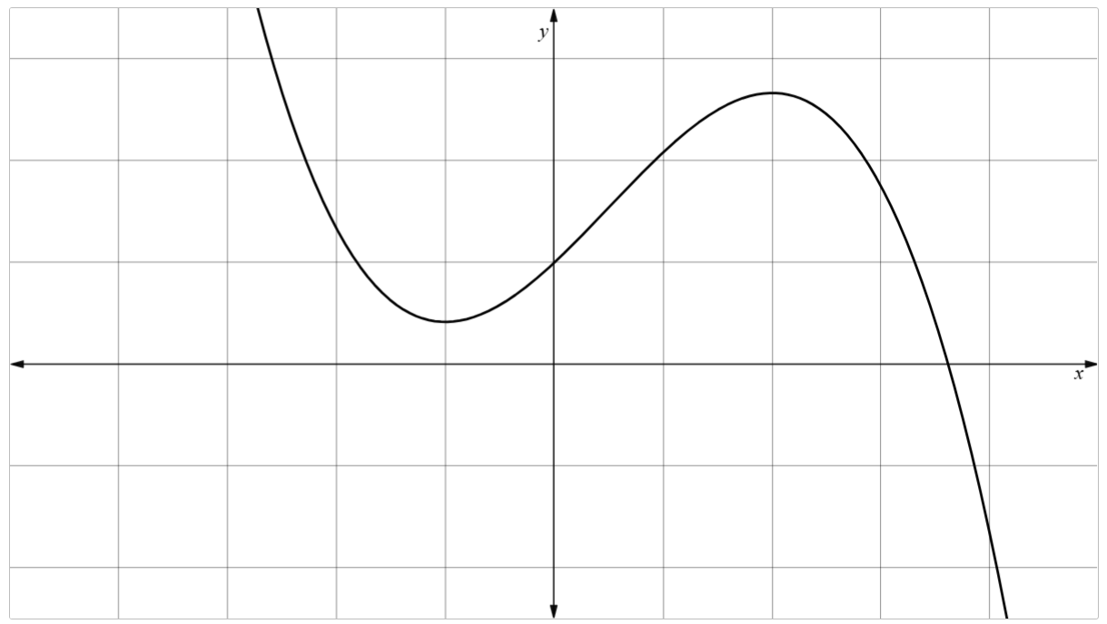
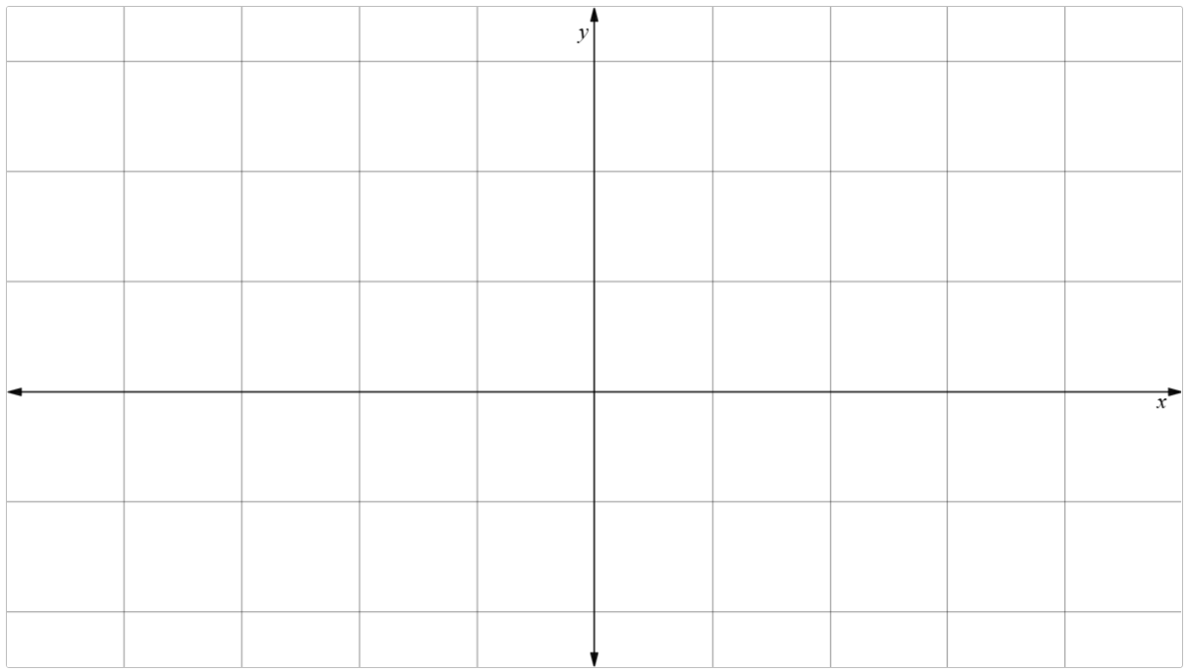

Your turn
Consider each function. Follow the process and sketch the derivative of each function below.
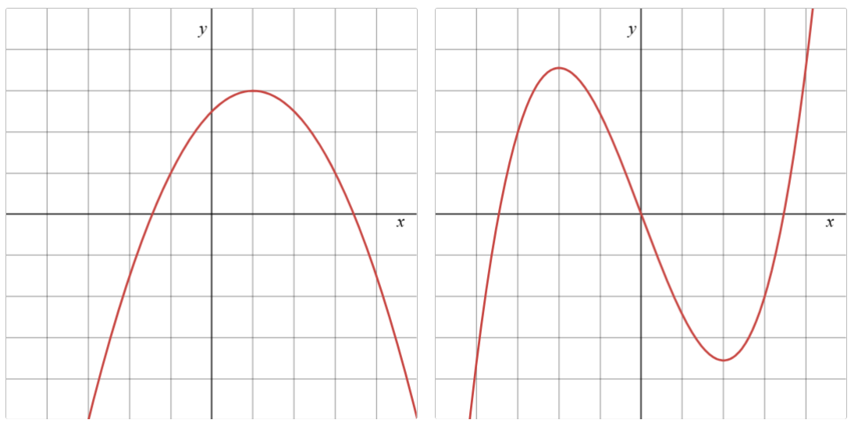
Derivative functions
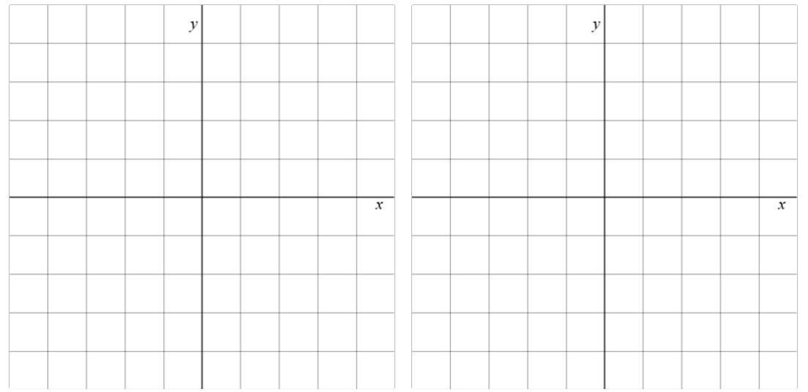

Appendix B

Variation Theory
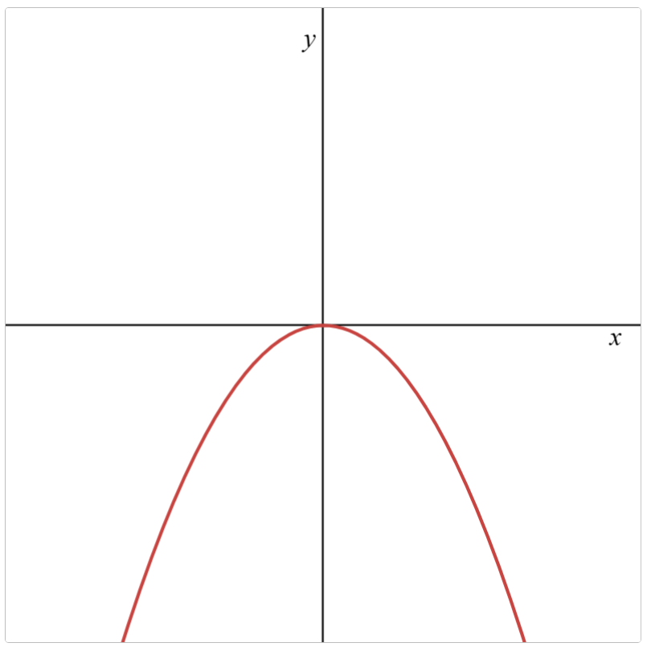 | 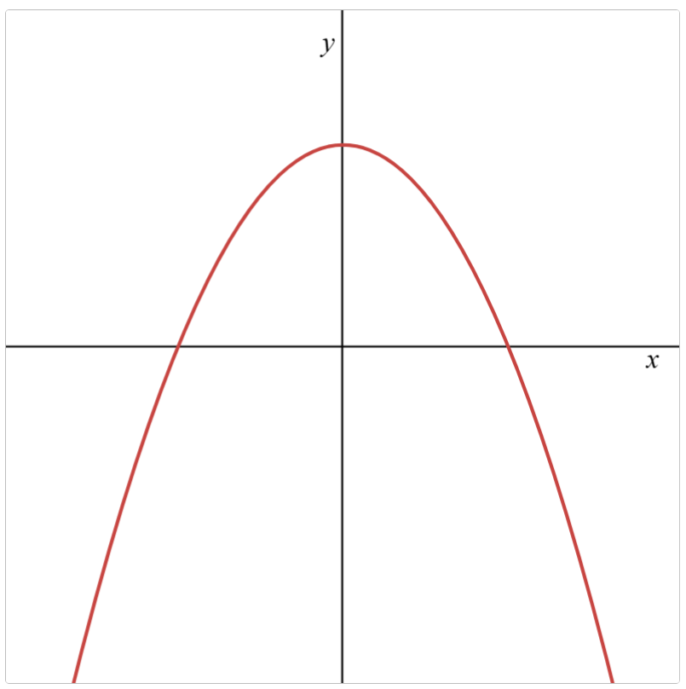 | 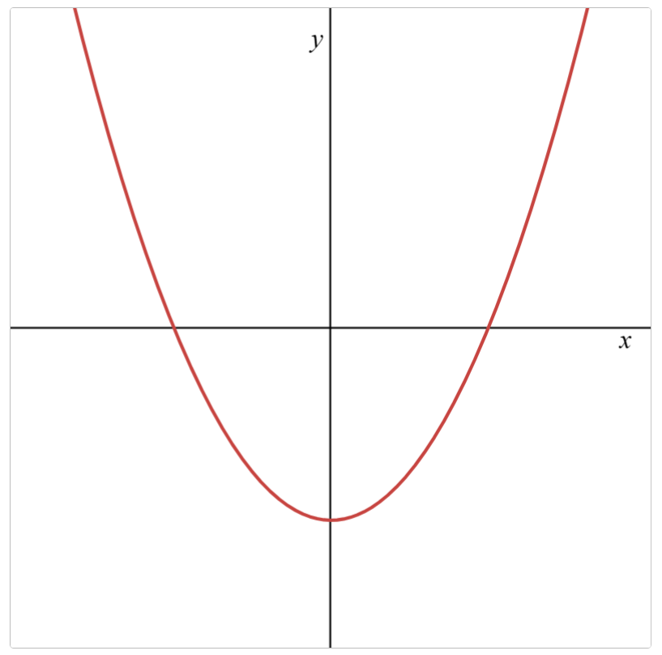 | 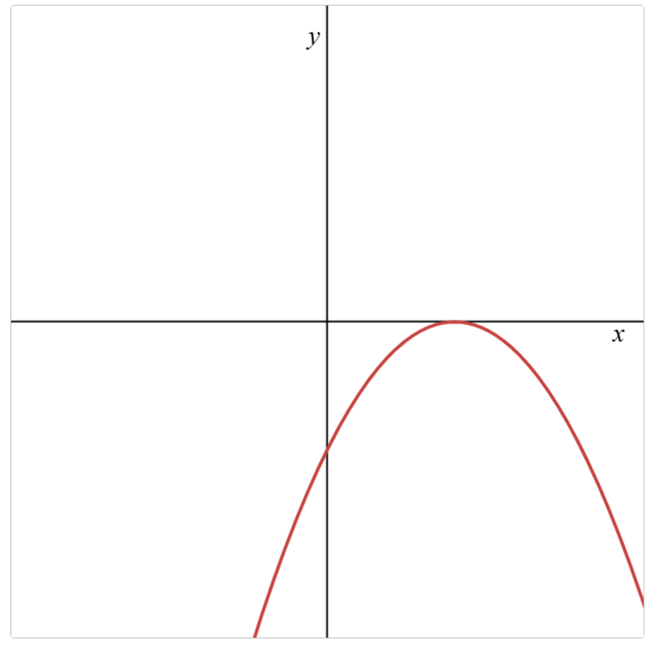
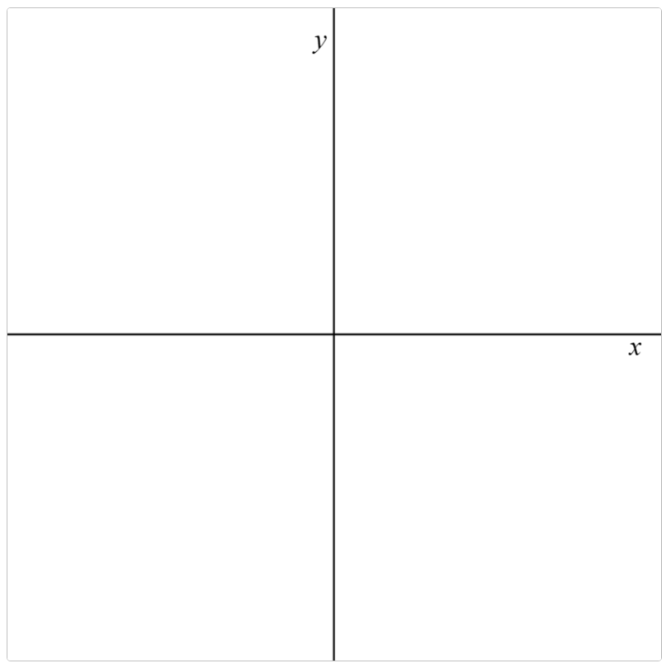
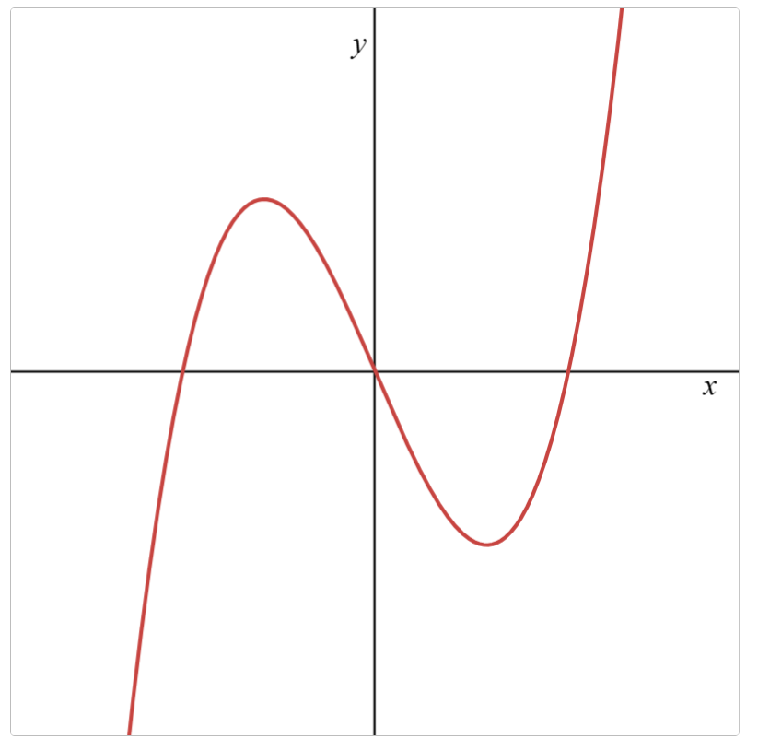 | 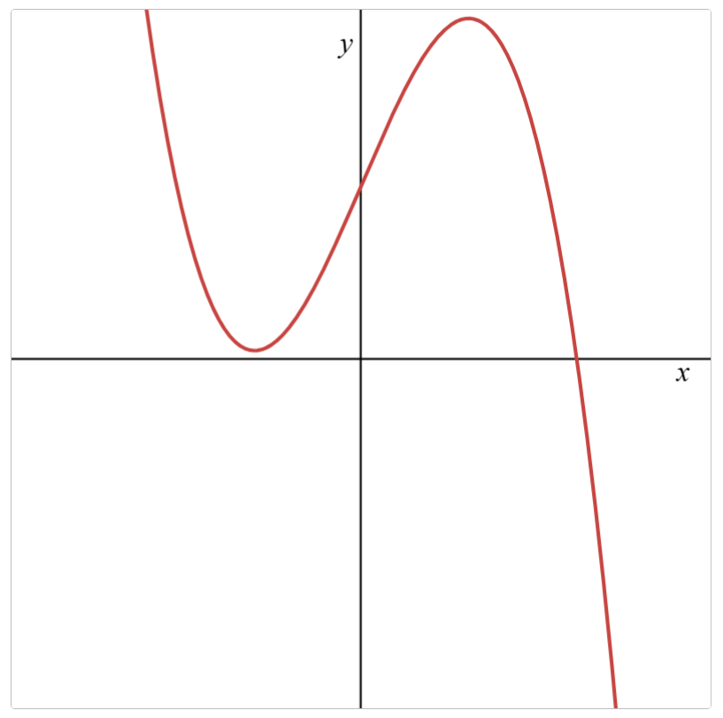 | 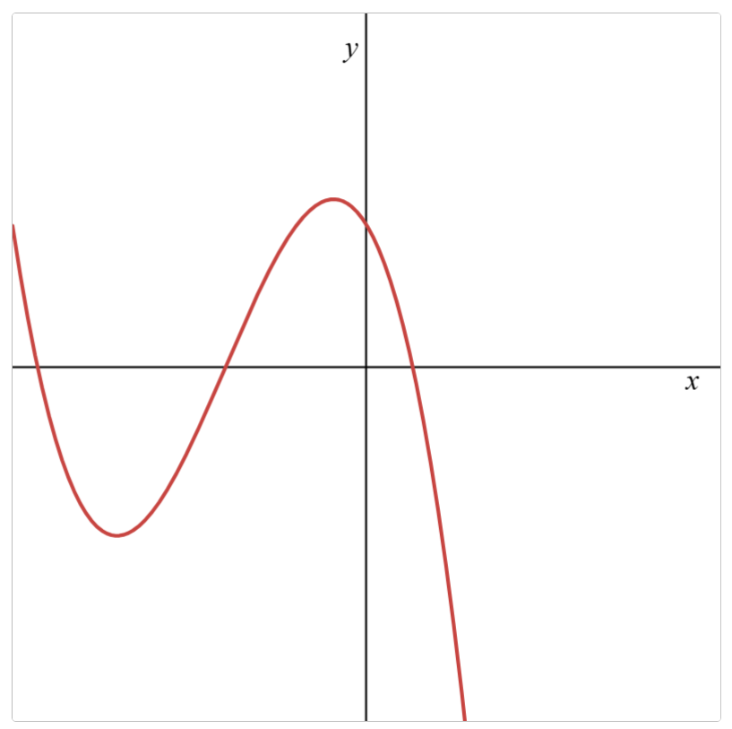 | 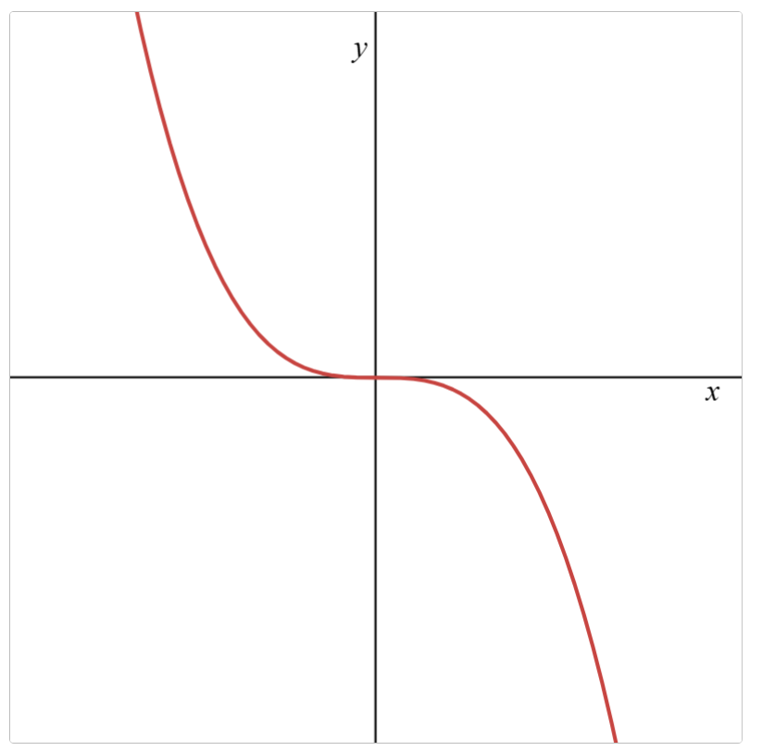

Challenge questions
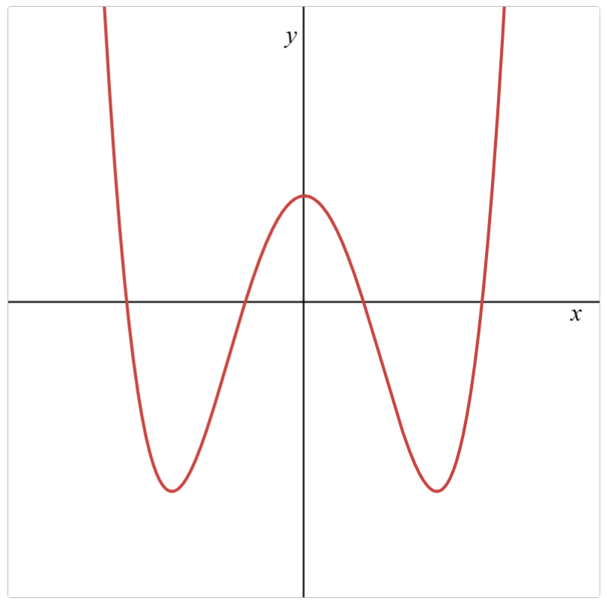 | 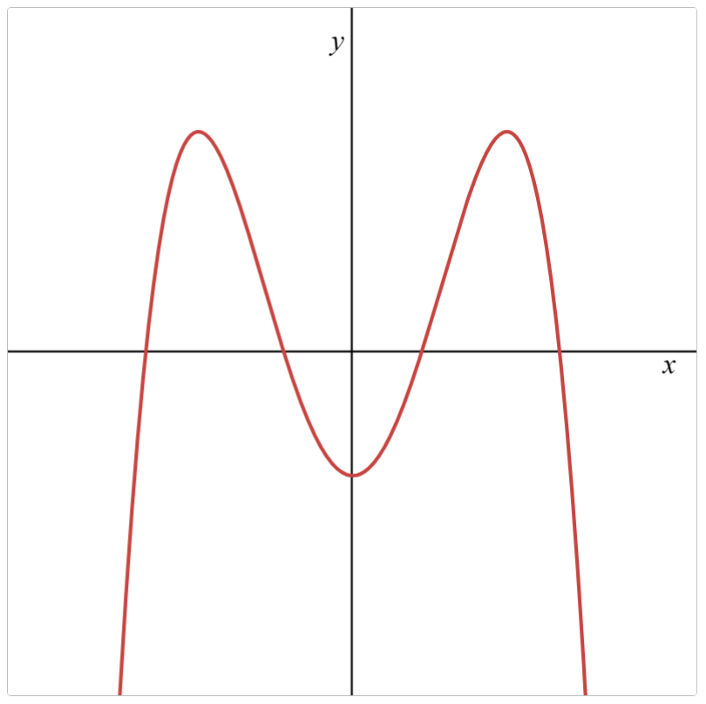 | 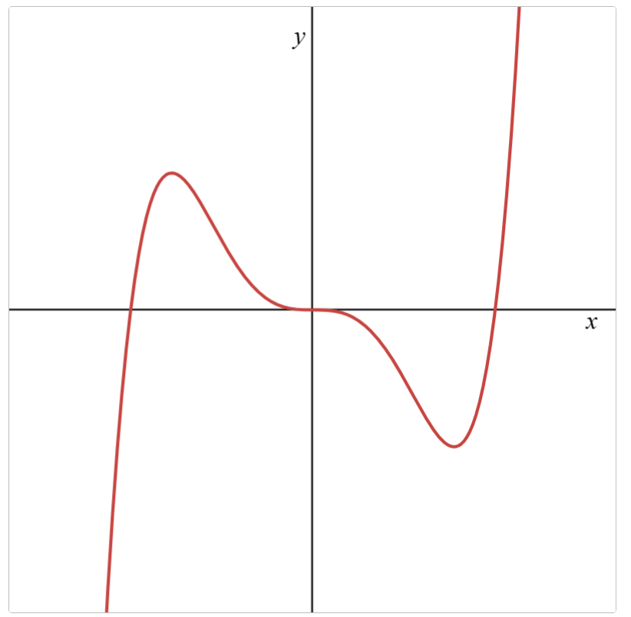 | 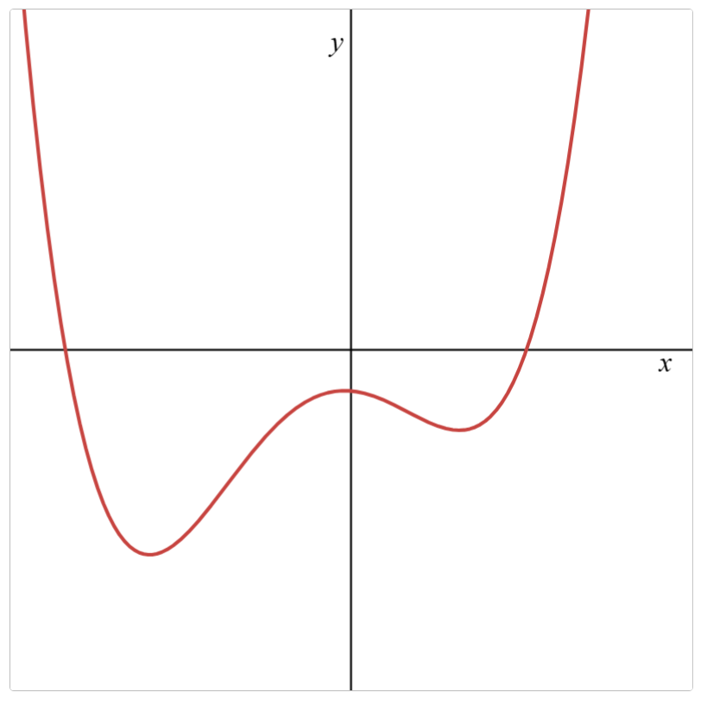

Appendix C

Four quadrant notes
Example 1  Graph the derivative of the function below.  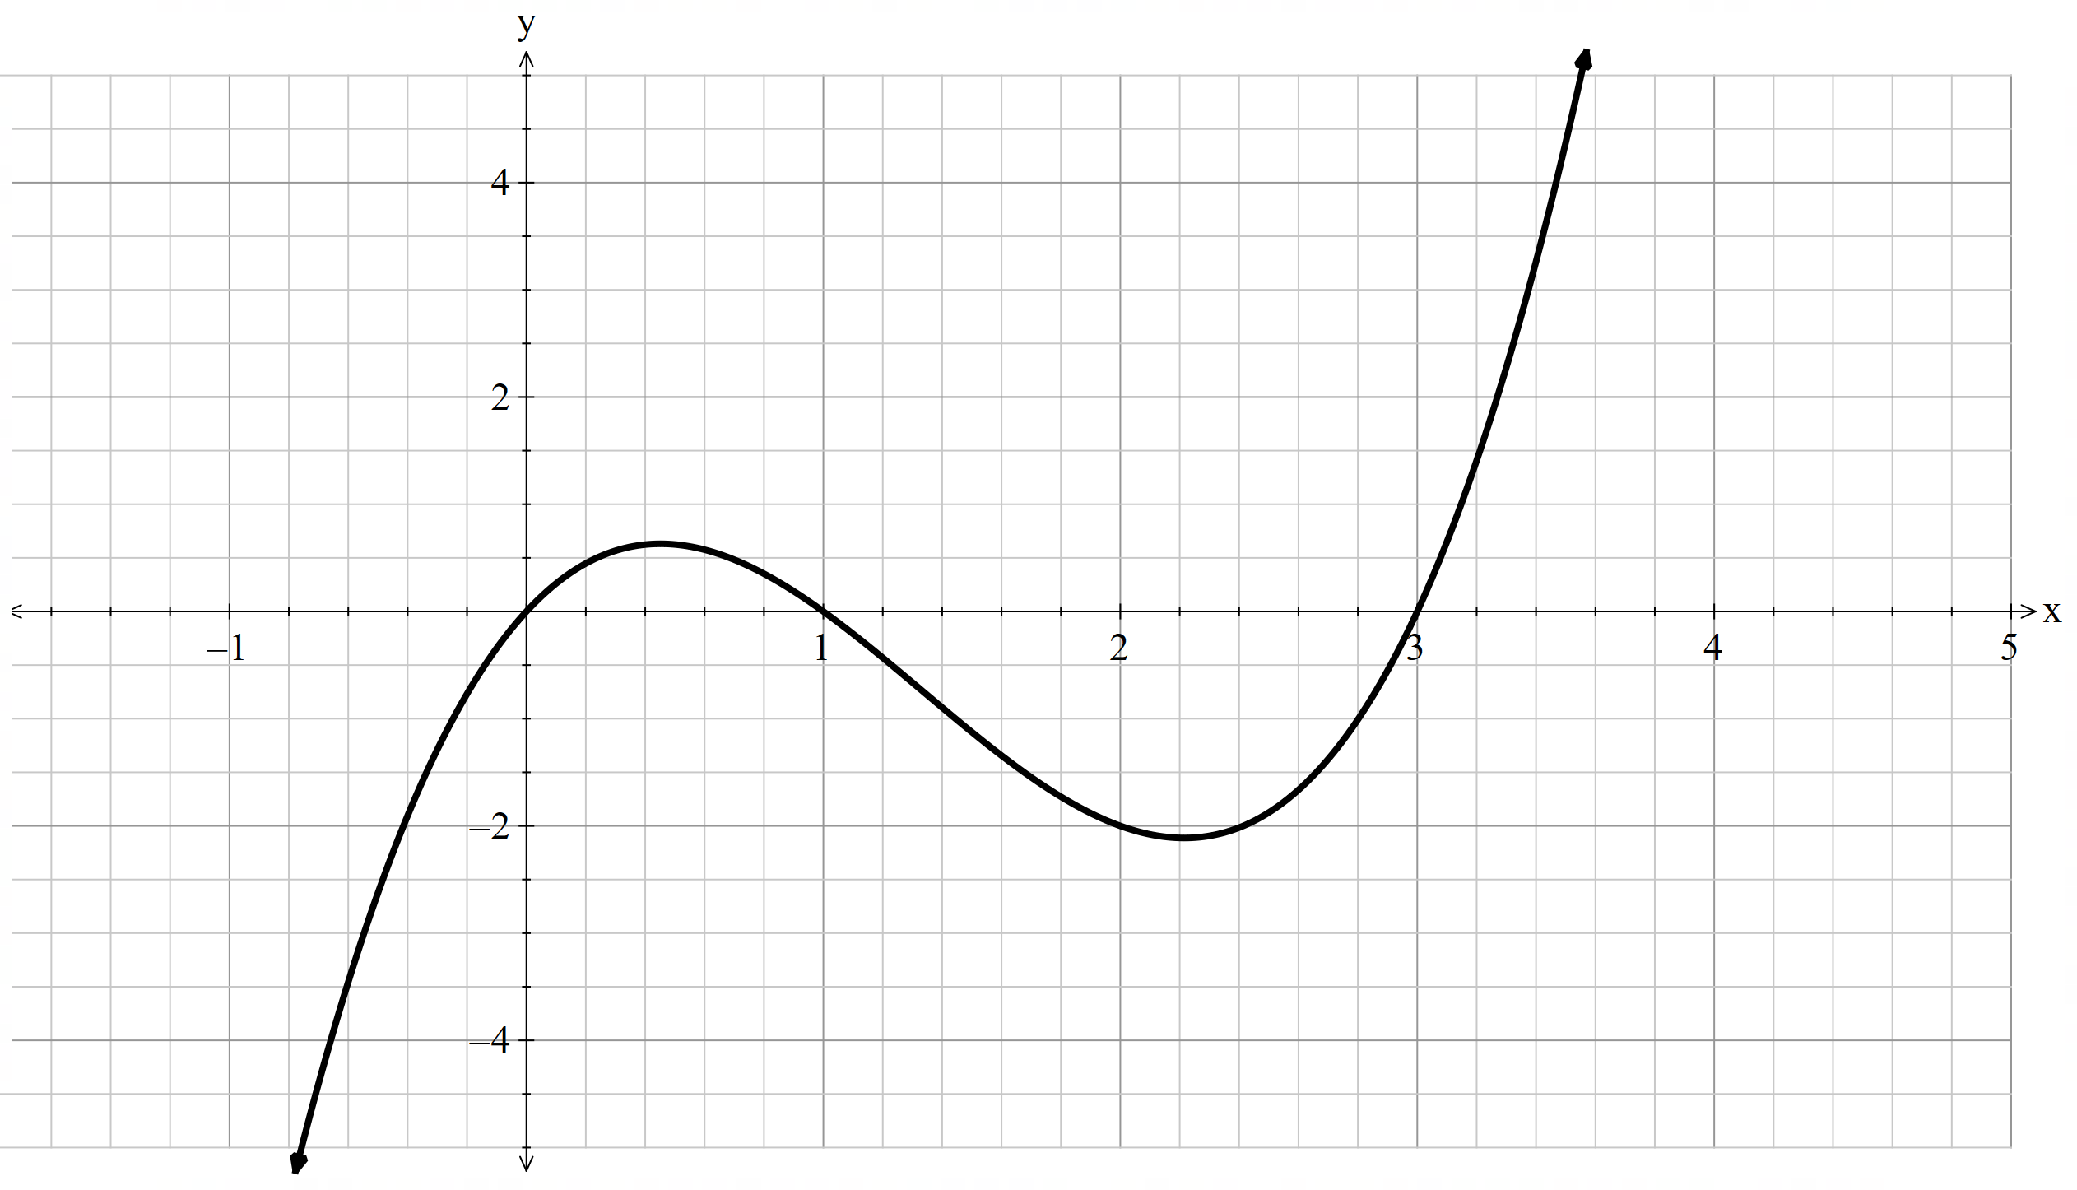  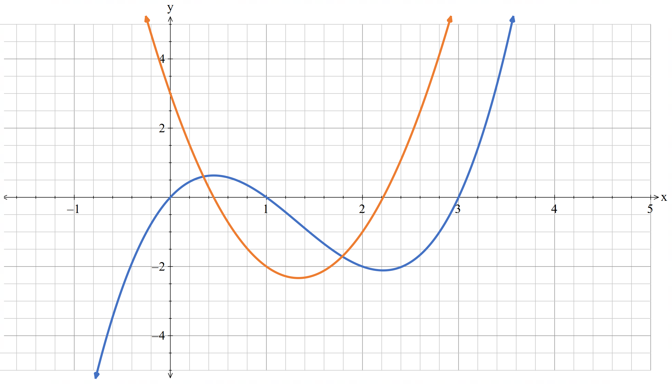 | Example 2  Graph the derivative of the function below.  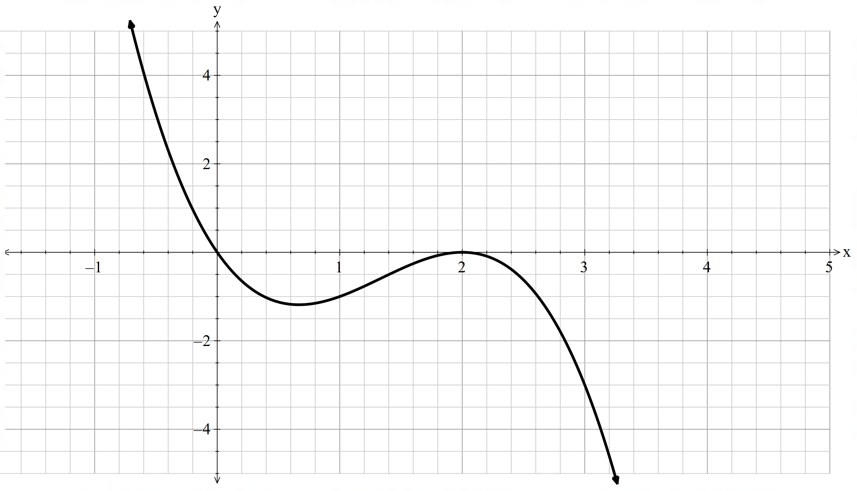  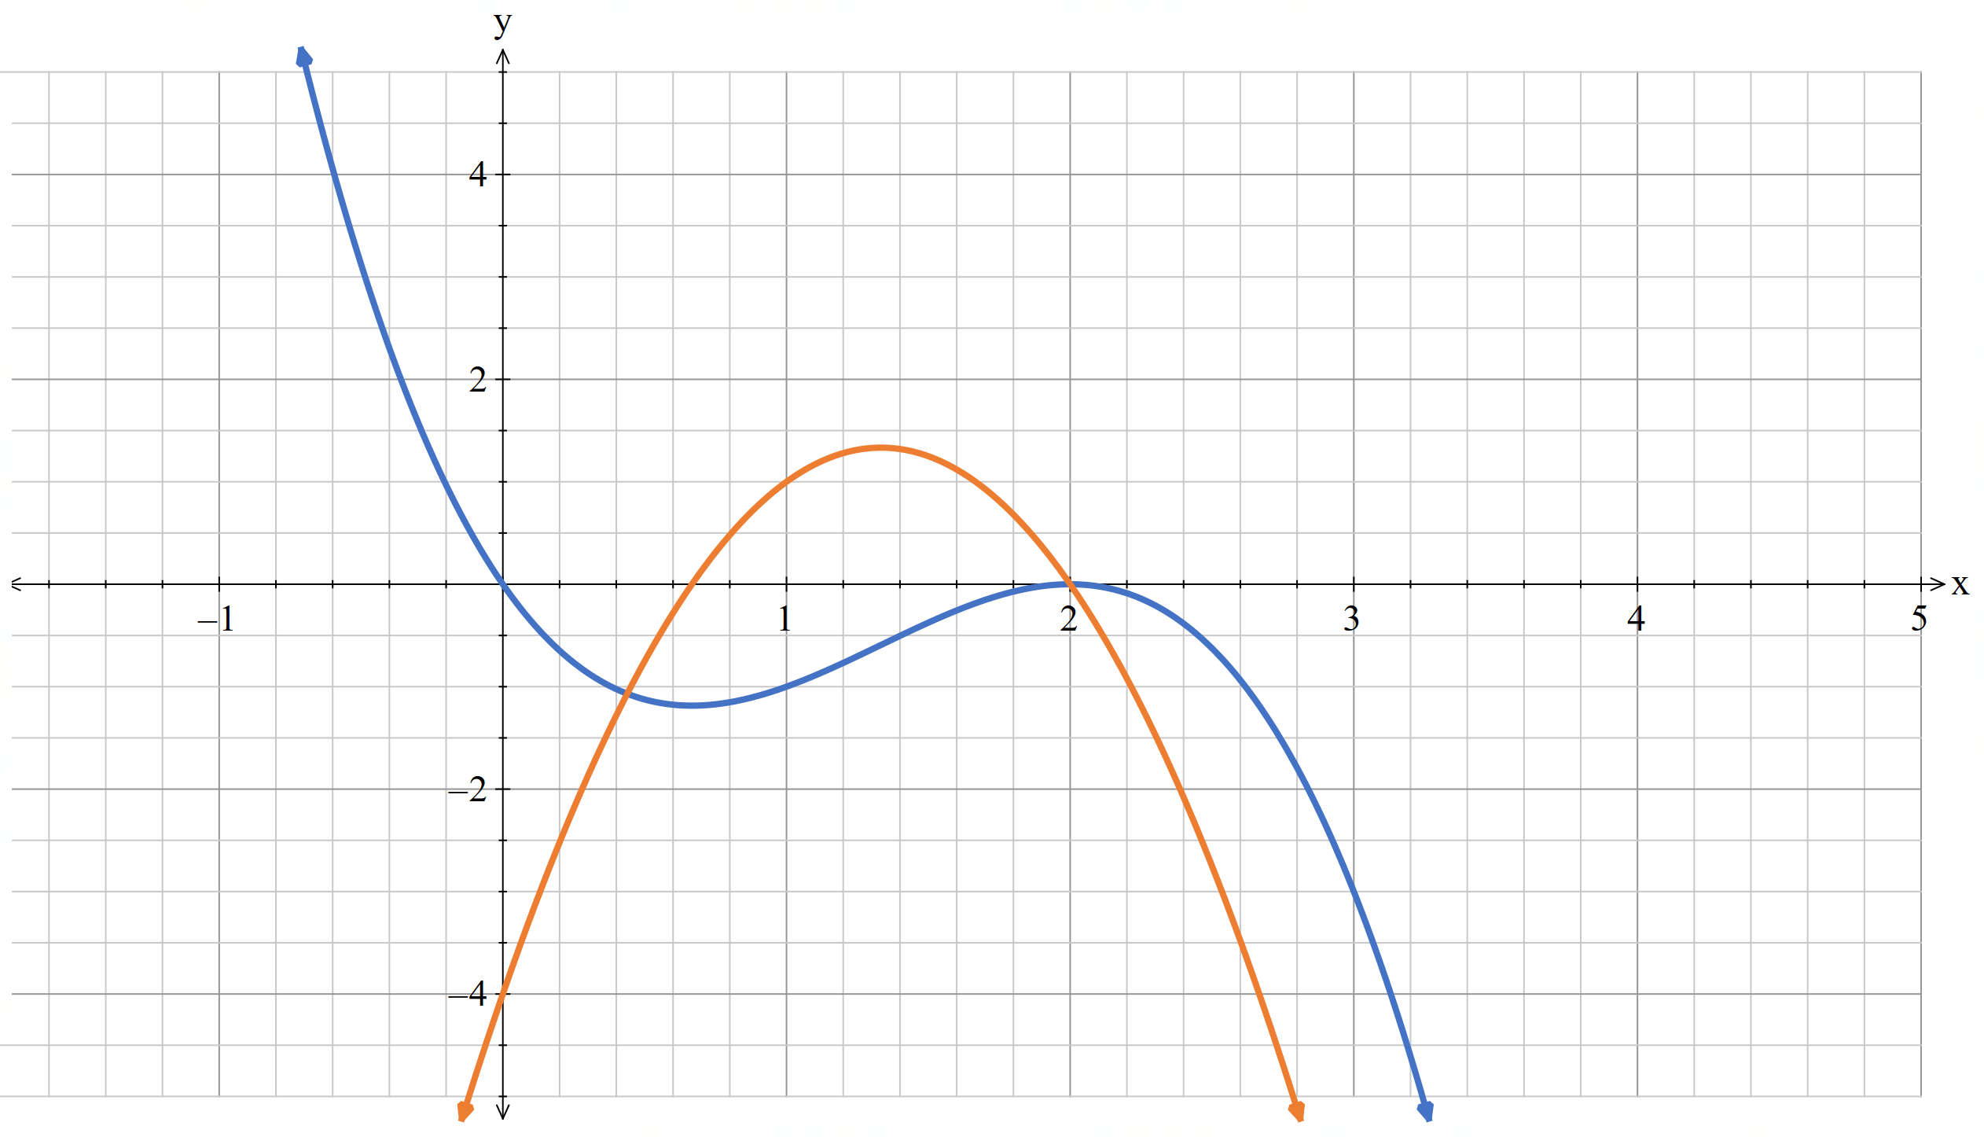
Things to remember | Example 3

Appendix D

HSC-style question
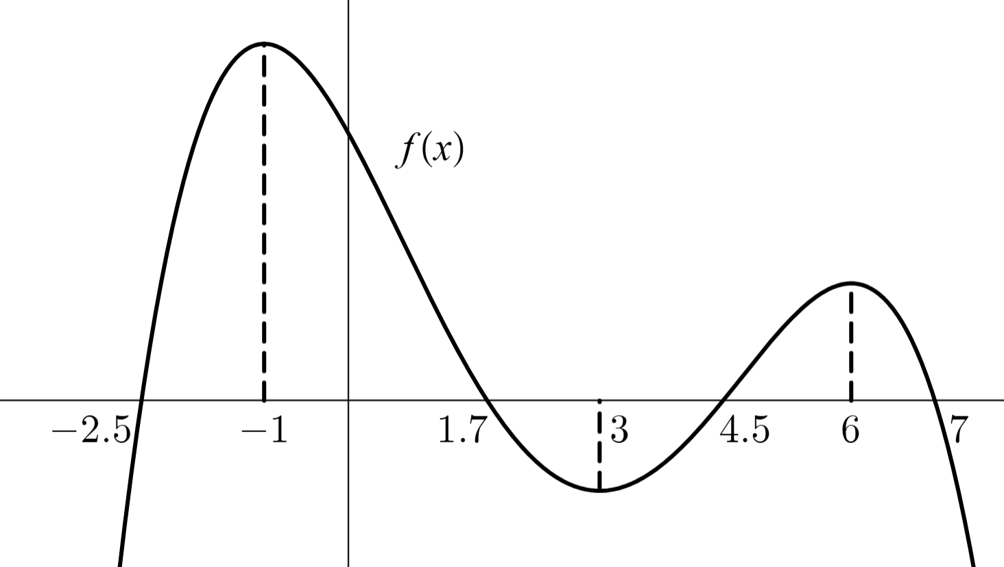
The diagram shows the graph of the function $y=f\left(x\right).$
- For which values of $x$ is the derivative, $f^{'}\left(x\right)$, negative? 1
...............................................................................................................................
...............................................................................................................................
...............................................................................................................................
...............................................................................................................................
...............................................................................................................................
...............................................................................................................................
- Sketch the graph $y=f'(x)$. 2

Sample solutions

Appendix A – Sketching the derivative
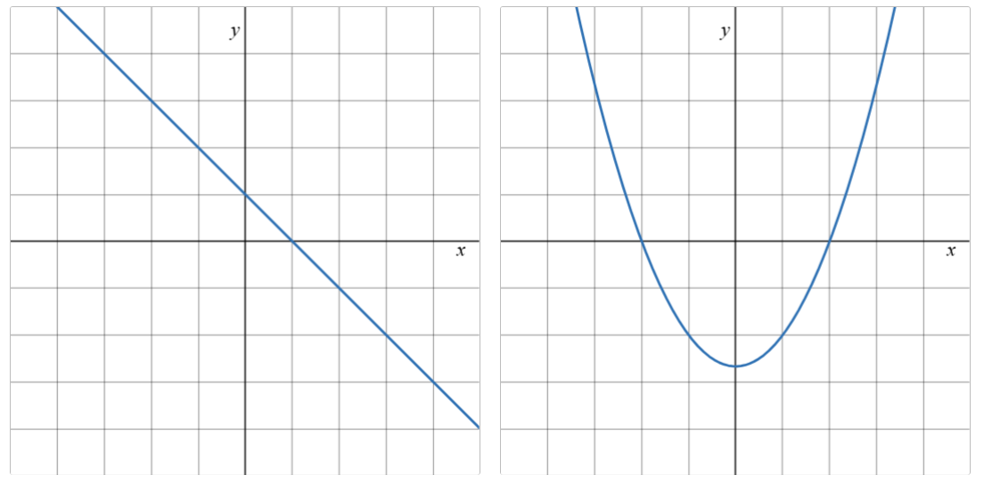

Appendix B – Variation Theory
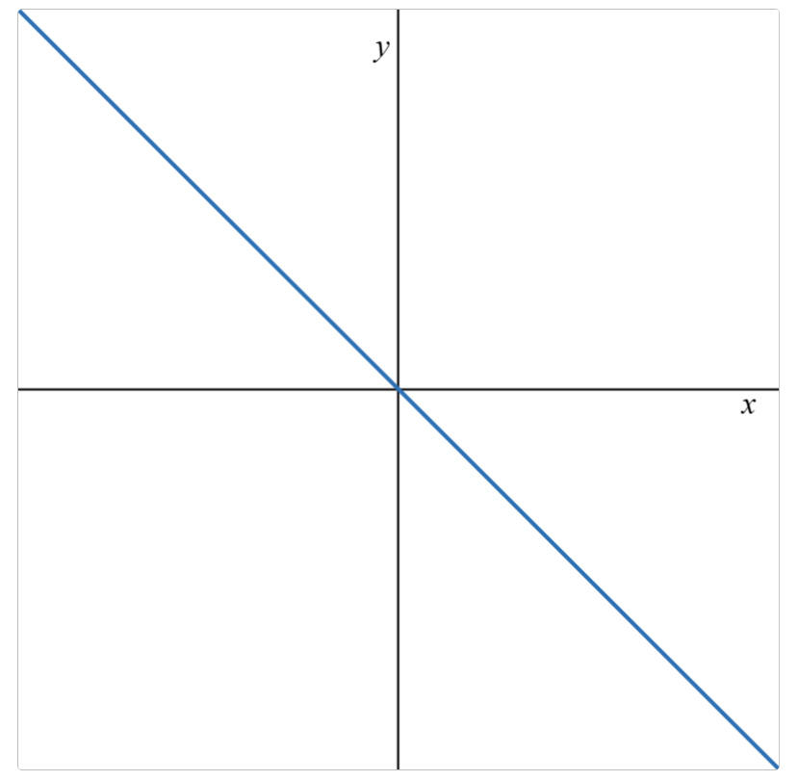 |  | 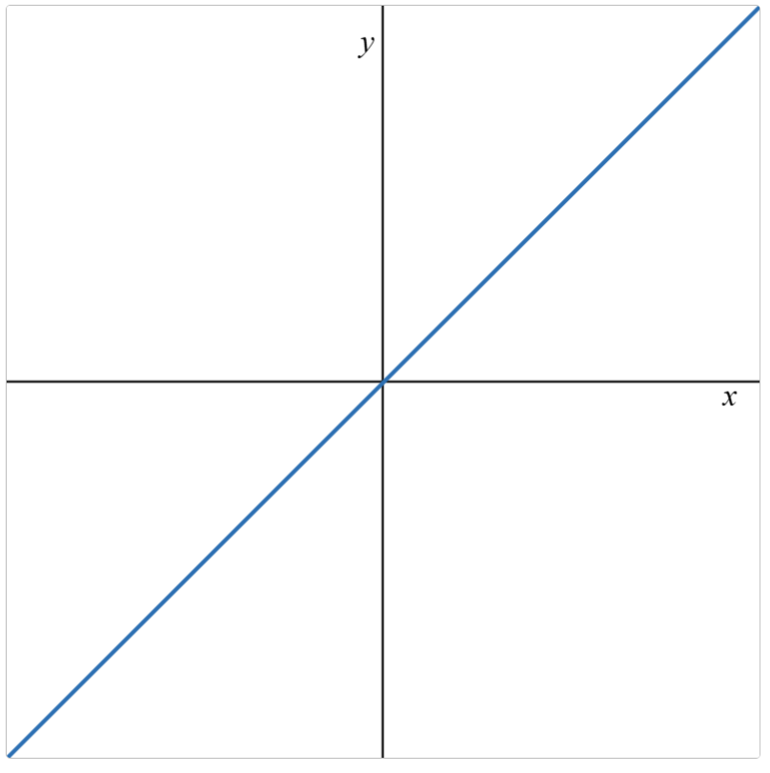 | 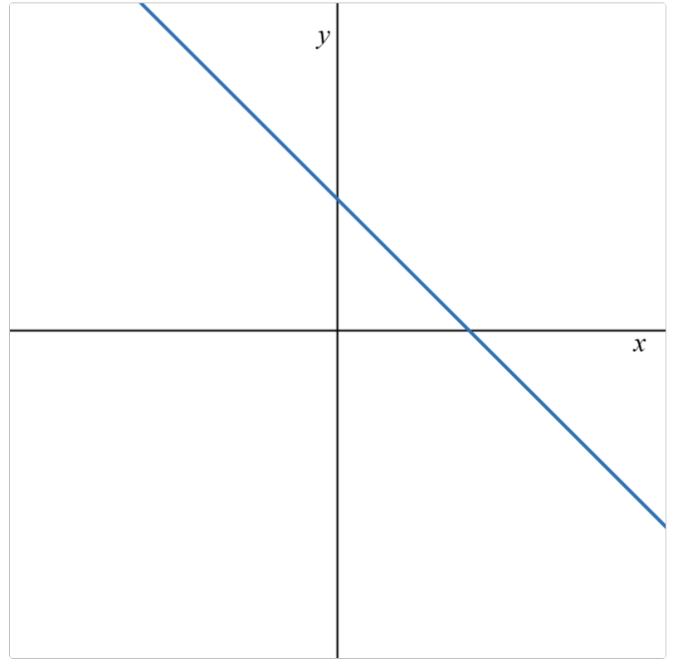
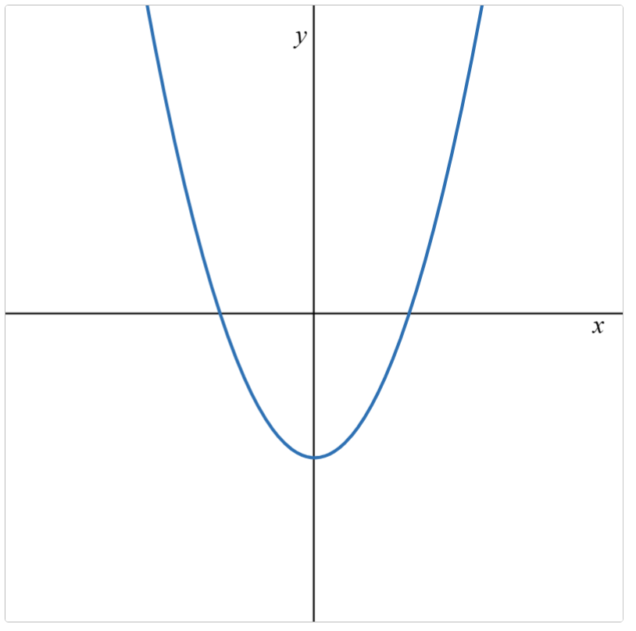 | 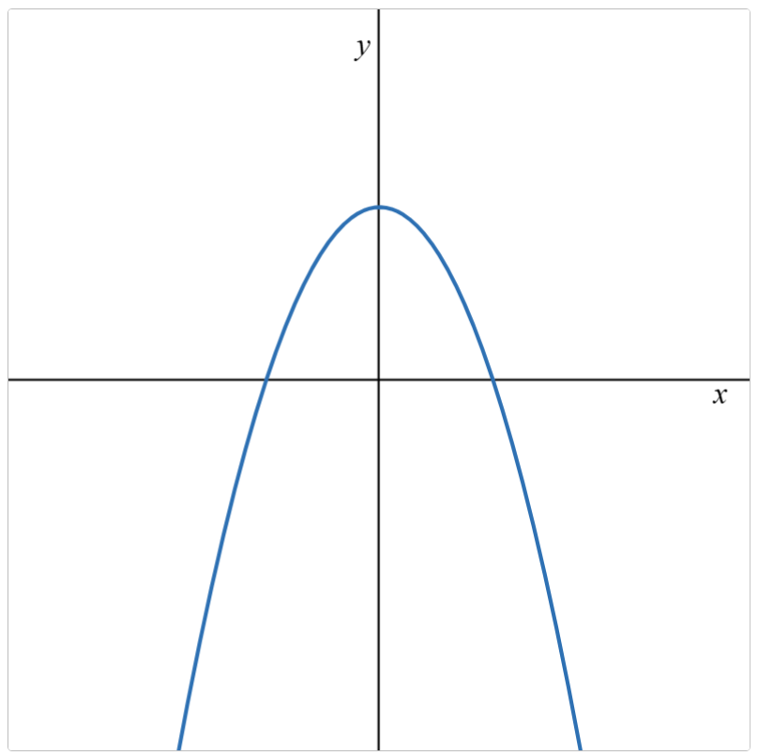 | 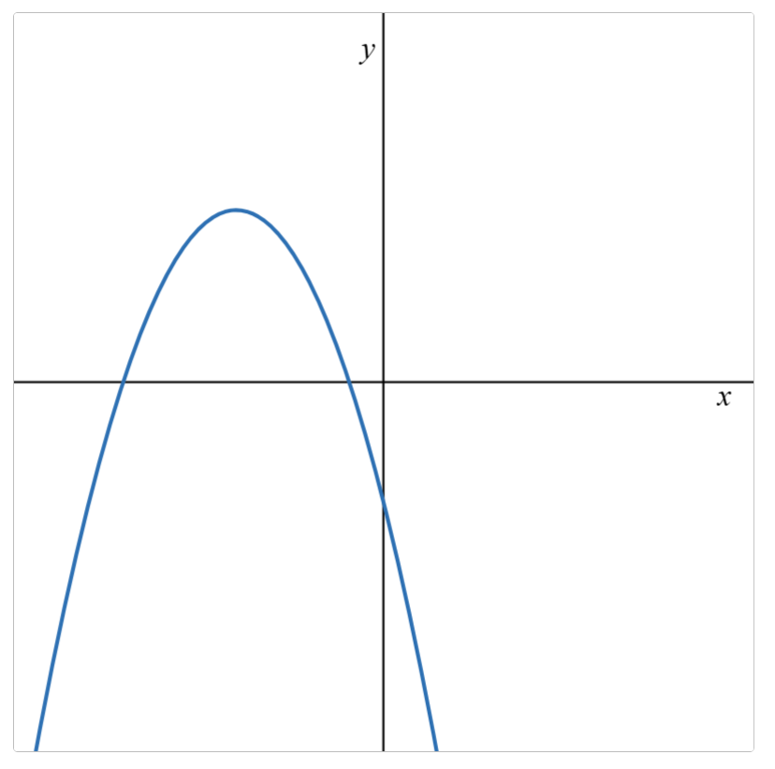 | 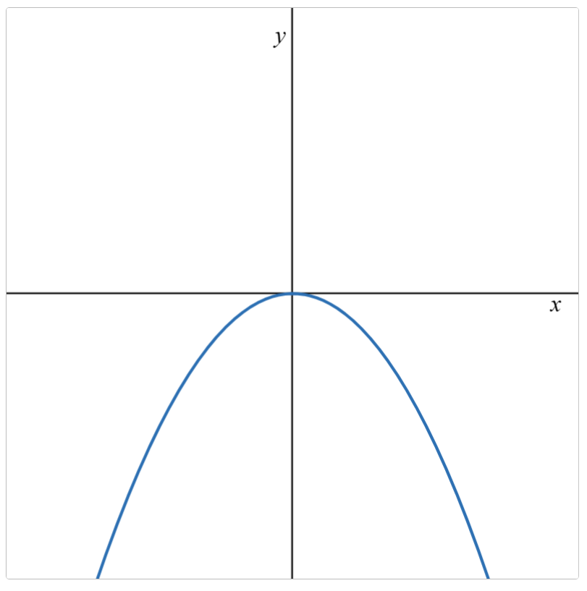

Challenge questions
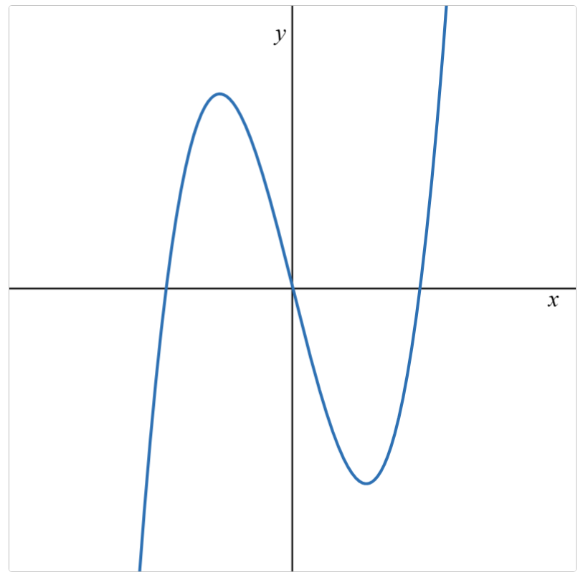 | 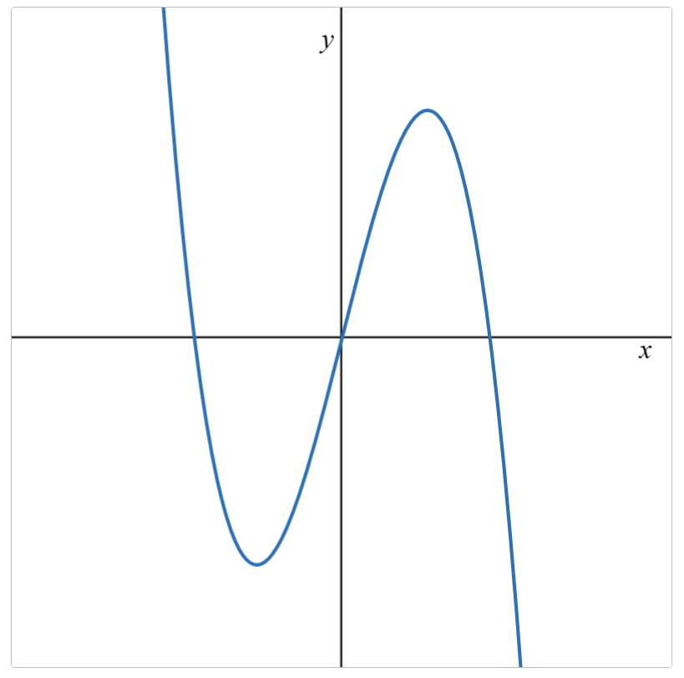 | 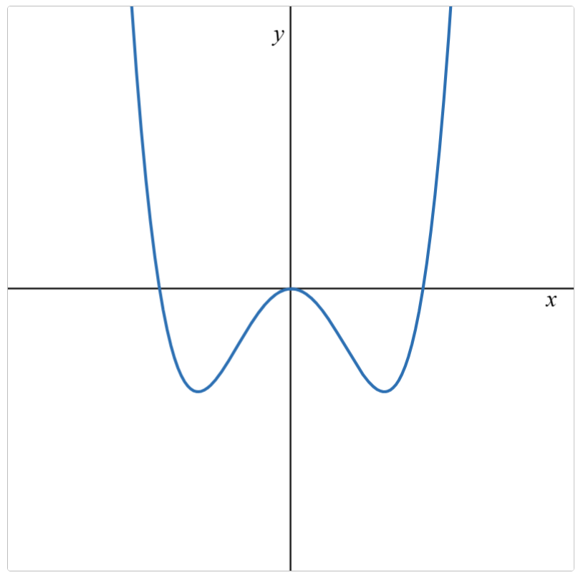 | 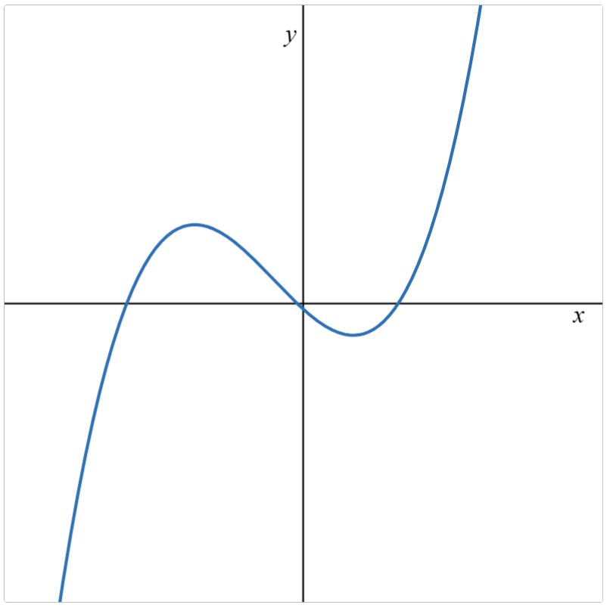

Appendix D – HSC-style question
- $-1<x<3$ and $x>6$.

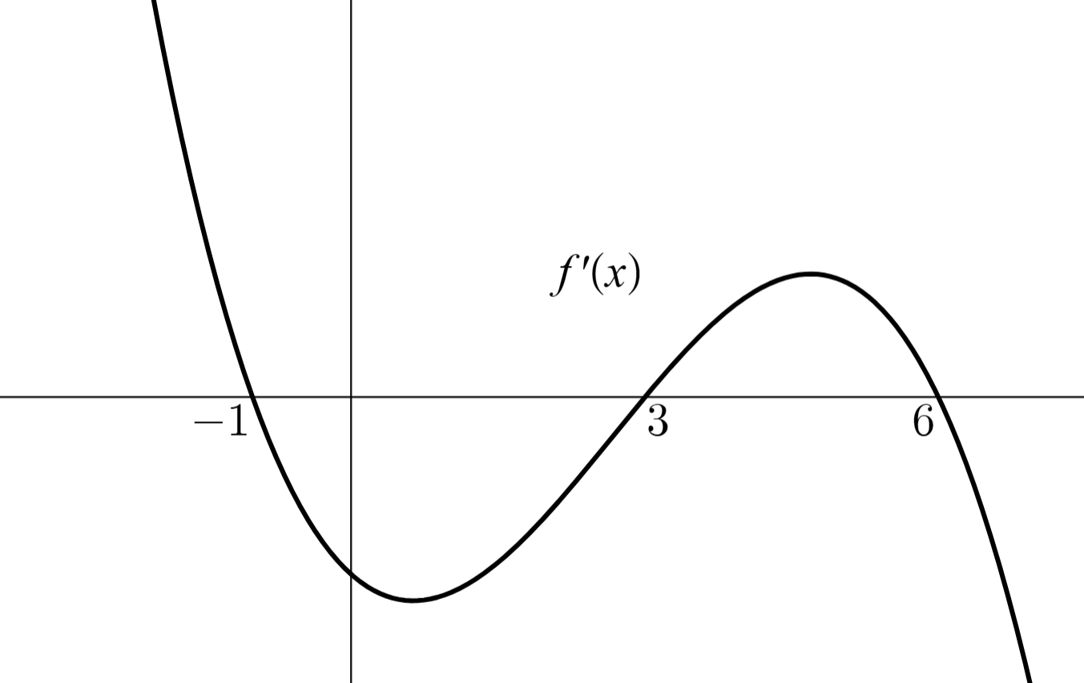

References
This resource contains NSW and syllabus content. The NSW Curriculum is developed by the NSW Education Standards Authority (NESA). This content is prepared by NESA for and on behalf of the Crown in right of the State of New South Wales. The material is protected by Crown copyright.
Please refer to the NESA Copyright Disclaimer for more information https://www.nsw.gov.au/education-and-training/nesa/copyright.
NESA holds the only official and up-to-date versions of the NSW Curriculum and syllabus documents. Please visit NESA https://www.nsw.gov.au/education-and-training/nesa and NSW Curriculum https://curriculum.nsw.edu.au.
Mathematics Advanced 11–12 Syllabus © NSW Education Standards Authority (NESA) for and on behalf of the Crown in right of the State of New South Wales, 2024.

© State of New South Wales (Department of Education), 2026
The copyright material published in this resource is subject to the Copyright Act 1968 (Cth) and is owned by the NSW Department of Education or, where indicated, by a party other than the NSW Department of Education (third-party material).
Copyright material available in this resource and owned by the NSW Department of Education is licensed under a Creative Commons Attribution 4.0 International (CC BY 4.0) license.

This license allows you to share and adapt the material for any purpose, even commercially.
Attribution should be given to © State of New South Wales (Department of Education), 2026.
Material in this resource not available under a Creative Commons license:
- the NSW Department of Education logo, other logos and trademark-protected material
- material owned by a third party that has been reproduced with permission. You will need to obtain permission from the third party to reuse its material.
Links to third-party material and websites
Please note that the provided (reading/viewing material/list/links/texts) are a suggestion only and implies no endorsement, by the New South Wales Department of Education, of any author, publisher, or book title. School principals and teachers are best placed to assess the suitability of resources that would complement the curriculum and reflect the needs and interests of their students.
If you use the links provided in this document to access a third-party's website, you acknowledge that the terms of use, including licence terms set out on the third-party's website apply to the use which may be made of the materials on that third-party website or where permitted by the Copyright Act 1968 (Cth). The department accepts no responsibility for content on third-party websites.

