Increasing and decreasing functions
Students look at increasing, decreasing and stationary functions by relating these ideas to the gradients at various points on a roller-coaster track, and then apply this understanding to different functions.
Students will need at least one digital device per pair to interact with Amplify Classroom during this lesson.
Learning intentions and success criteria should be shared with students later in the learning episode.

Learning intention
- To understand how the derivative’s sign shows if a function is increasing, decreasing or stationary at a point.

Success criteria
- I can use the first derivative to determine if a function is increasing or decreasing at a point.
- I can find where $\frac{dy}{dx}=0$ and describe this as a stationary point.
- I can read and interpret stationary points from a graph as increasing or decreasing intervals.
- I can find intervals where the function is increasing or decreasing based on derivative values.

Outcomes
A student:
- develops understanding and fluency in mathematics through exploring and connecting mathematical concepts, choosing and applying mathematical techniques to solve problems, and communicating their thinking and reasoning coherently and clearly MAO-WM-01
- interprets the meaning of the derivative and determines the derivative of functions to solve problems MAV-11-06

Content

Graphical applications of the derivative
- Interpret 𝑓(𝑥) as increasing at 𝑥 = 𝑐 when 𝑓'(𝑐) > 0 and decreasing at 𝑥 = 𝑐 when 𝑓'(𝑐) < 0.
- Describe the behaviour of a function at a point as stationary when the tangent at the point is parallel to the 𝑥-axis and recognise that 𝑓(𝑥) is stationary at 𝑥 = 𝑐 when 𝑓'(𝑐) = 0.
- Identify stationary points on the graph of a cubic function, and the values of $x$ for which the function is increasing and/or decreasing, by first calculating the derivative, and justify conclusions.
Mathematics Advanced 11–12 Syllabus © NSW Education Standards Authority (NESA) for and on behalf of the Crown in right of the State of New South Wales, 2024.

Table 1: lesson summary
Section | Summary of activity | Teaching strategies | Teaching points
Retrieval practice | Students use slide 3 of the PowerPoint to solve quadratic inequalities. |  | Students will need these skills later in the lesson.
Activating prior knowledge | Students work through screens 1–3 of the Amplify Classroom activity (bit.ly/IncreaseDecrease). |  | Students start using the words increasing, decreasing and neither to describe curves.
Connecting learning | Students work through slides 4–10 of the Amplify Classroom activity making connections to the derivative and where the graph is increasing, decreasing or stationary. Reveal the learning intention and success criteria (slide 5) | Think-Pair-Share  Pose-Pause-Pounce-Bounce | Students conclude that if $\frac{dy}{dx}>0$ the curve is increasing, $\frac{dy}{dx}<0$ the curve is decreasing and if $\frac{dy}{dx}=0$ the curve is stationary.
Releasing responsibility | Use slide 7 of the PowerPoint to formalise rules. Slide 8 asks students to compare 2 different strategies for finding the nature of the curve of a quadratic and why only using the derivative works for a cubic function. Use slides 9–10 to model worked examples before practising (Appendix B) and writing notes. | Comparison strategy  Think-Pair-Share  Faded examples  Notes to future forgetful selves | The axis of symmetry formula can be used for quadratic functions.
Independent practice | Students practise from an existing resource before working in pairs to complete Appendix B. |  | Student should use the Approaching questions scaffold.

Activity structure
Please use the associated PowerPoint Increasing and decreasing functions to display images in this lesson.

Retrieval practice
- Display slide 3 of the PowerPoint and have students solve the quadratic inequalities. Click to animate the slide to reveal solutions.

Activating prior knowledge
- With at least one device per pair of students, assign the Amplify Classroom activity ‘Increasing and decreasing’ (bit.ly/IncreaseDecrease) for students to complete to the end of screen 3.
Before completing this activity, you will need to set up an Amplify Classroom (bit.ly/createdesmosclassroom) and use the pacing feature to restrict the students to slides 1–3.
Amplify Classroom provides the opportunity for immediate feedback as well as tailored feedback from the teacher as students progress through the activity.
- Bring the class back together and discuss students’ responses to screen 3.
- Inform students that they will be using the derivative to describe curves during this lesson.

Connecting learning
- Assign students to work through screens 4–5 of the Amplify Classroom activity, investigating the relationship between a linear graph’s slope and the derivative.
- In a Think-Pair-Share (bit.ly/thinkpairsharestrategy), ask students to discuss the relationship between the slope of the linear graph and the sign of its derivative.
Students should conclude that if $\frac{dy}{dx}>0$ the line is increasing and if $\frac{dy}{dx}<0$ the line is decreasing.
- Allow students time to consolidate their understanding by completing screen 6 of the Amplify Classroom activity. This will provide feedback to students once complete.
- Have students work through screen 7of the Amplify Classroom activity.
- Define a stationary point as the point on a curve where $\frac{dy}{dx}=0$
- Have students work through screens 8–10 of the Amplify Classroom activity.
- Using the Pose-Pause-Pounce-Bounce questioning strategy (PDF 557 KB) (bit.ly/posepausepouncebounce), have students discuss how they would know if the gradient is increasing, decreasing or stationary at a particular point. Prompting questions could include:
- How can you tell if the gradient at a point is increasing, decreasing or stationary?
- How could you use differentiation to check the graph’s nature at a given value of $x$?
Students should conclude that the value is substituted into the derivative to determine if the graph is increasing, decreasing or stationary at that point.
- Use slide 5 of the PowerPoint to reveal the learning intention and success criteria.

Releasing responsibility
- Display slide 7 of the PowerPoint to formalise students’ learning.
- Display slide 8 which compares 2 different methods of determining where a curve is increasing (bit.ly/supportingstrategies). Allow students time in a Think-Pair-Share to discuss how Grace and Adam find where the graph was increasing.
- Animate the slide and have students consider which method would work best for the cubic function displayed on the slide.
In the discussion, draw out that finding the axis of symmetry will not work for the cubic function and that students must use the other method.
- Use slides 9–10 from the PowerPoint to model worked examples of finding the nature of a function using the derivative. This explicit teaching uses the Worked examples (Your turn) method (bit.ly/supportingstrategies).
- Animate slide 9 to reveal the self-explanation prompts and a graph of the function. Have students confirm their thinking using the visual representation before attempting the question on slide 10.
- Students are to complete the faded examples (bit.ly/fadedexamplesstrategy) in Appendix A ‘Problems’. These gradually release responsibility and model communicating mathematically.
Teachers may wish to adjust Appendix A if students are more familiar with the critical points method of solving quadratic inequalities.
- Have students annotate Appendix A outlining any important information or information they may need to remember. This will form their notes to their future forgetful selves (bit.ly/notestofutureself).

Independent practice
- Students are to practise questions from an existing resource.
- Distribute Appendix B ‘HSC-style questions’ and have students work in pairs to complete the questions.
- Have pairs combine with another pair to compare answers. If answers differ, have them reason and justify which answer is correct.

Assessment and differentiation

Suggested opportunities for differentiation
Retrieval practice
- Students could be given quadratic inequalities already in factorised form to solve.
- Students could be given non-monic quadratic inequalities that cannot be easily factorised.
Connecting learning
- Students may need to be reminded that a horizontal line has a gradient of zero.
- The Amplify Classroom pacing function can be adjusted to suit your students.
Releasing responsibility
- Students could benefit from practising determining where quadratic equations are increasing, decreasing and stationary, before moving to cubic equations.
- Students may benefit from graphing the functions using the Desmos graphing calculator to confirm their solutions.
Independent practice
- The questions can be adjusted to suit the ability level of your students.
- Students could find the decimal value of questions 4 and 5.

Suggested opportunities for assessment
Retrieval practice
- Students’ responses to the questions should be used to assess students’ ability to factorise and solve quadratic inequalities.
Connecting learning
- Students’ responses to the Amply Classroom questions should be used to assess students’ understanding of the connections between the derivative and if a curve is increasing, decreasing or stationary.
Releasing responsibility
- Monitor students’ responses to the self-explanation prompts to assess their ability to solve quadratic inequalities.
- Students’ notes and Appendix A could be collected to assess students’ understanding of the key concepts covered in this lesson.
Independent practice
- Create an exit ticket using one of the HSC-style questions.

Appendix A

Problems
Find the stationary points for $f\left(x\right)=x^{3}-3x^{2}-9x$ | Find the stationary points for  $$f\left(x\right)=2x^{3}-3x^{2}-12x+4$$ | Find the stationary points for  $$f\left(x\right)=-x^{3}+3x^{2}+9x-2$$ | Find the stationary points for  $$f\left(x\right)=-2x^{3}+3x^{2}+12x-5$$
$$f^{'}\left(x\right)=3x^{2}-6x-9$$$f^{'}\left(x\right)=0$ for stationary points.  $$0=3x^{2}-6x-9 \\ =3\left(x^{2}-2x-3\right) \\ =3\left(x+1\right)\left(x-3\right) \\ x=-1, x=3$$ | $$f^{'}\left(x\right)=6x^{2}-6x-12$$$f^{'}\left(x\right)=0$ for stationary points  $$0=6x^{2}-6x-12 \\ =6\left(x^{2}-x-2\right) \\ =6\left(x-2\right)\left(x+1\right)$$  $$x=2, x=-1$$ | $$f^{'}\left(x\right)=-3x^{2}+6x+9$$$f^{'}\left(x\right)=0$ for stationary points
Where is the graph increasing? | Where is the graph decreasing? | Where is the graph increasing? | Where is the graph decreasing?
For increasing $f'(x)>0$$$3\left(x+1\right)\left(x-3\right)>0$$  $$x<-1 and x>3$$ | For decreasing $f'(x)<0$ | For increasing $f'(x)>0$

Appendix B

HSC-style questions
- Prove that the curve $f\left(x\right)=x^{4}-4x^{3}+3x^{2}-8$ is decreasing at $x=2$.
- Find the exact values for which $f\left(x\right)=x^{3}-6x^{2}+10x-3$ is increasing.
- Find the exact values for which $f\left(x\right)=-x^{3}-2x^{2}+x-1$ is decreasing.
- Use your knowledge of function transformation to prove that $y={\left(3-x\right)}^{3}+1$ is decreasing except for the stationary point. Without calculus, predict the stationary point.
- Prove that $f\left(x\right)=\frac{1}{3}x^{3}-2x^{2}+4x+1$ is never decreasing.

Sample solutions

Appendix A – problems
Find the stationary points for $f\left(x\right)=x^{3}-3x^{2}-9x$ | Find the stationary points for  $$f\left(x\right)=2x^{3}-3x^{2}-12x+4$$ | Find the stationary points for  $$f\left(x\right)=-x^{3}+3x^{2}+9x-2$$ | Find the stationary points for  $$f\left(x\right)=-2x^{3}+3x^{2}+12x-5$$
$$f^{'}\left(x\right)=3x^{2}-6x-9$$$f^{'}\left(x\right)=0$ for stationary points.  $$0=3x^{2}-6x-9 \\ =3\left(x^{2}-2x-3\right) \\ =3\left(x+1\right)\left(x-3\right) \\ x=-1, x=3$$ | $$f^{'}\left(x\right)=6x^{2}-6x-12$$$f^{'}\left(x\right)=0$ for stationary points  $$0=6x^{2}-6x-12 \\ =6\left(x^{2}-x-2\right) \\ =6\left(x-2\right)\left(x+1\right)$$  $$x=2, x=-1$$ | $$f^{'}\left(x\right)=-3x^{2}+6x+9$$$f^{'}\left(x\right)=0$ for stationary points  $$0=-3x^{2}+6x+9 \\ =-3\left(x^{2}-2x-3\right) \\ =-3\left(x-3\right)\left(x+1\right)$$  $$x=3,x= -1$$ | $$f^{'}\left(x\right)=-6x^{2}+6x+12$$$f^{'}\left(x\right)=0$ for stationary points  $$0=-6x^{2}+6x+12 \\ =-6\left(x^{2}-x-2\right) \\ =-6\left(x-2\right)\left(x+1\right) \\ x=2, x= -1$$
Where is the graph increasing? | Where is the graph decreasing? | Where is the graph increasing? | Where is the graph decreasing?
For increasing $f'(x)>0$$$3\left(x+1\right)\left(x-3\right)>0$$  $$x<-1and x>3$$ | For decreasing $f'(x)<0$  $$6\left(x-2\right)\left(x+1\right)<0$$  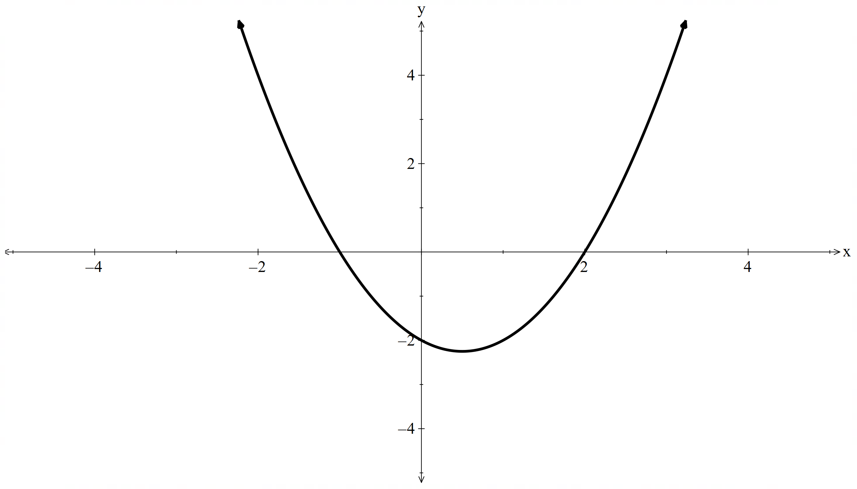  $$-2<x<1$$ | For increasing $f'(x)>0$  $$-3\left(x-3\right)\left(x+1\right)>0$$  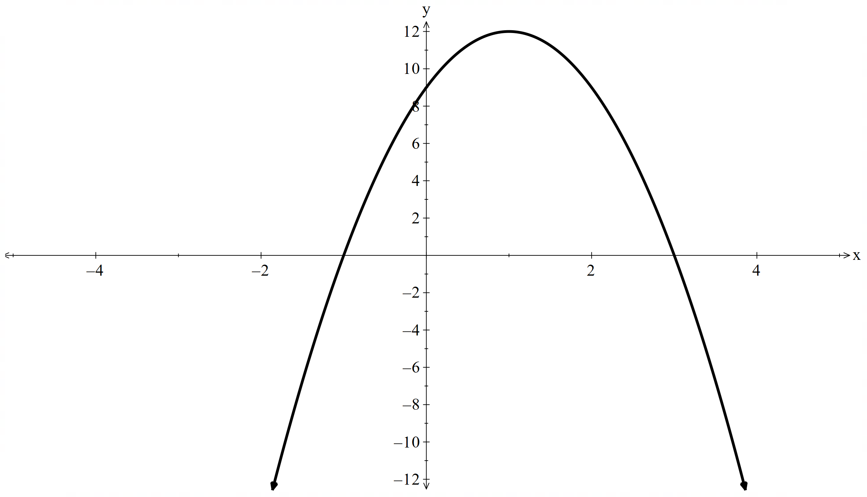$-1<x<3$ | For decreasing $f^{'}\left(x\right)<0$  $$-6\left(x-2\right)\left(x+1\right)<0$$  $$-1<x<2$$

Appendix B – HSC-style questions
- To prove that the curve $f\left(x\right)=x^{4}-4x^{3}+3x^{2}-8$ is decreasing at $x=2$.
$$f\left(x\right)=x^{4}-4x^{3}+3x^{2}-8 \\ f^{'}\left(x\right)=4x^{3}-12x^{2}+6x \\ f^{'}\left(2\right)=4{\left(2\right)}^{3}-12{\left(2\right)}^{2}+6\left(2\right) \\ =-4$$$f^{'}\left(x\right)<0$at $x=2∴$ decreasing
- Find the exact values for which $f\left(x\right)=x^{3}-6x^{2}+10x-3$ is increasing.
$$f\left(x\right)=x^{3}-6x^{2}+10x-3 \\ f^{'}\left(x\right)=3x^{2}-12x+10 \\ x=\frac{-b±\sqrt{b^{2}-4ac}}{2a} \\ =\frac{12±\sqrt{{12}^{2}-4\left(3\right)\left(10\right)}}{2×3} \\ =\frac{12±\sqrt{24}}{6}$$$x=2-\frac{\sqrt{6}}{3}$ or $x=2+\frac{\sqrt{6}}{3}$
For increasing $f^{'}\left(x\right)>0$$$3x^{2}-12x+10>0$$$x<2-\frac{\sqrt{6}}{3} or x>2+\frac{\sqrt{6}}{3}$
- Find the exact values for which $f\left(x\right)=-x^{3}-2x^{2}+x-1$ is decreasing.
$$f\left(x\right)={-x}^{3}-2x^{2}+x-1 \\ f^{'}\left(x\right)=-3x^{2}-4x+1 \\ x=\frac{-b±\sqrt{b^{2}-4ac}}{2a} \\ =\frac{4±\sqrt{4^{2}-4\left(-3\right)\left(1\right)}}{-2×3} \\ =\frac{4±\sqrt{28}}{-6}$$$x=\frac{-2-\sqrt{7}}{3}$ or $x=\frac{-2+\sqrt{7}}{3}$
For decreasing $f^{'}\left(x\right)<0$
$$-3x^{2}-4x+1<0 \\ x<\frac{-2-\sqrt{7}}{3} or x>\frac{-2+\sqrt{7}}{3}$$
- Use your knowledge of function transformation to prove that $y={\left(3-x\right)}^{3}+1$ is decreasing except for the stationary point. Without calculus, predict the stationary point.
$y={\left(3-x\right)}^{3}+1$ is a negative cubic translated up 1 and across 3. Being a negative cubic means that the graph will be decreasing except for the stationary point.
The stationary point will be at $(3,1)$
- Prove that $f\left(x\right)=\frac{1}{3}x^{3}-2x^{2}+4x+1$ is never decreasing.
$$f\left(x\right)=\frac{1}{3}x^{3}-2x^{2}+4x+1 \\ f^{'}\left(x\right)=x^{2}-4x+4 \\ ={\left(x-2\right)}^{2}$$
Since $f'(x)$ is a squared number $f^{'}\left(x\right)≥0$ meaning the graph is never decreasing.

References
This resource contains NSW and syllabus content. The NSW Curriculum is developed by the NSW Education Standards Authority (NESA). This content is prepared by NESA for and on behalf of the Crown in right of the State of New South Wales. The material is protected by Crown copyright.
Please refer to the NESA Copyright Disclaimer for more information https://www.nsw.gov.au/education-and-training/nesa/copyright.
NESA holds the only official and up-to-date versions of the NSW Curriculum and syllabus documents. Please visit NESA https://www.nsw.gov.au/education-and-training/nesa and NSW Curriculum https://curriculum.nsw.edu.au.
Mathematics Advanced 11–12 Syllabus © NSW Education Standards Authority (NESA) for and on behalf of the Crown in right of the State of New South Wales, 2024.

© State of New South Wales (Department of Education), 2026
The copyright material published in this resource is subject to the Copyright Act 1968 (Cth) and is owned by the NSW Department of Education or, where indicated, by a party other than the NSW Department of Education (third-party material).
Copyright material available in this resource and owned by the NSW Department of Education is licensed under a Creative Commons Attribution 4.0 International (CC BY 4.0) license.

This license allows you to share and adapt the material for any purpose, even commercially.
Attribution should be given to © State of New South Wales (Department of Education), 2026.
Material in this resource not available under a Creative Commons license:
- the NSW Department of Education logo, other logos and trademark-protected material
- material owned by a third party that has been reproduced with permission. You will need to obtain permission from the third party to reuse its material.
Links to third-party material and websites
Please note that the provided (reading/viewing material/list/links/texts) are a suggestion only and implies no endorsement, by the New South Wales Department of Education, of any author, publisher, or book title. School principals and teachers are best placed to assess the suitability of resources that would complement the curriculum and reflect the needs and interests of their students.
If you use the links provided in this document to access a third-party's website, you acknowledge that the terms of use, including licence terms set out on the third-party's website apply to the use which may be made of the materials on that third-party website or where permitted by the Copyright Act 1968 (Cth). The department accepts no responsibility for content on third-party websites.

