Mixed differentiation
In this lesson, students will consolidate their understanding of the product, quotient and chain rules by focusing on how to determine the most appropriate differentiation method for a given function. They will practise identifying whether to use a single rule or a combination of rules when differentiating more complex functions.

Learning intention
- To choose and apply the appropriate differentiation rules for any function.

Success criteria
- I can identify which rule or combination of rules to use for a given function.
- I can differentiate complex functions that require combining multiple rules.
- I can explain my reasoning for choosing a particular rule or combination of rules.

Outcomes
A student:
- develops understanding and fluency in mathematics through exploring and connecting mathematical concepts, choosing and applying mathematical techniques to solve problems, and communicating their thinking and reasoning coherently and clearly MAO-WM-01
- interprets the meaning of the derivative and determines the derivative of functions to solve problems MAV-11-06

Content

Calculations with the derivative
- Identify and apply the product, quotient or chain rule, or a combination of the rules, as appropriate to differentiate a given function.
Mathematics Advanced 11–12 Syllabus © NSW Education Standards Authority (NESA) for and on behalf of the Crown in right of the State of New South Wales, 2024.

Table 1: lesson summary
Section | Summary of activity | Teaching strategies | Teaching points
Activating prior knowledge | Use slide 4 to display 4 questions which are same surface different deep. | Same surface different deep | Students revisit basic differentiation and apply their knowledge of tangents and normals.
Connecting learning | Students sort Appendix A into 4 groups: chain rule, product rule, quotient rule and other before comparing strategies and discussing which strategy would be best and why. | Visibly random groups of 3  Vertical non-permanent surfaces  Gallery walk  Pose-Pause-Pounce-Bounce | Discuss questions where there were different methods used to initiate a discussion on why one method may be better than another.
Releasing responsibility | Students discuss strategies before completing a Tarsia puzzle (Appendix B). Students use Appendix C to create notes. | Pose-Pause-Pounce-Bounce | Students should create a thorough set of summary notes
Independent practice | Students use their summary notes to practise HSC-style questions (Appendix D) |  | Students choose the most appropriate rule to differentiate each function.

Activity structure
Please use the associated PowerPoint Mixed differentiation to display images in this lesson.

Activating prior knowledge
- Show slide 4 of the PowerPoint that displays a same surface different deep question (bit.ly/S_S_D_D) as seen below in Figure 1.
Figure 1: Same surface different deep question
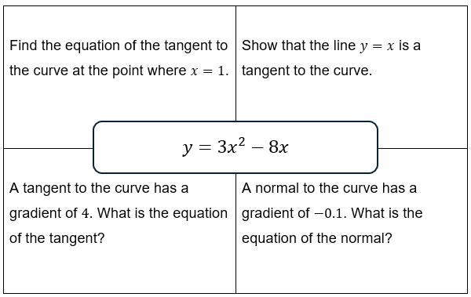
- Have students compare their responses with a neighbouring student and work together to resolve any solutions where there is a discrepancy.

Connecting learning
- Assign students to visibly random groups of 3 (bit.ly/visiblegroups) on vertical non-permanent surfaces (bit.ly/VNPSstrategy).
- Ask students to divide their vertical non-permanent surface into quarters and label the sections ‘Chain rule’, ’Product rule’, ‘Quotient rule’ and ‘Other’.
- Distribute Appendix A ‘Card sort questions’ to each group and have students cut up the cards and, using adhesive putty, decide which rule would be the best way to approach each question. Tell students to use the ‘Other’ category if they wouldn’t use a rule or would use multiple rules.
- To explore other strategies and gain a deeper understanding, students are to do a gallery walk (bit.ly/DLSgallerywalk) of other group’s selections. Ask students to focus on the questions that groups completed that were different to their group and consider whether the alternate method would be better.
- Use the Pose-Pause-Pounce-Bounce questioning strategy (PDF 557 KB) (bit.ly/posepausepouncebounce) to initiate a class discussion on which method would be the most suitable to approach each question and why.
The teacher should select 2–3 questions to discuss based on the class’s responses to the task. They should select questions where there were different methods used to initiate a discussion on why one method may be better than another.
- Have students work through each of the problems from the card sorting activity, selecting the most appropriate method to solve the problem.
- Once completed, have students solve the problems using an alternate method, where possible, confirming the suitability of the method chosen.

Releasing responsibility
- Using a Pose-Pause-Pounce-Bounce questioning strategy, conduct a class discussion about the different approaches and rules for different types of questions. Questions could include:
- Were there any questions that were significantly easier to solve using one method over another?
- What made a particular method easier or harder for a question?
- Was this method difficult or easier for all the questions?
- In pairs, students are to complete the jigsaw activity from Appendix B ‘Tarsia’.
These cards can be precut and placed in snap lock bags before the lesson.
- Distribute Appendix C ‘Reference sheet’, which contains the relevant section from the HSC reference sheet.
- Have students annotate the reference sheet with when each rule should be used and some examples. Include all forms of notation in the annotation.
Students need to be familiar with the other forms the syllabus uses for the chain rule that are not shown on the reference sheet. These may be used in an HSC examination.
$\frac{dy}{dx}=\frac{dy}{du}×\frac{du}{dx}$ and $h^{'}\left(x\right)=f^{'}\left(g\left(x\right)\right)g^{'}\left(x\right).$
- Have students compare their annotated sheet with another student and add in relevant information that they may have forgotten.

Independent practice
- Distribute Appendix D ‘HSC-style questions’ to each student.
- Have students work through the questions meeting with a partner after each question to discuss answers. If answers differ, have students negotiate the correct answer with a partner.

Assessment and differentiation

Suggested opportunities for differentiation
Activating prior knowledge
- The same surface different deep questions could be completed in pairs.
Connecting learning
- The questions in Appendix A could be changed for less ready students to include differentiation questions that clearly fit into a given category.
Releasing responsibility
- To support students, the teacher could give students one example for each rule and students must write the solution using different notation.
Independent practice
- Challenge students to find the values of $x$ for which $f^{'}\left(x\right)>0$ or $f^{'}\left(x\right)<0$.
- Students could create their own Tarsia for their peers at a level reflective of their understanding.

Suggested opportunities for assessment
Activating prior knowledge
- Teachers can observe students’ understanding of differentiation when students are working in pairs on their mini whiteboards.
Connecting learning
- Teachers can observe students’ understanding during the questioning discussion as well as when pairs are working through the different approaches.
Releasing responsibility
- Teachers can review the notes and the annotated reference sheet to determine students’ understanding of when and how to use the rules.
Independent practice
- Teachers can observe students’ understanding during the questioning discussion as well as when pairs are working through the different approaches.
- Teachers could collect Appendix C as evidence of learning.

Appendix A

Card sort questions
$$f\left(x\right)=\left(x^{2}-3\right)\left(x+4\right)$$ | $$f\left(x\right)=\frac{1}{{\left(x^{3}+2x\right)}^{4}}$$
$$f\left(x\right)=\frac{1}{\left(x^{2}+1\right)}$$ | $$f\left(x\right)=x^{3}\left(x^{2}-4x+1\right)$$
$$f\left(x\right)=\frac{x^{2}+1}{x^{2}-1}$$ | $$f\left(x\right)=\frac{1}{\sqrt{x^{2}+4}}$$
$$f\left(x\right)=\frac{x^{2}}{{\left(x+1\right)}^{3}}$$ | $$f\left(x\right)=\frac{x^{2}+2x}{x^{3}}$$

Appendix B

Tarsia
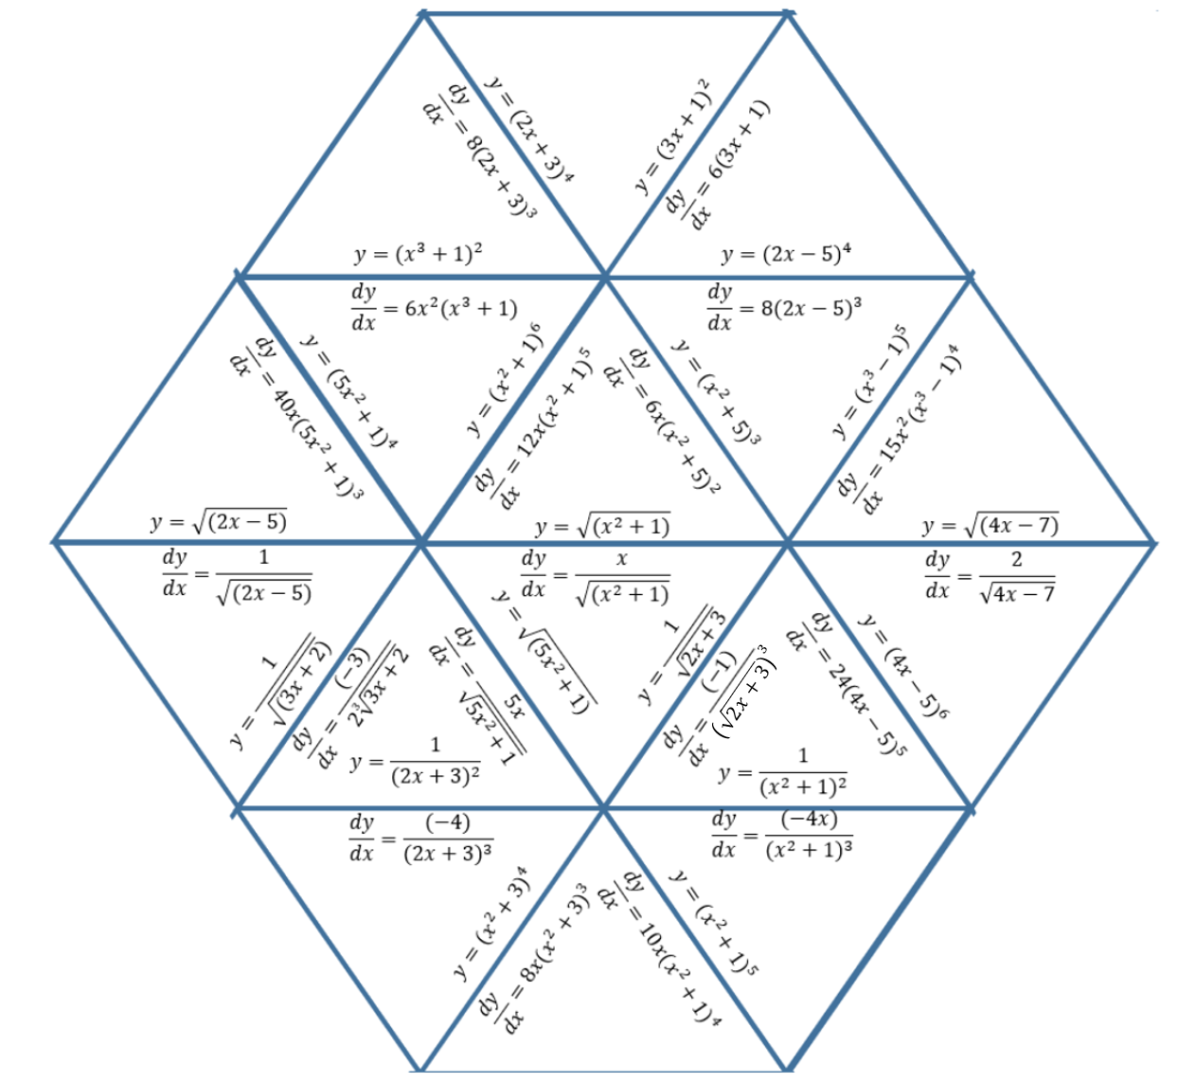

Appendix C

Reference sheet
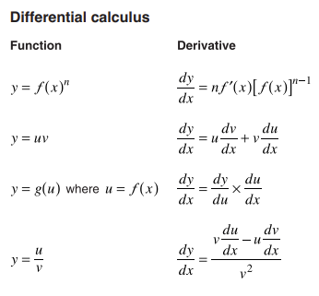

Appendix D

HSC-style questions
- A curve is defined by
$$y=\left(x^{2}+1\right)\left(x-1\right).$$
The tangent to the curve at certain points is parallel to the line $y=2x+5$.
Find the coordinates of these points.
- A curve is defined by
$$y=x^{\frac{1}{3}}{\left(x^{2}+2\right)}^{3}.$$
Find the gradient of the tangent to the curve at $x = 1$.
- For the curve
$$y=\left(x^{2}+1\right)\left({2x}^{\frac{1}{2}}-3\right),$$
find the equation of the tangent at $x =1 .$
- The curve is given by
$y=\frac{x^{2}+1}{x+1}$.
- Find the point(s) on the curve where the normal is parallel to the line $y=x-3.$
- Write the equations of the tangents at these points.
- Find $f’\left(x\right)$ and find all values of $x$ such that $f’\left(x\right)=0$ for these questions:
- $f\left(x\right)=\left(x-2\right){\left(x+3\right)}^{2}$
- $f\left(x\right)=2x{\left(x^{2}-9\right)}^{3}$
- $f\left(x\right)=\frac{x^{2}}{x+1}​$
- $f\left(x\right)={\left(x^{2}+1\right)}^{-1}$
- $f\left(x\right)=\sqrt{x^{2}-2x+5}$

Sample solutions

Activating prior knowledge
$$y=3x^{2}-8x \\ \frac{dy}{dx}=6x-8 \\ m_{t}=6×1-8 \\ =-2 \\ y=3×1^{2}-8×1 \\ =-5 \\ ∴m=-2 at \left(1,-5\right) \\ y+5=-2\left(x-1\right) \\ y=-2x-3$$ | $$\frac{dy}{dx}=6x-8 \\ m=1 \\ 1=6x-8 \\ 6x=9 \\ x=\frac{3}{2} \\ y=6×({\frac{3}{2})}^{2}-8×\frac{3}{2} \\ y= \frac{3}{2} \\ ∴m=1 at\left(\frac{3}{2},\frac{3}{2}\right) \\ y-\frac{3}{2}=1\left(x-\frac{3}{2}\right) \\ y-\frac{3}{2}=x-\frac{3}{2} \\ ∴y=x$$
$$\frac{dy}{dx}=6x-8$$  $$4=6x-8 \\ 12=6x \\ x=2 \\ y=3×({2)}^{2}-8×2 \\ y=-4 \\ ∴m=4 at \left(2,-4\right) \\ y+4=4(x-2) \\ y+4=4x-8 \\ y=4x-12$$ | $$\frac{dy}{dx}=6x-8 \\ m_{normal}=-0.1 \\ m_{tangent}=10 \\ 10=6x-8 \\ 6x=18 \\ x=3 \\ y=3×({3)}^{2}-8×3 \\ y=27-24 \\ y=3 \\ ∴m=-0.1 at \left(3,3\right) \\ y-3=-0.1(x-3) \\ 10y-30=-x+3 \\ 10y=-x+33 \\ y=\frac{-x+33}{10}$$

Appendix A – card sort questions
$$f\left(x\right)=\frac{1}{\left(x^{2}+1\right)}$$ | $$u=1 ∴u^{'}=0$$  $$v=x^{2}+1∴v^{'}=2x$$  $$f^{'}\left(x\right)=\frac{\left(0\right)×\left(x^{2}+1\right)-\left(1\right)\left(2x\right)}{{\left(x^{2}+1\right)}^{2}} \\ =\frac{-2x}{{\left(x^{2}+1\right)}^{2}}$$ | $$f\left(x\right)={\left(x^{2}+1\right)}^{-1} \\ f^{'}\left(x\right)=-1{\left(x^{2}+1\right)}^{-2}×2x \\ =\frac{-2x}{{\left(x^{2}+1\right)}^{2}}$$
$$f\left(x\right)=\left(x^{2}-3\right)\left(x+4\right)$$ | $$f\left(x\right)=x^{3}+4x^{2}-3x-12 \\ f^{'}\left(x\right)=3x^{2}+8x-3$$ | $$u=x^{2}-3 \\ \frac{du}{dx}=2x \\ v=x+4 \\ \frac{dv}{dx}=1 \\ f^{'}\left(x\right)=u×\frac{dv}{dx}+v×\frac{du}{dx} \\ =\left(x^{2}-3\right)\left(1\right)+\left(2x\right)\left(x+4\right) \\ =x^{2}-3+2x^{2}+8x \\ =3x^{2}+8x-3$$
$$f\left(x\right)=\frac{x^{2}+2x}{x^{3}}$$ | $$f^{'}\left(x\right)=\frac{\left(2x+2\right)x^{3}-\left(x^{2}+2x\right)\left(3x^{2}\right)}{x^{6}} \\ =\frac{2x^{4}+2x^{3}-3x^{4}-6x^{3}}{x^{6}} \\ =\frac{-x^{3}\left(x+4\right)}{x^{6}} \\ =\frac{-\left(x+4\right)}{x^{3}}$$ | $$f\left(x\right)=\frac{x^{2}}{x^{3}}+\frac{2x}{x^{3}} \\ =x^{-1}+2x^{-2} \\ f^{'}\left(x\right)=-x^{-2}-4x^{-3} \\ = \frac{-1}{x^{2}}-\frac{4}{x^{3}} \\ =\frac{-\left(x+4\right)}{x^{3}}$$
$$f\left(x\right)=\frac{x^{2}}{{\left(x+1\right)}^{3}}$$ | Let  $$u=x^{2} \\ \frac{du}{dx}=2x \\ v={\left(x+1\right)}^{3} \\ \frac{dv}{dx}=3{\left(x+1\right)}^{2}$$  $$f^{'}\left(x\right)=\frac{2x×{\left(x+1\right)}^{3}-{3\left(x+1\right)}^{2}×x^{2}}{{\left(x+1\right)}^{6}} \\ =\frac{2x{\left(x+1\right)}^{3}-{3x^{2}\left(x+1\right)}^{2}}{{\left(x+1\right)}^{6}} \\ =\frac{x{\left(x+1\right)}^{2}\left(2\left(x+1\right)-3x\right)}{{\left(x+1\right)}^{6}} \\ =\frac{x\left(2-x\right)}{{\left(x+1\right)}^{4}}$$ | $$f\left(x\right)={x^{2}×\left(x+1\right)}^{-3}$$  Let  $$u=x^{2} \\ \frac{du}{dx}=2x \\ v={\left(x+1\right)}^{-3} \\ \frac{dv}{dx}=-3{\left(x+1\right)}^{-4} \\ f^{'}\left(x\right)=x^{2}×-3{\left(x+1\right)}^{-4}+2x×{\left(x+1\right)}^{-3} \\ =\frac{-3x^{2}}{{\left(x+1\right)}^{4}}+\frac{2x}{{\left(x+1\right)}^{3}} \\ =\frac{-3x^{2}+\left(x+1\right)×2x}{{\left(x+1\right)}^{4}} \\ =\frac{-x^{2}+2x}{{\left(x+1\right)}^{4}} \\ =\frac{x\left(2-x\right)}{{\left(x+1\right)}^{4}}$$
$$f(x)=\frac{1}{\sqrt{x^{2}+4}}$$ | Let  $$u=1 \\ \frac{du}{dx}=0 \\ v={\left(x^{2}+4\right)}^{\frac{-1}{2}} \\ \frac{dv}{dx}=\frac{-1}{2}{\left(x^{2}+4\right)}^{\frac{-3}{2}}×2x \\ =-x{\left(x^{2}+4\right)}^{\frac{-3}{2}} \\ f^{'}\left(x\right)=1×-x{\left(x^{2}+4\right)}^{\frac{-3}{2}}+0×{\left(x^{2}+4\right)}^{\frac{-1}{2}} \\ =\frac{-x}{\sqrt{{{(x}^{2}+4)}^{3}}}$$ | $$f\left(x\right)={\left(x^{2}+4\right)}^{-\frac{1}{2}} \\ f^{'}\left(x\right)=-\frac{1}{2}{\left(x^{2}+4\right)}^{-\frac{3}{2}}×2x \\ =\frac{-x}{\sqrt{{{(x}^{2}+4)}^{3}}}$$
$$f\left(x\right)=\frac{1}{{\left(x^{3}+2x\right)}^{4}}$$ | Let  $$u=1 \\ \frac{du}{dx}=0 \\ v={\left(x^{3}+2x\right)}^{4} \\ \frac{dv}{dx}=4{\left(x^{3}+2x\right)}^{3}×\left(3x^{2}+2\right) \\ f^{'}\left(x\right)=\frac{{\left(x^{3}+2x\right)}^{4}×0-1×4{\left(x^{3}+2x\right)}^{3}×\left(3x^{2}+2\right)}{{\left(x^{3}+2x\right)}^{8}} \\ =\frac{-4{\left(x^{3}+2x\right)}^{3}\left(3x^{2}+2\right)}{{\left(x^{3}+2x\right)}^{8}} \\ =\frac{-4\left(3x^{2}+2\right)}{{\left(x^{3}+2x\right)}^{5}}$$ | $$f\left(x\right)={\left(x^{3}+2x\right)}^{-4} \\ f^{'}\left(x\right)=-4{\left(x^{3}+2x\right)}^{-5}×\left(3x^{2}+2\right) \\ =\frac{-4\left(3x^{2}+2\right)}{{\left(x^{3}+2x\right)}^{5}}$$
$$f\left(x\right)=x^{3}\left(x^{2}-4x+1\right)$$ | $$f\left(x\right)=x^{3}\left(x^{2}-4x+1\right) \\ =x^{5}-4x^{4}+x^{3}$$  $$f^{'}\left(x\right)=5x^{4}-16x^{3}+3x^{2} \\ =x^{2}\left(5x^{2}-16x+3\right)$$ | $$u=x^{3} \\ \frac{du}{dx}=3x^{2} \\ v=x^{2}-4x+1 \\ \frac{dv}{dx}=2x-4 \\ f^{'}\left(x\right)=u×\frac{dv}{dx}+v×\frac{du}{dx} \\ =x^{3}×\left(2x-4\right)+\left(x^{2}-4x+1\right)×3x^{2} \\ =x^{2}\left(2x^{2}-4x+3x^{2}-12x+3\right) \\ =x^{2}\left(5x^{2}-16x+3\right)$$

$$f\left(x\right)=\frac{x^{2}+1}{x^{2}-1}$$ | $$u=x^{2}+1 \\ \frac{du}{dx}=2x \\ v=x^{2}-1 \\ \frac{dv}{dx}=2x$$  $$f^{'}\left(x\right)=\frac{(x^{2}-1)×(2x)-{(x}^{2}+1)×2x}{{\left(x^{2}-1\right)}^{2}} \\ f’\left(x\right)=\frac{2x\left(x^{2}-1-x^{2}-1\right)}{{\left(x^{2}-1\right)}^{2}} \\ =\frac{-4x}{{\left(x^{2}-1\right)}^{2}}$$

Appendix D – HSC-style questions
- $y=\left(x^{2}+1\right)\left(x-1\right)$
$$u=x^{2}+1, \frac{du}{dx}=2x \\ v=x-1∴\frac{dv}{dx}=1 \\ \frac{dy}{dx}=\left(x^{2}+1\right)×\left(1\right)+\left(2x\right)×\left(x-1\right) \\ =x^{2}+1+2x^{2}-2x \\ =3x^{2}-2x+1 \\ \text{So} \frac{dy}{dx}=3x^{2}-2x+1$$
Tangent parallel to $y=2x+5∴ gradient =2.$
$$2=3x^{2}-2x+1 \\ 3x^{2}-2x-1=0 \\ x=\frac{2±\sqrt{4+12}}{6} \\ =\frac{2±4}{6} \\ x=1\text{ or }x=-\frac{1}{3}$$$When x=1$:
$$y=\left(1^{2}+1\right)\left(1-1\right) \\ =\left(2\right)×\left(0\right) \\ =0$$
$When x=-\frac{1}{3}$:
$$y=\left({-\frac{1}{3}}^{2}+1\right)\left(-\frac{1}{3}-1\right) \\ =\left(\frac{10}{9}\right)\left(-\frac{4}{3}\right) \\ =-\frac{40}{27}$$
So, the points are: $\left(1,0\right)and\left(-\frac{1}{3},-\frac{32}{27}\right).$
- $y=x^{\frac{1}{3}}{\left(x^{2}+2\right)}^{3}$$$u=x^{\frac{1}{3}},\frac{du}{dx}=\frac{1}{3}x^{\frac{-2}{3}} \\ v= {\left(x^{2}+2\right)}^{3},\frac{ dv}{dx}=6x{\left(x^{2}+2\right)}^{2} \\ \frac{dy}{dx}=x^{\frac{1}{3}}×6x{\left(x^{2}+2\right)}^{2}+\frac{1}{3}x^{\frac{-2}{3}}×{\left(x^{2}+2\right)}^{3} \\ =6x^{\frac{4}{3}}{\left(x^{2}+2\right)}^{2}+\frac{1}{3}x^{\frac{-2}{3}}{\left(x^{2}+2\right)}^{3} \\ m\left(1\right)=6{\left(1\right)}^{\frac{4}{3}}{\left({\left(1\right)}^{2}+2\right)}^{2}+\frac{1}{3}{\left(1\right)}^{\frac{-2}{3}}{\left({\left(1\right)}^{2}+2\right)}^{3} \\ = 6×9+\frac{1}{3}×27 \\ =63$$
- $y=\left(x^{2}+1\right)\left(2\sqrt{x}-3\right)$
$$u=x^{2}+1,\frac{du}{dx}=2x \\ v= 2\sqrt{x}-3,\frac{ dv}{dx}=x^{-\frac{1}{2}} \\ \frac{dy}{dx}=2x\left(2\sqrt{x}-3\right)+\left(x^{2}+1\right)×x^{-\frac{1}{2}} \\ = 2x\left(2\sqrt{x}-3\right)+\frac{\left(x^{2}+1\right)}{\sqrt{x}} \\ m\left(1\right)=2×1\left(2\sqrt{1}-3\right)+\frac{\left(1^{2}+1\right)}{\sqrt{1}} \\ = 2×-1+2 \\ =0 \\ y=\left(1^{2}+1\right)\left(2\sqrt{1}-3\right) \\ =2×-1 \\ =-2 \\ ∴m=0 at \left(1,-2\right) \\ y-y_{1}=m\left(x-x_{1}\right) \\ y+2=0\left(x-1\right) \\ y+2=0 \\ y=-2$$

- $y=\frac{x^{2}+1}{x+1}$.
- $u=x^{2}+1,\frac{du}{dx}=2x$$$v= x+1,\frac{ dv}{dx}=1 \\ \frac{dy}{dx}=\frac{2x\left(x+1\right)-\left(x^{2}+1\right)}{{\left(x+1\right)}^{2}} \\ =\frac{2x^{2}+2x-x^{2}-1}{{\left(x+1\right)}^{2}} \\ =\frac{x^{2}+2x-1}{{\left(x+1\right)}^{2}} \\ m_{normal}=1 \\ m_{tangent}=-1 \\ -1=\frac{x^{2}+2x-1}{{\left(x+1\right)}^{2}} \\ -{\left(x+1\right)}^{2}=x^{2}+2x-1 \\ -x^{2}-2x-1=x^{2}+2x-1 \\ 2x^{2}+4x=0 \\ 2x\left(x+2\right)=0 \\ x=0 \text{and} x=-2$$
$\text{When} x=0, y=$1
when $x=-2$
$y=\frac{x^{2}+1}{x+1}$
= $\frac{{-2}^{2}+1}{-2+1}$$$=-5 \\ ∴\text{Points are}\left(0,1\right)\text{ and }\left(-2,-5\right)$$
- When $x=0$.
$$y-1=-1\left(x-0\right) \\ y-1=-x \\ y=-x+1$$
$$\text{When} x=-2, y=-5 \\ y+5=-\left(x+2\right) \\ y=-x-7$$

- $f\left(x\right)=\left(x-2\right){\left(x+3\right)}^{2}$$$=\left(x-2\right)\left(x^{2}+6x+9\right) \\ =x^{3}+6x^{2}+9x-2x^{2}-12x-18 \\ =x^{3}+4x^{2}-3x-18 \\ f^{'}\left(x\right)=3x^{2}+8x-3 \\ =\left(3x-1\right)\left(x+3\right) \\ f^{'}\left(x\right)=-3, x=\frac{1}{3}$$
- $f\left(x\right)=2x{\left(x^{2}-9\right)}^{3}$$$f^{'}\left(x\right)=2x×3×2x{\left(x^{2}-9\right)}^{2}+{2×\left(x^{2}-9\right)}^{3} \\ =2{\left(x^{2}-9\right)}^{2}\left[\left(x^{2}-9\right)+6x^{2}\right] \\ =2{\left(x^{2}-9\right)}^{2}\left(7x^{2}-9\right)$$$f^{'}\left(x\right)=0,\left(x^{2}-9\right)=0$and $\left(7x^{2}-9\right)=0$$$x=±3 and±\frac{3}{\sqrt{7}}$$
- $f\left(x\right)=\frac{x^{2}}{x+1} ​\left(\text{domain} x≠-1\right)$$$f^{'}\left(x\right)=\frac{\left(x+1\right)\left(2x\right)-x^{2}}{{\left(x+1\right)}^{2}} \\ =\frac{x^{2}+2x}{{\left(x+1\right)}^{2}} \\ =\frac{x\left(x+2\right)}{{\left(x+1\right)}^{2}} \\ f^{'}\left(x\right)=0, x=0, -2$$
- $f\left(x\right)={\left(x^{2}+1\right)}^{-1}$$$f^{'}\left(x\right)=-1⋅{\left(x^{2}+1\right)}^{-2}⋅\left(2x\right) \\ =-\frac{2x}{{\left(x^{2}+1\right)}^{2}} \\ f^{'}\left(x\right)=0, x=0$$
- $f\left(x\right)=\sqrt{x^{2}-2x+5}$$$={\left(x^{2}-2x+5\right)}^{1/2} \\ f^{'}\left(x\right)=\frac{1}{2}{\left(x^{2}-2x+5\right)}^{-1/2}\left(2x-2\right) \\ =\frac{x-1}{\sqrt{x^{2}-2x+5}} \\ f^{'}\left(x\right)=0, x=1$$

References
This resource contains NSW and syllabus content. The NSW Curriculum is developed by the NSW Education Standards Authority (NESA). This content is prepared by NESA for and on behalf of the Crown in right of the State of New South Wales. The material is protected by Crown copyright.
Please refer to the NESA Copyright Disclaimer for more information https://www.nsw.gov.au/education-and-training/nesa/copyright.
NESA holds the only official and up-to-date versions of the NSW Curriculum and syllabus documents. Please visit NESA https://www.nsw.gov.au/education-and-training/nesa and NSW Curriculum https://curriculum.nsw.edu.au.
Mathematics Advanced 11–12 Syllabus © NSW Education Standards Authority (NESA) for and on behalf of the Crown in right of the State of New South Wales, 2024.

© State of New South Wales (Department of Education), 2026
The copyright material published in this resource is subject to the Copyright Act 1968 (Cth) and is owned by the NSW Department of Education or, where indicated, by a party other than the NSW Department of Education (third-party material).
Copyright material available in this resource and owned by the NSW Department of Education is licensed under a Creative Commons Attribution 4.0 International (CC BY 4.0) license.

This license allows you to share and adapt the material for any purpose, even commercially.
Attribution should be given to © State of New South Wales (Department of Education), 2026.
Material in this resource not available under a Creative Commons license:
- the NSW Department of Education logo, other logos and trademark-protected material
- material owned by a third party that has been reproduced with permission. You will need to obtain permission from the third party to reuse its material.
Links to third-party material and websites
Please note that the provided (reading/viewing material/list/links/texts) are a suggestion only and implies no endorsement, by the New South Wales Department of Education, of any author, publisher, or book title. School principals and teachers are best placed to assess the suitability of resources that would complement the curriculum and reflect the needs and interests of their students.
If you use the links provided in this document to access a third-party's website, you acknowledge that the terms of use, including licence terms set out on the third-party's website apply to the use which may be made of the materials on that third-party website or where permitted by the Copyright Act 1968 (Cth). The department accepts no responsibility for content on third-party websites.

