Tangents and normals
Students use the first derivative to find the gradient at a point, then apply straight-line equations to determine the equations of tangents and normals.
Students will need at least one digital device per pair to interact with an online graphing tool during this lesson.

Learning intention
- To be able to use differentiation to find the equations of tangents and normals to a curve at a point.

Success criteria
- I can find the gradient of a tangent and normal at a point.
- I can use the gradient and a point on the curve to find the equation of the tangent.
- I can use the gradient and a point on the curve to find the equation of the normal.

Outcomes
A student:
- develops understanding and fluency in mathematics through exploring and connecting mathematical concepts, choosing and applying mathematical techniques to solve problems, and communicating their thinking and reasoning coherently and clearly MAO-WM-01
- interprets the meaning of the derivative and determines the derivative of functions to solve problems MAV-11-06

Content

Calculations with the derivative
- Use the rules for differentiation to find equations of tangents and normals to a curve at points on the curve
- Find the points on a curve where the tangent or normal has a given gradient
Mathematics Advanced 11–12 Syllabus © NSW Education Standards Authority (NESA) for and on behalf of the Crown in right of the State of New South Wales, 2024.

Table 1: lesson summary
Section | Summary of activity | Teaching strategies | Teaching points
Retrieval practice | Using Appendix A, students complete the same surface, different deep problem (slide 4). | Same surface, different deep | Revising information about equations of straight lines.
Activating prior knowledge | Students recall information about tangents to curves (slide 6), including finding the gradient of the tangent, before completing a mind map. | Mini whiteboards  Pose-Pause-Pounce-Bounce  Mind maps | Students should include what a tangent is, that it can be calculated at a point by using the first derivative and gradients of parallel and perpendicular lines.
Connecting learning | Students graph the cubic function $y=4x^{3}-5x^{2}$and find the equation of the tangent at $x=1.$ Students revisit the relationship between perpendicular lines before defining (slide 8) and finding the equation of the normal. | Think-Pair-Share  Mini whiteboards  Pose-Pause-Pounce-Bounce | Students make the connection between the gradient of the tangent and its perpendicular normal.
Releasing responsibility | Use slides 10–11 to show worked examples for finding the equations of tangents. Students use Appendix B to find a tangent and normal before spotting the error using Appendix C (slides 12–13). | Worked examples (Your turn)  Variation Theory  Pose-Pause-Pounce-Bounce  Visibly random groups of 3  Vertical non-permanent surfaces  Notes to future forgetful selves | Students look at how to approach these questions and consider common mistakes and misconceptions.
Independent practice | Students work through Appendix D before completing these HSC-style questions using Appendix E. | Banner task | Students practise and consolidate learning with an HSC focus.

Activity structure
Please use the associated PowerPoint Tangents and normals to display images in this lesson.

Retrieval practice
- Distribute Appendix A ‘Same surface, different deep’ (bit.ly/S_S_D_D) to pairs of students. This is also shown on slide 4 of the PowerPoint.
- Have students complete the questions, comparing their answers with a different neighbouring pair once completed.

Activating prior knowledge
- Show students slide 6 of the PowerPoint, revealing a curve with a tangent at a point.
- Using the Pose-Pause-Pounce-Bounce questioning strategy (PDF 557KB) (bit.ly/posepausepouncebounce), ask students what they recall about tangents to curves. Prompting questions could include:
- What is a tangent?
- What is the gradient function and how did you find it?
- How do you use the gradient function to find the gradient of the tangent?
- Have students construct a mind map (bit.ly/DLS-concept-maps) showing the relevant information recalled during discussion.
- Have students consult a partner to compare mind maps and add any additional information or links they may have missed.
Points students should have on their map include:
- A tangent is a line that just touches a curve at a particular point.
- The derivative is the gradient function of a function $f\left(x\right)$ and can be denoted by $f^{'}\left(x\right).$
- The derivative of $y$ with respect to $x$ can be denoted by $\frac{dy}{dx}$or$y^{'}$.
- The gradient of a tangent at a point on a curve is found from the first derivative.
- The gradients of parallel lines are equal.
- The gradients of perpendicular lines multiply to -1.
- The gradient formula $y=\frac{rise}{run}=\frac{y_{2}-y_{1}}{x_{2}-x_{1}}$.
- The point gradient formula $y-y_{1}=m\left(x-x_{1}\right)$.

Connecting learning
- With at least one device per pair, have students navigate to the Desmos graphing calculator (desmos.com/calculator) and use it to graph the cubic function $y=4x^{3}-5x^{2}$.
Teachers can choose a different cubic function for individual students.
- In a Think-Pair-Share (bit.ly/thinkpairsharestrategy), ask students to consider what the tangent to the curve at $x=1$ would look like.
- Continuing with a Think-Pair-Share and using mini whiteboards (bit.ly/miniwhiteboards), have pairs consider what information they would need to find the equation of the tangent.
Students should realise that the tangent is a straight line and to find the equation of a straight line they would need the gradient and another point, which could be the $y$-intercept. Students may also realise that they can find the gradient of the tangent by using the gradient function and the point $\left(1,-1\right)$.
- Allow students time to find the equation of the tangent.
$y=2x-3$ or $2x-y-3=0$
- Initiate a class discussion about the different formats of equations of straight lines and when each is used.
Students should recall that the equation of a straight line can be written in gradient–intercept form or general form. The gradient–intercept form can be helpful when finding the gradient and $y$-intercept, but both are helpful for graphing.
- Have students enter the equation into the Desmos graphing calculator to draw the tangent to the curve $y=4x^{3}-5x^{2}$ at the point $x=1$.
- In a Think-Pair-Share, ask students to recall what the relationship is between the gradient of perpendicular lines.
Gradients of perpendicular lines were studied in Lesson 8 – parallel and perpendicular lines of Unit 5 – foundations of differentiation.
- Inform students that the line that is perpendicular to a tangent is called a normal. Display slide 8 showing the definition from the NESA syllabus glossary.
The NESA syllabus glossary defines the normal to a curve at a given point $P$ is the straight line that is perpendicular to the tangent to the curve at a given point, $P$ (NESA 2024).
- Using mini whiteboards, have students determine the gradient of the normal before finding the equation of the normal. Have students share their equation with the teacher and the class by displaying their mini whiteboard.
$y=-\frac{1}{2}x-\frac{1}{2}$ or $x+2y+1=0$
- Have students enter the equation into the Desmos graphing calculator to graph the normal to the curve $y=4x^{3}-5x^{2}$ at the point $x=1$.
- Continuing in pairs, have students create 2 random functions like the above example. Students could use a random number generator to create co-efficients if needed.
- Ask students to find the:
- gradient function
- gradient of the tangent at $x=2$
- gradient of the normal at $x=2$.
- Using their gradients from above, ask students to find the equation of the tangent and the equation of the normal at $x=2$.
- Students should then plot the 3 functions (the original curve, the tangent and the normal) into the Desmos graphing calculator to check their solution.
Students should recognise that for the equations to be correct all 3 functions intersect at the same point and the tangent and normal are perpendicular.

Releasing responsibility
- Use slides 10–11 from the PowerPoint to model worked examples for finding the equations of tangents using the Worked examples (Your turn) method (bit.ly/supportingstrategies).
The worked example uses the formula $y-y_{1}=m\left(x-x_{1}\right)$ to find the equation of the line. Students may choose to use $y=mx+c$ to find their equations.
- Distribute a copy of Appendix B ‘Variation Theory questions’ (variationtheory.com/introduction) to each pair.
- Students are to complete the questions, finding the equation of the tangent and normal before comparing responses with a neighbouring group.
- Assign students to visibly random groups of 3 (bit.ly/visiblegroups) at vertical non-permanent surfaces (bit.ly/VNPSstrategy), and distribute Appendix C ‘Spot the error’’ to each group. Have groups discuss the scenario and work out the correct solution, justifying the reasoning for their conclusion. These are also shown on slides 12–13.
Scenario 1 – student has found the derivative correctly but used the derivative to find the corresponding $y$ value for use in the equation.
Scenario 2 – student has correctly found the gradient but forgotten the negative when finding the gradient of the normal.
- Use the Pose-Pause-Pounce-Bounce questioning strategy to discuss why each situation is an error and the misconception the student may have in each scenario.
- Students are to create notes to their future forgetful selves (bit.ly/notestofutureself) on how to find the equation of a tangent and a normal.

Independent practice
- Students are to complete the banner task (bit.ly/supportingstrategies) from Appendix D ‘Banner task’.
- Check for understanding of finding equations of tangents and normals by completing Appendix E ‘HSC-style questions’.

Assessment and differentiation

Suggested opportunities for differentiation
Activating prior knowledge
- Challenge more advanced students to include further concepts such as horizontal and vertical lines.
- Provide a partially completed concept map to scaffold for students needing additional support.
Connecting learning
- Students could start off with a quadratic function rather than a cubic function if they are still having difficulty.
- Teachers could model a method for finding a straight line to assist students.
- Teachers can challenge students to find the equation of the tangents and normal using 2 different methods.
Releasing responsibility
- Student’s may benefit from working independently on Appendix B before consulting with a neighbour about the solutions.
- Appendix B could be ordered in terms of difficulty.
- Teachers can provide students with faded examples to scaffold if needed.
- Students could continue to work in groups when completing practice questions from an existing resource if having difficulty.
Independent practice
- A whole class discussion could be undertaken to discuss the solutions to Appendix D if further clarification regarding solutions is needed.

Suggested opportunities for assessment
Retrieval practice
- Teachers can review the responses to the same surface, different deep activity to ensure students are ready to progress.
Activating prior knowledge
- Teachers to review mind maps to assess students’ understanding of straight lines.
- Reviewing neighbouring groups’ concept maps can provide feedback to those groups.
Connecting learning
- Teachers can formatively assess students’ knowledge and understanding of differentiation and substituting values into functions to find the gradient and students’ ability to find perpendicular gradients through the class discussions.
Releasing responsibility
- Teachers can assess student understanding by observing groups’ work at the vertical non-permanent surfaces.
Independent practice
- Groups gain feedback from their peers when they consult with neighbouring groups.

Appendix A

Same surface, different deep
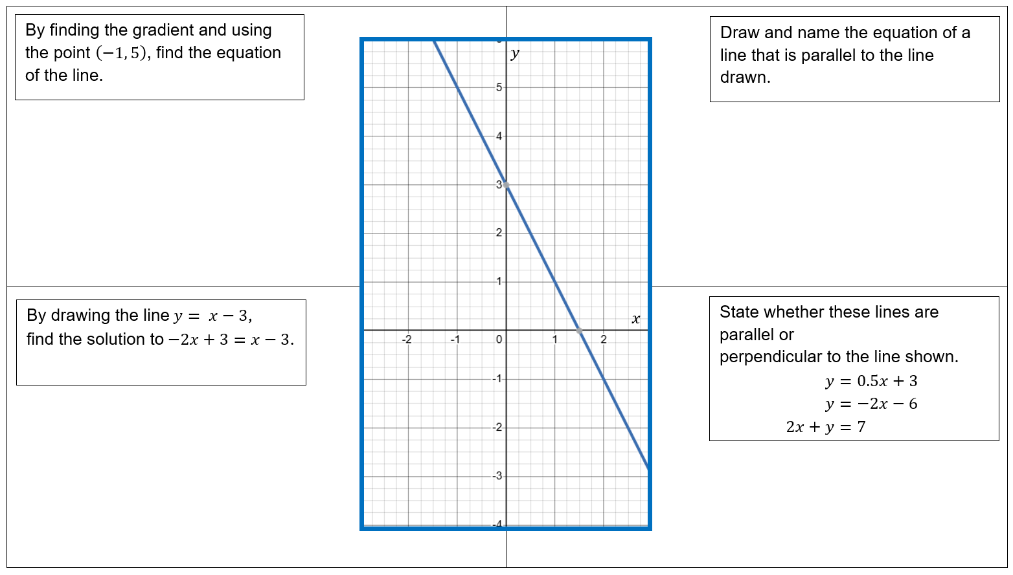

Appendix B

Variation Theory questions
- Find the $y$ value at $x=2$ for the curve $y=2x^{3}-4x^{2}$.
- Find the derivative of the curve $y=2x^{3}-4x^{2}$.
- Find the gradient of the tangent to the curve $y=2x^{3}-4x^{2}$at $x=2$.
- Find the equation of the tangent to the curve $y=2x^{3}-4x^{2}$ at $x=2$.
- Find the gradient of the normal to the curve $y=2x^{3}-4x^{2}$at $x=2$.
- Find the equation of the normal to the curve $y=2x^{3}-4x^{2}$at $x=2$.
- Find the $y$ value at $x=2$ for the curve $y=2x^{3}-4x^{2}+x.$
- Find the derivative of the curve $y=2x^{3}-4x^{2}+x$.
- Find the equation of the tangent to the curve $y=2x^{3}-4x^{2}+x$ at $x=2.$
- Find the equation of the normal to the curve $y=2x^{3}-4x^{2}+x$ at $x=2.$
- Find the equation of the tangent to the curve $y=2x^{3}-4x^{2}- 5x$ at $x=2.$
- Find the equation of the normal to the curve $y=2x^{3}-4x^{2}-5x$ at $x=2.$

Appendix C

Spot the error
Scenario 1 | Scenario 2
Find the equation of the tangent to $f\left(x\right)=x^{2}-5x$ at $x=3$. | Find the equation of the normal to the curve $f\left(x\right)=4x^{3}+2x$ at $x=\frac{1}{2}$.
$$f^{'}\left(x\right)=2x-5 \\ \text{Point when }x=3,y=2×3-5 \\ y=1 \\ y-y_{1}=m\left(x-x_{1}\right) \\ y-1=1\left(x-3\right) \\ y=x-2$$ | $$f^{'}\left(x\right)=12x^{2}+2 \\ m_{tangent}=12×{\left(\frac{1}{2}\right)}^{2}+2 \\ =5 \\ m_{normal}=\frac{1}{5} \\ when x=\frac{1}{2}y=4x^{3}+2x \\ y=4×{\left(\frac{1}{2}\right)}^{3}+2×\frac{1}{2} \\ y=\frac{3}{2} \\ ∴m=\frac{1}{5}at\left(\frac{1}{2},\frac{3}{2}\right) \\ y-y_{1}=m\left(x-x_{1}\right) \\ y-\frac{3}{2}=\frac{1}{5}\left(x-\frac{1}{2}\right) \\ y=x-2$$

Appendix D

Banner task
- A tangent to the curve $f\left(x\right)=x^{2}+2x$ has equation $y=4x-1$.
At what point on the curve does this tangent occur?
- The normal to the curve $f\left(x\right) = x^{2}$ has the equation $y=-\frac{1}{2}x+\frac{3}{2}$.
At what point does this normal touch the curve?
- A curve has equation $f\left(x\right)=x^{3}-3x^{2}+2$.The tangent at some point has gradient 0.
Find the coordinates of the point(s) where this occurs.
- For what values of $y=4x^{2}-6x$ is the normal vertical?
- Consider the curve defined by $y=x^{3}-4x^{2}+5x+4$.
Find the coordinates of the point(s) on the curve where the tangent is horizontal.
- Consider the curve $f\left(x\right)=x^{3}-6x^{2}+8x$.
Find the equation of the normal where the gradient of the tangent is $-1$.

Appendix E

HSC-style questions
- Find the equation of the tangent to the curve $y=3x^{4}-\frac{2}{\sqrt{x}}$ at the point $\left(1,1\right)$.
- Find the equation of the normal to the curve $y=\frac{x^{\frac{3}{2}}}{2}+\frac{x}{2}$ at the point $\left(4,6\right)$.

Sample solutions

Appendix A – same surface, different deep
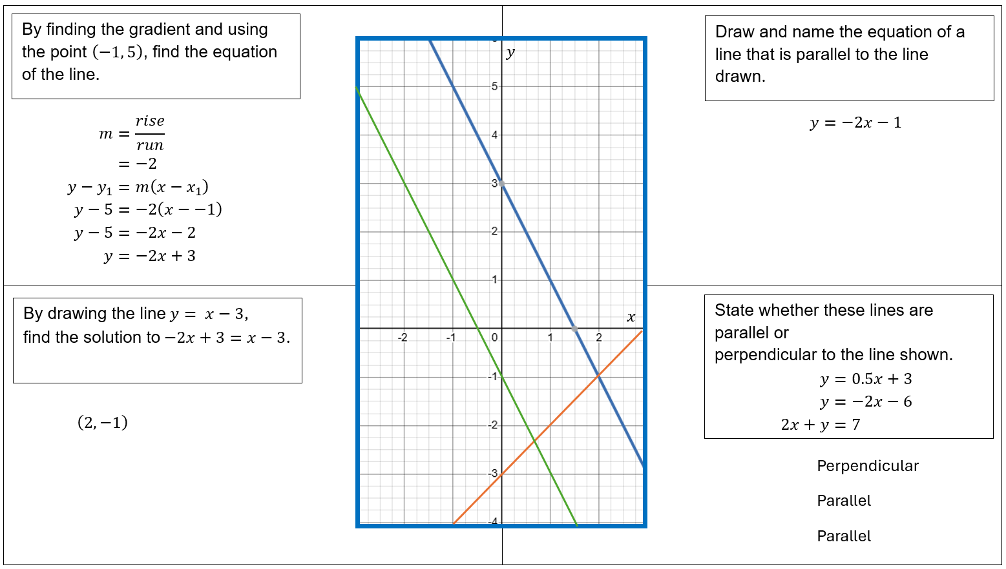

Appendix B – Variation Theory questions
- $y=2x^{3}-4x^{2}$
$$y=2×{\left(2\right)}^{3}-4{×\left(2\right)}^{2} \\ =16-16 \\ =0$$
- $\frac{dy}{dx}=6x^{2}-8x$
- Gradient of the tangent at $x=2$
$$m_{t}=6\left(2^{2}\right)-8×\left(2\right) \\ =24-16 \\ =8$$
- Equation of the tangent at $x=2$
$$y-0=8\left(x-2\right) \\ y=8x-16$$
- Gradient of the normal at $x=2$
$$m_{n}=-\frac{1}{m_{t}} \\ =-\frac{1}{8}$$
- Equation of the normal at $x=2$​
$$y-0=-\frac{1}{8}\left(x-2\right) \\ y=-\frac{1}{8}x+\frac{1}{4}$$
- $y=2x^{3}-4x^{2}+x$
$$y=2×\left(2^{3}\right)-4×\left(2^{2}\right)+2 \\ =16-16+2 \\ =2$$
- $\frac{dy}{dx}=6x^{2}-8x+1$
- Gradient of the tangent at $x=2$
$$m_{t}=6×\left(2^{2}\right)-8×\left(2\right)+1 \\ =24-16+1 \\ =9$$
Equation of the tangent at $x=2$
$$y-2=9\left(x-2\right) \\ y=9x-16$$
- Gradient of the normal at $x=2$
$$m_{n}=-\frac{1}{9}$$
Equation of the normal at $x=2$
$$y-2=-\frac{1}{9}\left(x-2\right) \\ y=-\frac{1}{9}x+\frac{20}{9}$$
- $y=2x^{3}-4x^{2}-5x$
$$y at x=2: \\ y=16-16-10 \\ =-10 \\ \frac{dy}{dx}=6x^{2}-8x-5$$
Gradient of the tangent at$x=2$$$m_{t}=6×\left(4\right)-8×\left(2\right)-5 \\ =24-16-5 \\ =3$$
Equation of the tangent at$x=2$$$y+10=3\left(x-2\right) \\ y=3x-16$$
- Gradient of the normal at $x=2$$$m_{n}=\frac{-1}{3}$$
Equation of the normal at $x=2$$$y+10=\frac{-1}{3}\left(x-2\right) \\ y=\frac{-1}{3}x-\frac{28}{3}$$

Appendix D – banner task
- $f\left(x\right)=x^{2}+2x$; given tangent $y=4x-1$
$f^{'}\left(x\right)=2x+2$
$$m=4 \\ ∴2x+2=4 \\ x=1 \\ y=f\left(1\right)=1+2 \\ =3 \\ ∴\left(1,3\right)$$
- $f\left(x\right)=x^{2}$; normal $y=-\frac{1}{2}x+\frac{3}{2}$
$\frac{dy}{dx}=2x∴m_{t}=2x$, $m_{n}=-\frac{1}{2}x$
since $m_{n}=-\frac{1}{2}$ $x=1,y=1$
- $f\left(x\right)=x^{3}-3x^{2}+2$
Horizontal tangent where $f^{'}\left(x\right)=0$$$f^{'}\left(x\right)=3x^{2}-6x \\ 0=3x\left(x-2\right) \\ x=0,2 \\ f\left(0\right)=2$$
$$f\left(2\right)=8-12+2=-2 \\ ∴\left(0,2\right) and \left(2,-2\right)$$
- $y=4x^{2}-6x$
$$\frac{dy}{dx}=0. \\ \frac{dy}{dx}=8x-6=0 \\ x=\frac{3}{4}$$
$$y=4{×\left(\frac{3}{4}\right)}^{2}-6×\left(\frac{3}{4}\right) \\ =\frac{9}{4}-\frac{9}{2} \\ =-\frac{9}{4} \\ =\left(\frac{3}{4},-\frac{9}{4}\right)$$
- $y=x^{3}-4x^{2}+5x+4$
$$\frac{dy}{dx}=3x^{2}-8x+5$$
$$\frac{dy}{dx}=3x^{2}-8x+5 =0$$
$$0=\left(3x-5\right)\left(x-1\right) \\ x=1, x=\frac{5}{3}$$
$$\left(1,6\right) \left(\frac{5}{3},\frac{158}{27}\right)$$
- $$m_{t}=-1 \\ m_{n}=1 \\ f\left(x\right)=x^{3}-6x^{2}+8x \\ f^{'}\left(x\right)=3x^{2}-12x+8 \\ f^{'}\left(x\right)=-1 \\ 3x^{2}-12x+8=-1 \\ 3x^{2}-12x+9=0 \\ \left(x-1\right)\left(x-3\right)=0 \\ x=1, x=3$$
$$When x=1, f\left(x\right)=1^{3}-6×1^{2}+8×1=3$$f$\left(x\right)=3^{3}-6×3^{2}+8×3$ $3$$$∴\left(1,3\right) and \left(3,-3\right) \\ -y_{1}=m\left(x-x_{1}\right) \\ y-3=1\left(x-1\right) \\ y=x+2 \\ y-y_{1}=m\left(x-x_{1}\right) \\ y+3=1\left(x-3\right) \\ y=x-6$$

Appendix E – HSC-style questions
- $y={3x}^{4}-2x^{-\frac{1}{2}}$
$$\frac{dy}{dx}=12x^{3}+x^{-\frac{3}{2}}$$
$$m=12x^{3}+x^{-\frac{3}{2}} \\ =12×{\left(1\right)}^{3}+{\left(1\right)}^{-\frac{3}{2}} \\ =13 \\ ∴m=13 at \left(1,1\right) \\ y-y_{1}=m\left(x-x_{1}\right) \\ y-1=13\left(x-1\right) \\ y=13x-12$$

$$y=\frac{x^{\frac{3}{2}}}{2}+\frac{x}{2} \\ \frac{dy}{dx}=\frac{3}{4}x^{\frac{1}{2}}+\frac{1}{2}$$
$$m=\frac{3}{4}×{\left(4\right)}^{\frac{1}{2}}+\frac{1}{2} \\ =2 \\ m_{n}=-\frac{1}{2} \\ ∴m=-\frac{1}{2}at\left(4,6\right) \\ y-y_{1}=m\left(x-x_{1}\right) \\ y-6=-\frac{1}{2}\left(x-4\right) \\ y-6=-\frac{x}{2}+2 \\ y=-\frac{x}{2}+8$$

References
This resource contains NSW and syllabus content. The NSW Curriculum is developed by the NSW Education Standards Authority (NESA). This content is prepared by NESA for and on behalf of the Crown in right of the State of New South Wales. The material is protected by Crown copyright.
Please refer to the NESA Copyright Disclaimer for more information https://www.nsw.gov.au/education-and-training/nesa/copyright.
NESA holds the only official and up-to-date versions of the NSW Curriculum and syllabus documents. Please visit NESA https://www.nsw.gov.au/education-and-training/nesa and NSW Curriculum https://curriculum.nsw.edu.au.
Mathematics Advanced 11–12 Syllabus © NSW Education Standards Authority (NESA) for and on behalf of the Crown in right of the State of New South Wales, 2024.

© State of New South Wales (Department of Education), 2026
The copyright material published in this resource is subject to the Copyright Act 1968 (Cth) and is owned by the NSW Department of Education or, where indicated, by a party other than the NSW Department of Education (third-party material).
Copyright material available in this resource and owned by the NSW Department of Education is licensed under a Creative Commons Attribution 4.0 International (CC BY 4.0) license.

This license allows you to share and adapt the material for any purpose, even commercially.
Attribution should be given to © State of New South Wales (Department of Education), 2026.
Material in this resource not available under a Creative Commons license:
- the NSW Department of Education logo, other logos and trademark-protected material
- material owned by a third party that has been reproduced with permission. You will need to obtain permission from the third party to reuse its material.
Links to third-party material and websites
Please note that the provided (reading/viewing material/list/links/texts) are a suggestion only and implies no endorsement, by the New South Wales Department of Education, of any author, publisher, or book title. School principals and teachers are best placed to assess the suitability of resources that would complement the curriculum and reflect the needs and interests of their students.
If you use the links provided in this document to access a third-party's website, you acknowledge that the terms of use, including licence terms set out on the third-party's website apply to the use which may be made of the materials on that third-party website or where permitted by the Copyright Act 1968 (Cth). The department accepts no responsibility for content on third-party websites.

