Parallel and perpendicular lines
Students deepen their understanding of the gradient of perpendicular lines and use this to find equations of lines a variety of ways.
Learning intentions and success criteria are shared during the ‘Connected learning’ section of this lesson.

Learning intention
- To be able to find the equation of a line that is parallel or perpendicular to a given line.

Success criteria
- I can find a gradient of a line parallel to another.
- I can find the gradient of a line perpendicular to another.
- I can justify why 2 lines are parallel or perpendicular.
- I can find the equation of a line parallel or perpendicular to a given line, using a point and gradient.

Outcomes
A student:
- develops understanding and fluency in mathematics through exploring and connecting mathematical concepts, choosing and applying mathematical techniques to solve problems, and communicating their thinking and reasoning coherently and clearly MAO-WM-01
- uses functions and relations to model, analyse and solve problems MAV-11-02

Content

Linear functions
- Find the equation of a line that is parallel or perpendicular to a given line
Mathematics Advanced 11–12 Syllabus © NSW Education Standards Authority (NESA) for and on behalf of the Crown in right of the State of New South Wales, 2024
Table 1: lesson summary
Section | Summary of activity | Teaching strategies | Teaching points
Retrieval practice | Using Appendix A, students identify whether the given information corresponds to a straight line and find the gradient if applicable. |  | Prompt students to find the gradient of colinear points to show they are linear.
Activating prior knowledge | Parallel lines are revisited using an Open Middle problem. Student use digits 0–9 (one digit repeated) and Appendix B to find 4 points that form a pair of parallel lines. They then repeat the activity without repeating digits. | Visibly random groups of 3  Vertical non-permanent surfaces  Gallery walk  Pose-Pause-Pounce-Bounce  Open Middle | Students learned that parallel lines have the same gradient in Stage 5.
Connecting learning | Students construct a line and find the midpoint using different coordinate pairs (Appendix C). They construct a perpendicular line and find the gradient. The Amplify Classroom (bit.ly/perpendicular_lines) confirms the relationship between the gradient. Students see the rule (slide 3–4) as if-then statements and make if-then statements for parallel lines. They practise finding gradients using slide 6–7. | Visibly random groups of 3  Vertical non-permanent surfaces  Gallery walk  Pose-Pause-Pounce-Bounce  Think-Pair-Share | Different pairs of points allow different pairs of gradients to be found, helping students recognise the change in sign and reciprocal gradient.
Releasing responsibility | Slides 9 and 10 focus on explicitly teaching how to find lines that are parallel to a given line. Students compare alternate methods using slide 11 before making notes. Students use Appendix D to write notes. | Worked example (Your turn)  Think-Pair-Share  Notes to future forgetful selves  Visibly random groups of 3  Vertical non-permanent surfaces | The point gradient formula and gradient intercept formula are used in comparison.
Independent practice | Students complete an Open Middle problem using slide 13. Students justify why the current Open Middle problem will not work for parallel lines. Students use Appendix E to combine parallel and perpendicular lines and geometric figures. | Visibly random groups of 3  Vertical non-permanent surfaces  Gallery walk  Think-Pair-Share  Open Middle | When the equation in general form is manipulated in the Open Middle problem to gradient intercept form, the gradient will become negative.

Activity structure
Please use the associated PowerPoint Parallel and perpendicular lines to display images in this lesson.
Parallel and perpendicular lines are studied in Stage 5 Linear relationships A Core outcome
MA5-LIN-C-01 and Linear relationships B Core outcome MA5-LIN-C-02. This lesson focuses on deepening students conceptual understanding of perpendicular lines. Finding the equation of the line using parallel and perpendicular lines will be revisited after students learn to differentiate, Lesson 2 – tangents and normals of Unit 6 – differentiation techniques and applications.

Retrieval practice
- Distribute Appendix A ‘Straight or not’ to pairs of students.
- Instruct students to work through each item and decide whether each equation or description represents a single straight line. Students should justify their decisions using their understanding of straight-line properties (for example, a constant gradient, lines in the form $y=mx+c,$ or collinear points).
- Have students find the gradient for the equations or descriptions that identify as a single straight line.
- Have each pair join with another pair to form a small group. Ask them to compare their responses. If there are any differences, students should explain and justify their reasoning to reach a shared understanding.

Activating prior knowledge
- Assign students to visibly random groups of 3 (bit.ly/visiblegroups) at vertical non-permanent surfaces (bit.ly/VNPSstrategy).
- Distribute an A3 sized printout of Appendix B ‘Cartesian plane’ in a plastic sleeve with adhesive putty.
- Direct groups to use the digits 0–9, at most once except for one digit which can be used twice. They are to create 4 points that will produce a pair of parallel lines. This task is adapted from an Open Middle problem (openmiddle.com/).
Possible solutions include $A\left(0,0\right), B\left(4,4\right), C\left(1,3\right), D\left(5,7\right)$or $A\left(0,0\right), B\left(4,2\right), C\left(2,1\right), D\left(6,3\right)$.
- Have groups use their points to find the gradient of each line.
- Allow groups time to do a gallery walk (bit.ly/DLSgallerywalk) observing the gradients of other groups and notice any relationship between the gradients of the pairs of parallel lines.
- Use the Pose-Pause-Pounce-Bounce questioning strategy (PDF 557 KB) (bit.ly/posepausepouncebounce) to make a connection between the gradients of parallel lines.
Students learned that parallel lines have equal gradients in Stage 5 Linear relationships A core outcome MA5-LIN-C-01.
- Direct groups to repeat step 3 from above but this time no digit can be used more than once. Have students confirm they are parallel by finding the gradients.
Possible solutions include $A\left(0,1\right), B\left(2,3\right), C\left(4,6\right), D\left(6,8\right)$or $A\left(9,0\right), B\left(7,2\right), C\left(6,5\right), D\left(8,3\right)$

Connecting learning
- Give each group of 3 a different pair of coordinates from Appendix C ‘Coordinate pairs’.
- Ask students to plot a line by marking their points on their Cartesian plane and drawing a straight line through both points. They are to label this Line 1.
- Have students calculate the gradient of Line 1 and label this gradient $m_{1}$.
- Have students find the midpoint of the 2 points and construct a line through the midpoint that is perpendicular to Line 1. Label this Line 2.
To make Line 2 perpendicular, students could either use a protractor, a pair of compasses or align it with a right-angled object, like the edge of a book or a ruler.
- Have students calculate the gradient of Line 2 and label this gradient $m_{2}$.
Students should leave the gradients of $m_{1}$ and $m_{2}$ in fraction form so they can observe the relationship between them more easily.
- Allow groups time to do a gallery walk observing other groups’ gradients and notice any relationship between the gradients of Line 1 and Line 2.
- Use the Pose-Pause-Pounce-Bounce questioning strategy to link the relationship between gradients of perpendicular lines.
Each pair of coordinates have different gradients giving a variety for students to observe. Students should observe that in each pair one gradient was positive and the other was negative, the fractions were reciprocals of each other, and the product of their gradients was −1.
- Bring the class back together and display the Amplify Classroom activity ‘Perpendicular lines’ (bit.ly/perpendicular_lines).
- Navigate to screen 2 of the activity and inform students that the 2 lines are perpendicular. Ask students to record the gradient of the 2 lines using $a$ and $b$.
The first line’s gradient is $\frac{a}{b}$ and the second line has a gradient $-\frac{b}{a}.$
- Outline the language used by telling students that we describe the second gradient as the negative reciprocal of the first.
- Display slide 3 of the PowerPoint to reveal 2 if-then statements linking the gradients of 2 perpendicular lines.
- In a Think-Pair-Share (bit.ly/thinkpairsharestrategy), have students discuss what an if-then statement is and if each works in this scenario.
- In another Think-Pair-Share, have students write 2 if-then statements for parallel lines. Use slide 4 to display the statements for students at the conclusion of the share.
- Reveal the learning intentions and success criteria for the lesson by displaying slide 5.
- Display slide 6 and have students complete the table by finding equations of lines that are parallel, perpendicular or an interesting neither for the given gradient. Slide 7 can be used to display sample answers.
The ‘interesting neither’ is to alert students to common misconceptions and mistakes regarding gradients of parallel and perpendicular lines.
Students could be challenged to find as many equations as they can.
- Invite students to share the different methods they know for finding the gradient. Use the Pose-Pause-Pounce-Bounce questioning technique to explore and discuss the various approaches together.
Students should recognise from previous lessons that they can find gradient using $\frac{∆rise}{∆run},\frac{y_{2}-y_{1}}{x_{2}-x_{1}}$, using first principles or by finding the gradient of a secant very close to the point.

Releasing responsibility
- Use slides 9–10 of the PowerPoint to model how to find the equation of a line perpendicular to a given equation through a given point using the Worked example (Your turn) ((bit.ly/supportingstrategies) method. Animate the slides to reveal self-explanation prompts and solutions.
- Display slide 11 modelling 2 correct but different solutions. Have students compare the 2 methods using a Think-Pair-Share.
The first method uses the point gradient formula to find the equation of the line whereas the second uses the gradient intercept formula. This activity aims to show students that either method is acceptable and will result in the same answer.
- Have students practise parallel and perpendicular line questions from an existing resource using equations presented in both gradient intercept form and general form.
- Assign students to new visibly random groups of 3 and ask them to complete Four quadrant notes to their future forgetful selves (bit.ly/supportingstrategies) from Appendix D ‘Four quadrant notes’ on a vertical non-permanent surface.

Independent practice
- Back in their random groups of 3 at vertical non-permanent surfaces, have students complete the Open Middle questions from slide 13. Students can reuse digits in this problem.
- Students should do a gallery walk to see other group’s solutions and check if they are correct.
2 perpendicular lines are$y=\frac{1}{3}x+7$ and $3x+y=5$.
- Still referencing the Open Middle problem from slide 13, in a Think- Pair-Share ask students to consider why finding 2 parallel lines is not possible.
When the equation in general form is manipulated to gradient intercept form, the gradient will become negative. The gradients therefore will have different signs and cannot be parallel.
- Distribute Appendix E ‘Shapes and gradients’ to students and have them complete the 4 questions.

Assessment and differentiation

Suggested opportunities for differentiation
Retrieval practice
- Students may need reminding of the different methods to find straight lines.
- This task can be simplified to contain only questions using the gradient intercept form or general form and ask students to find the gradient of each.
Activating prior knowledge
- Less ready students could be given one line and asked to find only 2 points that produce a second, parallel, line.
- Challenge students by asking them to find 3 parallel lines using 2 digits more than once.
Connecting learning
- Less ready students may focus primarily on identifying the relationship between the gradients of perpendicular lines, rather than working with if-then statements.
- Students can be extended to find the gradient using different methods.
Releasing responsibility
- The worked example could be modified so that the question are presented in general form.
- Students can be extended to find the gradient using different methods.
Independent practice
- Students may benefit from graphing the equations of the lines in Appendix E with or without digital tools.
- Students could be encouraged to find equations of lines that create geometric shapes.

Suggested opportunities for assessment
Retrieval practice
- Use students’ responses to assess their understanding of finding the gradients of straight lines presented in different forms.
Activating prior knowledge
- Monitor students’ responses to evaluate their understanding of the characteristics that define parallel lines.
- Assess students’ ability to justify and communicate their mathematical thinking by examining their explanations of why the lines are parallel.
Connecting learning
- Review completed tables from slide 6 of the PowerPoint to check students’ ability to find gradients of lines parallel and perpendicular to a given gradient.
- Use questioning during Pose-Pause-Pounce-Bounce to probe understanding of gradient relationships and conditional statements
Releasing responsibility
- Students’ Four quadrant notes could be used to assess their ability to find lines parallel or perpendicular to another line.
Independent practice
- Appendix E could be used to assess students’ ability to justify and reason using parallel and perpendicular lines gradients.

Appendix A

Straight or not
- $5x+y=10$
- $y=-3$
- The points $\left(2,5\right)$ and $(-1,-1)$
- $2y-3x=0$
- The points $\left(-2,4\right), \left(1, -1\right)$ and $\left(4, -6\right)$
- The point $(3,-2)$
- The point $(3,-2)$ and a constant change of $\frac{1}{2}$
- The points $\left(2, 4\right), \left(1,1\right)$ and $\left(0, -1\right)$
- $y=x^{2}-3$
- $y^{2}=x^{2}$
- $y+6=-2(x-3)$
- $\frac{1}{2}x+\frac{1}{2}y=1$
- $6x-8y+32=0$

Appendix B

Cartesian plane
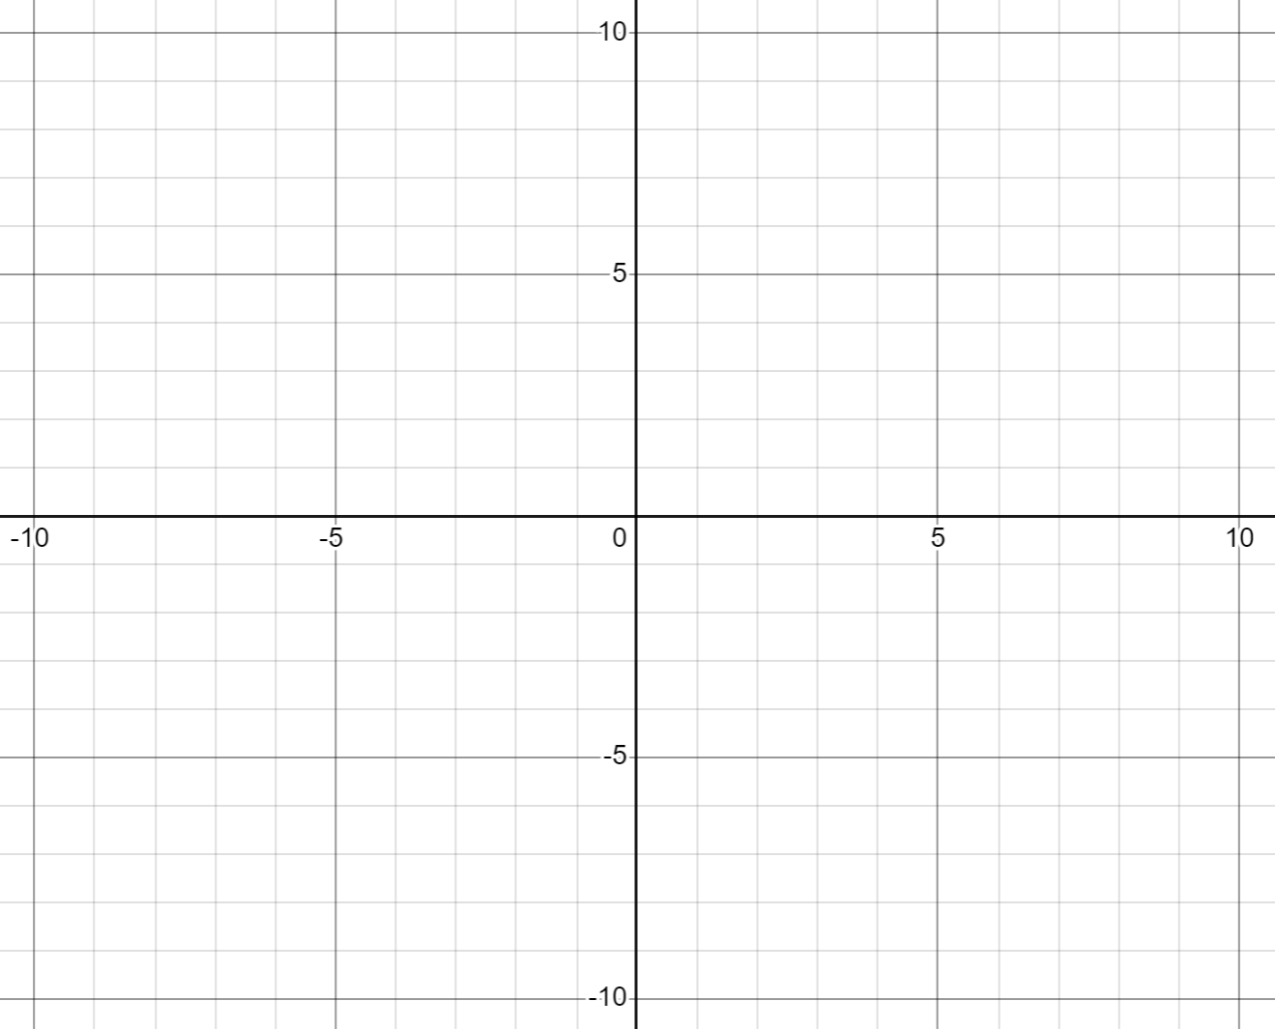

Appendix C

Coordinate pairs
Pair | Points | Midpoint | Gradient
A | $$\left(0,0\right)\left(6,2\right)$$
B | $$(2,2) (6,3)$$
C | $$(0,2) (10,4)$$
D | $$(0,0) (6,4)$$
E | $$(2,2) (6,6)$$
F | $$(0,2) (10,6)$$
G | $$(0,0) (6, -4)$$
H | $$(2,2) (6, 0)$$
I | $$(0,2) (10, -4)$$
J | $$(0,0) (6, -2)$$

Appendix D

Four quadrant notes
Example 1  Find the equation of the line perpendicular to $y=-\frac{2}{5}x-2$ and through the point $(3,6).$  $$m_{1}=-\frac{2}{5}∴m_{2}=□$$  $$y-y_{1}=m\left(x-x_{1}\right) \\ y-6=□\left(x-3\right)$$ | Example 2  Find the equation of the line perpendicular to $7x-4y=0$ and through the point $(3,6).$
Things to remember | Example 3

Appendix E

Shapes and gradients
These 3 lines create a triangle.  Justify why this triangle is a right-angled triangle.  $$3x-4y=0 \\ 4x+3y-12=0 \\ 7x-y-25=0$$ | These 4 lines create a quadrilateral.  Determine the type of quadrilateral and justify with relevant calculations.  $$2x-3y+3=0 \\ 2x-3y-15=0 \\ 3x+2y-14=0 \\ 3x+2y+2=0$$
Determine the shape formed by joining the points $A(-4,-3), B(-3,4), C(4,3), D(3,-4).$  Justify your answer. | These 4 lines intersect to form a trapezium. Find an equation that could represent the perpendicular height.  $$x-3y+6=0 \\ 4x+5y-5=0 \\ x+3y+6=0 \\ 4x+5y+15=0$$

Sample solutions

Appendix A – straight or not
- Straight line $m=-5$
- Straight line $m=0$
- Straight line $m=2$
- Straight line $m=\frac{3}{2}$
- Straight line $m=-\frac{5}{3}$
- Not a straight line
- Straight line $m=\frac{1}{2}$
- Not a straight line
- Not a straight line
- Not a straight line
- Straight line $m=-2$
- Straight line $m=-1$
- Straight line $m=\frac{3}{4}$

Appendix C – coordinate pairs
Pair | Points | Midpoint | Gradient
A | $$\left(0,0\right)\left(6,2\right)$$ | $$\left(3,1\right)$$ | $$m=\frac{1}{3}$$
B | $$(2,2) (6,3)$$ | $$(4,2.5)$$ | $$m=\frac{1}{4}$$
C | $$(0,2) (10,4)$$ | $$(5,3)$$ | $$m=\frac{1}{5}$$
D | $$(0,0) (6,4)$$ | $$(3,2)$$ | $$m=\frac{2}{3}$$
E | $$(2,2) (6,6)$$ | $$(4,4)$$ | $$m=1$$
F | $$(0,2) (10,6)$$ | $$(5,4)$$ | $$m=\frac{2}{5}$$
G | $$(0,0) (6, -4)$$ | $$(3, -2)$$ | $$m=-\frac{2}{3}$$
H | $$(2,2) (6, 0)$$ | $$(4,1)$$ | $$m=-\frac{1}{2}$$
I | $$(0,2) (10, -4)$$ | $$(5, -1)$$ | $$m=-\frac{3}{5}$$
J | $$(0,0) (6, -2)$$ | $$(3, -1)$$ | $$m=-\frac{1}{3}$$

Appendix D – Four quadrant notes
Example 1  Find the equation of the line perpendicular to $y=-\frac{2}{5}x-2$ and through the point $(3,6).$  $$m_{1}=-\frac{2}{5}∴m_{2}=\frac{5}{2}$$  $$y-y_{1}=m\left(x-x_{1}\right) \\ y-6=\frac{5}{2}\left(x-3\right) \\ 2y-12=5x-15 \\ 5x-2y-3=0$$ | Example 2  Find the equation of the line perpendicular to $7x-4y=0$ and through the point $(3,6).$  $$m_{1}=\frac{7}{4}∴m_{2}=-\frac{4}{7}$$  $$y-y_{1}=m\left(x-x_{1}\right) \\ y-6=-\frac{4}{7}\left(x-3\right) \\ 7y-42=-4x+12 \\ 4x+7y-54=0$$

Appendix E – shapes and gradient
These 3 lines create a triangle.  Justify why this triangle is a right-angled triangle.  $$3x-4y=0 \\ 4x+3y-12=0 \\ 7x-y-25=0$$ $m_{1}=\frac{3}{4}$ $m_{2}=-\frac{4}{3}$ $m_{3}=7$  Since $m_{1}×m_{2}=-1$ this is a right-angled triangle. | These 4 lines create a quadrilateral.  Determine the type of quadrilateral and justify with relevant calculations.  $$2x-3y+3=0 \\ 2x-3y-15=0 \\ 3x+2y-14=0 \\ 3x+2y+2=0$$  $m_{1}=\frac{2}{3}$ $m_{2}=\frac{2}{3}$ $m_{3}=-\frac{3}{2}$ $m_{4}=-\frac{3}{2}$  There are 2 pairs of parallel and 2 pairs of perpendicular lines, therefore this is a rectangle.
Determine the shape formed by joining the points $A(-4,-3), B(-3,4), C(4,3), D(3,-4).$  Justify your answer.  $m_{AC}=\frac{3}{4}$ $m_{BD}=-\frac{4}{3}$  Since $m_{AC}×m_{BD}=-1$ ABCD must form a kite or rhombus.  The size of each side is equal, making this a rhombus. | These 4 lines intersect to form a trapezium. Find an equation that could represent the perpendicular height.  $$x-3y+6=0 \\ 4x+5y-5=0 \\ x+3y+6=0 \\ 4x+5y+15=0$$  The 2 parallel sides $m=-\frac{4}{5}$. The gradient of the perpendicular height must be $m=\frac{5}{4}$.  $∴y=\frac{5}{4}x$ is an equation of the perpendicular height.

References
This resource contains NSW Curriculum and syllabus content. The NSW Curriculum is developed by the NSW Education Standards Authority. This content is prepared by NESA for and on behalf of the Crown in right of the State of New South Wales. The material is protected by Crown copyright.
Please refer to the NESA Copyright Disclaimer for more information https://educationstandards.nsw.edu.au/wps/portal/nesa/mini-footer/copyright.
NESA holds the only official and up-to-date versions of the NSW Curriculum and syllabus documents. Please visit the NSW Education Standards Authority (NESA) website https://educationstandards.nsw.edu.au/ and the NSW Curriculum website https://curriculum.nsw.edu.au/.
Mathematics Advanced 11–12 Syllabus © NSW Education Standards Authority (NESA) for and on behalf of the Crown in right of the State of New South Wales, 2024.

© State of New South Wales (Department of Education), 2025
The copyright material published in this resource is subject to the Copyright Act 1968 (Cth) and is owned by the NSW Department of Education or, where indicated, by a party other than the NSW Department of Education (third-party material).
Copyright material available in this resource and owned by the NSW Department of Education is licensed under a Creative Commons Attribution 4.0 International (CC BY 4.0) license.

This license allows you to share and adapt the material for any purpose, even commercially.
Attribution should be given to © State of New South Wales (Department of Education), 2025.
Material in this resource not available under a Creative Commons license:
- the NSW Department of Education logo, other logos and trademark-protected material
- material owned by a third party that has been reproduced with permission. You will need to obtain permission from the third party to reuse its material.
Links to third-party material and websites
Please note that the provided (reading/viewing material/list/links/texts) are a suggestion only and implies no endorsement, by the New South Wales Department of Education, of any author, publisher, or book title. School principals and teachers are best placed to assess the suitability of resources that would complement the curriculum and reflect the needs and interests of their students.
If you use the links provided in this document to access a third-party's website, you acknowledge that the terms of use, including licence terms set out on the third-party's website apply to the use which may be made of the materials on that third-party website or where permitted by the Copyright Act 1968 (Cth). The department accepts no responsibility for content on third-party websites.

