Algebraic fractions
Students build on their knowledge of algebraic fractions from Stage 5. They look at different ways to calculate algebraic fraction calculations and progress into having algebraic terms on the numerator.

Learning intention
- To be able to solve problems involving algebraic fractions.

Success criteria
- I can add and subtract algebraic fractions.
- I can multiply and divide algebraic fractions.

Outcomes
A student:
- develops understanding and fluency in mathematics through exploring and connecting mathematical concepts, choosing and applying mathematical techniques to solve problems, and communicating their thinking and reasoning coherently and clearly MAO-WM-01
- applies algebraic techniques and the laws of indices and surds to manipulate expressions and solve problems MAV-11-01

Content

Algebraic techniques
- Expand, factorise and simplify algebraic expressions
- Simplify expressions involving algebraic fractions
Mathematics Advanced 11–12 Syllabus © NSW Education Standards Authority (NESA) for and on behalf of the Crown in right of the State of New South Wales, 2024
Table 1: lesson summary
Section | Summary of activity | Teaching strategies | Teaching points
Retrieval practice | Students complete the ‘And another …’ activity to review equivalent fractions by asking students to write a fraction or expression equivalent to one-third and then extending that to include algebraic terms and then fraction or expression equivalent to $\frac{a}{3}$. Students then complete Appendix A to revisit factorising quadratics. | Mini whiteboards  And another …  Class discussion | Students are revising fraction and algebraic skills needed for the lesson.
Activating prior knowledge | Students work in pairs on a problem from slide 4 of the PowerPoint Algebraic fractions, comparing methods and solutions. Using the speed dating strategy and class discussion, they review and formalise their understanding with support from slide 5. | Same Surface, Different Deep  Speed dating  Class discussion | Students are revising fraction calculations needed for the lesson.
Connecting learning | Students use Appendix B to compare algebraic calculation methods, also shown on slides 7–9. After a Think-Pair-Share, they write notes explaining the key idea behind each method. | Compare and discuss  Pose-Pause-Pounce-Bounce  Notes for future forgetful selves | Students look at different methods to perform algebraic calculations, looking at benefits and disadvantages of each.
Releasing responsibility | Use slides 11–14 to model algebraic fractions. Students complete a scavenger hunt using Appendix C, then solve area and perimeter problems using Appendix D. | Worked example (Your turn)  Scavenger hunt  Visibly random groups of 3 | Students extend their knowledge of algebraic fractions to include ones with pronumerals on the bottom and the apply those skills.
Independent practice | Students solve problems from Appendix E, then conduct a class discussion on their reasoning. Students then explore a division shortcut shown on slide 16, and understanding is checked using the exit ticket from Appendix F. | Visibly random groups of 3  Vertical non-permanent surfaces  Exit ticket

Activity structure
Please use the associated PowerPoint Algebraic fractions to display images in this lesson.

Retrieval practice
- Issue students with a mini whiteboard (bit.ly/miniwhiteboards).
- Engage the class in ‘And another …’ activity (bit.ly/and_another_strategy) using the following prompts to review simplifying fractions. Give me an example of:
- a fraction or expression equivalent to one-third … and another … and another
- a fraction or expression equivalent to one-third that involves algebraic terms … and another … and another
- a fraction or expression equivalent to $\frac{a}{3}$ … and another … and another.
- Lead a class discussion after each point and share the whiteboard displays to revise understanding of equivalent fractions and simplifying fractions.
- Group students into pairs. Distribute Appendix A ‘Product problems’ to each pair. Using mini whiteboards, have students work through the algebraic product puzzles to review factorising quadratic expressions.

Activating prior knowledge
- Display slide 4 of the PowerPoint showing an example of a Same Surface, Different Deep (bit.ly/S_S_D_D) problem.
- Continuing in pairs, have students work through the questions before comparing their solutions and the different methods used in a class discussion.
Solutions are $\frac{3a}{4}×\frac{2a}{5}=\frac{3a^{2}}{10}$, $\frac{3a}{4}÷\frac{2a}{5}=\frac{15}{8}$, $\frac{3a}{4}+\frac{2a}{5}=\frac{23a}{20}$, $\frac{3a}{4}-\frac{2a}{5}=\frac{7a}{20}$.
- Display slide 5 for the class to review.
- Use the speed dating strategy (bit.ly/strategyspeed) for students to discuss the solution.
$$\frac{5a}{6}<a$$
- Conduct a class discussion to formalise students’ solutions.

Connecting learning
- Distribute Appendix B ‘Compare the pair’ (compareanddiscuss.com/about) to each pair and have them review the connections between each method. The comparisons are shown on slides 7–9 for teacher reference if needed.
- After reviewing each solution set, use the Pose-Pause-Pounce-Bounce questioning strategy (PDF 557 KB) (bit.ly/posepausepouncebounce) for students to share which method they would use and why.
- Students create notes to their future forgetful selves (bit.ly/notestofutureself) on algebraic fractions.

Releasing responsibility
- Use slides 11–14 from the PowerPoint to model worked examples of algebraic fractions using the Worked examples (Your turn) method (bit.ly/supportingstrategies).
- Assign students to visibly random groups of 3 (bit.ly/visiblegroups) to complete the scavenger hunt task from Appendix C ‘Scavenger hunt’.
Print one set of question cards, separate each card (cutting along the bold lines), and place the cards around the room. A vertical non-permanent surface could be useful at each card to assist the groups with their calculations.
Each group should start at one of the cards. Students work in groups of 3 to solve the problem.
Once a group of 3 has solved the problem, they need to move around the room to find the solution on another card. Once they have found their solution, they should solve the question attached to the solution and repeat the process.
The activity is finished once the pair returns to their original card.
Cards are printed in order so the solution to one question is the answer number on the next card.
- Continuing in groups of 3 at vertical non-permanent surfaces (bit.ly/VNPSstrategy), issue each group a copy of Appendix D ‘Area and perimeter questions’, where they will work to solve area and perimeter problems with algebraic fractions.
Some students may benefit from completing practice questions from an existing resource to consolidate their learning.

Independent practice
- Distribute Appendix E ‘Questions’ to each group of 3. Have groups split their vertical working space into 4 areas to solve the problems, leaving their solutions on the board.
- Lead a class discussion about the solutions to each problem, focusing on the students' reasoning for each solution.
- Display slide 16 showing a shortcut consideration for division of fractions. In pairs, discuss and prove the relationship. $\frac{\frac{a}{b}}{\frac{c}{d}}=\frac{a×d}{b×c}$.
- Check for understanding by using the exit ticket (bit.ly/exitticketstrategy) in Appendix F ‘Exit ticket – HSC-style question’.

Assessment and differentiation

Suggested opportunities for differentiation
Retrieval practice
- Work with targeted pairs whilst completing Appendix A, modelling an example before the students continue independently.
- Challenge students to create more complex algebraic equivalents, for example, $\frac{6x^{2}}{18x}$, and justify why they are equivalent.
- Ask students to design their own ‘Product problem’ puzzles to swap with another pair.
- Encourage connections between simplifying fractions and simplifying rational expressions.
Activating prior knowledge
- Provide worked examples for each operation with fractions as a reference scaffold.
- Ask students to create their own Same Surface, Different Deep problems and swap them with another pair.
- Rotate partners strategically during ‘speed dating’ so that all students encounter a mix of ability levels and explanations.
Connecting learning
- Provide a partially scaffolded comparison template, a table with columns: Method A steps, Method B steps, What’s the same, What’s different.
- Pair less confident students with peers who can verbalise reasoning clearly.
- Challenge students to identify contexts in which each method would be most efficient (for example, factorising versus expanding).
Releasing responsibility
- During the scavenger hunt, allow some groups a ‘hint card’ with worked examples to reference.
- Challenge stronger students to create an additional scavenger hunt card or write a ‘trick’ question that incorporates a common misconception.
- Encourage high-achieving groups to generalise their strategies (for example, explaining when and why common denominators are needed versus when they are not).
- Challenge confident students to create and solve their own area/perimeter problem involving algebraic fractions.
Independent practice
- Provide step-by-step scaffolds (worked examples with missing steps to fill in).
- Allow the use of algebra tiles or visual models for students who benefit from concrete representations.
- Pair less confident students with supportive peers for guided collaboration.
- Encourage generalisation: ‘What would happen if we divided 3 fractions in sequence?’

Suggested opportunities for assessment
Retrieval practice
- Formatively assess students as they contribute during the ‘And another’ activity.
- Monitor how pairs approach the factorising puzzles; note whether they rely on procedural recall or demonstrate conceptual understanding.
Activating prior knowledge
- Circulate while students attempt operations with algebraic fractions. Check carefully that the correct operation is being applied (multiplication, division, addition or subtraction).
- Use targeted questioning to expose misconceptions (for example, students confusing the rules for adding/subtracting with multiplying/dividing fractions).
- Listen to group discussions. Assess whether students can:
- justify their chosen method
- explain why different operations require different approaches
- challenge or support a peer’s explanation.
Connecting learning
- Circulate and listen for students’ ability to articulate the similarities and differences between the methods being compared.
- Use probing questions to deepen thinking (for example, ‘What makes Method A more efficient here?’ or ‘What are the risks of using Method B?’).
- Record evidence of reasoning, noting whether students justify their method choice in terms of efficiency, clarity and generalisability.
Releasing responsibility
- During the ‘Your turn’ phase, use questioning to check that students can apply the modelled process without additional prompts.
- Watch for recurring misconceptions (for example, missing the lowest common denominator, errors when simplifying).
- Review the solutions left on boards for process clarity as well as accuracy.
- Observe group collaboration for evidence that students can justify and refine their methods through peer discussion.
- In the scavenger hunt, use spot checks by asking a student in each group to explain the reasoning behind their most recent solution.
Independent practice
- Collect individual exit tickets and assess whether each student has grasped the key concepts independently.
- Use questioning to probe conceptual understanding of the shortcut: check that students can explain why $\frac{\frac{a}{b}}{\frac{c}{d}}=\frac{a×d}{b×c}$, rather than simply applying the rule mechanically.

Appendix A

Product problems
Complete the product problem by entering the factors into the table.

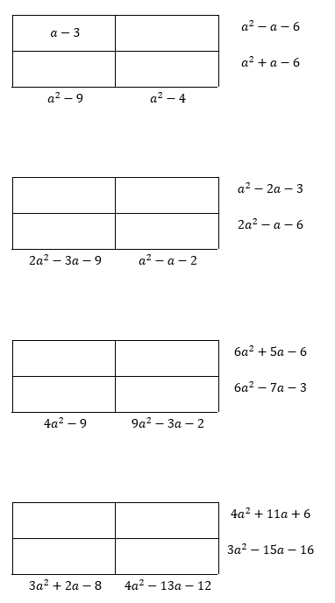
Appendix B

Compare the pair
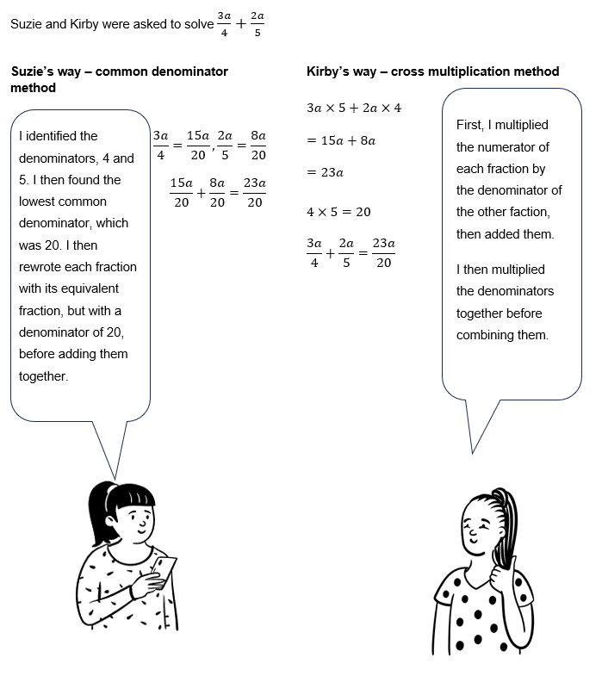
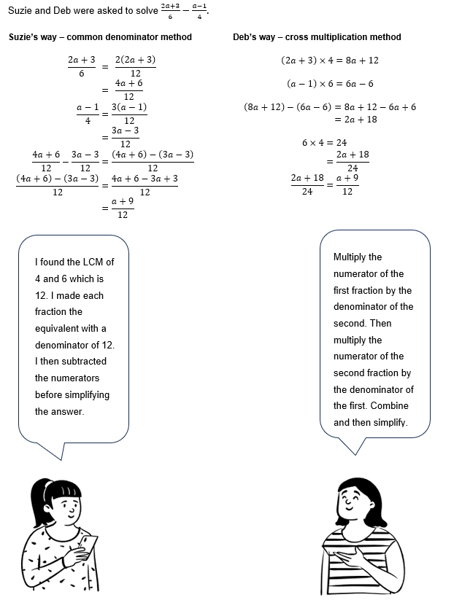
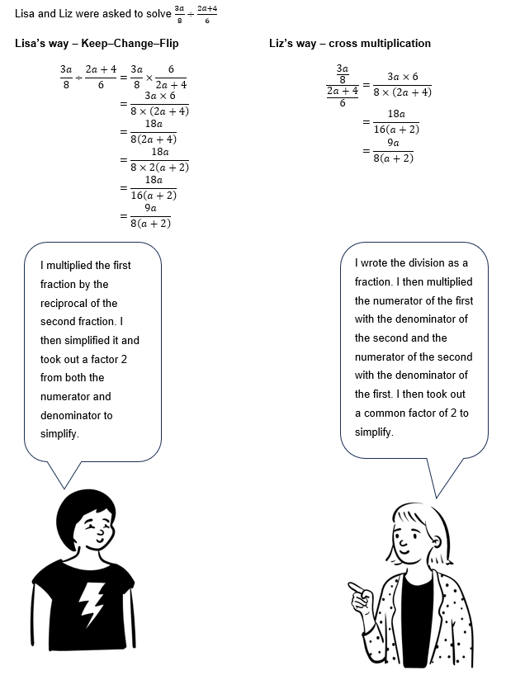


Answer:
$$\frac{5x^{2}+2x+3}{\left(x+1\right)\left(x-1\right)}$$
Question:

Simplify

$$\frac{x^{2}-5x+6}{x^{2}-4}$$

Answer:
$$\frac{x-3}{x+2}$$
Question:

Simplify
$$\frac{3}{x}+\frac{5}{x}$$

Appendix C

Scavenger hunt

Answer:  $$\frac{8}{x}$$ | Answer:  $$\frac{x+4}{4}$$
Question:  Simplify  $$\frac{x^{2}-16}{x^{2}-4x}$$ | Question:  Simplify  $$\frac{x^{2}-9}{x+3}×\frac{x+1}{x-1}$$
Answer:  $$\frac{\left(x-3\right)\left(x+1\right)}{x-1}$$ | Answer:  $$\frac{3x\left(2x-3\right)}{3x}$$
Question:  Simplify  $$\frac{{6x}^{2}-9x}{3x}$$ | Question:  Simplify  $$\frac{2}{x-1}+\frac{4}{x+2}$$
Answer:  $$\frac{6x}{\left(x-1\right)\left(x+2\right)}$$ | Answer:  $$\frac{3}{2}$$
Question:  Simplify  $$\frac{2x}{3}×\frac{9}{4x}$$ | Question:  Simplify  $$\frac{x^{3}-8}{x^{2}-4x+4}$$
Answer:  $$\frac{x^{2}+2x+4}{x-2}$$ | Answer:  $$\frac{x^{2}-4x+6}{\left(x-2\right)\left(x-1\right)}$$
Question:  Simplify  $$\frac{x}{x-2}-\frac{3}{x-1}$$ | Question:  Simplify  $$\frac{2x}{x+1}+\frac{x+3}{x-1}$$
Answer:  $$\frac{{3x}^{2}+2x+3}{\left(x+1\right)\left(x-1\right)}$$ | Answer:  $$x-2$$
Question:  Simplify  $$\frac{x^{2}-4}{x-2}÷\frac{x+2}{x-2}$$ | Question:  Simplify  $$\frac{x^{2}-x-6}{x+2}×\frac{x+3}{x-2}$$
Answer:  $$\frac{\left(x-3\right)\left(x+3\right)}{x-2}$$ | Answer:  $$\frac{x^{2}+9x-2}{\left(x+2\right)\left(x+3\right)}$$
Question:  Simplify  $$\frac{2x}{x+2}-\frac{x-1}{x+3}$$ | Question:  Simplify  $$\frac{3x+2}{x-1}+\frac{2x-1}{x+1}$$

Appendix D

Area and perimeter questions
- The length of a rectangle is $\frac{3x}{2}$ cm and the width is $\frac{x+2}{3}$ cm.
- Write an expression for the perimeter of the rectangle.
- Write an expression for the area of the rectangle.
- A triangle has base $\frac{4x}{x+1}$ cm and height $\frac{h=3x+2}{2}$ cm.
- Write an expression for the area of the triangle.
- Simplify the expression as much as possible.
- A rectangle has length $L=\frac{2x^{2}+3x}{x+1}$ m and width $W=\frac{x+4}{2}$ m.
- Find the perimeter of the rectangle as a single simplified algebraic fraction.
- Find the area as a simplified fraction.
- A composite shape is made of a square of side $\frac{2x+1}{x-1}$ m and a rectangle attached with a width $\frac{x+3}{x-1}$ m and length $x$ m.
- Find an expression for the total area of the shape.
- Express the total perimeter in simplest form.
- A circle has radius $r=\frac{3x}{x+2}$ cm.
- Express the circumference in terms of $π$ and simplify.
- Express the area in terms of $π$ and simplify.

Appendix E

Questions
- For what values of $b$ is $\frac{2b}{5}-\frac{b}{3}>1?$
- Brendan says it does not matter what value we choose for $c$ in the expression $\frac{3c}{4}÷\frac{9c}{2}$. Is he correct? Give reasons for your answer.
- Dave says that the inequality $\frac{3d}{4}+\frac{d}{2}>d$ is true for all values of d. Fiona says that it is only true for positive values of $d$. Miriam says that it is only true for positive integer values of $d$. Who do you agree with? Mathematically justify your answer.
- For what values of $e$ will this statement be correct? $\frac{4e^{2}-9}{2e-3}=2e+3$. Give reasons for your answer.

Appendix F

Exit ticket – HSC-style question
A chemist is preparing 2 solutions:
- Solution A has a concentration of $\frac{3x+4}{x}$ grams per litre.
- Solution B has a concentration of $\frac{2x-1}{x+1}$ grams per litre.
The chemist mixes 1 litre of each solution.
- Express the total concentration of the mixtures as a single simplified algebraic fraction.
- If the total concentration is exactly 5 grams per litre, solve for $x$.
- For what values can $x$ not exist?

Sample solutions

Appendix A – product problems
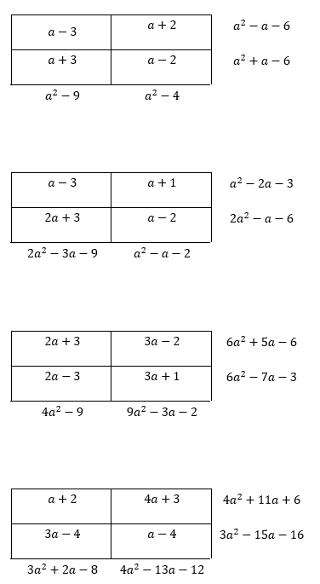

Appendix D – questions
- Solve $\frac{2b}{5}-\frac{b}{3}>1$  $$\frac{2b}{5}-\frac{b}{3}=\frac{6b-5b}{15} \\ =\frac{b}{15}>1⇒b>15$$ | - Brendan on $\frac{3c}{4}÷\frac{9c}{2}$  $$\frac{3c}{4}÷\frac{9c}{2}=\frac{3c}{4}×\frac{2}{9c} \\ =\frac{6c}{36c} \\ =\frac{1}{6} provided c≠0.$$  If $c=0$, the original expression is $0÷0$, which is undefined.  Conclusion: Brendan is not fully correct—for all $c≠0$ the value is $\frac{1}{6}$, but it’s undefined at $c=0$.
- Who’s right about $\frac{3d}{4}+\frac{d}{2}>d$?  $$\frac{3d}{4}+\frac{d}{2}=\frac{3d}{4}+\frac{2d}{4} \\ =\frac{5d}{4}$$  Inequality: $\frac{5d}{4}>d ⇔ \frac{5d}{4}-d=\frac{d}{4}>0 d>0$.  True for $d>0$; false for $d=0$ and for $d<0$.  Fiona is correct: it holds only for positive values of $d$. | - Values of e for which  $\frac{4e^{2}-9}{2e-3}=2e+3$ is correct.  Factor the numerator: $4e^{2}-9=\left(2e-3\right)\left(2e+3\right)$  If $2e-3≠0\left(i.e.,e≠\frac{3}{2}​\right),$  $\frac{\left(2e-3\right)\left(2e+3\right)}{2e-3}=2e+3$.  At $e=\frac{3}{2}$ the left side is undefined.  Answer: true for all real $e≠\frac{3}{2}$​.

Appendix E – area and perimeter questions
Length: $L=\frac{3x}{2}$, Width: $W=\frac{x+2}{3}$  Perimeter:  $$P=2\left(L+W\right) \\ =2\left(\frac{3x}{2}+\frac{x+2}{3}\right) \\ =2\left(\frac{9x+2\left(x+2\right)}{6}\right) \\ =2\left(\frac{9x+2x+4}{6}\right) \\ =2\left(\frac{11x+4}{6}\right) \\ =\frac{22x+8}{6} \\ =\frac{11x+4}{3}$$  Area:  $$A=L×W \\ =\frac{3x}{2}×\frac{x+2}{3} \\ =\frac{3x\left(x+2\right)}{6} \\ =\frac{x\left(x+2\right)}{2}$$ | Base: $b=\frac{4x}{x+1},$ Height: $h=\frac{3x+2}{2}$  Area:  $$A=\frac{1}{2}bh \\ =\frac{1}{2}×\frac{4x}{x+1}×\frac{3x+2}{2} \\ =\frac{4x\left(3x+2\right)}{4\left(x+1\right)} \\ =\frac{x\left(3x+2\right)}{x+1}$$  Domain restriction: $x≠-1$
- Length: $L=\frac{2x^{2}+3x}{x+1}$, Width: $W=\frac{x+4}{2}$  Perimeter:  $$P=2\left(L+W\right) \\ =2\left(\frac{2x^{2}+3x}{x+1}+\frac{x+4}{2}\right) \\ =2\left(\frac{2\left(2x^{2}+3x\right)+\left(x+1\right)\left(x+4\right)}{2\left(x+1\right)}\right) \\ =2\left(\frac{4x^{2}2+6x+x^{2}+5x+4}{2\left(x+1\right)}\right) \\ =2×\frac{5x2+11x+4}{2\left(x+1\right)} \\ =\frac{5x^{2}+11x+4}{x+1}$$  Area:  $$A=L×W \\ =\frac{2x^{2}+3x}{x+1}×\frac{x+4}{2} \\ =\frac{\left(2x^{2}+3x\right)\left(x+4\right)}{2\left(x+1\right)} \\ =\frac{2x^{3}+8x^{2}+3x^{2}+12x}{2\left(x+1\right)} \\ =\frac{2x^{3}+11x^{2}+12x}{2\left(x+1\right)} \\ =\frac{x\left(2x^{2}+11x+12\right)}{2\left(x+1\right)}​$$  Domain restriction: $x≠-1$ | - Square side: $s=\frac{2x+1}{x-1}$  Rectangle width: $w = \frac{x+3}{x-1}​ ,$length: $L=x$  Total area:  $$A_{\text{total}}=s^{2}+w×L \\ ={\left(\frac{2x+1}{x-1}\right)}^{2}+x×\frac{x+3}{x-1} \\ =\frac{{\left(2x+1\right)}^{2}}{{\left(x-1\right)}^{2}}+\frac{x\left(x+3\right)}{x-1} \\ A=\frac{{\left(2x+1\right)}^{2}+x\left(x+3\right)\left(x-1\right)}{{\left(x-1\right)}^{2}} \\ =\frac{4x^{2}+4x+1+\left(x^{2}+2x-3\right)x}{{\left(x-1\right)}^{2}} \\ =\frac{4x^{2}+4x+1+x^{3}+2x^{2}-3x}{{\left(x-1\right)}^{2}} \\ =\frac{x^{3}+6x^{2}+x+1}{{\left(x-1\right)}^{2}}​$$  Perimeter:  $P=4s+2L+2w$− (subtract overlapping sides)  (This can be adjusted per diagram, assuming shared side counted once.)  Domain restriction: $x≠1$
Radius: $r=\frac{3x}{x+2}$
Circumference:
$$C=2πr=2π×\frac{3x}{x+2}=\frac{6πx}{x+2}$$
Area:
$$A=πr^{2} \\ =π{\left(\frac{3x}{x+2}\right)}^{2} \\ =π\frac{9x^{2}}{{\left(x+2\right)}^{2}} \\ =\frac{9πx^{2}}{{\left(x+2\right)}^{2}}$$
Domain restriction: $x≠-2$

Appendix F – exit ticket – HSC-style question
Given:  $$\text{Solution A: }\frac{3x+4}{x}, \text{Solution B: }\frac{2x-1}{x+1}, x≠0,-1$$  - Total concentration as a single fraction  Add the 2 fractions:  $$\frac{3x+4}{x}+\frac{2x-1}{x+1}=\frac{\left(3x+4\right)\left(x+1\right)+\left(2x-1\right)\left(x\right)}{x\left(x+1\right)}​$$  Expand numerators:  $$\left(3x+4\right)\left(x+1\right)=3x^{2}+3x+4x+4=3x^{2}+7x+4$$  $$\left(2x-1\right)\left(x\right)=2x^{2}-x$$  Add them:  $$3x^{2}+7x+4+2x^{2}-x=5x^{2}+6x+4$$  So, the total concentration:  $$\frac{5x^{2}+6x+4}{x\left(x+1\right)}​​$$  Domain restriction: $x≠0,-1$ | - Solve for total concentration = 5  Set the fraction equal to 5:  $$\frac{5x^{2}+6x+4}{x\left(x+1\right)}=5$$  Multiply both sides by $x\left(x+1\right):$  $$5x^{2}+6x+4=5x\left(x+1\right)=5x^{2}+5x$$  Subtract $5x^{2} + 5x$ from both sides:  $$\left(5x^{2}+6x+4\right)-\left(5x^{2}+5x\right)=0⟹x+4=0$$  Check restrictions: $x≠0,-1, so x=-4$ is valid.
- Domain restrictions  From denominators:  $$x≠0,x≠-1$$ | Answer  - $\frac{5x^{2}+6x+4}{x\left(x+1\right)}$  - $x=-4$  - $x≠0,-1$

References
This resource contains NSW Curriculum and syllabus content. The NSW Curriculum is developed by the NSW Education Standards Authority. This content is prepared by NESA for and on behalf of the Crown in right of the State of New South Wales. The material is protected by Crown copyright.
Please refer to the NESA Copyright Disclaimer for more information https://educationstandards.nsw.edu.au/wps/portal/nesa/mini-footer/copyright.
NESA holds the only official and up-to-date versions of the NSW Curriculum and syllabus documents. Please visit the NSW Education Standards Authority (NESA) website https://educationstandards.nsw.edu.au/ and the NSW Curriculum website https://curriculum.nsw.edu.au/.
Mathematics Advanced 11–12 Syllabus © NSW Education Standards Authority (NESA) for and on behalf of the Crown in right of the State of New South Wales, 2024.

© State of New South Wales (Department of Education), 2025
The copyright material published in this resource is subject to the Copyright Act 1968 (Cth) and is owned by the NSW Department of Education or, where indicated, by a party other than the NSW Department of Education (third-party material).
Copyright material available in this resource and owned by the NSW Department of Education is licensed under a Creative Commons Attribution 4.0 International (CC BY 4.0) license.

This license allows you to share and adapt the material for any purpose, even commercially.
Attribution should be given to © State of New South Wales (Department of Education), 2025.
Material in this resource not available under a Creative Commons license:
- the NSW Department of Education logo, other logos and trademark-protected material
- material owned by a third party that has been reproduced with permission. You will need to obtain permission from the third party to reuse its material.
Links to third-party material and websites
Please note that the provided (reading/viewing material/list/links/texts) are a suggestion only and implies no endorsement, by the New South Wales Department of Education, of any author, publisher, or book title. School principals and teachers are best placed to assess the suitability of resources that would complement the curriculum and reflect the needs and interests of their students.
If you use the links provided in this document to access a third-party's website, you acknowledge that the terms of use, including licence terms set out on the third-party's website apply to the use which may be made of the materials on that third-party website or where permitted by the Copyright Act 1968 (Cth). The department accepts no responsibility for content on third-party websites.

