Negative and fractional indices
Students develop rules for the relationships with negative indices and fractional indices by building on their pre-existing knowledge of index laws before applying the index laws to problem-solving questions.

Learning intentions
- To be able to simplify algebraic expressions using index laws.
- To be able to solve problems involving index notation.

Success criteria
- I can write algebraic expressions using index notation.
- I can rewrite expressions in expanded form (without index notation).
- I can apply index laws to simplify expressions using index notation.
- I can apply index laws when simplifying expressions written in function notation.

Outcomes
A student:
- develops understanding and fluency in mathematics through exploring and connecting mathematical concepts, choosing and applying mathematical techniques to solve problems, and communicating their thinking and reasoning coherently and clearly MAO-WM-01
- applies algebraic techniques and the laws of indices and surds to manipulate expressions and solve problems MAV-11-01

Content

Algebraic techniques
- Use index laws to simplify expressions and solve problems involving positive, negative, zero or fractional indices
Mathematics Advanced 11–12 Syllabus © NSW Education Standards Authority (NESA) for and on behalf of the Crown in right of the State of New South Wales, 2024
Table 1: lesson summary
Section |  | Summary of activity | Teaching strategies | Teaching points
Activating prior knowledge | Students complete the tarsia puzzle from Appendix A in pairs. |  | Jigsaw | Students revise index laws from Stage 4 and core Stage 5.
Connecting learning | Students are introduced to negative indices by applying the division index law where indices are subtracted using slides 4–5 of the PowerPoint Negative and fraction indices. Students are then introduced to fractional indices through considering the squaring and multiplication index laws through slides 6–11. |  | Mini whiteboards  Think-Pair-Share | Students develop the negative and fractional index laws.
Releasing responsibility | Students look at worked examples on slides 12–15. Students create their own notes on the rules using a foldable, Appendix B, before completing a banner task, Appendix C, to practise fluency. Students look at common misconceptions, Appendix D, engaging in a class discussion after reviewing the questions. |  | Banner task  Worked example (Your turn)  Visibly random groups of 3  Vertical non-permanent surfaces  Pose-Pause-Pounce-Bounce  Class discussion | Students take notes through scaffold, practise basic skills and look at common misconceptions.
Independent practice | Students apply their skills to function notation questions, Appendix E, and real-life examples of questions, Appendix F. |  | Visibly random groups of 3  Vertical non-permanent surfaces | Students apply index law skills to function notation questions and questions based on real-life scenarios.

Activity structure
Please use the associated PowerPoint Negative and fractional indices to display images in this lesson.

Activating prior knowledge
In pairs, have students complete the tarsia puzzle on index laws from Appendix A ‘Tarsia’, discussing the index laws and reasoning.
It may be beneficial for teachers to have the tarsia puzzles pre-cut in small snap-lock bags.
The tarsia goes over 2 pages but is all one tarsia puzzle.
The tarsia may not be completed in the allocated time. Students should advance through the problem as far as they can.

Connecting learning

Negative indices
- Display slide 4 from the PowerPoint.
- In pairs and using mini whiteboards (bit.ly/miniwhiteboards), ask students to find the answer to the question using index laws, leaving the answer in index form.
Students should recall that when dividing terms written in index form with the same base, they can subtract the powers.
- Animate the slide once to show the answer using index laws.
- Ask pairs to discuss and show this result, on their mini whiteboards, by writing the question as a fraction and then expanding the numerator and denominator and simplifying.
- Animate the slide to show the algebraic result through each step:
- expanded form with groups of 1 circled
- simplified expression
- overview.
- Ask pairs to establish a rule and share it on their mini whiteboards.
Some students may recall negative-integer indices from Core and Path content in Stage 5. Core Indices A outcome MA5-IND-C-01 used the rule with numerical expressions and Path looked at algebraic expressions in Indices B outcome MA5-IND-P-01.
- Display slide 5 showing the index law for negative indices.

Fractional indices
- Display slide 6 of the PowerPoint showing an example of a multiplication expression with fractional indices.
- Continuing in pairs and using mini whiteboards, ask students to show a method of simplifying this expression. Once they have found one way, challenge students to find another method.
Students may add the indices to get an answer of $x^{1}$. Other pairs may notice that they are multiplying by the same number – so squaring $x^{\frac{1}{2}}$ to get $x$.
- Animate the slide to show the equivalent expressions.
- Display slide 7. In a Think-Pair-Share (bit.ly/thinkpairsharestrategy), ask students, ‘How else can$x^{\frac{1}{2}}$ be written?’
Students may recognise that ${(\sqrt{x})}^{2}$ is $x$, so this would be $\sqrt{x}$.
- Display slide 8. Continuing with the Think-Pair-Share, ask students what they think $x^{\frac{1}{3}}$ would be. Animate the slide twice and discuss with the class.
- Display slide 9 and using a Think-Pair-Share and mini whiteboards, ask students to reason what the answer would be.
- In a Think-Pair-Share, ask pairs to establish a rule for fractional indices and share it on their mini whiteboards.
Some students may recall this rule from the Stage 5 Indices C Path outcome MA5-IND-P-02.
- Display slide 10, showing the index law for fractional indices.

Releasing responsibility
- Use slides 12 and 13 to model worked examples of negative indices using the Worked examples (Your turn) method (bit.ly/supportingstrategies).
- Use slides 14 and 15 to model worked examples of fractional indices.
- Working in pairs, have students each complete a foldable using the example in Appendix B ‘Foldable’. Students need to cut out both sheets around the outside rectangle and fold along the 2 centre lines of the top sheet. They then need to cut up the side lines to the centre line as shown in the diagram. Students should then stick the top sheet to the bottom one along the centre spine (see Figure 1).
Figure 1: foldable
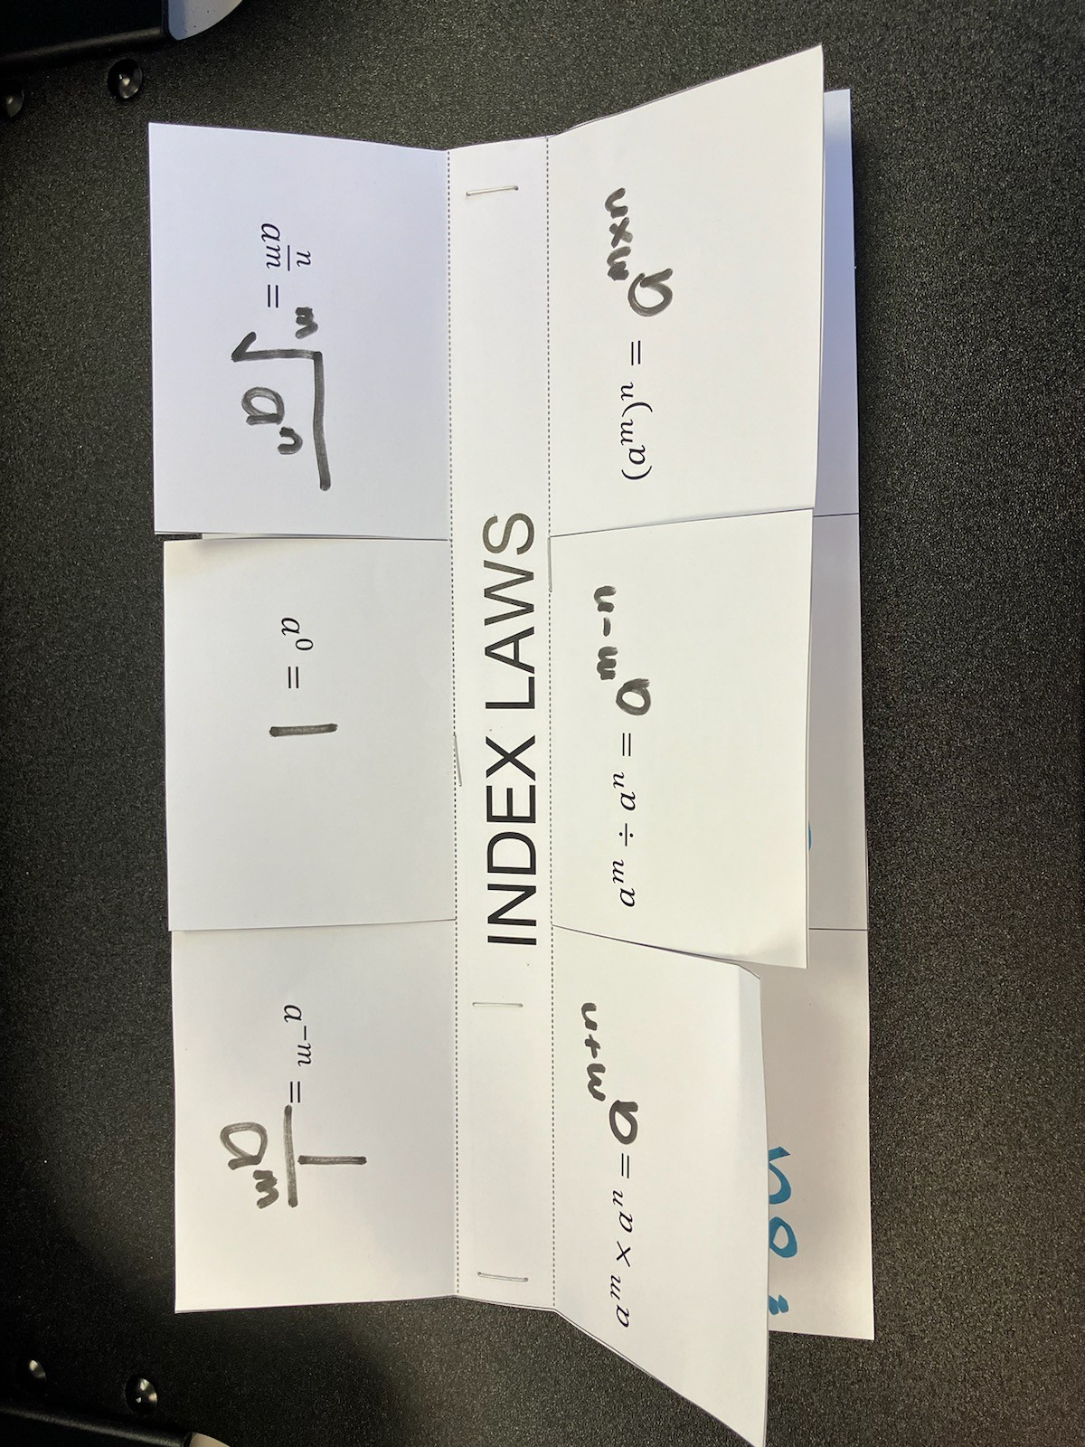
- On the top part of the foldable, list the index law. In the underneath section use the space to write examples. Space has been left for 6 index laws to include examples from previous stages. Students can refer to existing resources for examples.
- Assign students to visibly random groups of 3 (bit.ly/visiblegroups), and ask them to complete the banner task activity (bit.ly/supportingstrategies) from Appendix C ‘Banner task’. on a vertical non-permanent surface (bit.ly/VNPSstrategy).
- Distribute Appendix D ‘Finding errors’ to each group of 3.
- In their groups of 3 at vertical non-permanent surfaces, have students discuss and explain what the correct answer should be and why.
- Use the Pose-Pause-Pounce-Bounce questioning strategy (PDF 557 KB) (bit.ly/posepausepouncebounce) to spark a class discussion about common misconceptions and key areas students should be aware of when solving these types of questions.

Independent practice
- Continuing in their groups of 3 at vertical non-permanent surfaces, distribute Appendix E ‘Function notation’ and have students work through the HSC style questions.
Students looked at function notation in Unit 2 – introduction to functions.
- Continuing in their groups of 3, distribute Appendix F ‘Application questions’ and have students work through the modelling questions.

Assessment and differentiation

Suggested opportunities for differentiation
Activating prior knowledge
- Time could be spent revising index laws for numerical bases before moving to algebraic form if needed.
- Teachers could develop their own tarsia that includes path content from Indices B and Indices C if students have previously covered that work.
Connecting learning
- Students who are confident in Indices B and C from Path content may be able to express the derived relationships quickly and could work on more challenging worked examples. Ideas for these could be sourced from existing resources.
- Students who are less ready to apply the index laws established may benefit from adding another worked example without the coefficients. However, it is important that students are exposed to examples with coefficients so that they can benefit from the ‘hidden knowledge’.
Releasing responsibility
- Students who are already proficient in index laws from Stage 5 Path content may benefit from some harder questions in the banner task. These can be sourced from existing resources.
- Students could also be extended by creating their own ‘non example’ for their peers to attempt and reason why the answer is incorrect.
Independent practice
- Students who require further practice for fluency may need to use additional resources to practise before attempting the questions using function notation.

Suggested opportunities for assessment
Activating prior knowledge
- Teachers can assess students’ understanding of applying index laws through the completion of the tarsia puzzle.
Connecting learning
- Teachers can assess students’ understanding of negative and fractional indices through the class discussions and answers shown on the mini whiteboards.
Releasing responsibility
- Teachers can observe the students’ working and reasoning as they complete the banner task questions at vertical non-permanent surfaces.
- Teachers can review the foldable created by students to ensure that they understand the index laws.
Independent practice
- Teachers can observe students’ working and reasoning as they complete the function notation questions at vertical non-permanent surfaces.

Appendix A

Tarsia
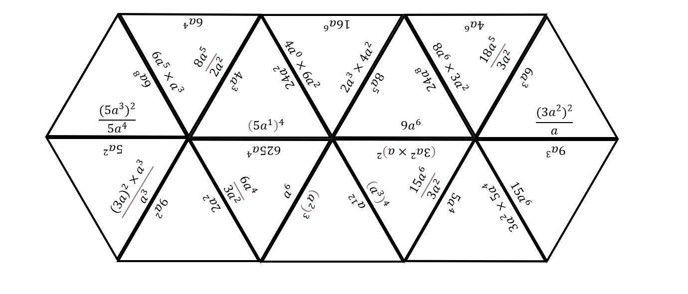
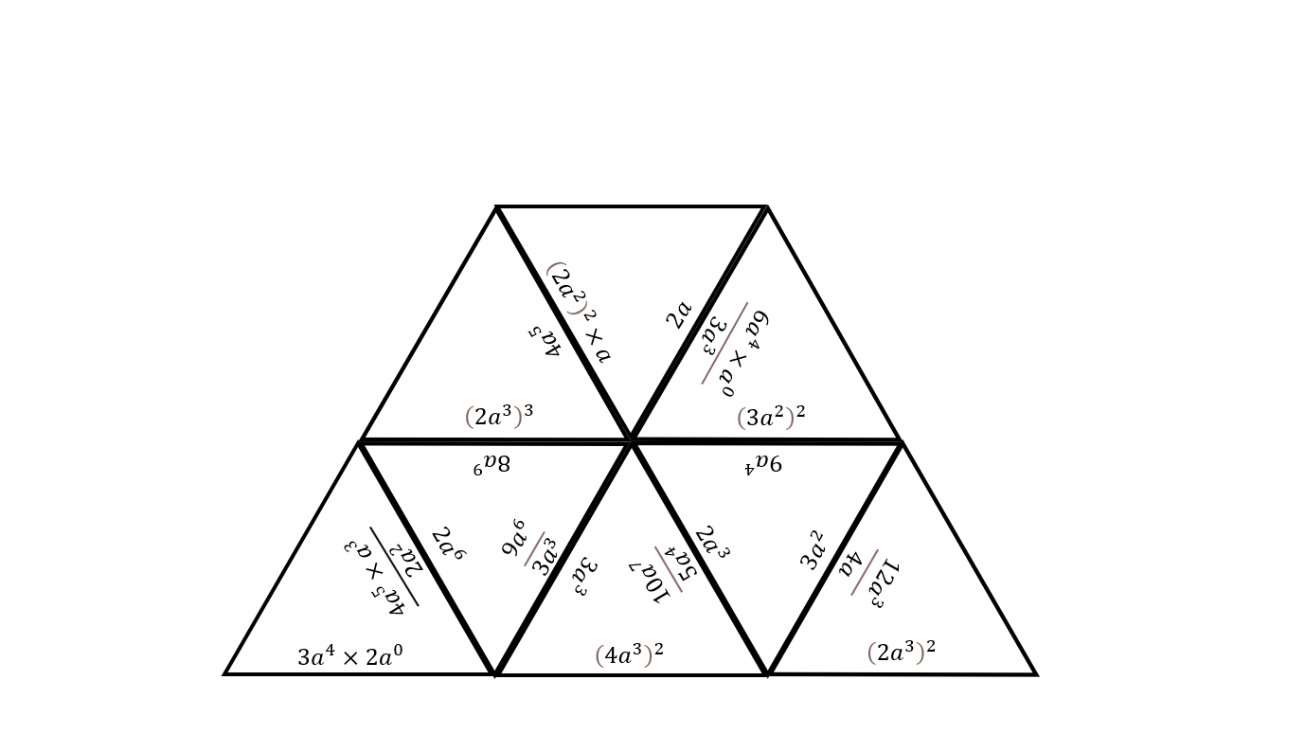

Appendix B

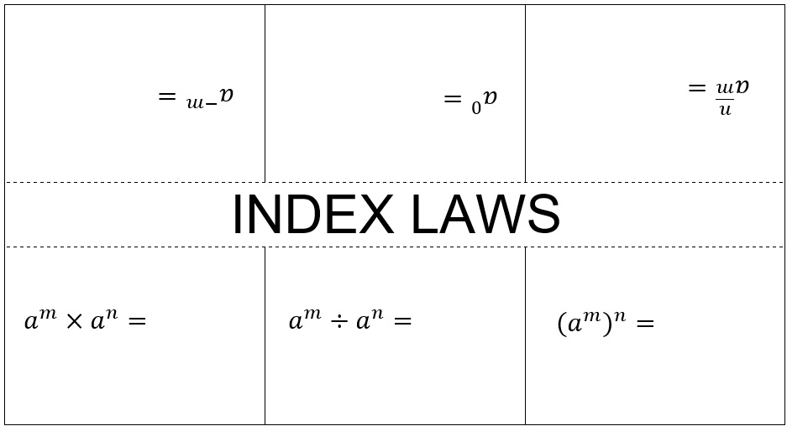
Foldable
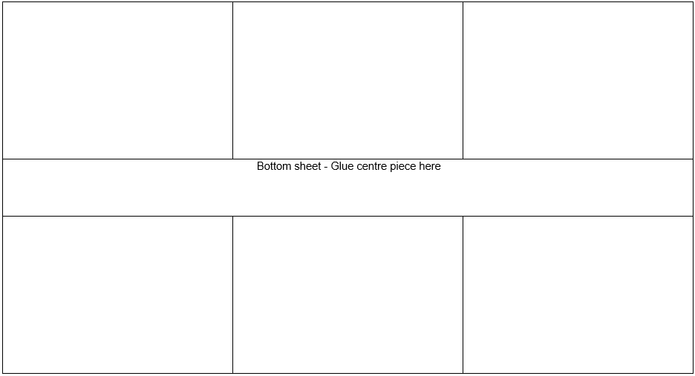

Appendix C

Banner task
Mild  - $a^{3}×a^{5}$  - $b^{12}÷b^{7}$  - ${\left(c^{4}\right)}^{3}$  - $x^{-3}×x^{2}$  - $y^{-2}÷y^{-5}$  - $\frac{1}{x^{2}}×x^{5}$  - $\frac{a^{3}}{a^{7}}$  - $\sqrt{m^{3}}$  - $\frac{1}{\sqrt{x^{3}}}$  - ${\left(\frac{1}{x^{3}}\right)}^{2}$  - $\sqrt{a}×\frac{1}{a^{3}}$ | Medium  - ${\left(2a^{3}b^{\left(-2\right)}\right)}^{2}$  - $\frac{\left(3x^{\left(-2\right)}y^{4}\right)}{\left(6x^{3}y^{\left(-1\right)}\right)}$  - $\sqrt{m}×\sqrt{\left(m^{3}\right)}$  - ${\left(\sqrt[3]{n}\right)}^{6}$  - $\sqrt[3]{\left(27x^{6}\right)}$  - $\frac{y^{4}}{\sqrt{y}}$  - $\frac{\sqrt{x}}{\sqrt[3]{x}}$  - (${\frac{1}{a^{2}b^{-1}})}^{3}$  - $3x^{2}×\frac{1}{x^{5}}$  - $\frac{6a^{-2}b^{3}}{2a^{2}b}$  - $\frac{4\sqrt{x}}{2x^{2}}$  - ${\left(5x^{-1}y^{\frac{1}{2}}\right)}^{2}$ | Spicy  - $\frac{{\left(x^{-1}y^{2}\right)}^{2}}{x^{\frac{1}{2}}}$  - ${\left(\frac{1}{x^{\frac{3}{2}}}\right)}^{2}×x^{-1}$  - $\frac{9x^{3}y^{-2}}{3\sqrt{x}y}$  - $\frac{\sqrt{\left(4p^{2}q^{\left(-3\right)}\right)}}{\left(2p^{\left(-1\right)}q\right)}$  - $\frac{{\left(ab^{\left(-2\right)} \right)}^{\left(-3\right)}}{\left(a^{\left(-1\right)} b\right)}$  - $\frac{\left(15u^{0}v^{\left(-3\right)}\right)}{\left(10u^{\left(-2\right)}\right)}$  - ${(\frac{a^{2}}{b^{-3}})}^{-2}$  - $\frac{{\left(x^{\left(-1/2\right)}y^{\left(3/2\right)}\right)}^{4}}{\left(x^{2}y^{\left(-1\right)}\right)}$

Appendix D

Finding errors
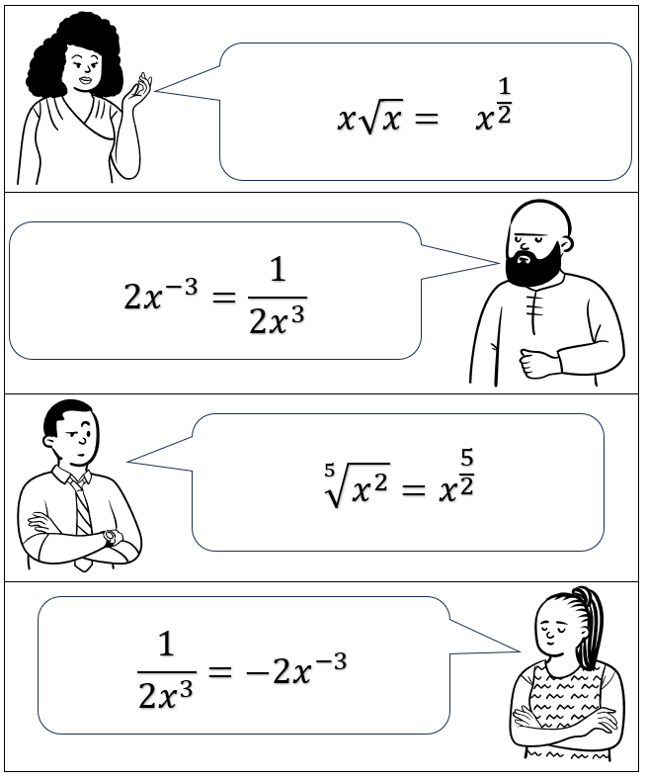

Appendix E

Function notation
- Let $f\left(x\right)=\frac{1}{x}+1$ and $g\left(x\right)=x^{2}$.
Find $f\left(g\left(x\right)\right)$.
- Let $f\left(x\right)=3\sqrt{x}$ and $g\left(x\right)=x+4$.
Find $f\left(g\left(x\right)\right).$
- Let $f\left(x\right)=x^{-2}$ and $g\left(x\right)=x^{3}$.
Find $f\left(g\left(x\right)\right).$
- Let $f\left(x\right)=x^{-1}+2$ and $g\left(x\right)=x^{2}.$
Find ${f\left(g\left(x\right)\right)}^{2}.$
- Let $f\left(x\right)=\sqrt{x}$ and $g\left(x\right)=x+9.$
Find $f{\left(g\left(x\right)\right)}^{\frac{1}{2}}$.
- Let $f\left(x\right)=\frac{2}{x}+3$ and $g\left(x\right)=\sqrt{x}-1$.
Find $f\left(g\left(\frac{1}{\sqrt{x}}\right)\right)$.
- Let $f\left(x\right)=x^{-2}+5$and $g\left(x\right)=x^{\frac{1}{3}}+2$.
Find $f(g({x))}^{-3}$.
- Let $f\left(x\right)=\frac{6}{\sqrt{x}}$ and $g\left(x\right)=2x^{2}$.
Find $f({g\left(x\right))}^{-2}$.

Appendix F

Application questions
- A company reduces its carbon emissions by 10% each year. The emissions are modelled by:
$$C\left(n\right)=1000×{\left(0.9\right)}^{n}$$
where $n$ is the number of years.
- Calculate $C\left(1\right),C\left(2\right)$and$C\left(5\right)$.
- Explain the meaning of the index in ${\left(0.9\right)}^{n}$.
- Write $C\left(n+1\right)$ in terms of $C\left(n\right).$
- An investment grows according to:
$$A\left(n\right)=2000×{\left(1.05\right)}^{n}$$
where $n$ is the number of years.
- Find $A\left(0\right),A\left(1\right)$and$A\left(10\right).$
- Express$A\left(n+1\right)$in terms of$A\left(n\right).$
- What does the index notation ${\left(1.05\right)}^{n}$ represent in this scenario?
- The amount of medicine remaining in the bloodstream after $n$ hours is:
$$M\left(n\right)=200×{\left(\frac{1}{2}\right)}^{n}$$
- How much medicine remains after 1, 3, and 6 hours?
- What fraction of the medicine remains after each additional hour?
- Show that $M\left(n+1\right)=\frac{1}{2}M\left(n\right).$
- The battery percentage of a phone decreases by 20% each hour. It is modelled by
$$B\left(n\right)=100×{\left(0.8\right)}^{n}$$
where $n$ is the number of hours.
- Write $B\left(n+3\right)$ in terms of $B\left(n\right)$ using index laws.
- If $B\left(2\right)=64$, show that $B\left(5\right)=32.768$.
- Use index laws to simplify:
$$\frac{B\left(n+5\right)}{B\left(n+2\right)}$$
- A tech company claims that the memory capacity (in $GB$) of its devices doubles every 18 months. This is modelled by:
$$M\left(n\right)=64×2^{n}$$
where $n$ is the number of 18-month periods since launch.
- Show that $M\left(n+2\right)=4M\left(n\right)$.
- Simplify:
$$\frac{M\left(n+3\right)}{M\left(n+1\right)}​$$
- If a device has 1024 GB of storage, solve for $n.$

Sample solutions

Appendix C – banner task
- $a^{3+5}=a^{8}$
- $b^{12-7}=b^{5}$
- $c^{4×3}=c^{12}$
- $x^{-3+2}=x^{-1}=\frac{1}{x}$
- $y^{-2-\left(-5\right)}=y^{3}$
- $x^{\left(-2+5\right)}=x^{3}$
- $a^{\left(3-7\right)}=a^{\left(-4\right)}=\frac{1}{a^{4}}$
- $m^{\left(3/2\right)}$
- $x^{\left(-3/2\right)}$
- $x^{\left(-3×2\right)}=x^{\left(-6\right)}=\frac{1}{x^{6}}$
- $a^{\left(1/2×-3\right)}=a^{\left(-3/2\right)}=\frac{1}{\sqrt{\left(a^{3}\right)}}$
- $2^{2}a^{6}b^{-4}=4a^{6}b^{-4}=\frac{4a^{6}}{b^{4}}$
- $\frac{3}{6} x^{-2-3} y^{4-\left(-1\right)}=\frac{1}{2} x^{-5} y^{5}=\frac{y^{5}}{2x^{5}}$
- $m^{1/2+3/2}=m^{4/2}=m^{2}$
- $n^{\left(1/3\right)×6}=n^{2}$
- ${27}^{\frac{1}{3}}× x^{\left(6×\frac{1}{3}\right)}=3{ x}^{2}$
- $y^{\left(4-\left(-1\right)/2\right)}=y^{\left(9/2\right)}=\sqrt{\left(y^{9}\right)}$
- $x^{\left(1/2-\left(-1\right)/3\right)}=x^{\left(5/6\right)}$
- $a^{\left(-2×3\right)} b^{\left(-\left(-1\right)×3\right)}=\frac{b^{3}}{a^{6}}$
- $3x^{\left(2-5\right)}=3x^{\left(-3\right)}=\frac{3}{x^{3}}$
- $3a^{\left(-2-2\right)}b^{\left(3-1\right)}=3a^{\left(-4\right)}b^{2}=\frac{\left(3b^{2}\right)}{a^{4}}$
- $2x^{\left(1/2-2\right)}=2x^{\left(-3/2\right)}=\frac{2}{\sqrt{\left(x^{3}\right)}}$
- $25x^{\left(-1×2\right)}y^{\left(1/2×2\right)}=\frac{25y}{x^{2}}$
- $x^{\left(-1×2-1/2\right)}y^{\left(2×2\right)}=x^{\left(\left(-5\right)/2\right)}y^{4}=\frac{y^{4}}{\sqrt{\left(x^{5}\right)}}$
- $x^{\left(\left(-3\right)/2×2-1\right)}=x^{\left(-4\right)}=\frac{1}{x^{4}}$
- $3x^{\left(3-1/2\right)}y^{\left(-2-1\right)}=3x^{\left(\left(-5\right)/2\right)}y^{\left(-3\right)}=\frac{3}{\sqrt{\left(x^{5}\right)}y^{3}}$
- $\frac{4^{\frac{1}{2}}p^{2}q^{\left(-3×\frac{1}{2}\right)}}{2p^{-1}q}=\frac{2{ p}^{1}q^{-3/2}}{2p^{-1}q}=p^{1-\left(-1\right)} q^{-3/2+1}=p^{2} q^{-1/2}=\frac{p^{2}}{\sqrt{q}}$
- $\frac{a^{-3}b^{6}}{a^{-1}b}=a^{-3-\left(-1\right)} b^{6-1}=a^{-2}b^{5}=\frac{b^{5}}{a^{2}}$
- $\frac{5}{10} u^{0-\left(-2\right)} v^{-3}=\frac{1}{2} u^{2} v^{-3}=\frac{u^{2}}{2v^{3}}$
- ${\left(a^{2}b^{3}\right)}^{-2}=a^{-4}b^{-6}=\frac{1}{a^{4}b^{6}}$
- $\frac{x^{-2}y^{6}}{x^{2}y^{-1}}=x^{-2-2} y^{6-\left(-1\right)}=x^{-4}y^{7}=\frac{y^{7}}{x^{4}}$

Appendix D – finding errors
- Claim: $x\sqrt{x}=x^{\frac{1}{2}}$. — Wrong.
Reason (algebra): $\sqrt{x}=x^{1/2}$, so
$$x\sqrt{x}=x×x^{1/2} \\ =x^{1+1/2} \\ =x^{3/2}$$
So, the correct result is $x^{3/2}$, not $x^{1/2}$.
- Claim: $2x^{-3}=\frac{1}{{2x}^{3}}$. — Wrong.
Reason (algebra):
$$2x^{-3}=2×x^{-3}$$$=\frac{2}{x^{3}}$.
The expression $\frac{1}{{2x}^{3}}$ equals $\frac{1}{2}$, which is half of $x^{-3}$, not twice it.
So, the correct simplification is $\frac{2}{x^{3}}$.
- Claim: $\sqrt[5]{x^{2}}=x^{\frac{5}{2}}$. — Wrong.
Reason (algebra): $$\sqrt[5]{x^{2}}={\left(x^{2}\right)}^{1/5} \\ =x^{2×\left(1/5\right)} \\ =x^{2/5}$$
So, the correct exponent is $\frac{2}{5}$, not $\frac{5}{2}$.
- Claim: $\frac{1}{{\left(2x\right)}^{3}}=-2x^{-3}$. — Wrong.
Reason (algebra): ${\left(2x\right)}^{3}=8x^{3}$, so
$$\frac{1}{{\left(2x\right)}^{3}}=\frac{1}{8x^{3}} \\ =\frac{1}{8} x^{-3}$$There is no negative sign, and the coefficient is $\frac{1}{8}$, not $-2$.

Appendix E – function notation
- $f\left(x\right)=\frac{1}{x} -1, g\left(x\right)=x^{2}.$Find$f\left(g\left(x\right)\right).$
$$f\left(g\left(x\right)\right)=\frac{1}{g\left(x\right)}+1 \\ =\frac{1}{x^{2}}+1 \\ =x^{-2}+1.$$
- $f\left(x\right)=3\sqrt{x}=3x^{1/2},g\left(x\right)=x+4$Find $f\left(g\left(x\right)\right)$.
$$f\left(g\left(x\right)\right)=3\sqrt{ g\left(x\right)} \\ =3\sqrt{x+4} \\ =3{\left(x+4\right)}^{\frac{1}{2}}.$$
- $f\left(x\right)=x^{-2},g\left(x\right)=x^{3}.$
Find $f\left(g\left(x\right)\right).$
$$f\left(g\left(x\right)\right)={\left(g\left(x\right)\right)}^{-2} \\ ={\left(x^{3}\right)}^{-2} \\ =x^{3×-2} \\ =x^{-6} \\ =\frac{1}{x^{6}}.$$
- $f\left(x\right)=x^{-1}+2,g\left(x\right)=x^{2}.$
Find ${\left(f\left(g\left(x\right)\right)\right)}^{2}$.
First compute $f\left(g\left(x\right)\right)$:
$f\left(g\left(x\right)\right)={\left(x^{2}\right)}^{-1}+2=x^{-2}+2=\frac{1}{x^{2}}+2$.
Now square it:
$${\left(f\left(g\left(x\right)\right)\right)}^{2}={\left(x^{-2}+2\right)}^{2} \\ =x^{-4}+4x^{-2}+4 \\ =\frac{1}{x^{4}}+\frac{4}{x^{2}}+4.$$
- $f\left(x\right)=\sqrt{x}=x^{1/2}, g\left(x\right)=x+9.$
Find ${\left(f\left(g\left(x\right)\right)\right)}^{1/2}$.
$$f\left(g\left(x\right)\right)=\sqrt{x+9} \\ ={\left(x+9\right)}^{\frac{1}{2}}, \\ {\left(f\left(g\left(x\right)\right)\right)}^{\frac{1}{2}}={\left({\left(x+9\right)}^{\frac{1}{2}}\right)}^{\frac{1}{2}} \\ ={\left(x+9\right)}^{\frac{1}{4}}.$$
- $f\left(x\right)=\frac{2}{x}-3 , g\left(x\right)=\sqrt{x}-1.$
Find $f\left(g\left(\sqrt{x} -1\right)\right).$
Evaluate $g$ at $t=\frac{1}{\sqrt{x}}$:
$$g\left(\frac{1}{\sqrt{x}}\right)=\sqrt{\frac{1}{\sqrt{x}}}-1 \\ ={\left(\frac{1}{\sqrt{x}}\right)}^{1/2}-1 \\ =x^{-1/4}-1.$$
Apply $f\left(u\right)=\frac{2}{u}+3$ with $u=x^{-1/4}-1$:
$f \left(g \left(\frac{1}{\sqrt{x}}x\right)\right)=\frac{2}{x^{-\frac{1}{4}}-1} +3.$
Optional algebraic simplification (clear the small fraction):
$$\frac{2}{x^{-1/4}-1}=\frac{2}{\frac{1-x^{1/4}}{x^{1/4}}}$$$=\frac{2x^{1/4}}{1-x^{1/4}}$.

So
$$f \left(g \left(\frac{1}{\sqrt{x}}\right)\right)=\frac{2x^{1/4}}{1-x^{1/4}}+3 \\ =\frac{3-x^{1/4}}{1-x^{1/4}}$$
(after combining over common denominator; you can keep either form).
- $f\left(x\right)=x^{-2}+5, g\left(x\right)=x^{\frac{1}{3}}+2.$Find ${\left(f\left(g\left(x\right)\right)\right)}^{-3}.$
First compute $f\left(g\left(x\right)\right)$:
$$f\left(g\left(x\right)\right)={\left(g\left(x\right)\right)}^{-2}+5 \\ ={\left(x^{1/3}+2\right)}^{-2}+5.$$
Now raise to $-3$:
$${\left(f\left(g\left(x\right)\right)\right)}^{-3}={\left({\left(x^{1/3}+2\right)}^{-2}+5\right)}^{-3}$$
You can leave it like that, or write as a reciprocal:
$${\left(f\left(g\left(x\right)\right)\right)}^{-3}=\frac{1}{{\left({\left(x^{1/3}+2\right)}^{-2}+5\right)}^{3}}.$$
(If desired you can expand ${\left(x^{1/3}+2\right)}^{-2}=\frac{1}{{\left(x^{1/3}+2\right)}^{2}}$ and combine into a single rational expression, but the boxed form above is the clean composition.)
- $f\left(x\right)=\frac{6}{\sqrt{x}}=6x^{-1/2},g\left(x\right)=2x^{2}.$Find ${\left(f\left(g\left(x\right)\right)\right)}^{-2}$.
$$f\left(g\left(x\right)\right)=6{\left(2x^{2}\right)}^{-1/2}$$
$$f\left(g\left(x\right)\right)=6×{\left(2x^{2}\right)}^{-\frac{1}{2}} \\ =6×2^{-\frac{1}{2}}×x^{-1} \\ =\frac{6}{\sqrt{2}}x^{-1} \\ =\frac{6}{\sqrt{2}}×\frac{1}{x} \\ =\frac{3\sqrt{2}}{x}$$$($since$\frac{6}{\sqrt{2}}=3\sqrt{2}).$
Raise to $-2$:
$${\left(f\left(g\left(x\right)\right)\right)}^{-2}={\left(\frac{3\sqrt{2}}{x}\right)}^{-2} \\ ={\left(3\sqrt{2}\right)}^{-2}×x^{2} \\ =\frac{x^{2}}{{\left(3\sqrt{2}\right)}^{2}} \\ =\frac{x^{2}}{2×9} \\ =\frac{x^{2}}{18}$$

Appendix F – application questions
- $A\left(n\right)=2000{\left(1.05\right)}^{n}$
- Evaluate
$$A\left(0\right)=2000{\left(1.05\right)}^{0}=2000$$
$$A\left(1\right)=2000{\left(1.05\right)}^{1}=2000×1.05=2100$$
$$A\left(10\right)=2000{\left(1.05\right)}^{10}≈2000×1.628894=3,257.79$$
- Recursive form
$$A\left(n+1\right)=2000{\left(1.05\right)}^{n+1} \\ =1.05⋅2000{\left(1.05\right)}^{n} \\ =1.05A\left(n\right)$$
- Meaning of ${\left(1.05\right)}^{n}$
It’s the growth factor applied $n$ times—each year the amount increases by $5\%$. After $n$ years the original amount has been multiplied by $1.05$ repeatedly $n$ times.
- $C\left(n\right)=1000{\left(0.9\right)}^{n}$
- Evaluate
$$C\left(1\right)=1000×0.9=900$$
$$C\left(2\right)=1000×{0.9}^{2}=810$$
$$C\left(5\right)=1000×{0.9}^{5}≈590.49$$
Meaning of ${\left(0.9\right)}^{n}$
It’s the decay factor applied $n$ times—each year emissions are $90\%$ of the previous year (a $10\%$ reduction), multiplied $n$ times.
- Recursive form
$$C\left(n+1\right)=1000{\left(0.9\right)}^{n+1} \\ =0.9⋅1000{\left(0.9\right)}^{n} \\ =0.9C\left(n\right)$$
Medicine dosage in the bloodstream
$$M\left(n\right)=200{\left(\frac{1}{2}\right)}^{n}$$
- Evaluate
$$M\left(1\right)=200×\frac{1}{2}=100$$
$$M\left(3\right)=200×\frac{1}{8}=25$$
$$M\left(6\right)=200×\frac{1}{64}=3.125$$
- Fraction remaining each hour
Each additional hour leaves half of the current amount: multiply by $\frac{1}{2}$.
- Show $M\left(n+1\right)=\frac{1}{2}M\left(n\right)$
$$M\left(n+1\right)=200{\left(\frac{1}{2}\right)}^{n+1} \\ =200{\left(\frac{1}{2}\right)}^{n}×\frac{1}{2} \\ =\frac{1}{2} M\left(n\right)$$
- $B\left(n\right)=100{\left(0.8\right)}^{n}$
- $B\left(n+3\right)=100{\left(0.8\right)}^{n+3}$$$=100{\left(0.8\right)}^{n}{\left(0.8\right)}^{3} \\ =B\left(n\right) {\left(0.8\right)}^{3} \\ =B\left(n\right)×0.512$$
- $B\left(5\right)=100{\left(0.8\right)}^{5}$$$=100{\left(0.8\right)}^{2}{\left(0.8\right)}^{3} \\ =B\left(2\right) {\left(0.8\right)}^{3} \\ =64×0.512 \\ =32.768$$
- $\frac{B\left(n+5\right)}{B\left(n+2\right)}=\frac{100{\left(0.8\right)}^{n+5}}{100{\left(0.8\right)}^{n+2}}$$$={\left(0.8\right)}^{\left(n+5\right)-\left(n+2\right)} \\ ={\left(0.8\right)}^{3} \\ =0.512$$
- $M\left(n\right)=64×2^{n}$
- $M\left(n+2\right)=64×2^{n+2}$$$=64×2^{n}×2^{2} \\ =4 \left[64×2^{n}\right] \\ =4M\left(n\right)$$
- $\frac{M\left(n+3\right)}{M\left(n+1\right)}=\frac{64⋅2^{n+3}}{64⋅2^{n+1}}$$$=2^{\left(n+3\right)-\left(n+1\right)} \\ =2^{2} \\ =4$$
- $64×2^{n}=1024 ⇒ 2^{n}=\frac{1024}{64}=16=2^{4} ⇒ n=4$
(That’s $4$ periods of $18 months → 4×18=72 months$ = $6 years$ after launch.)

References
This resource contains NSW Curriculum and syllabus content. The NSW Curriculum is developed by the NSW Education Standards Authority. This content is prepared by NESA for and on behalf of the Crown in right of the State of New South Wales. The material is protected by Crown copyright.
Please refer to the NESA Copyright Disclaimer for more information https://educationstandards.nsw.edu.au/wps/portal/nesa/mini-footer/copyright.
NESA holds the only official and up-to-date versions of the NSW Curriculum and syllabus documents. Please visit the NSW Education Standards Authority (NESA) website https://educationstandards.nsw.edu.au/ and the NSW Curriculum website https://curriculum.nsw.edu.au/.
Mathematics Advanced 11–12 Syllabus © NSW Education Standards Authority (NESA) for and on behalf of the Crown in right of the State of New South Wales, 2024.

© State of New South Wales (Department of Education), 2025
The copyright material published in this resource is subject to the Copyright Act 1968 (Cth) and is owned by the NSW Department of Education or, where indicated, by a party other than the NSW Department of Education (third-party material).
Copyright material available in this resource and owned by the NSW Department of Education is licensed under a Creative Commons Attribution 4.0 International (CC BY 4.0) license.

This license allows you to share and adapt the material for any purpose, even commercially.
Attribution should be given to © State of New South Wales (Department of Education), 2025.
Material in this resource not available under a Creative Commons license:
- the NSW Department of Education logo, other logos and trademark-protected material
- material owned by a third party that has been reproduced with permission. You will need to obtain permission from the third party to reuse its material.
Links to third-party material and websites
Please note that the provided (reading/viewing material/list/links/texts) are a suggestion only and implies no endorsement, by the New South Wales Department of Education, of any author, publisher, or book title. School principals and teachers are best placed to assess the suitability of resources that would complement the curriculum and reflect the needs and interests of their students.
If you use the links provided in this document to access a third-party's website, you acknowledge that the terms of use, including licence terms set out on the third-party's website apply to the use which may be made of the materials on that third-party website or where permitted by the Copyright Act 1968 (Cth). The department accepts no responsibility for content on third-party websites.

