Instantaneous speed
Students find the instantaneous speed of a linear distance–time graph before progressing to non-linear graphs. They are introduced to secants and their use in estimating the instantaneous speed.

Learning intentions
- To understand the difference between average speed and instantaneous speed.
- To be able to use a distance–time graph to estimate instantaneous speed.

Success criteria
- I can explain the difference between average speed and instantaneous speed.
- I can approximate instantaneous speed using average speed over a short time interval.
- I can explain why calculating average speed over smaller time intervals gives better approximations of instantaneous speed.

Outcomes
A student:
- develops understanding and fluency in mathematics through exploring and connecting mathematical concepts, choosing and applying mathematical techniques to solve problems, and communicating their thinking and reasoning coherently and clearly MAO-WM-01
- interprets the meaning of the derivative and determines the derivative of functions to solve problems MAV-11-06

Content

Estimating change
- Define the average rate of change of 𝑦 with respect to 𝑥 for a function 𝑦 = 𝑓(𝑥) over the domain [𝑎,𝑏] as $\frac{Δy}{Δx}$ = $\frac{change in y}{change in x}$ , that is $\frac{Δy}{Δx}$= $\frac{f\left(b\right)-f\left(a\right)}{b-a}$, and recognise $\frac{f\left(b\right)-f\left(a\right)}{b-a}$ as the gradient of the secant through (𝑎,𝑓(𝑎)) and (𝑏,𝑓(𝑏)) on the graph of 𝑦 = 𝑓(𝑥)
- Describe the difference between the average speed of an object and its instantaneous speed
- Determine that the instantaneous speed of an object at time 𝑡 can be approximated by the average speed between its position at time 𝑡 and its position sometime later and explain how this approximation can be improved
- Relate the instantaneous speed of an object to the gradient of the tangent at that point on its distance–time graph
- Estimate the instantaneous speed of an object from its distance–time graph
Mathematics Advanced 11–12 Syllabus © NSW Education Standards Authority (NESA) for and on behalf of the Crown in right of the State of New South Wales, 2024
Table 1: lesson summary
Section | Summary of activity | Teaching strategies | Teaching points
Activating prior knowledge | Slide 4 from the PowerPoint Instantaneous speed is used to compare instantaneous and average speed cameras. Students are asked to consider a scenario to unpack which is fairer. | Pose-Pause-Pounce-Bounce  Think-Pair-Share | Students differentiate between instantaneous and average speed.
Connecting learning | Students find the average and instantaneous speed of a linear function (slide 6) before attempting to find it for a non-linear function. Students use a secant (slides 7 and 8) to estimate the instantaneous speed at $x = 2$ using Appendix A | Pose-Pause-Pounce-Bounce  Think-Pair-Share | Students discover that using smaller secants produces a better estimate of the instantaneous speed.
Releasing responsibility | Define ‘tangent’ using the GeoGebra activity (bit.ly/1principles) and link it to secant and instantaneous speed. Students draw tangents and discuss why they are all different. | Pose-Pause-Pounce-Bounce  Think-Pair-Share | There are 2 activities in the GeoGebra activity. Students will need to scroll down.
Independent practice | Students estimate instantaneous speed using a cyclist’s journey (Appendix B) and use this to describe the route the cyclist may have taken. | Visibly random groups of 3 | Appendix B does not contain a grid to encourage students to use function values.

Activity structure
Please use the associated PowerPoint Instantaneous speed to display images in this lesson.

Activating prior knowledge
- Display slide 4 from the PowerPoint showing the image of an average speed camera and an instantaneous speed camera.
- In a Think-Pair-Share (bit.ly/thinkpairsharestrategy), have students discuss the difference between instantaneous speed and average speed.
Average speed refers to the overall speed calculated for the entire journey, while instantaneous speed is the exact speed at a specific moment in time.
- Pose the following scenario to students.
Imagine someone drives 120 km in 2 hours, so their average speed for the whole trip is 60 km/h. There’s a mobile speed camera on part of the road where the speed limit is 80 km/h, is it possible that the driver could be speeding when they pass the mobile speed camera? Allow students time to consider their response using a Think-Pair-Share.
Students could suggest that the driver was going faster at some points and slower at others or may even stop during the journey. The teacher may wish to represent these suggestions on a distance–time graph.
- Using the Pose-Pause-Pounce-Bounce questioning strategy (PDF 557 KB) (bit.ly/posepausepouncebounce) have students consider which type of camera they think is fairer for drivers, average speed or instantaneous and why?

Connecting learning
- Show slide 6 of the PowerPoint displaying the distance time graph representing the function $d\left(t\right)=60t.$ The graph is modelling a car’s journey.
- Have students engage in a Think-Pair-Share to calculate:
- the average speed for the whole journey
- the instantaneous speed at the 2-hour mark of the journey.
Average speed and instantaneous speed are both 60 km/h. The instantaneous speed is calculated using the gradient of the line at the 2-hour mark of the journey.
- Pose the question, ‘Why do the average speed and instantaneous speed come out the same in this case?’ Use the Pose-Pause-Pounce-Bounce questioning strategy to draw out that the function is linear and therefore the rate of change is constant.
- Show slide 7 which uses the function $d\left(t\right)=3t^{2}+2t$ to model a jogger’s journey over 3 hours.
- Distribute Appendix A ‘Jogger’s journey’.
- In another Think-Pair-Share, have students calculate the average speed of the jogger over the 3 hours.
The average speed for the journey is 11 km/h. Students should be encouraged to substitute 3 into the function $d\left(t\right)=3t^{2}+2t$ to get an accurate answer.
- Have students draw a straight line to represent the average speed from 0–3 hours. Tell students that this line is called a secant.
- Animate slide 7 to model the average speed as a secant for students and formally define the term ‘secant’.
The NESA syllabus glossary defines a secant as ‘A straight line passing through 2 points on the graph of a function.’ (NESA 2024)
- In another Think-Pair-Share, have students attempt to calculate the instantaneous speed at the 2-hour mark of the journey. At this point, they should begin to realise the difficulty in finding instantaneous speed directly.
- Display slide 8 to model how using secants over progressively smaller intervals allows the average speed to approach the instantaneous speed.
- Animate slide 8 to show the tangent to the curve and tell students that this represents the instantaneous speed at the 2-hour mark.
- Use the Pose-Pause-Pounce-Bounce questioning strategy to check students’ understanding of the diagram on slide 8. Possible questions could include:
- Which secant best estimates the instantaneous speed at the 2-hour mark of the journey?
- What do you think might happen if I chose 2 points even closer together on the curve, both nearer to $x=2$?
- Tell students that the jogger’s smart phone has a speedometer. His speedometer app indicates that the instantaneous speed at the 2-hour mark of the journey was 14 km/h.
- Using Appendix A, have pairs construct a secant and find its gradient.
- Repeat step 14, this time constructing a secant that has a better approximation of the instantaneous speed.
- Have pairs join with another pair and compare the gradients of their secants to the actual instantaneous speed of 14 km/h.
- In a Think-Pair-Share, ask students which secant they think is a better representation of instantaneous speed at the 2-hour mark and why?
Students should suggest that using smaller secants would produce a better estimate of the instantaneous speed.

Releasing responsibility
- Display the GeoGebra activity (bit.ly/1principles).
This GeoGebra has 2 activities. The teacher will need to scroll down to display the second activity.
- Explain to students that the line that represents instantaneous speed on a curve is called a tangent. Formally define the term ‘tangent’.
For a curve at a given point the tangent can be described intuitively as the straight line that ‘just touches’ the curve at that point (NESA 2024).
- While displaying the first GeoGebra activity, in a Think-Pair-Share, have students predict what will happen to the blue line (secant) and the red line (tangent) as the slider decreases the distance between the 2 points.
- Adjust the slider to verify student’s predictions.
- Explain to students that the rate of change at a point is represented by the gradient of the tangent.
- While displaying the second GeoGebra activity, ask students to write the gradient of the tangent at point $\left(a, f\left(a\right)\right)$ and $(b, f\left(b\right))$.
- Again, in a Think-Pair-Share, have students predict what will happen to the gradient of the secant and the tangent as the slider moves towards 0.
- Adjust the slider to verify students’ predictions and reiterate that the gradient of the secant is the same as the gradient of the tangent at the point as the slider approaches 0.
- Drawing students back to Appendix A, have them construct a tangent on their graph at $t=2$ to represent the instantaneous speed and find the gradient of this line.
- Have students compare their tangents with the neighbouring pairs.
- Conduct a class discussion about why the gradients of their tangents are different and therefore not accurate.
Students need to realise that for a secant, we can calculate the gradient accurately using 2 points on the function. However, for a tangent, we only have one point on the function and drawing an accurate tangent by eye is difficult.
- Use the Pose-Pause-Pounce-Bounce questioning strategy to have students consider how they could approximate the instantaneous rate of change at a particular point if it is not possible to construct an accurate tangent.
Students should recognise that the gradient of a very small secant close to the point is the best estimate.

Independent practice
- Distribute Appendix B ‘Cyclist journey’ to students. This appendix includes the distance–time graph of the function $d\left(t\right)=-3t^{3}+18t^{2}+6t$ where $d\left(t\right)$ is the distance in $km$ and $t$ is the time in hours.
- Instruct students to calculate the average speed for the entire 4-hour journey.
Average speed $=\frac{120}{4}=30 km/h$.
- Direct students to approximate the instantaneous speed of the cyclist at $t=0.5, t=1.5, t=2.5$ and $t=3.5$ hours by drawing secants, choosing appropriate intervals, to estimate the gradient of the tangent at each point.
Instantaneous speeds at $t=0.5, t=1.5, t=2.5$,and $t=3.5$respectively are $21.75 km/h$, $39.75 km/h$, $39.75 km/h$, $21.75 km/h$.
- In visibly random groups of 3 (bit.ly/visiblegroups), have students compare their secants. Students are to decide which gradient is the best approximation for each stage of the journey.
- Using the best approximations from their group, have student use the instantaneous speeds to describe the journey of the cyclist.

Assessment and differentiation

Suggested opportunities for differentiation
Activating prior knowledge
- Students could be given a copy of the graph on slide 4 of the PowerPoint to use to find the gradient rather than using function notation.
- Speed cameras in the local area could be used to further explain the difference between instantaneous speed cameras and average speed cameras.
Connecting learning
- Students could be provided with pre-drawn secants, a table of values or modelled worked examples to find average speed.
- The difficulty of the function could be modified to extend students.
Releasing responsibility
- The GeoGebra model could be co-constructed to aid students’ understanding.
- The metaphor ‘going off on a tangent’ could be used to build understanding of the term ‘tangent’.
Independent practice
- Provide a grid on the graph to support students in calculating gradients.
- Challenge students to create their own function to model a cyclist’s 4-hour journey and use secants to check whether the speeds are reasonable.

Suggested opportunities for assessment
Connected learning
- Students’ responses about the car journey could be used to check for understanding of average and instantaneous speed using a linear function.
- Check students’ gradients of secants to assess their ability to find function values and gradients.
- Monitor responses in class discussions to check for student understanding of how to estimate instantaneous speed.
Releasing responsibility
- Monitor students’ responses during class discussions to check for understanding of the difference between a secant and a tangent and what rates of change they represent.
Independent practice
- Appendix B could be used as an exit ticket to assess students’ ability to find the gradient of a secant and use it to estimate instantaneous speed.

Appendix A

Jogger’s journey
$$d\left(t\right)=3t^{2}+2t$$
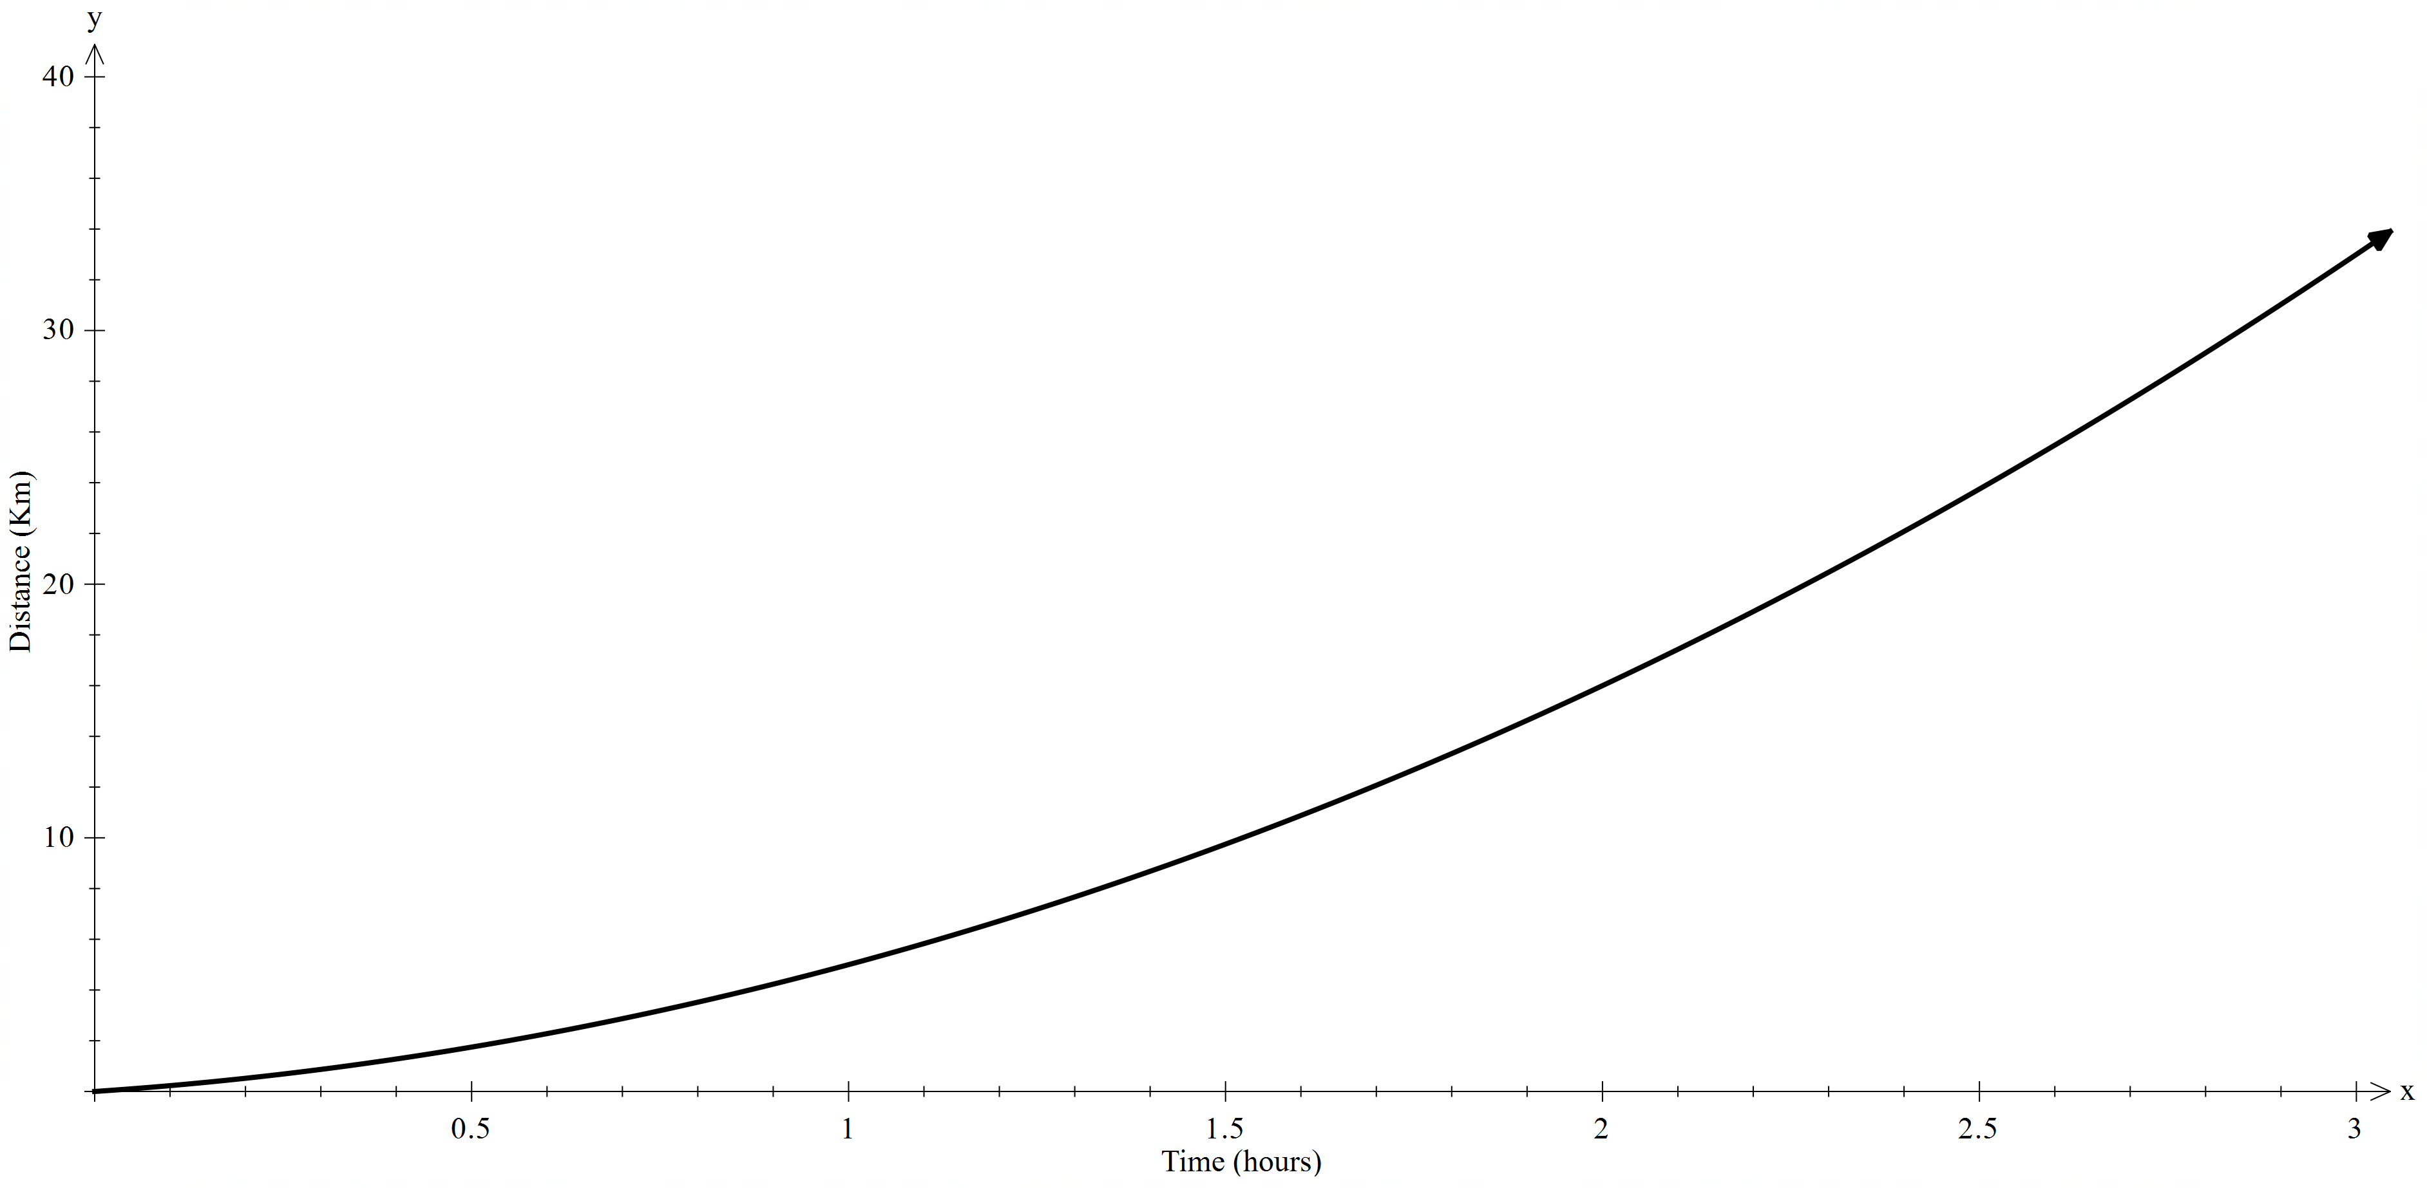

Appendix B

Cyclist journey
$d\left(t\right)=-3t^{3}+18t^{2}+6t$ 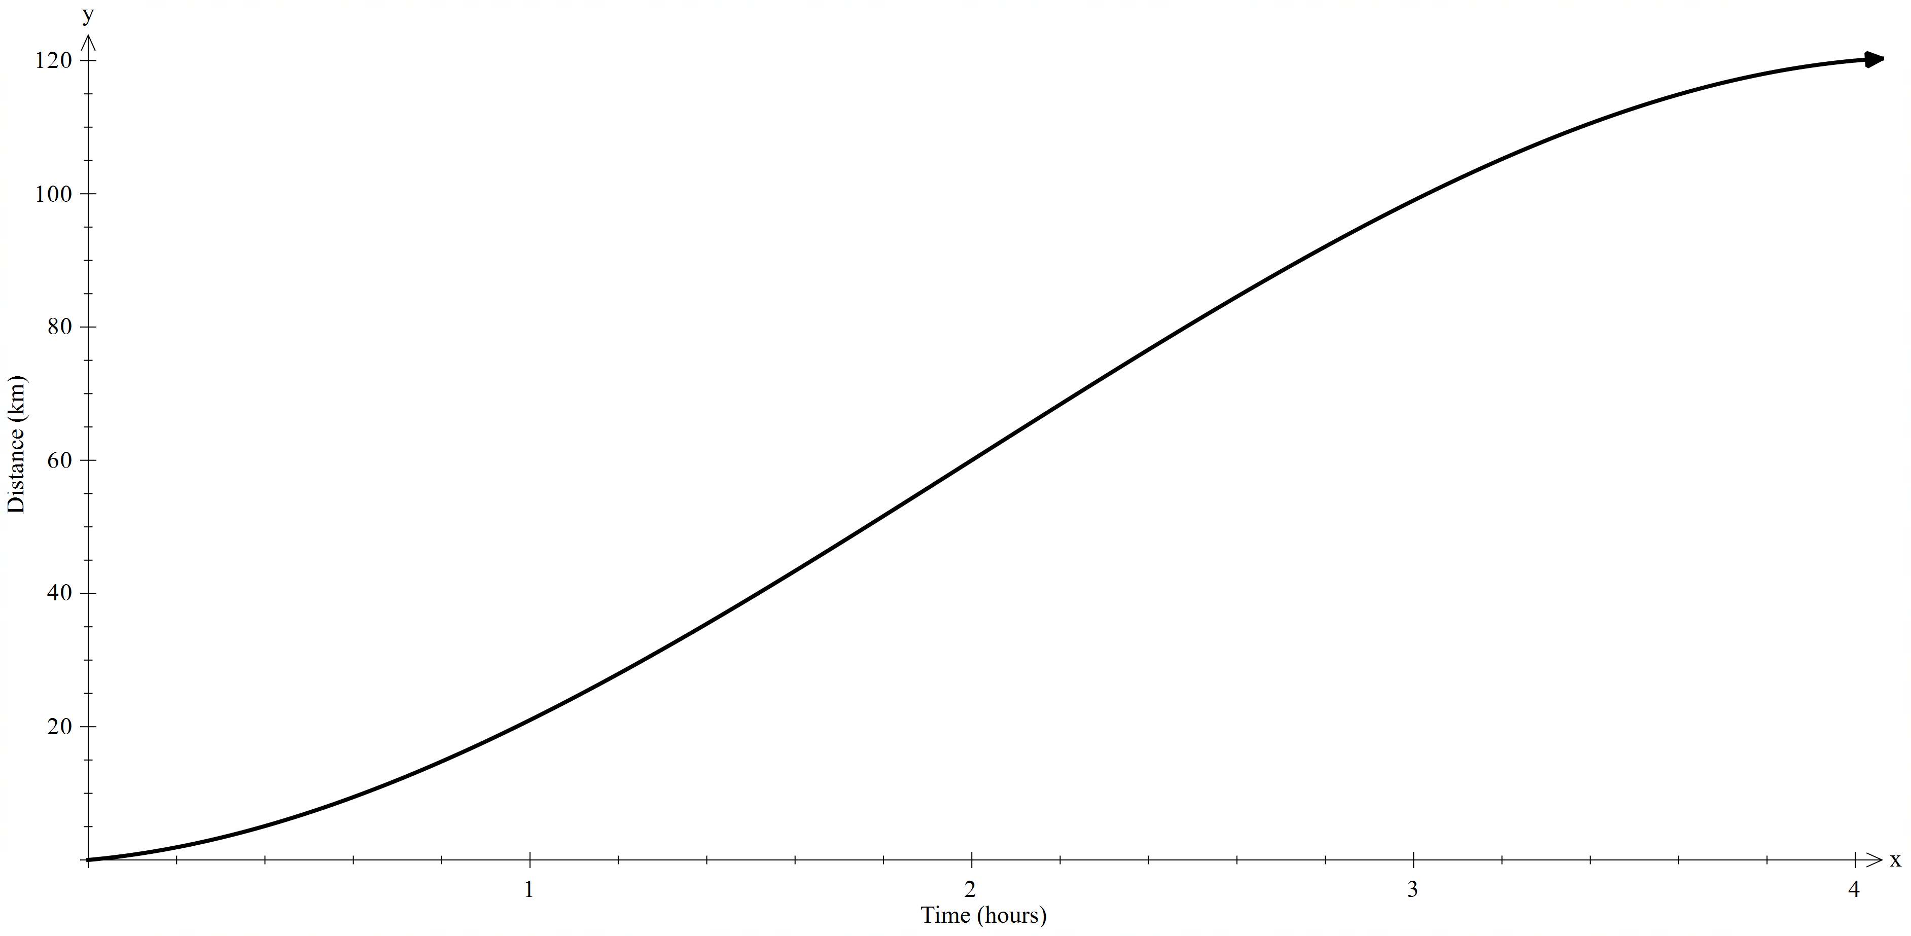

References
This resource contains NSW Curriculum and syllabus content. The NSW Curriculum is developed by the NSW Education Standards Authority. This content is prepared by NESA for and on behalf of the Crown in right of the State of New South Wales. The material is protected by Crown copyright.
Please refer to the NESA Copyright Disclaimer for more information https://educationstandards.nsw.edu.au/wps/portal/nesa/mini-footer/copyright.
NESA holds the only official and up-to-date versions of the NSW Curriculum and syllabus documents. Please visit the NSW Education Standards Authority (NESA) website https://educationstandards.nsw.edu.au/ and the NSW Curriculum website https://curriculum.nsw.edu.au/.
Mathematics Advanced 11–12 Syllabus © NSW Education Standards Authority (NESA) for and on behalf of the Crown in right of the State of New South Wales, 2024.
NESA (NSW Education Standards Authority (2024) ‘Glossary’, Mathematics Advanced 11–12 (2024), NESA website, accessed 22 July 2025.
© State of New South Wales (Department of Education), 2025
The copyright material published in this resource is subject to the Copyright Act 1968 (Cth) and is owned by the NSW Department of Education or, where indicated, by a party other than the NSW Department of Education (third-party material).
Copyright material available in this resource and owned by the NSW Department of Education is licensed under a Creative Commons Attribution 4.0 International (CC BY 4.0) license.

This license allows you to share and adapt the material for any purpose, even commercially.
Attribution should be given to © State of New South Wales (Department of Education), 2025.
Material in this resource not available under a Creative Commons license:
- the NSW Department of Education logo, other logos and trademark-protected material
- material owned by a third party that has been reproduced with permission. You will need to obtain permission from the third party to reuse its material.
Links to third-party material and websites
Please note that the provided (reading/viewing material/list/links/texts) are a suggestion only and implies no endorsement, by the New South Wales Department of Education, of any author, publisher, or book title. School principals and teachers are best placed to assess the suitability of resources that would complement the curriculum and reflect the needs and interests of their students.
If you use the links provided in this document to access a third-party's website, you acknowledge that the terms of use, including licence terms set out on the third-party's website apply to the use which may be made of the materials on that third-party website or were permitted by the Copyright Act 1968 (Cth). The department accepts no responsibility for content on third-party websites.

