Average speed
In this lesson, students consider how an average speed camera (point-to-point camera) works and connect average speed to the gradient of a linear function.

Learning intentions
- To understand and calculate average speed as a rate of change of distance with respect to time.
- To be able to interpret and analyse distance–time graphs.

Success criteria
- I can identify and calculate the change in distance and the change in time from data and graphs to calculate average speed.
- I can determine average speed from a distance–time graph.
- I can explain why average speed may differ from instantaneous speeds during a journey.
- I can recognise that the average speed is represented by the gradient of a linear function.

Outcomes
A student:
- develops understanding and fluency in mathematics through exploring and connecting mathematical concepts, choosing and applying mathematical techniques to solve problems, and communicating their thinking and reasoning coherently and clearly MAO-WM-01
- interprets the meaning of the derivative and determines the derivative of functions to solve problems MAV-11-06

Content

Estimating change
- Define the average rate of change of 𝑦 with respect to 𝑥 for a function 𝑦 = 𝑓(𝑥) over the domain [𝑎,𝑏] as Δ𝑦/Δ𝑥 = (change in 𝑦)/(change in 𝑥), that is Δ𝑦/Δ𝑥= (𝑓(𝑏)-𝑓(𝑎))/(𝑏−𝑎), and recognise (𝑓(𝑏)-𝑓(𝑎))/(𝑏−𝑎) as the gradient of the secant through (𝑎,𝑓(𝑎)) and (𝑏,𝑓(𝑏)) on the graph of 𝑦 = 𝑓(𝑥)
- Recognise speed as a rate of change of distance with respect to time
- Use the definition for average rate of change to determine the average speed of an object from a given distance–time graph
- Recognise when modelling with a linear function that its gradient is the rate of change and determine the rate of change for linear functions in practical situations
Mathematics Advanced 11–12 Syllabus © NSW Education Standards Authority (NESA) for and on behalf of the Crown in right of the State of New South Wales, 2024
Table 1: lesson summary
Section | Summary of activity | Teaching strategies | Teaching points
Activating prior knowledge | Students explore how average speed cameras work through discussion, a video (bit.ly/average_speed_camera) (1:00), and slides 4–5 of the PowerPoint Average speed, linking to the constant speed. They calculate the distance and time between cameras. | Pose-Pause-Pounce-Bounce  Think-Pair-Share  Mini whiteboards | Students revise the calculations of average speed.
Connecting learning | Students calculate average speeds from slide 7, interpret and label a distance–time graph from slide 8 and Appendix A and connect gradients to speed using slide 9. They use delta notation to link rate of change on slide 10, then compare section speeds with overall speed. | Pose-Pause-Pounce-Bounce  Think-Pair-Share  Mini whiteboards | Students are introduced to delta notation and make connections between the gradient formula and the average speed formula.
Releasing responsibility | Students look at the distance–time graph in Appendix B and slide 12, to find whether the cars were speeding during the average speed camera section. They then make notes with Appendix C. | Pose-Pause-Pounce-Bounce  Mini whiteboards  Frayer diagram | Students calculate the average speed between 2 points given a function, connecting the co-efficient of $x$ (gradient) to speed.
Independent practice | Students watch (bit.ly/thehareandthetortoise) (0:44) and then use the equations on slides 14 and 15 to find the average speeds and plot them on a distance–time graph Appendix D. | Think-Pair-Share | Students apply skills to the tale of The Hare and The Tortoise.

Activity structure
Please use the associated PowerPoint Average speed to display images in this lesson.

Activating prior knowledge
- Display slide 4 of the PowerPoint Average speed showing an example of average speed cameras on the Hume Highway at Coolac, NSW, to activate prior knowledge.
Average speed cameras are also known as point-to-point cameras.
- Use the Pose-Pause-Pounce-Bounce questioning strategy (PDF 557 KB) (bit.ly/posepausepouncebounce) to initiate a class discussion on ‘How do you think speed cameras work?’
- Show the video, ‘How average speed cameras work’ (1:00) (bit.ly/average_speed_camera).
- Continuing the class discussion, ask students:
- If you drove 100 km in 1 hour, what would be your average speed?
- Is this the speed you travel at for the entire 100 km? Why/why not?
Students should be able to determine that the average speed is $100 km/h$, making connection to the speed formula, $speed =\frac{ distance}{time}$.
Students should also notice that maintaining a constant speed of $100 km/h$ is extremely difficult as speed may vary with traffic, road conditions, terrain, weather conditions and the driver’s physical capabilities. Students may refer to cruise control, but it is important to note that cruise control doesn’t always maintain the top speed.
- In a Think-Pair-Share (bit.ly/thinkpairsharestrategy), and using mini whiteboards (bit.ly/miniwhiteboards), have students use the information shown on slide 5 to calculate the distance between the 2 average speed cameras.
The distance is found by $d=s× t║d=90×\frac{1}{60}║d=15 km$. Students may need to review how to use the ‘degrees, minutes, seconds’ key on their calculator to enter the time in minutes unless they enter the time as a fraction of an hour.
- Continuing on mini whiteboards, in a Think-Pair-Share, ask students to calculate the minimum time it should have taken the car to drive between the cameras.
Students could use the formula $t=\frac{d}{s}$ to find the time, 11 minutes and 15 seconds.

Connecting learning
- Inform students that the distance between the 2 cameras on the Hume Highway from slide 4 of the PowerPoint is 16 km.
- Display slide 7 showing 3 examples of different times taken to travel between the 2 cameras.
- Working in pairs, students use mini whiteboards to find the average speed travelled between the 2 cameras, given the times taken to pass between the 2 cameras.
- Animate the slide to show the calculation of each speed.
- Display slide 8 and distribute a copy of Appendix A ‘Travel along the Hume Highway’ to each pair. This appendix shows a distance–time graph of Jack travelling in a car on a journey along the Hume highway from Melbourne to Sydney. Read the following scenario:
Jack leaves Melbourne at 6 am and travels along the Hume Highway to Sydney. He stops for an hour at Jugiong for a break. Roadworks affect travel for the next hour as he heads towards Bookham. After Bookham, he increases his speed as he continues travelling to Sydney.
- Have students label the start and end of the journey (at Sydney, 6 pm) and the different places from the scenario on their graph.
- In a Think-Pair-Share, ask students:
- Which part of the graph is the steepest?
- How could you show that it is the steepest part?
- Which part of the graph is the least steep?
- What is happening when the graph is the flattest?
Students should observe that the steepest part is the first part of the journey, and the flattest part is when Jack stops for an hour in the middle of the journey. Students should be able to calculate the gradient of each section of the graph using the gradient formula. Students may need reminding of the gradient formula from Unit 3 – working with linear and quadratic functions.
- Display slide 9 showing the calculations for the gradient for each section.
- Ask students to calculate the average speed travelled between Bookham and Sydney.
- In a Pose-Pause-Pounce-Bounce, ask students what they notice about the gradient of the graph between Bookham and Sydney, and the average speed travelled between the 2 places.
Students should connect the distance travelled as $y_{2}-y_{1}$ and the time taken as $x_{2}-x_{1}$. They should make the connection that the gradient of a section in the distance–time graph represents the speed for that section.
- Display slide 10 showing the average speed formula, introducing delta notation. Explicitly make a connection to the distance travelled as the ‘change in distance’ and the time taken as ‘change in time’. Animate the slide once to show the self-explanation prompt.
Delta notation: Delta is the fourth letter of the Greek alphabet. The uppercase letter is represented by the symbol $∆$ and is used in mathematics to mean ‘change of’.
- In a Think-Pair-Share, ask:
- What was the average speed between Melbourne and Jugiong?
- Hence, what is the rate of change (gradient of the line) on the distance–time graph from Melbourne to Jugiong?
Students should make the connection that the rate of change, in this case, the speed, is given by the gradient of the line connecting the 2 points.
- In pairs and using mini whiteboards, have students write an expression in terms of distance and time for a car travelling at a constant speed of 80 km/h.
Students should notice that this is a direct variation relationship and the equation is $d=80×t,$ where 80 is the constant of variation.
- Animate slide 10 showing the formula is $\frac{∆y}{∆x}=\frac{f\left(b\right)-f\left(a\right)}{b-a}$.
- Using the formula shown on the slide, have students calculate the average speed (rate of change) between 8 hours and 12 hours of Jack’s trip.
$$\frac{∆y}{∆x}=\frac{f\left(b\right)-f\left(a\right)}{b-a} \\ =\frac{80×12-80×8}{12-8}=\frac{320}{4}=80 km/h$$
Students should notice that because the speed is constant, the line is linear, and the speed (and gradient) is consistent all along the line.
- Have students draw a line from Melbourne to Sydney on their graph.
- Ask students to calculate the ‘overall average speed’ between Melbourne and Sydney.
- In a Think-Pair-Share, ask students why the calculated figure is not a speed they have travelled at over the journey?
The overall average speed is the overall distance divided by the total time and includes times when they are stopped and going at different speeds.$s=\frac{950}{12}=79 km/h$.
Students may also notice that the line is almost the same as the line representing the journey from Bookham to Sydney, however the calculation shows that it is slightly slower.

Releasing responsibility
- Use the Pose-Pause-Pounce-Bounce questioning strategy to initiate a class discussion on the following questions:
- How realistic is the scenario that the car travels at 80 km/h for the whole of a $3$ hour trip?
- How could someone speed and still have the same average speed as someone driving safely?
- A car travels 60 km in the first hour, then 40 km in the second hour. What is their average speed? Do they ever travel at that speed? Why/why not?
Students should recognise that while the 2 cars may have the same average speed, one may constantly remain at that speed, while the other's speed may fluctuate, including periods where they are travelling above the speed limit.
- Using their mini whiteboards (or A3 plastic sleeves), ask students to draw a graph to represent a car travelling 90 km in 1.5 hours. Calculate the average speed of the car from the graph.
- Distribute Appendix B ‘Average speed camera travel’ to each pair.
- Display slide 12 showing the journey of 5 cars (from Appendix B) that are travelling through average speed cameras. The average speed cameras are between 9 and 20 km into the journey. The speed limit is 110 km/h.
- Working in pairs, have students determine which drivers were speeding and which were not. The average speed cameras have a tolerance of 2 km/h.
- Students are to compare decisions with a neighbouring pair, justifying their determination.
Students’ answers may vary slightly depending on how accurately they have read the graphs. They should be encouraged to approximate to one decimal place for their time calculations.
- To clarify the concept of average speed, have students complete their own Appendix C ‘Frayer diagram’ (bit.ly/frayerdiagram).

Independent practice
- Watch the video ‘The Hare and The Tortoise’ (0:44) (bit.ly/thehareandthetortoise) to remind or introduce students to the story before reading this scenario:
When a hare mocked a tortoise for being so slow, the tortoise replied that it could beat the hare in a race. The hare agreed to race against the tortoise. When the race started, both animals took off. The hare raced off at a constant speed represented by $f\left(x\right)=15x$. The hare was so confident they would win that they stopped to have a sleep half an hour in. The tortoise continued at a constant speed, represented by the equation $f\left(x\right)= 10x$. The hare woke up half an hour later, realised it had overslept and raced to the finish line at a speed represented by $f\left(x\right)=20x$, but the tortoise just beat the hare to the finish line ‘by a nose’.
- Display slide 14 of the PowerPoint, which shows the details of the race, and ask students, in a Think-Pair-Share, to calculate the average speed of the tortoise. Distribute Appendix D ‘The Hare and The Tortoise’ and have students complete the distance–time graph for the tortoise.
$$\frac{∆y}{∆x}=\frac{f\left(b\right)-f\left(a\right)}{b-a} \\ =\frac{10×1-10×0}{1-0}=\frac{10}{1}=10 km/h$$
Students may also recognise the speed as the rate, or gradient ($m$) in the equation $f\left(x\right)=mx$.
- Continuing in pairs, ask students to determine the average speed in the 3 sections of the hare’s race, and draw it on the graph before finding the overall average speed of the hare.
Before the rest, the hare’s speed was 15 km/h, during the nap it was 0 km/h and after the nap it was 20 km/h.
If the tortoise just beat the hare home, the finish line must be just before where the 2 graphs intersect after the hare’s rest. The distance could then be used to determine the overall average speed of the hare. The lines intersect at 12.5 km.

The overall average
$$\frac{∆y}{∆x}=\frac{f\left(b\right)-f\left(a\right)}{b-a} \\ =\frac{12.5-0}{1 h 15 mins-0}=\frac{12.5}{1°{15}^{'}} \\ =10 km/h$$
- Using a Think-Pair-Share, students determine how much quicker the hare would have completed the race if it had maintained its initial speed and not stopped to sleep.
- Read the following scenario out to the students. It is also shown on slide 15.
A donkey also competed in the race. The donkey was confident that it could beat both the hare and the tortoise. When the race started, the donkey took off quickly. However, the donkey got lost, had to retrace its steps, stubbornly refused to cross a stream and slowed down to graze on some delicious grass as it raced. Donkey ended up finishing the race after the hare and the tortoise.
- Continuing in pairs, ask students to add to the distance–time graph, a journey that fits the scenario above and then calculate the average speed during each section of the graph and the overall average speed.
Emphasise the link between the story events (nap, grazing, retracing steps) and the graph features (flat lines, downward slopes, shallow gradients).

Assessment and differentiation

Suggested opportunities for differentiation
Activating prior knowledge
- Assist students who need support in using the degrees, minutes and seconds function on their calculator.
- Use sentence starters for discussions: ‘I think speed cameras work by …’, ‘Average speed is different from constant speed because …’
Connecting learning
- Challenge students by adjusting the times along the Hume Highway journey to see how the average speed varies.
- Allow responses in either form: ‘$speed =\frac{ rise}{run} = \frac{240}{3} = 80 km/h$’ or ‘The car travels 240 km in 3 h, so 80 km/h.’
- Use sentence starters or scaffolds for explanations:
- The steepest part of the graph is … because the car is travelling …
- The gradient is … km/h because the change in distance is … and the change in time is …
Releasing responsibility
- Provide a structured table for students needing support with columns for distance travelled, time, speed calculation and tolerance check.
- Ask students to extend, ‘What if the speed limit was lowered to 100 km/h? How would that change the fines?’
- For students who need language support, provide word banks with definitions (for example, speed, constant, average, limit, tolerance).
- For advanced learners, extend the non-examples in the Frayer diagram to include instantaneous speed versus variable speed to deepen conceptual contrast.
Independent practice
- Provide a pre-labelled axis with time and distance for students needing support to focus on plotting points. Higher-ability students can set up scales, determine intercepts and identify the exact intersection point.
- Give a scaffolded table of times and distances with missing values for students to fill in for each stage of donkey’s journey.
- Challenge students to create their own plausible non-linear time journey for the donkey and/or providing a different race distance. Ask students to recalculate average speeds and determine if the outcome changes.

Suggested opportunities for assessment
Activating prior knowledge
- Formatively assess depth of understanding and misunderstanding through Pose-Pause-Pounce-Bounce questioning.
- Assess students' ability to communicate reasoning alongside correct answers, through Think-Pair-Share responses.
Connecting learning
- Use mini whiteboards responses to assess students’ understanding and identify any misconceptions about average speed.
Releasing responsibility
- Review students completed Frayer diagrams to check for understanding of average speed and rates of change.
- Students can justify their choices to peers about who is fined, before the teacher checks clarity and accuracy of reasoning.
Independent practice
- Appendix D can be reviewed as a work sample for evidence of understanding.

Appendix A

Travel along the Hume Highway
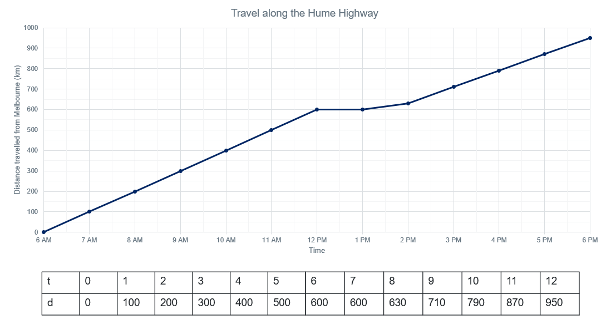

Appendix B

Average speed camera travel
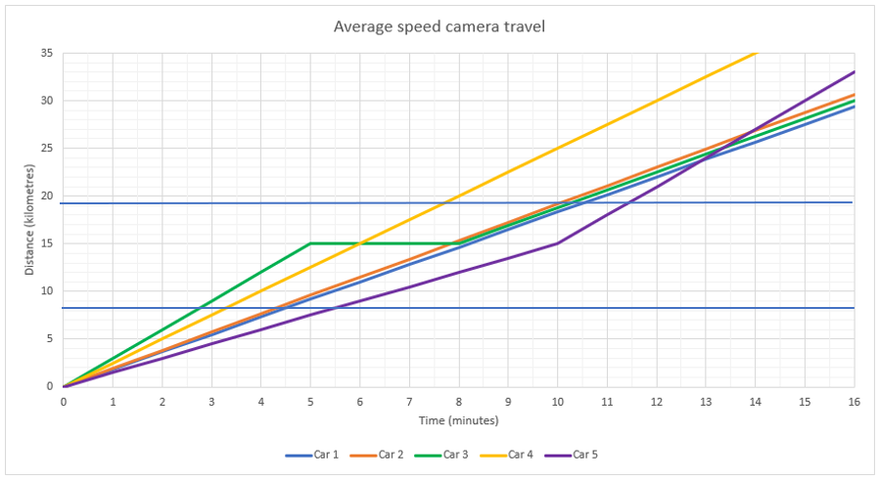

Appendix C

Frayer diagram
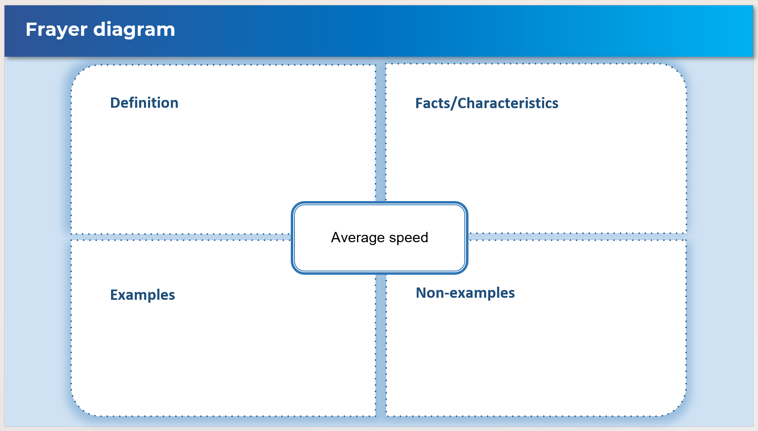

Appendix D

The Hare and The Tortoise
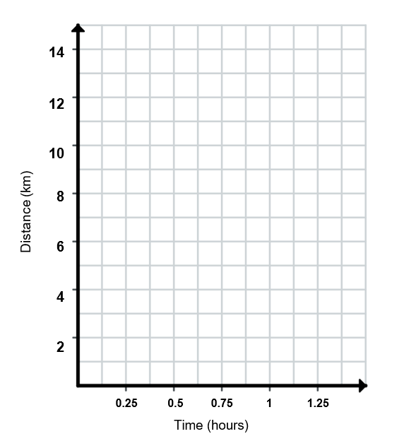

Sample solutions

Appendix B – average speed camera travel
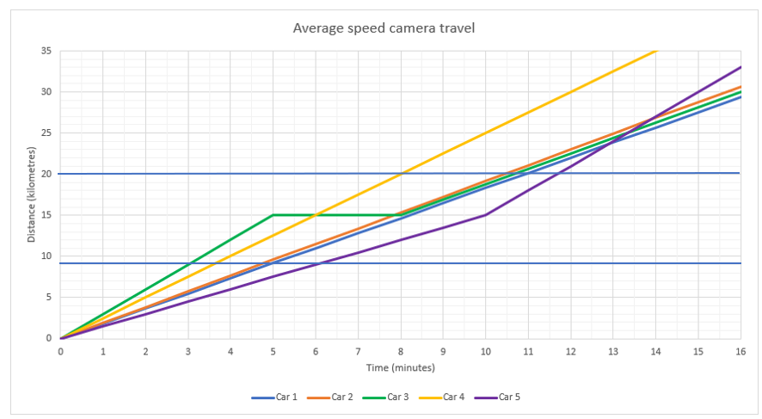
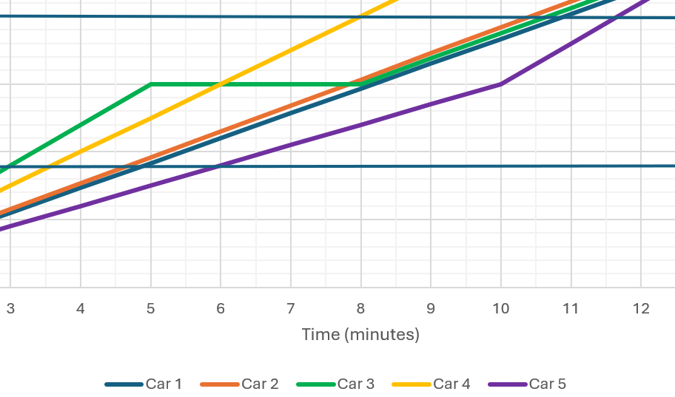
Car 1 Blue | Car 2 Orange | Car 3 Green | Car 4 Yellow | Car 5 Purple
$$s=\frac{d}{t} \\ =\frac{11 km}{\left(6÷60\right) h} \\ =110 km/h$$ | $$s=\frac{d}{t} \\ =\frac{11 km}{\left(5.9÷60\right) h} \\ =111.9 km/h \\ =112 km/h$$ | $$s=\frac{d}{t} \\ =\frac{11 km}{\left(6.6÷60\right) h} \\ =100 km/h$$ | $$s=\frac{d}{t} \\ =\frac{11 km}{\left(4.5÷60\right) h} \\ =147 km/h$$ | $$s=\frac{d}{t} \\ =\frac{11 km}{\left(5.7÷60\right) h} \\ =115.8 km/h$$
On speed limit – no fine | Within tolerance – no fine | Under limit – no fine | Over speed limit – fine | Over speed limit – fine

Appendix C – Frayer diagram
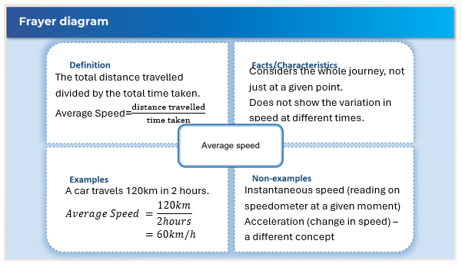

Appendix D – The Hare and The Tortoise
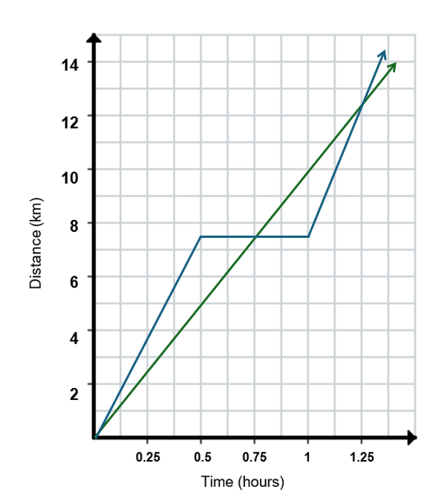

References
This resource contains NSW Curriculum and syllabus content. The NSW Curriculum is developed by the NSW Education Standards Authority. This content is prepared by NESA for and on behalf of the Crown in right of the State of New South Wales. The material is protected by Crown copyright.
Please refer to the NESA Copyright Disclaimer for more information https://educationstandards.nsw.edu.au/wps/portal/nesa/mini-footer/copyright.
NESA holds the only official and up-to-date versions of the NSW Curriculum and syllabus documents. Please visit the NSW Education Standards Authority (NESA) website https://educationstandards.nsw.edu.au/ and the NSW Curriculum website https://curriculum.nsw.edu.au/.
Mathematics Advanced 11–12 Syllabus © NSW Education Standards Authority (NESA) for and on behalf of the Crown in right of the State of New South Wales, 2024.

© State of New South Wales (Department of Education), 2025
The copyright material published in this resource is subject to the Copyright Act 1968 (Cth) and is owned by the NSW Department of Education or, where indicated, by a party other than the NSW Department of Education (third-party material).
Copyright material available in this resource and owned by the NSW Department of Education is licensed under a Creative Commons Attribution 4.0 International (CC BY 4.0) license.

This license allows you to share and adapt the material for any purpose, even commercially.
Attribution should be given to © State of New South Wales (Department of Education), 2025.
Material in this resource not available under a Creative Commons license:
- the NSW Department of Education logo, other logos and trademark-protected material
- material owned by a third party that has been reproduced with permission. You will need to obtain permission from the third party to reuse its material.
Links to third-party material and websites
Please note that the provided (reading/viewing material/list/links/texts) are a suggestion only and implies no endorsement, by the New South Wales Department of Education, of any author, publisher, or book title. School principals and teachers are best placed to assess the suitability of resources that would complement the curriculum and reflect the needs and interests of their students.
If you use the links provided in this document to access a third-party's website, you acknowledge that the terms of use, including licence terms set out on the third-party's website apply to the use which may be made of the materials on that third-party website or where permitted by the Copyright Act 1968 (Cth). The department accepts no responsibility for content on third-party websites.

