Applying graphing transformations
In this lesson students will examine the effects of multiple transformations on a function. They will use Amplify Classroom to identify when the order of transformations is important before practising sketching transformed functions and identifying the key features in their graphs.
Students will need at least one digital device per pair to interact with Amplify Classroom during this lesson.

Learning intention
- To be able to recognise and apply transformations to functions.

Success criteria
- I can apply multiple transformations to graphs of functions.
- I can describe the key features of the transformed graph.
- I can identify the order and type of transformation applied to the equation of a graph.

Outcomes
A student:
- develops understanding and fluency in mathematics through exploring and connecting mathematical concepts, choosing and applying mathematical techniques to solve problems, and communicating their thinking and reasoning coherently and clearly MAO-WM-01
- analyses and solves algebraic and graphical problems involving transformations of functions and relations MAV-11-03

Content

Graph transformations
- Apply reflections, translations and dilations to functions within the scope of the Mathematics Advanced course, excluding trigonometric functions, determine the function rule and the graph of the transformed function, the domain and range of the transformed graph, any intercepts, asymptotes and discontinuities where appropriate, and describe which transformations have been applied
- Recognise that the order in which individual transformations are applied to functions is important
Mathematics Advanced 11–12 Syllabus © NSW Education Standards Authority (NESA) for and on behalf of the Crown in right of the State of New South Wales, 2024.

Table 1: lesson summary
Section | Summary of activity | Teaching strategies | Teaching points
Activating prior knowledge | Lead a class discussion for students to recall the different types of transformations before using slide 4 of the PowerPoint Applying graphing transformations to have students complete 2 transformations. Display slide 5 to lead a discussion around how the order of transformations can change the final equation and graph. | Mini whiteboards  Notice and wonder | This section is designed for students to recall the transformations studied in this unit before considering what happens to an equation when 2 transformations are applied to it.
Connecting learning | Using the Amplify Classroom (bit.ly/ApplyingGraphingTransfromations) activity, students will investigate when the order of transformations matters before using slides 7–10 to complete worked examples where 3 transformations are applied to an equation. | Pose-Pause-Pounce-Bounce  Think-Pair-Share  Worked examples (Your turn) | Students will learn that when a translation and dilation or reflection are applied in the same direction, the order of transformation matters.
Releasing responsibility | Students will write notes to summarise their learning of transformations before using Appendix A to practise applying multiple transformations to equations and sketch their graphs. As students sketch these graphs, they need to identify the transformed domain and range as well as key features such as asymptotes and $x$- and $y$-intercepts. They will then complete Appendix B which is an HSC style question. | Visibly random groups of 3  Vertical non-permanent surfaces  Notes to future forgetful selves | Consolidate student learning by having them write notes and sketch graphs where multiple transformations are applied.
Independent practice | Using slides 12–16, students will solve an HSC style question and consider different methods for solving the same problem. | Approaching question scaffold  Gallery walk | This section looks at an HSC style question that can be solved algebraically using student understanding of quadratic functions and intercepts or with transformations.

Activity structure
Please use the associated PowerPoint Applying graphing transformations to display images in this lesson.

Activating prior knowledge
- Have students work in pairs, on mini whiteboards (bit.ly/miniwhiteboards) to recall the different transformations that can be applied to a graph. The transformations are:
- Reflect across the $y$-axis: replace $x$ with $-x$.
- Reflect across the $x$-axis: replace $y$ with $-y$.
- Translate up: replace $y$ with $y-b$.
- Translate down: replace $y$ with $y+b$.
- Translate left: replace $x$ with $x+b$.
- Translate right: replace $x$ with $x-b$.
- Enlarge/reduce by a factor of $k$: replace $x$ and $y$ with $\frac{x}{k}$ and $\frac{y}{k}$. When $k>1$, it is an enlargement, when $0<k<1$, it is a reduction.
- Dilate horizontal by a factor of $k$: replace $x$ with $\frac{x}{k}$.
- Dilate vertically by a factor of $l$: replace $y$ with $\frac{y}{l}$.
- Display slide 4 of the PowerPoint which shows the graph of $y=x^{3}$ and a description of a transformation. Ask students to sketch the transformed graph on their mini whiteboards, identifying key features including domain and range, before writing the equation of the transformed function.
Click to animate the slide 4 to reveal the solution.
- Display slide 5 which shows the same original cubic and 2 transformed graphs. Explain to students that both transformed graphs have undergone a translation of 5 units and a horizontal dilation factor of 2. Ask them to notice and wonder (bit.ly/noticewonderstrategy) about the differences in the graphs and their functions.
Students may notice that the graphs have the same shape but have different intercepts. They may also notice that both the functions have a minus 5 and are divided by 2, but the division is applied to only the $x$ in one function and to $x-5$ in the other. They may wonder how this has occurred.

Connecting learning
- With at least one device per pair, assign the Amplify Classroom activity ‘Applying graphing transformations’ (bit.ly/ApplyingGraphingTransfromations) for students to complete.
Before using this activity, you will need to set up an Amplify Classroom. (bit.ly/createamplifyclassroom).
When students enter their functions, ensure they are not entering any extra spaces as it will say that the answer is incorrect.
- By restricting students to screens 1–4 they will consider how the order of a translation upwards and a vertical dilation affects the function and the graph.
- Use the responses from screen 4 to lead a class discussion around why students think the graphs are different.
Students may suggest that the order of the transformations affects the graph.
- Extend the pacing to screens 5–7 where students consider how the order of the translation upwards and a horizontal dilation does not change the function or graph.
Screen 8 of the Amplify Classroom will be used in the ‘Releasing responsibility’ section of the lesson.
- Use the Pose-Pause-Pounce-Bounce questioning strategy (PDF 557 KB) (bit.ly/posepausepouncebounce) to lead a class discussion around why and when the order of a translation and dilation changes the final transformed graph. Some possible prompts include:
- How does translating a graph up or down affect the coordinates?
- How does vertically dilating a graph affect the coordinates?
- How does this relate to your understanding of order of operations?
- Would the order of translating left or right and then vertically dilating change the final function or graph?
Students should suggest that translation is an additive transformation while a dilation is a multiplicative transformation. When these are applied to the same axis ($x$- or $y$-), then the order of operations will apply to the transformation, resulting in different functions and graphs. When the transformations are applied to separate axes, the order does not matter.
- In a Think-Pair-Share (bit.ly/thinkpairsharestrategy), ask students to consider how a reflection affects a function and if it would affect the order of transformation.
Students should suggest that a reflection is multiplicative, so when it is applied on the same axis:
- with a translation, the order is important
- with a dilation, the order does not matter.
- Display slides 7–10 to use the Worked example (Your turn) (bit.ly/supportingstrategies) method for students to complete worked examples of 3 transformations and consider when the order is important.

Releasing responsibility
- Assign students to visibly random groups of 3 (bit.ly/visiblegroups) at vertical non-permanent surfaces (bit.ly/VNPSstrategy) and have them complete notes to their future forgetful selves (bit.ly/notestofutureself).
Some concepts that students should include in their notes are that:
- translations have an additive effect on functions while dilations and reflections have a multiplicative effect
- the order of transformations matters only when it is across the same axis and a translation is applied with a dilation or reflection.
- Print and cut out Appendix A ‘Transformation cards’ for students to complete on a sheet of graph paper printed on A3 in a plastic sleeve.
Teachers may wish to pre-cut these cards prior to the lesson. Graph paper can be found on the website ‘Free Printable Graph Paper’ (print-graph-paper.com/).
- Tell students that they will be practising graphing transformations by randomly drawing a function card and 2 transformations. Groups will then need to:
- Write the transformed function.
- Sketch the graph of the transformed function, identifying key features such as intercepts and asymptotes.
- State the domain and range of the transformed function.
- Enter their function into screen 8 of the Amplify Classroom activity to check their sketches.
- Continuing in their groups at vertical non-permanent surfaces, distribute Appendix B ‘Applying transformations’ which shows an HSC style question and gradually develops transformations from a given graph.

Independent practice
- Display slide 12 of the PowerPoint which shows an HSC-style question.
- Using the ‘Approaching questions scaffold’ on slide 13, lead a class discussion around the different focus areas that can be used to solve the problem.
Students should identify that this question requires them to apply their understanding of finding intercepts by solving quadratics and graphing transformations.
- Continuing in their groups of 3, provide time for groups to solve Part A at their vertical non-permanent surfaces.
- Conduct a gallery walk (bit.ly/DLSgallerywalk) such that students can give and receive feedback on how they solved Part A.
Some groups may have used transformations to find the second intercept while other groups may have solved the quadratic equation.
- Lead a discussion around how students could check their answer.
- Display slide 14 which shows the worked solution for Part A.
- Continuing in their groups, display slide 15 which shows Part B of the question. Provide time for students to complete Part B.
- Conduct another gallery walk for students to compare their solutions to Part B and make any adjustments they need to their solution.
- Display slide 16 which shows the solution to Part B and lead a discussion around the different methods of obtaining the solution.

Assessment and differentiation

Suggested opportunities for differentiation
Activating prior knowledge
- Support students who are still developing their graphing skills providing them with the graph of $y=x^{3}$ on the graph paper.
Connecting learning
- Monitor class progress on the teacher dashboard of Amplify Classroom and adjust pacing accordingly.
Releasing responsibility
- Using Appendix A, adjust the functions and transformations based on student needs. This activity can be adapted to support students by either focusing on a limited number of functions or transformations or by having them start with one transformation and gradually build to multiple transformations. You can also extend students by having them do more than 2 transformations.
- Extend students by having them consider if there is another way to obtain the same result, but using different transformations in a different order while they are completing Appendix A.
Independent practice
- Extend students by asking them to describe the transformations that have been applied to $g(x)$ or by writing $g(x)$ in terms of $f(x)$.

Suggested opportunities for assessment
Activating prior knowledge
- Teachers can monitor student progress and check for understanding of translations and dilations while students are working at vertical non-permanent surfaces.
- Students working in visibly random groups of 3 and during the gallery walk give and receive peer feedback.
Connecting learning
- Teachers can monitor student progress and understanding of how translations and dilations are represented in the equation of a graph by using the teacher dashboard in Amplify Classroom.
- Monitor student responses during class discussions to check for understanding of how translations are additive, while dilations and reflections are multiplicative, and that order matters when translations and dilations or reflections are done along the same axis.
- Student responses to the self-explanation prompts during worked examples provide an opportunity to assess student reasoning while monitoring student responses in the ‘Your turn’ section allows for checking for understanding of multiple transformations in order.
Releasing responsibility
- Monitor student responses as they collaborate to write notes to their future forgetful selves while they complete Appendix A and Appendix B. This will allow teachers to check for student understanding of transformations and how to apply them to functions, except trigonometric functions, within the context of the Mathematics Advanced course.
Independent practice
- Students could complete this section independently and their work could be collected as a work sample or Part B could be used as an exit ticket to check for understanding.

Appendix A

Transformation cards
Print and cut out the function and transformation cards. Teachers may wish the print the function cards on a different colour.
$$y=x$$ | $$y=x^{2}$$ | $$y=x^{3}$$
$$y=\left|x\right|$$ | $$y=\frac{1}{x}$$ | $$y=2^{x}$$

Translate left by 1 unit | Translate left by 3 units | Translate right by 1 unit
Translate up by 2 units | Translate up by 3 units | Translate down by 2 units
Translate down by 3 units | Reflect along $y$-axis | Reflect along $x$-axis
Horizontal dilation by a factor of 2 | Horizontal dilation by a factor of 0.5 | Horizontal dilation by a factor of 3
Horizontal dilation by a factor of 0.25 | Horizontal dilation by a factor of 1.5 | Vertical dilation by a factor of 2
Vertical dilation by a factor of 0.5 | Vertical dilation by a factor of 3 | Vertical dilation by a factor of 0.25
Vertical dilation by a factor of 0.75 | Enlarge by a factor of 2 | Reduce by a factor of 0.5
Horizontal dilation by a factor of 4 | Vertical dilation by a factor of 0.6 | Vertical dilation by a factor of 1.25

Appendix B

Applying transformations
Consider the graph of $y=f(x)$ as shown.
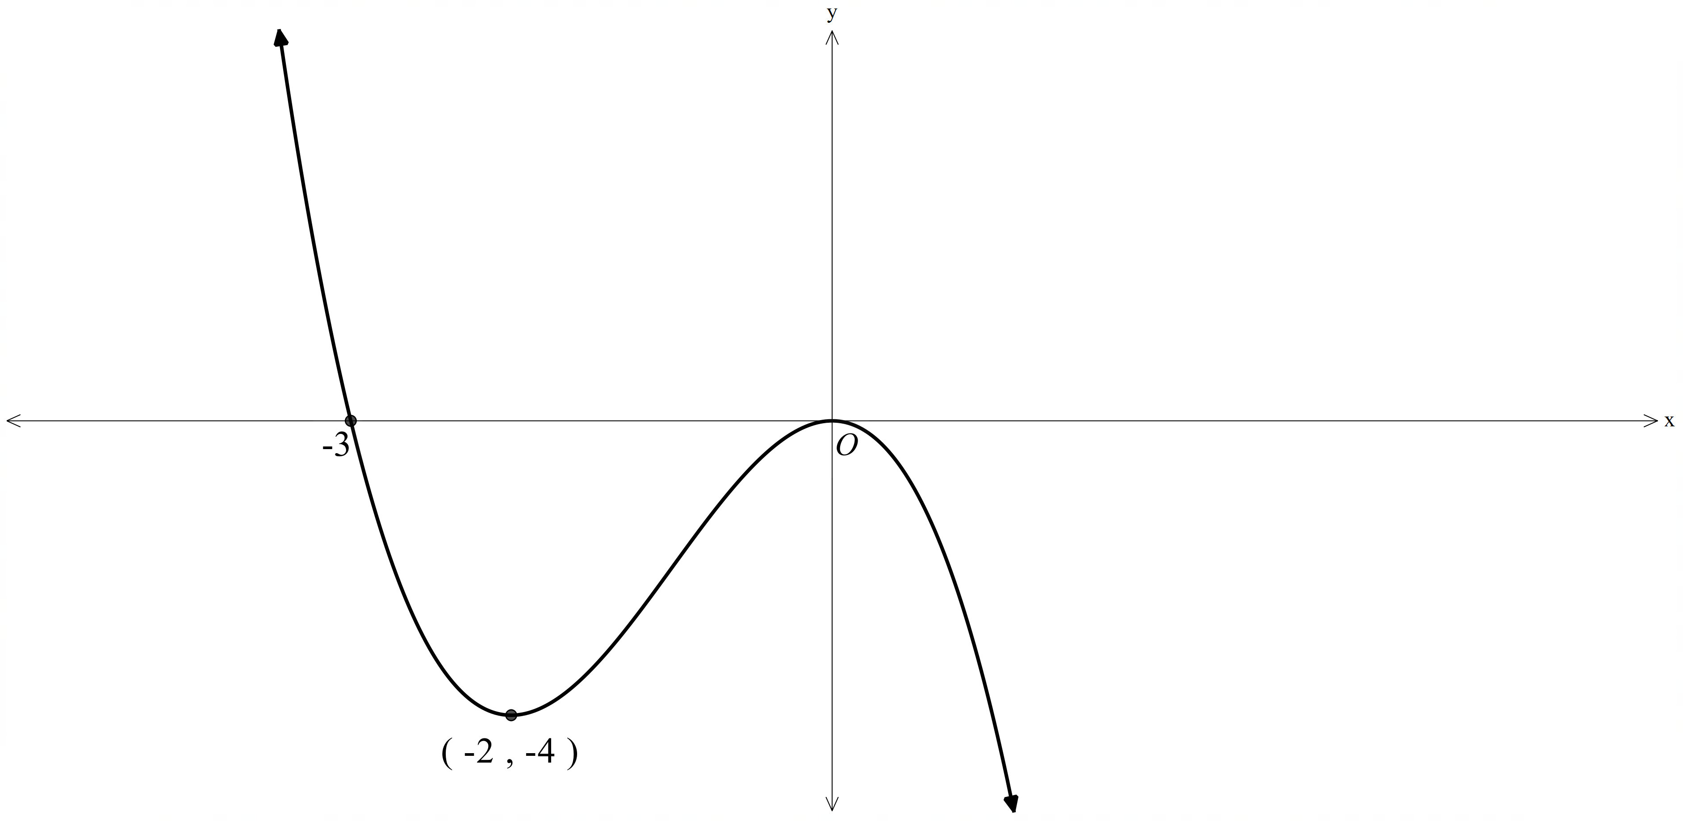
Sketch the graph of the following, showing the $x$-intercepts and the coordinates of the labelled point.
- $y=f\left(2x\right)$
- $y=f(2x-4)$
- $y=3f\left(2x-4\right)$
- $y=-3f\left(2x-4\right)$

Sample solutions

Appendix B – applying transformations
- $y=f(2x)$
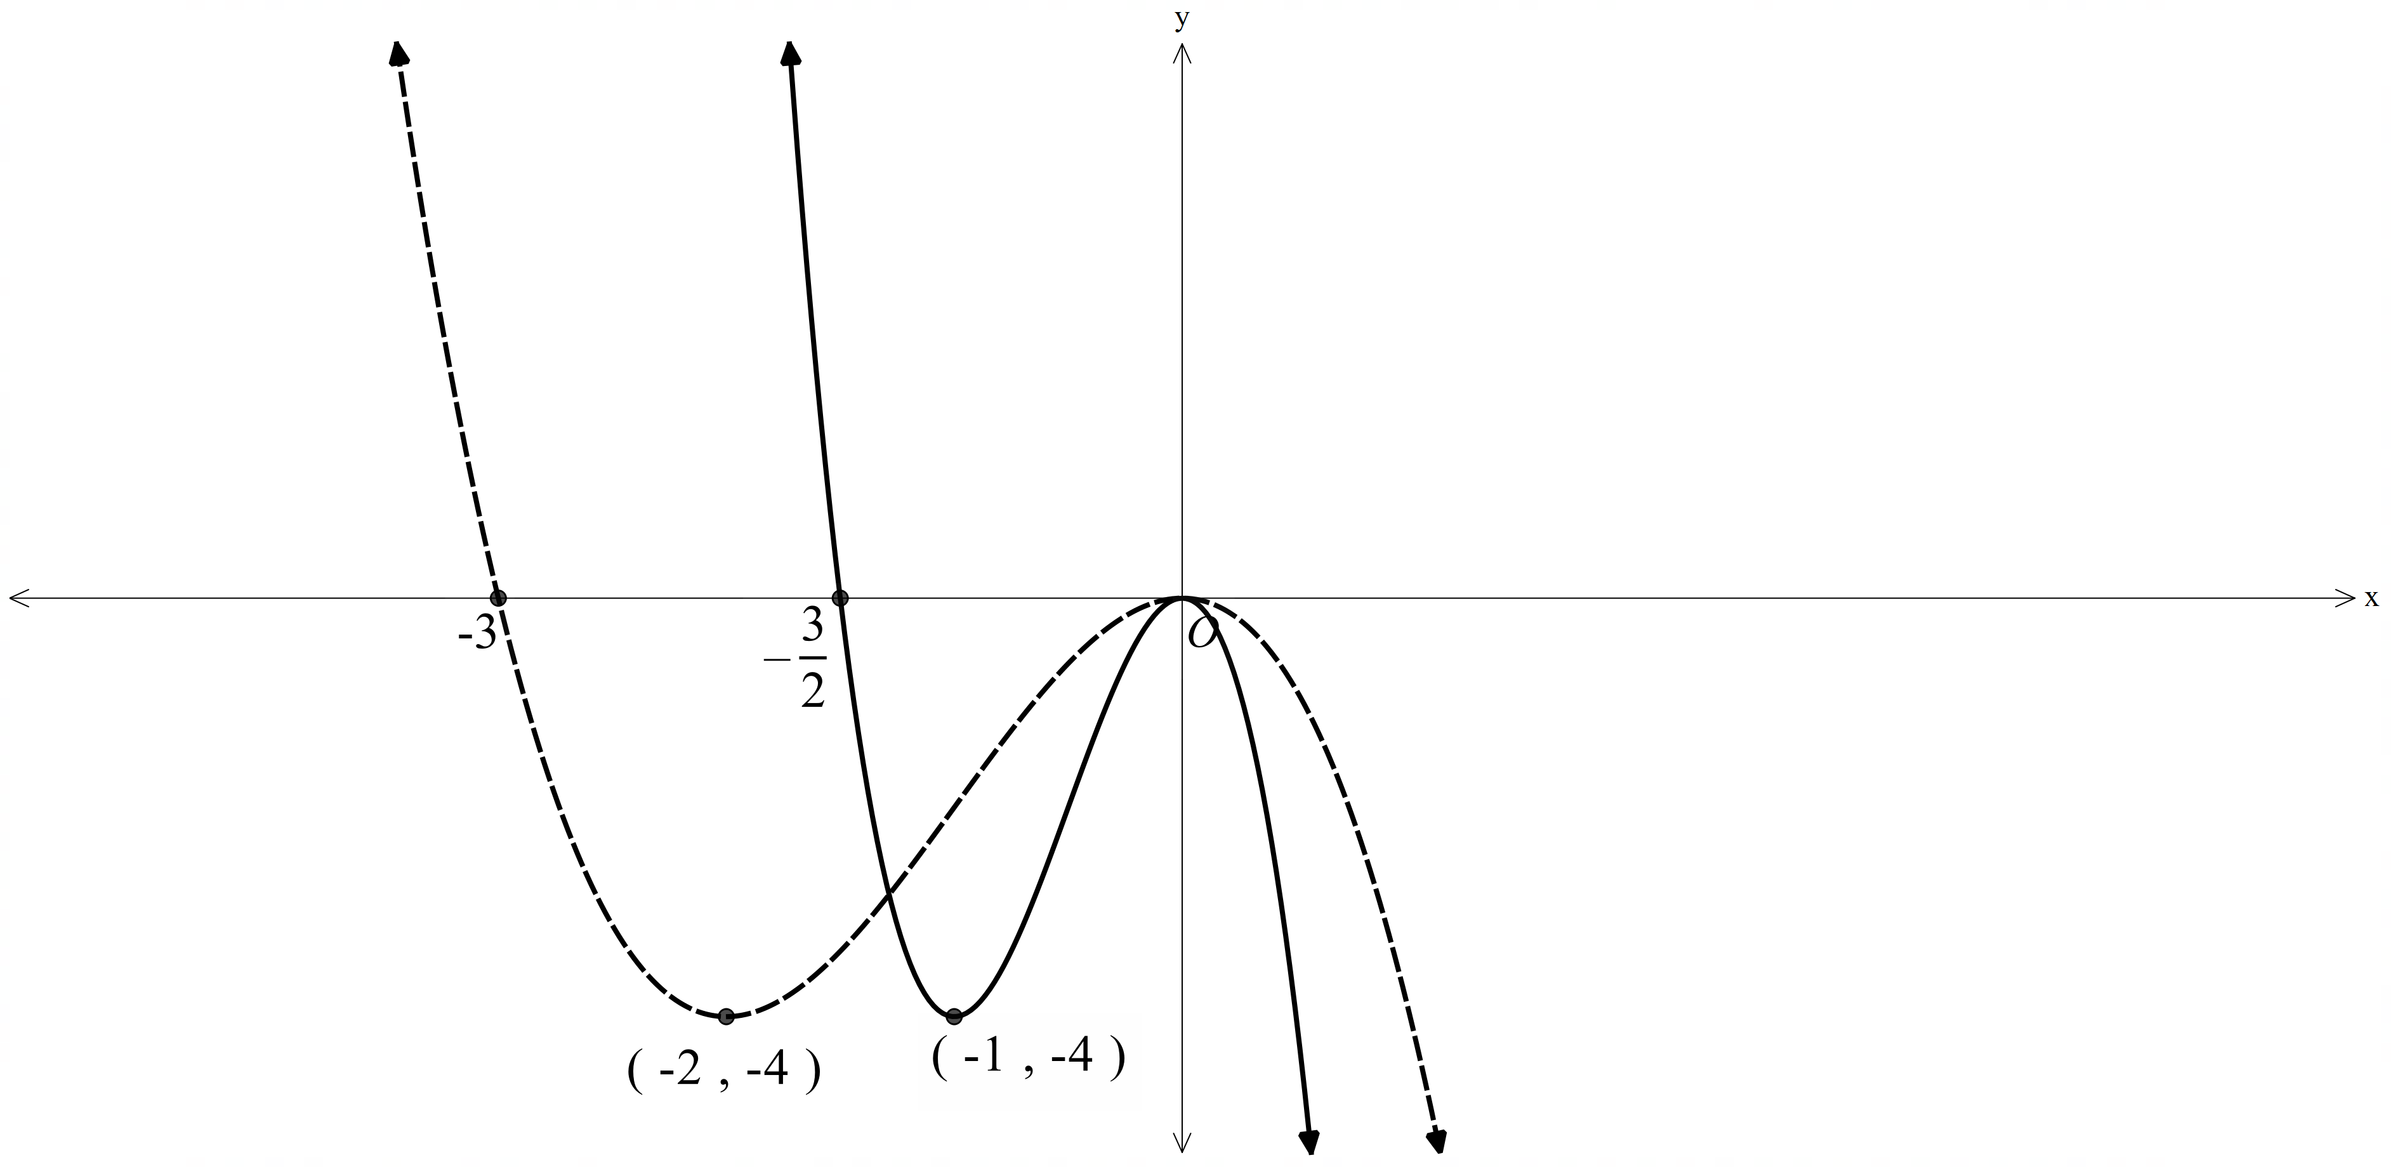
- $y=f(2x-4)$
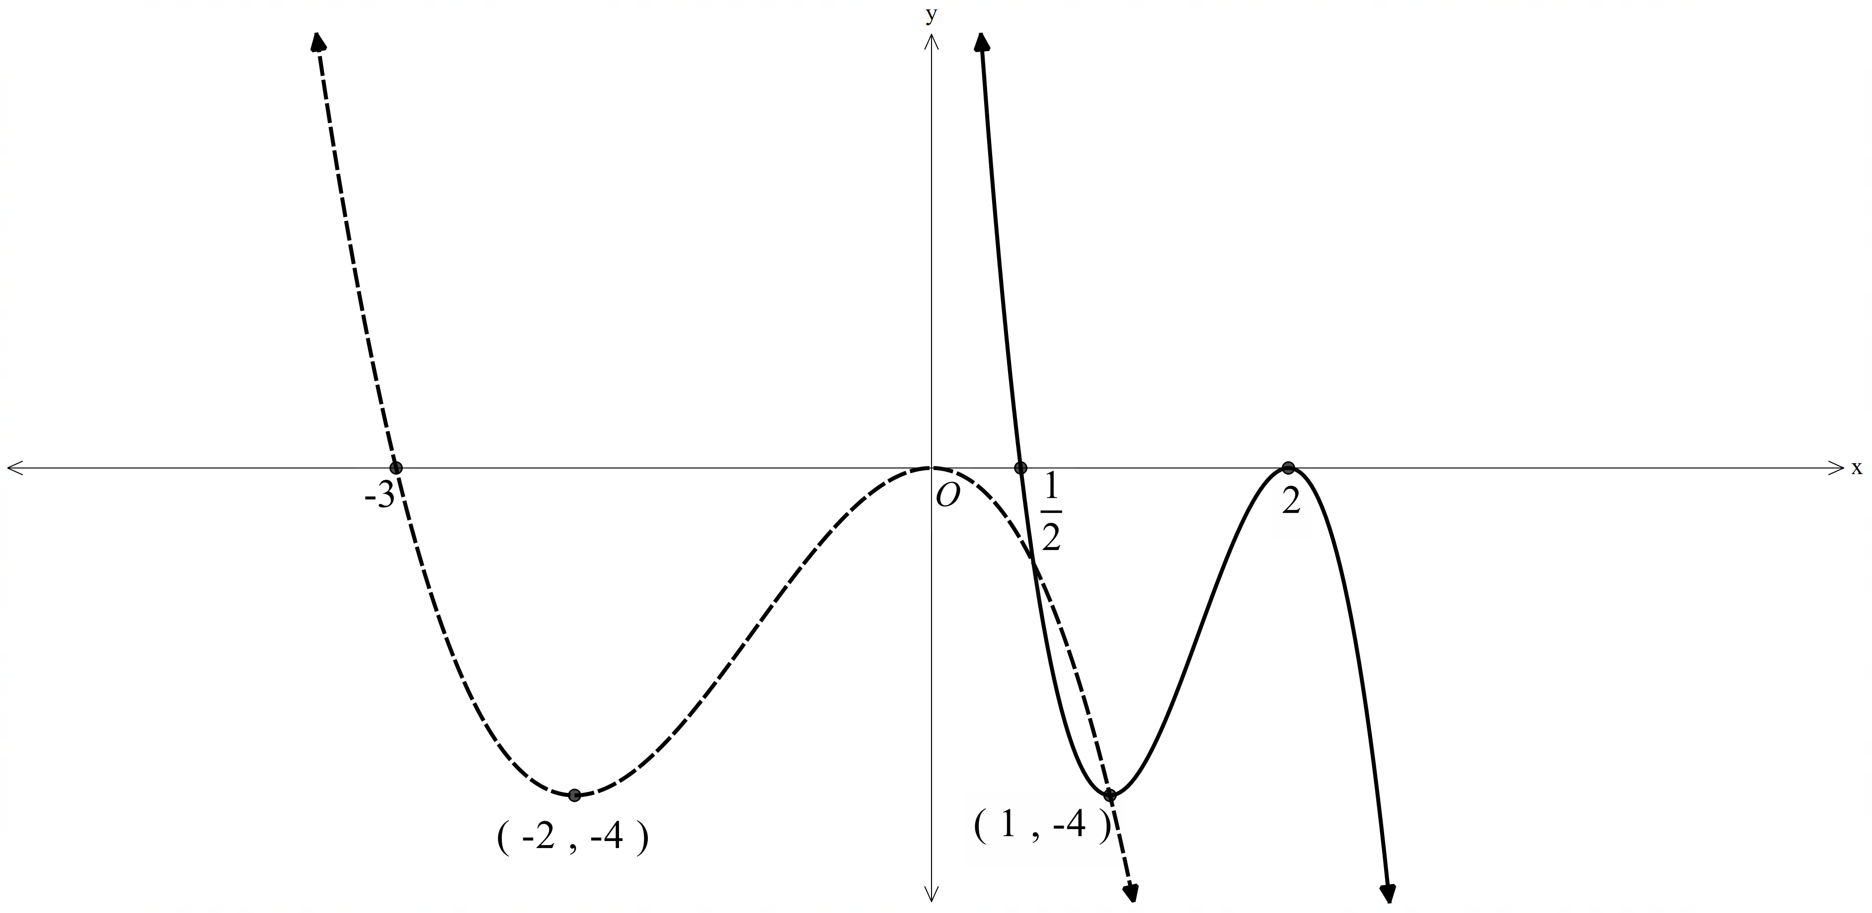

- $y=3f(2x-4)$
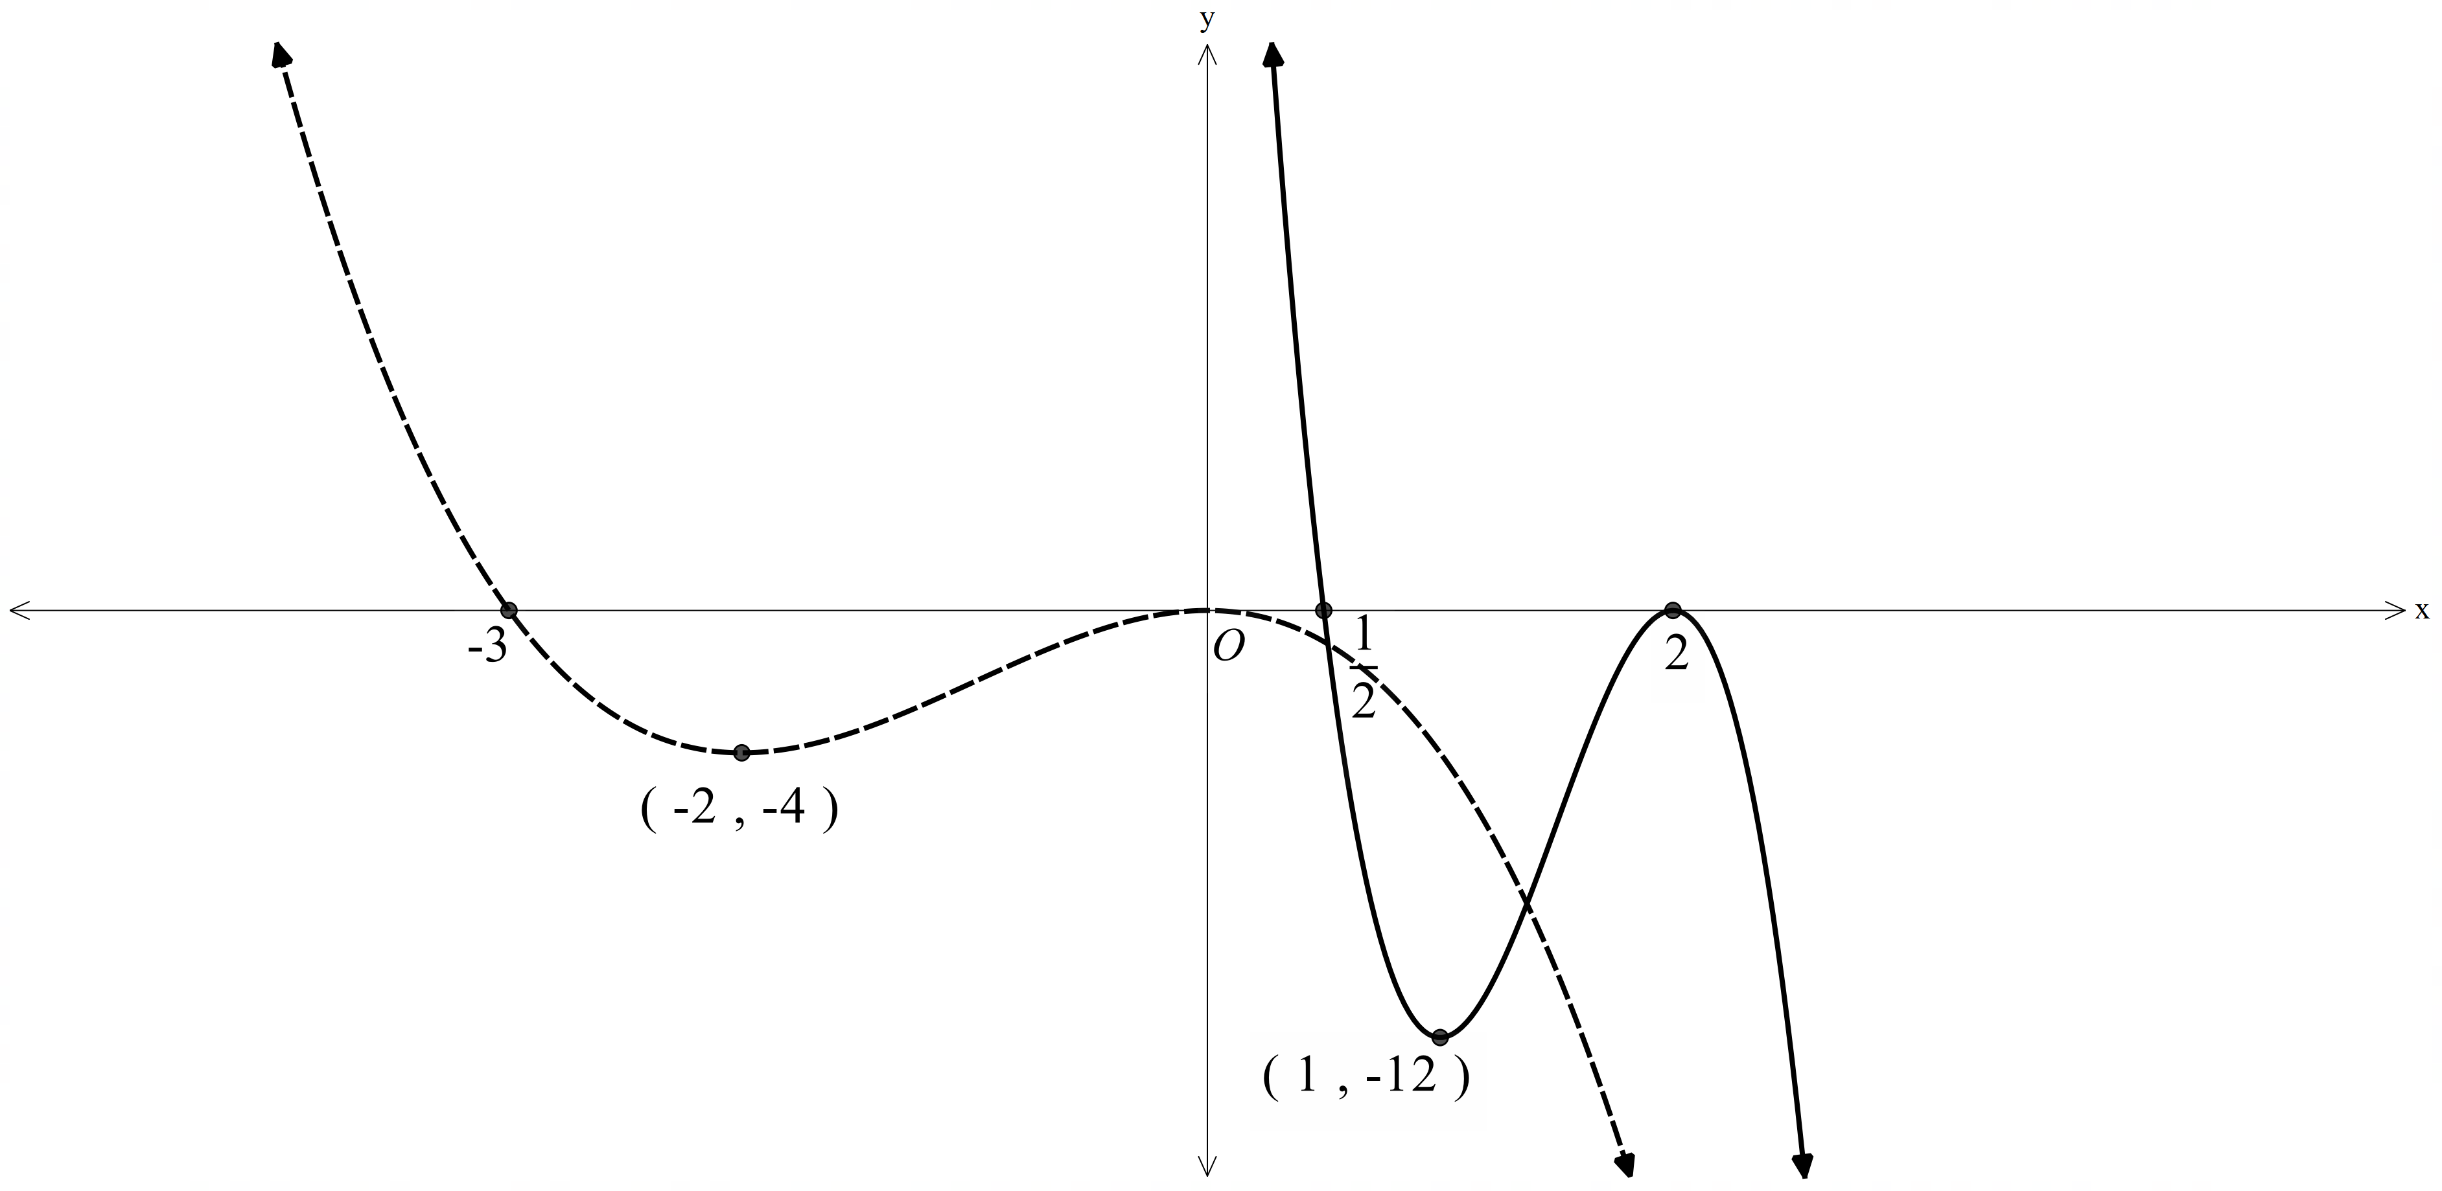
- $y=-3f\left(2x-4\right)$
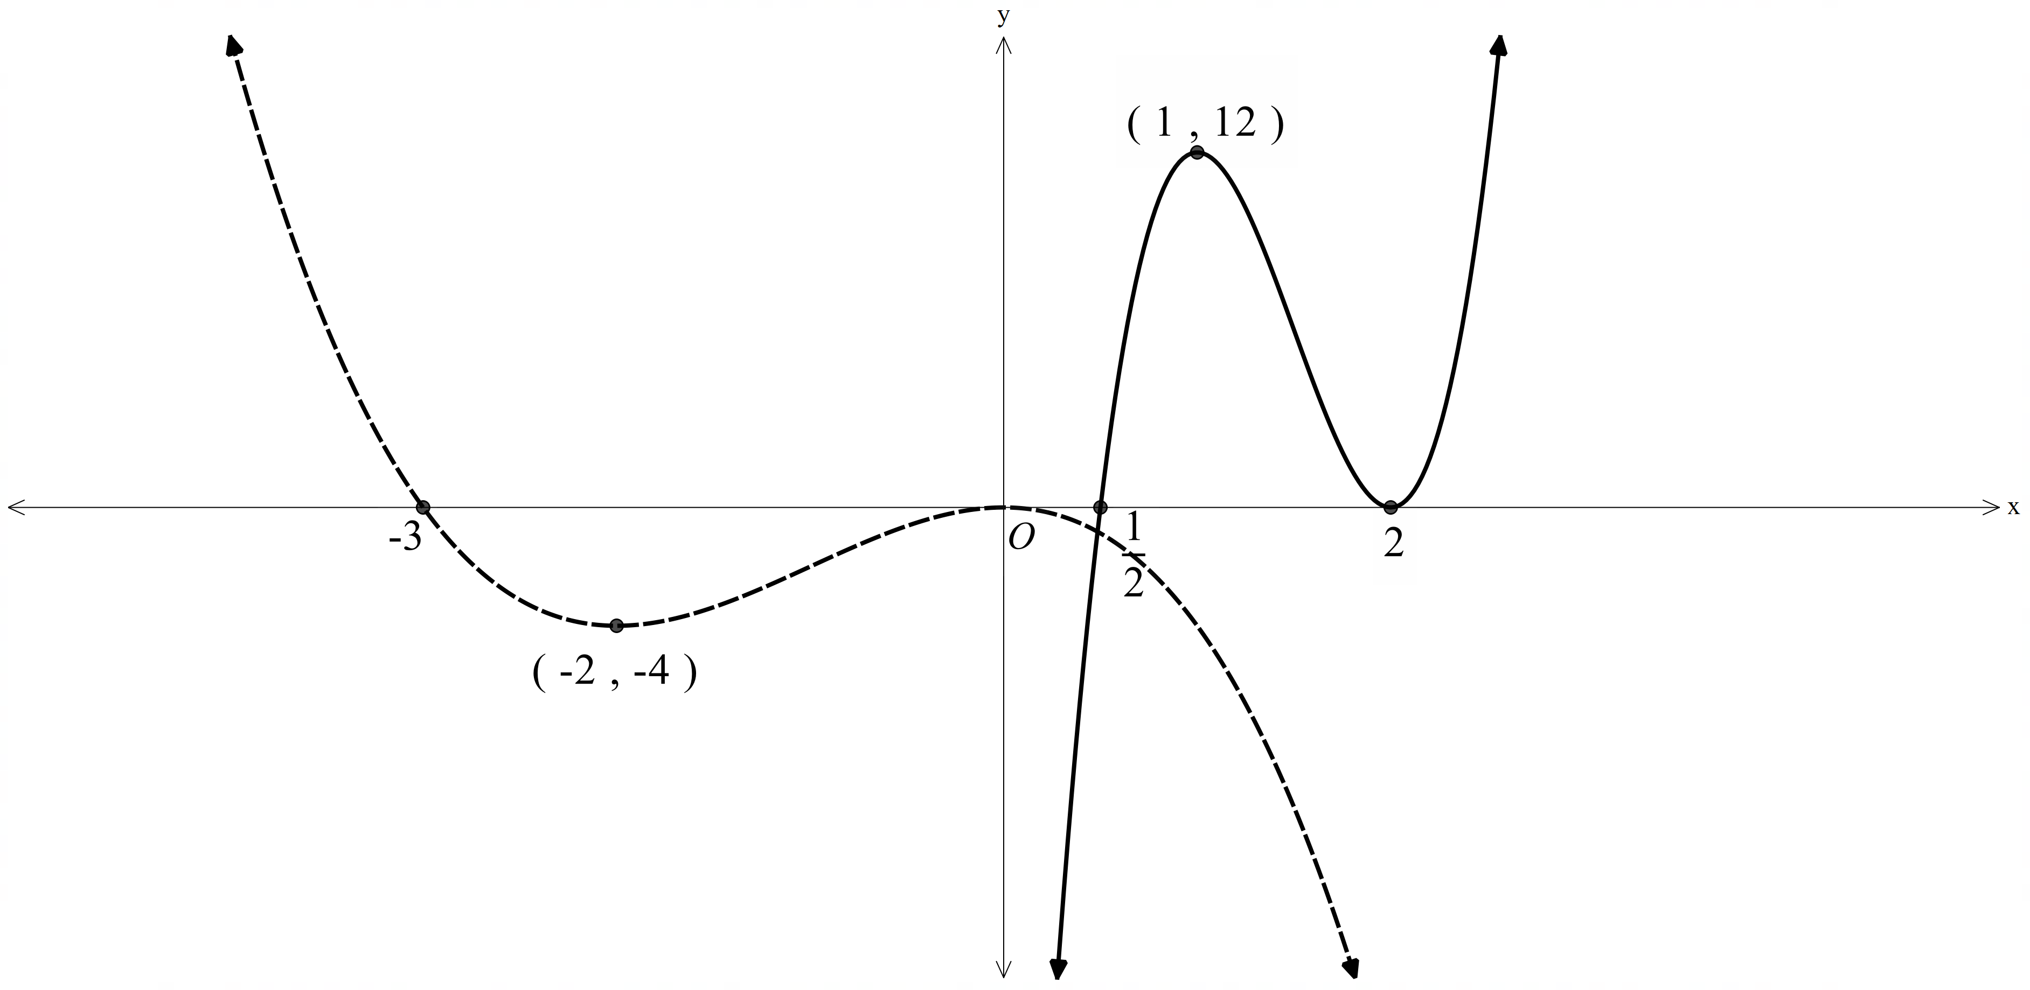

References
This resource contains NSW Curriculum and syllabus content. The NSW Curriculum is developed by the NSW Education Standards Authority. This content is prepared by NESA for and on behalf of the Crown in right of the State of New South Wales. The material is protected by Crown copyright.
Please refer to the NESA Copyright Disclaimer for more information https://educationstandards.nsw.edu.au/wps/portal/nesa/mini-footer/copyright.
NESA holds the only official and up-to-date versions of the NSW Curriculum and syllabus documents. Please visit the NSW Education Standards Authority (NESA) website https://educationstandards.nsw.edu.au/ and the NSW Curriculum website https://curriculum.nsw.edu.au/.
Mathematics Advanced 11–12 Syllabus © NSW Education Standards Authority (NESA) for and on behalf of the Crown in right of the State of New South Wales, 2024.

© State of New South Wales (Department of Education), 2025
The copyright material published in this resource is subject to the Copyright Act 1968 (Cth) and is owned by the NSW Department of Education or, where indicated, by a party other than the NSW Department of Education (third-party material).
Copyright material available in this resource and owned by the NSW Department of Education is licensed under a Creative Commons Attribution 4.0 International (CC BY 4.0) license.

This license allows you to share and adapt the material for any purpose, even commercially.
Attribution should be given to © State of New South Wales (Department of Education), 2025.
Material in this resource not available under a Creative Commons license:
- the NSW Department of Education logo, other logos and trademark-protected material
- material owned by a third party that has been reproduced with permission. You will need to obtain permission from the third party to reuse its material.
Links to third-party material and websites
Please note that the provided (reading/viewing material/list/links/texts) are a suggestion only and implies no endorsement, by the New South Wales Department of Education, of any author, publisher, or book title. School principals and teachers are best placed to assess the suitability of resources that would complement the curriculum and reflect the needs and interests of their students.
If you use the links provided in this document to access a third-party's website, you acknowledge that the terms of use, including licence terms set out on the third-party's website apply to the use which may be made of the materials on that third-party website or where permitted by the Copyright Act 1968 (Cth). The department accepts no responsibility for content on third-party websites.

