Dilations (horizontal and vertical)
Students will use graphing applications to investigate how applying dilations in either the horizontal or vertical direction modifies the curve before applying different dilation factors to equations.
Students will need at least one digital device per pair to interact with Amplify Classroom during this lesson.

Learning intentions
- To understand the notation of dilations.
- To be able to sketch dilated curves.

Success criteria
- I can use function notation to describe vertical and horizontal dilations of a graph.
- I can explain and identify whether a dilation factor causes a stretch or a compression, depending on whether it's greater or less than 1.
- I can sketch the key features of a function that has been horizontally dilated by a factor of $k$.
- I can sketch the key features of the graph $y=f(x)$ that has been vertically dilated by a factor of $l$.
- I can apply and sketch different vertical and horizontal dilations to the same function.

Outcomes
A student:
- develops understanding and fluency in mathematics through exploring and connecting mathematical concepts, choosing and applying mathematical techniques to solve problems, and communicating their thinking and reasoning coherently and clearly MAO-WM-01
- analyses and solves algebraic and graphical problems involving transformations of functions and relations MAV-11-03

Content

Graph transformations
- Describe a horizontal dilation as a stretch from the $y$-axis and a vertical dilation as a stretch from the $x$-axis
- Establish using graphing applications that replacing $x$ by $\frac{x}{k}$ in the equation of a graph corresponds to a horizontal dilation of a graph by a factor of $k$, that replacing $y$ by $\frac{y}{l}$ corresponds to a vertical dilation by a factor of $l$, and determine the effects on the graph when the magnitude of the dilation factor lies between 0 and 1
Mathematics Advanced 11–12 Syllabus © NSW Education Standards Authority (NESA) for and on behalf of the Crown in right of the State of New South Wales, 2024.
Table 1: lesson summary
Section | Summary of activity | Teaching strategies | Teaching points
Activating prior knowledge | Play the video ‘The Beauty of Slow Motion – Tennis Ball Bounce’ (0:20) (bit.ly/DilationTennis) and show slide 4 of the PowerPoint Dilations. Students should be guided to observe the vertical and horizontal stretching of the ball’s shape. | Think-Pair-Share  Notice and wonder | The aim of this section is to connect a real-world context to the concept of dilation using visuals to distinguish between vertical and horizontal dilations.
Connecting learning | Students complete the Amplify Classroom activity ‘Dilations – horizontal and vertical’ (bit.ly/AmplifyDilationsVertHorz), analysing the order in which they can be applied. | Pose-Pause-Pounce-Bounce  Assessing and advancing questions | The purpose of this section is to deepen students’ understanding that a horizontal dilation affects the $x$ in the equation, while vertical dilations affect the $y$. Students should understand that the order does not matter when applying dilations only.
Releasing responsibility | Use slides 6–7 to model how to apply multiple dilations. Students then complete Appendix A. | Worked examples (Your turn)  Four quadrant notes to their future forgetful selves  Vertical non-permanent surfaces  Visibly random groups of 3 | Students start to combine dilations, connecting the algebraic representations of the dilation with its graph.
Independent practice | Use slides 9–12 to work through HSC-style problems. | Approaching questions scaffold  Visibly random groups of 3  Vertical non-permanent surfaces | Students focus on planning, predicting and reflecting on their solutions, applying their knowledge from this and previous lessons.

Activity structure
Please use the associated PowerPoint Dilations (horizontal and vertical) to display images in this lesson.

Activating prior knowledge
This lesson is the second lesson in this unit on dilations and builds on ideas covered in Lesson 8 – dilations (enlargements and reductions).
- Show students the video ‘The Beauty of Slow Motion - Tennis Ball Bounce (0:20)’ (bit.ly/DilationTennis). This can be supported by slide 4 of the PowerPoint, which displays 2 cartoon pictures of the tennis ball from the video.
- In a Think-Pair-Share (bit.ly/thinkpairsharestrategy) ask students to discuss what they notice and wonder (bit.ly/noticewonderstrategy) about the shape of the tennis ball as it moves in slow motion.
Students should notice that the shape has reduced in size in the vertical direction and slightly increased in size in the horizontal direction. Students may wonder how this is demonstrated mathematically.

Connecting learning
- Assign the Amplify Classroom activity ‘Dilations (horizontal or vertical)’ (bit.ly/AmplifyDilationsVertHorz) for students to complete.

Before using this activity, you will need to set up an Amplify Classroom (bit.ly/createamplifyclassroom) and use the pacing feature to restrict the students to screens 1–14. Refer to differentiation strategies to explore further ways to pace this resource.
As students attempt the remaining activities in the Amplify Classroom activity, move around the classroom and encourage students to exhibit deeper reasoning through the use of assessing and advancing questions (bit.ly/supportingstrategies). Some examples are included in Table 2 below.
Table 2: assessing and advancing questions
Assessing questions | Advancing questions
What do you notice when $k$ changes? | How can you predict the effect of any value of $k$ before graphing?
Which points on the graph help you see the difference most clearly? | How could you connect what you see with an algebraic rule for each type of dilation?
What stays the same about the graph when we dilate it in different directions? | What happens if you apply 2 dilations in the same direction in a row?
Does the same effect happen on different graphs? | How would dilations in each direction affect the asymptotes of reciprocal or exponential graphs?
- Pause the activity and use a Pose-Pause-Pounce-Bounce questioning strategy (PDF 557 KB) (bit.ly/posepausepouncebounce) for students to share their thoughts on horizontal dilations. Sample questions include:
- Why is the effect of a horizontal dilation opposite to what we might expect?
- How would the transformation differ if $k$ were negative?
- How would the transformation look different if it were a vertical dilation instead?
The suggested question prompts are a guide for extending student understanding about horizontal dilations.
- Modify the pacing to have students access screens 15–20 of the Amplify Classroom activity which concentrates on vertical dilations.
- Pause the activity and use a Pose-Pause-Pounce-Bounce questioning strategy for students to share their understanding of vertical dilations. Sample questions include:
- How does $\frac{y}{l}$ connect to the graph of the function $y=lf(x)$?
- How does a vertical dilation affect the peaks of the graph?
- If we graph $y=3f(x)$ and $y=f(3x)$, how are their shapes and spreads different?
- Conduct a Think-Pair-Share where students consider how to identify and interpret vertical and horizontal dilations when different dilations are applied to the same function.
Students may suggest that horizontal dilation can be seen inside the function and the vertical dilation factor is outside the function. Students may share opinions on which dilation they would apply first, however it does not matter when it is just dilations.

Releasing responsibility
- Use slides 6–7 of the PowerPoint to model worked examples of multiple dilations using the Worked examples (Your turn) method (bit.ly/supportingstrategies).
- Use an existing resource for students to have further practice sketching dilations, including multiple dilations.
- Assign students to visibly random groups of 3 (bit.ly/visiblegroups), and ask them to complete Four quadrant notes to their future forgetful selves (bit.ly/supportingstrategies) from Appendix A ‘Four quadrant notes’ on a vertical non-permanent surface (bit.ly/VNPSstrategy).

Independent practice
- Use slide 9 to unpack the ‘Approaching questions scaffold’ for students.
The ‘Approaching questions scaffold’ offers students a 4-step framework to work through questions. Each step is accompanied by an icon which corresponds to different aspects of the solution process.
- Students will continue working in their existing visibly random groups of 3 at vertical non-permanent surfaces. Display the problem from slide 10 of the PowerPoint for each group to solve. Prompt students to plan their answer within their groups by predicting what the dilated graph will look like.
Students should be provided with an A3 copy of a Cartesian plane inside an A3 plastic sleeve with adhesive putty. Copies of the Cartesian plane can be printed from resources such as print-graph-paper.com/.
- Circulate the room to monitor students’ understanding of solving dilation problems. Prior to providing the solution, ask students to reflect on their initial prediction as a check for reasonableness. Once students have reflected on their solution, reveal the correct solution using slide 11, which also contains self-explanation prompts for groups to discuss.
- Conduct a class discussion, where students share their answers to the self-explanation prompts and discuss the strategies used for each step of the approaching questions scaffold.
- In their groups, have students work through the second HSC-style question, from slide 12. The solution is provided on slide 13.
- Have students complete a gallery walk to observe the use of the ‘Approaching questions scaffold’ in other groups’ solutions.

Assessment and differentiation

Suggested opportunities for differentiation
Activating prior knowledge
- A notice and wonder strategy is used where there is no correct answer, so that all students can participate in the discussion.
- The video can be paused and replayed to give students more of an opportunity to process the footage.
- The playback speed can be modified using the video’s settings.
Connecting learning
- Adjust the pacing of the Amplify Classroom activity to chunk the activity appropriately, based on the needs of your students.
- Students can work collaboratively on the Amplify Classroom task.
- The Amplify Classroom activity allows an exploration for students that does not depend on their skills with constructing graphs.
Releasing responsibility
- The examples can be modified in either difficulty or quantity to meet student needs.
- The existing resource should be selected at a level appropriate for student understanding.
- Sentence starters could be supplied for the four quadrant notes passage for selected students.
- The examples given as part of the Four quadrant notes could be adjusted to meet the cognitive demands of students.

Independent practice
- The questions can be modified to suit the needs of the students.
- The individual parts of the question could be chunked to support student understanding.
- The translation of a circle could be revised through a check for understanding of the circle equation.

Suggested opportunities for assessment
Activating prior knowledge
- Monitor responses in class discussions to check for student understanding of dilation.
Connecting learning
- Amplify Classroom keeps a record of student-submitted responses, which can be used as part of an assessment.
- Amplify Classroom activities can be paused and checks for understanding can be conducted based on student need.
- A class discussion could be facilitated at the point of need where students’ reasoning and justification is observed in response to the provided prompts around dilation.
Releasing responsibility
- The existing resource could be collected for assessment.
- When placed in groups of 3, students provide and receive peer feedback on their understanding of dilations.
- Students working at vertical non-permanent surfaces means student progress on the Four quadrant notes can be assessed and support provided where appropriate.
Independent practice
- Observe students during the discussion on problem solving and completion of HSC style questions.

Appendix A

Four quadrant notes
Example 1  Sketch the graph of $y=f\left(\frac{x}{3}\right)$ showing the intercepts and the coordinates of the vertex.  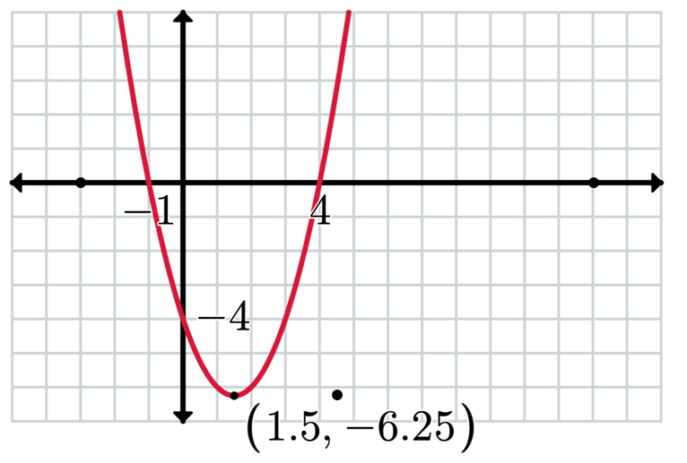 | Example 2  Sketch the graph of $y=2f(x)$ showing the intercepts and the coordinates of the labelled points.  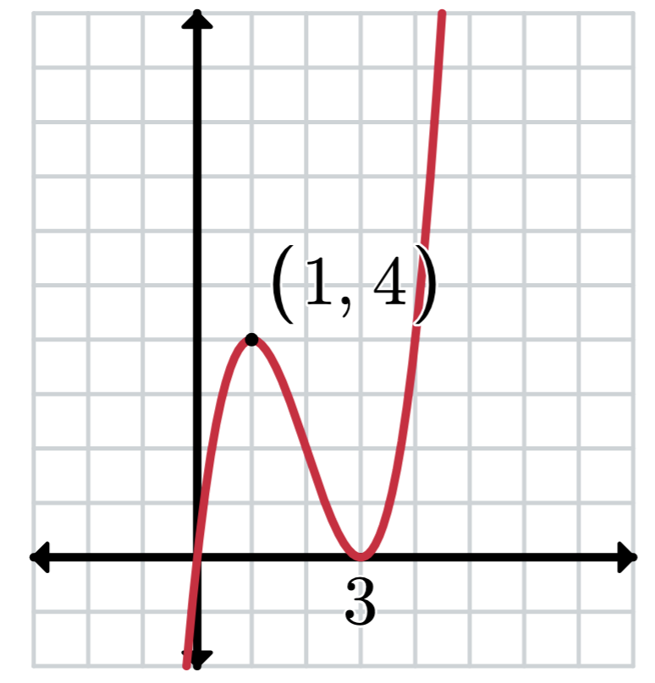
Things to remember | Example 3

Sample solutions

Appendix A – Four quadrant notes
Example 1  Sketch the graph of $y=f\left(\frac{x}{3}\right)$ showing the intercepts and the coordinates of the vertex.  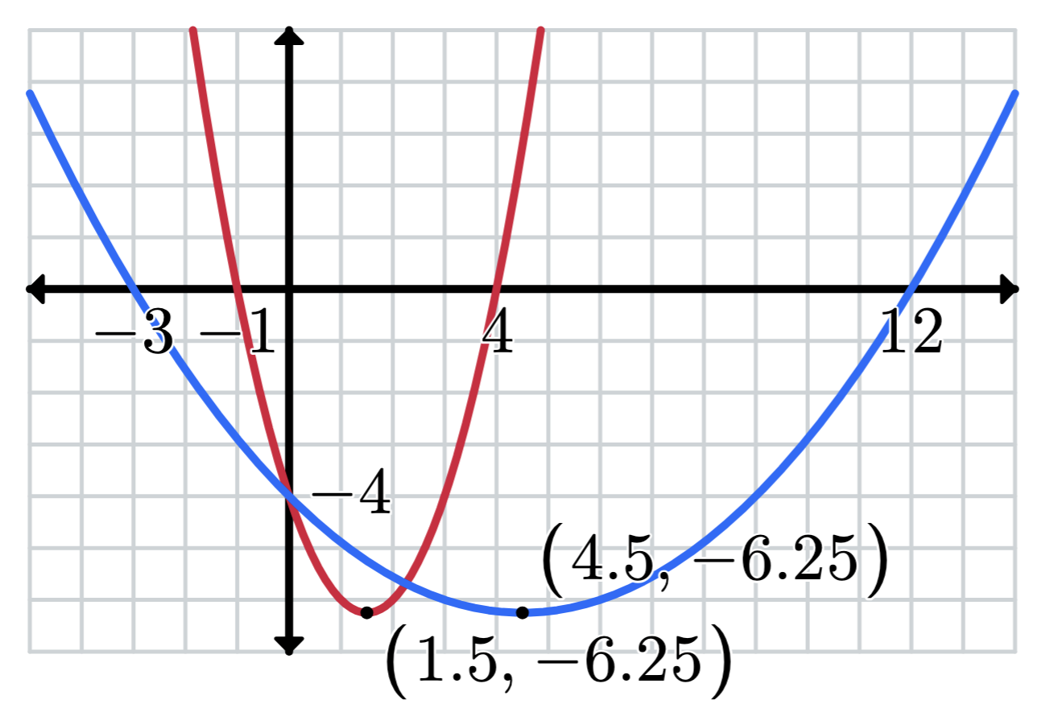 | Example 2  Sketch the graph of $y=2f(x)$ showing the intercepts and the coordinates of the labelled points.  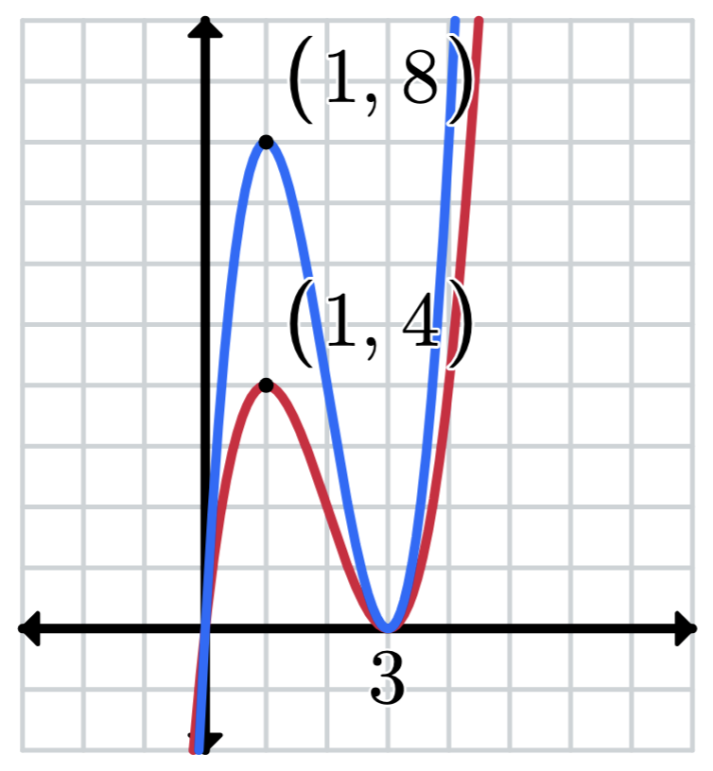
Things to remember  - Replace $x$ by $\frac{x}{k}$ to horizontally dilate a function in the direction of $x$ by a factor of $k$.  - Replace $y$ by $\frac{y}{l}$ to horizontally dilate a function in the direction of $y$ by a factor of $l$.  - Use points on the graph and apply the dilation factor to each coordinate to sketch the graph. | Example 3  Sketch the graph of $3y =f\left(\frac{x}{2}\right).$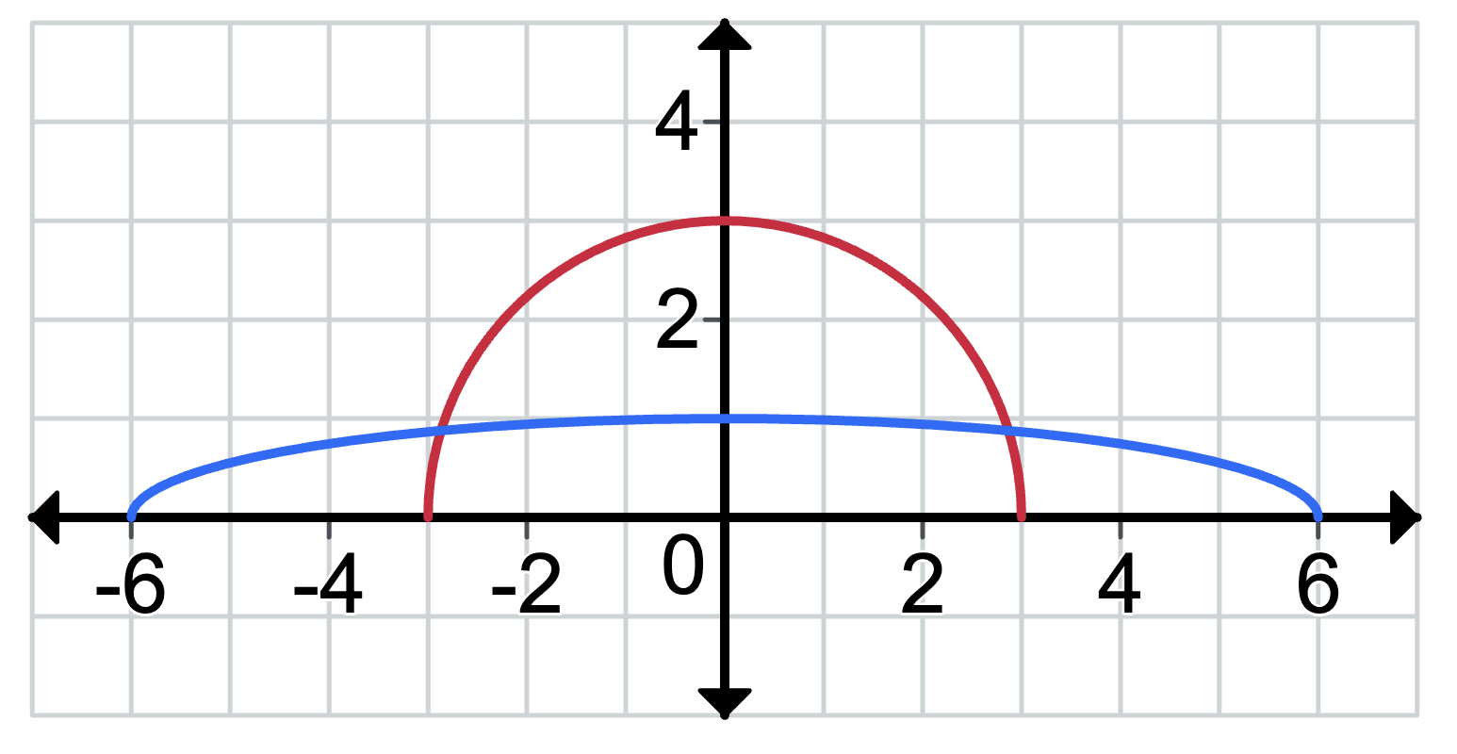

References
This resource contains NSW Curriculum and syllabus content. The NSW Curriculum is developed by the NSW Education Standards Authority. This content is prepared by NESA for and on behalf of the Crown in right of the State of New South Wales. The material is protected by Crown copyright.
Please refer to the NESA Copyright Disclaimer for more information https://educationstandards.nsw.edu.au/wps/portal/nesa/mini-footer/copyright.
NESA holds the only official and up-to-date versions of the NSW Curriculum and syllabus documents. Please visit the NSW Education Standards Authority (NESA) website https://educationstandards.nsw.edu.au/ and the NSW Curriculum website https://curriculum.nsw.edu.au/.
Mathematics Advanced 11–12 Syllabus © NSW Education Standards Authority (NESA) for and on behalf of the Crown in right of the State of New South Wales, 2024.

© State of New South Wales (Department of Education), 2025
The copyright material published in this resource is subject to the Copyright Act 1968 (Cth) and is owned by the NSW Department of Education or, where indicated, by a party other than the NSW Department of Education (third-party material).
Copyright material available in this resource and owned by the NSW Department of Education is licensed under a Creative Commons Attribution 4.0 International (CC BY 4.0) license.

This license allows you to share and adapt the material for any purpose, even commercially.
Attribution should be given to © State of New South Wales (Department of Education), 2025.
Material in this resource not available under a Creative Commons license:
- the NSW Department of Education logo, other logos and trademark-protected material
- material owned by a third party that has been reproduced with permission. You will need to obtain permission from the third party to reuse its material.
Links to third-party material and websites
Please note that the provided (reading/viewing material/list/links/texts) are a suggestion only and implies no endorsement, by the New South Wales Department of Education, of any author, publisher, or book title. School principals and teachers are best placed to assess the suitability of resources that would complement the curriculum and reflect the needs and interests of their students.
If you use the links provided in this document to access a third-party's website, you acknowledge that the terms of use, including licence terms set out on the third-party's website apply to the use which may be made of the materials on that third-party website or where permitted by the Copyright Act 1968 (Cth). The department accepts no responsibility for content on third-party websites.

