Dilations (enlargements and reductions)
Students use graphing applications to explore function dilations through enlargements and reductions, before consolidating their understanding.
Students will need at least one digital device per pair to interact with Amplify Classroom during this lesson.

Learning intention
- To be able to apply enlargements and reductions to functions by replacing both $x$ by $\frac{x}{k}$ and $y$ by $\frac{y}{k}$.

Success criteria
- I can define the term ‘dilation’.
- I can explain the effect on the graph when replacing $x$ by $\frac{x}{k}$ and $y$ by $\frac{y}{k}$ when $k > 1$.
- I can explain the effect on the graph when replacing $x$ by $\frac{x}{k}$ and $y$ by $\frac{y}{k}$ when $0<k< 1$.

Outcomes
A student:
- develops understanding and fluency in mathematics through exploring and connecting mathematical concepts, choosing and applying mathematical techniques to solve problems, and communicating their thinking and reasoning coherently and clearly MAO-WM-01
- analyses and solves algebraic and graphical problems involving transformations of functions and relations MAV-11-03

Content

Graph transformations
- Establish, using graphing applications, replacing $x$ by $\frac{x}{k}$ and replacing $y$ by $\frac{y}{k}$ in the equation of a graph corresponds to a dilation by a factor of $k$, that is, an enlargement of the graph when $k>1$ and a reduction of the graph when $0<k<1$
Mathematics Advanced 11–12 Syllabus © NSW Education Standards Authority (NESA) for and on behalf of the Crown in right of the State of New South Wales, 2024.

Table 1: lesson summary
Section | Summary of activity | Teaching strategies | Teaching points
Activating prior knowledge | Students complete screens 1–4 of the Amplify Classroom activity ‘Dilations (enlargements and reductions)’. | Pose-Pause-Pounce-Bounce | This section activates students’ familiarity with the word dilation using a real-world context. Students should also look at how the scale factor $k$ determines whether a dilation represents an enlargement or reduction.
Connecting learning | Students continue to work through the Amplify Classroom activity, completing screens 5–22. Students investigate dilations of a range of equations. | Pose-Pause-Pounce-Bounce  Assessing and advancing questions | The aim of this section is to connect enlargements and reductions with the algebraic structure of functions.
Releasing responsibility | Students complete Appendix A, which can be shown using slide 4 of the PowerPoint Dilations. Use slides 5–6 to model enlargements and reductions and have students complete Appendix B. | Frayer diagram  Worked examples (Your turn)  Variation Theory  Turn and talk | The purpose of this section is to formalise the definition of dilation using examples and non-examples and apply the factor of $k$ in modelled worked examples.
Independent practice | Students complete Appendix C which contains HSC style questions. | Turn and talk | This section allows students to apply their knowledge to HSC-style questions, by justifying the effect of dilations on different functions and accurately describing the changes.

Activity structure
Please use the associated PowerPoint Dilations (enlargements and reductions) to display images in this lesson.

Activating prior knowledge
- Assign the Amplify Classroom activity ‘Dilations (enlargements and reductions)’ (bit.ly/AmplifyDilationsBothxy) for students to complete.
Before using this activity, you will need to set up an Amplify Classroom (bit.ly/createamplifyclassroom) and use the pacing feature to restrict the students to screens 1–2.
- Pause the activity to discuss student responses to the prompt on screen 2, activating prior knowledge of the word ‘dilation’. Select students to elaborate on their thinking where appropriate to support deeper understanding.
The term dilation also appears in the Science 7–10 Syllabus under the Stage 5 Disease outcome SC5-DIS-01. Students are also expected to apply an appropriate scale to enlarge or reduce a diagram in the Stage 5 Properties of geometrical figures A Core outcome MA5-GEO-C-01. According to the syllabus glossary, ‘a dilation is a process of stretching or compressing the graph of a function. This could happen either in the $x$ or $y$ direction or both’ (NESA 2004). This lesson addresses dilations in both directions, while Lesson 9 focuses on direction-specific dilations.
- Extend the pacing to include screens 3–4 for students to complete.
- Pause the activity and use a Pose-Pause-Pounce-Bounce questioning strategy (PDF 557 KB) (bit.ly/posepausepouncebounce) for students to share their thoughts about the value of $k$ and its connection to enlargement and reduction.
Students should identify that when the value of $k$ increases beyond one, the triangle becomes larger, and between the values of zero and one, the triangle reduces in size.

Connecting learning
- Extend the pacing to include screens 5–12. Instruct students to continue working through these screens to investigate the effect of $k$ on the equation of a circle.
The purpose of these screens is to help students connect their understanding of enlargements and reductions to the standard equation of a circle, and to manipulate this equation algebraically to link the scale factor to the dilation substitutions.
As students attempt the remaining activities in the Amplify Classroom activity, move around the classroom and encourage students to exhibit deeper reasoning through the use of assessing and advancing questions (bit.ly/supportingstrategies). Some examples are included in Table 2 below.
Table 2: assessing and advancing questions
Assessing questions | Advancing questions
What do you notice when $k$ changes? | How can you predict the effect of any value of $k$ before graphing?
Which points on the graph help you see the difference most clearly? | How could you connect what you see with an algebraic rule for dilations?
What stays the same about the graph when we dilate it? | What happens if you apply 2 dilations in a row?
Does the same effect happen on different graphs? | How would dilations affect the asymptotes of reciprocal or exponential graphs?
- Pause the activity and use a Pose-Pause-Pounce-Bounce questioning strategy for students to share their thoughts about the value of $k$ and its relationship with the equation of the circle.
- Extend the pacing to include screens 13–17. Students explore enlargements and reductions of linear functions.
These screens aim to establish that the dilation factor can be applied to functions and begin developing the idea of using coordinates to map points. Students may observe that the dilation resembles a translation, which can be explained by the fact that all the coordinates are scaled.
- Extend the pacing to include screens 18–20. Students investigate dilations of quadratic functions, applying their prior understanding from earlier screens.
The purpose of this section is to consolidate learning by applying dilation principles to a new type of function and observing consistent patterns.
- Extend the pacing to include screens 21–23. Students examine a reciprocal function to determine whether any point can be used to map enlargements and reductions before completing a final reflection.
The key insight is that all points transform by the scale factor $k$, reinforcing the generality of the dilation concept when applied to both variables.

Releasing responsibility
- To check for understanding, have students complete Appendix A ‘Frayer diagram’ (bit.ly/frayerdiagram) on the term ‘dilation’. A copy of the diagram is also displayed on slide 4 of the PowerPoint.
- Use slides 5–6 to model worked examples of enlargements and reductions using the Worked examples (Your turn) method (bit.ly/supportingstrategies).
- Distribute Appendix B ‘Applying dilations’, which uses Variation Theory (variationtheory.com/introduction/) to support fluency and conceptual understanding.
- Instruct students to compare solutions using a turn and talk strategy (bit.ly/classroomtalkmoves), discussing intercepts and steepness of each graph.

Independent practice
- Distribute Appendix C ‘HSC style questions’ for students to complete independently.
- Instruct students to compare solutions using a turn and talk strategy, discussing intercepts and the steepness of each graph.

Assessment and differentiation

Suggested opportunities for differentiation
Activating prior knowledge
- The pacing of screens 1–4 of the Amplify Classroom activity could be adjusted to suit the needs of your students.
- Some students may benefit from first reviewing scale factor.
- A word bank with terms such as ‘enlargement’, ‘reduction’, ‘multiplier’ and ‘scale factor’ could be given to prompt students to respond to the questions.
- Noticing and wondering is used throughout the discussions in this lesson to allow all students to participate in a risk-free environment.
- Amplify Classroom offers the ability to make students anonymous, providing a risk-free environment to encourage student participation if student progress or students’ responses are projected to the class.
Connecting learning
- The pacing feature could be used to adjust the chunking of the content to meet the needs of students.
- The student's view of Amplify Classroom could be used to demonstrate screens to the whole class.
Releasing responsibility
- Appendix B could be adapted to include different variations.
- Existing resources could be used to further support student progress.
Independent practice
- Questions could be adapted to include more challenging or more accessible functions to better meet students’ needs.
- Students could complete the activity in pairs.

Suggested opportunities for assessment
Activating prior knowledge
- Monitor responses in class discussions to check for student understanding of the terms dilation and scale factor.
Connecting learning
- Amplify Classroom can be used to observe and check student understanding of enlargements and reductions throughout the lesson.
- Amplify Classroom collects student responses and can be used as work samples for assessment.
- Students could be prompted to explain their reasoning in the Amplify Classroom activity.
Releasing responsibility
- Appendix A and/or Appendix B could be used to check student progress in their fluency with enlargements and reductions.
- Student responses to the self-explanation prompts during worked examples provide an opportunity to assess student reasoning.
Independent practice
- Appendix C could be collected to check student understanding of dilations. Alternatively, student work could be observed while they complete it.

Appendix A

Frayer diagram
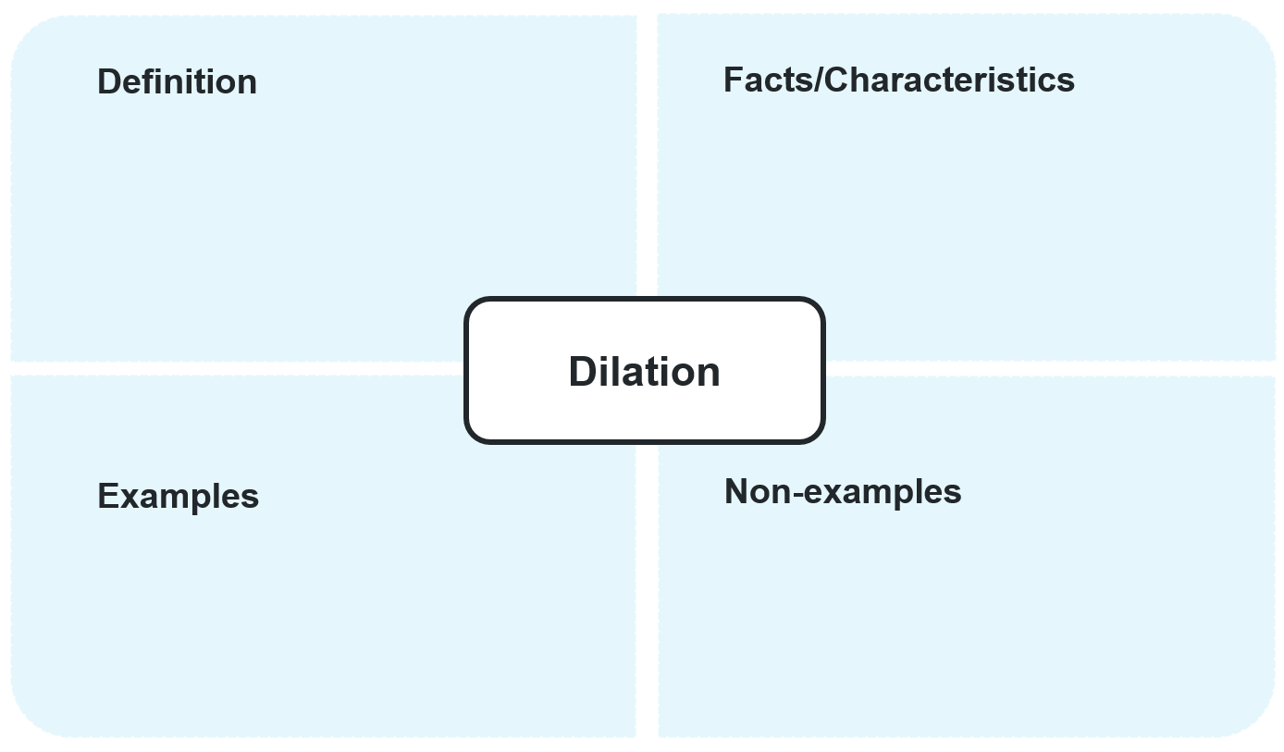

Appendix B

Applying dilations
For each function below, sketch the transformed graph after applying the specified dilation to each axis.
- Function: $y=2x-3$ Dilation: $k=\frac{1}{2}$  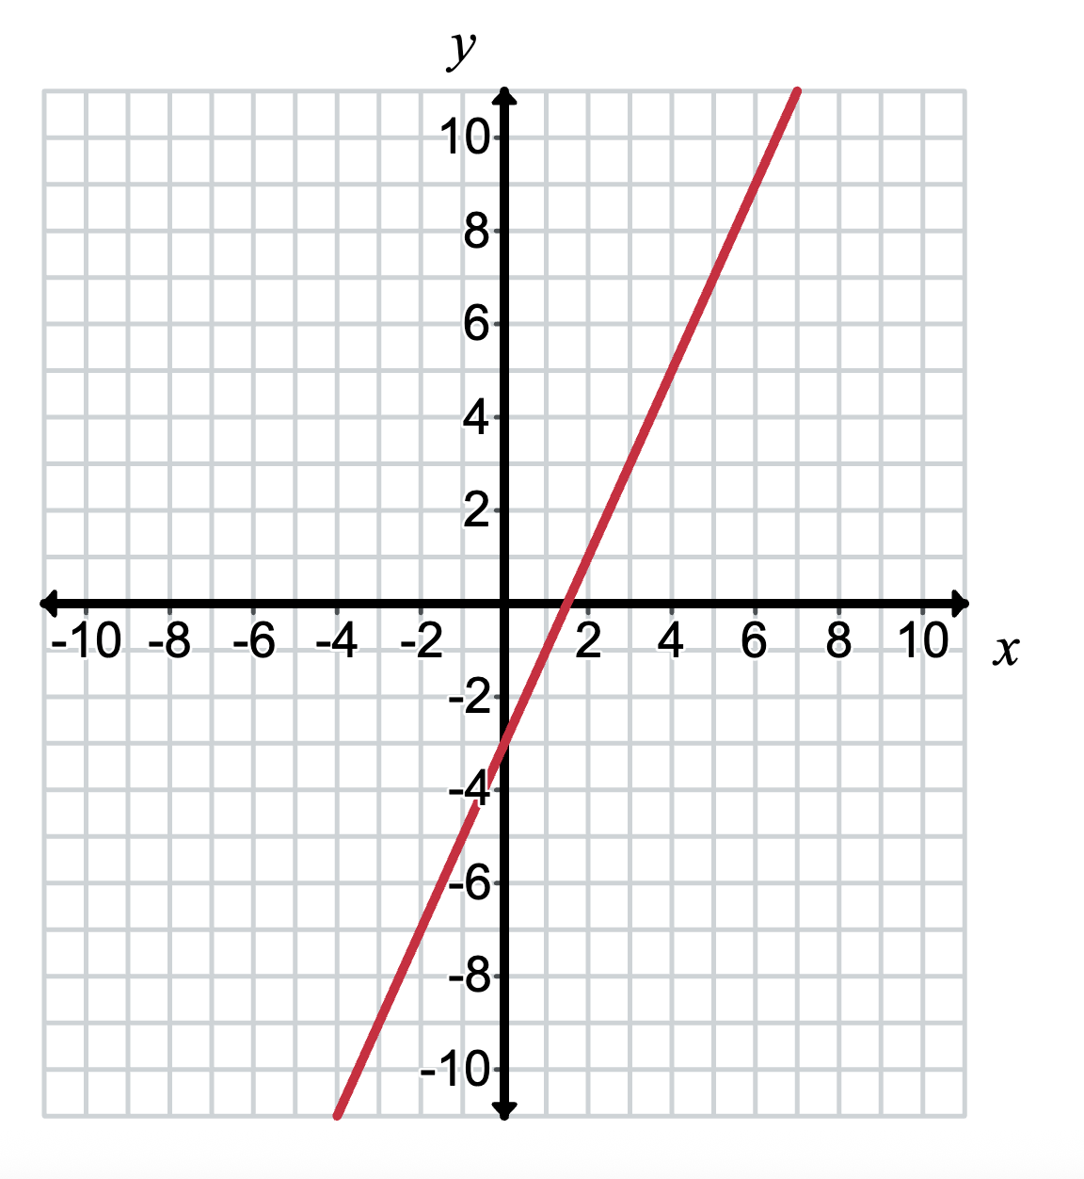 | - Function: $y=2x-3$ Dilation: $k=2$
- Function: $y=x^{2}-3$ Dilation: $k=2$  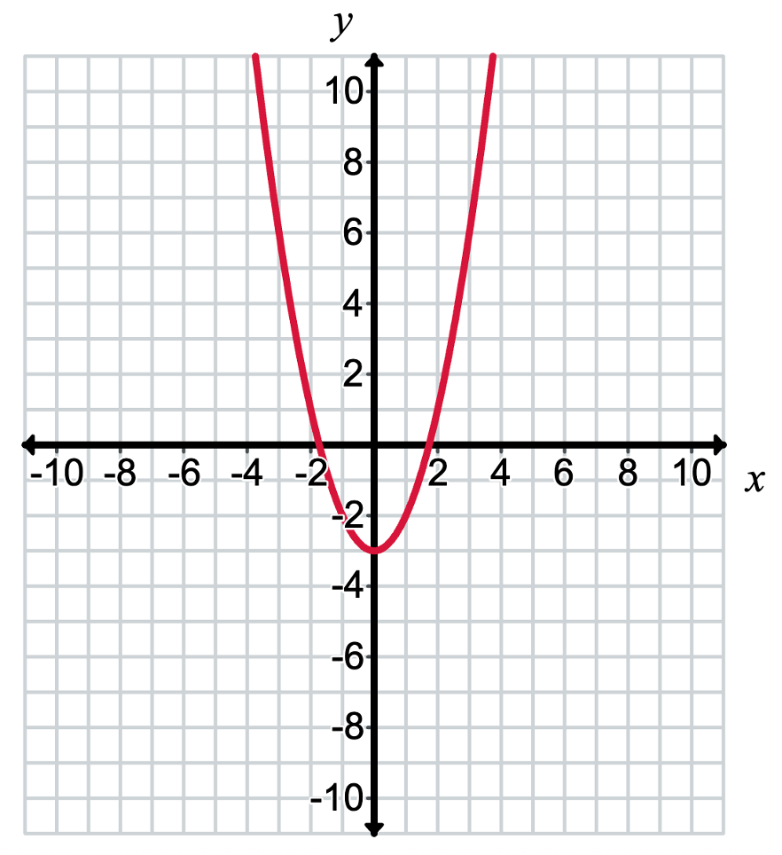 | - Function: $y=x^{2}-3$ Dilation: $k=3$
- Function: $y=x^{2}-3x$ Dilation: $k=3$  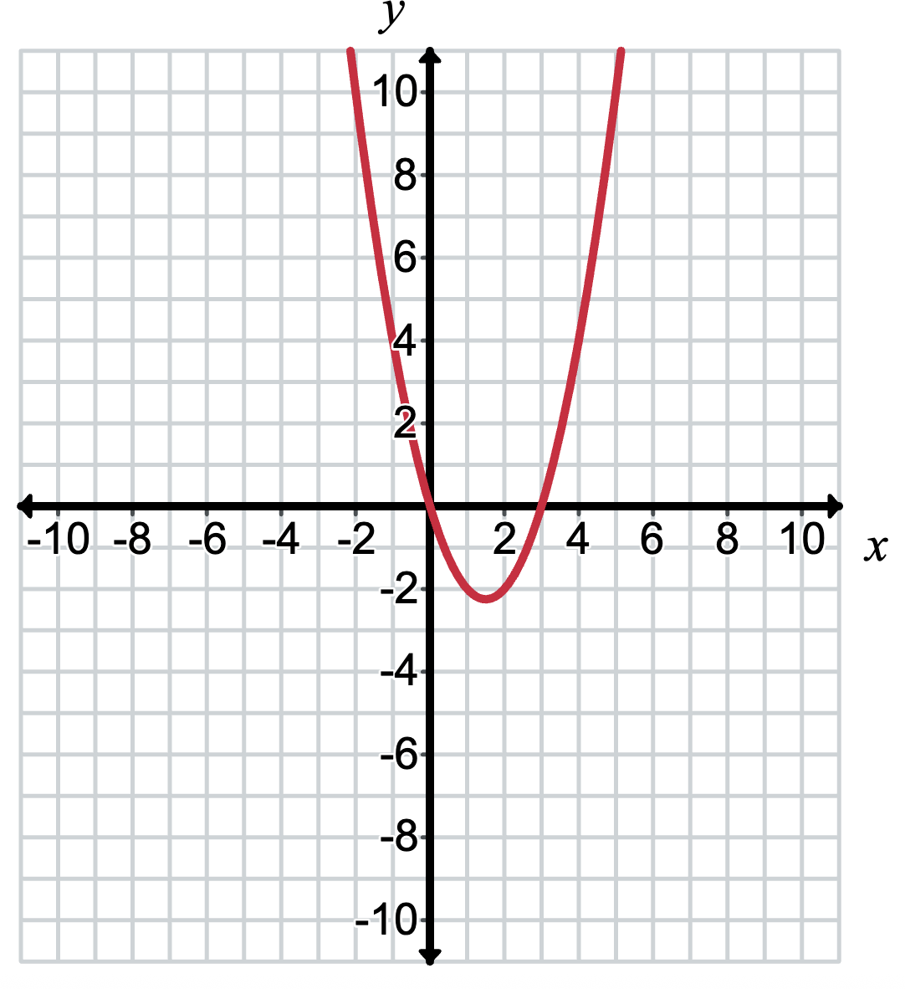 | - Function: $y=x^{2}-3x$ Dilation: $k=\frac{3}{2}$
- Function: $y=x^{3}-3x$ Dilation: $k=\frac{3}{2}$  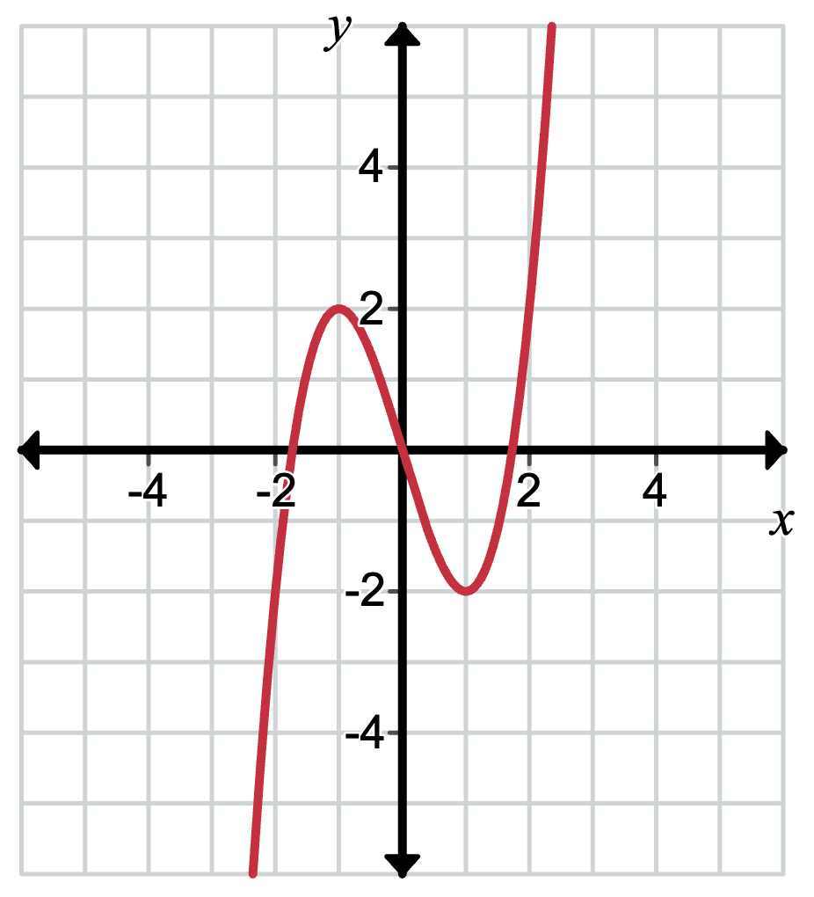 | - Function: $y=x^{3}-3x$ Dilation: $k=\frac{1}{3}$

Appendix C

HSC style questions
- Consider the graph of $y=f(x)$ as shown.
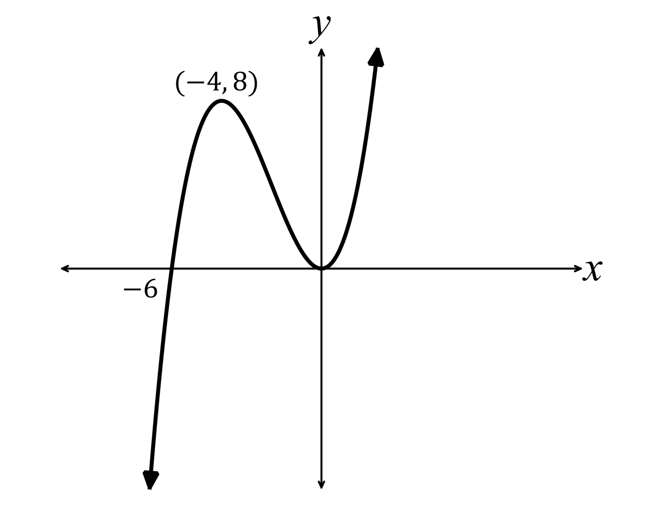
Apply a reduction to $f(x)$ of $k=\frac{1}{2}$ and sketch the graph showing the $x$-intercepts and the coordinates of the turning points.
- Consider the graph of $y=f(x)$ as shown.
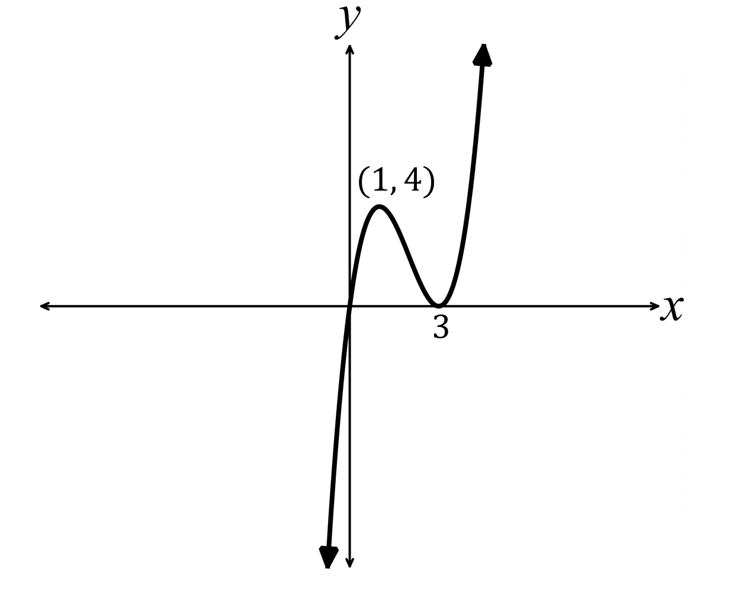
Apply an enlargement to $f(x)$ of $k=3$ and sketch the graph showing the $x$-intercepts and the coordinates of the turning points.

Sample solutions

Appendix A – Frayer diagram
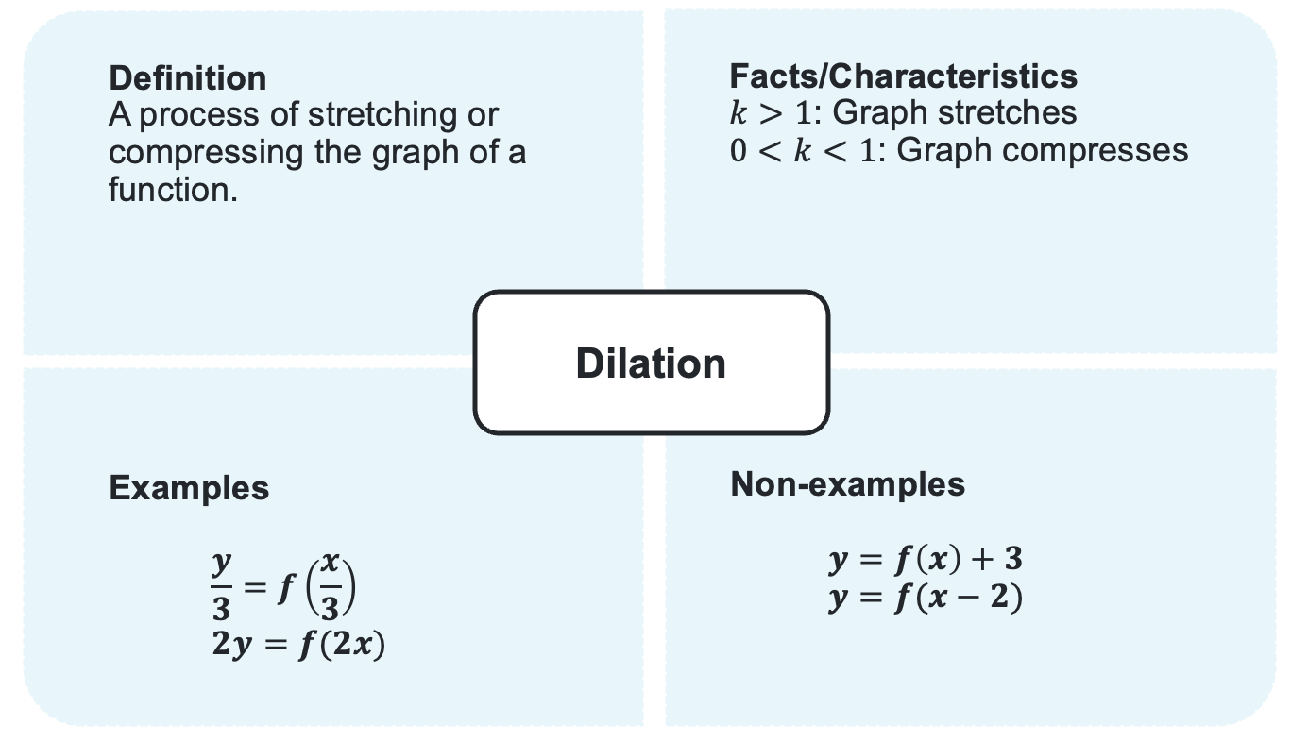

Appendix B – applying dilations
Question 1 and 2  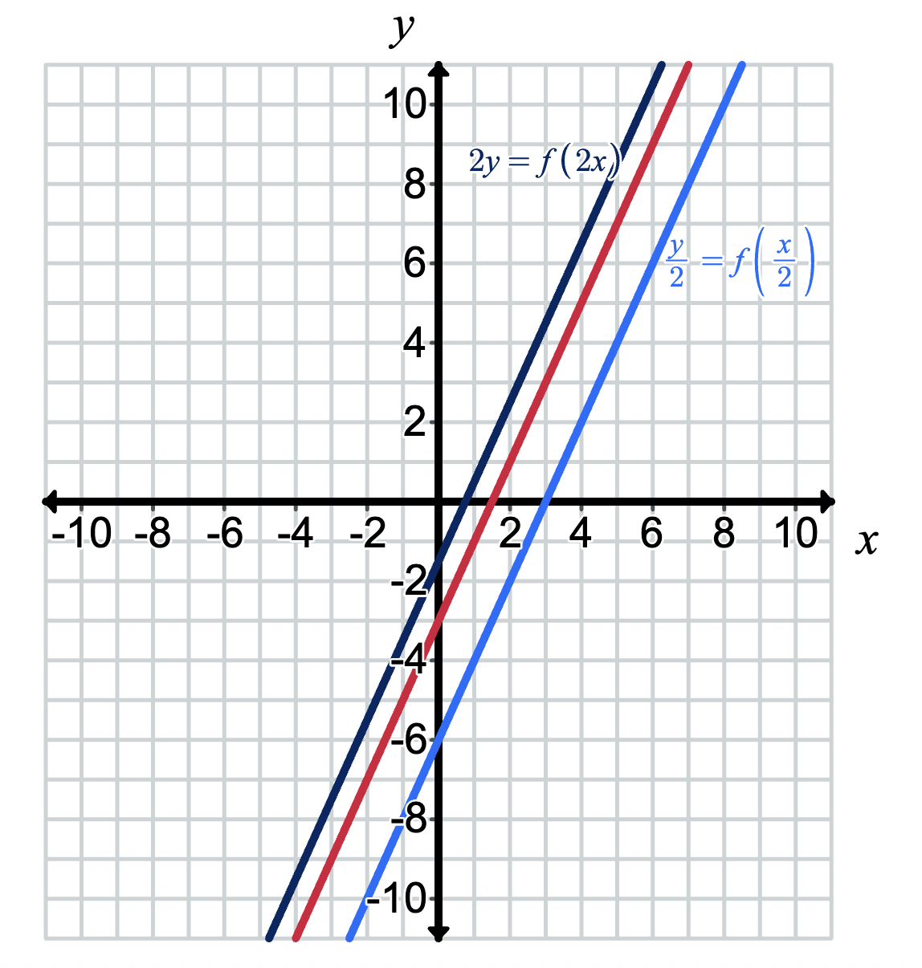 | Questions 3 and 4  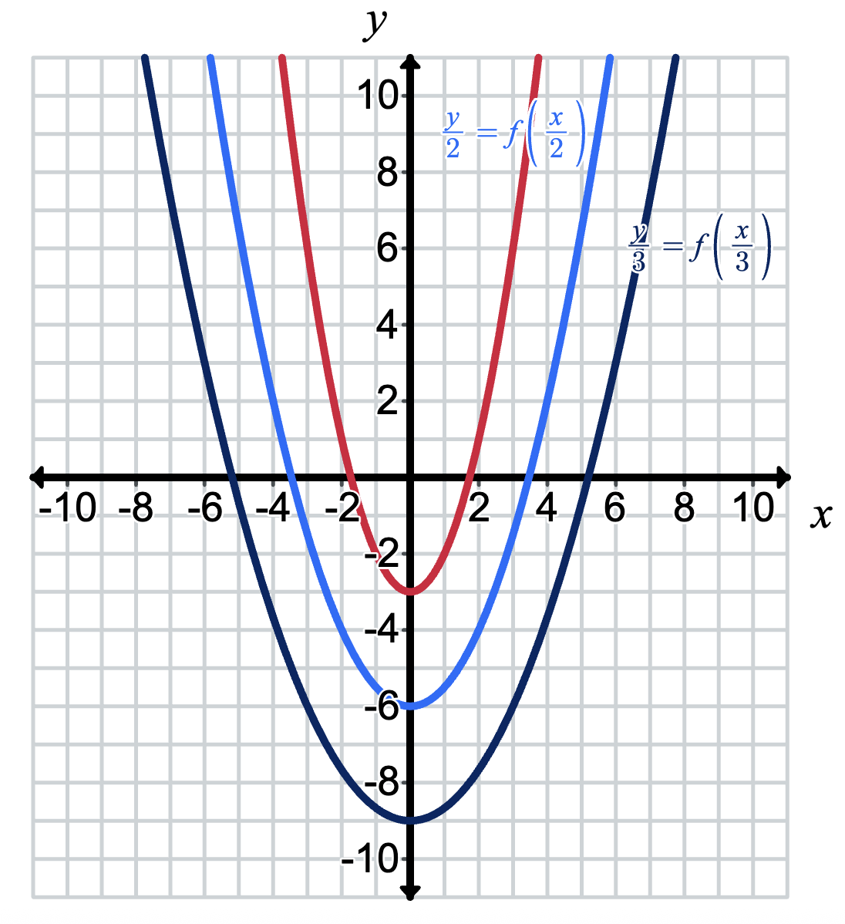
Questions 5 and 6  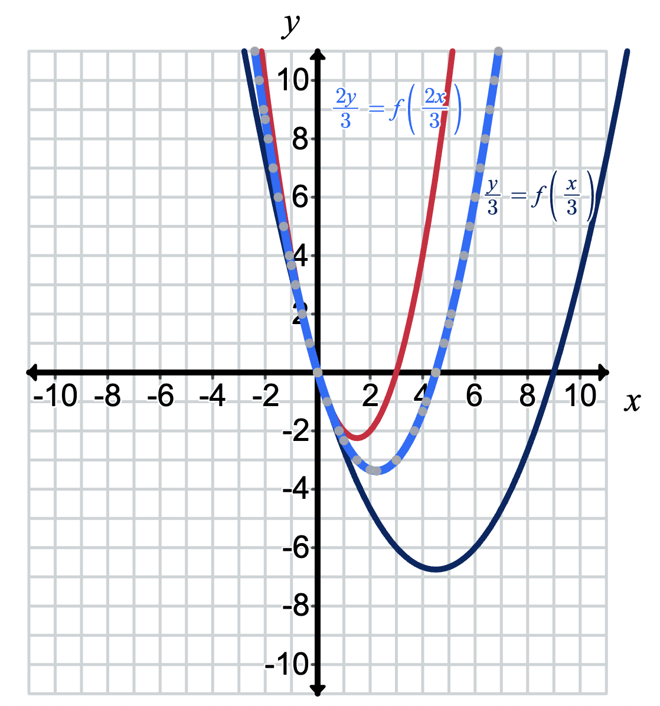 | Questions 7 and 8  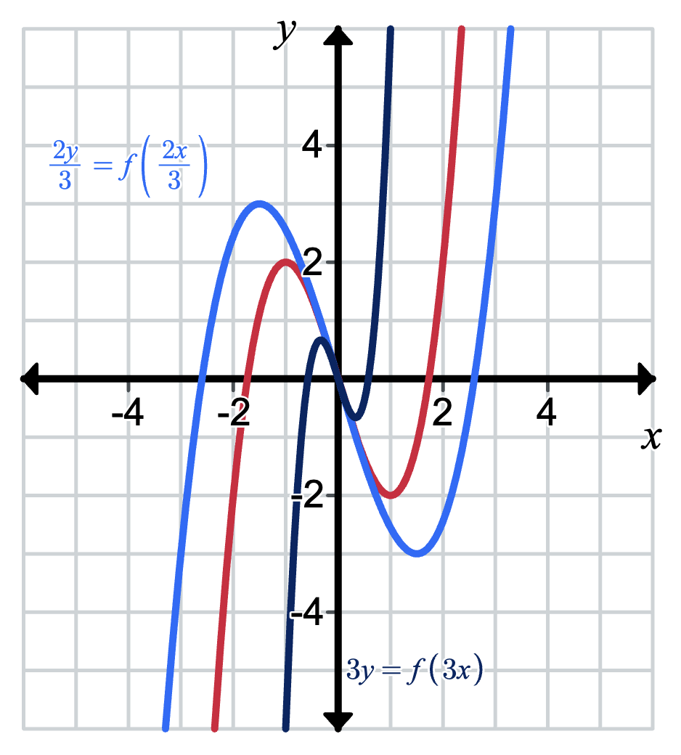

Appendix C – HSC style questions
Question 1
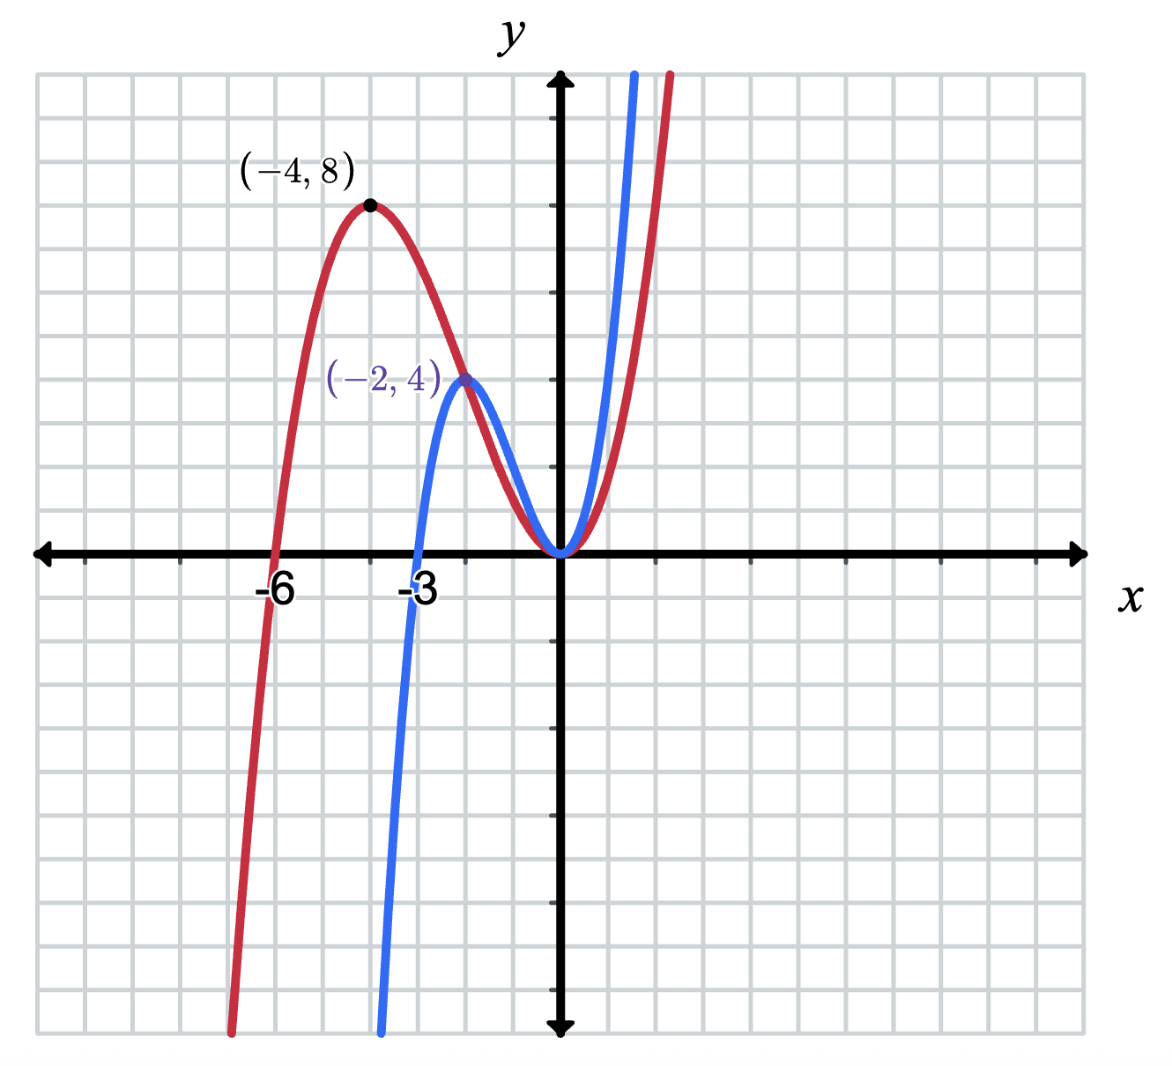
Question 2
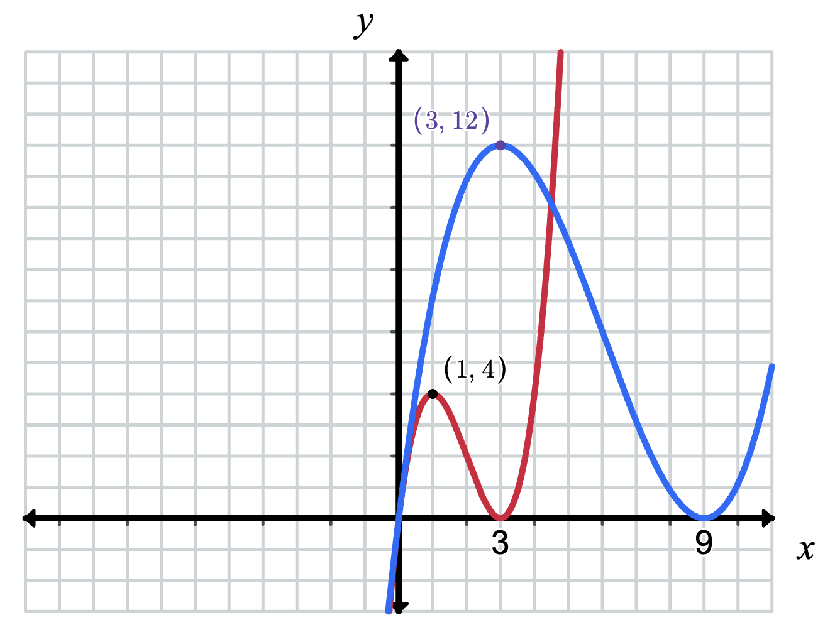

References
This resource contains NSW Curriculum and syllabus content. The NSW Curriculum is developed by the NSW Education Standards Authority. This content is prepared by NESA for and on behalf of the Crown in right of the State of New South Wales. The material is protected by Crown copyright.
Please refer to the NESA Copyright Disclaimer for more information https://educationstandards.nsw.edu.au/wps/portal/nesa/mini-footer/copyright.
NESA holds the only official and up-to-date versions of the NSW Curriculum and syllabus documents. Please visit the NSW Education Standards Authority (NESA) website https://educationstandards.nsw.edu.au/ and the NSW Curriculum website https://curriculum.nsw.edu.au/.
Mathematics Advanced 11–12 Syllabus © NSW Education Standards Authority (NESA) for and on behalf of the Crown in right of the State of New South Wales, 2024.

© State of New South Wales (Department of Education), 2025
The copyright material published in this resource is subject to the Copyright Act 1968 (Cth) and is owned by the NSW Department of Education or, where indicated, by a party other than the NSW Department of Education (third-party material).
Copyright material available in this resource and owned by the NSW Department of Education is licensed under a Creative Commons Attribution 4.0 International (CC BY 4.0) license.

This license allows you to share and adapt the material for any purpose, even commercially.
Attribution should be given to © State of New South Wales (Department of Education), 2025.
Material in this resource not available under a Creative Commons license:
- the NSW Department of Education logo, other logos and trademark-protected material
- material owned by a third party that has been reproduced with permission. You will need to obtain permission from the third party to reuse its material.
Links to third-party material and websites
Please note that the provided (reading/viewing material/list/links/texts) are a suggestion only and implies no endorsement, by the New South Wales Department of Education, of any author, publisher, or book title. School principals and teachers are best placed to assess the suitability of resources that would complement the curriculum and reflect the needs and interests of their students.
If you use the links provided in this document to access a third-party's website, you acknowledge that the terms of use, including licence terms set out on the third-party's website apply to the use which may be made of the materials on that third-party website or where permitted by the Copyright Act 1968 (Cth). The department accepts no responsibility for content on third-party websites.

