Further cubic functions
Students extend their understanding of cubic functions to include functions in the form $f\left(x\right)=(x-a)(x-b)(x-c)$ and apply their prior knowledge of roots to this function.
Students will need at least one digital device per pair to interact with Desmos during this lesson.

Learning intention
- To be able to recognise and graph cubic functions of the form $f\left(x\right)=(x-a)(x-b)(x-c)$.

Success criteria
- I can identify the $x$-intercepts from the factorised form of a cubic function.
- I can graph a cubic function of the form $f\left(x\right)=\left(x-a\right)\left(x-b\right)\left(x-c\right).$
- I can write the equation of a cubic function when given the $x$-intercepts.
- I can describe and apply translations and reflections to cubic functions.

Outcomes
A student:
- develops understanding and fluency in mathematics through exploring and connecting mathematical concepts, choosing and applying mathematical techniques to solve problems, and communicating their thinking and reasoning coherently and clearly MAO-WM-01
- applies algebraic techniques and the laws of indices and surds to manipulate expressions and solve problems MAV-11-01
- uses functions and relations to model, analyse and solve problems MAV-11-02
- analyses and solves algebraic and graphical problems involving transformations of functions and relations MAV-11-03

Content

Quadratic and cubic functions
- Recognise and graph cubic functions of the form $f(x)=kx^{3}$ and $f\left(x\right)=k\left(x-a\right)\left(x-b\right)\left(x-c\right)$, where $a$, $b$, $c$ and $k$ are constants and $k≠0$
Mathematics Advanced 11–12 Syllabus © NSW Education Standards Authority (NESA) for and on behalf of the Crown in right of the State of New South Wales, 2024.

Table 1: lesson summary
Section | Summary of activity | Teaching strategies | Teaching points
Activating prior knowledge | Students work in groups to sketch and compare quadratic and cubic functions, identifying horizontal translations and their effects on $x$-intercepts. Through guided prompts and peer discussion, they explain how changes to the function change the intercepts. | Visibly random groups of 3  Vertical non-permanent surfaces  Turn and talk | Students recall information of how the factored form of an equation provides insights into the $x$-intercepts of a graph.
Connecting learning | Students plot coordinates to visualise a cubic equation before engaging with an Amplify Classroom activity ‘Further cubic functions’ (bit.ly/FurtherCubicFunctions). Students consolidate this activity with a Variation Theory activity from Appendix A. | Pose-Pause-Pounce-Bounce  Variation Theory  Turn and talk | Students extend their knowledge of $x$-intercepts to cubic functions and begin recognising features of a cubic function.
Releasing responsibility | The class engage in a discussion about cubic functions prior to writing notes to their future forgetful selves. | Pose-Pause-Pounce-Bounce  Notes to future forgetful selves | Students reflect on key features.
Independent practice | Students use the intercepts and features of graphs to match equations and identify other equations from Appendix B. | Visibly random groups of 3  Vertical non-permanent surfaces  Gallery walk  TAG feedback | Students interchangeably move between factored form of a cubic function and its graph.

Activity structure

Activating prior knowledge
- Assign students to visibly random groups of 3 (bit.ly/visiblegroups) at vertical non-permanent surfaces (bit.ly/VNPSstrategy).
The following steps in this learning episode can alternatively be supported by using graph paper (print-graph-paper.com/), printed on A3 paper, placed in a plastic sleeve and affixed with adhesive putty.
- Ask students to sketch the following equations on the same set of axes:
- $y=x^{2}$
- $y=\left(x-2\right)(x-2)$
- In their groups, ask students to discuss the following prompts in a turn and talk (bit.ly/classroomtalkmoves):
- What translation is represented in the graph shown?
- What would you expect to happen to the graph if only one of the factors in the second parabola changed? (For example, $(x - 2)(x - 2)$ became $\left(x - 2\right)\left(x - a\right).$)
Students should recognise a horizontal translation of 2 units, as discussed in Lesson 5 – translations, and understand that changing this value to another constant $a$ will result in the parabola having 2 $x$-intercepts instead of one.
- Select a non-volunteer student to share their group’s thinking.
- Ask students to sketch the following equation on the same axis as the previous 2 equations:
- $y=x(x-2)$
- In their groups, ask students to discuss the following prompts in a turn and talk:
- How could you describe the change between these graphs through a pair of translations?
- What does the equation tell us about the $x$-intercepts of the graph?
Students were introduced to horizontal and vertical translations in Lesson 5 – translations.
- Select a non-volunteer student to share their group’s thinking.
The pair of translations would be a horizontal translation of one unit and a vertical translation of down one unit.
- Ask students to erase their current graph and sketch the equation $y = x^{3}$.
- On the same axis, instruct students to apply the translation properties they know to attempt to sketch the equation $y = {\left(x-2\right)}^{3}$.
- In their groups, ask students to discuss the following prompts in a turn and talk:
- What translation has been represented here?
- What would changing one of the factors in the second equation tell us about the
$x$-intercepts of the graph?
- Select a non-volunteer student to share their group’s thinking.
Students should identify a horizontal translation of 2 units and that changing one of the set of factors would change the intercepts.

Connecting learning
- Continuing in their groups of 3, ask students to consider the equation $y=x{\left(x-2\right)}^{2}$ and discuss what they think its graph will look like.
- Have students confirm their predictions by completing a table of values for integer inputs from $-3$ to $3$ on their vertical non-permanent surface and sketch the equation.
- Ask students to examine the equation $y=x(x+1)(x-2)$ and discuss how its zeros might influence the shape and position of the graph.
- Again, have students complete a table of values from $-3$ to $3$ and sketch the graph on the vertical non-permanent surface to test their predictions.
Students may find it challenging to predict where the graph turns. Let them know that this will be explored in greater depth later in the course using calculus.
- Use the Pose-Pause-Pounce-Bounce questioning strategy (PDF 557 KB) (bit.ly/posepausepouncebounce) to check for understanding of cubic functions and their connection to the intercepts. Below are suggested prompts:
- How can you identify the $x$-intercepts from the equation of a cubic function?
- How can you identify the $y$-intercept from the equation of a cubic function?
- What is the difference graphically between cubic functions that have repeated factors and ones which have 3 distinct factors?
- Students are to complete the Amplify Classroom activity ‘Further cubic functions’ (https://bit.ly/FurtherCubicFunctions) to consolidate and deepen student thinking by connecting their new learning about cubic functions to prior learning.
Before using this activity, you will need to set up an Amplify Classroom (bit.ly/createamplifyclassroom). Discuss the student findings before continuing the lesson.
- Distribute Appendix A ‘Graphing cubic functions’ to each student to complete in their exercise books which uses Variation Theory (variationtheory.com/introduction/).
- Instruct students to compare solutions using a turn and talk, telling them to discuss the variations between individual questions.

Releasing responsibility
- Use the Pose-Pause-Pounce-Bounce questioning strategy to consolidate understanding of cubic functions and their features. Suggested question prompts include:
- How can we tell the equation of a cubic function from its $x$-intercepts?
- How can you determine from a cubic function whether it just touches the $x$-axis or intersects it?
- How can you tell from its graph if there is a negative sign in front of a cubic equation written in factored form?
Students learned about the negative sign and its relationship with reflections in Lesson 4 – reflections. The dilation factor of $k$ will be unpacked further in Lesson 9 – dilations (horizontal and vertical).
- Students are to create notes to their future forgetful selves (bit.ly/notestofutureself) on cubic functions and their properties.

Independent practice
This activity has been adapted to include cubic functions, based on a similar task from ‘Underground Mathematics – Which Parabola?’ https://undergroundmathematics.org/quadratics/which-parabola.
- Students return to their original groups of 3 at the vertical non-permanent surfaces used earlier in the lesson.
- Distribute adhesive putty and Appendix B ‘Which cubic?’ to each group.
It is recommended that this appendix be printed on A3 paper. If colour printing is not available, students could read the display from a digital device.
- Read aloud the following information from Appendix B and write the corresponding equations on the board.

Given that 2 of the cubic functions have the equations
$$y=(x-2)(x+4)(x-5)$$
and
$$y={(x+1)}^{2}\left(x+4\right)$$
can you determine the equations of the other cubic functions?
- Give students time to attempt the activity, moving around the room to monitor progress.
- Students are to go on a gallery walk and give peer feedback using the TAG feedback strategy (bit.ly/DLSpeerfeedback).
Ensure students complete the gallery walk before finishing the activity, so all groups can gain insights into how others used the functions to determine the remaining ones.
- Give students time to apply the feedback provided to them.
In their groups of 3, have students discuss the graph features they used to complete the task and how these features relate to the equations. Invite selected students to share their insights with the whole class.

Assessment and differentiation

Suggested opportunities for differentiation
Activating prior knowledge
- Students could be challenged to express the difference between zeros, roots and $x$-intercepts.
- The pacing of this activity can be adjusted to suit students’ needs. For example, you might have students graph all 3 quadratics simultaneously to compare transformations. Alternatively, you could provide additional equations in factored form for students to practise identifying and graphing $x$-intercepts.
- Different quadratic functions could be selected for students to graph.
Connecting learning
- The Pose-Pause-Pounce-Bounce questions could be modified to target deeper reasoning using the Wiederhold question matrix or by asking questions that require increased critical thinking or prediction.
- The pacing feature could be used during the Amplify Classroom activity to bring students’ attention to specific aspects of the cubic function.
- The questions in Appendix A could be adapted to meet students’ needs or an existing resource could be used to supplement student fluency.
Releasing responsibility
- An existing resource could be used to reinforce using the $x$-intercepts to write the cubic function.
- Sentence prompts could be given to support students in writing notes to their future forgetful selves.

Independent practice
- The graphs in Appendix B can be modified using this Desmos graphing calculator (https://www.desmos.com/calculator/6e54df05f9). The activity can be customised by modifying, hiding or adding functions. Teachers can then take a new screenshot to adapt the task to better suit their students’ needs.
- Challenge students to write explanations of their reasoning when identifying each cubic function, using appropriate mathematical language throughout.
- Join groups together that have produced different solutions to the same problem, and state ‘At least one of you is incorrect’.

Suggested opportunities for assessment
Activating prior knowledge
- Monitor students’ responses during class discussions to assess their understanding of translations and how $x$-intercepts can be used to graph quadratic and cubic equations.
Connecting learning
- Students working at vertical non-permanent surfaces means the teacher can assess student progress and provide support where appropriate.
- Amplify Classroom keeps a record of student responses. These responses could be used to check students’ understanding of cubic functions.
Releasing responsibility
- Review students’ notes to their future forgetful selves for understanding of cubic functions.
Independent practice
- When placed in groups of 3, students provide and receive peer feedback on their understanding.
- Students working at vertical non-permanent surfaces means the teacher can assess student progress and provide support where appropriate.

Appendix A

Graphing cubic functions
Graph the following cubic equations in your exercise book:
- $y = {x\left(x+2\right)}^{2}$
- $y = x(x-2)(x+2)$
- $y=-x\left(x-2\right)\left(x+2\right)$
- $y=-x{\left(x-2\right)}^{2}$
- $y=x{\left(x-2\right)}^{2}$
- $y=x(x-1)(x-2)$
- $y=\left(x-1\right)\left(x-2\right)\left(x-3\right)$
- $y=\left(x+1\right)\left(x+2\right)\left(x+3\right)$
- $y=(1-x)(2-x)(3-x)$

Appendix B

Which cubic?
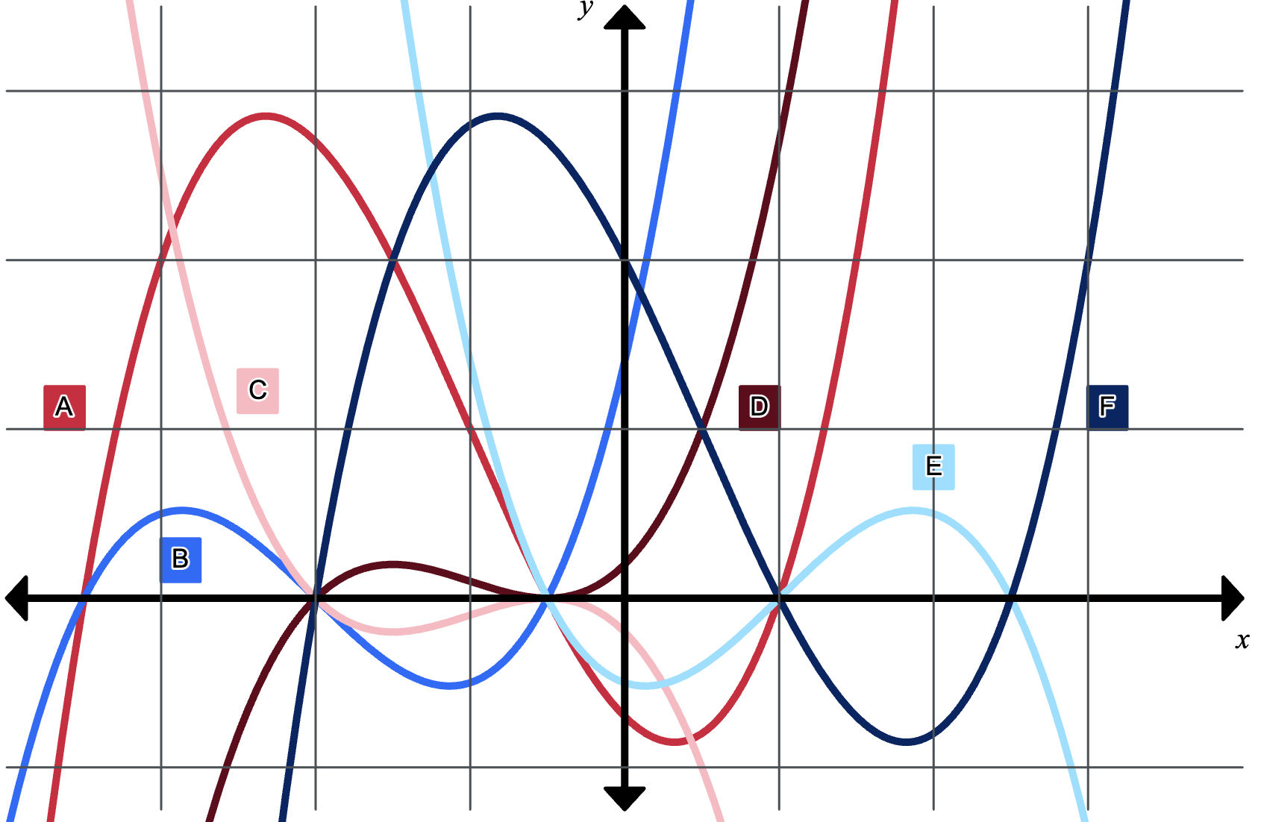

Sample solutions

Appendix A – graphing cubic functions
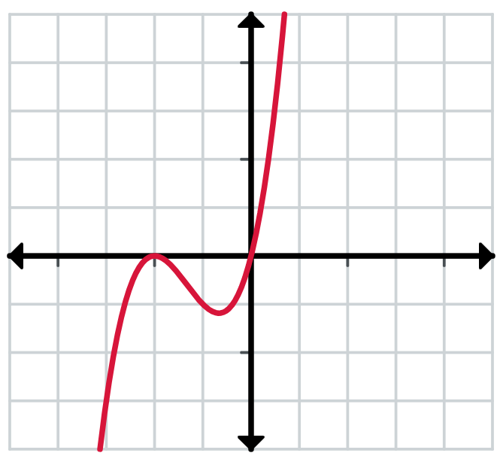 | 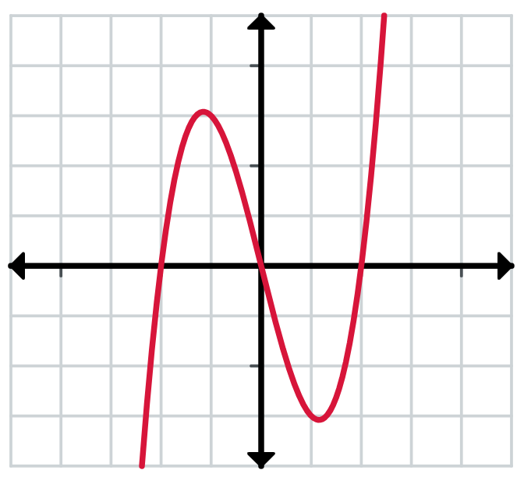 | 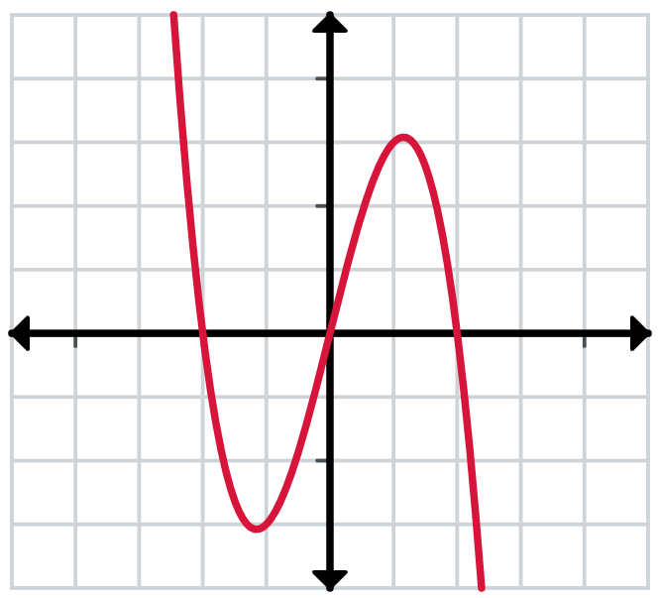
$$y=x{\left(x+2\right)}^{2}$$ | $$y=x(x-2)(x+2)$$ | $$y=-x(x-2)(x+2)$$
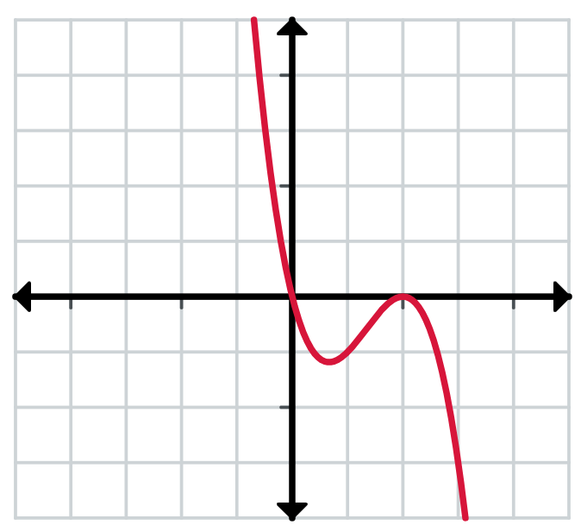 | 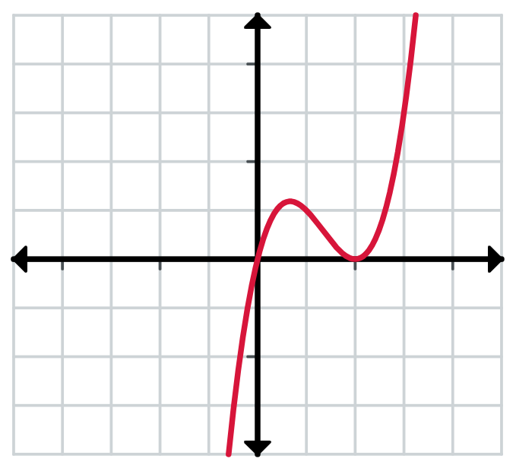 | 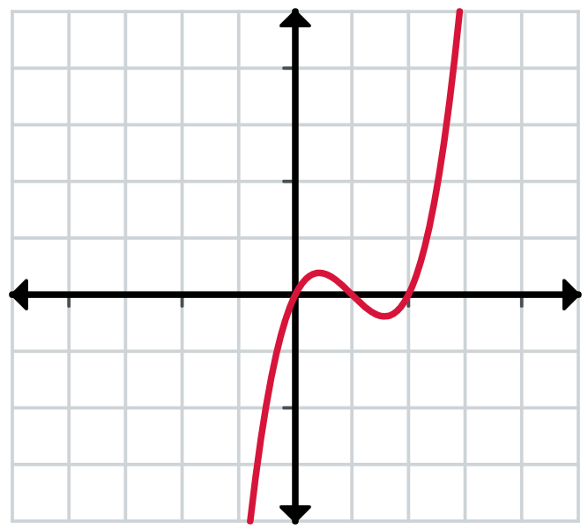
$$y=-x{\left(x-2\right)}^{2}$$ | $$y=x{\left(x-2\right)}^{2}$$ | $$y=x(x-1)(x-2)$$
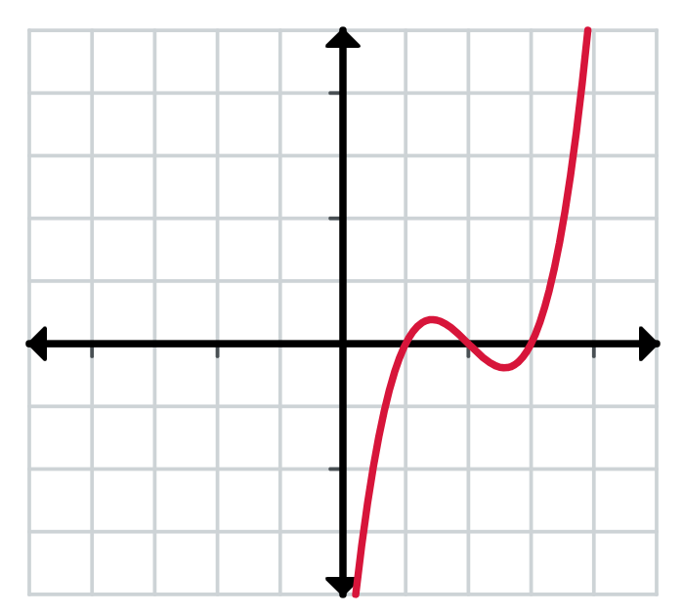 | 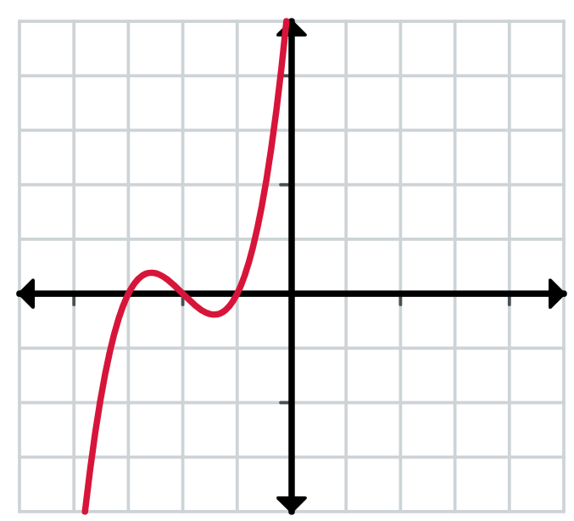 | 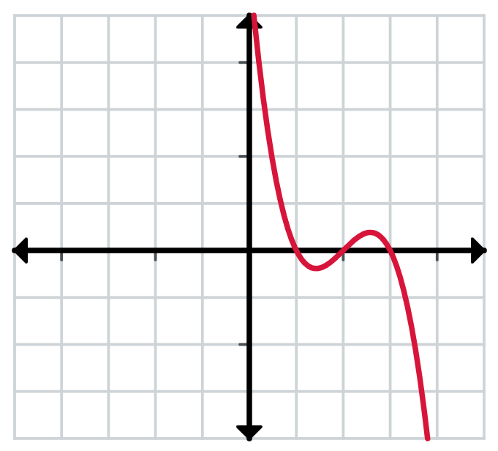
$$y=(x-1)(x-2)(x-3)$$ | $$y=(x+1)(x+2)(x+3)$$ | $$y=(1-x)(2-x)(3-x)$$

Appendix B – Which cubic?
A: $f\left(x\right)=\left(x-1\right)\left(x+7\right)\left(x-2\right)$
B: $f\left(x\right)=\left(x+4\right)\left(x+7\right)\left(x+1\right)$
C: $f\left(x\right)=-{\left(x+1\right)}^{2}\left(x+4\right)$
D: $f\left(x\right)={\left(x+1\right)}^{2}\left(x+4\right)$
E: $f\left(x\right)=-\left(x+1\right)\left(x-2\right)\left(x-5\right)$
F: $f\left(x\right)=(x-2)(x+4)(x-5)$

References
This resource contains NSW Curriculum and syllabus content. The NSW Curriculum is developed by the NSW Education Standards Authority. This content is prepared by NESA for and on behalf of the Crown in right of the State of New South Wales. The material is protected by Crown copyright.
Please refer to the NESA Copyright Disclaimer for more information https://educationstandards.nsw.edu.au/wps/portal/nesa/mini-footer/copyright.
NESA holds the only official and up-to-date versions of the NSW Curriculum and syllabus documents. Please visit the NSW Education Standards Authority (NESA) website https://educationstandards.nsw.edu.au/ and the NSW Curriculum website https://curriculum.nsw.edu.au/.
Mathematics Advanced 11–12 Syllabus © NSW Education Standards Authority (NESA) for and on behalf of the Crown in right of the State of New South Wales, 2024.

© State of New South Wales (Department of Education), 2025
The copyright material published in this resource is subject to the Copyright Act 1968 (Cth) and is owned by the NSW Department of Education or, where indicated, by a party other than the NSW Department of Education (third-party material).
Copyright material available in this resource and owned by the NSW Department of Education is licensed under a Creative Commons Attribution 4.0 International (CC BY 4.0) license.

This license allows you to share and adapt the material for any purpose, even commercially.
Attribution should be given to © State of New South Wales (Department of Education), 2025.
Material in this resource not available under a Creative Commons license:
- the NSW Department of Education logo, other logos and trademark-protected material
- material owned by a third party that has been reproduced with permission. You will need to obtain permission from the third party to reuse its material.
Links to third-party material and websites
Please note that the provided (reading/viewing material/list/links/texts) are a suggestion only and implies no endorsement, by the New South Wales Department of Education, of any author, publisher, or book title. School principals and teachers are best placed to assess the suitability of resources that would complement the curriculum and reflect the needs and interests of their students.
If you use the links provided in this document to access a third-party's website, you acknowledge that the terms of use, including licence terms set out on the third-party's website apply to the use which may be made of the materials on that third-party website or where permitted by the Copyright Act 1968 (Cth). The department accepts no responsibility for content on third-party websites.

