Further circles
In this lesson, students learn how translating a circle affects its equation, graph and key features such as centre, radius, domain and range. They identify the relationship between completing the square, the equation of a circle and its graph.

Learning intention
- To understand how translating a circle changes its equation and graph.

Success criteria
- I can explain how the values in the equation ${\left(x-a\right)}^{2}+{\left(y-b\right)}^{2}=r^{2}$ represent a translation from the origin.
- I can sketch a circle using the principles of translation and describe its domain and range.
- I can determine the centre and radius of a circle from its equation, by completing the square.

Outcomes
A student:
- develops understanding and fluency in mathematics through exploring and connecting mathematical concepts, choosing and applying mathematical techniques to solve problems, and communicating their thinking and reasoning coherently and clearly MAO-WM-01
- analyses and solves algebraic and graphical problems involving transformations of functions and relations MAV-11-03

Content

Graph transformations
- Use the principles of translations to identify the centre, radius, domain and range of graphs of circles in the form ${(x-a)}^{2}+{(y-b)}^{2}=r^{2}$, where $a$, $b$ and $r$ are constants
- Find the centre and radius of circles of the form $x^{2}+y^{2}+ax+by+c=0$, where $a$, $b$ and $c$ are constants, by completing the squares
- Graph circles given their equations and find the equation of a circle from its graph
Mathematics Advanced 11–12 Syllabus © NSW Education Standards Authority (NESA) for and on behalf of the Crown in right of the State of New South Wales, 2024.

Table 1: lesson summary
Section | Summary of activity | Teaching strategies | Teaching points
Activating prior knowledge | Using slides 4–5 of the PowerPoint Further circles, students sketch quadratic and reciprocal functions, noting domain and range changes from translations and comparing effects between functions.  They then sketch a circle with centre $(0,0)$ and radius 4, using slide 6 and predict domain and range changes from translations. | Visibly random groups of 3  Vertical non-permanent surfaces | The purpose of this activity is to review students’ prior knowledge of translations and connect the effect that translation has on the domain and range. Students then transfer this understanding to predict what might happen to a circle if it were translated.
Connecting learning | Students apply their knowledge of how translations affect the equation, to find the equations of translated circles.  Use slides 8–10 to formalise the equation of a circle with centre $(a, b)$. Students then complete Appendix A. | Pose-Pause-Pounce-Bounce  Think-Pair-Share  Worked examples (Your turn) | The aim of this activity is to make explicit links between the equation of a circle and its graphical representation. Students connect translations in the equation to changes in the centre and radius.
Releasing responsibility | Use slides 12–15 to model how to find the centre and radius of circles of the form $x^{2}+y^{2}+ax+by+c=0$, by completing the square.  Students then complete Appendix B. | Worked examples (Your turn)  Faded examples  Notes to future forgetful selves | The purpose of this activity is to guide students through completing the square for circle equations. Watch for common errors such as forgetting to balance the equation, misidentifying the radius, or misinterpreting the centre’s coordinates after translation.
Independent practice | Use slide 17 to present a translation and reflection problem for students to attempt. Students then analyse incorrect solutions on slides 18–20, before reflecting on correct solutions on slide 21 as well as a marking guideline. | Incorrect worked examples | This activity consolidates learning by applying both a reflection and a translation in the same problem. Analysing incorrect solutions helps students recognise and correct misunderstandings while reinforcing links between algebra and graphs.

Activity structure
Please use the associated PowerPoint Further circles to display images in this lesson.

Activating prior knowledge
- Assign students to visibly random groups of 3 (bit.ly/visiblegroups) at vertical non-permanent surfaces (bit.ly/VNPSstrategy).
- Display slide 4 of the PowerPoint and instruct groups to sketch each of the 4 quadratic functions. Click to animate the slide and have students consider how the domain and range changes with each translation.
- Display slide 5 and instruct groups to sketch each of the 4 reciprocal functions. Click to animate the slide and have groups consider how the domain and range changes with each translation using the self-explanation prompt that appears.
Solutions for slides 4 and 5, including each function’s domain and range can be found in the sample solutions section of this document.
- Initiate a class discussion to consider whether translations affect the domain and range in the same way for the parabola and reciprocal function. Some suggested prompts include:
- Is there a connection between the transformation and the domain or range? Why might that be the case?
- Can the same transformation change the domain but not the range, or vice versa? Why might that happen?
Students should have concluded that for parabolas, a vertical translation changes only the range. This is because the parabola has no restrictions on the domain, so a horizontal translation would keep the domain as all real $x$.
For the reciprocal function, both the domain and range can change depending on the translation: a horizontal translation affects the domain, while a vertical translation affects the range.
- In their groups at their vertical non-permanent surfaces, have students sketch a circle centred at the origin with a radius of 4. Encourage students to include the equation of the circle, all key features and the domain and range.
Students have previously graphed circles and semi-circles with the centre at the origin in Lesson 4 – circles and semi-circles of Unit 2 – introduction to functions.
Students should recall the formula for a circle centred at the origin as $x^{2}+y^{2}=r^{2}$.
- Display slide 6 and have students consider the question in their groups. Encourage students to draw the new translated circle to consolidate their thinking.
- Repeat this process for 2 additional questions, by animating the slide.
- Once students have completed the 3 questions, ask them to consider how the number of $x$- and $y$-intercepts change with each translation.
- Have students return to their workspaces and initiate a class discussion to review answers, considering if translating circles affects the domain and range in the same way as translations of quadratic and reciprocal functions.
Students should share that the circle with centre $(0, 0)$ and a radius of 4 has a domain $-4≤x≤4$, and a range of $-4≤y≤4$.
- When the circle is translated to the right by 3 units, a horizontal translation has occurred. In a similar way to the reciprocal function this would affect the domain, shifting the entire domain 3 units to the right. Students may share that the domain would be $-1≤x≤7$.
- When the circle is translated up by 5 units, a vertical translation has occurred. In a similar way to the parabola and the reciprocal function this would affect the range, shifting the entire range 5 units up. Students may share that the range would be $1≤y≤9$.
- When both a horizontal and vertical translation occur, both the domain and range of a circle will change. Students may share that the domain would be $-1≤x≤7$ and the range would be $1≤y≤9$.

Connecting learning
- Use the Pose-Pause-Pounce-Bounce questioning strategy (PDF 557 KB) (bit.ly/posepausepouncebounce) to review how translations affect a graph’s equation. Suggested prompts include:
- If a graph is translated $a$ units horizontally, how does the equation change?
- If a graph is translated $b$ units vertically, how does the equation change?
- What does the sign of $a$ and $b$ tell you about the direction of the translation?
Students have previously learned how replacing $x$ by $x-a$ corresponds to a horizontal translation by $a$. Replacing $y$ by $y-b$ corresponds to a vertical translation by $b.$ Students have previously learned that the sign of $a$ and $b$ determines the direction of the translation in Lesson 5 – translations.
- In a Think-Pair-Share (bit.ly/thinkpairsharestrategy) ask students to consider what the equation of a circle would be after a horizontal translation of $a$ units and a vertical translation of $b$ units.
Students should share that the equation would be ${\left(x-a\right)}^{2}+{\left(y-b\right)}^{2}=r^{2}$.
- Use slide 8, which shows the graph of $x^{2}+y^{2}=9$, surrounded by related equations of the form ${\left(x-a\right)}^{2}+{\left(y-b\right)}^{2}=9$. In a Think-Pair-Share ask students to explain and consider how the original graph will be translated, encourage them to describe the direction and how this relates to the values of $a$ and $b$.
- Facilitate a class discussion to unpack the equation of a circle ${\left(x-a\right)}^{2}+{\left(y-b\right)}^{2}=r^{2}$. Some suggested prompts include:
- Which features of the circle can be identified from the equation?
- How might the values of $a$ and $b$ help determine the centre of the circle?
The Desmos Graphing Calculator ‘Circle, centre $(a,b)$’ (https://www.desmos.com/calculator/tkixmjqzyw) can be used to demonstrate how changes to $a$ and $b$ translate the circle and change the centre.
- Use slides 9–10 to model how to identify the centre and radius of a circle from its equation, and the graph circles in the form ${\left(x-a\right)}^{2}+{\left(y-b\right)}^{2}=r^{2}$ using the Worked examples (Your turn) strategy (bit.ly/supportingstrategies).
Use the self-explanation prompts to guide students to consider why $x$- and $y$-intercepts aren’t the focus when graphing circles, unlike parabolas and other functions, and instead, how the centre and radius determine the graph. Encourage students to also describe how the domain and range are linked to these key features.
- Distribute Appendix A ‘Graphing circles’ for students to complete in pairs. In this activity, students sketch circles using principles of translations, describe the transformation from a circle centred at the origin, and determine how the domain and range have changed as a result.
- Initiate a class discussion to review students’ answers and analyse how translations affect the intercepts and the graph more broadly. Some suggested prompts include:
- How does translating a circle affect the domain and range?
- Does translating a circle affect how many $x$- or $y$-intercepts it has?

Releasing responsibility
- Ask students to consider if the equation of circles will always be in the form ${\left(x-a\right)}^{2}+{\left(y-b\right)}^{2}=r^{2}$.
- Write both forms ${\left(x-a\right)}^{2}+{\left(y-b\right)}^{2}=r^{2}$ and $x^{2}+y^{2}+ax+by+c=0$ on the board and ask students why there are 2 forms and how they might move between each.
Students may need to revise how to complete the square before progressing to the next step. Students have previously learned this in Lesson 7 – completing the square of Unit 3 – working with linear and quadratic functions.
- Use slides 12–15 to model how to find the centre and radius of circles of the form
$x^{2}+y^{2}+ax+by+c=0$, where $a$, $b$ and $c$ are constants, by completing the square, using the Worked examples (Your turn) strategy.
- Distribute Appendix B ‘Faded examples’ (bit.ly/fadedexamplesstrategy) for students to complete. Students will need to complete the square to find the centre and radius of a circle, before sketching.
- Encourage students to annotate Appendix B to serve as notes to their future forgetful selves (bit.ly/notestofutureself). Students should be encouraged to make notes on how to complete the square to find the centre and radius of a circle, as well as what the signs of $a$ and $b$ indicate in the equation ${\left(x-a\right)}^{2}+{\left(y-b\right)}^{2}=r^{2}$.
- Students may benefit from completing practice questions from an existing resource for finding the centre and radius of circles; by completing the square, sketching circles and finding the equation of a circle from its graph.

Independent practice
- Display slide 17 which shows a question involving translation and reflection of a circle. Allow students time in pairs to complete the question.
Students learned about reflection in Lesson 4 – reflection. Don’t reveal a solution to this question until after step 2.
- Use slides 18–20 which display incorrect worked examples (bit.ly/incorrectworkedexamples) for the question on slide 17. In a Think-Pair-Share, have students discuss why the solution is incorrect or incomplete. As each incorrect solution is discussed, have students consider their own solutions and adjust if needed.

- Slide 18 contains an error in the second line of working. The constants $+1$ and $+4$ have been added twice, instead of correctly applying $+1$ and $-1$, and $+4$ and $-4$, when completing the square. As a result, the equation has been rearranged incorrectly, leading to a radius of $-1$, which is not possible.
- Slide 19 is incorrect, as $x$ has been replaced with $-x$, rather than $y$ being replaced with $-y$.
- Slide 20 is incorrect and incomplete. The radius is the square root of the right-hand side, so the radius should be $\sqrt{9}=3$. The solution also doesn’t have a sketch of the reflected circle.
- Display slide 21, which shows the correct solution. This solution might be quite different to their own and students may share that they followed a similar process to the solution on slide 20 by replacing $y$ with $-y$. As a class discuss the different approaches to the question.
- Table 2: marking criteria, can be used as a discussion point with students to see how each of the incorrect solutions and their own may have been marked. This is an example marking guideline based on previous HSC questions.
Table 2: marking criteria
Marks | Criteria
3 | - Provides the correct solution
2 | - Finds the centre and the radius of the original circle or of the reflected circle, or equivalent merit
1 | - Completes the square for the equation, or equivalent merit

Assessment and differentiation

Suggested opportunities for differentiation
Activating prior knowledge
- The quadratic and reciprocal functions can be adjusted to suit the needs of each student, either by simplifying or adding complexity.
- Students could be provided with the initial graphs $y=3x^{2}+1$ and $y=\frac{2}{x}$ to support them in focusing on the translations.
- Allow students to choose whether they show translations algebraically, graphically or using a verbal explanation when discussing changes to domain and range.
Connecting learning
- Allow students to work with the provided Desmos graph or another graphing application to explore the translation visually.
- Offer students the choice to present the translations in graphical, verbal or algebraic forms.
- A connection to the distance formula and Pythagoras’ theorem can be made for students to see how the equation of a circle with centre $(a, b)$ is derived.
Releasing responsibility
- Students can be provided with a range of fully worked examples first rather than the Worked examples (Your turn) strategy.
- To connect the working to previous lessons on completing the square, the constant has been added and subtracted from one side of the equation. Different methods could be discussed with students, such as adding a constant to both sides of the equation instead.
Independent practice
- Emphasise to students that there are a variety of methods to answer this question.
- Allow students to self or peer assess their own solution using the marking guideline.

Suggested opportunities for assessment
Activating prior knowledge
- Circulate and listen to group discussion to formatively assess students’ prior knowledge of translation and their ability to sketch functions.
Connecting learning
- Use the responses to the self-explanation prompts to collect evidence of procedural fluency, for example, can they extract the centre and radius from the equation?
- Appendix A can be collected to check students’ understanding of finding the equations of a circle from a graph and graphing a circle form a given equation.
Releasing responsibility
- Track students’ progress with Appendix B to assess if they can complete questions independently.
- Review students’ annotations to assess their understanding of the process of completing the square and if they can successfully find the domain and range.
Independent practice
- When students share the reasons for a solution being incorrect, formatively assess for their depth of conceptual understanding and any misconceptions they may be displaying in reflection, equation manipulation or completing the square.

Appendix A

Graphing circles
Complete each section of the table by writing equations of circles, determining the domain and range, sketching and describing translations.
Circle 1 with centre $(0,0)$ | Graph of circle 1 | Translation description | Circle 2 with centre $(a,b)$ | Graph of circle 2
Equation  $$x^{2}+y^{2}=9$$  Domain and range  Domain: $-3≤x≤3$  Range: $-3≤y≤3$ | 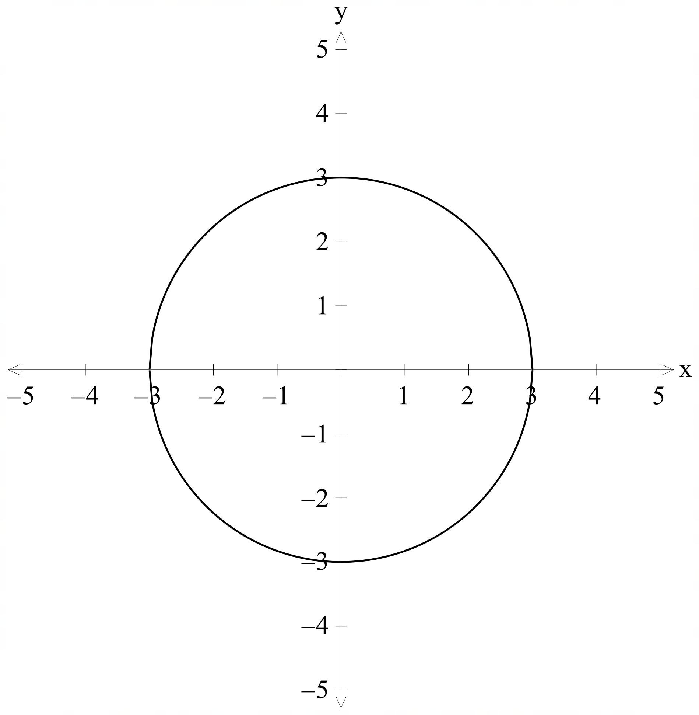 | Translated 3 units up. | Equation  Domain and range  Domain:  Range: | 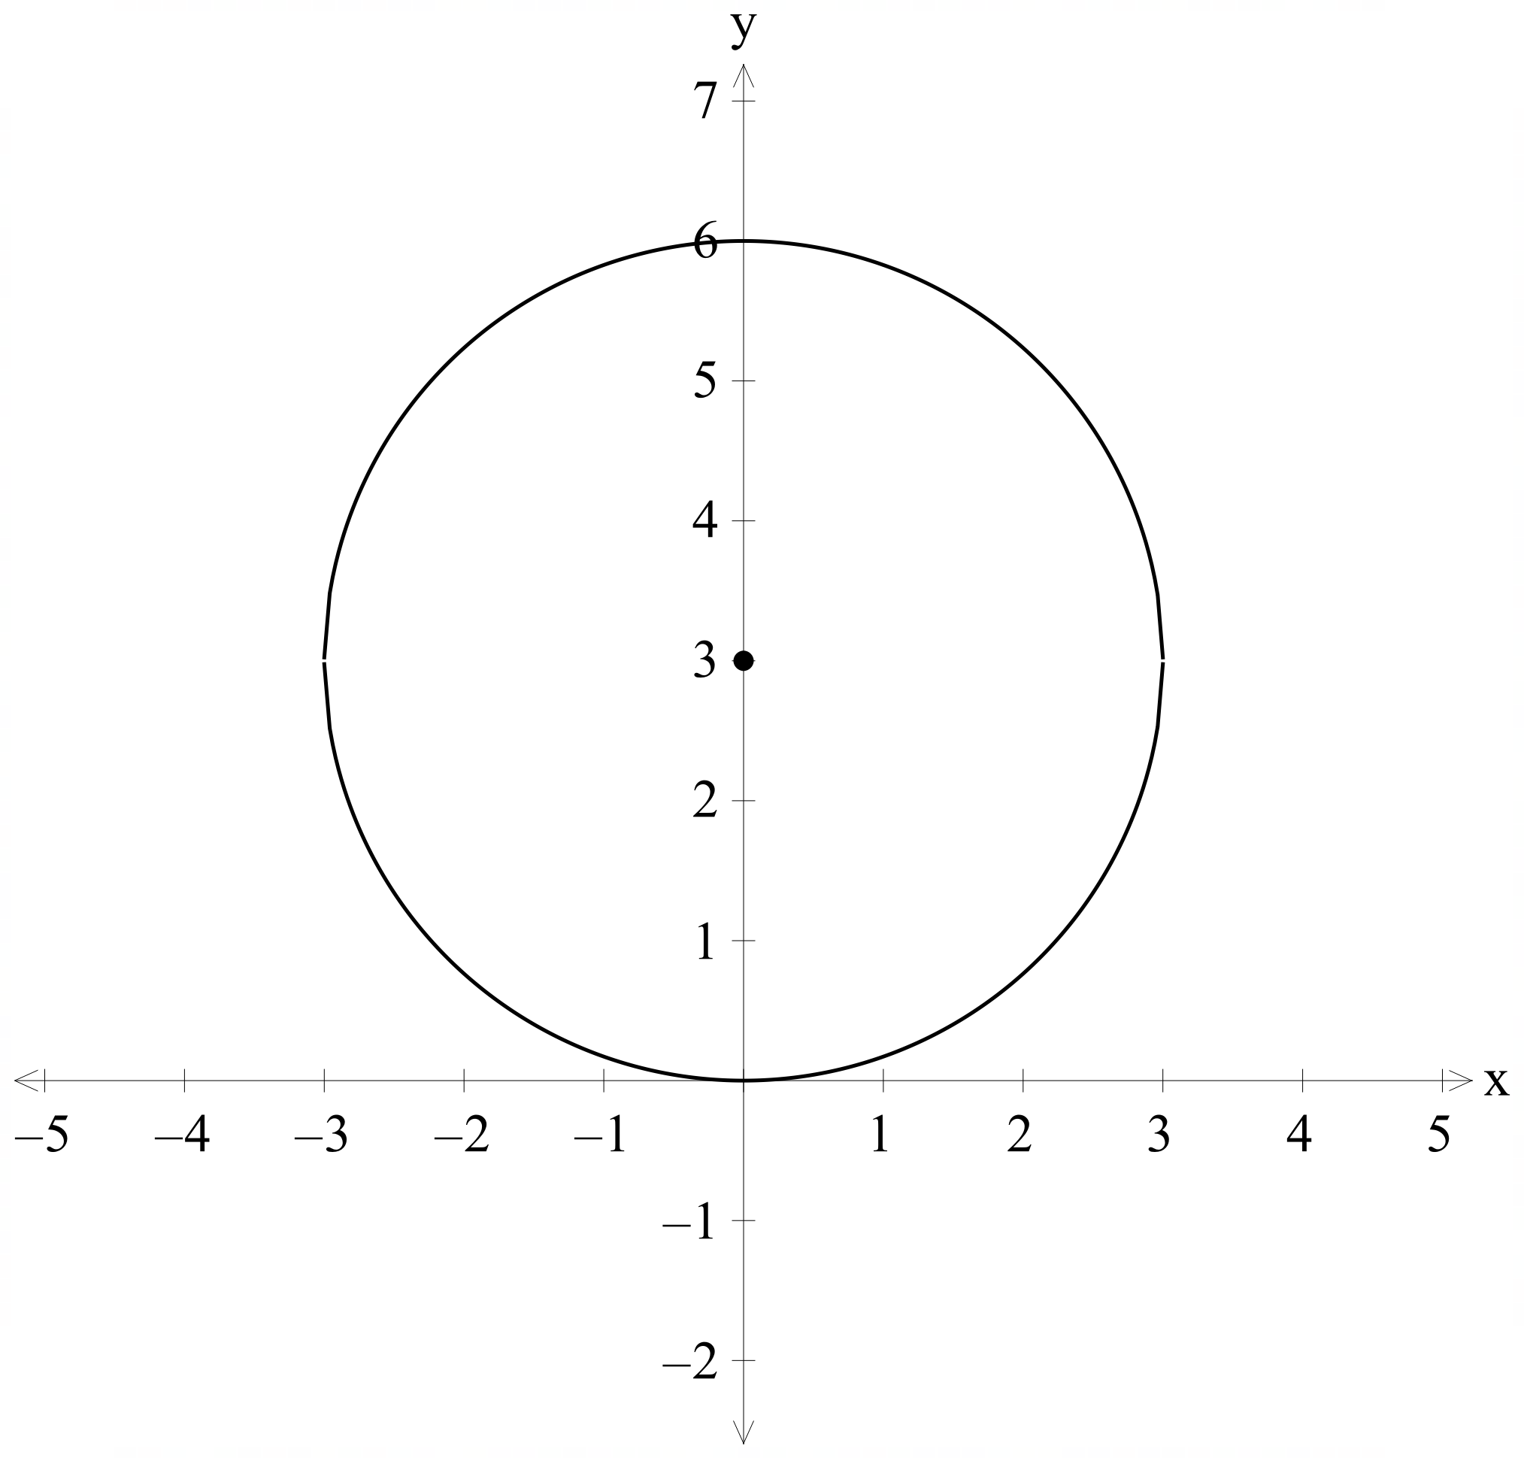
Equation  $$x^{2}+y^{2}=16$$  Domain and range  Domain:  Range: | 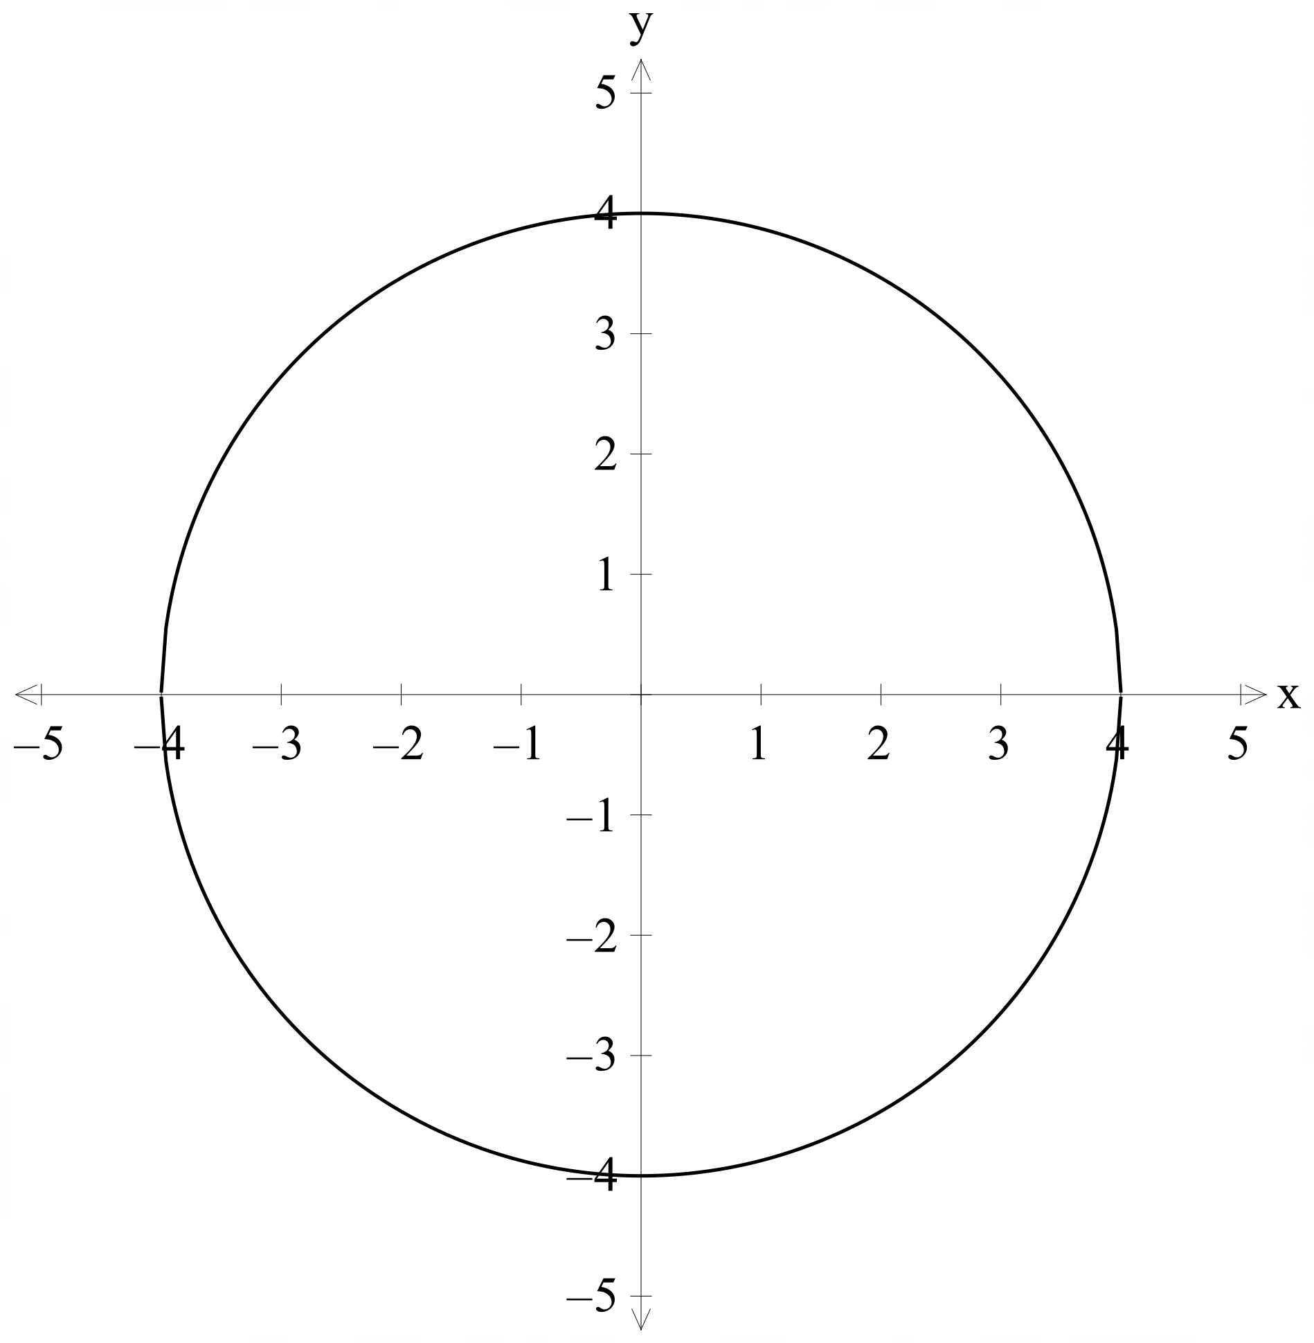 |  | Equation  $${\left(x-2\right)}^{2}+{\left(y+1\right)}^{2}=16$$  Domain and range  Domain:  Range: | 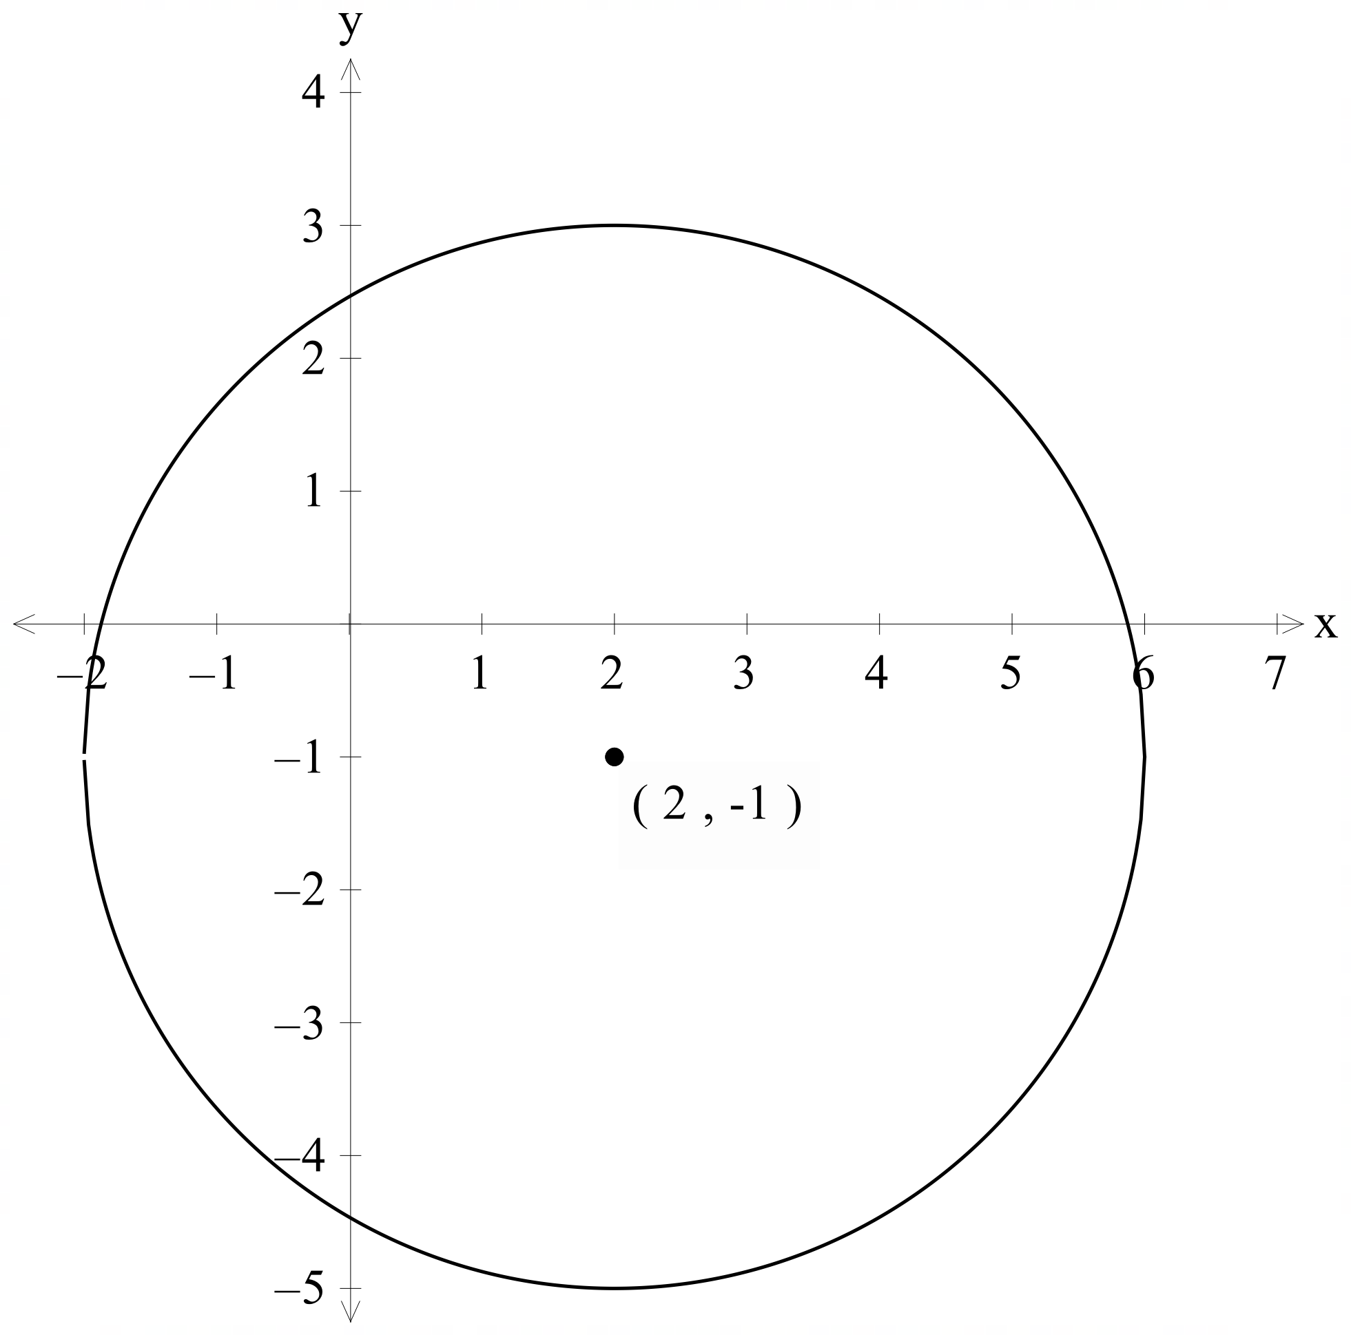
Equation  Domain and range  Domain: $-2≤x≤2$  Range: $-2≤y≤2$ | 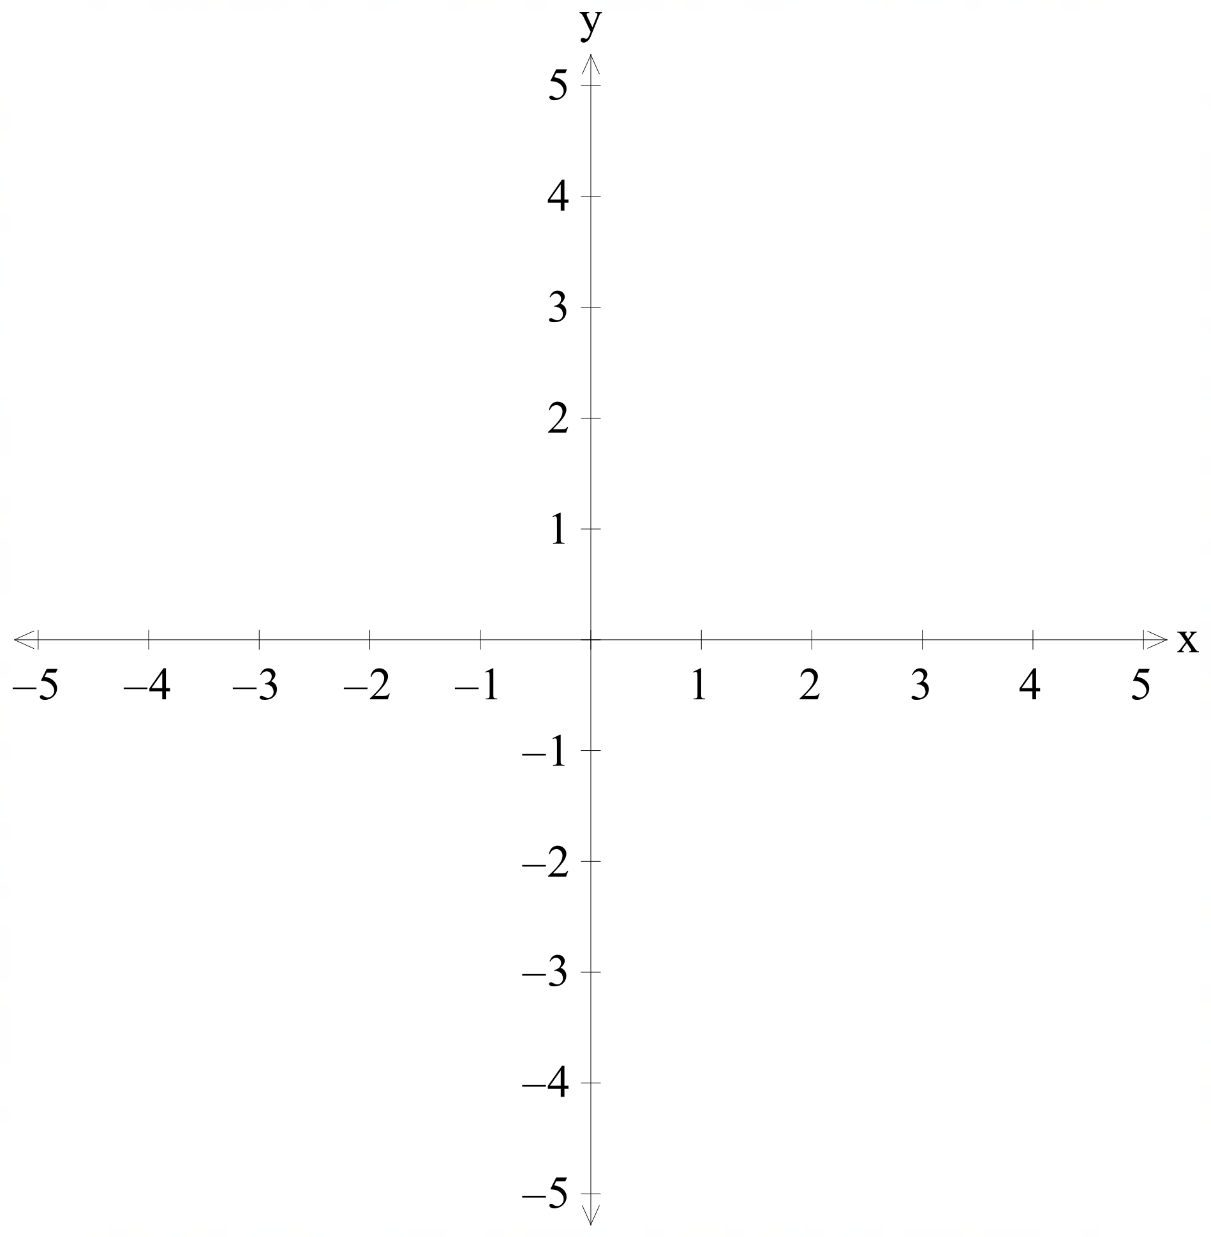 | Translated 2 units up and 2 units left. | Equation  Domain and range  Domain:  Range: | 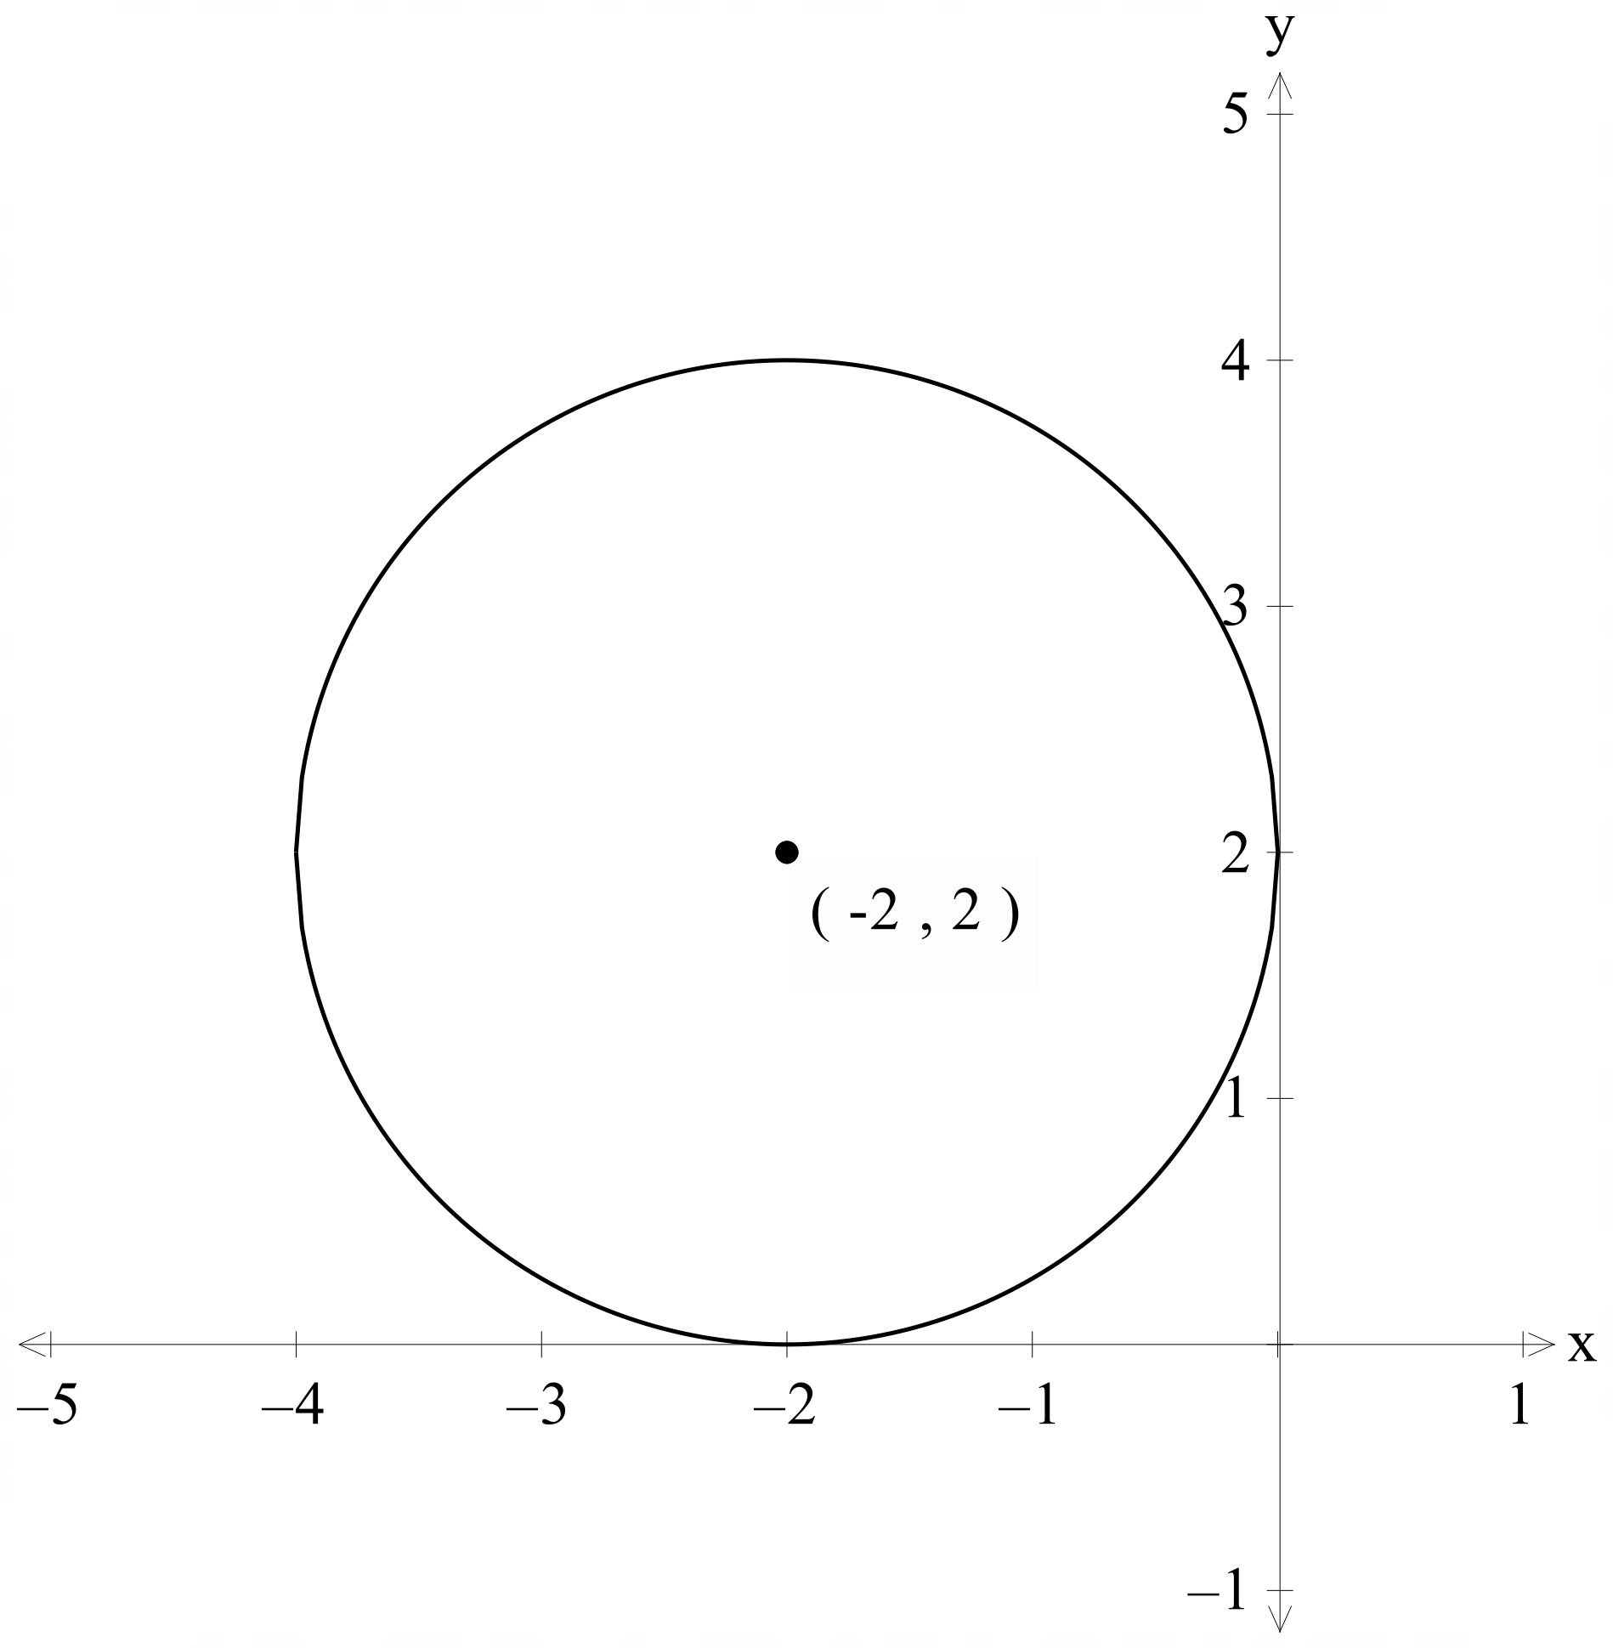
Equation  $$x^{2}+y^{2}=9$$  Domain and range  Domain:  Range: |  |  | Equation  $${\left(x+3\right)}^{2}+{\left(y+1\right)}^{2}=9$$  Domain and range  Domain:  Range:

Appendix B

Faded examples
Question 1 | Question 2 | Question 3
Sketch the circle, $x^{2}+y^{2}+2x-8y+1=0$, showing the centre and radius, and state the domain and range.  Step 1: complete the square  $$x^{2}+2x+y^{2}-8y+1=0$$  $$x^{2}+2x+1+y^{2}-8y+16 +1-1-16=0$$  $${\left(x+1\right)}^{2}+{\left(y-4\right)}^{2}-16=0$$  $${\left(x+1\right)}^{2}+{\left(y-4\right)}^{2}=16$$  $${\left(x+1\right)}^{2}+{\left(y-4\right)}^{2}=4^{2}$$  Step 2: determine centre and radius  Centre at $(-1, 4)$  Radius is $4$  Step 3: sketch the circle  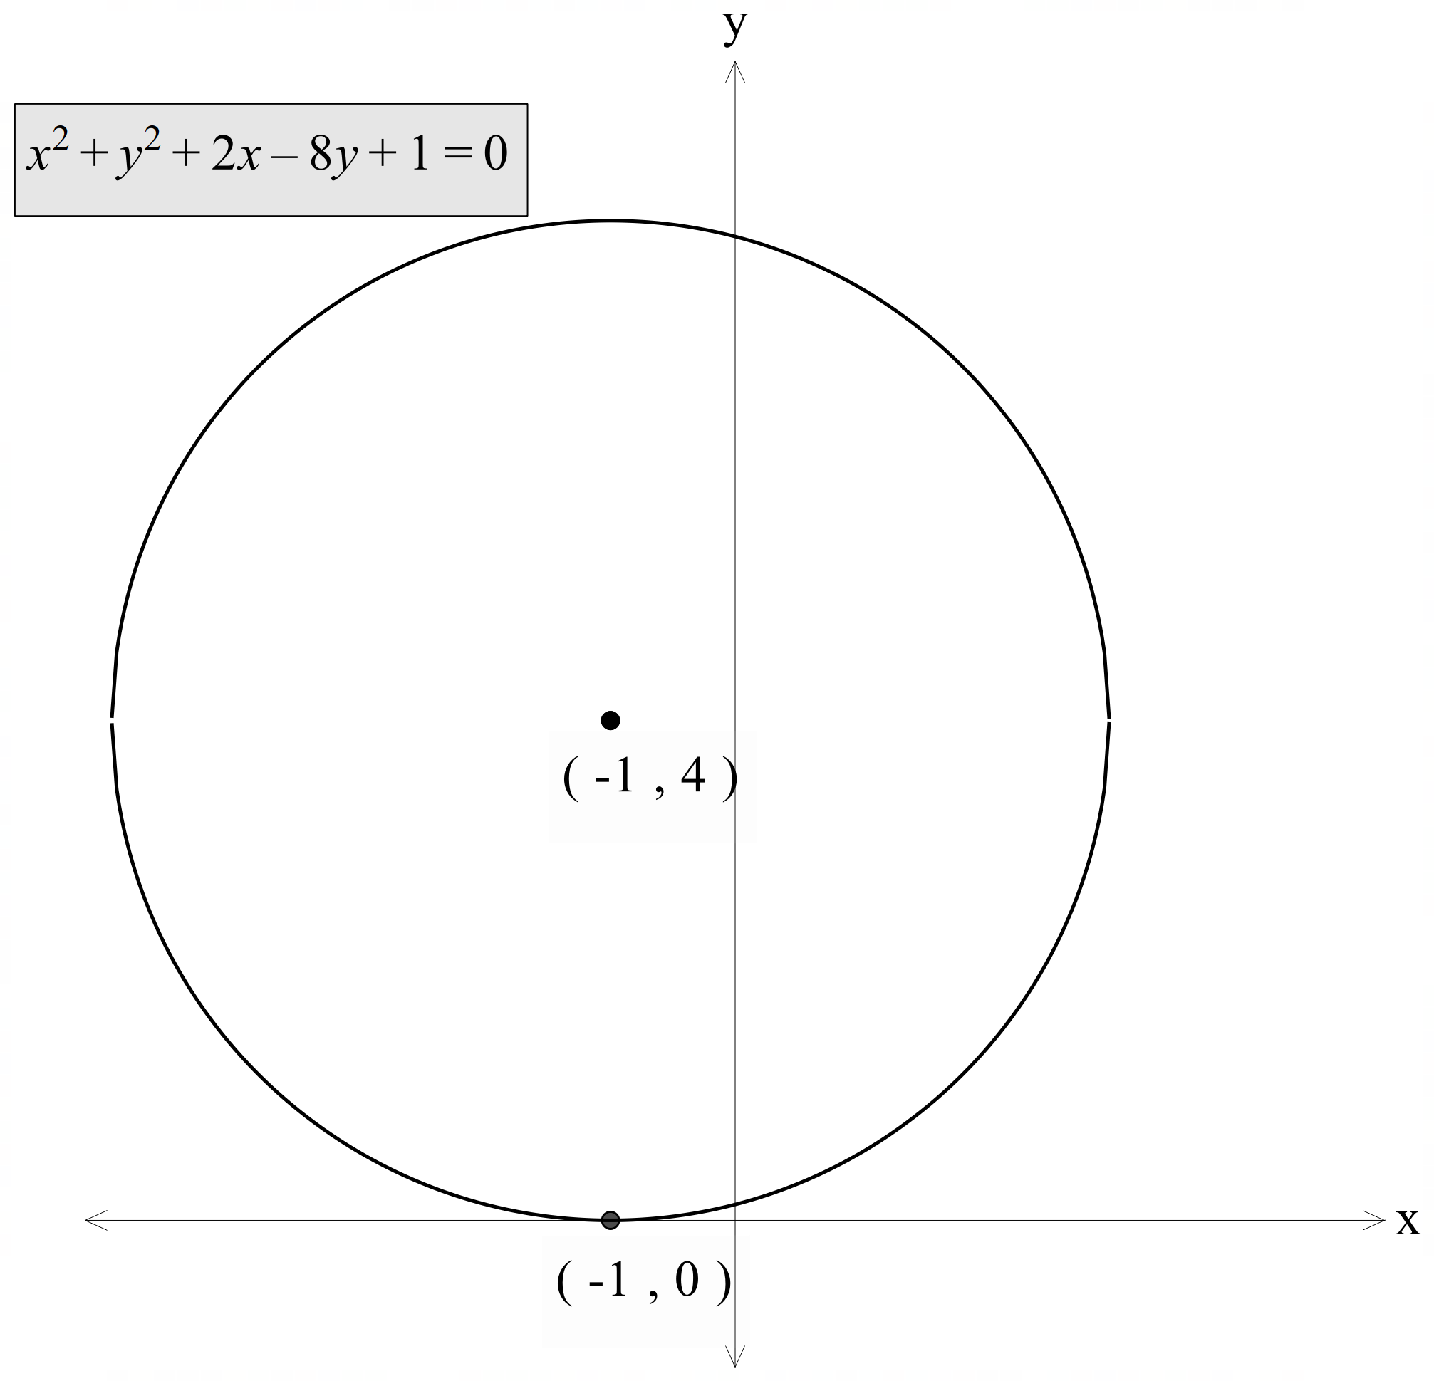  Step 4: state the domain and range  Domain: $[-5, 3]$  Range: $[0, 8]$ | Sketch the circle,  $x^{2}+y^{2}-10x-2y+17=0$, showing the centre and radius, and state the domain and range.  Step 1: complete the square  Step 2: determine centre and radius  Step 3: sketch the circle  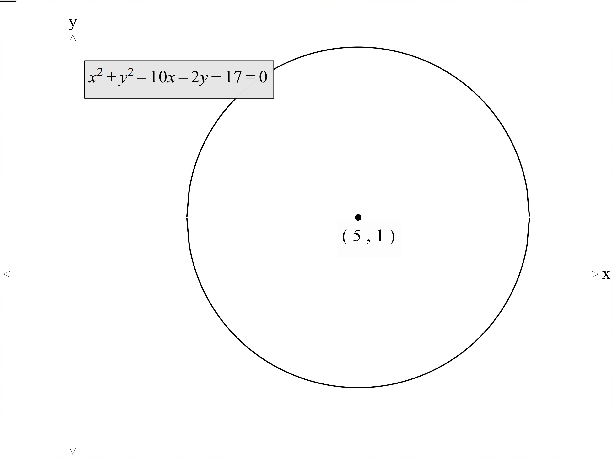  Step 4: state the domain and range  Domain: $[2, 8]$  Range: $[-2, 4]$ | Sketch the circle,  $x^{2}+y^{2}+8x-6y+21=0$, showing the centre and radius, and state the domain and range.  Step 1: complete the square  Step 2: determine centre and radius  Step 3: sketch the circle  Step 4: state the domain and range

Sample solutions

Activating prior knowledge activity

Slide 4 – parabolas
$$y=3x^{2}+1$$ | $$y=3{\left(x+2\right)}^{2}+1$$ | $$y-4=3x^{2}+1$$ | $$y-4=3{\left(x+2\right)}^{2}+1$$
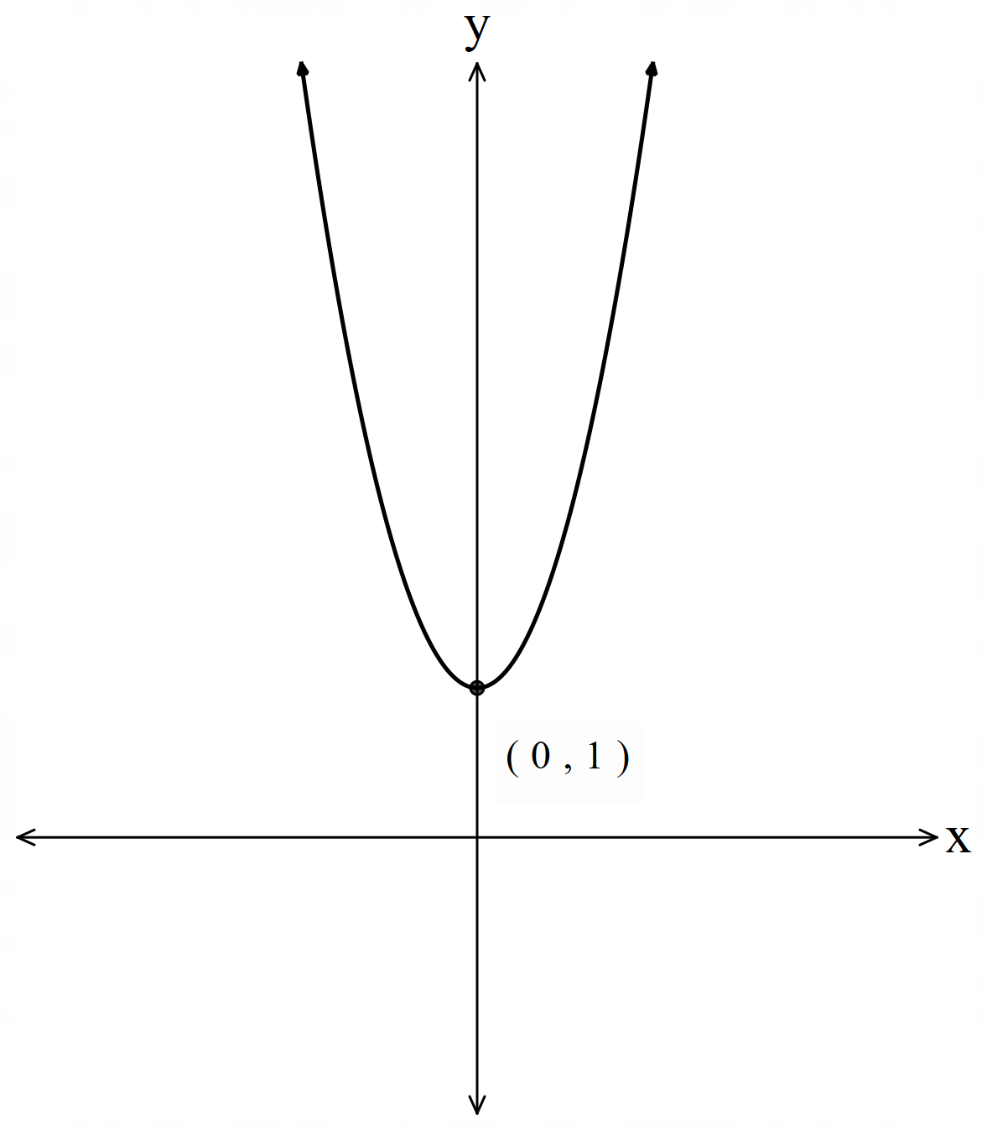 | 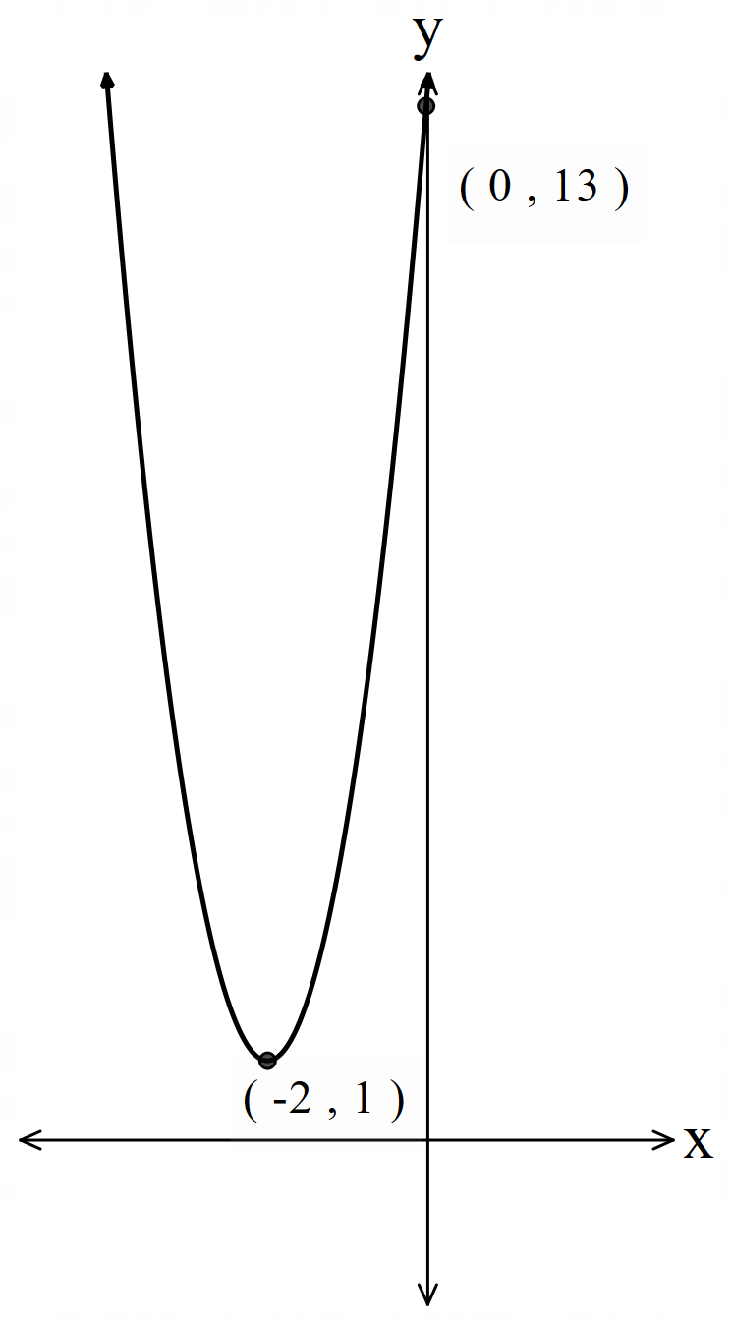 | 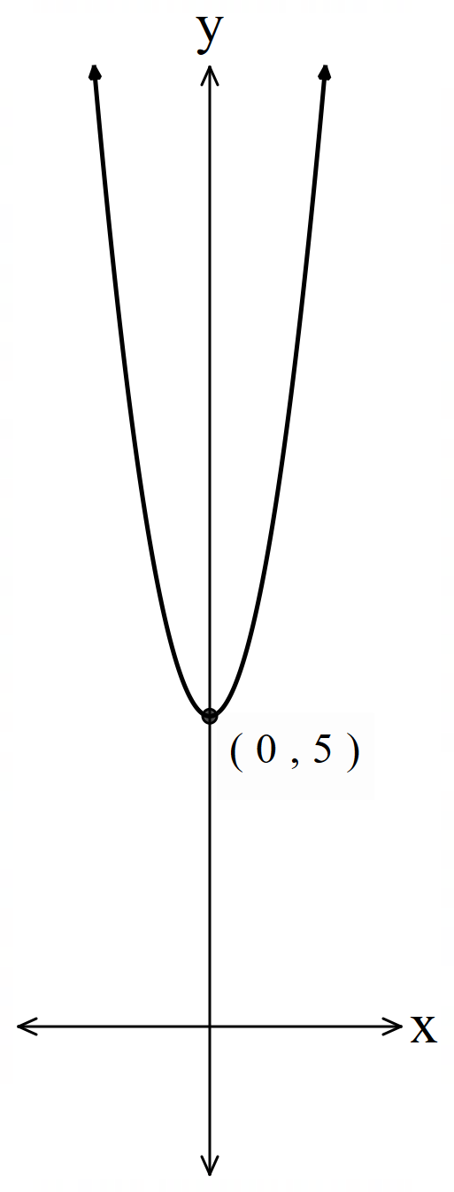 | 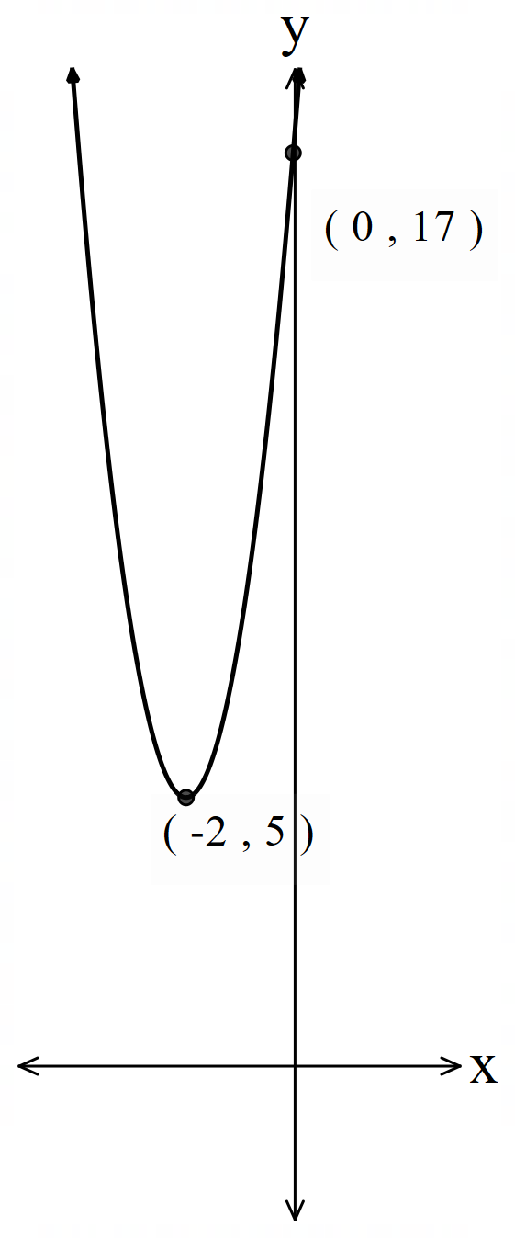
Domain: all real $x$  Range: $y≥1$ | Domain: all real $x$  Range: $y≥1$ | Domain: all real $x$  Range: $y≥5$ | Domain: all real $x$  Range: $y≥5$

Slide 5 – reciprocal functions
$$y=\frac{2}{x}$$ | $$y=\frac{2}{x-1}$$ | $$y+3=\frac{2}{x}$$ | $$y+3=\frac{2}{x-1}$$
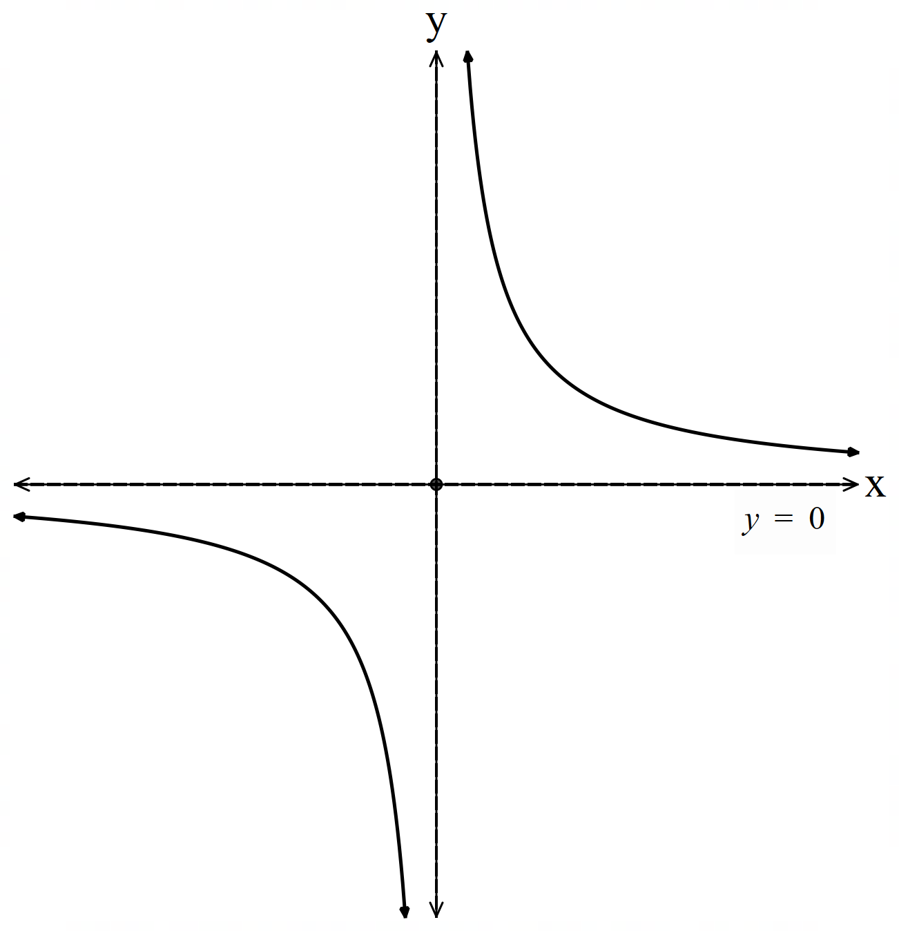 | 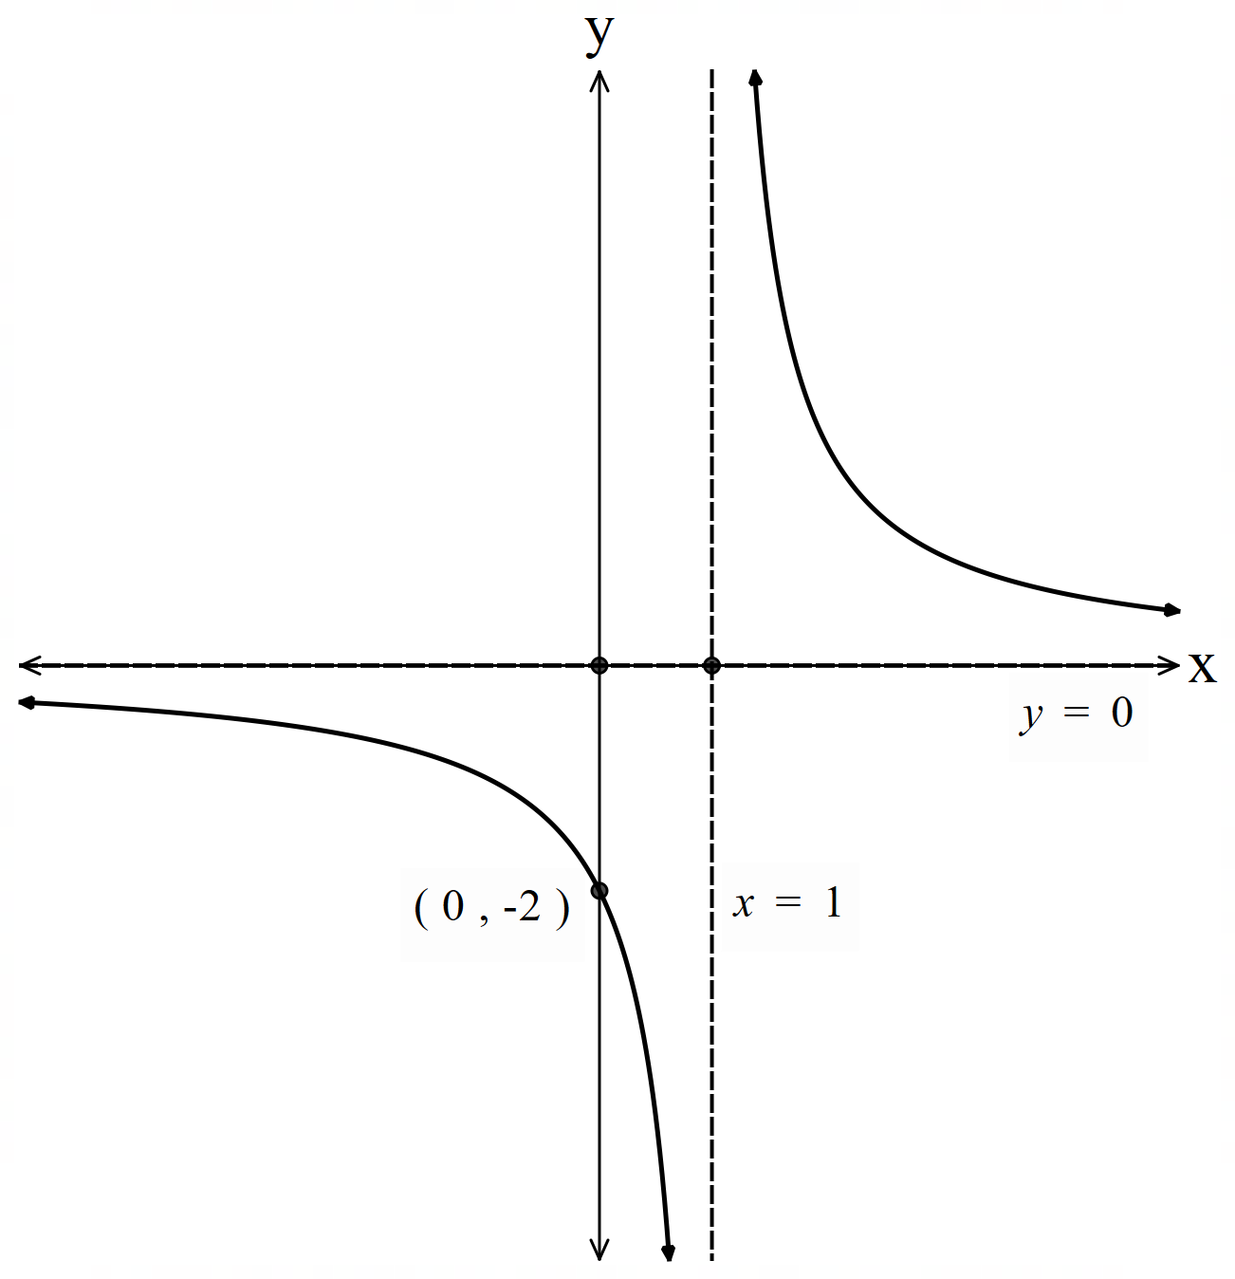 | 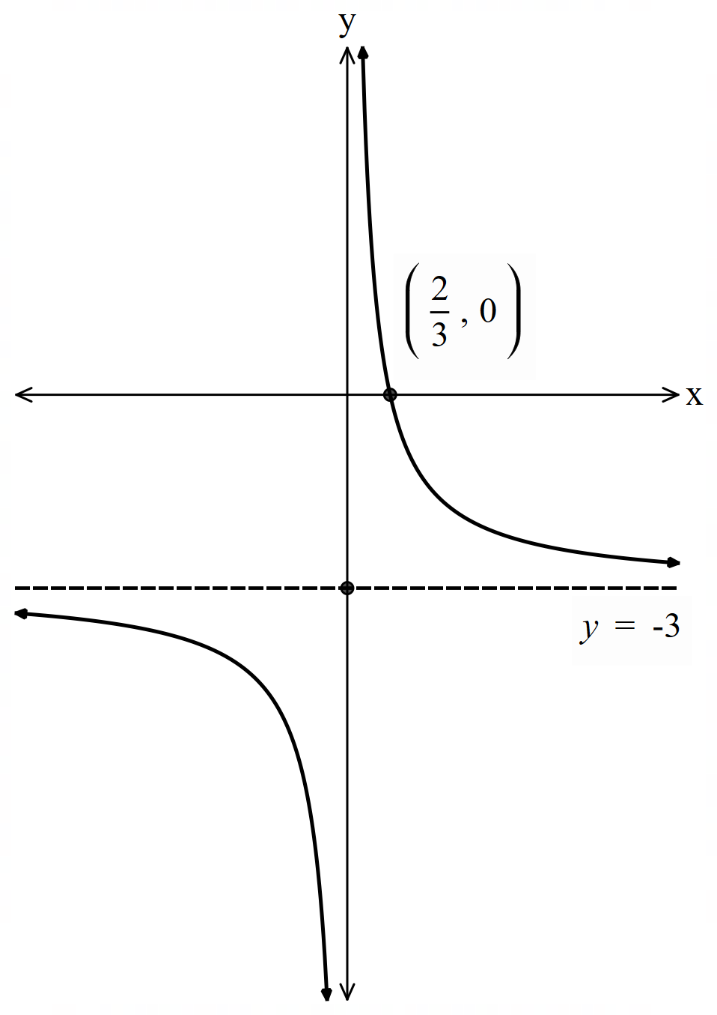 | 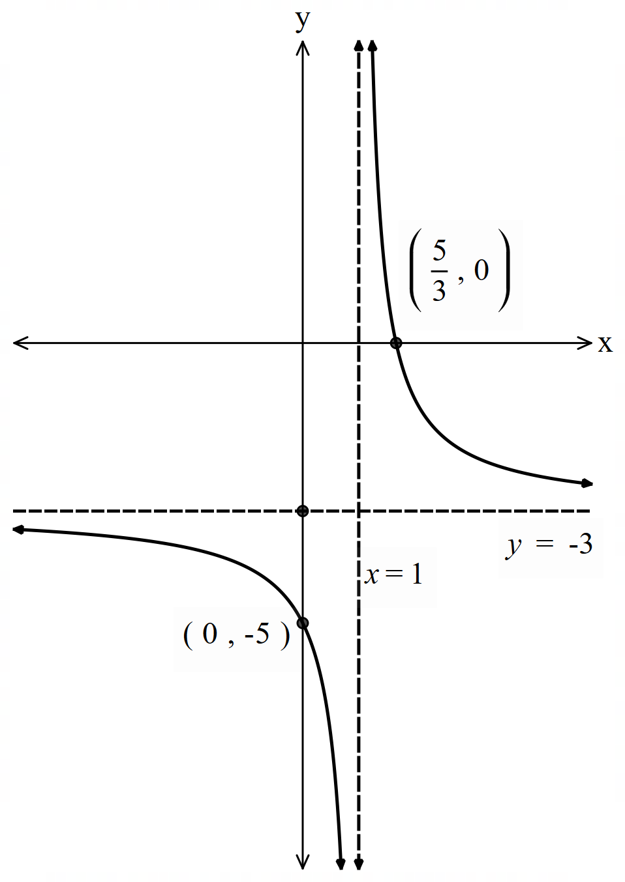
Domain: all real $x$, $x≠0$  Range: all real $y, y≠0$ | Domain: all real $x, x≠1$  Range: all real $y, y≠0$ | Domain: all real $x, x≠0$  Range: all real $y, y≠-3$ | Domain: all real $x, x≠1$  Range: all real $y, y≠0$

Appendix A – graphing circles
Circle 1 with centre $(0,0)$ | Graph of circle 1 | Translation description | Circle 2 with centre $(a,b)$ | Graph of circle 2
Equation  $$x^{2}+y^{2}=9$$  Domain and range  Domain: $-3≤x≤3$  Range: $-3≤y≤3$ |  | Translated 3 units up. | Equation  $$x^{2}+{\left(y-3\right)}^{2}=9$$  Domain and range  Domain: $-3≤x≤3$  Range: $0≤y≤6$
Equation  $$x^{2}+y^{2}=16$$  Domain and range  Domain: $-4≤x≤4$  Range: $-4≤y≤4$ |  | Translated 1 unit down and 2 units right. | Equation  $${\left(x-2\right)}^{2}+{\left(y+1\right)}^{2}=16$$  Domain and range  Domain: $-2≤x≤6$  Range: $-5≤y≤3$
Equation  $$x^{2}+y^{2}=4$$  Domain and range  Domain: $-2≤x≤2$  Range: $-2≤y≤2$ | 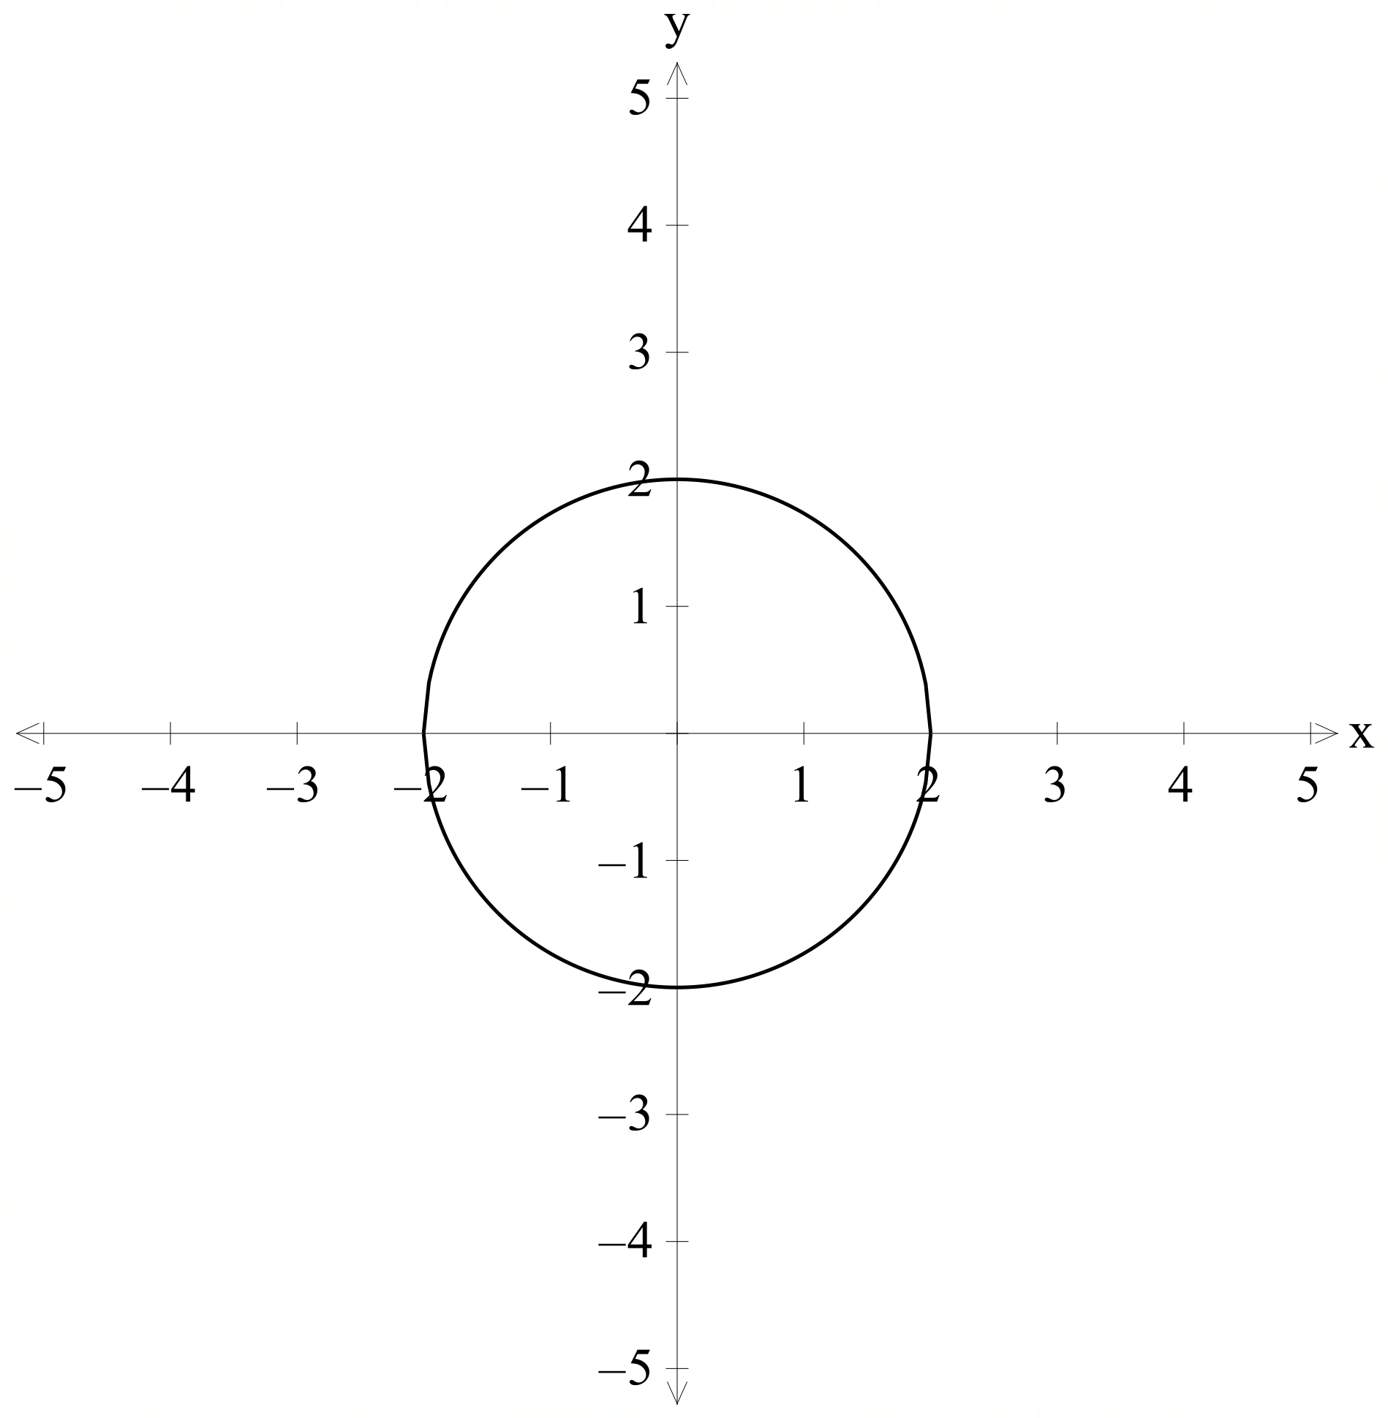 | Translated 2 units up and 2 units left. | Equation  $${\left(x+2\right)}^{2}+{\left(y-2\right)}^{2}=4$$  Domain and range  Domain: $-4≤x≤0$  Range: 0$≤y≤4$
Equation  $$x^{2}+y^{2}=9$$  Domain and range  Domain: $-3≤x≤3$  Range: $-3≤y≤3$ |  | Translated 1 unit down and 3 units left. | Equation  $${\left(x+3\right)}^{2}+{\left(y+1\right)}^{2}=9$$  Domain and range  Domain: $-5≤x≤-1$  Range: -3$≤y≤1$ | 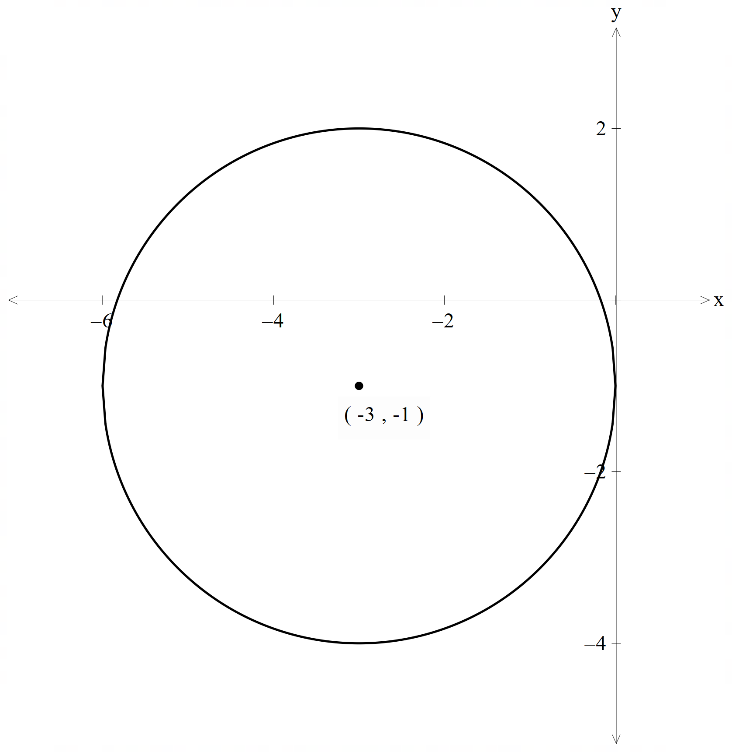

Appendix B – faded examples
Question 1 | Question 2 | Question 3
Sketch the circle, $x^{2}+y^{2}+2x-8y+1=0$, showing the centre and radius, and state the domain and range.  Step 1: complete the square  $$x^{2}+2x+y^{2}-8y+1=0$$  $$x^{2}+2x+1+y^{2}-8y+16 +1-1-16=0$$  $${\left(x+1\right)}^{2}+{\left(y-4\right)}^{2}-16=0$$  $${\left(x+1\right)}^{2}+{\left(y-4\right)}^{2}=16$$  $${\left(x+1\right)}^{2}+{\left(y-4\right)}^{2}=4^{2}$$  Step 2: determine centre and radius  Centre at $(-1, 4)$  Radius is $4$  Step 3: sketch the circle  Step 4: state the domain and range  Domain: $[-5, 3]$  Range: $[0, 8]$ | Sketch the circle,  $x^{2}+y^{2}-10x-2y+17=0$, showing the centre and radius, and state the domain and range.  Step 1: complete the square  $$x^{2}-10x+y^{2}-2y+17=0$$  $$x^{2}-10x+25+y^{2}-2y+1 +17-25-1=0$$  $${\left(x-5\right)}^{2}+{\left(y-1\right)}^{2}-9=0$$  $${\left(x-5\right)}^{2}+{\left(y-1\right)}^{2}=9$$  $${\left(x-5\right)}^{2}+{\left(y-1\right)}^{2}=3^{2}$$  Step 2: determine centre and radius  Centre at $(5, 1)$  Radius is $3$  Step 3: sketch the circle  Step 4: state the domain and range  Domain: $[2, 8]$  Range: $[-2, 4]$ | Sketch the circle,  $x^{2}+y^{2}+8x-6y+21=0$, showing the centre and radius, and state the domain and range.  Step 1: complete the square  $$x^{2}+8x+y^{2}-6y+21=0$$  $$x^{2}+8x+16+y^{2}-6y+9 +21-16-9=0$$  $${\left(x+4\right)}^{2}+{\left(y-3\right)}^{2}-4=0$$  $${\left(x+4\right)}^{2}+{\left(y-3\right)}^{2}=4$$  $${\left(x+4\right)}^{2}+{\left(y-3\right)}^{2}=2^{2}$$  Step 2: determine centre and radius  Centre at $(-4, 3)$  Radius is $2$  Step 3: sketch the circle  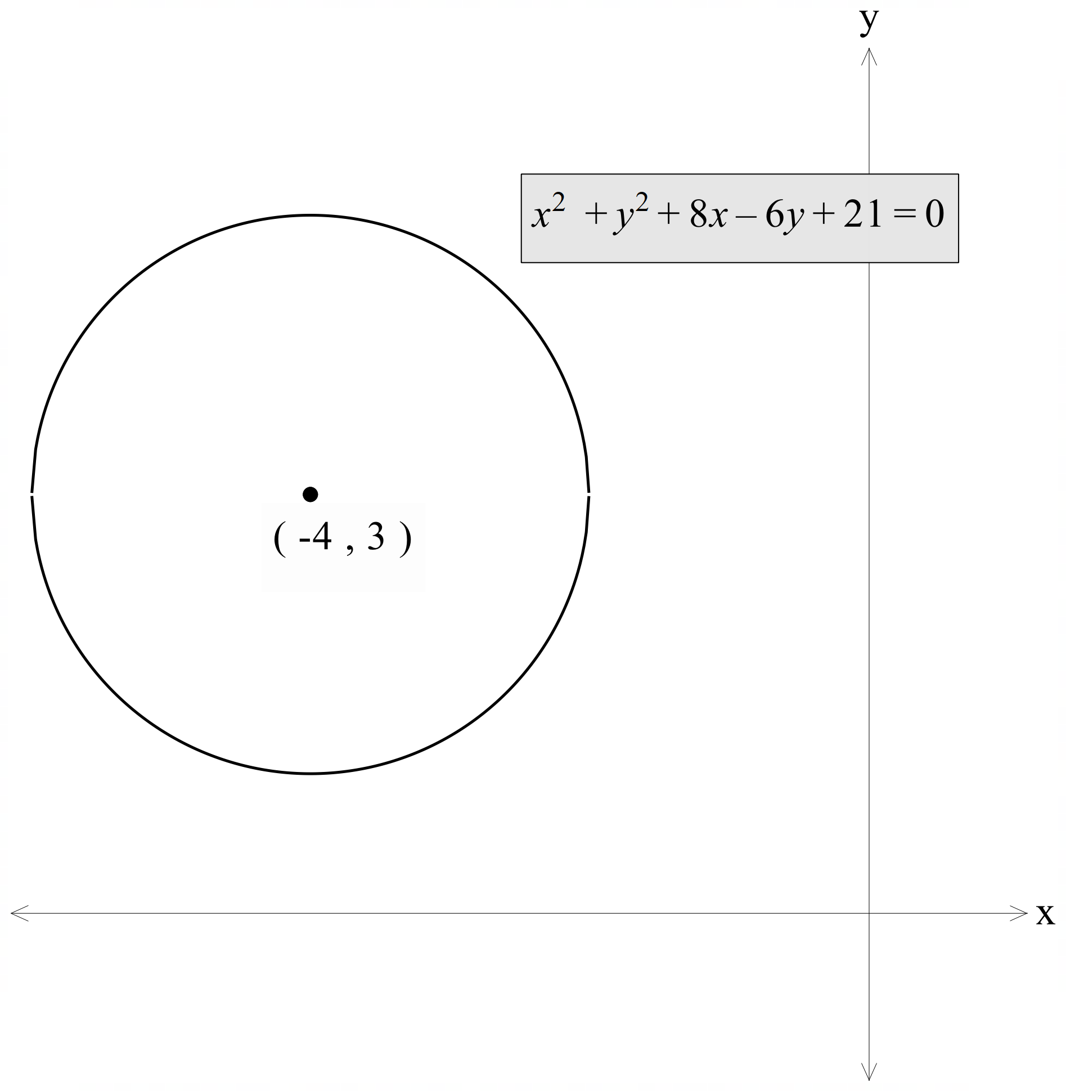  Step 4: state the domain and range  Domain: $[-6, -2]$  Range: $[1, 5]$

References
This resource contains NSW Curriculum and syllabus content. The NSW Curriculum is developed by the NSW Education Standards Authority. This content is prepared by NESA for and on behalf of the Crown in right of the State of New South Wales. The material is protected by Crown copyright.
Please refer to the NESA Copyright Disclaimer for more information https://educationstandards.nsw.edu.au/wps/portal/nesa/mini-footer/copyright.
NESA holds the only official and up-to-date versions of the NSW Curriculum and syllabus documents. Please visit the NSW Education Standards Authority (NESA) website https://educationstandards.nsw.edu.au/ and the NSW Curriculum website https://curriculum.nsw.edu.au/.
Mathematics Advanced 11–12 Syllabus © NSW Education Standards Authority (NESA) for and on behalf of the Crown in right of the State of New South Wales, 2024.

© State of New South Wales (Department of Education), 2025
The copyright material published in this resource is subject to the Copyright Act 1968 (Cth) and is owned by the NSW Department of Education or, where indicated, by a party other than the NSW Department of Education (third-party material).
Copyright material available in this resource and owned by the NSW Department of Education is licensed under a Creative Commons Attribution 4.0 International (CC BY 4.0) license.

This license allows you to share and adapt the material for any purpose, even commercially.
Attribution should be given to © State of New South Wales (Department of Education), 2025.
Material in this resource not available under a Creative Commons license:
- the NSW Department of Education logo, other logos and trademark-protected material
- material owned by a third party that has been reproduced with permission. You will need to obtain permission from the third party to reuse its material.
Links to third-party material and websites
Please note that the provided (reading/viewing material/list/links/texts) are a suggestion only and implies no endorsement, by the New South Wales Department of Education, of any author, publisher, or book title. School principals and teachers are best placed to assess the suitability of resources that would complement the curriculum and reflect the needs and interests of their students.
If you use the links provided in this document to access a third-party's website, you acknowledge that the terms of use, including licence terms set out on the third-party's website apply to the use which may be made of the materials on that third-party website or where permitted by the Copyright Act 1968 (Cth). The department accepts no responsibility for content on third-party websites.

