Translations
Students learn about vertical and horizontal translations, connecting the transformation of the graphs to changes in their equations.
Students will need at least one digital device per pair to interact with Amplify Classroom during this lesson.

Learning intention
- To understand how translations affect the position and equation of a graph.

Success criteria
- I can describe how a graph moves vertically and horizontally.
- I can adjust an equation to represent a given vertical or horizontal translation.
- I can determine the horizontal and vertical translations of a graph from its equation.
- I can explain how the sign of $a$ or $b$ affect the direction of a translation, if $x$is replaced with$x-a$ or $y$ is replaced with $y-b$.

Outcomes
A student:
- develops understanding and fluency in mathematics through exploring and connecting mathematical concepts, choosing and applying mathematical techniques to solve problems, and communicating their thinking and reasoning coherently and clearly MAO-WM-01
- analyses and solves algebraic and graphical problems involving transformations of functions and relations MAV-11-03

Content

Graph transformations
- Establish using graphing applications that replacing $x$ by $x-a$ in the equation of a graph corresponds to a horizontal translation of a graph by $a$, that replacing $y$ by $y-b$ corresponds to a vertical translation by $b$, and recognise that the sign of $a$ and $b$ determines the direction of the translation
Mathematics Advanced 11–12 Syllabus © NSW Education Standards Authority (NESA) for and on behalf of the Crown in right of the State of New South Wales, 2024.

Table 1: lesson summary
Section | Summary of activity | Teaching strategies | Teaching points
Activating prior knowledge | Using Appendix A, students draw and identify features of parabolas, developing equations of the form $y={\left(x-a\right)}^{2}+c$. Slide 4 of the PowerPoint Translations can be used for sample solutions and to aid the discussion on how moving a parabola affects the equation. Translation is then defined using the NESA glossary. | Visibly random groups of 3  Vertical non-permanent surfaces  Pose-Pause-Pounce-Bounce | The purpose of this activity is to review students’ prior knowledge of quadratic equations and to start to see how changes in the equation affect the parabola’s position on the Cartesian plane.
Connecting learning | Students complete the Amplify Classroom activity (bit.ly/AmplifyTranslations) exploring both vertical and horizontal translations and analysing how the equation changes. | Pose-Pause-Pounce-Bounce | This activity uses graphing applications to establish how replacing $x$ with $x-a$ and $y$ with $y-b$ relates to the graph being translated. Students test and notice patterns before rules are formalised.
Releasing responsibility | Use slides 6–11 to formally define vertical and horizontal translations and model how to adjust and graph translated equations using worked examples. Students then complete Appendix B. | Think-Pair-Share  Pose-Pause-Pounce-Bounce  Worked examples (Your turn)  Four quadrant notes | This section moves to formal definitions and independent application of translations. Students establish how the sign of $a$ and $b$ determines the direction of the translation.
Independent practice | Use slide 13 to model the ‘Approaching questions scaffold’, before using slides 14–15 for students to attempt problems and compare strategies. Use slides 16–18 to show alternate solution methods and discuss marking approaches. | Approaching questions scaffold | This section aims to give students opportunities to apply translations to an HSC-style question, while combining 2 transformations (reflection and translation) to the one graph.

Activity structure
Please use the associated PowerPoint Translations to display images in this lesson.

Activating prior knowledge
The following activity has been modified from Lesson 13 – discriminating with the discriminant of Stage 5 Unit 12 – investigating parabolas.
- Assign students to visibly random groups of 3 (bit.ly/visiblegroups) and distribute Appendix A ‘Coloured graphs’, printed in colour on A3 paper in A3 plastic sleeves, to each group. Have students stick the A3 sleeve either onto a vertical non-permanent surface (bit.ly/VNPSstrategy) or to a wall around the classroom.
- Ask groups to draw parabolas by joining the coordinates of the same colour. Students are then to identify specific features of each graph, which could include the vertex, intercepts and axis of symmetry before finally, developing the equation of each parabola in the form $y={\left(x-a\right)}^{2}+c$.
Students should be familiar with how to find the equation of parabolas given sufficient graphical features as it was covered in Lesson 12 – finding quadratic functions from a graph of Unit 3 – working with linear and quadratic functions.
Slide 4 of the PowerPoint contains sample solutions. ‘AOS’ has been used to abbreviate ‘axis of symmetry’.
- Use the Pose-Pause-Pounce-Bounce questioning strategy (PDF 557 KB) (bit.ly/posepausepouncebounce) to unpack the variety of graphs presented. Some suggested prompts include:
- How does moving the vertex left or right show up in the equation?
- What do you notice about the equation when the parabola moves up or down?
During this discussion specific graphs could be identified to compare such as: black and green, or red, dark blue and yellow, or pink and light blue.
- Remind students of the form $y={\left(x-a\right)}^{2}+c$ and connect this to the changes they observed in the graphs, focusing on how $a$ and $c$ affect the position of the parabola and its vertex.
- Explain to students that the dark blue, pink, green and yellow graphs are translations of the red parabola. Each of these graphs have been shifted by 4 units either left, right, up or down. The black and turquoise graphs demonstrate 2 translations from the original red parabola.
- Clearly define the term ‘translation’ for students.
The NESA Glossary definition of translation is a type of transformation that moves a shape (or all the points in a plane) by the same amount to the left or right, or up or down.
Students may have translated coordinates if they completed the Stage 5 Linear relationships C (Path) outcome MA5-LIN-P-01.

Connecting learning
Before using this activity, you will need to set up an Amplify Classroom (bit.ly/createamplifyclassroom) and use the pacing feature to restrict the students to screens
1–6.
Amplify Classroom provides the opportunity for immediate feedback as well as tailored feedback from the teacher as students’ progress through the activity.

Vertical translations
- Assign the Amplify Classroom activity ‘Translations’ (bit.ly/AmplifyTranslations) for students to work on in pairs, restricting the activity to screens 1–6.

In this activity, students will draw on their prior knowledge of linear and quadratic functions to translate given graphs vertically. A practical example, a cannon man launch, is included to help students connect the concept to how the coordinates of a function change during a vertical translation.
- Use the teacher dashboard to check student responses to the questions from screens 1–7, pausing to discuss as a class the explanation provided for a vertical translation on screen 6 and to unpack what happens to the coordinates of a graph during this transformation.
Students should share that only the $y$- value of every coordinate changed by the number of units the graph is translated, while the $x$- coordinate remains unchanged.
- Extend the pacing to pause the activity on screen 8 and have students read the formal definition of a vertical translation and attempt the true or false question.
- Initiate a class discussion to clarify the formal definition from the syllabus content point, that ‘replacing $y$ by $y-b$ corresponds to a vertical translation by $b$’ (NESA 2024).
Students may find both the question and the definition challenging, which is expected. The subsequent screens will explore the concept in greater detail.
Students may attempt to articulate how the sign of $b$ may indicate the direction of the translation. At this stage, students do not need to understand the significance of the sign.
- Use the Amplify Classroom teacher dashboard to extend pacing to screens 9–12, for students to complete.
- Use the Pose-Pause-Pounce-Bounce questioning strategy to discuss how the equation changes when the graph is translated vertically.
- What patterns did you notice in the equations when the graph is moved up and down?
- When replacing $y$ with $y-b$ in an equation, how does the graph’s position change?
- How could you describe the connection between the sign of $b$ and the direction of the graph’s vertical translation?
The definition of vertical translation and the significance of the sign of $b$ will be formalised in the ‘Releasing responsibility’ section of this lesson.

Horizontal translations
- Return students to the Amplify Classroom activity ‘Translations’ and extend the pacing to screens 13–18. Allow students time to explore how graphs and equations change when translated horizontally.
- Use the pause feature on the Amplify Classroom teacher dashboard to restrict students to screen 18.
- Initiate a class discussion to clarify the formal definition from the syllabus content point, that ‘replacing $x$ by $x-a$ corresponds to a horizontal translation by $a$’ (NESA 2024). Students might attempt to articulate how the sign of $a$ may indicate the direction of the translation, connecting their understanding from vertical translations.
- Extend the pacing to include screens 19–22, for students to complete.
- Use the Pose-Pause-Pounce-Bounce questioning strategy to discuss how the equation changes when the graph is translated horizontally.
- What patterns did you notice in the equations when the graph is moved left and right?
- When replacing$x$ with $x-a$in an equation, how does the graph’s position change?
- How could you describe the connection between the sign of $a$ and the direction of the graph’s horizontal translation?
The definition of horizontal translation and the significance of the sign of $a$ will be formalised in the ‘Releasing responsibility’ section of this lesson.

Releasing responsibility
- Display slide 6 which defines how replacing $y$ by $y-b$ corresponds to a vertical translation by $b$. Click to animate translated graphs and use the self-explanation prompts to get students, in a Think-Pair-Share (bit.ly/thinkpairsharestrategy) to consider how the sign of $b$ determines the direction of the translation.
- Use the Pose-Pause-Pounce-Bounce questioning strategy to discuss how the sign of $b$ indicates the direction of the translation. Some suggested prompts include:
- Looking at the 2 examples on slide 6, what similarities and differences do you notice in how the graphs moved?
- How does the sign of $b$ seem to affect the direction of the movement?
Conclude with students that replacing $y$ by $y-b$ translates the graph vertically, up when $b$ is positive and down when $b$ is negative.
To reinforce this concept, some students may benefit from seeing additional examples. This could be done by revisiting the Amplify Classroom activity or further exploration with a graphing application.
- Use slides 7–8 to model how to adjust an equation that has been translated vertically and how to graph this equation using the Worked examples (Your turn) strategy (bit.ly/supportingstrategies).
- Display slide 9 which defines how replacing $x$ by $x-b$ corresponds to a horizontal translation by $a$. Use the self-explanation prompts to get students, in a Think-Pair-Share to consider how the sign of $a$ determines the direction of the translation.
- Use the Pose-Pause-Pounce-Bounce questioning strategy to discuss how the sign of $a$ indicates the direction of the horizontal translations. Suggested prompts include:
- Looking at the 2 examples on slide 9, what similarities and differences do you notice in how the graphs moved?
- How does the sign of $a$ seem to affect the direction of the movement?
Conclude with students that replacing $x$ by $x-a$ translates the graph horizontally, right when $a$ is positive and left when $a$ is negative.
To reinforce this concept, some students may benefit from seeing additional examples. This could be done by revisiting the Amplify Classroom activity or exploring further with a graphing application.
- Use slides 10–11 to model how to adjust an equation that has been translated horizontally and how to graph this equation using the Worked examples (Your turn) strategy.
- Students should complete practice questions from an existing resource that focuses on translating graphs horizontally and vertically and identifying the corresponding changes in their equations.
- Distribute Appendix B ‘Four quadrant notes to future forgetful self’ (bit.ly/supportingstrategies) for students to discuss in pairs, before completing independently. Encourage students to make notes on the impact that replacing $x$ with $x-a$ and $y$ with $y-b$ in the equation has on the graph, as well as how the sign of $a$ and $b$ determines the direction of the translation.

Independent practice
- Use slide 13 to unpack the ‘Approaching questions scaffold’ for students.
The ‘Approaching questions scaffold’ offers students a 4-step scaffold to tackle questions. Each step is accompanied by an icon and corresponds to different aspects of the solution process.
- Use slide 14 to display Problem 1 for students to attempt in pairs. Encourage students to use the steps outlined in the ‘Approaching questions scaffold’.
If students are having difficulty, Problem 1 can be completed as a class.
- Click to animate the solution on slide 14.
- Progress to slide 15 to display Problem 2 and have students complete this in pairs. Once students have finished their solution, challenge them to consider an alternate solution that would produce the same answer. Students can compare their answers with another pair.
- Initiate a class discussion about the different strategies used to complete Problem 2. Discuss with students how this question may have been marked and whether each method, if correct, would have received full marks. A marking criteria has been provided on slide 16.
Slides 17 and 18 contain 2 approaches to answering the question, one using the properties of translation and one using properties of absolute value equations as well as simultaneous equations.

Assessment and differentiation

Suggested opportunities for differentiation
Activating prior knowledge
- Provide sentence starters or guiding questions, such as ‘The vertex moves … units …’, to help students articulate observations.
- Students can use graphing applications to confirm their answers.
Connecting learning
- Students may need to be provided with further practical examples, other than the cannon launch, to consolidate their understanding.
- Students can be challenged to combine both vertical and horizontal shifts.
Releasing responsibility
- Allow students who need more support to revisit the Amplify Classroom activity to consolidate their understanding.
- Offer extension prompts for students to predict translations with combined transformations.
Independent practice
- Scaffold the task, using the ‘Approaching questions scaffold’ for students who need structure.

Suggested opportunities for assessment
Activating prior knowledge
- Observe group discussion to check students’ understanding of recalling how to find the equation of a parabola.
Connecting learning
- Use the Amplify Classroom teacher dashboard to monitor responses and identify misconceptions.
Releasing responsibility
- Use the Pose-Pause-Pounce-Bounce questioning strategy to check student reasoning about the sign of $a$ and $b$.
Independent practice
- Ask students to explain their choice of method and justify each step, assessing conceptual understanding as well as procedural accuracy.

Appendix A

Coloured graphs
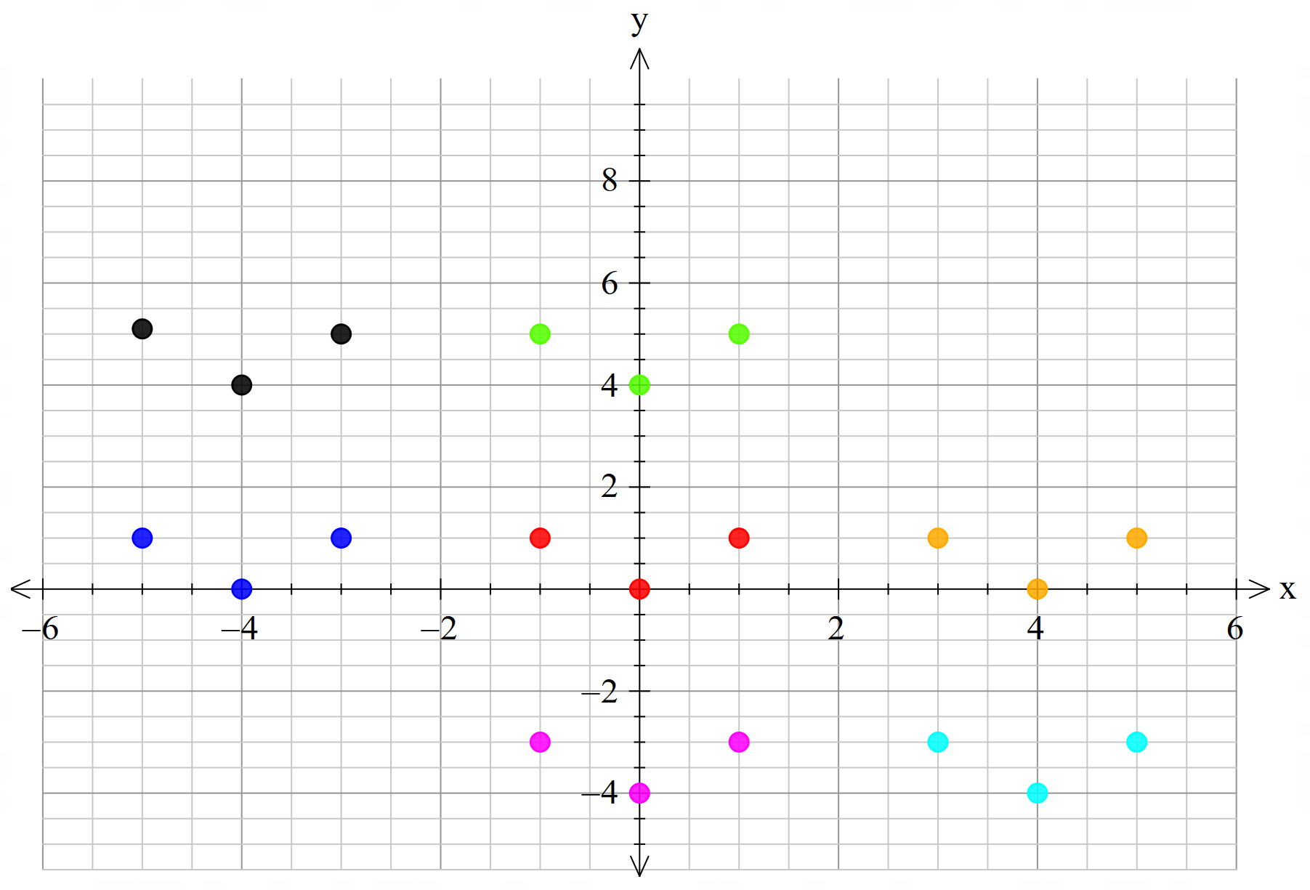

Appendix B

Four quadrant notes to future forgetful self
Example 1  The parabola $y={\left(x-2\right)}^{2}+1$ is translated 3 units to the left.  Write the equation of the resulting parabola. | Example 2  For the exponential $y=3^{x}$, $y$ is replaced with $y-4$.  Describe the resulting translation and sketch the new exponential function.
Things to remember | Example 3

Sample solutions

Appendix B – Four quadrant notes to future forgetful self
Example 1  The parabola $y={\left(x-2\right)}^{2}+1$ is translated 3 units to the left.  Write the equation of the resulting parabola.  Horizontal translation, $x$ is replaced with $x-a$  $a=-3$, as it is a translation to the left.  $$y={\left(x-\left(-3\right)-2\right)}^{2}+1$$  $$∴y={\left(x+1\right)}^{2}+1$$ | Example 2  For the exponential $y=3^{x}$, $y$ is replaced with $y-4$.  Describe the resulting translation and sketch the new exponential function.  Vertical translation, $y$ is replaced with $y-b$.  $b=4$, which describes a vertical translation down by 4 units.  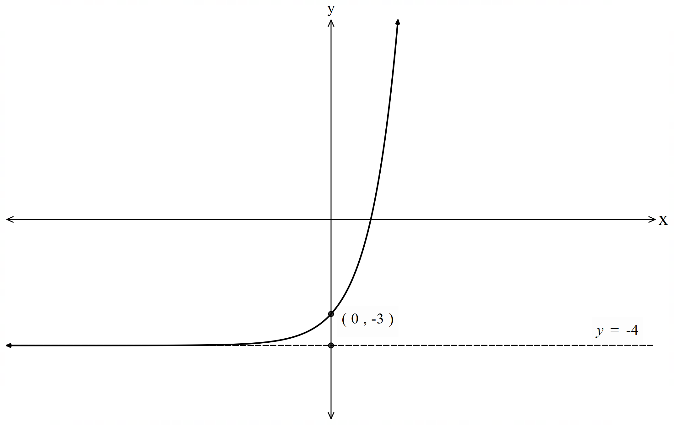

References
This resource contains NSW Curriculum and syllabus content. The NSW Curriculum is developed by the NSW Education Standards Authority. This content is prepared by NESA for and on behalf of the Crown in right of the State of New South Wales. The material is protected by Crown copyright.
Please refer to the NESA Copyright Disclaimer for more information https://educationstandards.nsw.edu.au/wps/portal/nesa/mini-footer/copyright.
NESA holds the only official and up-to-date versions of the NSW Curriculum and syllabus documents. Please visit the NSW Education Standards Authority (NESA) website https://educationstandards.nsw.edu.au/ and the NSW Curriculum website https://curriculum.nsw.edu.au/.
Mathematics Advanced 11–12 Syllabus © NSW Education Standards Authority (NESA) for and on behalf of the Crown in right of the State of New South Wales, 2024.

© State of New South Wales (Department of Education), 2025
The copyright material published in this resource is subject to the Copyright Act 1968 (Cth) and is owned by the NSW Department of Education or, where indicated, by a party other than the NSW Department of Education (third-party material).
Copyright material available in this resource and owned by the NSW Department of Education is licensed under a Creative Commons Attribution 4.0 International (CC BY 4.0) license.

This license allows you to share and adapt the material for any purpose, even commercially.
Attribution should be given to © State of New South Wales (Department of Education), 2025.
Material in this resource not available under a Creative Commons license:
- the NSW Department of Education logo, other logos and trademark-protected material
- material owned by a third party that has been reproduced with permission. You will need to obtain permission from the third party to reuse its material.
Links to third-party material and websites
Please note that the provided (reading/viewing material/list/links/texts) are a suggestion only and implies no endorsement, by the New South Wales Department of Education, of any author, publisher, or book title. School principals and teachers are best placed to assess the suitability of resources that would complement the curriculum and reflect the needs and interests of their students.
If you use the links provided in this document to access a third-party's website, you acknowledge that the terms of use, including licence terms set out on the third-party's website apply to the use which may be made of the materials on that third-party website or where permitted by the Copyright Act 1968 (Cth). The department accepts no responsibility for content on third-party websites.

