Reflection
Students will use Amplify Classroom to explore the effects of replacing $x$ with $-x$ and $y$ with $-y$ in the equation of a graph. They will have an opportunity to practise sketching and writing equations of reflected graphs before applying their understanding to a piecewise defined function.
Students will need at least one digital device per pair to interact with Amplify Classroom during this lesson.

Learning intention
- To understand how to reflect a graph across the $x$ and $y$-axis.

Success criteria
- I can describe the effect on a graph when $x$ is replaced with $-x$ or $y$ is replaced with $-y$.
- I can reflect a graph along the appropriate axis.
- I can state the domain and range of a reflected equation.

Outcomes
A student:
- develops understanding and fluency in mathematics through exploring and connecting mathematical concepts, choosing and applying mathematical techniques to solve problems, and communicating their thinking and reasoning coherently and clearly MAO-WM-01
- analyses and solves algebraic and graphical problems involving transformations of functions and relations MAV-11-03

Content

Graph transformations
- Establish using graphing applications that replacing $x$ by $-x$ in the equation of a graph corresponds to the reflection of the graph in the $y$-axis, and that replacing $y$ by $-y$ corresponds to a reflection in the $x$-axis
Mathematics Advanced 11–12 Syllabus © NSW Education Standards Authority (NESA) for and on behalf of the Crown in right of the State of New South Wales, 2024.

Table 1: lesson summary
Section | Summary of activity | Teaching strategies | Teaching points
Activating prior knowledge | Use slide 4 of the PowerPoint Reflection for students to determine if a given function is odd or even algebraically before observing that an even function remains unchanged when reflected across the $y$-axis. | Mini whiteboards  Turn and talk | Use student understanding of the definition of an even function and a graph that is unchanged to introduce reflections and connect it to prior knowledge.
Connecting learning | Using slide 6, students consider if a given function is even and use the graph to confirm their result. Students then use the Amplify Classroom (https://bit.ly/amplify_reflection) to understand the effect on the graph of replacing $x$ with $-x$ in the equation, including its domain and range. They then repeat this process to determine the effect of replacing $y$ with $-y$ in the equation. | Pose-Pause-Pounce-Bounce | Explore the effect of replacing $x$ with $-x$ as a reflection in terms of the equation, coordinates, graph and domain and range before considering the effect of replacing $y$ with $-y$.
Releasing responsibility | Use slide 8 to define a reflection before distributing Appendix A to pairs of students for them to match the reflected graph with the original graph. Students then write notes to their future forgetful selves. | Notes to their future forgetful selves | Define a reflection before identifying and matching reflected graphs with their original graph and write the equation of the reflection.
Independent practice | Display slide 10 and distribute Appendix B for students to reflect a piecewise function across both the $y$- and $x$-axes to determine the graph and equation. Use slide 11 for students to repeat this with another piecewise function. |  | Consider a reflection of a piecewise function and the effect of reflecting an equation across both the $y$- and $x$-axis.

Activity structure
Please use the associated PowerPoint Reflection to display images in this lesson.

Activating prior knowledge
- Using slide 4 of the PowerPoint, display the function $f\left(x\right)=x^{4}-6x^{2}+5$ and its graph. In pairs, using mini whiteboards (bit.ly/miniwhiteboards), have students determine algebraically if the function is even, odd or neither.
- In a turn and talk (bit.ly/classroomtalkmoves), ask students to discuss some of the features of the graph that indicate it is an even function and how it relates to the algebra.
Connect the algebraic example to its graph and discuss how the symmetry shown in the graph is reflected in the algebraic solution.
- Click to animate slide 4 to show the algebraic solution and reflection in the $y$-axis to confirm to students that the graph of an even function is unchanged under reflection in the $y$-axis.
Students are familiar with odd and even functions from Lesson 7 – odd and even functions of Unit 2 – introduction to functions.

Connecting learning
- Using slide 6, display the equation $f(x)=x^{2}+x$ and have students determine algebraically if the function is even.
Click to animate the solution.
- With at least one device per pair, assign the Amplify activity ‘Reflection’ (https://bit.ly/amplify_reflection) for students to complete and use the pacing feature to restrict students to screens 1–4.
Before using this activity, you will need to set up an Amplify Classroom (bit.ly/createamplifyclassroom).
- Lead a class discussion on how replacing $x$ with $-x$ in an equation affects the graph, using student responses from screen 4 as a starting point.
- Extend the pacing to screens 5–8 for students to sketch and write the equation of the graph when it is reflected across the $y$-axis.
- Lead a class discussion on how the coordinates and equation changes when it is reflected across the $y$-axis, using student responses from screen 8 as a starting point.
- Extend the pacing to screens 9–11 for students to explore the effect of a reflection across the $y$-axis on the domain and range of a graph.
- Use the Pose-Pause-Pounce-Bounce questioning strategy (PDF 557 KB) (bit.ly/posepausepouncebounce) to lead a class discussion around how the features of the domain and range change when a graph is reflected across the $y$-axis.
- Extend pacing to screens 12–18 for students to explore graphically the effect of replacing $y$ with $-y$.
Students will complete screen 19 of the Amplify Classroom activity in the ‘Independent practice’ section.
- Use the Pose-Pause-Pounce-Bounce questioning strategy to check for understanding of reflections. Some possible prompts are:
- When a graph is reflected across the $x$-axis, algebraically, what is occurring?
- What happens to the domain and range when you reflect an equation of a graph along each axis?
- In the context of a reflection, what is the difference between $f(-x)$ and $-f(x)$?

Releasing responsibility
- Display slide 8 of the PowerPoint to define a reflection of the graph across the axis.
- Distribute Appendix A ‘Matching activity’ to each pair of students. Students will need to cut out each of the blue reflection graphs and then match the original graphs to their reflections and write the equation for each graph.
Teachers may wish to pre-cut the reflection graphs prior to the lesson.
- Students are to write notes to their future forgetful selves (bit.ly/notestofutureself) about reflections. Some suggested prompts for students to use to guide their notes include:
- What occurs graphically when $x$ is replaced with $-x$ or $y$ with $-y$?
- A reflection across the $x$-axis is the equivalent to replacing which variable with its negative?
- What happens to the domain and range when a graph is reflected?

Independent practice
- Use slide 10 of the PowerPoint to display a piecewise function. Use a Think-Pair-Share (bit.ly/thinkpairsharestrategy) for students to consider what would happen to the function if it were reflected along the $y$-axis. Some possible questions include:
- If the piecewise function is continuous, does it remain continuous when reflected?
- What happens when you reflect the constant section?
- What happens to the domain and range when you reflect this function?
Students may suggest that the piecewise function will remain continuous when reflected if it was originally continuous. They may notice that the reflection of the constant section will remain constant, but for a different domain. Students may suggest that the when the piecewise function is reflected across the $y$-axis, the domain will reflect but the range will remain the same.
- Continuing in pairs, distribute Appendix B ‘Piecewise function’ which shows the graph on slide 10 and have students write and sketch the piecewise function that is reflected across the $y$-axis.
- In a turn and talk, ask students to predict what would happen if the graph were then reflected along the $x$-axis after it has been reflected across the $y$-axis. Have students sketch this on Appendix B and share their sketch with another group.
- Return to the Amplify Classroom activity and restrict students to screen 19 where they can use the sliders to reflect the piecewise function along the $y$-axis before reflecting it along the $x$-axis to verify their sketches.
- Display slide 11 for students to complete another reflection independently in their workbook or on mini whiteboards.
Click to animate slide 11 to reveal the reflected graph and function.

Assessment and differentiation

Suggested opportunities for differentiation
Activating prior knowledge
- If students are confident that even functions are reflective across the $y$-axis, then skip forward to the ‘Connecting learning’ section of the lesson.
Connecting learning
- Support students by pausing the Amplify Classroom activity at screens 2 and 3 to discuss students’ responses about what the axis of reflection is and its effect on the coordinates.
- Support students by pausing the Amplify Classroom activity at screen 9 to discuss student responses about the reflection of the square root function.
- Pause the Amplify Classroom activity after screen 12 to support students to justify their prediction in a class discussion.
- Pause the Amplify Classroom activity after screens 15 and 16 to lead a class discussion around the effects of domain and range when reflecting a graph across the $x$-axis.
- Extend students by asking them if the transformation on screen 5 could be described by another type of transformation.
Students study translations in Lesson 5 – translations, however some students may be familiar with parabolas and their transformations from the Stage 5 Non-linear relationships C (Path) outcome MA5-NLI-P-01.
- Extend students by having them consider what the equation of the function would be if the function is reflected across both axes.
- Extend students by asking them to consider if the order of the reflection matters and if they can show that algebraically.
- Enrich student learning by having them predict what a reflection across the line $y=x$ would look like.
Note: reflection across the line $y=x$ is beyond the scope of the syllabus.
Releasing responsibility
- Scaffold Appendix A to support students by having them complete either the matching or writing of the equations before completing the rest of the task.
- Challenge students by not providing the matching cards, instead have students sketch the graph themselves.
Independent practice
- Support students to reflect each part of the piecewise function individually as a scaffold for them to build their understanding of reflecting piecewise functions.
- For slide 11, support students by providing them with the piecewise function graph.

Suggested opportunities for assessment
Activating prior knowledge
- Mini whiteboards can be used to check for student understanding of how to determine if a function is even, odd or neither.
Connecting learning
- Using the teacher screen in the Amplify Classroom, check for student understanding by reviewing their responses to the sketches and the effects of domain and range on the equation of the graph.
- A Think-Pair-Share provides students with the opportunity to reflect on their own understanding of reflections across the $y$-axis.
- Monitor student responses in class discussions to check for understanding of the effects of replacing $x$ with $-x$ and $y$ with $-y$ on the equation of a graph.
Releasing responsibility
- Collect Appendix A and review students’ notes to their future forgetful selves to check for understanding of reflections and how they change the equation and how they affect a function or relation’s domain and range.
Independent practice
- Collect Appendix B to check for student understanding of how to sketch a reflection prior to students checking their work in Amplify Classroom.

Appendix A

Matching activity
Match each graph with its reflection and then write the equation of the reflection.
Reflection along $y$-axis | Original equation | Reflection along $x$-axis
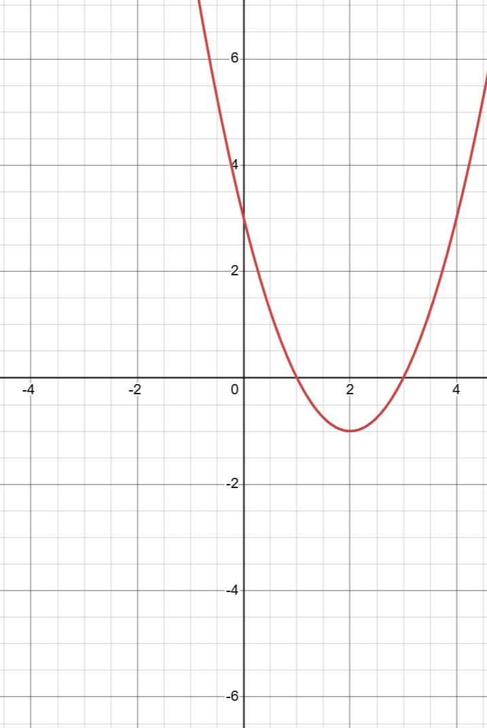
$$y=x^{2}-4x+3$$
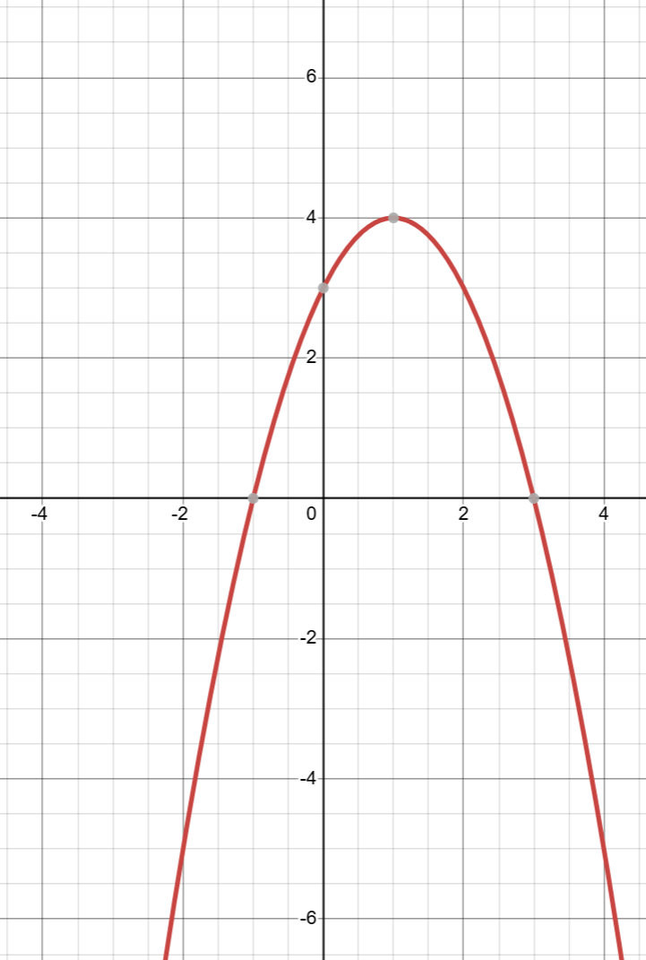
$$y=-x^{2}+2x+3$$
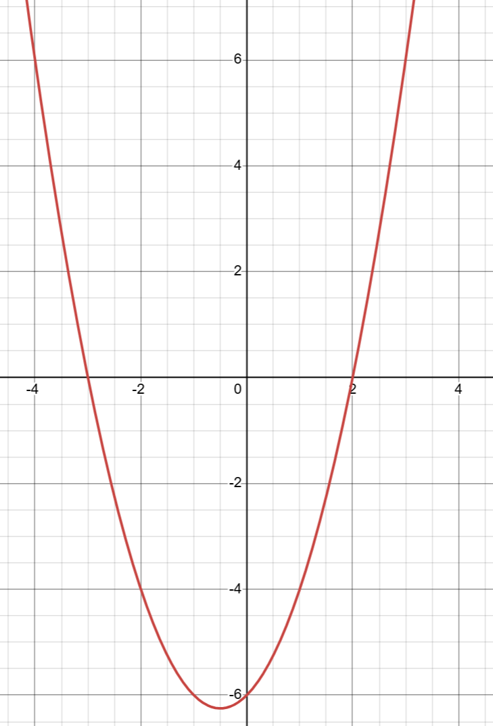
$$y=x^{2}+x-6$$
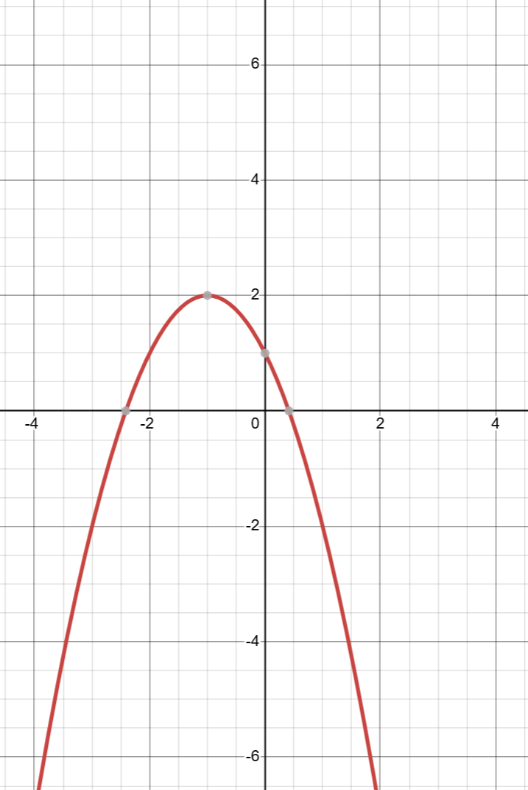
$$y=-x^{2}-2x+1$$

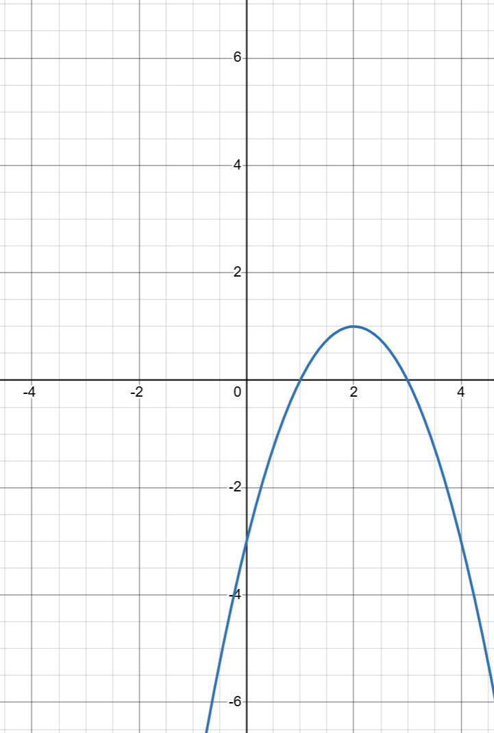 | 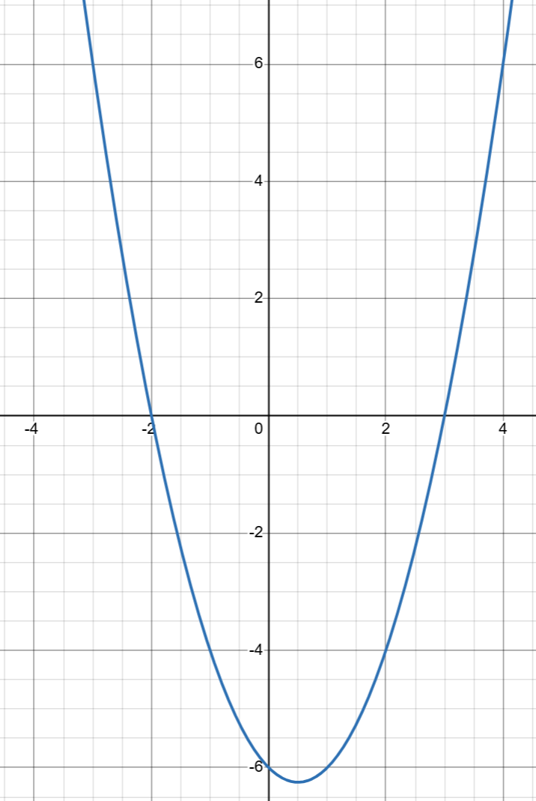 | 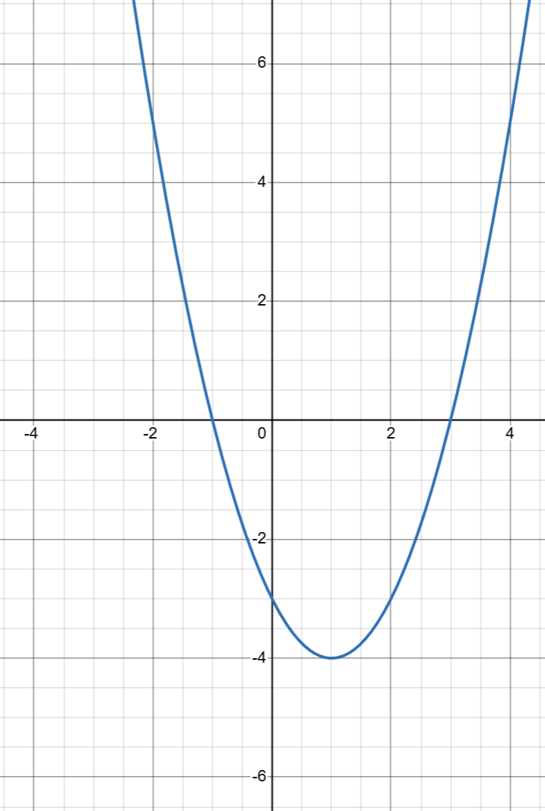
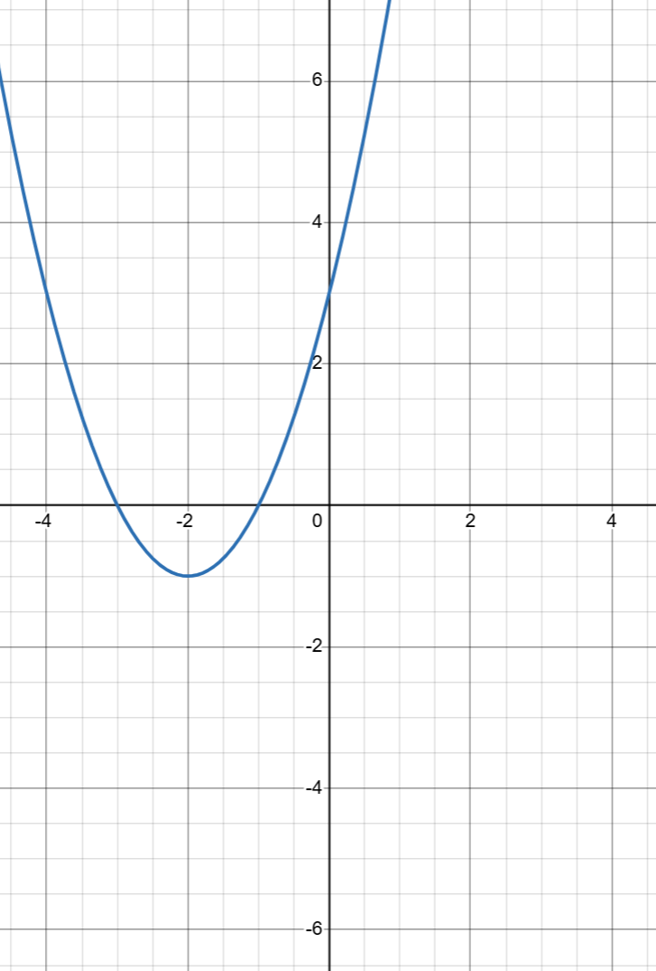 | 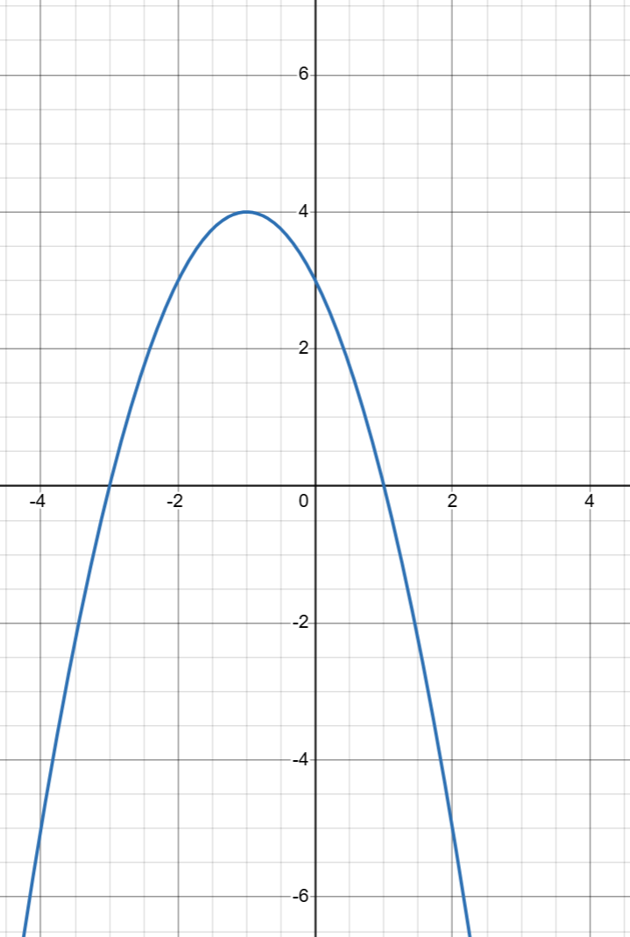 | 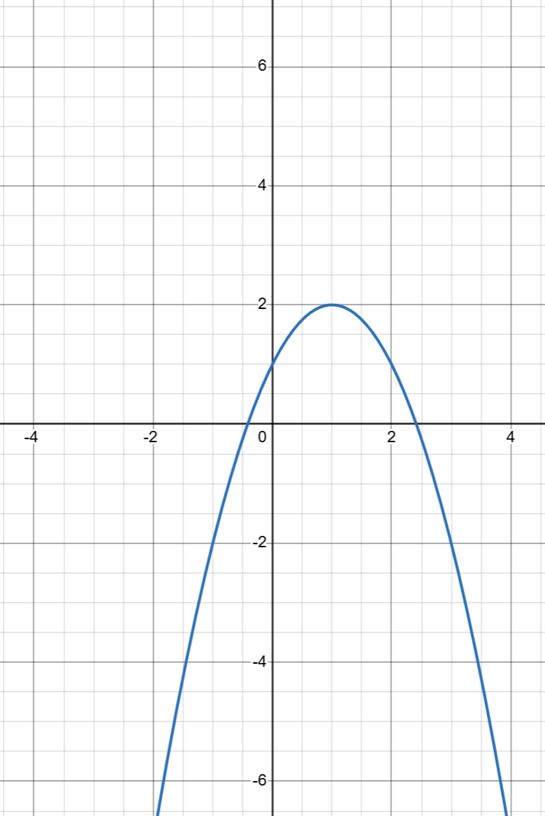
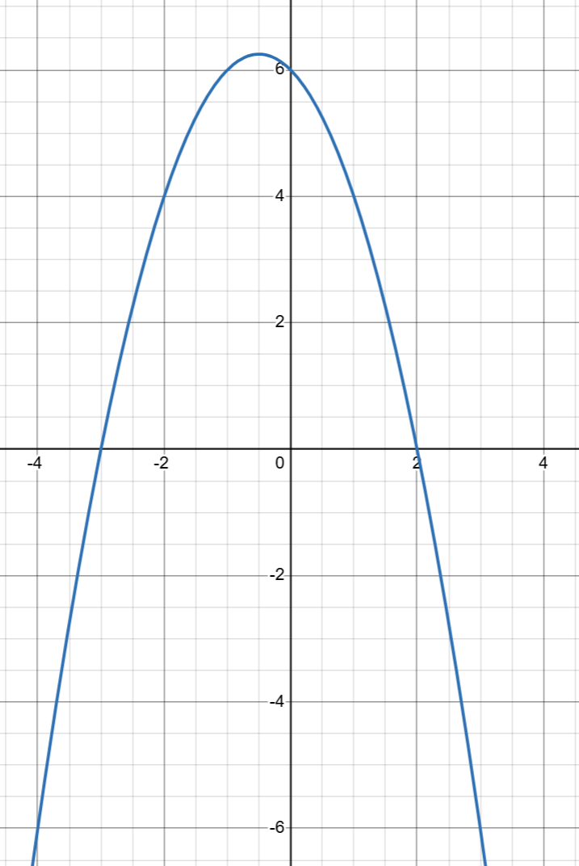 | 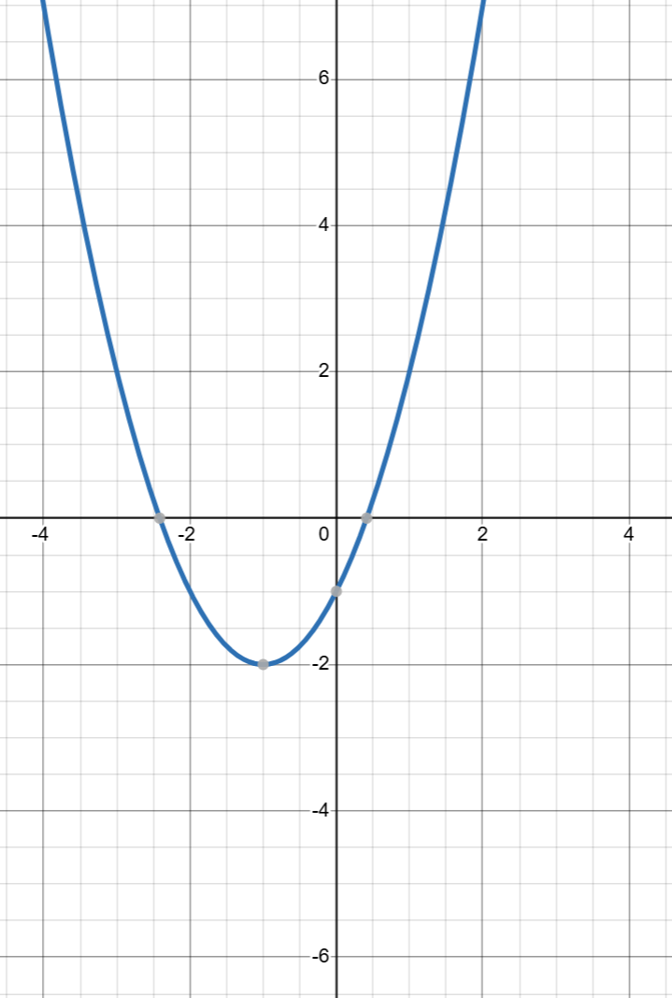 | Blank cell

Appendix B

Piecewise function
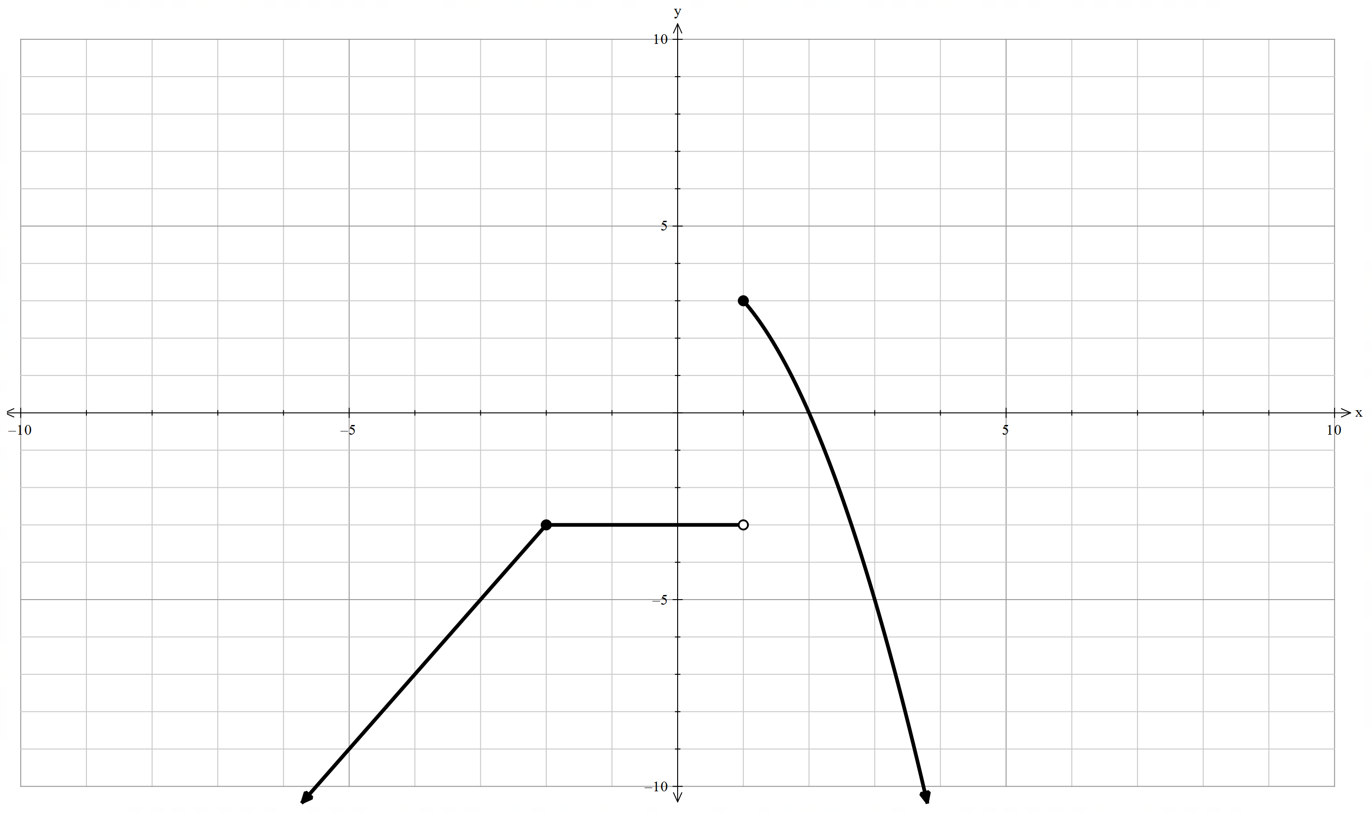

Sample solutions

Appendix A – matching activity
Reflection along $y$-axis | Original equation | Reflection along $x$-axis
$$y=x^{2}+4x+3$$ | $$y=x^{2}-4x+3$$ | $$y=-x^{2}+4x-3$$
$$y=-x^{2}-2x+3$$ | $$y=-x^{2}+2x+3$$ | $$y=x^{2}-2x-3$$
$$y=x^{2}-x-6$$ | $$y=x^{2}+x-6$$ | $$y=-x^{2}-x+6$$
$$y=-x^{2}+2x+1$$ | $$y=-x^{2}-2x+1$$ | $$y=x^{2}+2x-1$$

References
This resource contains NSW Curriculum and syllabus content. The NSW Curriculum is developed by the NSW Education Standards Authority. This content is prepared by NESA for and on behalf of the Crown in right of the State of New South Wales. The material is protected by Crown copyright.
Please refer to the NESA Copyright Disclaimer for more information https://educationstandards.nsw.edu.au/wps/portal/nesa/mini-footer/copyright.
NESA holds the only official and up-to-date versions of the NSW Curriculum and syllabus documents. Please visit the NSW Education Standards Authority (NESA) website https://educationstandards.nsw.edu.au/ and the NSW Curriculum website https://curriculum.nsw.edu.au/.
Mathematics Advanced 11–12 Syllabus © NSW Education Standards Authority (NESA) for and on behalf of the Crown in right of the State of New South Wales, 2024.

© State of New South Wales (Department of Education), 2025
The copyright material published in this resource is subject to the Copyright Act 1968 (Cth) and is owned by the NSW Department of Education or, where indicated, by a party other than the NSW Department of Education (third-party material).
Copyright material available in this resource and owned by the NSW Department of Education is licensed under a Creative Commons Attribution 4.0 International (CC BY 4.0) license.

This license allows you to share and adapt the material for any purpose, even commercially.
Attribution should be given to © State of New South Wales (Department of Education), 2025.
Material in this resource not available under a Creative Commons license:
- the NSW Department of Education logo, other logos and trademark-protected material
- material owned by a third party that has been reproduced with permission. You will need to obtain permission from the third party to reuse its material.
Links to third-party material and websites
Please note that the provided (reading/viewing material/list/links/texts) are a suggestion only and implies no endorsement, by the New South Wales Department of Education, of any author, publisher, or book title. School principals and teachers are best placed to assess the suitability of resources that would complement the curriculum and reflect the needs and interests of their students.
If you use the links provided in this document to access a third-party's website, you acknowledge that the terms of use, including licence terms set out on the third-party's website apply to the use which may be made of the materials on that third-party website or where permitted by the Copyright Act 1968 (Cth). The department accepts no responsibility for content on third-party websites.

