Solving absolute value equations
Students learn to solve absolute value equations using both graphical and algebraic methods. They explain why such equations can have 2, one or no solutions and compare the efficiency and clarity of different approaches to solving such equations.

Learning intention
- To be able to solve absolute value equations of the form $\left|ax+b\right|=k$.

Success criteria
- I can solve an absolute value equation graphically.
- I can solve an absolute value equation algebraically.
- I can solve an absolute value equation by considering the critical point.
- I can compare the different methods used to solve absolute value problems.

Outcomes
A student:
- develops understanding and fluency in mathematics through exploring and connecting mathematical concepts, choosing and applying mathematical techniques to solve problems, and communicating their thinking and reasoning coherently and clearly MAO-WM-01
- applies algebraic techniques and the laws of indices and surds to manipulate expressions and solve problems MAV-11-01
- uses functions and relations to model, analyse and solve problems MAV-11-02

Content

Absolute value functions
- Solve absolute value equations of the form $\left|ax+b\right|=k$ algebraically and graphically
Mathematics Advanced 11–12 Syllabus © NSW Education Standards Authority (NESA) for and on behalf of the Crown in right of the State of New South Wales, 2024.

Table 1: lesson summary
Section | Summary of activity | Teaching strategies | Teaching points
Activating prior knowledge | Using slide 4 of the PowerPoint Solving absolute value equations, students will recall how to solve a pair of equations graphically before recalling how to set up the pair of equations to solve them algebraically. | Think-Pair-Share  Mini whiteboards | This section helps students recall their understanding of solving simultaneous equations and focuses on how pairs of equations can be solved graphically and algebraically.
Connecting learning | Using slide 6, students investigate graphically when an absolute value equation will have solutions. Slide 7 connects the pairs of equations in the graph to the absolute value equation while slide 8 has students consider the limitations of reading intercepts from a graph. Slides 9–11 have students investigate how to solve absolute value equations using the piecewise-defined function definition while slides 12–15 consider how to use the distance definition to identify the critical point to solve the equation. | Pose-Pause-Pounce-Bounce  Think-Pair-Share  Turn and talk  Worked examples (Your turn) | In this section, students will investigate 3 methods of solving absolute value equations, graphically, algebraically and using the critical point.
Releasing responsibility | Students will use Appendix A and slide 17 to study and consider the advantages of each method before completing further practice from an existing resource. | Pose-Pause-Pounce-Bounce | Students consider all 3 methods to solve the same problem so they can see the advantages of using each method.
Independent practice | Using Appendix B, students solve a variety of absolute value equation problems by applying any method of their choice. They will then complete a gallery walk to give and provide feedback to their peers about their chosen methods before adjusting and finalising their work. | Visibly random groups of 3  Vertical non-permanent surfaces  Gallery walk  Peer feedback | Students consolidate their understanding by applying their learning to solve a variety of problems.

Activity structure
Please use the associated PowerPoint Solving absolute value equations to display images in this lesson.

Activating prior knowledge
- Display slide 4 of the PowerPoint to show students 2 graphs, one linear and one quadratic, both with a horizontal line through them.
- In a Think-Pair-Share (bit.ly/thinkpairsharestrategy) check for student understanding by asking students how many solutions there are for each pair of equations and what the solution(s) are.
Students should identify that for the pair of linear equations there is one solution at $x=1$ by interpreting the intercept and reading the value from the graph. Looking at the quadratic and linear equations, students should know that there are 2 solutions as there are 2 intercepts and may estimate the solutions by reading them from the graph.
- In pairs, using mini whiteboards (bit.ly/miniwhiteboards), have students write down the first steps to solve each pair of equations algebraically.
Students are familiar with solving simultaneous equations involving a linear and a quadratic function from Lesson 4 – solving simultaneous equations of Unit 3 – exploring linear and quadratic functions.

Connecting learning

Solving graphically
- Display slide 6 of the PowerPoint and use the Pose-Pause-Pounce-Bounce questioning strategy (PDF 557 KB) (bit.ly/posepausepouncebounce) to lead a class discussion around the number of intercepts between an absolute value graph and a horizontal line $y=k$. Some possible prompts include:
- Will the number of intercepts remain the same for all horizontal lines?
- Can there ever be more than 2 intercepts? Why?
- When is there only one intercept?
- When are there no intercepts?
- Play the animation on slide 6, demonstrating the number of intercepts between an absolute value graph and a horizontal line, $y=k$, for changing values of $k$.
Students may describe the horizontal line as being above, at or below the $x$-axis. Encourage them to consider how the number of intercepts relates to different values of $k$. That is, when $k>0$ there are 2 intercepts, when $k=0$ there is one intercept and when $k<0$ there are no intercepts.
- Display slide 7 and ask students to write down the solutions to the pair of equations on their mini whiteboards.
- In a turn and talk (bit.ly/classroomtalkmoves), ask students to discuss how they determined the solutions.
- Click to animate slide 7 to reveal the solutions and a self-explanation prompt. Lead a class discussion using the prompt to connect the pair of equations $y=|2x+5|$ and $y=7$ with the equation $\left|2x+5\right|=7$.
- Display slide 8 and ask students to write down the solutions to the pair of equations on their mini whiteboards.
Students should notice that one intercept is simple to read from the graph, however the other is not, requiring them to estimate the solution.
- Click to animate slide 8 to reveal the intercept points on the graph and lead a discussion around some of the limitations of reading the intercepts from a graph and what other methods may be used to solve the equations.
Students should be familiar with using algebraic techniques as an alternate method to solve equations.

Solving algebraically
- Explain to students that to solve an absolute value equation, they can use the piecewise definition of the absolute value function and that there are 2 methods to doing this.
- Display slide 9 to show both methods. Click to animate the slide to display a prompt for students to discuss the similarities and differences about the 2 methods, in a Think-Pair-Share.
- Use slides 10–11 to model how to solve absolute value equations algebraically using the Worked example (Your turn) (bit.ly/supportingstrategies) method.
Click to animate slide 10 to display self-explanation prompts and slide 11 to display the solution.

Solving using the critical point
The syllabus explicitly states that students need to solve absolute value equations algebraically and graphically, however using the critical point builds on students’ understanding of the absolute value as the distance.
- Explain to students that there is a third method they may use to solve absolute value equations using the distance on a number line from a critical (central) point.
- Display slide 12 which shows an example and prompt. Lead a class discussion to answer the prompt. Animate the slide to see additional examples and prompts for students to answer to support their understanding of how to use the critical point method.
Using the second prompt, connect the critical point to the axis of symmetry of an absolute value function which students are familiar with from Lesson 2 – absolute value.
- Have students complete the last example on slide 12 on their mini whiteboards. Have students display their work to check for understanding of using the critical point method.
The solution to the last example is $x=-10 \text{or} 4$.
- Display the question on slide 13 and ask students to turn and talk to discuss how they would use the critical point method to solve $\left|5x+2\right|=7$ before having students attempt this on their mini whiteboards.
Some students may take into consideration the gradient when using the number line, however if they do not, they will get an incorrect result of $x=-\frac{37}{5} \text{or }\frac{33}{5}$. The correct result is on slide 14 as a worked example.
- Click to animate slide 13 to show the solution graphically and lead a discussion around why the solution is different. Explain to students that for an absolute value function of the form $y=|x+b|$, the solution can be easily read off a number line because the gradient is $1$. When solving absolute value equations of the form $|ax+b|$, the effect of the gradient needs to be considered when determining the horizontal distance from the critical point.
- Use slides 14 and 15 and the Worked example (Your turn) method to model how to solve absolute value equations of the form $\left|ax+b\right|=k$ using the critical point method.

Releasing responsibility
- Distribute Appendix A ‘Worked example comparison’ and display slide 17 of the PowerPoint.
Appendix A and slide 17 both display an HSC style question showing how the different methods are applied to solve the question.
- Using the prompt on slide 17, provide time for students to study the different methods and turn and talk about some of the advantages of each method.
- Provide time for students to annotate Appendix A with advantages of each method.
- Using a Pose-Pause-Pounce-Bounce questioning strategy, lead a class discussion comparing the methods. Encourage students to consider when each method might be more efficient, clearer or more appropriate. Some possible prompts include:
- Which method do you find easier to apply and why?
- How does each method help you check your answer?
- Which method would be useful if the function had non-integer solutions?
Students may suggest that graphing or using the critical point is easier to apply as it is a visual representation of the solution and can also support students to check their solution. They may also suggest that using the algebraic or critical point method can be better to find non-integer solutions as accurately drawing a graph to scale without graphing software can be challenging.
- Students may benefit from further practice of solving absolute value equations using any method of their choice from an existing resource.

Independent practice
- Distribute Appendix B ‘Absolute value problems’ for students to complete in visibly random groups of 3 (bit.ly/visiblegroups) at vertical non-permanent surfaces (bit.ly/VNPSstrategy).
- Have students complete a gallery walk (bit.ly/DLSgallerywalk) to provide and receive peer feedback (bit.ly/DLSpeerfeedback) on how well the chosen methods have worked and if other methods may be more effective.
- Provide time for students to return to their vertical non-permanent surface and adjust their work according to the feedback they have received.

Assessment and differentiation

Suggested opportunities for differentiation
Activating prior knowledge
- Extend students by having them solve the equations algebraically.
- Support students by showing one equation and graph at a time, starting with the linear graph before showing the quadratic.
Connecting learning
- Adjust the pacing of each method to extend or support students solving absolute value equations as required.
- The teacher may wish to demonstrate how to square both sides of an absolute value to solve an equation to connect $\left|x\right|=\sqrt{x^{2}}$.
- Extend students to consider the solutions for inequalities. This can be done visually using the critical point method and the number line to connect to students’ prior knowledge.
Solving algebraic inequalities is beyond the scope of the Mathematics Advanced course however it is in the Mathematics Extension 1 course.
Independent practice
- Support students by using problem solving prompts such as:
- What would this look like on a graph or number line?
- Can you write this information as a piecewise function and interpret?

Suggested opportunities for assessment
Activating prior knowledge
- A Think-Pair-Share provides students with the opportunity to reflect on their understanding of simultaneous equations and how it relates to the intercepts of graphs.
- Using the mini whiteboards, check for understanding of how to set up the system of simultaneous equations to solve algebraically.
Connecting learning
- Monitor student responses during the class discussion to check for understanding of how the number of intercepts corresponds to the number of solutions.
- Use the mini whiteboards to check for student understanding of how to solve absolute value equations using the different methods.
- Student responses to the self-explanation prompts during worked examples provide an opportunity to assess student reasoning; while monitoring student responses to the ‘Your turn’ section will check for student understanding of how to solve absolute value equations using either algebra or with the critical point.
Releasing responsibility
- Students will demonstrate their Working mathematically skills as they consider and discuss the advantages of each of the 3 methods to solve absolute value equations.
Independent practice
- Review Appendix B as a work sample of students understanding of how to solve absolute value problems using a variety of methods.
- Providing time for students to complete a gallery walk allows students to give and receive peer feedback on their understanding of absolute value equations.

Appendix A

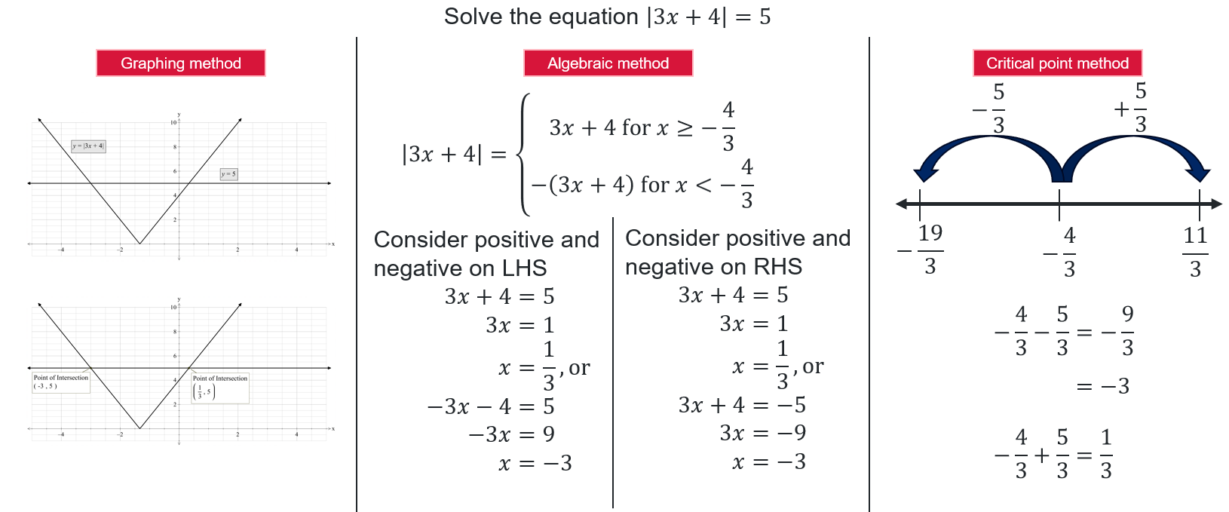
Worked example comparison

Appendix B

Absolute value problems
- The equation $\left|2x+b\right|=6$ has a solution at $x=3$. What is the value of $b$?
- The equation $\left|ax+b\right|=6$ has solutions at $x=-1$ and $x=5$. What could the values of $a$ and $b$ be?
- Suppose the solutions to $\left|x+b\right|=k$ are symmetric around $x=4$. What can you infer about the axis of symmetry of the graph and its relationship with $b$?
- The graph of $y=\left|ax+b\right|$ passes through the points $(2,0)$ and $(6,8)$. Find possible values of $a$ and $b$.
- The equation $\left|ax+b\right|=k$ has 2 solutions that are 8 units apart. What could $a$ and $b$ be if $k=12$?

Sample solutions

Appendix B – absolute value questions
$$\left|2x+b\right|=6 \\ \left|2\left(3\right)+b\right|=6 \\ \left|6+b\right|=6 \\ 6+b=6 \\ b=0,\text{ or} \\ -6-b=6 \\ b=-12$$
Consider the critical point for $\left|ax+b\right|=6$
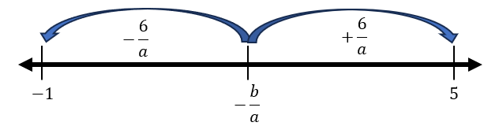
Distance between $-\frac{b}{a}$ and $-1$ or $5$ is $\frac{6}{a}$.
Midpoint between $-1$ and $5$ is $2.$
$$\frac{6}{a}=3 \\ a=2 \\ -\frac{b}{a}=2 \\ b=-4$$
$∴a=2, b=-4$
Since the axis of symmetry for the graph $y=|x+b|$ is $x=-b$ and the solutions are symmetry around $x=4$, then $b=-4$.
Plot both $(2,0)$ and $(6,8)$ on a graph.
Since $(2,0)$ is on the $x$-axis and the equation is in the form $y=|ax+b|$, $x=2$ is the axis of symmetry.
Use the points to determine the gradient of $2$, therefore $a=2$.
Since the axis of symmetry is $x=-\frac{b}{a}$, therefore $b=4.$
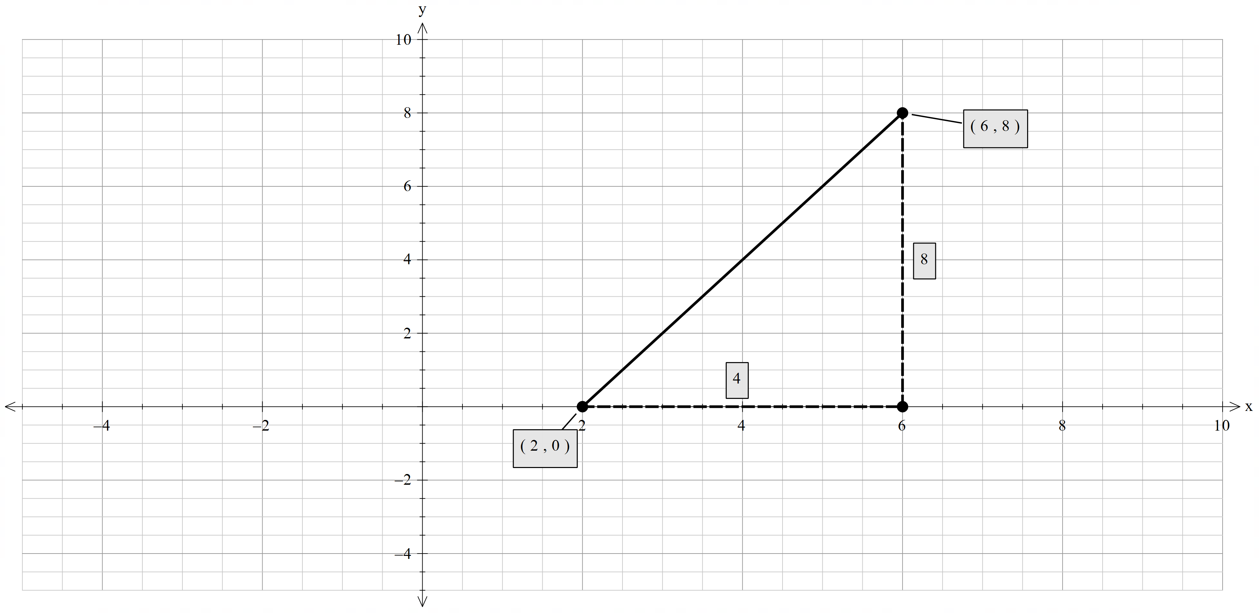
- Consider $\left|ax+b\right|=12$ on the number line. Let the 2 solutions be $x_{1}$ and $x_{1}+8$.
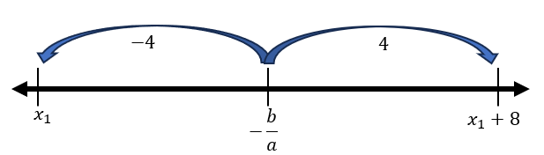
Since 2 solutions are $8$ units apart, then
$$\frac{12}{a}=4 \\ a=3$$
Then,
$$x_{1}=-\frac{b}{3}-4 \\ 3x_{1}=-b-12 \\ b=-3x_{1}-12$$
Since $x_{1}$ is all real $x$, therefore $b$ is also all real $x$.

References
This resource contains NSW Curriculum and syllabus content. The NSW Curriculum is developed by the NSW Education Standards Authority. This content is prepared by NESA for and on behalf of the Crown in right of the State of New South Wales. The material is protected by Crown copyright.
Please refer to the NESA Copyright Disclaimer for more information https://educationstandards.nsw.edu.au/wps/portal/nesa/mini-footer/copyright.
NESA holds the only official and up-to-date versions of the NSW Curriculum and syllabus documents. Please visit the NSW Education Standards Authority (NESA) website https://educationstandards.nsw.edu.au/ and the NSW Curriculum website https://curriculum.nsw.edu.au/.
Mathematics Advanced 11–12 Syllabus © NSW Education Standards Authority (NESA) for and on behalf of the Crown in right of the State of New South Wales, 2024.

© State of New South Wales (Department of Education), 2025
The copyright material published in this resource is subject to the Copyright Act 1968 (Cth) and is owned by the NSW Department of Education or, where indicated, by a party other than the NSW Department of Education (third-party material).
Copyright material available in this resource and owned by the NSW Department of Education is licensed under a Creative Commons Attribution 4.0 International (CC BY 4.0) license.

This license allows you to share and adapt the material for any purpose, even commercially.
Attribution should be given to © State of New South Wales (Department of Education), 2025.
Material in this resource not available under a Creative Commons license:
- the NSW Department of Education logo, other logos and trademark-protected material
- material owned by a third party that has been reproduced with permission. You will need to obtain permission from the third party to reuse its material.
Links to third-party material and websites
Please note that the provided (reading/viewing material/list/links/texts) are a suggestion only and implies no endorsement, by the New South Wales Department of Education, of any author, publisher, or book title. School principals and teachers are best placed to assess the suitability of resources that would complement the curriculum and reflect the needs and interests of their students.
If you use the links provided in this document to access a third-party's website, you acknowledge that the terms of use, including licence terms set out on the third-party's website apply to the use which may be made of the materials on that third-party website or where permitted by the Copyright Act 1968 (Cth). The department accepts no responsibility for content on third-party websites.

