Absolute value
Students learn about absolute value functions, including their definition, piecewise-defined form, symmetry, domain and range. They graph functions, match them to piecewise-defined forms and determine if different equations are equivalent using Amplify Classroom.
Students will need at least one digital device per pair to interact with Amplify Classroom during this lesson.

Learning intentions
- To understand how absolute value functions can be represented as a piecewise-defined function.
- To understand how symmetry, domain and range relate to absolute value functions.

Success criteria
- I can draw an absolute value graph from its function.
- I can write an absolute value function as a piecewise-defined function.
- I can determine the axis of symmetry for an absolute value function.
- I can determine the domain and range of an absolute value function.

Outcomes
A student:
- develops understanding and fluency in mathematics through exploring and connecting mathematical concepts, choosing and applying mathematical techniques to solve problems, and communicating their thinking and reasoning coherently and clearly MAO-WM-01
- applies algebraic techniques and the laws of indices and surds to manipulate expressions and solve problems MAV-11-01
- uses functions and relations to model, analyse and solve problems MAV-11-02

Content

Piecewise-defined functions
- Graph piecewise-defined functions involving functions covered in the scope of the Mathematics Advanced course, test if they are even or odd, and determine the domain and range

Absolute value functions
- Define the absolute value $\left|x\right|$ of a number $x$, also known as the magnitude of $x$, to be the distance from the origin to $x$ on the number line
- Establish and use the piecewise definition $\left|x\right|=\left\{\begin{matrix}x, \text{for} x≥0, \\ -x, \text{for} x<0\end{matrix}\right.$
- Show using numerical substitutions that $\sqrt{x^{2}}=\left|x\right|$ and use the result
- Graph the function $y=\left|x\right|$, describe its symmetry, and identify its domain and range
- Graph $y=\left|ax+b\right|$ with and without graphing applications, and identify its symmetry, domain and range
Mathematics Advanced 11–12 Syllabus © NSW Education Standards Authority (NESA) for and on behalf of the Crown in right of the State of New South Wales, 2024.

Table 1: lesson summary
Section | Summary of activity | Teaching strategies | Teaching points
Activating prior knowledge | Display slide 4 of the PowerPoint Absolute value for students to notice and wonder about an absolute value function before writing the equations for each half of the function. | Notice and wonder  Think-Pair-Share  Mini whiteboards | Establish that an absolute value function is a piecewise-defined function.
Connecting learning | Use slides 6 and 7 to define the absolute value function as a piecewise-defined function and its’ equivalent square root function. Students will use Amplify Classroom (bit.ly/abs_value_graph) to explore the domain, range and axis of symmetry and when the absolute value function is even. | Think-Pair-Share  Pose-Pause-Pounce-Bounce | Define the absolute value function and explore the effects of $a$ and $b$ on the function $y=|ax+b|$ in terms of domain, range and axis of symmetry.
Releasing responsibility | Using Appendix A, students practise sketching and determining symmetry, domain and range of absolute value functions while matching them to their equivalent piecewise-defined and square root functions. Use slides 9 and 10 and Appendix B to determine equivalent absolute value functions before completing Four quadrant notes in Appendix C. | Mini whiteboards  Four quadrant notes | Students practise sketching and defining absolute value functions before considering if 2 absolute value functions are equivalent.
Independent practice | Using Appendix D, students determine the absolute value function from given graphs. | Turn and talk | Consolidate student understanding of absolute value functions by having them determine the function from given graphs and write it using absolute value notation and piecewise notation.

Activity structure
Please use the associated PowerPoint Absolute value to display images in this lesson.

Activating prior knowledge
- Use slide 4 of the PowerPoint to display an image of a graph and pose the following scenario.
Andrew likes riding his bike to and from his favourite lake on Tuesdays. He created the following distance-time graph to represent the distance he is away from the lake while biking.
- Activate prior knowledge by asking students to consider what they notice and wonder (bit.ly/noticewonderstrategy) about the graph.
Students may notice that the graph is symmetrical around $x=15$ or that the range is $0≤y≤3$ due to the context. Students may wonder about the algebraic relationship between the 2 sections of the piecewise-defined function.
- In a Think-Pair-Share (bit.ly/thinkpairsharestrategy) on mini whiteboards (bit.ly/miniwhiteboards), have students determine the equation of the 2 linear functions that make up the graph and write it as a piecewise function.
Students are familiar with determining linear functions from Unit 3 – exploring linear and quadratic functions and piecewise-defined functions from Lesson 1 – piecewise-defined functions of Unit 4 – graphing and transformations.
- Ask students to notice and wonder about the graph and equations.
Students may notice that there is similarity between the 2 linear equations or notice that one function is the negative of the other function. They may wonder if there is a way of writing this in a more concise manner.

Connecting learning
- Using slide 6 of the PowerPoint, in pairs on mini whiteboards, students complete the table of values for $y=\sqrt{x^{2}}$.
- In a Think-Pair-Share, ask students to predict what this graph will look like. Provide time for students to graph the function. Click to animate the slide to show the graph.
- Using the Pose-Pause-Pounce-Bounce questioning strategy (PDF 557 KB) (bit.ly/posepausepouncebounce) lead a class discussion around some of the features of this graph. Prompts could include:
- Is the graph symmetrical? If so, what is the axis of symmetry?
- What does the graph’s symmetry tell us about whether the function is odd or even?
- What is the domain and range for the graph?
- What would the piecewise-defined function of this graph look like?
Students are familiar with domain and range and odd and even functions from Lesson 5 – domain and range of Unit 2 – introduction to functions.
- Use slide 7 to display the definition of absolute value.
The absolute value is the magnitude or size of a real number, i.e. the distance of the number from the origin on a number line.
Formally, it has the piecewise definition $\left|x\right|=\left\{\begin{aligned}x \text{if} x≥0 \\ -x \text{if} x<0\end{aligned}\right.$ (NESA 2024).
- With at least one device per pair, assign the Amplify Classroom activity ‘Absolute value graphs’ (bit.ly/abs_value_graph) for students to complete.

Before using this activity, you will need to set up an Amplify Classroom. (bit.ly/createamplifyclassroom) and use the pacing feature to restrict students to screens 1–7.
If devices are not available, the activity should be completed as a whole class, with student input sections explored and discussed together.
- Provide time for students to complete screens 2–7.
To enter the $≥$ symbol in Amplify Classroom, students will type the > symbol followed by the = symbol. Amplify will combine these 2 actions and replace them with the $≥$ symbol.
- Use a Pose-Pause-Pounce-Bounce questioning strategy to check for understanding of the effect of $a$ on the absolute value function based on student responses from screen 7.
- Pace students forward to screens 8–12 and provide time for them to complete.
- Use the Pose-Pause-Pounce-Bounce questioning strategy to lead a class discussion to check for understanding of the effect of $b$ on the absolute value function based on student responses from screen 9.
- Pace students forward to screen 10 and provide time for students to explore the effect of both $a$ and $b$ on the absolute value graph.
From the syllabus, the absolute value function is restricted to $y=\left|ax+b\right|$.
Students should be able to identify that the absolute value function changes gradients and moves due to the variables $a$ and $b$ and may be able to describe, informally, the direction of movement. Translations and dilations will be studied in future lessons in this unit.

Releasing responsibility
- Using mini whiteboards, distribute Appendix A ‘Absolute value functions’ for students to complete. For each function, students will need to:
- sketch the graph
- determine domain and range
- state the axis of symmetry
- match each absolute value function with its equivalent piecewise-defined function and square root function.
Piecewise-defined functions have been written with a negative that has not been simplified to highlight the link between the absolute value function and its piecewise-defined function.
- In pairs, students are to give and provide feedback on their work before making any necessary adjustments.
- Lead a class discussion around if the absolute value function is an example of a continuous or discontinuous function based on the informal definition.
- Display slide 9 of the PowerPoint. Continuing in their pairs on mini whiteboards, have students justify why the functions are equivalent.
- Display slide 10 to have each pair explain why $y=|2x-1|$ is the same as $y=|1-2x|$.
Students may wish to sketch both graphs to show that they are equivalent or write them as piecewise-defined functions to show that both absolute value functions have the same piecewise-defined function.
- Distribute Appendix B ‘Equivalent or not’ to each pair and have them determine if each pair of absolute value functions are equivalent by either writing them as a piecewise-defined function or graphing.
Students may benefit from further practice using an existing resource.
- Students are to complete Four quadrant notes to their future forgetful self (bit.ly/supportingstrategies) from Appendix C ‘Four quadrant notes’ on a vertical non-permanent surface.

Independent practice
- Distribute Appendix D ‘Graphs’ for pairs to determine the absolute value function from the graph, writing the answer using absolute value notation and piecewise notation.
- In a turn and talk (bit.ly/classroomtalkmoves), each pair is to compare their answers with another pair and discuss if there are any differences.
- Have students return to Appendix C to add notes about how to write functions using absolute value notation and piecewise notation.

Assessment and differentiation

Suggested opportunities for differentiation
Activating prior knowledge
- Support students with the linear functions by using prompting questions to help them identify the $y$-intercept and gradient.
Connecting learning
- Adjust the pacing of the Amplify Classroom activities to allow students to explain and share their thinking.
- Extend students by being specific around the transformations of the graph $y=|ax+b|$. Have students describe the change in $b$ as a translation left or right and the change in $a$ as a horizontal dilation.
Releasing responsibility
- Support students’ sketching skills by having them identify the $x$- and $y$-intercepts of the linear function.
- Appendix B can be completed by either having students write the piecewise-defined function or by graphing. Teachers may wish to direct students to use one method or the other depending on the needs of their students.
- Extend students by having them generalise about the domain and range for an absolute value function in the form $y=|ax+b|$ and by considering what the equation would look like if the range changed from $y≥0$.
Independent practice
- Support students by having them write the equations of the graphs in only absolute value notation.

Suggested opportunities for assessment
Activating prior knowledge
- Students give each other peer feedback on the equation of the linear functions, before sharing with the class in a Think-Pair-Share.
Connecting learning
- Monitor responses in class discussions to check for student understanding of the features of an absolute value graph.
- Monitor student responses in the Amplify Classroom to check for understanding of how students determine the axis of symmetry, domain and range and the effect on the absolute value function due to the variables $a$ and $b$.
Releasing responsibility
- Students give and receive peer feedback while using mini whiteboards to complete Appendix A.
- Collect Appendix C as a work sample to check for student understanding.
Independent practice
- Collect Appendix D as a work sample to check for student understanding.

Appendix A

Absolute value functions
For each absolute value function, complete the following:
- Sketch the graph.
- Determine the domain and range.
- Identify the axis of symmetry.
- Match each function with its equivalent piecewise-defined function and square root function.
- $y=\left|x+3\right|$
- $y=\left|x-3\right|$
- $y=\left|4x+3\right|$
- $y=|4x-3|$
- $y=\left|-5x-6\right|$
- $y=|-5x+6|$
$$y=\left\{\begin{aligned}x-2, \text{if} x≥3 \\ -(x-2), \text{if} x<3\end{aligned}\right.$$ | $$y=\left\{\begin{aligned}x+3,\text{ if} x≥-3 \\ -\left(x+3\right),\text{ if} x<-3\end{aligned}\right.$$
$$y=\left\{\begin{aligned}-5x-6, \text{if} x≥-\frac{6}{5} \\ -\left(-5x-6\right), \text{if} x<-\frac{6}{5}\end{aligned}\right.$$ | $$y=\left\{\begin{aligned}4x-3, \text{if} x≥\frac{3}{4} \\ -(4x-3), \text{if} x<\frac{3}{4}\end{aligned}\right.$$
$$y=\left\{\begin{aligned}4x+3, \text{if} x≥-\frac{3}{4} \\ -(4x+3), \text{if} x<\frac{3}{4}\end{aligned}\right.$$ | $$y=\left\{\begin{aligned}-5x+6, \text{if} x≥\frac{6}{5} \\ -\left(-5x+6\right),\text{ if} x<\frac{6}{5}\end{aligned}\right.$$
$$y=\sqrt{{\left(x-3\right)}^{2}}$$ | $$y=\sqrt{{\left(-5x+6\right)}^{2}}$$
$$y=\sqrt{{\left(4x-3\right)}^{2}}$$ | $$y=\sqrt{{\left(x+3\right)}^{2}}$$
$$y=\sqrt{{\left(-5x-6\right)}^{2}}$$ | $$y=\sqrt{{\left(4x+3\right)}^{2}}$$

Appendix B

Equivalent or not
State if each pair of absolute value functions are equivalent or not.
Question | Function 1 | Function 2 | Equivalent
1 | $$y=\left|x+4\right|$$ | $$y=\left|-x-4\right|$$
2 | $$y=\left|3x+5\right|$$ | $$y=\left|-3x-5\right|$$
3 | $$y=\left|x-6\right|$$ | $$y=\left|-x-6\right|$$
4 | $$y=\left|2x+7\right|$$ | $$y=\left|-2x+7\right|$$
5 | $$y=\left|4x+3\right|$$ | $$y=\left|3-4x\right|$$

Appendix C

Four quadrant notes
Example 1  Sketch the function $y=|2x+1|$. State its domain and range, axis of symmetry and piecewise-defined function.  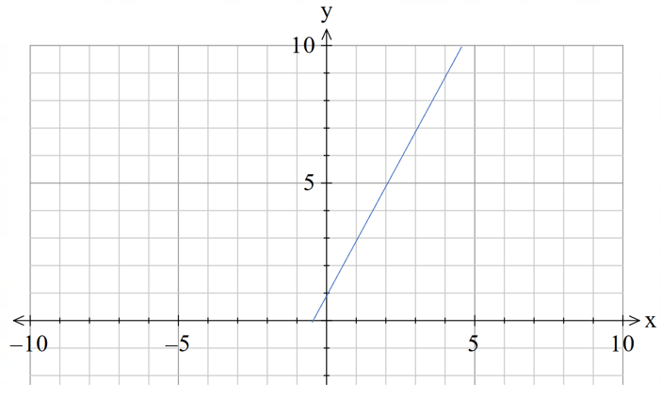  Domain:  Range:  Axis of symmetry: $x=\boxed{}$  Piecewise-defined function:$y=\left\{\begin{aligned}\boxed{} \\ \boxed{}\end{aligned}\right.$ | Example 2  Sketch the function $y=|7-5x|$. State its domain and range, axis of symmetry and piecewise-defined function. 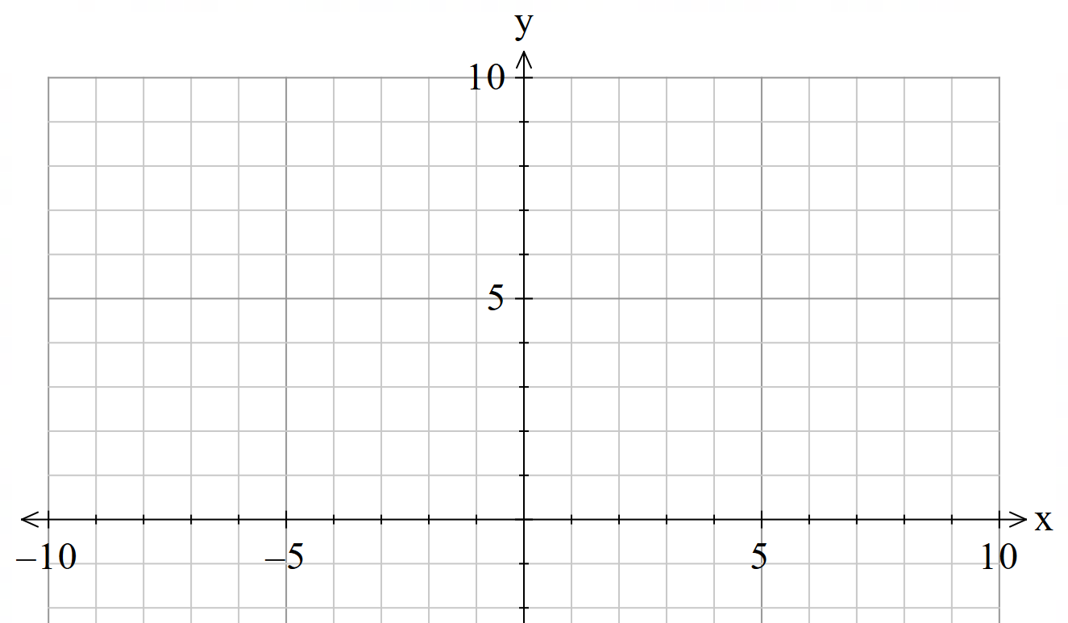
Things to remember | Example 3

Appendix D

Graphs
Determine the function for each graph. Write your answer using absolute value notation and piecewise notation.
1 | 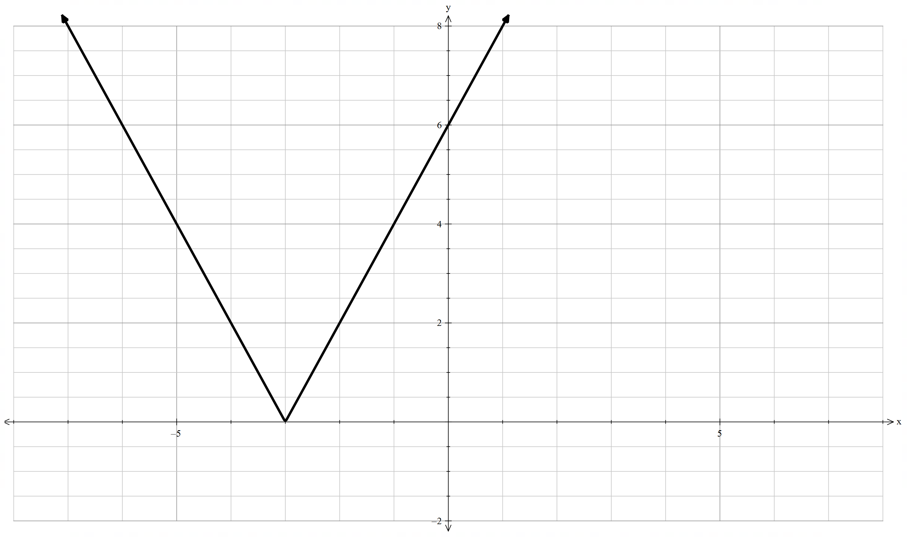
2 | 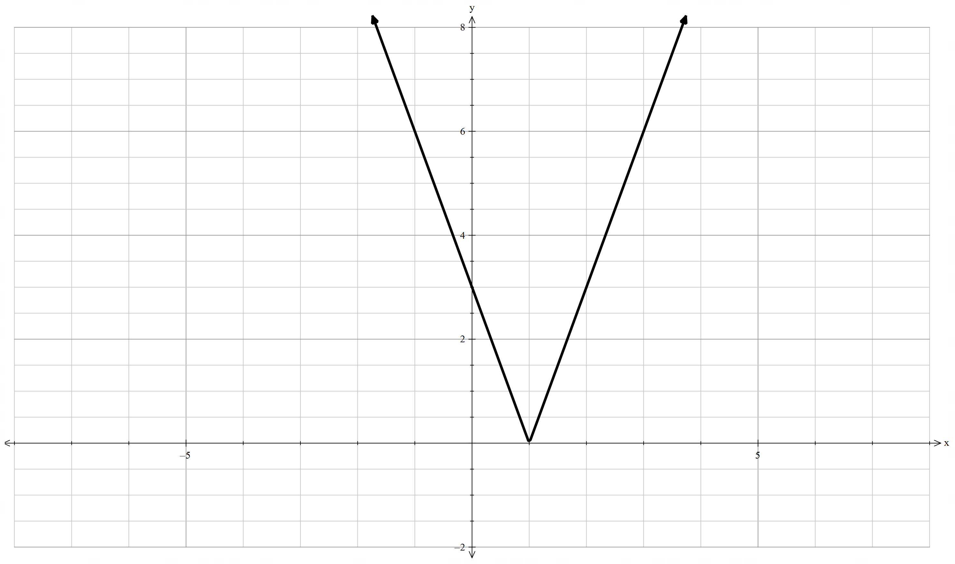

3 | 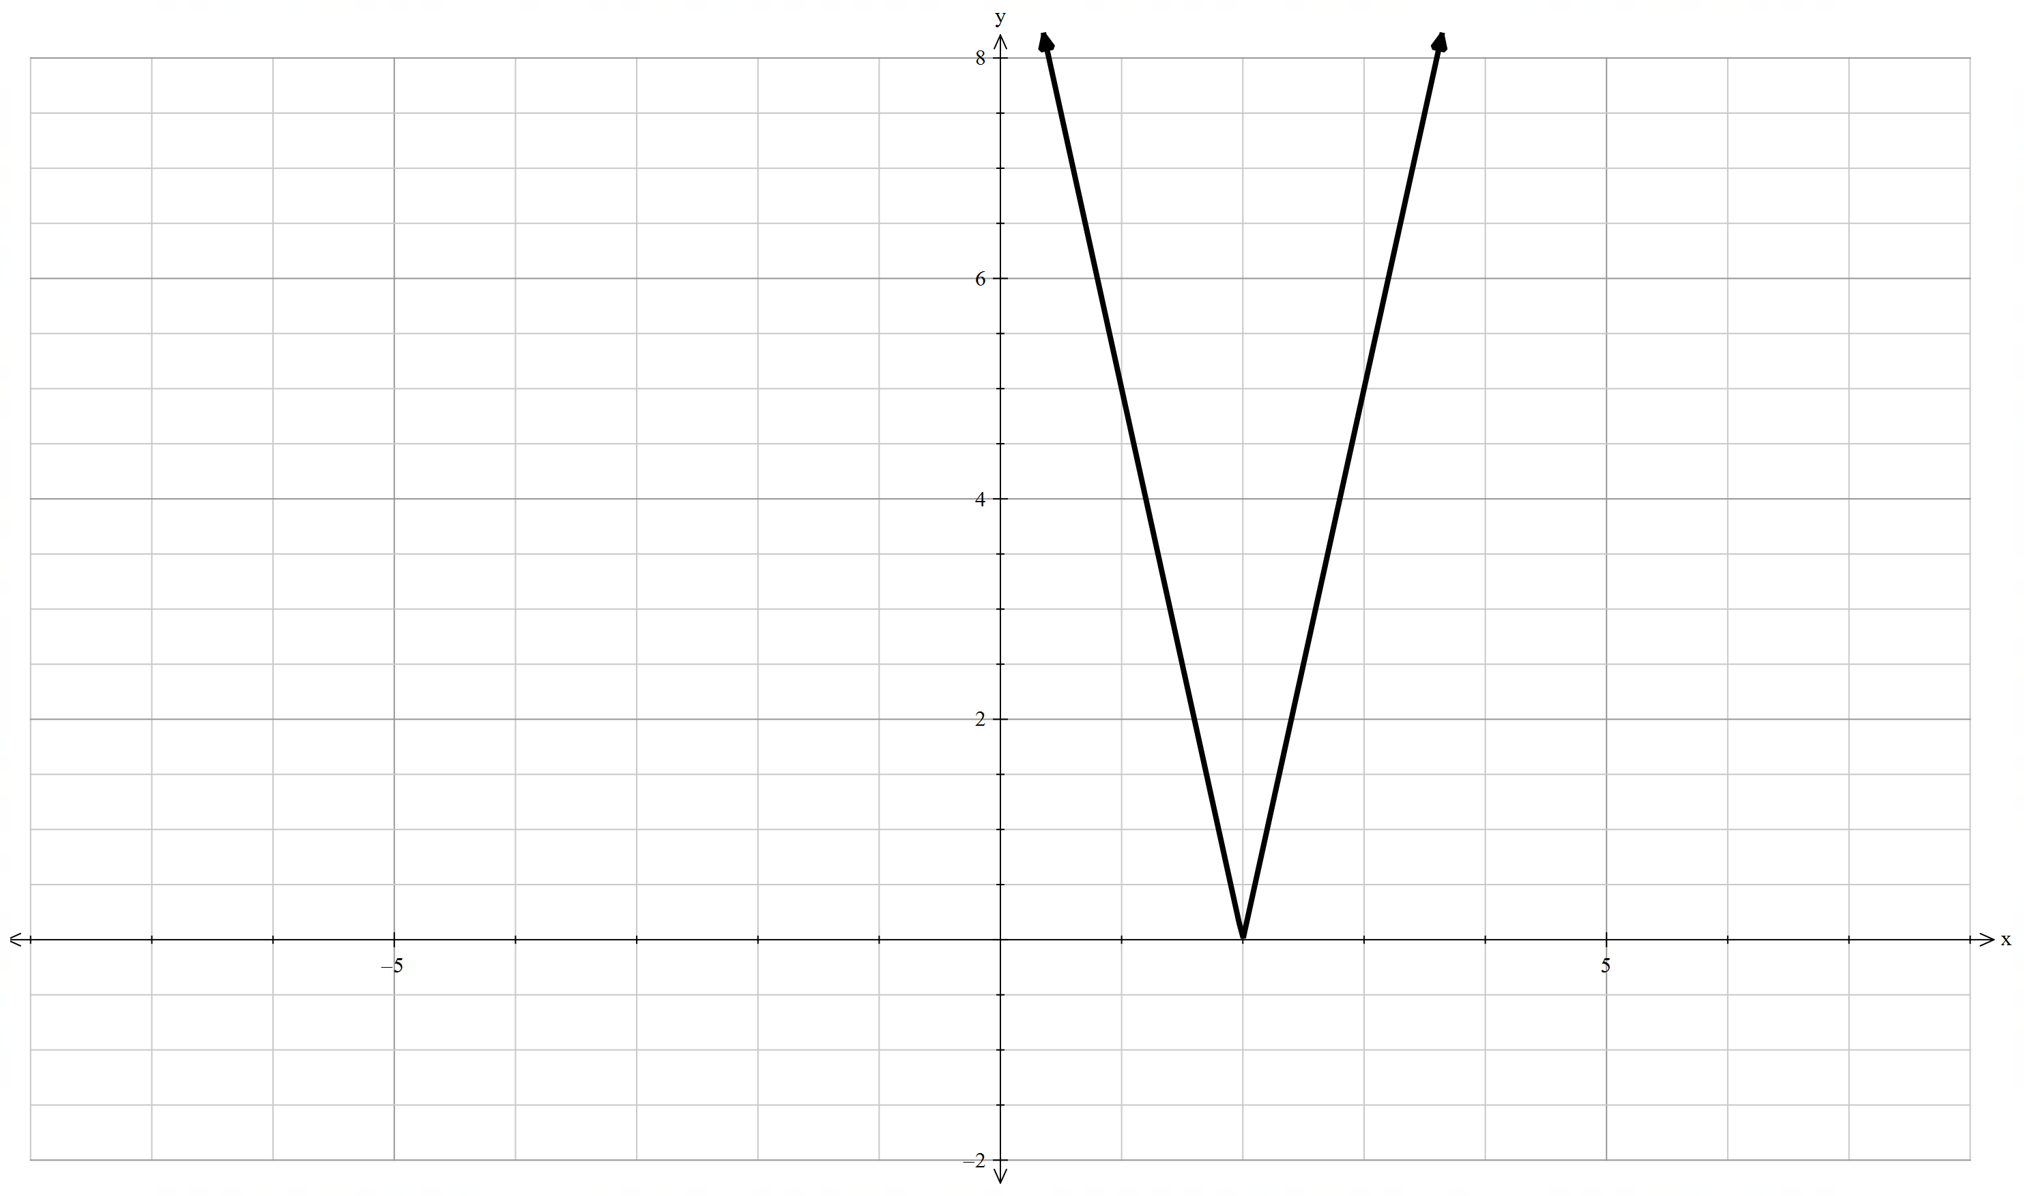
4 | 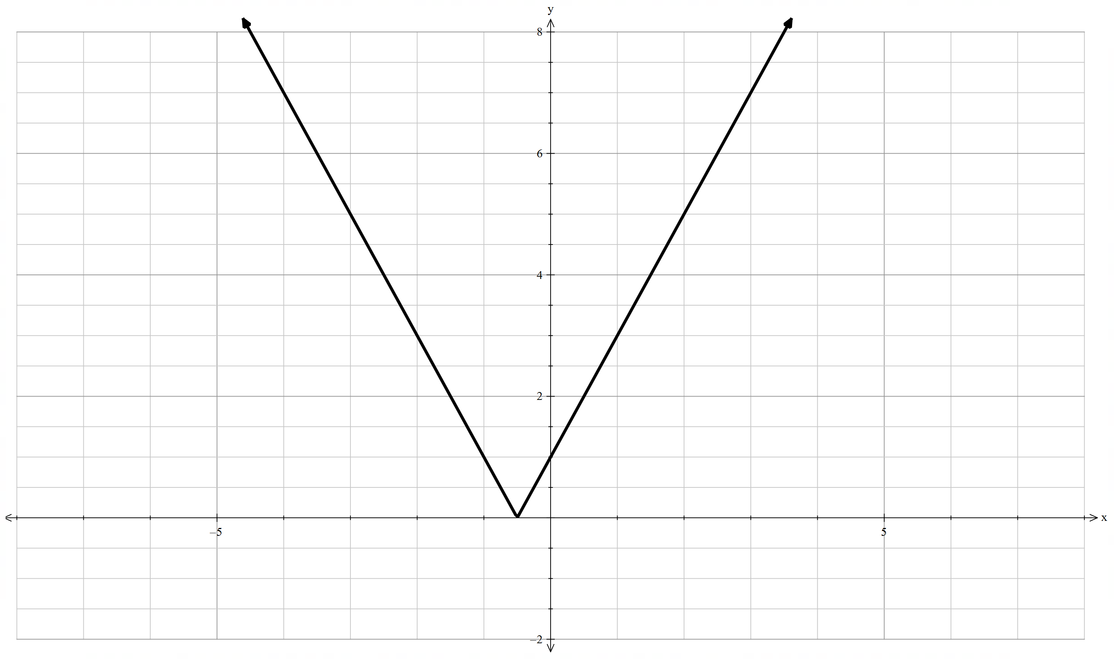

5 | 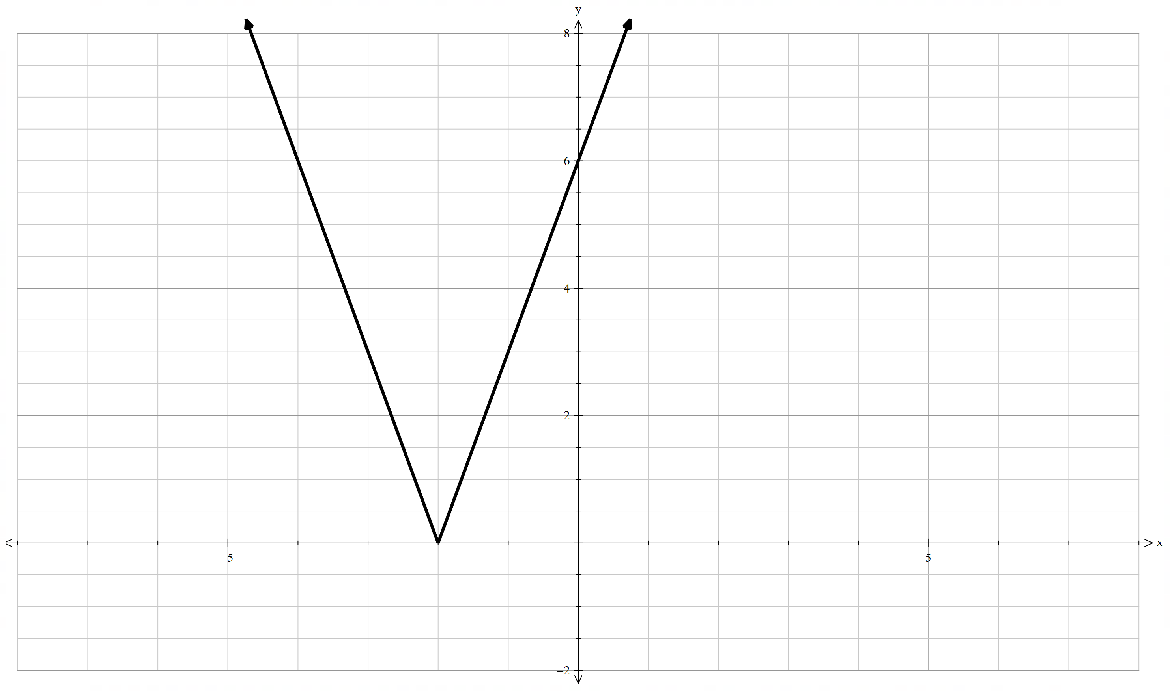

Sample solutions

Appendix A – absolute value functions
- $y=\left|x+3\right|$
Domain: All real $x$
Range: $y≥0$
Axis of symmetry: $x=-3$
Piecewise-defined function: $y=\left\{\begin{aligned}x+3,\text{ if} x≥-3 \\ -\left(x+3\right),\text{ if} x<-3\end{aligned}\right.$
Square root function: $y=\sqrt{{\left(x+3\right)}^{2}}$
- $y=\left|x-3\right|$
Domain: All real $x$
Range: $y≥0$
Axis of symmetry: $x=3$
Piecewise-defined function: $y=\left\{\begin{aligned}x-3, \text{if} x≥3 \\ -(x-3), \text{if} x<3\end{aligned}\right.$
Square root function: $y=\sqrt{{\left(x-3\right)}^{2}}$
- $y=\left|4x+3\right|$
Domain: All real $x$
Range: $y≥0$
Axis of symmetry: $x=-\frac{3}{4}$
Piecewise-defined function: $y=\left\{\begin{aligned}4x+3, \text{if} x≥-\frac{3}{4} \\ -\left(4x+3\right), \text{if} x<-\frac{3}{4}\end{aligned}\right.$
Square root function: $y=\sqrt{{\left(4x+3\right)}^{2}}$
- $y=|4x-3|$
Domain: All real $x$
Range: $y≥0$
Axis of symmetry: $x=\frac{3}{4}$
Piecewise-defined function: $y=\left\{\begin{aligned}4x-3, \text{if} x≥\frac{3}{4} \\ -(4x-3), \text{if} x<\frac{3}{4}\end{aligned}\right.$
Square root function: $y=\sqrt{{\left(4x-3\right)}^{2}}$
- $y=|-5x-6|$
Domain: All real $x$
Range: $y≥0$
Axis of symmetry: $x=-\frac{6}{5}$
Piecewise-defined function: $y=\left\{\begin{aligned}-5x-6, \text{if} x≥-\frac{6}{5} \\ -(-5x-6), \text{if} x<-\frac{6}{5}\end{aligned}\right.$
Square root function: $y=\sqrt{{\left(-5x-6\right)}^{2}}$
- $y=\left|-5x+6\right|$
Domian: All real $x$
Range: $y≥0$
Axis of symmetry: $x=\frac{6}{5}$
Piecewise-defined function: $y=\left\{\begin{aligned}-5x+6, \text{if} x≥\frac{6}{5} \\ -\left(-5x+6\right), \text{if} x<\frac{6}{5}\end{aligned}\right.$
Square root function: $y=\sqrt{{\left(-5x+6\right)}^{2}}$

Appendix B – equivalent or not
Question | Function 1 | Function 2 | Equivalent
1 | $$y=\left|x+4\right|$$ | $$y=\left|-x-4\right|$$ | Equivalent
2 | $$y=\left|3x+5\right|$$ | $$y=\left|-3x-5\right|$$ | Equivalent
3 | $$y=\left|x-6\right|$$ | $$y=\left|-x-6\right|$$ | Not equivalent
4 | $$y=\left|2x+7\right|$$ | $$y=\left|-2x+7\right|$$ | Not equivalent
5 | $$y=\left|4x+3\right|$$ | $$y=\left|3-4x\right|$$ | Not equivalent

Appendix C – Four quadrant notes
Example 1  Sketch the function $y=|2x+1|$. State its domain and range, axis of symmetry and piecewise-defined function.  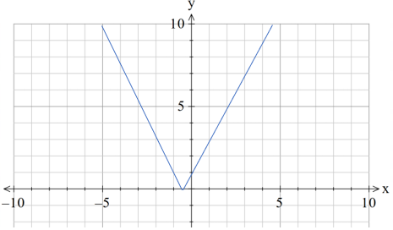  Domain: All real $x$  Range: $y≥0$  Axis of symmetry: $x=\boxed{-\frac{1}{2}}$  Piecewise-defined function:$y=\left\{\begin{aligned}\boxed{2x+1 \text{for} x≥-\frac{1}{2}} \\ \boxed{-2x-1 \text{for} x<-\frac{1}{2}}\end{aligned}\right.$ | Example 2  Sketch the function $y=|7-5x|$. State its domain and range, axis of symmetry and piecewise-defined function.  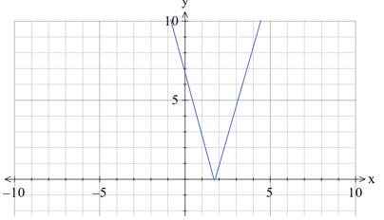  Domain: All real $x$  Range: $y≥0$  Axis of symmetry: $x=\boxed{\frac{7}{5}}$  Piecewise-defined function:$y=\left\{\begin{aligned}\boxed{5x-7 \text{for} x≥\frac{7}{5}} \\ \boxed{7-5x \text{for} x<\frac{7}{5}}\end{aligned}\right.$

Appendix D – graphs
- $y=\left|2x+6\right|$
$$y=\left\{\begin{aligned}2x+6, \text{if} x≥-3 \\ -\left(2x+6\right), \text{if} x<-3\end{aligned}\right.$$
- $y=\left|3x-3\right|$
$$y=\left\{\begin{aligned}3x-3, \text{if} x≥1 \\ -\left(3x-3\right), \text{if} x<1\end{aligned}\right.$$
- $y=\left|5x-10\right|$
$$y=\left\{\begin{aligned}5x-10, \text{if} x≥2 \\ -\left(5x-10\right), \text{if} x<2\end{aligned}\right.$$
- $y=\left|2x+1\right|$
$$y=\left\{\begin{aligned}2x+1, \text{if} x≥-\frac{1}{2} \\ -\left(2x+1\right), \text{if} x<-\frac{1}{2}\end{aligned}\right.$$
- $y=|3x+6|$
$$y=\left\{\begin{aligned}3x+6, \text{if} x≥-2 \\ -\left(3x-6\right), \text{if} x<-2\end{aligned}\right.$$

References
This resource contains NSW Curriculum and syllabus content. The NSW Curriculum is developed by the NSW Education Standards Authority. This content is prepared by NESA for and on behalf of the Crown in right of the State of New South Wales. The material is protected by Crown copyright.
Please refer to the NESA Copyright Disclaimer for more information https://educationstandards.nsw.edu.au/wps/portal/nesa/mini-footer/copyright.
NESA holds the only official and up-to-date versions of the NSW Curriculum and syllabus documents. Please visit the NSW Education Standards Authority (NESA) website https://educationstandards.nsw.edu.au/ and the NSW Curriculum website https://curriculum.nsw.edu.au/.
Mathematics Advanced 11–12 Syllabus © NSW Education Standards Authority (NESA) for and on behalf of the Crown in right of the State of New South Wales, 2024.

© State of New South Wales (Department of Education), 2025
The copyright material published in this resource is subject to the Copyright Act 1968 (Cth) and is owned by the NSW Department of Education or, where indicated, by a party other than the NSW Department of Education (third-party material).
Copyright material available in this resource and owned by the NSW Department of Education is licensed under a Creative Commons Attribution 4.0 International (CC BY 4.0) license.

This license allows you to share and adapt the material for any purpose, even commercially.
Attribution should be given to © State of New South Wales (Department of Education), 2025.
Material in this resource not available under a Creative Commons license:
- the NSW Department of Education logo, other logos and trademark-protected material
- material owned by a third party that has been reproduced with permission. You will need to obtain permission from the third party to reuse its material.
Links to third-party material and websites
Please note that the provided (reading/viewing material/list/links/texts) are a suggestion only and implies no endorsement, by the New South Wales Department of Education, of any author, publisher, or book title. School principals and teachers are best placed to assess the suitability of resources that would complement the curriculum and reflect the needs and interests of their students.
If you use the links provided in this document to access a third-party's website, you acknowledge that the terms of use, including licence terms set out on the third-party's website apply to the use which may be made of the materials on that third-party website or where permitted by the Copyright Act 1968 (Cth). The department accepts no responsibility for content on third-party websites.

