Piecewise-defined functions
In this lesson, students learn about piecewise-defined functions and develop an understanding of continuity by interpreting graphs and solving equations to find domain boundaries.

Learning intention
- To be able to interpret and construct piecewise-defined functions.

Success criteria
- I can describe a piecewise-defined function.
- I can identify the functions and domains that make up a piecewise-defined function.
- I can determine whether a piecewise-defined function is continuous or discontinuous at a given point.
- I can construct the graph of a piecewise-defined function.

Outcomes
A student:
- develops understanding and fluency in mathematics through exploring and connecting mathematical concepts, choosing and applying mathematical techniques to solve problems, and communicating their thinking and reasoning coherently and clearly MAO-WM-01
- applies algebraic techniques and the laws of indices and surds to manipulate expressions and solve problems MAV-11-01
- uses functions and relations to model, analyse and solve problems MAV-11-02

Content

Piecewise-defined functions
- Interpret piecewise-defined functions, where the function is defined differently in different parts of the domain
- Graph piecewise-defined functions involving functions covered in the scope of the Mathematics Advanced course, test if they are even or odd, and determine the domain and range
- Define informally that a function is continuous at a point if the curve can be drawn through the point without lifting the pen off the paper
- Identify points where piecewise-defined functions and other functions are not continuous
- Define a discontinuity of a function informally as a point where the function is not continuous
Mathematics Advanced 11–12 Syllabus © NSW Education Standards Authority (NESA) for and on behalf of the Crown in right of the State of New South Wales, 2024.

Table 1: lesson summary
Section | Summary of activity | Teaching strategies | Teaching points
Activating prior knowledge | Introduce students to the ‘City to surf’ fun run and use slide 4 of the PowerPoint Piecewise-defined functions to display a runner’s distance travelled graph. Show the course map (bit.ly/CourseMapCity2Surf) to interpret how elevation may affect a runner’s speed.  Discuss why linear segments vary and what limitations exist with the linear model. | Notice and wonder | The purpose of this activity is to connect to student prior knowledge of linear modelling. Students should interpret that the graph combines multiple segments of linear functions of differing gradients, before they formalise a piecewise-defined function.
Connecting learning | Use slide 6 to define a piecewise-defined graph. Progress to slides 7–8 to present an example and discuss continuity and discontinuity as well as features of the graph.  Students complete Appendix A and then match these graphs to equations on slide 9. | Variation Theory | The aim of this section is to interpret the graphs of piecewise-defined functions, building their skills to then graph them in the next sections.
Releasing responsibility | Use slides 11–14 to model graphing piecewise-defined functions. Students then complete Appendix B. | Worked examples (Your turn)  Four quadrant notes  Pose-Pause-Pounce-Bounce | Students should be able to apply open and closed circles correctly on their piecewise-defined functions, as well as calculate the end points of each domain.
Independent practice | Students complete Appendix C before discussing the different strategies used as a class. | Pose-Pause-Pounce-Bounce | The purpose of this activity is to connect students’ prior knowledge of simultaneous equations and apply it to both graphical and algebraic understandings to create and analyse continuous piecewise-defined functions.

Activity structure
Please use the associated PowerPoint Piecewise-defined functions to display images in this lesson.

Activating prior knowledge
- Explain to students that they will be analysing the pace of a runner in the ‘City to Surf’ event (city2surf.com.au/). As a class, briefly discuss what the ‘City to Surf’ is.
The ‘City to Surf’ is a 14 km fun run held each year in Sydney, where thousands of participants run from the city centre to Bondi Beach.
- Display slide 4 of the PowerPoint, showing the graph of a runner’s distance over time for the ‘City to Surf’ event. Ask students to consider what they notice and wonder (bit.ly/noticewonderstrategy) about this graph.
Students may notice that the graph shows the runner completed the race in approximately 95 minutes. They may notice that the graph is composed of several linear segments, each with a different gradient, and may wonder why the gradient changes between intervals.
- Display the course map, which includes the distance and elevation data, from the ‘City to Surf Course Map’ (bit.ly/CourseMapCity2Surf).
- Initiate a class discussion to explore the meaning of the linear segments in the graph and their relationship to the elevation map. Some suggested prompts include:
- What might cause the gradient of a segment to change along the course?
- Why might a runner’s speed not remain constant?
- What are some limitations on using linear relationships to model this scenario?
The purpose of this discussion is to help students understand that distance over time graphs are made up of segments that might not be perfectly linear, because a runner’s speed can change depending on factors such as hills and fatigue.

Connecting learning
- Explain to students that what they have been looking at is an example of a piecewise-defined function, where the function is defined differently in different parts of the domain. The ‘Distance travelled’ graph was a linear based piecewise-defined function.
- Use slide 6 to display the NESA glossary definition of a piecewise-defined function.
- Unpack the language in the definition by prompting students to recall what a function is and to discuss how the domain describes the set of real numbers where the function or relation applies.
- Ask students to interpret the example by explaining which functions are used to make up the piecewise-defined function and how the piecewise-defined function would appear graphically.
Students should explain that this function is defined by a quadratic, linear and cubic function. The domain restrictions for each part ensure that there is no overlap.
Students were introduced to the definitions of functions, domain and range in Unit 2 – introduction to functions and inequalities in Unit 3 – exploring linear and quadratic functions.
- Display slide 7, which shows the graphs of the 3 individual functions that together form the piecewise-defined function from slide 6.
- Lead a class discussion to interpret each graph and how they relate to the overall piecewise-defined function. Discuss why some sections of the graphs are red and how they were chosen.
- Use slide 8 to display the graph of the complete piecewise-defined function. Click to animate the slide and use the self-explanation prompts to initiate a class discussion unpacking the features of this graph.
- Define informally that a function is continuous at a point if the curve can be drawn through the point without lifting the pen off the paper.
Students should easily recognise that the piecewise-defined function’s graph on slide 8 is not continuous. Piecewise-defined graphs are continuous at a point when the endpoints of adjacent domains meet at the same value.
Students could be asked to recall the distance travelled graph that they observed on slide 4. Explaining that this piecewise-defined function would be an example of a continuous function since it could be drawn without lifting their pen off the paper.
- Define a discontinuity of a function informally as a point where the function is not continuous and ask students to decide the points where the piecewise-defined function on slide 8 is not continuous.
Students should identify that the graph is discontinuous when $x=-1$ and when $x=1$.
- Distribute Appendix A ‘Piecewise-defined functions’ to each student and instruct them to work together in pairs to complete it. In this activity, students work with 6 piecewise-defined graphs designed using principles of Variation Theory (variationtheory.com/introduction). For each graph, they analyse key features and make observations about its structure and properties.
This activity requires students to determine if the function is odd, even or neither and to explain why. Students have previously learned this in Lesson 7 – odd and even functions of Unit 2 – introduction to functions.
- Once most pairs have finished the activity, display slide 9, which shows the equations corresponding to the 6 graphs. Ask each pair to match the equations to the graphs they analysed.

Releasing responsibility
- Use slides 11–14 to model how to graph piecewise-defined functions using the Worked examples (Your turn) strategy (bit.ly/supportingstrategies).
- Use the Pose-Pause-Pounce-Bounce questioning strategy (PDF 557 KB) (bit.ly/posepausepouncebounce) to identify the key steps involved in graphing a piecewise-defined function. Draw out and connect students’ ideas, such as the importance of identifying which function applies in each domain and ensuring the correct $y$-values are calculated at the boundaries of those domains. Some suggested prompts include:
- Why is it important to calculate and plot the $y$-values at the interval boundaries?
- How can we tell if a piecewise function is continuous or discontinuous?
- Distribute Appendix B ‘Four quadrant notes to future self’ (bit.ly/supportingstrategies) to each student. Students can discuss this in pairs, prior to completing their own independently.
Encourage students to describe both continuous and discontinuous functions within their notes and to refer to the difference between open and closed circles when graphing piecewise-defined functions.
- Students can complete practice questions from an existing resource to consolidate their understanding of graphing and interpreting piecewise-defined functions.

Independent practice
- Distribute Appendix C ‘Creating a continuous piecewise-defined function’ and explain to students that they will be working on determining the domain boundaries that ensure continuity of piecewise-defined functions. They will be given 3 piecewise-defined functions, each with missing domain intervals. Their task is to find the missing domain values so that each piecewise function is continuous across its entire domain.
Students can complete this task in pairs. This activity requires students to solve both linear and quadratic simultaneous equations. Students have previously learned this in Unit 3 – exploring linear and quadratic functions.
- Once students begin to finish, have them swap their question 2 piecewise-defined function with another pair for them to check that it is continuous.
Students can also be challenged to create a continuous piecewise-defined function with 3 different functions within the complete domain.
- Use the Pose-Pause-Pounce-Bounce questioning strategy to discuss strategies that students used to find the missing values. Some suggested prompts include:
- How can we be confident that a piecewise function is continuous at the boundary without graphing it?
- If 2 functions are equal at only one point, is that enough to guarantee continuity at that point? Why/why not?

Assessment and differentiation

Suggested opportunities for differentiation
Activating prior knowledge
- Students can be challenged to create their own distance–time graph using the ‘Distance Travelled’ data on slide 4, with the $y$-axis labelled as ‘Distance from the starting point’. Clarify that, for this course, participants return to the start as the finishing point.
- A corresponding table of values could be provided for students to support them to interpret the graph on slide 4.
- Challenge students to estimate gradients for each segment of the graph.
Connecting learning
- To support students, encourage them to colour-code each segment of the graph according to the function type to reinforce the concept of domain restrictions.
- Challenge students to sketch additional piecewise-defined functions combining more complex functions such as exponentials and reciprocal functions, predicting continuity or discontinuity points.
Releasing responsibility
- Provide partially completed graphs or structured templates for students who need more support, such as axes already labelled or one domain graphed with annotations.
- Challenge students to create their own piecewise function to graph that has up to 4 different parts.
Independent practice
- Students can use a graphing application to check their solutions.
- Provide worked examples or structured steps for students who need support solving simultaneous equations.
- Challenge students to create a piecewise-defined function that has 3 different types of functions.

Suggested opportunities for assessment
Activating prior knowledge
- Check for mathematical understanding by asking students to compare gradients between segments and justify differences.
Connecting learning
- Observe student discussion when interpreting each graph and identifying function types and domain restrictions to assess conceptual understanding.
- Check students’ ability to identify discontinuities and justify why the graph is continuous or not at a point.
- Use self-explanation prompts during the slide animations to assess whether students can articulate the relationships between segments, continuity and function properties.
Releasing responsibility
- As students work on the example problems, observe how they label domains, calculate boundary values and use open/closed circles, to check for their understanding of how to graph a piecewise-defined function.
- Collect Appendix B to assess whether students can explain key concepts like continuity and domain splits in their own words.
Independent practice
- Circulate during the task and note how students set up and solve their equations. Pay attention to whether they are checking continuity algebraically and explaining their reasoning with their partner.
- Use the Pose-Pause-Pounce-Bounce questioning strategy to assess depth of understanding during the debrief discussion. Focus on whether students can justify continuity without relying solely on visual cues.

Appendix A

Piecewise-defined functions

Graphs
Graph 1  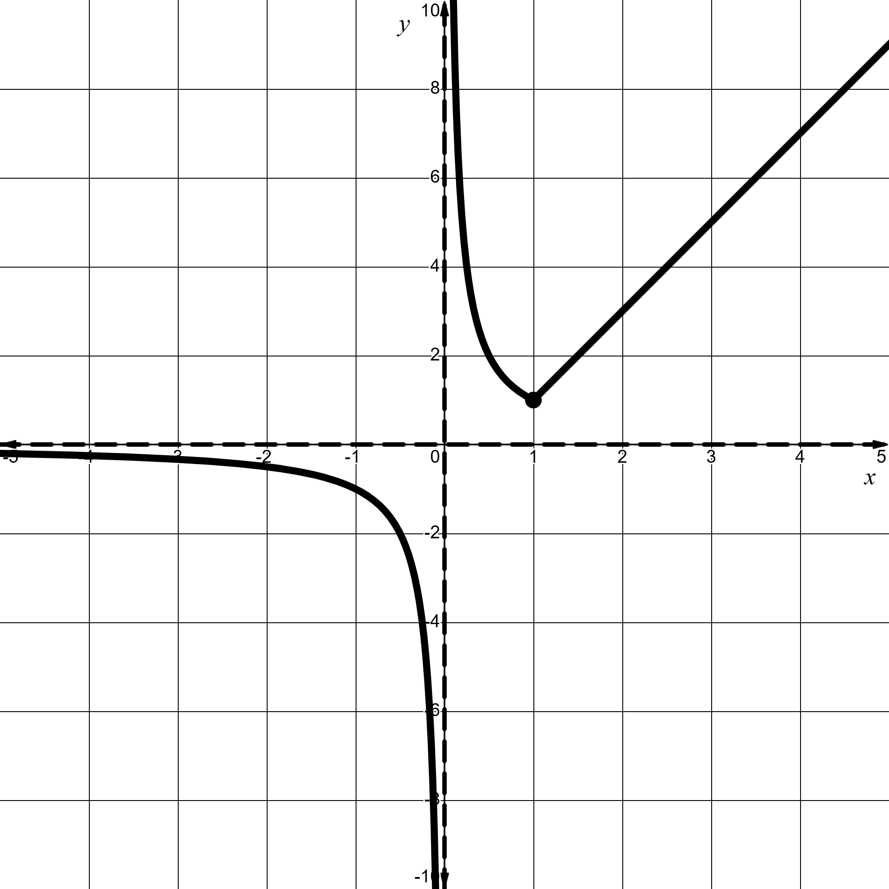 | Graph 2  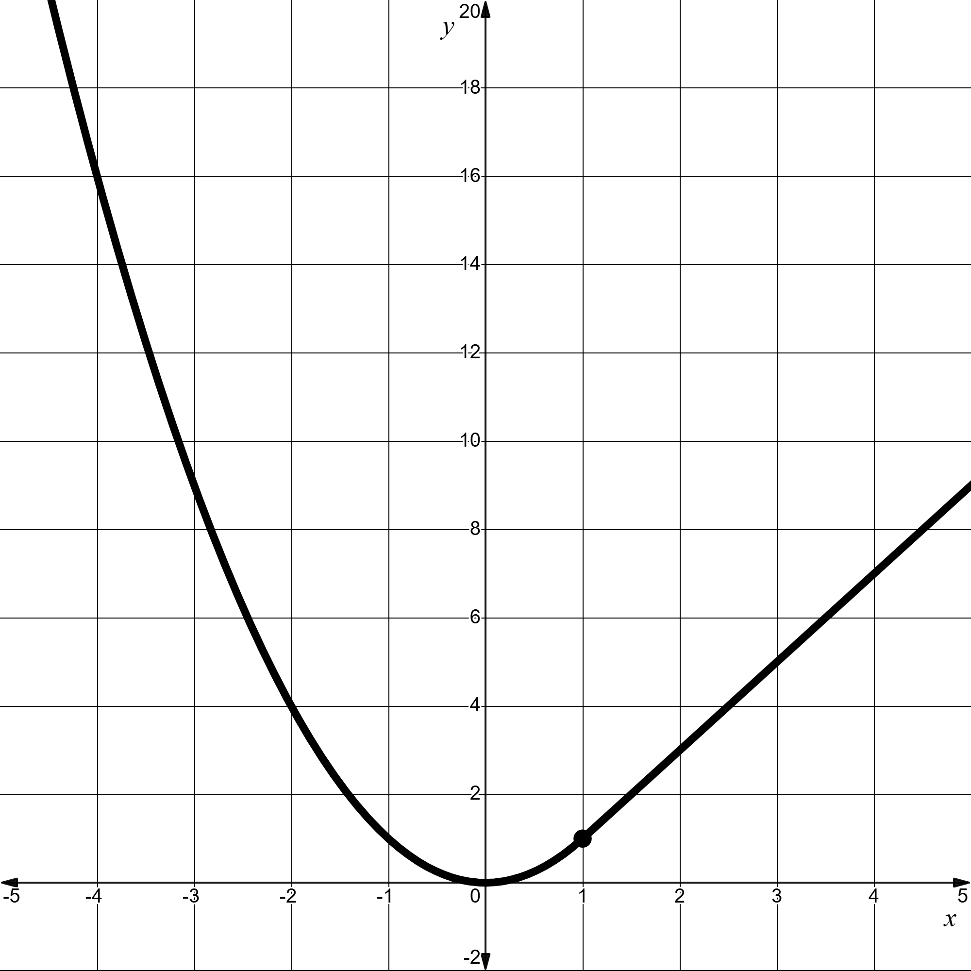 | Graph 3  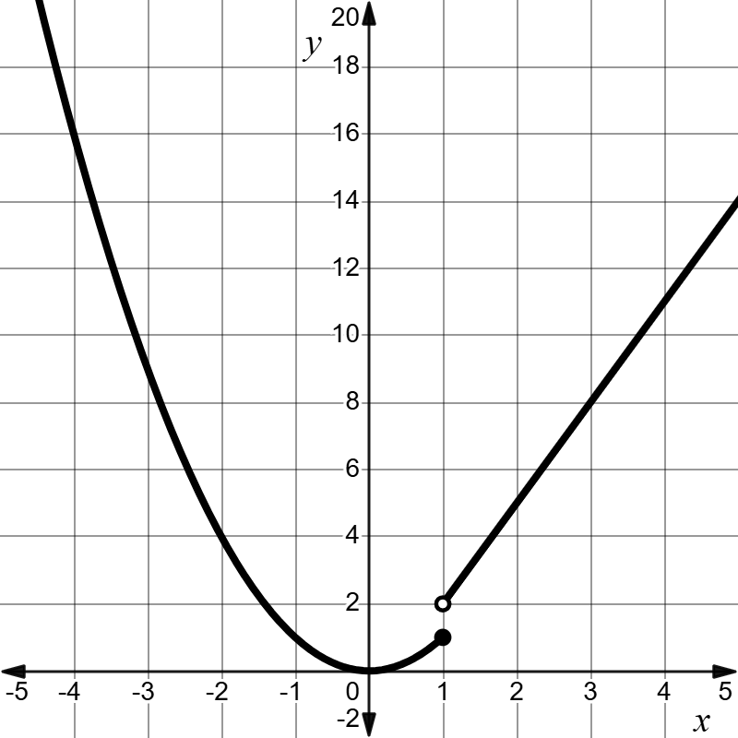
Graph 4  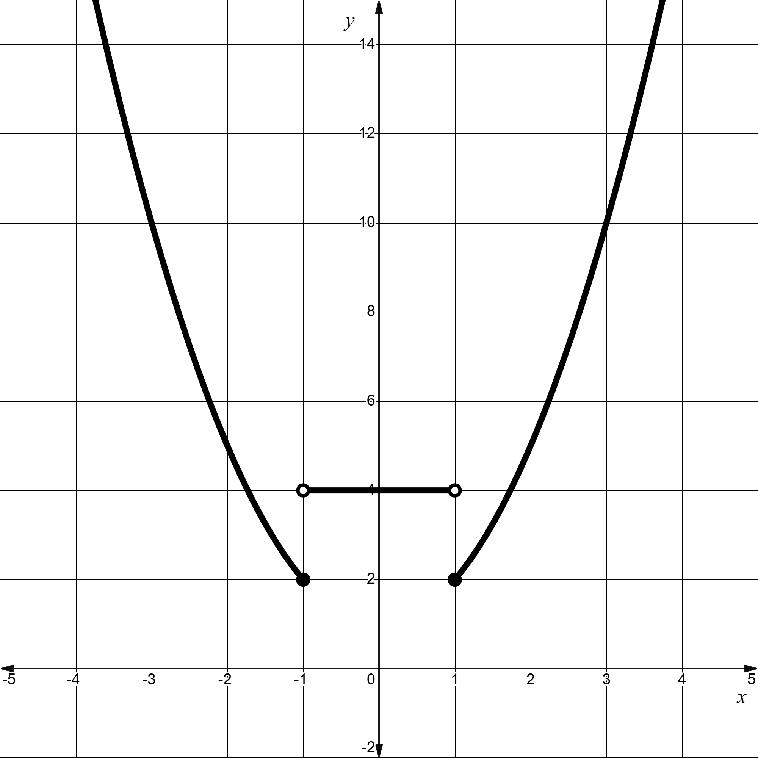 | Graph 5  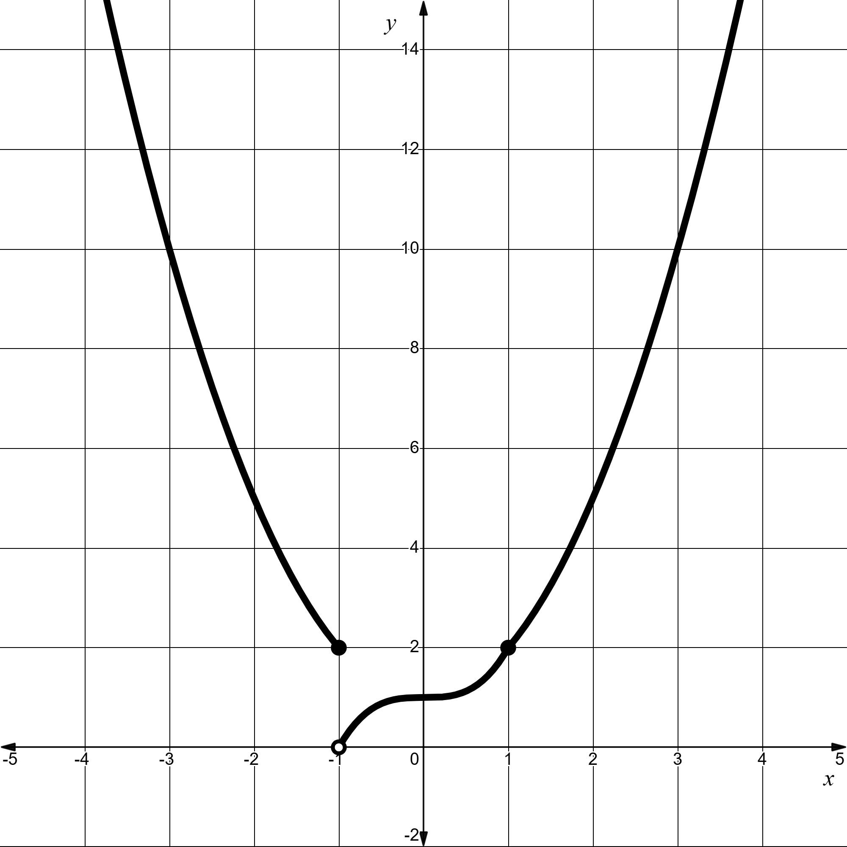 | Graph 6  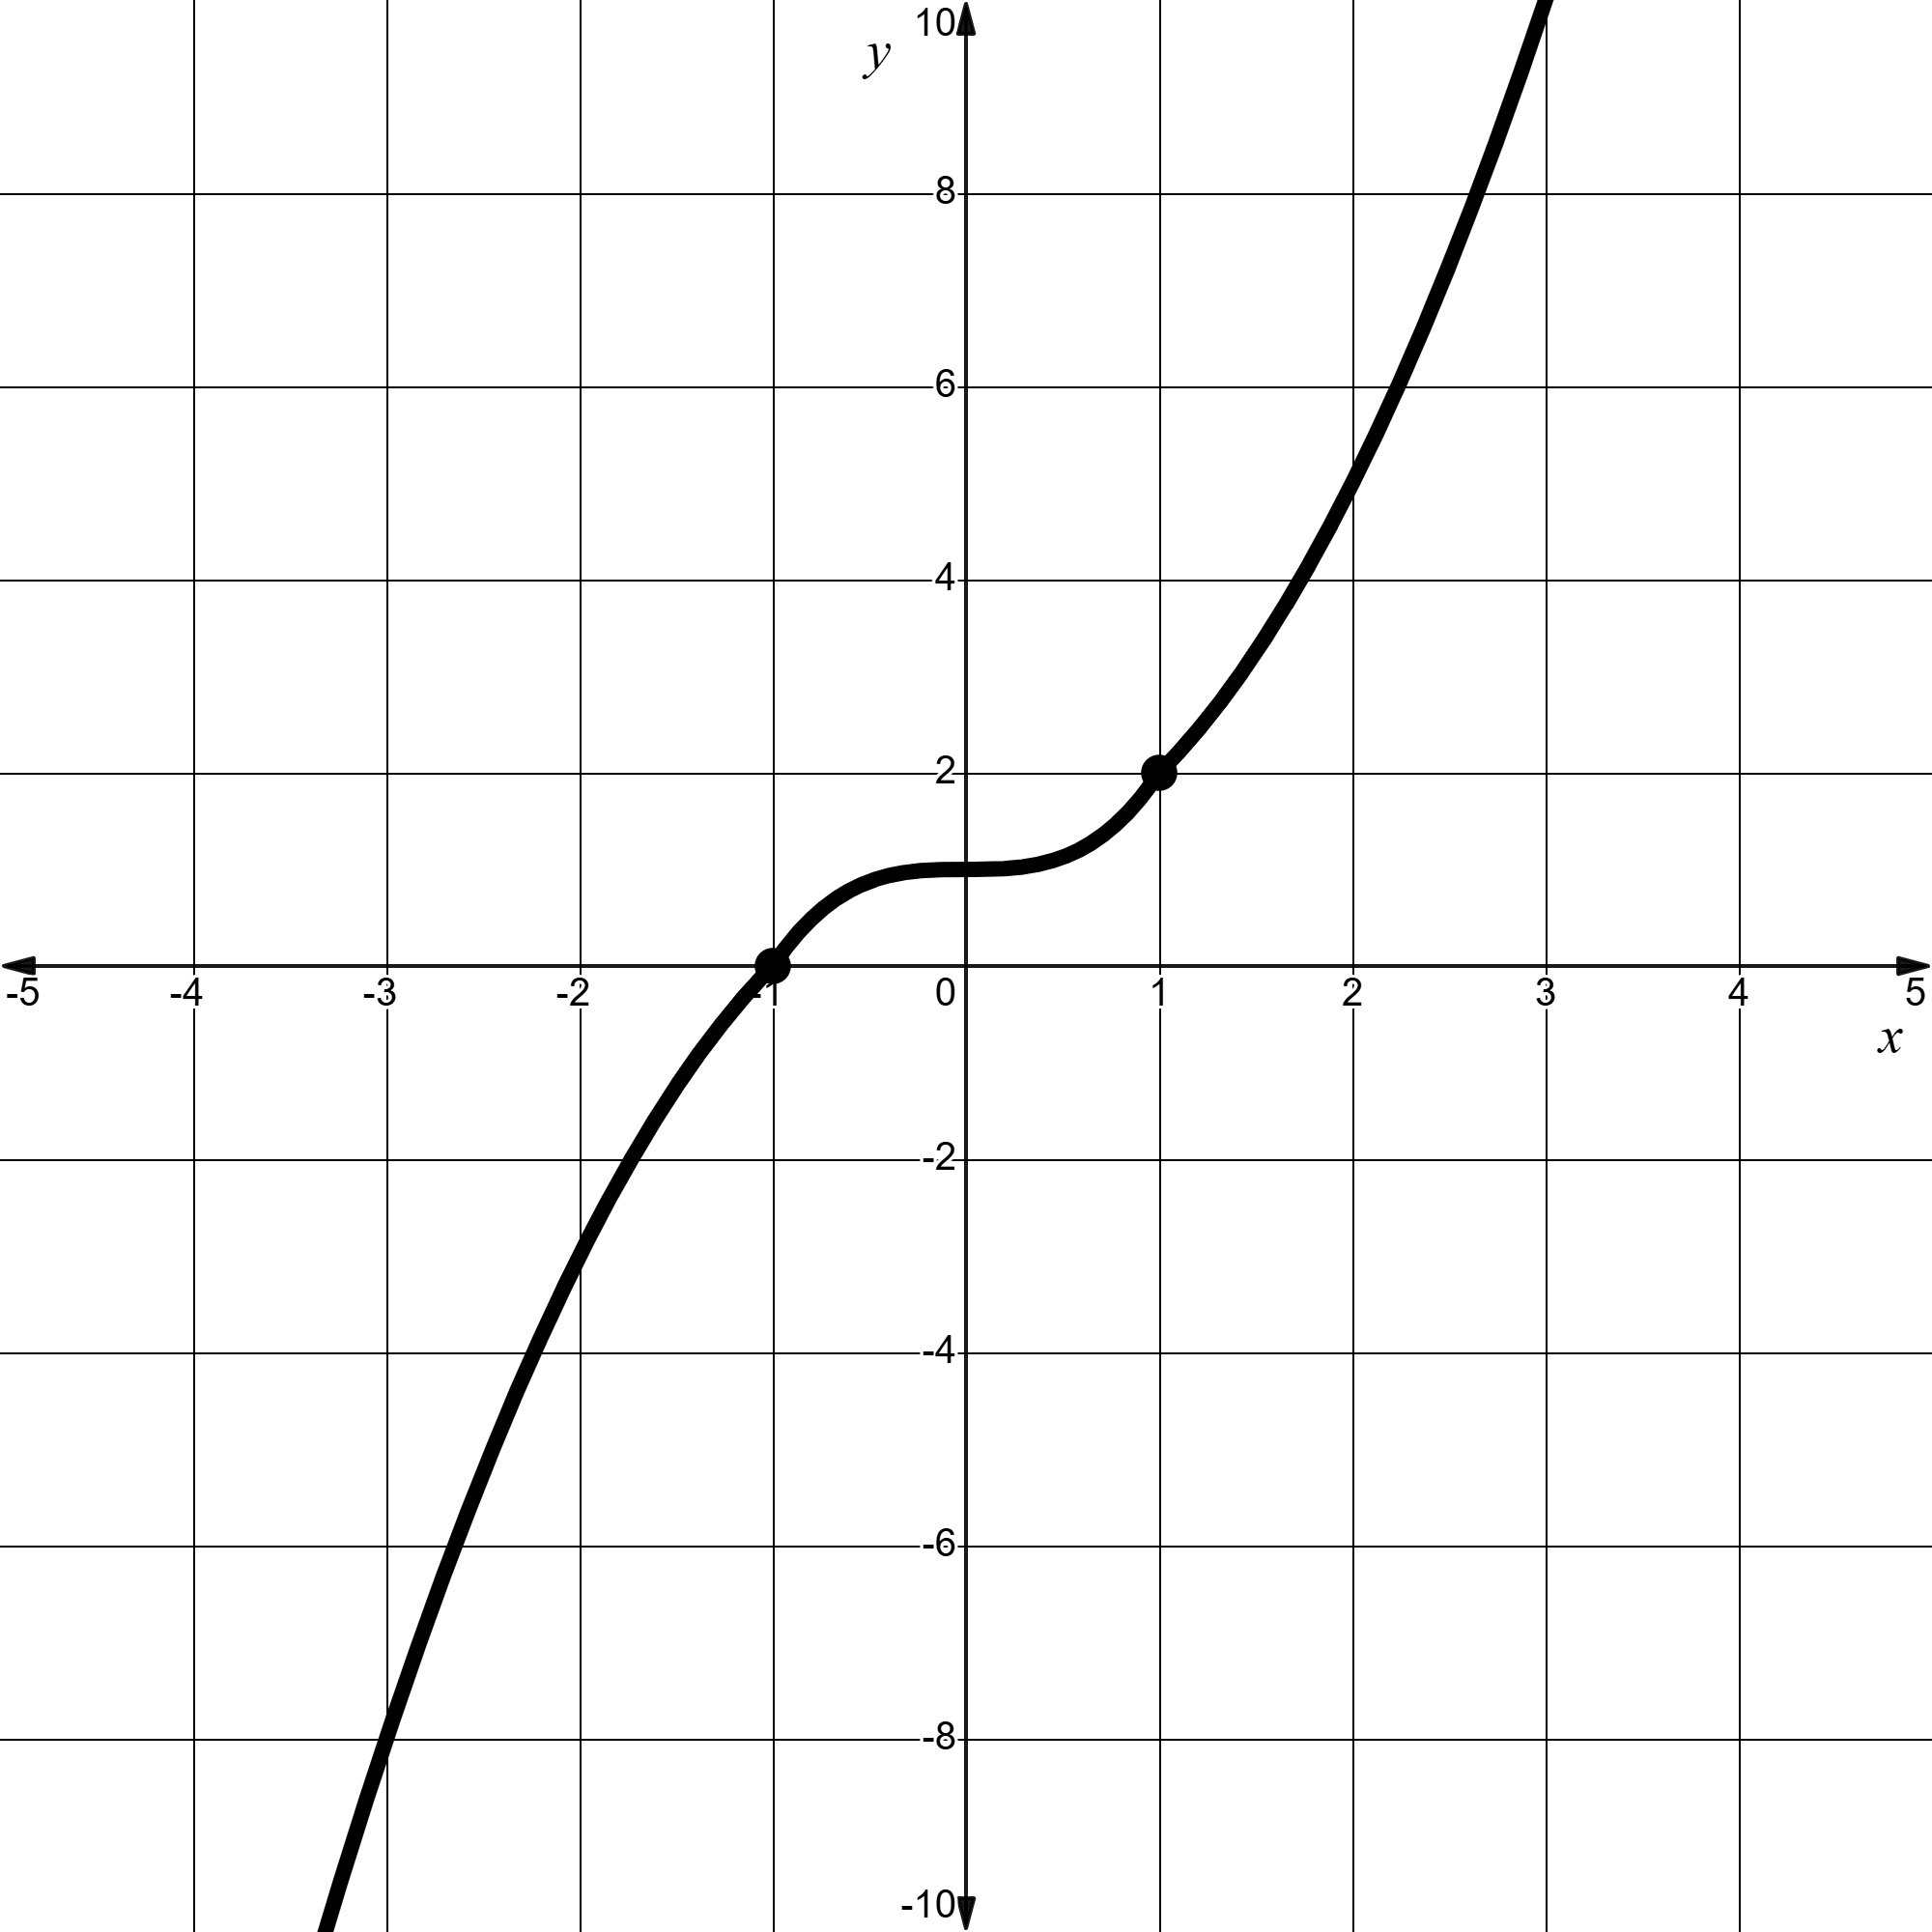

Graph | Describe the function in words | Identify the domains for each piece | Determine the overall domain and range | Identify any discontinuities | Odd, even or neither and explain why
1 | A hyperbola and a straight line | $x≤1$ and $x>1$ | Domain: all real $x,x≠0$  Range: $y<0$ or $y≥1$ | Discontinuous at $$x=0$$ | Neither. The graph is changed under reflection in the $y$-axis and changed under rotation of $180°$ about the origin.
2
3
4
5
6

Appendix B

Four quadrant notes to future self
Example 1  Sketch $f\left(x\right)=\left\{\begin{aligned}\frac{1}{x} \text{for} x<1 \\ x^{3}\text{ for} x≥1\end{aligned}\right.$ | Example 2  Sketch $f\left(x\right)=\left\{\begin{aligned}x+2 \text{for} x<0 \\ x^{2} \text{for} 0≤x<2 \\ 4x-4 \text{for} x≥2\end{aligned}\right.$
Things to remember | Example 3

Appendix C

Creating a continuous piecewise-defined function
- Below are 3 piecewise-defined functions with missing domain intervals. Your task is to find the missing values for the domain so that each piecewise-defined function is continuous throughout its entire domain.
- For the function, $f\left(x\right),$ determine the value of $k$ so that the function is continuous and then sketch the function.
$$f\left(x\right)=\left\{\begin{aligned}2x+3 \\ -x+9 \end{aligned}\right.\begin{matrix}\text{for} x<k \\ \text{for} x≥k\end{matrix}$$
- For the function, $g\left(x\right),$ determine the value of $l$ so that the function is continuous and then sketch the function.
$$g\left(x\right)=\left\{\begin{aligned}3x-1 \\ x^{2}-3x+4 \end{aligned}\right.\begin{matrix}\text{for} x<l \\ \text{for} x≥l\end{matrix}$$
- For the function, $h\left(x\right),$ determine the value of $n$ so that the function is continuous and then sketch the function.
$$h\left(x\right)=\left\{\begin{aligned}2x^{2}-8x+6 \\ -x^{2}+4x-3 \end{aligned}\right.\begin{matrix}\text{for} x≤n \\ \text{for} x>n\end{matrix}$$
- Determine equations for each domain of the piecewise-defined function so that it is a continuous function.
$$f\left(x\right)=\left\{\begin{aligned} \\ \end{aligned}\begin{matrix}\text{for} x<2 \\ \text{for} x≥2\end{matrix}\right.$$

Sample solutions

Appendix A – piecewise-defined functions
Graph | Describe the function in words | Identify the domains for each piece | Determine the overall domain and range | Identify any discontinuities | Odd, even or neither and explain why
1 | A hyperbola and a straight line | $x≤1$ and $x>1$ | Domain: all real $x,x≠0$  Range: $y<0$ or $y≥1$ | Discontinuous at $x=0$ | Neither. The graph is changed under reflection in the $y$-axis and changed under rotation of $180°$ about the origin.
2 | A parabola and a straight line | $x≤1$ and $x>1$ | Domain: all real $x$  Range: $y≥0$ | Continuous | Neither. The graph is changed under reflection in the $y$-axis and changed under rotation of $180°$ about the origin.
3 | A parabola and a straight line | $x≤1$ and $x>1$ | Domain: all real $x$  Range: $y≥0$ | Discontinuous at $x=1$ | Neither. The graph is changed under reflection in the $y$-axis and changed under rotation of $180°$ about the origin.
4 | A parabola, horizontal line, followed by the same parabola | $x≤-1$, $-1<x<1$ and $x≥1$ | Domain: all real $x$  Range: $y≥1$ | Discontinuous at $x=-1$ and $x=1$ | Even function, as the graph is unchanged under reflection in the $y$- axis.
5 | A parabola, cubic function, followed by the same parabola | $x≤-1$, $-1<x<1$ and $x≥1$ | Domain: all real $x$  Range: $y>0$ | Discontinuous at $x=-1$ | Neither. The graph is changed under reflection in the $y$-axis and changed under rotation of $180°$ about the origin.
6 | A concave down parabola, cubic function, followed by a concave up parabola | $x≤-1$, $-1<x<1$ and $x≥1$ | Domain: all real $x$  Range: all real $y$ | Continuous | Neither. The graph is changed under reflection in the $y$-axis and changed under rotation of $180°$ about the origin.

Appendix B – Four quadrant notes to future self
Example 1  Sketch $f\left(x\right)=\left\{\begin{aligned}\frac{1}{x} \text{for} x<1 \\ x^{3}\text{ for} x≥1\end{aligned}\right.$  For the reciprocal function  Asymptote at $x=0$ and $y=0$  When $x=1$, $y=\frac{1}{1}$  $∴(1, 1)$ is the end point.  For the cubic function  The function goes through the origin $(0, 0)$.  When $x=1, y={\left(1\right)}^{3}$  $∴(1, 1)$ is the starting point.  The piecewise-defined graph is continuous.  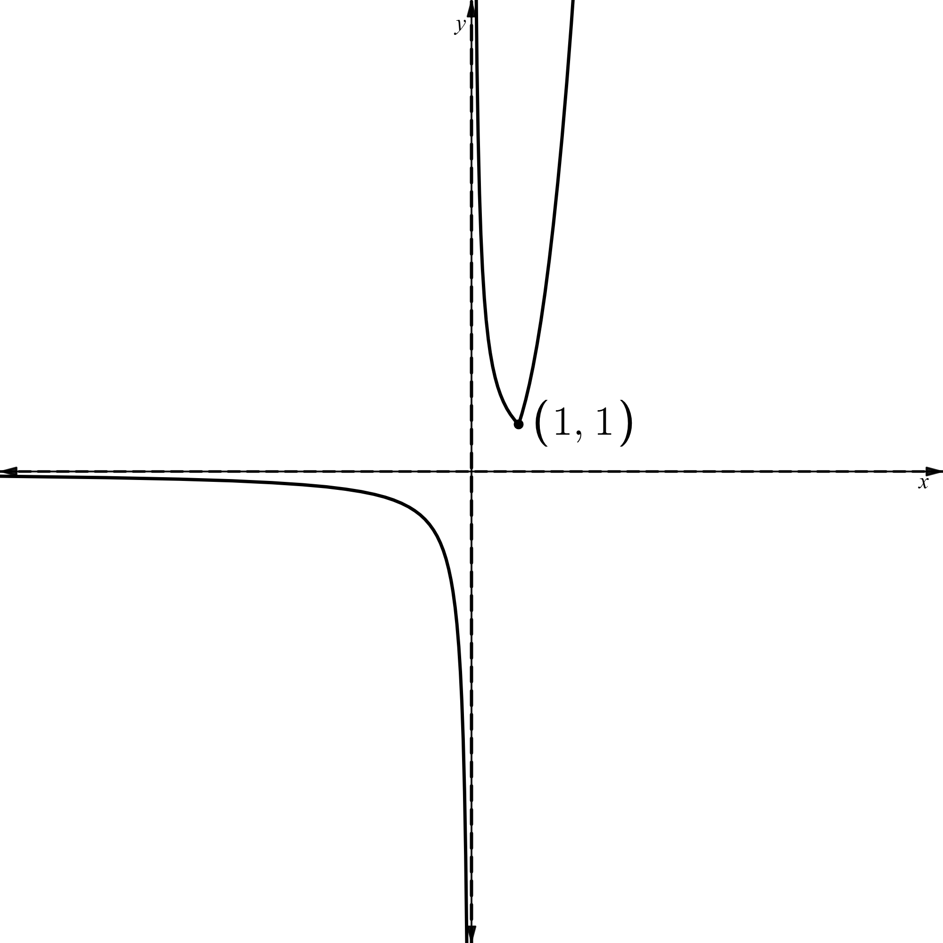 | Example 2  Sketch $f\left(x\right)=\left\{\begin{aligned}x+2 \text{for} x<0 \\ x^{2} \text{for} 0≤x<2 \\ 6-x \text{for} x≥2\end{aligned}\right.$  For the straight line, $y=x+2$  $$0=x+2$$  $$∴x\text{-intercept}=-2$$  $y\text{-intercept}$, $y=\left(0\right)+2$  $∴y=2$ and end point is $(0,2)$  For the parabola with vertex at $(0, 0)$, $y=x^{2}$  When $x=2, y={\left(2\right)}^{2}$  End point is $(2,4)$  The first straight line and the parabola are discontinuous.  For, $y=6-x$  $$0=6-x$$  $$∴x\text{-intercept}=6$$  $y\text{-intercept}$, $y=6-\left(0\right)$  $$∴y=6$$  Starting point when $x=2, y=6-2$  $∴(2, 4)$ is where it starts and the parabola and second straight line are continuous.  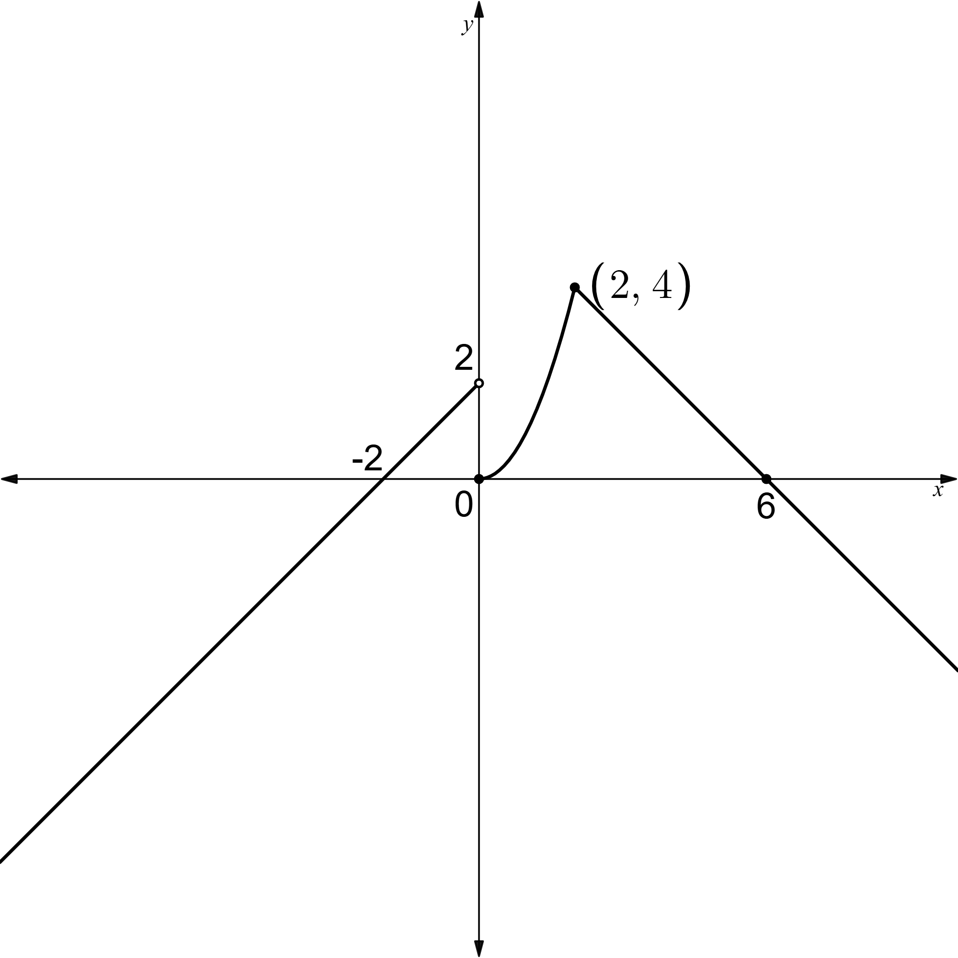

Appendix C – creating a continuous piecewise-defined function

- $f\left(x\right)=\left\{\begin{aligned}2x+3 \text{for} x<k \\ -x+9 \text{for }x≥k\end{aligned}\right.$
$$2x+3=-x+9 \\ 3x=6 \\ x=2$$
When $x=2, y=2\left(2\right)+3$
$∴$ lines intersect at $(2, 7)$
$$∴k=2$$
$$f\left(x\right)=\left\{\begin{aligned}2x+3 \text{for} x<2 \\ -x+9 \text{for }x≥2\end{aligned}\right.$$
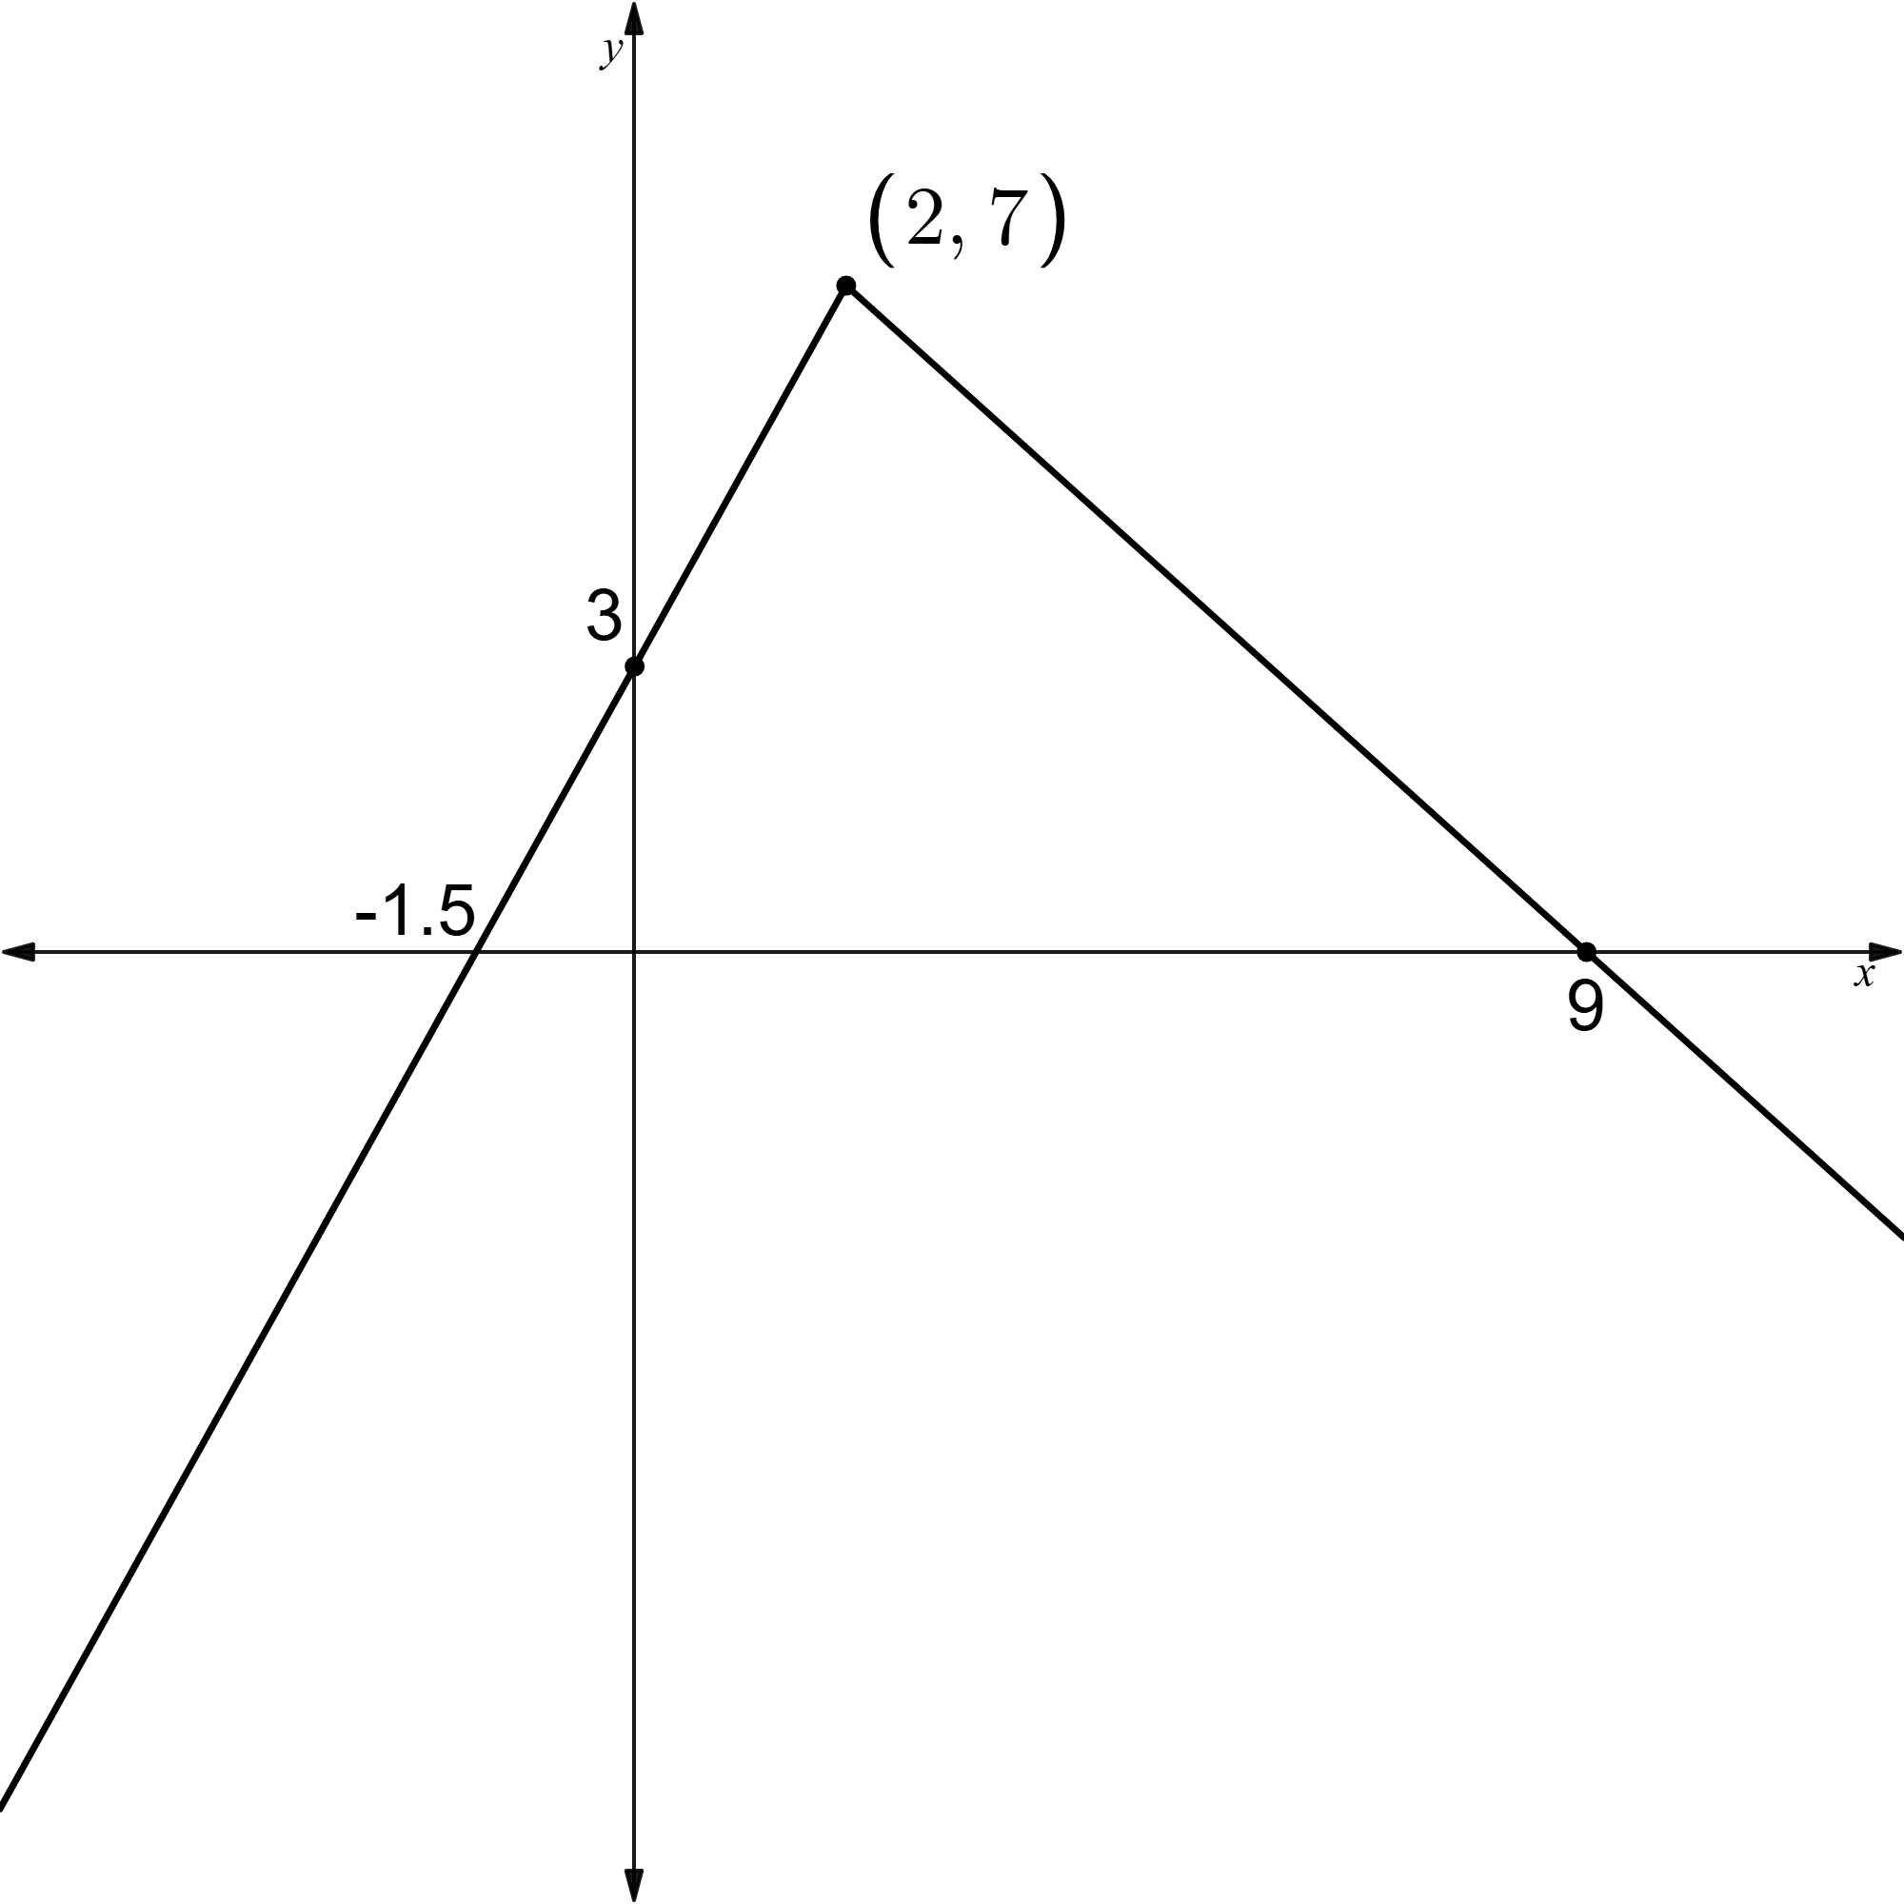
- $g\left(x\right)=\left\{\begin{aligned}3x-1 for x<l \\ x^{2}-3x+4 for x≥l\end{aligned}\right.$
$$3x-1=x^{2}-3x+4 \\ x^{2}-6x+5=0 \\ \left(x-5\right)\left(x-1\right)=0 \\ x=1, 5 \\ ∴l=1 \text{or} 5$$
The graph below shows the piecewise function when $l=1$
$$g\left(x\right)=\left\{\begin{aligned}3x-1 for x<1 \\ x^{2}-3x+4 for x≥1\end{aligned}\right.$$
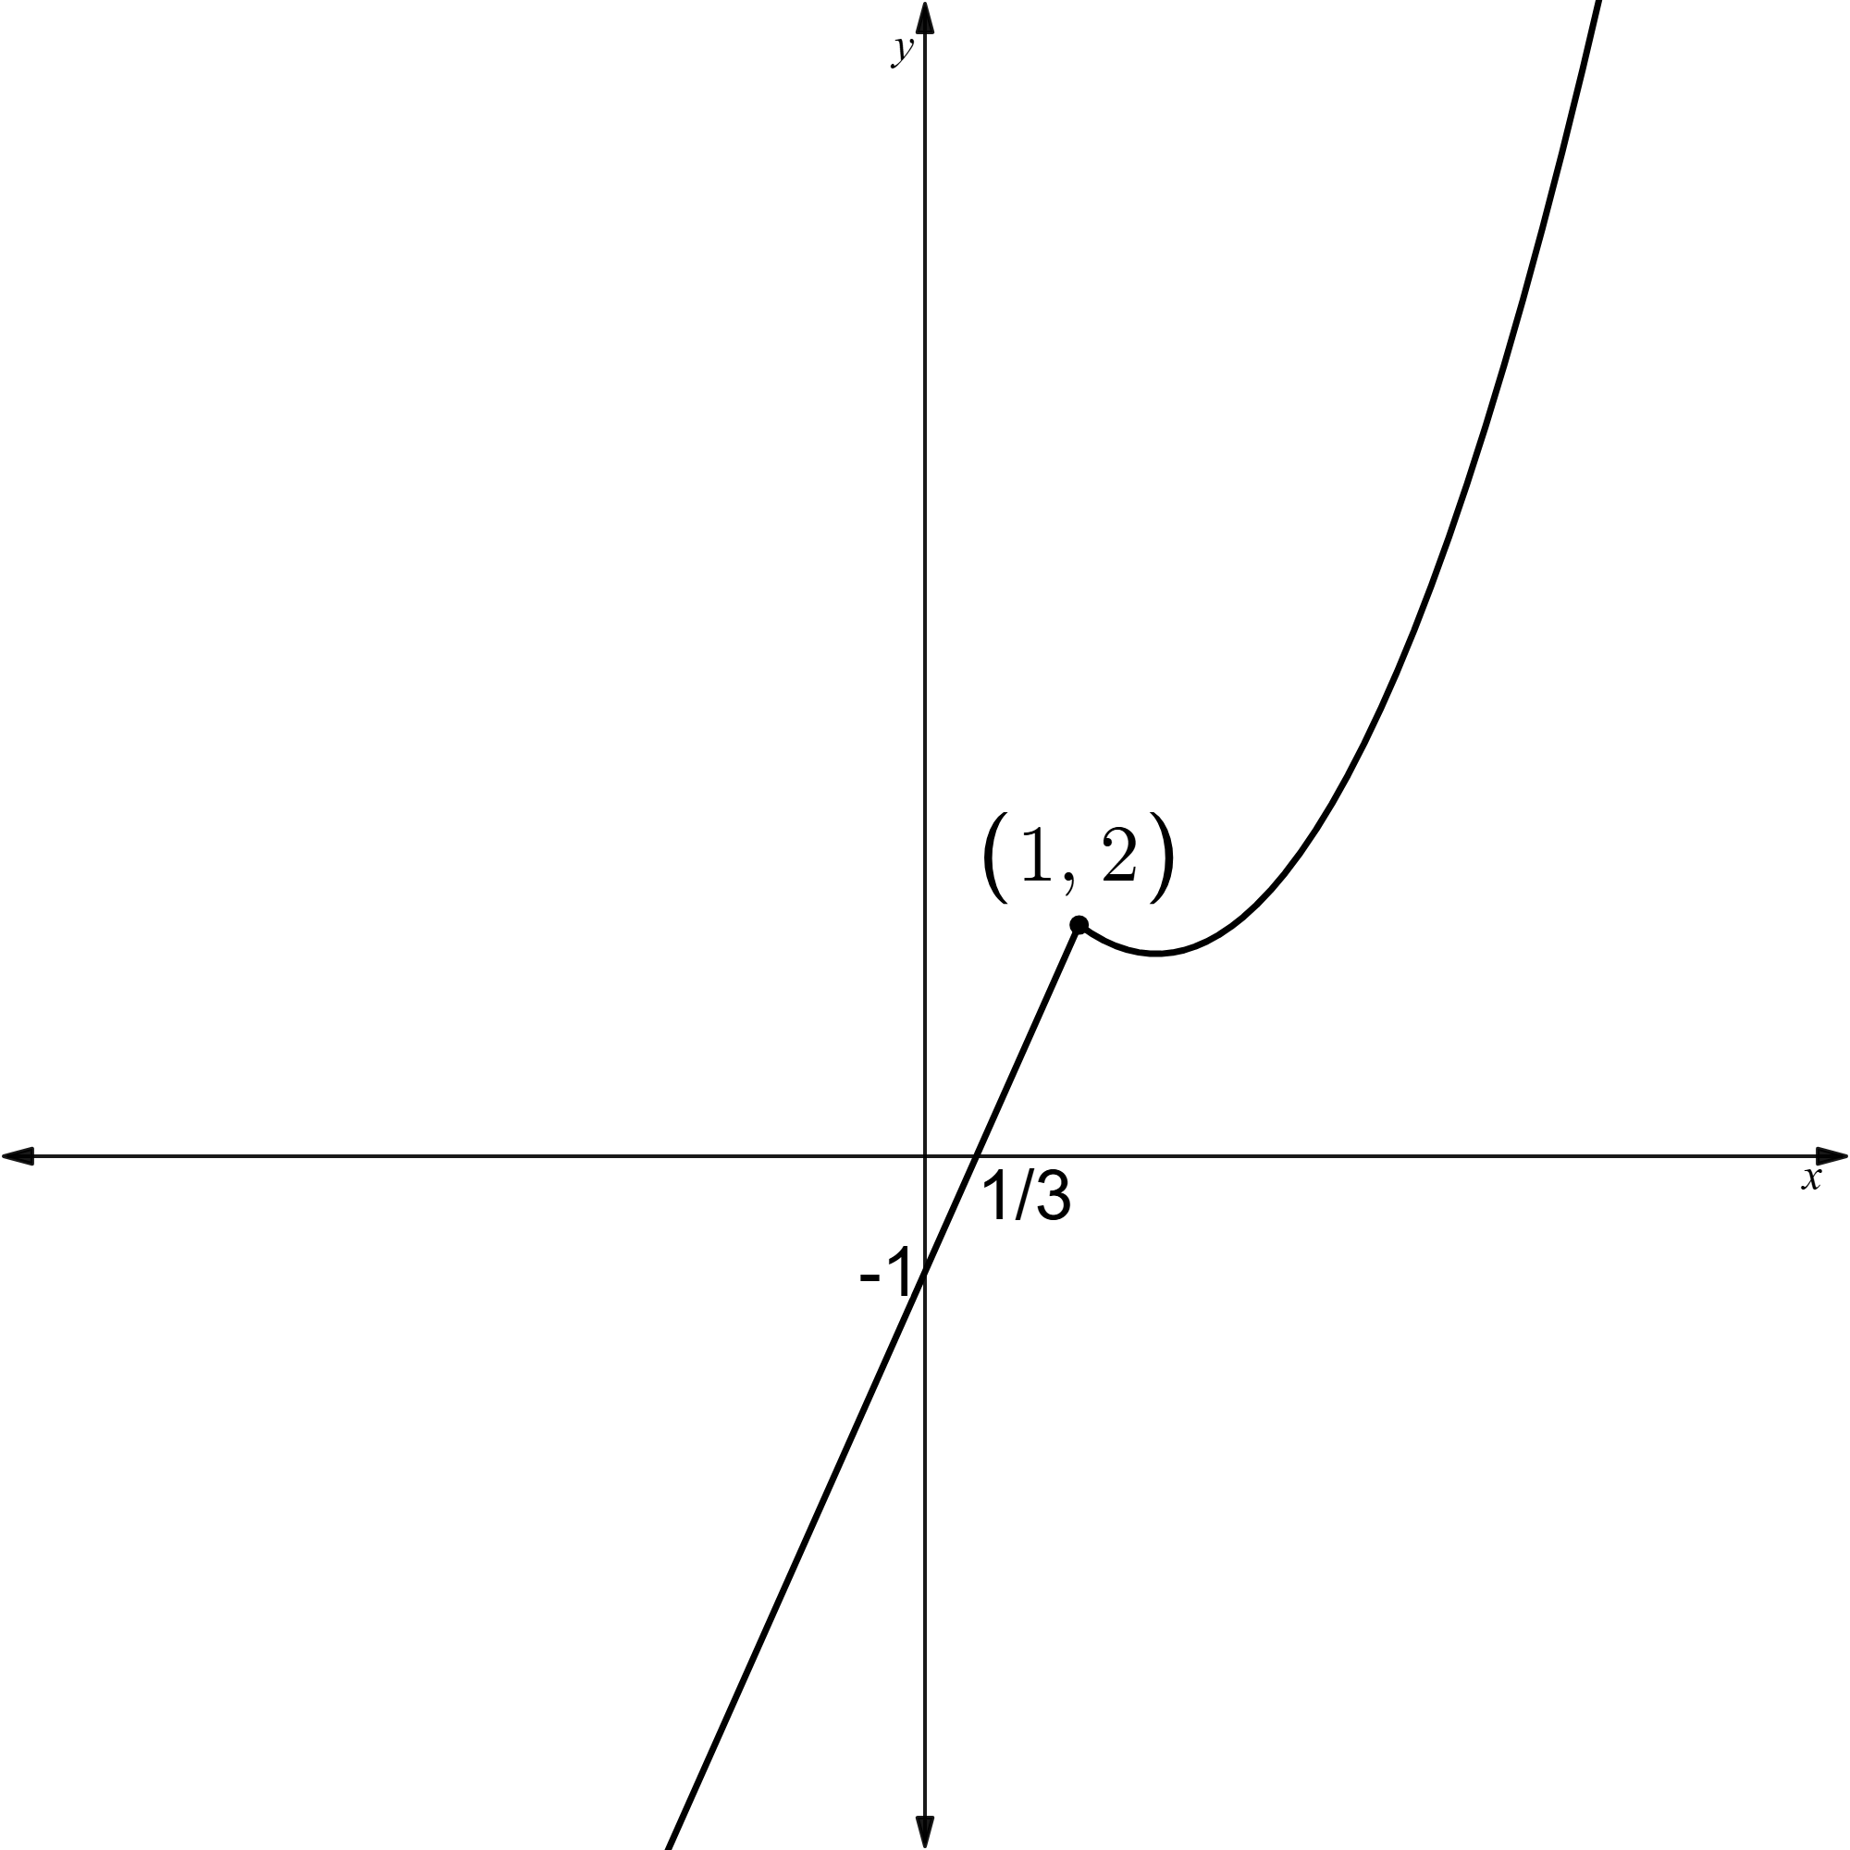
- $h\left(x\right)=\left\{\begin{aligned}2x^{2}-8x+6 \text{for} x≤n \\ -x^{2}+4x-3 \text{for }x>n\end{aligned}\right.$
$$2x^{2}-8x+6=-x^{2}+4x-3 \\ 3x^{2}-12x+9=0 \\ x^{2}-4x+3=0 \\ \left(x-1\right)\left(x-3\right)=0 \\ ∴x=1, 3$$
$$n=1 \text{or} 3$$
The graph below shows the piecewise function when $l=3$
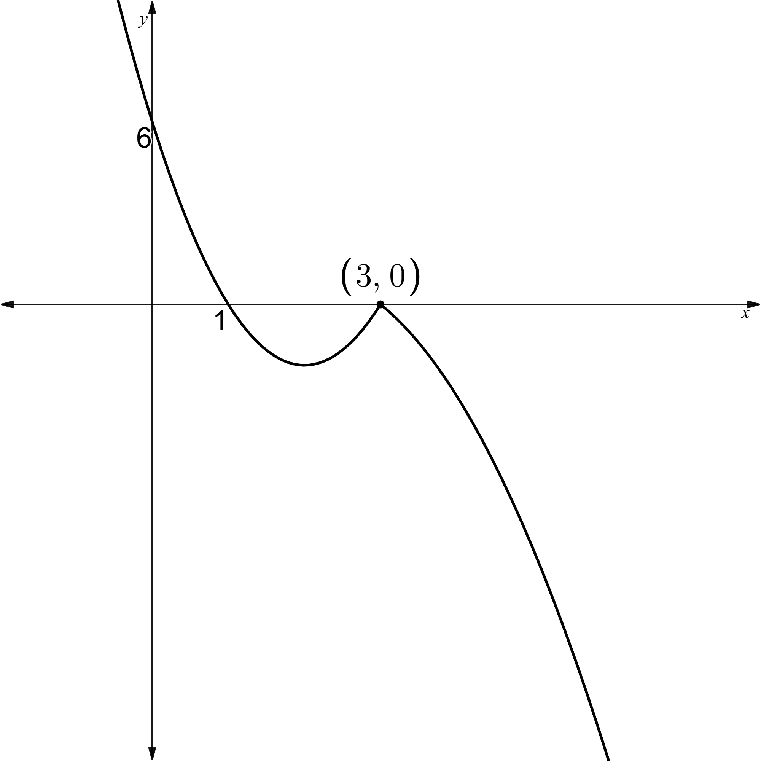
- Various answers

References
This resource contains NSW Curriculum and syllabus content. The NSW Curriculum is developed by the NSW Education Standards Authority. This content is prepared by NESA for and on behalf of the Crown in right of the State of New South Wales. The material is protected by Crown copyright.
Please refer to the NESA Copyright Disclaimer for more information https://educationstandards.nsw.edu.au/wps/portal/nesa/mini-footer/copyright.
NESA holds the only official and up-to-date versions of the NSW Curriculum and syllabus documents. Please visit the NSW Education Standards Authority (NESA) website https://educationstandards.nsw.edu.au/ and the NSW Curriculum website https://curriculum.nsw.edu.au/.
Mathematics Advanced 11–12 Syllabus © NSW Education Standards Authority (NESA) for and on behalf of the Crown in right of the State of New South Wales, 2024.

© State of New South Wales (Department of Education), 2025
The copyright material published in this resource is subject to the Copyright Act 1968 (Cth) and is owned by the NSW Department of Education or, where indicated, by a party other than the NSW Department of Education (third-party material).
Copyright material available in this resource and owned by the NSW Department of Education is licensed under a Creative Commons Attribution 4.0 International (CC BY 4.0) license.

This license allows you to share and adapt the material for any purpose, even commercially.
Attribution should be given to © State of New South Wales (Department of Education), 2025.
Material in this resource not available under a Creative Commons license:
- the NSW Department of Education logo, other logos and trademark-protected material
- material owned by a third party that has been reproduced with permission. You will need to obtain permission from the third party to reuse its material.
Links to third-party material and websites
Please note that the provided (reading/viewing material/list/links/texts) are a suggestion only and implies no endorsement, by the New South Wales Department of Education, of any author, publisher, or book title. School principals and teachers are best placed to assess the suitability of resources that would complement the curriculum and reflect the needs and interests of their students.
If you use the links provided in this document to access a third-party's website, you acknowledge that the terms of use, including licence terms set out on the third-party's website apply to the use which may be made of the materials on that third-party website or where permitted by the Copyright Act 1968 (Cth). The department accepts no responsibility for content on third-party websites.

