Solving quadratic inequalities
This lesson aims to apply students’ knowledge of graphing quadratic functions to solving quadratic inequalities. Students also develop their understanding of solving quadratic inequalities through algebraic methods, including consideration of critical points.
Learning intentions and success criteria should be shared with students later in the learning episode.

Learning intention
- To be able to solve quadratic inequalities.

Success criteria
- I can solve quadratic inequalities using graphical techniques.
- I can use algebraic techniques to solve quadratic inequalities, considering critical points.
- I can apply my knowledge of quadratics and quadratic inequalities to solve real-world problems.

Outcomes
A student:
- develops understanding and fluency in mathematics through exploring and connecting mathematical concepts, choosing and applying mathematical techniques to solve problems, and communicating their thinking and reasoning coherently and clearly MAO-WM-01
- applies algebraic techniques and the laws of indices and surds to manipulate expressions and solve problems MAV-11-01
- uses functions and relations to model, analyse and solve problems MAV-11-02

Content

Quadratic and cubic functions
- Solve quadratic inequalities
Mathematics Advanced 11–12 Syllabus © NSW Education Standards Authority (NESA) for and on behalf of the Crown in right of the State of New South Wales, 2024.

Table 1: lesson summary
Section | Summary of activity | Teaching strategies | Teaching points
Activating prior knowledge | Using slides 3–6 of the PowerPoint Solving quadratic Inequalities, students consider techniques and sketch quadratic functions in preparation for applying this knowledge to inequalities. | Mini whiteboards  Pose-Pause-Pounce-Bounce | The aim of this activity is for students to activate quadratic function graphing skills and to bounce techniques and strategies off each other.
Connecting learning | Students view a short news clip regarding oversized trucks attempting to pass under low overpasses, and this leads to the driving question of the lesson. Slides 8–11 develop students’ skills in solving quadratic inequalities. | Think-Pair-Share  Visibly random groups of 3  Vertical non-permanent surfaces  Gallery walk | In this activity, students are provided with context to reinforce the application of solving quadratic inequalities and connect their skills in graphing quadratics to solving simple inequalities.
Releasing responsibility | Students use slides 13–16 to complete worked examples and consolidate their learning via Appendix A. Returning to the driving questions on slide 17, students develop their capacity to determine critical points and solve quadratic inequalities algebraically through slides 18–21. Appendix B is then provided to consolidate skills. | Worked examples (Your turn)  Variation Theory  Pose-Pause-Pounce-Bounce  Vertical non-permanent surfaces  Visibly random groups of 3 | This activity continues with the thread of a truck and bridge and develops students’ skills in solving quadratic inequalities via algebraic methods to ensure accurate solutions.
Independent practice | Students apply their knowledge and understanding of solving quadratic inequalities to contextual questions, using slides 23–26. The notion of testing the discriminant is considered with an example as a means of efficient calculation.  Using slide 27, students then complete an HSC style question in their groups. | Vertical non-permanent surfaces  Visibly random groups of 3  Pose-Pause-Pounce-Bounce | In this activity, students are exposed to various applications of quadratic inequalities and the use of the discriminant as a viable test for possible solutions.

Activity structure
Please use the associated PowerPoint Solving quadratic Inequalities to display images in this lesson.

Activating prior knowledge
- Display slide 3 of the PowerPoint and ask students to sketch the quadratic function in their workbooks showing all key features.
If available, mini whiteboards (bit.ly/miniwhiteboards) can be used to complete this activity.
- Initiate a class discussion using the Pose-Pause-Pounce-Bounce questioning strategy (PDF 557 KB) (bit.ly/posepausepouncebounce) to provide students with an opportunity to explain and justify the strategy they used to sketch the quadratic function.
- Animate the slide to reveal the graph and allow students time to check their own sketch.
- Animate the slide for question 2 and repeat steps 1–3. Repeat this process for slides for slides 4–6.
This activity revisits students’ prior understanding of graphing parabolas, consolidating their ability to choose appropriate techniques before applying these skills to solve quadratic inequalities.

Connecting learning
- Show students the following video ‘Nine News Sydney: Another truck nearly jams itself in the Sydney Harbour Tunnel (28/7/2014)’ (1:53) (bit.ly/TruckNewsTPS).
- In a Think-Pair-Share (bit.ly/thinkpairsharestrategy), have students consider the following:
- What went wrong and what could have been done to avoid it?
- Would it be enough to check the clearance of a bridge/tunnel at one point only?
- Provide students with the following explanation of the linked video and driving question for the lesson.
In our video, the problem was simple, the truck was taller than the lowest part of the tunnel. But sometimes bridge or tunnel height is curved, so the lowest point might be in the middle, not at the edges. Today we’ll see how we can predict whether a truck will make it through.
Driving question: Will the truck make it?
- Display slide 8 of the PowerPoint and have students consider the problem.
A curved pedestrian bridge has been built over a flat section of road. Engineers model the gap between the road and bridge (in metres) as:
$$h\left(x\right)=-0.05{\left(x-8\right)}^{2}+5$$
Where $x$is the horizontal distance (in metres) from the left end of the bridge and $h(x)$ is the clearance above the road.
A council safety officer needs to check whether a removal truck, 4.2 metres tall, can pass safely anywhere under the bridge.
- By working in visibly random groups of 3 (bit.ly/visiblegroups) at vertical non-permanent surfaces (bit.ly/VNPSstrategy), ask students to:
- sketch the shape of the clearance height under the bridge
- shade the zone showing where the truck can pass through.
Note that students have covered sketching quadratics and quadratic modelling in Lesson 14 – modelling quadratic functions.
- To check for understanding, students complete a gallery walk (bit.ly/DLSgallerywalk) of each other’s sketches.
As students conduct the gallery walk, instruct them to observe how other groups have displayed the key features of their sketch, such as points of intersection and scales, and consider how these choices affect the ease or difficulty of interpreting the sketch.
- Display slide 9 for students to confirm their sketch of $h(x)$.
- Using their graph, have students estimate the values for $x$for which the removal truck can safely pass under the pedestrian bridge, and share this with the class.
At a later stage of the lesson, students will return to this problem to solve the inequality algebraically.
- Return students to their desks and display slide 10, providing students with time to consider the learning intentions and success criteria of the lesson
- Proceed to slide 11, which contains questions 3 and 4 from the ‘Activating prior knowledge’ section of the lesson. Using a Think-Pair-Share activity, have students discuss what they can learn from the truck and bridge problem to help them solve these representations.
Students should recognise that, for question 3, the function is above the $x$-axis when $0<x<4.$ For question 4, the function is above the $x$-axis when $x<-3$and$x>1$.
The teacher can revisit the other graphs from ‘Activating prior knowledge’ to further consolidate students’ understanding.

Releasing responsibility
- Use slides 13–16 of the PowerPoint to model a worked example of solving a quadratic inequality using graphical techniques. Use the Worked examples (Your turn) method (bit.ly/supportingstrategies) to provide students with an opportunity to consolidate their understanding.
- Distribute Appendix A ‘Solving quadratic inequalities’ which uses Variation Theory (variationtheory.com/introduction/) to connect learning.
- Display slide 17 which returns students to consider the driving question, ‘Will the truck make it?’
- Inform students that while we have accurate graphs, as engineers, we need to show algebraically the values for which the truck can safely pass under the bridge.
- Have students note the key pieces of information from the problem into their notebook. Return students to their visibly random groups of 3, then display slide 18.
- Using the Pose-Pause-Pounce-Bounce questioning strategy, ask students, ‘What are the critical or key pieces of information from the written question and the graph?’
Students should note the points of intersection, the intercepts and the vertex.
In this discussion, have students consider if and why these points are critical to the question.
The discussion should tend towards the points of intersection between the parabola and $y=4.2$ as a ‘critical’ or key to finding the solution to the problem.
- Animate slide 18 to show where the critical points occur on the graph.
- Progress to slide 19, which provides an explicit definition of a critical point.
- Display slide 20 to highlight the steps required to solve a quadratic inequality.
- Animate slide 20 and lead a class discussion around the importance of testing on and around the critical points.
The importance of testing on and around critical points lies in determining how the sign of the quadratic changes. Critical points mark where the expression equals zero, and testing values just before and after them shows which regions make the inequality true, since the sign of the quadratic remains consistent between critical points but can change at them.
- Leaving slide 20 projected, have students return to their vertical non-permanent surfaces and give them an opportunity to solve $h\left(x\right)≥4.2$ algebraically, based on the ‘Will the truck make it?’ problem.
The teacher should circulate the room to check each groups’ progress on the question and provide either prompts to progress the group’s solution or deepen their understanding of the problem. Furthermore, the teacher might suggest to ‘peek’ at a neighbouring group or combine groups to further thinking.
- Display slide 21 which provides an algebraic solution to the problem through animations with the final animation restating the problem, ‘Can the truck pass safely anywhere under the bridge?’
- With the restating of the problem, ask groups to provide reasoning and justification.
The teacher should highlight where the critical points appear on the graph and demonstrate how the graph $h(x)$ being above or below the horizontal line $y=4.2$ confirms the algebraic solution.
- Students remain in their visibly random groups of 3 to complete the scavenger hunt task from Appendix B ‘Scavenger hunt’.
- Print one set of question cards, separate each card, and place the cards around the room. A vertical non-permanent surface could be useful at each card to assist the groups with their calculations.
- Each group should start at one of the cards. The students work in their groups of 3 to solve the problem.
- Once a group has solved the problem, they need to move around the room to find the solution on another card. Once they have found their solution, they should solve the question attached to the solution and repeat the process.
- The activity is finished once each group has made it back to their original card.
Cards are printed in order so the solution to one question is the answer number on the next card.

Independent practice
- Place students back at vertical non-permanent surfaces.
- Display slide 23 of the PowerPoint and instruct students to sketch a graph of the problem and to indicate on their graph what they are being required to find.
- On completion, have groups view their neighbouring group’s sketch, and provide feedback if necessary.
- Give groups an opportunity to solve the problem either algebraically or graphically.
Note that the solution to this problem is irrational, therefore students who opt to solve the problem graphically, will eventually need an algebraic solution.
- As groups complete the problem, walk around the room to check for understanding within students’ work. Join groups together that have produced different solutions to the same problem and state ‘At least one of you is incorrect.’
- On completion, allow groups to check their solution with a neighbouring group, and if solutions differ, provide them with an opportunity to further investigate these differences. A worked solution is provided on slide 24.
- Remaining in their visibly random groups of 3 and on vertical non-permanent surfaces, display slide 25 and ask students what they notice and wonder about the problem.
Students should notice that this is a concave down parabola, the constant $k$ will affect the shape or position of the parabola, and that the clearance must be less than 8 metres. Students may wonder what $k$ represents physically, if there is a maximum clearance and what values of $x$ satisfy the clearance condition.
The problem on slide 25 does not have a solution. The intention of this is for students to consider checking and interpreting the discriminant of a quadratic function as an efficient method to determining if a solution exists.
- Provide students with time to productively struggle with this question, but not enough time to realise that there is no solution to the problem. When appropriate, instruct students that you (the teacher) have a solution that only takes 4 or 5 lines.
- Give groups the opportunity to consider the statement that you made and to see if they can reevaluate their working solution to the problem.
The teacher could provide hints to students such as considering roots, to think back to their lesson on the discriminant or consider how we could prove that the boat can or cannot safely pass.
- As groups complete the problem, walk around the room to check for understanding within students’ work. If a group has the correct solution (that there is no solution) by using the discriminant, invite other groups to view their work and explanation.
- Gain students’ attention and advance the PowerPoint to slide 26 which contains a worked solution to the problem. Talk through the solution in the first column, then before animating, use the Pose-Pause-Pounce-Bounce strategy to discuss reasons as to why there is no solution.
- Display slide 27 and have students discuss in their groups and then share with the class the approach they would take complete the question.
Students may share that they could solve it algebraically or graphically.
- Have students complete the question, using their preferred method in their groups.
- Click to animate the solution, both algebraically and graphically, and discuss with the class which method may have been the most effective.
Students may benefit from further independent work on solving quadratic inequalities.

Assessment and differentiation

Suggested opportunities for differentiation
Activating prior knowledge
- The teacher can pair students of varying abilities to provide support during the graphing process.
- To extend students, restrict domains and ranges or informally provide students with a piecewise function.
Connecting learning
- Students from non-English speaking backgrounds may require explicit English language support and scaffolding for the bridge problem.
- When estimating the values for $x$in which the removal truck can safely pass, extend students by asking them to provide reasoning and justification.
- When discussing the solutions on slides 12–15 of the PowerPoint, support students by writing or saying the inequality in plain English.
Releasing responsibility
- For discussion of critical points, provide an analogy to support students understanding. An analogy could include when a road/hill is above or below sea level.
- When assigning groups to their starting positions in the scavenger hunt, strategically position students to a particular question to give them early success or challenge.
Independent practice
- To support students, lead this section as a whole-class activity.
- A simplified quadratic function, $h\left(t\right)={\left(t-2\right)}^{2}+4$ could be used with the safety height required being 6 metres above the ground.

Suggested opportunities for assessment
Activating prior knowledge
- Check for understanding and skills in graphing quadratic equations by observing students’ notebooks, mini whiteboards or considering students’ verbal responses.
Connecting learning
- Students working at vertical non-permanent surfaces means the teacher can assess student progress and provide support where appropriate.
- Student responses to the self-explanation prompts during worked examples provide an opportunity to assess student reasoning.
Releasing responsibility
- When placed in groups of 3, students provide and receive peer feedback on their understanding.
- When discussing critical or key points with students, encourage students to think about their decisions.
Independent practice
- Monitor responses in class discussions to check for student understanding of the features of the parabola.
- Collect student responses to the provided prompts as a work sample for assessment.
- Facilitate a class discussion and observe students’ reasoning and justification in response to the provided prompts.

Appendix A

Solving quadratic inequalities
Before you start solving, look carefully at the set of questions. Notice how each one changes slightly from the last. Predict how these changes will affect the graph, the position of the $x$-intercepts, and the solution to the inequality before you work them out. After solving each question, check if your prediction was correct and adjust your thinking for the next one.
- $x^{2}+5x+6>0$
- $x^{2}+5x+6≥0$
- $x^{2}+5x+6≤0$
- $x^{2}+5x+6<0$
- $x^{2}+x-6<0$
- $x^{2}+x-6>0$
- $x^{2}-x-6>0$
- $x^{2}-x-12>0$
- $x^{2}-x-12≥0$
- $x^{2}+x-12≤0$

Appendix B

Scavenger hunt
$$x≤-1 or x≥\frac{2}{3}$$ |  | $$\frac{-3-\sqrt{33}}{2}<x<\frac{-3+\sqrt{33}}{2}$$ |  | $$\frac{1}{2}≤x≤2$$
Solve the following inequality |  | Solve the following inequality |  | Solve the following inequality
$${\left(x+1\right)}^{2}≤16$$ |  | $$x^{2}+6x+5<4$$ |  | $$2x^{2}-3x-2>0$$
$$-5≤x≤3$$ |  | $$-3-2\sqrt{2}<x<-3+2\sqrt{2}$$ |  | $$x<-\frac{1}{2} or x>2$$
Solve the following inequality |  | Solve the following inequality |  | Solve the following inequality
$${\left(x-2\right)}^{2}≤9$$ |  | $$-x^{2}+4x+5>0$$ |  | $$3x^{2}+x-2≥0$$
$$-1≤x≤5$$ |  | $$-1<x<5$$
Solve the following inequality |  | Solve the following inequality
$$x^{2}+3x-4<2$$ |  | $$2x^{2}-5x+3≤1$$

Sample solutions

Appendix A – solving quadratic inequalities
- $x^{2}+5x+6>0$
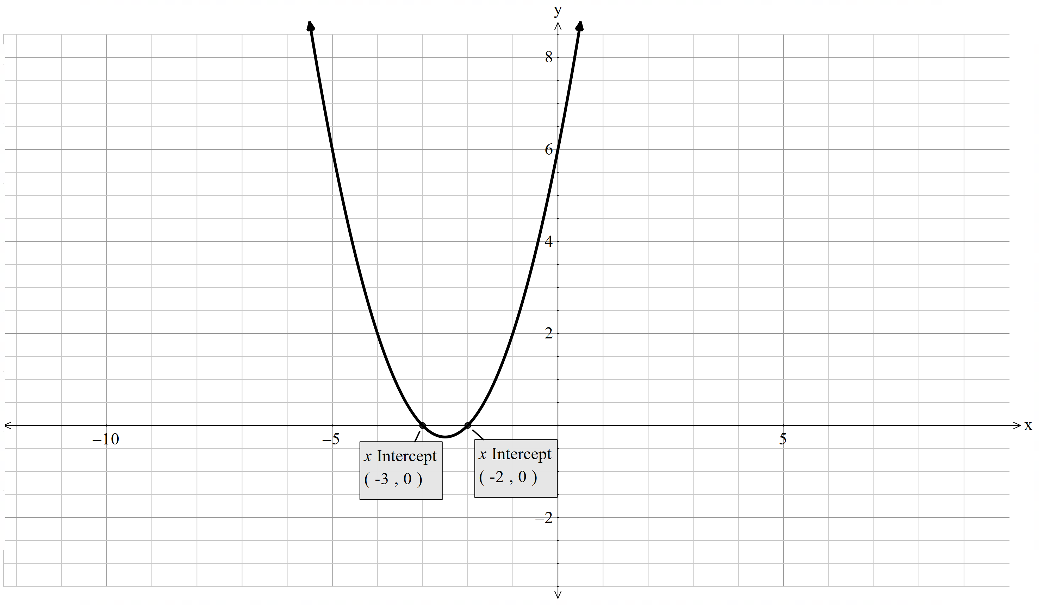
$$∴x<-3 and x>-2$$
- $x^{2}+5x+6≥0$
See graph from part a).
$$∴x≤-3 and x≥-2$$
- $x^{2}+5x+6≤0$
See graph from part a)
$$∴-3≤x≤-2$$
- $x^{2}+5x+6<0$
See graph from part a)
$$∴ -3<x<-2$$
- $x^{2}+x-6<0$
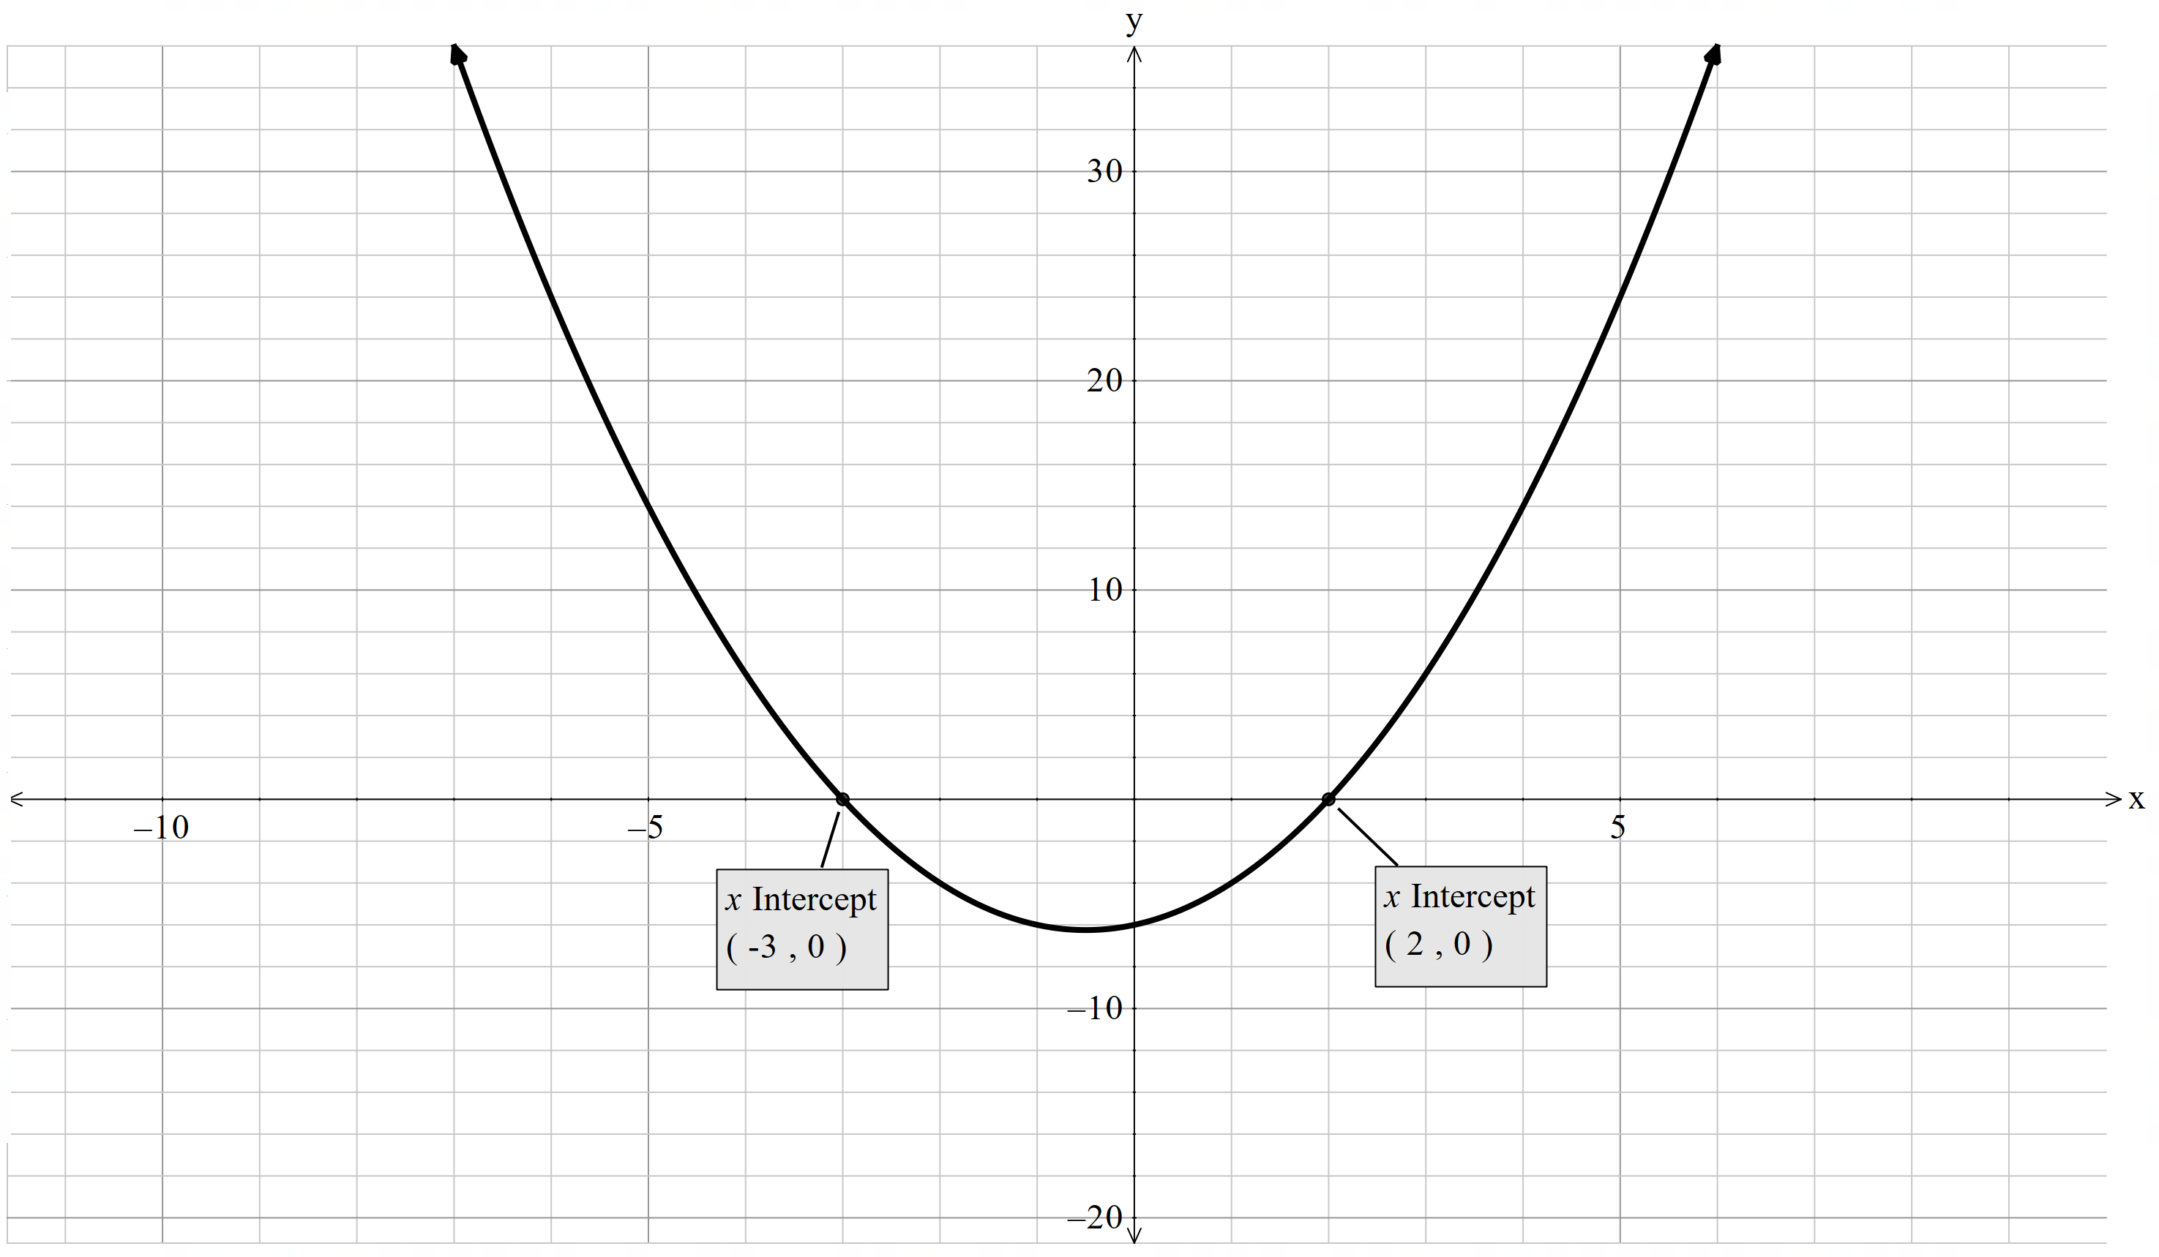
$$∴-3<x<2$$
- $x^{2}+x-6>0$
See graph from part e)
$$x<-3 and x>2$$

- $x^{2}-x-6>0$
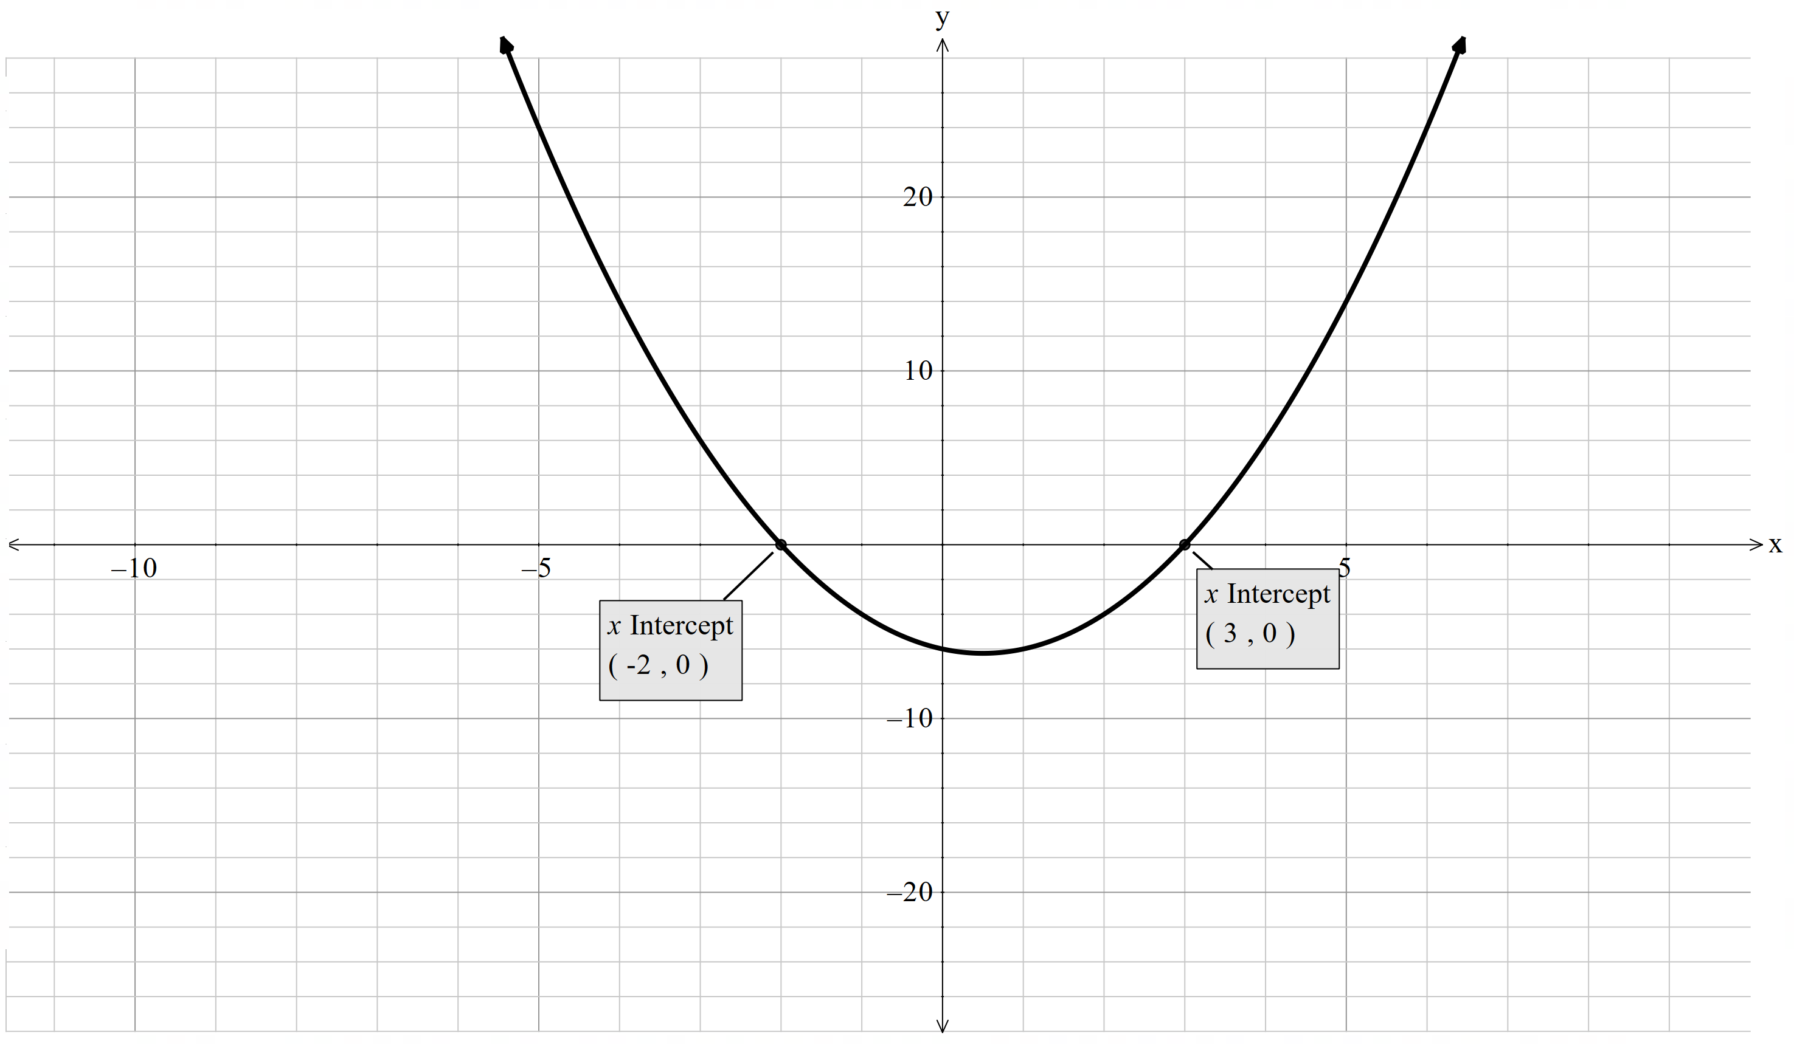
$$∴x<-2 and x>3$$
- $x^{2}-x-12>0$
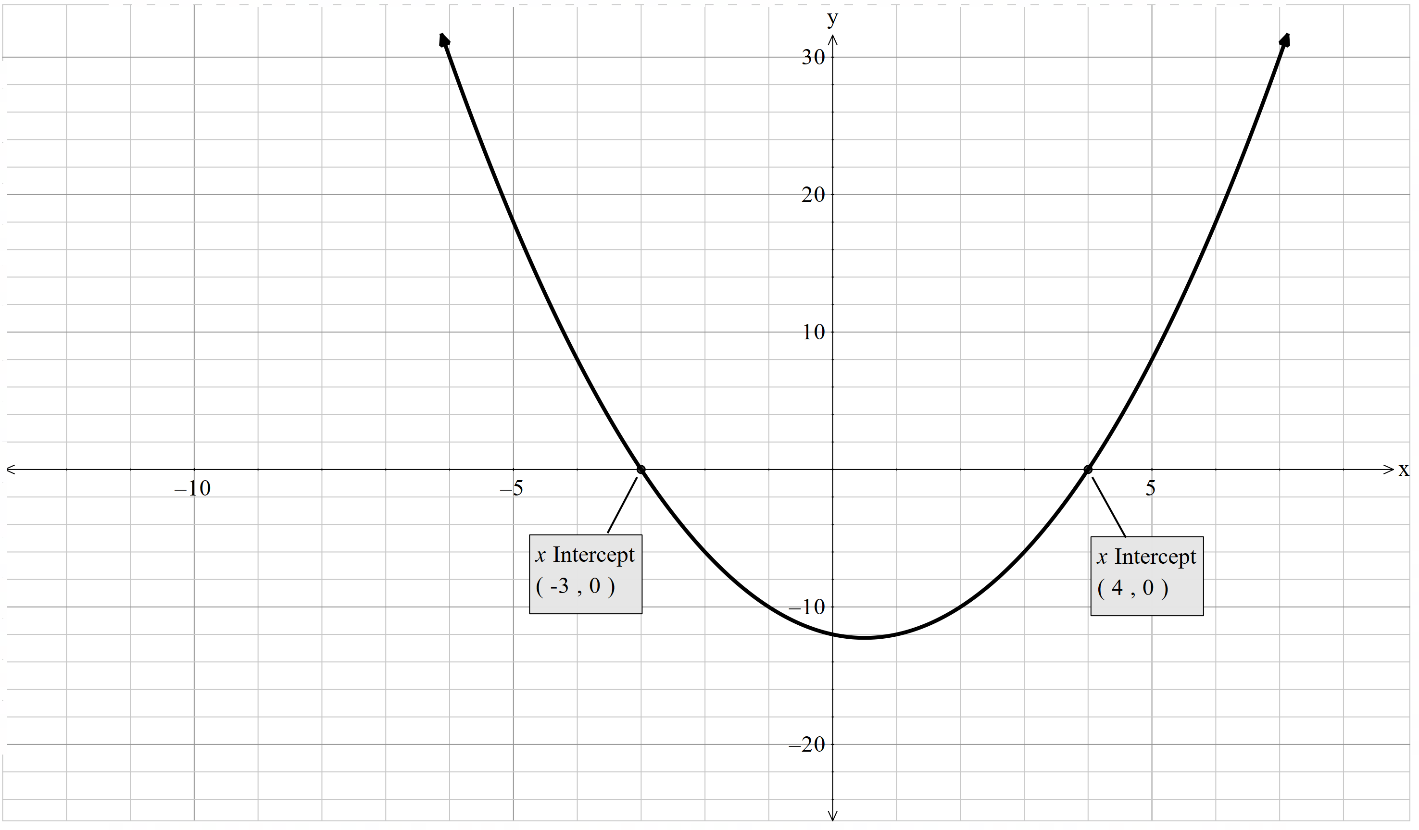
$$∴x<-3 and x>4$$
- $x^{2}-x-12≥0$
See graph from part h)
$$x≤-3 and x≥4$$
- $x^{2}+x-12≤0$
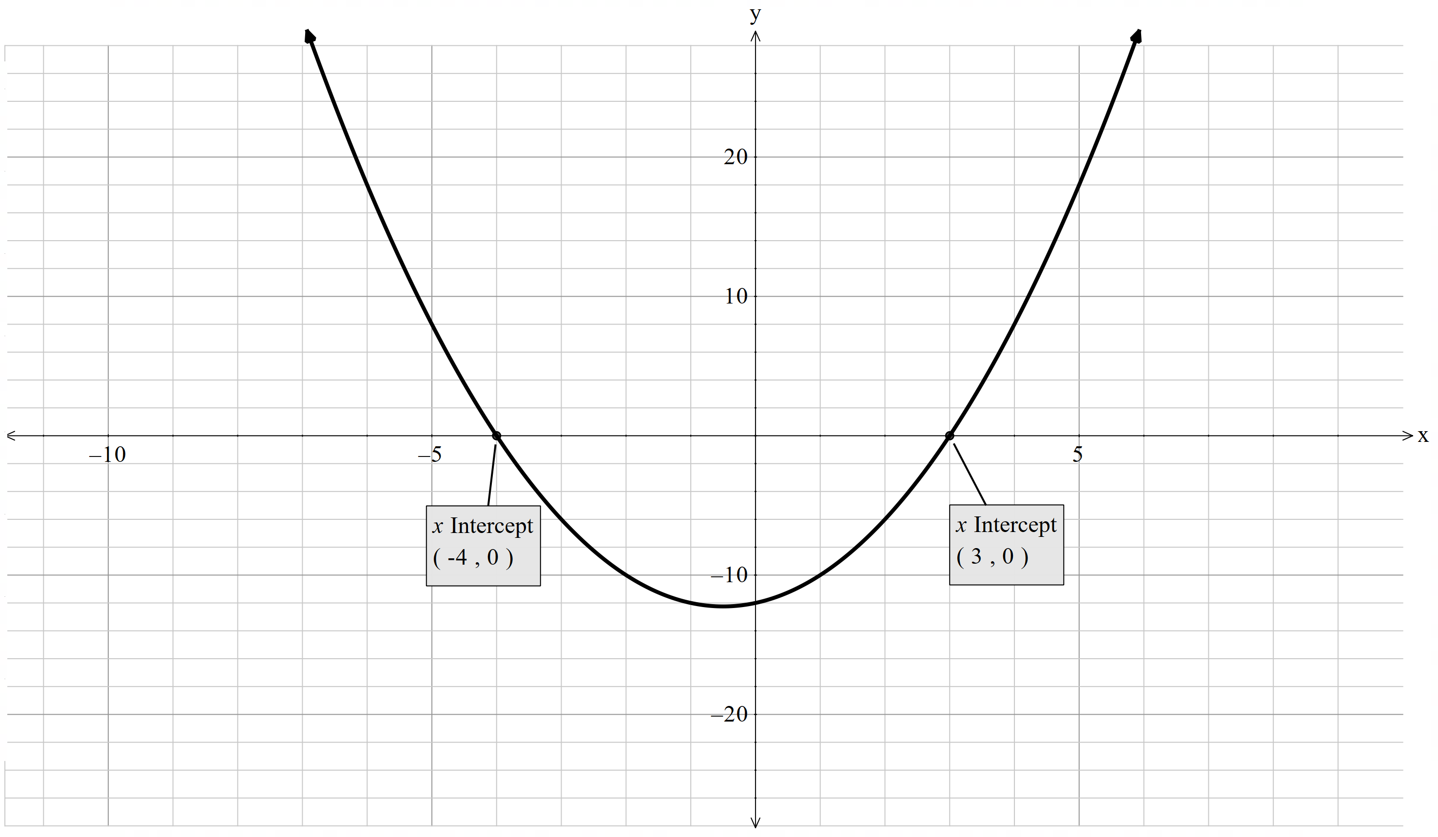
$$∴-4≤x≤3$$

References
This resource contains NSW Curriculum and syllabus content. The NSW Curriculum is developed by the NSW Education Standards Authority. This content is prepared by NESA for and on behalf of the Crown in right of the State of New South Wales. The material is protected by Crown copyright.
Please refer to the NESA Copyright Disclaimer for more information https://educationstandards.nsw.edu.au/wps/portal/nesa/mini-footer/copyright.
NESA holds the only official and up-to-date versions of the NSW Curriculum and syllabus documents. Please visit the NSW Education Standards Authority (NESA) website https://educationstandards.nsw.edu.au/ and the NSW Curriculum website https://curriculum.nsw.edu.au/.
Mathematics Advanced 11–12 Syllabus © NSW Education Standards Authority (NESA) for and on behalf of the Crown in right of the State of New South Wales, 2024.

© State of New South Wales (Department of Education), 2025
The copyright material published in this resource is subject to the Copyright Act 1968 (Cth) and is owned by the NSW Department of Education or, where indicated, by a party other than the NSW Department of Education (third-party material).
Copyright material available in this resource and owned by the NSW Department of Education is licensed under a Creative Commons Attribution 4.0 International (CC BY 4.0) license.

This license allows you to share and adapt the material for any purpose, even commercially.
Attribution should be given to © State of New South Wales (Department of Education), 2025.
Material in this resource not available under a Creative Commons license:
- the NSW Department of Education logo, other logos and trademark-protected material
- material owned by a third party that has been reproduced with permission. You will need to obtain permission from the third party to reuse its material.
Links to third-party material and websites
Please note that the provided (reading/viewing material/list/links/texts) are a suggestion only and implies no endorsement, by the New South Wales Department of Education, of any author, publisher, or book title. School principals and teachers are best placed to assess the suitability of resources that would complement the curriculum and reflect the needs and interests of their students.
If you use the links provided in this document to access a third-party's website, you acknowledge that the terms of use, including licence terms set out on the third-party's website apply to the use which may be made of the materials on that third-party website or where permitted by the Copyright Act 1968 (Cth). The department accepts no responsibility for content on third-party websites.

