Simultaneous quadratic equations
Students solve simultaneous linear and quadratic equations using graphical and algebraic methods. They then apply these skills to pairs of quadratics, practising through worked examples and an HSC-style task.

Learning intention
- To be able to solve simultaneous equations involving linear and quadratic functions or two quadratic functions.

Success criteria
- I can identify the intersection points of a linear and quadratic function, or 2 quadratic functions, using a graph.
- I can solve simultaneous equations algebraically using substitution.
- I can determine the number of solutions using the discriminant and explain which solutions are valid in context.
- I can apply these methods to solve real-world or HSC-style problems.

Outcomes
A student:
- develops understanding and fluency in mathematics through exploring and connecting mathematical concepts, choosing and applying mathematical techniques to solve problems, and communicating their thinking and reasoning coherently and clearly MAO-WM-01
- applies algebraic techniques and the laws of indices and surds to manipulate expressions and solve problems MAV-11-01
- uses functions and relations to model, analyse and solve problems MAV-11-02

Content

Quadratic and cubic functions
- Solve problems by finding the solution to simultaneous equations involving a linear and a quadratic function, or two quadratic functions, both algebraically and graphically
Mathematics Advanced 11–12 Syllabus © NSW Education Standards Authority (NESA) for and on behalf of the Crown in right of the State of New South Wales, 2024.

Table 1: lesson summary
Section | Summary of activity | Teaching strategies | Teaching points
Activating prior knowledge | Using slide 4 of the PowerPoint Simultaneous quadratic equations, students apply simultaneous linear equations to solve a demand and supply problem involving concert ticket sales. The solution can be displayed using slide 5. | Pose-Pause-Pounce-Bounce  Think-Pair-Share | In this activity, students examine the features and limitations of the demand and supply functions to solve the problem.
Connecting learning | Students connect the concept of the point of intersection of linear functions with those of quadratic functions, using slide 7. Using slide 8, students are asked to prove that a pair of simultaneous equations has no solution, with the graphical solution provided on slide 9. | Pose-Pause-Pounce-Bounce  Visibly random groups of 3  Vertical non-permanent surfaces | This activity connects students’ understanding of solving linear simultaneous equations graphically to solving quadratic simultaneous equations and then extends to determining the number of solutions using the discriminant.
Releasing responsibility | Students practise solving quadratic simultaneous equations using algebraic techniques using the concert problem using slides 11–13. Appendix A allows them to consolidate their skills. | Think-Pair-Share  Worked examples (Your turn)  Banner tasks | The aim of this activity is for students to develop their understanding and skills in solving pairs of quadratic simultaneous equations using algebraic techniques.
Independent practice | Using Appendix B, students work in pairs to solve HSC-style questions, using the ‘Approaching questions scaffold’ on slide 15. Students then discuss the marking criteria using slides 16–18. | Think-Pair-Share | The aim of this activity is for students to be exposed to HSC-style questions, consider the language involved in these questions and to consider the marking criteria.

Activity structure
Please use the associated PowerPoint Simultaneous quadratic equations to display images in this lesson.

Activating prior knowledge
- Using the Pose-Pause-Pounce-Bounce questioning strategy (PDF 557 KB) (bit.ly/posepausepouncebounce), discuss with students their understanding of ‘supply and demand’ and how if they consider the linear forms of their graphs, how they might relate.
Some question prompts could include:
- What do you think the phrase ‘supply and demand’ means?
- Can you give an example of a product or an item that people want a lot of?
- What happens to the price of a product or item if the demand is high, but there isn’t much available?
- What happens to the price of a product or item if the supply is high, but not many people want it?
- Display slide 4 of the PowerPoint which shows 2 linear functions related to the supply and demand of tickets being sold for a concert.
- In a Think-Pair-Share (bit.ly/thinkpairsharestrategy), ask students what features of demand and supply functions they can identify without calculations, and if there are limitations on the functions.
Students should identify that the demand function is decreasing while the supply function is increasing. They should also identify the $y$-intercepts of each function. The limitation on both functions is that they can only occur when $x$ and $y$ are positive.
- Continuing with a Think-Pair-Share, ask students to consider the following questions:
- What is the maximum amount that fans are willing to pay for a ticket?
- For every extra ticket that is released (supplied), what impact does this have on the price of the ticket?
- What do you think the ‘$+10$’ represents in the supply equation?
The maximum fans are willing to pay for a ticket is $100. For each additional ticket that is released, the price of the ticket reduces by $2. The +10 in the supply equation might relate to a fixed cost.
- Ask a non-volunteer student if the supply and demand functions intercept each other and if so, how many times do they expect them to intercept.
The student should state that the 2 functions intercept each other once only.
Students have previously learned how to solve linear simultaneous equations both graphically and algebraically in Lesson 4 – solving simultaneous equations.
- In their pairs, have students solve the following problem to determine the point of intersection.
If students in the class study Stage 6 Business Studies or Economics, you may want to refer to the point of intersection as the ‘equilibrium point’.
- Confirm students’ understanding by displaying the solution on slide 5.
- Using the Pose-Pause-Pounce-Bounce questioning strategy, have students consider part (b) of the problem.
Is the 500-seat venue appropriate for the local band?
Students will need to consider the contextual meaning of the point of intersection. That is, a ticket price of $18 will mean a concert attendance of 64 people which is not appropriate for the 500-seat venue.

Connecting learning
- Pose to students the following statement and question and make links to the previous problem.
If 2 graphs have one point of intersection, we know that there is one solution to their simultaneous equations … So, if we have 2 intersections, what does that mean? And what if they don’t intersect at all?
- Using the Pose-Pause-Pounce-Bounce strategy, gain an understanding of what students’ predictions are to the notion of 2 intersections or no intersections.
Conclude with students that the number of intersections indicates the number of solutions to simultaneous equations.
- Display slide 7 of the PowerPoint and ask students to show how many solutions each graph has by holding up the corresponding number of fingers.
- Assign students to visibly random groups of 3 (bit.ly/visiblegroups) at vertical non-permanent surfaces (bit.ly/VNPSstrategy), and display slide 8 which poses the following problem.
Prove that the following pair of simultaneous equations have no solutions.
$$y=x+1 \\ y=x^{2}+2$$
- Observe each group to assess students’ understanding as they collaborate. If you notice a group considering the discriminant, earmark them for the following discussion.
Many groups may try to sketch both functions. The graphs can get close to each other but not actually meet, which can be hard to see just by looking. That’s why it is important to confirm the number of solutions using algebra.
- Remaining at their vertical non-permanent surfaces, ask groups to share their methods for solving the problem.
It is recommended that the teacher is strategic in the groups they ask to share, starting with those who attempted to solve the problem via graphical methods, then to those who attempted to solve via an elimination or substitution method, then to a group who may have used the discriminant. Should no group consider the discriminant, the teacher can hint towards this method.
- Using the Pose-Pause-Pounce-Bounce questioning strategy, ask students how the discriminant can be used to determine the number of solutions and what that tells us.
Students should be able to link that if $∆>0$ we would have 2 solutions to the simultaneous equation, $∆=0$ indicates 1 solution and $∆<0$indicates no solutions. The discussion should then extend to asking if we find the discriminant of the single quadratic equation or if we must combine the quadratic and linear equation.
- Give the visibly random groups of 3 an opportunity to prove that the pair of simultaneous equations on slide 8 have no solutions via the discriminant.
- Animate slide 8 to show the algebraic solution and progress to slide 9 to show the solution graphically.
- Return students to their desks and return the PowerPoint to slide 7. Instruct students to prove, using the discriminant, that the first pair of simultaneous equations has 2 solutions and the second pair has one solution.

Releasing responsibility
- Return students to the concert ticket problem, but extend the concept to include the following:
We have looked at supply and demand as a straight line, which is simple and easy to calculate. But real life is not always that neat. Imagine the concert tickets, the first few tickets may be very popular as the fans are willing to pay a lot, but as more tickets are available (or a second release occurs), fans start thinking, ‘I don’t need to pay that much’ and the price they are willing to pay drops faster, giving a curved demand line instead of a straight one.
- Use slide 11 of the PowerPoint to show students the new demand and supply model and conduct a Think-Pair-Share on the algebraic strategies they would use to solve the problem.
- Using the animations on slide 11, show students the solution to the pair of simultaneous quadratic equations, and use the self-explanation prompts to generate discussion about the solution.
- Use slides 12 and 13 to model worked examples of solving simultaneous quadratic equations using the Worked examples (Your turn) method (bit.ly/supportingstrategies).
- On completion of these questions, conduct a Think-Pair-Share, asking students why the elimination method may not be the most effective method to solve a quadratic simultaneous equation.
Students may incorrectly believe that the elimination method can be used to remove the $x^{2}$ terms; however, this misconception leads to losing an entire solution. This should be explicitly addressed with the class, highlighting that eliminating $x^{2}$ still results in a quadratic, just as in substitution. Encourage students to use substitution to avoid these errors.
- Keep students in their visibly random groups of 3 and distribute Appendix A ‘Banner task’ (bit.ly/supportingstrategies) for them to complete.

Independent practice
- Use slide 15 of the PowerPoint to unpack the ‘Approaching questions scaffold’ for students.
The ‘Approaching questions scaffold’ offers students a 4-step scaffold to tackle questions. Each step is accompanied by an icon and corresponds to different aspects of the solution process.
- Distribute Appendix B ‘HSC-style question’ to students and have them work in pairs to solve the question.
- Display slides 16–18 and use a Think-Pair-Share to prompt discussion of the mark allocations for each of the questions.
Teachers should highlight the importance of effort to the students. Even if students are unable to complete the problem, they can still obtain partial marks for correctly completing some of the steps.
- Teachers can unpack the components required in part (c).
- Teachers can unpack the marking criteria.

Assessment and differentiation

Suggested opportunities for differentiation
Activating prior knowledge
- Students may need further support in conceptualising the supply and demand curves and students learning English as an additional language or dialect may benefit from ensuring that language is used in context.
- Students can be extended by considering the impact of prices the further they go along the demand and supply functions.
Connecting learning
- The teacher can provide graphing applications to aid students in sketching simultaneous equations.
Releasing responsibility
- The teacher can use real-life examples of where supply is greater than demand to reinforce the change to the demand/supply model.
- To extend students, the teacher can remove steps to the solution and have the students use their knowledge and skills to solve problems.
Independent practice
- Students could work in visibly random groups of 3 (bit.ly/visiblegroups) at vertical non-permanent surfaces (bit.ly/VNPSstrategy) so they can attempt the question in a larger group and see the working of others.
- Students could be extended by working individually and using the marking criteria to mark a peer’s work.

Suggested opportunities for assessment
Activating prior knowledge
- Monitor responses in class discussions to check for student understanding of modelling functions.
Connecting learning
- When placed in groups of 3, students provide and receive peer feedback on their understanding.
- Students working at vertical non-permanent surfaces means the teacher can assess student progress and provide support where appropriate.
Releasing responsibility
- Student responses to the self-explanation prompts during the worked examples provide an opportunity to assess student reasoning.
- A Think-Pair-Share provides students with the opportunity to reflect on their understanding.
Independent practice
- Work samples of Appendix B could be collected to check for understanding of the whole process of forming equations and solving them simultaneously.
- Monitor responses in class discussions to check for student understanding of the steps required to gain each additional mark.

Appendix A

Banner task
Solve the following pairs of simultaneous equations.
- $y= x+1y=x^{2}-3$
- $y=2x+3y=x^{2}-2x+3$
- $y=-x+1$
$y=x^{2}+x+5$
- $y=x^{2}+2x+1$
$y=2x^{2}-x+3$
- $y=x^{2} y=x^{2}-3$
- $y=x^{2}+2y=x^{2}-3$
- Solve graphically
$y=3x-2$ $y=x^{2}+1$
- Solve graphically
$y=-x^{2}+4$ $y={\left(x-2\right)}^{2}$
- $y=\frac{1}{2}x+4y=x^{2}$
- $y=-2x+6y=x^{2}-2x+4$

Appendix B

HSC-style question
A park is designing a fountain display. Water jets are modelled by the following functions:
- Jet A: $y= -0.2x^{2}+2x+1$
- Jet B: $y=1.5x$.
Where $x$ is the horizontal distance $(m)$ from the nozzle, and $y$ is the height $(m)$ of the water above the ground.
- On the same axes, sketch both functions for the domain $(0, 5)$. Label approximate points of intersection. (3 marks)
- Solve the simultaneous equations to find the exact coordinates where the water jets intersect. (4 marks)
- A designer asserts that, ‘Jet B will always be below Jet A for all distances along the fountain.’
Use your sketch and calculations to explain whether this statement is correct or incorrect and why. (3 marks)

Sample solutions

Appendix A – banner task
- $y=x+1$ and $y=x^{2}-3$  $$x^{2}-3=x+1 \\ x^{2}-x-4=0$$  $$∆ =17>0∴two real solutions$$  $$x=\frac{1±\sqrt{17}}{2}$$  When $x=\frac{1+\sqrt{17}}{2}$ , $y=\frac{3+\sqrt{17}}{2}$  And $x= \frac{1-\sqrt{17}}{2}, y=\frac{3-\sqrt{17}}{2}$ | - $y=2x+3$ and $y=x^{2}+2x+3$  $$x^{2}+2x+3=2x+3 \\ x^{2}=0 \\ x=0$$  When $x=0, y=3$
- $y=-x+1$ and $y=x^{2}+x+5$  $$x^{2}+x+5=-x+1 \\ x^{2}+2x+4=0$$  $$∆ ={\left(2\right)}^{2}-4\left(1\right)\left(4\right) \\ ∆ = -12<0 \\ ∴no real solutions$$ | - $y=x^{2}+2x+1$ and $y=2x^{2}-x+3$  $$x^{2}+2x+1=2x^{2}-x+3 \\ x^{2}-3x+2=0 \\ \left(x-2\right)\left(x-1\right)=0$$  $$∴x=2, y=9 \\ x=1, y=4$$
- $y=x^{2}$ and $y={\left(x-1\right)}^{2}+1$  $$x^{2}={\left(x-1\right)}^{2}+1 \\ x^{2}=x^{2}-2x+2 \\ -2x+2=0 \\ x=1$$  When $x=1, y=1$ | - $y=x^{2}+2$ and $y=x^{2}-3$  $$x^{2}+2=x^{2}-3 \\ 5=0$$Impossible. Hence no solutions.
- $y=3x-2$ and $y=x^{2}+1$  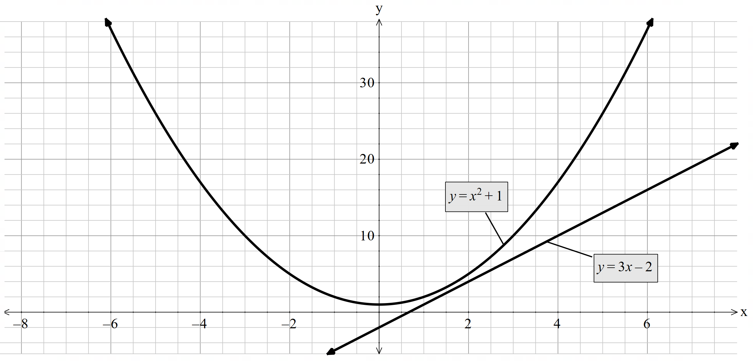 | - $y=-x^{2}+4$ and $y={\left(x-2\right)}^{2}$  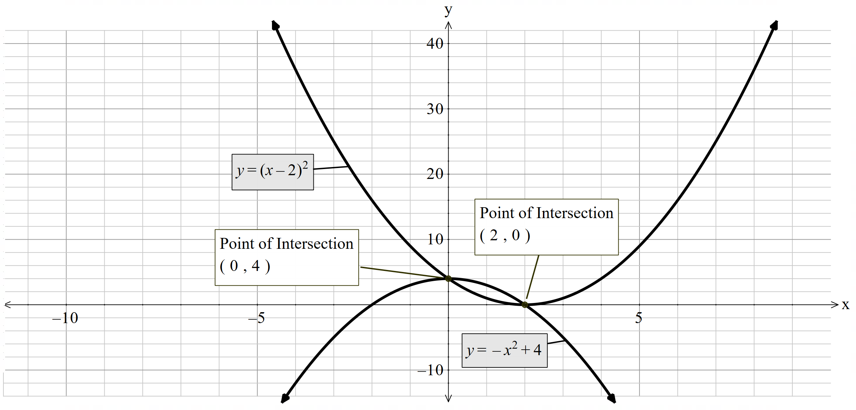
- $y=\frac{1}{2}x+4$ and $y=x^{2}$  $$x^{2}=\frac{1}{2}x+4 \\ x^{2}-\frac{1}{2}x-4=0$$  $∆=16.25>0,$ Hence 2 real solutions  Using the quadratic formula,  $$x=\frac{\left(1±\sqrt{65}\right)}{4}$$  $$∴when x=\frac{\left(1+\sqrt{65}\right)}{4} , y=\frac{33+\sqrt{65}}{8} \\ x=\frac{\left(1-\sqrt{65}\right)}{4} , y=\frac{33-\sqrt{65}}{8}$$ | - $y=-2x+6$ and $y=x^{2}-2x+4$  $$-2x+6=x^{2}-2x+4 \\ x^{2}-2=0$$  $$∴x= ±\sqrt{2}$$  $$when x=\sqrt{2} , y= -2\sqrt{2}+6$$  $$and x=-\sqrt{2} , y= 2\sqrt{2}+6$$

Appendix B – HSC-style question

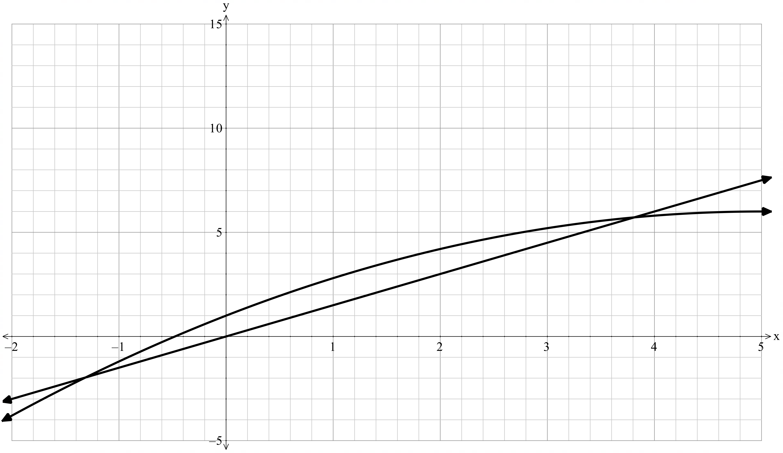
*Note: this graph provides an extended domain of $-2≤x≤5$ for illustrative purposes.
- $-0.2x^{2}+2x+1=1.5x0.2x^{2}-0.5x-1=0$
$∆>0∴$2 real solutions Using the quadratic formula: $x=\frac{0.5±\sqrt{1.05}}{0.4}$
Hence, when $x=\frac{0.5+\sqrt{1.05}}{0.4} , y≈5.72$
Note we disregard the solution of $x=\frac{0.5-\sqrt{1.05}}{0.4}$ due to the context of the problem.
- At first, Jet A starts above Jet B. However, when we solve the equations, they intersect at about $x=3.8$metres with a height of about $y=5.7$. This means that up to that point Jet B is lower, but after that point Jet B rises above Jet A. So, the statement is not always correct as Jet B is only below Jet A for part of the fountain, and then it overtakes.

References
This resource contains NSW Curriculum and syllabus content. The NSW Curriculum is developed by the NSW Education Standards Authority. This content is prepared by NESA for and on behalf of the Crown in right of the State of New South Wales. The material is protected by Crown copyright.
Please refer to the NESA Copyright Disclaimer for more information https://educationstandards.nsw.edu.au/wps/portal/nesa/mini-footer/copyright.
NESA holds the only official and up-to-date versions of the NSW Curriculum and syllabus documents. Please visit the NSW Education Standards Authority (NESA) website https://educationstandards.nsw.edu.au/ and the NSW Curriculum website https://curriculum.nsw.edu.au/.
Mathematics Advanced 11–12 Syllabus © NSW Education Standards Authority (NESA) for and on behalf of the Crown in right of the State of New South Wales, 2024.

© State of New South Wales (Department of Education), 2025
The copyright material published in this resource is subject to the Copyright Act 1968 (Cth) and is owned by the NSW Department of Education or, where indicated, by a party other than the NSW Department of Education (third-party material).
Copyright material available in this resource and owned by the NSW Department of Education is licensed under a Creative Commons Attribution 4.0 International (CC BY 4.0) license.

This license allows you to share and adapt the material for any purpose, even commercially.
Attribution should be given to © State of New South Wales (Department of Education), 2025.
Material in this resource not available under a Creative Commons license:
- the NSW Department of Education logo, other logos and trademark-protected material
- material owned by a third party that has been reproduced with permission. You will need to obtain permission from the third party to reuse its material.
Links to third-party material and websites
Please note that the provided (reading/viewing material/list/links/texts) are a suggestion only and implies no endorsement, by the New South Wales Department of Education, of any author, publisher, or book title. School principals and teachers are best placed to assess the suitability of resources that would complement the curriculum and reflect the needs and interests of their students.
If you use the links provided in this document to access a third-party's website, you acknowledge that the terms of use, including licence terms set out on the third-party's website apply to the use which may be made of the materials on that third-party website or where permitted by the Copyright Act 1968 (Cth). The department accepts no responsibility for content on third-party websites.

