Modelling quadratic functions
Students learn how quadratic equations can be applied to model and solve real-world problems.

Learning intentions
- To understand how quadratic functions can be used to model and solve practical problems.
- To be able to make connections between key features of the graph of a quadratic function and the context of a problem.

Success criteria
- I can identify real-world situations where quadratic functions are applicable.
- I can interpret the solutions of a quadratic model to solve problems.
- I can create a quadratic model to represent and solve a given practical problem.

Outcomes
A student:
- develops understanding and fluency in mathematics through exploring and connecting mathematical concepts, choosing and applying mathematical techniques to solve problems, and communicating their thinking and reasoning coherently and clearly MAO-WM-01
- applies algebraic techniques and the laws of indices and surds to manipulate expressions and solve problems MAV-11-01
- uses functions and relations to model, analyse and solve problems MAV-11-02

Content

Constructing and using functions
- Model and solve practical problems involving quadratic functions and justify conclusions in the context of the problem
Mathematics Advanced 11–12 Syllabus © NSW Education Standards Authority (NESA) for and on behalf of the Crown in right of the State of New South Wales, 2024.

Table 1: lesson summary
Section | Summary of activity | Teaching strategies | Teaching points
Activating prior knowledge | Show the video (bit.ly/SkewTheScriptMcRib) from 0:30 until 2:08 and use slides 4–6 of the PowerPoint Modelling quadratic functions to introduce the real-world context of the McRib. Use questioning for students to propose a more suitable profit model. | Think-Pair-Share  Pose-Pause-Pounce-Bounce | This section revisits linear modelling and challenges students to critically evaluate its limitations in representing real-world scenarios.
Connecting learning | Use slide 8, to analyse a quadratic model of McRib profit over time, to determine when profit is maximised. Students sketch the graph, interpret key features and draw conclusions about how long the McRib should be available. | Pose-Pause-Pounce-Bounce | The purpose of this section to connect abstract features of a quadratic function to a meaningful context and deepening students’ understanding of how parabolas can model situations with increasing and then decreasing trends.
Releasing responsibility | Use slides 10–12 of the PowerPoint to model how to solve practical problems with quadratics. Students then apply their understanding through guided and independent practice, including selected past HSC questions. |  | The aim of this activity is to support students to transition from teacher-led modelling to independent practice, helping students consolidate their understanding of quadratic applications in real-world and exam-style questions.
Independent practice | Use slides 14–16 of the PowerPoint to introduce students to the 'Approaching question scaffold', solve a contextual problem involving area and perimeter and then have students compare their solutions. | Vertical non-permanent surfaces  Visibly random groups of 3  Gallery walk | The purpose of this activity is to encourage deeper thinking by constructing a quadratic model in a new context, supporting students to approach an unfamiliar problem.

Activity structure
Use the associated PowerPoint Modelling quadratic functions to display images in this lesson.
This lesson has been adapted from ‘Lesson 4.1 – Quadratics (Standard Form)’ (skewthescript.org/algebra/4-1) by Skew The Script.
The Amplify Classroom activity (bit.ly/DesmosLesson4_1Skewthescript) can be assigned for students to complete, rather than using the PowerPoint and class discussions for the ‘Activating prior knowledge’ and ‘Connecting learning’ sections of this lesson.

Activating prior knowledge
- Show students the video ‘Algebra 4.1 – Quadratic (Standard Form)’ (13:49) (bit.ly/SkewTheScriptMcRib) from 0:30 until 2:08. This video follows the 30-year journey of the McDonald’s McRib burger, known for its limited time returns and sudden disappearances from the menu.
- Explain to students that they will be analysing the following question.
If the McRib is so popular, why is it only offered on a limited time basis?
- Show slide 4 of the PowerPoint which introduces some key information on the ‘McRib’.
When the McRib first comes back onto McDonald’s menu:
- It costs McDonald’s $250 000 to produce the McRib every day.
- McDonald’s makes $400 000 each day in combined McRib sales.
- Use a Think-Pair-Share (bit.ly/thinkpairsharestrategy) to prompt students to consider what the equations for both the revenue and the cost of producing the McRib might look like, if $x$ represents the number of days.
Students were introduced to the terms ‘revenue’ and ‘cost’ in Lesson 2 – modelling linear functions.
- Display slide 5 which shows the equation of both the cost ($C=250 000x$) and the revenue ($R=400 000x$) for the McRib, according to the information provided.
Students could be asked to explain why the graph only shows the first quadrant.
- Ask students, using a Think-Pair-Share, to interpret what the graph suggests about McRib production and extend their thinking to consider a possible equation for profit.
Students should recognise that McDonald’s profit increases over time, as revenue grows faster than the cost of producing the burger. Students should share that the equation for profit can be found by:
$$\text{Profit}=\text{Revenue}-\text{cost}$$$\text{Profit}=150 000x$.
- Display slide 6 which contains the graph of the profit, $P=150 000x$ and the following question. Use a Think-Pair-Share for students to discuss the question.
Is this a realistic representation of how sales would trend? Explain your reasoning.
Students should share that the current representation shows that the longer the McRib is on the menu, the more money it makes for McDonalds. Students may conclude that this isn’t realistic since generally, as time goes on, the novelty of a new item wears off and profit slows.
It is valuable to discuss why the graph only shows the first 10 days, students could be asked to think about how long they think it will take for sales to slow down.
- Conclude with students that companies often release products for a ‘limited time only’ because, over time, profits tend to decline while costs can continue to rise, making the product less viable.
- Use the Pose-Pause-Pounce-Bounce questioning strategy (PDF 557 KB) (bit.ly/posepausepouncebounce) to prompt students to suggest a more suitable model for the profits of an item available for only a limited time, and to justify their reasoning. Some suggested questions include:
- What might happen to the profit after the initial excitement wears off?
- If we graphed the profit over time, would a straight line make sense to use as a model? Why or why not?
- Which graphical model might be best suited to represent the profit over time and why?
Students should suggest that the model needs to increase and then decrease, so therefore it could be a concave down parabola. In the following section, students will look at using a quadratic function to model this scenario.

Connecting learning
- Explain to students that they will now analyse an alternate model to represent the McRib’s profit over time, with the goal of helping the company determine how many days it should be available to maximise profit.
- Use slide 8 of the PowerPoint to display an alternate model, $P=-400x^{2}+200 000x$, representing the accumulated profit over time.
Don’t animate the slide to show the graph of $P=-400x^{2}+200 000x$ until after step 3.
- Use the Pose-Pause-Pounce-Bounce questioning strategy to check students’ understanding of what the graph of this equation might look like.
- What type of graph do you think this equation will produce? How do you know?
- Explain what you think the graph tells us about how profit changes over time.
- Once students have established that the model is a quadratic function, ask them to draw a sketch of the function in their workbooks, prior to animating the graph on slide 8.
- Have students share the strategy they used to graph the quadratic function.
Students should share that they found both the $x$- and $y$-intercepts. In previous lessons, students have chosen and applied appropriate techniques to graph a parabola of the form $y=ax^{2}+bx+c$, so a class discussion on which technique students used may be beneficial.
Most students likely produced a graph like the one shown in Figure 1.
Figure 1: graph of the accumulated profit (P) over several days (x)
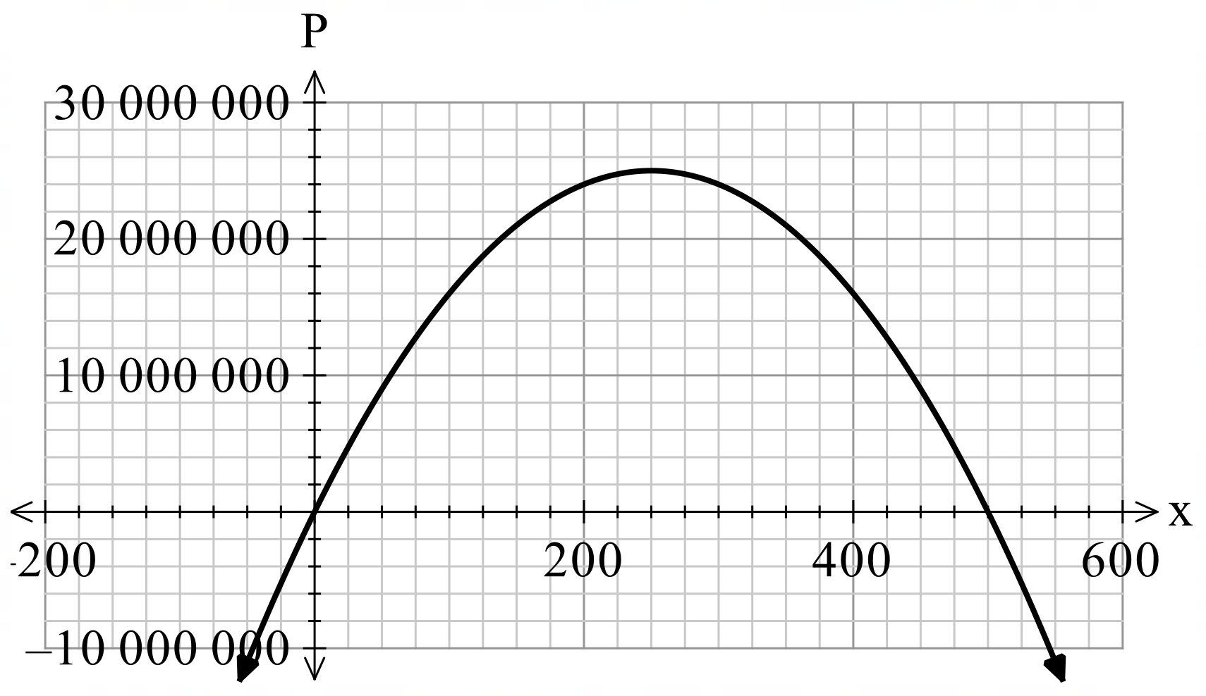
- Initiate a class discussion to determine if a graph in all 4 quadrants makes sense in the context of the question. That is, if you can have a negative number of days.
- Animate the graph on slide 8 for students to check their working. This slide correctly shows the graph only in the first quadrant.
- Using the Pose-Pause-Pounce-Bounce questioning strategy, discuss why this model better reflects real sales patterns, and how the key features of the parabola, that is, the vertex and $x$-intercepts, relate to the McRib’s sales. Some suggested prompts include:
- How long should McDonald’s release the McRib burger for in order to maximise profit? Why?
- Using the graph, explain how long it would take McDonald’s to lose all the profits it has made.
- How might these 2 values be found without the graph?
Students should share that the vertex of the parabola represents the number of days (250), into selling the McRib that it will take to reach the maximum profit of $25 million. They may indicate that the $x$-intercept of 500 is the number of days it takes McDonald’s to lose all profits made.
Students could suggest that finding the axis of symmetry, $x=-\frac{b}{2a}$ will find the number of days it takes to reach the maximum profit and solving $P\left(x\right)=0$ will find how long it takes to lose all profits.
- Lead a class discussion to decide how many days McDonald’s should offer the McRib to maximise profit using this model.
Students should suggest 250 days.

Releasing responsibility
- Initiate a class discussion to consider why quadratic functions might be more suitable than linear equations for certain scenarios.
Quadratic equations have a maximum or minimum point, making them more applicable for situations where there is a peak or trough in the data.
- Use slides 10–12 of the PowerPoint to model how to solve practical problems involving quadratic functions using the Worked examples (Your turn) method (bit.ly/supportingstrategies).
- Students should complete practice questions from an existing resource that requires them to model and solve practical problems involving quadratic functions. Students could also complete past HSC questions.

The following questions from NESA’s past HSC exam papers could be used, although the graphs have been provided in each of these so consider adjusting the complexity of these questions.
- Question 26, 2024 Standard 2 HSC exam paper
- Question 20, 2023 Standard 2 HSC exam paper
- Question 9, 2022 Standard 2 HSC exam paper
- Question 19, 2020 Standard 2 HSC exam paper

Independent practice
- Explain to students that at times they will need to construct a quadratic equation themselves before using it to model real-world situations.
- Assign students to visibly random groups of 3 (bit.ly/visiblegroups) at vertical non-permanent surfaces (bit.ly/VNPSstrategy).
- Use slide 14 of the PowerPoint to unpack the ‘Approaching question scaffold’ with students.
The ‘Approaching questions scaffold’ offers students a structured scaffold to approach questions. Each stage is accompanied by an icon that corresponds to different aspects of the process.
- Display slide 15 for students to work through the following problem in their groups.
You are designing a rectangular flower bed surrounded by a uniform-width path. The total area of the garden, including the flower bed and path, is 80 square metres.
If the dimensions of the flower bed are 6 metres by 4 metres, how wide is the path?
- Encourage students to perform a gallery walk (bit.ly/DLSgallerywalk) to compare their solution and visual representations to other groups.
- Slide 16 can be used to display the solution.
- Facilitate a class discussion to unpack how this question differs from earlier examples and to consider whether a graph would support their solution.

Assessment and differentiation

Suggested opportunities for differentiation
Activating prior knowledge
- Students may require a table of values to help them see that the models are a linear relationship.
- Students can be challenged to just graph the profit linear relationship rather than the cost and revenue to start with.
Connecting learning
- Students may need support by providing a scaffolded table of values prior to graphing the quadratic function.
- Students can use a graphing technology, such as Desmos Graphing Calculator (desmos.com/calculator), to aid in their understanding and to check their working.
- Challenge students to find the vertex and/or axis of symmetry prior to graphing the parabola.
Releasing responsibility
- Students may need to be provided with the ‘Approaching questions’ scaffold on slide 14 of the PowerPoint to complete the ‘Your turn’ question.
- Students could be challenged to create their own realistic scenario that could be modelled with a quadratic function and to pose the question to their partner.
- If students complete the NESA past HSC exam papers for Standard 2, the scaffolds from the questions can be removed, as well as the graphs to challenge students.
Independent practice
- Depending on the class, the question on slide 15 could be completed as a whole-class activity or a scaffold could be provided.

Suggested opportunities for assessment
Activating prior knowledge
- Monitor conversations during the Think-Pair-Share activity to check for students’ understanding of identifying both the shape of the graph and its contextual meaning.
Connecting learning
- Monitor responses in the questioning section to check for students’ understanding of the quadratic function’s graphical features and how they relate to the context of the question.
Releasing responsibility
- Use questions such as ‘Can you think of a real-world situation where there’s a peak or a low point?’, to assess conceptual understanding of why quadratic models are more suitable than linear models in certain situations.
- Circulate the classroom during individual or pair work and listen for correct identification of quadratic forms, reasoning when solving equations and contextual interpretation of answers.
Independent practice
- Encourage students to apply peer assessment during the gallery walk.

References
This resource contains NSW Curriculum and syllabus content. The NSW Curriculum is developed by the NSW Education Standards Authority. This content is prepared by NESA for and on behalf of the Crown in right of the State of New South Wales. The material is protected by Crown copyright.
Please refer to the NESA Copyright Disclaimer for more information https://educationstandards.nsw.edu.au/wps/portal/nesa/mini-footer/copyright.
NESA holds the only official and up-to-date versions of the NSW Curriculum and syllabus documents. Please visit the NSW Education Standards Authority (NESA) website https://educationstandards.nsw.edu.au/ and the NSW Curriculum website https://curriculum.nsw.edu.au/.
Mathematics Advanced 11–12 Syllabus © NSW Education Standards Authority (NESA) for and on behalf of the Crown in right of the State of New South Wales, 2024.
Skew The Script (2025) Lesson 4.1 - Quadratics (Standard Form), Skew the Script website, accessed 18 November 2025.

© State of New South Wales (Department of Education), 2025
The copyright material published in this resource is subject to the Copyright Act 1968 (Cth) and is owned by the NSW Department of Education or, where indicated, by a party other than the NSW Department of Education (third-party material).
Copyright material available in this resource and owned by the NSW Department of Education is licensed under a Creative Commons Attribution 4.0 International (CC BY 4.0) license.

This license allows you to share and adapt the material for any purpose, even commercially.
Attribution should be given to © State of New South Wales (Department of Education), 2025.
Material in this resource not available under a Creative Commons license:
- the NSW Department of Education logo, other logos and trademark-protected material
- material owned by a third party that has been reproduced with permission. You will need to obtain permission from the third party to reuse its material.
Links to third-party material and websites
Please note that the provided (reading/viewing material/list/links/texts) are a suggestion only and implies no endorsement, by the New South Wales Department of Education, of any author, publisher, or book title. School principals and teachers are best placed to assess the suitability of resources that would complement the curriculum and reflect the needs and interests of their students.
If you use the links provided in this document to access a third-party's website, you acknowledge that the terms of use, including licence terms set out on the third-party's website apply to the use which may be made of the materials on that third-party website or where permitted by the Copyright Act 1968 (Cth). The department accepts no responsibility for content on third-party websites.

