Finding quadratic functions from a graph
Students discuss the minimum number of features required on a parabola to determine a quadratic function. Students then examine that 2 quadratic functions are equal for all values of $x$ if and only if the corresponding coefficients are equal.

Learning intentions
- To understand how many graphical features are required to find the equation of a parabola.
- To be able to solve problems when 2 quadratic functions are equal.

Success criteria
- I can use the features of a graph to find the equation of a parabola.
- I can justify the minimum number of graphical features needed to find the equation of a parabola.
- I can recognise that 2 quadratic functions are equal if their corresponding coefficients are equal.
- I can solve problems by equating corresponding coefficients.

Outcomes
A student:
- develops understanding and fluency in mathematics through exploring and connecting mathematical concepts, choosing and applying mathematical techniques to solve problems, and communicating their thinking and reasoning coherently and clearly MAO-WM-01
- applies algebraic techniques and the laws of indices and surds to manipulate expressions and solve problems MAV-11-01
- uses functions and relations to model, analyse and solve problems MAV-11-02

Content

Quadratic and cubic functions
- Find the equation of a parabola given sufficient graphical features
- Use the fact that two quadratic functions are equal for all values of $x$ if and only if the corresponding coefficients are equal to solve related problems
Mathematics Advanced 11–12 Syllabus © NSW Education Standards Authority (NESA) for and on behalf of the Crown in right of the State of New South Wales, 2024.

Table 1: lesson summary
Section | Summary of activity | Teaching strategies | Teaching points
Activating prior knowledge | Discuss the key features of a parabola and use slides 4–6 of the PowerPoint Finding quadratic functions from a graph to identify which equations represent the line given the key features of the equation. Conduct a finger vote to check what students currently think is the minimum number of features required to determine an equation from a graph. | Think-Pair-Share  2 truths, one lie | To get students thinking about the minimum number of features required to graph a parabola.
Connecting learning | Students engage in a sequence of slow reveal graph activities using slides 8–16, each designed to develop their understanding of how graphical features determine the equation of a parabola. | Slow reveal graphs  Think-Pair-Share  Incorrect worked examples | Students should critically evaluate whether the information provided is sufficient to determine the equation, especially when the parabola is non-monic.
Releasing responsibility | Students complete Appendix A to consolidate their understanding of the features needed to define a quadratic equation before writing notes. Slides 18–23 are then used to model verification of equivalent forms of quadratic equations. | Turn and talk  Notes to future forgetful selves  Visibly random groups of 3  Vertical non-permanent surfaces  Worked examples (Your turn) | Students consolidate which points can be used in combination to write an equation of a parabola and understand that equivalent quadratic equations can be written in multiple forms.
Independent practice | Students collaborate to complete a scavenger hunt using the questions in Appendix B to build fluency using equivalence of quadratics to solve problems. Students end the lesson by completing the exit ticket from Appendix C. | Visibly random groups of 3  Vertical non-permanent surfaces  Scavenger hunt | Reinforce the concept that 2 quadratic functions represent the same graph if and only if their corresponding coefficients are equal.

Activity structure
Please use the associated PowerPoint Finding quadratic functions from a graph to display images in this lesson.

Activating prior knowledge
- Using a Think-Pair-Share (bit.ly/thinkpairsharestrategy), prompt students to activate their prior knowledge by discussing the key features that should be labelled when graphing a parabola.
Students should identify and label the $x$-intercepts if they exist, the $y$-intercept, the vertex and the axis of symmetry.
- Use slides 4–6 of the PowerPoint with the 2 truths, one lie strategy (bit.ly/2truthsoneliestrategy). Each slide presents 2 correct equations and one incorrect equation. In a Think-Pair-Share, ask students to consider each function and determine what graphical features each hypothetical student may have used to determine their function and identify which student is incorrect.
- Slide 4: $x(x+4)$ is incorrect. The student may have only considered the $x$-intercepts.
- Slide 5: $-x^{2}+6$ is incorrect. The student may have relied solely on the $y$-intercept and concavity.
- Slide 6: ${\left(x-3\right)}^{2}+8$ is incorrect. The student may have only used the vertex.
- Pose the question: ‘Is one feature enough to define a parabola?’ Ask students to critically reflect on the minimum number of features needed to write the equation of a parabola. Conduct a finger vote where:
- 1 finger = always
- 2 fingers = sometimes
- 3 fingers = never.
Repeat this process for combinations of 2 features, then 3, with students justifying their decision with examples.

Connecting learning
- Use slide 8 of the PowerPoint to facilitate an adaptation of the Slow Reveal Graphs strategy (slowrevealgraphs.com), applied to the context of parabolas. Students will observe 2 graphical features revealed through animation.
Begin by prompting students to notice what information is shown and to wonder what possible equations match the graph. This process of wondering may involve students listing potential equations and systematically eliminating those invalidated by later reveals.
- The first animation reveals the $y$-intercept.
- The second animation reveals the vertex.
- Display slide 9 which shows the full equation of the parabola. Animate the self-explanation prompts and guide students through a Think-Pair-Share to discuss their reasoning and connections.
- Repeat this process using slides 10 and 11.
- Slide 10 gradually reveals the $x$-intercepts and then the vertex.
- Slide 11 shows the equation and accompanying self-explanation prompts.
- Repeat this activity using slides 12–14, which includes a variation where slide 13 presents an incorrect example (bit.ly/incorrectworkedexamples).
- Slide 12 reveals the $x$-intercepts and the vertex.
- Slide 13 presents an incorrect equation. Animate the self-explanation prompt to facilitate a Think-Pair-Share.
- Slide 14 then reveals the correct equation, inviting reflection on why the earlier equation was incorrect.
This example reintroduces a non-monic parabola, encouraging students to consider how the vertex or $y$-intercept can be used to verify the coefficient of $x^{2}$.
- Repeat the strategy of slow reveal accompanied by analysis of the equation for a new example using slides 15 and 16.
- The animations on slide 15 reveal the $y$-intercept followed by the vertex.
- Slide 16 displays the corresponding equation.

Releasing responsibility
- Distribute Appendix A ‘What’s enough?’ to each student to complete individually, asking them to determine whether given features are sufficient to define a quadratic equation uniquely.
- Have students compare their solutions through a turn and talk (bit.ly/classroomtalkmoves) and reflect on how their conclusions align or differ from their initial expectations during the earlier finger vote.
The discussion should highlight that the vertex and one additional unique point are sufficient to determine a quadratic function, whereas 3 distinct points are needed in the absence of the vertex.
- Students are to create notes to their future forgetful selves (bit.ly/notestofutureself) on the minimum number of features required to write the equation of a parabola from a graph.
- Assign students to visibly random groups of 3 (bit.ly/visiblegroups) at vertical non-permanent surfaces (bit.ly/VNPSstrategy). Display slide 18 of the PowerPoint and ask groups to determine whether the 2 equations shown are equivalent.
The equations are $y=2x^{2}+16x+13 and y=2{\left(x+4\right)}^{2}-3$. Students could expand and simplify the second equation to show this.
- Display slide 19 and ask students to silently reflect on its meaning before discussing it with their group.
- Use slides 20–23 from the PowerPoint to model worked examples using the Worked examples (Your turn) method (bit.ly/supportingstrategies).
In this case, the Worked examples method should be adapted to working in groups of 3, with students discussing the self-explanation prompts in their groups and collaborating on the solution to the ‘Your turn’ problem. The first pair of examples focuses on a question using completing the square, while the second pair of examples reflect the example in the syllabus. Explicitly direct students’ attention to how the understanding developed in Example 1 can be applied to more abstract contexts in Example 2.

Independent practice
- Students are to complete the scavenger hunt task from Appendix B ‘Scavenger hunt’.
These questions have been modelled from the example question featured in the syllabus.
- Print one set of question cards, separate each card, and place the cards around the room. A vertical non-permanent surface should be used at each card to assist the groups with their solutions.
- Each group should start at one of the cards. The students work in their groups of 3 to solve the problem.
- Once a group has solved the problem, they need to move around the room to find the solution on another card. Once they have found their solution, they should solve the question attached to the solution and repeat the process.
- The activity is finished once the group returns to their original card.
Cards are printed in order. This means the solution to one question is the answer on the next card.
- Check for understanding by using the exit ticket (bit.ly/exitticketstrategy) in Appendix C ‘Exit ticket’.

Assessment and differentiation

Suggested opportunities for differentiation
Activating prior knowledge
- The slides could be adjusted to include other misconceptions, such as ignoring concavity or incorrectly substituting values into the vertex form.
- The finger vote allows students to participate in a risk-free environment.
Connecting learning
- Slow reveal graphs employ a notice and wonder strategy, where there is no correct answer, so that all students can participate in the discussion.
- The pacing of the activity could be adjusted depending on student needs. For example, students with extensive prior knowledge may benefit from increased exposure to non-monic examples, while some classes may benefit from increased work with monic quadratics.
Releasing responsibility
- Students could complete Appendix A in pairs, allowing them to verbalise their thinking, hear alternate strategies, and fill in knowledge gaps in real time.
- Appendix A could be adapted to include other combinations of features.
- The self-explanation prompts could be adapted to focus the class on areas of concern relevant to their needs.
- The questions in the worked examples could be adapted to meet student needs.
Independent practice
- Hints could be provided to support groups' engagement with the task.
- Scaffolds could be independently created to support student progress.

Suggested opportunities for assessment
Activating prior knowledge
- Monitor responses in class discussions to check for student understanding of the key features of a parabola.
Connecting learning
- Students have opportunities to contribute to and hear from pair and class discussions, which act as opportunities for self and peer reflection.
Releasing responsibility
- Appendix A could be collected to check student understanding of the combination of graphical features needed to find the equation of a parabola.
- Student responses to the self-explanation prompts during worked examples provide an opportunity to assess student reasoning.
- Monitor student responses in the ‘Your turn’ section to check for understanding of using the fact that 2 quadratic functions are equal for all values of $x$ if and only if the corresponding coefficients are equal to solve related problems.
Independent practice
- When placed in groups of 3, students provide and receive peer feedback on their solutions.
- Students working at vertical non-permanent surfaces means the teacher can assess student progress and provide support where appropriate.

Appendix A

What’s enough?
Each parabola has been displayed within the bounds of –10 to 10 on both axes.
Use the table provided to record:
- Which features of the parabola are given.
- Whether this information is sufficient to determine the quadratic equation uniquely.
- If it is sufficient, write the equation.
- If it is not sufficient, explain which additional feature(s) would be needed and why.
Parabola | Features | Equation/explanation
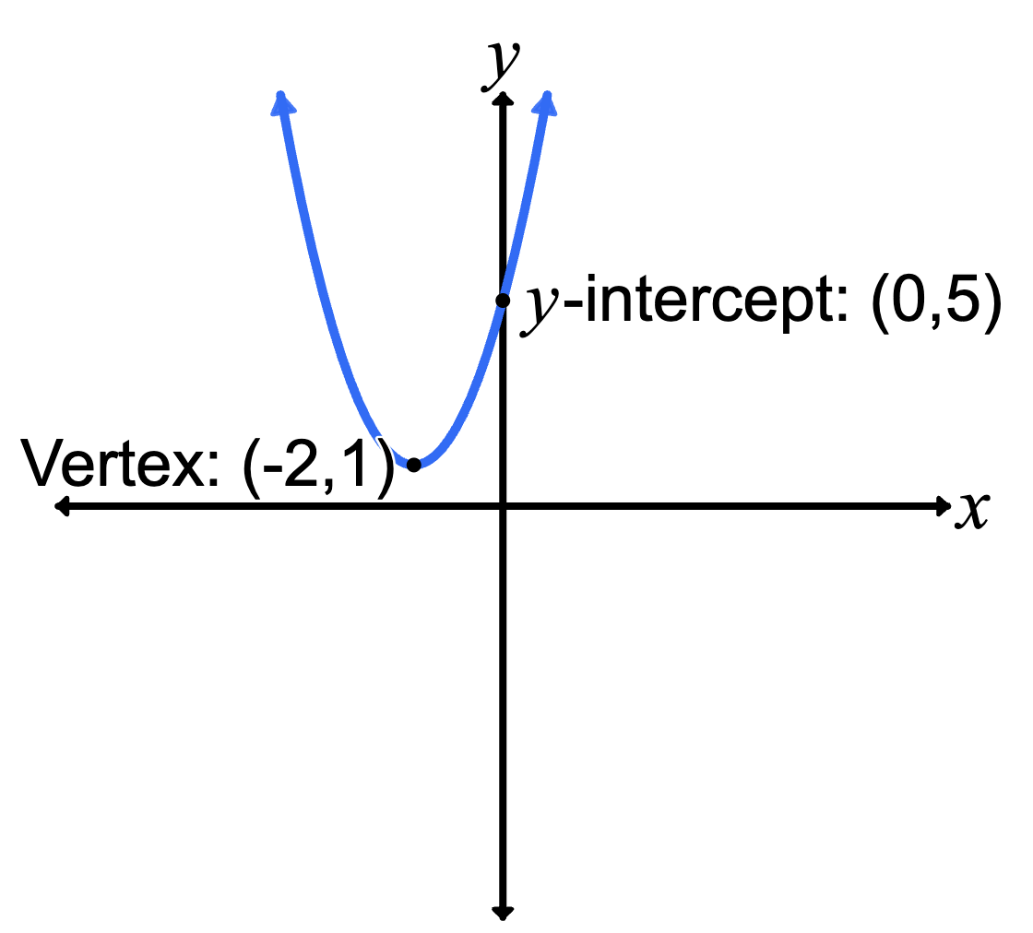 | - Vertex  - $y$-intercept  - One $x$-intercept  - 2 $x$-intercepts  - Axis of symmetry | - Sufficient features?
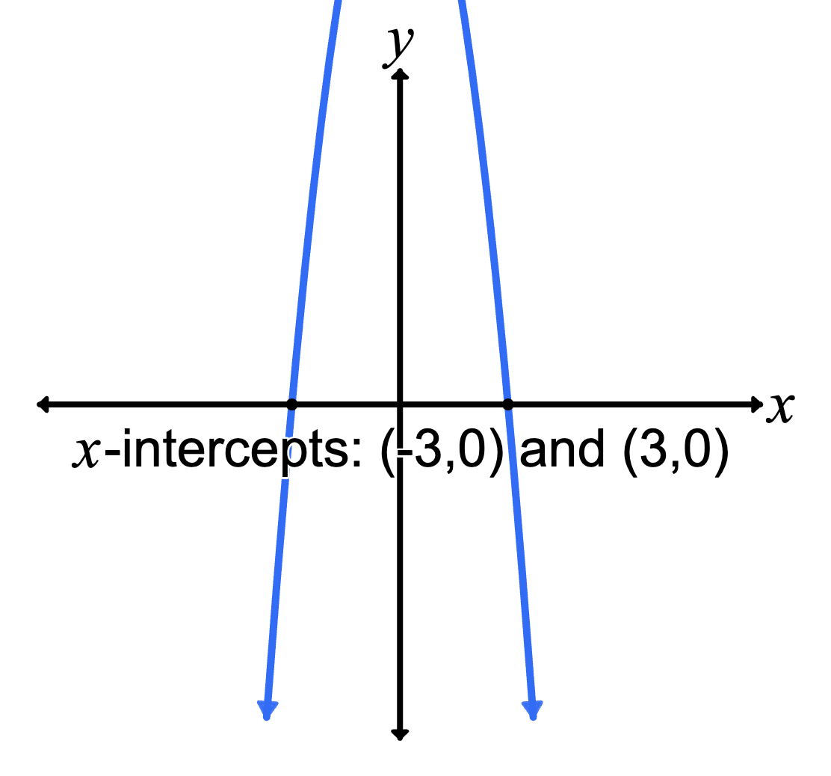 | - Vertex  - $y$-intercept  - One $x$-intercept  - 2 $x$-intercepts  - Axis of symmetry | - Sufficient features?
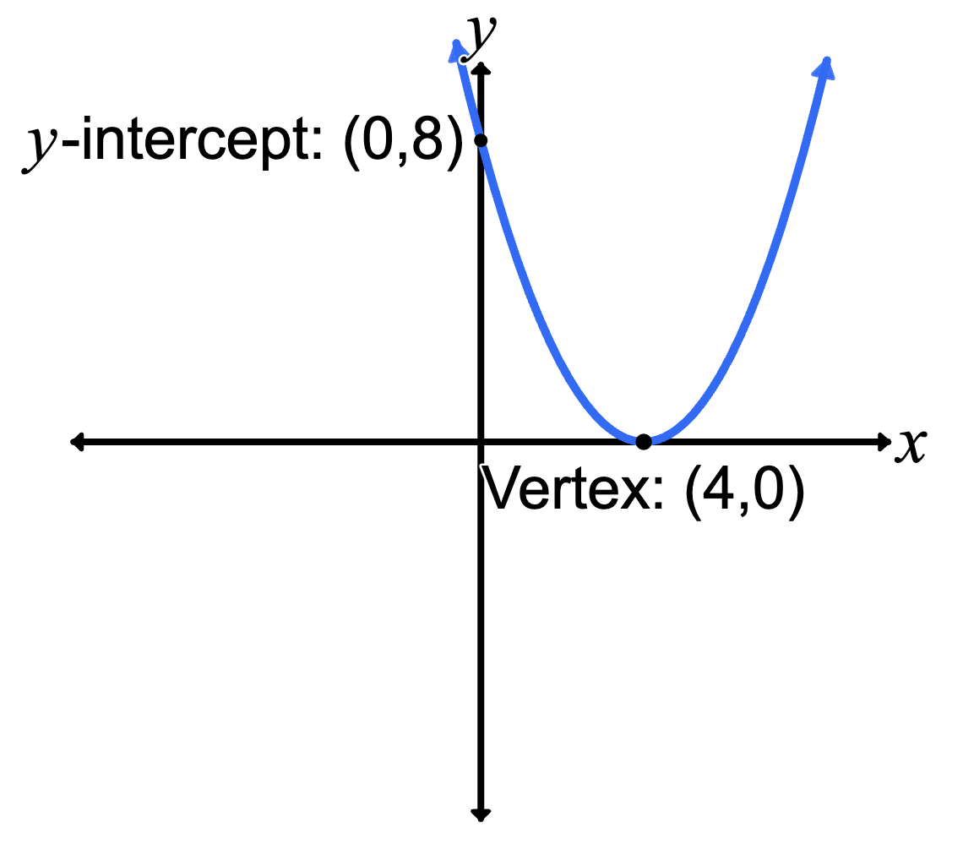 | - Vertex  - $y$-intercept  - One $x$-intercept  - 2 $x$-intercepts  - Axis of symmetry | - Sufficient features?
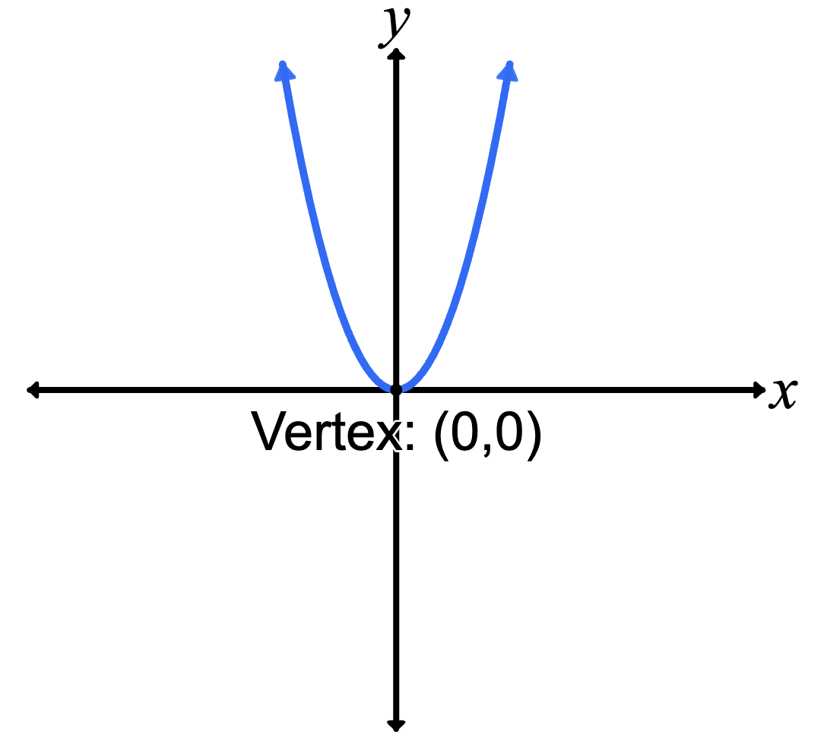 | - Vertex  - $y$-intercept  - One $x$-intercept  - 2 $x$-intercepts  - Axis of symmetry | - Sufficient features?
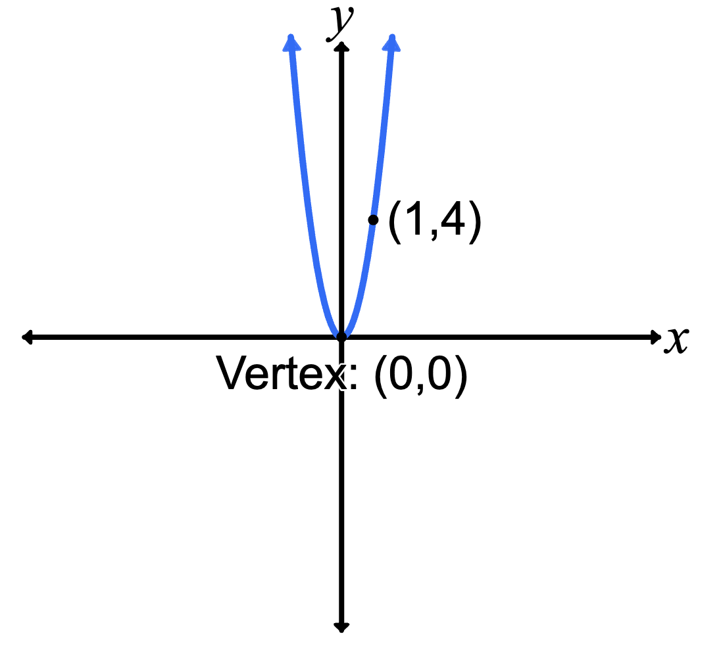 | - Vertex  - $y$-intercept  - One $x$-intercept  - 2 $x$-intercepts  - Axis of symmetry | - Sufficient features?
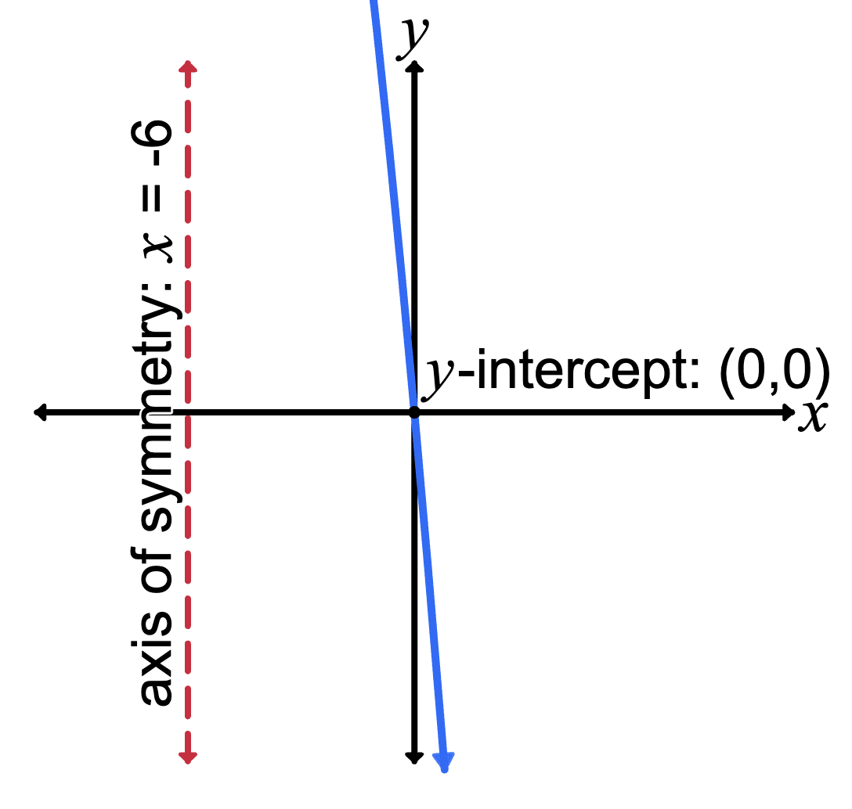 | - Vertex  - $y$-intercept  - One $x$-intercept  - 2 $x$-intercepts  - Axis of symmetry | - Sufficient features?
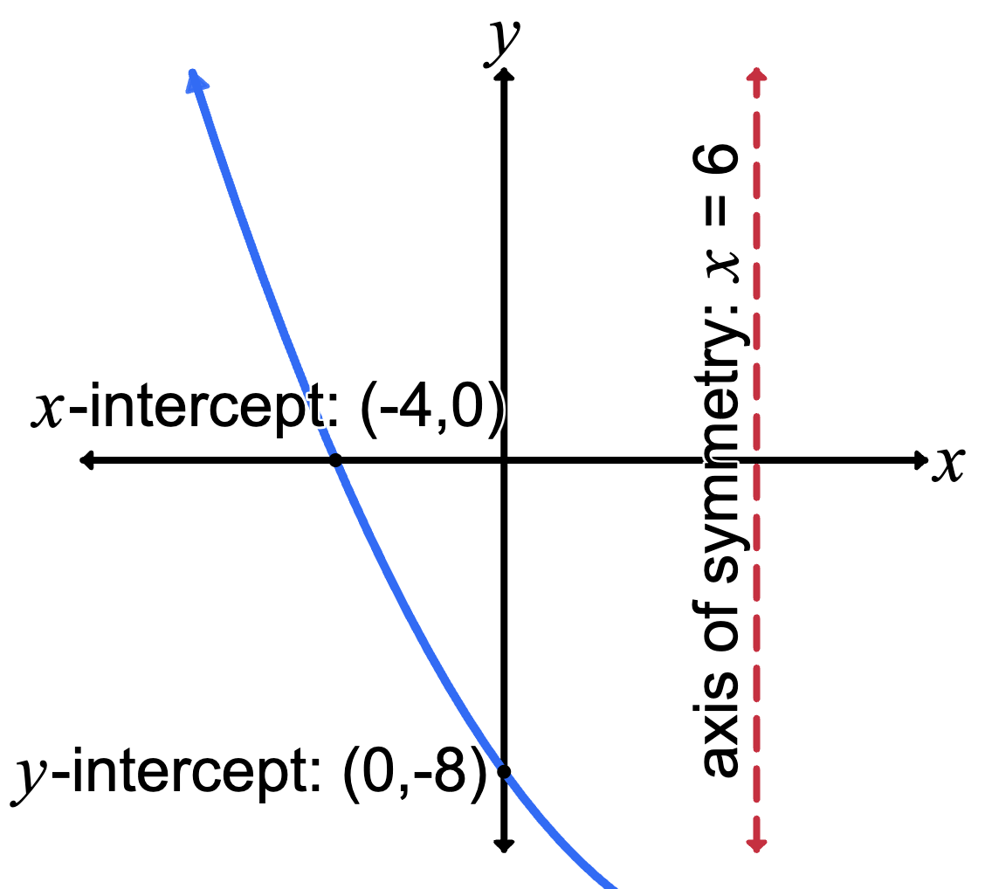 | - Vertex  - $y$-intercept  - One $x$-intercept  - 2 $x$-intercepts  - Axis of symmetry | - Sufficient features?

Appendix B

Scavenger hunt
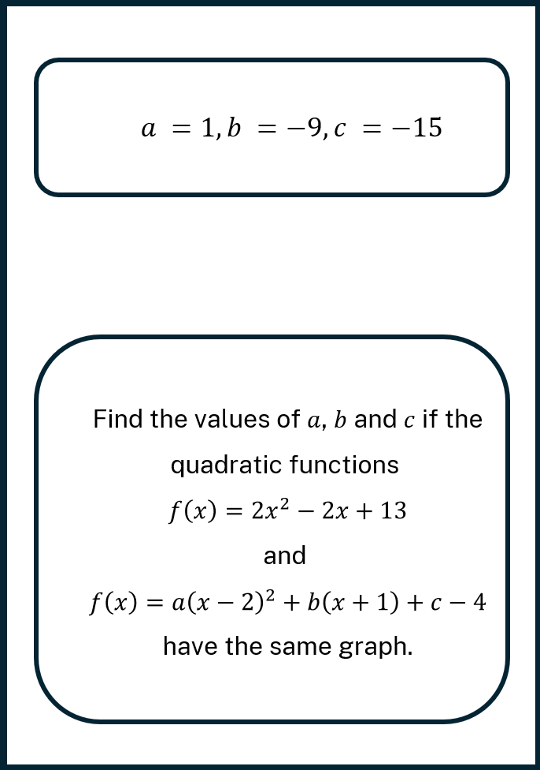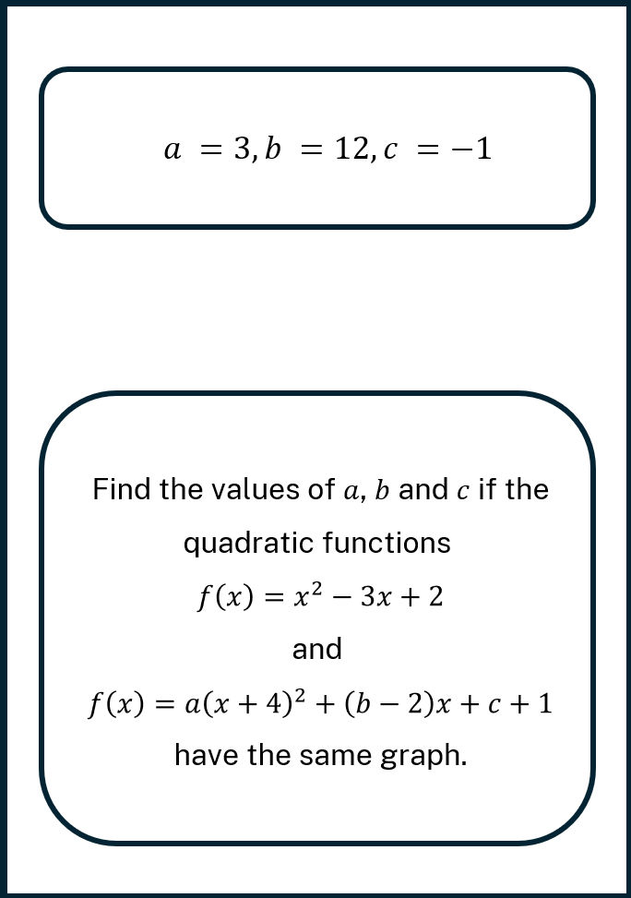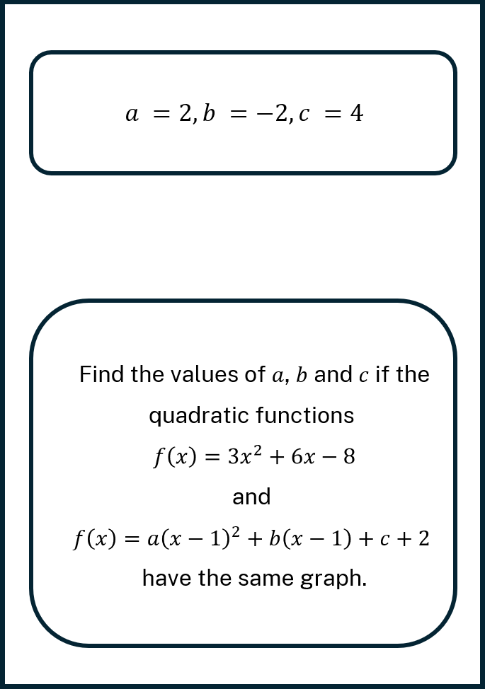
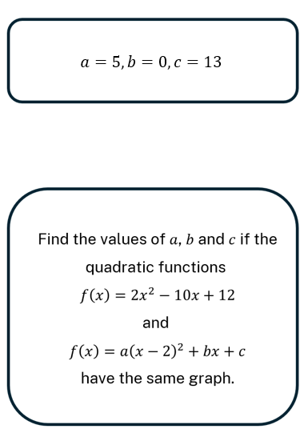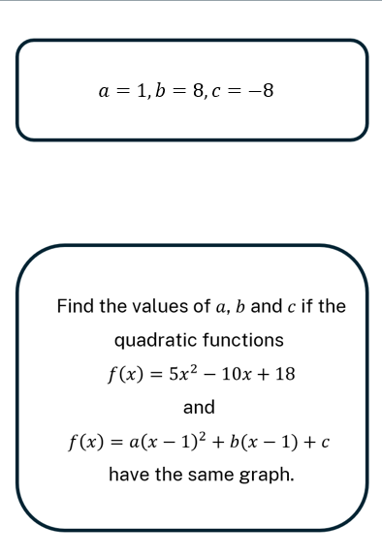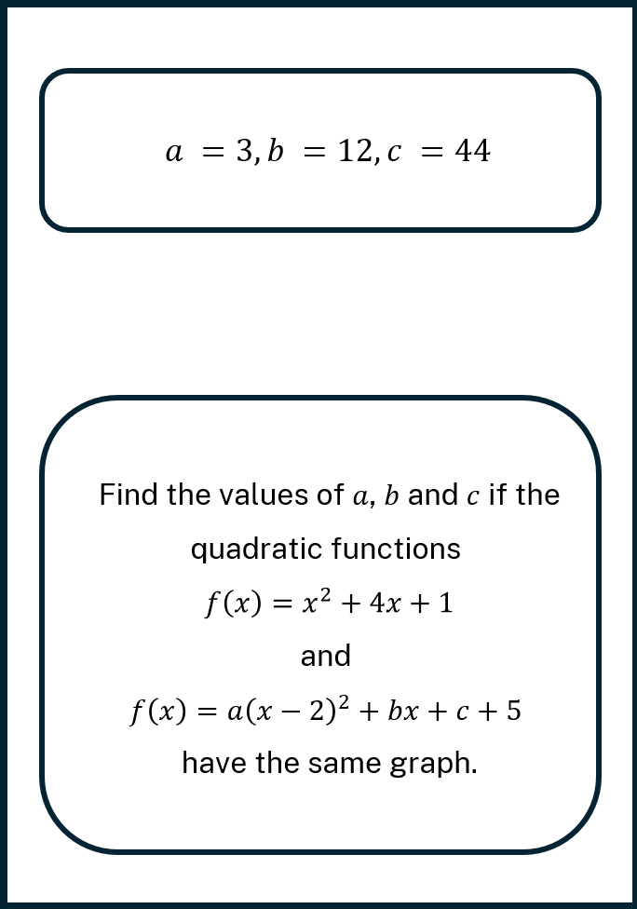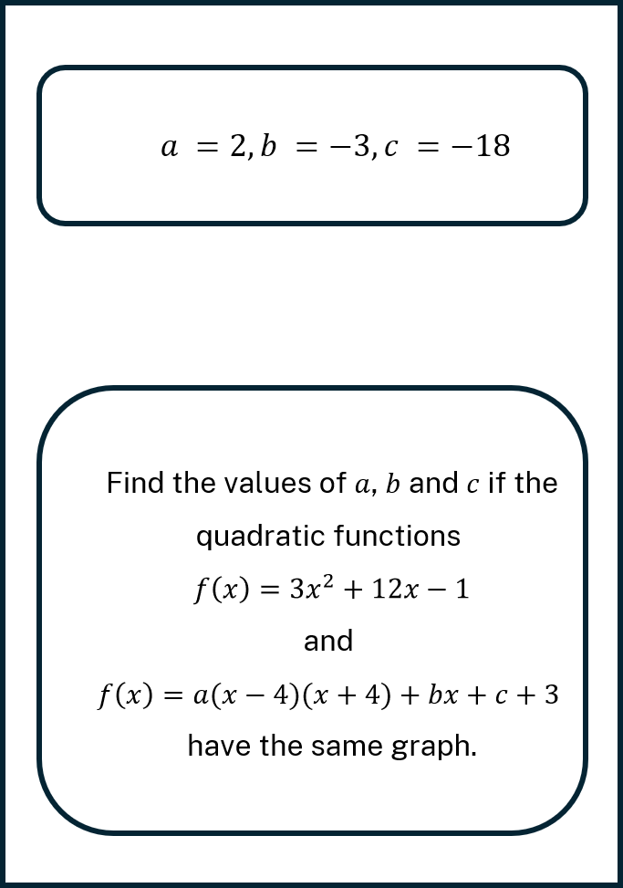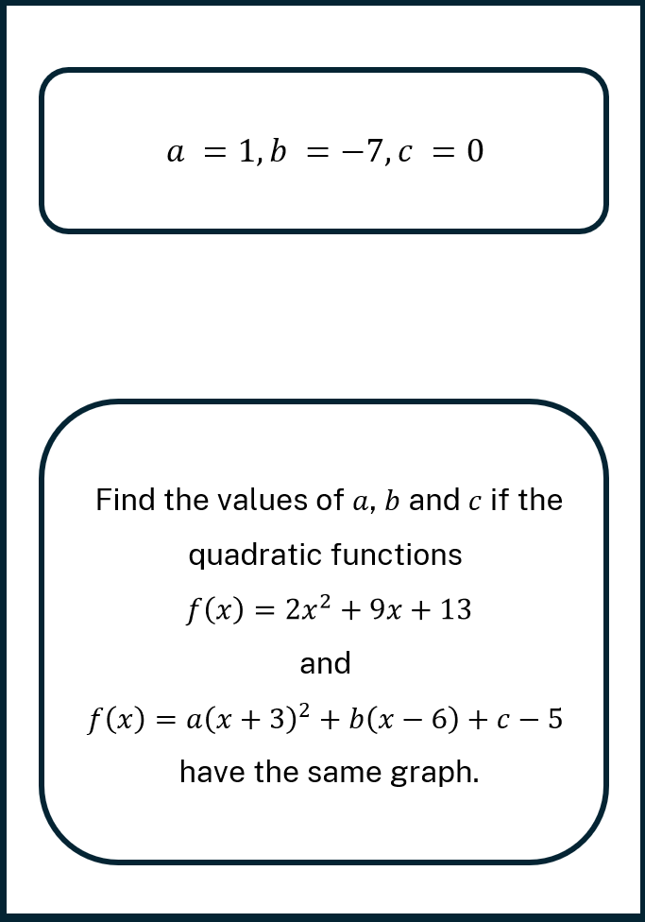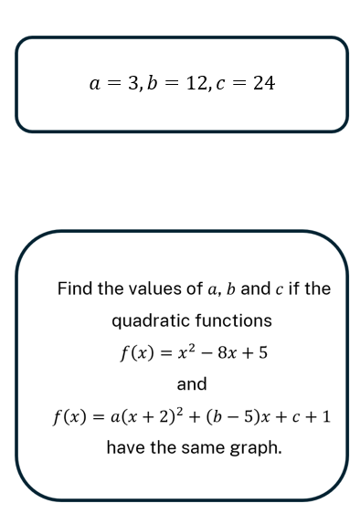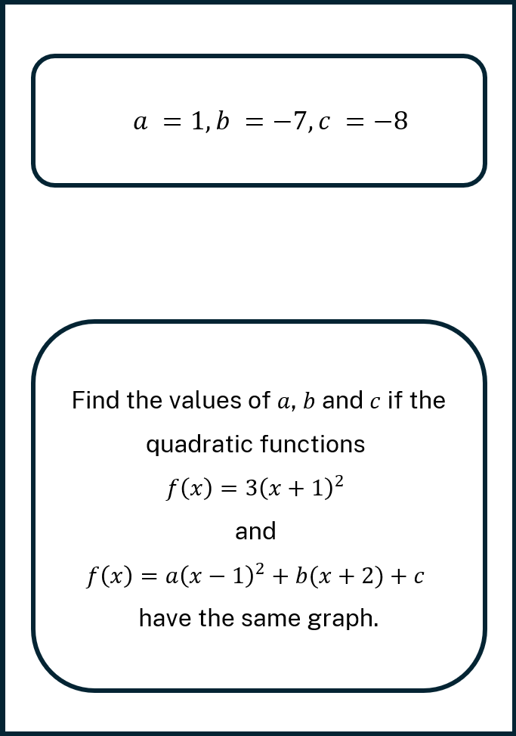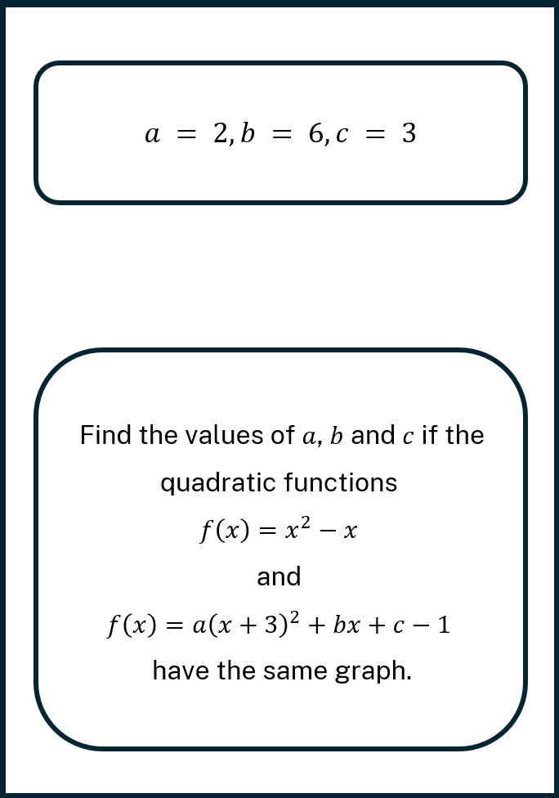

Appendix C

Exit ticket
- Understanding the features
A parabola has the vertex $(4,-2)$ and the $x$-intercepts are $(2,0)$ and $(6,0)$.
Determine the equation of this parabola.
- Equating quadratics
The following 2 quadratic functions are said to be equivalent:
$f(x)=2{\left(x-1\right)}^{2}+3$ and $g\left(x\right)=ax^{2}+bx+c$
Find the values of $a,b$and $c$ by expanding and matching coefficients.
- Equating quadratics challenge
The following 2 quadratics are equal for all vales of $x$
$$2{\left(x+1\right)}^{2}-5≡a\left(x-1\right)\left(x+3\right)+c$$Find the values of $a$ and $c$. Show all working.

Sample solutions

Appendix A – What’s enough?
Parabola | Features | Equation/explanation
 | - Vertex  - $y$-intercept  - One $x$-intercept  - 2 $x$-intercepts  - Axis of symmetry | - Sufficient features?  $$y={\left(x+2\right)}^{2}+1$$  $$y=x^{2}+4x+4+1$$  $$y=x^{2}+4x+5$$
 | - Vertex  - $y$-intercept  - One $x$-intercept  - 2 $x$-intercepts  - Axis of symmetry | - Sufficient features?  It is non-monic because we can’t see the $y$-intercept. We will need an additional point to determine the equation of the parabola to find what $a$ equals.
 | - Vertex  - $y$-intercept  - One $x$-intercept  - 2 $x$-intercepts  - Axis of symmetry | - Sufficient features?  $$y={a\left(x+4\right)}^{2}$$  $$y=a\left(x^{2}+8x+16\right)$$  $$when x=0, y=8$$  $$8=16a$$  $$a=\frac{1}{2}$$  $$y={\frac{1}{2}\left(x+4\right)}^{2}$$
 | - Vertex  - $y$-intercept  - One $x$-intercept  - 2 $x$-intercepts  - Axis of symmetry | - Sufficient features?  Since all the features are the same point, we need at least one more point to verify if it is non-monic.
 | - Vertex  - $y$-intercept  - One $x$-intercept  - 2 $x$-intercepts  - Axis of symmetry | - Sufficient features?  $$y={ax}^{2}$$  $$when x=1, y=4$$  $$4=a$$  $$y=4x^{2}$$
 | - Vertex  - $y$-intercept  - One $x$-intercept  - 2 $x$-intercepts  - Axis of symmetry | - Sufficient features?  Can’t determine if it is monic or non-monic as there is insufficient information to determine a.
 | - Vertex  - $y$-intercept  - One $x$-intercept  - 2 $x$-intercepts  - Axis of symmetry | - Sufficient features?  $$y=a(x+4)(x-16)$$  $$y=a\left(x^{2}-12x-64\right)$$  $$when x=0, y=-8$$  $$-8=-64a$$  $$a=\frac{1}{8}$$  $$y=\frac{1}{8}(x+4)(x-16)$$

Appendix B – scavenger hunt
Problem 1  Given:  $$f\left(x\right)=x^{2}-x$$  $$f\left(x\right)=a{\left(x+3\right)}^{2}+b x+c-1 \\ =ax²+(6a+b)x+(9a+c-1)$$  Equate coefficients:  Match coefficients with $x²-x+0$:  $$→a=1$$  $$→6a+b=-1⇒b=-7$$  $$→9a+c-1=0⇒c=-8$$ | Problem 2  Given:  $$f\left(x\right)=3{\left(x+1\right)}^{2}$$  $$f\left(x\right)=a{\left(x-1\right)}^{2}+b\left(x+2\right)+c \\ =ax²+(-2a+b)x+(a+2b+c)$$Equate coefficients:  Match with $3x^{2}+6x+3$:  $$→a=3$$  $$→-2a+b=6⇒b=12$$  $$→ a+2b+c=3⇒c=24$$
Problem 3  Given:  $$f(x)=x²-8x+5$$  $$f\left(x\right)=a{\left(x+2\right)}^{2}+\left(b-5\right)x+c+1 \\ =ax²+(4a+b-5)x+(4a+c+1)$$Equate coefficients:  Match with $x^{2}-8x+5$:  $$→a=1$$  $$→4a+b-5=-8⇒b=-7$$  $$→4a+c+1=5⇒c=0$$ | Problem 4  Given:  $$f(x)=2x²+9x+13$$  $$f\left(x\right)=a{\left(x+3\right)}^{2}+b\left(x-6\right)+c-5 \\ =ax²+(6a+b)x+(9a-6b+c-5)$$Equate coefficients:  Match with $2x²+9x+13$:  $$→a=2 \\ →6a+b=9⇒b=-3 \\ →9a-6b+ c-5=13⇒c=-18$$
Problem 5  Given:  $$f(x)=3x²+12x-1$$  $$f\left(x\right)=a\left(x-4\right)\left(x+4\right)+bx+c+3 \\ =ax²+bx+(-16a+c+3)$$  Equate coefficients:  Match with $3x²+12x-1$:  $$→a=3 \\ →b=12 \\ →-16a+c+3=-1⇒c=44$$ | Problem 6  Given:  $$f(x)=x²+4x+1$$  $$f\left(x\right)=a{\left(x-2\right)}^{2}+bx+c+5 \\ =ax²+(-4a+b)x+(4a+c+5)$$Equate coefficients:  Match with $x²+4x+1$:  $$→a=1 \\ →-4a+b=4⇒b=8 \\ →4a+c+5=1⇒c=-8$$

Problem 7  Given:  $$f\left(x\right)=5x^{2}-10x+18$$  $$f\left(x\right)=a{\left(x-1\right)}^{2}+b\left(x-1\right)+ c \\ =ax²+(-2a+b)x+(a-b+c)$$  Equate coefficients:  Match with $5x^{2}-10x+18$:  $$→a=5 \\ →-2a+b=-10⇒b=0 \\ →a-b+c=18⇒c=13$$ | Problem 8  Given:  $$f(x)=2x²-10x+12$$  $$f\left(x\right)=a{\left(x-2\right)}^{2}+bx+c \\ =ax²+(-4a+b)x+(4a+c)$$  Equate coefficients:  Match with $2x²-10x+12$:  $$→a=2 \\ →-4a+b=-10⇒b=-2 \\ →4a+c=12⇒c=4$$
Problem 9  Given:  $$f(x)=3x²+6x-8$$  $$f\left(x\right)=a{\left(x-1\right)}^{2}+b\left(x-1\right)+c+2 \\ =ax²+(-2a+b)x+(a-b+c+2)$$  Equate coefficients:  Match with $3x²+6x-8$:  $$→a=3 \\ →-2a+b=6⇒b=12 \\ →a-b+c+2=-8⇒c=-1$$ | Problem 10  Given:  $$f(x)=x²-3x+2$$  $$f\left(x\right)=a{\left(x+4\right)}^{2}+\left(b-2\right)x+c+1 \\ =ax²+(8a+b-2)x+(16a+c+1)$$  Equate coefficients:  Match with $x²-3x+2$:  $$→a=1 \\ →8a+b-2=-3⇒b=-9 \\ →16a+c+1=2⇒c=-15$$
Problem 11
Given:
$$f(x)=2x²-2x+13$$
$$f\left(x\right)=a{\left(x-2\right)}^{2}+b\left(x+1\right)+c-4 \\ =ax²+(-4a+b)x+(4a+b +c-4)$$
Equate coefficients:
Match with $2x²-2x+13$:
$$→a=2 \\ →-4a+b=-2⇒b=6 \\ →4a+b+c-4=13⇒c=3$$

Appendix C – exit ticket
- Roots are $x=2$and $x=6∴f\left(x\right)=a\left(x-2\right)\left(x-6\right)$
Using the vertex $\left(4, -2\right)$ we get $a=\frac{1}{2}$
Hence $f\left(x\right)=\frac{1}{2}(x-2)(x-6)$.
- $2{\left(x-1\right)}^{2}+3≡ax^{2}+bx+c$$$2\left(x^{2}-2x+1\right)+3≡ax^{2}+bx+c \\ 2x^{2}-4x+5≡ax^{2}+bx+c$$Hence, $a=2, b= -4, c=5$.
- $2{\left(x+1\right)}^{2}-5≡a\left(x-1\right)\left(x+3\right)+c$$$2x^{2}+4x-3≡ax^{2}+2ax-3a+c \\ ∴a=2 \\ -3a+c=-3$$$c=3$.

References
This resource contains NSW Curriculum and syllabus content. The NSW Curriculum is developed by the NSW Education Standards Authority. This content is prepared by NESA for and on behalf of the Crown in right of the State of New South Wales. The material is protected by Crown copyright.
Please refer to the NESA Copyright Disclaimer for more information https://educationstandards.nsw.edu.au/wps/portal/nesa/mini-footer/copyright.
NESA holds the only official and up-to-date versions of the NSW Curriculum and syllabus documents. Please visit the NSW Education Standards Authority (NESA) website https://educationstandards.nsw.edu.au/ and the NSW Curriculum website https://curriculum.nsw.edu.au/.
Mathematics Advanced 11–12 Syllabus © NSW Education Standards Authority (NESA) for and on behalf of the Crown in right of the State of New South Wales, 2024.

© State of New South Wales (Department of Education), 2025
The copyright material published in this resource is subject to the Copyright Act 1968 (Cth) and is owned by the NSW Department of Education or, where indicated, by a party other than the NSW Department of Education (third-party material).
Copyright material available in this resource and owned by the NSW Department of Education is licensed under a Creative Commons Attribution 4.0 International (CC BY 4.0) license.

This license allows you to share and adapt the material for any purpose, even commercially.
Attribution should be given to © State of New South Wales (Department of Education), 2025.
Material in this resource not available under a Creative Commons license:
- the NSW Department of Education logo, other logos and trademark-protected material
- material owned by a third party that has been reproduced with permission. You will need to obtain permission from the third party to reuse its material.
Links to third-party material and websites
Please note that the provided (reading/viewing material/list/links/texts) are a suggestion only and implies no endorsement, by the New South Wales Department of Education, of any author, publisher, or book title. School principals and teachers are best placed to assess the suitability of resources that would complement the curriculum and reflect the needs and interests of their students.
If you use the links provided in this document to access a third-party's website, you acknowledge that the terms of use, including licence terms set out on the third-party's website apply to the use which may be made of the materials on that third-party website or where permitted by the Copyright Act 1968 (Cth). The department accepts no responsibility for content on third-party websites.

