The discriminant
This lesson develops students’ understanding of the discriminant as a tool to determine the number of real roots of a quadratic equation. Students use the discriminant to identify the number of $x$-intercepts and the position of the parabola relative to the $x$-axis.
Students will need at least one digital device per pair to interact with an interactive graph during this lesson.
Learning intentions and success criteria should be shared with students later in the learning episode.

Learning intention
- To be able to use the discriminant to analyse and describe the roots and graph of a quadratic function.

Success criteria
- I can calculate the discriminant and use the value to identify how many roots a quadratic equation has.
- I can use the discriminant to identify whether the roots of a quadratic equation are equal, distinct, real or rational.
- I can interpret the value of the discriminant to explain the position of a parabola in relation to the $x$-axis.
- I can solve problems using the discriminant.

Outcomes
A student:
- develops understanding and fluency in mathematics through exploring and connecting mathematical concepts, choosing and applying mathematical techniques to solve problems, and communicating their thinking and reasoning coherently and clearly MAO-WM-01
- applies algebraic techniques and the laws of indices and surds to manipulate expressions and solve problems MAV-11-01
- uses functions and relations to model, analyse and solve problems MAV-11-02

Content

Algebraic techniques
- Define the discriminant as $∆=b^{2}-4ac$ and use it to solve problems involving the number of real roots of a quadratic equation and determine the conditions for roots to be equal, distinct, real or rational

Quadratic and cubic functions
- Use the discriminant to determine the number of $x$-intercepts on a parabola and justify its position in relation to the $x$-axis
Mathematics Advanced 11–12 Syllabus © NSW Education Standards Authority (NESA) for and on behalf of the Crown in right of the State of New South Wales, 2024.

Table 1: lesson summary
Section | Summary of activity | Teaching strategies | Teaching points
Activating prior knowledge | Use slide 3 of the PowerPoint The discriminant for students to engage in a notice and wonder, before students apply the quadratic formula to find the $x$-intercepts paying attention to the value within the square root. | Notice and wonder  Pose-Pause-Pounce-Bounce | This activity activates prior knowledge of the quadratic formula and builds curiosity about how the square root value affects the number of solutions, laying the foundation for introducing the discriminant.
Connecting learning | Use slides 5–7 to highlight the discriminant in the quadratic formula and introduce ∆ notation. Provide sets of $a$, $b$ and $c$ values for students to calculate the discriminant, interpret the roots, and link to the graph using the interactive graph (bit.ly/UMdiscriminantgraph). Students then work through Appendix A. | Think-Pair-Share  Pose-Pause-Pounce-Bounce  Variation Theory | The aim of this section is to explicitly define the discriminant and connect the algebraic calculations to the visual graph. Students also build their precise mathematical language and develop a conceptual understanding.
Releasing responsibility | Use slide 9 of the PowerPoint to summarise discriminant cases with refined terminology: equal, distinct, rational and irrational. Students complete Appendix B and annotate with examples and graphs. |  | Students deepen their mathematical language with unfamiliar terms, using the discriminant to classify roots. This activity consolidates the link between the discriminant, algebra and graph representations.
Independent practice | Students use the interactive graph with varying values of $b$ and $c$ to solve posed problems, investigating discriminant-based conditions for roots.  Use slides 11–12 to model discriminant applications with worked examples. Students then complete Appendix C. | Worked examples (Your turn) | The purpose of this section is to apply students’ discriminant knowledge to solve problems and develop generalisations about how quadratic coefficients affect the number and type of solutions.

Activity structure
Please use the associated PowerPoint The discriminant to display images in this lesson.

Activating prior knowledge
- Display slide 3 of the PowerPoint, which shows 3 graphs with similar equations and ask students to consider what they notice and wonder (bit.ly/noticewonderstrategy).
Students may notice that the equations are all in the form $y=ax^{2}+bx+c$ and they all contain $y=3x^{2}+6x$ with differing values of $c$. They might wonder how changing $c$ affects the graph and why some functions have 0, 1 or 2 $x$-intercepts.
The purpose of this activity is for students to consider how adjusting the value of $c$ influences the number of $x$-intercepts, rather than exploring the overall vertical shift itself. The concept of translation will be examined in detail in Unit 4 – graph transformations.
- Ask students to locate the quadratic formula on their Mathematics Advanced – HSC reference sheet and use it to calculate the $x$-intercepts for each function shown on the slide. Prompt them to pay close attention to how the value under the square root differs for each function.
Encourage students to show their full working, as the purpose of this activity is to explore how the value varies within the square root. Even if some equations can be factorised, ask students to apply the quadratic formula to highlight how this value affects the graph.
Solutions to this can be found in the ‘Sample solution’ section.
- Use the Pose-Pause-Pounce-Bounce questioning strategy (PDF 557 KB) (bit.ly/posepausepouncebounce) to discuss what students noticed about the quadratic formula, particularly the value within the square root. Some prompting questions could include:
- What do you notice about the relationship between the value within the square root and the number of $x$-intercepts?
- Will this relationship hold for all quadratics? Why or why not?
Students may state that:
- A positive value within the square root (such as 12) produced 2 $x$-intercepts.
- When the value within the square root was zero, this parabola had one $x$-intercept and the vertex occurred on the $x$-axis.
- A negative value within the square root (such as –12) meant there were no $x$-intercepts.

Connecting learning
- Display slide 5 of the PowerPoint to reveal the learning intention and success criteria for the lesson.
- Display slide 6 which displays the quadratic formula, highlighting the axis of symmetry formula.
Students examined how the quadratic formula shows the axis of symmetry in Lesson 9 – the quadratic formula. They may like to revisit their earlier working to confirm that $x=1$ consistently appears as the axis of symmetry in each example.
- Explain to students that they will now be analysing the section of the formula that is within the square root. Animate the slide, defining the discriminant in relation to the quadratic formula.
- Introduce the symbol delta (Δ), a Greek letter commonly used in mathematics to represent ‘change’ and explain that it is the label used for the discriminant of a quadratic equation.
- Display slide 7 and connect the discriminant’s value to the ‘Activating prior knowledge’ activity, where students examined how different values determine the number of $x$-intercepts of a parabola.
- Explain to students that the solutions to an equation can also be defined as roots.
The NESA syllabus glossary defines a root as ‘the solution to an equation. For example, $\left(x-1\right)\left(x+3\right)=0$ has roots $x=1$ and $x=-3$’ (NESA 2024).
Students may need to review the term ‘real’ which was defined in Lesson 5 – domain and range of Unit 2 – introduction to functions.
- Animate slide 7 to show how the different values of the discriminant relate to the number of roots.
- Explain to students that you will provide values of $a$,$b$ and $c$ verbally. In a Think-Pair-Share (bit.ly/thinkpairsharestrategy) have students:
- calculate the discriminant
- interpret the number of roots this quadratic equation has
- make connections to what this may represent visually on the graph of the quadratic.
- Some examples of $a$, $b$, and $c$ combinations are provided below, although a range could be explored. For each row, read the values aloud. After students share their responses, display the interactive graph (bit.ly/UMdiscriminantgraph) to link the algebraic calculations to the parabola’s graph.
Question | $$a$$ | $$b$$ | $$c$$ | $$∆=b^{2}-4ac$$
1 | $$1$$ | $$-1$$ | $$-2$$ | $$∆ =9$$
2 | $$2$$ | $$-1$$ | $$2$$ | $$∆ =-7$$
3 | $$-2$$ | $$4$$ | $$-2$$ | $$∆ =0$$
This will help students connect the algebraic concept of finding the discriminant to the conceptual understanding and the visual representation.
- Use the Pose-Pause-Pounce-Bounce questioning strategy to discuss the link between the discriminant and the position of the graph of a quadratic function. Prompting questions could include:
- What part of the quadratic formula is left if $∆=0$? What does this mean for the position of the graph?
- What happens if $∆<0$? What does this mean for the position of the graph?
- What happens if $∆>0$? What does this mean for the position of the graph?
Students may describe that $-\frac{b}{2a}$ still remains in the quadratic formula when $∆ =0$, which is the axis of symmetry formula and means that there is only one $x$-intercept since there is only one solution to the axis of symmetry.
Students may benefit from having the following terminology clarified, explaining that functions have zeroes and equations have roots.
For example, for the function $f\left(x\right)=(x-1)(x+3)$:
- The solution to the equation $\left(x-1\right)\left(x+3\right)=0$ is $x=1$and$-3$.
- The roots of the equation $\left(x-1\right)\left(x+3\right)=0$ are $x=1$and$-3$.
- The zeros of the function, $f(x)$, are $1$ and $-3$, since a zero is the solution of the equation $f\left(x\right)=0$.
- The graph of $f(x)$ has $x$-intercepts at $(1,0)$ and $(-3,0)$.
- Distribute Appendix A ‘Using the discriminant’ for students to work through in pairs. This activity uses Variation Theory (variationtheory.com/introduction) to help students identify how small changes to a quadratic function affect the discriminant, the number of $x$-intercepts and the position of the graph in relation to the $x$-axis.
Students can use the interactive graph (bit.ly/UMdiscriminantgraph) to confirm their answers.
- Initiate a class discussion to discuss the benefits of determining the discriminant, reflecting on its significance. A suggested prompt might be: ‘Why might this be useful before we even solve the quadratic?’
- Have each pair sketch the second and third quadratic functions from Appendix A ‘Using the discriminant’, $y=2x^{2}-3x-3$ and $y=2x^{2}-x-3$, clearly labelling the intercepts.
- Use a Pose-Pause-Pounce-Bounce questioning strategy to help students investigate how the value of the $x$-intercepts of each quadratic function they sketched differed. Suggested prompts might include:
- How do the $x$-intercept values differ for each quadratic function ($x≈2.186, -0.686$ and $x=1.5, -1)$?
- How do the discriminant values differ ($∆=33$ and $∆=25$)?
- Can you summarise a rule that links the discriminant to whether the solution will be rational or irrational?
Students may need further pairs of quadratic functions to compare and generalise a rule, such as $y=x^{2}-6x+5$ ($∆ =16$) and $y=x^{2}-6x+4$ ($∆ =20$).
- Conclude with students that if the discriminant is a square number, the parabola has 2 rational $x$-intercepts. This is because the square root of the discriminant will be a rational number, so applying the quadratic formula gives rational solutions.

Releasing responsibility
- Display slide 9 of the PowerPoint, which shows in detail how the discriminant determines the number and type of solutions.
- Initiate a class discussion to analyse the new terminology and connect it to the previous activity, Appendix A. The unfamiliar terms have been highlighted in red text.
- ‘One real root’ has now been replaced with ‘2 equal real roots’, when $∆=0$. Explain to students that 2 real roots are the same as saying one real root and that the root is rational. Question 5 from Appendix A can be used to explain this.
- ‘Two real roots’, has been expanded to include the word ‘distinct’. Explain that distinct means ‘different, not equal’ (NESA 2024).
- The 2 real distinct roots can then be classified as either rational or irrational.
The following activity has been modified from Lesson 13 – discriminating the discriminant of Stage 5 Unit 12 – investigating parabolas.
- Distribute Appendix B ‘Flowchart’ to each student. Have students work in pairs to complete the flowchart.
- Once pairs have completed their flowchart, have them return to Appendix A and describe the roots using the new language of equal, distinct, rational and irrational. Students can then use these quadratic functions as examples on their flowchart, by adding the equation and sketching the related graph for each category on the flowchart.
- Have students complete practice questions from an existing resource where they have to calculate the discriminant and identify if the roots will be equal, distinct, real or rational. Students should then connect this to the graphical representation of the quadratic equation.

Independent practice
- Pose the following problem for the class to consider.
For what values of $c$ will the parabola, $y=x^{2}+2x+c$, have no real$x$-intercepts, one $x$-intercept or 2 distinct real $x$-intercepts?
- Have pairs investigate the problem using interactive graph (bit.ly/UMdiscriminantgraph).
Students should discover that if:
- $c<1$ the parabola had 2 distinct real $x$-intercepts
- $c=1$ the parabola had one $x$-interecepts
- $c>1$, the parabola had no $x$ intercepts.
- Pose the following problem for the class to consider, and have pairs continue to use the interactive graph (bit.ly/UMdiscriminantgraph).
For what values of $b$ will the parabola, $y=x^{2}+bx+1$, have no real$x$- intercepts, one $x$-intercept or 2 distinct real $x$-intercepts?
Students should discover that if:
- $b<-2$ or $b>2$ the parabola has 2 distinct real $x$-intercepts
- $b=±2$ the parabola has one $x$-intercept
- $-2<b<2$, the parabola has no $x$ intercepts.
- Explain to students that the discriminant can be used to determine these values. Prompt students to consider how the discriminant could be used and why it works.
- Use slides 11–12 of the PowerPoint to guide students through how the discriminant can be used to determine these values, using the Worked examples (Your turn) strategy (bit.ly/supportingstrategies).
- Distribute Appendix C ‘Discriminant problems’ for students to complete independently. This activity contains HSC-style problems that involve using the discriminant, where the first 2 questions relate to the previously posed problems.
These questions have been purposely selected to not contain any quadratic inequalities.
Students will learn about solving quadratic inequalities in Lesson 16 – solving quadratic inequalities.
- After completing the activity, have students compare their answers with a partner. Then, facilitate a class discussion to explore observations and insights they discovered, highlighting, for example, the differences between question 3 and question 4.

Assessment and differentiation

Suggested opportunities for differentiation
Activating prior knowledge
- Provide scaffolded quadratic formula prompts for students who need support, for example, the substitution steps could be pre-written.
- Allow confident students to extend by factorising as well as using the quadratic formula, comparing methods.
Connecting learning
- Allow students to check their reasoning using the interactive graph.
- Challenge students to generate their own quadratics with a chosen discriminant value.
Releasing responsibility
- The flowchart activity can be completed by printing Appendix C on A3 paper for students to discuss and complete a draft copy, before distributing an individual A4 size copy of Appendix C for students to complete their own summary.
- Offer a glossary of terms (equal roots, distinct roots, rational) with definitions and examples for students who need help with the new vocabulary.
Independent practice
- Students may benefit from reviewing solving linear inequalities prior to these activities.
- Encourage use of interactive graph for visual learners, to graph their quadratic equation once they have found the value of $m$ to confirm their understanding.
- Challenge students to create their own quadratic functions and specify conditions on $b$ or $c$ for several types of roots.

Suggested opportunities for assessment
Activating prior knowledge
- Observe the ‘notice and wonder’ responses to gauge students’ prior understanding of quadratic function graphs.
- Use responses from class discussions to assess students’ reasoning on the value within the square root.
Connecting learning
- Monitor Think–Pair–Share discussions to see if students can link the discriminant value to number of roots.
- Ask pairs to justify their answers using both algebraic working and graph interpretation.
- Assess accuracy of sketches from Appendix A.
Releasing responsibility
- Review students’ completed flowcharts to ensure correct classification of roots and accurate sketches of graphs.
- Have pairs swap flowcharts to compare how each set of examples has been labelled, discussing any differences or misconceptions.
Independent practice
- Observe whether students can use discriminant values, that is, not just graphs to justify their answers.

Appendix A

Using the discriminant
Complete the table below by predicting how the minor change in the previous row will affect your answers before calculating.
Question | Quadratic function of a parabola | Calculate the discriminant ($∆$) | Number of real $x$-intercepts on the parabola | Justify the position of the parabola in relation to the $x$-axis
1 | $$y=2x^{2}-3x+3$$ | $$∆ ={\left(-3\right)}^{2}-4(2)(3) \\ =-15$$ | No real roots, $∴$ no real $x$- intercepts | The parabola is concave up, meaning that the graph is entirely above the $x$-axis.
2 | $$y=2x^{2}-3x-3$$
3 | $$y=2x^{2}-x-3$$
4 | $$y=2x^{2}+8x-3$$
5 | $$y={2x}^{2}+8x+8$$
6 | $$y=-2x^{2}+8x+8$$
7 | $$y=-2x^{2}-6x-8$$

Appendix B

Flowchart
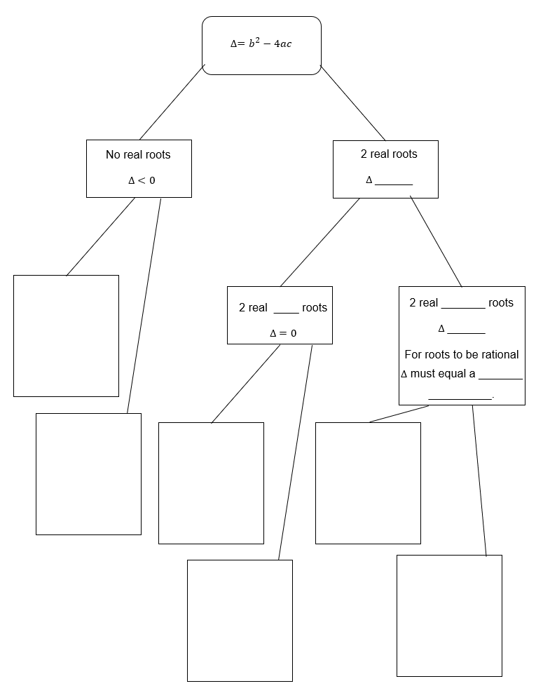

Appendix C

Discriminant problems
Use the discriminant to answer the following problems.
- Find the values of $c$ for which the parabola, $y=x^{2}+2x+c$, has no $x$-intercepts.
- Find the values of $b$ for which the parabola, $f\left(x\right)=x^{2}+bx+1$ has 2 equal $x$-intercepts.
- For the quadratic equation, $x^{2}-4x+\left(5-3k\right)=0$, find the values of $k$ such that the equation has 2 real roots.
- For the quadratic equation, $x^{2}-4x+\left(5-3k\right)=0$, find the values of $k$ such that the equation has 2 real distinct roots.
- For the quadratic equation, $y=x^{2}+\left(k-3\right)x+k+2$, find the values of $k$ for which the parabola has one $x$-intercept.

Sample solutions

Activating prior knowledge solution
Graph 1 | Graph 2 | Graph 3
$$f\left(x\right)=3x^{2}+6x+2$$  Let $f\left(x\right)=0$  $$3x^{2}+6x+2=0$$  Using the quadratic formula  $$x=\frac{-(6)±\sqrt{{\left(6\right)}^{2}-4(3)(2)}}{2(3)} \\ =\frac{-6±\sqrt{12}}{6} \\ =\frac{-6±2\sqrt{3}}{6} \\ =\frac{-3±\sqrt{3}}{3} \\ =\frac{-3+\sqrt{3}}{3} \text{or }\frac{-3-\sqrt{3}}{3} \\ =-1.566 \text{or}-0.422$$ | $$f\left(x\right)=3x^{2}+6x+3$$  Let $f\left(x\right)=0$  $$3x^{2}+6x+3=0$$  Using the quadratic formula  $$x=\frac{-(6)±\sqrt{{\left(6\right)}^{2}-4(3)(3)}}{2(3)} \\ =\frac{-6±\sqrt{0}}{6} \\ =-\frac{6}{6} \\ =-1$$ | $$f\left(x\right)=3x^{2}+6x+4$$  Let $f\left(x\right)=0$  $$3x^{2}+6x+4=0$$  Using the quadratic formula  $$x=\frac{-(6)±\sqrt{{\left(6\right)}^{2}-4(3)(4)}}{2(3)} \\ x=\frac{-6±\sqrt{-12}}{6}$$  $∴x \text{has no real solutions}$

Appendix A – using the discriminant
 | Quadratic function | Calculate the discriminant | Number of real $x$-intercepts | Justify its position in relation to the $x$- axis
1 | $$y=2x^{2}-3x+3$$ | $$∆ ={\left(-3\right)}^{2}-4(2)(3) \\ =-15$$ | No real roots, $∴$ no real $x$-intercepts | The parabola is concave up, meaning that the graph is entirely above the $x$-axis.
2 | $$y=2x^{2}-3x-3$$ | $$∆ ={\left(-3\right)}^{2}-4(2)(-3) \\ =33$$ | 2 real roots, $∴$ 2 real $x$-intercepts | The graph is positioned so that it crosses the $x$-axis twice, at its 2 $x$-intercepts.
3 | $$y=2x^{2}-x-3$$ | $$∆ ={\left(-1\right)}^{2}-4(2)(-3) \\ =25$$ | 2 real roots, $∴$ 2 real $x$- intercepts | The graph is positioned so that it crosses the $x$-axis twice, at its 2 $x$-intercepts.
4 | $$y=2x^{2}+8x-3$$ | $$∆ ={\left(8\right)}^{2}-4(2)(-3) \\ =88$$ | 2 real roots, $∴$ 2 real $x$- intercepts | The graph is positioned so that it crosses the $x$-axis twice, at its 2 $x$-intercepts.
5 | $$y={2x}^{2}+8x+8$$ | $$∆ ={\left(8\right)}^{2}-4(2)(8) \\ =0$$ | One real root, $∴$ 2 real $x$- intercepts | The graph is positioned such that the vertex is on the $x$-axis and the parabola is concave up.
6 | $$y=-2x^{2}+8x+8$$ | $$∆ ={\left(8\right)}^{2}-4(-2)(8) \\ =128$$ | 2 real roots, $∴$ 2 real $x$-intercepts | The graph is positioned so that it crosses the $x$-axis twice, at its 2 $x$-intercepts.
7 | $$y=-2x^{2}-6x-8$$ | $$∆ ={\left(-6\right)}^{2}-4(-2)(-8) \\ =-28$$ | No real roots, $∴$ no real $x$- intercepts | The parabola is concave down, meaning that the graph is entirely below the $x$-axis.

Appendix B – flowchart
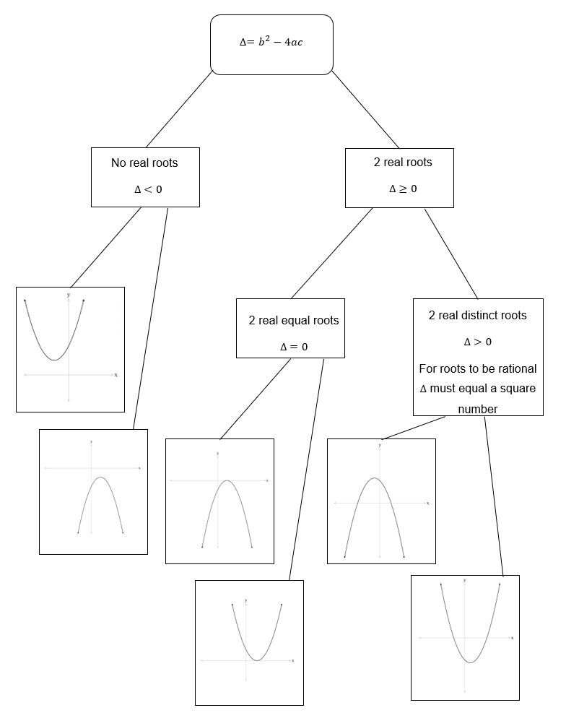

Appendix C – discriminant problems
- Find the values of $c$ for which the parabola, $y=x^{2}+2x+c$, has no $x$-intercepts.
$$∆ ={\left(2\right)}^{2}-4(1)(c) \\ =4-4c$$
$$∆<0$$
$$4-4c<0 \\ -4c<-4 \\ c>1$$
- Find the values of $b$ for which the parabola, $f\left(x\right)=x^{2}+bx+1$ has 2 equal $x$-intercepts.
$$∆ ={\left(b\right)}^{2}-4(1)(1) \\ =b^{2}-4$$
$$∆ =0$$
$$b^{2}-4=0 \\ b^{2}=4 \\ b=±2$$
- For the quadratic equation, $x^{2}-4x+\left(5-3k\right)=0$, find the values of $k$ such that the equation has 2 real roots.
$$∆ ={\left(-4\right)}^{2}-4(1)(5-3k) \\ =16-4(5-3k) \\ =16-20+12k \\ =12k-4$$
$$∆ ≥0$$
$$12k-4≥0 \\ 12k≥4 \\ k≥\frac{1}{3}$$

- For the quadratic equation, $x^{2}-4x+\left(5-3k\right)=0$, find the values of $k$ such that the equation has 2 real distinct roots.
$$∆ ={\left(-4\right)}^{2}-4(1)(5-3k) \\ =16-4(5-3k) \\ =16-20+12k \\ =12k-4$$
$$∆ >0$$
$$12k-4>0 \\ 12k>4 \\ k>\frac{1}{3}$$
- For the quadratic equation, $y=x^{2}+\left(k-3\right)x+k+2$, find the values of $k$ for which the parabola has no $x$-intercepts.
$$∆ ={\left(k-3\right)}^{2}-4(1)(k+2) \\ =k^{2}-6k+9-4k-8 \\ =k^{2}-10k+1$$
$$∆ =0$$
$$k^{2}-10k+1=0$$
$$k=\frac{-\left(-10\right)±\sqrt{{\left(-10\right)}^{2}-4(1)(1)}}{2(1)} \\ =\frac{10±\sqrt{96}}{2} \\ =\frac{10±4\sqrt{6}}{2} \\ =5±2\sqrt{6}$$

References
This resource contains NSW Curriculum and syllabus content. The NSW Curriculum is developed by the NSW Education Standards Authority. This content is prepared by NESA for and on behalf of the Crown in right of the State of New South Wales. The material is protected by Crown copyright.
Please refer to the NESA Copyright Disclaimer for more information https://educationstandards.nsw.edu.au/wps/portal/nesa/mini-footer/copyright.
NESA holds the only official and up-to-date versions of the NSW Curriculum and syllabus documents. Please visit the NSW Education Standards Authority (NESA) website https://educationstandards.nsw.edu.au/ and the NSW Curriculum website https://curriculum.nsw.edu.au/.
Mathematics Advanced 11–12 Syllabus © NSW Education Standards Authority (NESA) for and on behalf of the Crown in right of the State of New South Wales, 2024.

© State of New South Wales (Department of Education), 2025
The copyright material published in this resource is subject to the Copyright Act 1968 (Cth) and is owned by the NSW Department of Education or, where indicated, by a party other than the NSW Department of Education (third-party material).
Copyright material available in this resource and owned by the NSW Department of Education is licensed under a Creative Commons Attribution 4.0 International (CC BY 4.0) license.

This license allows you to share and adapt the material for any purpose, even commercially.
Attribution should be given to © State of New South Wales (Department of Education), 2025.
Material in this resource not available under a Creative Commons license:
- the NSW Department of Education logo, other logos and trademark-protected material
- material owned by a third party that has been reproduced with permission. You will need to obtain permission from the third party to reuse its material.
Links to third-party material and websites
Please note that the provided (reading/viewing material/list/links/texts) are a suggestion only and implies no endorsement, by the New South Wales Department of Education, of any author, publisher, or book title. School principals and teachers are best placed to assess the suitability of resources that would complement the curriculum and reflect the needs and interests of their students.
If you use the links provided in this document to access a third-party's website, you acknowledge that the terms of use, including licence terms set out on the third-party's website apply to the use which may be made of the materials on that third-party website or where permitted by the Copyright Act 1968 (Cth). The department accepts no responsibility for content on third-party websites.

