Rationalising the denominator
This lesson builds on students’ understanding of solving quadratic equations and the difference of two squares to introduce and apply the process of rationalising the denominator. Students connect algebraic and geometric representations of surds to develop fluency with conjugates and the manipulation of irrational expressions.

Learning intention
- To be able to write equivalent expressions without surds in the denominator.

Success criteria
- I can apply the difference of two squares.
- I can solve quadratic equations in the form $ax^{2}-c=0$.
- I can explain why $\frac{1}{\sqrt{a}}$ and $\frac{\sqrt{a}}{a}$ represent the same value when $a>0$.
- I can rationalise denominators containing a single surd.
- I can rationalise denominators of surds in the form of $\frac{a}{\sqrt{b}±\sqrt{c}}$ and $\frac{\sqrt{a}±\sqrt{d}}{\sqrt{b}±\sqrt{c}}$.

Outcomes
A student:
- develops understanding and fluency in mathematics through exploring and connecting mathematical concepts, choosing and applying mathematical techniques to solve problems, and communicating their thinking and reasoning coherently and clearly MAO-WM-01
- applies algebraic techniques and the laws of indices and surds to manipulate expressions and solve problems MAV-11-01
- uses functions and relations to model, analyse and solve problems MAV-11-02

Content

Algebraic techniques
- Expand and simplify expressions involving surds
- Identify the conjugate of $\sqrt{a}±\sqrt{b}$, and rationalise the denominators of expressions of the form $\frac{a}{\sqrt{b}±\sqrt{c}}$ and $\frac{\sqrt{a}±\sqrt{d}}{\sqrt{b}±\sqrt{c}}$, where $a, b, c$ and $d$ are positive rational numbers
- Solve quadratic equations $ax^{2}+bx+c=0$ by factorisation, completing the square and using the quadratic formula $x=\frac{-b±\sqrt{b^{2}-4ac}}{2a}$ where $a, b$ and $c$ are real numbers and $a≠0$
Mathematics Advanced 11–12 Syllabus © NSW Education Standards Authority (NESA) for and on behalf of the Crown in right of the State of New South Wales, 2024.

Table 1: lesson summary
Section | Summary of activity | Teaching strategies | Teaching points
Retrieval practice | Students complete Appendix A revising factorising quadratic expressions of the form $ax^{2}+bx+c$. Class discussion surfaces connections between expanded and factorised forms, leading to the introduction of the difference of two squares, $a^{2}-b^{2}=(a+b)(a-b)$. | Visibly random groups of 3  Vertical non-permanent surfaces  Banner task | Reinforce that quadratic expressions of the form $ax^{2}-c$ can be expressed as a product of 2 binomials and surface this as a difference of two squares.
Activating prior knowledge | Students solve $2x^{2}-1=0$, identifying surd solutions and discussing their representation on the number line. Using Appendix B and slide 4 of the PowerPoint Rationalising the denominator, the class compares multiple solution strategies, recognising the equivalence of $\frac{1}{\sqrt{2}}$ and $\frac{\sqrt{2}}{2}$. | Mini whiteboards  Notice and wonder  Comparative worked examples | Build conceptual curiosity in establishing $\frac{1}{\sqrt{2}}$ and $\frac{\sqrt{2}}{2}$ are different representations of the same value.
Connecting learning | Through a Polypad visualisation on slide 6, students explore the geometric meaning of the solution to $f(x)=2x^{2}-1$. The teacher leads students to rationalising the denominator. Students extend this understanding through variation tasks in Appendix C, linking algebraic manipulation to graphical interpretations of $f\left(x\right)=3x^{2}-4$ and $g(x)=3x^{2}-2$. The concept of conjugates is foreshadowed via exploration of a complex expression such as $\frac{3+\sqrt{5}}{\sqrt{2}-1}$. | Pose-Pause-Pounce-Bounce  Variation Theory  Comparative worked examples  Mini whiteboards | Develop conceptual understanding that rationalising the denominator produces an equivalent form that’s easier to interpret geometrically and develop the reasoning behind multiplying by conjugates.
Releasing responsibility | The teacher explicitly models rationalising denominators using conjugates with slides 11–12, making connections to the difference of two squares and algebraic expansion. Use an existing resource to build further fluency with surd conjugation. Students complete notes on the content covered in the lesson. | Worked examples (Your turn)  Notes to future forgetful selves | Model the process of rationalising the denominator using a difference of two squares.
Independent practice | Students complete Appendix D, collaboratively applying Variation Theory to discern and articulate patterns between examples. |  | Apply rationalising the denominator.

Activity structure
Please use the associated PowerPoint Rationalising the denominator to display images in this lesson.

Retrieval practice
- Assign students to visibly random groups of 3 (bit.ly/visiblegroups) at vertical non-permanent surfaces (bit.ly/VNPSstrategy).
- Students are to complete the banner task (bit.ly/supportingstrategies) from Appendix A ‘Banner tasks’.
The purpose of this activity is to review students' understanding of factorising quadratic expressions of the form $ax^{2}+bx+c$. Students have previously learned this skill in Lesson 5 – factorising monic quadratic functions and Lesson 7 – factorising and graphing non-monic quadratic functions.
- Initiate a class discussion at the conclusion of this activity to connect the factorised form with the expanded form. Some suggested prompts may include:
- What did you notice about each of the expanded expressions?
- What did you notice about each of the factorised expressions?
- How might the numbers in the factorised form connect to the numbers in the expanded form?
- How does the missing middle term relate to the terms in the brackets of the factorised form?
Clearly establish that when a quadratic expression factorises into 2 factors with equal magnitude but different directions, the result can be written in the form $(a+b)(a-b)$. Explain to students that this special product, $a^{2}-b^{2}=(a+b)(a-b)$ is called the difference of two squares. Students may be familiar with this if they learned the Stage 5 Algebraic techniques C Path outcome MA5-ALG-P-02.

Activating prior knowledge
- Students use mini whiteboards (bit.ly/miniwhiteboards) to display the solutions to the equation $2x^{2}-1=0.$
It is expected that students will solve this equation through a difference of two squares leading from the retrieval practice activity or by rearranging the equation as reflected in Appendix B.
- Prompt students to consider and discuss the representation of the value of $x$ and what they notice and wonder about it (bit.ly/noticewonderstrategy).
Students should notice that the square root value is in the denominator, which they will only have previously seen if they completed related Path content in Stage 5 Indices C outcome
MA5-IND-P-02 and Stage 5 Trigonometry D outcome MA5-TRG-P-02. Students may wonder about how this length could be represented on the number line and what it means.
- Use Appendix B ‘Comparative worked example – $2x^{2}-1=0$’ and slide 4 from the PowerPoint to compare different solution approaches to solving the equation $2x^{2}-1=0$ using the Worked examples (comparison) method.
The discussion should identify that the approach using the quadratic formula is longer and produces an answer that looks different. Students may indicate by using a calculator that these 2 answers are different representations of the same value and may identify that $\frac{\sqrt{2}}{2}$ may be easier to show the representation of on the number line than $\frac{1}{ \sqrt{2}}$.
The corresponding ‘Your turn’ example has been intentionally withheld until step 4 of ‘Connecting learning’, to provide opportunity for the teacher to lead an exploration of why these representations are the same.

Connecting learning
- Display slide 6 of the PowerPoint, which contains a recording of a Polypad screen, where a representation of the length of $\sqrt{2}$ is shown in relation to the function $f\left(x\right)=2x^{2}-1$. Alternatively, the Polypad visualisation could be demonstrated in class using ‘Graph of $y=2x^{2}-1$’ (bit.ly/PolypadGraphRationalise).
The purpose of the Polypad activity is to connect solving $2x^{2}-1=0$ with finding the $x$-intercepts of $f\left(x\right)=2x^{2}-1$, as introduced in Unit 2 – introduction to functions, Lesson 2 – function values and intercepts and revisited in Lesson 6 – graphing monic quadratic functions. By positioning the length of $\sqrt{2}$, which was established in Lesson 10 – simplifying surds, between the two intercepts and halving it, students can visualise that each $x$-intercept lies $\frac{\sqrt{2}}{2}$ units from the origin, reinforcing the equivalence between their algebraic and geometric solutions.
- Lead a discussion connecting the visual of $\frac{\sqrt{2}}{2}$ to the equations and solutions. Use the Pose-Pause-Pounce-Bounce questioning strategy (PDF 557 KB) (bit.ly/posepausepouncebounce) to deepen understanding about the connection between $\frac{1}{\sqrt{2}}$ and $\frac{\sqrt{2}}{2}$. Suggested prompts can include:
- What could we multiply 1 by to get $\sqrt{2}$? How do we know this?
- What could we multiply $\sqrt{2}$ by to get $2$? How do we know this?
- Why can we multiply the numerator and denominator by $\sqrt{2}$ and still have an equivalent value?
- Summarise the discussion by introducing the concept of rationalising the denominator.
- Use slides 7–8 to continue building upon the comparative worked example explored in Appendix B and ask the students to add the step of rationalising the denominator to their copy of the examples in Appendix B.
Slide 7 checks student understanding by displaying the rationalising of the denominator and invites further reflection on which process is better. For these questions, students may identify rearranging the equation as the better process, however it will depend on the question what strategy they use.
- Distribute Appendix C ‘Expanding with surds’ which uses Variation Theory (variationtheory.com/introduction/) to connect learning through a gradual release of small changes.
- As part of a turn and talk, ask students to compare solutions, discussing variations they noticed between each question and how none of the solutions contain surds.
- On their mini whiteboards, ask students to use their solutions to questions 4 and 11 of Appendix C to assist in sketching $f\left(x\right)=3x^{2}-4$ and $g\left(x\right)=3x^{2}-2$, showing all intercepts.
- Use the Pose-Pause-Pounce-Bounce questioning strategy to draw attention to the difference of two squares playing a role in the functions featuring rational numbers and the $x$-intercepts involving surds. Suggested prompts include:
- What do you notice about the numbers in the functions when compared to the $x$-intercepts?
- How could we use the $x$-intercepts and difference of two squares to rewrite these functions?
- Reveal slide 9, which shows the number $\frac{3+\sqrt{5}}{\sqrt{2}-1}$ and inform the students that numbers can be presented in this format. Continue the questioning strategy, by posing the following question: ‘How might we use the skills we have developed so far, to rationalise the denominator of this number?’
Students do not need to work this out, however should be able to identify that a difference of two squares has been useful in converting expressions with irrational components into rational numbers.

Releasing responsibility
- Use slides 11–12 of the PowerPoint to model worked examples of rationalising the denominator by first identifying the conjugate using the Worked examples (Your turn) method.
The discussion supporting this example should unpack the role of the difference of two squares in rationalising the denominator and the similarities between surd expansion and algebraic expansion.
Students will need to be introduced to the term ‘conjugate’ and its meaning.
- Use an existing resource to build further fluency with surd conjugation.
- Students are to create notes to their future forgetful selves (bit.ly/notestofutureself) on the difference of two squares, rationalising the denominator and how to use the difference of two squares to rationalise the denominator.

Independent practice
- Distribute Appendix D ‘Rationalising the denominator spider’ to students to complete in pairs, which uses Variation Theory (variationtheory.com/introduction/).
Instructions for implementing the Spider diagram can be found on the Spider diagram page on the Variation Theory website (bit.ly/VTSpider). Slide 14 of the PowerPoint can be used to support student understanding of the routine. Note that the boxes around the edge mean the following:
- Reflect: How is this example the same and how is it different from the example in the middle?
- Expect: Based on what you noticed, can you predict anything about what the answer will be?
- Check: Work out the answer and write it in the box.
- Explain: If your expectation and check are different, can you understand the relationship now? If your expectation and check are the same, how would you explain the relationship to someone who doesn’t understand yet?
- Randomly select non-volunteer students to share their pair’s insights from their discussions related to each problem.

Assessment and differentiation

Suggested opportunities for differentiation
Retrieval practice
- Groups of 3 could be temporarily combined if misconceptions are evident, with the groups being required to justify their difference of opinion.
- The expressions in Appendix A can be adjusted to suit students’ needs.
Activating prior knowledge
- Self-explanation prompts can be modified to bring attention to other aspects of the comparison.
- A notice and wonder strategy is used where there is no correct answer, so that all students can participate in the discussion.
- Students should be challenged to make connections with relevant Stage 5 Path content from MA5-IND-P-02 and MA5-TRG-P-02.
Connecting learning
- The Pose-Pause-Pounce-Bounce questions could be modified to target deeper reasoning using the Wiederhold question matrix or asking questions that require increased critical thinking or prediction.
- The equations in Appendix C can be adjusted to suit students’ needs.
Releasing responsibility
- Worked examples can be adjusted to meet students’ needs.
- Self-explanation prompts can be modified to bring attention to other aspects of the question.
- Provide an existing resource to build fluency that reflects student capabilities and their experience of Path learning in Stage 5.

Suggested opportunities for assessment
Retrieval practice
- Students working at vertical non-permanent surfaces means the teacher can assess student progress and provide support where appropriate.
Activating prior knowledge
- Encourage students to explain their reasoning aloud as they display their work on mini whiteboards to assess depth of understanding.
- Monitor class discussion to assess student understanding of the different approaches to solving the quadratic equations and existing knowledge of surds.
Connecting learning
- Appendix C could be collected to check for understanding of rationalising the denominator.
- Monitor student responses on mini whiteboards to gauge individual understanding and identify misconceptions quickly.
- Monitor responses in class discussions to check for student understanding of the connection between difference of two squares and rationalising surds.
Releasing responsibility
- Review students ‘Your turn’ attempts for understanding of rationalising the denominator.
- Students can work with peers to self-assess their learning.
- Check student notes for understanding of rationalising the denominator.
Independent practice
- Appendix D could be collected to check for student understanding of conjugates.

Appendix A

Banner task
Factorise the following quadratic expressions:
- $x^{2}-4$
- $x^{2}-36$
- $x^{2}-121$
- $x^{2}-5$
- $x^{2}-27$
- $4x^{2}-64$
- $3x^{2}-75$
- $\frac{1}{2}x^{2}-32$

Appendix B

Comparative worked example – $2x^{2}-1=0$
Solve $2x^{2}-1=0$.
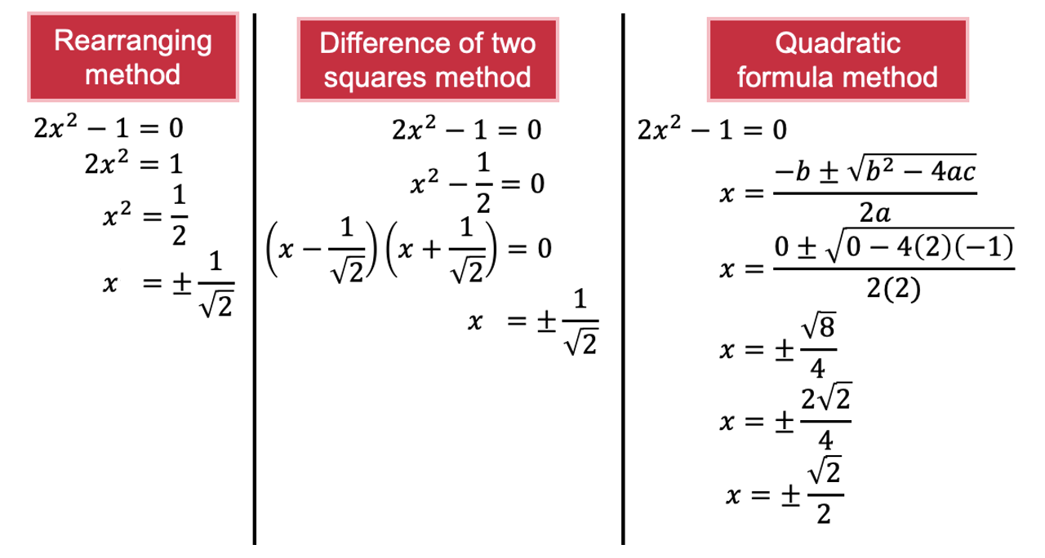
Which method is better?

Appendix C

Expanding with surds
Expand the following expressions:
- $\left(\sqrt{5}x-1\right)\left(\sqrt{5}x+1\right)$
- $\left(\sqrt{7}x-1\right)\left(\sqrt{7}x+1\right)$
- $\left(\sqrt{7}x-2\right)\left(\sqrt{7}x+2\right)$
- $\left(\sqrt{3}x-2\right)\left(\sqrt{3}x+2\right)$
- $\left(\sqrt{3}x-4\right)\left(\sqrt{3}x+4\right)$
- $(4x-\sqrt{3})(4x+\sqrt{3})$
- $4(x-\sqrt{3})(x+\sqrt{3})$
- $2(x-\sqrt{3})(x+\sqrt{3})$
- $(2x-\sqrt{3})(2x+\sqrt{3})$
- $\left(\sqrt{2}x-\sqrt{3}\right)\left(\sqrt{2}x+\sqrt{3}\right)$
- $\left(\sqrt{3}x-\sqrt{2}\right)\left(\sqrt{3}x+\sqrt{2}\right)$

Appendix D

Rationalising the denominator spider
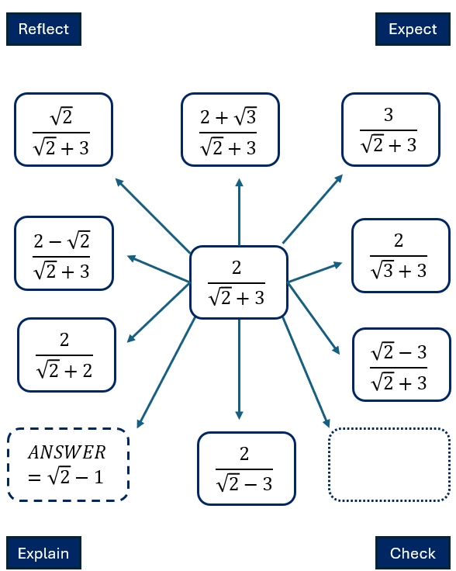

Sample solutions

Appendix A – banner task
- $x^{2}-4=(x-2)(x+2)$
- $x^{2}-36=(x-6)(x+6)$
- $x^{2}-121=(x-11)(x+11)$
- $x^{2}-5=(x-\sqrt{5})(x+\sqrt{5})$
- $x^{2}-27=\left(x-\sqrt{27}\right)\left(x+\sqrt{27}\right)$$$x^{2}-27=\left(x-3\sqrt{3}\right)\left(x+3\sqrt{3}\right)$$
- $4x^{2}-64=4\left(x^{2}-16\right)$$$4x^{2}-64=4(x-4)(x+4)$$
- $3x^{2}-75=3\left(x^{2}-25\right)$$$3x^{2}-75=3(x-5)(x+5)$$
- $\frac{1}{2}x^{2}-32=\frac{1}{2}\left(x^{2}-64\right)$$$\frac{1}{2}x^{2}-32=\frac{1}{2}(x-8)(x+8)$$

Appendix C – expanding with surds
- $\left(\sqrt{5}x-1\right)\left(\sqrt{5}x+1\right)=5x^{2}-1$
- $\left(\sqrt{7}x-1\right)\left(\sqrt{7}x+1\right)=7x^{2}-1$
- $\left(\sqrt{7}x-2\right)\left(\sqrt{7}x+2\right)=7x^{2}-4$
- $\left(\sqrt{3}x-2\right)\left(\sqrt{3}x+2\right)=3x^{2}-4$
- $\left(\sqrt{3}x-4\right)\left(\sqrt{3}x+4\right)=3x^{2}-16$
- $\left(4x-\sqrt{3}\right)\left(4x+\sqrt{3}\right)=16x^{2}-3$
- $4\left(x-\sqrt{3}\right)\left(x+\sqrt{3}\right)=4x^{2}-12$
- $2\left(x-\sqrt{3}\right)\left(x+\sqrt{3}\right)=2x^{2}-6$
- $\left(2x-\sqrt{3}\right)\left(2x+\sqrt{3}\right)=4x^{2}-3$
- $\left(\sqrt{2}x-\sqrt{3}\right)\left(\sqrt{2}x+\sqrt{3}\right)=2x^{2}-3$
- $\left(\sqrt{3}x-\sqrt{2}\right)\left(\sqrt{3}x+\sqrt{2}\right)=3x^{2}-2$

Appendix D – rationalising the denominator spider
$$\frac{\sqrt{2}}{\sqrt{2}+3}×\frac{\sqrt{2}-3}{\sqrt{2}-3}=\frac{2-3\sqrt{2} }{2-9} \\ =\frac{2-3\sqrt{2}}{-7} \\ =\frac{3\sqrt{2}-2}{7}$$ | $$\frac{2+\sqrt{3}}{\sqrt{2}+3}×\frac{\sqrt{2}-3}{\sqrt{2}-3}=\frac{2\sqrt{2}-6+\sqrt{6}-3\sqrt{3} }{2-9} \\ =\frac{2\sqrt{2}-6+\sqrt{6}-3\sqrt{3}}{-7} \\ =\frac{6+3\sqrt{3}-\sqrt{6}-2\sqrt{2}}{7}$$
$$\frac{3}{\sqrt{2}+3}×\frac{\sqrt{2}-3}{\sqrt{2}-3}=\frac{3\sqrt{2}-9 }{2-9} \\ =\frac{3\sqrt{2}-9}{-7} \\ =\frac{9-3\sqrt{2}}{7}$$ | $$\frac{2-\sqrt{2}}{\sqrt{2}+3}×\frac{\sqrt{2}-3}{\sqrt{2}-3}=\frac{2\sqrt{2}-6-\sqrt{4}+3\sqrt{2} }{2-9} \\ =\frac{5\sqrt{2}-8}{-7} \\ =\frac{8-5\sqrt{2}}{7}$$
$$\frac{2}{\sqrt{2}+3}×\frac{\sqrt{2}-3}{\sqrt{2}-3}=\frac{2\sqrt{2}-6 }{2-9} \\ =\frac{2\sqrt{2}-6}{-7} \\ =\frac{6-2\sqrt{2}}{7}$$ | $$\frac{2}{\sqrt{3}+3}×\frac{\sqrt{3}-3}{\sqrt{3}-3}=\frac{2\sqrt{3}-6 }{3-9} \\ =\frac{2\sqrt{2}-6}{-6} \\ =\frac{6-2\sqrt{2}}{6}$$
$$\frac{2}{\sqrt{2}+2}×\frac{\sqrt{2}-2}{\sqrt{2}-2}=\frac{2\sqrt{2}-4 }{2-9} \\ =\frac{2\sqrt{2}-4}{-7} \\ =\frac{4-2\sqrt{2}}{7}$$ | $$\frac{\sqrt{2}-3}{\sqrt{2}+3}×\frac{\sqrt{2}-3}{\sqrt{2}-3}=\frac{2-6\sqrt{2}+9 }{2-9} \\ =\frac{11-6\sqrt{2}}{-7} \\ =\frac{6\sqrt{2}-11}{7}$$
Answers will vary  $$\frac{1}{\sqrt{2}+1}×\frac{\sqrt{2}-1}{\sqrt{2}-1}=\frac{\sqrt{2}-1 }{2-1} \\ =\sqrt{2}-1$$ | $$\frac{\sqrt{2}}{\sqrt{2}-3}×\frac{\sqrt{2}+3}{\sqrt{2}+3}=\frac{2+3\sqrt{2} }{2-9} \\ =\frac{2+3\sqrt{2}}{-7} \\ =-\frac{2+3\sqrt{2}}{7}$$

References
This resource contains NSW Curriculum and syllabus content. The NSW Curriculum is developed by the NSW Education Standards Authority. This content is prepared by NESA for and on behalf of the Crown in right of the State of New South Wales. The material is protected by Crown copyright.
Please refer to the NESA Copyright Disclaimer for more information https://educationstandards.nsw.edu.au/wps/portal/nesa/mini-footer/copyright.
NESA holds the only official and up-to-date versions of the NSW Curriculum and syllabus documents. Please visit the NSW Education Standards Authority (NESA) website https://educationstandards.nsw.edu.au/ and the NSW Curriculum website https://curriculum.nsw.edu.au/.
Mathematics Advanced 11–12 Syllabus © NSW Education Standards Authority (NESA) for and on behalf of the Crown in right of the State of New South Wales, 2024.

© State of New South Wales (Department of Education), 2025
The copyright material published in this resource is subject to the Copyright Act 1968 (Cth) and is owned by the NSW Department of Education or, where indicated, by a party other than the NSW Department of Education (third-party material).
Copyright material available in this resource and owned by the NSW Department of Education is licensed under a Creative Commons Attribution 4.0 International (CC BY 4.0) license.

This license allows you to share and adapt the material for any purpose, even commercially.
Attribution should be given to © State of New South Wales (Department of Education), 2025.
Material in this resource not available under a Creative Commons license:
- the NSW Department of Education logo, other logos and trademark-protected material
- material owned by a third party that has been reproduced with permission. You will need to obtain permission from the third party to reuse its material.
Links to third-party material and websites
Please note that the provided (reading/viewing material/list/links/texts) are a suggestion only and implies no endorsement, by the New South Wales Department of Education, of any author, publisher, or book title. School principals and teachers are best placed to assess the suitability of resources that would complement the curriculum and reflect the needs and interests of their students.
If you use the links provided in this document to access a third-party's website, you acknowledge that the terms of use, including licence terms set out on the third-party's website apply to the use which may be made of the materials on that third-party website or where permitted by the Copyright Act 1968 (Cth). The department accepts no responsibility for content on third-party websites.

