Simplifying surds
This lesson focuses on simplifying and manipulating surds in exact form, including analysing irrational numbers as $x$-intercepts.

Learning intention
- To be able to simplify surds.

Success criteria
- I can identify rational and irrational $x$-intercepts of quadratic functions.
- I can express an $x$-intercept as a surd in exact form.
- I can simplify surds to express quadratic equation solutions in exact form.
- I can apply the 4 operations to expand expressions involving surds.

Outcomes
A student:
- develops understanding and fluency in mathematics through exploring and connecting mathematical concepts, choosing and applying mathematical techniques to solve problems, and communicating their thinking and reasoning coherently and clearly MAO-WM-01
- applies algebraic techniques and the laws of indices and surds to manipulate expressions and solve problems MAV-11-01
- uses functions and relations to model, analyse and solve problems MAV-11-02

Content

Algebraic techniques
- Expand and simplify expressions involving surds
Mathematics Advanced 11–12 Syllabus © NSW Education Standards Authority (NESA) for and on behalf of the Crown in right of the State of New South Wales, 2024.

Table 1: lesson summary
Section | Summary of activity | Teaching strategies | Teaching points
Activating prior knowledge | Display slide 4 and have students discuss in pairs the Which one doesn’t belong? activity, prompting students to focus on $x$-intercepts. Discuss rational and irrational solutions, using the $x$-intercepts for the parabolas on slide 4 and then slide 5 which shows types of numbers. | Which one doesn’t belong?  Think-Pair-Share | The aim of this activity is for students to recall prior knowledge of techniques they can use to find the $x$-intercepts of parabolas. Students should then be encouraged to recall the difference between rational and irrational numbers.
Connecting learning | Students review exact form through Pythagoras’ theorem on slide 7 and watch a video that compares $\sqrt{2}$ and $\sqrt{8}$ using visual representations. Slides 9–10 and Appendix A have been provided for additional consolidation of simplifying surds, if required. Use slide 11 to simplify surds when finding $x$-intercepts, discussing why exact form may be used rather than decimal approximations. Students then complete Appendix B. | Think-Pair-Share  Worked examples (Your turn) | The purpose of this section is to introduce simplifying surds by solving quadratic equations in relation to finding $x$-intercepts of parabolas.  It should be emphasised that exact form maintains accuracy over decimals.
Releasing responsibility | Use slides 13–18 to model further simplification of surds. Students then complete further consolidation questions. | Worked examples (Your turn)  Notes to future forgetful selves | This section aims to connect processes in simplifying surds, to simplifying algebraic expressions.
Independent practice | Students complete Appendix C ‘Variation Theory’ in pairs, exploring how small changes in surd expressions affect expansion. They practise applying algebraic rules to expand and simplify while noticing patterns across successive questions. | Variation Theory | This section extends students into further surd simplification involving expanding.

Activity structure
Please use the associated PowerPoint Simplifying surds to display images in this lesson.

Activating prior knowledge
- Display slide 4 of the PowerPoint which displays a ‘Which one doesn’t belong?’ activity (talkingmathwithkids.com/wodb-about).
- In a Think-Pair-Share (bit.ly/thinkpairsharestrategy), ask students to consider the quadratic functions and choose which one doesn’t belong. Students could be prompted to consider graphical features of each of the quadratic functions, that is, where it is positioned on the Cartesian plane or the $x$-intercept(s).
Students were introduced to factorising monic and non-monic quadratic expressions, as well as perfect square factorisations in Lessons 5–8. Students have also been graphing quadratic functions of this form within these lessons. Possible student responses for each function are:
- $f\left(x\right)=x^{2}-4x+4=f\left(x\right)={\left(x-2\right)}^{2}$: It is a perfect square, so it will only have one $x$-intercept, which is the vertex at $x=2$.
- $f\left(x\right)=x^{2}-x-12$: The only quadratic where both $x$-intercepts are 2 different integers, $x=-3$and$4$.
- $f\left(x\right)={2x}^{2}-3x-2$: It is the only one that has a fractional $x$-intercept and the only non-monic quadratic.
- $f\left(x\right)=x^{2}-2:$ This is the only one that is symmetrical about the $y$-axis, that is, an even function. It is also the only one with irrational roots. Students should be familiar with this language from the Stage 4 Fractions, decimals and percentages outcome MA4-FRC-C-01.
- If students didn’t mention irrational roots in the previous activity, initiate a class discussion to compare each of the $x$-intercepts from slide 4. Students should have found that the function, $f\left(x\right)=x^{2}-2$ had $x$-intercepts at $x=±\sqrt{2}≈±1.414$, which are irrational. Whereas the other $x$-intercepts were rational numbers.
- Use slide 5 to review the different types of numbers.
Students have previously seen this slide in Lesson 5 – domain and range of Unit 2 – introduction to functions. Students will also revisit this slide in Lesson 12 – discriminant.
- Extend the class discussion to compare rational and irrational numbers in relation to the $x$-intercepts that they found during the activity on slide 4. Some suggested prompts include:
- How might we recognise an irrational number when solving quadratics?
- Where might we have seen square roots and/or irrational numbers before?
Students may recognise that the square root can at times create irrational numbers when using the quadratic formula. Students may mention that they have used square roots when using Pythagoras’ theorem.

Connecting learning
Some students may need to review their understanding of exact form. Students have previously learned this concept in the Stage 4 Right-angled triangles (Pythagoras’ theorem) outcome
MA4-PYT-C-01.
- Display slide 7 and ask students to find the length of the hypotenuse in exact form of each triangle.
- Animate the slide to reveal the answers as $\sqrt{2}$ and $\sqrt{8}$.
- Progress to slide 8 and show students the embedded video. Animate the slide showing the self-explanation prompts and have students discuss these in a Think-Pair-Share.
During the sharing, students should share that $\sqrt{8}=2\sqrt{2}$ using the visual representation along with the equations developed in the video. Students may wonder how to simplify $\sqrt{8}$to$2\sqrt{2}$ without using triangles.
- Explain to students that another way to simplify $\sqrt{8}$ is to express it as $\sqrt{8}=\sqrt{4×2}=\sqrt{4}×\sqrt{2}=2\sqrt{2}$. This is due to the surd law of $\sqrt{a}×\sqrt{b}=\sqrt{ab}$.
Students may need modelling of how to simplify surds. These have been included on slides 9–10 if required, using the Worked examples (Your turn) (bit.ly/supportingstrategies) strategy.
If students need further consolidation of this concept, they may complete Appendix A ‘Simplifying surds hexagon jigsaw’.
- In a Think-Pair-Share ask students to sketch the quadratic function $f\left(x\right)=x^{2}-12$, by firstly finding the $x$-intercepts in exact form.
- Use slide 11 to display the sketch of $f\left(x\right)=x^{2}-12$ and a prompt asking why we might use exact form. Allow students time in a Think-Pair-Share to discuss the prompt.
We simplify surds and express answers in exact form to maintain accuracy and avoid rounding errors. Decimal values are often approximations, especially for irrational numbers such as $\sqrt{2}$, which have infinite, non-repeating decimals. Using exact form ensures results remain precise and can be used reliably in further calculations.
Working with surds also helps students recognise number patterns and relationships, supporting their algebraic reasoning and understanding of equivalence. While exact form is preferred in mathematical reasoning and problem solving, decimal form is still useful when estimating or interpreting results in real-world contexts.
- Distribute Appendix B ‘Comparing $x$-intercepts’ to each student. Have students complete this in pairs. Students will find the $x$-intercepts, in exact form, for parabolas that have already been sketched. They will then compare each pair of $x$-intercepts, noting similarities and differences.
Students may struggle to completely simplify the $x$-intercepts in row 4. This will be addressed more closely in the ‘Releasing responsibility’ section.
- Review the appendix solutions as a class, highlighting that working with surds means being able to manipulate, simplify and combine them, just like algebraic expressions.

Releasing responsibility
- Use slides 13–18 to model further simplifying surds using the Worked examples (Your turn) strategy. Students will compare simplifying expressions involving surds, to simplifying algebraic expressions.
- Initiate a class discussion to compare simplifying surds to simplifying algebraic expressions.
If required, return to row 4 of Appendix B to completely simplify each of the $x$-intercepts.
- Students may benefit from completing further practice questions on simplifying surds from an existing resource.
- Students should make notes to their future forgetful selves (bit.ly/notestofutureself) on the processes and properties for simplifying surds.

Independent practice
- Explain to students that they will now be exposed to further simplifying surds as they expand expressions involving surds. Remind students that surds behave in the same way as algebraic terms, so all the rules for expanding, combining like terms and simplifying still apply.
- Distribute Appendix C ‘Variation Theory’ (variationtheory.com/introduction) for students to complete in pairs. Students should discuss how each successive question is different to the previous and how this might change the answer.

Assessment and differentiation

Suggested opportunities for differentiation
Activating prior knowledge
- Students may need prompting to recall rational and irrational numbers.
Connecting learning
- Students may need the video continually paused to explain step by step the process that is occurring.
- Use slides 9 and 10, as well as Appendix A, for students who need further support simplifying surds.
- Challenge students to justify simplifications beyond the use of the triangles.
Releasing responsibility
- Model row 4 of Appendix B for students needing guided support.
- Allow extension questions for advanced students to manipulate more complex surds.
Independent practice
- Provide hints or partial scaffolds for students less confident with multi-step expansions.

Suggested opportunities for assessment
Activating prior knowledge
- Observe the responses in the Think-Pair-Share activity to check students’ understanding of rational and irrational numbers.
Connecting learning
- Monitor the conversations and sharing in the Think-Pair-Share on slide 8 for self-explanation quality.
- Appendix B can be collected to check students’ working.
Releasing responsibility
- Check students’ notes to their future forgetful selves for understanding of properties.
Independent practice
- Review Appendix C to see if students recognise small changes and their effects.

Appendix A

Simplifying surds hexagon jigsaw
Cut out each of the triangles. Shuffle the pieces and match the sides of the triangles using equivalent expressions.
Note: this resource was created using Tarsia software. You can download the free software using the following link: http://www.mmlsoft.com/index.php/products/tarsia.
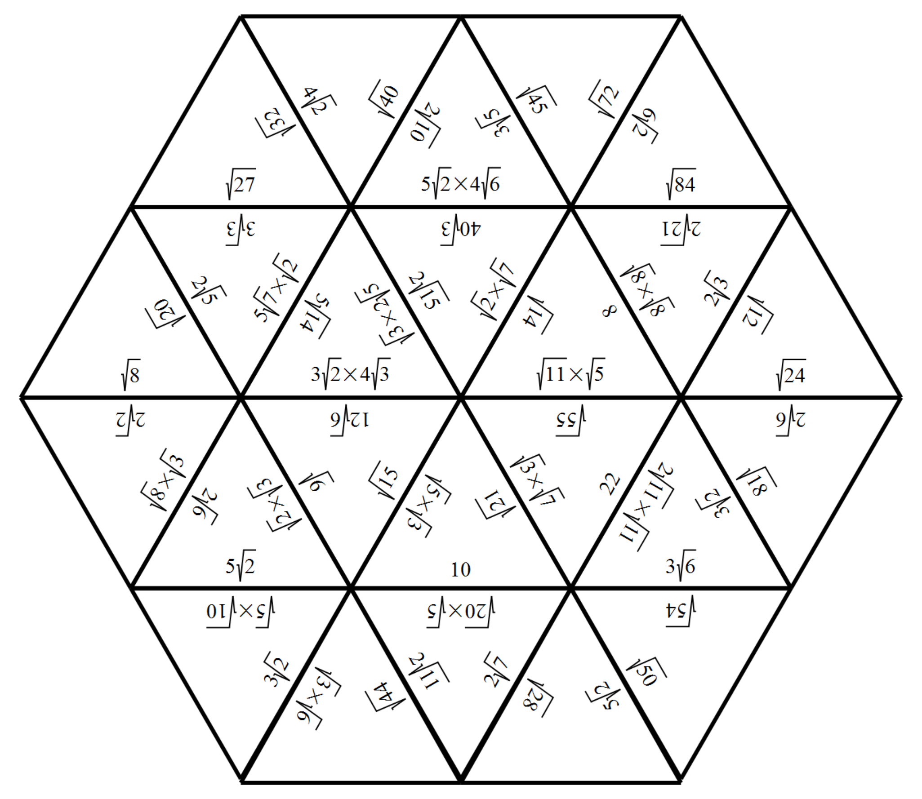

Appendix B

Comparing $x$-intercepts
For each row, examine the 2 parabolas shown alongside the related sketch.
- Identify and label the $x$-intercepts in exact form.
- Comparison: explain how the $x$-intercepts of the 2 parabolas are similar and different.
Row | Parabola 1 | Parabola 2 | Comparison
1 | $$y=x^{2}-18$$  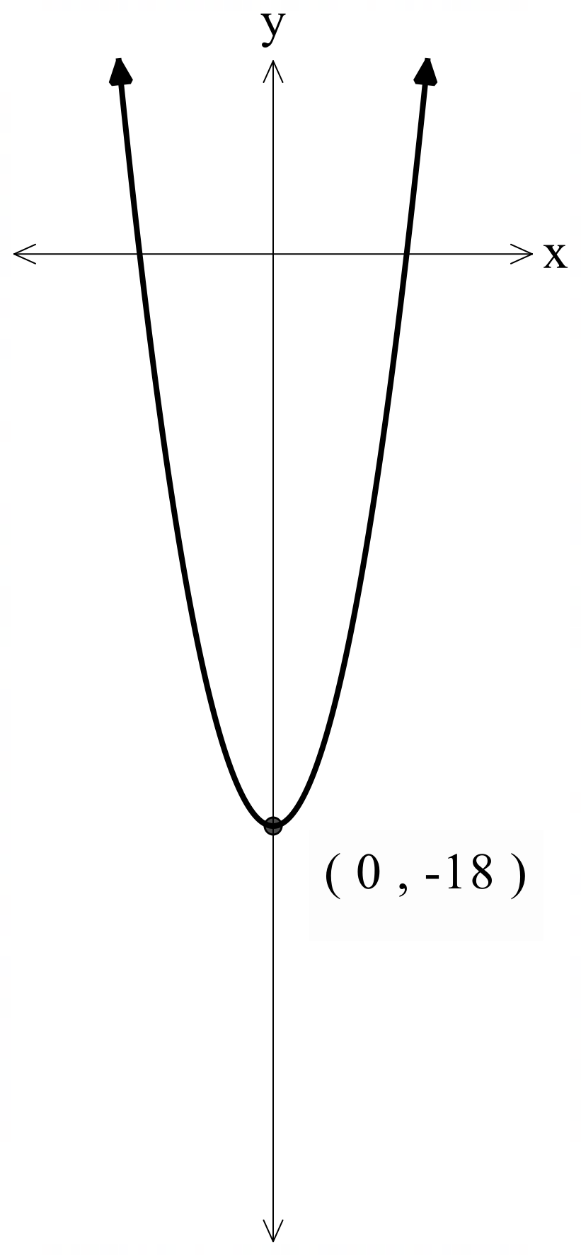 | $$y=x^{2}-27$$  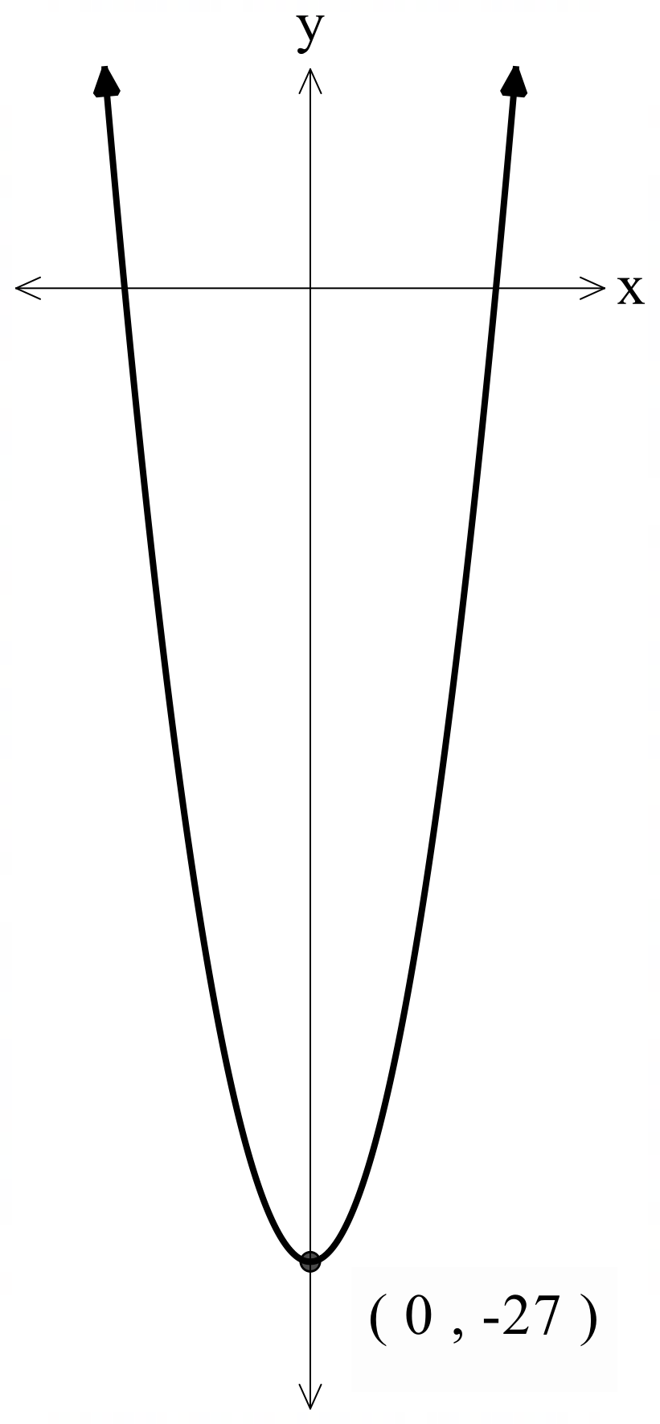
2 | $$y=x^{2}-20$$  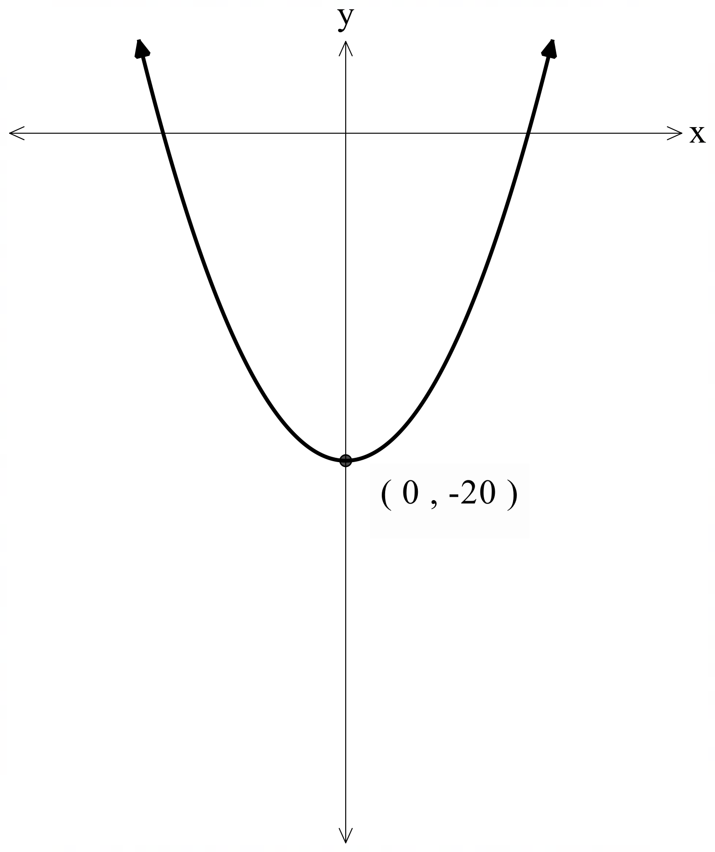 | $$y=x^{2}-45$$  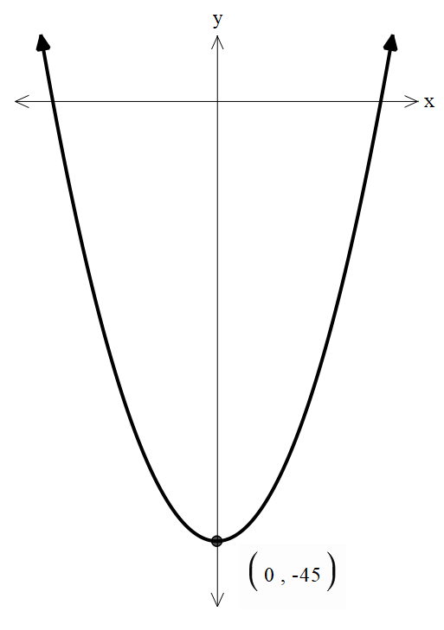
3 | $$y=x^{2}-5$$  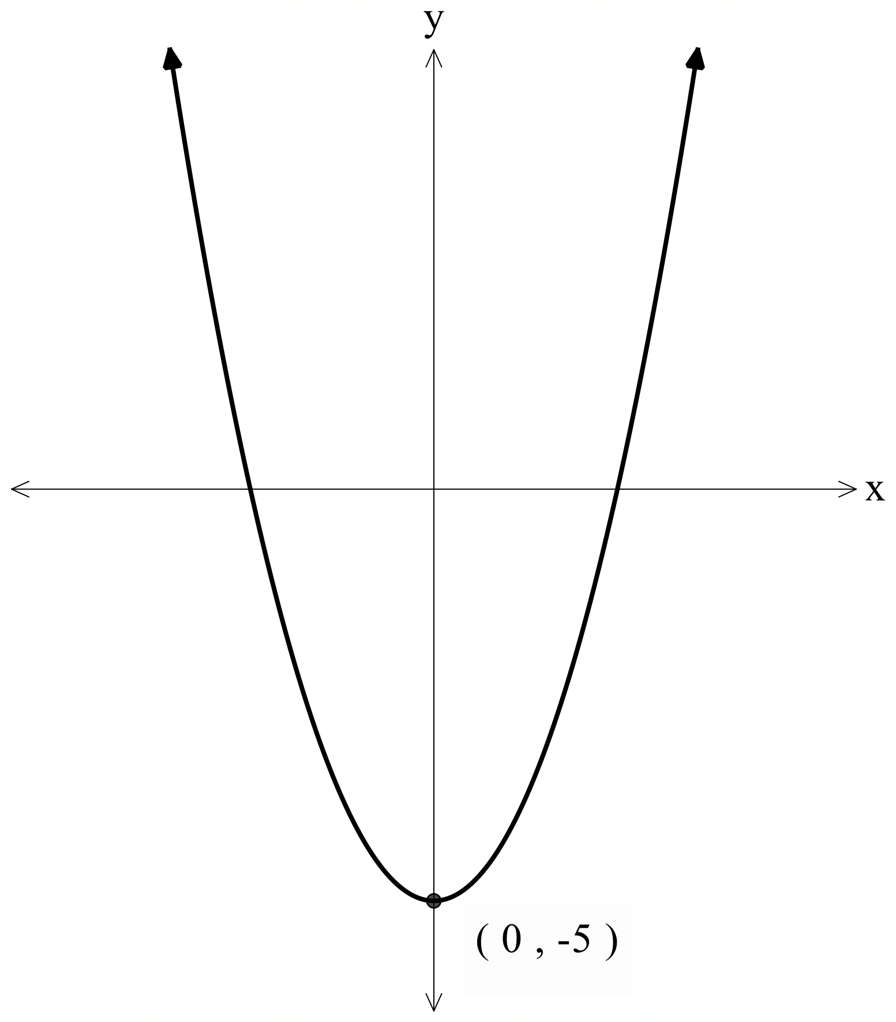 | $$y=\frac{1}{2}x^{2}+x-2$$  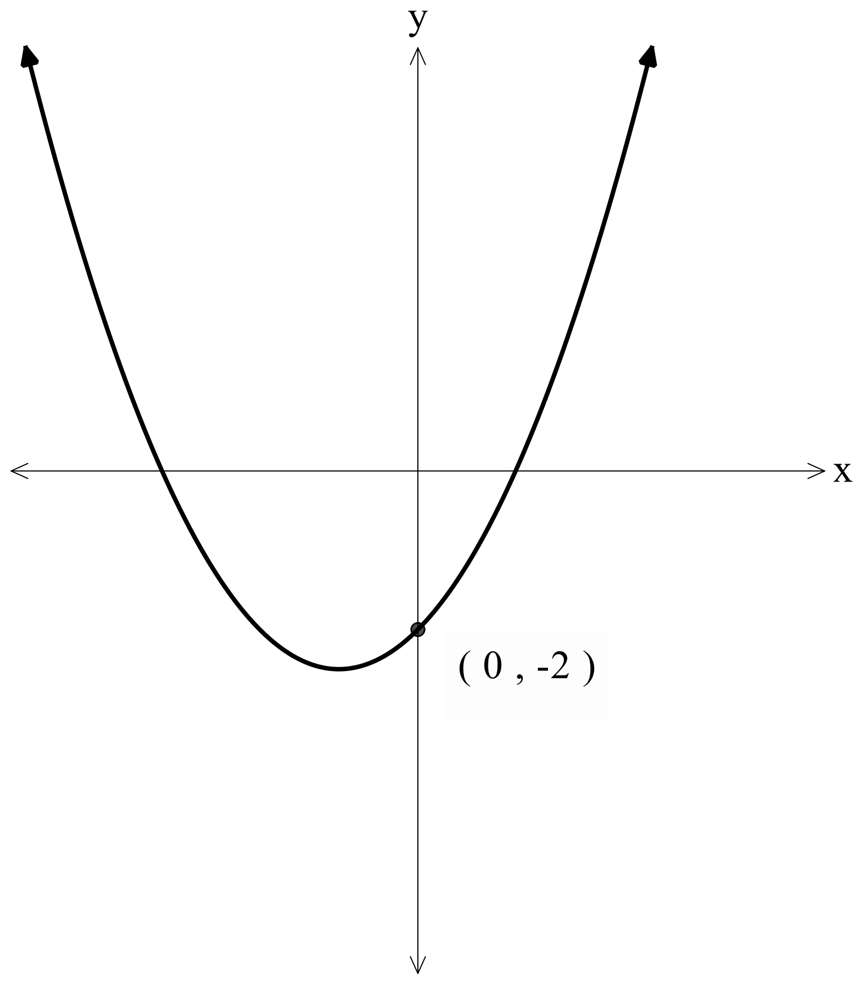
4 | $$y=x^{2}-2x-7$$  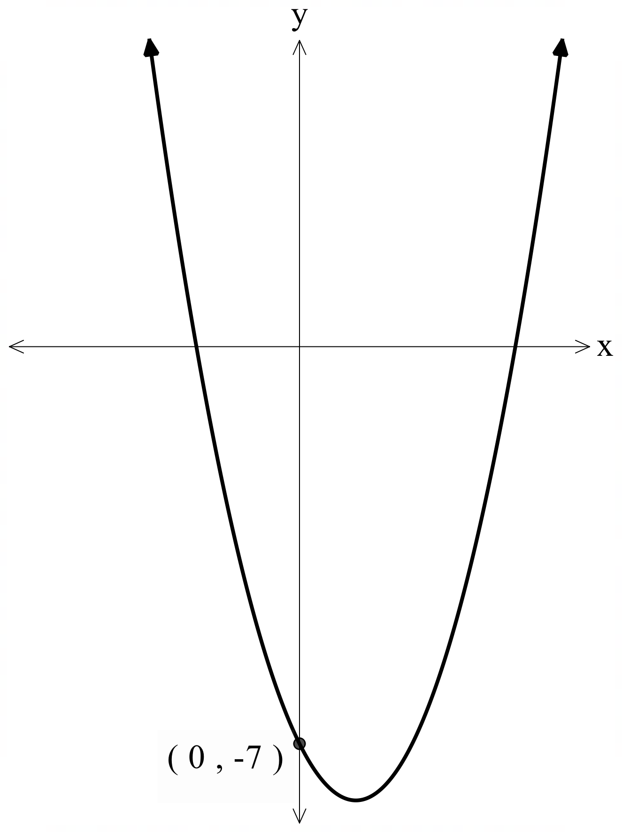 | $$y=\frac{5}{2}x^{2}-3x-\frac{63}{10}$$  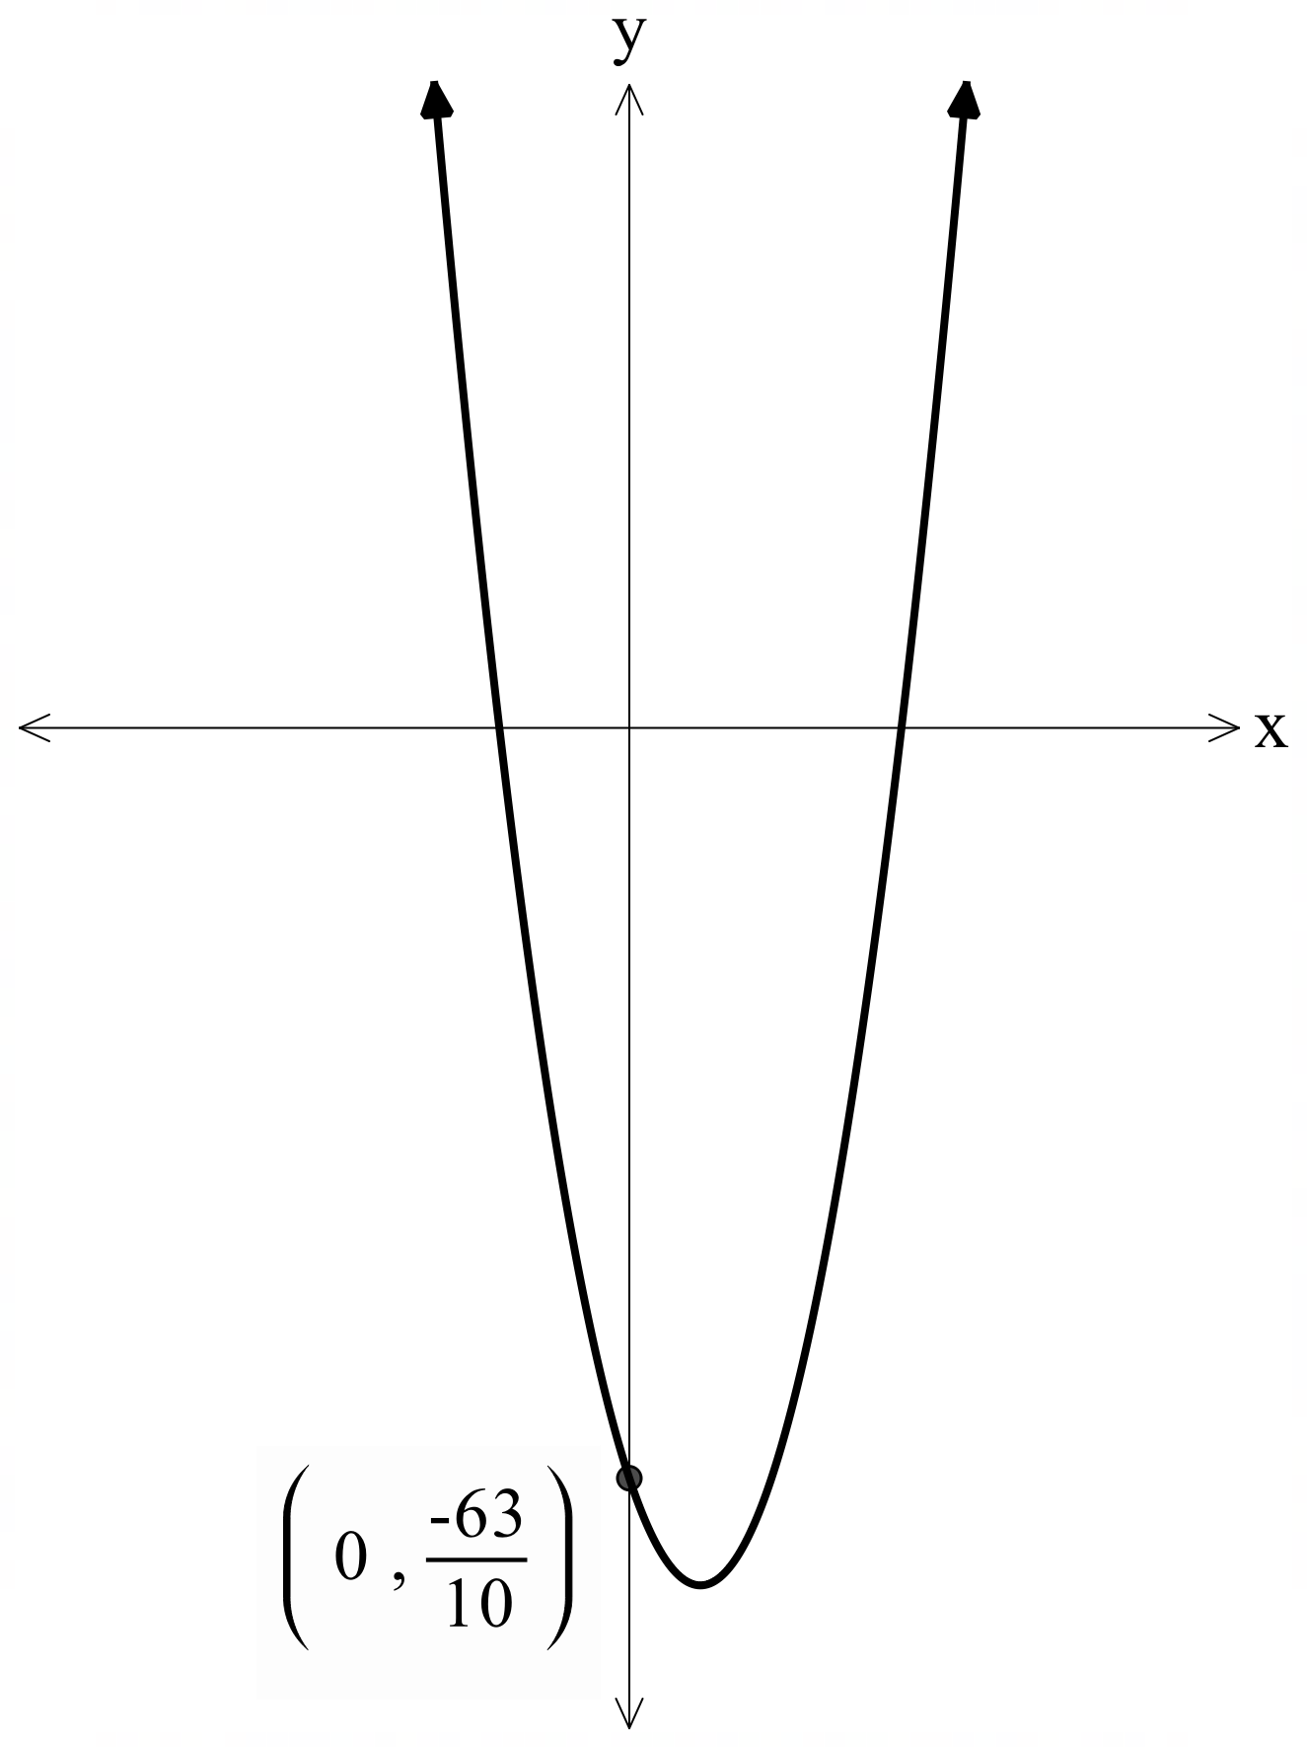

Appendix C

Variation Theory
Explore how small changes in a surd expression affect the expansion and simplification. Work in pairs and discuss your reasoning.
Expand and simplify:
- $\sqrt{3}\left(\sqrt{2}+1\right)$
- $2\sqrt{3}\left(\sqrt{2}+1\right)$
- $2\sqrt{3}\left(\sqrt{2}-\sqrt{3}\right)$
- ${\left(\sqrt{2}-\sqrt{3}\right)}^{2}$
- $\left(\sqrt{2}-\sqrt{3}\right)\left(\sqrt{2}+1\right)$
- $\left(\sqrt{2}-2\right)\left(\sqrt{2}+1\right)$
- $\left(3\sqrt{2}-2\right)\left(3\sqrt{2}+1\right)$

Sample solutions

Appendix B – comparing $x$-intercepts
Row | Parabola 1 | Parabola 2 | Comparison
1 | $$y=x^{2}-18$$  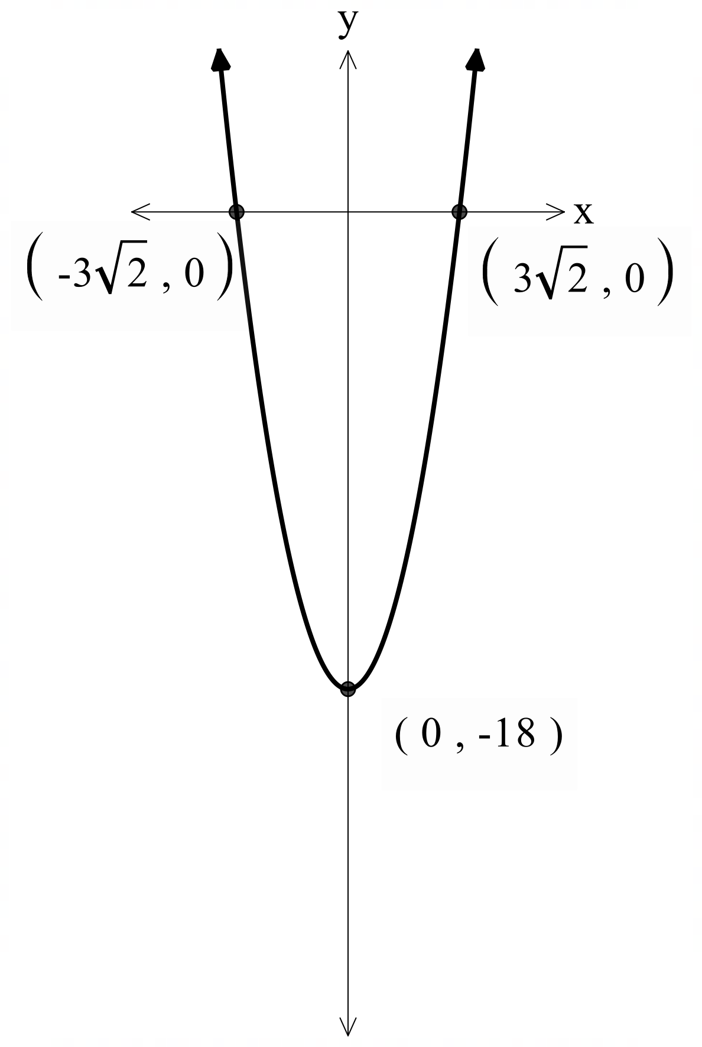  $x$-intercepts, let $y=0$  $$0=x^{2}-18 \\ x^{2}=18 \\ x=±\sqrt{18} \\ x=±\sqrt{9}×\sqrt{2} \\ x=±3\sqrt{2}$$ | $$y=x^{2}-27$$  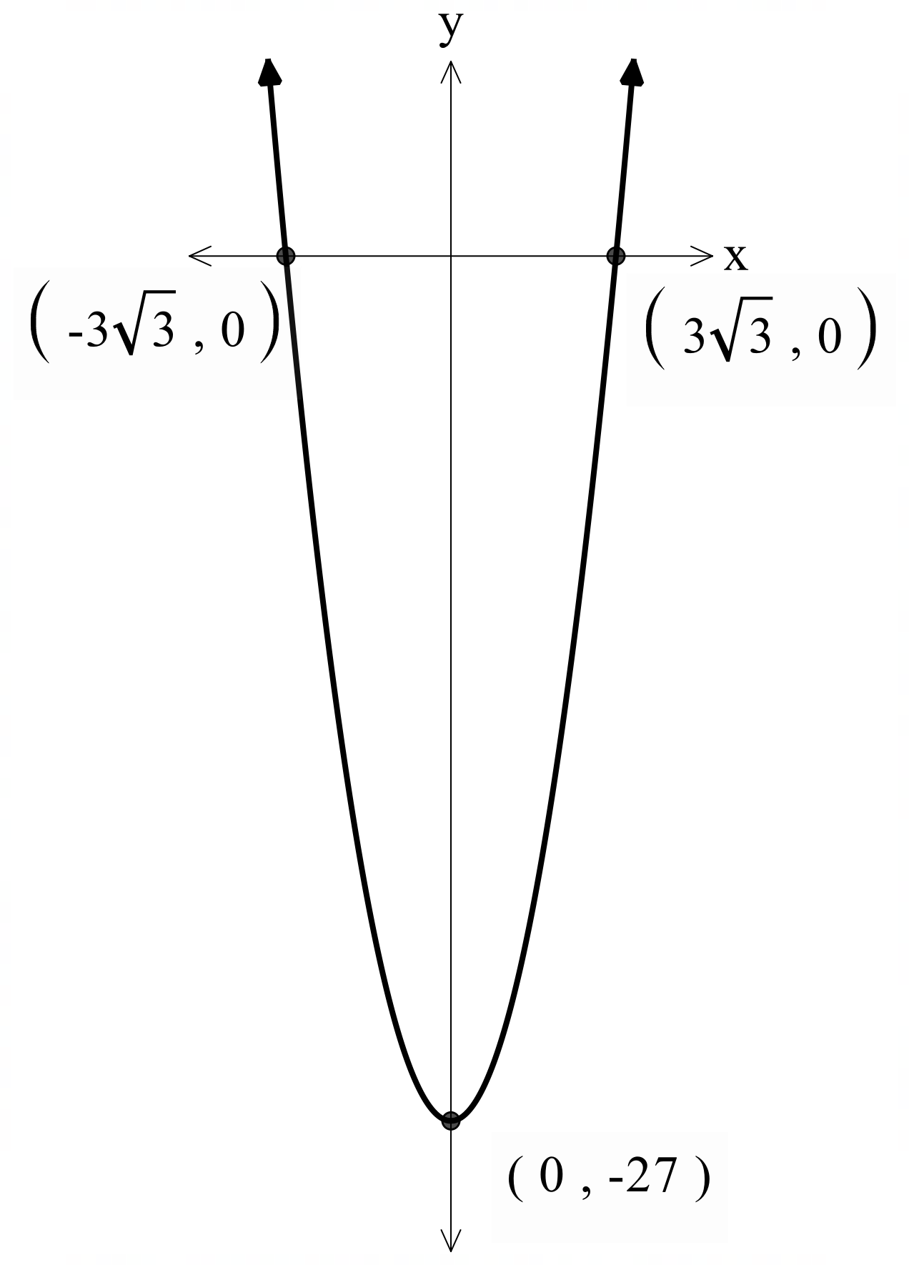  $x$-intercepts, let $y=0$  $$0=x^{2}-27 \\ x^{2}=27 \\ x=±\sqrt{27} \\ x=±\sqrt{9}×\sqrt{3} \\ x=±3\sqrt{3}$$ | They’re similar because both include $\sqrt{3}$, but they’re different because one has a 2 in front and the other has a 3 in front.
2 | $$y=x^{2}-20$$  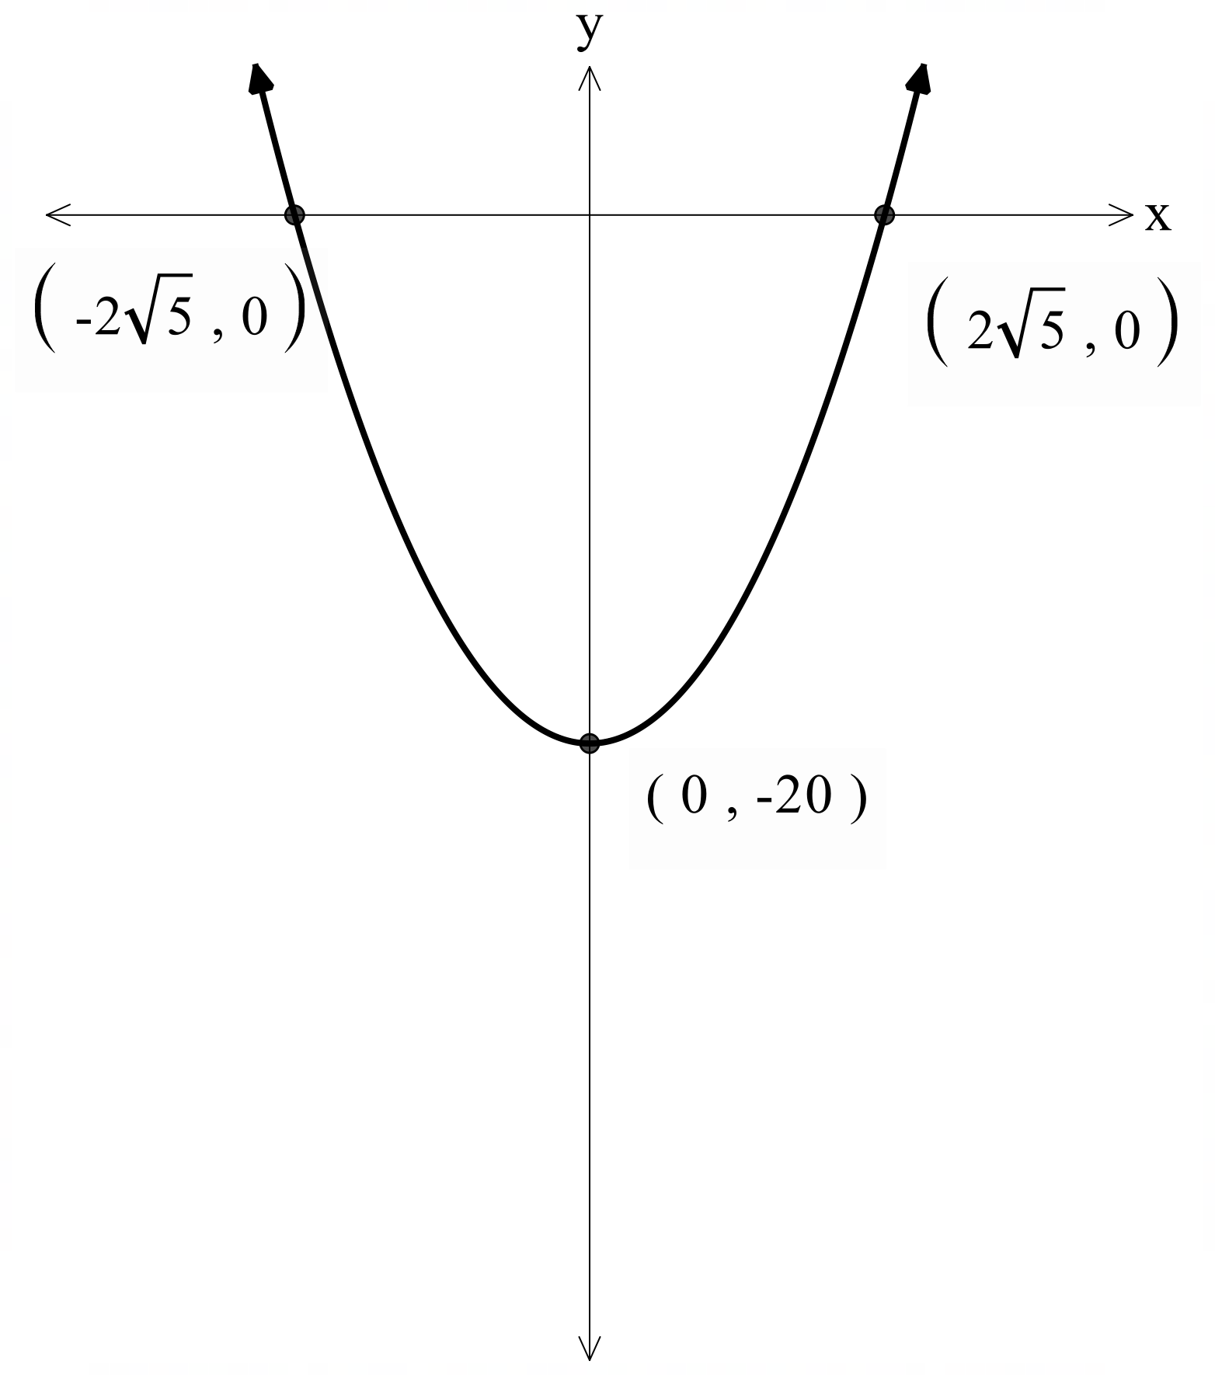  $x$-intercepts, let $y=0$  $$0=x^{2}-20 \\ x^{2}=20 \\ x=±\sqrt{20} \\ x=±\sqrt{4}×\sqrt{5} \\ x=±2\sqrt{5}$$ | $$y=x^{2}-45$$  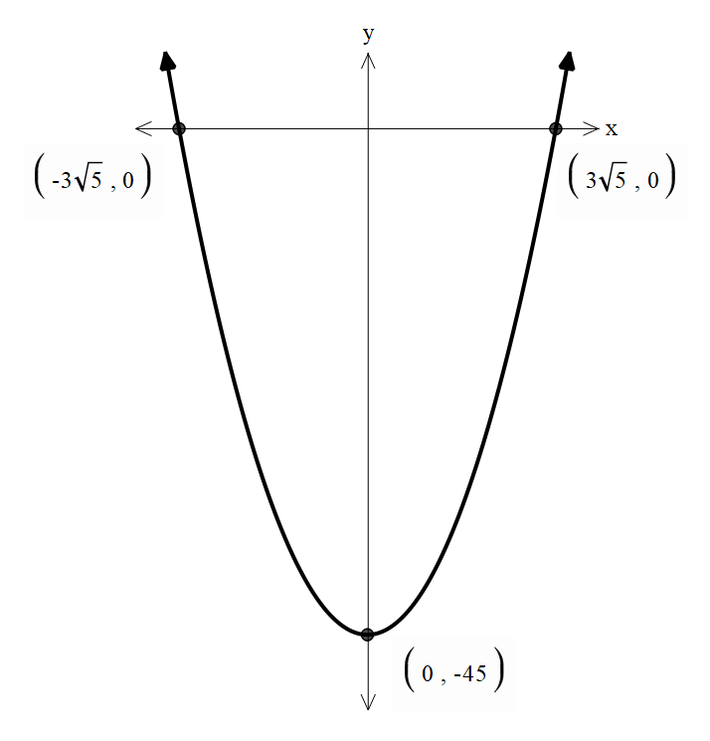  $x$-intercepts, let $y=0$  $$0=x^{2}-45 \\ x^{2}=45 \\ x=±\sqrt{45} \\ x=±\sqrt{9}×\sqrt{5} \\ x=±3\sqrt{5}$$ | They’re similar because both include $\sqrt{5}$, but they’re different because one has a 2 in front and the other has a 3 in front.
3 | $$y=x^{2}-5$$  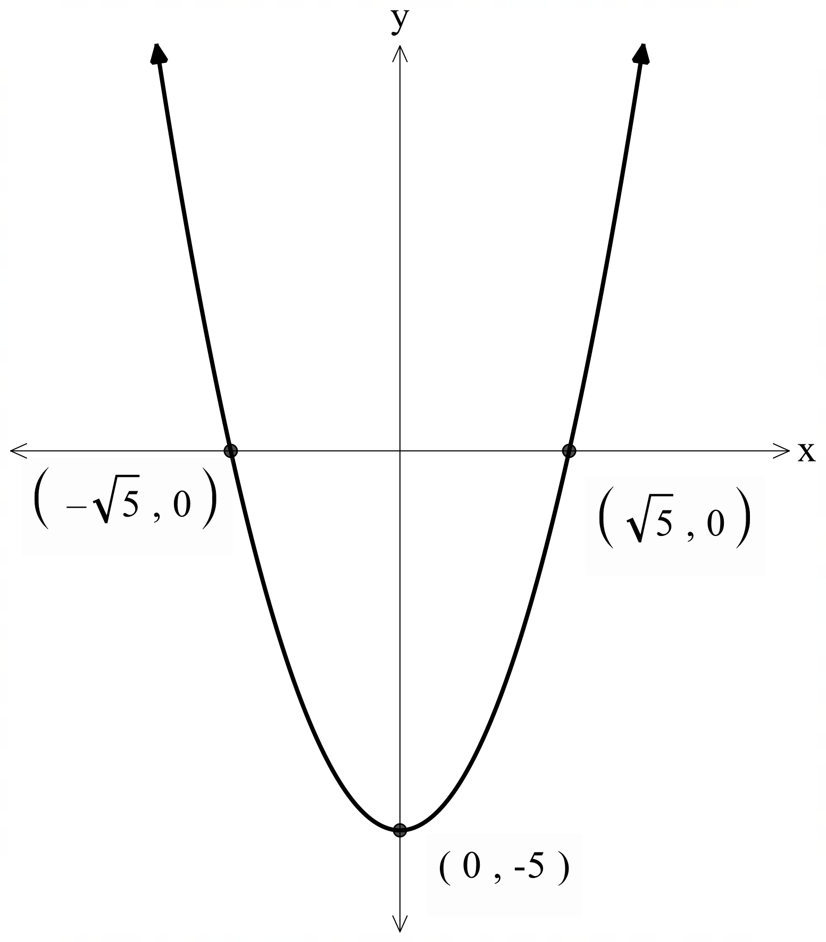  $x$-intercepts, let $y=0$  $$0=x^{2}-5 \\ x^{2}=5 \\ x=±\sqrt{5}$$ | $$y=\frac{1}{2}x^{2}+x-2$$  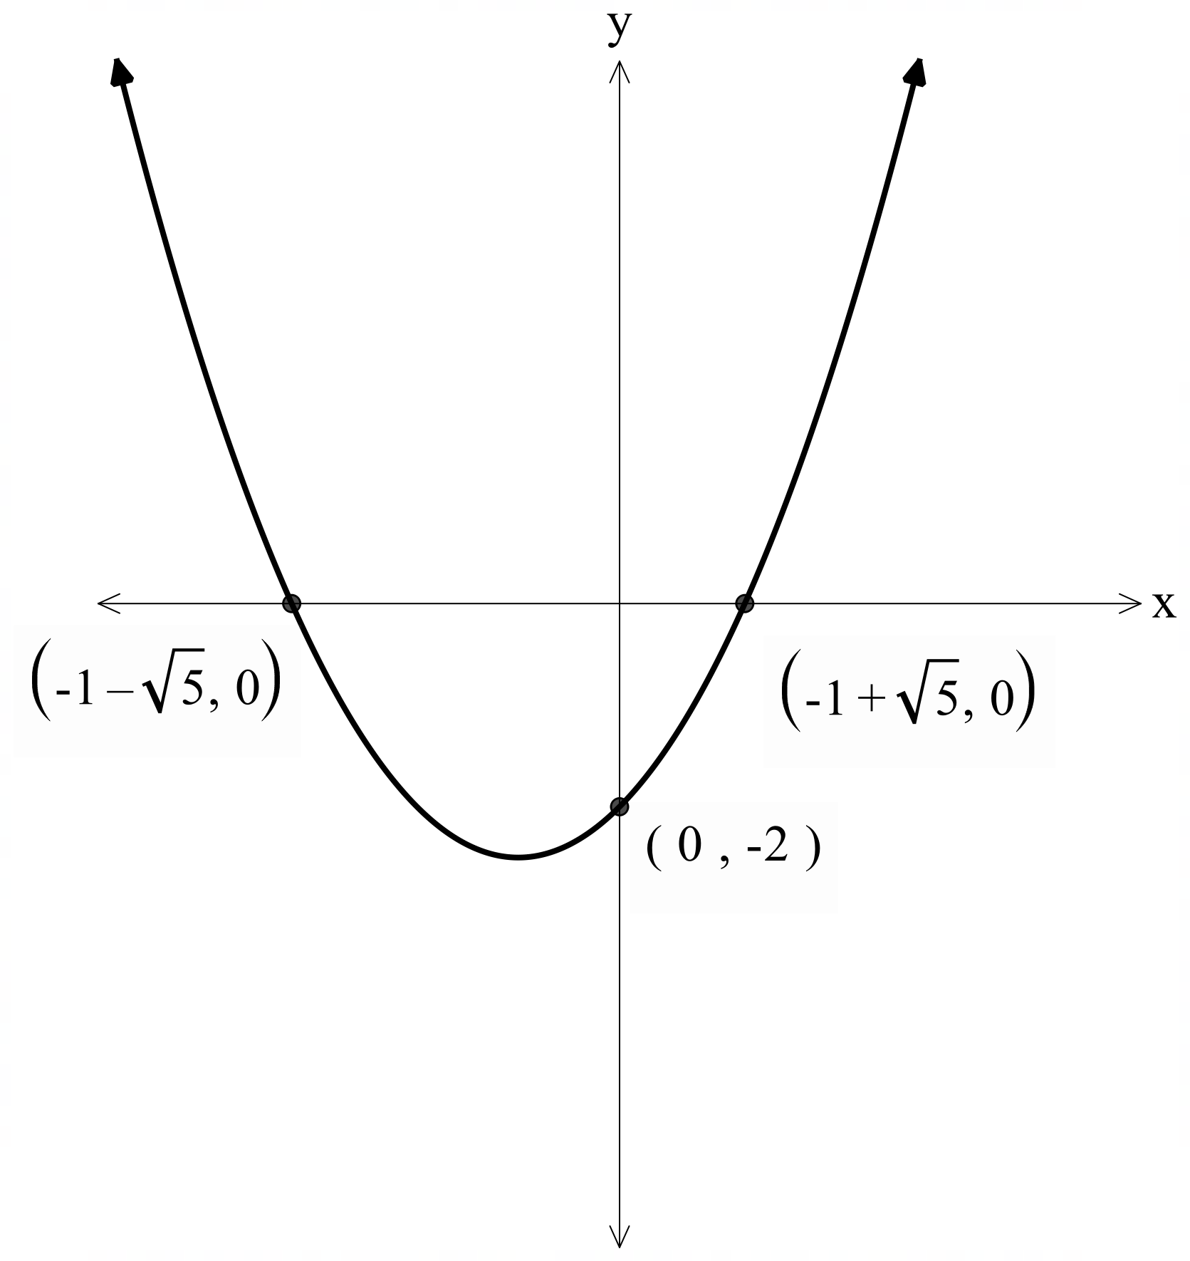  $x$-intercepts, let $y=0$  $$0={\frac{1}{2}x}^{2}+x-2$$  Using the quadratic formula  $$x=\frac{-1±\sqrt{1^{2}-4×\frac{1}{2}×-2}}{2×\frac{1}{2}} \\ =\frac{-1±\sqrt{5}}{1} \\ =-1±\sqrt{5}$$ | They’re similar because both include $\sqrt{5}$, but they’re different because one has symmetrical $x$-intercepts at $±\sqrt{5}$, while the other is shifted to $-1 ± \sqrt{5}$. The second set needed the quadratic formula to solve.
4 | $$y=x^{2}-2x-7$$  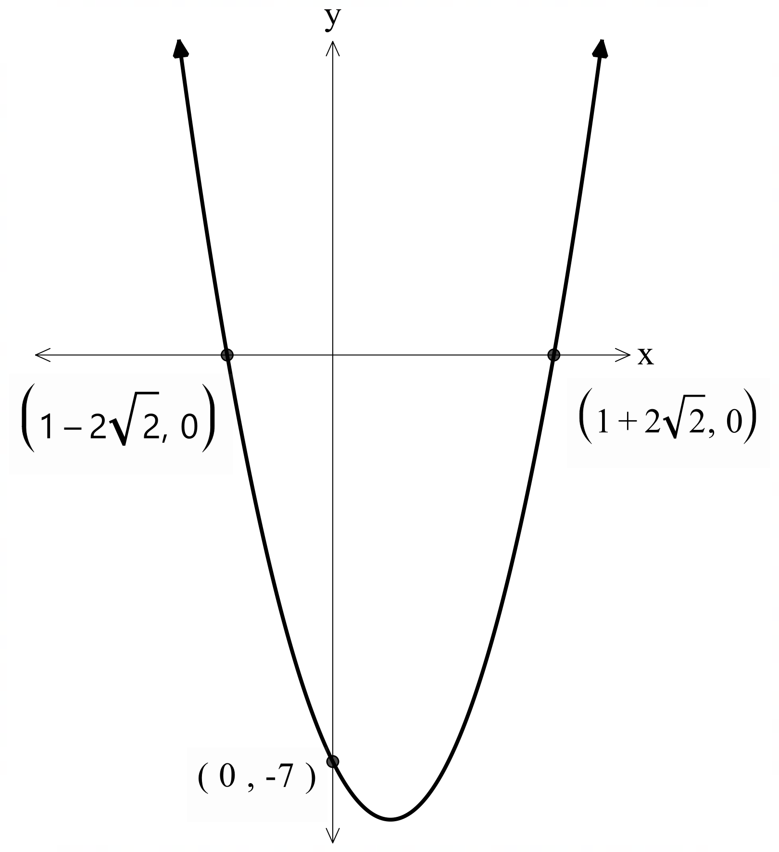  $x$-intercepts, let $y=0$  $$0=x^{2}-2x-7$$  Using the quadratic formula  $$x=\frac{-(-2)±\sqrt{{(-2)}^{2}-4×1×-7}}{2×1} \\ =\frac{2±\sqrt{32}}{2} \\ =\frac{2±(\sqrt{16}×\sqrt{2})}{2}$$  $$=\frac{2±4\sqrt{2}}{2}$$  $$=\frac{2(1±2\sqrt{2})}{2}$$  $$1±2\sqrt{2}$$ | $$y=\frac{5}{2}x^{2}-3x-\frac{63}{10}$$  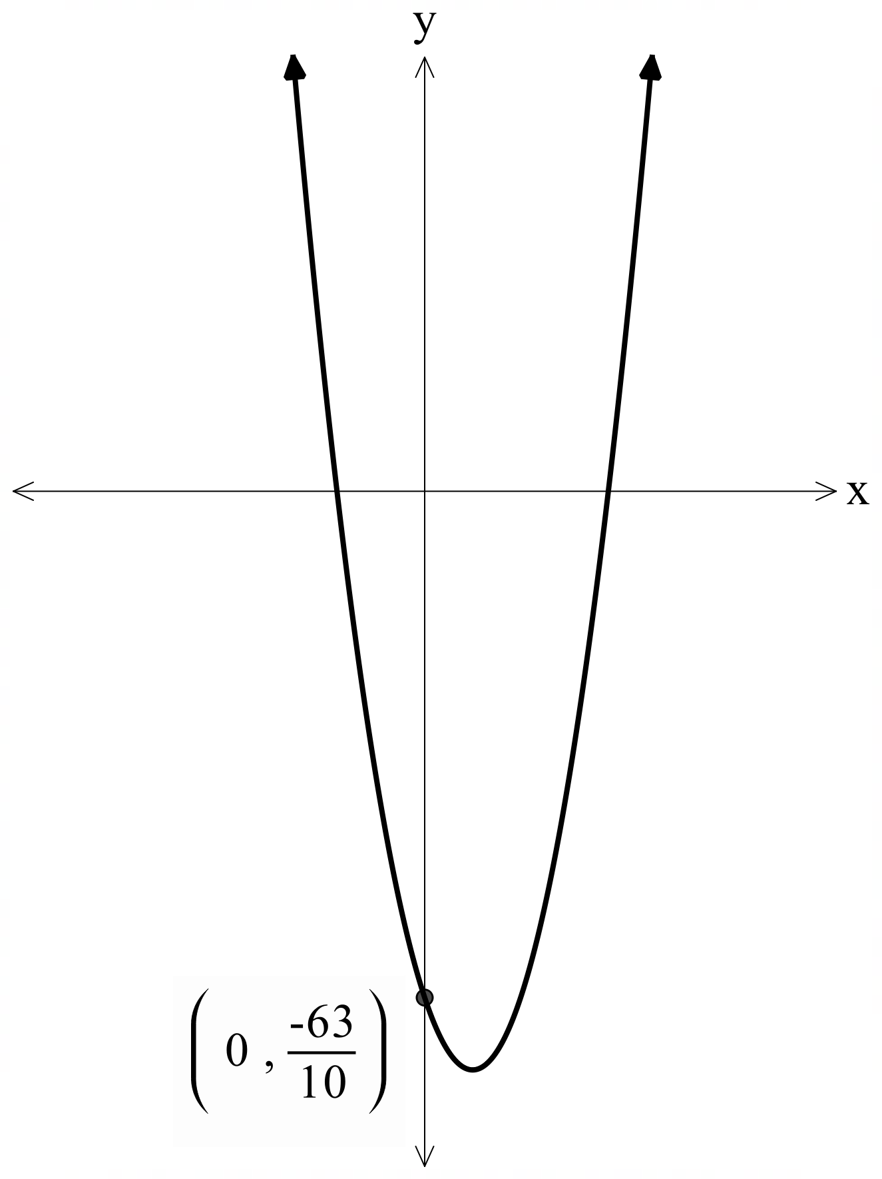  $x$-intercepts, let $y=0$  $$0=\frac{5}{2}x^{2}-3x-\frac{63}{10}$$  Using the quadratic formula  $$x=\frac{-(3)±\sqrt{{(-3)}^{2}-4×\frac{5}{2}×-\frac{63}{10}}}{2×\frac{5}{2}} \\ =\frac{-3±\sqrt{72}}{5} \\ =\frac{-3±(\sqrt{36}×\sqrt{2})}{5}$$  $$=\frac{-3±6\sqrt{2}}{5}$$  $$=\frac{-3(1±2\sqrt{2})}{5}$$ | They’re similar since both solutions contain $1±2\sqrt{2}$ and that you had to use the quadratic formula.  However, the equations are quite different, with one being monic and the other non-monic. The first parabola also has integers as the coefficients, whereas the second has fractions.

Appendix C – Variation Theory
Explore how small changes in a surd expression affect the expansion and simplification. Work in pairs and discuss your reasoning.
Expand and simplify:
- $\sqrt{3}\left(\sqrt{2}+1\right)=\sqrt{6}+\sqrt{3}$
- $2\sqrt{3}\left(\sqrt{2}+1\right)=2\sqrt{6}+2\sqrt{3}$
- $2\sqrt{3}\left(\sqrt{2}-\sqrt{3}\right)=2\sqrt{6}-6$
- ${\left(\sqrt{2}-\sqrt{3}\right)}^{2}=2-2\sqrt{2}\sqrt{3}+3$$${\left(\sqrt{2}-\sqrt{3}\right)}^{2}=5-2\sqrt{6}$$
- $\left(\sqrt{2}-\sqrt{3}\right)\left(\sqrt{2}+1\right)=4+\sqrt{2}-\sqrt{6}-\sqrt{3}$
- $\left(\sqrt{2}-2\right)\left(\sqrt{2}+1\right)=2+\sqrt{2}-2\sqrt{2}-2$$$\left(\sqrt{2}-2\right)\left(\sqrt{2}+1\right)=-\sqrt{2}$$
- $\left(3\sqrt{2}-2\right)\left(3\sqrt{2}+1\right)=18+3\sqrt{2}-6\sqrt{2}-2$$$\left(3\sqrt{2}-2\right)\left(3\sqrt{2}+1\right)=16-3\sqrt{2}$$

References
This resource contains NSW Curriculum and syllabus content. The NSW Curriculum is developed by the NSW Education Standards Authority. This content is prepared by NESA for and on behalf of the Crown in right of the State of New South Wales. The material is protected by Crown copyright.
Please refer to the NESA Copyright Disclaimer for more information https://educationstandards.nsw.edu.au/wps/portal/nesa/mini-footer/copyright.
NESA holds the only official and up-to-date versions of the NSW Curriculum and syllabus documents. Please visit the NSW Education Standards Authority (NESA) website https://educationstandards.nsw.edu.au/ and the NSW Curriculum website https://curriculum.nsw.edu.au/.
Mathematics Advanced 11–12 Syllabus © NSW Education Standards Authority (NESA) for and on behalf of the Crown in right of the State of New South Wales, 2024.

© State of New South Wales (Department of Education), 2025
The copyright material published in this resource is subject to the Copyright Act 1968 (Cth) and is owned by the NSW Department of Education or, where indicated, by a party other than the NSW Department of Education (third-party material).
Copyright material available in this resource and owned by the NSW Department of Education is licensed under a Creative Commons Attribution 4.0 International (CC BY 4.0) license.

This license allows you to share and adapt the material for any purpose, even commercially.
Attribution should be given to © State of New South Wales (Department of Education), 2025.
Material in this resource not available under a Creative Commons license:
- the NSW Department of Education logo, other logos and trademark-protected material
- material owned by a third party that has been reproduced with permission. You will need to obtain permission from the third party to reuse its material.
Links to third-party material and websites
Please note that the provided (reading/viewing material/list/links/texts) are a suggestion only and implies no endorsement, by the New South Wales Department of Education, of any author, publisher, or book title. School principals and teachers are best placed to assess the suitability of resources that would complement the curriculum and reflect the needs and interests of their students.
If you use the links provided in this document to access a third-party's website, you acknowledge that the terms of use, including licence terms set out on the third-party's website apply to the use which may be made of the materials on that third-party website or where permitted by the Copyright Act 1968 (Cth). The department accepts no responsibility for content on third-party websites.

