The quadratic formula
In this lesson, students are introduced to the quadratic formula and use it to derive the equation of the axis of symmetry. They compare and apply different techniques for sketching the graph of a quadratic function.

Learning intentions
- To understand how to solve quadratic equations that cannot be factorised with integer solutions.
- To be able to use different strategies to find key features of a parabola to support accurate graphing.

Success criteria
- I can recognise when a quadratic function does not have integer solutions.
- I can use the quadratic formula to solve a quadratic equation.
- I can compare the quadratic formula and completing the square and explain which method is more efficient in a given context.
- I can choose an appropriate strategy to sketch the graph of a quadratic function based on its equation.

Outcomes
A student:
- develops understanding and fluency in mathematics through exploring and connecting mathematical concepts, choosing and applying mathematical techniques to solve problems, and communicating their thinking and reasoning coherently and clearly MAO-WM-01
- applies algebraic techniques and the laws of indices and surds to manipulate expressions and solve problems MAV-11-01
- uses functions and relations to model, analyse and solve problems MAV-11-02

Content

Algebraic techniques
- Solve quadratic equations $ax^{2}+bx+c=0$ by factorisation, completing the square and using the quadratic formula $x=\frac{-b±\sqrt{b^{2}-4ac}}{2a}$ where $a, b$ and $c$ are real numbers and $a≠0$

Quadratic and cubic functions
- Show by completing the square on the general quadratic $y=ax^{2}+bx+c$ that the axis of symmetry is $x=-\frac{b}{2a}$ where $a, b$ and $c$ are constants
- Choose and apply appropriate techniques to graph a parabola of the form $y=ax^{2}+bx+c$ by identifying its $x$-intercepts if they exist, its $y$-intercept, its axis of symmetry using $x=-\frac{b}{2a}$ and its vertex
Mathematics Advanced 11–12 Syllabus © NSW Education Standards Authority (NESA) for and on behalf of the Crown in right of the State of New South Wales, 2024.

Table 1: lesson summary
Section | Summary of activity | Teaching strategies | Teaching points
Activating prior knowledge | Use slides 4–7 of the PowerPoint The quadratic formula to select an appropriate Venn diagram activity for students to complete.  Students compare solutions with other groups and discuss how different forms of a quadratic equation affect graphing. | Visibly random groups of 3  Vertical non-permanent surfaces  Gallery walk  Pose-Pause-Pounce-Bounce | The purpose of this activity is to consolidate skills in manipulating quadratics and show how different forms affect graphing. It also addresses the misconception that all quadratics can be factorised, highlighting the need for alternative methods.
Connecting learning | Use slides 9–10 to introduce the quadratic formula. An optional video ‘But where does the quadratic formula come from?’ (2:58) (bit.ly/Quadratic-Formula-Explanation) (from 1:17–2:58) can be shown to derive the formula. Use slides 11–15 for students to compare completing the square and the quadratic formula to solve and graph quadratics, linking the axis of symmetry formula to the quadratic formula. Students then complete Appendix A. | Worked examples (Your turn)  Pose-Pause-Pounce-Bounce | This activity broadens students’ methods beyond factorising and completing the square, highlighting how the quadratic formula provides key insights for solving and graphing quadratics.
Releasing responsibility | Discuss with the class the different techniques that can be used to graph a parabola, reflecting on when each method is most useful. Students complete Appendix B. | Pose-Pause-Pounce-Bounce | The aim of this activity is for students to reflect on and justify appropriate technique choice.
Independent practice | Use slide 17 of the PowerPoint for students to complete a problem in pairs. Follow with a class discussion to share and justify strategies. | Same Surface, Different Deep | This activity encourages students to apply different methods to solve quadratic equations and decide which technique is most efficient for each problem.

Activity structure
Please use the associated PowerPoint The quadratic formula to display images in this lesson.

Activating prior knowledge
The following activity is based on ‘Rich Venn Diagram maths activities’ from Craig Barton (mathsvenns.com). If you are unfamiliar with this type of activity, take a moment to read the explanation on the webpage.
- Assign students to visibly random groups of 3 (bit.ly/visiblegroups) at vertical non-permanent surfaces (bit.ly/VNPSstrategy).
- Use slides 4–7 of the PowerPoint to select the most appropriate Venn diagram to display for students to work on in groups. Students should re-create the Venn diagram on their vertical non-permanent surfaces and collaborate to determine suitable equations for each region of the diagram.
The purpose of this activity is to consolidate students’ prior understanding of completing the square and factorising quadratics. You can use the range of provided Venn diagram activities, including both double and triple Venn diagram options, with examples for monic and non-monic quadratic functions, to choose what best suits your students.
Possible solutions are available in the ‘Sample solutions’ section of this lesson.
- Have groups complete a gallery walk (bit.ly/DLSgallerywalk) to compare their solutions with those of other groups. As they move through the gallery walk, students can review and verify the solutions presented by their peers.
- Return students to their workspaces and use the Pose-Pause-Pounce-Bounce questioning strategy (PDF 557 KB) (bit.ly/posepausepouncebounce) to explore whether the quadratic equations they created in the Venn diagram activity are presented in a form that makes graphing straightforward. Suggested prompts include:
- What features of the equation’s form help you understand how to sketch its graph?
- How might changing the form of the quadratic equation affect the ease or accuracy of graphing it?

Connecting learning
- Explain to students that besides completing the square, there is another strategy that can be used to find the $x$-intercepts when the quadratic function cannot be factorised into a binomial product with integer solutions.
- Refer students to their ‘Mathematics Advanced – HSC reference sheet’ and have them locate the quadratic formula $x=\frac{-b±\sqrt{b^{2}-4ac}}{2a}$.
Students may have seen the quadratic formula in Stage 5 Equations C Path outcome MA5-EQU-P-02.
Students can be shown the video ‘But where does the quadratic formula come from?’ (2:58) (bit.ly/Quadratic-Formula-Explanation) (from 1:17–2:58), which demonstrates how the quadratic formula is derived using a visual representation. Knowing how to derive this formula is beyond the scope of the Mathematics Advanced course.
Students could also complete the Underground Mathematics activity ‘Proving the quadratic formula’ (undergroundmathematics.org/quadratics/proving-quad-formula).
- Use slides 9–10 of the PowerPoint to model how to use the quadratic formula to solve quadratic equations using the Worked examples (Your turn) method (bit.ly/supportingstrategies).
Students may need to consolidate their understanding of using the quadratic formula to solve equations prior to progressing to the next activity. Lesson 12 – can't factorise, no problem of Stage 5 Unit 12 – investigating parabolas, could be used to provide further support.
In Lesson 12 – discriminant, students will learn about the discriminant, quadratic equations that cannot be solved and the implications of these.
- Display slide 11 and have students, in pairs and in their workbooks, graph $y=x^{2}+6x+4$ by finding the $x$-intercept and $y$-intercept using both the completing the square method and using the quadratic formula.
- Encourage students to compare their solutions from both methods to confirm they match before animating the solution on the slide.
- Use slide 12 to display both methods used to graph of $y=x^{2}+6x+4$, showing its axis of symmetry. Direct students’ attention to the second last line of working to highlight to students that the axis of symmetry is within this working.
- Explain to students that the axis of symmetry has a formula and can be found from the general quadratic $y=ax^{2}+bx+c$ rather than finding the average of the $x$-intercepts.
- Use slides 13–14 to analyse the quadratic formula and highlight that the axis of symmetry for a parabola is $x=-\frac{b}{2a}$, shown by both completing the square and using the quadratic formula.
Slide 15 has been included to show how the axis of symmetry formula can also be derived using the quadratic formula for students who would like to be extended.
- Distribute Appendix A ‘Which method?’ to students where they will compare both the completing the square and quadratic formula strategies to graph parabolas.

Releasing responsibility
- Use the Pose-Pause-Pounce-Bounce questioning strategy to reflect on the different techniques for solving quadratic equations and how they relate to identifying key features of parabolas. Different techniques can include factorisation, completing the square and using the quadratic formula. Suggested prompts include:
- Can all techniques be used for every parabola? Why or why not?
- What are the advantages and disadvantages of each technique?
- When might one strategy be better than the others?

Students should reflect on the benefits and costs of different strategies to solve quadratic equations. Students may identify that the quadratic formula can be applied to all quadratic functions; however, it is time consuming. Students may identify that completing the square is great for finding the vertex of an equation. Students should realise that each method requires additional work to find out all the key features of a parabola.
- Distribute Appendix B ‘Comparing techniques’ to each student, where they will summarise and compare all 3 methods: factorising, completing the square and the quadratic formula.
For this activity, adjust Appendix B to suit the needs of individual students. The template is blank, although students may benefit from having an example to complete prior to determining when each technique is most useful and the key features that it identifies.
- Students may benefit from completing practice questions from an existing resource where they solve quadratic equations and apply appropriate techniques to graph a parabola of the form $y=ax^{2}+bx+c$.

Independent practice
- Display slide 17 of the PowerPoint, which shows a Same Surface, Different Deep (bit.ly/S_S_D_D) problem. Instruct students to complete this in pairs. Encourage students to discuss which technique is best to use for each question.
- Initiate a class discussion where students can share their strategies and then justify the technique that they applied for each question.
Sample solutions have been provided.

Assessment and differentiation

Suggested opportunities for differentiation
Activating prior knowledge
- A variety of Venn diagrams have been provided to suit the needs of individual students.
- If the activity being a Venn diagram is causing confusion, complete this activity without the Venn diagrams. That is, write out the questions for each region of the Venn diagram and remove the diagrams.
Connecting learning
- Students can be extended to analyse how the quadratic formula is derived.
- Students may need support working with and simplifying surds. Encourage the use of a calculator to support some students.
- Students may benefit from selecting either slide 13 or 14 of the PowerPoint for visualising the axis of symmetry.
Releasing responsibility
- Appendix B can be adjusted to provide additional support for students or be kept quite open ended to challenge students.
- Provide optional challenge tasks that involve students creating their own quadratic equations and identifying the best strategy to solve and/or graph them.
Independent practice
- Students can be challenged to create their own quadratic equation in a given form and to create 4 different questions that relate to it.

Suggested opportunities for assessment
Activating prior knowledge
- Observe students’ reasoning and discussion to check students’ understanding and address any misconceptions.
- Listen to the responses provided in the Pose-Pause-Pounce-Bounce questioning strategy to check students’ conceptual understanding of how different forms give different pieces of information about the graph.
Connecting learning
- Appendix A can be collected to check students’ understanding of comparing each of the methods.
Releasing responsibility
- Use class discussion prompts to elicit higher-order thinking and assess comparative reasoning between strategies.
- Review students' completed Appendix B for accuracy, clarity of comparison and conceptual understanding of when it is best to use each method.
Independent practice
- Use Same Surface, Different Deep problems as evidence of method selection and execution.

Appendix A

Which method?

Monic quadratic function
- For the function $f\left(x\right)=x^{2}+10x+17$, complete the table to use both strategies to find the intercepts and vertex of the parabola. Then graph the function on the provided axes, stating the domain and range.
Finding the $x$-intercepts
The quadratic formula | Completing the square
- From which method would best assist with determining the range for the parabola?

Finding the vertex
The quadratic formula | Completing the square

Finding the $y$-intercept
- Sketch the function $f\left(x\right)=x^{2}+10x+17$ and show all the features.
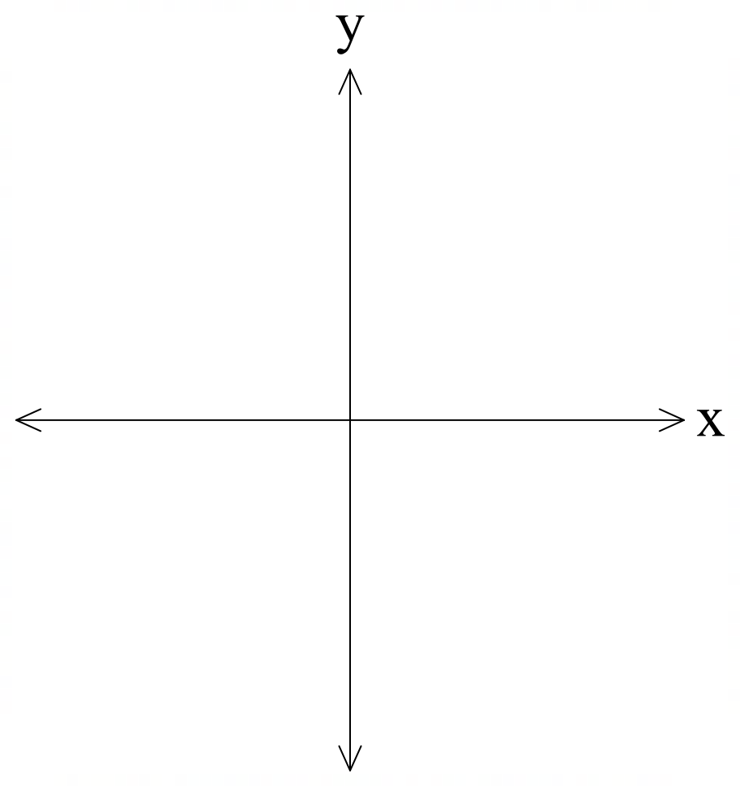
- State the domain and range.
Questions
- Which method made it the easiest to find the $x$-intercepts? Explain your reasoning.
- Which method made it the easiest to find the vertex of the parabola? Why?
- Is it possible to determine the domain and range before graphing the parabola? If so, which method helped the most and why?

Non-monic quadratic function
- For the function $f\left(x\right)=2x^{2}-12x+17$, complete the table to use both strategies to find the intercepts and vertex of the parabola. Then graph the function on the provided axes, stating the domain and range.
Finding the $x$-intercepts
The quadratic formula | Completing the square
- From which method could you easily determine the range for the parabola at this point?

Finding the vertex
The quadratic formula | Completing the square

Finding the $y$-intercept
- Sketch the function $f\left(x\right)={2x}^{2}-12x+17$ and show all the features.
- State the domain and range.
Questions
- Which method made it the easiest to find the $x$-intercepts? Explain your reasoning.
- Which method made it the easiest to find the vertex of the parabola? Why?
- Is it possible to determine the domain and range before graphing the parabola? If so, which method helped the most and why?

Appendix B

Comparing techniques
Technique | When is this technique the most useful? | Key features identified | Example
Factorisation
Completing the square
The quadratic formula

Sample solutions

Activating prior knowledge

Option 1 – double Venn diagram and monic quadratic
- Region A: ${\left(x+4\right)}^{2}+5$
- Region B: $x^{2}+6x+8=(x+2)(x+4)$
- Region C: $x^{2}+8x+12={\left(x+4\right)}^{2}-4$
- Region D: $x^{2}+10x+7$

Option 2 – double Venn diagram and non-monic quadratic
- Region A: $3x^{2}-12x+17=3{\left(x-2\right)}^{2}+5$
- Region B: $2x^{2}+7x+3=(2x+1)(x+3)$
- Region C: $2x^{2}-8x+6=2{\left(x-2\right)}^{2}-2$
- Region D: $3x^{2}+5x+1$

Option 3 – triple Venn diagram and monic quadratic
- Region A: $x^{2}+12x+20=(x+10)(x+2)$
- Region B: $x^{2}+8x+21={\left(x+4\right)}^{2}+5$
- Region C: $x^{2}+4x+8$
- Region D: $x^{2}+8x+12$
- Region E: $x^{2}+8x+8$
- Region F: $x^{2}+6x+8$
- Region G: impossible
- Region H: $x^{2}+10x+7$

Option 4 – triple Venn diagram and monic quadratic
- Region A: ${2x}^{2}+5x+2=(2x+1)(x+2)$
- Region B: $2x^{2}-12x+5={2\left(x-3\right)}^{2}-13$
- Region C: $2x^{2}+x+6$
- Region D: ${2x}^{2}-12x=2{\left(x-3\right)}^{2}-18$
- Region E: $2x^{2}-12x+6=2{\left(x-3\right)}^{2}-12$
- Region F: ${2x}^{2}+7x+6=(2x+3)(x+2)$
- Region G: $\frac{3}{4}x^{2}-\frac{9}{2}x+6=\frac{3}{4}\left(x-2\right)\left(x-4\right)=\frac{3}{4}{\left(x-3\right)}^{2}-\frac{3}{4}$
- Region H: ${2x}^{2}+5x+1$

Appendix A – Which method?

Monic quadratic function
- For the function $f\left(x\right)=x^{2}+10x+17$, complete the table to use both strategies to find the intercepts and vertex of the parabola. Then graph the function on the provided axes, stating the domain and range.
Finding the $x$-intercepts
Strategy | The quadratic formula | Completing the square
Find the $x$-intercepts | $$x=\frac{-b±\sqrt{b^{2}-4ac}}{2a} \\ =\frac{-10±\sqrt{{10}^{2}-4×1×17}}{2×1} \\ =\frac{-10±\sqrt{32}}{2} \\ =-7.83,-2.17 \text{(2.d.p)}$$ | $$f\left(x\right)=x^{2}+10x++17 \\ f\left(x\right)=x^{2}+10x+25+17-25 \\ f\left(x\right)={\left(x+5\right)}^{2}-8$$  Let $f\left(x\right)=0$  $${\left(x+5\right)}^{2}-8=0 \\ {\left(x+5\right)}^{2}=8 \\ x+5=±\sqrt{8} \\ x=±2\sqrt{2}-5 \\ x=-7.83,-2.17 \text{(2.d.p)}$$
Finding the vertex
Strategy | The quadratic formula | Completing the square
Find the vertex | $$x=-\frac{b}{2a} \\ =-\frac{10}{2×1} \\ =-5$$  $$f\left(-5\right)={\left(-5\right)}^{2}+10\left(-5\right)+17 \\ =-8$$  Vertex at $(-5,-8)$ | Vertex at $(-5, -8)$, since the vertex is $(a,c)$ when in the form $y={\left(x-a\right)}^{2}+c.$
Finding the $y$-intercept
$$f\left(0\right)=0^{2}+10\left(0\right)+17 \\ ∴y=17$$
- Sketch the function $f\left(x\right)=x^{2}+10x+17$ and show all the features.
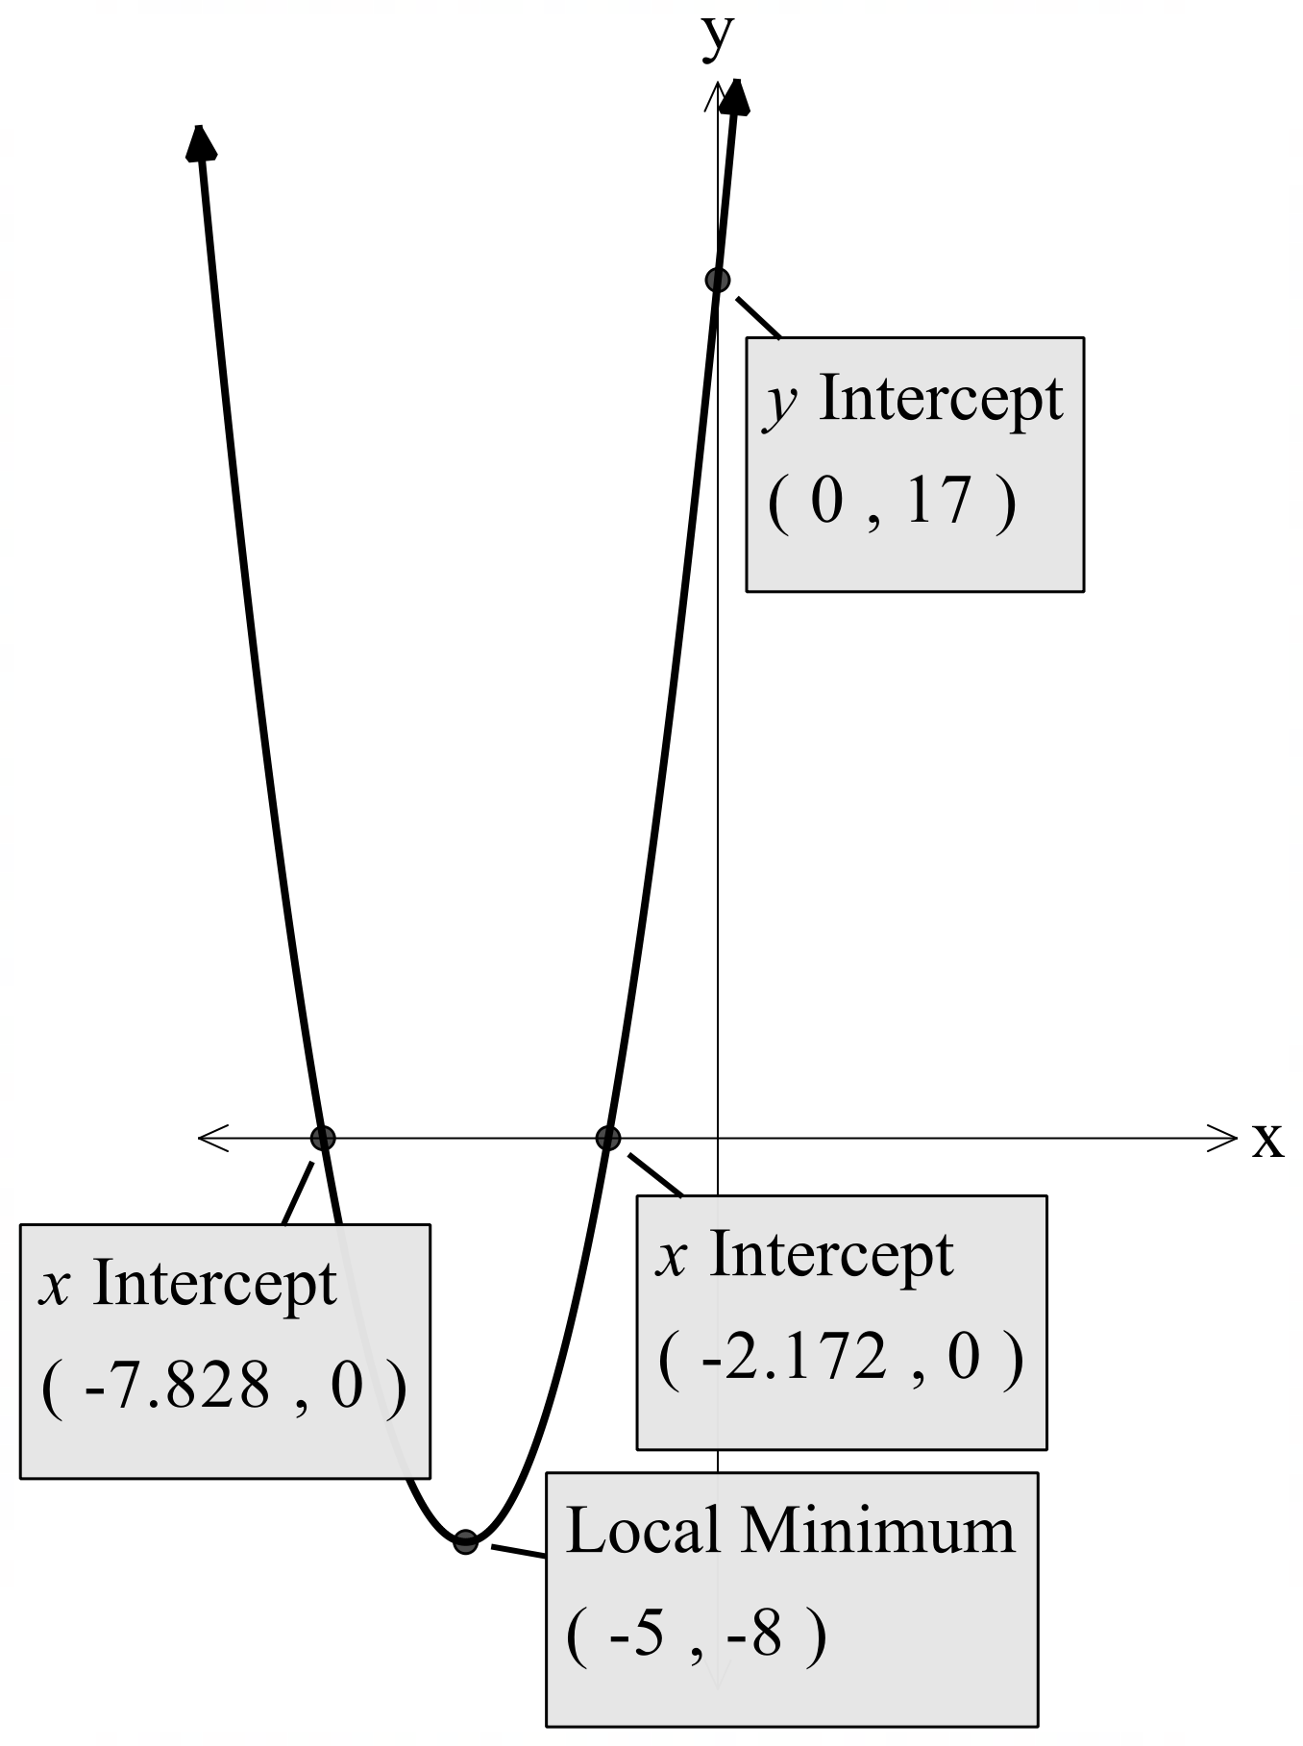
- State the domain and range.
- Domain: all real $x$
- Range: all real $y, y≥-8$

Non-monic quadratic function
- For the function $f\left(x\right)={2x}^{2}-12x+17$, complete the table to use both strategies to find the intercepts and vertex of the parabola. Then graph the function on the provided axes, stating the domain and range.
Finding the $x$-intercepts
Strategy | The quadratic formula | Completing the square
Find the $x$-intercepts | $$x=\frac{-b±\sqrt{b^{2}-4ac}}{2a} \\ =\frac{-(-12)±\sqrt{{(-12)}^{2}-4×2×17}}{2×2} \\ =\frac{12±\sqrt{8}}{4} \\ =2.293, 3.707 \text{(2.d.p)}$$ | $$f\left(x\right)={2(x}^{2}-6x)+17 \\ =2\left(x^{2}-6x+\right)+17-2×□ \\ ={2(x}^{2}-6x+9)+17-2×9 \\ =2{\left(x-3\right)}^{2}-1$$Let $f\left(x\right)=0$  $${2\left(x-3\right)}^{2}-1=0 \\ {2\left(x-3\right)}^{2}=1 \\ {\left(x-3\right)}^{2}=\frac{1}{2} \\ x-3=±\frac{1}{\sqrt{2}} \\ x=±\frac{1}{\sqrt{2}}+3 \\ x=2.293, 3.707 \text{(2.d.p)}$$
Finding the vertex
Strategy | The quadratic formula | Completing the square
Find the vertex | $$x=-\frac{b}{2a} \\ =-\frac{(-12)}{2×2} \\ =-3$$  $$f\left(-3\right)={2\left(-3\right)}^{2}-12\left(-3\right)+17 \\ =-1$$  Vertex at $(-3,-1)$ | Vertex at $(-3, -1)$, since the vertex is $(a,c)$ when in the form $y=k{\left(x-a\right)}^{2}+c.$
Finding the $y$-intercept
$$f\left(0\right)={2(0)}^{2}-12\left(0\right)+17 \\ ∴y=17$$
- Sketch the function $f\left(x\right)=2x^{2}-12x+17$ and show all the features.
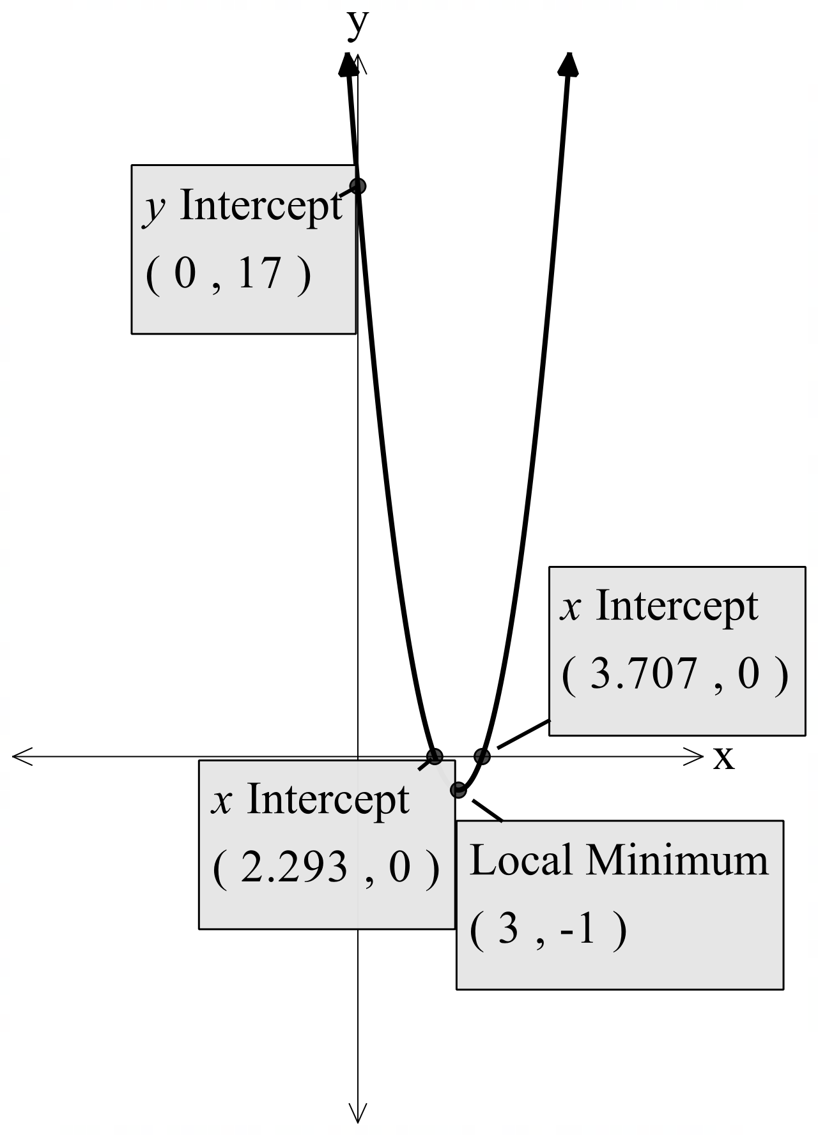
- State the domain and range.
- Domain: all real $x$
- Range: all real $y, y≥-1$

Independent practice – Same Surface, Different Deep
- Determine the $x$-intercepts for the parabola $y=2x^{2}+7x+3$.
Let $y=0$
$$2x^{2}+7x+3=0 \\ \left(2x+1\right)\left(x+3\right)=0$$
$2x+1=0$ or $x+3=0$
$$∴x=-\frac{1}{2}, -3$$
- Find the vertex and the axis of symmetry for the parabola $y=2x^{2}+7x+3$.
$$y=2\left(x^{2}+\frac{7}{2}x+\right)+3 \\ =2\left(x^{2}+\frac{7}{2}x+\frac{49}{16}\right)+3-2×\frac{49}{16} \\ =2{\left(x+\frac{7}{4}\right)}^{2}-\frac{25}{8}$$
$∴$ Vertex at $\left(-\frac{7}{4},-\frac{25}{8}\right)$ and axis of symmetry at $x=-\frac{7}{4}$.
- State the domain and range of the parabola $y=2x^{2}+7x+3$.
- Domain: all real $x$
- Range: $y≥-\frac{25}{8}$
- Sketch the parabola $y=2x^{2}+7x+3$, showing all key features.
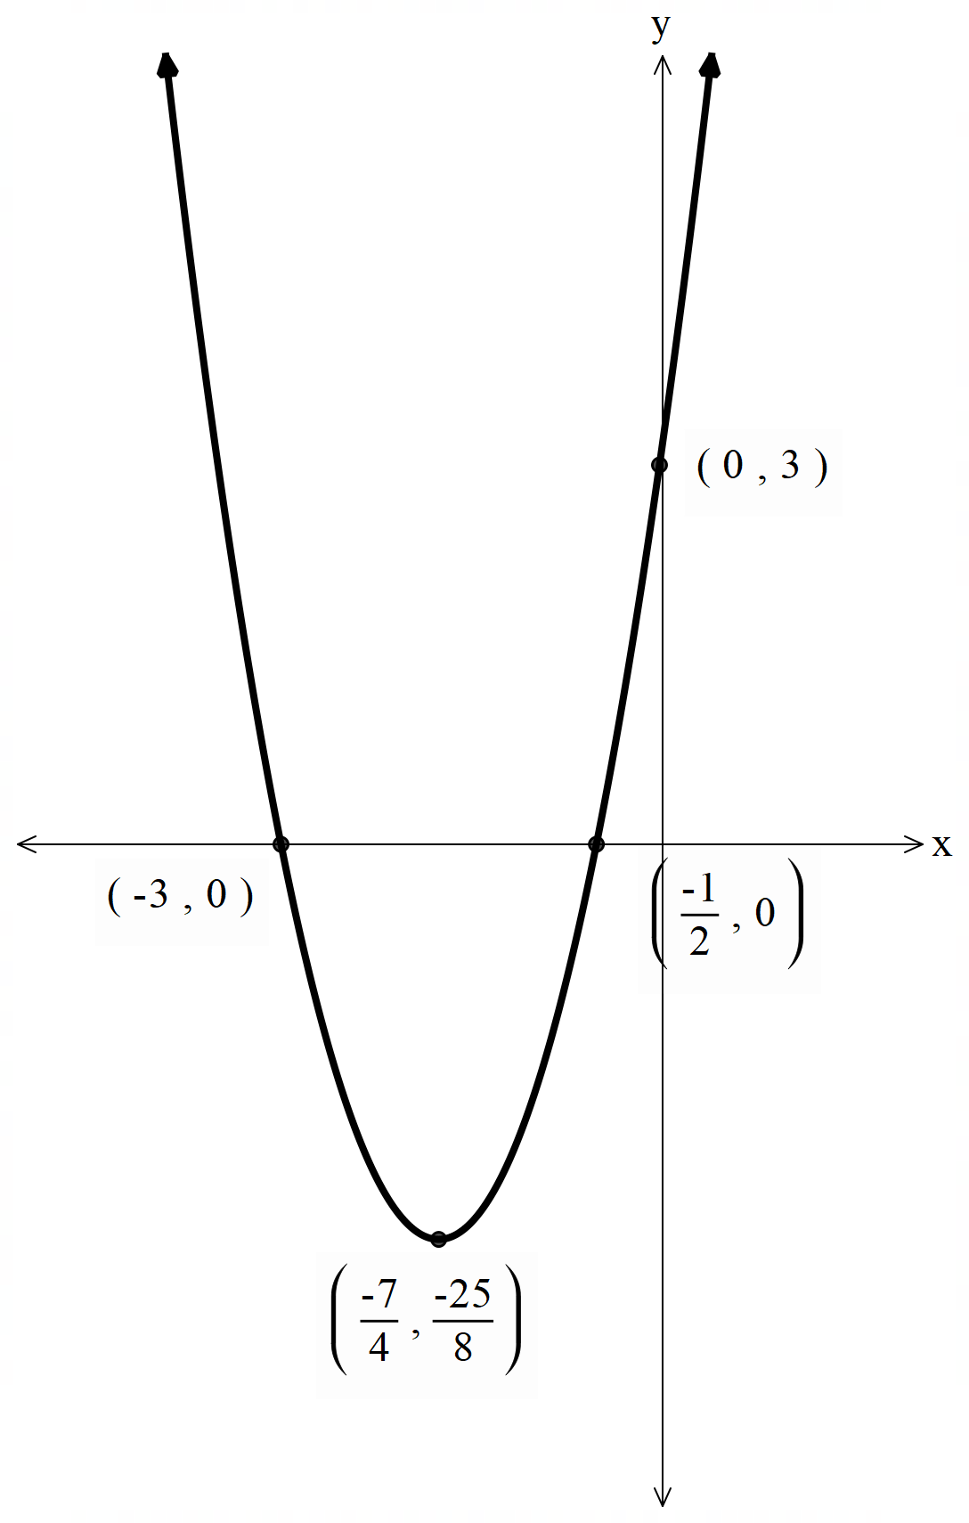

References
This resource contains NSW Curriculum and syllabus content. The NSW Curriculum is developed by the NSW Education Standards Authority. This content is prepared by NESA for and on behalf of the Crown in right of the State of New South Wales. The material is protected by Crown copyright.
Please refer to the NESA Copyright Disclaimer for more information https://educationstandards.nsw.edu.au/wps/portal/nesa/mini-footer/copyright.
NESA holds the only official and up-to-date versions of the NSW Curriculum and syllabus documents. Please visit the NSW Education Standards Authority (NESA) website https://educationstandards.nsw.edu.au/ and the NSW Curriculum website https://curriculum.nsw.edu.au/.
Mathematics Advanced 11–12 Syllabus © NSW Education Standards Authority (NESA) for and on behalf of the Crown in right of the State of New South Wales, 2024.
Barton C (n.d.) Maths Venns [website], accessed 26 November 2025.

© State of New South Wales (Department of Education), 2025
The copyright material published in this resource is subject to the Copyright Act 1968 (Cth) and is owned by the NSW Department of Education or, where indicated, by a party other than the NSW Department of Education (third-party material).
Copyright material available in this resource and owned by the NSW Department of Education is licensed under a Creative Commons Attribution 4.0 International (CC BY 4.0) license.

This license allows you to share and adapt the material for any purpose, even commercially.
Attribution should be given to © State of New South Wales (Department of Education), 2025.
Material in this resource not available under a Creative Commons license:
- the NSW Department of Education logo, other logos and trademark-protected material
- material owned by a third party that has been reproduced with permission. You will need to obtain permission from the third party to reuse its material.
Links to third-party material and websites
Please note that the provided (reading/viewing material/list/links/texts) are a suggestion only and implies no endorsement, by the New South Wales Department of Education, of any author, publisher, or book title. School principals and teachers are best placed to assess the suitability of resources that would complement the curriculum and reflect the needs and interests of their students.
If you use the links provided in this document to access a third-party's website, you acknowledge that the terms of use, including licence terms set out on the third-party's website apply to the use which may be made of the materials on that third-party website or where permitted by the Copyright Act 1968 (Cth). The department accepts no responsibility for content on third-party websites.

