Completing the square
In this lesson, students learn techniques for sketching the graph of a quadratic function when it cannot be easily factorised. They complete the square to rewrite quadratic functions of the form $y={k(x-a)}^{2}+c$ and identify key features such as the vertex and axis of symmetry, linking the equation to the graph.
Learning intentions and success criteria should be shared with students later in the learning episode.

Learning intentions
- To understand how to solve quadratic equations that cannot be easily factorised with rational solutions.
- To be able to use different strategies to find key features of a parabola to accurately graph.

Success criteria
- I can recognise when a quadratic function cannot be easily factorised.
- I can complete the square to rewrite a quadratic equation in the form $y={k\left(x-a\right)}^{2}+c$.
- I can solve quadratic equations by completing the square and use this to find the $x$-intercepts of their graphs.
- I can explain how the equation of a quadratic relates to its graph.

Outcomes
A student:
- develops understanding and fluency in mathematics through exploring and connecting mathematical concepts, choosing and applying mathematical techniques to solve problems, and communicating their thinking and reasoning coherently and clearly MAO-WM-01
- applies algebraic techniques and the laws of indices and surds to manipulate expressions and solve problems MAV-11-01
- uses functions and relations to model, analyse and solve problems MAV-11-02

Content

Algebraic techniques
- Solve quadratic equations $ax^{2}+bx+c=0$ by factorisation, completing the square and using the quadratic formula $x=\frac{-b±\sqrt{b^{2}-4ac}}{2a}$ where $a, b$ and $c$ are real numbers and $a≠0$

Quadratic and cubic functions
- Show by completing the square on the general quadratic $y=ax^{2}+bx+c$ that the axis of symmetry is $x=-\frac{b}{2a}$ where $a, b$ and $c$ are constants
- Identify the axis of symmetry and vertex of a parabola by completing the square on its quadratic function
- Choose and apply appropriate techniques to graph a parabola of the form $y=ax^{2}+bx+c$ by identifying its $x$-intercepts if they exist, its $y$- intercept, its axis of symmetry using $x=-\frac{b}{2a}$ and its vertex
Mathematics Advanced 11–12 Syllabus © NSW Education Standards Authority (NESA) for and on behalf of the Crown in right of the State of New South Wales, 2024.

Table 1: lesson summary
Section | Summary of activity | Teaching strategies | Teaching points
Retrieval practice | Students review their factorising knowledge through a banner task Appendix A, to discover a special product, a perfect square. | Visibly random groups of 3  Vertical non-permanent surfaces  Banner task | The aim of this activity is to revise how to factorise quadratic expressions, while noticing a pattern of the special product, a perfect square. Attention should be drawn to how the terms in the factorised form relate to those in the expanded form.
Activating prior knowledge | Students sketch a series of quadratic functions through a banner task Appendix B, to review how this skill and recognise that not all quadratics can be easily factorised. | Visibly random groups of 3  Vertical non-permanent surfaces  Pose-Pause-Pounce-Bounce | The purpose of this activity is to review graphing methods for factorisable quadratics and create the need for a new technique.
Connecting learning | Reveal learning intentions and success criteria using slide 3, then use slides 5–7 of the PowerPoint Completing the square to model how completing the square rewrites $y=x²+6x+4$ in the form $y={\left(x-a\right)}^{2}+c$, identifying vertex, intercepts, domain, and range. Students complete Appendix C in pairs to practise identifying features from the form $y={\left(x-a\right)}^{2}+c$. | Think-Pair-Share  Pose-Pause-Pounce-Bounce | This activity connects prior work to the new method of completing the square, highlighting the efficiency of the form $y={\left(x-a\right)}^{2}+c$ for graphing.
Releasing responsibility | Use slides 9–17 to model completing the square for monic and non-monic quadratics, linking to the graph it produces. Students complete Appendix D to consolidate the process. | Think-Pair-Share  Worked examples (Your turn)  Four quadrant notes | The aim of this activity is to guide students toward independently using completing the square to graph quadratics, with a focus on recognising the vertex and axis of symmetry in all cases.
Independent practice | Students complete the Appendix E, matching equations to graphs using completing the square to identify features. Students then complete Appendix F, which contains past HSC questions. |  | To strengthen fluency in using completing the square to quickly extract the vertex, axis of symmetry and intercepts, even when factorisation isn’t possible. This stage reinforces recognition of the form $y={\left(x-a\right)}^{2}+c$ as an efficient graphing tool and builds accuracy.

Activity structure
Please use the associated PowerPoint Completing the square to display images in this lesson.

Retrieval practice
- Assign students to visibly random groups of 3 (bit.ly/visiblegroups) at vertical non-permanent surfaces (bit.ly/VNPSstrategy).
- Students are to complete the banner task (bit.ly/supportingstrategies) from Appendix A ‘Banner task A’.
The purpose of this activity is to review students’ understanding of factorising quadratic expressions of the form $ax^{2}+bx+c$. Students have previously learned this skill in Lesson 5 – factorising monic quadratic functions and Lesson 7 – factorising and graphing non-monic quadratic functions.
- Initiate a class discussion at the conclusion of this activity to connect the factorised form with the expanded form. Some suggested prompts may include:
- What did you notice about each of the factorised expression?
- How might the numbers in the factorised form connect to the numbers in the expanded form?
- How does the middle term relate to the terms in the brackets of the factorised form?
Clearly establish that when a quadratic expression factorises into 2 identical factors, the result can be written in the form ${\left(a+b\right)}^{2}$. Explain to students that this special product, $a^{2}+2ab+b^{2}={\left(a+b\right)}^{2}$ is called a perfect square. Students may be familiar with this if they learned the Stage 5 Algebraic techniques C Path outcome MA5-ALG-P-02.

Activating prior knowledge
- Continuing in their groups of 3, students now complete the banner task from Appendix B ‘Banner task B’.
Only give out question 7, $y=x^{2}+6x+4$ at the end as you start to wrap up the activity, do not leave students on this question for long as they will not be able to factorise it to find the $x$-intercepts. Only allow them a few minutes to come to this conclusion before pausing the activity. Students can find the $y$-intercept to be $4$.
- Use the Pose-Pause-Pounce-Bounce questioning strategy (PDF 557 KB) (bit.ly/posepausepouncebounce) to initiate a class discussion. Some suggested questions include:
- What strategies did you use to sketch each equation?
- What was different about the final equation?
Conclude with students that not all quadratic equations can be easily factorised. Because of this, we need another method to help us sketch the graph when that approach doesn’t work.

Connecting learning
- By revealing the learning intentions and success criteria on slide 3 of the PowerPoint, explain to students that they will now be learning a different technique that can be used to graph a parabola of the form $y=x^{2}+bx+c$.
- Display slide 4 which shows balancing scales of $x^{2}+6x+4$, the expression from the earlier activity that students recognised couldn’t be factorised into a binomial product. Initiate a class discussion to check their understanding of what’s displayed.
Students should understand that initially the scales are not balanced since when expanded, ${\left(x+3\right)}^{2}=x^{2}+6x+9$, not $x^{2}+6x+4$.
In subtracting 5 from the right-hand side scales, the expressions are now equal. Since
${\left(x+3\right)}^{2}-5=x^{2}+6x+9-5$, which simplifies to $x^{2}+6x+4$.
Students will learn how to complete the square in the ‘Releasing responsibility’ section of this lesson.
- Progress to slide 5 which contains both expressions $y={\left(x+3\right)}^{2}-5$ and $y=x^{2}+6x+4$, Students should recognise that these are the same expressions, just expressed in a different way. Use a Think-Pair-Share (bit.ly/thinkpairsharestrategy) to ask students to find the $x$-intercepts and sketch the graph using the second structure of the equation.
- Animate the solution to show the $x$-intercepts as well as the sketch of the curve. Use a Think-Pair-Share for students to consider what the domain and range of their parabola would be.
Students should share that the domain is all real $x$. Some students may struggle to find the range as all real $y, y≥-3$. Students are yet be shown the formula $x=-\frac{b}{2a}$ that finds the axis of symmetry. For those that could find the range, ask them to explain how they determined this. Some students may have found the average of their 2 $x$-intercepts and substituted it back into the original equation to find the vertex. See below for this working.
Axis of symmetry at $x=\frac{-5.24-0.76}{2}$
$$∴x=-3$$
$$y={\left(-3\right)}^{2}+6\left(-3\right)+4 \\ y=-5$$
Vertex at $(-3,-5)$
Students may benefit from completing further practice questions to graph parabolas by completing the square, including finding the $x$-intercepts and the vertex.
- Use a Think-Pair-Share as you progress to slide 8, asking students to make a connection between the graphical features and the equation.
Students may notice that the $x$-coordinate of the vertex is found by solving $x+3=0$ and that the $y$-coordinate of the vertex is equal to the $-5$ in the equation $y={\left(x+3\right)}^{2}-5$.
- Conclude with students that when an equation is expressed in the form $y={\left(x-a\right)}^{2}+c$ the vertex is $(a, c)$ and the axis of symmetry is $x=a.$This can be displayed using slide 7.
- Use the Pose-Pause-Pounce-Bounce questioning strategy to discuss with students the key graphical features of a parabola that is needed to draw a sketch. Some suggested prompts include:
- Is the vertex of a parabola enough information in order to sketch the graph? How do you know?
- Can you determine the concavity of a parabola from the vertex?
- How might the coefficient of $x^{2}$ help when sketching a parabola?
- Are both the $x$- and $y$-intercepts needed to sketch the graph, if the vertex is known? Why or why not?
Students should identify the key features needed to sketch a parabola (vertex, intercepts, concavity) and explain why the vertex alone is not enough. They should link the coefficient of $x^{2}$ to concavity and see how factorised form reveals intercepts.
- Distribute Appendix C ‘Graphing using the vertex’ to students for them to complete in pairs. This activity has students identifying the vertex from the equation, determining the $x$-intercept and $y$-intercept, if they exist, sketching the graph and then recording the domain and range.
- Use the Pose-Pause-Pounce-Bounce questioning strategy to check for student understanding of the benefits of having the equation in the form $y={\left(x-a\right)}^{2}+c$. The following are some suggested prompts:
- Which form of a quadratic, either $y=x^{2}+bx+c$ or $y={\left(x-a\right)}^{2}+c$ is the most effective to graph and why?
- In what ways does knowing the vertex help you determine the range of a quadratic function?
Students should recognise that form $y={\left(x-a\right)}^{2}+c$ highlights the turning point, making it easier to sketch the graph. They should understand how the vertex determines whether the function has a maximum or minimum and how this links to the range. Students should also appreciate that the form $y={\left(x-a\right)}^{2}+c$ is often more efficient than standard form when graphing.

Releasing responsibility
- Explain to students that they will now be working through how to transform a quadratic expression into the form $y={\left(x-a\right)}^{2}+c$.
- Display slide 9 of the PowerPoint, which shows the expressions $x^{2}+6x$ and ${\left(x+3\right)}^{2}$ on scales. Use a Think-Pair-Share as you animate the questions, asking students whether the sides are balanced and how they could make them equal.
Students can use different strategies such as expanding, substituting or using an area model to justify their response. Students should conclude that the sides are not balanced, since ${\left(x+3\right)}^{2}=x^{2}+6x+9$.
Students might suggest adding 9 to the left-hand side or subtracting 9 from the right-hand side.
- Display slide 10, which shows 2 methods that could be used to balance the scales. Explain to the class that we can manipulate expressions to create equivalent forms that are easier to work with and that this is the process that we follow to convert quadratic equations of the form $y=x^{2}+bx+c$ to the form $y={\left(x-a\right)}^{2}+c$.
- Use slides 11–14 to model completing the square and graphing quadratics using the Worked examples (Your turn) method (bit.ly/supportingstrategies).
Throughout the worked examples, use the self-explanation prompts to unpack the method of completing the square. Students should understand how to halve the middle term and square it to get the third term in the expression.
The first worked example involves only completing the square, while the second uses completing the square to graph a quadratic function. The first worked example shows how to complete the square for the expression that has been previously used throughout this lesson, $y=x^{2}+6x+4$.
The next set of slides demonstrates how to complete the square for non-monic quadratics. Students may benefit from practising monic cases first, using existing resources, before moving on to non-monic examples.
- Explain to students that these questions have been for parabolas of the form $y=x^{2}+bx+c$, that is, monic quadratic equations. Display slide 15 to students which shows the format of completing the square for non-monic quadratic equations, that is, $y=k{\left(x-a\right)}^{2}+c$.
- Initiate a class discussion to ask students if the vertex and the axis of symmetry can still be found when a quadratic equation is rearranged to be of the form $y=k{\left(x-a\right)}^{2}+c$.
Students should conclude that the vertex is still $(a, c)$ and the axis of symmetry remains as $x=a$. They may wonder what effect the $k$ has on the graph. Explain to students that the $k$ has the same effect that the 2 of $y=2x^{2}$ has on the graph $y=x^{2}$.
Students will learn about transformations of graphs in Unit 4 – graph transformations. However, the Desmos Graphing Calculator ‘A quadratic function in vertex form’ (bit.ly/QuadraticInVertexForm) can be shown to students to connect how changes in the equation when in the form $y={\left(x-a\right)}^{2}+c$ are represented in the graphical form.
- Use slides 16–17 to model completing the square and graphing non-monic quadratic functions using the Worked examples (Your turn) method (bit.ly/supportingstrategies).
- Distribute Appendix D ‘Four quadrant notes’ and ask students to complete four quadrant notes to their future forgetful selves (bit.ly/supportingstrategies).
- Students may complete practice questions from an existing resource to consolidate their understanding of solving quadratic equations, identifying the axis of symmetry and vertex by completing the square.

Independent practice
- Distribute Appendix E ‘Quadratic card sort’ to each pair of students. Beforehand, cut and shuffle the cards so that students can match each quadratic function to its corresponding graph. Encourage students to complete the square for each of the 5 functions, in order to find the vertex, axis of symmetry and the $x$-intercepts from the provided function.
All functions in this task share a y-intercept of 4 to encourage students to use completing the square to find key features like the vertex and axis of symmetry.
Some students may need additional practice with the completing the square method before attempting the activity.
- Distribute Appendix F ‘Past HSC questions’ for students to complete independently, reflecting on their own solution with their partner.

Assessment and differentiation

Suggested opportunities for differentiation
Activating prior knowledge
- This activity has multiple entry points, through intercepts, symmetry and factorising techniques.
- For students who need more support a scaffold could be provided that identifies the steps required to graph the parabolas.
Connecting learning
- Linking visual representation of balancing scales, algebraic expressions and graphs should support students conceptional understanding.
Releasing responsibility
- Students may need time to consolidate their understanding of monic completing the square quadratics, prior to progressing to the non-monic quadratic functions.
Independent practice
- Working in pairs allows students to verbalise their reasoning and compare solutions.

Suggested opportunities for assessment
Activating prior knowledge
- Circulate the room during the group activity to check for students understanding of factorising and using intercepts to sketch a curve.
- Photos can be taken of students sketches at vertical non-permanent surfaces to check their understanding of the features required and accuracy.
Connecting learning
- Use the responses from the Pose-Pause-Pounce-Bounce to assess students understanding of the purpose of using the form $y={\left(x-a\right)}^{2}+c$ and the connection between the equation and the graph.
- Appendix C can be collected to check for student understanding of extracting the vertex of the parabola from the equation when in the form $y={\left(x-a\right)}^{2}+c$.
Releasing responsibility
- Review Appendix D ‘Four quadrant notes’ to check for students understanding of how to complete the square.
Independent practice
- Students’ completed Appendix F worksheets can be reviewed for accuracy.

Appendix A

Banner task A
Factorise the following quadratic expressions.
- $x^{2}+2x+1$
- $x^{2}-6x+9$
- $x^{2}-10x+25$
- $x^{2}-4x+4$
- $x^{2}+8x+16$
- $49x^{2}+14x+1$
- $4x^{2}+12x+9$
- $16x^{2}+40x+25$
- $25x^{2}-30x+9$
- $9x^{2}-12x+4$

Appendix B

Banner task B
For each equation, find the intercepts and sketch the graph.
- $y=x^{2}-1$
- $y=3x^{2}-6x$
- $y=x^{2}-4x+3$
- $y=x^{2}+2x+1$
- $y=x^{2}-8x+16$
- $y=4x^{2}+12x+9$
- $y=x^{2}+6x+4$

Appendix C

Graphing using the vertex
Function | Vertex | $y$-intercept | $x$-intercept | Sketch the function | Domain and range
$$y={\left(x-2\right)}^{2}-1$$ | $$(2, -1)$$ | $$y=x^{2}-4x+4-1$$  Let $x=0$  $$y=0^{2}-4\left(0\right)+4-1$$  $$y=3$$ | $$y=x^{2}-4x+3$$Let $y=0$  $$0=x^{2}-4x+3 \\ 0=\left(x-3\right)\left(x-1\right)$$  Hence, $x$-intercepts at $x=3$and$x=1$ | 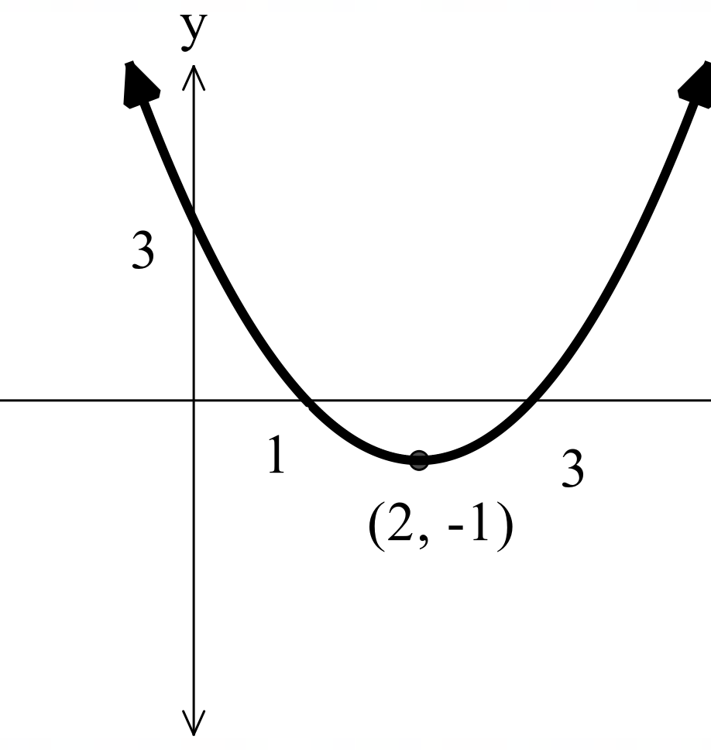 | Domain: all real $x$  Range: all real $y,y≥-1$
$$y={\left(x+2\right)}^{2}-1$$ |  |  |  | 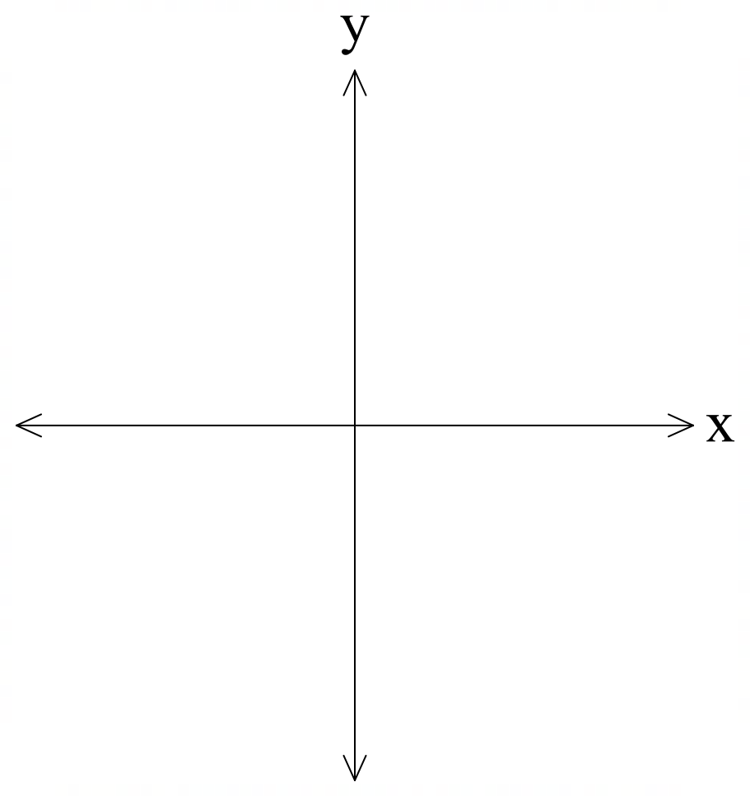
$$f\left(x\right)={\left(x+2\right)}^{2}-3$$
$$y=2{\left(x+1\right)}^{2}-3$$

Appendix D

Four quadrant notes
Example 1  Express $y=x^{2}+4x-1$ in the form $y={\left(x-a\right)}^{2}+c$ and determine the coordinates of the vertex. Find the intercepts and graph the parabola showing its vertex, $x$- and $y$-intercept.  $$y=x^{2}+4x+-1$$  $$y=x^{2}+4x+-1-$$  $$y={\left(x+\right)}^{2}-$$  Vertex $(,)$  $x$-intercepts:  $y$-intercept: | Example 2  Express $y={3x}^{2}-18x+23$ in the form $y={k\left(x-a\right)}^{2}+c$ and determine the coordinates of the vertex. Find the intercepts and graph the parabola showing its vertex,  $x$- and $y$-intercept.
Things to remember | Example 3

Appendix E

Quadratic card sort
Quadratic function | Graph
$$y=x^{2}+6x+4$$ | 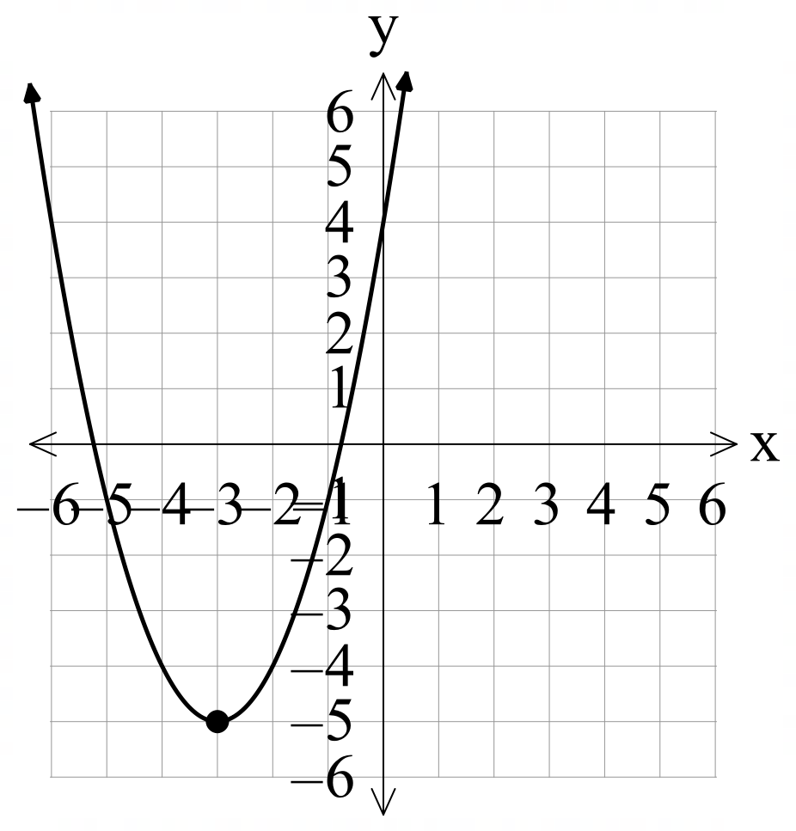
$$y=x^{2}-6x+4$$ | 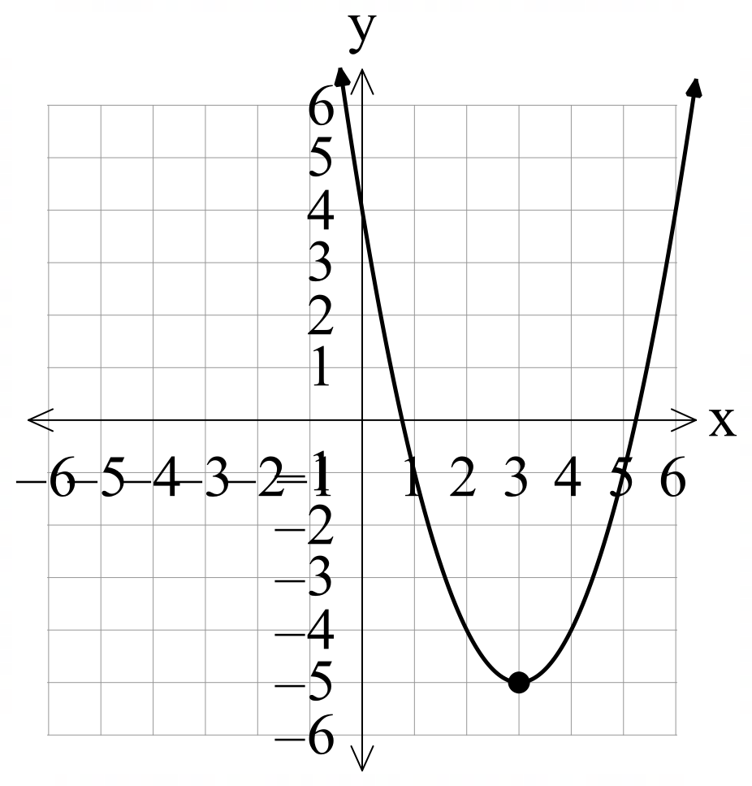
$$y=2x^{2}+7x+4$$ | 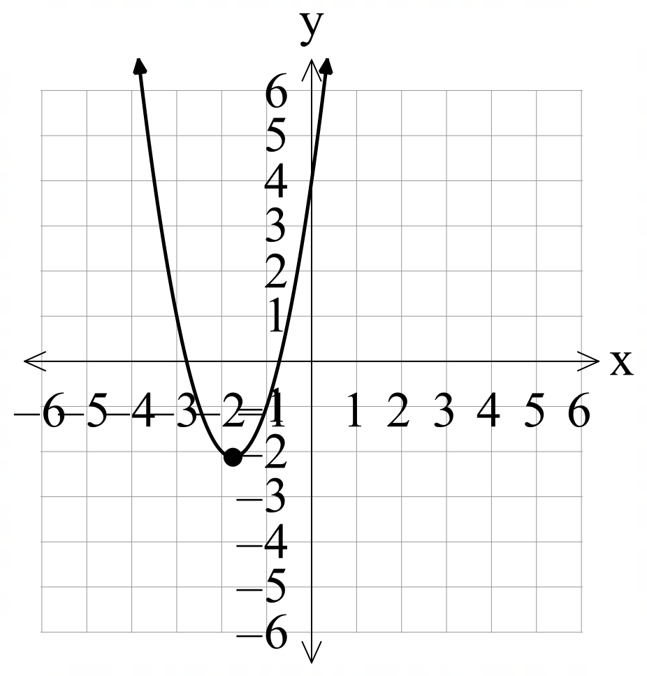
$$y=3x^{2}+9x+4$$ | 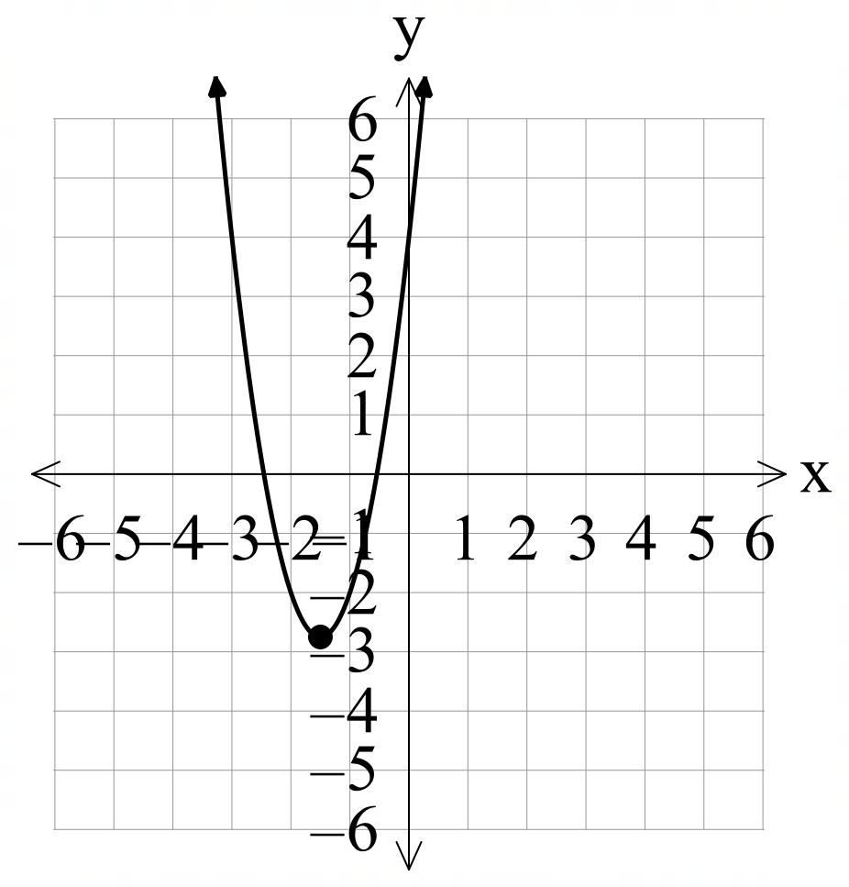
$$y=4x^{2}+9x+4$$ | 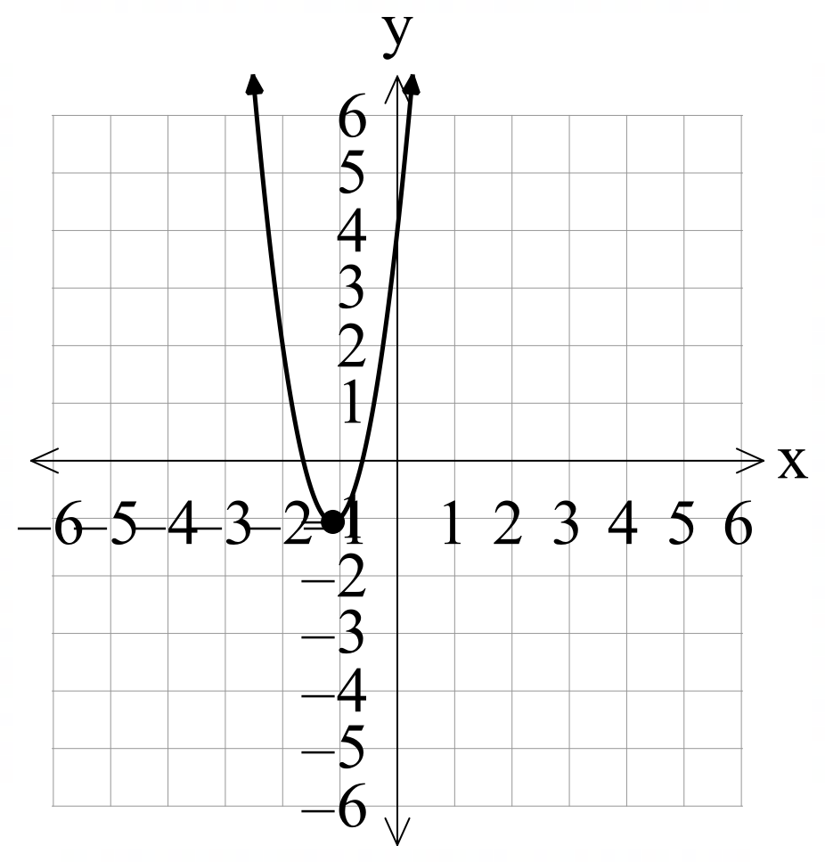
$$y=-x^{2}+2x+4$$ | 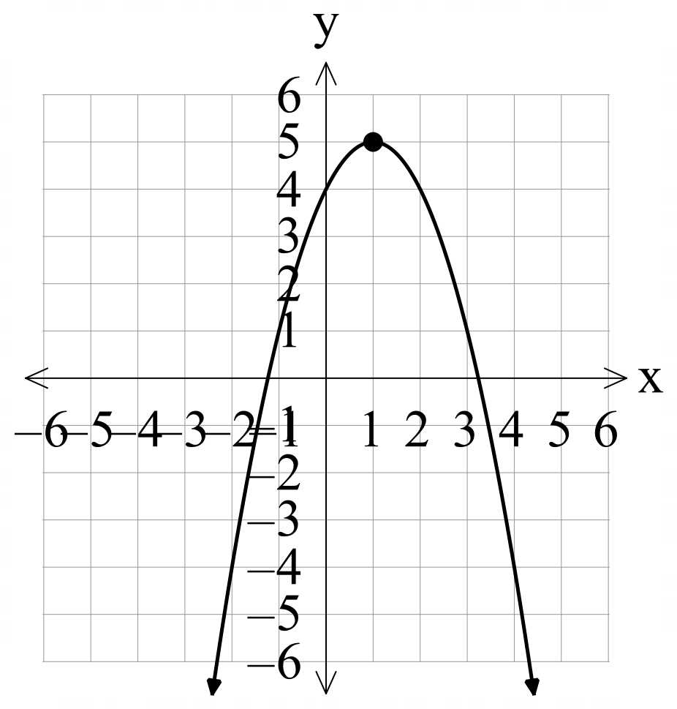
$$y=-x^{2}-4x+4$$ | 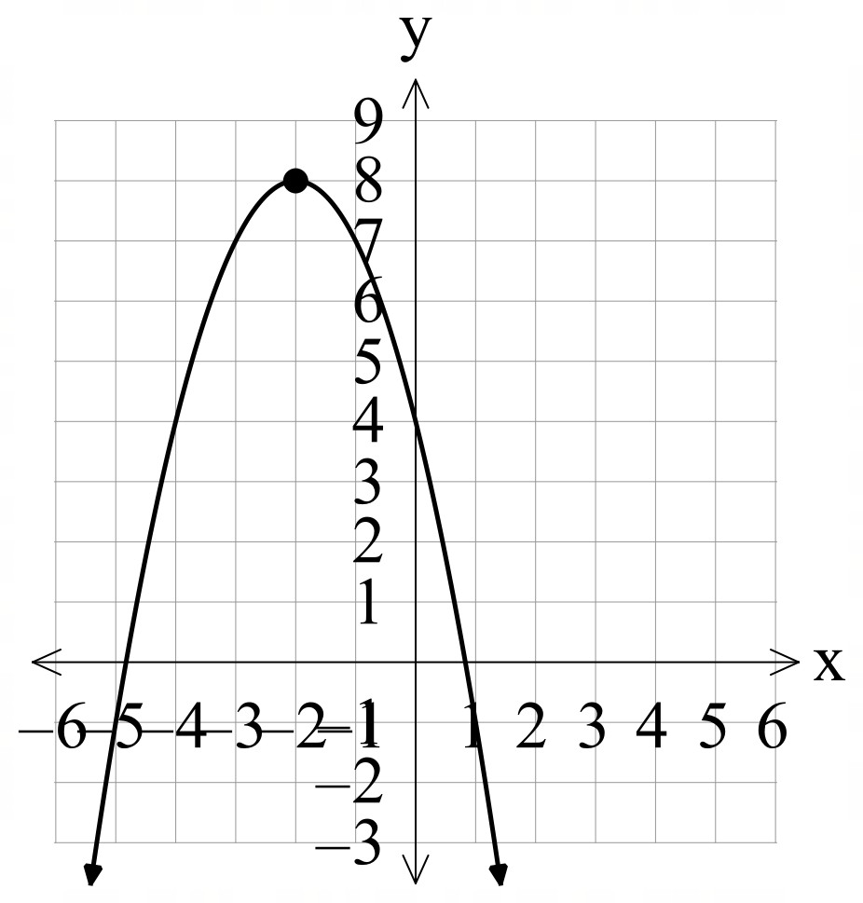
$$y=-2x^{2}+3x+4$$ | 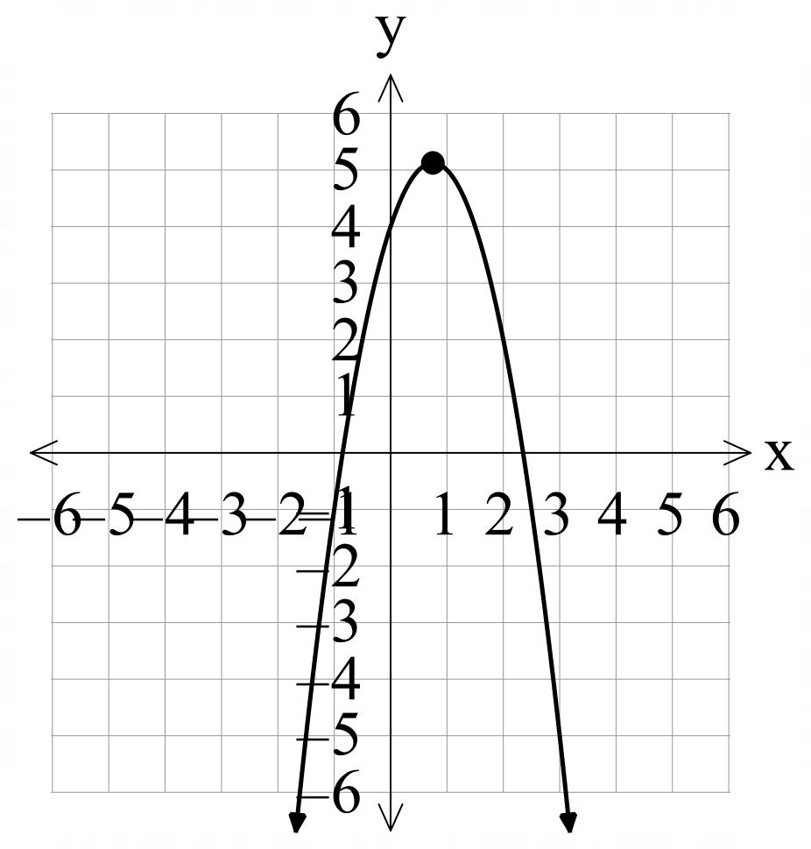

Appendix F

Past HSC questions
Complete the following past HSC questions.
- Which diagram best shows the graph of the parabola $y=3-{\left(x-2\right)}^{2}$? (Board of Studies, Teaching and Educational Standards NSW 2016).
(A)  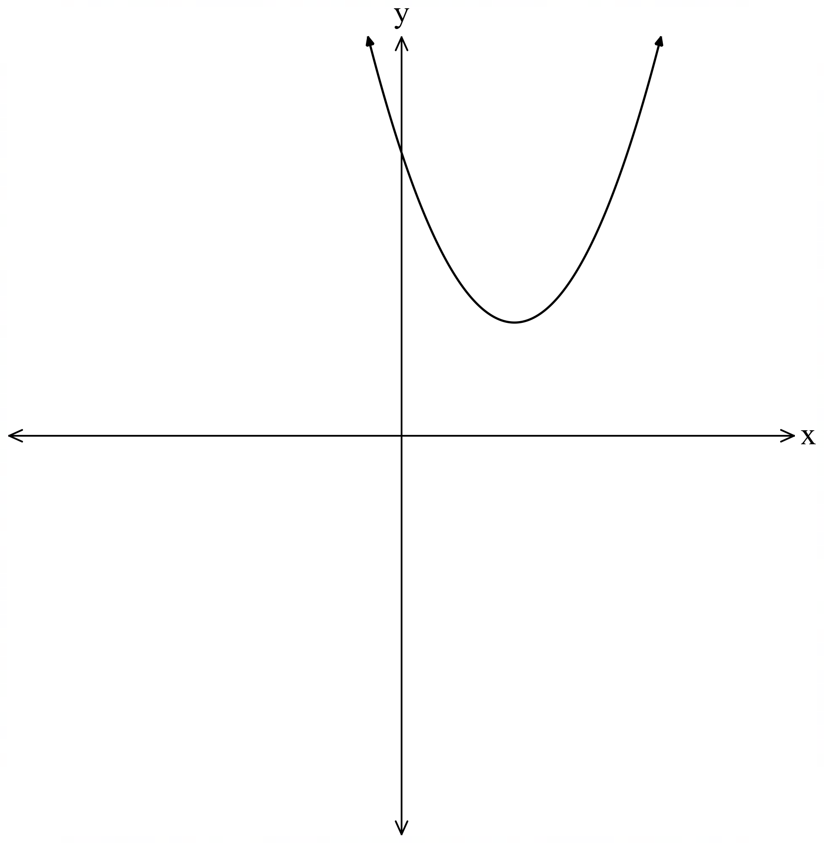 | (B)  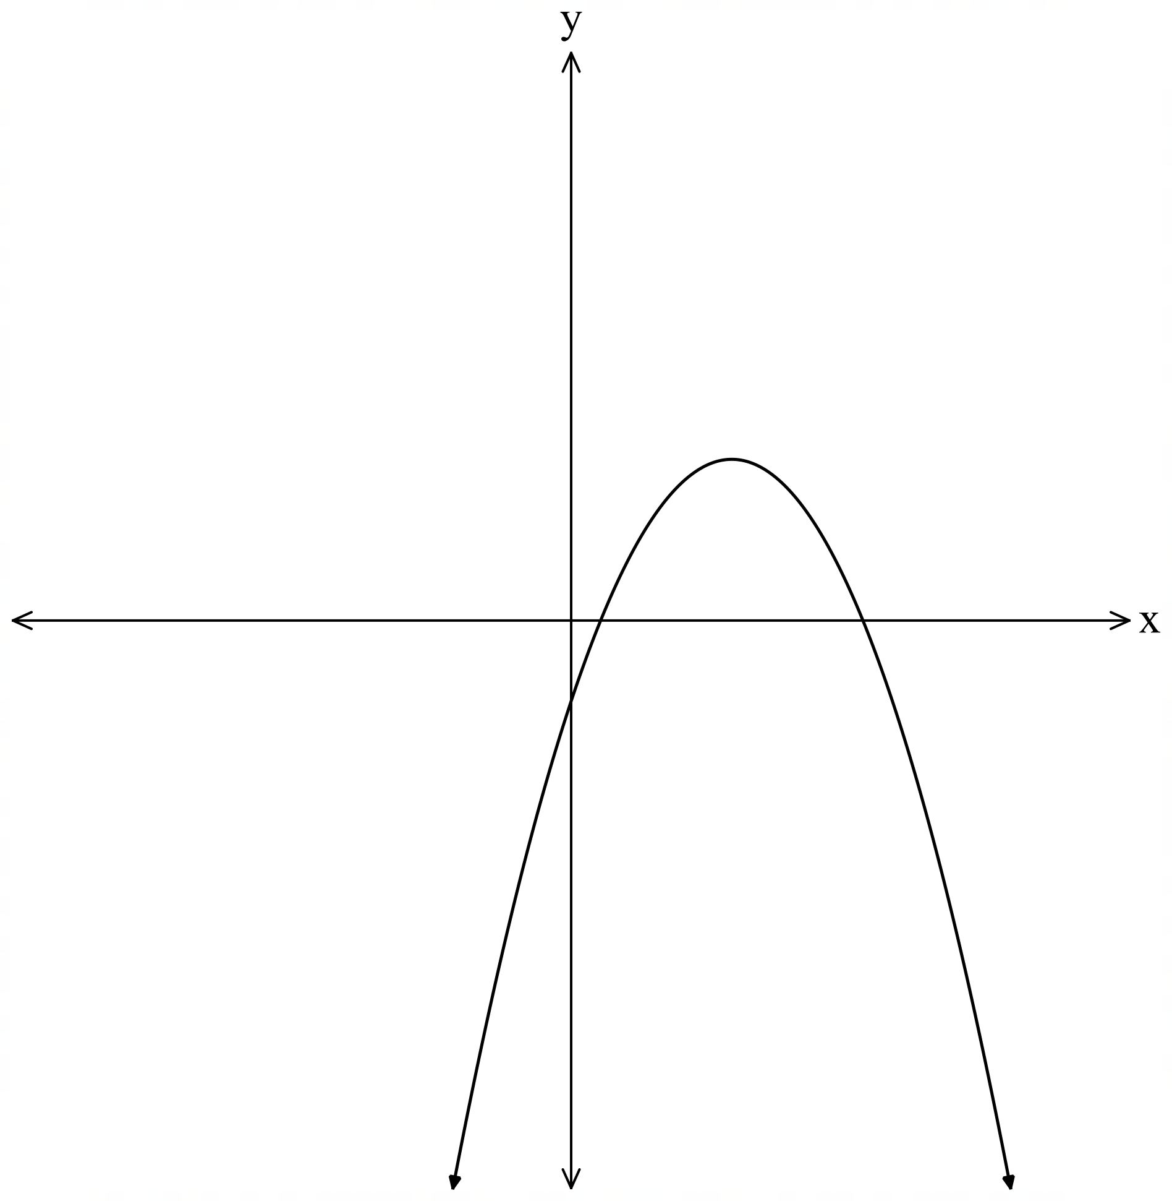
(C)  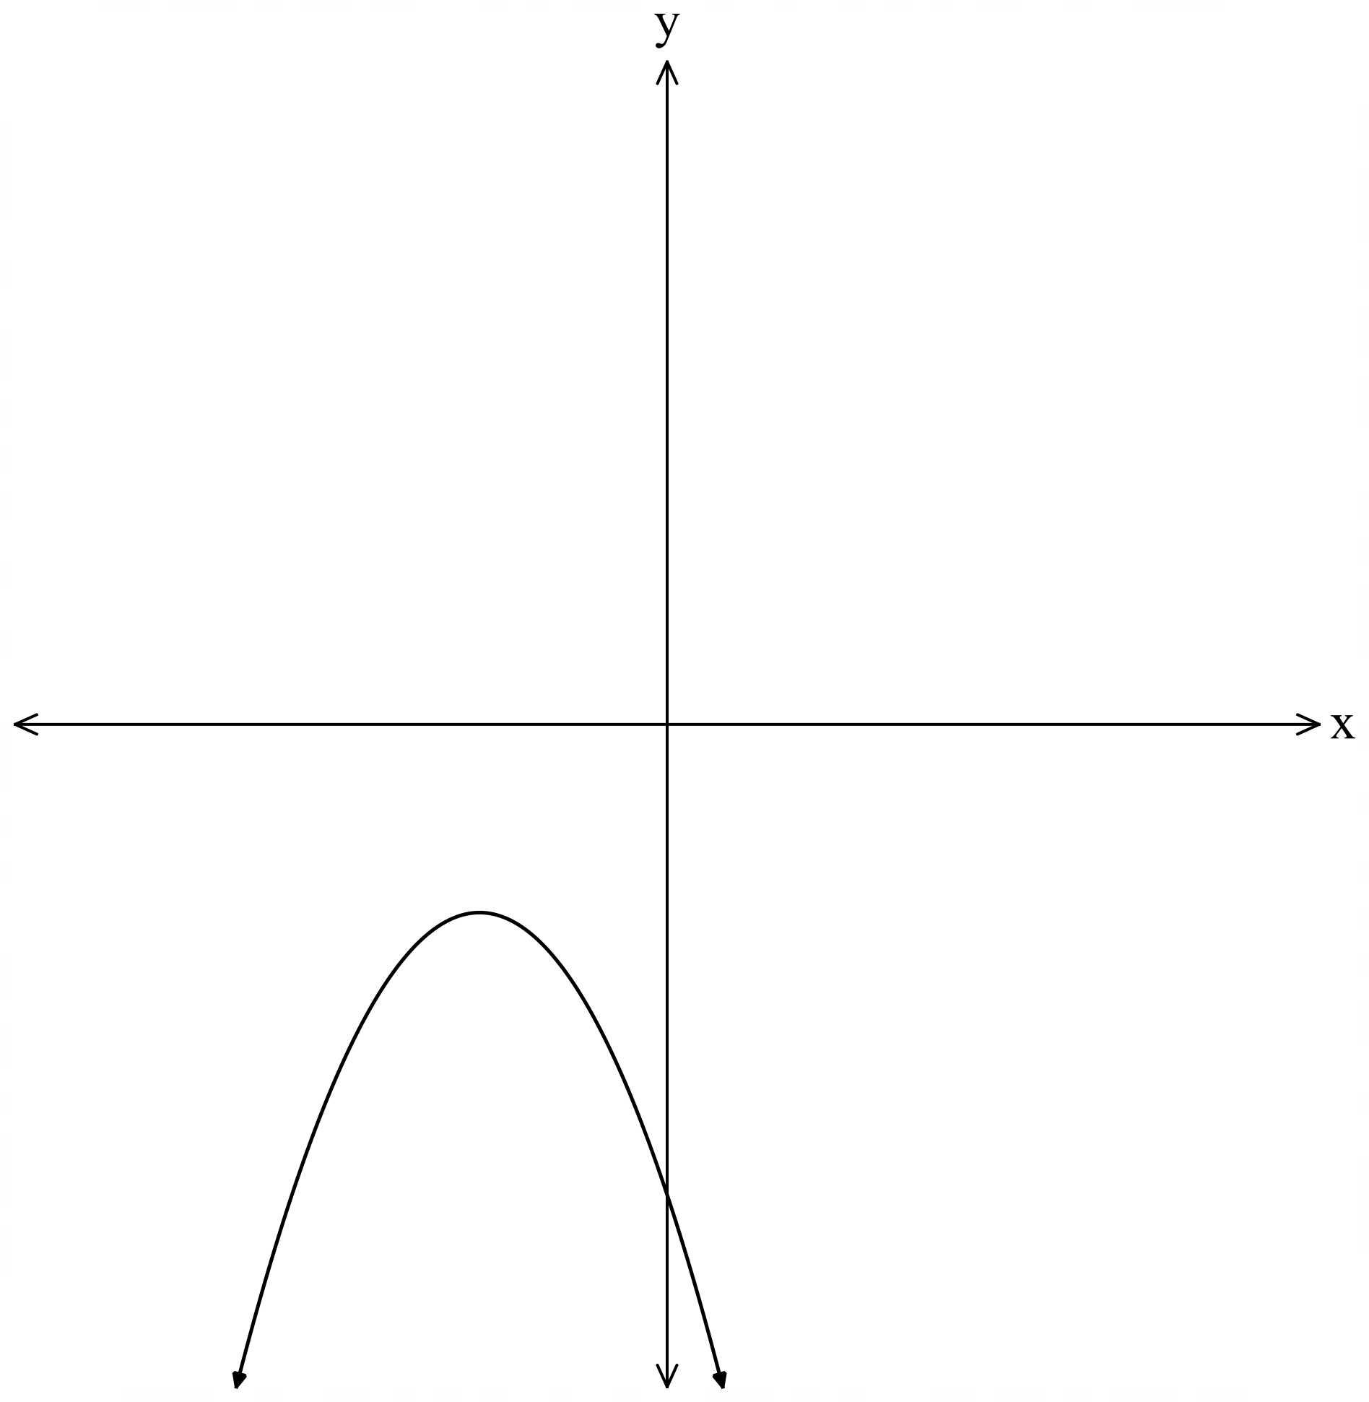 | (D)  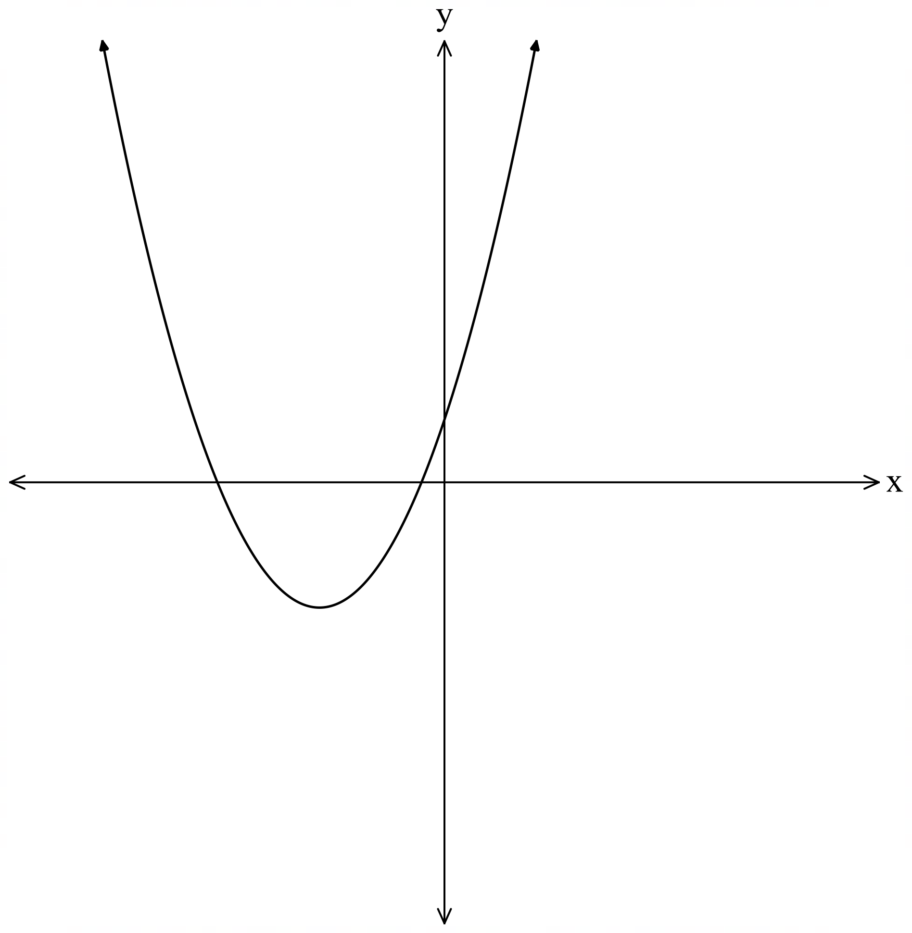
- Consider the parabola $y=x^{2}-8x+2$. Find the coordinates of the vertex.

Sample solutions

Appendix A – banner task A
Factorise the following quadratic expressions.
- $x^{2}+2x+1={\left(x+1\right)}^{2}$
- $x^{2}-6x+9={\left(x-3\right)}^{2}$
- $x^{2}-10x+25={\left(x-5\right)}^{2}$
- $x^{2}-4x+4={\left(x-2\right)}^{2}$
- $x^{2}+8x+16={\left(x+4\right)}^{2}$
- $49x^{2}+14x+1={\left(7x+1\right)}^{2}$
- $4x^{2}+12x+9={\left(2x+3\right)}^{2}$
- $16x^{2}+40x+25={\left(4x+5\right)}^{2}$
- $25x^{2}-30x+9={\left(5x-3\right)}^{2}$
- $9x^{2}-12x+4={\left(3x-2\right)}^{2}$

Appendix B – banner task B
For each equation, find the intercepts and sketch the graph.
- $y=x^{2}-1$
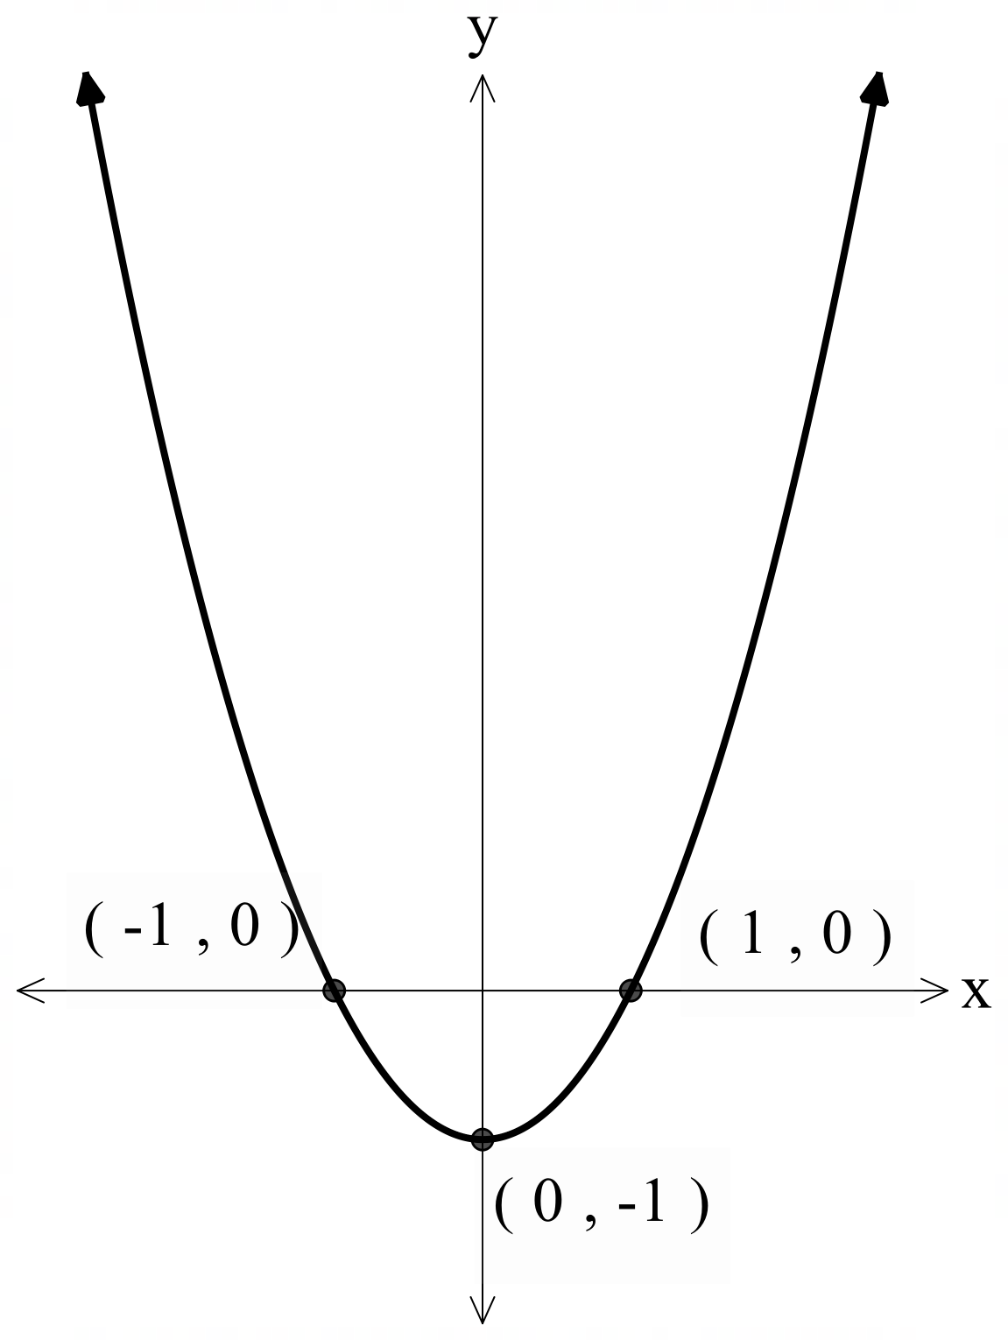
- $y=3x^{2}-6x$
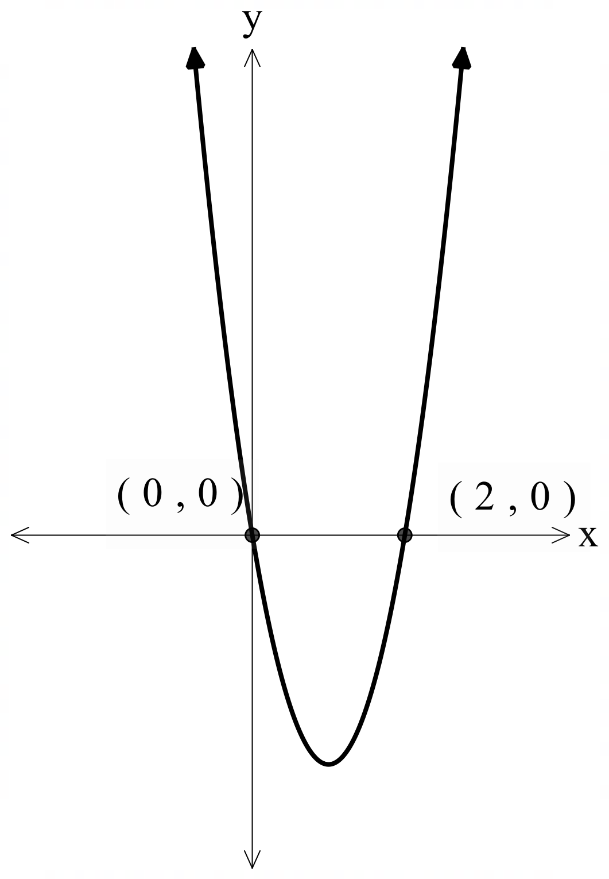
- $y=x^{2}-4x+3$
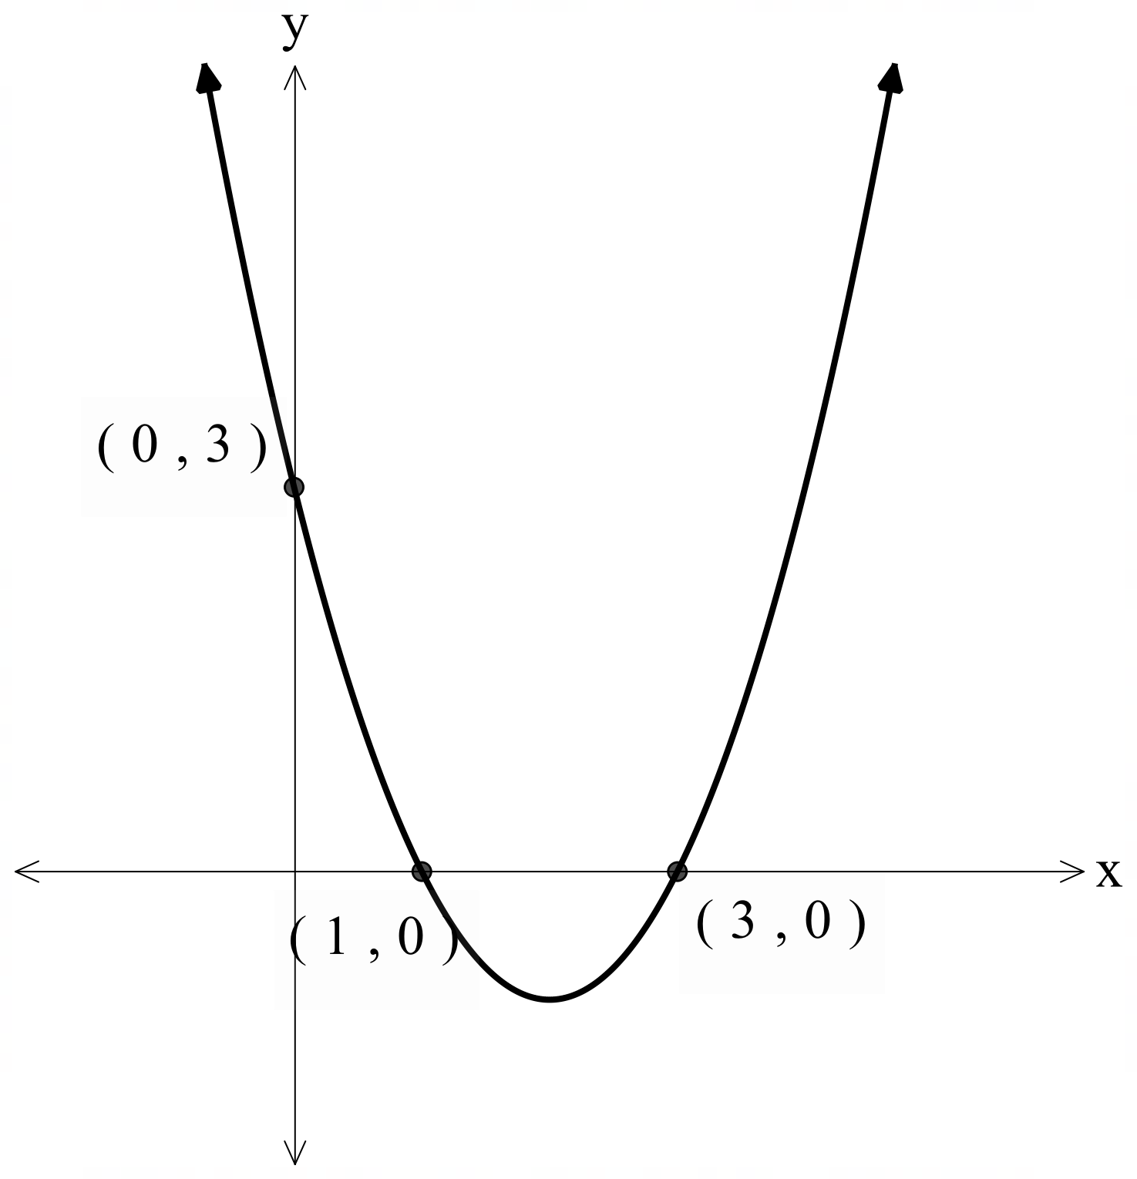
- $y=x^{2}+2x+1$
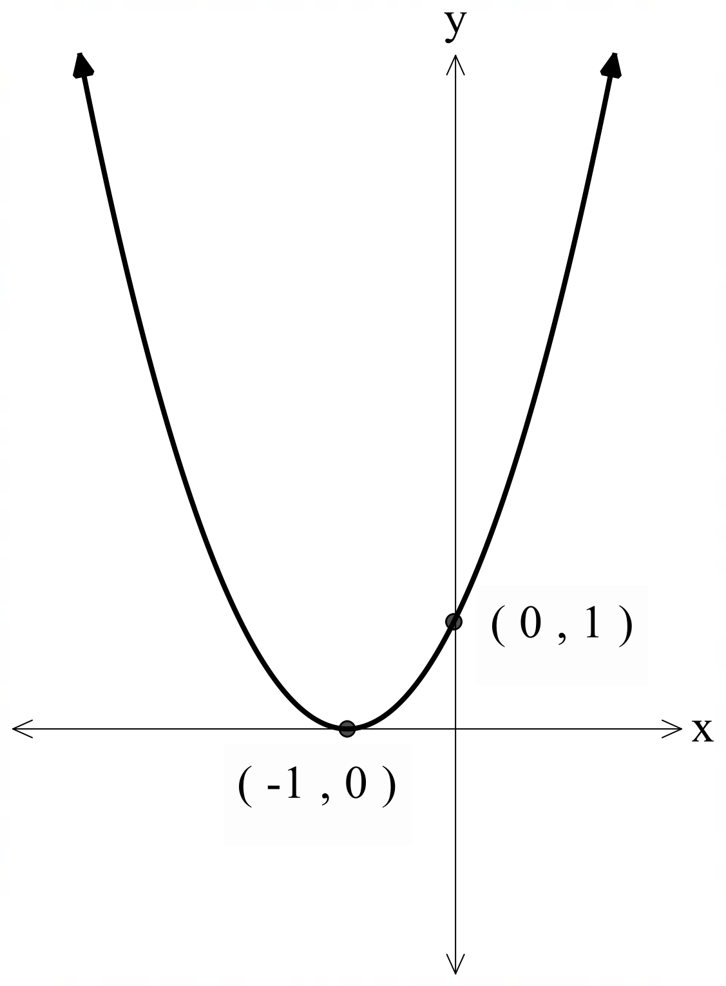
- $y=x^{2}-8x+16$
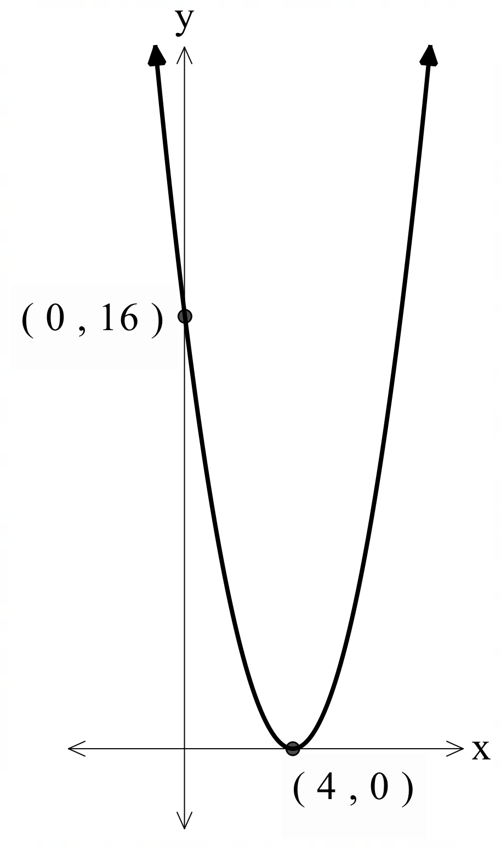
- $y=4x^{2}+12x+9$
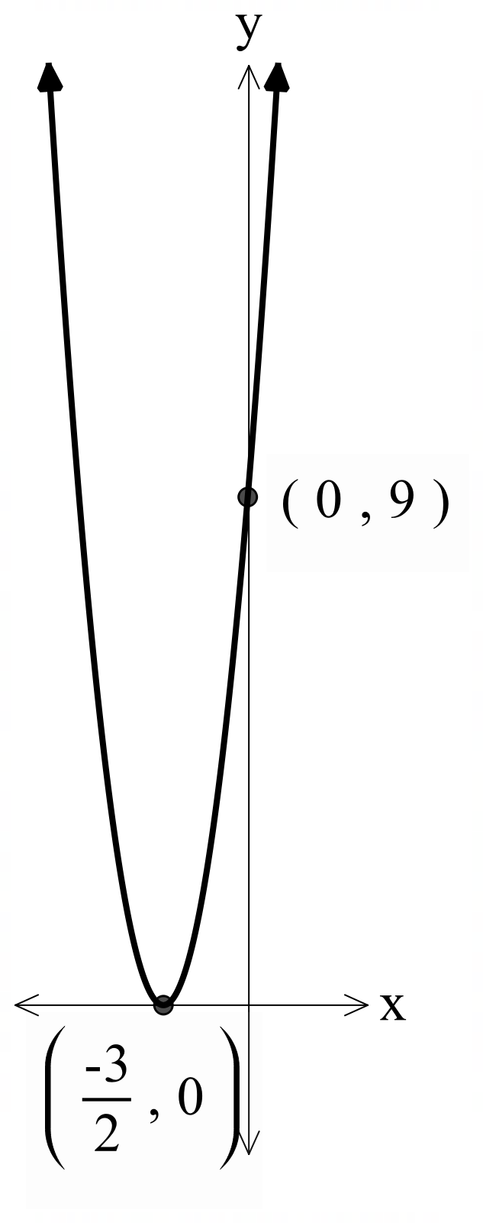
- $y=x^{2}+6x+4$

Appendix C – graphing using the vertex
Function | Vertex | $y$-intercept | $x$-intercept | Sketch the function | Domain and range
$$y={\left(x-2\right)}^{2}-1$$ | $$(2, -1)$$ | $$y=x^{2}-4x+4-1$$  Let $x=0$  $$y=0^{2}-4\left(0\right)+4-1$$  $$y=3$$ | $$y=x^{2}-4x+3$$Let $y=0$  $$0=x^{2}-4x+3 \\ 0=\left(x-3\right)\left(x-1\right)$$  Hence, $x$-intercepts at $x=3 and x=1$ | 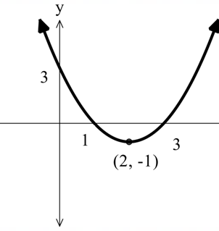 | Domain: all real $x$  Range: all real $y,y≥-1$
$$y={\left(x+2\right)}^{2}-1$$ | $$(-2,-1)$$ | $$y=x^{2}+4x+4-1$$  Let $x=0$  $$y=0^{2}+4\left(0\right)+4-1$$  $$y=3$$ | $$y=x^{2}+4x+3$$  Let $y=0$  $$0=x^{2}+4x+3 \\ 0=(x+3)(x+1)$$  Hence, $x$-intercepts at $x=-3 and$$$x=-1$$ | 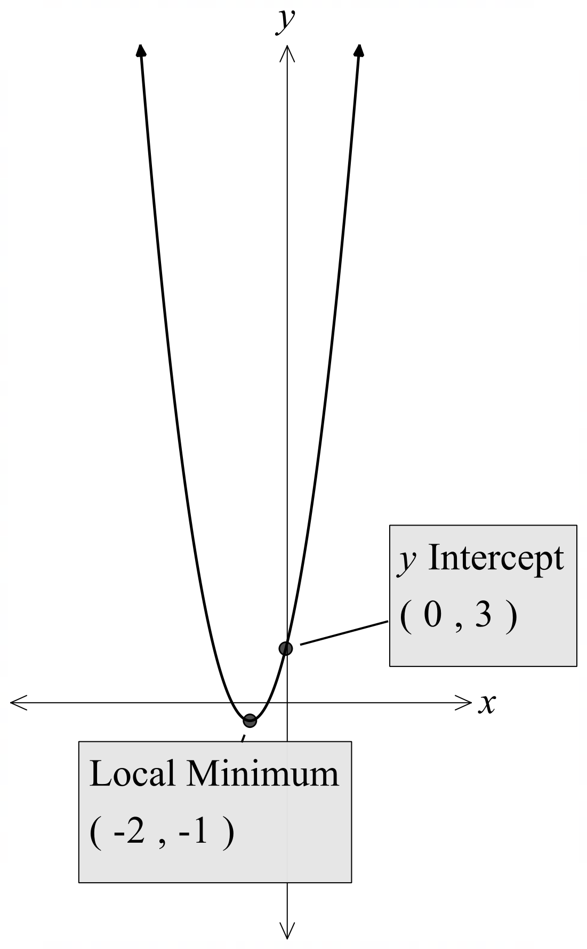 | Domain: all real $x$  Range: all real $y, y≥-1$
$$f\left(x\right)={\left(x+2\right)}^{2}-3$$ | $$(-2,-3)$$ | $$f(x)=x^{2}+4x+1$$  Let $x=0$  $$y=0^{2}+4\left(0\right)+4-3$$  $$y=1$$ | $$set f\left(x\right)=0 \\ 0={\left(x+2\right)}^{2}-3 \\ {\left(x+2\right)}^{2}=3 \\ \left(x+2\right)=±\sqrt{3} \\ x=-2±\sqrt{3}$$Hence, $x$-intercepts at $x=-2+\sqrt{3} and$$$x=-2-\sqrt{3}$$ | 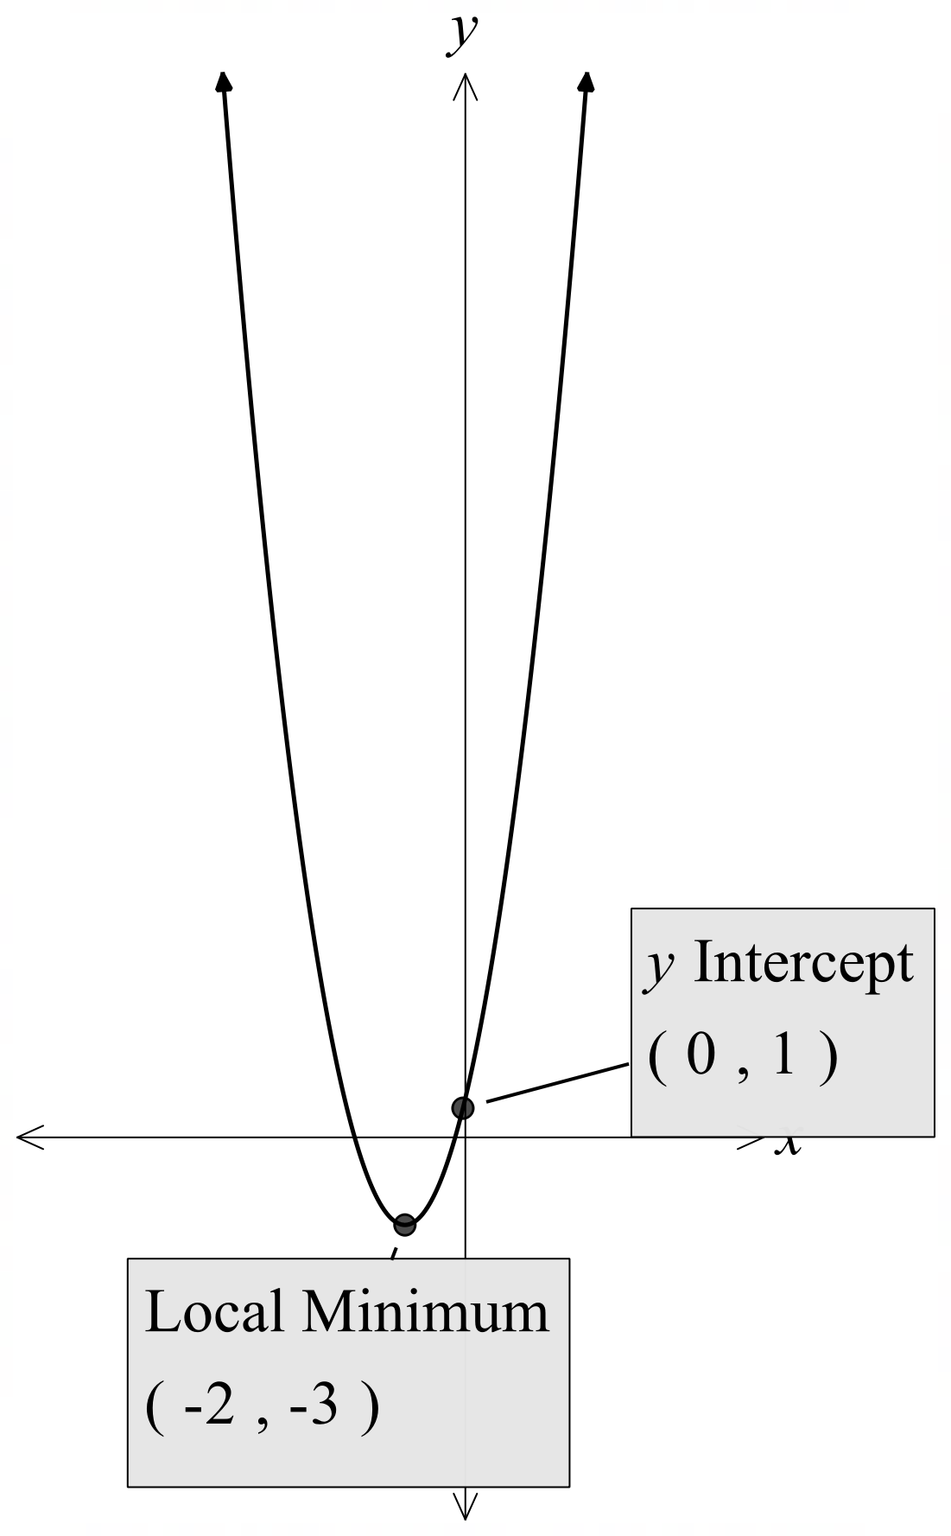 | Domain: all real $x$  Range: all real $y$, $y≥-3$
$$y=2{\left(x+1\right)}^{2}-3$$ | $$(-1, 3)$$ | Let $x=0$  $$y=2{\left(0+1\right)}^{2}-3$$  $$y=2\left(1\right)-3$$  $$y=-1$$ | Let $y=0$  $$0=2{\left(x+1\right)}^{2}-3 \\ {\left(x+1\right)}^{2}=\frac{3}{2} \\ x=-1±\sqrt{\frac{3}{2}}$$  Hence, $x$-intercepts at $x=-1+\sqrt{\frac{3}{2}}$$$and x=-1-\sqrt{\frac{3}{2}}$$ | 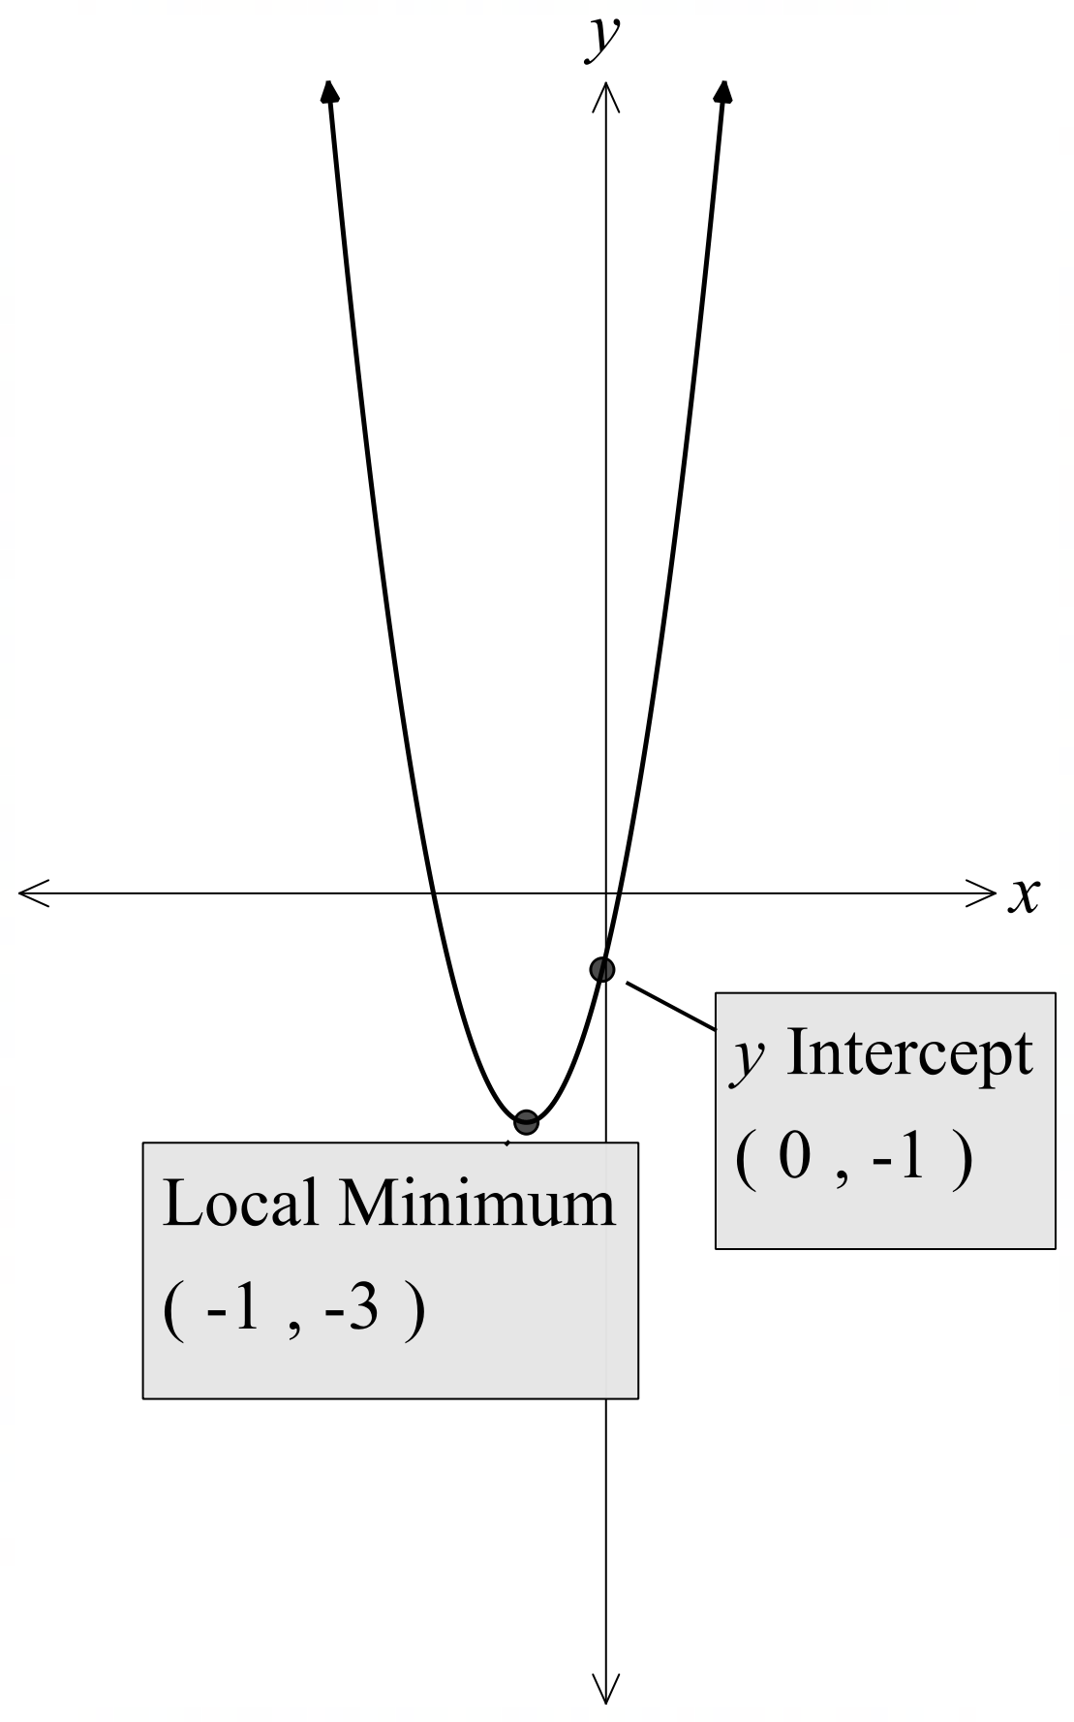 | Domain: all real $x$  Range: all real $y, y≥-3$

Appendix D – Four quadrant notes
Example 1  Express $y=x^{2}+4x-1$ in the form $y={\left(x-a\right)}^{2}+c$ and determine the coordinates of the vertex. Find the intercepts and graph the parabola showing its vertex, $x$- and $y$-intercept.  $$y=x^{2}+4x+-1$$  $$y=x^{2}+4x+4-1-4$$  $$y={\left(x+2\right)}^{2}-5$$  Vertex $(-2,-5)$  $x$-intercepts:  $${\left(x+2\right)}^{2}-5=0$$  $${\left(x+2\right)}^{2}=5$$  $$x+2=±\sqrt{5}$$  $$x=±\sqrt{5}-2$$  $$x≈-4.24, 0.23$$  $y$-intercept = $-1$  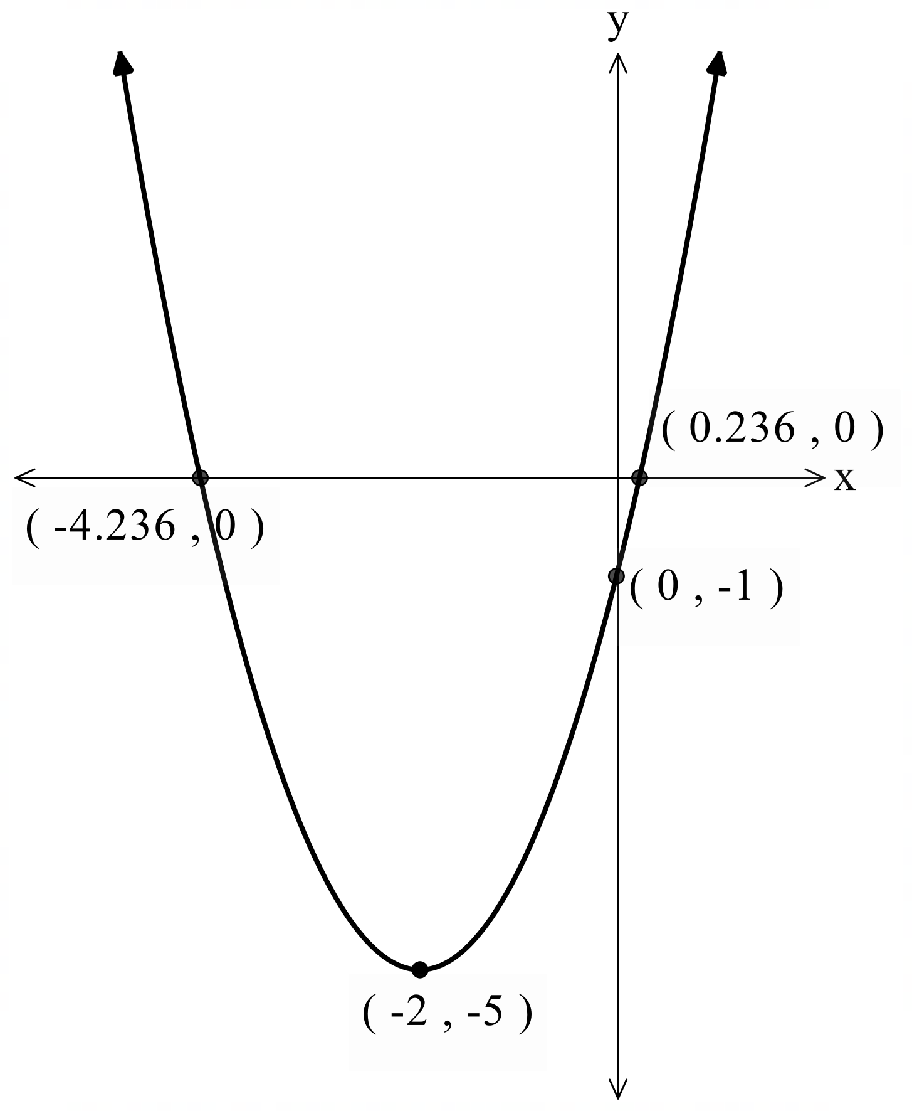 | Example 2  Express $y={3x}^{2}-18x+23$ in the form $y={k\left(x-a\right)}^{2}+c$ and determine the coordinates of the vertex. Find the intercepts and graph the parabola showing its vertex, $x$- and $y$-intercept.  $$y=3\left(x^{2}-6x\right)+23$$  $$y=3\left(x^{2}-6x+9\right)+23-3×9$$  $$y=3{\left(x-3\right)}^{2}-4$$  Vertex $(3, -4)$  $x$-intercepts  $$3{\left(x-3\right)}^{2}-4=0$$  $$3{\left(x-3\right)}^{2}=4$$  $${\left(x-3\right)}^{2}=\frac{4}{3}$$  $$x-3=\frac{±2}{\sqrt{3}}$$  $$x=\frac{±2}{\sqrt{3}}+3$$  $$x≈1.85, 4.15$$  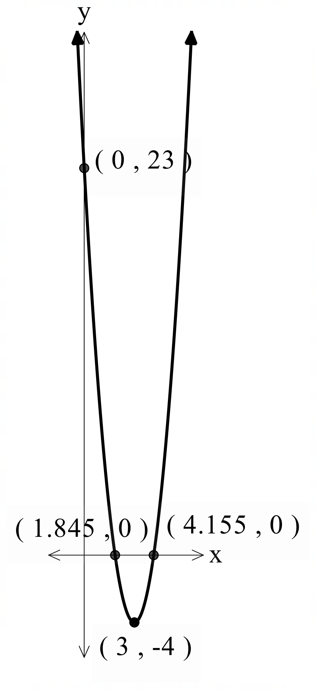

Appendix E – quadratic card sort
Quadratic function | Possible student working | Graph
$$y=x^{2}+6x+4$$ | $$y=x^{2}+6x+9+4-9 \\ y={\left(x+3\right)}^{2}-5$$  Vertex at $(-3,-5)$  Let $x=0$  $$y={(0)}^{2}+6\left(0\right)+4$$  $y$- intercept at 4
$$y=x^{2}-6x+4$$ | $$y=x^{2}-6x+9+4-9 \\ y={\left(x-3\right)}^{2}-5$$  Vertex at $(3,-5)$  Let $x=0$  $$y={\left(0\right)}^{2}-6\left(0\right)+4$$  $y$- intercept at 4
$$y=2x^{2}+7x+4$$ | $$y=2\left(x^{2}+\frac{7}{2}x+\frac{49}{16}\right)+4-2\left(\frac{49}{16}\right) \\ y=2{\left(x+\frac{7}{4}\right)}^{2}-\frac{17}{8}$$  Vertex at $\left(-\frac{7}{4}, -\frac{17}{8}\right)$  Let $x=0$  $$y=2{\left(0\right)}^{2}+7\left(0\right)+4$$  $y$- intercept at 4
$$y=3x^{2}+9x+4$$ | $$y=3\left(x^{2}+3x+\frac{9}{4}\right)+4-3\left(\frac{9}{4}\right) \\ y=3{\left(x+\frac{3}{2}\right)}^{2}-\frac{11}{4}$$  Vertex at $\left(-\frac{3}{2}, -\frac{11}{4}\right)$  Let $x=0$  $$y=3{\left(0\right)}^{2}+9\left(0\right)+4$$  $y$- intercept at 4
$$y=4x^{2}+9x+4$$ | $$y=4\left(x^{2}+\frac{9}{4}x+\frac{81}{64}\right)+4-4\left(\frac{81}{64}\right) \\ y=4{\left(x+\frac{9}{8}\right)}^{2}-\frac{17}{16}$$  Vertex at $\left(-\frac{9}{8}, -\frac{17}{16}\right)$  Let $x=0$  $$y=4{\left(0\right)}^{2}+9\left(0\right)+4$$  $y$- intercept at 4
$$y=-x^{2}+2x+4$$ | $$y=-(x^{2}-2x+1)+4+1 \\ y=-{\left(x-1\right)}^{2}+5$$  Vertex at $(1, 5)$  Let $x=0$  $$y=-{\left(0\right)}^{2}+2\left(0\right)+4$$  $y$- intercept at 4 | 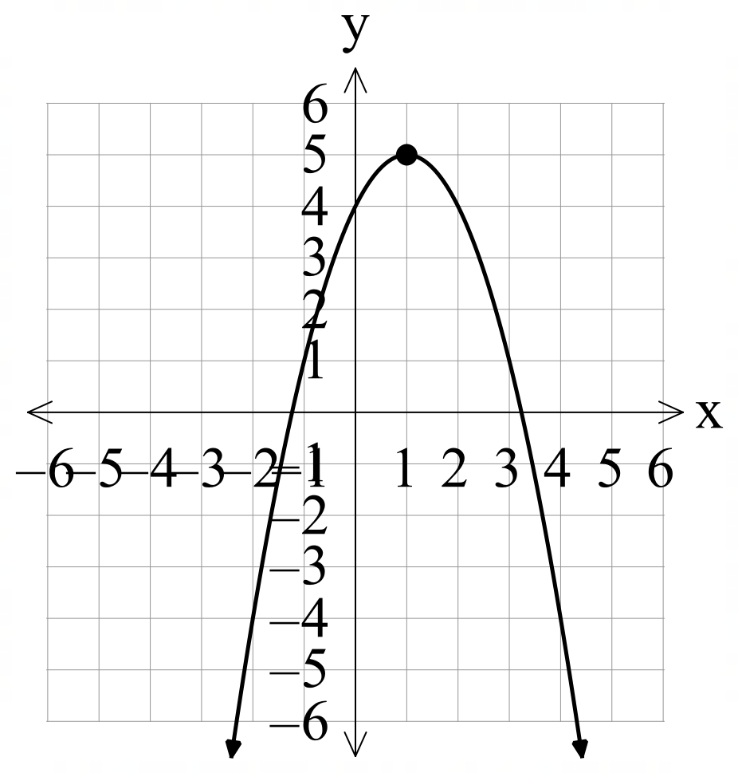
$$y=-x^{2}-4x+4$$ | $$y=-{\left(x^{2}-4x+4\right)}^{2}+4+4 \\ y=-{\left(x-2\right)}^{2}+8$$  Vertex at $(-2, 8)$  Let $x=0$  $$y=-{\left(0\right)}^{2}-4\left(0\right)+4$$  $y$- intercept at 4
$$y=-2x^{2}+3x+4$$ | $$y=-2{\left(x^{2}-\frac{3}{2}x+\frac{9}{16}\right)}^{2}+4+2\left(\frac{9}{16}\right) \\ y=-{\left(x-\frac{3}{4}\right)}^{2}+8$$  Vertex at $\left(\frac{3}{4},\frac{41}{8}\right)$  Let $x=0$  $$y=-2{\left(0\right)}^{2}+3\left(0\right)+4$$  $y$- intercept at 4

Appendix F – past HSC questions

$$y=-{\left(x-3\right)}^{2}+3$$
Vertex at $(3, 3)$
Let $x=0$
$$y=-{\left(0-3\right)}^{2}+3 \\ =-\left(9\right)+3 \\ =-6$$
The parabola is concave down as shown by the expansion below.
$$y=-\left(x^{2}-6x+9\right)+3 \\ =-x^{2}+6x-9+3 \\ =-x^{2}+6x-6$$
$∴$ B shows a parabola with a vertex of $(3, 3)$, concave down and a $y$-intercept at $-6$.

$$y=x^{2}-8x+2 \\ ={\left(x-4\right)}^{2}+2-16 \\ ={\left(x-4\right)}^{2}-14$$
Vertex $(4, -14)$

References
This resource contains NSW Curriculum and syllabus content. The NSW Curriculum is developed by the NSW Education Standards Authority. This content is prepared by NESA for and on behalf of the Crown in right of the State of New South Wales. The material is protected by Crown copyright.
Please refer to the NESA Copyright Disclaimer for more information https://educationstandards.nsw.edu.au/wps/portal/nesa/mini-footer/copyright.
NESA holds the only official and up-to-date versions of the NSW Curriculum and syllabus documents. Please visit the NSW Education Standards Authority (NESA) website https://educationstandards.nsw.edu.au/ and the NSW Curriculum website https://curriculum.nsw.edu.au/.
Mathematics Advanced 11–12 Syllabus © NSW Education Standards Authority (NESA) for and on behalf of the Crown in right of the State of New South Wales, 2024.
Board of Studies, Teaching and Educational Standards NSW (2016) Mathematics: 2016 Higher School Certificate Examination [PDF 641 KB], accessed 1 December 2025.
NESA (NSW Education Standards Authority (2024) ‘Glossary’, Mathematics Advanced 11–12 Syllabus (2024), NESA website, accessed 11 August 2025.

© State of New South Wales (Department of Education), 2025
The copyright material published in this resource is subject to the Copyright Act 1968 (Cth) and is owned by the NSW Department of Education or, where indicated, by a party other than the NSW Department of Education (third-party material).
Copyright material available in this resource and owned by the NSW Department of Education is licensed under a Creative Commons Attribution 4.0 International (CC BY 4.0) license.

This license allows you to share and adapt the material for any purpose, even commercially.
Attribution should be given to © State of New South Wales (Department of Education), 2025.
Material in this resource not available under a Creative Commons license:
- the NSW Department of Education logo, other logos and trademark-protected material
- material owned by a third party that has been reproduced with permission. You will need to obtain permission from the third party to reuse its material.
Links to third-party material and websites
Please note that the provided (reading/viewing material/list/links/texts) are a suggestion only and implies no endorsement, by the New South Wales Department of Education, of any author, publisher, or book title. School principals and teachers are best placed to assess the suitability of resources that would complement the curriculum and reflect the needs and interests of their students.
If you use the links provided in this document to access a third-party's website, you acknowledge that the terms of use, including licence terms set out on the third-party's website apply to the use which may be made of the materials on that third-party website or where permitted by the Copyright Act 1968 (Cth). The department accepts no responsibility for content on third-party websites.

