Factorising and graphing non-monic quadratic functions
This lesson focuses on factorising non-monic quadratics and using these to graph parabolas accurately. Students compare methods, explore graph changes and address common misconceptions through reasoning.

Learning intentions
- To understand how to factorise non-monic quadratic expressions.
- To be able to use the factorised form of a quadratic function to graph the related parabola.

Success criteria
- I can select an appropriate strategy and use it to factorise non-monic quadratic expressions.
- I can use the factorised form to identify $x$-intercepts and sketch a parabola accurately.
- I can describe how the features of the graph relate to the algebraic form of the quadratic.
- I can identify and explain common misconceptions in factorising and graphing quadratic functions and justify the correct solutions.

Outcomes
A student:
- develops understanding and fluency in mathematics through exploring and connecting mathematical concepts, choosing and applying mathematical techniques to solve problems, and communicating their thinking and reasoning coherently and clearly MAO-WM-01
- applies algebraic techniques and the laws of indices and surds to manipulate expressions and solve problems MAV-11-01
- uses functions and relations to model, analyse and solve problems MAV-11-02

Content

Algebraic techniques
- Expand, factorise and simplify algebraic expressions
- Solve quadratic equations $ax²+bx+c=0$ by factorisation, completing the square and using the quadratic formula $x=\frac{-b±\sqrt{b^{2}-4ac}}{2a}$ where $a$, $b$ and $c$ are real numbers and $a≠0$

Quadratic and cubic functions
- Identify the 𝑥-intercepts of a parabola whose quadratic function is expressed in factored form
- Choose and apply appropriate techniques to graph a parabola of the form $y=ax^{2}+bx+c$by identifying its $x$-intercepts if they exist, its $y$-intercept, its axis of symmetry using $x=-\frac{b}{2a}$ and its vertex
Mathematics Advanced 11–12 Syllabus © NSW Education Standards Authority (NESA) for and on behalf of the Crown in right of the State of New South Wales, 2024.

Table 1: lesson summary
Section | Summary of activity | Teaching strategies | Teaching points
Activating prior knowledge | Use slide 4 of the PowerPoint Factorising and graphing non-monic quadratic functions for students to sketch and compare pairs of quadratic functions. Use slide 5 to introduce a non-monic quadratic that students cannot yet factorise, then have them expand an equivalent expression to reveal the connection. | Visibly random groups of 3  Vertical non-permanent surfaces  Pose-Pause-Pounce-Bounce | The purpose of this activity is for students to review and apply their prior knowledge of graphing quadratic functions of the form $y=ax^{2}$ and $y=x^{2}+bx+c$ that they are able to factorise.
Connecting learning | Use slide 7 for students to analyse an incorrect area model factorisation and identify the issue. Have students complete Appendix A to observe patterns, then use slides 8–13 to model 2 methods for factorising non-monic quadratics, with Appendix B available for additional optional strategies. | Think-Pair-Share  Worked examples (Your turn) | This activity makes explicit links between familiar factorisation methods and the challenges of non-monic quadratics, enabling students to explore multiple approaches and select the one they find most effective.
Releasing responsibility | Use a class discussion to compare preferred factorisation methods and link them to finding $x$-intercepts for graphing. Have students complete Appendix C, create notes on their chosen method, and practise solving and graphing non-monic quadratics using an existing resource. | Faded examples  Notes to their future forgetful selves | The purpose of this activity is for students to apply their skills in factorising non-monic quadratics to accurately determine$x$-intercepts, reinforcing the connection between algebraic methods and graphing quadratic functions.
Independent practice | Use Appendix D for students to identify and explain an error in a quadratic-related statement before providing the correct solution. | Visibly random groups of 3  Vertical non-permanent surfaces | The purpose of this activity is for students to consolidate their understanding of quadratic concepts by identifying and correcting common misconceptions in a collaborative setting.

Activity structure
Please use the associated PowerPoint Factorising and graphing non-monic quadratics functions to display images in this lesson.

Activating prior knowledge
- Assign students to visibly random groups of 3 (bit.ly/visiblegroups) at vertical non-permanent surfaces (bit.ly/VNPSstrategy).
- Display slide 4 of the PowerPoint which contains instructions for students to sketch $y=x^{2}$ and $y=2x^{2}$ on the same set of axes. Have students complete this in their groups. Encourage students to look at the groups next to them to check and compare their sketches.
- Click to animate the second question, followed by the third question at appropriate times when groups have had sufficient time to complete each required sketch.
The related sketches for slide 4 have been provided in the solutions section of this document. Students have learned how to factorise monic quadratic equations in Lesson 5 – factorising monic quadratic functions.
- Use the Pose-Pause-Pounce-Bounce questioning strategy (PDF 557 KB) (bit.ly/posepausepouncebounce) to check for understanding of the progression of quadratic functions that students just sketched. The following are some suggested prompts:
- In each pairing of sketches, how did the graph change?
- In each pairing of sketches, did the 2 have any effect on the $x$-intercept and/or
$y$-intercept? Why or why not?
- How can you tell the graphs are related just by looking at their equations?
Students should identify that the $x$-intercept and $y$-intercept remained unchanged, but the graph of the function with the 2 became narrower. Both equations are parabolas since the highest power of $x$ is $x^{2}$ and the second equation is a multiple of 2 of the first.
- Display slide 5 which asks students to discuss in their groups how they might go about sketching the function $y=2x^{2}-5x-3$.
Students are yet to learn how to factorise non-monic quadratics within this unit, so they will not know how to factorise this function. Encourage students to consider the $y$-intercept as well as the concavity. Explain to students that we will factorise this later in the lesson, specifically on slide 8.
Although, students who completed Stage 5 Algebraic techniques C Path outcome MA5-ALG-P-02 may be confident factorising quadratic trinomials (monic and non-monic).
- Animate slide 5 to ask students in their groups on their vertical non-permanent surfaces to sketch $y=(2x+1)(x-3)$, showing any intercepts.
- Animate slide 5, which contains an area model, instructing students to expand
$(2x+1)(x-3)$.
Students should discover that $y=2x^{2}-5x-3$ is the same as $y=(2x+1)(x-3)$.
- Have students return to their workspaces and initiate a class discussion to highlight the difficulty in factorising the first function, $y=2x^{2}-5x-3$, and to draw out the need for a reliable method to factorise non-monic quadratics.

Connecting learning
- Display slide 7 of the PowerPoint, which displays an attempt to factorise the quadratic $6x^{2}-5x-4$ using an area model.
Students have previously used the area model to factorise monic quadratics in Lesson 5 – factorising monic quadratic functions.
If students are not familiar with using the area model to factorise, initiate a class discussion on how students may know how to factorise.
- In a Think-Pair-Share (bit.ly/thinkpairsharestrategy), ask students to consider why this is difficult to factorise and why the area models are incorrect.
Students should recognise that since the quadratic function is non-monic, that there are more than 2 factors for $6x^{2}$ and this affects the terms that create $-5x$.
- State to students that there are other methods we can use when factorising non-monic quadratic expressions.
The following activity has been modified from Lesson 8 – factorising non-monics of Stage 5
Unit 12 – investigating parabolas.
- Verbally define ‘non-monic quadratic functions’ to students as a quadratic function in which the coefficient of the $x^{2}$ is a numerical value other than 1. Explain to students that non-monic quadratic equations would be in the form $ax^{2}+bx+c=0$ where $a≠1$.
- Distribute Appendix A ‘Product, sum, factors (PSF)’ to each student and have them complete the expanded form and quadratic expression columns only. Students can compare their solutions at any time with a peer.
- Use slides 8–9 for modelling worked examples of finding the factors for non-monic quadratics using the Worked examples (Your turn) method (bit.ly/supportingstrategies).
- Have students complete the PSF columns in Appendix A. Students may like to use mini whiteboards (bit.ly/miniwhiteboards) or their workbooks to find different sets of factors.
- After completing the table, in a Think-Pair-Share, students are to share what they notice and wonder (bit.ly/noticewonderstrategy) about the table.
Students may notice that the factors are the middle 2 terms in the expanded expression and wonder how this can help them to factorise the quadratic equation.
- Use slides 10–13 for modelling worked examples of factorising non-monic quadratics using grouping in pairs and the area model methods, using the Worked examples (Your turn) method.

For this lesson, only 2 methods are included in the PowerPoint as worked examples. Teachers are encouraged to choose as many of the 6 available methods as they feel are appropriate for their class. Appendix B 'Strategies for factorising' provides worked examples for the remaining 4 approaches.
Demonstrating multiple methods is recommended to allow students to select the one they find most accurate and efficient. Students are encouraged to consistently use their preferred method for each factorisation.
- Once a variety of methods for factorising have been modelled, students should select their preferred method for factorisation. Using this method, students should complete practice questions from an existing resource to consolidate their understanding of factorising non-monic quadratic expressions.

Releasing responsibility
- Conduct a class discussion on which method students preferred, encouraging students to share the reasons why.
- Explain to students that in this lesson, the purpose of factorising quadratics is to find the $x$-intercepts of a parabola so that they can be graphed accurately. By accurately graphing $x$- intercepts, these points can be used to interpret and predict key outcomes when quadratic functions are used to model real-world examples.
Note that students will learn about quadratic modelling in Lesson 14 – modelling quadratic functions.
Students have previously solved quadratic equations in factorised form in Lesson 5 – factorising monic quadratics. Further practice may be required, prior to progressing to the next activity, where they need to apply this understanding to find the $x$-intercepts of quadratic functions.
- Distribute Appendix C ‘Faded examples’ (bit.ly/fadedexamplesstrategy) which contains questions on graphing quadratic functions by factorising a non-monic quadratic expression.
- Students are to create notes to their future forgetful selves (bit.ly/notestofutureself) on their preferred method of factorising a non-monic quadratic and how to use the factorised form to solve quadratic equations of the form $ax^{2}+bx+c=0$.
- Students should complete practice questions from an existing resource to consolidate their understanding of graphing parabolas by first factorising and finding intercepts.

Independent practice
- Instruct students to return to their groups of 3 from the start of the lesson and to return to their vertical non-permanent surfaces.
- Distribute Appendix D ‘Reviewing misconceptions in quadratics functions’ for students to complete in their groups.
- Encourage groups to engage with adjacent groups to check their working and compare solutions.

Assessment and differentiation

Suggested opportunities for differentiation
Activating prior knowledge
- For students who are struggling, allow the use of a graphing applications to support them.
- To extend students, the provided equations on slide 4 can be adjusted.
- Some students may need to be supported by being provided with the key vocabulary used such as ‘concavity’, ‘intercept’ and ‘factorise’. Providing a visual or a glossary may assist students from non-English speaking backgrounds.
Connecting learning
- Students will have a range of prior knowledge on factorising quadratic expressions. Some students may need to be supported by being provided a partially completed version of Appendix A or a template with area models.
- Encourage students to trial a range of factorising strategies and choose one that makes sense most to them.
- To extend students, they can be encouraged to create their own non-monic quadratic expressions that factorise neatly.
Releasing responsibility
- Encourage students to use their preferred factorising method and demonstrate a range of strategies during whole-class modelling.
- Appendix C can be adjusted to provide further questions, with the solutions fading less rapidly.
Independent practice
- Allow students to express their reasoning through a variety of ways, including sketches, algebraically, verbal explanations or graphing applications to suit different learning preferences.

Suggested opportunities for assessment
Activating prior knowledge
- Circulate the room while students are at vertical non-permanent surfaces and observe their conversations and accuracy of sketches.
- Use responses in the Pose-Pause-Pounce-Bounce questioning strategy to check for students’ understanding of how changes in the function create changes in the graphical representation.
Connecting learning
- Responses to Appendix A can be collected to monitor and check for students’ understanding of factorising.
- Use student reasoning as they identify why the area model is incorrect to establish if they understand the factorising process.
Releasing responsibility
- Review students’ notes to their future forgetful selves to check for understanding of their chosen factorising strategy and the accuracy in applying this strategy to solve quadratic equations.
Independent practice
- As groups discuss and compare with adjacent groups, circulate and listen for their mathematical justifications and whether they can accurately identify and explain the misconception.
- For groups that may be struggling, encourage them to take a gallery walk to observe other groups.

Appendix A

Product, sum, factors
Factorised form | Expanded form | Quadratic expression | Product | Sum | Factors
$$(2x-1)(x+3)$$ | $$2x^{2}+6x-x-3$$ | $$2x^{2}+5x-3$$
$$\left(2x-1\right)\left(x-3\right)$$
$$\left(2x+1\right)\left(x-3\right)$$
$$\left(x-2\right)\left(3x+2\right)$$
$$\left(x+2\right)\left(3x+2\right)$$
$$\left(x+2\right)\left(3x+4\right)$$
$$\left(2x-1\right)\left(5x+4\right)$$
$$\left(2x-1\right)\left(3x+8\right)$$

Appendix B

Strategies for factorising

Lyszkowski/Howell method
Factorise $6x^{2}-5x-4.$
P | −24
S | −5
F | 3, −8
Create 2 brackets with the first term $6x$and divide both brackets by 6.
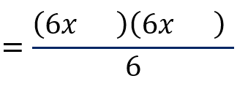
Add factors into the brackets.
$$=\frac{\left(6x-8\right)\left(6x+3\right)}{6}$$
Factorise and simplify.
$$=\frac{2\left(3x-4\right)×3\left(2x+1\right)}{6} \\ =\left(3x-4\right)\left(2x+1\right)$$

Cross method
Factorise $6x^{2}-5x-4$.
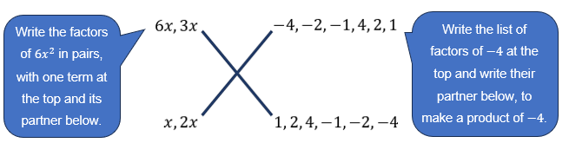
Test the combinations by multiplying diagonally and adding the 2 terms to see if the sum equals the middle term of the quadratic:
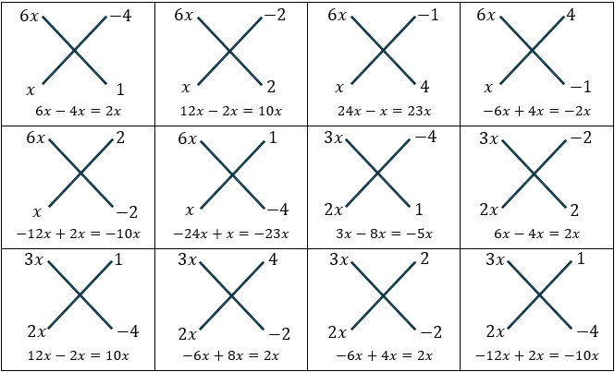
It is not necessary to draw a cross for each of the combinations.
You can stop testing the combinations when you have found the right one.
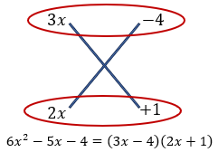

Magic X
Factorise $6x^{2}-5x-4$.
P | −24
S | −5
F | 3, −8
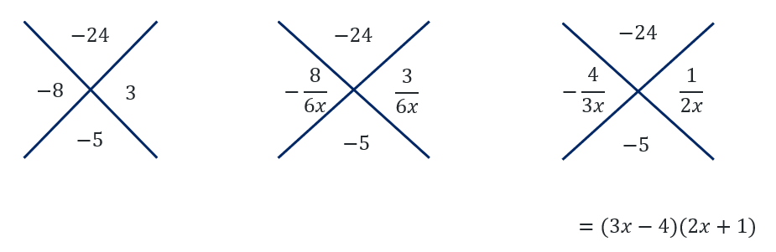
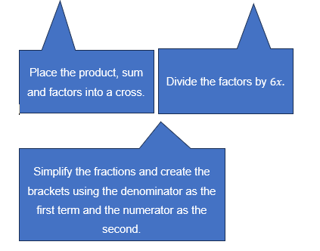

Area model
Factorise $6x^{2}-5x-4$.
P | −24
S | −5
F | 3, −8
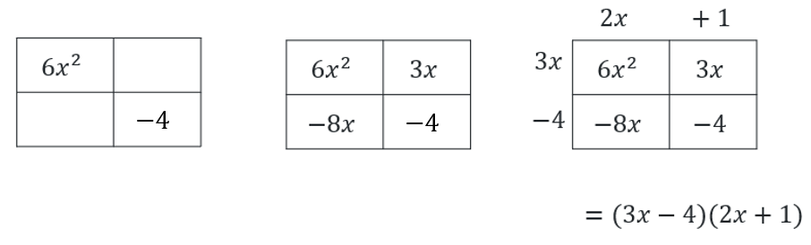
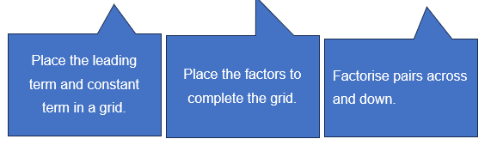

Non-monic to monic
Factorise $6x^{2}-5x-4.$
Process | Example
Make the expression an equation | Let $y= 6x^{2}-5x-4$
Multiply by 6 | $$6y=6\left(6x^{2}-5x-4\right)$$
Expand the brackets | $$6y=36x^{2}-30x-24$$
Factor $6x$ from all possible terms | $$6y={\left(6x\right)}^{2}-5\left(6x\right)-24$$
Replace $6x$ with $A$ | Let $A=6x$  $$6y=A^{2}-5A-24$$
Factorise the monic quadratic | $$6y=\left(A-8\right)\left(A+3\right)$$
Replace $A$ with $6x$ | $$6y=\left(6x-8\right)\left(6x+3\right)$$
Factorise out the common factor in each binomial | $$6y=2\left(3x-4\right)×3\left(2x+1\right)$$  $$6y=6\left(3x-4\right)\left(2x+1\right)$$
Divide by 6 | $$y=\left(3x-4\right)\left(2x+1\right)$$

Appendix C

Faded examples
Question 1 | Question 2 | Question 3
Sketch the graph of the parabola $f(x)=2x^{2}-7x+3$  Step 1: factorise  $P=6$, $S=-7$, $F=-1, -6$  $$f(x)=2x^{2}-x-6x+3$$  $$f(x)=x\left(2x-1\right)-3\left(2x-1\right)$$  $$f(x)=(2x-1)(x-3)$$  Step 2: determine intercepts  $2x-1=0$ or $x-3=0$  $2x=1$ or $x=3$  $∴x$-intercepts at $\frac{1}{2}$ and $3$  $$f\left(0\right)=2{\left(0\right)}^{2}-7\left(0\right)+3$$  $∴y$-intercept at $3$  Step 3: sketch the graph  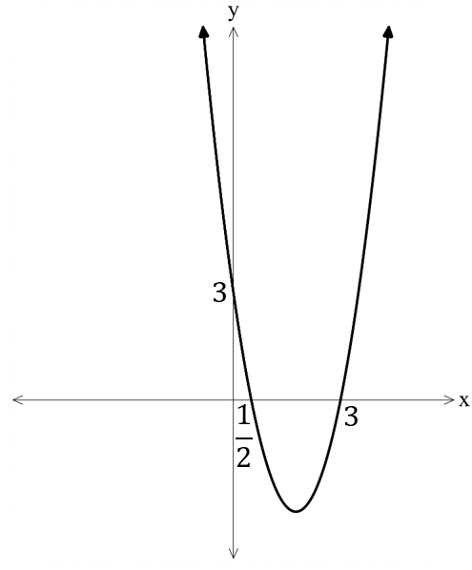 | Sketch the graph of the parabola $y=4x^{2}-3x-1$  Step 1: factorise  Step 2: determine intercepts  $∴x$-intercepts at $-\frac{1}{4}$ and $1$  Let $x=0$  $$y=4{\left(0\right)}^{2}-5\left(0\right)+1$$  $∴y$-intercept at 1  Step 3: sketch the graph  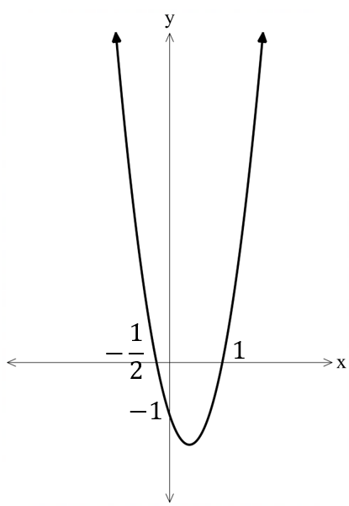 | Sketch the graph of the parabola $y=8x^{2}+22x+5$  Step 1: factorise  Step 2: determine intercepts  Step 3: sketch the graph

Appendix D

Reviewing misconceptions in quadratics functions
Each of the following statements contains a mathematical error. Identify the mistake, explain why it is incorrect and provide a correct solution.
- Luca factorised the quadratic function $y=2x^{2}+5x+2$ as $y=(2x+1)(x+2)$. He then stated that the $x$-intercepts are $x=2$ and $x=1$.
- Sienna factorised the quadratic function $y=5x^{2}+9x+4$ as $y=(5x+1)(x+4)$. She then found the $x$-intercepts to be $x=-\frac{1}{5}$ and $-4$.
- For the function $f\left(x\right)=2x^{2}+5x+3$, Emi says one of the $x$-intercepts is 1, since $f\left(1\right)=0$.
- Noah factorised the quadratic, $y=2x^{2}-3x-2$ as $y=(2x+1)(x+2)$. He then graphed the parabola with $x$-intercepts at $x=-\frac{1}{2}$ and $x=-2$.

Sample solutions

Activating prior knowledge
- Sketch both $f\left(x\right)=x^{2}$ and $f(x)=2x^{2}$ on the same set of axes, clearly labelling any intercepts.
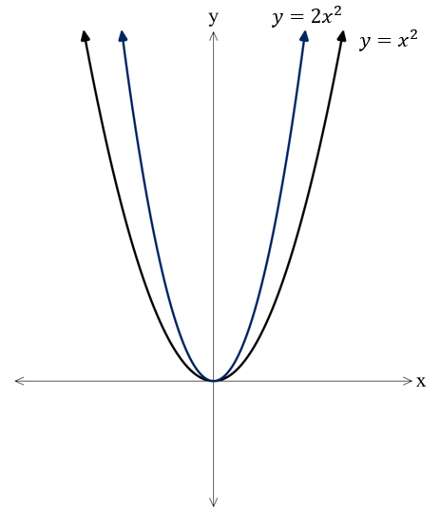
- Sketch both $f\left(x\right)=(x+2)(x-4)$ and $f\left(x\right)=2(x+2)(x-4)$ on the same set of axes, clearly labelling any intercepts.
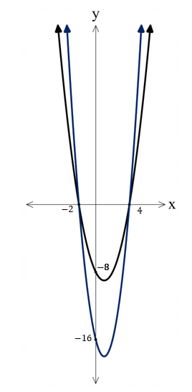
- Sketch both $f\left(x\right)=x^{2}-2x-15$ and $f\left(x\right)=2x^{2}-4x-30$ on the same set of axes, clearly labelling any intercepts.
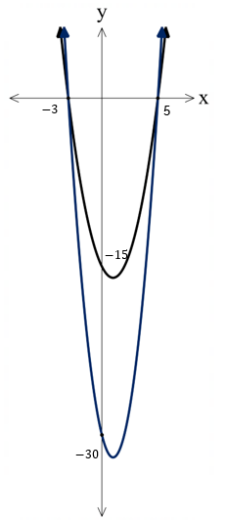

Appendix A – product, sum, factors (PSF)
Factorised form | Expanded form | Quadratic expression | Product | Sum | Factors
$$(2x-1)(x+3)$$ | $$2x^{2}+6x-x-3$$ | $$2x^{2}+5x-3$$ | $$-6$$ | $$5$$ | $$6,-1$$
$$\left(2x-1\right)\left(x-3\right)$$ | $$2x^{2}-6x-x+3$$ | $$2x^{2}-7x+3$$ | $$6$$ | $$-7$$ | $$-6, -1$$
$$\left(2x+1\right)\left(x-3\right)$$ | $$2x^{2}-6x+x-3$$ | $$2x^{2}-5x-3$$ | $$-6$$ | $$-5$$ | $$-6, 1$$
$$\left(x-2\right)\left(3x+2\right)$$ | $$3x^{2}-6x+2x-4$$ | $$3x^{2}-4x-4$$ | $$-12$$ | $$-4$$ | $$-6,2$$
$$\left(x+2\right)\left(3x+2\right)$$ | $$3x^{2}+2x+6x+4$$ | $$3x^{2}+8x+4$$ | $$12$$ | $$8$$ | $$6,2$$
$$\left(x+2\right)\left(3x+4\right)$$ | $$3x^{2}+6x+4x+8$$ | $$3x^{2}+10x+8$$ | $$24$$ | $$10$$ | $$6,4$$
$$\left(2x-1\right)\left(5x+4\right)$$ | $$10x^{2}-5x-8x-4$$ | $$10x^{2}-13x-4$$ | $$-40$$ | $$-13$$ | $$-5, -8$$

Appendix C – faded examples
Question 1 | Question 2 | Question 3
Sketch the graph of the parabola $f(x)=2x^{2}-7x+3$  Step 1: factorise  $P=6$, $S=-7$, $F=-1, -6$  $$f\left(x\right)=2x^{2}-x-6x+3 \\ =x\left(2x-1\right)-3\left(2x-1\right) \\ =(2x-1)(x-3)$$  Step 2: determine intercepts  $2x-1=0$ or $x-3=0$  $2x=1$ or $x=3$  $∴x$-intercepts at $\frac{1}{2}$ and $3$  $$f\left(0\right)=2{\left(0\right)}^{2}-7\left(0\right)+3$$  $∴y$-intercept at $3$  Step 3: sketch the graph | Sketch the graph of the parabola $y=4x^{2}-3x-1$  Step 1: factorise  $$P=-4,S=-3, F=-4,1$$  $$y=4x^{2}-4x+x-1 \\ =4x\left(x-1\right)+(x-1) \\ =(4x+1)(x-1)$$  Step 2: determine intercepts  $4x+1=0$ or $x-1=0$  $4x=-1$ or $x=1$  $∴x$-intercepts at $-\frac{1}{4}$ and $1$  Let $x=0$  $$y=4{\left(0\right)}^{2}-5\left(0\right)+1$$  $∴y$-intercept at 1  Step 3: sketch the graph | Sketch the graph of the parabola $y=8x^{2}+22x+5$  Step 1: factorise  $$P=40, S=22, F= 2, 20$$  $$y=8x^{2}+2x+20x+5 \\ =2x\left(4x+1\right)+5(4x+1) \\ =(2x+5)(4x+1)$$  Step 2: determine intercepts  $2x+5=0$ or $4x+1=0$  $2x=-5$ or $4x=-1$  $∴x$-intercepts at $-\frac{5}{2}$ and $-\frac{1}{4}$  Let $x=0$  $$y=8{\left(0\right)}^{2}+22\left(0\right)+5$$  $∴y$-intercept at 5  Step 3: sketch the graph  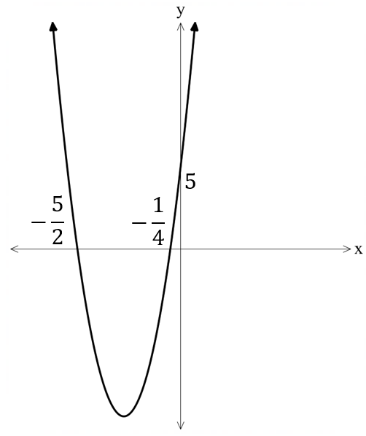

Appendix D – reviewing misconceptions in quadratics functions
- Luca factorised the quadratic function $y=2x^{2}+5x+2$ as $y=(2x+1)(x+2)$. He then stated that the $x$-intercepts are $x=2$ and $x=1$.
Luca has incorrectly solved the quadratic equation $f\left(x\right)=0$, meaning that their $x$-intercepts are incorrect. The $x$-intercepts should be $x=-\frac{1}{2}$ and $x=-2$.
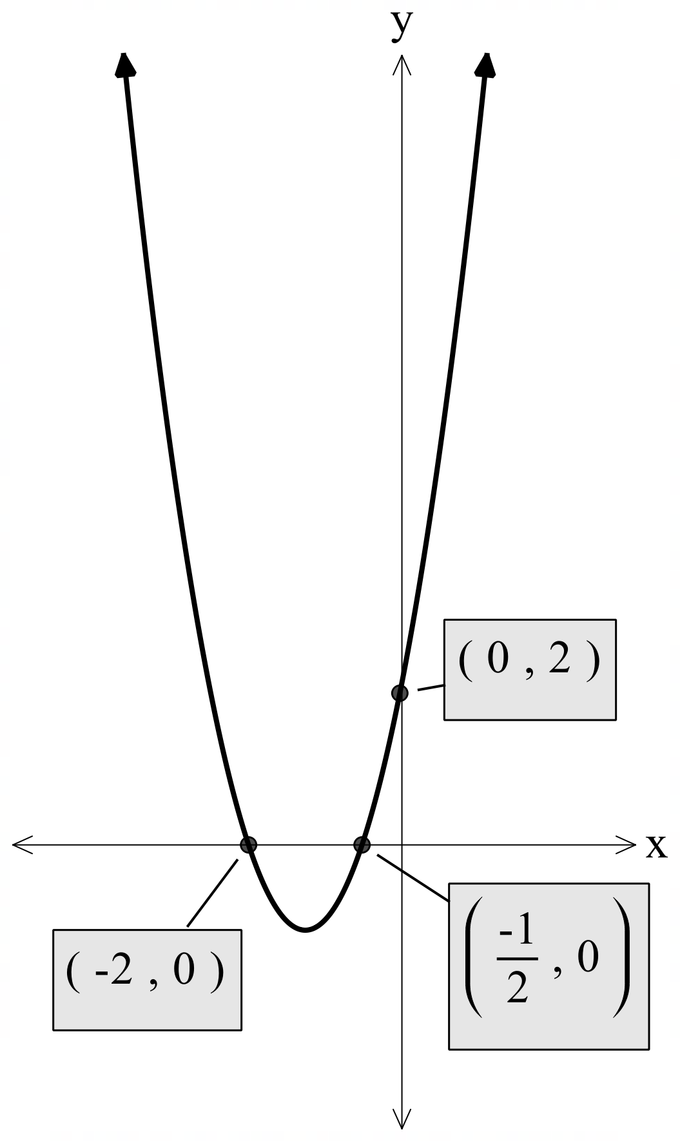
- Sienna factorised the quadratic function $y=5x^{2}+9x+4$ as $y=(5x+1)(x+4)$. She then found the $x$-intercepts to be $x=-\frac{1}{5}$ and $-4$.
Sienna has incorrectly factorised $5x^{2}+9x+4=(5x+4)(x+1)$. So, the $x$-intercepts should be $-\frac{4}{5}$ and $-1$.
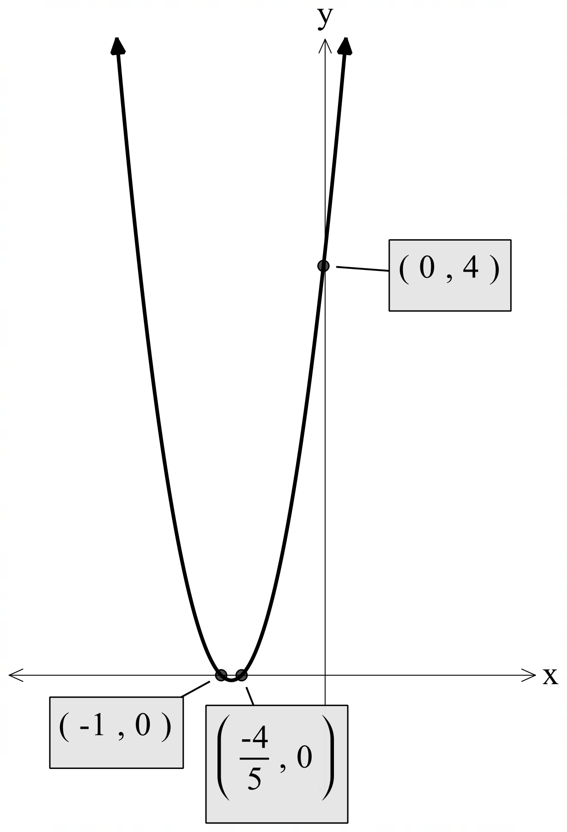
- For the function $f\left(x\right)=2x^{2}+5x+3$, Emi says one of the $x$-intercepts is 1, since $f\left(1\right)=0$.
Emi is incorrect since $f\left(1\right)=10$.
$f\left(x\right)=(2x+3)(x+1)$. So, the $x$-intercepts are at $x=-1.5, -1$
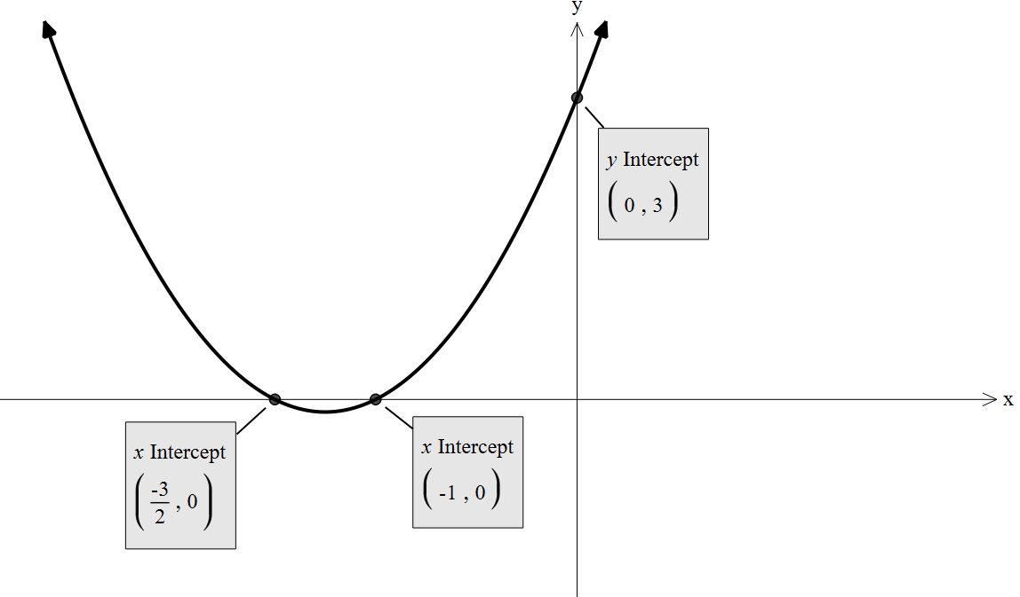
- Noah factorised the quadratic, $y=2x^{2}-3x-2$ as $y=(2x+1)(x+2)$. He then graphed the parabola with $x$-intercepts at $x=-\frac{1}{2}$ and $x=-2$.
Noah has incorrectly factorised the quadratic. It should have been $y=(2x+1)(x-2)$. Then the $x$-intercepts are at $x=-\frac{1}{2}$ and $x=2$.
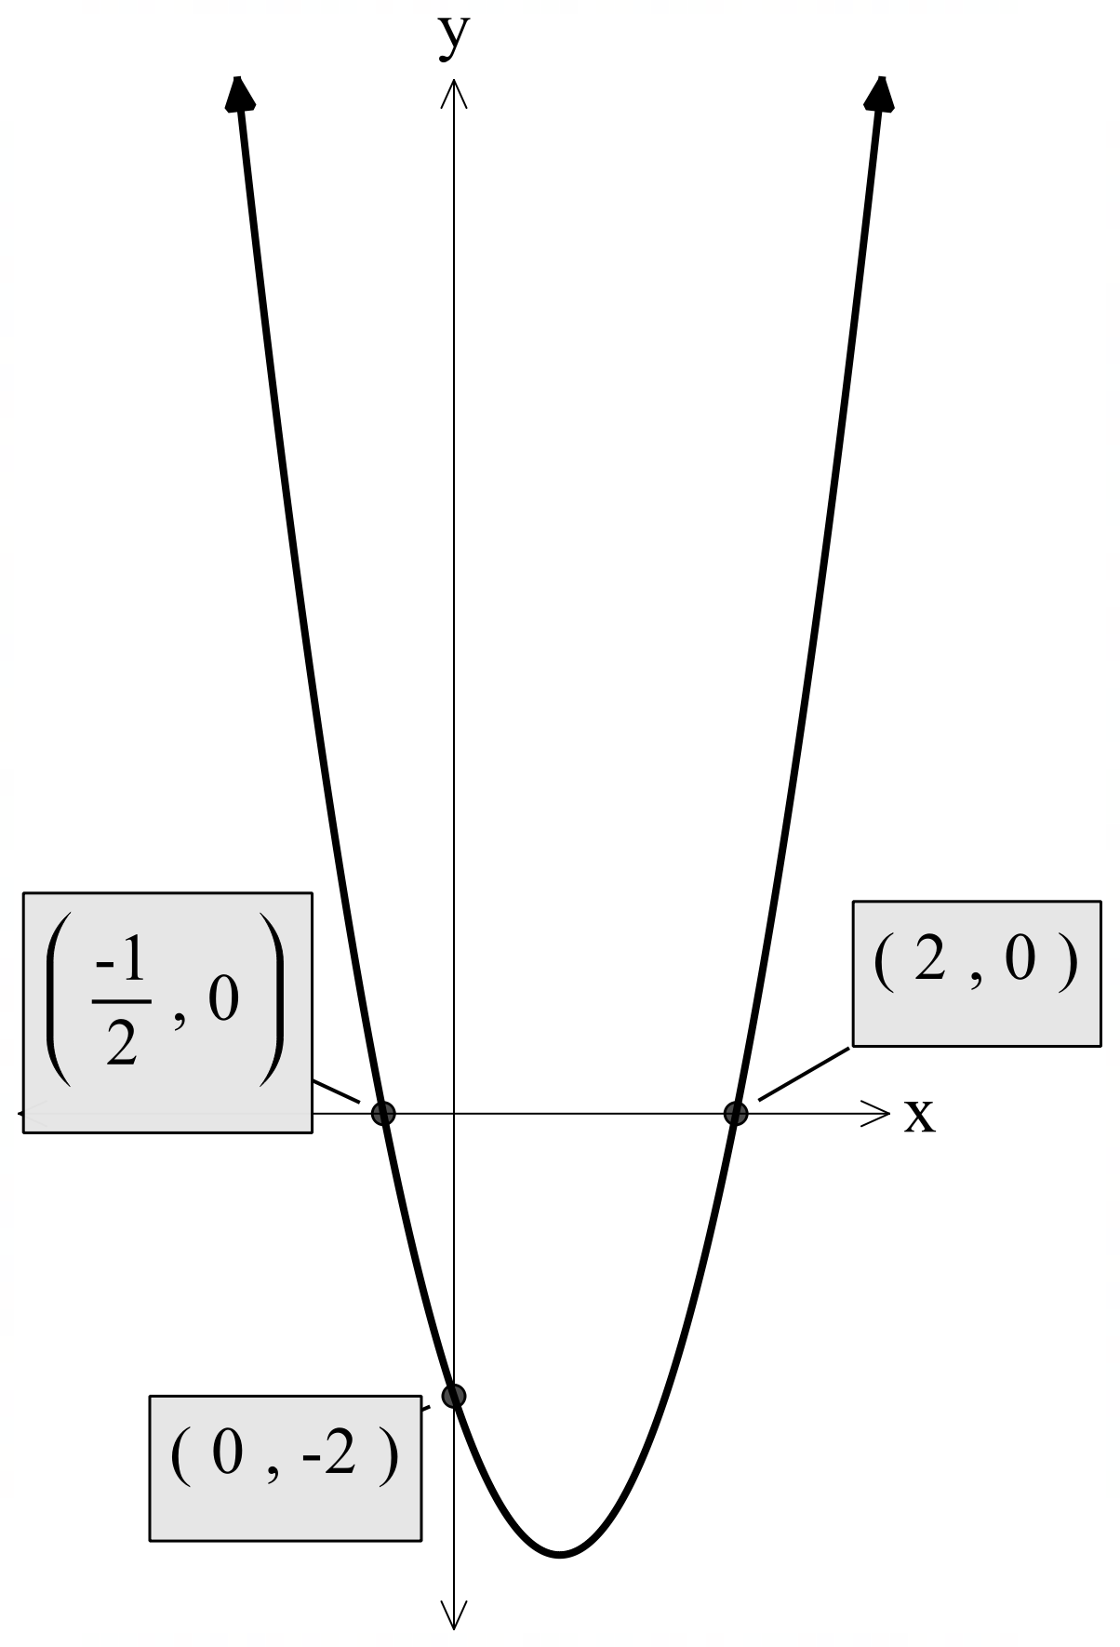

References
This resource contains NSW Curriculum and syllabus content. The NSW Curriculum is developed by the NSW Education Standards Authority. This content is prepared by NESA for and on behalf of the Crown in right of the State of New South Wales. The material is protected by Crown copyright.
Please refer to the NESA Copyright Disclaimer for more information https://educationstandards.nsw.edu.au/wps/portal/nesa/mini-footer/copyright.
NESA holds the only official and up-to-date versions of the NSW Curriculum and syllabus documents. Please visit the NSW Education Standards Authority (NESA) website https://educationstandards.nsw.edu.au/ and the NSW Curriculum website https://curriculum.nsw.edu.au/.
Mathematics Advanced 11–12 Syllabus © NSW Education Standards Authority (NESA) for and on behalf of the Crown in right of the State of New South Wales, 2024.

© State of New South Wales (Department of Education), 2025
The copyright material published in this resource is subject to the Copyright Act 1968 (Cth) and is owned by the NSW Department of Education or, where indicated, by a party other than the NSW Department of Education (third-party material).
Copyright material available in this resource and owned by the NSW Department of Education is licensed under a Creative Commons Attribution 4.0 International (CC BY 4.0) license.

This license allows you to share and adapt the material for any purpose, even commercially.
Attribution should be given to © State of New South Wales (Department of Education), 2025.
Material in this resource not available under a Creative Commons license:
- the NSW Department of Education logo, other logos and trademark-protected material
- material owned by a third party that has been reproduced with permission. You will need to obtain permission from the third party to reuse its material.
Links to third-party material and websites
Please note that the provided (reading/viewing material/list/links/texts) are a suggestion only and implies no endorsement, by the New South Wales Department of Education, of any author, publisher, or book title. School principals and teachers are best placed to assess the suitability of resources that would complement the curriculum and reflect the needs and interests of their students.
If you use the links provided in this document to access a third-party's website, you acknowledge that the terms of use, including licence terms set out on the third-party's website apply to the use which may be made of the materials on that third-party website or where permitted by the Copyright Act 1968 (Cth). The department accepts no responsibility for content on third-party websites.

