Graphing monic quadratic functions
Students use the fact that if the product of 2 numbers is zero, then one or both numbers must be zero (Null Factor Law) to make connections between the algebraic and graphical representations of quadratic functions.

Learning intention
- To be able to graph parabolas that are represented in factorised form.

Success criteria
- I can use the properties of a product equalling zero to identify the intercepts of a parabola.
- I can graph a parabola of the form $y=(x-a)(x-b)$.
- I can factorise a monic quadratic with integer intercepts and sketch the corresponding parabola.

Outcomes
A student:
- develops understanding and fluency in mathematics through exploring and connecting mathematical concepts, choosing and applying mathematical techniques to solve problems, and communicating their thinking and reasoning coherently and clearly MAO-WM-01
- applies algebraic techniques and the laws of indices and surds to manipulate expressions and solve problems MAV-11-01
- uses functions and relations to model, analyse and solve problems MAV-11-02

Content

Algebraic techniques
- Solve quadratic equations $ax²+bx+c=0$ by factorisation, completing the square and using the quadratic formula $x=\frac{-b±\sqrt{b^{2}-4ac}}{2z}$ where $a, b$ and $c$ are real numbers and $a≠0$

Quadratic and cubic functions
- Identify the 𝑥-intercepts of a parabola whose quadratic function is expressed in factored form
- Choose and apply appropriate techniques to graph a parabola of the form $y=ax²+bx+c$ by identifying its $x$- intercepts if they exist, its $y$-intercept, its axis of symmetry using $x=-\frac{b}{2a}$ and its vertex
Mathematics Advanced 11–12 Syllabus © NSW Education Standards Authority (NESA) for and on behalf of the Crown in right of the State of New South Wales, 2024.

Table 1: lesson summary
Section | Summary of activity | Teaching strategies | Teaching points
Activating prior knowledge | Students discuss slide 4 of the PowerPoint Graphing monic quadratic functions, before developing the concept that if the product of 2 numbers is zero, then one or both numbers must be zero. | Think-Pair-Share  Pose-Pause-Pounce-Bounce | Students become familiar with the Null Factor Law.
Connecting learning | Students complete a banner task to practise solving equations using the Null Factor Law. Students make the connection between the Null Factor Law and its relationship with graphing, using slide 6 and then Appendix B. | Think-Pair-Share  Banner task  Pose-Pause-Pounce-Bounce | Connect the Null Factor Law to the intercepts of a parabola occurring when $y=0$.
Releasing responsibility | Worked examples model graphing quadratics using slides 8–9. Teachers use an existing resource to consolidate skills with graphing parabolas. Students consolidate their learning by writing Four quadrant notes using Appendix C. | Worked examples (Your turn)  Turn and talk  Visibly random groups of 3  Vertical non-permanent surfaces  Four quadrant notes | Students build confidence using the product, sum, factor method of factorising a quadratic.
Independent practice | Students complete Appendix D using the information on slide 11. | Visibly random groups of 3  Vertical non-permanent surfaces  Gallery walk  TAG feedback strategy | Students recognise differences with intercepts and their connection with the equation.

Activity structure
Please use the associated PowerPoint Graphing monic quadratic functions to display images in this lesson.

Activating prior knowledge
The following activity has been modified from Lesson 9 – solving quadratic equations of Stage 5 Unit 12 – investigating parabolas.
- Display slide 4, which shows several multiplication questions with an answer of zero.
- In a Think-Pair-Share (bit.ly/thinkpairsharestrategy), ask students to discuss what they notice and wonder.
Students should notice that all the expressions have a product of zero. They should also notice that all the questions contain at least one zero multiplied by another term. They may wonder what this information can be used to show.
- Use a Pose-Pause-Pounce-Bounce questioning strategy (PDF 557 KB) (bit.ly/posepausepouncebounce) for students to share their thoughts. Some suggested prompts include:
- If the product equals zero, what might that tell us about the numbers we multiplied?
- Could a product be zero if neither factor was zero?
Students should conclude that to get an answer of zero from a product, at least one of the factors must be zero.
- Recap the discussion by introducing the Null Factor Law, which states that if the product of 2 or more numbers is zero, then one or both numbers must be zero.

Connecting learning
- Assign students to visibly random groups of 3 (bit.ly/visiblegroups) at vertical non-permanent surfaces (bit.ly/VNPSstrategy).
- Students are to complete the banner task (bit.ly/supportingstrategies) from Appendix A ‘Banner tasks’ which asks students to ‘solve for $x$’ using their knowledge of the Null Factor Law.
It is important for students to understand that the Null Factor Law does not involve simply taking the numbers from the brackets and swapping the signs.
The following section builds on the prior learning covered in Lesson 5 – factorising monic quadratic functions, where students learned to factorise monic quadratic functions with integer factors.
- Use the Pose-Pause-Pounce-Bounce questioning strategy to check students’ understanding of finding $x$-intercepts and connecting this idea to the Null Factor Law. The following are some suggested starting prompts:
- What is the value of $y$ equal to at $x$-intercepts? Why?
- Can the product be zero if neither bracket equals zero? Why?
- How can we use the Null Factor Law to find the $x$-intercepts?
Students should recall from Lesson 2 – function values and intercepts of Unit 2 – introduction to functions, that the $x$-intercepts of the graph $y=f(x)$ are its zeroes, the solution of the $f\left(x\right)=0$.
Students may have previously solved quadratic equations in the Stage 5 Equations B Path outcome MA5-EQU-P-01.
- Display slide 6 of the PowerPoint, which shows 3 quadratic relationships and the steps in the working resulting from letting $f\left(x\right)=0$.
- Initiate a class discussion for students to discuss how they might solve the quadratic equations displayed on slide 6. Some suggested prompts may include:
- What might $x$ be when solving the quadratic equation $2x=0$?
- What might $x$ be when solving the quadratic equation $2\left(x-3\right)=0?$
- What might $x$ be when solving the quadratic equation ${\left(x+1\right)}^{2}=0$?
- Distribute Appendix B ‘Card sort’ to pairs of students. Students match the cards to show the connection between factored form, expanded form, the solution steps and the graph.
Cards are not in order, so students could be issued with scissors to cut the cards themselves.
- Conclude with the class, that to solve a quadratic equation in factorised form, either one of the terms must equal to zero, as per the Null Factor Law. Animate the solutions on slide 6.

Releasing responsibility
- Use slides 8–9 of the PowerPoint to model a worked example of graphing a parabola of the form $y=x^{2}+bx+c,$ following the Worked examples (Your turn) method (bit.ly/supportingstrategies).
- Students should complete practice questions from an existing resource to consolidate their understanding of graphing a parabola of the form $y=x²+bx+c$.
- Ask students to verify their solutions with a turn and talk (bit.ly/classroomtalkmoves).
- Assign students to new visibly random groups of 3, and ask them to complete Four quadrant notes to their future forgetful selves (bit.ly/supportingstrategies) from Appendix C ‘Four quadrant notes’ on a vertical non-permanent surface (bit.ly/VNPSstrategy).

Independent practice
This activity has been adapted from ‘Underground Mathematics – Which Parabola?’ (undergroundmathematics.org/quadratics/which-parabola) to include only monic quadratic equations.
- Continuing in their groups of 3, distribute adhesive putty and Appendix D ‘Which parabola?’ to each group.
It is recommended that this appendix be printed on A3 paper.
- Display slide 11 of the PowerPoint, which gives information about 2 equations from Appendix D.
The equations displayed on the PowerPoint are $y=x^{2}-10x+24$ and $y=x^{2}+4x+4$.
- Give students time to attempt the activity, moving around the room to monitor progress.
- Students are to go on a gallery walk and give peer feedback using the TAG feedback strategy (bit.ly/DLSpeerfeedback).
- Give students time to apply the feedback provided to them.
- In their groups of 3, have students discuss the graph features they used to complete the task and how these features relate to the equations. Invite selected students to share their insights with the class.

Assessment and differentiation

Suggested opportunities for differentiation
Activating prior knowledge
- The pacing of this activity could be adjusted depending on the Path content covered and retained from Stage 5.
Connecting learning
- Equations can be modified in the PowerPoint, or students could be prompted for a range of values for the table of values.
- Graphing strategies could be modified depending on the Path content covered and retained from Stage 5.
Releasing responsibility
- The ‘Your turn’ example from the worked examples could be modified. Additional ‘Your turn’ questions could also be provided to explore different cases with the sign of the coefficient of $x$ and the constant term.
- Self-explanation prompts in the worked examples could be modified to address other aspects of the reasoning in the worked solution.
- Existing resources could be tailored to students’ needs for graphing monic quadratics.
Independent practice
- More equations from the solutions could be provided on slide 11.

Suggested opportunities for assessment
Activating prior knowledge
- Student reasoning and communication skills can be assessed on how they discuss the multiplications by zero.
Connecting learning
- Students give each other peer feedback, before sharing with the class in a Think-Pair-Share.
- Observe students’ reasoning and justification in the class discussion as they give responses to the connection between the Zero Factor Law and sketching a parabola.
Releasing responsibility
- Student responses to the self-explanation prompts during worked examples provide an opportunity to assess student reasoning.
- Monitor student responses in the ‘Your turn’ section to check for understanding.
- Monitor the parabola graphs produced by students from the existing resource, giving feedback on the size and detail of their sketches.
- When placed in groups of 3, students can provide and receive peer feedback.
Independent practice
- Students working at vertical non-permanent surfaces means the teacher can assess student progress and provide support where appropriate.

Appendix A

Banner tasks
Solve for $x:$
- $\left(x+6\right)\left(x+3\right)=0$
- $\left(x-6\right)\left(x+3\right)=0$
- $\left(x-6\right)\left(x-6\right)=0$
- $\left(x-6\right)\left(x+3\right)\left(x-2\right)=0$
- $\left(2x-6\right)\left(x-2\right)=0$
- $\left(3x-2\right)\left(4x-4\right)=0$
- $\left(\frac{1}{2}x-1\right)\left(\frac{1}{3}x-2\right)=0$
- $\left(x^{2}-4\right)\left(x-3\right)=0$
- $\left(x^{3}-27\right)\left(x^{2}-9\right)=0$
- $\left(2x^{4}-32\right)\left(x-1\right)=0$

Appendix B

Card sort
Cut out the cards and match the following:
- expanded form
- factored form
- solution steps
- graph.
$$x^{2}-4x-5=0$$ | $$x^{2}-4x-5=0$$ | $$\left(x+1\right)\left(x-5\right)=0$$ | $$\left(x-1\right)\left(x-5\right)=0$$
$$x^{2}-6x+5=0$$ | $$x^{2}-6x+5=0$$ | $$\left(x+1\right)\left(x+5\right)=0$$ | $$\left(1+x\right)\left(x-5\right)=0$$
$$x^{2}+6x+5=0$$ | $$-x^{2}+6x-5=0$$ | $$\left(1-x\right)\left(x-5\right)=0$$ | $$\left(1-x\right)\left(5-x\right)=0$$
$1-x=0$or $5-x=0$  $$∴x=1, 5$$ | $x-1=0$or $x-5=0$  $$∴x=1, 5$$ | 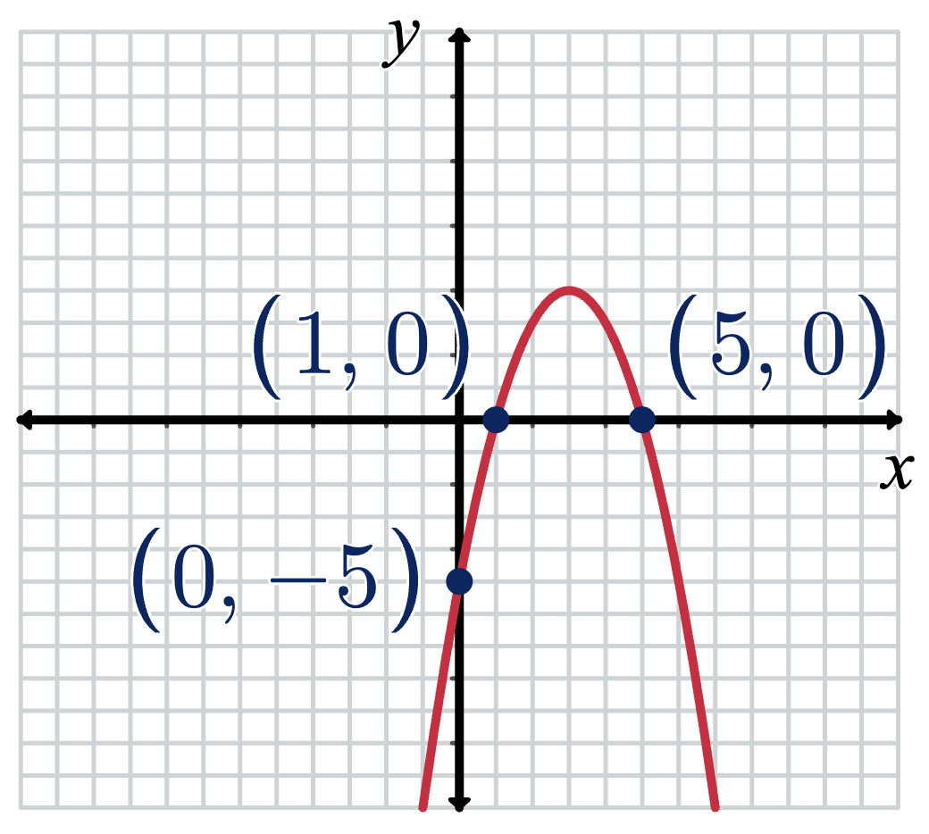 | 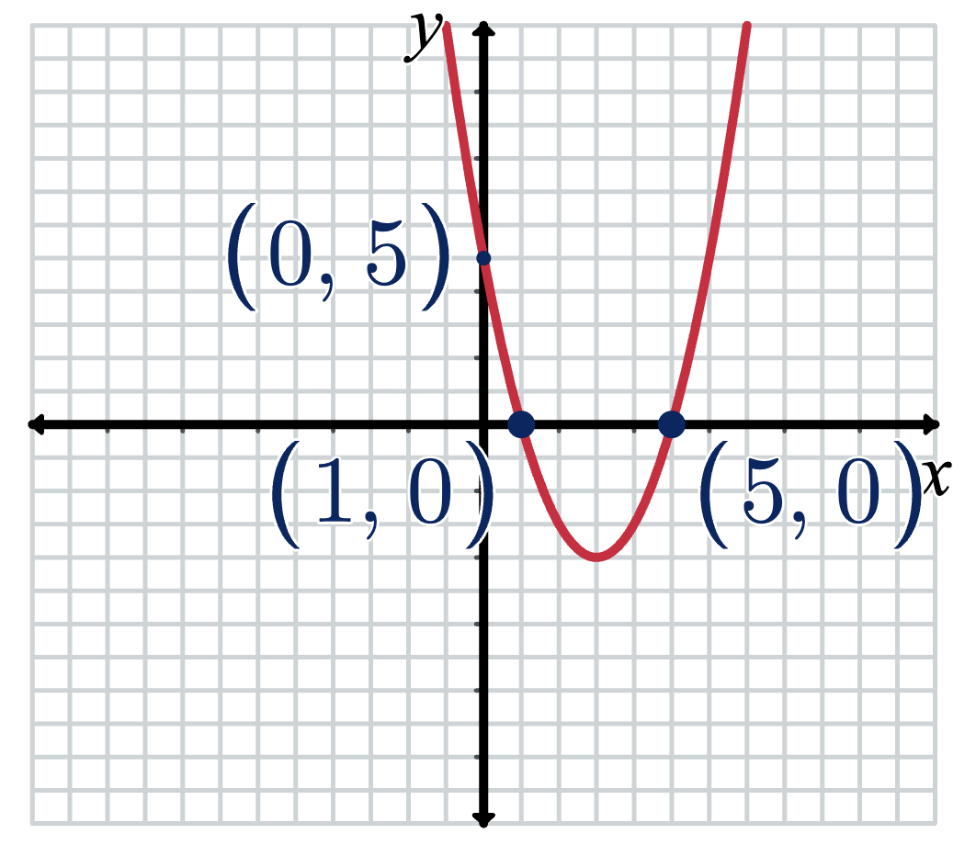
$x+1=0$or $x-5=0$  $$∴x=-1, 5$$ | $x+1=0$or $x+5=0$  $$∴x=-1,- 5$$ | 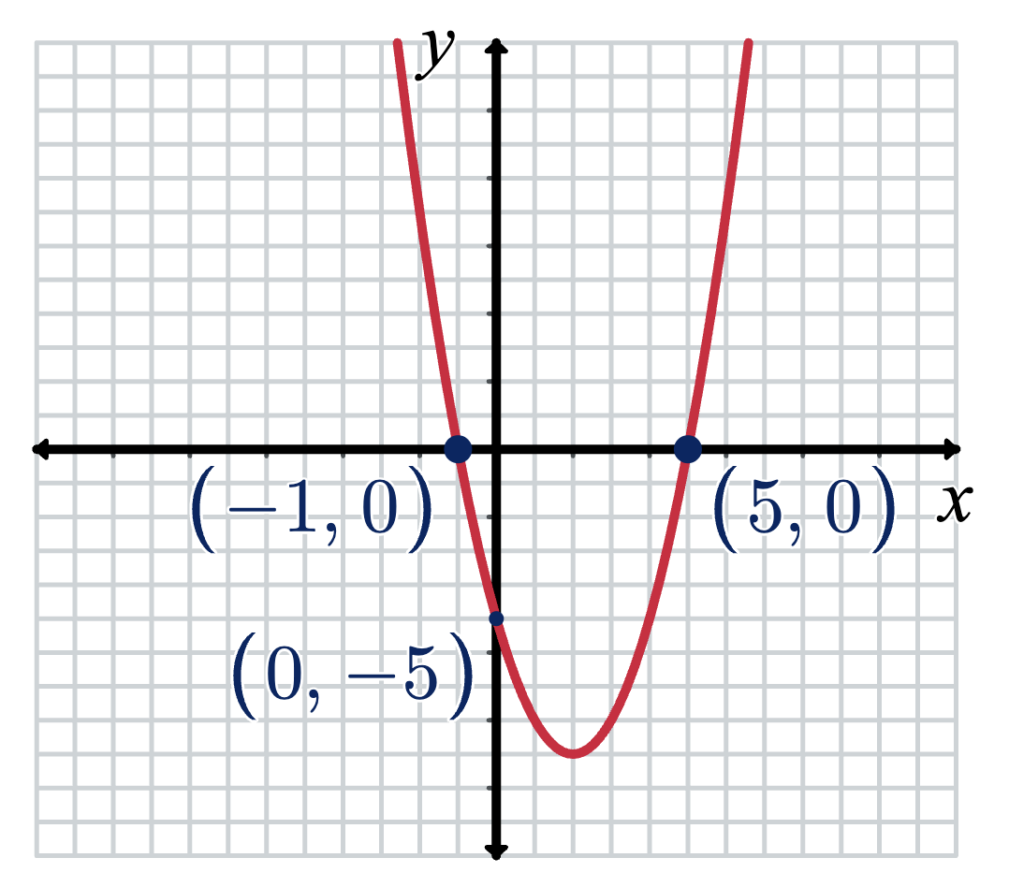
$1+x=0$or $x-5=0$  $$∴x=-1, 5$$ | $1-x=0$or $x-5=0$  $$∴x=1, 5$$ |  | 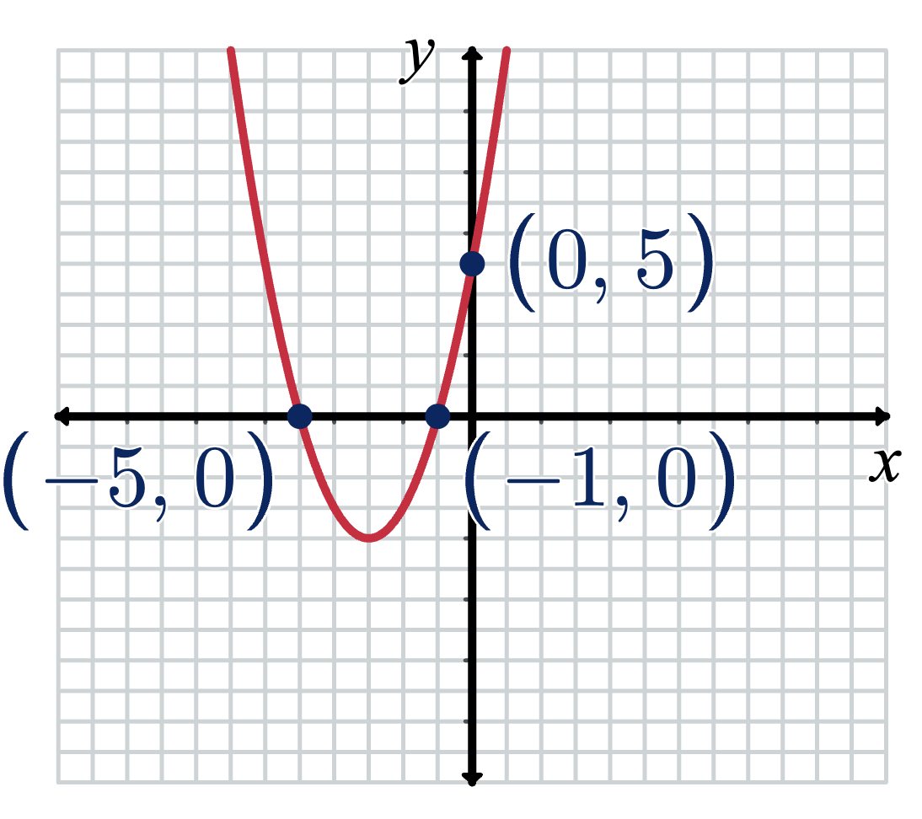

Appendix C

Four quadrant notes
Example 1  Graph $f(x)=x^{2}-6x+5$  $$f\left(x\right)=x^{2}-6x+5$$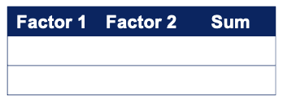  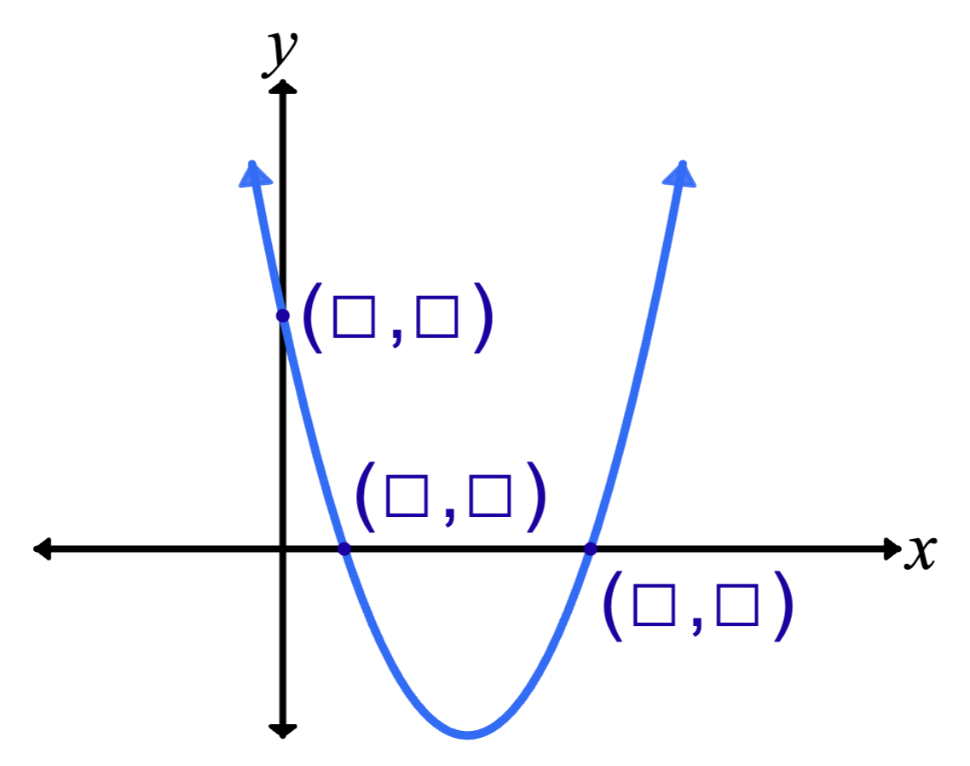 | Example 2  Graph $f(x)=x^{2}+2x-15$
Things to remember | Example 3

Appendix D

Which parabola?
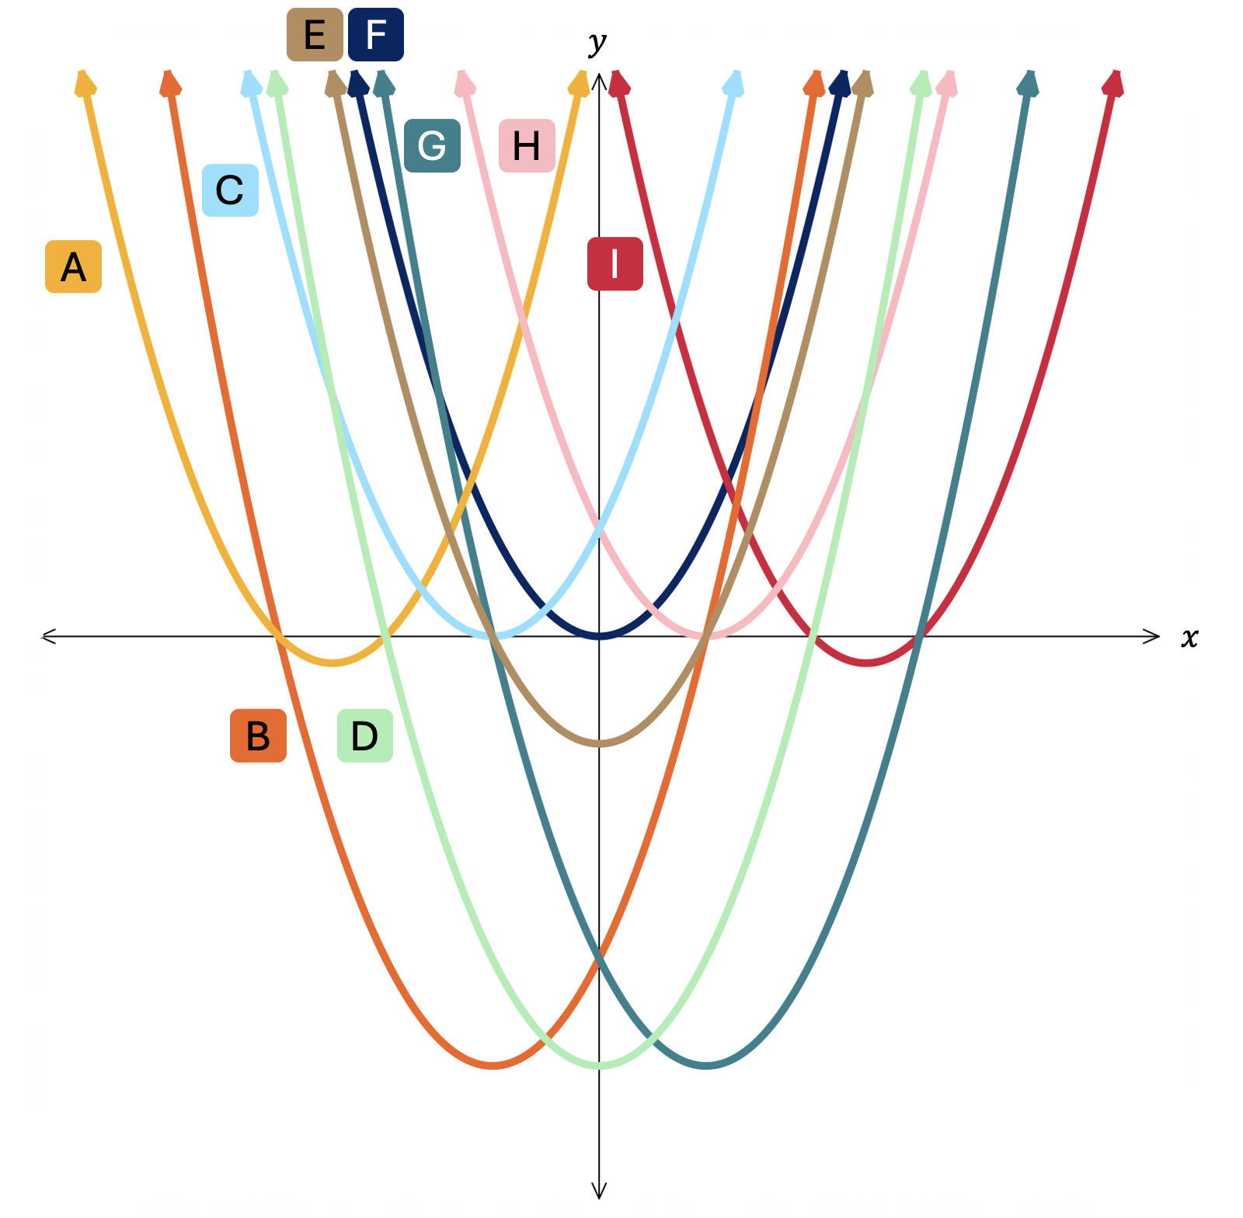

Sample solutions

Appendix A – banner tasks
- $\left(x+6\right)\left(x+3\right)=0$
$$x=-6,x=-3$$
- $\left(x-6\right)\left(x+3\right)=0$
$$x=6,x=-3$$
- $\left(x-6\right)\left(x-6\right)=0$
$$x=6$$
- $\left(x-6\right)\left(x+3\right)\left(x-2\right)=0$
$$x=6,x=-3, x=2$$
- $\left(2x-6\right)\left(x-2\right)=0$
$$x=3,x=2$$
- $\left(3x-2\right)\left(4x-4\right)=0$
$$x=\frac{2}{3},x=1$$
- $\left(\frac{1}{2}x-1\right)\left(\frac{1}{3}x-2\right)=0$
$$x=2,x=6$$
- $\left(x^{2}-4\right)\left(x-3\right)=0$
$$x=2,x=-2, x=3$$
- $\left(x^{3}-27\right)\left(x^{2}-9\right)=0$
$$x=3,x=-3$$
- $\left(2x^{4}-32\right)\left(x-1\right)=0$
$$x=2,x=-2, x=1$$

Appendix B – card sort
$$x^{2}-4x-5=0$$ | $$\left(x+1\right)\left(x-5\right)=0$$ | $x+1=0$or $x-5=0$  $$∴x=-1, 5$$
$$x^{2}-6x+5=0$$ | $$\left(x-1\right)\left(x-5\right)=0$$ | $x-1=0$or $x-5=0$  $$∴x=1, 5$$
$$x^{2}+6x+5=0$$ | $$\left(x+1\right)\left(x+5\right)=0$$ | $x+1=0$or $x+5=0$  $$∴x=-1,- 5$$
$$x^{2}-4x-5=0$$ | $$\left(1+x\right)\left(x-5\right)=0$$ | $1+x=0$or $x-5=0$  $$∴x=-1, 5$$
$$x^{2}-6x+5=0$$ | $$\left(1-x\right)\left(5-x\right)=0$$ | $1-x=0$or $5-x=0$  $$∴x=1, 5$$
$$-x^{2}+6x-5=0$$ | $$\left(1-x\right)\left(x-5\right)=0$$ | $1-x=0$or $x-5=0$  $$∴x=1, 5$$

Appendix C – Four quadrant notes
Example 1  Graph $f\left(x\right)=x^{2}-6x+5$’  $$f\left(x\right)=x^{2}-6x+5$$  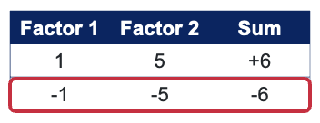 $$f\left(x\right)=(x-1)(x-5)$$  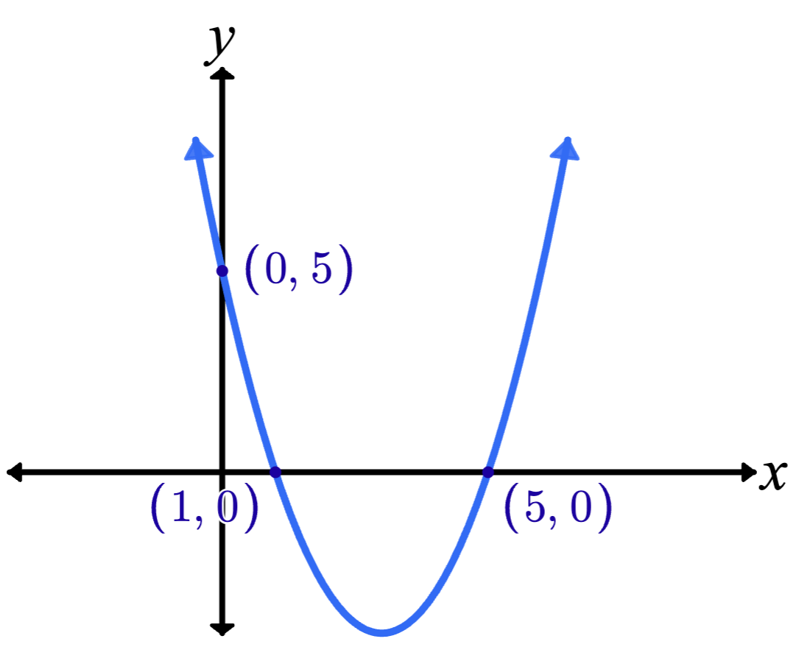 | Example 2  Graph $f(x)=x^{2}+2x-15$$$f\left(x\right)=x^{2}+5x-3x-15 \\ f\left(x\right)=(x+5)(x-3)$$  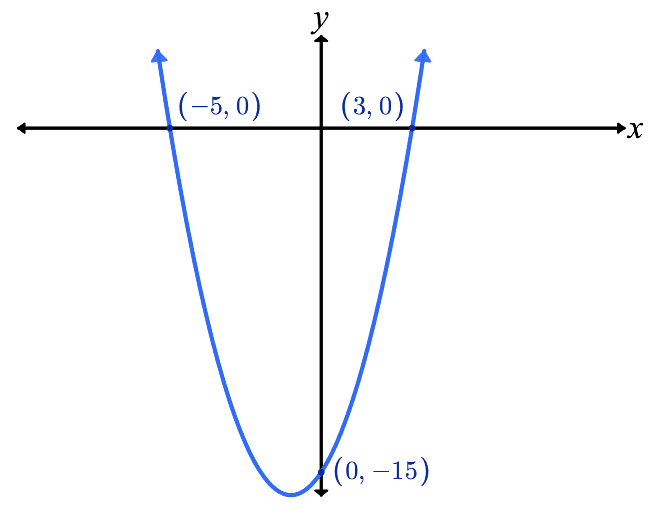
Things to remember  Key features of a graph  $x$-intercepts, $y$-intercepts  Null Factor Law – the product of 2 numbers is zero, then one or both numbers must be zero  For $f\left(x\right)=0$, one of the factors has to equal zero, so solve each factor to find the $x$-intercepts. | Example 3  Graph $f\left(x\right)=x^{2}-9$  $$f\left(x\right)=(x-3)(x+3)$$  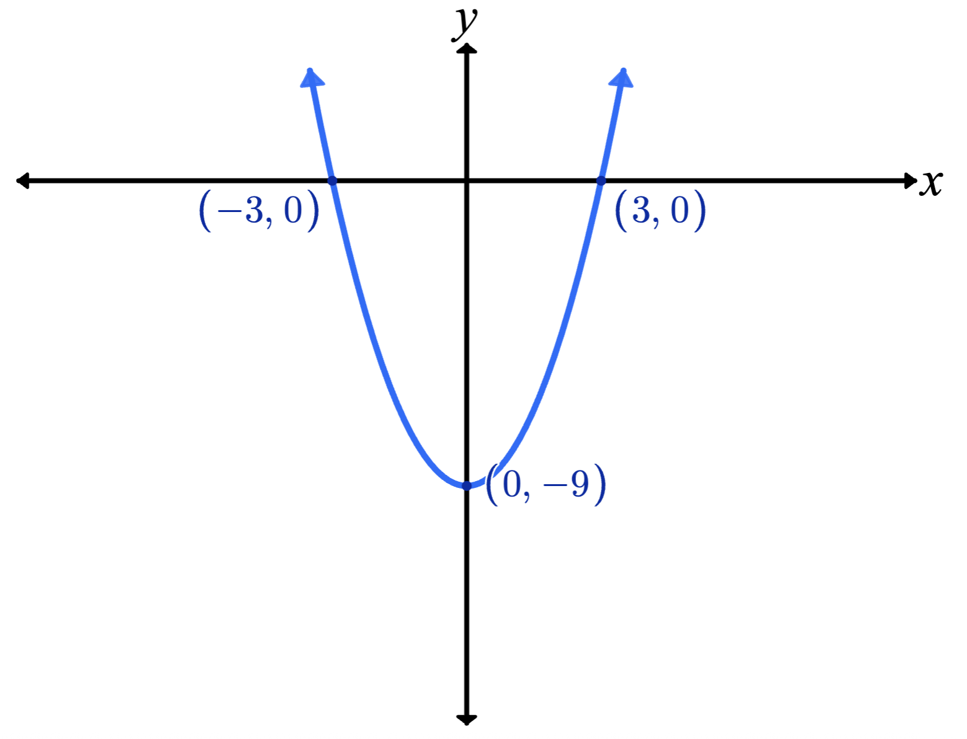

Appendix D – Which parabola?
A: $f\left(x\right)= x^{2}+10x + 24=(x+6)(x+4)$
B: $f\left(x\right)=x^{2}+4x-12=\left(x-2\right)\left(x+6\right)$
C: $f\left(x\right)=x^{2}+4x+4={\left(x+2\right)}^{2}$
D: $f\left(x\right)=x^{2}-16=\left(x-4\right)\left(x+4\right)$
E: $f\left(x\right)=x^{2}-4=\left(x-2\right)\left(x+2\right)$
F: $f(x) = x^{2}$
G: $f\left(x\right)=x^{2}-4x-12=\left(x-6\right)\left(x+2\right)$
H: $f\left(x\right)= x^{2}-4x+4={\left(x-2\right)}^{2}$
I: $f\left(x\right)= x^{2} -10x + 24=(x-6)(x-4)$

References
This resource contains NSW Curriculum and syllabus content. The NSW Curriculum is developed by the NSW Education Standards Authority. This content is prepared by NESA for and on behalf of the Crown in right of the State of New South Wales. The material is protected by Crown copyright.
Please refer to the NESA Copyright Disclaimer for more information https://educationstandards.nsw.edu.au/wps/portal/nesa/mini-footer/copyright.
NESA holds the only official and up-to-date versions of the NSW Curriculum and syllabus documents. Please visit the NSW Education Standards Authority (NESA) website https://educationstandards.nsw.edu.au/ and the NSW Curriculum website https://curriculum.nsw.edu.au/.
Mathematics Advanced 11–12 Syllabus © NSW Education Standards Authority (NESA) for and on behalf of the Crown in right of the State of New South Wales, 2024.
University of Cambridge (2013–2025) ‘Which parabola?’, Package problems, Underground Mathematics website, accessed 26 November 2025.

© State of New South Wales (Department of Education), 2025
The copyright material published in this resource is subject to the Copyright Act 1968 (Cth) and is owned by the NSW Department of Education or, where indicated, by a party other than the NSW Department of Education (third-party material).
Copyright material available in this resource and owned by the NSW Department of Education is licensed under a Creative Commons Attribution 4.0 International (CC BY 4.0) license.

This license allows you to share and adapt the material for any purpose, even commercially.
Attribution should be given to © State of New South Wales (Department of Education), 2025.
Material in this resource not available under a Creative Commons license:
- the NSW Department of Education logo, other logos and trademark-protected material
- material owned by a third party that has been reproduced with permission. You will need to obtain permission from the third party to reuse its material.
Links to third-party material and websites
Please note that the provided (reading/viewing material/list/links/texts) are a suggestion only and implies no endorsement, by the New South Wales Department of Education, of any author, publisher, or book title. School principals and teachers are best placed to assess the suitability of resources that would complement the curriculum and reflect the needs and interests of their students.
If you use the links provided in this document to access a third-party's website, you acknowledge that the terms of use, including licence terms set out on the third-party's website apply to the use which may be made of the materials on that third-party website or where permitted by the Copyright Act 1968 (Cth). The department accepts no responsibility for content on third-party websites.

