Factorising monic quadratic functions
Students expand binomial products and factorise quadratic functions, making connections between these algebraic representations.
Students will need at least one digital device per pair to interact with Amplify Classroom during this lesson.

Learning intention
- To be able to expand and factorise algebraic expressions involved in quadratic functions.

Success criteria
- I can expand binomial products.
- I can factorise monic quadratic functions.
- I can connect the concept of expansion and factorisation.

Outcomes
A student:
- develops understanding and fluency in mathematics through exploring and connecting mathematical concepts, choosing and applying mathematical techniques to solve problems, and communicating their thinking and reasoning coherently and clearly MAO-WM-01
- applies algebraic techniques and the laws of indices and surds to manipulate expressions and solve problems MAV-11-01
- uses functions and relations to model, analyse and solve problems MAV-11-02

Content

Algebraic techniques
- Expand, factorise and simplify algebraic expressions
Mathematics Advanced 11–12 Syllabus © NSW Education Standards Authority (NESA) for and on behalf of the Crown in right of the State of New South Wales, 2024.

Table 1: lesson summary
Section | Summary of activity | Teaching strategies | Teaching points
Activating prior knowledge | Students apply the area model to the questions in Appendix A to expand binomial products, then discuss the differences between the functions in each question before comparing the area model to the FOIL method using Appendix B and slides 4–5 of the PowerPoint Factorising monic quadratic functions. | Variation Theory  Turn and talk  Think-Pair-Share  Worked examples (comparison) | Students activate prior knowledge of expanding binomial products, identifying the differences caused by different signs. They compare different methods of expanding binomial products to establish their strategy for expanding.
Connecting learning | Explain to students that factorising reverses the expansion of binomial products. Use the associated Amplify Classroom activity (bit.ly/FactorisingMonics) so students can use Algebra tiles to first find factors (screens 1–4), then begin recognising the product, sum, factor (PSF) method of factorising (screens 5–11) and test their hypothesis (screens 12–14). |  | Students connect expanding and factorising, recognising that the constant term is the product and the $x$-coefficient is the sum of the factors.
Releasing responsibility | Demonstrate the PSF method of factorising using slides 7–8, before building fluency with an existing resource. Appendix C is provided as an alternative. Students consolidate their learning by writing Four quadrant notes using Appendix D. | Worked examples (Your turn)  Turn and talk  Visibly random groups of 3  Vertical non-permanent surfaces  Four quadrant notes | Students build confidence using the PSF method of factorising a quadratic.
Independent practice | Students complete Appendix E before creating their own area mazes to challenge their peers. | Visibly random groups of 3  Vertical non-permanent surfaces | Students develop their capacity to interchangeably move between factored and expanded form.

Activity structure
Please use the associated PowerPoint Factorising monic quadratic functions to display images in this lesson.

Activating prior knowledge
- Distribute Appendix A ‘Revisiting the area model’ for each student to complete. This task uses Variation Theory (variationtheory.com/introduction/) to activate prior learning by drawing attention to small changes in expanding binomial products using the area model.
Students should already be familiar with using the area model for expanding binomial products, as introduced in Stage 5 Algebraic techniques A outcome MA5-ALG-C-01. If your class requires further support, refer to Lesson 4 – area for expansion in Stage 5 Unit 12 – investigating parabolas.
- To check for understanding, prompt students to participate in a turn and talk (bit.ly/classroomtalkmoves), comparing their solutions and discussing how each question in Appendix A varies from the one before.
Questions 5–8 also serve as a formative assessment opportunity to surface special quadratic identities, such as perfect square trinomials and the difference of 2 squares. These concepts will be explored in more detail during Lesson 8 – completing the square and Lesson 11 – rationalising the denominator.
- In a Think-Pair-Share (bit.ly/thinkpairsharestrategy), ask students to consider the type of function generated by the expansions in Appendix A and to justify their responses.
Students were introduced to the different types of functions in Lesson 2 – the vertical line test and intercepts of Unit 2 – introduction to functions. They should recognise that having $x^{2}$ as the leading term indicates this is a quadratic function.
- Use Appendix B ‘Comparative worked example – expanding binomial products’ and slides 4–5 from the PowerPoint to discuss whether the area model or the FOIL method is better for expanding binomial products using the Worked examples (comparison) method.

Connecting learning
- Establish the idea that just like with linear expressions, factorising quadratic expressions and functions reverses the steps taken when expanding the expression or function.
- Assign the Amplify Classroom activity ‘Factorising monic quadratic functions’ (bit.ly/FactorisingMonics) for students to complete.
Before starting this activity, you will need to set up Amplify Classroom (bit.ly/createamplifyclassroom) and use the pacing feature to restrict the students to screens 1–4.
Alternatively, students could use algebra tiles to create a rectangle from the quadratic expression $x^{2}+4x+3$. If using algebra tiles, recreate the remaining steps in the activity using the Amplify Classroom activity as the teacher display.
- Display a student sample of a successful attempt at moving the algebra tiles on screen 2 and engage the class in a discussion about how this representation could be used to factorise the quadratic function.
Students may identify that along the left-hand side and the bottom side, the tiles represent $(x+1)$ and $\left(x+4\right),$ respectively. Students will need to know that the dimensions of the $x$ tile are $x$ and 1.
- Extend the pacing to include screens 5–11 for students to complete. These screens present a series of quadratic functions where the constant term is 12 and they must first rearrange the area model before predicting the factored form. As students attempt the activity, move around the room and ask students what aspects of the function they are considering when creating the rectangle with the algebra tiles.
- Display a selection of responses to the question on screen 11 to the class. Use these responses as a stimulus to discuss the pattern that appears when comparing the factorised form of the function to the expanded form of the function.
Students may observe that the constant term is the same for all the functions, while others may recognise that this term is also the equivalent to the product of the 2 integers in the factored form. Students may also observe that the coefficient of $x$ is always the sum of the 2 integers in the factored form.
- Extend the pacing to include screens 12–14, so students can test the previous observation on a pair of quadratic functions with the constant term 6 before validating their previous reflection.

Releasing responsibility
- Use slides 7–8 to model a worked example of the product, sum, factor method of factorising using the Worked examples (Your turn) method (bit.ly/supportingstrategies).
- Students should complete practice questions from an existing resource to consolidate their understanding of factorising monic quadratics. Alternatively, students could work in pairs to complete Appendix C ‘Monic quadratics tarsia’.
- Ask students to verify their solutions with a turn and talk (bit.ly/classroomtalkmoves).
- Assign students to visibly random groups of 3, and ask them to complete four quadrant notes to their future forgetful selves (bit.ly/supportingstrategies) from Appendix D ‘Four quadrant notes’ on a vertical non-permanent surface (bit.ly/VNPSstrategy).

Independent practice
- Continuing with established groups of 3 students, distribute adhesive putty and Appendix E ‘Quadratic functions area mazes’ to each group.
- Give students time to attempt the activity, moving around the room to monitor progress.
- Once students complete the area mazes, challenge groups to create their own area maze and swap with other groups to complete each other’s area maze.

Assessment and differentiation

Suggested opportunities for differentiation
Activating prior knowledge
- Students may benefit from first revising how to use the area model to expand quadratic expressions.
- Students could be given sentence starters as prompts, such as ‘The coefficient of $x$ changes when …’
- Discussion of the Variation Theory questions in Appendix A could challenge students to consider what other ways questions 6, 7 and 8 could be expressed, with students identifying that they could be presented as ${\left(x-a\right)}^{2}$.
- The comparative worked examples could be adjusted to look at different cases.
- The self-explanation prompts in the comparative worked example could be modified to address other aspects of the reasoning in the worked solution.
Connecting learning
- The pacing of the activity could be modified to reflect students’ previous experience of factorising quadratic expressions.
- For high-readiness students, the Polypad sections of the Amplify Classroom activity could be completed by the teacher before the lesson, and mini whiteboards (bit.ly/miniwhiteboards) could be used to check for understanding of the factorisations.
- For low-readiness students, screens could be copied and adjusted to give additional opportunity to build fluency.
Releasing responsibility
- The ‘Your turn’ example from the worked examples could be modified. Additional ‘Your turn’ questions could also be provided to explore different cases with the sign of the coefficient of $x$ and the constant term.
- Self-explanation prompts in the worked examples could be modified to address other aspects of the reasoning in the worked solutions.
- Existing resources could be tailored to students’ needs for factorising monic quadratics.
Independent practice
- Different area mazes could be created to tailor the activity to students’ needs.

Suggested opportunities for assessment
Activating prior knowledge
- Appendix A could be collected to check students’ understanding of expanding using the area model.
- Students’ reasoning and communication skills can be assessed on how they discuss the variations identified in Appendix A, following the turn and talk.
- Students give each other peer feedback, before sharing with the class in a Think-Pair-Share.
Connecting learning
- Monitor responses in class discussions to check for students’ understanding of factorising.
- Amplify Classroom keeps a record of student work, which can be used to assess understanding.
Releasing responsibility
- Student responses to the self-explanation prompts during worked examples provide an opportunity to assess student reasoning.
- If using Appendix C, monitor discussions between pairs to hear student reasoning of matching pairs.
- When placed in groups of 3, students can provide and receive peer feedback.
Independent practice
- Students working at vertical non-permanent surfaces means the teacher can assess students’ progress and provide support where appropriate.

Appendix A

Revisiting the area model
Expand the following binomial products.
- $f\left(x\right)=\left(x-2\right)\left(x-7\right)$
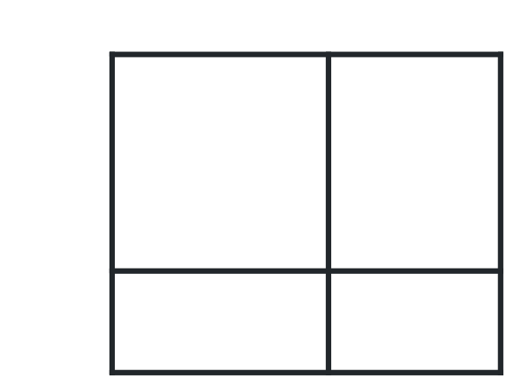
- $f\left(x\right)=\left(x+2\right)\left(x-7\right)$
- $f\left(x\right)=\left(x+2\right)\left(x+7\right)$
- $f\left(x\right)=\left(x-2\right)\left(x+7\right)$
- $f\left(x\right)=\left(x-2\right)\left(x+2\right)$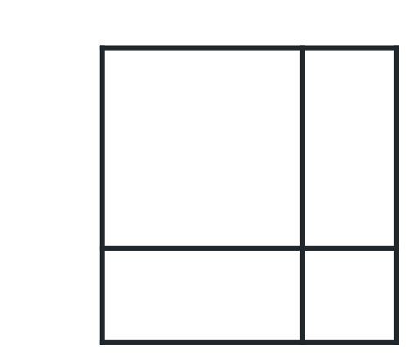
- $f\left(x\right)=\left(x-2\right)\left(x-2\right)$
- $f\left(x\right)=\left(x+2\right)\left(x+2\right)$
- $f\left(x\right)=\left(x+7\right)\left(x+7\right)$
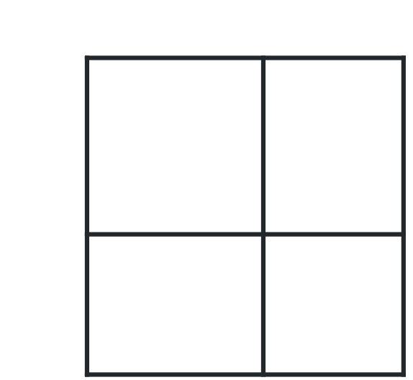

Appendix B

Comparative worked example – expanding binomial products
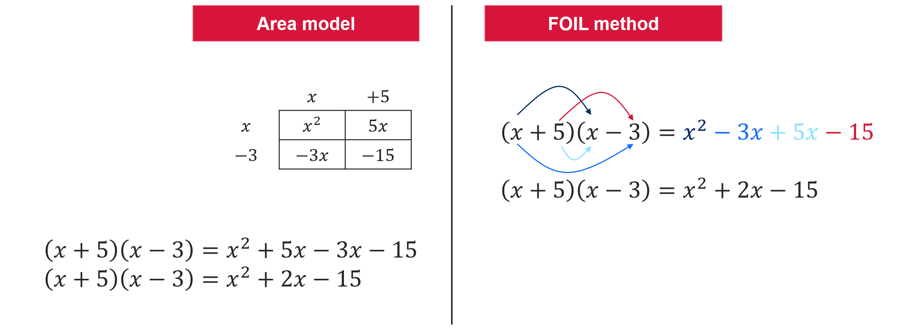
Which method is better?

Appendix C

Monic quadratics tarsia
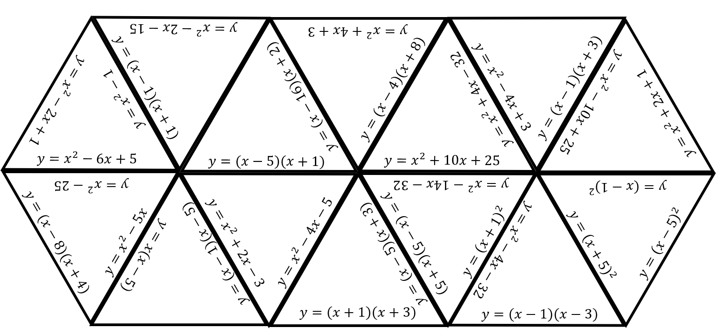

Appendix D

Four quadrant notes
Example 1  Expand $f(x)=(x+3)(x+9)$  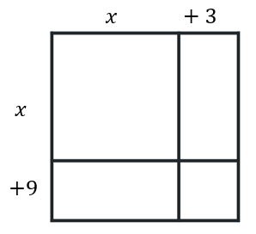$$f\left(x\right)=x^{2} ☐x ☐x ☐ \\ f\left(x\right)=$$ | Example 2  Factorise $f\left(x\right)=x^{2}+11x+30$
Things to remember | Example 3

Appendix E

Quadratic functions area mazes
Find the expanded expression that corresponds to the question marks in the following diagrams.
All shapes are rectangles but are not drawn to scale.
All quadratic functions are monic with whole-number factors.
- 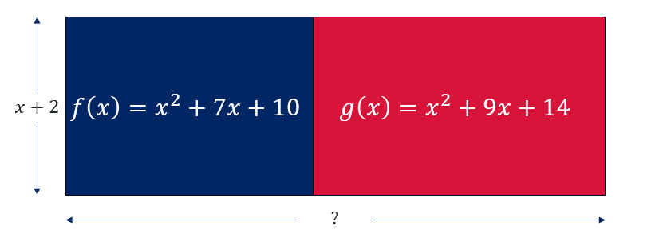
- 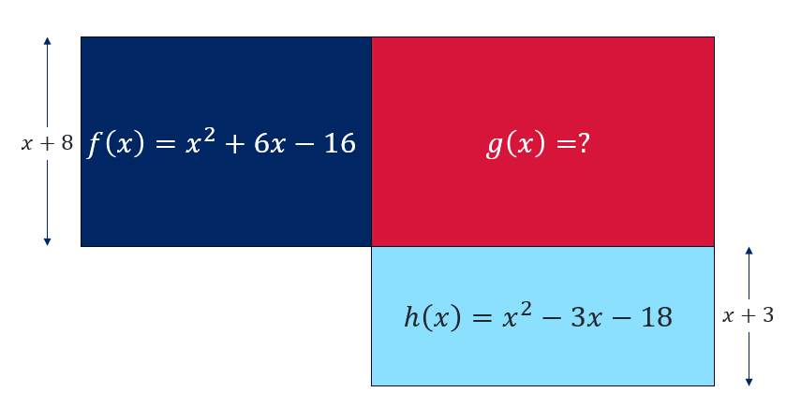
- 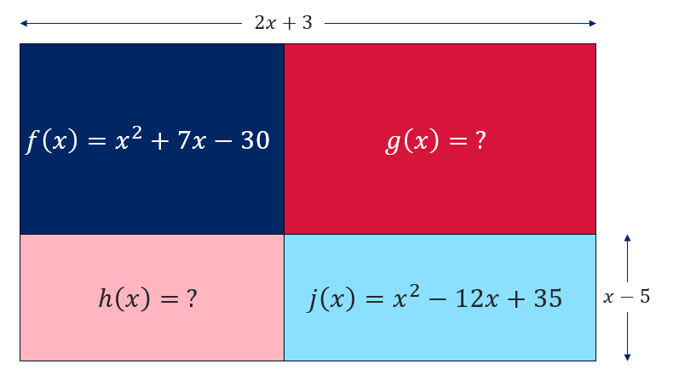

Sample solutions

Appendix A – revisiting the area model
- $f\left(x\right)=\left(x-2\right)\left(x-7\right)=x^{2}-9x+14$
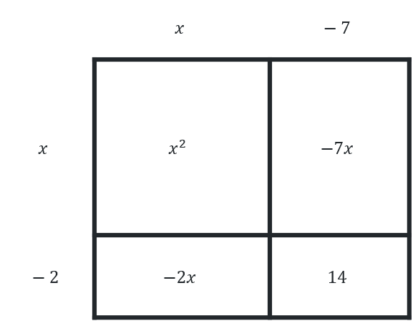
- $f\left(x\right)=\left(x+2\right)\left(x- 7\right)=x^{2}-5x-14$
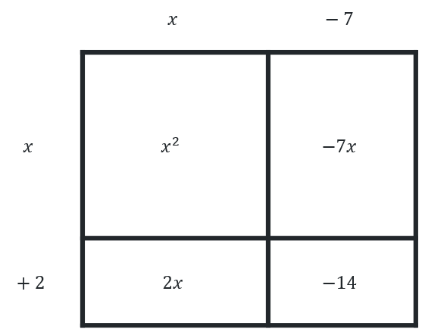
- $f\left(x\right)=\left(x+2\right)\left(x+7\right)=x^{2}+9x+14$
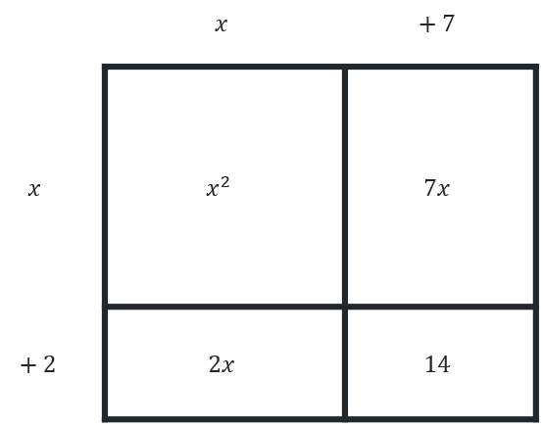
- $f\left(x\right)=\left(x-2\right)\left(x+7\right)=x^{2}+5x-14$
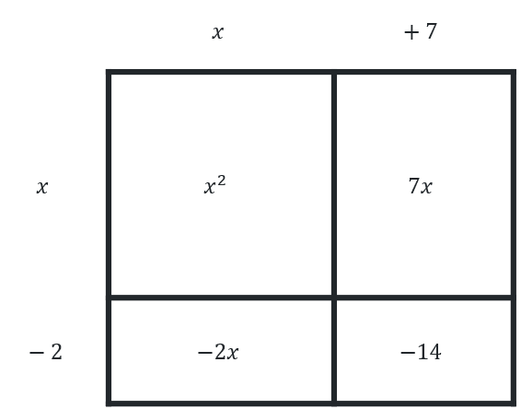
- $f\left(x\right)=\left(x-2\right)\left(x+2\right)=x^{2}-4$
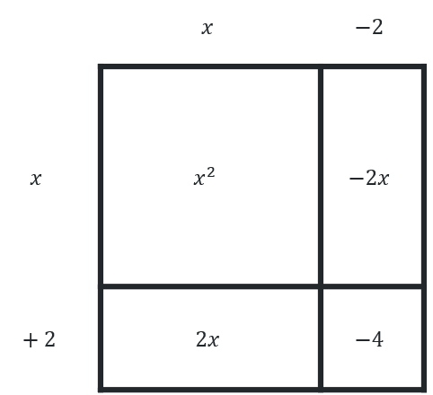
- $f\left(x\right)=\left(x-2\right)\left(x-2\right)=x^{2}-4x+4$
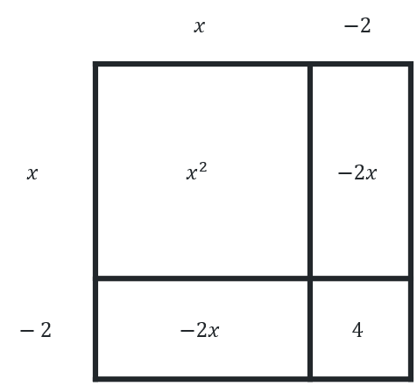
- $f\left(x\right)=\left(x+2\right)\left(x+2\right)=x^{2}+4x+4$
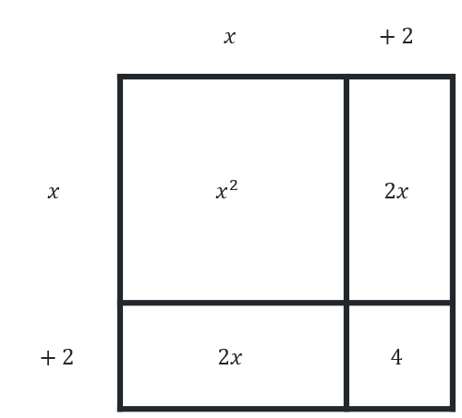
- $f\left(x\right)=\left(x+7\right)\left(x+7\right)=x^{2}+14x+49$
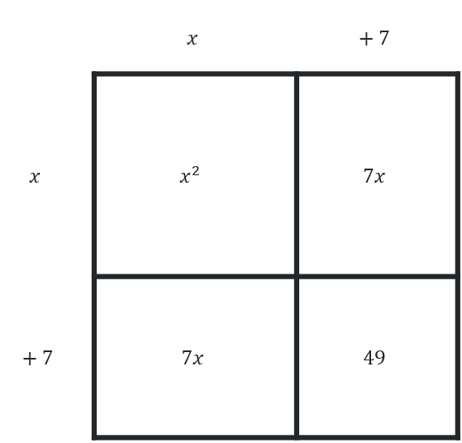

Appendix C – Tarsia
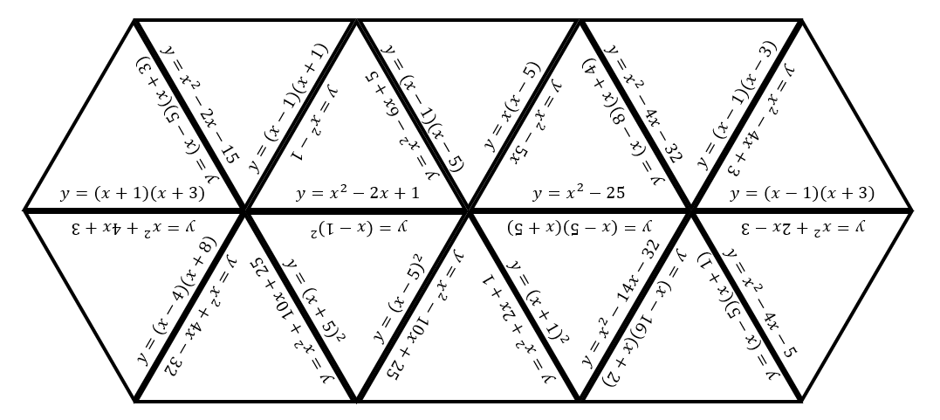

Appendix D – Four quadrant notes
Example 1  Expand $f(x)=(x+3)(x+9)$  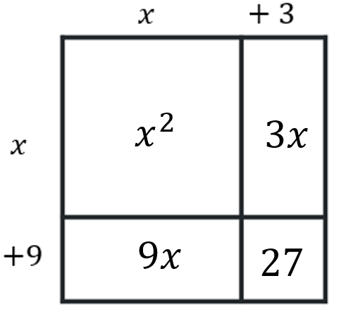$$f\left(x\right)=x^{2}+9x+3x+27 \\ f\left(x\right)=x^{2}+12x+27$$ | Example 2  Factorise $f\left(x\right)=x^{2}+11x+30$  Factor: 1, 30 Sum: 31  Factor: 2, 15 Sum: 17  Factor: 3, 10 Sum: 13  Factor: 5, 6 Sum: 11  $$f\left(x\right)=x^{2}+11x+30$$  $$f\left(x\right)=(x+5)(x+6)$$
Things to remember  Expanding  - Multiply each term in the first bracket by each term in the second bracket  - Collect and simplify like terms  - Write the final answer  Factorising  - Find 2 numbers that multiply to c  - Find 2 numbers that sum to b.  - Write the factors in brackets  - Check your answer. | Example 3  Factorise $f\left(x\right)=x^{2}+6x-7$  Factor: -1, 7 Sum: 6  Factor: 1, -7 Sum: -6  $$f\left(x\right)=x^{2}+6x-7$$  $$f\left(x\right)=(x-1)(x+7)$$

Appendix E – quadratic functions area mazes
- $f\left(x\right)=x^{2}+7x+10$$$f\left(x\right)=\left(x+2\right)\left(x+5\right) \\ g\left(x\right)=x^{2}+9x+14 \\ g\left(x\right)=\left(x+2\right)\left(x+7\right) \\ ?=2x+12$$
- $f\left(x\right)=x^{2}+6x-16$$$f\left(x\right)=\left(x+8\right)\left(x-2\right) \\ h\left(x\right)=x^{2}-3x-18 \\ h\left(x\right)=\left(x+3\right)\left(x-6\right) \\ g\left(x\right)=\left(x-6\right)\left(x+8\right) \\ g\left(x\right)=x^{2}+2x-48$$
- $f\left(x\right)=x^{2}+7x-30$$$f\left(x\right)=\left(x+10\right)\left(x-3\right) \\ j\left(x\right)=x^{2}-12x+35 \\ j\left(x\right)=\left(x-7\right)\left(x-5\right) \\ Top of dark blue square=2x+3-\left(x-7\right) \\ Top of dark blue square=x+10 \\ g\left(x\right)=\left(x+3\right)\left(x-7\right) \\ g\left(x\right)=x^{2}-4x-21 \\ h\left(x\right)=\left(x-5\right)\left(x+10\right)$$$h\left(x\right)=x^{2}+5x-50$

References
This resource contains NSW Curriculum and syllabus content. The NSW Curriculum is developed by the NSW Education Standards Authority. This content is prepared by NESA for and on behalf of the Crown in right of the State of New South Wales. The material is protected by Crown copyright.
Please refer to the NESA Copyright Disclaimer for more information https://educationstandards.nsw.edu.au/wps/portal/nesa/mini-footer/copyright.
NESA holds the only official and up-to-date versions of the NSW Curriculum and syllabus documents. Please visit the NSW Education Standards Authority (NESA) website https://educationstandards.nsw.edu.au/ and the NSW Curriculum website https://curriculum.nsw.edu.au/.
Mathematics Advanced 11–12 Syllabus © NSW Education Standards Authority (NESA) for and on behalf of the Crown in right of the State of New South Wales, 2024.

© State of New South Wales (Department of Education), 2025
The copyright material published in this resource is subject to the Copyright Act 1968 (Cth) and is owned by the NSW Department of Education or, where indicated, by a party other than the NSW Department of Education (third-party material).
Copyright material available in this resource and owned by the NSW Department of Education is licensed under a Creative Commons Attribution 4.0 International (CC BY 4.0) license.

This license allows you to share and adapt the material for any purpose, even commercially.
Attribution should be given to © State of New South Wales (Department of Education), 2025.
Material in this resource not available under a Creative Commons license:
- the NSW Department of Education logo, other logos and trademark-protected material
- material owned by a third party that has been reproduced with permission. You will need to obtain permission from the third party to reuse its material.
Links to third-party material and websites
Please note that the provided (reading/viewing material/list/links/texts) are a suggestion only and implies no endorsement, by the New South Wales Department of Education, of any author, publisher, or book title. School principals and teachers are best placed to assess the suitability of resources that would complement the curriculum and reflect the needs and interests of their students.
If you use the links provided in this document to access a third-party's website, you acknowledge that the terms of use, including licence terms set out on the third-party's website apply to the use which may be made of the materials on that third-party website or where permitted by the Copyright Act 1968 (Cth). The department accepts no responsibility for content on third-party websites.

