Solving simultaneous equations
Students learn how to solve simultaneous linear equations using the elimination and substitution methods and choose the most efficient method to solve problems.

Learning intention
- To be able to solve simultaneous linear equations algebraically.

Success criteria
- I can identify whether to add, subtract or scale equations to use elimination.
- I can rearrange an equation to make one variable the subject.
- I can substitute one expression into another and simplify correctly.
- I can solve for both variables using elimination or substitution.
- I can check that my solution satisfies both original equations.

Outcomes
A student:
- develops understanding and fluency in mathematics through exploring and connecting mathematical concepts, choosing and applying mathematical techniques to solve problems, and communicating their thinking and reasoning coherently and clearly MAO-WM-01
- uses functions and relations to model, analyse and solve problems MAV-11-02

Content
Constructing and using functions
- Solve practical problems involving a pair of simultaneous linear equations both algebraically and graphically, with and without graphing applications, and justify conclusions in the context of the problem
Mathematics Advanced 11–12 Syllabus © NSW Education Standards Authority (NESA) for and on behalf of the Crown in right of the State of New South Wales, 2024.

Table 1: lesson summary
Section | Summary of activity | Teaching strategies | Teaching points
Activating prior knowledge | Using Appendix A, students consider cost and revenue equations to graphically determine the break-even point for a business. From this, students discuss the inaccuracies that can occur when graphing, leading to the need for an algebraic solution. | Pose-Pause-Pounce-Bounce | This activity aims to reactivate students’ skills in forming and graphing linear equations. It considers the limitations that graphing has when attempting to find an accurate solution.
Connecting learning | Use slides 4–7 of the PowerPoint Solving simultaneous equations to make connections between a simultaneous equations picture puzzle, bar model and graphical representation. | Think-Pair-Share  Notice and wonder | In this activity, students build their skills in interpreting simultaneous equations problems and begin building an understanding of how to solve these through algebraic means.
Releasing responsibility | Students are formally introduced to the elimination and substitution methods. Slides 9–14 model the elimination method and the students’ understanding is consolidated through class discussions. Appendix C consolidates students’ skills with solving problems via the elimination method. Slides 14–17 model the substitution method with Appendix D to consolidating this learning. | Worked examples (Your turn)  Pose-Pause-Pounce-Bounce  Faded examples  Think-Pair-Share  Notes to their future forgetful selves | The activity aims to formalise algebraic methods to solve simultaneous equations. Worked examples, along with the appendices, provide opportunities for students to develop their skills.
Independent practice | Using Appendix E, students work in pairs to solve HSC-style questions and discuss the elements of the HSC-style questions including language and marking criteria. | Think-Pair-Share | The aim of this activity is for students to be exposed to HSC-style questions and consider the language involved in these questions and the marking criteria.

Activity structure
Please use the associated PowerPoint Solving simultaneous equations to display images in this lesson.

Activating prior knowledge
Students have previously solved simultaneous equations, graphically and identified the break-even point in Lesson 2 – modelling linear functions.
- Distribute Appendix A ‘Break-even example’ to each student. In pairs, have students complete question 1.
- On completion, lead a class discussion to share students’ approaches to the question and confirm their cost and revenue equations.
- Students then attempt question 2 of Appendix A, to solve the break-even point graphically.
These equations have been chosen to show that graphing may not be the best method to solve certain simultaneous equations due to a lack of accuracy.
- Ask pairs to share their answers to question 2 and encourage groups to share any different answers they may have.
If all students report the same estimated solution, the teacher can deliberately suggest a slightly different rounded value and ask students to check whether that alternative is consistent with their graphs. This helps highlight the uncertainty inherent in graphical solutions and encourages discussion about the acceptable range of answers.
- Use the Pose-Pause-Pounce-Bounce questioning strategy (PDF 557 KB) (bit.ly/posepausepouncebounce) to initiate a class discussion on why different student pairs may be getting different answers. Use students’ responses to suggest that another method may be required to solve simultaneous equations accurately. Suggested discussion prompts include:
- How did you determine the $x$- and $y$-values of the intersection point?
- How might you find the break-even point exactly?
Reasons may include:
- the point of intersection does not occur at a clear or distinct value on either axis
- inaccurate sketching
- difficulties in reading the scale.

Connecting learning
- Display slide 4 of the PowerPoint and, using a Think-Pair-Share (bit.ly/thinkpairsharestrategy), ask students to solve the picture puzzle and share their methods.
Students are not yet able to solve simultaneous equations algebraically, and the intention of this slide is for them to share their methods of how it could be solved, rather than forming equations.
- Initiate a class discussion to see if students can express each picture as an equation. Suggested prompts include:
- How could we represent the cost of each instrument using variables?
- What equation could we write to represent each scenario in the image?
- Display slide 5 and, using a Think-Pair-Share, ask students to make connections between the picture puzzle, the equations that they established and the bar model shown. Animate the slide to show self-explanation prompts.

Students should make connections between the images and the bar model. For example, the picture puzzle has the price of 2 guitars and 1 drumkit equalling $550 and the bar model represents $2g+d=550$.
- Display slide 6 and, using a Think-Pair-Share, ask students to make connections between the graphical solution and the previous solutions.
Students should recognise these as different methods of solving the same problem.
- Display slide 7 and, using the notice and wonder (bit.ly/noticewonderstrategy) strategy, ask students to consider what is similar and different in the bar model and algebraic representations.
Students should recognise the algebraic representation as a summary of the information in the bar model. Students should notice how the first bar model image in step 1 represents equation 1 $4g+d=850$, and then how the subsequent operations to the bar models are represented in the equations. Furthermore, students may wonder why the bar model reduces to just representing $'g^{'}.$

Releasing responsibility

Elimination method
- Use slides 9–14 of the PowerPoint to model how to solve simultaneous equations using the elimination method, by using the Worked examples (Your turn) method (bit.ly/supportingstrategies).
- Use the Pose-Pause-Pounce-Bounce questioning strategy to check students’ understanding of the elimination method. Suggested prompts include:
- What is the goal of the elimination method?
- How do you know whether to add or subtract the equations?
- Why might we need to multiply one (or both) of the equations first?
Responses may include:
- The goal is to eliminate one of the variables so that we can solve the problem using just one equation.
- To eliminate a particular variable, both equations need to have the same coefficient. If the signs at the front of the variable are the same, we subtract the equation; if they are different, we add them.
- Sometimes we need to multiply one or both equations so the coefficients of a variable match, which makes it possible to eliminate that variable.
Appendix B ‘Simultaneous equations – bar model’ can be used if your students would benefit from additional practice using bar models. It has been reproduced from the Department of Education sample units, Stage 5 Unit 6 – constant rates of change, Lesson 13 – simultaneous shopping.
- Students complete the faded worked examples (bit.ly/fadedexamplesstrategy) in Appendix C ‘Elimination method’.
Students may benefit from independent practice from an existing resource that requires them to solve non-contextual simultaneous equations using the elimination method.
- On completion of Appendix C, conduct a Think-Pair-Share and ask students what strategies they used to work out which equation to multiply and to consider how they can confirm their final answer to each question is correct.
Students should note that they select the equation to multiply to get 2 terms the same and that they can substitute their final answer back into the original equation.
Teachers should consider giving students the opportunity to practise from an existing resource, if required.

Substitution method
- Use slides 15 and 16 to model how to solve simultaneous equations using the substitution method, using the Worked examples (Your turn) method.
- Use the Pose-Pause-Pounce-Bounce questioning strategy to check students’ understanding of the substitution method. Suggested prompts include:
- What do you notice about equation (1) in both questions?
- How could you use this method if neither equation was arranged such that one variable was the subject of the equation?
- How might you solve one of the elimination problems from earlier using the substitution method?
Students should recognise $a$ was the subject of equation (1) in both questions.
Students rearranged equations in Lesson 1 – linear functions. Students might suggest that to use the substitution method on the earlier problems, they would first need to rearrange the equation. If time permits, it could be beneficial to attempt one of the questions from the elimination method section of the lesson with the substitution method.
- Students complete the faded worked examples in Appendix D ‘Substitution method’.
- Show slide 17 and allow time for students to Think-Pair-Share which strategy they would choose to solve each pair of simultaneous equations. Encourage students to share their reasoning and guide them to efficient choices.
- For a: the first equation is already rearranged to make $y$ the subject of the equation, so substitution is quick and straightforward.
- For b: the $y$-terms have opposite coefficients ($+3y$, $-3y$), making it ideal for elimination.
- For c: it’s easy to make either $x$ in the second equation or $y$ in the first equation the subject of the equation and then use substitution.
- For d: multiplying the first equation by 2 allows elimination of $2y$ and $4y$ by subtracting. Alternatively, the first equation could be multiplied by 3 to allow for the elimination of $3x$ in both.
Students should understand that in some cases, both methods may be efficient, and it may come down to personal preference. Students may consider the graphical approach to solving equations and their proficiency with sketching linear functions would be influential on their consideration of this as genuine solution approach.
- Students should complete practice questions from an existing resource to consolidate their understanding of solving simultaneous equations algebraically using the elimination and substitution methods.
- Students are to create notes to their future forgetful selves (bit.ly/notestofutureself) on how to use the substitution and elimination methods to solve simultaneous linear equations as well as strategies to confirm their answers to be correct.

Independent practice
- Use slide 19 of the PowerPoint to unpack the ‘Approaching questions scaffold’ for students.
The ‘Approaching questions scaffold’ offers students a 4-step scaffold to tackle questions. Each step is accompanied by an icon and corresponds to different aspects of the solution process.
- Distribute Appendix E ‘HSC-style question’ to students and have them work in pairs to plan a solution to the question by considering graphical, substitution and elimination methods as well as different iterations of substituting and eliminating the equations.
- Select non-volunteer students to discuss different approaches and what considerations would be made in how to approach a question.
- Give students time to complete the question in pairs.
- Display slide 20 and use a Think-Pair-Share to prompt discussion of the mark allocations.
Teachers should highlight the importance of effort to the students. Even if students are unable to complete the problem, they can still obtain partial marks for correctly completing some of the steps.
- Teachers can unpack the meaning of ‘or otherwise’ in the question.
- Teachers can unpack the meaning of ‘or equivalent merit’ in the marking criteria.

Assessment and differentiation

Suggested opportunities for differentiation
Activating prior knowledge
- Students requiring extra support could be asked to draw lines from the intersection point to the axes, to aid reading the scale.
Connecting learning
- Students could be given manipulatives to assist in understanding bar models.
Releasing responsibility
- Students who would benefit from extra support could practise with the bar model using Appendix B.
- Students could be challenged to create their own scenario and question to share with their peers.
Independent practice
- Students could work in visibly random groups of 3 (bit.ly/visiblegroups), at vertical non-permanent surfaces (bit.ly/VNPSstrategy), so they can attempt the question in a larger group and see the working of others.
- Students could be extended by working individually and using the marking criteria to peer mark.

Suggested opportunities for assessment
Activating prior knowledge
- Monitor responses in class discussions to check for student understanding of the difficulties of getting exact results using graphical methods.
Connecting learning
- Monitor responses in class discussions to check that students understand simplifying the expressions by removing the matching sections of the bars.
- Monitor responses in class discussions to check for student understanding of the connection between the pictures in the puzzle, the boxes in the bar and the terms in the equation.
Releasing responsibility
- Review student working to check for communication conventions in their working by looking for competent use of equation labels to explain reasoning at new steps.
- Monitor responses in class discussions to check for student understanding of eliminating one variable and solving using the resulting equation to solve the problem.
- Collect Appendices C and D for evidence of learning to solve equations using algebraic methods.
Independent practice
- Work samples from Appendix E could be collected to check for understanding of the whole process of forming equations and solving them simultaneously.
- Monitor responses in class discussions to check for student understanding of the steps required to gain each additional mark.

Appendix A

Break-even example
A small business sells handmade candles for $2 each. The candle mould costs $4 and each candle uses 30c worth of materials.
- Let $x$ be the number of candles. Write down the cost and revenue equations.
- Cost$=$
- Revenue $=$
- Graph the cost and revenue functions on the axes below. Using the graph, solve to determine the break-even point for the business.
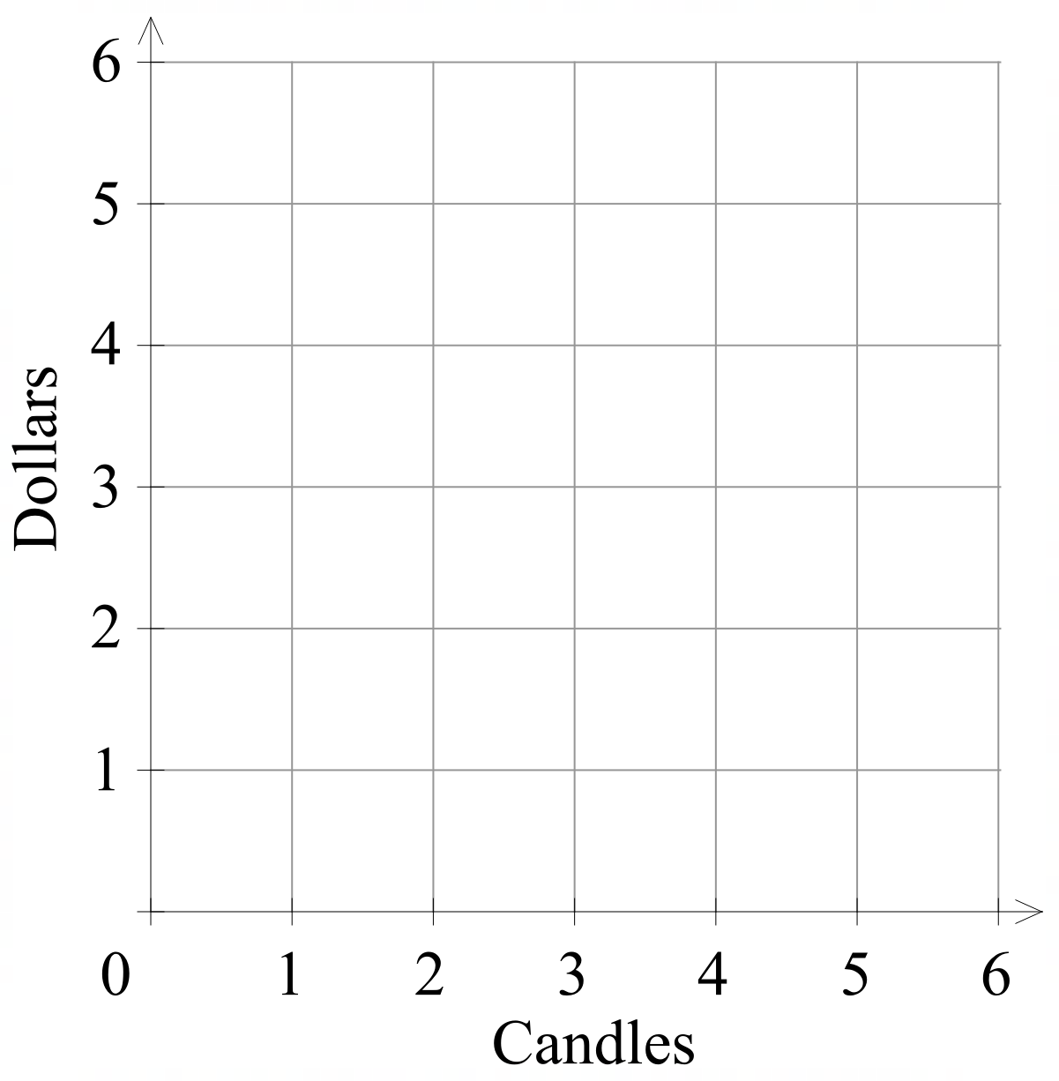

Appendix B

Simultaneous equations – bar model
Bar model | Equations | Solution
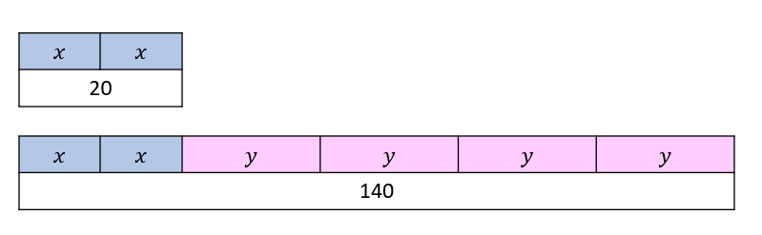 | $$2x=20 \\ 2x+4y=140$$ | $$x=10$$  $$y=30$$
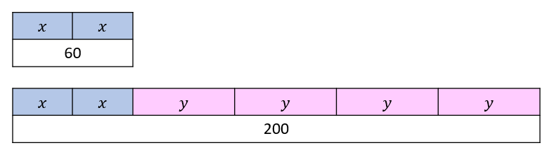
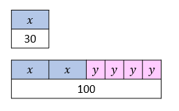
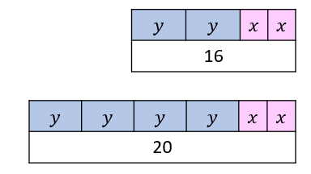
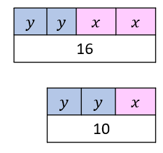
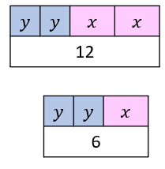
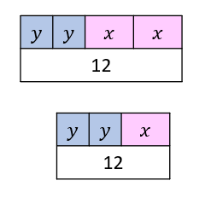
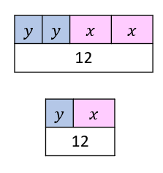
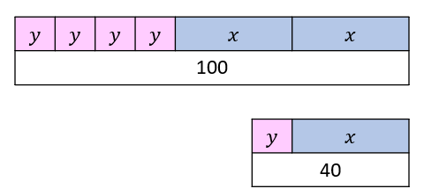
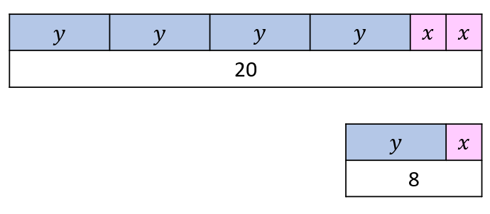

Appendix C

Elimination method
Solve the following pairs of simultaneous equations using the elimination method.
On a farm, there are chickens and cows. Altogether, there are 30 animals. If the total number of legs is 100, how many chickens and how many cows are there? | At a café, Emma orders 2 sandwiches and 1 smoothie and pays $17. Noah orders 1 sandwich and 2 smoothies and pays $16. What is the cost of 1 sandwich and 1 smoothie?
Let $x$ = number of chickens (2 legs) and $y$ = number of cows (4 legs).  $x+y=30$(1)  $2x+4y=100​$(2)  $2×$(1): $2x+2y=60$(3)  (2)$-$(3): $2y=40$  $y=20$  Sub $y=20$ into $(1)$:  $$x+20=30$$  $$x=10$$  Solution: $x=10, y=20$  That is, 10 chickens and 20 cows. | Let $x=$ sandwich price and $y=$ smoothie price.  $2x+y=17$ (1)$x+2y=16$ (2)  $2×(1)$: $4x+2y=34$ (3)  $\left(3\right)-(2)$:  $$3x=18$$  $$x=6$$  Sub $x=6$ into  $×+=$  $$=$$  Solution: $x=, y=$  That is,

A car rental company charges a daily rate plus a per-kilometre fee. One customer rents a car for 3 days and drives 200 km, paying $230. Another rents for 2 days and drives 300 km, paying $240. What is the daily charge and the per-kilometre rate? | Jordan buys 3 paintbrushes and 2 sketchbooks for $28. Taylor buys 2 paintbrushes and 3 sketchbooks for $27. What is the cost of a paintbrush and a sketchbook?
Let $d=$ daily cost and $k=$ cost per kilometre.  $3d+200k=230$ (1)  $2d+300k=240$ (2)  $2×(1)$: $6d+400k=460$ (3)  $3×(2)$: $6d+900k=720$ (4)  $\left(4\right)-(3)$: $k=$  Sub: $k=$  Solution: | Let $p=$ the cost of a paintbrush and $s=$ the cost of a sketchbook.

Appendix D

Substitution method
Solve the following pairs of simultaneous equations using the substitution method.
The cost for 2 burgers and 3 drinks is $38. The cost for 1 burger and 1 drink is $16. How much does a burger and drink cost individually? | Julie is selling cupcakes at a school fete. The stand cost her $40 and each cupcake costs $0.50 to make. If she sells them for $4.50 each, how many does she need to sell to break even?
Let $b=$ the cost of the burger and $d=$ the cost of the drink.  $2b+3d=38$ (1)  $b+d=16$ (2)  $b=16-d$ (3)  Sub (3) into (1):  $$2\left(16-d\right)+3d=38$$  $$32-2d+3d=38$$  $$d=6$$  Sub $d=6$ into (2): $b+6=16$  $$b=10$$  $$∴d=6, b=10$$  A burger is $10 and a drink is $6. | Let $d=$ the dollar value and $c=$ the number of cupcakes.  Cost: $d=40+0.5c$ (1)  Revenue: $d=4.5c$ (2)  Sub (2) into (1): $4.5c=40+0.5c$  $$4c=40$$  $$c=10$$  Sub $c=10$ into : $=×$  $$∴c=10, =$$

A large pizza costs $3 more than a small pizza. The total cost of 2 small pizzas and 1 large pizza is $27. What are the prices of a small and a large pizza? | At a festival, an adult and 2 child tickets costs $\$15$. The cost of 2 adult tickets and 3 child tickets is $35. What is the cost of 1 adult ticket and 1 child ticket?
Let $l=$ the price of a large pizza and $s=$ the price of a small pizza.  $l=s+3$ (1)  $2s+l=27$ (2)  $s=l-3$ (3)  Sub into  Sub $()$ into $()$  Sub $=$ into $()$:  $$∴=, =$$  That is, | Let $a=$ the adult cost and $c=$ the child cost.  $a+2c=15$ (1)  $2a+3c=35$ (2)

Appendix E

HSC-style question
Two teams play a game. There are only 2 possible ways to score points: entering a zone on the field or scoring a goal. Scoring a goal scores $G$ points and entering the zone on the field scores $E$ points. The results of a game are shown.
Team | Number of goals | Number of zone entries | Total score
Team 1 | 5 | 2 | 29
Team 2 | 3 | 7 | 29
By forming a pair of simultaneous equations, or otherwise, find the values of $G$ and $E$. (3 marks)

Sample solutions

Appendix A – break-even example
- Cost $=4+0.3x$
Revenue $=2x$

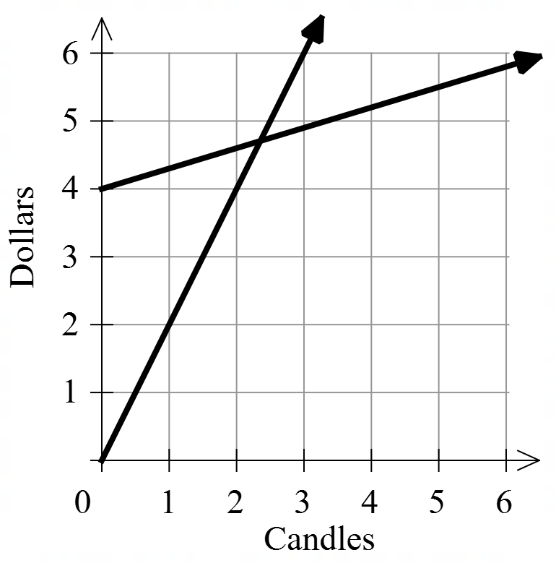
The exact point of intersection is $(2.4, 4.8)$.
Note: your answer may be different, as reading from a graph may not give exact results.

Appendix B – simultaneous equations – bar model
Bar model | Equations | Solution
 | $$2x=20$$  $$2x+4y=140$$ | $$x=10$$  $$y=30$$
 | $$2x=60$$  $$2x+4y=200$$ | $$x=30$$  $$y=35$$
 | $$x=30$$  $$2x+4y=100$$ | $$y=10$$
 | $$2y+2x=16$$  $$4y+2x=20$$ | $$y=2$$  $$x=6$$
 | $$2y+2x=16$$  $$2y+x=10$$ | $$x=6$$  $$y=2$$
 | $$2y+2x=12$$  $$2y+x=6$$ | $$x=6$$  $$y=0$$
 | $$2y+2x=12$$  $$2y+x=12$$ | $$x=0$$  $$y=6$$
 | $$2y+2x=12$$  $$y+x=12$$ | No solution  Parallel lines
 | $$4y+2x=100$$  $$y+x=40$$ | $$x=30$$  $$y=10$$
 | $$4y+2x=20$$  $$y+x=8$$ | $x=$6  $$y=2$$

Appendix C – elimination method
On a farm, there are chickens and cows. Altogether, there are 30 animals. If the total number of legs is 100, how many chickens and how many cows are there? | At a café, Emma orders 2 sandwiches and 1 smoothie and pays $17. Noah orders 1 sandwich and 2 smoothies and pays $16. What is the cost of one sandwich and one smoothie?
Let $x$ = number of chickens (2 legs) and $y$ = number of cows (4 legs).  $x+y=30$ (1)  $2x+4y=100$ (2)  $2×(1)$:  $$2x+2y=60(3)$$  $(2)-(3)$:  $$2y=40$$  $$y=20$$  Sub $y=20$ into $\left(1\right)$:  $$x+20=30$$  $$x=10$$  Solution: $x=10, y=20$  That is, 10 chickens and 20 cows. | Let $x=$ sandwich price and $y=$ smoothie price.  $2x+y=17$ (1)  $x+2y=16$ (2)  $2×(1)$:  $4x+2y=34$ (3)  $\left(3\right)-(2)$:  $$3x=18$$  $$x=6$$  Sub $x=6$ into (1):  $$2×6+y=17$$  $$y=5$$  $$∴x=6, y=5$$  That is, a sandwich is $6 and a smoothie is $5.

A car rental company charges a daily rate plus a per-kilometre fee. One customer rents a car for 3 days and drives 200 km, paying $230. Another rents for 2 days and drives 300 km, paying $240. What is the daily charge and the per-kilometre rate? | Jordan buys 3 paintbrushes and 2 sketchbooks for $28. Taylor buys 2 paintbrushes and 3 sketchbooks for $27. What is the cost of a paintbrush and a sketchbook?
Let $d=$ daily cost and $k=$ cost per kilometre.  $3d+200k=230$ (1)  $2d+300k=240$ (2)  $2×(1)$: $6d+400k=460$ (3)  $3×(2)$: $6d+900k=720$ (4)  $\left(4\right)-(3)$: $6d+900k-\left(6d+400k\right)=720-460$  $$500k=260$$  $$k=0.52$$  Sub $k=0.52$ into (1):$3d+200×0.52=230$  $$3d=126$$  $$d=42$$  $$∴d=42, k=0.52$$  That is, the rate is $42 per day and $\$0.52$ per km. | Let $p=$ the cost of a paintbrush and$s=$ the cost of a sketchbook.  $3p+2s=28$ (1)  $2p+3s=27$ (2)  $2×(1)$: $6p+4s=56$ (3)  $3×(2)$: $6p+9s=81$ (4)  $$\left(4\right)-\left(3\right)$$  $$5s=25$$  $s=5$  Sub $s=5$ into (1): $3p+2×5=28$  $$3p=18$$  $$p=6$$  $$∴s=5, p=6$$  That is, a paintbrush is $6 and a sketchbook is $5.

Appendix D – substitution method
Solve the following pairs of simultaneous equations using the substitution method.
The cost for 2 burgers and 3 drinks is $38. The cost for 1 burger and 1 drink is $16. How much does a burger and drink cost individually? | Julie is selling cupcakes at a school fete. The stand cost her $40 and each cupcake costs $0.50 to make. If she sells them for $4.50 each, how many does she need to sell to break even?
Let $b=$ the cost of the burger and $d=$ the cost of the drink.  $2b+3d=38$ (1)  $b+d=16$ (2)  $b=16-d$ (3)  Sub (3) into (1):  $$2\left(16-d\right)+3d=38 \\ 32-2d+3d=38 \\ d=6$$  Sub $d=6$ into (2): $b+6=16$  $$b=10$$  $$∴d=6, b=10$$  A burger is $10 and a drink is $6. | Let $d=$ the dollar value and $c=$ the number of cupcakes.  Cost: $d=40+0.5c$ (1)  Revenue: $d=4.5c$ (2)  Sub (2) into (1):  $$4.5c=40+0.5c \\ 4c=40 \\ c=10$$  Sub $c=10$ into (2):  $$d=4.5(10) \\ d=45$$  $$∴c=10, d=45$$  That is, the break-even point is 10 cupcakes, $45.

A large pizza costs $3 more than a small pizza. The total cost of 2 small pizzas and 1 large pizza is $27. What are the prices of a small and a large pizza? | At a festival, an adult and 2 child tickets costs $\$15$. The cost of 2 adult tickets and 3 child tickets is $35. What is the cost of 1 adult ticket and 1 child ticket?
Let $l=$ the price of a large pizza and $s=$ the price of a small pizza.  $l=s+3$ (1)  $2s+l=27$ (2)  Sub (1) into (2):  $$2s+s+3=27 \\ 3s+3=27 \\ 3s=24 \\ s=8$$  Sub $s=8$ into (1): $l=8+3$  $$l=11$$  $$∴s=8, l=11$$  i.e. a small pizza costs $8 and a large $11. | Let $a=$ the adult cost and $c=$ the child cost.  $a+2c=15$ (1)  $2a+3c=35$ (2)  $a=15-2c$ (3)  Sub (3) into (2):  $$2\left(15-2c\right)+3c=35 \\ 30-4c+3c=35 \\ c=5$$  Sub $c=5$ into (1): $a=2×5$  $$a=10$$  $$∴a=10, c=5$$  That is, an adult ticket costs $10 and a child ticket $5.

Appendix E – HSC-style question
Solution:
$5G+2E=29$ (1)
$3G+7E=29$ (2)
$3×(1)$: $15G+6E=87$ (3)
$5×(2)$: $15G+35E=145$ (4)
$(4)-(3)$: $29E=58$
$$E=2$$
Sub $F=2$ into (1): $5G+2\left(2\right)=29$
$$5G=25$$
$$G=5$$
$$∴E=2, G=5$$
Entering the scoring zone gives 2 points and scoring a goal gives 5 points.

References
This resource contains NSW Curriculum and syllabus content. The NSW Curriculum is developed by the NSW Education Standards Authority. This content is prepared by NESA for and on behalf of the Crown in right of the State of New South Wales. The material is protected by Crown copyright.
Please refer to the NESA Copyright Disclaimer for more information https://educationstandards.nsw.edu.au/wps/portal/nesa/mini-footer/copyright.
NESA holds the only official and up-to-date versions of the NSW Curriculum and syllabus documents. Please visit the NSW Education Standards Authority (NESA) website https://educationstandards.nsw.edu.au/ and the NSW Curriculum website https://curriculum.nsw.edu.au/.
Mathematics Advanced 11–12 Syllabus © NSW Education Standards Authority (NESA) for and on behalf of the Crown in right of the State of New South Wales, 2024.

© State of New South Wales (Department of Education), 2025
The copyright material published in this resource is subject to the Copyright Act 1968 (Cth) and is owned by the NSW Department of Education or, where indicated, by a party other than the NSW Department of Education (third-party material).
Copyright material available in this resource and owned by the NSW Department of Education is licensed under a Creative Commons Attribution 4.0 International (CC BY 4.0) license.

This license allows you to share and adapt the material for any purpose, even commercially.
Attribution should be given to © State of New South Wales (Department of Education), 2025.
Material in this resource not available under a Creative Commons license:
- the NSW Department of Education logo, other logos and trademark-protected material
- material owned by a third party that has been reproduced with permission. You will need to obtain permission from the third party to reuse its material.
Links to third-party material and websites
Please note that the provided (reading/viewing material/list/links/texts) are a suggestion only and implies no endorsement, by the New South Wales Department of Education, of any author, publisher, or book title. School principals and teachers are best placed to assess the suitability of resources that would complement the curriculum and reflect the needs and interests of their students.
If you use the links provided in this document to access a third-party's website, you acknowledge that the terms of use, including licence terms set out on the third-party's website apply to the use which may be made of the materials on that third-party website or where permitted by the Copyright Act 1968 (Cth). The department accepts no responsibility for content on third-party websites.

