Modelling linear functions
Students model linear functions with a particular focus on using cost and revenue contexts, building to solving simultaneous equations graphically and interpreting points of intersection in real-world scenarios.
Students will need at least one digital device per pair to interact with Desmos or GeoGebra during this lesson.
Learning intentions and success criteria should be shared with students later in the learning episode.

Learning intentions
- To be able to construct and model linear functions.
- To be able to solve practical problems with simultaneous equations graphically.

Success criteria
- I can identify the independent and dependent variables in a linear model.
- I can describe what the point of intersection of a graph represents in context.
- I can justify conclusions in the context of the problem.
- I can model situations where cost and revenue are represented linearly.
- I can model linear relationships digitally.

Outcomes
A student:
- develops understanding and fluency in mathematics through exploring and connecting mathematical concepts, choosing and applying mathematical techniques to solve problems, and communicating their thinking and reasoning coherently and clearly MAO-WM-01
- applies algebraic techniques and the laws of indices and surds to manipulate expressions and solve problems MAV-11-01
- uses functions and relations to model, analyse and solve problems MAV-11-02

Content

Constructing and using functions
- Construct and use linear functions to model and solve problems in real-world situations, identifying the independent and dependent variables and any restrictions on these variables, and justify conclusions in the context of problem
- Solve practical problems involving a pair of simultaneous linear equations both algebraically, graphically, with and without graphing applications, and justify conclusions in the context of the problem
- Construct and use simultaneous equations to model and solve a problem where cost and revenue are represented by linear equations, identify and analyse the break-even point, and justify conclusions in the context of the problem
Mathematics Advanced 11–12 Syllabus © NSW Education Standards Authority (NESA) for and on behalf of the Crown in right of the State of New South Wales, 2024.

Table 1: lesson summary
Section | Summary of activity | Teaching strategies | Teaching points
Activating prior knowledge | Students discuss which one doesn’t belong in the graphs on slides 3 and 4 of the PowerPoint Modelling linear functions. | Think-Pair-Share | Students activate prior knowledge of the point of intersection while consolidating their understanding of gradient and $y$-intercept.
Connecting learning | In visibly random groups of 3, students model a series of equations described by the teacher and graph them. As students are introduced to each model, they consider which variables are dependent and independent, and whether there will be restrictions on the domain and range of the linear function. | Visibly random groups of 3  Vertical non-permanent surfaces  Turn and talk | Students connect their prior knowledge of independent and dependent variables to an algebra context and consider how contexts, such as time in a linear model, will restrict the domain. Students start connecting the point of intersection to a practical meaning.
Releasing responsibility | A break-even analysis is detailed before worked examples are completed using slides 10–15. Students consolidate their understanding with a broader range of models using faded examples in Appendix A. Students verify their solutions digitally. | Worked examples (Your turn)  Faded examples | Students understand that the point of intersection is called the break-even point when comparing cost and revenue and develop mathematical awareness of profit and loss before extending that to other models.
Independent practice | Students complete HSC-style problems using slides 17–21 and digital devices to plot the graphs. | Think-Pair-Share | Students model linear equations involving the use of the point-gradient formula.

Activity structure
Please use the associated PowerPoint Modelling linear functions to display images in this lesson.

Activating prior knowledge
- Display slide 3 of the PowerPoint and, in a Think-Pair-Share (bit.ly/thinkpairsharestrategy), ask students to activate prior learning by choosing which one doesn’t belong (talkingmathwithkids.com/wodb-about).
Students may identify the following features that make each image not belong:
- Top left: $y$-intercept is not 2 or $-2$.
- Top right: $y$-intercept is negative.
- Bottom left: gradient is not a whole number.
- Bottom right: gradient is negative.
- Display slide 4, which adds a blue line to each existing graph and, in a Think-Pair-Share, ask students which one doesn’t belong now.
Students may identify the following features that make each image not belong:
- Top left: the point of intersection is outside of the frame.
- Top right: the lines are parallel.
- Bottom left: the lines are perpendicular.
- Bottom right: the point of intersection is at a point with whole numbers.

Students should be familiar with identifying the point of intersection from the Stage 4 Linear relationships outcome MA4-LIN-C-01 and the equation properties of parallel and perpendicular lines from the Stage 5 Linear relationships B Core outcome MA5-LIN-C-02. Students will be given further opportunities to consolidate their understanding of parallel and perpendicular lines in Unit 6 – differentiation techniques and applications.

Connecting learning
- Display slide 6 of the PowerPoint to introduce the learning intentions and success criteria for the lesson.
- Assign students to visibly random groups of 3 (bit.ly/visiblegroups) at vertical non-permanent surfaces (bit.ly/VNPSstrategy).
In their groups, students will be responding to a series of prompts designed to check for understanding of linear modelling.
- In a turn and talk (bit.ly/classroomtalkmoves), ask students to discuss what would be the dependent and independent variables in a scenario where the variables are hiring an e-scooter and time.
Students may identify that the passing of time is always an independent variable.
- Ask students to represent each of the following scenarios as an equation while you circulate to observe their responses. Prompts should be read aloud. Each new response should be written below the previous one.
- Community e-scooter hire costs $0.90 per minute, with a $1 unlocking fee. Kevin hires the e-scooter for 14 minutes and pays $13.60.
- Community e-scooter hire costs $0.90 per minute, with a $1 unlocking fee. Kevin hires the e-scooter for $t$ minutes and pays $13.60.
- Community e-scooter hire costs $0.90 per minute, with a $1 unlocking fee. Kevin hires the e-scooter for $t$ minutes and pays $$P$.
- Students should write the first equation as $14×0.9+1=13.60.$
- The second equation should be written as $0.9t+1=13.60.$
- The final equation could be written as $P=0.9t+1$.
- Reveal slide 7 which displays 3 related scenarios, and prompt groups to critically reflect on how the changes in each statement influenced their mathematical response.
The purpose of reading the prompts aloud before showing all 3 statements is to focus students’ attention on each statement, leading to a comparison of the differences between each line.
- Ask groups to consider what limitations must be applied to the domain and range of the variables given the context of the model. Nominate students to present insights from their group discussions to the class.
Inform the class that time cannot be negative if their discussions have not raised this, so the domain must be restricted to $t≥0$ and the resulting impact on the variable $P$ is $P≥1$.
- Instruct students to sketch the e-scooter hire equation on their vertical non-permanent surface.
To enable accuracy, students should be provided with a Cartesian plane (bit.ly/Grid_Paper_mathlinks) in a plastic sleeve with adhesive putty.
- Read the following prompt aloud and ask students to develop an equation that represents the scenario and determine what would be the appropriate domain and range.
The same e-scooter company offers a special deal where you can get up to 90 minutes of riding for $19 with no unlocking fee.
The equation of the line should be$P=19$ with the domain limited to $0≤t≤90$.
- Instruct students to graph the equation on the same axes as the previous equation.
- Estimate the point of intersection for the 2 lines.
The point of intersection would be $(20, 19)$. This can be displayed digitally using the Desmos Graphing Calculator ‘Scooter price comparison’ (bit.ly/DesmosScooter).
- Lead a discussion with the students about what this point of intersection means in the context of the problem.
Students may identify that if a person is planning to ride an e-scooter for more than 20 minutes, they should buy the special deal.
- Ask students to erase their previous solutions and write an equation for the following scenario.
A local band sells T-shirts for $75 each. Stuart sells $Q$ T-shirts and earns $\$R$.
- Ask students to discuss which variable is independent and identify any restrictions on the domain based on the context.
- Instruct students to suitably scale their Cartesian plane and sketch the relationship between the number of T-shirts sold and earnings.
- While keeping the previous work on the vertical non-permanent surface, ask students to write an equation for the following scenario.
To make T-shirts, there is a fixed cost of $300 as well as a variable cost of $50 per T-shirt. For Bob to make $Q$ T-shirts, it will cost him $\$C$.
- Ask students to identify the independent variable and discuss any domain restriction based on the context.
- Instruct students to sketch the cost relationship on the same Cartesian plane as the previous equation.
- In their groups of 3, have students discuss the following question prompts. Then nominate a few groups to share their responses with the class:
- Where is the point of intersection between these 2 lines?
- What could that point of intersection mean?
The point of intersection occurs at $(12, 900)$, which would be the break-even point in this context.

Releasing responsibility
- Have students return to their workstations and view slide 9 of the PowerPoint, which shows a pair of simultaneous linear equations modelling cost and revenue.
- Click to animate the self-explanation prompts on the slide, then use a Think-Pair-Share to guide student discussion of each prompt.
- Use slides 10–15 to present worked examples of constructing linear cost and revenue models following the Worked examples (Your turn) method (bit.ly/supportingstrategies).
The worked example question is scaffolded with 3 parts, labelled a, b and c. Animate the slides to highlight key information, the self-explanation prompts and worked solutions.
- Distribute Appendix A ‘Faded examples’ and ask each student to complete the faded examples (bit.ly/fadedexamplesstrategy).
This is an example of forward faded examples where students are required to find the first steps. Questions 1, 4 and 5 of the faded examples are provided in the context of income and cost.
- If required, give students the opportunity to obtain further experience developing equations from a linear model using an existing resource.
- Instruct students to verify their solutions digitally by modelling their functions using an online graphics calculator such as the Desmos Graphing Calculator (desmos.com/calculator) or GeoGebra Graphing Calculator (geogebra.org/graphing).

Independent practice
- Display slide 17 of the PowerPoint to revisit the ‘Approaching questions scaffold’ with students.
The ‘Approaching questions scaffold’ offers students a 4-step framework to work through questions. Each step is accompanied by an icon that corresponds to different aspects of the solution process.
- Show the HSC-style problem from slide 18. Use a Think-Pair-Share to prompt a discussion on the possible mark allocation for each part of the question.
- Instruct pairs to attempt the question.
- Circulate the room to monitor understanding as students develop linear models and use their digital devices to solve pairs of simultaneous equations graphically.
- Once most pairs have attempted the task, display slide 19, which includes animated self-explanation prompts alongside the solution.
- Conduct a Think-Pair-Share using the self-explanation prompts before a class discussion about the strategies used for each step of the approaching questions scaffold.
- In their pairs, have students work through Problem 2 on slide 20. The solution is provided on slide 21.

Assessment and differentiation

Suggested opportunities for differentiation
Activating prior knowledge
- Students may benefit from first reviewing how to identify the gradient and $y$-intercept from a graph of a linear equation to engage fully in the ‘Which one doesn’t belong?’ activity.
- The graphs could be modified to bring attention to other characteristics, such as including vertical and/or horizontal lines.
- Students could be challenged to identify multiple reasons why images do not belong or to write the equation of each line based on the information provided.
Connecting learning
- The pace of the activity could be adjusted to include more modelled examples for students. Alternatively, the T-shirt scenarios could be scaffolded in a similar manner to the e-scooter scenarios to help connect student understanding.
- The context of the examples could be adjusted to include items of interest for students.
- Digital graphing applications such as the Desmos Graphing Calculator (desmos.com/calculator) or GeoGebra Graphing Calculator (geogebra.org/graphing) could be used throughout the lesson to help students visualise graphs.
Releasing responsibility
- Both worked examples and faded examples could be adjusted to meet students’ needs.
- If students have not yet covered functions in your scope and sequence, the function notation should be switched to $C=$ and $I=$ in the slides.
- Self-explanation prompts in the worked examples could be modified to draw attention to different aspects of the question, such as the language, or how to draw the graph.
- Appendix A could be modified to include models with differing levels of complexity.
- Students unfamiliar with online graphical applications may need additional demonstration on how to display linear equations and to modify what parts of the axis are displayed.
Independent practice
- Questions could be modified to meet the needs of students.
- Groups could be temporarily combined to justify their responses when misconceptions occur.

Suggested opportunities for assessment
Activating prior knowledge
- Monitor responses in class discussions to check for student understanding of gradient, $y$-intercept, point of intersection, parallel lines and perpendicular lines.
- Students will demonstrate their Working mathematically skills in discussions and justifications of why particular images do not belong.
Connecting learning
- Students working on vertical non-permanent surfaces enables high visibility for assessing progress and provide support where appropriate.
- Monitor responses in class discussions to check for student understanding of dependent and independent variables, as well as restrictions on the domain.
Releasing responsibility
- A Think-Pair-Share provides students with the opportunity to reflect on their understanding of break-even analysis.
- Work samples from Appendix A could be collected to check for understanding of modelling linear equations.
- Students can self-assess their linear equations by comparing their graphs to the digital representation.
Independent practice
- Students have opportunities to contribute to and hear from pair and class discussions, which act as opportunities for self- and peer-reflection.
- Self-explanation prompts assist in facilitating class discussions and observing of students’ reasoning and justification in responses.

Appendix A

Faded examples
Question 1 | Question 2 | Question 3
Mark designs and sells custom sneakers online for $150. His website has a set-up cost of $300, and each sneaker costs $120 to make. How many sneakers need to be sold to break even?  Step 1: write the equations  $$C\left(x\right)= 300+120x$$  $$R\left(x\right)=150x$$  Step 2: graph the solution  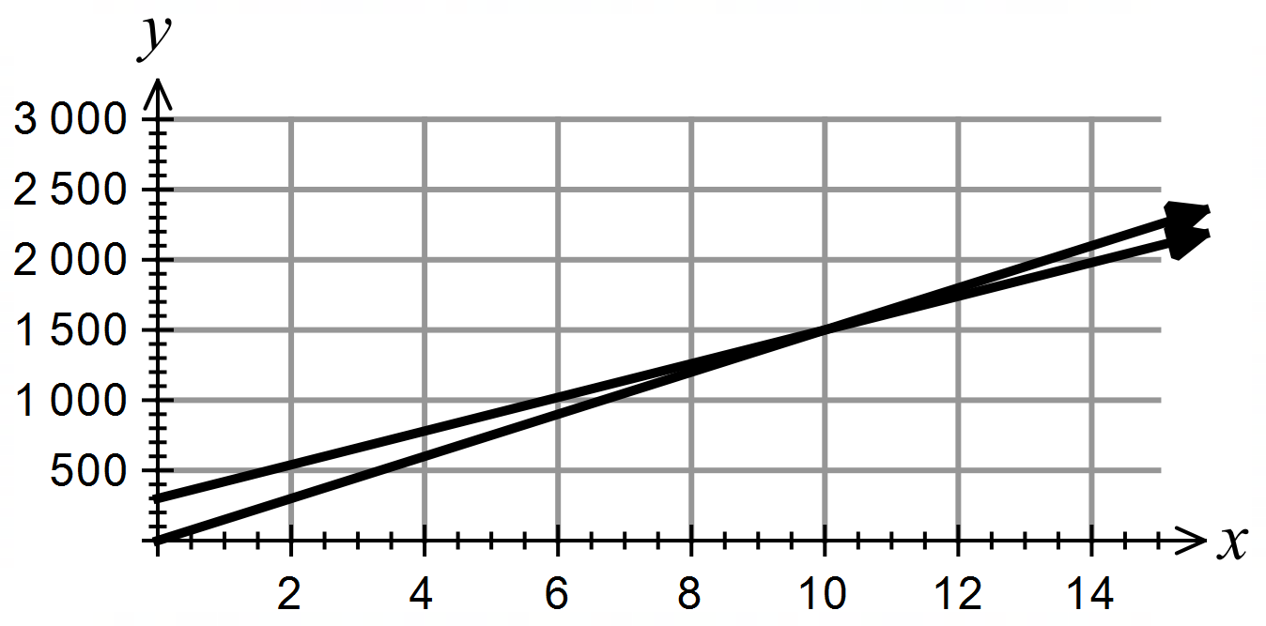  Step 3: determine the point of intersection  $$(10, 1500)$$  Step 4: put your answer in context  Mark will need to sell 10 sneakers. | A theatre is hired for $1200 for an amateur performance. Tickets are sold for $25 each. How many tickets need to be sold to break even?  Step 1: write the equations  $$C\left(x\right)=$$  $$R\left(x\right)=$$  Step 2: graph the solution  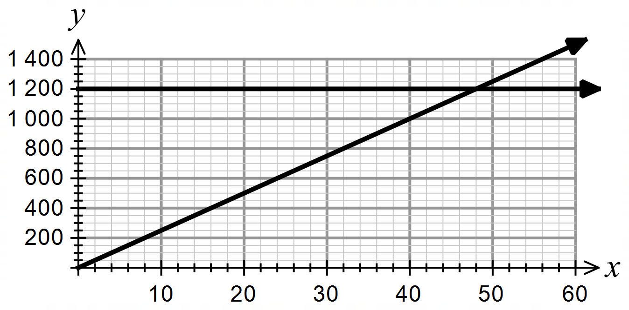  Step 3: determine the point of intersection  $$(48,1200)$$  Step 4: put your answer in context  They need to sell 48 tickets to break even. | It costs $3 to 3D print a phone case, and the printer costs $210. Each case is sold for $10. How many cases need to be sold to break even?  Step 1: write the equations  Step 2: graph the equation  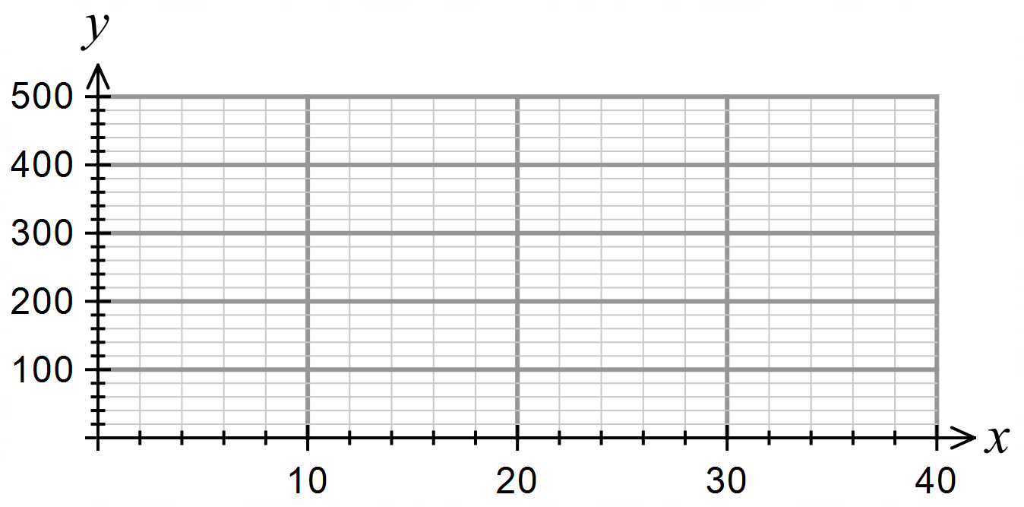  Step 3: determine the point of intersection  $$(30,300)$$  Step 4: put your answer in context  30 cases need to be sold.

Question 4 | Question 5
A square has a side length of $2x$ cm and a rectangle has a length of  $x + 5$ cm and a width of $x - 1$ cm. For what value of $x$ will the perimeter be the same for each?  Step 1: write the equations  Step 2: graph the solution  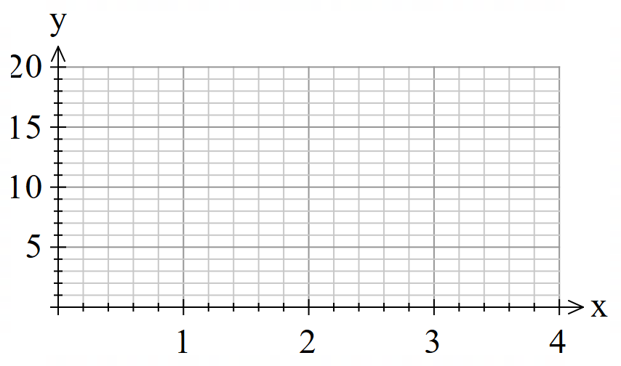  Step 3: determine the point of intersection  Step 4: put your answer in context | Carl walks at 5 km/h and starts 10 km from Jerry’s starting point. Jerry cycles at 17.5 km/h and travels along the same path as Carl. When will Jerry catch up to Carl?  Step 1: write the equations  Step 2: graph the solution  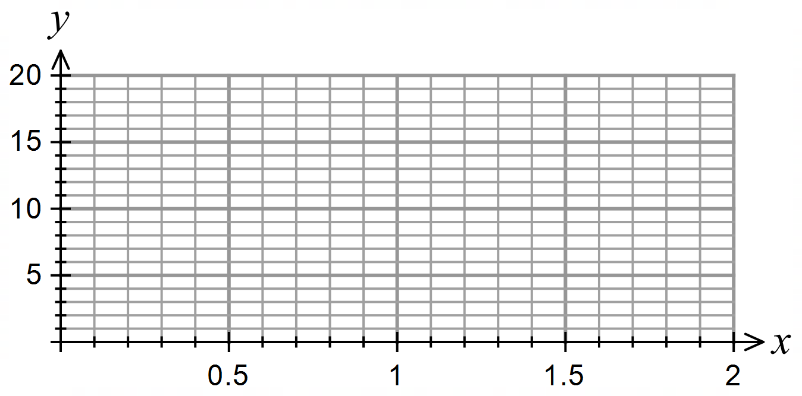  Step 3: determine the point of intersection  Step 4: put your answer in context

Sample solutions

Appendix A – faded examples
Question 1 | Question 2 | Question 3
Mark designs and sells custom sneakers online for $150. His website has a set-up cost of $300, and each sneaker costs $120 to make. How many sneakers need to be sold on break even?  Step 1: write the equation  $$C\left(x\right)= 300+120x$$  $$R\left(x\right)=150x$$  Step 2: graph the solution  Step 3: determine the point of intersection  $$(10,1500)$$  Step 4: put your answer in context  Mark will need to sell 10 sneakers. | A theatre is hired for $1200 for an amateur performance. Tickets are sold for $25 each. How many tickets need to be sold to break even?  Step 1: write the equation  $$C\left(x\right)=1200 \\ R\left(x\right)=25x$$  Step 2: graph the solution  Step 3: determine the point of intersection  $$(48,1200)$$  Step 4: put your answer in context  They need to sell 48 tickets to break even. | It costs $3 to 3D print a phone case, and the printer costs $210. Each case is sold for $10. How many cases need to be sold to break even?  Step 1: write the equation  $$C\left(x\right)=210+3x \\ R\left(x\right)=10x$$  Step 2: graph the equation  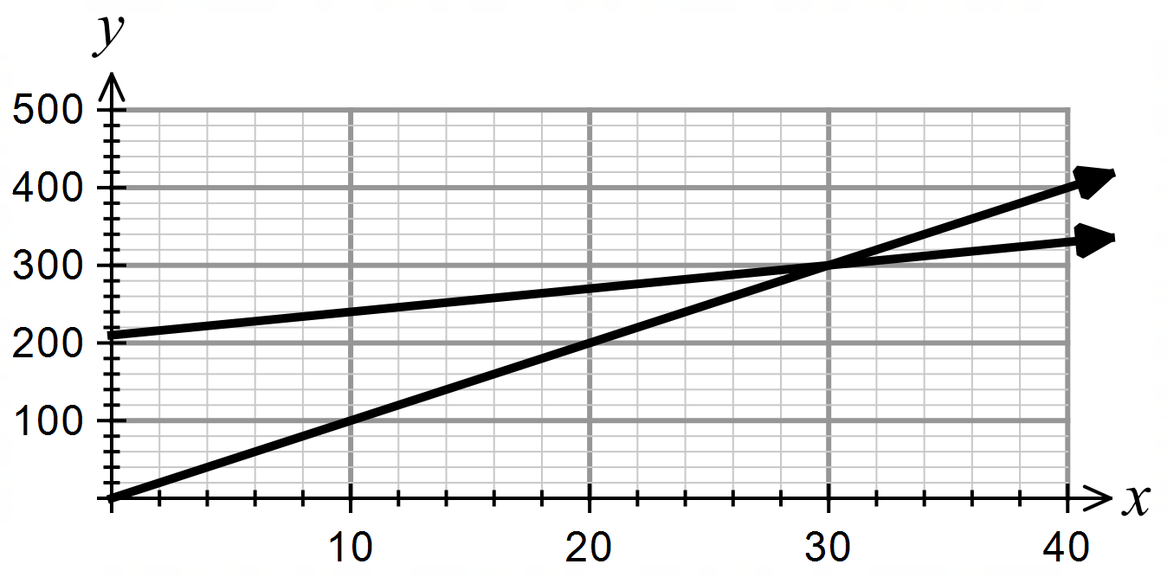  Step 3: determine the point of intersection  $$(30,300)$$  Step 4: put your answer in context  30 cases need to be sold.

Question 4 | Question 5
A square has a side length of $2x$ cm and a rectangle has a length of  $x + 5$ cm and a width of $x - 1$ cm. For what value of $x$ will the perimeter be the same for each?  Step 1: write the equation  $$S\left(x\right)=8x$$  $$R\left(x\right)=4x+8$$  Step 2: graph the solution  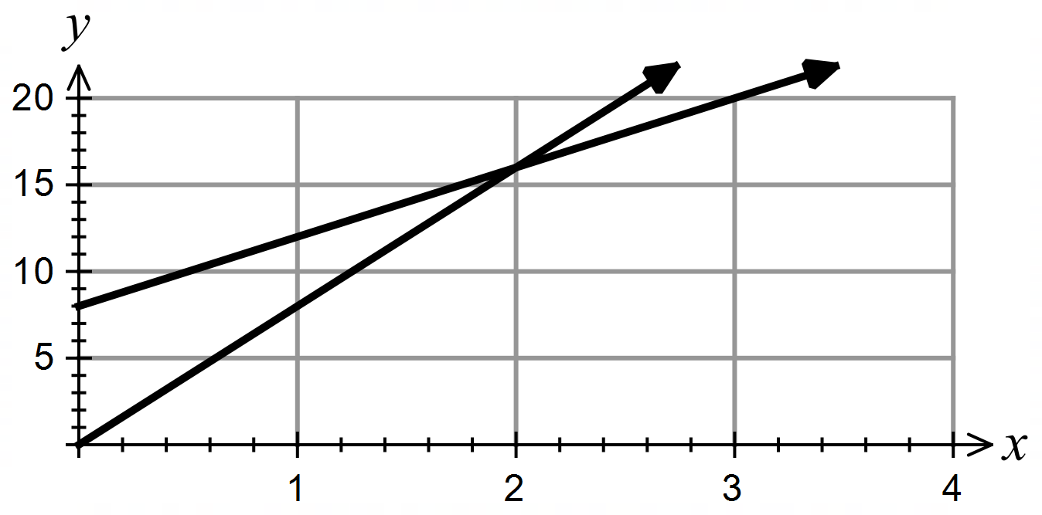  Step 3: determine the point of intersection  $$(2,16)$$  Step 4: put your answer in context  The perimeter will be the same when $x = 2$. | Carl walks at 5 km/h and starts 10 km from Jerry’s starting point. Jerry cycles at 17.5 km/h and travels along the same path as Carl. When will Jerry catch up to Carl?  Step 1: write the equation  $$C\left(x\right)=10+5x$$  $$J\left(x\right)=17.5x$$  Step 2: graph the solution  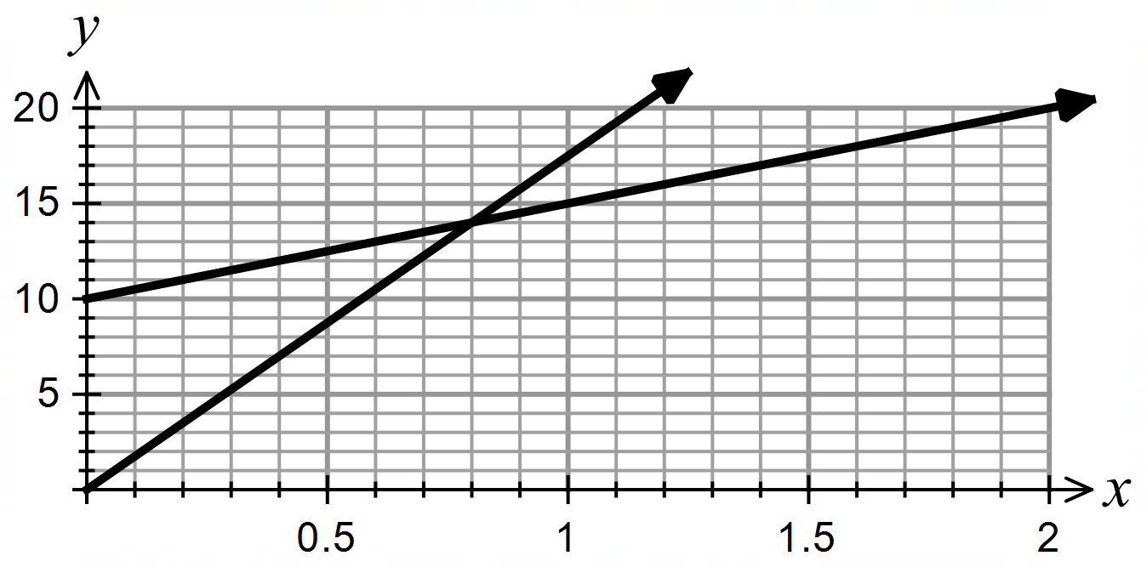  Step 3: determine the point of intersection  $$\left(\frac{4}{5},14\right)$$  Step 4: put your answer in context  Jerry will catch up after 48 minutes.

References
This resource contains NSW Curriculum and syllabus content. The NSW Curriculum is developed by the NSW Education Standards Authority. This content is prepared by NESA for and on behalf of the Crown in right of the State of New South Wales. The material is protected by Crown copyright.
Please refer to the NESA Copyright Disclaimer for more information https://educationstandards.nsw.edu.au/wps/portal/nesa/mini-footer/copyright.
NESA holds the only official and up-to-date versions of the NSW Curriculum and syllabus documents. Please visit the NSW Education Standards Authority (NESA) website https://educationstandards.nsw.edu.au/ and the NSW Curriculum website https://curriculum.nsw.edu.au/.
Mathematics Advanced 11–12 Syllabus © NSW Education Standards Authority (NESA) for and on behalf of the Crown in right of the State of New South Wales, 2024.

© State of New South Wales (Department of Education), 2025
The copyright material published in this resource is subject to the Copyright Act 1968 (Cth) and is owned by the NSW Department of Education or, where indicated, by a party other than the NSW Department of Education (third-party material).
Copyright material available in this resource and owned by the NSW Department of Education is licensed under a Creative Commons Attribution 4.0 International (CC BY 4.0) license.

This license allows you to share and adapt the material for any purpose, even commercially.
Attribution should be given to © State of New South Wales (Department of Education), 2025.
Material in this resource not available under a Creative Commons license:
- the NSW Department of Education logo, other logos and trademark-protected material
- material owned by a third party that has been reproduced with permission. You will need to obtain permission from the third party to reuse its material.
Links to third-party material and websites
Please note that the provided (reading/viewing material/list/links/texts) are a suggestion only and implies no endorsement, by the New South Wales Department of Education, of any author, publisher, or book title. School principals and teachers are best placed to assess the suitability of resources that would complement the curriculum and reflect the needs and interests of their students.
If you use the links provided in this document to access a third-party's website, you acknowledge that the terms of use, including licence terms set out on the third-party's website apply to the use which may be made of the materials on that third-party website or where permitted by the Copyright Act 1968 (Cth). The department accepts no responsibility for content on third-party websites.

