Linear functions
Students will strengthen their understanding of linear functions by determining equations from given points and examining the various forms in which linear equations can be expressed.

Learning intention
- To be able to determine the equation of a straight line.

Success criteria
- I can calculate the gradient from 2 points.
- I can determine the equation of the line from 2 points in gradient-intercept form.
- I can determine the equation of the line from 2 points in general form.
- I can determine the intercepts of a straight line from its equation.
- I can determine the equation of a line using the point-gradient formula.

Outcomes
A student:
- develops understanding and fluency in mathematics through exploring and connecting mathematical concepts, choosing and applying mathematical techniques to solve problems, and communicating their thinking and reasoning coherently and clearly MAO-WM-01
- applies algebraic techniques and the laws of indices and surds to manipulate expressions and solve problems MAV-11-01
- uses functions and relations to model, analyse and solve problems MAV-11-02

Content

Linear functions
- Determine the equations of straight lines in gradient-intercept form $y=mx+c$ with gradient $m$ and $y$-intercept $c$
- Determine the equations of straight lines in general form $ax+by+c=0$, where $a$,$b$ and $c$ are constants
- Determine the $x$-intercept and $y$-intercept of a straight line given its equation
- Choose and apply appropriate techniques to graph a straight line given its equation
- Determine the equation of a straight line passing through a point $(x_{1},y_{1})$ with gradient $m$ using the point-gradient formula $y-y_{1}=m(x-x_{1})$
- Determine the equation of a straight line passing through 2 points $(x_{1},y_{1})$and $(x_{2},y_{2})$ by calculating its gradient $m$ using the formula $m=\frac{y_{2}-y_{1}}{x_{2}-x_{1}}$
Mathematics Advanced 11–12 Syllabus © NSW Education Standards Authority (NESA) for and on behalf of the Crown in right of the State of New South Wales, 2024.

Table 1: lesson summary
Section | Summary of activity | Teaching strategies | Teaching points
Activating prior knowledge | Students complete the goal-free problem in Appendix A and discuss their prior knowledge from Stage 5. | Goal-free problem  Turn and talk  Pose-Pause-Pounce-Bounce | The purpose of this activity is to establish the baseline level of knowledge from Stage 5.
Connecting learning | Students compare graphical methods to algebraic methods to find the equation of a line using Appendix B and self-explanation prompts on slides 4–5 of the PowerPoint Linear functions. This is followed by opportunities to explicitly teach concepts also covered in Stage 5 Path content, such as the point-gradient formula using slides 6–10. Students are to practise finding the equation using the point-gradient formula from an existing resource, prior to writing notes on this formula. Students practise finding intercepts from the linear equations developed using slide 11 as motivation to introduce the general form. Define ‘general form’ using slide 12. | Worked examples (comparison)  Worked examples (Your turn)  Think-Pair-Share  Incorrect examples  Variation Theory  Notes to future forgetful selves | Make the connection between using the graph to find the gradient and the point-gradient formula to build fluency.  To establish the general form of a linear equation.
Releasing responsibility | Students complete notes to their future forgetful selves before completing the faded examples in Appendix C and graphing the results. Opportunity is also provided to supplement learning with an existing resource. | Notes to future forgetful selves  Graphic organiser  Faded examples  Pose-Pause-Pounce-Bounce | Clearly define the general form of a linear equation and use it to find intercepts.
Independent practice | Students complete the Open Middle prompt from slide 14 of the PowerPoint. Once students are given sufficient time to provide solutions, they develop additional restrictions to the problem to challenge their peers. | Vertical non-permanent surfaces  Random groups of 3  Gallery walk | To build flexible thinking to show multiple strategies to find linear equations.

Activity structure
Please use the associated PowerPoint Linear functions to display images in this lesson.

Activating prior knowledge
- Distribute Appendix A ‘Goal-free problem’ (bit.ly/goalfreeproblems) and allow students approximately 5 minutes to individually annotate the graph with all the information they can identify.
- Have students compare responses through a turn and talk (bit.ly/classroomtalkmoves).
The purpose of this activity is to assess students’ understanding of Stage 5 content and determine the degree of support and explicit teaching required in this lesson.
The graphs were selected so that the red line’s equation can be determined using techniques from Stage 5 Linear relationships A Core outcome MA5-LIN-C-01, while finding the equation of the blue line requires the skills from Stage 5 Linear relationships C Path outcome MA5-LIN-P-01. The point of intersection can be identified by inspection, as introduced in Stage 4 Linear relationships outcome MA4-LIN-C-01.
The blue line has an equation of $y=-\frac{1}{5}x+\frac{7}{5}$ and the red line has an equation of $y=\frac{2}{3}x+4$. The lines intersect at $\left(-3, 2\right)$.
- Use the Pose-Pause-Pounce-Bounce questioning strategy (PDF 557 KB) (bit.ly/posepausepouncebounce) to check students’ understanding of their prior knowledge of the mathematical concepts underpinning the graphs. Some suggested prompts include:
- What information could you read directly from the graphs?
- How did you use the information on the graph to find out other information, such as the equation of the line?
- Why is the point of intersection important and how could you check its coordinates?
If misconceptions are evident, an existing resource may need to be used to remediate understanding of Stage 5 Core content, such as intercepts and gradients.

Connecting learning
- Distribute Appendix B ‘Comparative worked example – linear functions’ and explain to students that they will now be examining how to find an equation of a line when given 2 points.
- Use Appendix B and slides 4–5 from the PowerPoint to model finding the equation of a line from 2 given points using the Worked examples (comparison) method (not yet published).
- Initiate a class discussion to unpack the 2 methods used. Possible questions include:
- How did the location of the given coordinates affect finding the equation of the line?
- Is there another algebraic method that could be used?
Students who have studied the Stage 5 Linear relationships C Path outcome MA5-LIN-P-01 may be familiar with using the point-gradient formula, $y-y_{1}=m(x-x_{1})$, to find the equation of a line that passes through 2 given points. Adapt steps 4–7 to reflect your context.

Point-gradient formula
- Display slide 6 for explicit teaching of the gradient and point-gradient formulas.
- Slides 7–8 apply the Worked examples (Your turn) method to model the point-gradient formula (bit.ly/supportingstrategies).
These slides have been adapted from Lesson 11 – it’s getting hot in here of Stage 5 Unit 6 – constant rates of change, which addresses these concepts (bit.ly/departmentresources).
- Use slides 9–10 to consolidate students' understanding of the point-gradient formula by having students, in a Think-Pair-Share (bit.ly/thinkpairsharestrategy), identify and explain errors in the incorrect examples (bit.ly/incorrec2rkedexamples).
Students should discuss the error and then, in their pairs, write out the correct solution.
Slide 9 shows an error by substituting in $8$ for $y_{1}$ instead of $-8$. Slide 10 has an error in the expansion of the gradient value in the point-gradient formula. Self-explanation prompts are animated on the slides to guide students in discussing these errors.
- Use an existing resource to consolidate student understanding of the point-gradient formula.
- Students are to create notes to their future forgetful selves (bit.ly/notestofutureself) on calculating the gradient algebraically and using the point-gradient formula to find the equation of a straight line.

$x$- and $y$-intercepts
- If required, distribute graph paper to each pair of students in a plastic sleeve.
Graph paper can be found on the website (print-graph-paper.com).
- Display slide 11 of the PowerPoint, which shows 5 pairs of coordinates. Ask students to plot each pair on their graph paper and draw a straight line connecting the coordinates.
- Ask students to estimate the $x$- and $y$-intercepts of each of the 5 straight lines from slide 11 using the graph.
Students who have studied Stage 5 Linear relationships C Path outcome MA5-LIN-P-01 may elect to determine the equation of the line to find the $x$- and $y$-intercepts. If this is the case, steps 11–14 in this sequence may need to be adapted.
- Facilitate a class discussion on which equations had more challenging intercepts to identify and why. Some suggested prompts include:
- Which intercepts were easiest to read from the graph and which were hardest? What made some more difficult than others?
- How could knowing the equation of a line help you determine the $x$- and $y$-intercepts more accurately than just using the graph?
The pairs of coordinates follow Variation Theory (variationtheory.com/introduction), so students may share that the first straight line had intercepts that were easy to identify, and they may have used this to find the $x$- and $y$-intercepts.
Students also learned how to use function notation to find the $x$- and $y$-intercepts from a linear function in Lesson 2 – function values and intercepts of Unit 2 – introduction to functions. They may use this approach to first find the function to assist with finding the intercepts. If students have transferred these skills to this lesson, steps 12–14 should be adapted to match your context.
- Animate slide 11 to show the equation of each of the pairs of straight lines. Draw attention to the fact that each equation is written in a slightly different way. Initiate a class discussion to ask students how they know each of these is a linear equation.
Students developed their initial understanding of linear equations and functions in Lesson 2 – function values and intercepts of Unit 2 – introduction to functions. In this lesson, they addressed the key features of a linear graph, including being a straight line, and labelling the intercepts.
- Bring students’ attention back to their graph paper and ask them to identify the key features of a linear equation. Prompt them to notice that for an $x$-intercept, $y=0$, and for a $y$- intercept, $x=0$, and discuss how this can be used to find the intercepts directly from the equations.
Conclude with students that to find $x$- and $y$-intercepts from the equation we substitute in $x=0$ to find the $y$-intercept and $y=0$ to find the $x$-intercept.
- Allow students time in their pairs to recalculate their $x$- and $y$-intercepts from the given equations and to compare these values with their initial estimates from the graphs.
- Initiate a class discussion for students to share which equations were easier or more difficult to use for calculating the $x$- and $y$-intercepts and ask students to explain why.

Students may note that equations in gradient-intercept form, $y=mx+c$, made it easiest to find the $y$-intercept. However, for equations 3 and 5, it was easier to find the $x$-intercept, as these required less rearranging of the equation, while the $y$-intercept was also straightforward to determine in this form.
- Use slide 12 to introduce the general form of a linear equation, highlighting how this form can make finding intercepts simpler because all the constants are integers and the leading term is positive.
The NESA syllabus glossary defines the general form (of a straight line) as ‘A straight line in general form is given as $ax+by+c=0$, where $a$, $b$ and $c$ are constants.’ (NESA 2024)
Students may have prior experience with general form from the Stage 5 Linear relationships C Path outcome MA5-LIN-P-01.

Releasing responsibility
- Students are to create notes to their future forgetful selves on writing an equation in general form. As part of the note making process, students should create a T-chart (bit.ly/DLSgraphicorganisers) comparing examples and non-examples of the general form.
- Distribute Appendix C ‘Faded examples’, which uses faded worked examples (bit.ly/fadedexamplesstrategy) to find the general form from any 2 given points. Before attempting the activity, ask students to silently read through the fully worked solution on the left. After students have read the example, use the Pose-Pause-Pounce-Bounce question strategy to unpack the solution. Suggested question prompts could include:
- Would it make a difference if we used $(-2, -6)$ in the point-gradient formula?
- How else could the equation be rearranged?
- Students then complete the faded worked examples (bit.ly/fadedexamplesstrategy) in Appendix C, which gradually release responsibility and model communicating mathematically.
- If required, distribute graph paper to each student and, using the information from their completed Appendix C, have them graph each straight line using the $x$- and $y$-intercepts.
- Students may benefit from completing practice questions from an existing resource to consolidate their understanding of determining equations and intercepts of equations, as well as graphing straight lines.

Independent practice
- Assign students to visibly random groups of 3 (bit.ly/visiblegroups) working at vertical non-permanent surfaces (bit.ly/VNPSstrategy).
- Display slide 14 showing the following Open Middle style prompt.
Direction: Using the digits $-9$ to $9$ at most one time each, place a digit in each box so that the linear equation, in general form, passes through the 2 points.
Point 1: $(, )$ Point 2: $(, )$
Equation: $x+y+ =0$
- Run a gallery walk (bit.ly/DLSgallerywalk), with students noting frequently used digits and common approaches.
- Facilitate a brief class discussion to highlight patterns and strategies.
These discussions will vary from class to class; however, one possible expectation would be groups identifying one of the points as an intercept to make calculations simpler.
- In groups, create a new condition for the problem and find a solution that meets it.
Possible conditions could be that the 2 points are in different quadrants, or the line must have a negative slope.
- Have groups attempt other groups’ conditions, adding solutions where possible.
- Conclude with a class discussion where groups share challenges, successful strategies and any interesting solution sets.

Assessment and differentiation

Suggested opportunities for differentiation
Activating prior knowledge
- Goal-free problems have a low floor and high ceiling, giving multiple entry points to access the task.
- The graph in Appendix A could be adapted to be simpler, with both lines being able to be calculated from techniques covered by Core outcomes, or made more challenging, by having both equations requiring the point-gradient formula if students are familiar with Stage 5 Path content.
- The Pose-Pause-Pounce-Bounce question prompts could be modified to target deeper reasoning using the Wiederhold question matrix.
Connecting learning
- The pacing and level of challenge of this activity must be adapted to reflect student understanding from Stage 5.
- Rather than using the animation to reveal the equations on slide 11, students could calculate the equations using the point-gradient formula and use the animation as a self-check.
Releasing responsibility
- Students could be given a set of examples to sort into the T-chart.
- The faded examples could be adapted to include coordinates with fractions.
- Existing resources should be selected at the students’ point of need.
Independent practice
- Additional restrictions can be applied to reduce the number of solutions and increase the challenge.
- Some students may benefit from being prompted to use an intercept.
- Students could be challenged to explain why certain solutions are not possible.

Suggested opportunities for assessment
Activating prior knowledge
- Monitor responses in class discussions to check for student understanding of linear functions from Stage 5.
Connecting learning
- Class discussions could be facilitated about the connections between the graph and the equations and observe students’ reasoning and justification in response to the provided prompts.
- Students could show their examples of graphing from 2 points as evidence of learning.
Releasing responsibility
- Students’ notes, faded examples or working from an existing resource could be collected as evidence of learning.
Independent practice
- When placed in groups of 3, students provide and receive peer feedback on their understanding.
- Students working on vertical non-permanent surfaces means the teacher can assess student progress and provide support where appropriate.

Appendix A

Goal-free problem
Annotate the graph below with all the information you can.
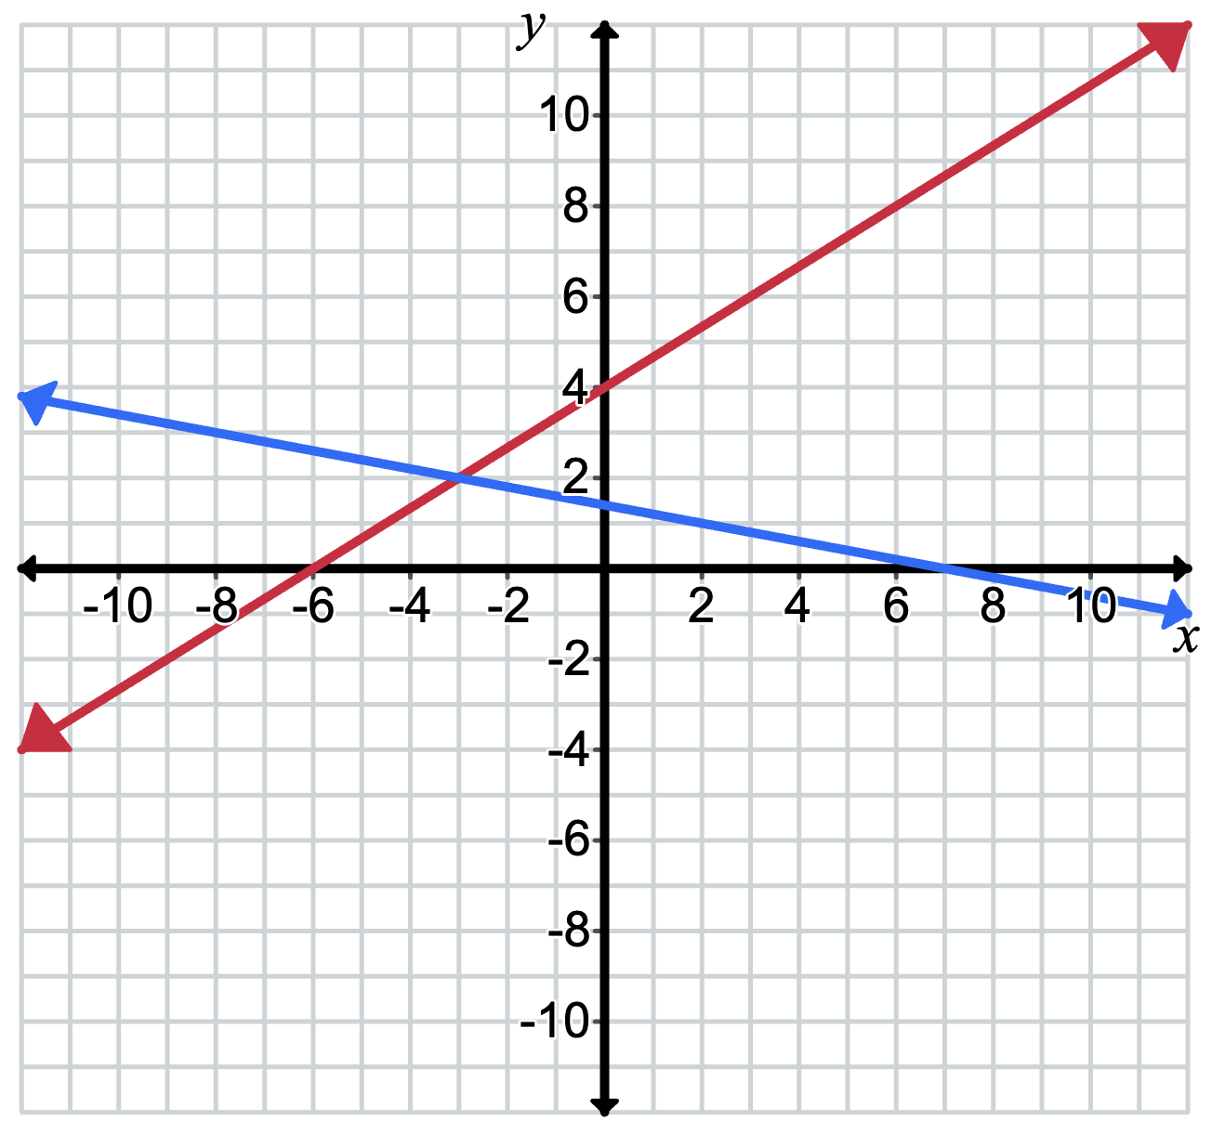

Appendix B

Comparative worked example – linear functions
Find the equation of the line passing through (1, 3) and (3, 7).
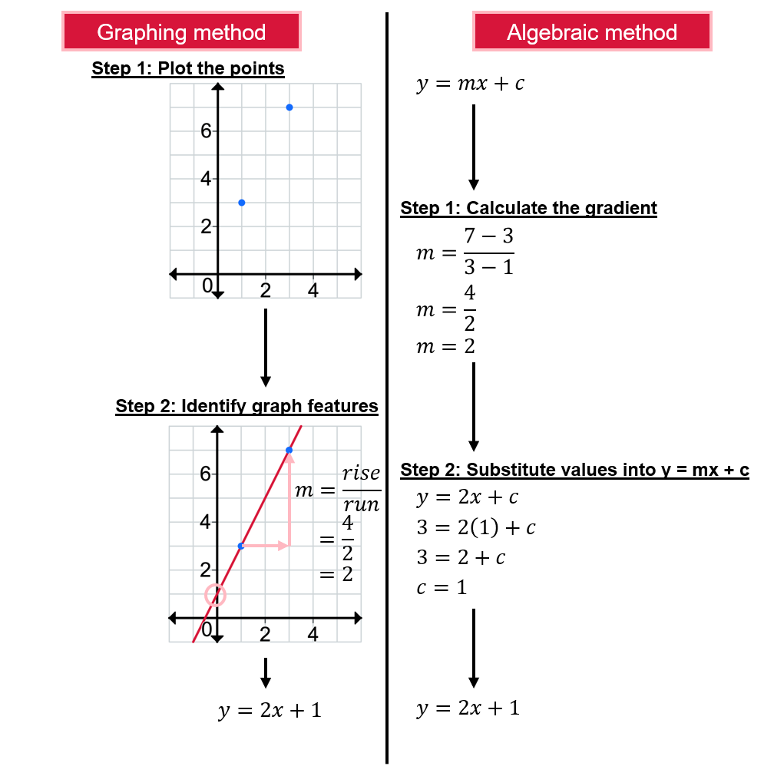
Why are the 2 answers the same?

Appendix C

Faded examples
Find the equation of the line, in general form, passing through (5,4) and (−2, −6) | Find the equation of the line, in general form, passing through (4,3) and (8, −7) | Find the equation of the line, in general form, passing through (2,5) and (6, −1) | Find the equation of the line, in general form, passing through (−2,5) and (4,1) | Find the equation of the line, in general form, passing through (1, −4) and (−3, −15)
$$m=\frac{y_{2}-y_{1}}{x_{2}-x_{1}} \\ =\frac{4-(-6)}{5-(-2)} \\ =\frac{10}{7}$$  $$y-y_{1}=m\left(x-x_{1}\right)$$  $$y-4=\frac{10}{7}(x-5)$$  $$7y-28=10x-50$$  $$10x-7y-22=0$$ | $$m=\frac{y_{2}-y_{1}}{x_{2}-x_{1}} \\ =\frac{3-\left(-7\right)}{4-8} \\ =\frac{10}{-4} \\ =-\frac{5}{2}$$  $$y-y_{1}=m\left(x-x_{1}\right)$$  $$y-3=-\frac{5}{2}(x-4)$$ | $$m=\frac{y_{2}-y_{1}}{x_{2}-x_{1}} \\ =\frac{5-\left(-1\right)}{2-6} \\ =\frac{6}{-4} \\ =-\frac{3}{2}$$ | $$m=\frac{y_{2}-y_{1}}{x_{2}-x_{1}} \\ =\frac{5-1}{-2-4}$$
Identify the $x$- and $y$-intercepts for each equation.

Sample solutions

Appendix C – faded examples
Find the equation of the line, in general form, passing through (5,4) and −2, −6) | Find the equation of the line, in general form, passing through (4,3) and (8, −7) | Find the equation of the line, in general form, passing through (2,5) and (6, −1) | Find the equation of the line, in general form, passing through (–2,5) and (4,1) | Find the equation of the line, in general form, passing through (1, −4) and (−3, −15)
$$m=\frac{y_{2}-y_{1}}{x_{2}-x_{1}} \\ =\frac{4-(-6)}{5-(-2)} \\ =\frac{10}{7}$$  $$y-4=\frac{10}{7}(x-5)$$  $$7y-28=10x-50$$  $$10x-7y-22=0$$ | $$m=\frac{y_{2}-y_{1}}{x_{2}-x_{1}} \\ =\frac{3-\left(-7\right)}{4-8} \\ =\frac{10}{-4} \\ =-\frac{5}{2}$$  $$y-3=-\frac{5}{2}(x-4)$$  $$2y-6=-5x+20$$  $$5x+2y-26=0$$ | $$m=\frac{y_{2}-y_{1}}{x_{2}-x_{1}} \\ =\frac{5-\left(-1\right)}{2-6} \\ =\frac{6}{-4} \\ =-\frac{3}{2}$$  $$y-5=-\frac{3}{2}(x-2)$$  $$2y-10=-3x+6$$  $$3x+2y-16=0$$ | $$m=\frac{y_{2}-y_{1}}{x_{2}-x_{1}} \\ =\frac{5-1}{-2-4} \\ =\frac{4}{-6} \\ =-\frac{2}{3}$$  $$y-5=-\frac{2}{3}(x--2)$$  $$3y-15=-2x-4$$  $$2x+3y-11=0$$ | $$m=\frac{y_{2}-y_{1}}{x_{2}-x_{1}} \\ =\frac{-4-(-15)}{1-(-3)} \\ =\frac{11}{4}$$  $$y-(-4)=\frac{11}{4}(x-1)$$  $$4y+16=11x-11$$  $$11x-4y-27=0$$
$x$-intercept$: \left(0, -\frac{22}{7}\right)$ | $x$-intercept$: \left(0,13\right)$ | $x$-intercept: $\left(0,8\right)$ | $x$-intercept:$\left(0, \frac{11}{3}\right)$ | $x$-intercept: $\left(0,-\frac{27}{4}\right)$
$y$-intercept: $\left(\frac{11}{5}, 0\right)$ | $y$-intercept:$\left(\frac{26}{5},0\right)$ | $y$-intercept: $\left(\frac{16}{3},0\right)$ | $y$-intercept:$\left(\frac{11}{2},0\right)$ | $y$-intercept:$\left(\frac{27}{11},0\right)$

Independent practice – Open Middle style problem
There are more than 9000 unique solutions. Below are samples of possible solutions:
1st and 2nd quadrant – Negative gradient  Point 1: $(-1, 7)$  Point 2: $(1, 2)$  Equation: $-5x-2y+9=0$ | 1st and 4th quadrant – Negative gradient  Point 1: $(1, 3)$  Point 2: $(2, -3)$  Equation: $-6x-1y+9=0$
2nd and 3rd quadrant – Negative gradient  Point 1: $(-6, 8)$  Point 2: $(-1, -2)$  Equation: $2x+y+4=0$ | 2nd and 4th quadrant – Negative gradient  Point 1: $(-4, 5)$  Point 2: $(8, -3)$  Equation: $2x+3y-7=0$
3rd and 4th quadrant – Negative gradient  Point 1: $(-2, -1)$  Point 2: $(6, -5)$  Equation: $x+2y+4=0$ | 1st and 2nd quadrant – Positive gradient  Point 1: $(2, 7)$  Point 2: $(-1,1)$  Equation: $-6x+3y-9=0$
1st and 3rd quadrant – Positive gradient  Point 1: $(1, 7)$  Point 2: $(-1,-2)$  Equation: $-9x+2y-5=0$ | 1st and 4th quadrant – Positive gradient  Point 1: $(-2, -3)$  Point 2: $(1, 9)$  Equation: $4x-y+5=0$
2nd and 3rd quadrant – Positive gradient  Point 1: $(-1, 2)$  Point 2: $(-2, -5)$  Equation: $-7x+y-9=0$ | 3rd and 4th quadrant – Positive gradient  Point 1: $(-3, -9)$  Point 2: $(1, -1)$  Equation: $-6x+3y+9=0$

References
This resource contains NSW Curriculum and syllabus content. The NSW Curriculum is developed by the NSW Education Standards Authority. This content is prepared by NESA for and on behalf of the Crown in right of the State of New South Wales. The material is protected by Crown copyright.
Please refer to the NESA Copyright Disclaimer for more information https://educationstandards.nsw.edu.au/wps/portal/nesa/mini-footer/copyright.
NESA holds the only official and up-to-date versions of the NSW Curriculum and syllabus documents. Please visit the NSW Education Standards Authority (NESA) website https://educationstandards.nsw.edu.au/ and the NSW Curriculum website https://curriculum.nsw.edu.au/.
Mathematics Advanced 11–12 Syllabus © NSW Education Standards Authority (NESA) for and on behalf of the Crown in right of the State of New South Wales, 2024.
NESA (NSW Education Standards Authority (2024) ‘Glossary’, Mathematics Advanced 11–12 (2024), NESA website, accessed 22 July 2025.

© State of New South Wales (Department of Education), 2025
The copyright material published in this resource is subject to the Copyright Act 1968 (Cth) and is owned by the NSW Department of Education or, where indicated, by a party other than the NSW Department of Education (third-party material).
Copyright material available in this resource and owned by the NSW Department of Education is licensed under a Creative Commons Attribution 4.0 International (CC BY 4.0) license.

This license allows you to share and adapt the material for any purpose, even commercially.
Attribution should be given to © State of New South Wales (Department of Education), 2025.
Material in this resource not available under a Creative Commons license:
- the NSW Department of Education logo, other logos and trademark-protected material
- material owned by a third party that has been reproduced with permission. You will need to obtain permission from the third party to reuse its material.
Links to third-party material and websites
Please note that the provided (reading/viewing material/list/links/texts) are a suggestion only and implies no endorsement, by the New South Wales Department of Education, of any author, publisher, or book title. School principals and teachers are best placed to assess the suitability of resources that would complement the curriculum and reflect the needs and interests of their students.
If you use the links provided in this document to access a third-party's website, you acknowledge that the terms of use, including licence terms set out on the third-party's website apply to the use which may be made of the materials on that third-party website or where permitted by the Copyright Act 1968 (Cth). The department accepts no responsibility for content on third-party websites.

