Odd and even functions
Students analyse line and rotational symmetry in the graphs of functions to classify them as odd, even, or neither, before applying algebraic tests using function notation to justify their classifications.
Students will need at least one digital device per pair to interact with Amplify (Desmos) during this lesson.

Learning intention
- To be able to identify odd and even functions through algebraic and graphical methods.

Success criteria
- I can justify why a graph represents an odd function.
- I can justify why a graph represents an even function.
- I can use algebraic tests to determine if a function is odd, even or neither.

Outcomes
A student:
- develops understanding and fluency in mathematics through exploring and connecting mathematical concepts, choosing and applying mathematical techniques to solve problems, and communicating their thinking and reasoning coherently and clearly MAO-WM-01
- applies algebraic techniques and the laws of indices and surds to manipulate expressions and solve problems MAV-11-01
- uses functions and relations to model, analyse and solve problems MAV-11-02

Content

Properties of functions, relations and graphs
- Define a function to be even if its graph is unchanged under reflection in the 𝑦-axis, and odd if its graph is unchanged under rotation of 180° about the origin
- Develop and use the tests that a function 𝑓(𝑥) is odd if 𝑓(−𝑥) = −𝑓(𝑥) and a function 𝑓(𝑥) is even if 𝑓(−𝑥) = 𝑓(𝑥)
- Solve problems involving even and odd functions
Mathematics Advanced 11–12 Syllabus © NSW Education Standards Authority (NESA) for and on behalf of the Crown in right of the State of New South Wales, 2024.

Table 1: lesson summary
Section | Summary of activity | Teaching strategies | Teaching points
Activating prior knowledge | Use slide 4 and 5 of the PowerPoint Odd and even functions to find the area of a composite shape with line and rotational symmetry.  Use slide 6 to show graphs of functions with symmetry features. | Think-Pair-Share  Pose-Pause-Pounce-Bounce | Build on students’ existing understanding of symmetry by applying it to geometric shapes, creating a meaningful bridge to the concept of even and odd functions.
Connecting learning | Use slide 8 to introduce the graphical definitions of odd and even functions and explore specific examples using slide 9.  Students then complete the Amplify (Desmos) activity ‘Odd and even functions’ (bit.ly/OddAndEvenFunctions). | Pose-Pause-Pounce-Bounce | Deepen students’ understanding of odd and even functions by linking their graphical features with coordinate patterns and function notation.
Releasing responsibility | Use slides 11–18 to introduce the definition of odd and even functions, before using worked examples to explain how to complete the algebraic tests.  Discuss with students the relevance of function symmetry in future Advanced mathematics concepts, such as Integral calculus. Distribute Appendix B for consolidation and allow time for students to complete further practice questions. | Pose-Pause-Pounce-Bounce  Worked examples (Your turn)  Think-Pair-Share  Four quadrant notes | Build students' conceptual understanding of function symmetry by making clear connections between algebraic tests and graphical representations.
Independent practice | Use Appendix C to identify mistakes in provided worked solutions. | Incorrect worked examples | Consolidate students’ understanding of the algebraic tests for odd, even functions by having them analyse common errors to eliminate future common misconceptions.

Activity structure
Please use the associated PowerPoint Odd and even functions to display images in this lesson.

Activating prior knowledge
- Display slide 4, which contains a composite shape on a Cartesian plane. Using a Think-Pair-Share (bit.ly/thinkpairsharestrategy), ask students to calculate the area of the shape, then consider as many alternative methods as they can for finding the same area.
Students may share that to find the area, the shape can be divided into squares, rectangles and triangles.
They may calculate the area of one side and then double it to find the total area, since the shape has line symmetry. This should be mentioned if students do not suggest it, as it provides a natural lead-in to the concept of even functions, which also involve symmetry about the $y$-axis.
The total area is 22 units².
- Display slide 5, which contains another composite shape on a Cartesian plane. Using a Think-Pair-Share, ask students to calculate the area of the shape, then consider as many alternate methods as they can for finding the same area.
Students may share that to find the area, the shape can be divided into squares, rectangles and triangles.
They may calculate the area of the sections in the first and fourth quadrant only or first and second quadrant only and double this answer to find the total area, since the shape displays rotational symmetry. This should be mentioned if students do not suggest it, as it provides a natural lead-in to the concept of odd functions, which also involve rotational symmetry of 180° about the origin.
The total area is 14 units².
The purpose of this activity is for students to consider how line and rotational symmetry can be used to simplify the process of finding areas. The concept of odd and even functions, which is the focus of this lesson will come into use when students learn how to find the area under and between curves, which is introduced in the Year 12 Mathematics Advanced Integral calculus outcome MAV-12-05.
- Using their knowledge of line and rotational symmetry, display slide 6 and use the Pose-Pause-Pounce-Bounce questioning strategy (PDF 557 KB) (bit.ly/posepausepouncebounce) to check students' understanding of how these concepts apply to graphical representations. Suggested prompts include:
- How might you describe the symmetry of each graph?
- Why do the equations result in graphs with different types of symmetry?

Connecting learning

Graphical features of odd and even functions
- Display slide 8, which contains the graphical definition of odd and even functions, including an example function. Ask students to suggest other equations and/or graphs they are aware of that are odd or even functions.
The algebraic properties of odd and even functions will be analysed later in the lesson.
Connect this definition with the previous language used in ‘Activating prior knowledge’, including line and rotational symmetry.
Students have previously learned about functions in Lesson 1 – functions of Unit 2 – introduction to functions.
- Use the Pose-Pause-Pounce-Bounce questioning strategy to deepen students’ understanding of odd and even functions based on their graphical properties. Suggested prompts include:
- Are all parabolas even functions? Explain your reasoning.
- Are all cubic functions odd? Explain your reasoning.
- Do you think all functions must be either odd or even? Why or why not?
- Can you describe or sketch a function that is neither odd nor even?
Slide 9 can be used to check for students’ understanding of the graphical features of odd and even functions prior to commencing the next activity.
Slide 9 contains 6 functions that can be classified as either odd, even or neither. Graphs 1 and 5 are examples of even functions, graphs 2, 3 and 4 are examples of odd functions and graph 6 is neither odd nor even.
- With at least one device per pair of students, assign the Amplify (Desmos) activity ‘Odd and even functions’ (bit.ly/OddAndEvenFunctions) for students to complete.
Before using this activity, you will need to set up an Amplify (Desmos) classroom (bit.ly/createamplifyclassroom) and use the pacing feature to restrict students to screens 1–5.
- Have a class discussion, using the teacher dashboard to display students’ explanations from screens 3 and 5, as well as any visuals they may have used to support their answers.
Students should conclude that not all parabolas will be even functions, only those which have a vertex on the $y$-axis. Students identified and described key features of parabolas of the form $y=kx^{2}$ and $y=kx^{2}+c$ in the Stage 5 Non-linear relationships B Core outcome MA5-NLI-C-02. Students will build on their understanding of parabolas in Unit 3 – exploring linear and quadratic functions. The purpose of this activity is to help students recognise that not all parabolas have their vertex on the $y$-axis.
Students should conclude that not all straight lines will be odd functions. Only straight lines that cross the origin are odd functions. Students may provide an example of the form $y=mx+c$, where $c≠0$.
- Extend the pacing to include screens 6–8. Students will begin to consider if all graphs fit into the categories of odd and even.
- Once most students have completed screens 6–8, use the pause feature to discuss the activities as a class, displaying student answers as needed.
Screen 6: explain to the class that an exponential function is not odd or even, since it does not contain any symmetry.
Screen 7: conclude with the class that only semicircles of the form $y=±\sqrt{x^{2}-r^{2}}$ are even functions.
Screen 8: by the vertical line test the vertical line is not a function, therefore the line, $y=0$, is neither an even nor odd function.

Algebraic properties of odd and even functions
- Explain to students that they will now be analysing the coordinates of both even and odd functions. Extend the pacing feature to include screens 9–11.
Alternatively, students can complete Appendix A ‘Moving points’ which is the same as screen 9 and 12 from the Amplify (Desmos) activity.
- Conduct a class discussion, using the teacher dashboard to display students’ explanations from screen 11. Use this opportunity to connect the table of values with the graph, and guide students to generalise what the pattern suggests about the rule for all values of $x$ in an even function. That is, for every positive $x$ value, the corresponding negative $x$ value produces the same $y$ value.
Students may have noticed that $f\left(-2\right)=f(2)$ and $f\left(-3\right)=f(3)$ and that this is represented on the graph; the $y$-values at $x=2$ and $x=-2$ are both $4$.
- Ask the class whether observing that $f\left(-x\right)=f(x)$ for just 2 values of $x$ is enough to conclude that a function is even.
Explain to students that to test if a function is even, $f\left(-x\right)=f(x)$ for all $x$ values.
- Extend the pacing feature to include screens 12–14, allowing students to complete the remainder of the activity.
- Conduct a class discussion using the teacher dashboard to display students’ explanations from screen 14. Use this opportunity to connect the table of values with the graph, and guide students to generalise what the pattern suggests about the rule for all values of $x$ in an odd function. That is, for every positive $x$ value, the corresponding negative $x$ value produces the opposite $y$ value.
Students may have noticed that $f\left(-2\right)=-f(2)$ and $f\left(-3\right)=-f\left(3\right).$ The $y$-values at $x=2$ and $x=-2$ are $y=8$ and $y=-8$ respectively.
- Ask the class whether observing that $f\left(-x\right)=-f(x)$ for just 2 values of $x$ is enough to conclude that a function is odd.
Explain to students that to test if a function is odd, $f\left(-x\right)=-f(x)$ for all $x$ values.

Releasing responsibility
- Use slide 11 to formally introduce the NESA Glossary definition of an even function, highlighting both its graphical representation and algebraic definitions.
- Use the Pose-Pause-Pounce-Bounce questioning strategy to build on students’ prior learning in the Amplify (Desmos) activity, reinforcing the connection between function notation, $f\left(-x\right)=f(x)$ and how this relates to specific coordinates and reflection properties. The following are suggested prompts:
- If an even function has the coordinate $(3, 9)$, what would $f(-3)$ equal? How do you know?
- How does the relationship $f\left(x\right)=f(-x)$ show up visually on the graph of any even function?
Before this discussion, consider clarifying the definition’s language and offering a simplified version to support understanding.
- Explain to students that to test algebraically if a function is even, they need to verify that $f\left(-x\right)=f(x)$. This confirms that for every value of $x$, the output is the same as that for $-x$, which is the defining property of an even function.
Emphasise that this algebraic verification is essential; it is not sufficient to check a single point or simply describe the graph’s symmetry.
- Use slides 12 and 13 to guide students through algebraic tests for even functions, using the Worked examples (Your turn) method (bit.ly/supportingstrategies).
Animate the worked example slides to reveal self-explanation prompts and once students have discussed these prompts, animate the graph of the function. Connect the algebraic example to its graph and discuss how the symmetry shown in the graph is reflected in the algebraic solution.
- Use slide 14 to formally introduce the definition of an odd function, highlighting both its graphical representations and algebraic definitions. Use the Pose-Pause-Pounce-Bounce questioning strategy to build on students’ prior learning in the Amplify (Desmos) activity, reinforcing the connection between function notation, $f\left(-x\right)=-f(x)$, the output they observed with the function machine and the rotational symmetry properties. The following are suggested prompts:
- If $(2,8)$ is a point on the graph of the odd function shown, what point must also lie on the graph?
- How does the equation $f\left(-x\right)=-f(x)$ relate to the rotational symmetry of the graph?
- Can you describe how the corresponding $y$-values for $x$ and $-x$ are related in an odd function?
- Use slides 15 and 16 to guide students through algebraic tests for odd functions, using the Worked examples (Your turn) method.
Animate the worked example slides to reveal self-explanation prompts and once students have discussed these prompts, animate the graph of the function. Connect the algebraic example to its graph and discuss how the rotational symmetry shown in the graph is reflected in the algebraic solution.
Students find it difficult to factorise $-1$ out of algebraic expressions. Be sure to check students’ understanding of this when they complete the ‘Your turn – Question 2’ on slide 16.
- In a Think-Pair-Share, prompt students to consider whether all functions must be either odd or even and how they could test or provide evidence that a function is neither.
Students should share that some functions are neither odd nor even, as they saw in the Amplify (Desmos) activity. They may share examples such as straight lines that do not have a $y$- intercept at the origin or an exponential function.
Students may share that if $f(-x)≠f(x)$ and $f\left(-x\right)≠-f(x)$, then the function must be neither odd nor even. If students do not identify this idea themselves, take a moment to explain it explicitly, as it is an important concept for their understanding.
- Use slides 17 and 18 to guide students through algebraic tests for functions that are neither odd nor even, using the Worked examples (Your turn) method.
Animate the worked example slides to reveal self-explanation prompts and once students have discussed these prompts, animate the graph of the function to help them identify that it is neither odd nor even. Students may be unfamiliar with graphing a parabola of the form $y=ax^{2}+bx+c$, as this concept is addressed in the Stage 5 Non-Linear relationships C Path outcome
MA5-NLI-P-01.
Connect the algebraic example to the graph provided and discuss how the symmetry of the graph does not align with the criteria for an even or odd function, supporting the conclusion that it is neither.
- Explain to students that knowing if a function is odd or even is useful in future studies of Advanced Mathematics, such as when analysing symmetry to simplifying calculations when finding the area under a curve, or when sketching more complex functions.
The syllabus content for odd and even functions states that students are to ‘develop and use the tests’. This lesson deliberately avoids using the term ‘prove that’ or requiring formal proof structures, in alignment with the intent of the syllabus.
Students may be extended to complete proofs in this lesson; however, they will formally engage with proof work in Unit 7 – trigonometry, which addresses the Trigonometric identities and equations outcome MAV-11-05 and focuses on proving trigonometric identities.
- Distribute Appendix B ‘Four quadrant notes’ (bit.ly/supportingstrategies). Have students discuss each section in pairs before completing the notes independently.
- Students can complete practice questions from an existing resource to consolidate their understanding of using tests to determine if a function is odd, even or neither.

Independent practice
- Distribute Appendix C ‘Spot the mistakes’, which contains incorrect worked examples (bit.ly/incorrectworkedexamples) for students to complete individually and then review with a partner.
- Instruct students to assess the accuracy of each solution. For any incorrect responses, they should write a correction and provide a justification.
Each question is designed to highlight common errors students may make when testing whether functions are odd, even, or neither. Solutions for this activity are provided.

Assessment and differentiation

Suggested opportunities for differentiation
Activating prior knowledge
- Ask more confident students to write a generalised explanation of why symmetry can simplify area calculations or to create their own symmetric shapes and explain how they would calculate the area.
- Allow students to express their understanding through verbal explanations, written justifications or visual annotations on the graphs.
Connecting learning
- Challenge students by asking them to create their own examples of even and odd functions within Amplify (Desmos) and explain their reasoning. Extend the task by challenging students to create a function that is neither even nor odd and another that is both odd and even.
Releasing responsibility
- Students can be provided with sentence starters to complete the ‘Things to remember’ section of the Four quadrant notes.
- Students can be provided with guided scaffolds for applying the odd and even tests.
- Challenge students to create their own example of a function that is neither odd nor even and justify why.
Independent practice
- Challenge confident students to write their own ‘mistaken’ worked example for a peer to critique and correct.
- Support students in Appendix C by giving students sentence starters for justifying their answers.
- Allow students to sketch or use graphing tools to support their algebraic reasoning, especially if they struggle with symbolic manipulation.

Suggested opportunities for assessment
Activating prior knowledge
- Use Think-Pair-Share responses to assess students’ understanding of how symmetry informs their method.
- Look for conceptual transfer. Do students link geometric symmetry to function symmetry naturally, or only when prompted?
Connecting learning
- Track student progress in real time using the Amplify (Desmos) teacher dashboard to identify misconceptions, provide targeted feedback and note which students may need additional support or extension.
Releasing responsibility
- Collect students completed Four quadrant notes to assess their ability to articulate definitions, graphical features, algebraic tests and common errors.
Independent practice
- Collect and evaluate Appendix C for completeness and depth of reflection. Use them as formative assessment to check students’ understanding of the tests for odd and even functions, student misconceptions and how well they can explain the reasoning in their own words.
- Listen to students discuss their answers as to whether they can not only identify errors but explain why the original reasoning was incorrect.

Appendix A

Moving points
- On your graph, plot points at$x=-4,-3,-2,-1$ so that the graph will become an even function.
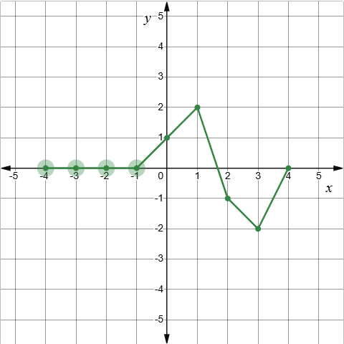

- On your graph, plot points at$x=-4,-3,-2,-1$ so that the graph will become an odd function.
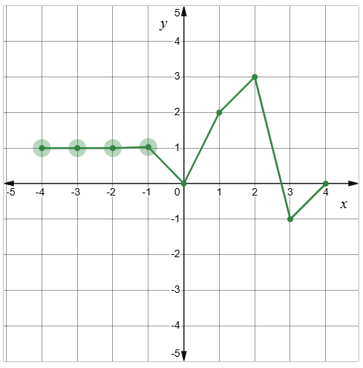

Appendix B

Four quadrant notes
Example 1  Test whether, $f\left(x\right)=x^{2}+{2x}^{4}$ is an even function.  For a function to be even, $f\left(-x\right)=f(x)$  $$f\left(x\right)=x^{2}+2x^{4} \\ f\left(-x\right)={\left(-x\right)}^{2}+2{\left(□\right)}^{4} \\ =□^{2}+2x^{4} \\ =f\left(x\right) \\ ∴the function is _________$$ | Example 2  Determine if the function, $f\left(x\right)=\frac{1}{x^{3}}$, is odd, even or neither.
Things to remember | Example 3

Appendix C

Spot the mistakes
Evaluate the accuracy of each worked solution. For any that are incorrect, write the correct solution and provide a clear justification for your correction.
Worked solution | Correction and justification, if required
Is the function, $y=\sqrt{4-x^{2}}$, odd, even or neither?
$$f\left(-x\right)=\sqrt{4--x^{2}} \\ =\sqrt{4+x^{2}} \\ ∴ the function is neither$$
Test whether the function $y={3x}^{4}+3$, is odd, even or neither.
$$f\left(-x\right)={\left(3-x\right)}^{4}+3 \\ =-12x^{4}+3 \\ ∴ the function is neither$$
Is the function, $f\left(x\right)=\frac{x^{3}}{x^{4}-x^{2}}$, odd, even or neither?
$$f\left(-x\right)=\frac{{\left(-x\right)}^{3}}{{\left(-x\right)}^{4}-{\left(-x\right)}^{2}} \\ =\frac{-x^{3}}{x^{4}-x^{2}} \\ =-f(x)$$
$$∴ the function is odd$$
Test whether the function $f\left(x\right)=\frac{x-3}{x+3}$, is odd, even or neither.
$$f\left(-x\right)=\frac{\left(-x\right)-3}{\left(-x\right)+3} \\ =\frac{-x-3}{-x+3} \\ =\frac{-\left(x+3\right)}{-\left(x-3\right)} \\ =\frac{x+3}{x-3} \\ ∴ the function is even$$
Test whether the function $f\left(x\right)={\left(x-2\right)}^{3}$, is odd, even or neither.
$$f\left(-x\right)={\left(-x-2\right)}^{3} \\ =-{\left(x-2\right)}^{3} \\ ∴ the function is odd$$
Is the function, $f\left(x\right)=(x-2)(x+3)$, odd, even or neither?
$$f\left(-x\right)=\left(-x-2\right)\left(-x+3\right) \\ =x^{2}+x-6 \\ ∴ the function is even, as f\left(-x\right)=-f(x)$$

Sample solutions

Appendix A – moving points
- On your graph, plot points at$x=-4,-3,-2,-1$ so that the graph will become an even function.
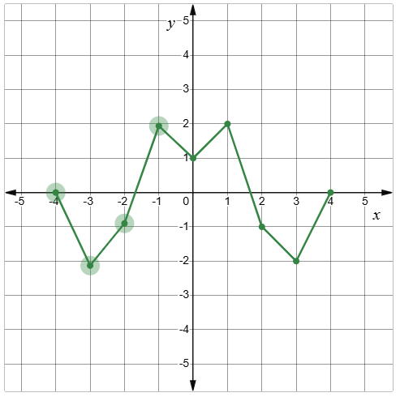
- On your graph, plot points at$x=-4,-3,-2,-1$ so that the graph will become an odd function.
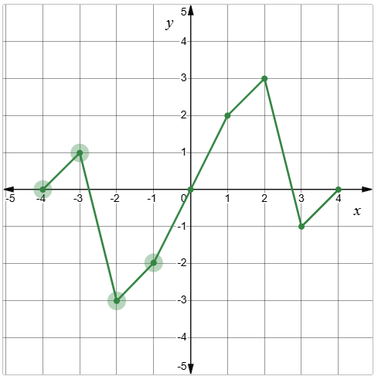

Appendix B – Four quadrant notes
Example 1  Test whether, $f\left(x\right)=x^{2}+{2x}^{4}$ is an even function.  For a function to be even, $f\left(-x\right)=f(x)$  $$f\left(x\right)=x^{2}+2x^{4} \\ f\left(-x\right)={\left(-x\right)}^{8}+3{\left(-x\right)}^{4}-2{\left(-x\right)}^{2} \\ =x^{8}+3x^{4}- {2x}^{2} \\ =f\left(x\right) \\ ∴the function is even$$ | Example 2  Determine if the function, $f\left(x\right)=\frac{1}{x^{3}}$ is odd, even or neither.  $$f\left(-x\right)=\frac{{\left(-x\right)}^{3}}{{\left(-x\right)}^{5}-{\left(-x\right)}^{2}} \\ =\frac{{-x}^{3}}{{-x}^{5}-x^{2}} \\ =\frac{{-x}^{3}}{{-(x}^{5}+x^{2})} \\ ∴the function is neithe$$

Appendix C – spot the mistakes
Worked solution | Correction and justification, if required
Is the function, $y=\sqrt{4-x^{2}}$, odd, even or neither?  $$f\left(-x\right)=\sqrt{4--x^{2}} \\ =\sqrt{4+x^{2}} \\ ∴ the function is neither$$ | $$f(-x) = \sqrt{4-{\left(-x\right)}^{2}} \\ =\sqrt{4-x^{2}} \\ ∴the function is even$$The solution didn’t use brackets around the $-x$. This led to an error and incorrect conclusion.
Test whether the function $y={3x}^{4}+3$, is odd, even or neither.  $$f\left(-x\right)={\left(3-x\right)}^{4}+3 \\ =-12x^{4}+3 \\ ∴ the function is neither$$ | $$f\left(-x\right)= 3{\left(-x\right)}^{4}+3 \\ =3x^{4}+3 \\ =f\left(x\right) \\ ∴the function is even$$  The brackets were incorrectly placed.
Is the function, $f\left(x\right)=\frac{x^{3}}{x^{4}-x^{2}}$, odd, even or neither?  $$f\left(-x\right)=\frac{{\left(-x\right)}^{3}}{{\left(-x\right)}^{4}-{\left(-x\right)}^{2}} \\ =\frac{-x^{3}}{x^{4}-x^{2}} \\ =-f(x)$$  $$∴ the function is odd$$ | The solution was correct.
Test whether the function $f\left(x\right)=\frac{x-3}{x+3}$, is odd, even or neither.  $$f\left(-x\right)=\frac{\left(-x\right)-3}{\left(-x\right)+3} \\ =\frac{-x-3}{-x+3} \\ =\frac{-\left(x+3\right)}{-\left(x-3\right)} \\ =\frac{x+3}{x-3} \\ ∴ the function is even$$ | $$f\left(-x\right)= \frac{\left(-x\right)-3}{\left(-x\right)+3} \\ = \frac{-x-3}{-x+3} \\ = \frac{-(x+3)}{ -(x-3)} \\ = \frac{(x+3)}{(x-3)} \\ ∴the function is neither.$$  The error is assuming that $\frac{x+3}{x-3}=f(x)$.
Test whether the function $f\left(x\right)={\left(x-2\right)}^{3}$, is odd, even or neither.  $$f\left(-x\right)={\left(-x-2\right)}^{3} \\ =-{\left(x-2\right)}^{3} \\ ∴ the function is odd$$ | $$f(-x) = (-x-2)^{3} \\ =-(x+2)^{3}$$  $$∴The function is neither.$$  The error was in the factorising of the negative.
Is the function, $f\left(x\right)=(x-2)(x+3)$, odd, even or neither?  $$f\left(-x\right)=\left(-x-2\right)\left(-x+3\right) \\ =x^{2}+x-6 \\ ∴ the function is even, as f\left(-x\right)=-f(x)$$ | $$f\left(x\right)=(x-2)(x+3) \\ f(-x) = (-x-2)(-x+3)$$  $$=x^{2}-x-6$$  $$∴function is neither$$  The error was expanding the function incorrectly.

References
This resource contains NSW Curriculum and syllabus content. The NSW Curriculum is developed by the NSW Education Standards Authority. This content is prepared by NESA for and on behalf of the Crown in right of the State of New South Wales. The material is protected by Crown copyright.
Please refer to the NESA Copyright Disclaimer for more information https://educationstandards.nsw.edu.au/wps/portal/nesa/mini-footer/copyright.
NESA holds the only official and up-to-date versions of the NSW Curriculum and syllabus documents. Please visit the NSW Education Standards Authority (NESA) website https://educationstandards.nsw.edu.au/ and the NSW Curriculum website https://curriculum.nsw.edu.au/.
Mathematics Advanced 11–12 Syllabus © NSW Education Standards Authority (NESA) for and on behalf of the Crown in right of the State of New South Wales, 2024.

© State of New South Wales (Department of Education), 2025
The copyright material published in this resource is subject to the Copyright Act 1968 (Cth) and is owned by the NSW Department of Education or, where indicated, by a party other than the NSW Department of Education (third-party material).
Copyright material available in this resource and owned by the NSW Department of Education is licensed under a Creative Commons Attribution 4.0 International (CC BY 4.0) license.

This license allows you to share and adapt the material for any purpose, even commercially.
Attribution should be given to © State of New South Wales (Department of Education), 2025.
Material in this resource not available under a Creative Commons license:
- the NSW Department of Education logo, other logos and trademark-protected material
- material owned by a third party that has been reproduced with permission. You will need to obtain permission from the third party to reuse its material.
Links to third-party material and websites
Please note that the provided (reading/viewing material/list/links/texts) are a suggestion only and implies no endorsement, by the New South Wales Department of Education, of any author, publisher, or book title. School principals and teachers are best placed to assess the suitability of resources that would complement the curriculum and reflect the needs and interests of their students.
If you use the links provided in this document to access a third-party's website, you acknowledge that the terms of use, including licence terms set out on the third-party's website apply to the use which may be made of the materials on that third-party website or where permitted by the Copyright Act 1968 (Cth). The department accepts no responsibility for content on third-party websites.

