Domain and range
Students learn how to determine and describe the domain and range of functions and relations using worded descriptions, inequalities and interval notation.
Students will need at least one digital device per pair to interact with Desmos during this lesson.

Learning intentions
- To understand the concepts of domain and range and how they apply to functions and relations.
- To be able to describe the domain and range of functions and relations.

Success criteria
- I can define the domain and range of a function or a relation.
- I can describe the domain and range using worded descriptions or inequalities.
- I can describe the domain and range using interval notation.

Outcomes
A student:
- develops understanding and fluency in mathematics through exploring and connecting mathematical concepts, choosing and applying mathematical techniques to solve problems, and communicating their thinking and reasoning coherently and clearly MAO-WM-01
- applies algebraic techniques and the laws of indices and surds to manipulate expressions and solve problems MAV-11-01
- uses functions and relations to model, analyse and solve problems MAV-11-02

Content

Introduction to functions and relations
- Define the domain of a function $f$ as the set of real numbers on which $f$ is defined
- Define the range of a function $f$ as the set of values of $f(x)$ obtained as $x$ varies over the domain of $f$

Properties of functions, relations and graphs
- Extend the definitions of domain and range to relations
- Recognise domains and ranges of functions and relations given in interval notation, as inequalities and as worded descriptions
- Determine and describe the domain and range of functions and relations, using interval notation, inequalities or worded descriptions
Mathematics Advanced 11–12 Syllabus © NSW Education Standards Authority (NESA) for and on behalf of the Crown in right of the State of New South Wales, 2024.

Table 1: lesson summary
Section | Summary of activity | Teaching strategies | Teaching points
Activating prior knowledge | Students consider the allowable inputs and possible outputs of a function machine and linear relationship using screens 1–5 of the Amplify (Desmos) activity (bit.ly/AmplifyDomainRange). | Pose-Pause-Pounce-Bounce | The purpose of this activity is to build on students’ prior understanding of inputs and outputs, to introduce the concept of domain and range. Students should recognise that not all inputs have outputs and that outputs may be limited.
Connecting learning | Use slides 4–6 of the PowerPoint Domain and range to define domain and range and briefly discuss the structure of the real number system. Students then complete screens 6–9 of the Amplify (Desmos) activity (bit.ly/AmplifyDomainRange) to describe the domain and range of familiar functions and relations in words from their graphs. | Pose-Pause-Pounce-Bounce | The aim of this activity is to connect prior graph knowledge to the concept of domain and range, starting gradually with students describing in words. The use of the interactive graphs should support students understanding.
Releasing responsibility | Use slide 8 to define an inequality, then progress to slides 9–14 for worked examples on writing domain and range using inequalities and other mathematical notation.  Use slides 15–16 to define interval notation, then progress to slides 17–19 to use examples to explain how to write domain and range using interval notation.  Students return to the Amplify (Desmos) activity to complete screen 10, then complete Appendix A, highlighting and annotating important notes. | Worked examples (Your turn)  Faded examples  Notes to their future forgetful selves | The aim of this section is to introduce inequalities and interval notation as a way to represent domain and range, building on the solid understanding developed in the previous section. It also addresses common misconceptions students may have when writing domain and range in this formation, such as the correct order of numbers and the proper use of infinity in interval notation.
Independent practice | Students complete a design challenge using Appendix B as a banner task, working from the domain and range to identify potential functions. Students compare and discuss their answers. | Visibly random groups of 3  Vertical non-permanent surfaces  Banner task | The purpose of this section is for students to apply their knowledge by working backwards: students now start with the domain and range and consider what the corresponding graph and equation could be.

Activity structure
Please use the associated PowerPoint Domain and range to display images in this lesson.

Activating prior knowledge
Students were introduced to the terminology of input and output in Lesson 1 – functions and Lesson 2 – function values and intercepts. This language is used in this section to form the foundation for students’ understanding of domain and range.
Domain and range may be familiar to students who have completed the Stage 5 Functions and other graphs Path outcome MA5-FNC-P-01.
- Assign the Amplify (Desmos) activity ‘Domain and range introduction’ (bit.ly/AmplifyDomainRange) for students to attempt individually or in pairs.
Before using this activity, you will need to set up an Amplify (Desmos) classroom (bit.ly/createamplifyclassroom) and use the pacing feature to restrict students to screens 1–5.
- Once most students have completed up to screen 5, use the pause feature in the teacher dashboard. Explain to students that they will return to this Amplify (Desmos) activity later in the lesson.
- Use the Pose-Pause-Pounce-Bounce questioning strategy (PDF 557 KB) (bit.ly/posepausepouncebounce) to discuss screens 1–5 with the class. The teacher dashboard can be used to display student responses. Some suggested prompts include:
- Why might some inputs have had no output and produced an error message on the vending machine?
- What did you notice about the outputs from the function machine?
- Are there any restrictions on the inputs and outputs of the linear and quadratic functions?
Students should notice that the vending machine only allows for dollars to be input and that the function machine only had positive integers as the output. The function machine represents an absolute value function, which students are yet to learn about.

Connecting learning
- Use slide 4 to define the domain of a function or relation. One example and its related graph have been provided. Use the self-explanation prompts to conduct a class discussion. The phrase ‘all-real $x$’ is unpacked on slide 5.
The vending machine can be referred to, where euros and yen were not allowed as inputs, meaning that the domain of the vending machine was dollars.
- Display slide 5 showing a Venn diagram for real numbers. This slide visually represents the relationships between subsets of real numbers, including rational numbers, irrational numbers and integers.
The slide shows the related symbols for real numbers, $R$, rational numbers, $Q$ and integers, $Z$ which students may not be familiar with. Whilst these symbols do not appear in the content of the Advanced Mathematics course, they do appear in the NESA Glossary. A class discussion could be used to explore their meaning and introduce the notation used in Extension 2 Mathematics, particularly in the Introduction to Complex Numbers outcome ME2-12-02, where students classify numbers using these sets as part of a structured number system.
- Allow students time to view the diagram and use the Pose-Pause-Pounce-Bounce questioning strategy (PDF 557 KB) (bit.ly/posepausepouncebounce) to check for student understanding of real numbers. Suggested question prompts include:
- Why don’t the ‘rational’ and ‘irrational number’ circles overlap?
- Why is the ‘integers’ circle inside the ‘rational numbers’ circles?
- Use slide 6 to define the range of a function or relation. Use the self-explanation prompt to conduct a class discussion. One example and its related graph have been provided, although further discussion is encouraged with reference to the functions and relations students are familiar with.
The function machine can be referred to, where the only output was positive integers, meaning that the range would be all real $y$, such that $y$ is greater than or equal to $0$.
A class discussion could be used to recall features, and thus the domain and range of both the equation and graphs of familiar linear and non-linear relationships. This includes straight lines, quadratic functions, cubic functions, reciprocal functions, circles and semicircles.
- Return students to the Amplify (Desmos) activity (http://bit.ly/AmplifyDomainRange) and extend the pacing to include screens 6–9 for students to complete.
In this set of screens, students will analyse interactive graphs and describe their domain and range in words.
- Once most students have completed up to screen 9, use the pause feature in the teacher dashboard. Explain to students that they will return to this Amplify (Desmos) activity later in the lesson.
- Use the Pose-Pause-Pounce-Bounce questioning strategy to discuss screens 6–9 with the class. The teacher dashboard can be used to display student responses. Some suggested prompts include:
- How did you determine the domain from a graph?
- How did the domain and range of a circle differ from the other functions?

Releasing responsibility
Inequalities
- Display slide 8, which contains the definition of an inequality. Allow time for students to read the definition.
- Animate the slide and use the self-explanation prompts to check student understanding.
All students should be familiar with the symbols $<, ≤, ≥$ and $>$ from the Stage 4 Computation with integers outcome MA4-INT-C-01. Students who have completed the Stage 5 Equations B Path outcome MA5-EQU-P-01 should be familiar with linear inequalities.
- Use slides 9–14 to model writing domain and range with inequalities and other mathematical notation, using the Worked examples (Your turn) method (bit.ly/supportingstrategies).
- For the circles on slides 11–12, students should become familiar with writing inequalities that show the domain and range limited to a specific interval, such as $-4≤x≤4$.
- For the reciprocal functions on slides 13–14, explain to students that a preferred, alternative method of writing 2 separate inequalities, $x<0$ and $x>0$, is to state, all real $x, x≠0$.
- In the following section, students will learn how to write the domain and range using interval notation. Some students may benefit from completing practice questions from an existing resource before moving on to this new content.

Interval notation
- Explain to students that domain and range can also be expressed using interval notation, as an alternative to inequalities. Discuss the meaning of the word ‘interval’ with the class.
Students may recall the word ‘interval’ from Stage 5 Linear relationships A Core outcome
MA5-LIN-C-01, where they found the length of intervals joining 2 points.
The NESA Glossary defines an interval as a continuous subset of the real number line. For example, the set of all real numbers greater than or equal to 10. An image has also been included.
Figure 1: NESA glossary image of an interval
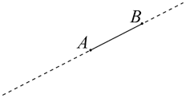
- Use slides 15–16 to define and explain how interval notation can be used to express the domain and range of functions and relations. Use the self-explanation prompts on the slides to unpack what is meant by the word ‘endpoints’ for the definition of interval notation.
Students should understand that inequalities and interval notation represent the same information. They should understand that interval notation is a way of representing the continuous subset of real numbers on a real number line using its endpoints.
Common misconceptions to address include:
- confusing square brackets and curved parentheses
- using the incorrect bracket with infinity
- writing intervals in the wrong order
- misunderstanding how to use the union symbol for split intervals.
- Use slides 17–19 to show 3 examples of using interval notation. On each slide allow students time read, understand and then have a class discussion to address the key information on each slide.
For each slide, emphasise the order in which the numbers are written within the notation.
- Slide 17 demonstrates the use of the square bracket in interval notation, linking it to $≤$ and $≥$.
- Slide 18 demonstrates how infinity is used within interval notation, as well as the use of the curved parentheses.
- Slide 19 shows both a domain and range where the interval notation is separated by the union symbol, $∪$.
Students were introduced to set notation in Unit 1 – probability and data, and the union symbol, $∪,$ was analysed in Lesson 4 – intersections and unions, although this may need to be revising.
- Have students return to the Amplify (Desmos) activity and turn off the pause feature, so that students can complete the final screen, screen 10. This screen features a card sort activity designed to assess understanding of the connection between graphs, their equations, and the domain and range expressed in both inequalities and interval notation.
- Once students start to finish, distribute Appendix A ‘Faded examples’ (bit.ly/fadedexamplesstrategy), for students to complete in the pairs.
- Have the students either create notes to their future forgetful selves (bit.ly/notestofutureself) on how to write domain and range using inequalities and interval notation, or alternatively, annotate their faded worked examples, highlighting important pieces of information to remember.
Solutions for Appendix A are provided at the end of this document. Ensure students have the correct answers before they annotate them as notes for their future forgetful selves.

Independent practice
- Assign students to visibly random groups of 3 (bit.ly/visiblegroups) at vertical non-permanent surfaces (bit.ly/VNPSstrategy).
- Instruct students to set up their board to complete a banner task (bit.ly/supportingstrategies).
- Read out the instructions and write up the first description from Appendix B ‘Banner task questions’.
Encourage groups to compare their answers with the group next to them and/or use graphing applications such as Desmos Graphing Calculator before they steal the next description.
- Use the Pose-Pause-Pounce-Bounce questioning strategy to discuss groups’ strategies, encouraging justification. The following are some suggested prompts:
- What features in the description helped to determine the equation?
- Were there any descriptions that could only be done one way? How do you know?
In this lesson, finding the domain and range of functions that fall outside the scope of the Advanced course has been intentionally excluded. For example, finding the domain of the function $f\left(x\right)=\sqrt{3x-2}$. Questions of this nature will be addressed in Unit 3 – exploring linear and quadratic functions Lesson 3 – linear inequalities.

Assessment and differentiation

Suggested opportunities for differentiation
Activating prior knowledge
- The teacher could provide additional scaffolding for students for screens 4 and 5 by highlighting on the graph specific allowable values, and specific outputs.
- Students could be challenged to consider what would happen to the allowable inputs, and outputs of more complex functions.
Connecting learning
- The teacher can provide additional pause and discussion points during the Amplify (Desmos) activity to provide support.
- Students can be extended by asking them to consider restrictions that can occur when modelling with functions, such as time, which is often restricted to be greater than zero.
Releasing responsibility
- The notation $x∈R$ can be introduced for ‘all real $x$’ to extend students who may choose Mathematics Extension 2.
- Students could be supported with additional scaffolded examples of converting between inequalities and interval notation.
- Students who may choose Extension 2 can be shown the notation: $y∈\left[0,1\right]$, instead of $[0, 1]$.
Independent practice
- Students requiring additional support could use a graphing application during the design challenge, in addition to checking their answers.
- Students could be extended by asking them to create their own design challenge questions.

Suggested opportunities for assessment
Activating prior knowledge
- Use the Amplify (Desmos) teacher dashboard to check students understanding of allowable input and output.
Connecting learning
- Monitor student responses through the Amplify (Desmos) teacher dashboard to check for students’ understanding of worded descriptions of domain and range.
Releasing responsibility
- Student responses to the faded questions and notes to future forgetful selves could be collected as work samples and to address any misconceptions.
Independent practice
- The teacher can observe student responses on the vertical non-permanent surfaces.

Appendix A

Faded examples
Question 1 | Question 2 | Question 3 | Question 4
$$y=-x-1$$  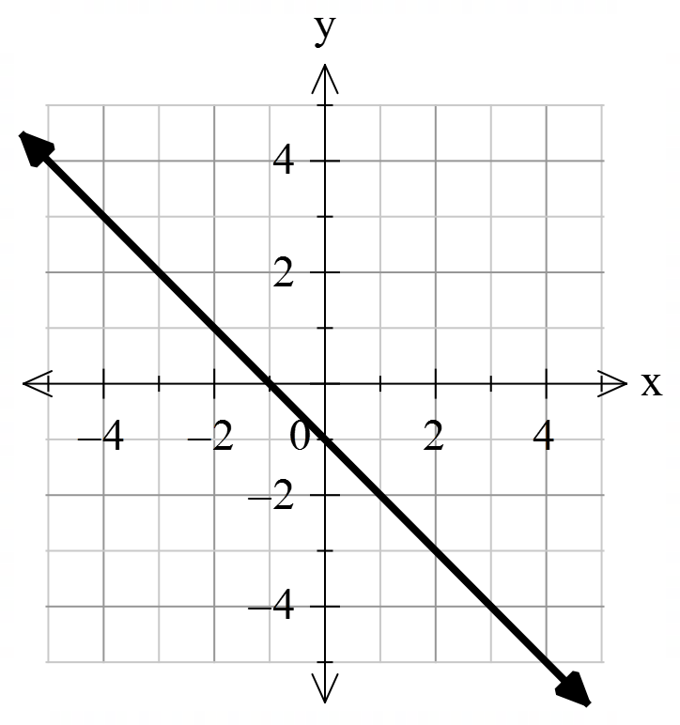  Worded description:  D: All real $x$  R: All real $y$  Using symbols or inequalities:  D: All real $x$  R: All real $y$  Interval notation:  D: $(-∞, ∞)$  R: $(-∞, ∞)$ | $$y=\frac{1}{x}$$  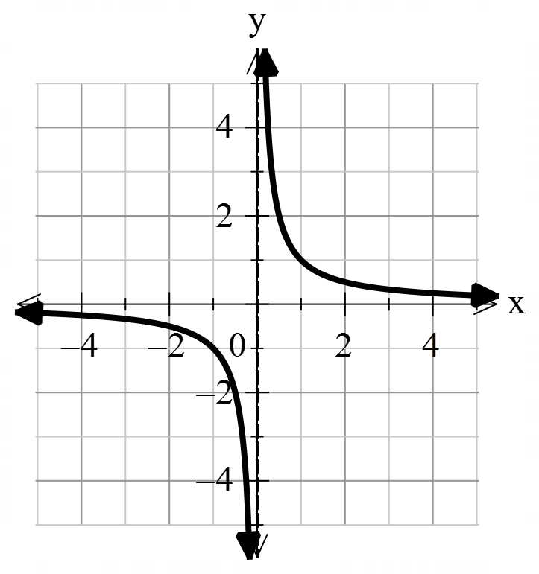  Worded description:  D:  R:  Using symbols or inequalities:  D: all real $x, x≠0$  R: all real $y, y≠0$  Interval notation:  D: $\left(-∞, 0\right)∪(0,∞)$  R: $\left(-∞, 0\right)∪(0,∞)$ | $$x^{2}+y^{2}=16$$  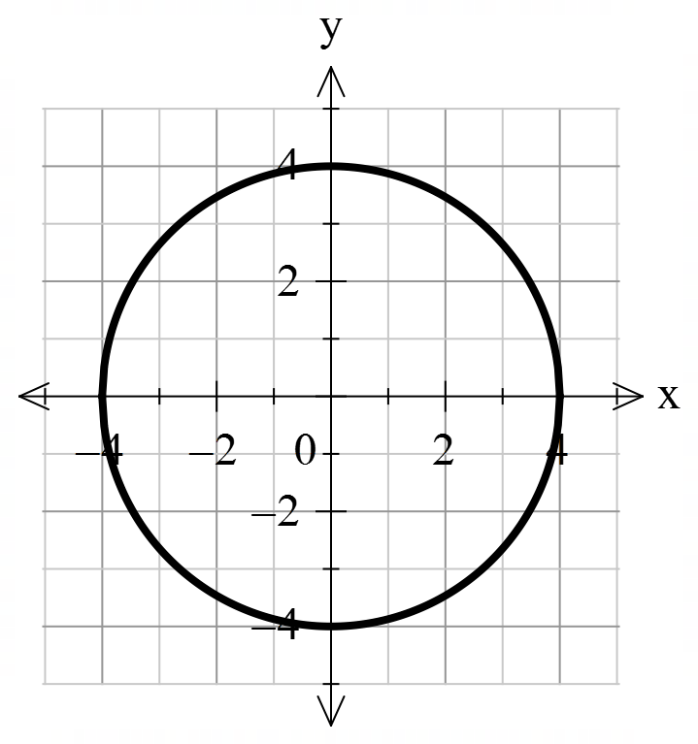  Worded description:  D:  R:  Using symbols or inequalities:  D:  R:  Interval notation:  D: $[-4, 4]$  R: $[-4, 4]$ | $$y=x^{2}-1$$  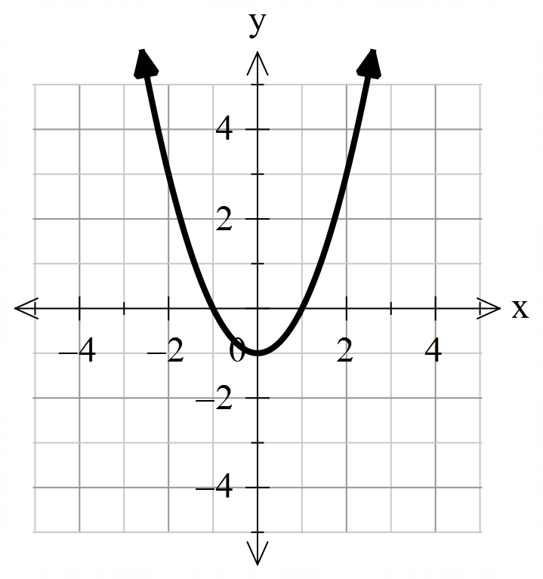  Worded description:  D:  R:  Using symbols or inequalities:  D:  R:  Interval notation:  D:  R:

Appendix B

Banner task questions
For each description, students will need to sketch a possible graph that matches the description and write a corresponding equation.
Description:
- A circle with domain: $[-2, 2]$.
- A semicircle with range from zero to 3.
- A quadratic function with range of all real $y$, such that $y$ is great than $-1$.
- A function with the domain and range of all real numbers.
- A function with the domain and range of $(-∞,0)∪(0,∞)$.
- A function with range $y≤2$.
- A function with range $y<0$.

Sample solutions

Appendix A – faded examples
Question 1 | Question 2 | Question 3 | Question 4
$$y=-x-1$$  Worded description:  D: All real $x$  R: All real $y$  Using symbols or inequalities:  D: All real $x$  R: All real $y$  Interval notation:  D: $(-∞, ∞)$  R: $(-∞, ∞)$ | $$y=\frac{1}{x}$$  Worded description:  D: All real x, except x=0  R: All real x, except x=0  Using symbols or inequalities:  D: all real $x, x≠0$  R: all real $y, y≠0$  Interval notation:  D: $\left(-∞, 0\right)∪(0,∞)$  R: $\left(-∞, 0\right)∪(0,∞)$ | $$x^{2}+y^{2}=16$$  Worded description:  D: $x$ between $-4$ and $4$, inclusive  R: $y$ between $-4$ and $4$, inclusive  Using symbols or inequalities:  D: $-4≤x≤4$  R: $-4≤y≤4$  Interval notation:  D: $[-4, 4]$  R: $[-4, 4]$ | $$y=x^{2}-1$$  Worded description:  D: All real x  R: y greater than or equal to $-1$  Using symbols or inequalities:  D: all real $x$  R: $y≥-1$  Interval notation:  D: $(-∞, ∞)$  R: $[-1, ∞)$

Appendix B – banner task solutions
      - $x^{2}+y^{2}=4$
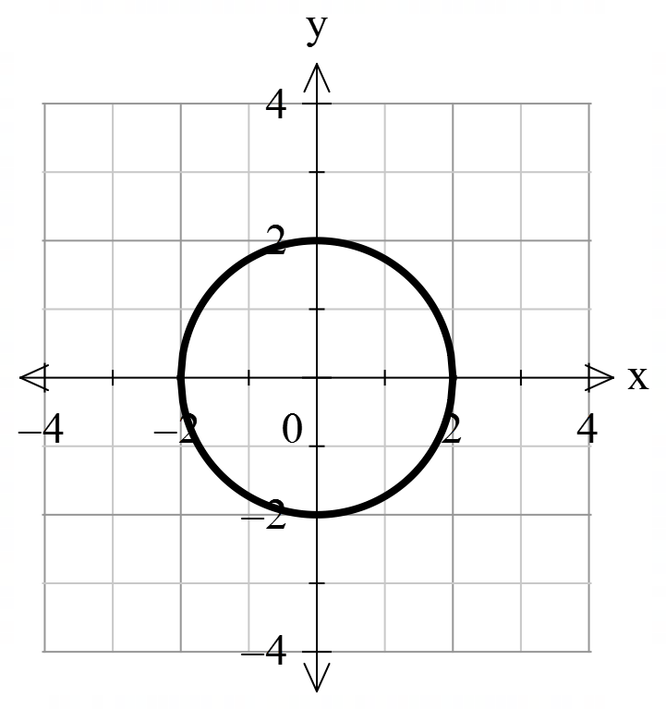
      - $y=\sqrt{9-x^{2}}$
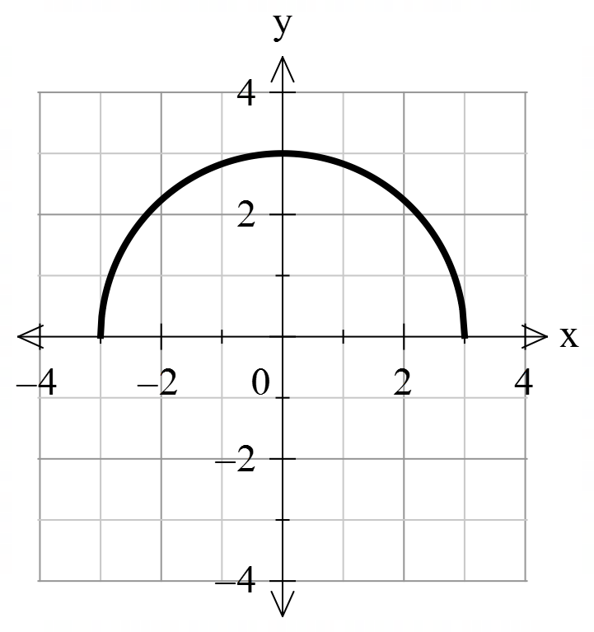
      - $y=kx^{2}-1$, where $k>0$.
      - $y=kx^{3}$ or an equation of any linear function with non-zero gradient.
      - $y=\frac{k}{x}$, where $k$ is any real number.
      - $y=kx^{2}+2$, where $k<0$.
      - $y={-k}^{x}$, where $k>0$.

References
This resource contains NSW Curriculum and syllabus content. The NSW Curriculum is developed by the NSW Education Standards Authority. This content is prepared by NESA for and on behalf of the Crown in right of the State of New South Wales. The material is protected by Crown copyright.
Please refer to the NESA Copyright Disclaimer for more information https://educationstandards.nsw.edu.au/wps/portal/nesa/mini-footer/copyright.
NESA holds the only official and up-to-date versions of the NSW Curriculum and syllabus documents. Please visit the NSW Education Standards Authority (NESA) website https://educationstandards.nsw.edu.au/ and the NSW Curriculum website https://curriculum.nsw.edu.au/.
Mathematics Advanced 11–12 Syllabus © NSW Education Standards Authority (NESA) for and on behalf of the Crown in right of the State of New South Wales, 2024.

© State of New South Wales (Department of Education), 2025
The copyright material published in this resource is subject to the Copyright Act 1968 (Cth) and is owned by the NSW Department of Education or, where indicated, by a party other than the NSW Department of Education (third-party material).
Copyright material available in this resource and owned by the NSW Department of Education is licensed under a Creative Commons Attribution 4.0 International (CC BY 4.0) license.

This license allows you to share and adapt the material for any purpose, even commercially.
Attribution should be given to © State of New South Wales (Department of Education), 2025.
Material in this resource not available under a Creative Commons license:
- the NSW Department of Education logo, other logos and trademark-protected material
- material owned by a third party that has been reproduced with permission. You will need to obtain permission from the third party to reuse its material.
Links to third-party material and websites
Please note that the provided (reading/viewing material/list/links/texts) are a suggestion only and implies no endorsement, by the New South Wales Department of Education, of any author, publisher, or book title. School principals and teachers are best placed to assess the suitability of resources that would complement the curriculum and reflect the needs and interests of their students.
If you use the links provided in this document to access a third-party's website, you acknowledge that the terms of use, including licence terms set out on the third-party's website apply to the use which may be made of the materials on that third-party website or where permitted by the Copyright Act 1968 (Cth). The department accepts no responsibility for content on third-party websites.

