Circles and semicircles
Students apply Pythagoras’ theorem to the Cartesian plane to derive and graph the equation of a circle and its semicircle with the centre at the origin.

Learning intentions
- To be able to derive and determine the equation of a circle in the form $x^{2}+y^{2}=r^{2}$.
- To understand how to represent the equation of a semicircle.

Success criteria
- I can explain and justify how the equation of a circle is derived from Pythagoras’ theorem on the Cartesian plane.
- I can interpret and apply the equation of a circle to accurately draw its graph on the Cartesian plane.
- I can rearrange the equation of a circle to represent semicircles.

Outcomes
A student:
- develops understanding and fluency in mathematics through exploring and connecting mathematical concepts, choosing and applying mathematical techniques to solve problems, and communicating their thinking and reasoning coherently and clearly MAO-WM-01
- applies algebraic techniques and the laws of indices and surds to manipulate expressions and solve problems MAV-11-01
- uses functions and relations to model, analyse and solve problems MAV-11-02

Content

Circles and semicircles
- Derive the equation of a circle of radius $r$ with centre at the origin by considering Pythagoras’ theorem
- Graph circles of the form $x²+y²=r²$ from their equations
- Determine the equation of a circle of the form $x²+y²=r²$ given its graph
- Identify and graph the semicircles $y=\sqrt{r² - x²}, y=-\sqrt{r^{2}- x^{2}},$and $x=\sqrt{r² - y²}$, $$x=-\sqrt{r^{2}- y^{2}}$$
Mathematics Advanced 11–12 Syllabus © NSW Education Standards Authority (NESA) for and on behalf of the Crown in right of the State of New South Wales, 2024.

Table 1: lesson summary
Section | Summary of activity | Teaching strategies | Teaching points
Activating prior knowledge | Using Appendix A, students plot given coordinates on a Cartesian plane and calculate their distances from the origin, within the context of locating a missing drone. | Visibly random groups of 3  Vertical non-permanent surfaces  Pose-Pause-Pounce-Bounce | Reinforce students’ understanding of distance on the Cartesian plane.
Connecting learning | Students derive the equation of a circle in the context of the missing drone. Using slides 4–5 of the PowerPoint Circles and semicircles and Appendix B, students establish the properties of circle graphs and equations and how the equation might be rearranged.  Using slides 6–7 students learn about semicircles, including whether these graphs represent functions, using the vertical line test and algebraic manipulation to rearrange equations. | Visibly random groups of 3  Vertical non-permanent surfaces  Pose-Pause-Pounce-Bounce  Think-Pair-Share | Develop students’ skills in using Pythagoras’ theorem or the distance formula to derive circle equations and develop semicircle equations.  Students should have a clear understanding of how to derive the equation of a circle and how this equation can be manipulated to form the equations of semicircles.
Releasing responsibility | Use slides 9–14 to work through modelled examples to practise converting between equations and graphs of circles and semicircles. Students then create annotated notes to consolidate key features. | Worked examples (Your turn)  Notes to future forgetful selves | Strengthen students’ ability to interpret and connect graphical and algebraic representations of circles and semicircles.
Independent practice | Students design an enclosed boundary using a combination of semicircles and other familiar graphs on a Cartesian plane. Samples have been included in Appendix C. | Vertical non-permanent surfaces | Consolidate students’ knowledge of various function types and their graphical representation.

Activity structure
Please use the associated PowerPoint Circles and semicircles to display images in this lesson.

Activating prior knowledge
- Read the following scenario to the class.
We've been called in to help locate a missing drone. All we know is that the drone is exactly 5 km away from the controller.
You’ve picked up a list of possible locations where the drone might have been spotted. Your job is to figure out which of these coordinates could be the location of the drone.
- Explain to students that they will complete an activity using a Cartesian plane and a list of possible locations to determine the drone’s potential positions. For this activity, clarify that one unit on the Cartesian plane represents one kilometre, and the drone controller is located at the origin.
- Provide students with Appendix A ‘Missing drone’ and assign students to visibly random groups of 3 (bit.ly/visiblegroups) at vertical non-permanent surfaces (bit.ly/VNPSstrategy) to complete the work for this activity.
The purpose of this activity is for students to apply their prior understanding of the distance of an interval on the Cartesian plane to determine which points lie exactly 5 units from the origin. Through plotting and calculations using Pythagoras’ theorem, students should begin to recognise that these equidistant points form a circle.
- Conduct a class discussion on how students might find the distance of an interval on the Cartesian plane. Encourage students to connect their prior knowledge of the distance of an interval by applying Pythagoras’ theorem.
Students have previously used the interval between 2 points as the hypotenuse of a right-angled triangle on the Cartesian plane and applied Pythagoras’ theorem to determine the length of the interval joining the 2 points, in Stage 5 Linear relationships A Core outcome MA5-LIN-C-01.
Students who completed Stage 5 Linear relationships C Path outcome MA5-LIN-P-01, have previously used the distance formula.
- Explain to students that they are to recreate the Cartesian plane at their vertical non-permanent surfaces, plot the given coordinates and find the distance from the origin to the coordinates to determine which locations are possible positions of the drone. Allow students time to complete the activity.
- As students start to finish, ask them to consider if there are any other points, not listed, that could also be possible drone locations based on the signal range?
- Once students have identified the coordinates that could represent possible positions of the drone, use the Pose-Pause-Pounce-Bounce questioning strategy (PDF 557 KB) (bit.ly/posepausepouncebounce) to unpack what each group may have discovered. The following are some suggested prompts:
- What do all the identified coordinates have in common?
- What shape do you think the identified points might make?
- Can you describe a rule for this set of points?
Students should conclude that the identified points form a circle, centred at the origin with radius 5. Students may be familiar with the equation of a circle, $x^{2}+y^{2}=25$, although the following activity has students derive this equation. Students might suggest that for the identified points, the addition of the square of the $x$ and $y$ values equal to 25.

Connecting learning

The circle
- Pose the following question to students:
What do we do if we haven’t recorded any sightings of the drone, but we want to figure out where it could be if it’s exactly 5 km away?
- Continuing in their groups of 3, guide students to reflect critically on how they might find the distance from the origin to an unknown point $(x,y)$. Encourage students to use their prior learning of Pythagoras’ theorem or the distance formula.
- Extend students to write and share an equation that would show an unknown point $(x,y)$ that is exactly 5 units away from the origin.
Students should share that the distance would be calculated using the formula $d=\sqrt{x^{2}+y^{2}}$ and following this they should come up with the equation $\sqrt{x^{2}+y^{2}}=5$.
Students using the distance formula, $d=\sqrt{{{(x}_{2}-x_{1})}^{2}+{{(y}_{2}-y_{1})}^{2}}$, should create the equation $d=\sqrt{{(x-0)}^{2}+{(y-0)}^{2}}$, which simplifies to the same equation above.
- Explain to students that the equation created is written in the form $x^{2}+y^{2}=25$, by squaring both sides.
- Generalise this by revealing the formula of a circle, $x^{2}+y^{2}=r^{2}$, on slide 4. Conduct a class discussion to check students’ understanding of how to use this formula. Some suggested prompts include:
- What might the equation of a circle be if it’s centred at the origin with radius 6?
- How might the equation of a circle change if the centre remains unchanged and the radius is reduced to 4?
- Have students return to their workspaces to complete Appendix B ‘Graphs and equations of circles’ in pairs, which involves students determining the equation of the graphs and graphing circles, given the equation.
- After some time, have students compare their responses with another pair, discussing any similarities or differences. Encourage them to justify their reasoning and work together to agree on a final answer.

The semicircle
- Use the Pose-Pause-Pounce-Bounce questioning strategy to initiate a class discussion on whether the graphs they have just examined in Appendix B represent functions. Possible questions could include:
- How can we test whether a graph represents a function?
- What does it mean for a relationship to be a function in terms of $x$ and $y$-values?
- Are there any parts of the graph that would pass the vertical line test?
- If we wanted to select just part of the graph to make it a function, which part would you choose, and why?
Students should conclude that a circle is not a function, as it does not pass the vertical line test and for most $x$-values there are 2 corresponding $y$-values.
The class may have suggested that you could just take the top or bottom half of the circle. Students may also have suggested that you could just take a quarter of the circle.
- Display slide 5, which shows the equation of a circle along with the steps to rearrange it to make $y$ the subject. Allow time for students to Think-Pair-Share (bit.ly/thinkpairsharestrategy) their answers to the self-explanation prompts.
- Relate the semicircles on slide 6 to the 2 equations from slide 5 to consolidate student understanding of how an equation of a circle can be rearranged to focus on just the top or bottom half.
- Initiate a class discussion on whether the semicircles displayed now represent functions and to consider what the equation might look like to obtain either the left- or right-hand side of the circle. Possible prompting questions could include:
- Do these represent functions? Why or why not?
- How can features of the equation be used to determine what the graph will look like?
- How might the equation of a circle be rearranged to just graph the left- or right-hand side?
- Allow students time to rearrange the equation of a circle such that $x$ is the subject.
- Display slide 7, which shows the graphs of the semicircles in the form $x=\sqrt{r^{2}-y^{2}}$ and $x=-\sqrt{r^{2}-y^{2}}$.
- Initiate a class discussion on whether these semicircles represent functions.
Conclude that the semicircles on slide 7 do not represent functions as they do not pass the vertical line test.

Releasing responsibility
- Use slides 9–14 to model how to convert between equations and graphs of circles and semicircles, using the Worked examples (Your turn) method (bit.ly/supportingstrategies). Use the self-explanation prompts to guide students in articulating their understanding of how features of the equation can be used to determine what the graph will look like and how features of the graph can be used to determine the equation.
- Students are to create notes to their future forgetful selves (bit.ly/notestofutureself) on the features of both the equations and graphs of circles and semicircles.
- Students should complete practice questions from an existing resource to consolidate their understanding of circles and semicircles.

Independent practice
- Verbally provide the following scenario to the class.
A new drone is flying around to avoid being found. Your new mission is to design a system of virtual barriers (using equations on the Cartesian plane) that will trap the drone within a specific area.
- Explain to students that they will be working in pairs to design the drone trap. Restrict students to work within the domain, $-5≤x≤5$, and a range of $-20≤y≤20$.
Note that students are not familiar with the terminology ‘domain’ and ‘range’, so when explaining this instruction to students, use informal mathematical language.
- Discuss with students that the aim is to provide an enclosed boundary using at least one semicircle and other known linear and non-linear relationships. The goal is to create a closed area that allows the drone the greatest possible freedom of movement. Encourage students to be creative and explore multiple options. They may choose to use 2, 3, or more equations to define their enclosed boundary.
In previous lessons students have revised their prior knowledge of how to graph linear relationships, quadratic functions of the form $y=ax^{2}+c$ and exponentials of the form $y=a^{x}$, and also learned how to graph cubic functions of the form $y=ax^{3}$ and reciprocal functions of the form $y=\frac{k}{x}$. Students can be encouraged to use any graphs known to them.
Finding the area under and between curves is beyond the scope of the Year 11 Mathematics Advanced course. If teachers wish students to calculate the area of their drone enclosure, students should apply their prior knowledge of two-dimensional shapes where appropriate.
Students will learn about the area under and between curves in the Year 12 Mathematics Advanced Integral calculus outcome MAV-12-05.
- Direct students to use a graphing application, such as Desmos, to assist them, or students can work at a vertical non-permanent surface.
- Once students have completed their barriers using equations, have them swap with another pair to check that their boundary is completely enclosed. Students can use a graphing application, such as Desmos to check.
Possible designs have been included in the solutions section of this lesson.

Assessment and differentiation

Suggested opportunities for differentiation
Activating prior knowledge
- Appendix A provides multiple access points. Some students may use Pythagoras’ theorem, and others may use the distance formula, based on their prior Stage 5 experiences.
- To make the activity more accessible, some groups could be given an A3 Cartesian plane in a plastic sleeve, so they don't need to draw their own set of axes.
Connecting learning
- Students are supported as they move from concrete to abstract representations, as they transition from a contextual scenario to generalisation of the circle equation. Concrete representations may need to be referenced to support student understanding.
- The Think-Pair-Share allows students to verbalise and test ideas with peers before sharing with the class.
Releasing responsibility
- The examples could be adapted to include surd solutions to extend students.
Independent practice
- The open-ended task offers flexibility; students can demonstrate their understanding of basic or complex linear and non-linear relationships.
- Encourage students to evaluate others’ work and learn alternative methods or representations.
- Students may use a graphical application to aid in their access to this activity.

Suggested opportunities for assessment
Activating prior knowledge
- Observe students’ work and conversations in the group work activity to use as formative assessment of their ability to apply Pythagoras’ theorem to find distances on the Cartesian plane.
- Assess students’ reasoning and ability to generalise patterns in the Pose-Pause-Pounce-Bounce questioning.
- Use student responses to determine readiness to move towards the abstract generalisation of a circle.
Connecting learning
- Use Appendix B to assess students conceptual understanding of the connections between equations and graphical forms.
Releasing responsibility
- Use students notes to their future forgetful selves to assess their understanding, as well as what they believe are key concepts and which elements they still find challenging.
Independent practice
- Collect student responses to Appendix C to assess their understanding of a variety of non-linear relationships.

Appendix A

Missing drone

Possible locations
$$(3, 4)$$ | $$(5, 1)$$ | $$(0, 5)$$
$$(-2, 2)$$ | $$(1, -4)$$ | $$(3, -4)$$
$$(-4, -3)$$ | $$(4, 4)$$ | $$(-3, 4)$$
- By plotting the points, or otherwise, determine which locations might be possible positions of the drone, considering the drone is exactly 5 units from the origin.
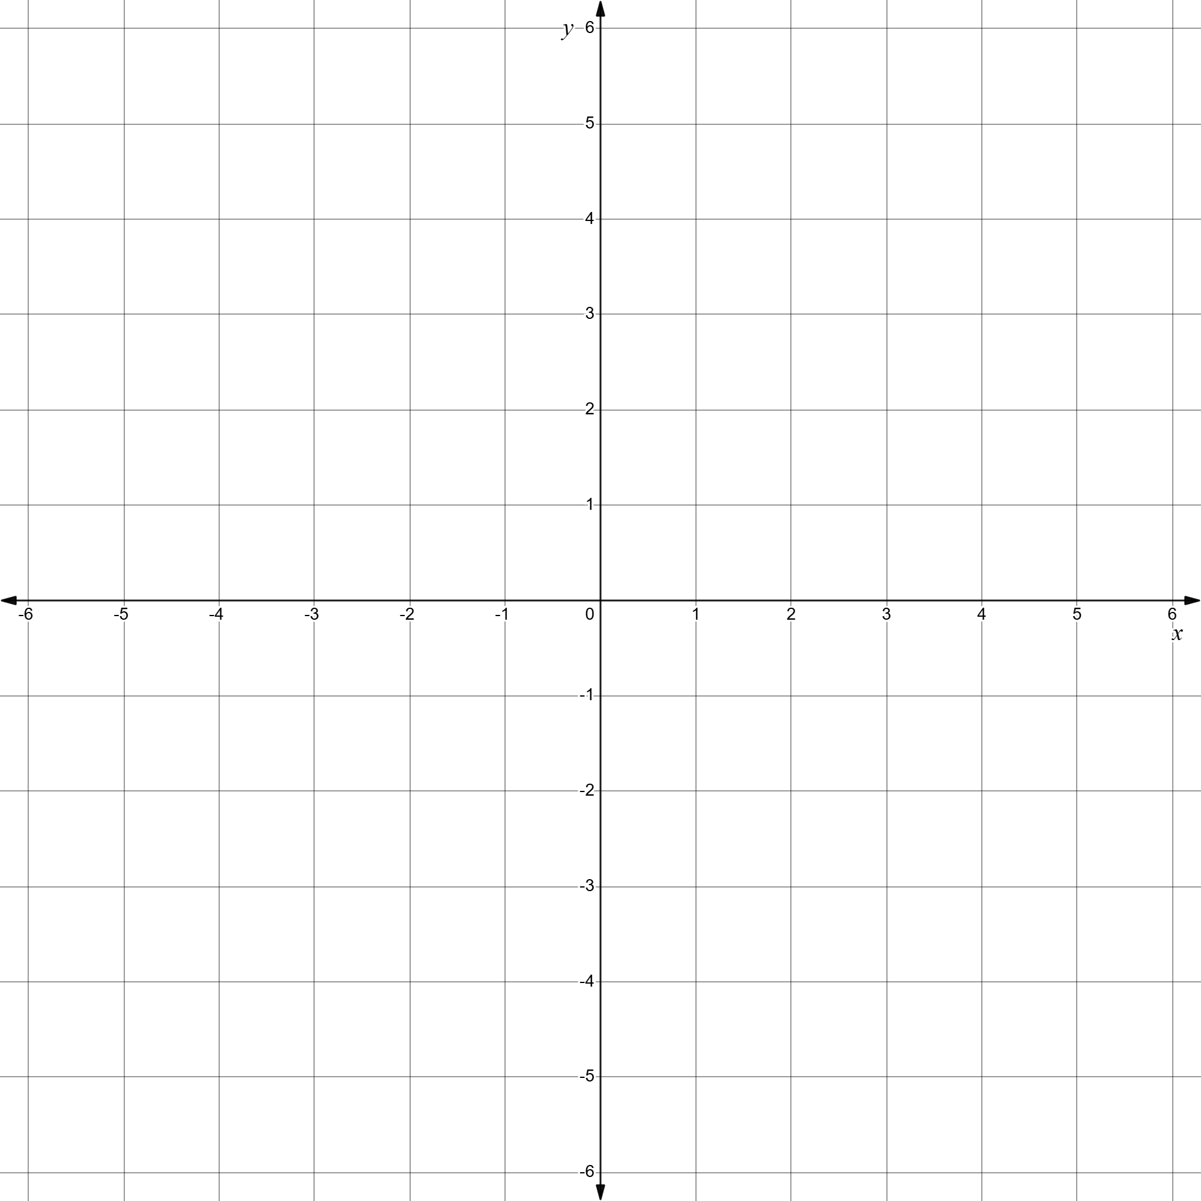

Appendix B

Graphs and equations of circles
Complete the table by either writing the correct equation from the given graph or sketching the correct graph of the given equation.
Equation | Graph
$$x^{2}+y^{2}=1$$ | 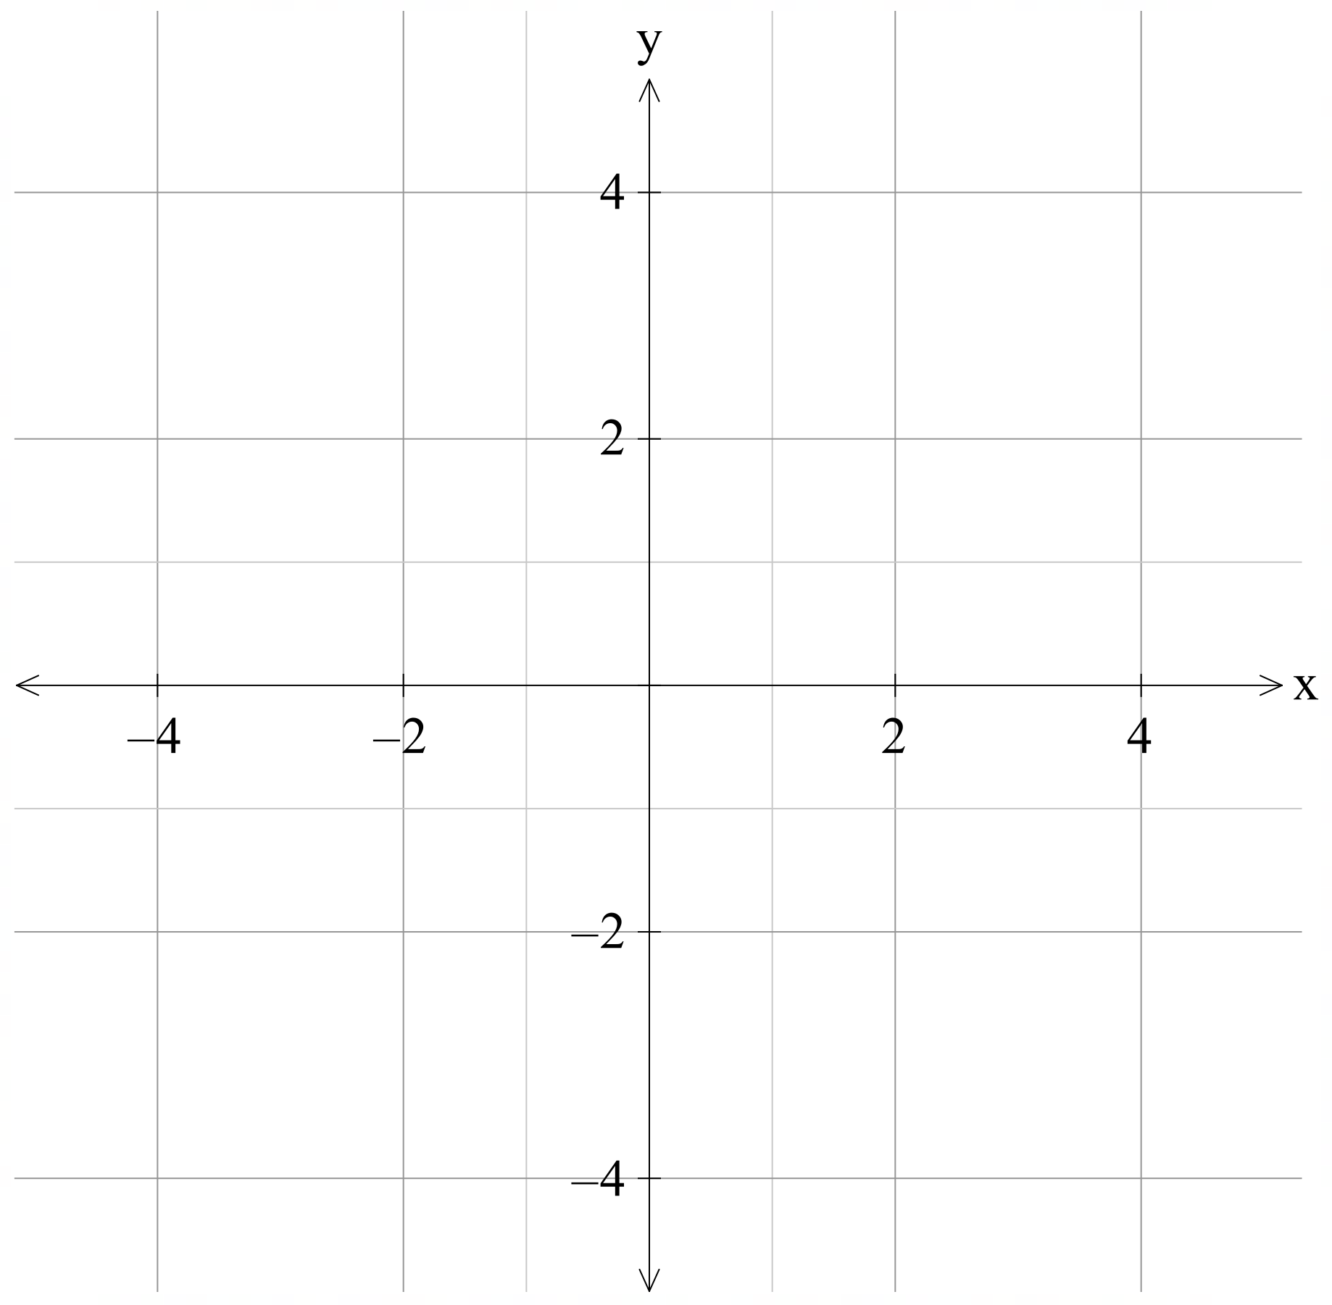
 | 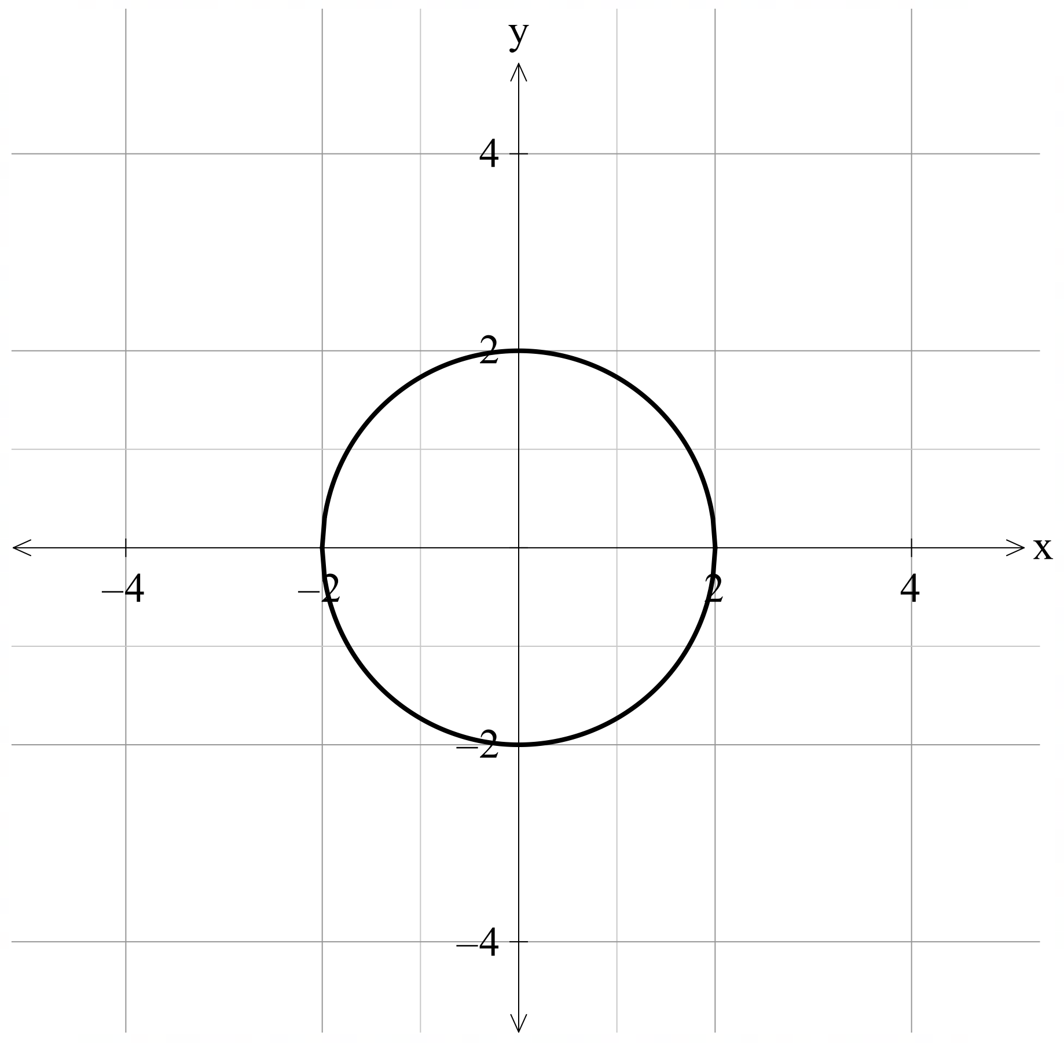
$$x^{2}+y^{2}=\frac{1}{4}$$
 | 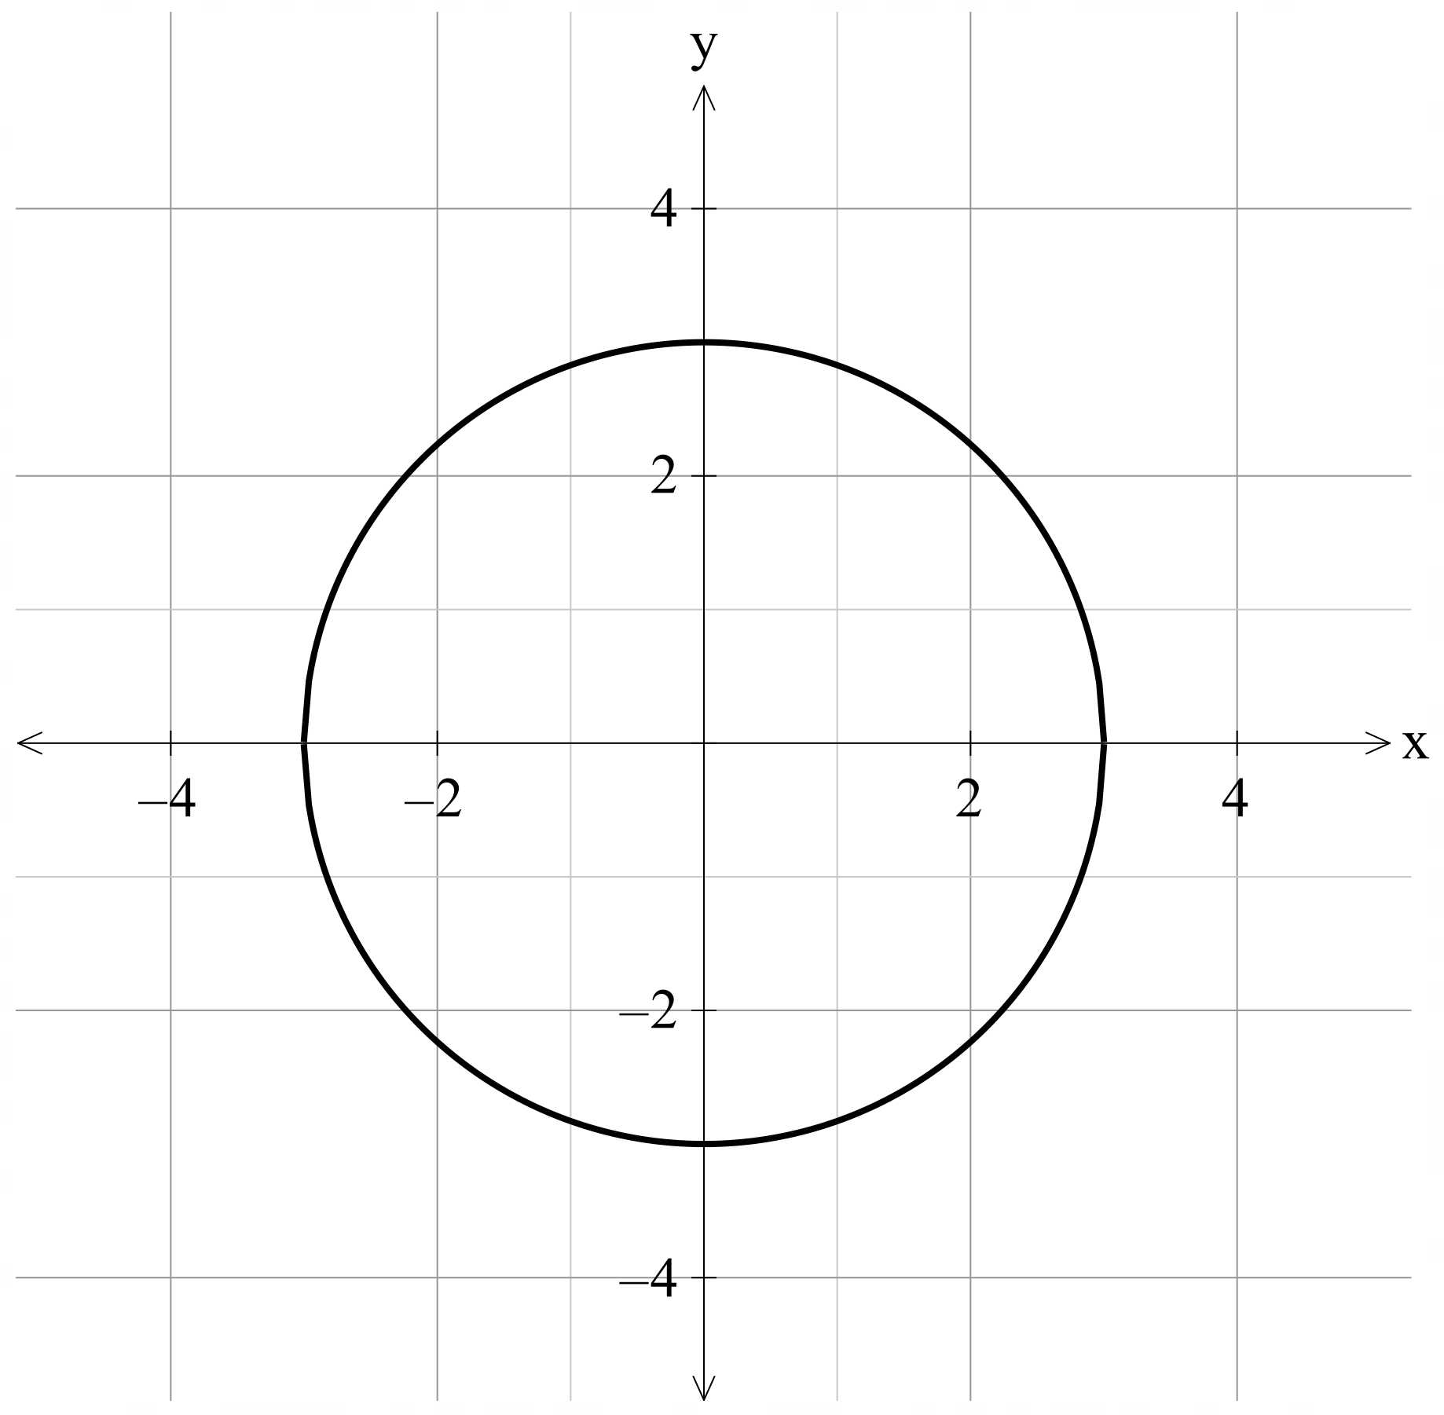
$$x^{2}+y^{2}=\frac{1}{9}$$ | 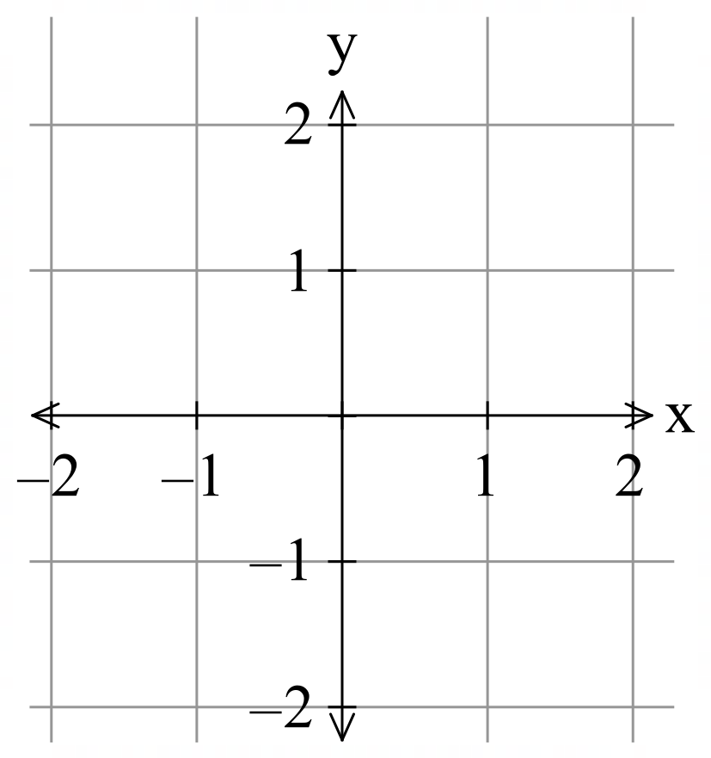
 | 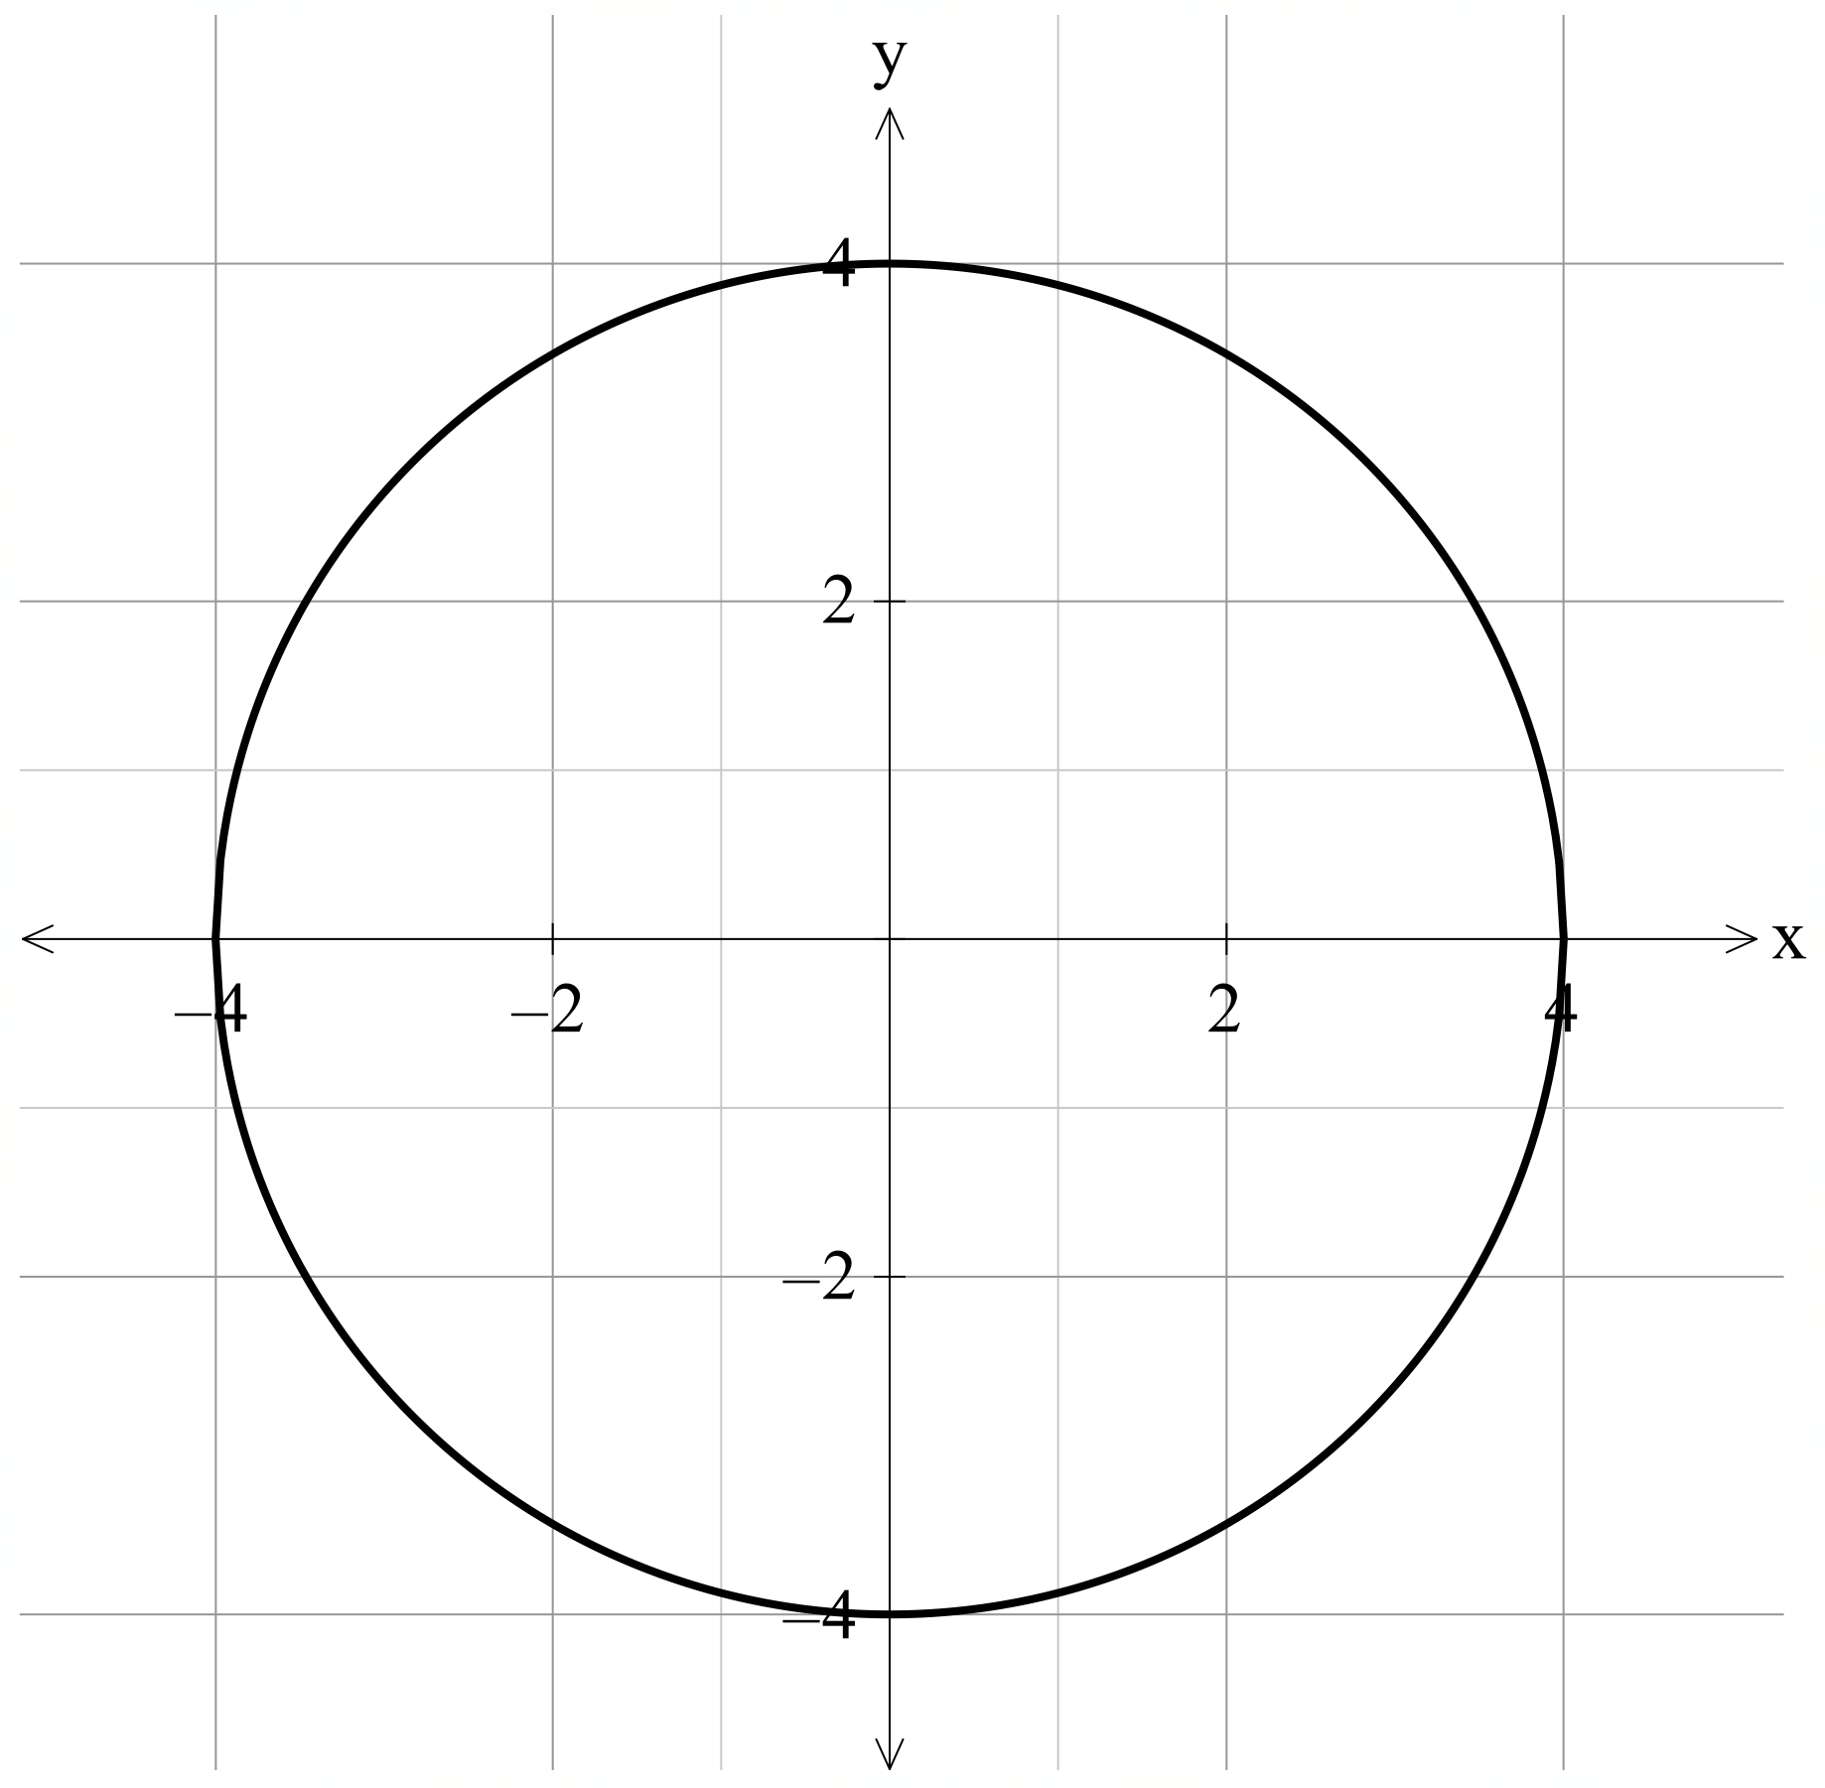

Sample solutions

Appendix A – missing drone
The following points are exactly 5 units from the origin.
$\left(0, 5\right), \left(3,4\right), \left(3,-4\right), \left(-4, -3\right), (-3,4)$.
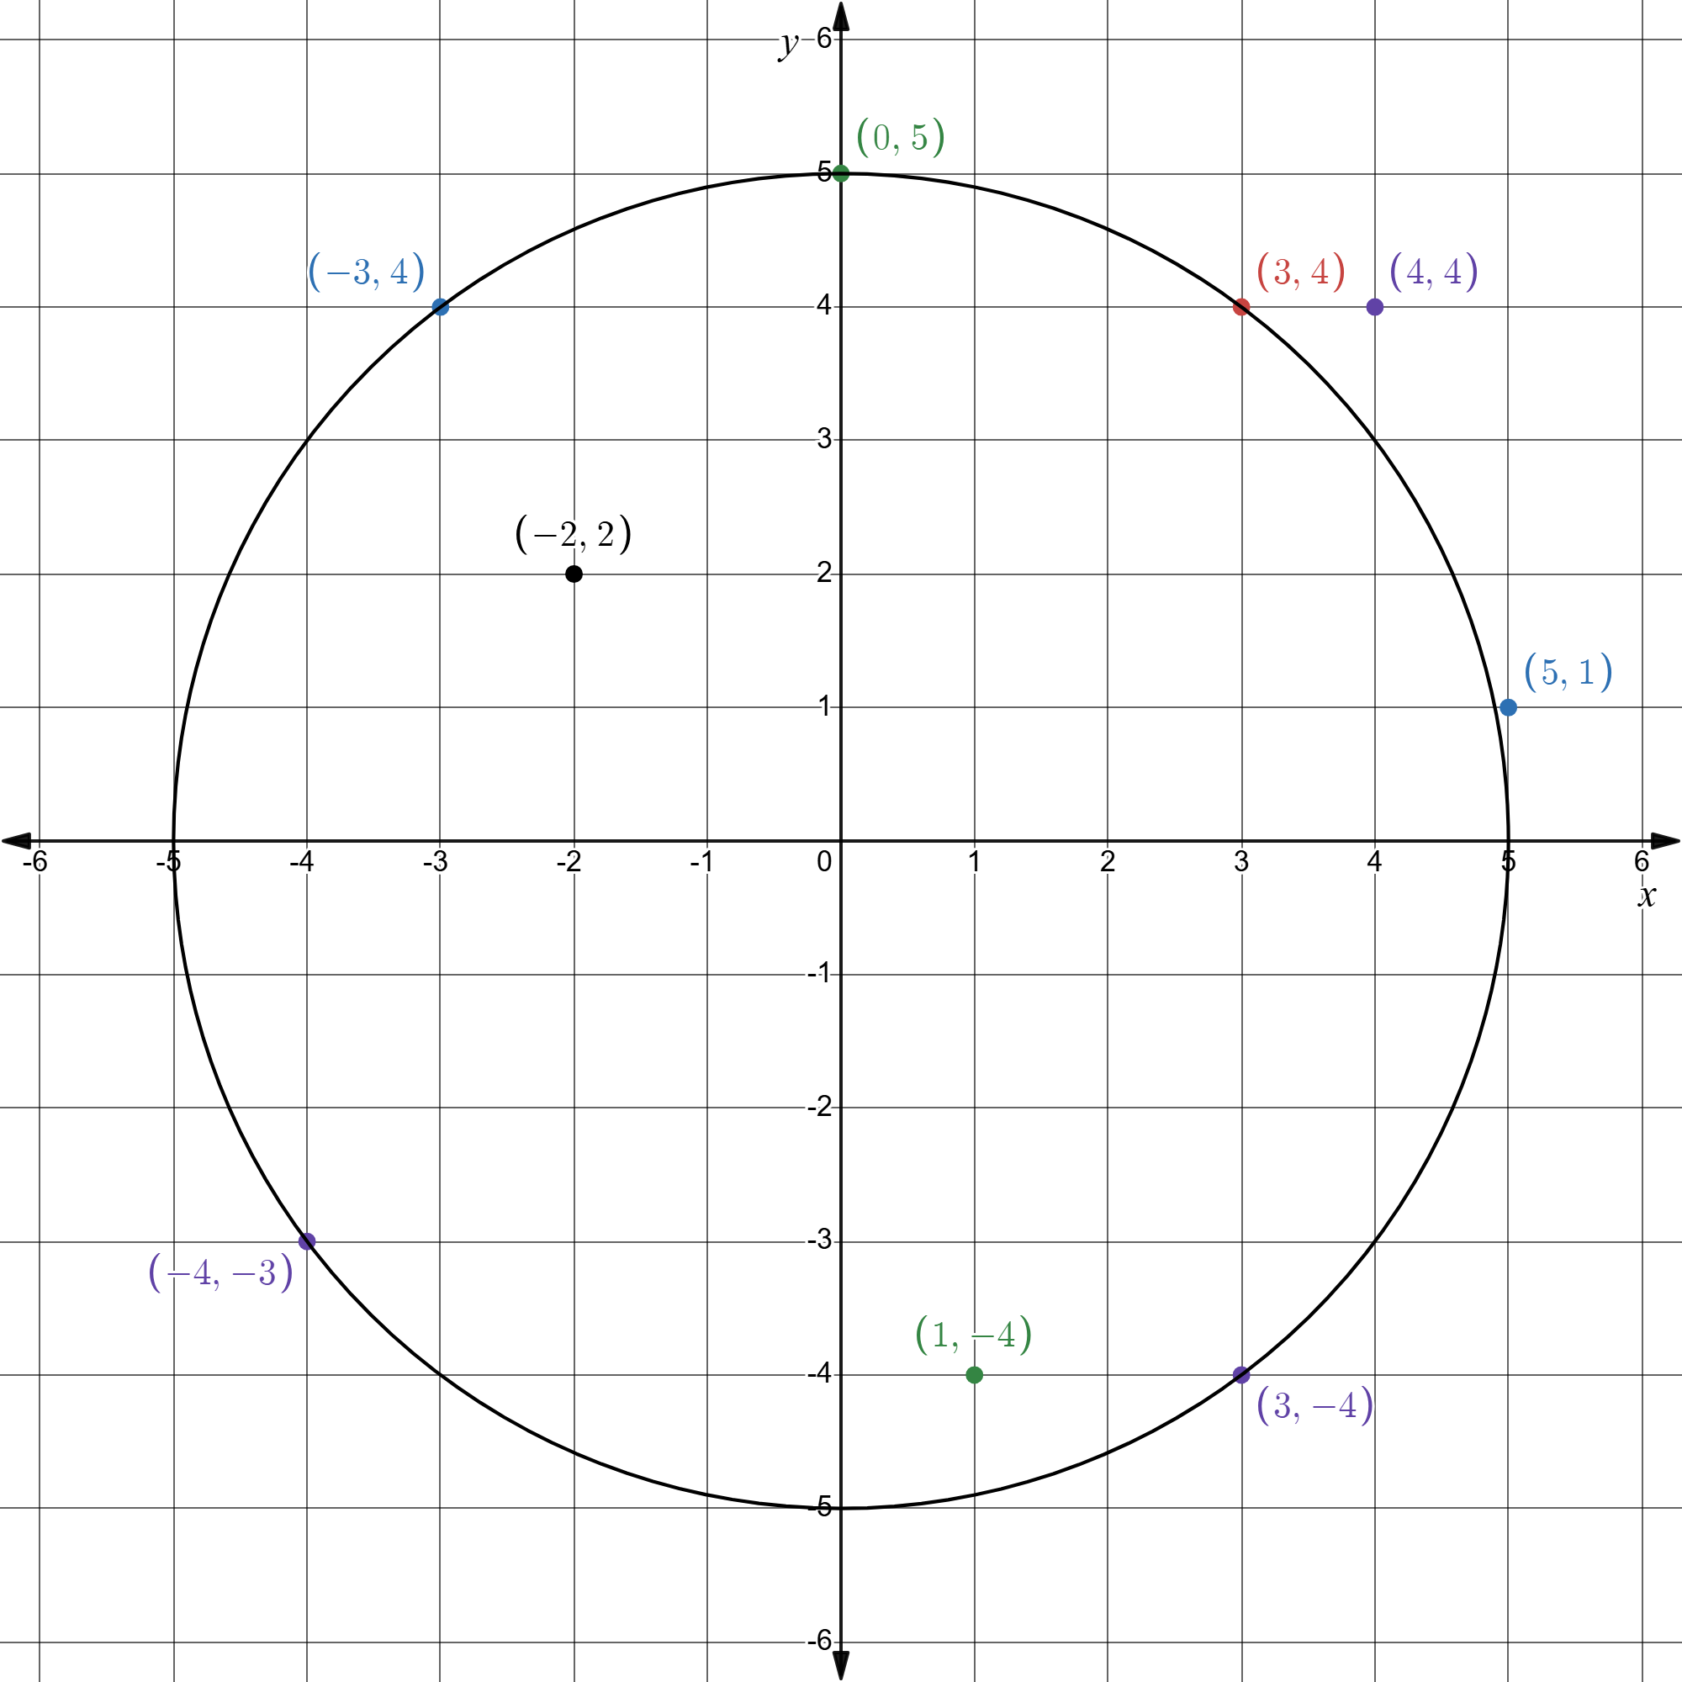

Appendix B – graphs and equations of circles
Equation | Graph
$$x^{2}+y^{2}=1$$ | 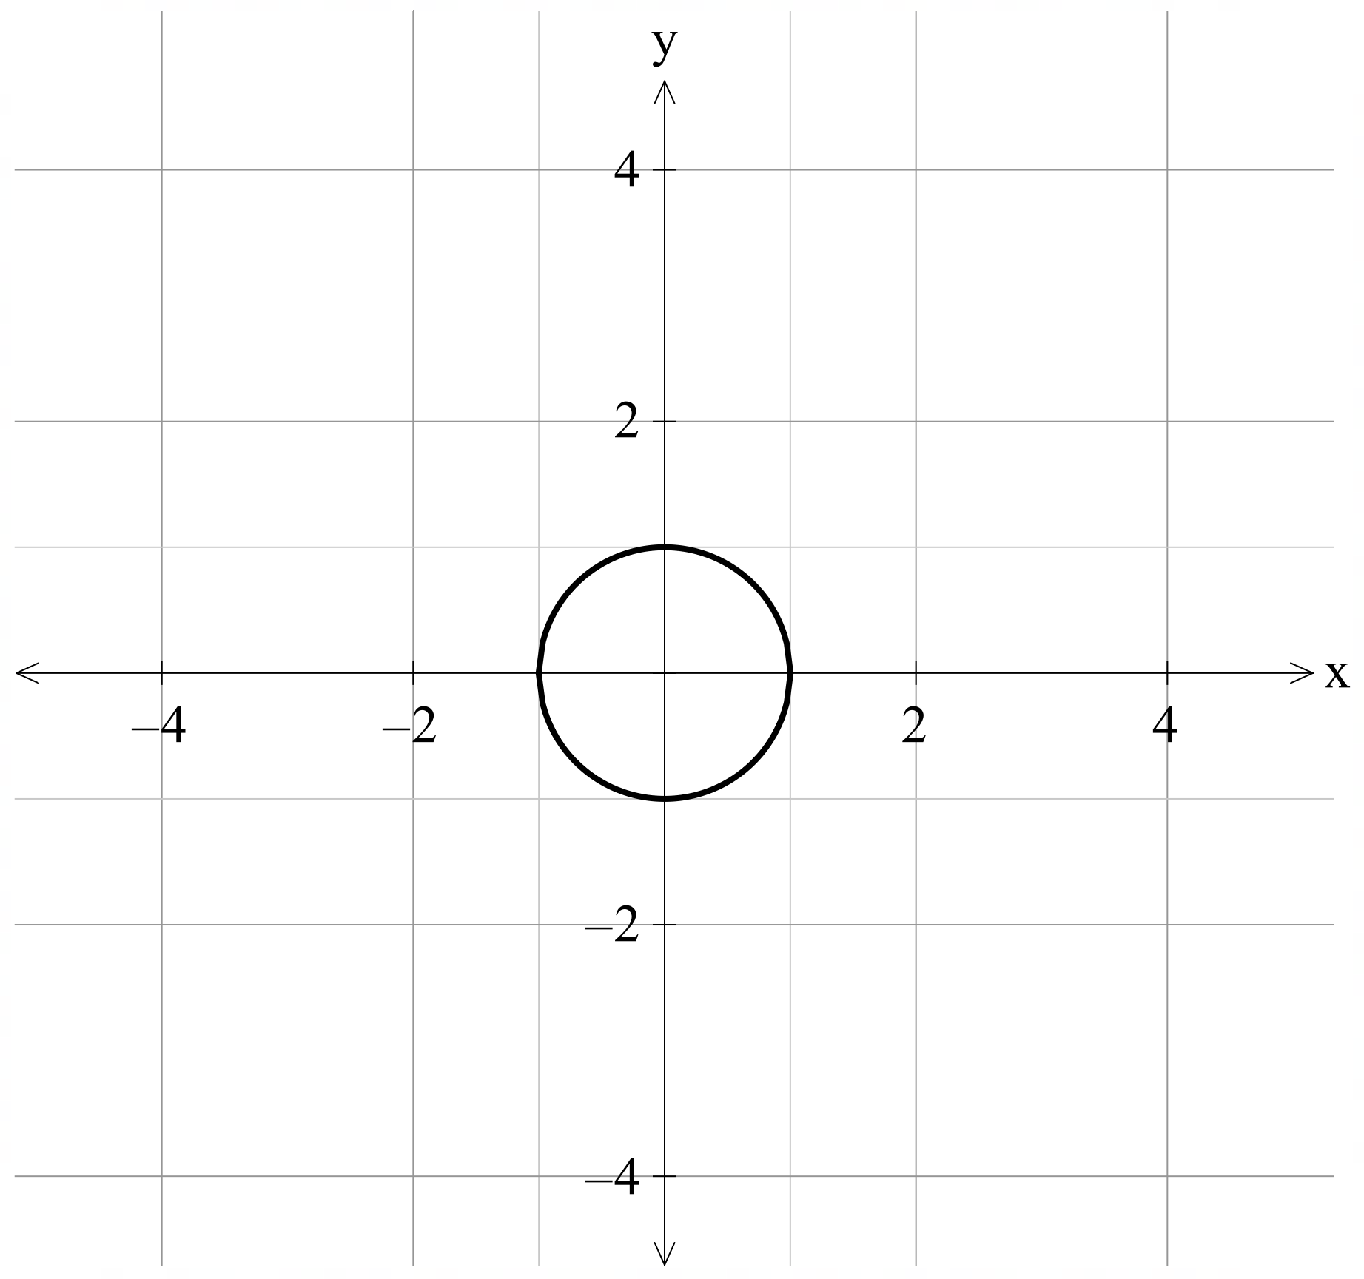
$$x^{2}+ y^{2}=4$$
$$x^{2}+y^{2}=\frac{1}{4}$$ | 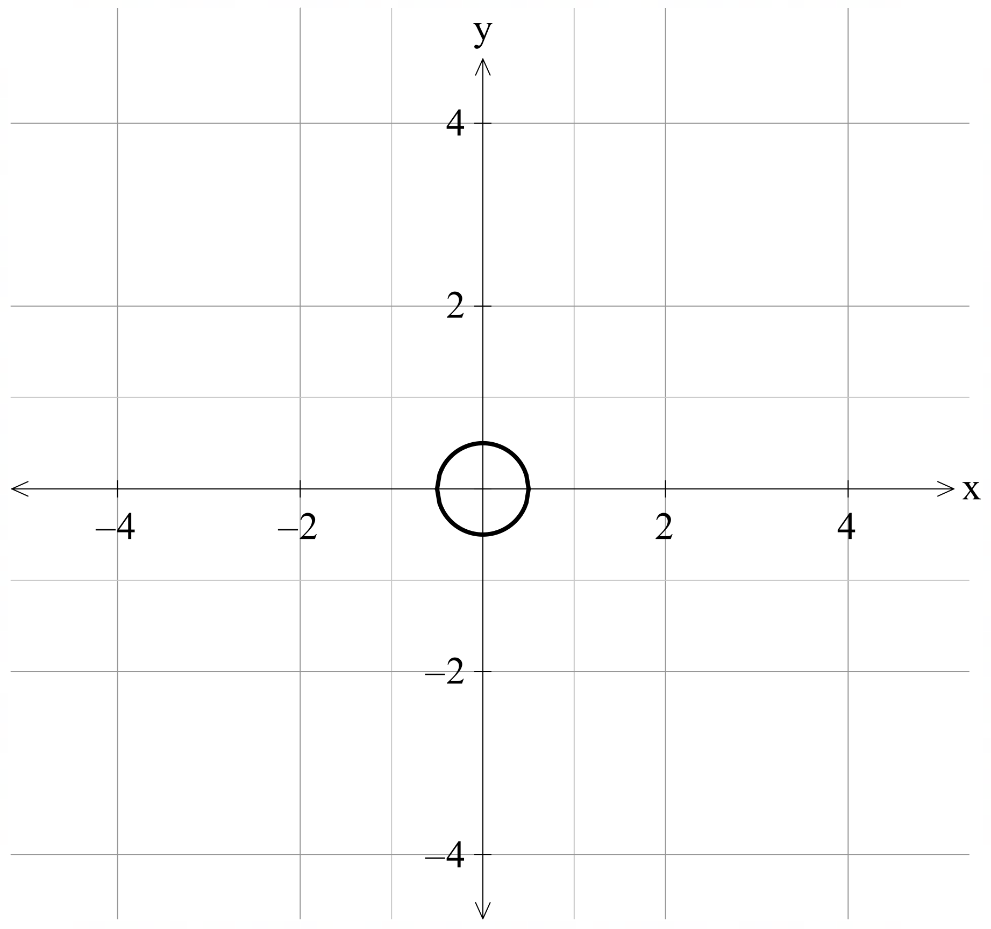
$$x^{2}+y^{2}=9$$
$$x^{2}+y^{2}=\frac{1}{9}$$ | 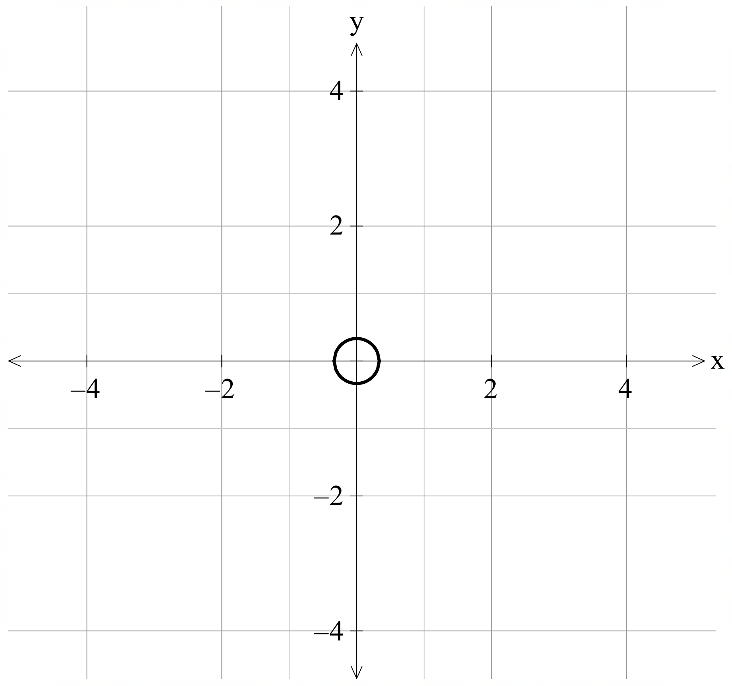
$$x^{2}+y^{2}=16$$

Independent practice activity
A semicircle and a parabola
$y=-x^{2}+16$ and $y=-\sqrt{16-x^{2}}$
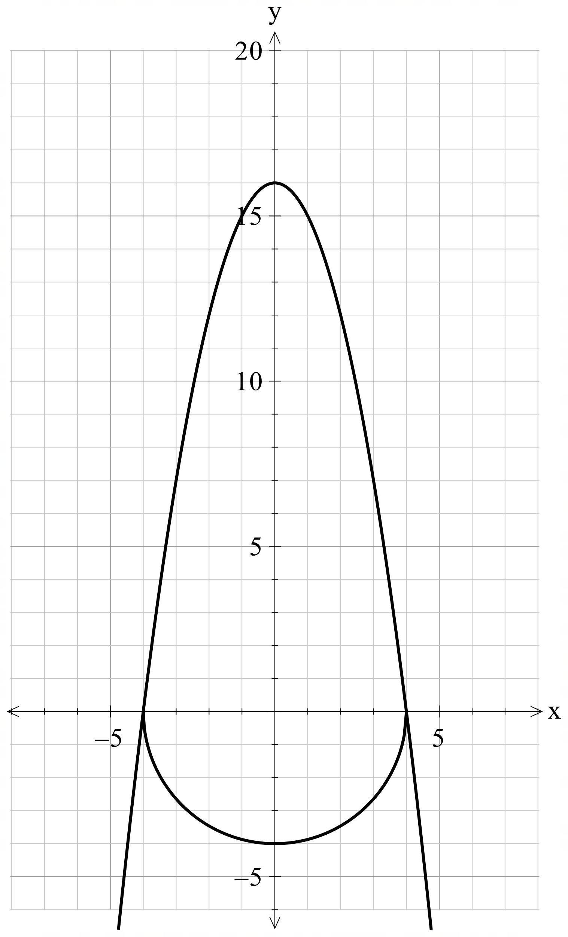
A semicircle and straight lines
$y=\sqrt{25-x^{2}}$, $y=x-5$ and $y=-x-5$
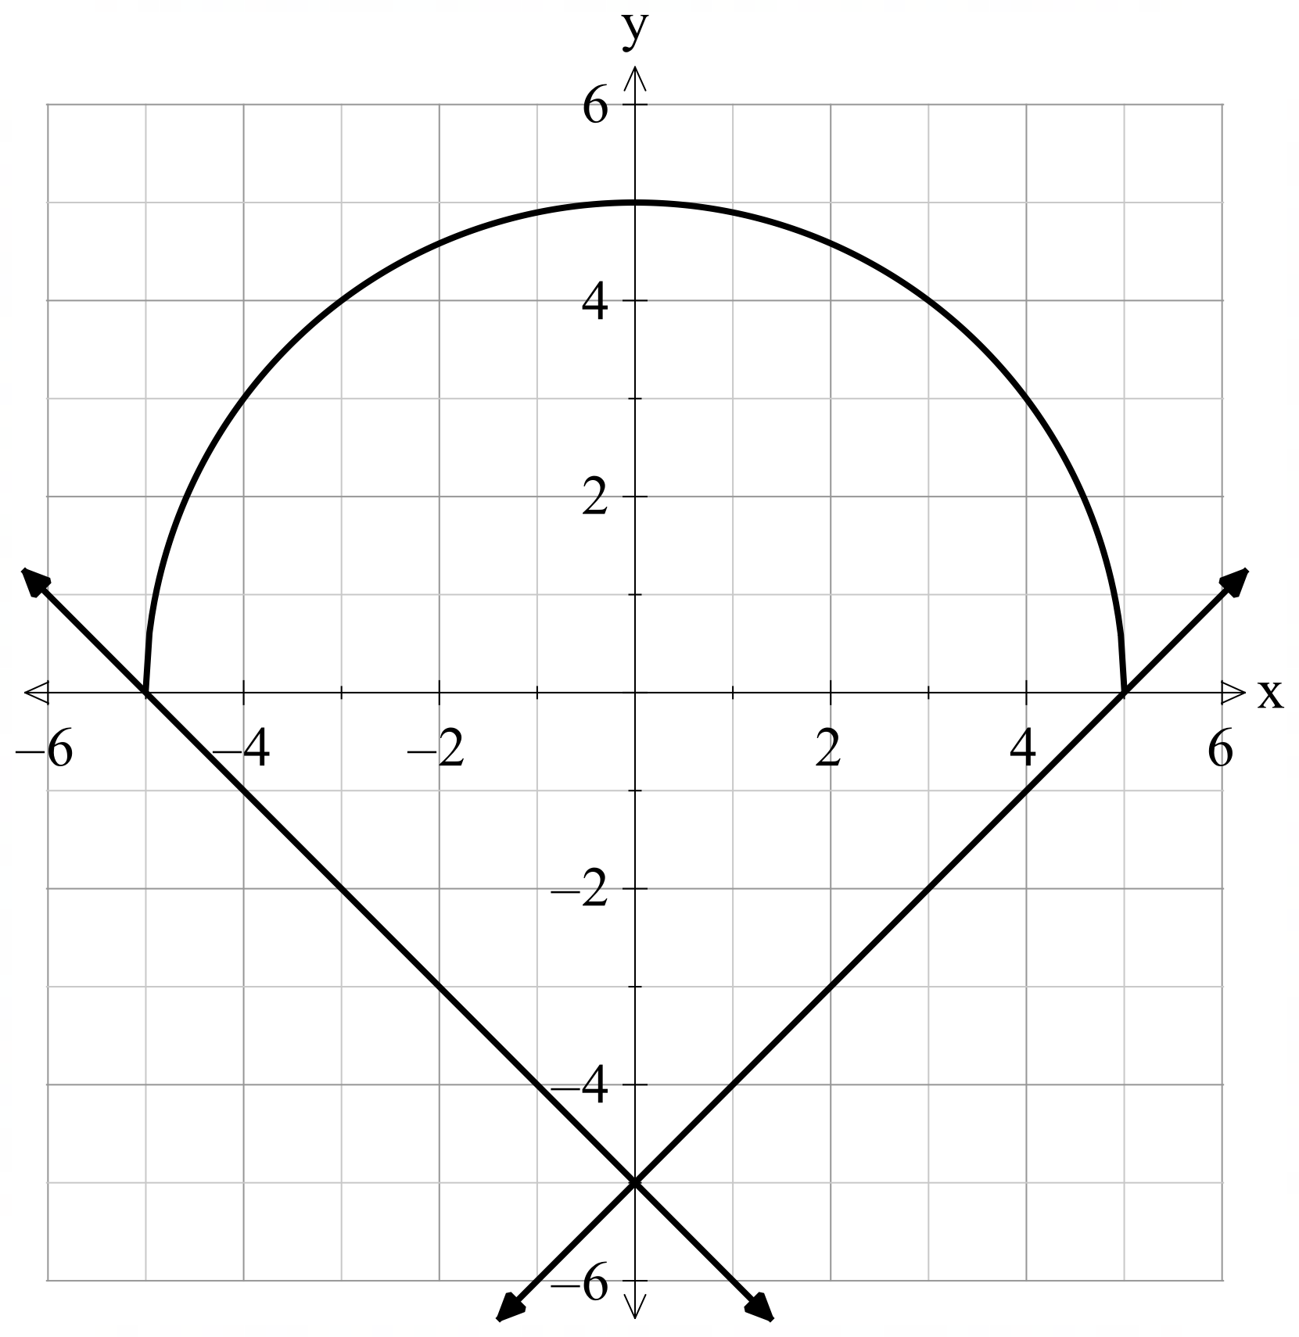
A semicircle, exponential and a straight line
$y=-\sqrt{16-x^{2}}$, $y=2^{x}$ and $y=-2x+8$
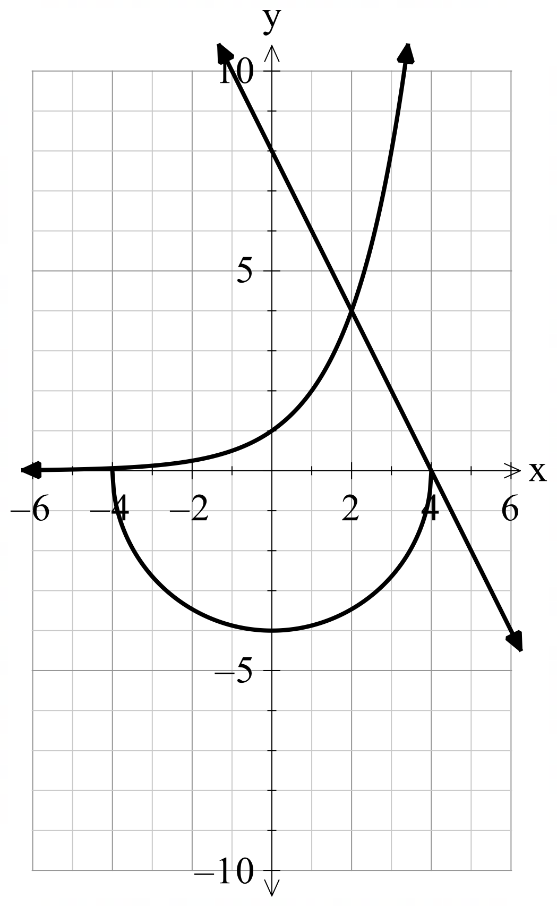
Semicircles and a vertical line
$x=-\sqrt{25-x^{2}}$, $x=-\sqrt{1-x^{2}}$ and $x=0$
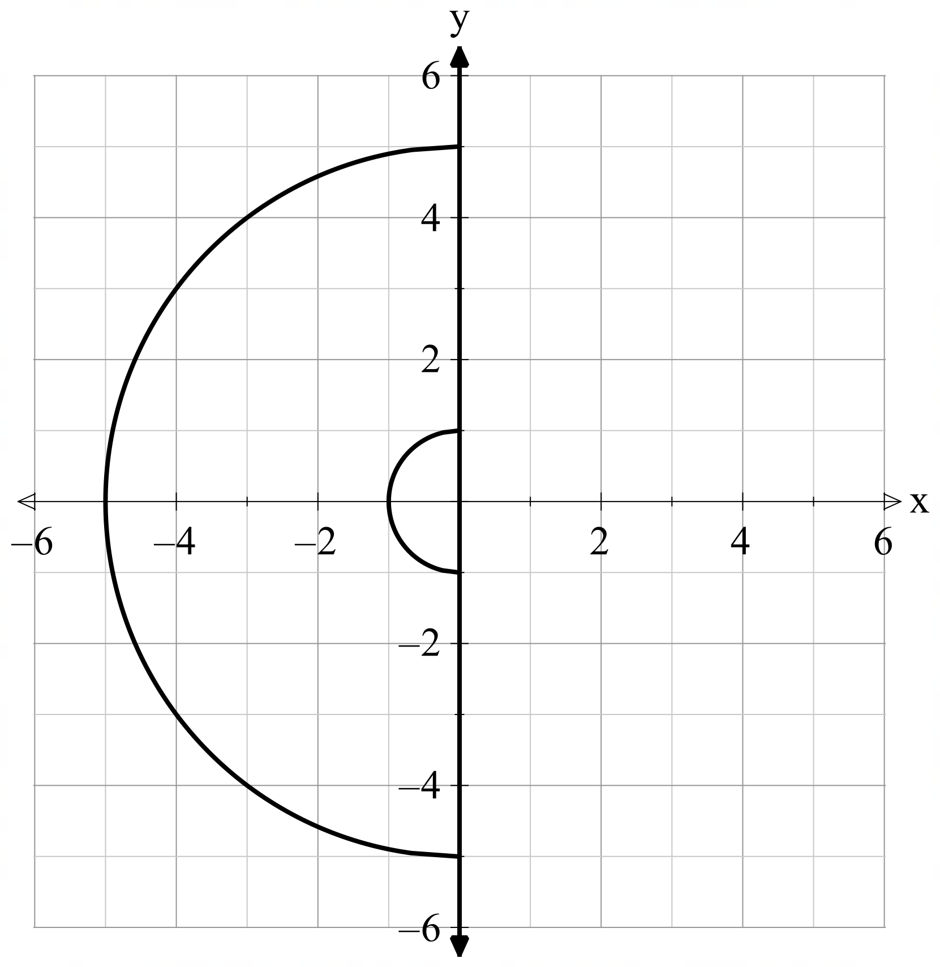

References
This resource contains NSW Curriculum and syllabus content. The NSW Curriculum is developed by the NSW Education Standards Authority. This content is prepared by NESA for and on behalf of the Crown in right of the State of New South Wales. The material is protected by Crown copyright.
Please refer to the NESA Copyright Disclaimer for more information https://educationstandards.nsw.edu.au/wps/portal/nesa/mini-footer/copyright.
NESA holds the only official and up-to-date versions of the NSW Curriculum and syllabus documents. Please visit the NSW Education Standards Authority (NESA) website https://educationstandards.nsw.edu.au/ and the NSW Curriculum website https://curriculum.nsw.edu.au.
Mathematics Advanced 11–12 Syllabus © NSW Education Standards Authority (NESA) for and on behalf of the Crown in right of the State of New South Wales, 2024.

© State of New South Wales (Department of Education), 2025
The copyright material published in this resource is subject to the Copyright Act 1968 (Cth) and is owned by the NSW Department of Education or, where indicated, by a party other than the NSW Department of Education (third-party material).
Copyright material available in this resource and owned by the NSW Department of Education is licensed under a Creative Commons Attribution 4.0 International (CC BY 4.0) license.

This license allows you to share and adapt the material for any purpose, even commercially.
Attribution should be given to © State of New South Wales (Department of Education), 2025.
Material in this resource not available under a Creative Commons license:
- the NSW Department of Education logo, other logos and trademark-protected material
- material owned by a third party that has been reproduced with permission. You will need to obtain permission from the third party to reuse its material.
Links to third-party material and websites
Please note that the provided (reading/viewing material/list/links/texts) are a suggestion only and implies no endorsement, by the New South Wales Department of Education, of any author, publisher, or book title. School principals and teachers are best placed to assess the suitability of resources that would complement the curriculum and reflect the needs and interests of their students.
If you use the links provided in this document to access a third-party's website, you acknowledge that the terms of use, including licence terms set out on the third-party's website apply to the use which may be made of the materials on that third-party website or where permitted by the Copyright Act 1968 (Cth). The department accepts no responsibility for content on third-party websites.

