The cubic and reciprocal function
This lesson builds on students’ prior knowledge of linear, quadratic and exponential graphs by introducing the key features of cubic and reciprocal functions. Students analyse how modifying the equations influences the shape, intercepts and overall behaviour of these more complex graphs.
Students may need at least one digital device per pair to interact with Amplify (Desmos) during this lesson, although an alternative activity that does not require technology has been provided.

Learning intentions
- To be able to describe the features of cubic and reciprocal functions.
- To understand how changes in the equation affect the shape and key features of cubic and reciprocal graphs.

Success criteria
- I can sketch and describe the features of cubic and reciprocal functions.
- I can explain how the coefficient changes the shape of the graph.
- I can compare cubic and reciprocal functions with linear, quadratic and exponential functions.
- I can justify my choice of an equation for a function based on its graphical description.

Outcomes
A student:
- develops understanding and fluency in mathematics through exploring and connecting mathematical concepts, choosing and applying mathematical techniques to solve problems, and communicating their thinking and reasoning coherently and clearly MAO-WM-01
- applies algebraic techniques and the laws of indices and surds to manipulate expressions and solve problems MAV-11-01
- uses functions and relations to model, analyse and solve problems MAV-11-02
- analyses graphs of exponential and logarithmic functions MAV-11-08

Content

Quadratic and cubic functions
- Recognise and graph cubic functions of the form $f(x)=kx³$ and $f(x)=k(x - a)(x - b)(x – c$), where $a, b, c$ and $k$ are constants and $k≠0$

Reciprocal functions
- Graph functions of the form $f\left(x\right)=\frac{k}{x}$, where $k$ is a constant and $k≠0$, and identify their hyperbolic shape and their asymptotes
- Describe the behaviour of $f\left(x\right)=\frac{k}{x}$ as $x→∞$ and $x→-∞$

Exponential functions
- Graph the exponential functions $y=k(a^{x})$ and $y=k(a^{-x})$ for constants $a$ and $k$ where $a>0$, $a≠1$ and $k≠0$, and identify its asymptote, $y$-intercept, domain and range
- Describe the behaviour of $y=k\left(a^{x}\right)$ and $y=k(a^{-x})$ as $x→∞$ and $x→-∞$
Mathematics Advanced 11–12 Syllabus © NSW Education Standards Authority (NESA) for and on behalf of the Crown in right of the State of New South Wales, 2024.

Table 1: lesson summary
Section | Summary of activity | Teaching strategies | Teaching points
Activating prior knowledge | Using slides 4–6, students sketch a base function, followed by a set of related functions. Students compare each new graph to the base function and identify how changes to the equation affect the gradient, shape and position. | Visibly random groups of 3  Vertical non-permanent surfaces  Pose-Pause-Pounce-Bounce | Activate students’ prior knowledge of linear, quadratic and exponential functions, building a foundation for understanding more complex graphs later in the lesson.
Connecting learning | Students can either use the Amplify activity (bit.ly/DesmosCubicReciprocal) or work in groups using slides 8–13 of the PowerPoint The cubic and reciprocal function. Students analyse the cubic and reciprocal functions by sketching base graphs using a table of values and building on this to graph related equations. | Visibly random groups of 3  Vertical non-permanent surfaces  Pose-Pause-Pounce-Bounce | Link students’ prior knowledge with examining how changes to equations affects the shape, position and features of new functions.
Releasing responsibility | Students create collaborative notes summarising the key features of cubic and reciprocal functions. | Visibly random groups of 3  Vertical non-permanent surfaces  Notes to future forgetful selves  Gallery walk | Consolidate students’ understanding of cubic and reciprocal functions by reinforcing key features of their graphs and equations.
Independent practice | Using Appendix A, students work in groups to write equations that match a given description of both linear and non-linear relationships. | Visibly random groups of 3  Vertical non-permanent surfaces  Pose-Pause-Pounce-Bounce | Reinforce students’ understanding of key graphical features and equations by challenging them to work backwards, from a graph to constructing a possible equation.

Activity structure
Please use the associated PowerPoint The cubic and reciprocal function to display images in this lesson.

Activating prior knowledge
- Assign students to visibly random groups of 3 (bit.ly/visiblegroups) at vertical non-permanent surfaces (bit.ly/VNPSstrategy).
- Display slide 4 of the PowerPoint. In their groups of 3, have students begin by discussing how the graph of $y=x$ would change for each of the 4 additional equations listed.
- At their vertical non-permanent surfaces, have each group first sketch $y=x,$ then sketch the 4 additional equations on the same set of axes.
Remind students that this is a sketch, so it doesn’t need to be perfectly to scale. If a group is unsure how to draw a graph, encourage them to consider the gradient and $y$-intercept of each.
- Use the Pose-Pause-Pounce-Bounce questioning strategy (PDF 557 KB) (bit.ly/posepausepouncebounce) to check for understanding of the graph of a straight line and how differing equations produce different graphs. The following are some suggested prompts:
- How does changing the coefficient of $x$ affect the graph of the line?
- How does a negative coefficient of $x$ affect the graph of the line?
- How is the graph of the line affected when $+3$ was added to the equation?
- Display slide 5 and have students work in their groups of 3 to sketch $y=x^{2}$ and begin discussing how the graph of $y=x^{2}$ would change for each of the 4 equations listed. Students can then sketch the 4 equations on the same set of axes.
- Use the Pose-Pause-Pounce-Bounce questioning strategy to check for understanding of the graph of a parabola and how differing equations produce different graphs. The following are some suggested prompts:
- How does changing the coefficient of $x^{2}$ affect the shape of the parabola?
- How does a coefficient larger than 1 compare to a coefficient smaller than 1?
- What effect does a negative coefficient of $x^{2}$ have on the graph of the parabola?
- How does adding a constant, like in $y=x^{2}+3$, affect the graph?
- Display slide 6 and in their groups of 3, have students sketch $y=3^{x}$ and begin discussing how the graph of $y=3^{x}$ would change for each of the 3 equations listed. Students can then sketch these 3 equations on the same set of axes.
- Use the Pose-Pause-Pounce-Bounce questioning strategy to check for understanding of the graph of an exponential and how differing equations produce different graphs. The following are some suggested prompts:
- How does multiplying the exponential function, $y=3^{x}$, by a constant affect the shape of the graph?
- What is the effect of multiplying the exponential function $y=3^{x}$ by $-1$?
- What do these exponential graphs have in common?
- How do the exponential graphs change as the value of $x$ changes from very small to very large?
- What might $y=3^{x}+2$ look like?
- Conduct a class discussion to determine if all the graphs that were drawn are functions. By selecting non-volunteer students, have them explain their reasoning as to why all the graphs represent functions.
Students graphed linear, quadratic and exponential functions in Lesson 1 – functions and Lesson 2 – function values and intercepts.
This activity is designed to activate students’ prior knowledge of how the coefficients of $x$ and $x^{2}$ influence the shape of a graph. It extends this understanding to exponential functions, including the role of the asymptote. This foundational knowledge will support students as they investigate cubic and reciprocal functions later in the lesson.

Connecting learning
Students can complete the activity below to explore non-linear relationships through collaborative discussion. They should work at vertical non-permanent surfaces in their groups of 3.
Alternatively, this activity can be completed in pairs, by assigning the Amplify (Desmos) activity ‘The cubic and reciprocal function’ (bit.ly/DesmosCubicReciprocal).
Before using this activity, you will need to set up an Amplify classroom (bit.ly/createamplifyclassroom).
Use the pacing feature to restrict students to view only screens 1–8 for the cubic function and then move to screens 9–16 for the reciprocal function. Discussion points and suggested questioning prompts should be used in conjunction with the Amplify activity.

The cubic function
- Display slide 8 and continuing in their groups of 3 on vertical non-permanent surfaces, have groups complete a table of values for the cubic equation $y=x^{3}$.
- Animate the self-explanation prompts followed by the completed table of values and have students discuss the prompts in their groups.
- Have a class discussion where students share their answers to the prompts. Ask students to draw in the air what they think the graph of $y=x^{3}$ might look like and then attempt to sketch it at their vertical non-permanent surfaces.
- Display slide 9 which contains a sketch of $y=x^{3}$. Have students make any necessary adjustments to their cubic sketches.
Students may find it challenging to describe the shape of the graph near the origin. Some students may mistakenly think the graph resembles the straight line $y=x$.
To address this misconception, have students examine whether the relationship is linear by looking at how the $y$-values change in a table of values. For example, if the function were linear, the difference in $y$-values would be constant for equal steps in $x$. However, students can observe that when $x$ increases from 0 to 1, the change in $y$ is 1; from 1 to 2, the change is 7; and from 2 to 3, the change is 19. This increasing rate of change indicates the relationship is non-linear.

While the term 'point of inflection’ is not required knowledge in the Year 11 Mathematics Advanced course, students will encounter it in Year 12 Mathematics Advanced Applications of calculus outcome MAV-12-06. At this stage, it can be helpful to describe a point of inflection using its visual characteristics rather than the formal calculus definition. For example, students can observe that the curve is concave down to the left of the origin and concave up to the right. A point of inflection is the point on the graph where change in concavity occurs.
- Animate the 3 additional cubic equations and have students sketch them on the same set of axes.
- Display slide 10, which shows the graph of the additional 3 cubic equations on the same set of axes as $y=x^{3}$. Use the Pose-Pause-Pounce-Bounce questioning strategy to check for understanding of the graph of a cubic function and how the differing equations produced different graphs. The following are some suggested prompts:
- How does changing the coefficient of $x^{3}$ affect the shape of the graph?
- What similarities do you notice across different types of functions when a coefficient is changed?
- What effect does a coefficient of $-1$have on the graph of $y=-x^{3}$?
- Is $y=x^{3}$ a function? How do you know?
- What might the graph of $y=x^{3}+3$look like?
The purpose of this questioning is for students to see the similarities in how changes to the equation affect the shape and position of different graphs. By comparing the cubic function to linear, quadratic and exponential graphs they have previously explored, students begin to develop a broader understanding of how equations relate to the behaviour of a graph.

The reciprocal function
- Display slide 11 and continuing in their groups of 3 on vertical non-permanent surfaces, have groups complete a table of values for the reciprocal equation $y=\frac{3}{x}$.
- Animate the self-explanation prompts followed by the completed table of values and have students in their groups discuss the prompts.
- Have a class discussion where students share their answers to the prompts. Ask students to draw in the air what they think the graph of $y=\frac{3}{x}$ might look like and then attempt to sketch it on their vertical non-permanent surfaces.
- Display slide 12 which contains a sketch of $y=\frac{3}{x}$ and have students compare and possibly correct their sketch.
Students may find it challenging to describe what happens to the graph near the vertical asymptote at $x=0$. To support their understanding, encourage students to examine how the values of $y=\frac{3}{x}$ change as $x$ gets closer to zero from the positive side and from the negative side.
You can help students link this behaviour to their prior knowledge of exponential graphs. Ask students to compare how $y=\frac{3}{x}$ increases or decreases sharply near $x=0$ to the behaviour of an exponential as $x→∞$ and $x→-∞$. This connection helps students develop a deeper understanding of how functions behave near boundaries.
Students can also notice that as $x$ becomes very large or very small (large negative), the values of $y$ get closer to zero, showing a horizontal asymptote at $y=0$. This behaviour is similar to how exponential graphs approach their horizontal asymptote.
- Animate the 3 additional reciprocal equations on slide 12 and have students sketch them on the same set of axes.
- Display slide 13, which shows the graph of the additional 3 reciprocal equations on the same set of axes as $y=\frac{3}{x}$. Use the Pose-Pause-Pounce-Bounce questioning strategy to check for understanding of the graph of a reciprocal function and how differing equations produce different graphs. The following are some suggested prompts:
- How does changing the value in the numerator affect the graph when compared to $y=\frac{3}{x}$?
- What effect does multiplying the equation by $-1$ have on the graph? Is this similar to how other non-linear graphs behave?
- Do any of the graphs have any zeroes? Why or why not?

Releasing responsibility
- Assign new visibly random groups of 3 at vertical non-permanent surfaces. Explain to students that they are to brainstorm what might be included in their notes to their future forgetful selves (bit.ly/notestofutureself) on the key features for both the equation and graph of a cubic and reciprocal function.
- Encourage the groups to draw visual representations to aid in their understanding and to include and describe:
- the shape of the function
- the behaviour of the graph as $x→0$ and $x→±∞$
- the effect on the graph if coefficients are adjusted or negative signs are added
- any asymptotes
- how each of these graphs may be related to prior knowledge of straight lines, parabolas and the exponential functions.
- Allow groups to do a gallery walk (bit.ly/DLSgallerywalk) to view other group’s responses or restrict groups to just look at neighbouring groups, noting any similarities or differences. Encourage students to return to their group to add or adjust their notes if necessary.
- Have a class discussion where groups share their understanding of both the cubic and reciprocal functions. Then have students return to their workspaces to create individual notes to their future forgetful selves on the features of both the equation and graph of the cubic and reciprocal function.
- Explain to the class that different types of functions can be used to model real-world scenarios. Specifically, cubic functions can be used to model volume problems, for example the growth of a cube and reciprocal functions can be used to model work problems, for example the more workers there are, the less time the work takes.
Students may recall from direct and inverse variation from Stage 5 Variation and rates of change A (Path) outcome MA5-RAT-P-01, where linear and reciprocal functions were used to present problems.

Independent practice
- Distribute Appendix A ‘Design a function challenge’ to each student and have students return to their groups of 3 from the last activity at vertical non-permanent surfaces. In this activity, students will design a possible equation for linear and non-linear relationships that match a provided description.
- Students can be encouraged to check their answers with the group next to them and/or use graphing applications such as Desmos Graphing Calculator.
- Use the Pose-Pause-Pounce-Bounce questioning strategy to share student answers and to encourage reasoning and justification for the equation selected. The following are some suggested prompts:
- How did you know to use that coefficient?
- What tells you this graph has no zeroes?
- How did you connect the description to the graphical representation?
- How did you connect the description to the equation that you selected?

Assessment and differentiation

Suggested opportunities for differentiation
Activating prior knowledge
- Students could be encouraged to draw a table of values to assist with their sketches.
- Students could look at parabolas of the form $y=kx^{2}+c$ as an extension.
- Some students may benefit from using a graphing application, such as Desmos Graphing Calculator, to either assist them in getting started on the activity or checking their graphs.
Connecting learning
- Two activities have been provided, one that requires technology and one that does not. A decision should be made on which one to use that best suit the needs of the class.
- Depending on your class, the equations explored could be extended to include more complex functions, such as $y=ax^{3}+c$, $y=(x-a)(x-b)(x-c)$ and $y=\frac{k}{x}+c$.
Releasing responsibility
- The activity may need to be completed as a whole class.
Independent practice
- Some students may need assistance to graph and create an equation for description 8 of Appendix A. This may need to be done as an entire class.
- For Appendix A, challenge students to identify a variety of functions that meet the given clues and explain why each one fits.

Suggested opportunities for assessment
- Students working at vertical non-permanent surfaces for the entire lesson means the teacher can assess student progress and provide support where appropriate.
Activating prior knowledge
- Monitor student responses during questioning to check for student understanding of prior learning of linear, quadratic and exponentials.
Connecting learning
- Student responses to the provided prompts could be collected as a work sample for assessment.
- When placed in groups of 3, students provide and receive peer feedback on their understanding.
Releasing responsibility
- Students’ notes to their future forgetful selves can be collected to check their understanding of cubic and reciprocal functions.
Independent practice
- Students will demonstrate their Working mathematically skills in discussions and justifications.

Appendix A

Design a function challenge
A set of descriptions for different graphs have been provided below. Your task is to sketch a graph that fits the description and then write an equation that could represent it.

Descriptions
- A non-linear relationship that increases steeply for large positive $x$ values, decreases steeply for large negative $x$ values and passes only through the origin.
- A graph that only passes through the point $(0,4)$ on the $y$-axis, has no zeroes and is concave up.
- A graph that never touches the $x$-axis, only has positive $y$-values and increases slowly at first, before growing rapidly.
- A graph that is similar to graph 3 but approaches infinity faster and still has no zeroes.
- A linear relationship with a negative gradient and has $f\left(0\right)=3$.
- A curve that has no zeroes and gets very close to both the $x$ and $y$-axis but never touches them.
- A function that is symmetrical about the $y$-axis and when $f\left(x\right)=0$, the solutions are $±3$.
- A non-linear relationship with rotational symmetry of $180°$ about the origin. The curve has no zeroes and gets very close to both the $x$ and $y$-axes but never touches them. The graph passes through the point $(2, 3)$.

Sample solutions

Appendix A – design a function challenge
- $f\left(x\right)=ax^{3}$, where $a≥0$.
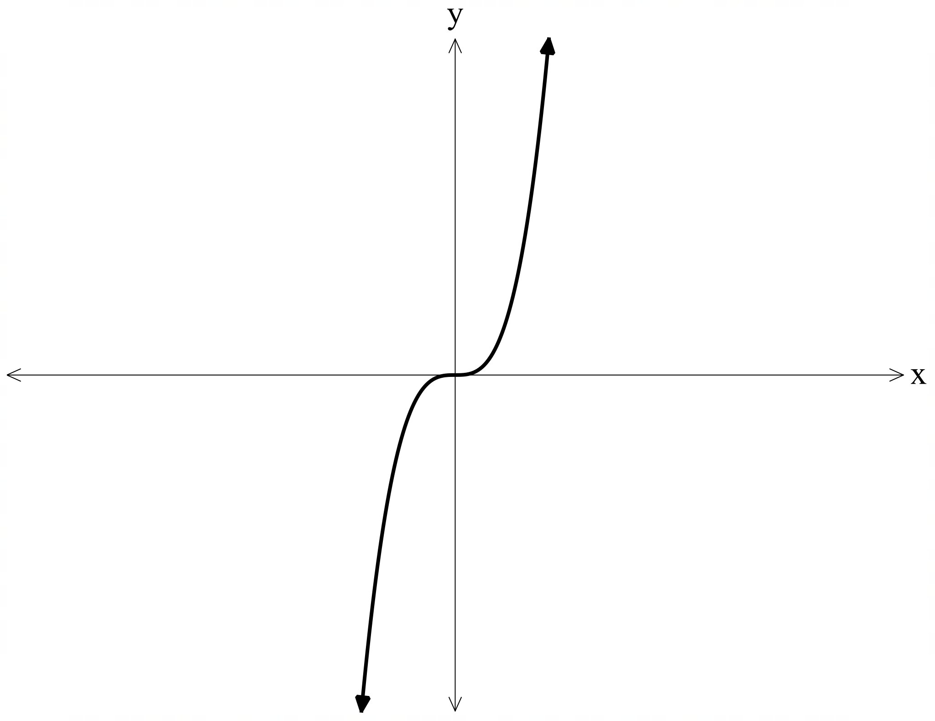
- $f\left(x\right)=x^{2}+4$.
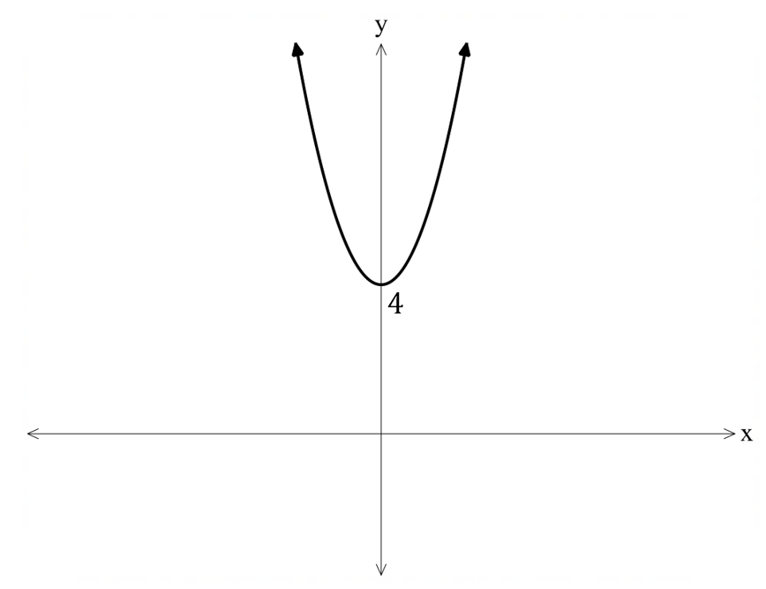
- $f\left(x\right)=a(k^{x})$, where $a>0$, $k>1$.
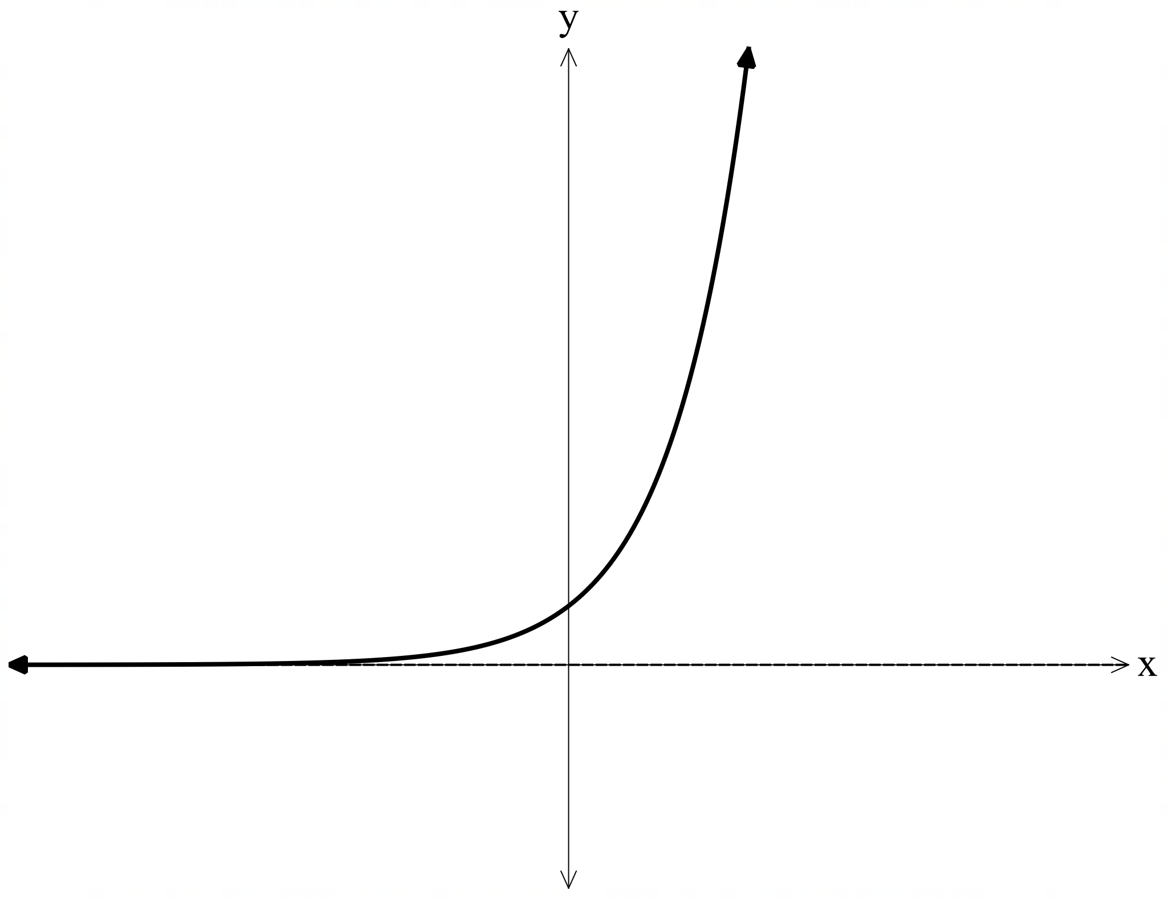

- $f\left(x\right)=a(k^{x})$, where $a>0$ and $k>$ the value of $k$ in graph 3.
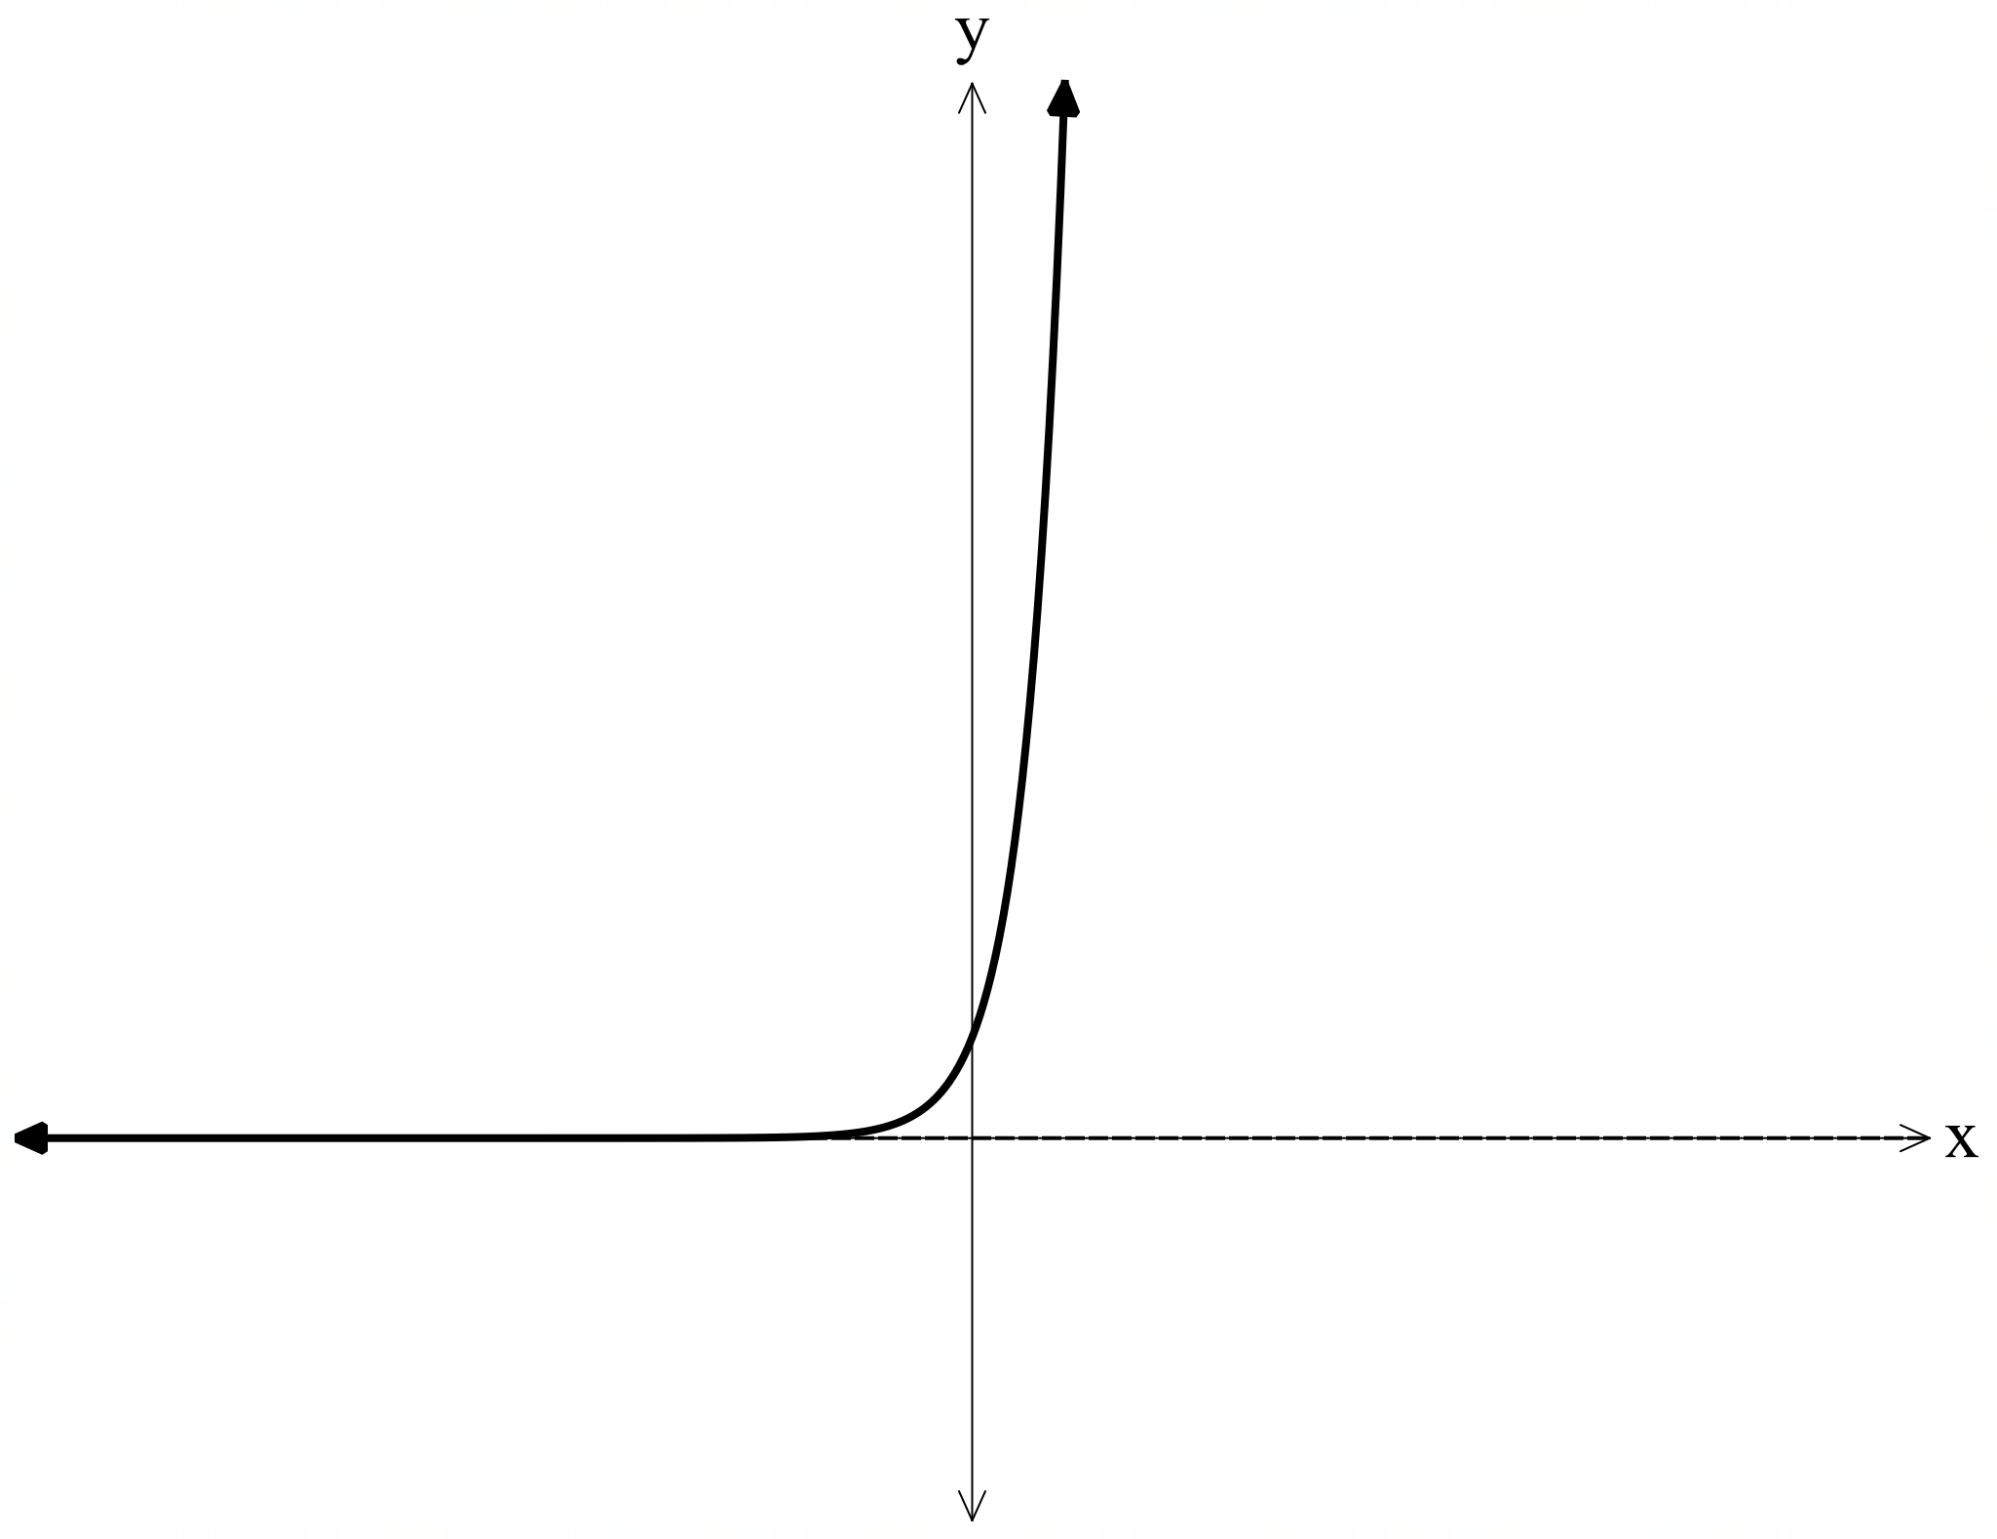
- $f\left(x\right)=mx+3$, where $m<0$.
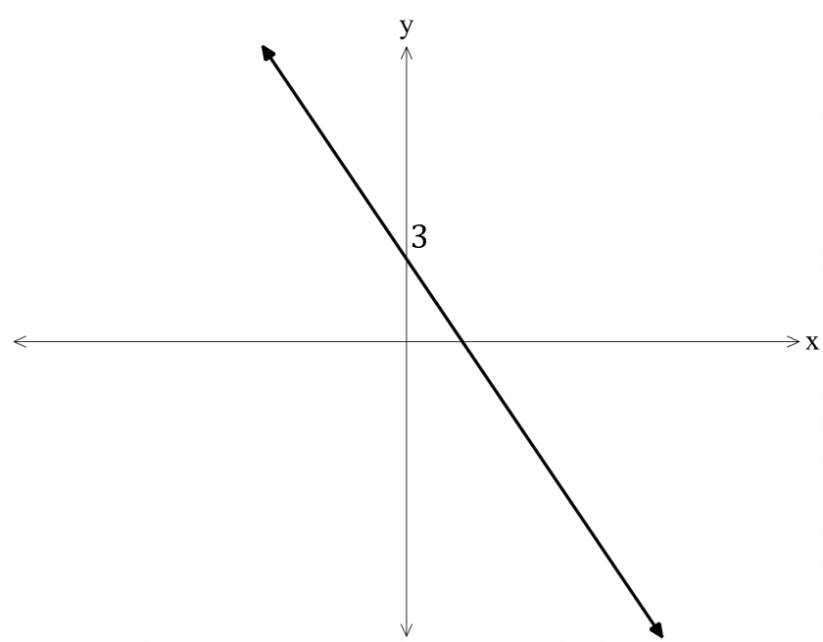
- $f\left(x\right)=\frac{k}{x}$ with $k≠0$.
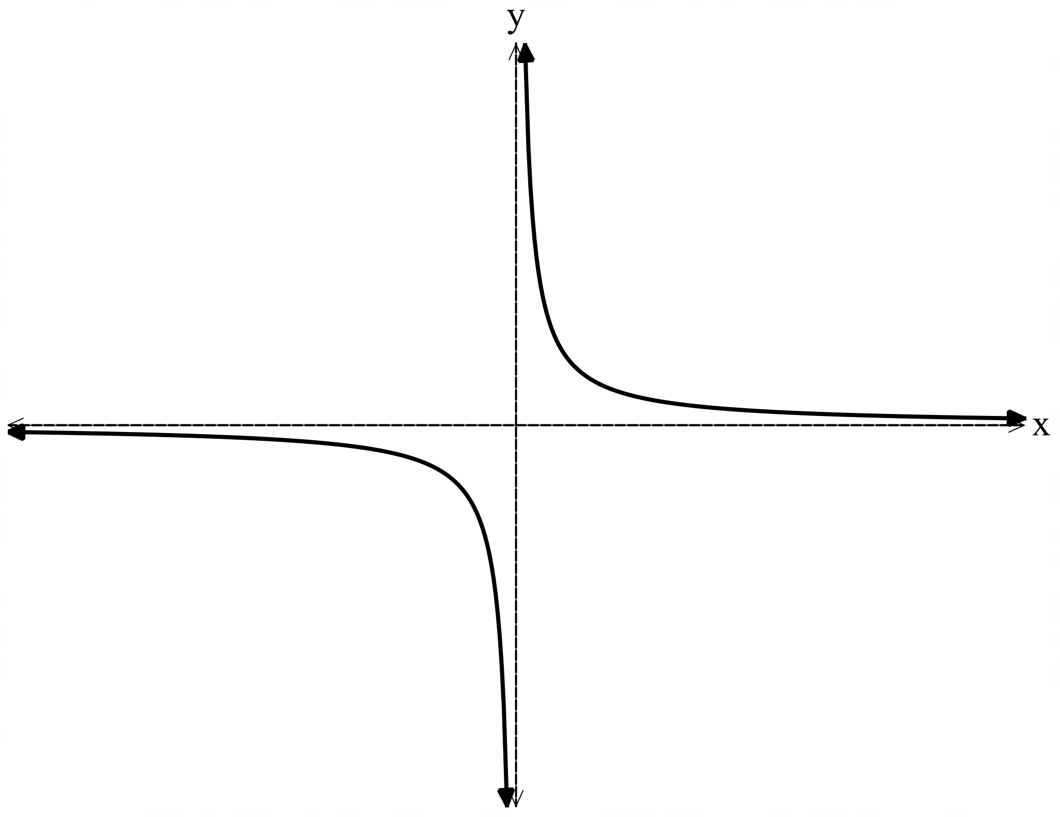

- $f\left(x\right)=x^{2}-9$.
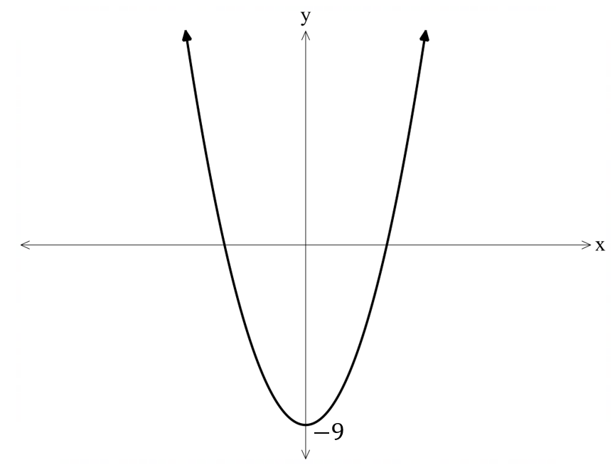
- $f\left(x\right)=\frac{6}{x}$.
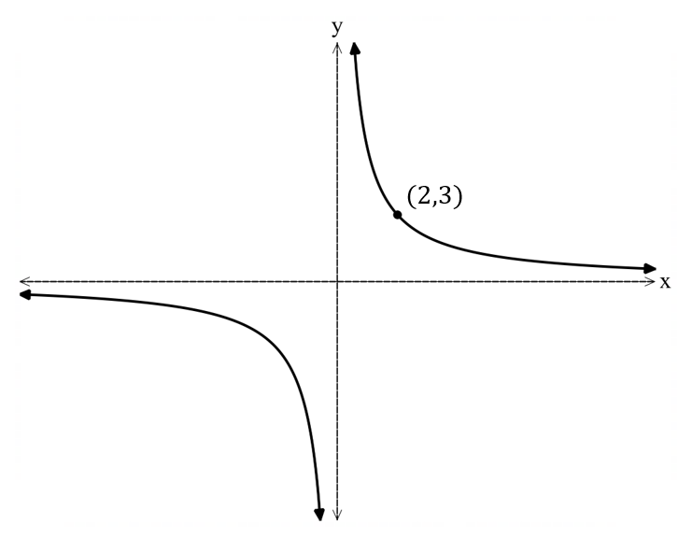

References
This resource contains NSW Curriculum and syllabus content. The NSW Curriculum is developed by the NSW Education Standards Authority. This content is prepared by NESA for and on behalf of the Crown in right of the State of New South Wales. The material is protected by Crown copyright.
Please refer to the NESA Copyright Disclaimer for more information https://educationstandards.nsw.edu.au/wps/portal/nesa/mini-footer/copyright.
NESA holds the only official and up-to-date versions of the NSW Curriculum and syllabus documents. Please visit the NSW Education Standards Authority (NESA) website https://educationstandards.nsw.edu.au/ and the NSW Curriculum website https://curriculum.nsw.edu.au/.
Mathematics Advanced 11–12 Syllabus © NSW Education Standards Authority (NESA) for and on behalf of the Crown in right of the State of New South Wales, 2024.

© State of New South Wales (Department of Education), 2025
The copyright material published in this resource is subject to the Copyright Act 1968 (Cth) and is owned by the NSW Department of Education or, where indicated, by a party other than the NSW Department of Education (third-party material).
Copyright material available in this resource and owned by the NSW Department of Education is licensed under a Creative Commons Attribution 4.0 International (CC BY 4.0) license.

This license allows you to share and adapt the material for any purpose, even commercially.
Attribution should be given to © State of New South Wales (Department of Education), 2025.
Material in this resource not available under a Creative Commons license:
- the NSW Department of Education logo, other logos and trademark-protected material
- material owned by a third party that has been reproduced with permission. You will need to obtain permission from the third party to reuse its material.
Links to third-party material and websites
Please note that the provided (reading/viewing material/list/links/texts) are a suggestion only and implies no endorsement, by the New South Wales Department of Education, of any author, publisher, or book title. School principals and teachers are best placed to assess the suitability of resources that would complement the curriculum and reflect the needs and interests of their students.
If you use the links provided in this document to access a third-party's website, you acknowledge that the terms of use, including licence terms set out on the third-party's website apply to the use which may be made of the materials on that third-party website or where permitted by the Copyright Act 1968 (Cth). The department accepts no responsibility for content on third-party websites.

