Function values and intercepts
Students use a function machine to substitute inputs and outputs into functions and connect this process to the graphical meaning of coordinates, intercepts and zeroes.
Students will need at least one digital device per pair to interact with Amplify (Desmos) during this lesson.

Learning intention
- To understand how substituting values into functions connects to key points and features on a graph.

Success criteria
- I can connect the inputs and outputs of functions to their graphical representation.
- I can accurately substitute numeric and algebraic expressions into functions.
- I can explain what $f(0)$ and $f\left(x\right)=0$ represent on a graph.
- I can find and use the zeroes and $y$-intercepts of functions to assist in graphing them.

Outcomes
A student:
- develops understanding and fluency in mathematics through exploring and connecting mathematical concepts, choosing and applying mathematical techniques to solve problems, and communicating their thinking and reasoning coherently and clearly MAO-WM-01
- applies algebraic techniques and the laws of indices and surds to manipulate expressions and solve problems MAV-11-01
- uses functions and relations to model, analyse and solve problems MAV-11-02

Content

Introduction to functions and relations
- Substitute numeric and algebraic expressions into the formulas of functions
- Refer to a value in the domain of a function at which the function is $0$ as a zero of the function
- Recognise that the $x$-intercepts of the graph of $y=f(x)$ are its zeroes, the solutions of $f(x)=0$, and that the $y$-intercept is $f(0)$
Mathematics Advanced 11–12 Syllabus © NSW Education Standards Authority (NESA) for and on behalf of the Crown in right of the State of New South Wales, 2024.

Table 1: lesson summary
Section | Summary of activity | Teaching strategies | Teaching points
Activating prior knowledge | Students review the definition of a function before investigating how inputs and outputs are represented using function machines in the Amplify (Desmos) activity (bit.ly/functionvaluesintercepts), restricting students to screens 1–7. | Pose-Pause-Pounce-Bounce | Help students to visualise how the input and output of a function relates to a table of values and the graph. Students connect numerical substitution to graphical points of functions with which they are familiar.
Connecting learning | Use slides 4–7 to model how to substitute numeric and algebraic expressions into functions.  Return students to the Amplify (Desmos) activity (bit.ly/functionvaluesintercepts), restricting students to screens 11–13, before using slides 8–9 of the PowerPoint Function values and intercepts to model how to solve equations involving function notation.  Students then complete screens 14–18 of the Amplify (Demos) activity. | Worked examples (Your turn)  Pose-Pause-Pounce-Bounce | Connect student understanding of how function notation connects to graphical representations, particular for interpreting intercepts.
Releasing responsibility | Using slides 11 and 12, define zeroes and connect that solving $f\left(x\right)=0$ find the $x$-intercept(s) of a function and $f(0)$ finds the $y$-intercept of a function.  Use slides 13–16 to model graphing a function by finding it’s zeroes and $f(0)$ value. | Worked examples (Your turn)  Notes to future forgetful selves | Help students to link function notation to graph features like intercepts and zeros, while teaching them to use the vertical line test to identify functions.
Independent practice | Students work in pairs to complete Appendix A, where they match each graph to its equation. |  | Develop students’ skills in working backwards from the graph to determine the equation.

Activity structure
Please use the associated PowerPoint Function values and intercepts to display images in this lesson.

Activating prior knowledge
- Initiate a class discussion to review the concept of a function. Prompting questions could include:
- What does it mean for relations to be called a function?
- How might we use a graph to check whether a relation is a function?
- If we only had a table of inputs and outputs, how could we tell whether it represents a function?
- Explain that the class will explore function inputs using a function machine.
- With at least one device per pair of students, assign the Amplify (Desmos) activity ‘Function values and intercepts’ (bit.ly/functionvaluesintercepts) for students to complete.
Before completing this activity, you will need to set up an Amplify classroom (bit.ly/createamplifyclassroom) and use the pacing feature to restrict students to screens 1–4.
- Use the Pose-Pause-Pounce-Bounce questioning strategy (PDF 557 KB) (bit.ly/posepausepouncebounce) to assess students’ understanding of the process represented by the function machine and its connection to the graph of the function. Suggested prompts include:
- How does the function machine confirm that $y=x^{2}$ is a function?
- What does the function machine seem to be doing to each input before it gives an output?
- How does the output in the table connect to the point that appears on the graph?
- Emphasise with the class that each input is substituted into the function to produce the output. These values, the input and the output, represent coordinates on the graph, where the input is the $x$-coordinate and the output is the $y$-coordinate.
- Extend the pacing to include screens 5–7. Explain to students that they will use the function machines to input values, find the outputs and plot the resulting coordinates on the graph.
Once students have finished, use the pause feature in the Amplify teacher dashboard and tell the class that this Amplify activity will be revisited later in the lesson.

Connecting learning
- Return students to the Amplify (Desmos) activity ‘Function values and intercepts’ (bit.ly/functionvaluesintercepts), using the pacing feature to restrict students to screens 8–10. In this set of screens, students complete a table of values for a given function, plotting each coordinate onto the provided graph, before function notation is introduced to determine values using a function machine.
- Explain to the class that substituting a numerical input into a function gives the corresponding $(x, y)$ coordinate, where the input represents the $x$ value and the output represents the $y$- value.
- Use slides 4–7 to model how to substitute numeric and algebraic expressions into functions using the Worked examples (Your turn) method (bit.ly/supportingstrategies).
Students may need to complete practice questions from an existing resource on substituting numeric and algebraic expressions into functions prior to continuing the next part of the Amplify (Desmos) activity.
- Extend the pacing to include screens 11–13. Explain to students that they will use the function machines to enter values as outputs and plot the resulting coordinates on the graph.
- Use slides 8–9 to model how to solve equations involving function notation, using the Worked examples (Your turn) method.
- Extend the pacing to include screens 14–18. Explain to students that they will now focus specifically on cases where the input or output is zero.
- Use the Pose-Pause-Pounce-Bounce questioning strategy to unpack the previous Amplify (Desmos) screens. Suggested prompts include:
- How could you describe what the function machine is finding when you set the input or output to 0?
- How could you describe what happens on the graph when you set the input or output to 0?
- If $f\left(0\right)=3$ for a particular function, how could you describe what this represents on the graph?
- If $f\left(1\right)=0$ for a particular function, how could you describe what this represents on the graph?
Conclude with students that for a function $y=f(x)$, an input of 0 will find the value of the $y$-intercept and an output of 0 will find the value of the $x$-intercept of the function.

Releasing responsibility
- Use slides 11 and 12 to connect function notation with the concept of intercepts and introduce the term zeroes to describe $x$-values where the function equals zero.
From these slides, students should develop a conceptual understanding of what $f(0)$ represents on a graph, and what it means to solve $f\left(x\right)=0$. They should also understand that the solutions to $f\left(x\right)=0$ are called the zeroes of the function and are the $x$-intercepts of the graph.
- Use slides 13–16 and the Worked examples (Your turn) strategy for modelling worked examples of graphing functions by finding zeroes and finding $f\left(0\right)$. Use the self-explanation prompts to guide students in articulating the process of finding the function’s zeroes by solving $f(x)$ and finding the $y$-intercept.

Students examined linear and non-linear relationships in Stage 5 Linear relationships A Core outcome MA5-LIN-C-01 and Non-linear relationships A Core outcome MA5-NLI-C-01. Within these outcomes students:
- Constructed a table of values to graph a variety of linear relationships.
- Constructed a table of values to graph non-linear relationships involving quadratics of the form $y=ax^{2}+c$.
- Students are to create notes to their future forgetful selves (bit.ly/notestofutureself) on:
- How the solution of $f\left(x\right)=0$ is the $x$-intercepts of the graph and the function’s zeroes.
- How the $y$-intercept is found using $f(0)$.
- Have students briefly compare notes with a partner and reflect on their own understanding.

Independent practice
- Distribute Appendix A ‘Working backwards from the graph’ to each pair of students. Students will work together to analyse a graph and:
- determine if it is a function
- identify key features of the graph
- find $f(0)$ and the zeroes of the function from the graph
- describe the features of the function’s equation.
- Once students have had sufficient time to complete the above activity, display slide 18, which contains a bank of equations. These equations represent the graphs from Appendix A. Allow pairs time to select the equation that best suits each graph, using the features that they found and described.
- Circulate the classroom encouraging pairs to:
- Calculate $f(0)$ and the zeroes from the equations if the graphs are too difficult to read an exact value.
- Create a table of values from the equations if they are unsure which equation links to a graph.
Solutions for this activity have been provided at the conclusion of this document. Ensure that pairs have matched the correct equation to its graph.
Students will learn the point-gradient formula in Unit 3 – exploring linear and quadratic functions, although some may use this concept to find the equation of the straight lines in this activity.

Assessment and differentiation

Suggested opportunities for differentiation
Activating prior knowledge
- To challenge students ask them to predict the outputs before using the function machine or to create their own input-output tables for new functions and justify why they define a function.
- To support students, linear examples could be used before attempting quadratics.
Connecting learning
- Some students may benefit from completing practice questions on substituting numeric and algebraic expressions into functions prior to recommencing the Amplify (Desmos) activity.
- To challenge students ask them to create their own function machines for a given $x$ and/or $y$-intercept.
Releasing responsibility
- Students can complete the notes to future forgetful selves activity in pairs, allowing them to support each other in identifying the most important concepts to remember.
- Teachers may choose to provide a scaffold for students’ notes to their future forgetful selves.
Independent practice
- For students with a strong understanding of graphing linear and non-linear relationships, such as those who have completed the related Path outcomes, consider adjusting the graphs and equations provided in Appendix A to include functions of the form $ax+by+c=0$ and/or $y=ax^{2}+bx+c$.

Suggested opportunities for assessment
Activating prior knowledge
- Observe students’ responses during the Pose-Pause-Pounce-Bounce questioning to check students’ conceptual understanding of how inputs connect to outputs and graphs.
- Use the Amplify (Desmos) teacher dashboard to monitor student responses, checking for understanding of how the input and output of the function machine relates to coordinates on the graph.
Connecting learning
- Use the Amplify (Desmos) teacher dashboard to check for correct use of function notation and accurate plotting of points.
- Listen to student explanations during the Pose-Pause-Pounce-Bounce questioning to assess students’ conceptual understanding of intercepts.
Releasing responsibility
- Facilitate a class discussion and observe students’ reasoning and justification in response to the provided prompts on the slides.
- Review students’ notes to future forgetful selves for understanding of linear and non-linear relationships, the vertical line test and zeroes.
Independent practice
- Appendix A can be collected as evidence of learning.

Appendix A

Working backwards from the graphs
Graph | Function? | Key features | Find $f(0)$ | Find the zeroes | Describe the equation
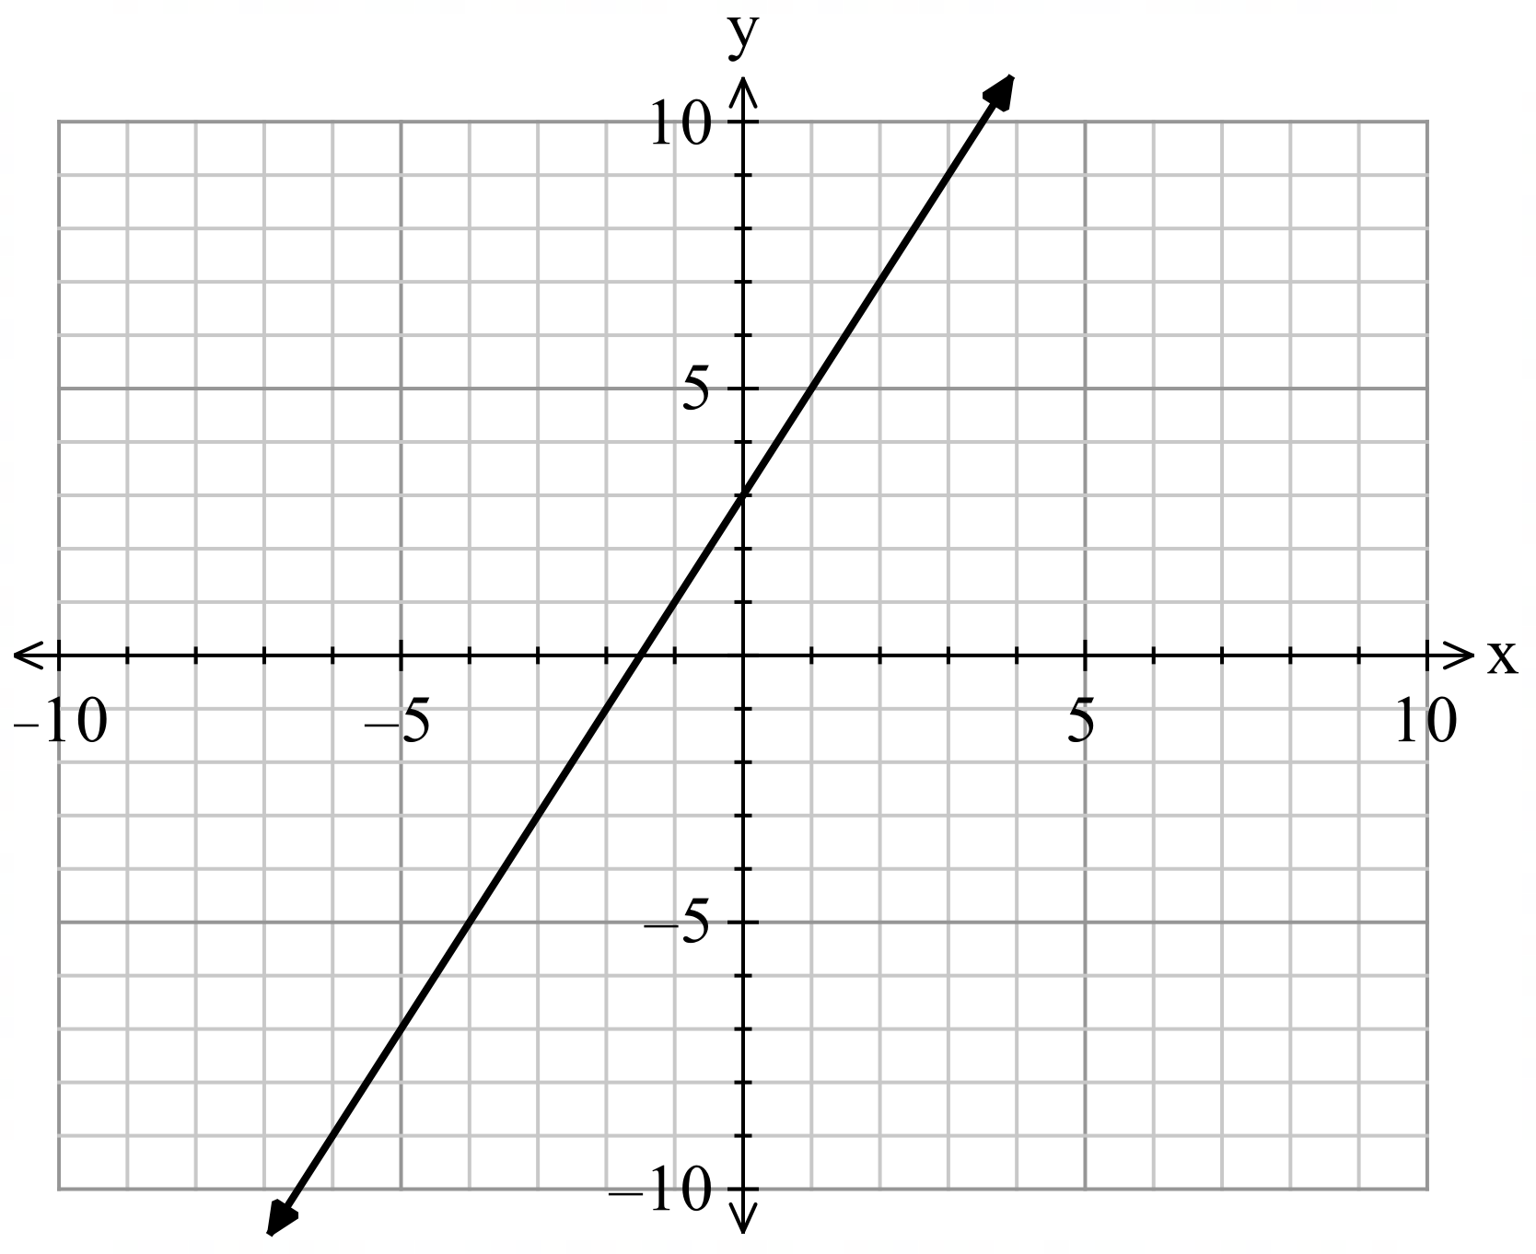
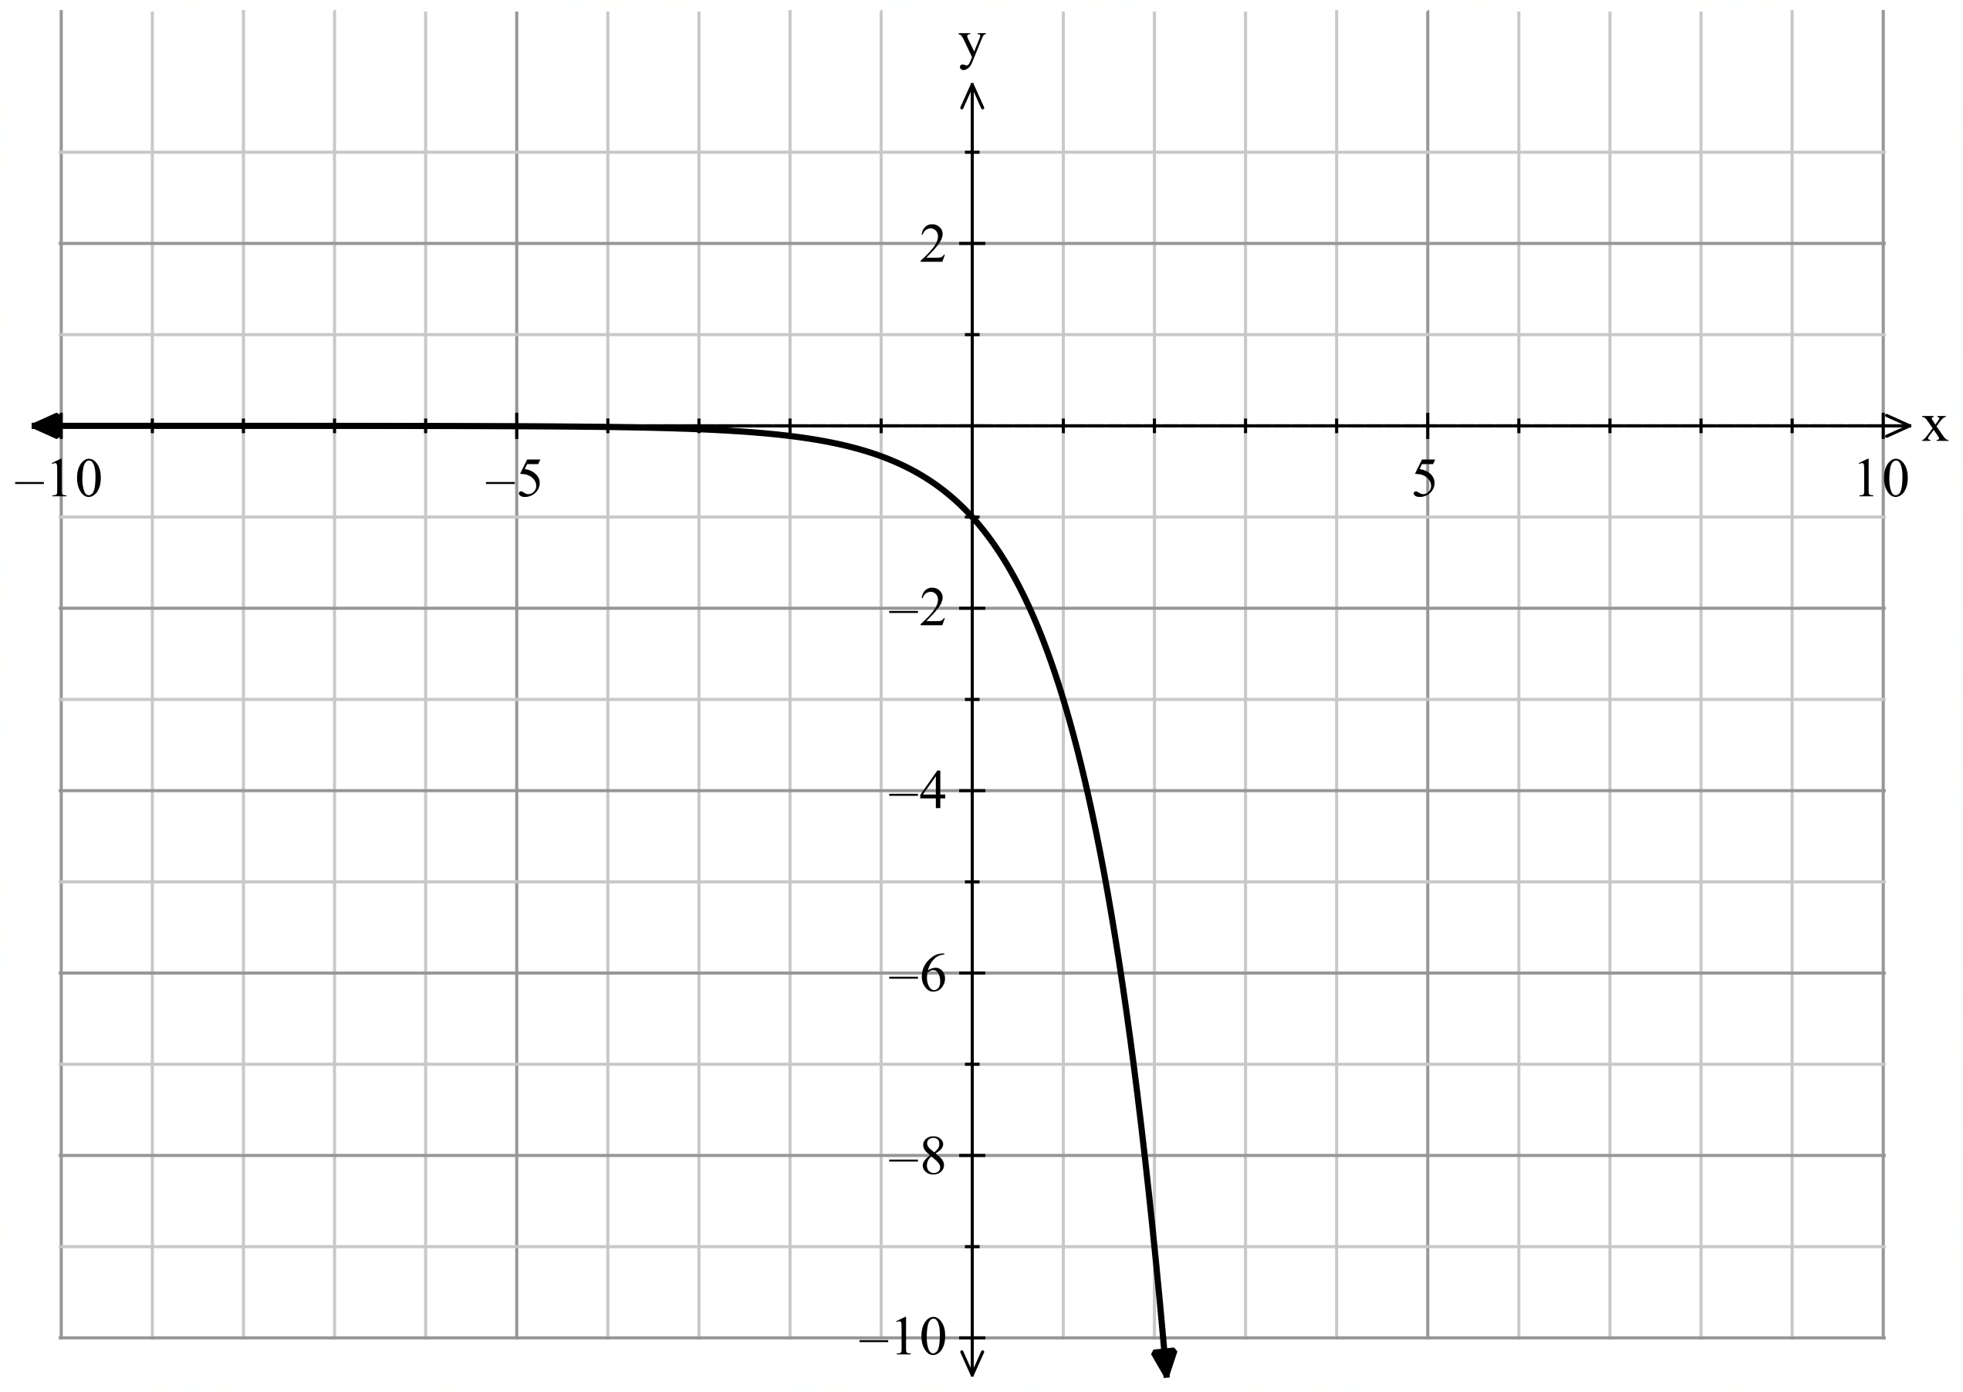
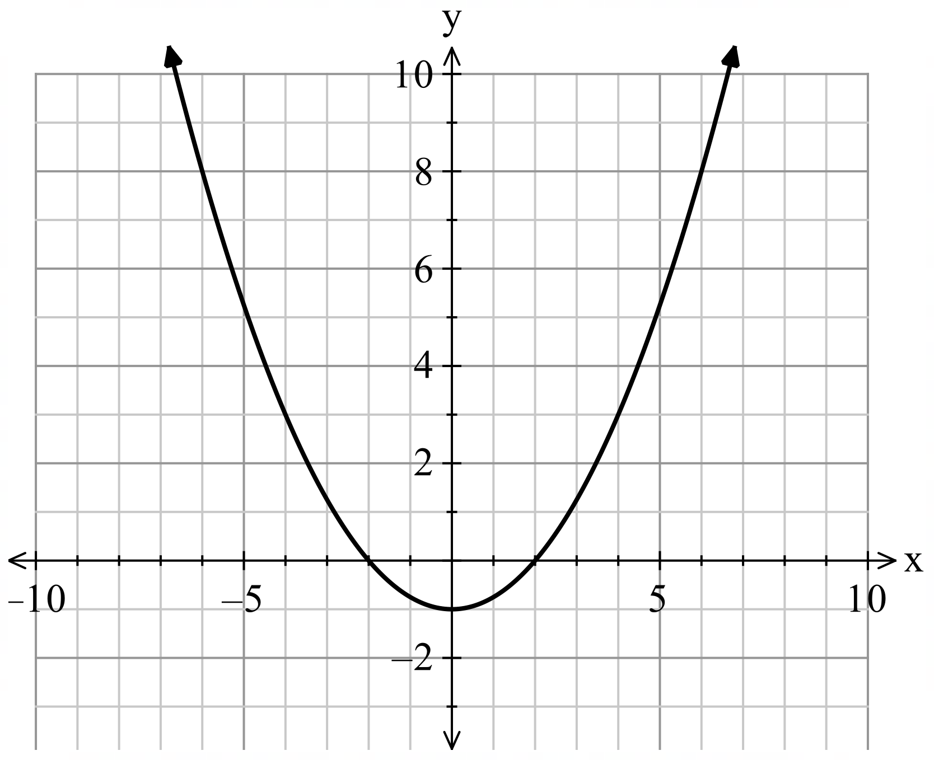
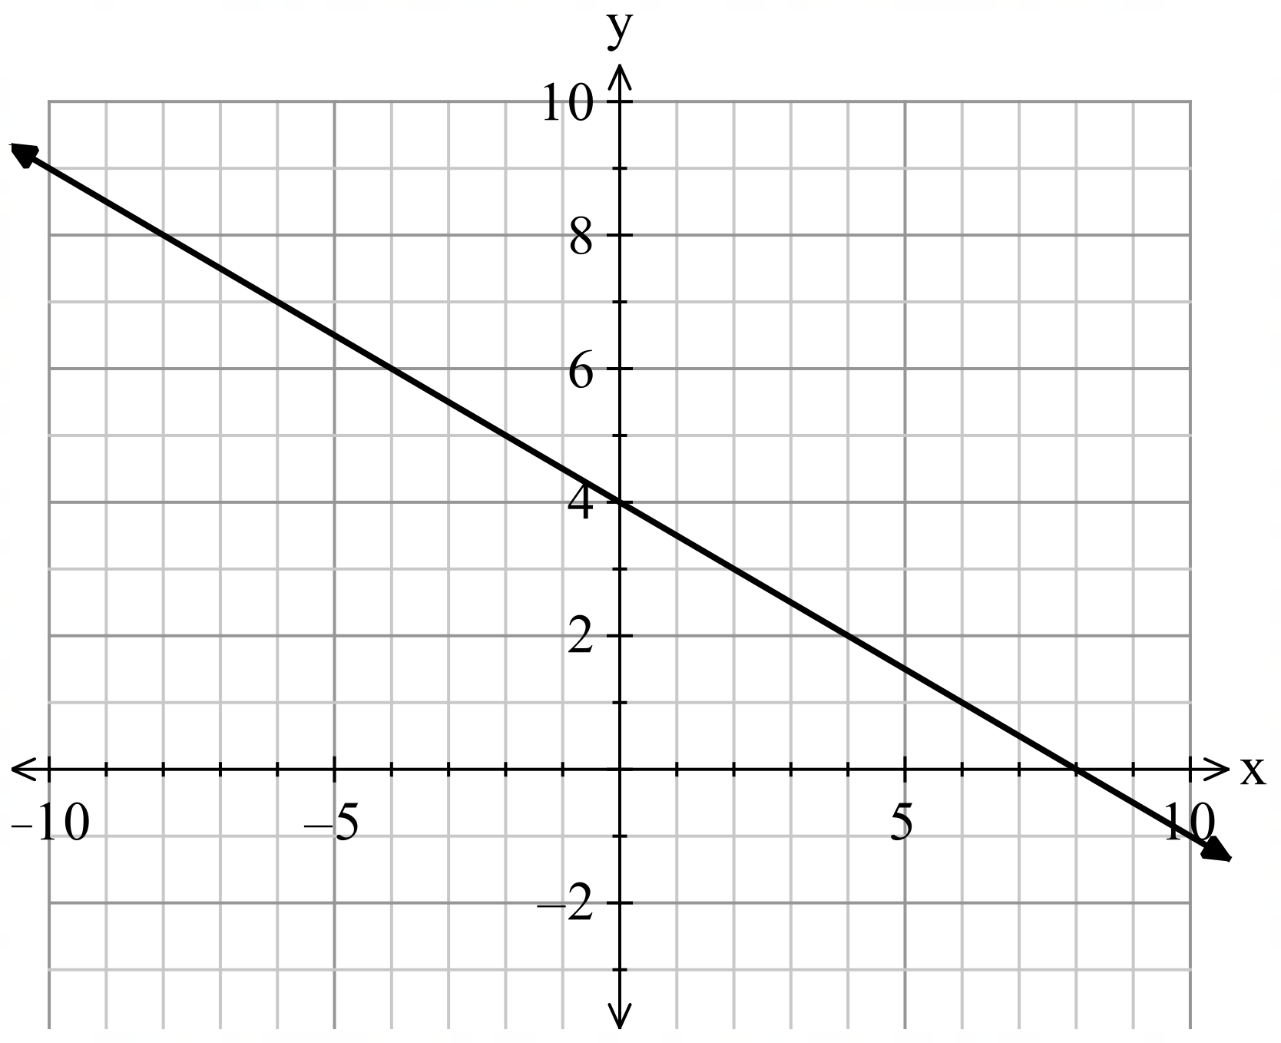
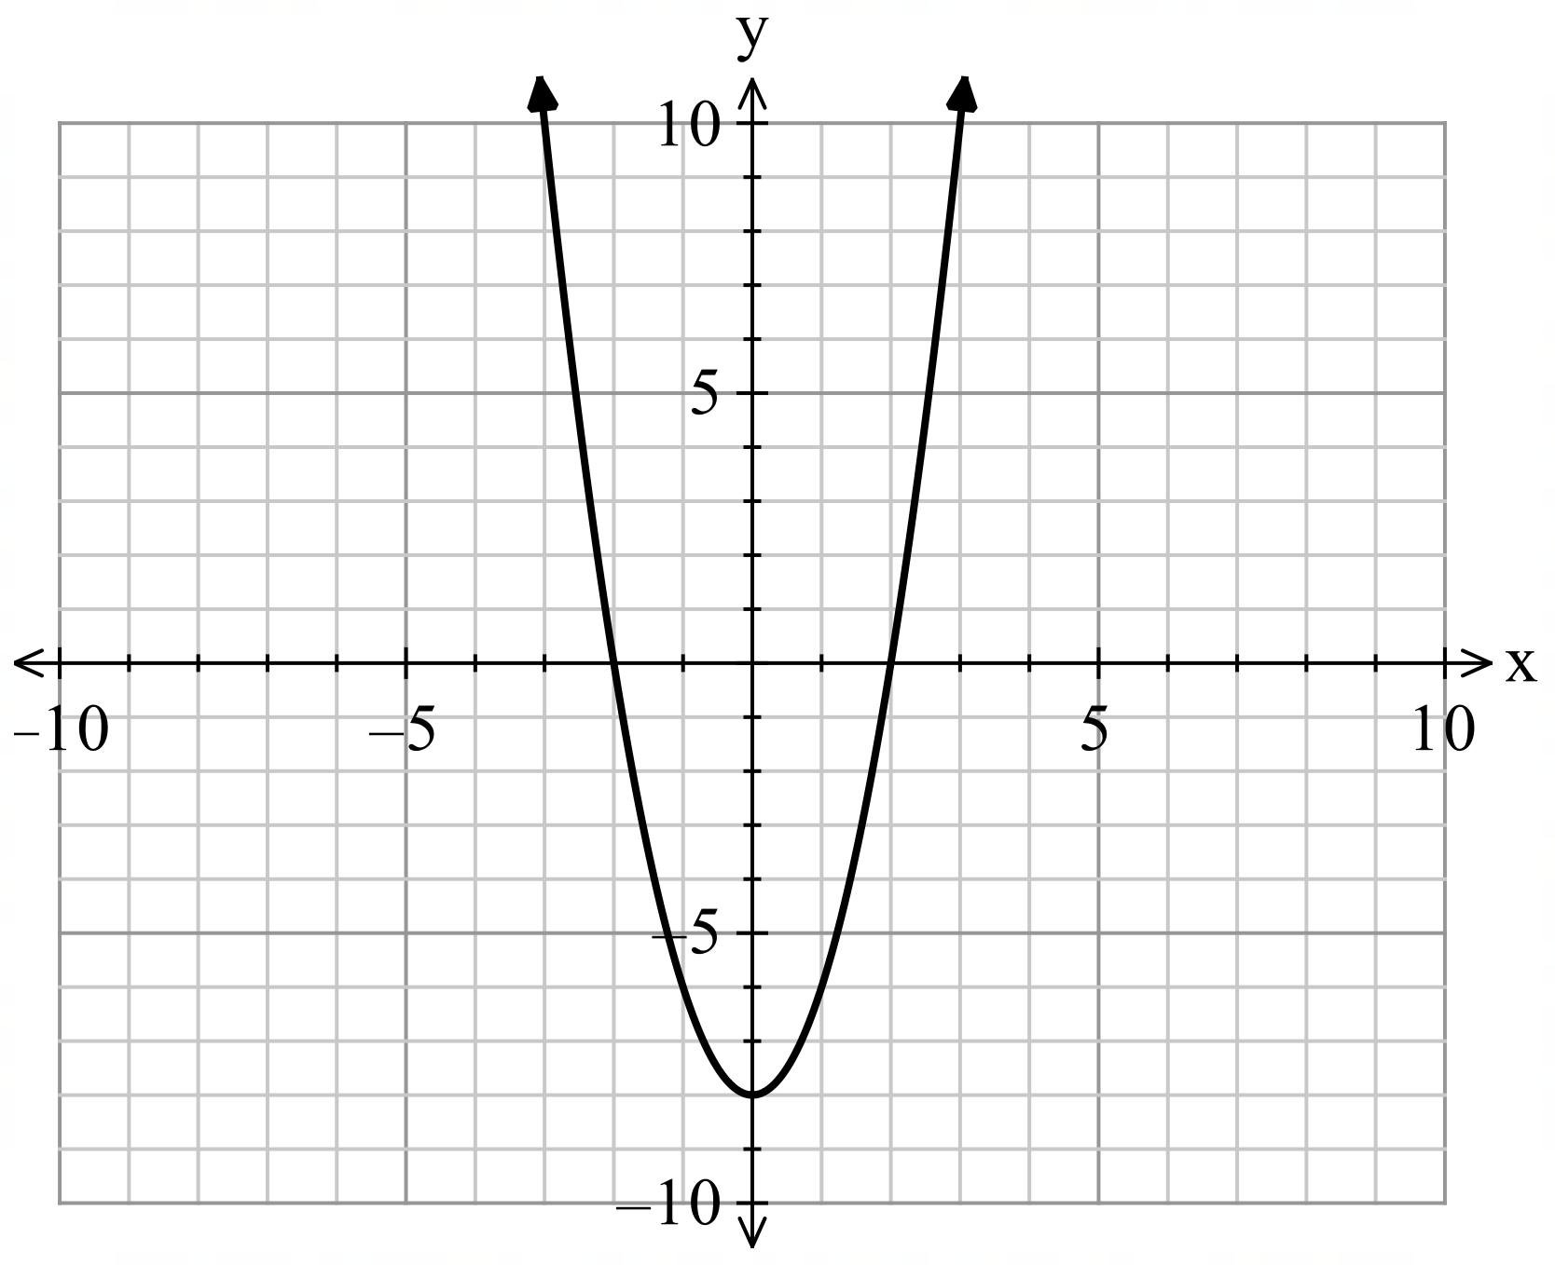
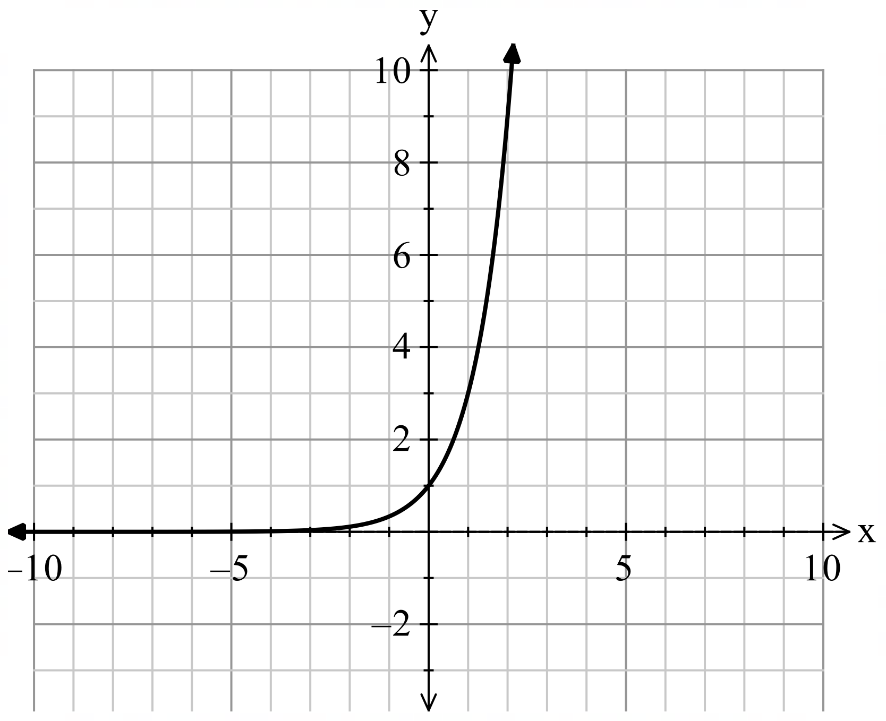
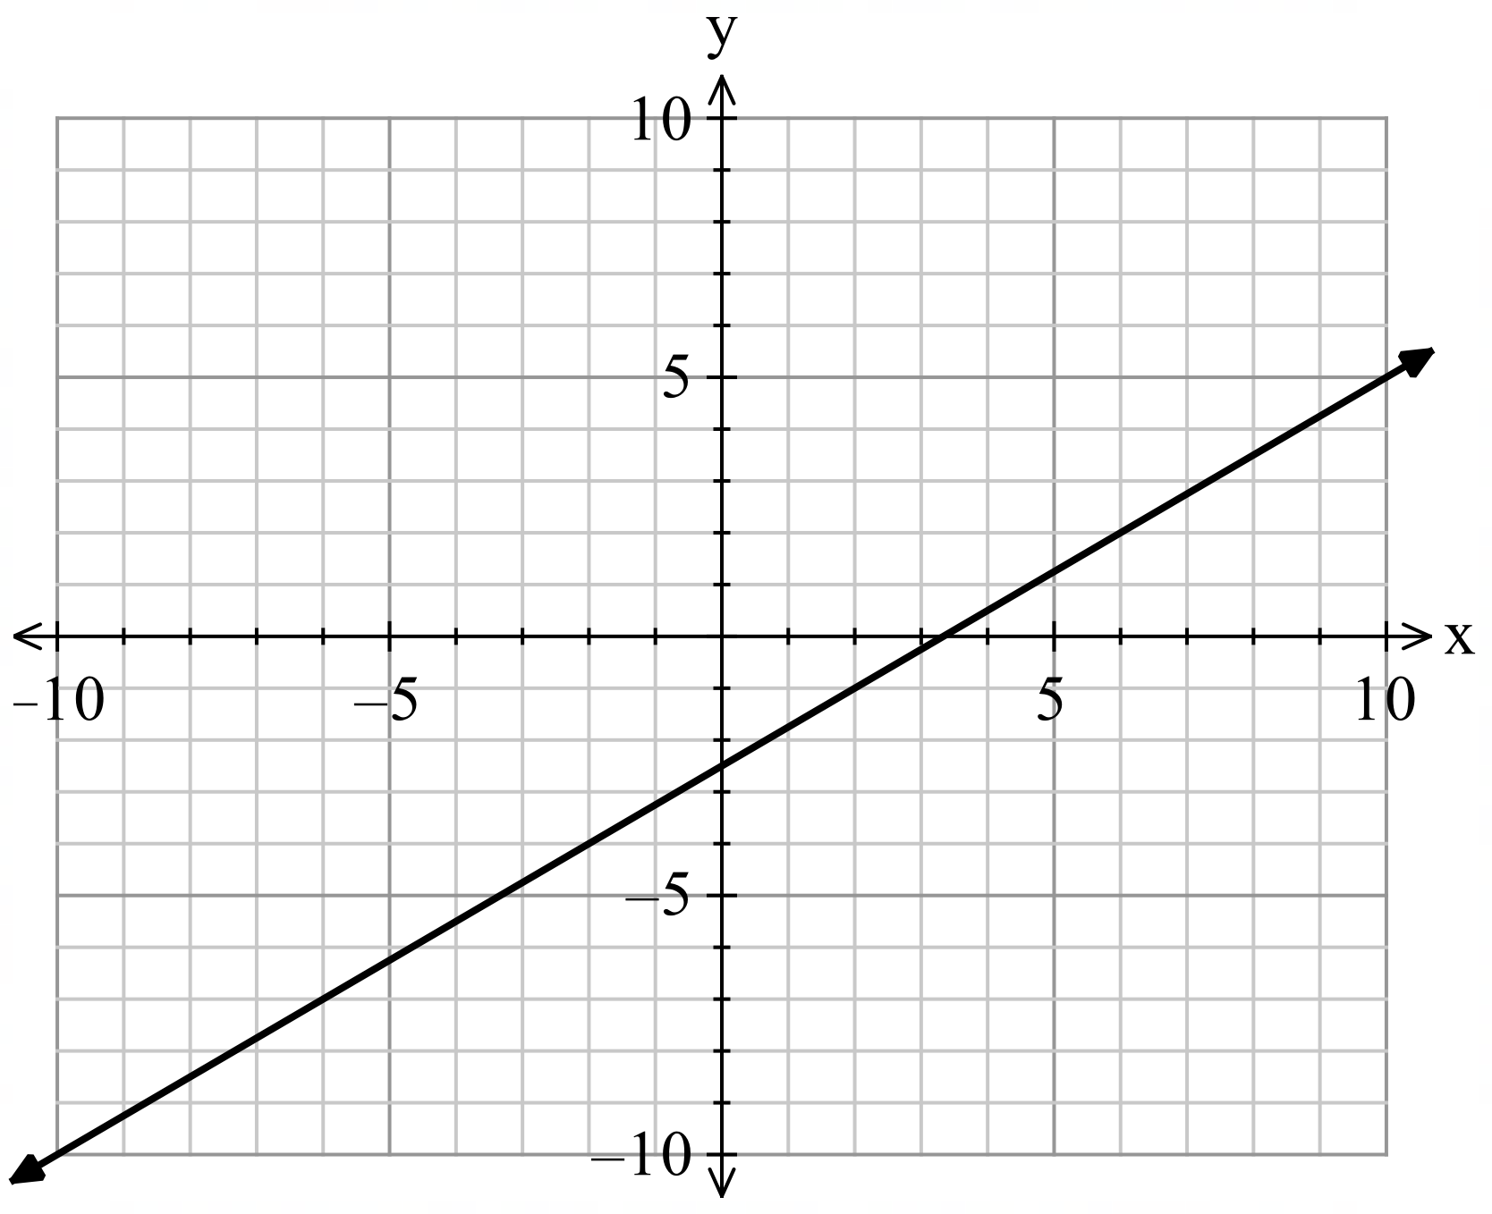
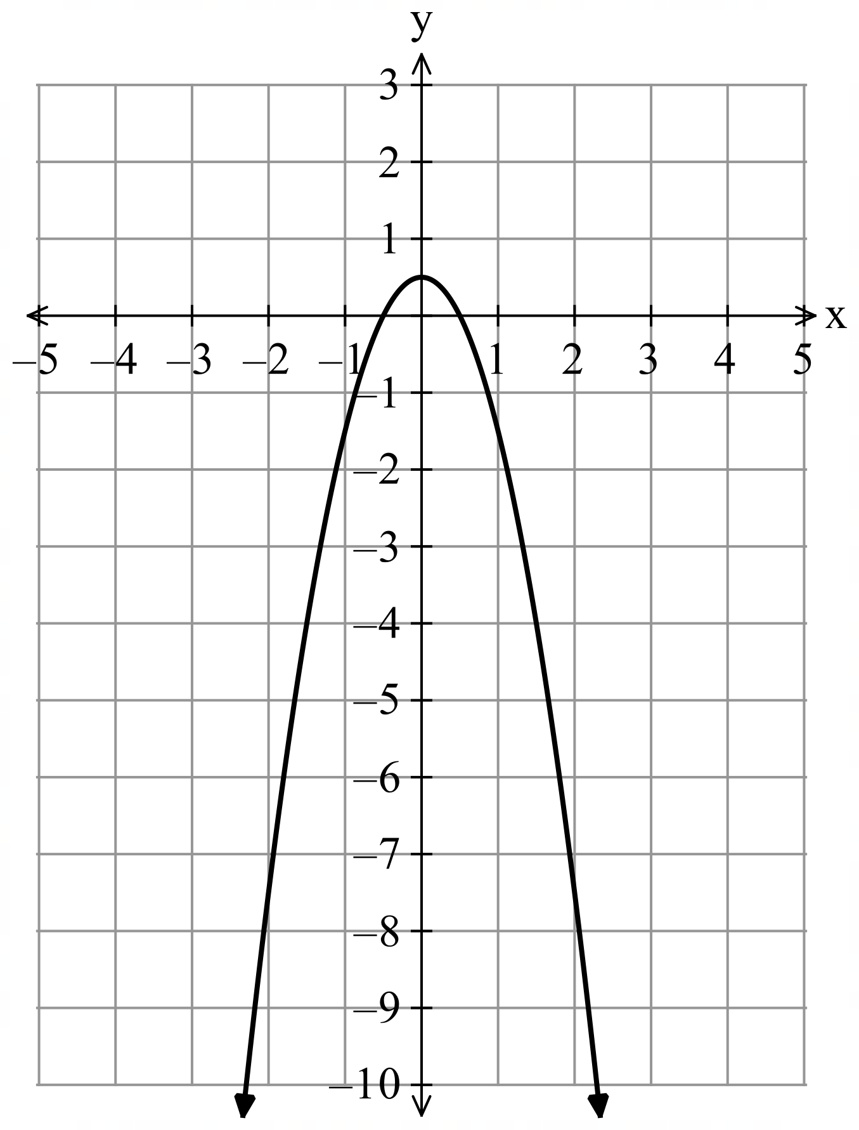

Sample solutions

Appendix A – working backwards from the graph
Graph 1  - The graph is a function, by the vertical line test.  - The graph represents a straight line.  - $f\left(0\right)=3$ and the zero of the function is $-\frac{2}{3}$.  - The associated equation will be a linear relationship.  - $f(x)=3+2x$ | Graph 2  - The graph is a function, by the vertical line test.  - The graph represents an exponential.  - $f\left(0\right)=-1$ and there are no zeroes.  - The associated equation will have $x$ in the exponent and a negative value.  - $f(x)={-3}^{x}$
Graph 3  - The graph is a function, by the vertical line test.  - The graph represents a concave up parabola.  - $f\left(0\right)=-1$ and the zeroes of the function are $-2, 2$.  - The associated equation will contain and positive $x^{2}$.  - $f(x)=\frac{1}{4}x^{2}-1$. | Graph 4  - The graph is a function, by the vertical line test.  - The graph represents a straight line.  - $f\left(0\right)=4$ and the zero of the function is $8$.  - The associated equation will be a linear relationship.  - $f(x)=4-\frac{1}{2}x$.
Graph 5  - The graph is a function, by the vertical line test.  - The graph represents a concave up parabola.  - $f\left(0\right)=-8$ and the zeroes of the function are $-2, 2$.  - The associated equation will contain and positive $x^{2}$.  - $f(x)=2x^{2}-8$. | Graph 6  - The graph is a function, by the vertical line test.  - The graph represents an exponential.  - $f\left(0\right)=1$ and there are no zeroes.  - The associated equation will have $x$ in the exponent.  - $f(x)=3^{x}$
Graph 7  - The graph is a function, by the vertical line test.  - The graph represents a straight line.  - $f\left(0\right)=-2.5$ and the zero of the function is $\frac{10}{3}$.  - The associated equation will be a linear relationship.  - $f(x)=-\frac{5}{2}+\frac{3}{4}x$ | Graph 8  - The graph is a function, by the vertical line test.  - The graph represents a concave down parabola.  - $f\left(0\right)=0.5$ and the zeroes of the function are $-\frac{1}{2},\frac{1}{2}$.  - The associated equation will contain and negative $x^{2}$.  - $f\left(x\right)=-2x^{2}+\frac{1}{2}$.

References
This resource contains NSW Curriculum and syllabus content. The NSW Curriculum is developed by the NSW Education Standards Authority. This content is prepared by NESA for and on behalf of the Crown in right of the State of New South Wales. The material is protected by Crown copyright.
Please refer to the NESA Copyright Disclaimer for more information https://educationstandards.nsw.edu.au/wps/portal/nesa/mini-footer/copyright.
NESA holds the only official and up-to-date versions of the NSW Curriculum and syllabus documents. Please visit the NSW Education Standards Authority (NESA) website https://educationstandards.nsw.edu.au/ and the NSW Curriculum website https://curriculum.nsw.edu.au/.
Mathematics Advanced 11–12 Syllabus © NSW Education Standards Authority (NESA) for and on behalf of the Crown in right of the State of New South Wales, 2024.

© State of New South Wales (Department of Education), 2025
The copyright material published in this resource is subject to the Copyright Act 1968 (Cth) and is owned by the NSW Department of Education or, where indicated, by a party other than the NSW Department of Education (third-party material).
Copyright material available in this resource and owned by the NSW Department of Education is licensed under a Creative Commons Attribution 4.0 International (CC BY 4.0) license.

This license allows you to share and adapt the material for any purpose, even commercially.
Attribution should be given to © State of New South Wales (Department of Education), 2025.
Material in this resource not available under a Creative Commons license:
- the NSW Department of Education logo, other logos and trademark-protected material
- material owned by a third party that has been reproduced with permission. You will need to obtain permission from the third party to reuse its material.
Links to third-party material and websites
Please note that the provided (reading/viewing material/list/links/texts) are a suggestion only and implies no endorsement, by the New South Wales Department of Education, of any author, publisher, or book title. School principals and teachers are best placed to assess the suitability of resources that would complement the curriculum and reflect the needs and interests of their students.
If you use the links provided in this document to access a third-party's website, you acknowledge that the terms of use, including licence terms set out on the third-party's website apply to the use which may be made of the materials on that third-party website or where permitted by the Copyright Act 1968 (Cth). The department accepts no responsibility for content on third-party websites.

