Functions
Students will investigate inputs and outputs through real-world examples, leading to a clear understanding of what defines a function. They will also be introduced to the vertical line test as a tool for identifying functions.
Students will need at least one digital device per pair to interact with Amplify (Desmos) during this lesson.

Learning intention
- To understand the concept of a relation and a function.

Success criteria
- I can define a relation.
- I can explain why a relation can also be defined as a function.
- I can recognise a function when represented as an equation, a table of values or a set of ordered pairs.
- I can apply the vertical line test to determine if a graph represents a function.

Outcomes
A student:
- develops understanding and fluency in mathematics through exploring and connecting mathematical concepts, choosing and applying mathematical techniques to solve problems, and communicating their thinking and reasoning coherently and clearly MAO-WM-01
- applies algebraic techniques and the laws of indices and surds to manipulate expressions and solve problems MAV-11-01
- uses functions and relations to model, analyse and solve problems MAV-11-02

Content

Introduction to functions and relations
- Describe a relation between 2 sets as an association between the elements of one set and the elements of the other set
- Define a real function $f$ of a real variable $x$ as a relation where each element $x$ of a given set is associated with exactly one element $y$ of the second set
- Recognise that a relation is a rule which can be represented by an algebraic formula, a table of values, a set of ordered pairs $(x, y)$ or a graph
- Use the notation $f(x)$ to identify the unique value of $y$ associated with $x$ when working with functions, and refer to it as the value of $f$ at $x$
- Refer to $x$ in a function $y=f(x)$ as the independent variable of the function, and refer to $y$ as the dependent variable
- Apply the vertical line test on the graph of a relation to determine whether it represents a function
Mathematics Advanced 11–12 Syllabus © NSW Education Standards Authority (NESA) for and on behalf of the Crown in right of the State of New South Wales, 2024.

Table 1: lesson summary
Section | Summary of activity | Teaching strategies | Teaching points
Activating prior knowledge | Students complete Appendix A and discuss the concept of inputs, outputs and how they relate to each other.  Revise the terminology of dependent and independent variables in the context of the activity. | Pose-Pause-Pounce-Bounce | Establish the idea that some relationships assign exactly one output to each input, while others do not.
Connecting learning | Students use the Amplify (Desmos) activity (bit.ly/FunctionsVendingMachine) to explore different representations of relations and functions, establishing the definition of a function. | Notice and wonder | Define a function and develop students’ ability to clearly reason why a relation qualifies as a function, using guided questioning that gradually moves from real-world scenarios to numerical and graphical representations.
Releasing responsibility | Students consider the definition of a function and the definition of dependent and independent variables, using slides 4 and 5 of the PowerPoint Functions, making connections to the Amplify (Desmos) activity.  The vertical line test is then established using the Desmos graph (bit.ly/DesmosVerticalLine).  Students then complete a Frayer diagram for functions, using Appendix B and located on slide 6. | Pose-Pause-Pounce-Bounce  Frayer diagram | Formally define a function and introduce the vertical line test as a means of verifying if a relation represents a function.
Independent practice | Using Appendix C, students graph a variety of relations and justify if they are functions. | Pose-Pause-Pounce-Bounce | Compare the effectiveness of the vertical line test with other methods of determining if a relation is also a function.

Activity structure
Please use the associated PowerPoint Functions to display images in this lesson.

Activating prior knowledge
- Distribute Appendix A ‘Birthdays’ to each student.
The Appendix could include the birthday of a well-known person or someone from the class. The activity could be adapted to ensure the example responses align with students' interests.
- Ask students to complete the 2 tables and independently reflect on the questions at the bottom of the activity.
- Use the Pose-Pause-Pounce-Bounce questioning strategy (PDF 557 KB) (bit.ly/posepausepouncebounce) to check students’ understanding of the activity. The following prompts were listed for students to reflect upon in Appendix A:
- If you use your name as the input to rule $A$, how many outputs are possible?
- If you use your birthday as the input to rule $B$, how many outputs are possible?
Students should recognise that when a person’s name is used as the input (Rule A), there is exactly one output, their birthday. In contrast, when a birthday is used as the input (Rule B), it may correspond to multiple outputs; different people who share that birthday.
- Have a class discussion to connect students’ understanding of dependent and independent variables to the Birthdays activity.
Students may be familiar with this term from the Stage 5 Data analysis B Core outcome
MA5-DAT-C-02.
The NESA syllabus glossary defines an independent variable as ‘a variable used to represent values in the domain (input values) of a function. Generally represented on the horizontal axis of a graph.’ (NESA 2024)
The NESA syllabus glossary defines a dependent variable as ‘a variable used to represent the output values of a function. A dependent variable is generally represented on the vertical axis of a graph.’ (NESA 2024)
This definition will be formalised later in the lesson when students are introduced to functions. For the purposes of this discussion, ensure that students understand that the independent variable is the input that is chosen to control or select, for example, a person’s name or a date. The dependent variable is the output that depends on the input, for example the birthday that corresponds to the person’s name or the list of people who have a birthday on the chosen date.

Connecting learning
- Explain to students that they will now be further analysing various inputs and their associated outputs.
- With at least one device per pair of students, assign the Amplify (Desmos) activity ‘Vending machines and other function machines’ (bit.ly/FunctionsVendingMachine) for students to complete.
Before completing this activity, you will need to set up an Amplify (Desmos) classroom (bit.ly/createamplifyclassroom) and use the pacing feature to restrict students to screens 1–3.
- Ask students to test multiple drink purchases from each category on screen 2.
- In their pairs, ask students to consider what they notice and wonder (bit.ly/noticewonderstrategy) about the vending machine, drawing connections to the birthday activity.
Students are to share their response by typing it into the text input box on screen 3.
- Use the pause feature to discuss and display student responses from screen 3 using the teacher dashboard. Select examples that model students noticing mathematical ideas and wondering critically about the situation.

Students may notice that flavoured vitamin water always comes from the same spot, however, water is dispensed at random. Students may connect it to the birthdays activity by recognising that each input produces one specific type of drink, just like each person has one birthday. Students may wonder why the vending machine selects different spots in the same category.
- Extend the pacing to include screens 4 and 5, then recommence the activity. Prompt students to test multiple purchases and think critically about whether they can now accurately predict the vending machine’s output after the adjustment.
Students are to share their response by typing into the text input box on screen 5.
- Use the pause feature to discuss and display student responses from screen 5 using the teacher dashboard, highlighting responses that identify that each input may result in a different output.
Students should identify that while there are fewer selections, the $2.50 and $3 input can result in multiple different drinks.
- Extend the pacing to include screens 6 and 7. Explain to students that screens 6 and 7 show mapping diagrams for 2 vending machines and ask students what they notice about each diagram.
Students should notice that for the blue vending machine, each input has exactly one output, whereas the red vending machine has multiple outputs for each input.
- Extend the pacing to include screen 8. This screen includes the NESA glossary definition of a function. Ask students to use their knowledge of inputs and outputs to decide whether each diagram represents a function.
Students share their reasoning by typing a response into the text input box on screen 8, which will appear after they make their selection.
- Remove pacing from the activity and resume the activity, with students completing screens 9–20.
Amplify (Desmos) will automatically provide feedback on the identification of whether the examples on the remaining slides are functions or not, but the teacher will have to monitor the teacher dashboard to ensure students are providing appropriate reasoning.

Releasing responsibility
- Display slide 4, which expands on the definition of a function from the Amplify (Desmos) activity.
- Use the Pose-Pause-Pounce-Bounce questioning strategy to check for students’ understanding of the definition of a function, by making connections to the Amplify (Desmos) activity. Suggested prompts include:
- How would you decide if a given relation (like the vending machine selections or birthdays) is a function?
- What evidence would you look for?
- How can you use different representations, such as tables, graphs, mapping diagrams to describe whether something is a function?
- Which representation do you find the easiest to understand and why?
- Lead a class discussion to revisit the definitions of dependent and independent variables using slide 5. Some suggested question prompts include:
- How does the idea of inputs and outputs relate to dependent and independent variables in the Amplify (Desmos) activity?
- How can understanding this help you to work with functions?
Conclude that in a function, each value of the independent variable, $x$, corresponds to exactly one value of the dependent variable.
- Continue the class discussion to transfer this conversation to consider the graphical representation of relations and functions. Explain to students that there is a test that can be used on a graphical representation to determine if a relation is a function. The test is called the vertical line test.
The vertical line test determines whether a relation or graph is also a function. If a vertical line intersects or touches a graph at more than one point, then the graph is not a function.
This test clearly shows how many outputs are assigned to each input value.
- Display the Desmos graph ‘The vertical line’ (bit.ly/DesmosVerticalLine) for the class to see. Select and drag on the red coordinate to demonstrate how a vertical line only ever intersects or touches the straight line once.
- Adjust the $f(x)$ input by opening the folder labelled ‘Functions’ and editing the equation to investigate other graphical displays with the class. Some suggestions include parabolas, exponentials and hyperbolas.
- Unselect the folder titled ‘Functions’ and select the folder titled ‘Not functions’ on the Desmos graph. A parabola with a horizontal axis of symmetry, $x=y^{2}$ will be shown with a vertical line. Select and drag the red coordinate along the $x$-axis, demonstrating to the class how the vertical line intersects the graph at more than one point. For example, at $x=4$, the vertical line intersects with the graph as $(4, 2)$ and $(4,-2)$, meaning that $x=y^{2}$ is not a function.
- To investigate other graphical displays with the class, adjust the equation in the first line. Some suggestions include a vertical line, such as $x=1$ and a circle.
- Use the Pose-Pause-Pounce-Bounce questioning strategy to check for students’ understanding of the vertical line test. Suggested prompts include:
- How does this test link back to the vending machines and birthdays scenarios?
- Why isn’t a horizontal line test used to determine if a relation is a function?
- Distribute Appendix B ‘Frayer diagram’ for students to complete independently. Encourage students to revisit the Amplify (Desmos) activity to assist with finding examples and non-examples.
A Frayer diagram has also been included on slide 6 to be displayed if required. A sample solution is provided at the conclusion of this document.

Independent practice
- Distribute Appendix C ‘Relation or function’ to each student. Working in pairs, students will first graph the given relation, then decide whether it represents a function, providing a written justification for their decision.
The purpose of this activity is to provide retrieval practice by having students apply their understanding of functions and the vertical line test to linear and non-linear relationships they should be familiar with from Stage 5. This unit will build on that prior knowledge to extend students’ skills to graphing cubic and reciprocal functions.
In Stage 5 Linear relationships A Core outcome MA5-LIN-C-01, Non-linear relationships A Core outcome MA5-NLI-C-01 and Non-linear relationships B Core outcome MA5-NLI-C-02 students have:
- constructed a table of values to graph a variety of linear relationships
- constructed a table of values to graph non-linear relationships involving quadratics and exponentials
- identified graphs and equations of parabolas and exponential curves.
- Once pairs have completed this activity, they are to compare their answers and justifications with another pair.
- Use the Pose-Pause-Pounce-Bounce questioning strategy to ask students which representation – the equation, list of coordinates, or graph – was easiest to use when determining if a relation is a function. Suggested prompts include:
- What did you notice when comparing the graph, equation, and set of pairs for each relation?
- How did the different representations support or challenge your thinking as you justified whether each relation was a function?
- Following this, ask students to annotate their Frayer diagram to include the preferred method of testing to determine if a relation is a function.

Assessment and differentiation

Suggested opportunities for differentiation
Activating prior knowledge
- A Think-Pair-Share (bit.ly/thinkpairsharestrategy) could be used to activate students’ prior knowledge of the terms ’input’ and ‘output’ if these are unfamiliar.
- To engage students, Appendix A could be adapted to reflect their interests – for instance, by changing the example birthdays to someone relevant to the group or shifting the context to a topic like car varieties (car make model, model car make).
- The Pose-Pause-Pounce-Bounce questions could be adapted to target deeper reasoning by incorporating the Wiederhold question matrix, for example, using prompts that begin with ‘what if …’ or ‘why might ...’.
Connecting learning
- Noticing and wondering is used throughout the discussions in this lesson to allow all students to participate in a risk-free environment.
- Encourage students to incorporate precise mathematical terminology in their responses.
- Further pacing from screen 9 of the Amplify (Desmos) activity could be used to manage cognitive load. The pace of the activity should be adapted to meet the needs of the students.
- The Amplify (Desmos) activity can be edited to include more complex examples to challenge students.
Releasing responsibility
- To support students the completion of the Frayer diagram could be scaffolded such that each section of the Frayer diagram is discussed as a class prior to students completing.
Independent practice
- The provided relations could be adjusted depending on each student’s ability to either include more complex equations or further scaffolding, such as providing a table of values.

Suggested opportunities for assessment
Activating prior knowledge
- During the class discussions, observe students’ reasoning and justification in response to the provided prompts in the Pose-Pause-Pounce-Bounce questioning strategy.
Connecting learning
- Students will demonstrate their working mathematically skills in their responses that are saved in the Amplify (Desmos) classroom for teachers to review and to use for discussions in class.
- The Amplify (Desmos) teacher dashboard can be used to review student work and check for their understanding of what a function is.
Releasing responsibility
- Review students’ Frayer diagram to check their understanding of functions.
Independent practice
- Appendix C can be collected to review students justification of whether each relation was a function to check students understanding of how to use the vertical line test.
- Use Appendix C to assess students prior knowledge of graphing linear and non-linear relationships that they may have seen in Stage 5. This assessment will determine if further review is required.

Appendix A

Birthdays
Rule $A$ accepts a person’s name as input and returns that individual’s birthday as output. Add 3 more input–output pairs to the table.
Input | Output
Taylor Swift | December 13
Rule $B$ takes a date as input and returns a person’s name as output. Add 3 more input–output pairs to the table.
Input | Output
December 13 | George Pólya
Consider the following questions:
- If you use your name as the input to $A$, how many outputs are possible?
- If you use your birthday as the input to $B$, how many outputs are possible?

Appendix B

Frayer diagram
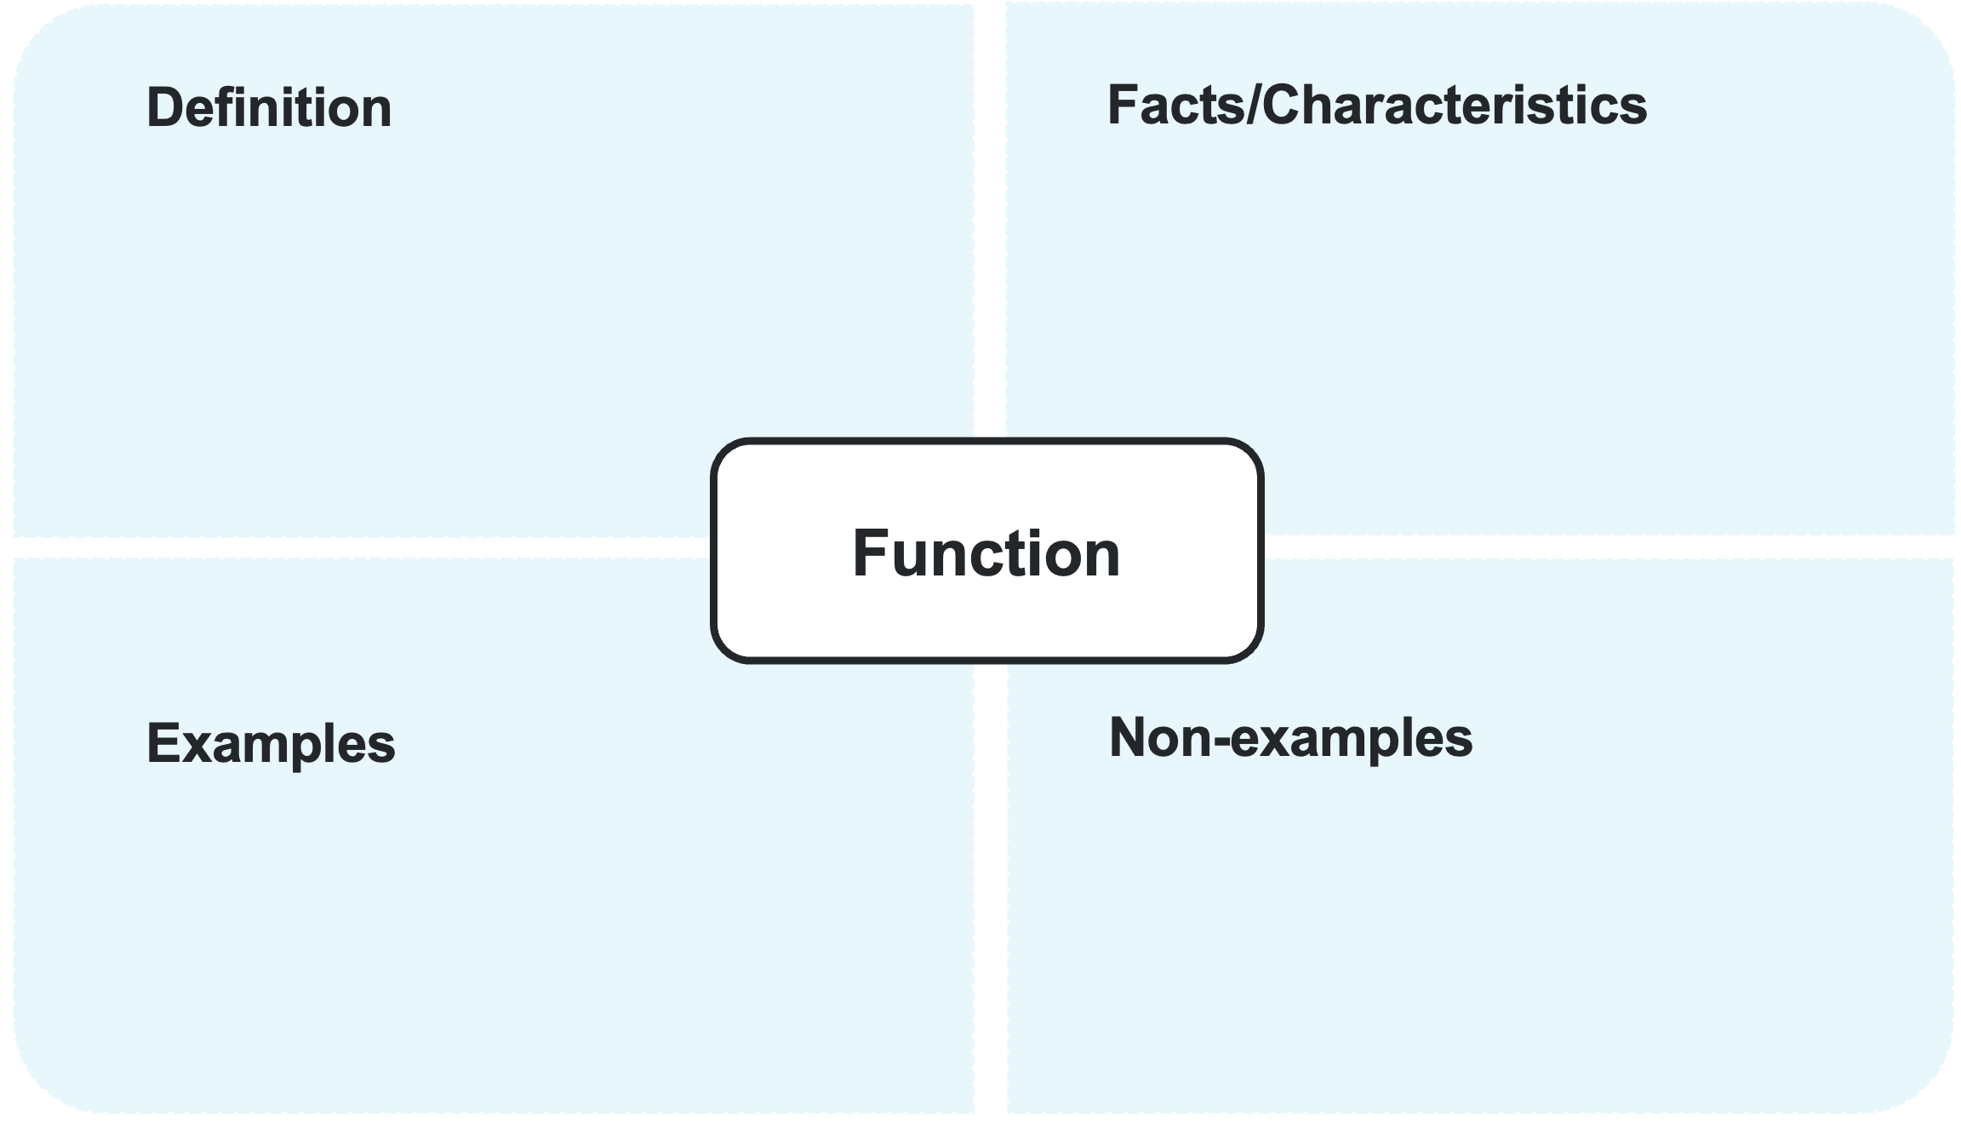

Appendix C

Relation or function
Relation | Graph | Is the relation a function? | Justification
$\left(0, 3\right), \left(1, 2\right), \left(2, 3\right), (2,4)$ | 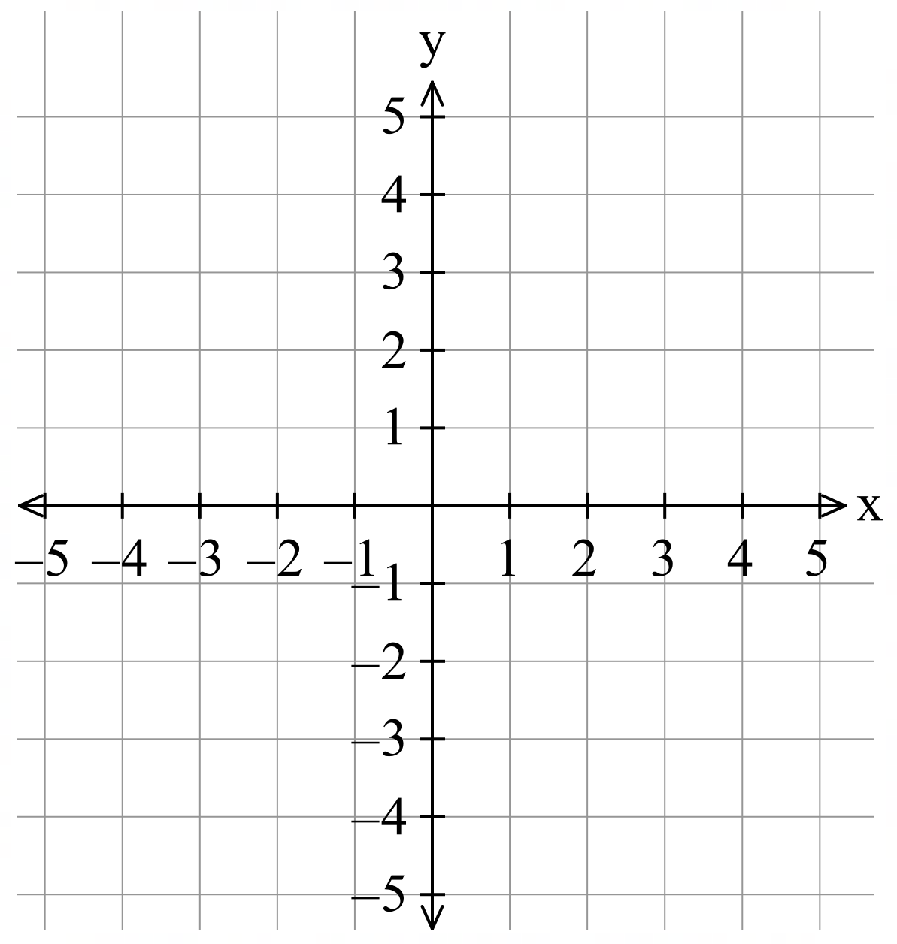
$$y=3x-2$$
$$y=x^{2}-3$$
$$x=-2$$
$$y=1$$
$$y=2^{x}$$

Sample solutions

Appendix A – birthdays
Answers to the tables will vary.
- Every input has exactly one output.
- Every input has many different outputs (potentially).

Appendix B – Frayer diagram
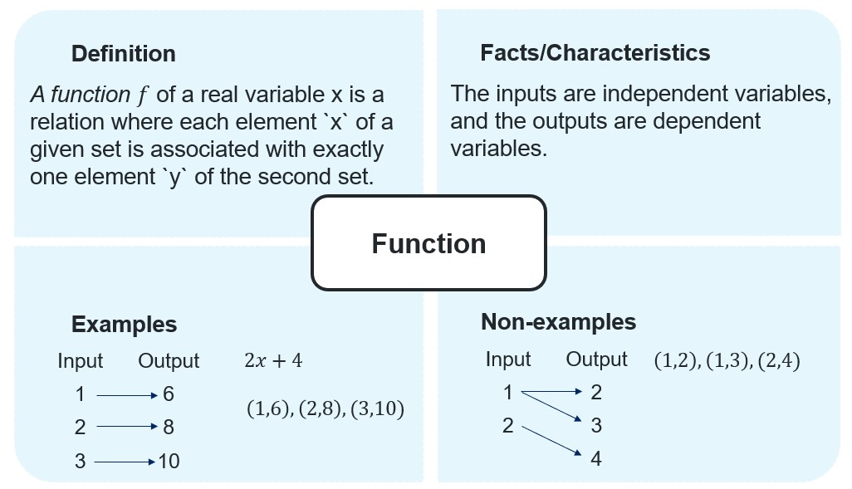

Appendix C – relation or function
Relation | Graph | Is the relation a function? | Justification
$\left(0, 3\right), \left(1, 2\right), \left(2, 3\right), (2,4)$ | 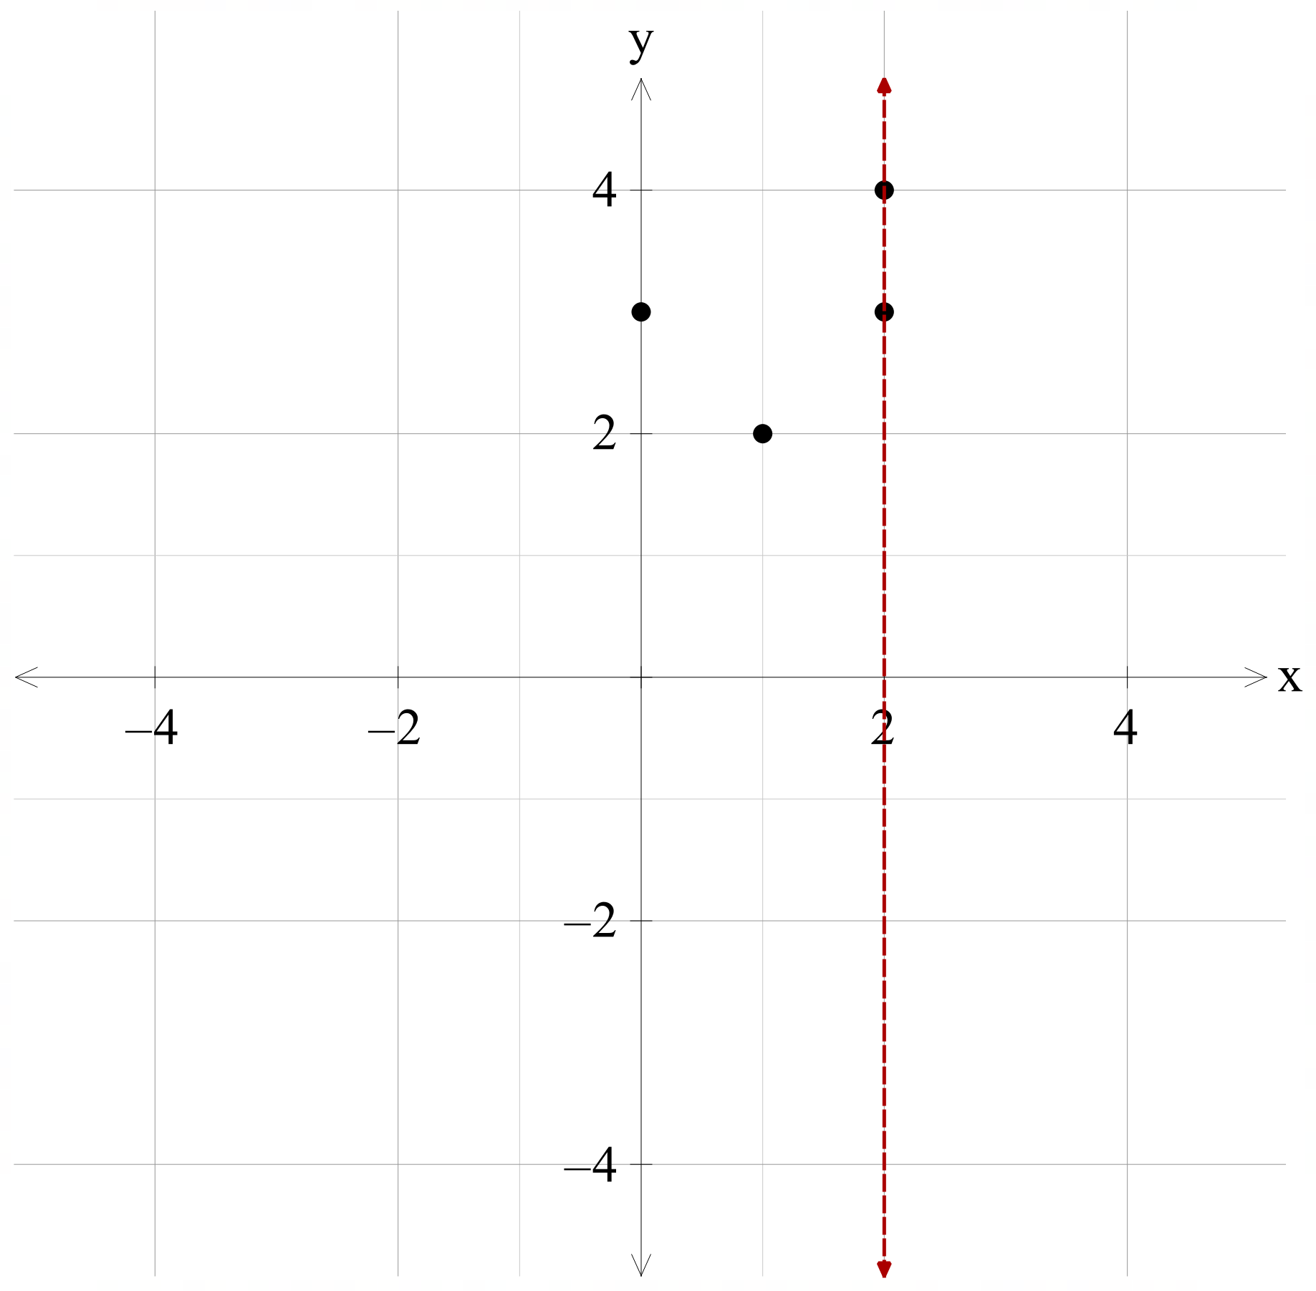 | No | The relation is not a function as it has 2 $y$-values assigned to the $x$-value 2.  The relation also fails the vertical line test as when $x=2$, the vertical line intersects the relation as the points $\left(2,3\right)$ and $(2, 4)$.
$$y=3x-2$$ | 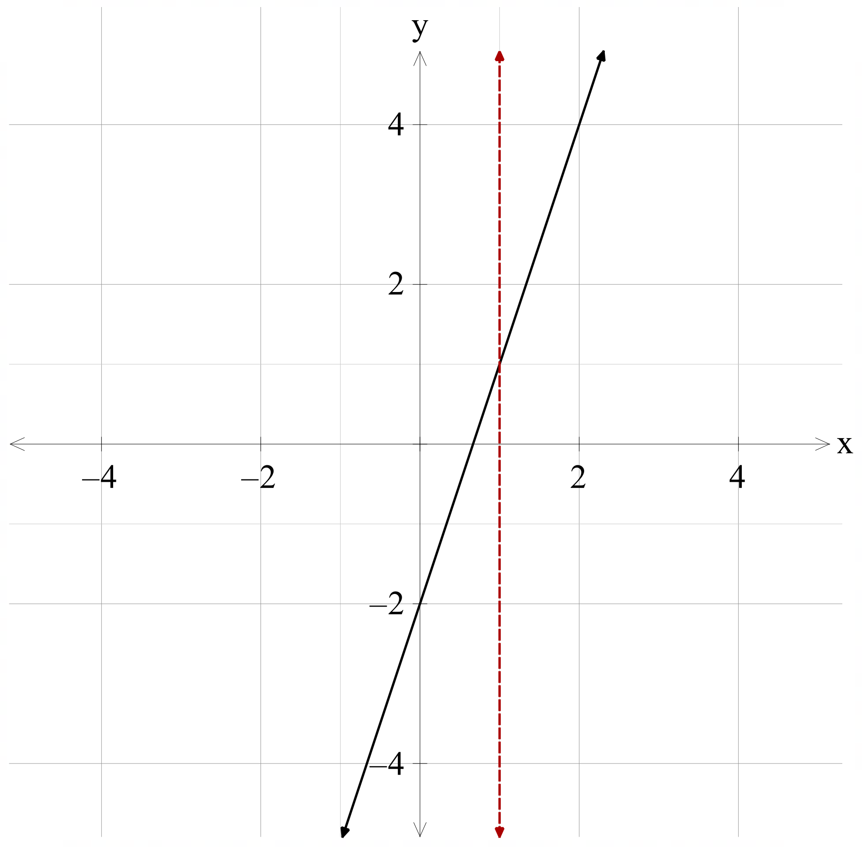 | Yes | The relation is a function, as the straight line passes the vertical line test, as for each $x$-value, the vertical line only intersects the graph once.
$$y=x^{2}-3$$ | 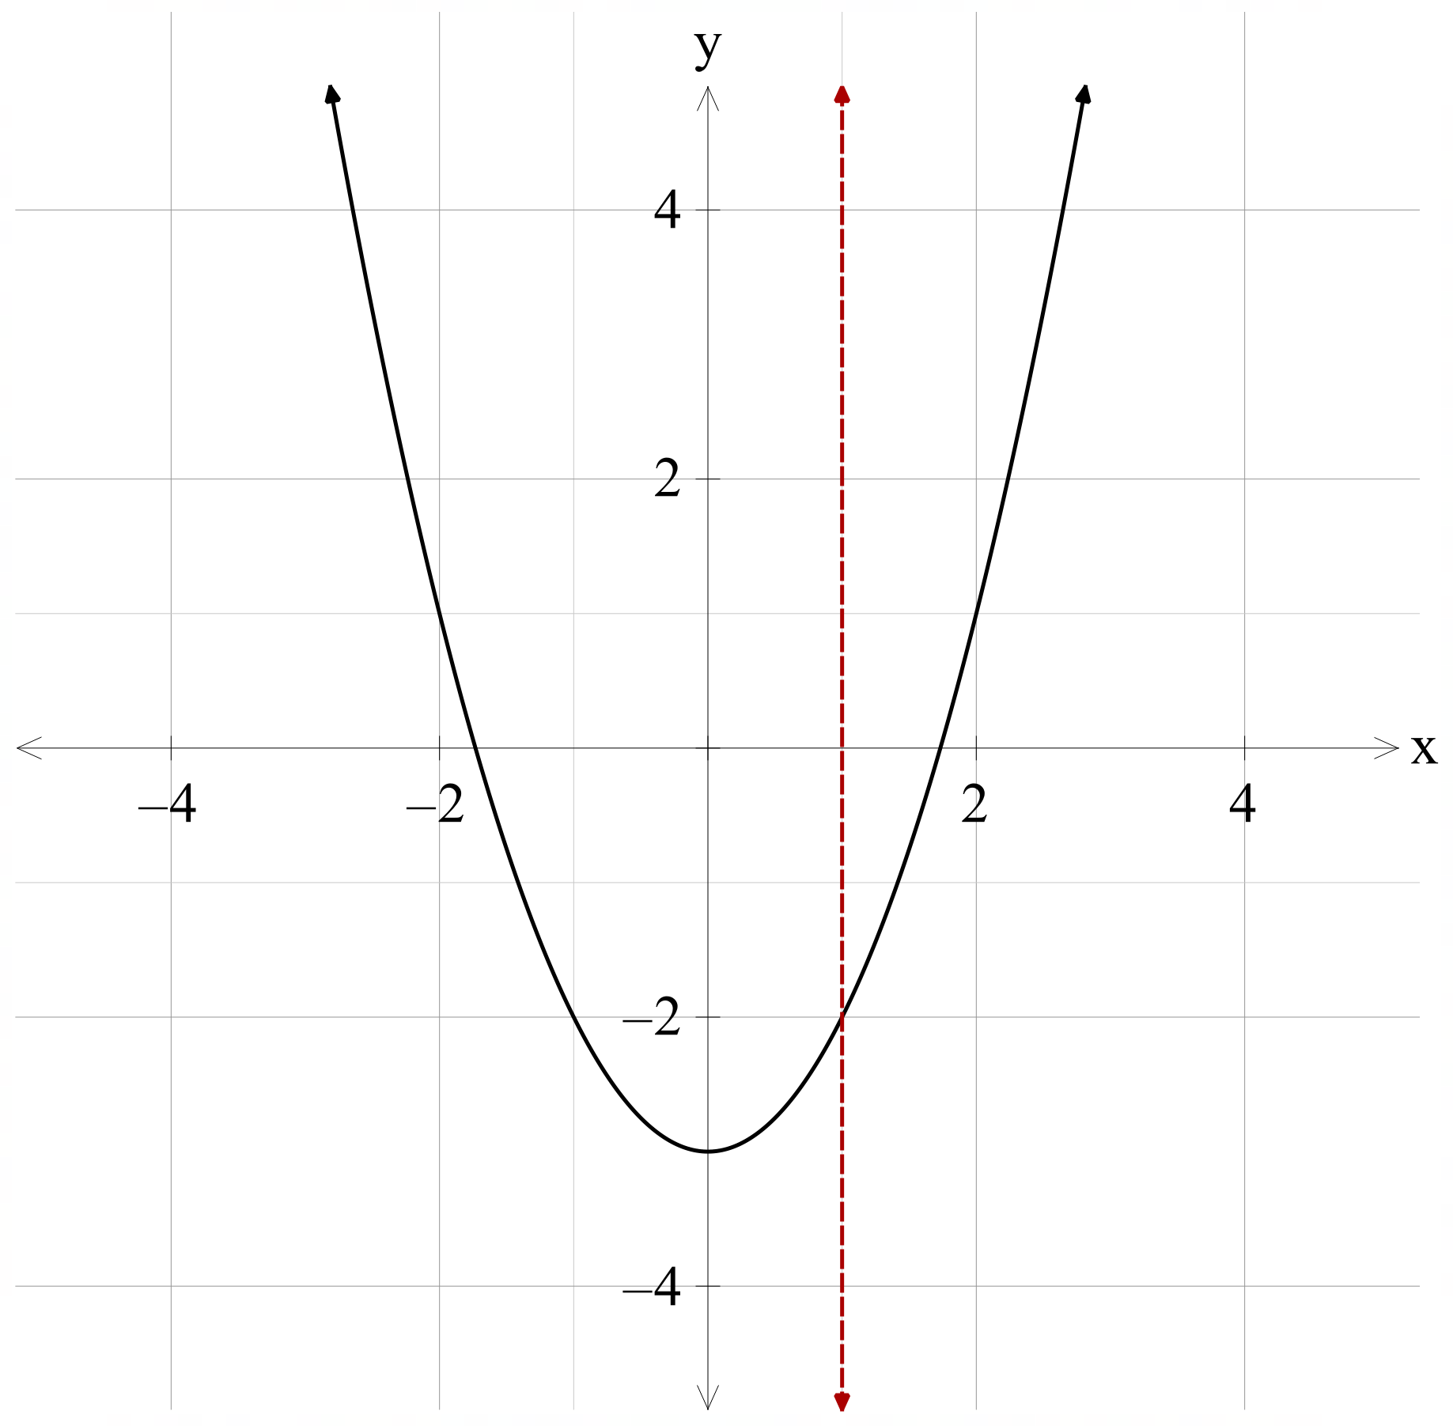 | Yes | The relation is a function, as the straight line passes the vertical line test, as for each $x$-value, the vertical line only intersects the graph once.
$$x=-2$$ | 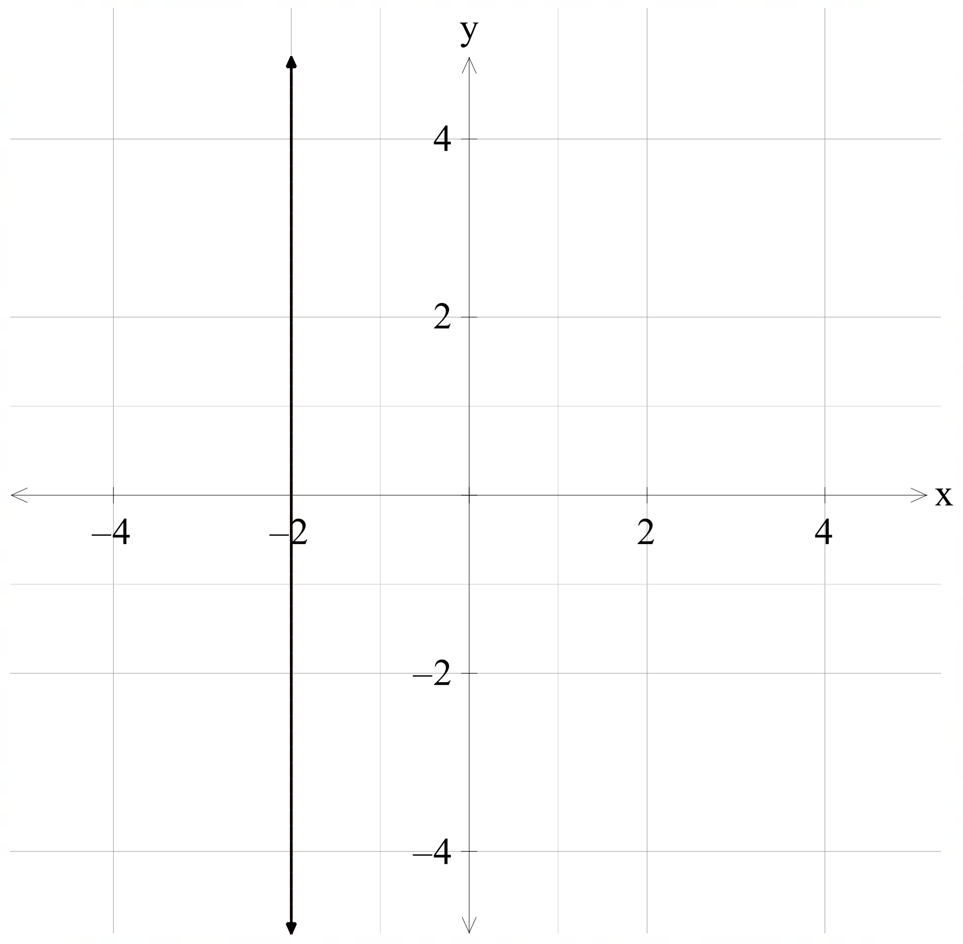 | No | The relation is not a function as it has infinitely many $y$-values assigned to the $x$-value $-2$.  The relation also fails the vertical line test as when $x=-2$, the vertical line intersects the relation infinitely many times.
$$y=1$$ | 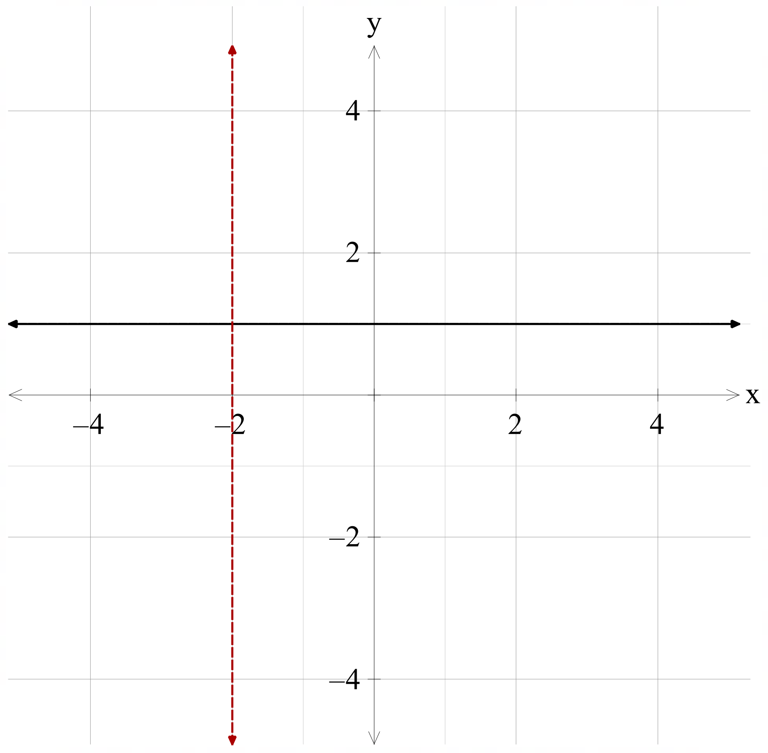 | Yes | The relation is a function, as the straight line passes the vertical line test, as for each $x$-value, the vertical line only intersects the graph once.
$$y=2^{x}$$ | 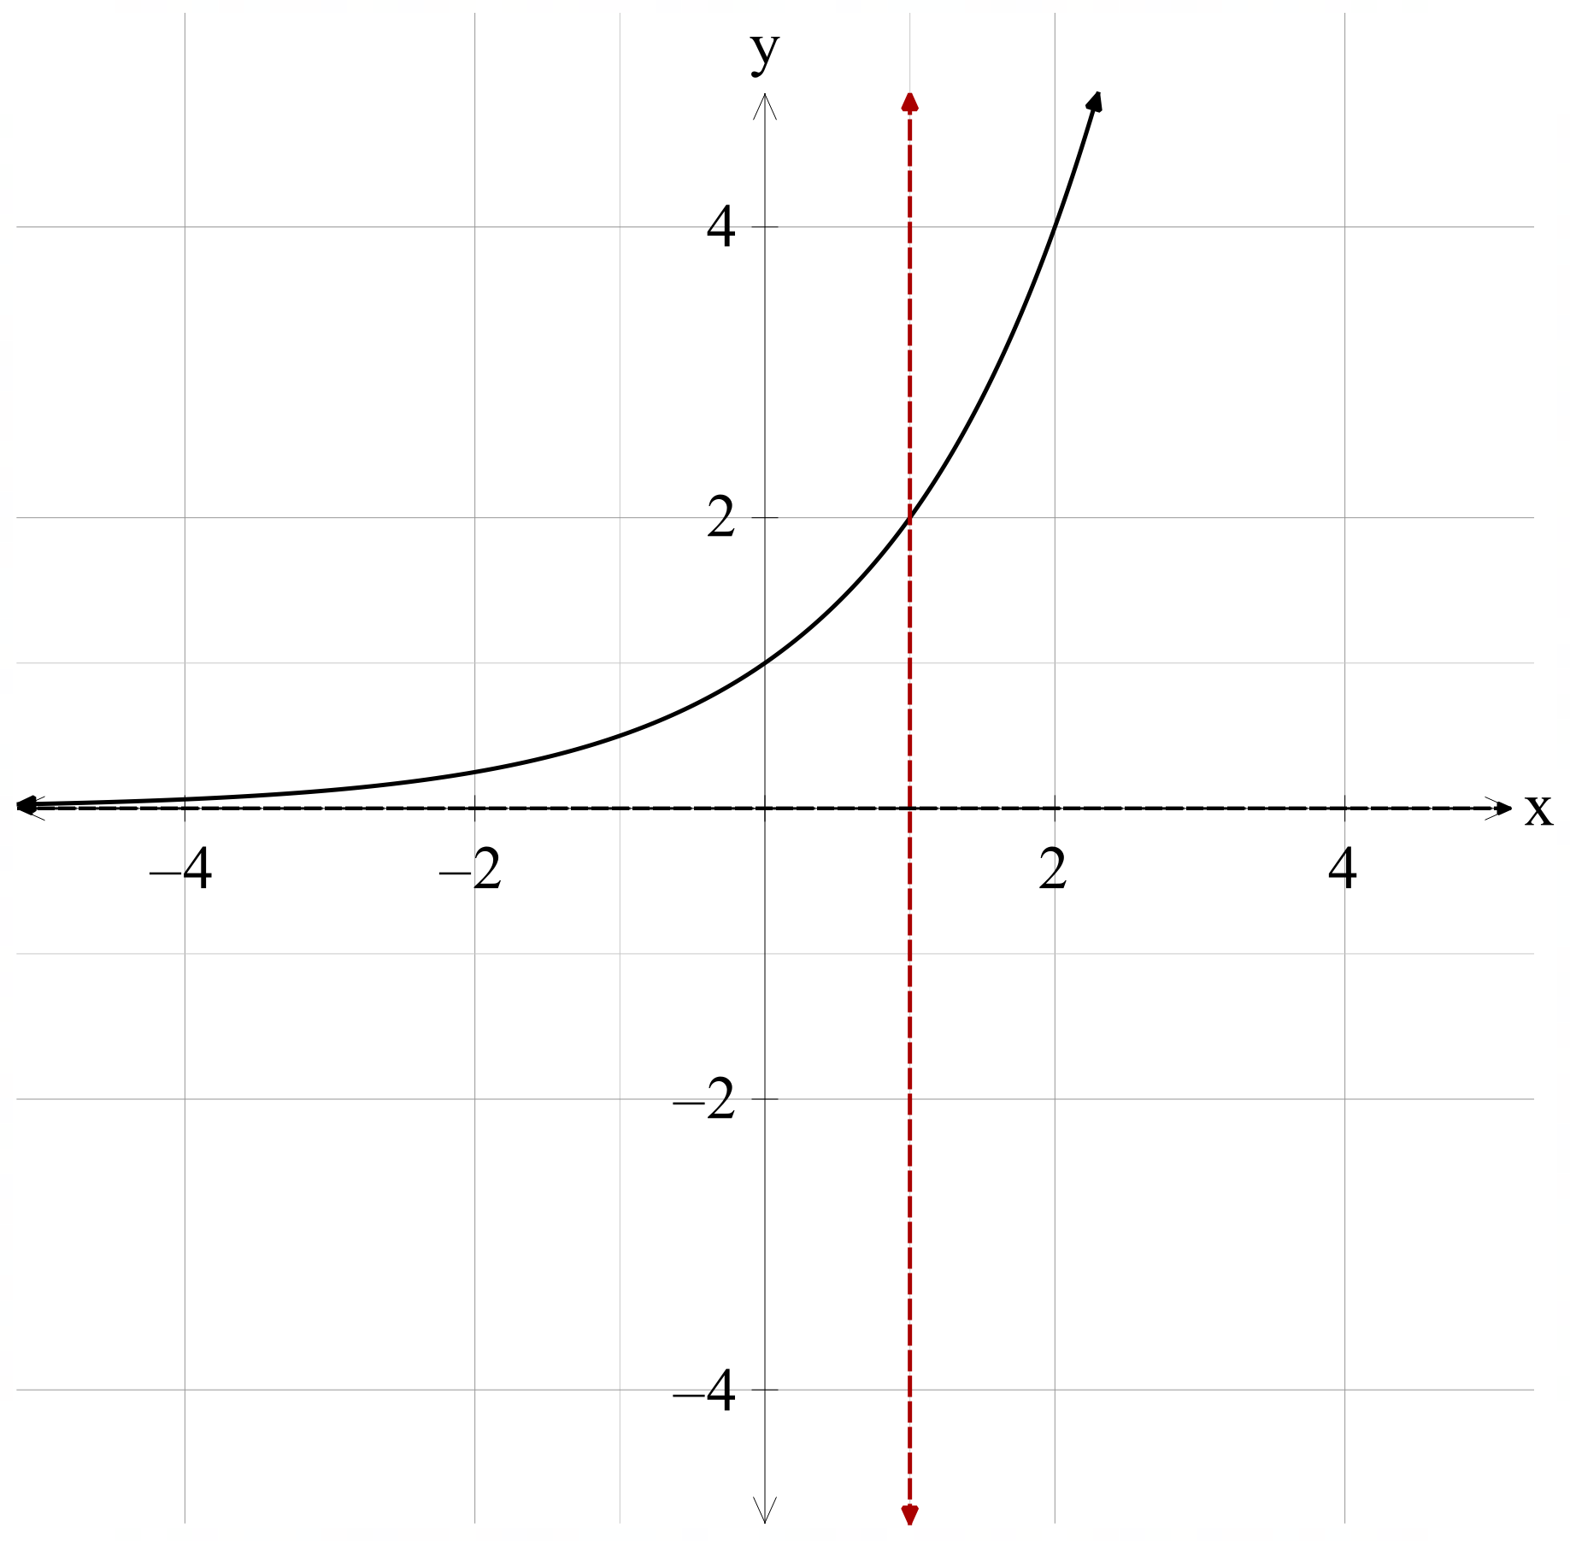 | Yes | The relation is a function, as the straight line passes the vertical line test, as for each $x$-value, the vertical line only intersects the graph once.

References
This resource contains NSW Curriculum and syllabus content. The NSW Curriculum is developed by the NSW Education Standards Authority. This content is prepared by NESA for and on behalf of the Crown in right of the State of New South Wales. The material is protected by Crown copyright.
Please refer to the NESA Copyright Disclaimer for more information https://educationstandards.nsw.edu.au/wps/portal/nesa/mini-footer/copyright.
NESA holds the only official and up-to-date versions of the NSW Curriculum and syllabus documents. Please visit the NSW Education Standards Authority (NESA) website https://educationstandards.nsw.edu.au/ and the NSW Curriculum website https://curriculum.nsw.edu.au/.
Mathematics Advanced 11–12 Syllabus © NSW Education Standards Authority (NESA) for and on behalf of the Crown in right of the State of New South Wales, 2024.
NESA (NSW Education Standards Authority (2024) ‘Glossary’, Mathematics Advanced 11–12 (2024), NESA website, accessed 22 July 2025.

© State of New South Wales (Department of Education), 2025
The copyright material published in this resource is subject to the Copyright Act 1968 (Cth) and is owned by the NSW Department of Education or, where indicated, by a party other than the NSW Department of Education (third-party material).
Copyright material available in this resource and owned by the NSW Department of Education is licensed under a Creative Commons Attribution 4.0 International (CC BY 4.0) license.

This license allows you to share and adapt the material for any purpose, even commercially.
Attribution should be given to © State of New South Wales (Department of Education), 2025.
Material in this resource not available under a Creative Commons license:
- the NSW Department of Education logo, other logos and trademark-protected material
- material owned by a third party that has been reproduced with permission. You will need to obtain permission from the third party to reuse its material.
Links to third-party material and websites
Please note that the provided (reading/viewing material/list/links/texts) are a suggestion only and implies no endorsement, by the New South Wales Department of Education, of any author, publisher, or book title. School principals and teachers are best placed to assess the suitability of resources that would complement the curriculum and reflect the needs and interests of their students.
If you use the links provided in this document to access a third-party's website, you acknowledge that the terms of use, including licence terms set out on the third-party's website apply to the use which may be made of the materials on that third-party website or where permitted by the Copyright Act 1968 (Cth). The department accepts no responsibility for content on third-party websites.

