Differentiating cosecant, secant and cotangent functions
Students differentiate cosecant, secant and cotangent functions using the rules of differentiation and apply these techniques to functions in a variety of forms.
Students will need at least one digital device per pair to interact with Desmos during this lesson.

Learning intention
- To be able to apply differentiation rules to functions involving $\operatorname{cosec}{x}$, $\sec{x}$ and $\cot{x}$.

Success criteria
- I can rewrite reciprocal trigonometric functions in different forms.
- I can find the derivatives of $\operatorname{cosec}{x}$, $\sec{x}$ and $\cot{x}$.
- I can apply rules of differentiation to differentiate functions involving $\operatorname{cosec}{x}$, $\sec{x}$ and $\cot{x}$.

Outcomes
A student:
- develops understanding and fluency in mathematics through exploring and connecting mathematical concepts, choosing and applying mathematical techniques to solve problems, and communicating their thinking and reasoning coherently and clearly MAO-WM-01
- selects and applies differentiation methods to solve problems MAV-12-04

Content

Differentiation with trigonometric functions
- Use the rules of differentiation to find the derivatives of $\operatorname{cosec}{x}$, $\sec{x}$ and $\cot{x}$

Using derivatives
- Apply the product, quotient and chain rules to differentiate functions of the form
$f\left(x\right)g\left(x\right)$, $\frac{f\left(x\right)}{g\left(x\right)}$ or $f(g(x))$, where $f(x)$ and $g(x)$ are any of the functions within the scope of the Mathematics Advanced course
Mathematics Advanced 11–12 Syllabus © NSW Education Standards Authority (NESA) for and on behalf of the Crown in right of the State of New South Wales, 2024.

Table 1: lesson summary
Section | Summary of activity | Teaching strategies | Teaching points
Activating prior knowledge | Use slides 4–5 of the PowerPoint Differentiating cosecant, secant and cotangent functions for students to complete and check a table of reciprocal trigonometric functions. They then recall how rewriting these functions supports differentiation and identify domain restrictions. | Think-Pair-Share | Highlight how rewriting reciprocal trigonometric functions (in terms of sine and cosine) enables the use of known differentiation rules. Draw attention to domain restrictions arising from zero denominators and their connection to asymptotes.
Connecting learning | Use a Desmos calculator activity (bit.ly/ReciprocalTrigFns) and mini whiteboards for students to analyse the graph of $\operatorname{cosec}{x}$, predict and determine its derivative, and verify results graphically. | Mini whiteboards  Think-Pair-Share | Draw connections between the graph of a function and the shape and sign of its gradient function. Highlight how rewriting reciprocal functions supports differentiation and how graphical verification reinforces algebraic results.
Releasing responsibility | Use slide 7 to model differentiation of reciprocal trigonometric functions using multiple methods, then use Appendix A for students to apply and compare approaches before confirming results on slide 8. | Worked example (comparison)  Think-Pair-Share | Highlight different approaches (chain and quotient rules) and when each may be more efficient. Support students to compare methods and consolidate key steps and structures when differentiating reciprocal trigonometric functions.
Independent practice | Use Appendix B for students to apply differentiation rules to reciprocal trigonometric functions through a banner task. | Visibly random groups of 3  Vertical non-permanent surfaces  Banner tasks | Reinforce application of differentiation rules across a range of reciprocal trigonometric functions. Support students to generalise strategies and check working for accuracy and efficiency.

Activity structure
Please use the associated PowerPoint Differentiating cosecant, secant and cotangent functions to display images in this lesson.

Activating prior knowledge
- Display slide 4 of the PowerPoint and have students complete the table in their workbook.
- To check for understanding, display the solutions on slide 5.
For cosecant, the syllabus uses the abbreviation $\operatorname{cosec}{x}$. However, it is sometimes seen abbreviated as $\csc{x}$, for example, in the Desmos graphing calculator.
- Use a Think-Pair-Share (bit.ly/thinkpairsharestrategy) to ask students to explain which angle values are excluded from the domain for each function and why.
Students should recognise that when a denominator becomes zero, the function becomes undefined.
- Prompt students to recall that we can rewrite $\tan{x}$ as $\frac{\text{sin}{x}}{\text{cos}{x}}$ and ask students how rewriting the reciprocal trigonometric functions like this might help us when differentiating.

Connecting learning
- With at least one device per pair, direct students to the Desmos graphing calculator ‘Reciprocal Trigonometric Functions’ (bit.ly/ReciprocalTrigFns).
If devices are not available, this can be displayed for students.
- Have students examine the graph of $y=\operatorname{cosec}{x}$ (appearing as $y=\csc{x}$), noting key features such as asymptotes, zeroes, period and shape.
Note that the asymptotes are not visually shown in the graphing calculator.
- In pairs, ask students to predict the sign and general shape of the derivative function before asking students to select the circle beside $y=f'(x)$ in the Desmos graphing calculator to display the graph of the gradient function.
Figure 1: Desmos graphing calculator view
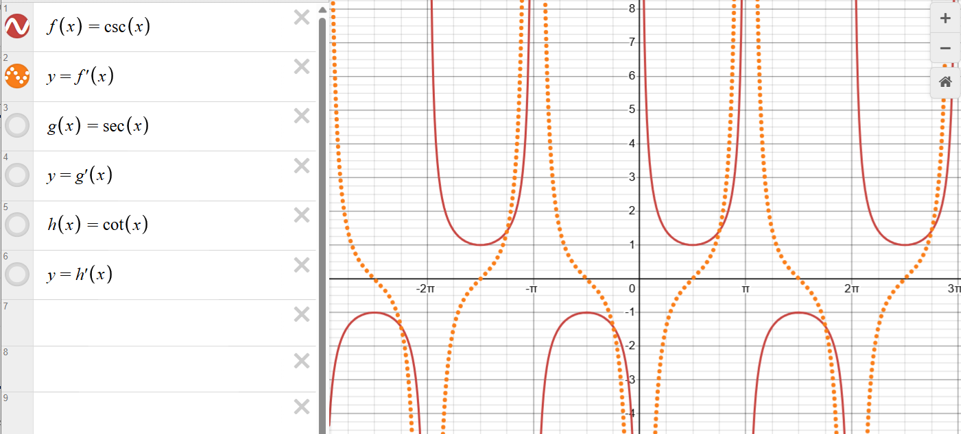
- Use a Think-Pair-Share to discuss how expressing reciprocal functions like $\operatorname{cosec}{x}$ in terms of sine affect the strategy used to differentiate.
- Using mini whiteboards (bit.ly/miniwhiteboards), in their pairs, have students differentiate
$y=\operatorname{cosec}{x}$ using known differentiation rules and simplify the result.
- To verify their derived function, ask students to graph the function using the Desmos graphing calculator and compare it to the gradient function $y=f'(x)$ of $f(x)=\operatorname{cosec}{x}$.
Students should have derived $\frac{d}{dx}\operatorname{cosec}{x}=-\frac{\cos{x}}{\sin^{2}{x}}$ using the quotient rule, which they may have been able to simplify to $\frac{dy}{dx}=-\operatorname{cosec}{x}\cot{x}$. This derivative should be entered into the Desmos graphing calculator as $y=(-\csc{x})(\cot{x})$ for the graph to appear.

Releasing responsibility
- Tell students that the derivatives of $\operatorname{cosec}{x}$, $\sec{x}$ and $\cot{x}$ do not need to be memorised and students should be able to find these derivatives by rewriting these functions in ways that let us apply familiar rules for differentiation.
- Use slide 7 to display a worked example of both chain and quotient rule approaches to differentiating $y=\operatorname{cosec}{x}$ using the Worked examples – comparison strategy (bit.ly/supportingstrategies).
- Animate the self-explanation prompts on slide 7 for students to discuss in pairs.
- Facilitate a Think-Pair-Share to compare the 2 methods and discuss if one might be simpler or more appropriate.
- Distribute Appendix A ‘Y chart’ to each student and have students record a complete solution to the derivative of $y=\operatorname{cosec}{x}$.
- Continuing with Appendix A, students should then complete the derivatives of $y=\sec{x}$ and $y=\cot{x}$ using either the chain rule or quotient rule method.
- Display slide 8, confirming the derivatives for all 3 reciprocal trigonometric functions.
- Provide students with time to compare their solutions and annotate the processes used in Appendix A, outlining the approach taken, the differentiation rules used and any key things to remember.
Students may like to record these on their own reference sheets. However, the derivatives of $\operatorname{cosec}{x}$, $\sec{x}$ and $\cot{x}$ do not need to be memorised and the focus should be on using known differentiation rules and the derivatives of $\sin{x}$, $\cos{x}$ and $\tan{x}$.

Independent practice
- Assign students to visibly random groups of 3 (bit.ly/visiblegroups) at vertical non-permanent surfaces (bit.ly/VNPSstrategy).
- Groups are to complete the banner task (bit.ly/supportingstrategies) using Appendix B ‘Banner tasks.’

Assessment and differentiation

Suggested opportunities for differentiation
Activating prior knowledge
- Partially complete the table for students who may struggle with recalling the alternative notations of reciprocal trigonometric functions.
- Offer sentence starters or guiding questions during the Think-Pair-Share to scaffold students’ explanations about why certain angle values are excluded.
- Challenge advanced students to also explain the implications of domain restrictions on real-world applications or on the graphs of the functions.
Connecting learning
- Students might need to be prompted to consider the reciprocal expression or negative index notation to differentiate $y=\operatorname{cosec}{x}$ using known rules of differentiation.
- Less scaffolding can be provided for more advanced students to establish the gradient function of $y=\operatorname{cosec}{x}$ using algebraic techniques and graphing software verification.
Releasing responsibility
- Encourage advanced students to compare and critique the efficiency or elegance of the chain rule versus quotient rule approaches in different scenarios.
Independent practice
- Partially complete the first few banner task questions for students needing more stepwise guidance to structure their problem-solving.
- Encourage some groups to generate ‘challenge problems’ related to the derivatives of trigonometric functions.

Suggested opportunities for assessment
Activating prior knowledge
- Review the completed tables from students’ workbooks to check accuracy and understanding before moving on.
- Use the Think-Pair-Share discussions to circulate and listen to students’ explanations, noting misconceptions or gaps in understanding regarding domains.
Connecting learning
- Prompt students to explain verbally how the graph of $y = f'(x)$ relates to the shape and key points of $y =\operatorname{cosec}{x}$ during pair discussions.
- Review students’ mini whiteboard differentiation work on the spot to correct errors and clarify misunderstandings immediately.
Releasing responsibility
- Use the Think-Pair-Share of the self-explanation prompts to assess depth of student reasoning and understanding of the different differentiation methods.
- Review Appendix A ‘Y chart' completed by students to check for accurate, thorough solutions and proper application of differentiation rules.
Independent practice
- Observe and note group discussions to identify students demonstrating conceptual understanding or struggling with specific steps.
- Observe solutions to the banner tasks and provide teacher feedback, focusing on process accuracy as well as final answers.

Appendix A

Y chart
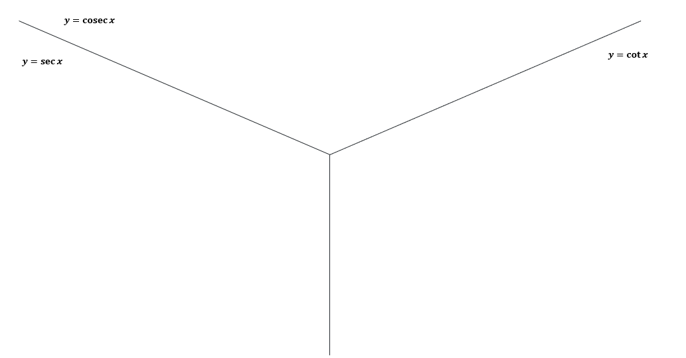

Appendix B

Banner tasks
Differentiate each of the following functions.
Function | Derivative
$$x\sec{x}$$ | $$\sec{x}+x\sec{x}\tan{x}=\sec{x}(1+x\tan{x})$$
$$\frac{\operatorname{cosec}{x}}{x^{2}}$$ | $$\frac{-\operatorname{cosec}{x}[x^{2}\cot{x}+2x]}{x^{4}}=\frac{-\operatorname{cosec}{x}[x\cot{x}+2]}{x^{3}}$$
$$e^{x}\sec{x}$$ | $$e^{x}sec{x}+e^{x}\sec{x}\tan{x=e^{x}\sec{x(1+\tan{x)}}}$$
$$\operatorname{cosec}{x}×\ln{x}$$ | $$\operatorname{cosec}{x}×\frac{1}{x}+\ln{x}×\left(-\operatorname{cosec}{x}\cot{x}\right)=\operatorname{cosec}{x}\left(\frac{1}{x}-\ln{x}×\cot{x}\right)$$
$$x^{2}\cot{x}$$ | $$2x\cot{x}+x^{2}\left(-{cosec}^{2}{x}\right)=x\left(2\cot{x}-x{cosec}^{2}{x}\right)$$
$$\frac{\sec{x}}{x}$$ | $$\frac{x\sec{x}\tan{x}-\sec{x}}{x^{2}}=\frac{\sec{x}\left(x\tan{x}-1\right)}{x^{2}}$$
$$\frac{e^{x}}{\operatorname{cosec}{x}}$$ | $$\frac{e^{x}\operatorname{cosec}{x}+e^{x}\operatorname{cosec}{x}\cot{x}}{{cosec}^{2}{x}}=\frac{e^{x}\left(1+\cot{x}\right)}{\operatorname{cosec}{x}}$$
$$\frac{\cot{x}}{\ln{x}}$$ | $$\frac{\ln{x}×\left(-{\operatorname{cosec}{x}}^{2}\right)-\cot{x}×\frac{1}{x}}{{\left(\ln{x}\right)}^{2}}$$
$$e^{\sec{x}}$$ | $$e^{\sec{x}}×(\sec{x}\tan{x})$$
$$\sec{(\sin{x})}$$ | $$y^{'}=\sec{(\sin{x})}\tan{(\sin{x}})\cos{x}$$
$$\ln{(\operatorname{cosec}{x})}$$ | $$-\cot{x}$$
$$\cot{x^{2}}$$ | $$-{{cosec}^{2}{(x}}^{2})×2x$$

References
This resource contains NSW Curriculum and syllabus content. The NSW Curriculum is developed by the NSW Education Standards Authority (NESA). This content is prepared by NESA for and on behalf of the Crown in right of the State of New South Wales. The material is protected by Crown copyright.
Please refer to the NESA Copyright Disclaimer for more information https://www.nsw.gov.au/education-and-training/nesa/copyright.
NESA holds the only official and up-to-date versions of the NSW Curriculum and syllabus documents. Please visit NESA https://www.nsw.gov.au/education-and-training/nesa and NSW Curriculum https://curriculum.nsw.edu.au.
Mathematics Advanced 11–12 Syllabus © NSW Education Standards Authority (NESA) for and on behalf of the Crown in right of the State of New South Wales, 2024.

© State of New South Wales (Department of Education), 2026
The copyright material published in this resource is subject to the Copyright Act 1968 (Cth) and is owned by the NSW Department of Education or, where indicated, by a party other than the NSW Department of Education (third-party material).
Copyright material available in this resource and owned by the NSW Department of Education is licensed under a Creative Commons Attribution 4.0 International (CC BY 4.0) license.

This license allows you to share and adapt the material for any purpose, even commercially. Attribution should be given to © State of New South Wales (Department of Education), 2026.
Material in this resource not available under a Creative Commons license:
- the NSW Department of Education logo, other logos and trademark-protected material
- material owned by a third party that has been reproduced with permission. You will need to obtain permission from the third party to reuse its material.
Links to third-party material and websites
Please note that the provided (reading/viewing material/list/links/texts) are a suggestion only and implies no endorsement, by the New South Wales Department of Education, of any author, publisher, or book title. School principals and teachers are best placed to assess the suitability of resources that would complement the curriculum and reflect the needs and interests of their students.
If you use the links provided in this document to access a third-party's website, you acknowledge that the terms of use, including licence terms set out on the third-party's website apply to the use which may be made of the materials on that third-party website or where permitted by the Copyright Act 1968 (Cth). The department accepts no responsibility for content on third-party websites.

