Differentiating tangent functions
Students differentiate tangent functions using differentiation rules. They apply these techniques to differentiate trigonometric functions in a variety of forms and solve problems involving equations of tangents and normals.

Learning intention
- To be able to apply differentiation rules to functions involving $\tan{f(x)}$.

Success criteria
- I can show that the derivative of $\tan{x}$ is $\sec^{2}{x}$.
- I can differentiate functions involving $\tan{f(x)}$ using chain rule.
- I can differentiate functions using the rules of differentiation, including when they contain trigonometric functions.
- I can solve problems involving equations of tangents and normals to trigonometric functions.

Outcomes
A student:
- develops understanding and fluency in mathematics through exploring and connecting mathematical concepts, choosing and applying mathematical techniques to solve problems, and communicating their thinking and reasoning coherently and clearly MAO-WM-01
- selects and applies differentiation methods to solve problems MAV-12-04

Content

Differentiation with trigonometric functions
- Use the rules of differentiation to show that $\frac{d}{dx}(\tan{x)=\sec^{2}}{x}$
- Use the chain rule to differentiate functions of the form $\sin{f\left(x\right)}$, $\cos{f\left(x\right)}$ and $\tan{f\left(x\right)}$

Using derivatives
- Apply the product, quotient and chain rules to differentiate functions of the form
$f\left(x\right)g\left(x\right)$, $\frac{f\left(x\right)}{g\left(x\right)}$ or $f(g(x))$, where $f(x)$ and $g(x)$ are any of the functions within the scope of the Mathematics Advanced course
- Solve problems involving equations of tangents and normals to curves involving any of the functions within the scope of the Mathematics Advanced course
Mathematics Advanced 11–12 Syllabus © NSW Education Standards Authority (NESA) for and on behalf of the Crown in right of the State of New South Wales, 2024.

Table 1: lesson summary
Section | Summary of activity | Teaching strategies | Teaching points
Activating prior knowledge | Use slide 4 of the PowerPoint Differentiating tangent functions and Appendix A to recall the identity for $\tan{x}$, connect it to its graph, and describe the key features of $y=\tan{x}$. | Mini whiteboards  Think-Pair-Share  Pose-Pause-Pounce-Bounce | Highlight the relationship between $\tan{x}=\frac{\sin{x}}{\cos{x}}$and the presence of vertical asymptotes. Draw connections between the behaviour of the function and the sign and magnitude of its gradient, particularly near asymptotes and at intercepts.
Connecting learning | Use Appendix A and slides 6–8 for students to reason about the behaviour of the gradient function of $y=\tan{x},$ then sketch and analyse the gradient function. Students compare this to $y=\sec^{2}{x}$, and compare chain rule and quotient rule methods to generalise a rule for differentiating $\tan{f(x)}$. | Turn and talk  Think-Pair-Share  Pose-Pause-Pounce-Bounce  Worked examples –comparison | Draw connections between the graph of $y=\tan{x}$and its gradient function, including the role of asymptotes. Highlight how known derivatives and identities support finding the derivative of $\tan{x}$, and how this extends to functions of the form $\tan{f(x)}$.
Releasing responsibility | Use the HSC reference sheet and slide 10 to recall the derivative of the tangent function, then use slides 11–14 to model worked examples and apply differentiation to functions involving $\tan{f(x)}$, before using Appendix B to consolidate understanding through notes. | Worked examples (Your turn)  Visibly random groups of 3  Vertical non-permanent surfaces  Four quadrant notes | Highlight the derivative of $\tan{x}$and its extension to $\tan{f(x)}$. Draw connections between the use of chain, product and quotient rules when differentiating functions involving tangent. Support students to consolidate key steps and common structures through structured note making.
Independent practice | Use slide 16 to review the Approaching questions scaffold, then use Appendix C for students to apply their understanding to tangent and normal problems, discussing and refining solutions with a partner. |  | Reinforce structured problem-solving and interpretation of gradients in context, including equations of tangents and normals. Support students to justify and refine their reasoning through peer discussion.

Activity structure
Please use the associated PowerPoint Differentiating tangent functions to display images in this lesson.

Activating prior knowledge
- Distribute mini whiteboards (bit.ly/miniwhiteboards) and ask students if they can recall the identity for $\tan{x}$ in terms of $\sin{x}$ and $\cos{x}$.
- Confirm the identity $\tan{x}=\frac{\sin{x}}{\cos{x}}$ by displaying slide 4 of the PowerPoint.
Students established this identity in Year 11 – Unit 7 – Lesson 3 – trigonometric identities.
- Animate slide 4, revealing the graph of $y=\tan{x}$ and distribute a printed copy from Appendix A ‘Tangent graph’ to each student.
- Use the Pose-Pause-Pounce-Bounce questioning strategy (PDF 557KB) (bit.ly/posepausepouncebounce) to ask students to consider what happens to the identity when $\cos{x}=0$ and what this looks like in the graph of $y=\tan{x}$.
Lead students to recognise that vertical asymptotes exist where $cos⁡x=0$. That is, at $x=\frac{π}{2}+kπ$.
Students learnt that when the denominator in a function is zero, it creates an asymptote on the graph in Year 11 – Unit 2 – introduction to functions and Unit 4 – graphing transformations.
- In a Think-Pair-Share (bit.ly/thinkpairsharestrategy) ask students to describe where the function:
- is increasing, decreasing or stationary
- crosses the $x$-axis and what happens to the gradient at these points.
Students learnt to describe where functions are increasing, decreasing and stationary in Year 11 – Unit 6 – Lesson 8 – increasing and decreasing functions. Students graphed $y=\tan{x}$ including its asymptotes in Year 11 – Unit 7 – Lesson 5 – graphing trigonometric functions.
The graph of $y=\tan{x}$ is always increasing. The gradient is the same and least steep at the $x$-intercepts.

Connecting learning
- Use the Pose-Pause-Pounce-Bounce questioning strategy to ask students what the graph tells them about the gradient function of $y=\tan{x}$. Prompting questions could include:
- What do you notice about the gradient near the asymptotes?
- Where will the gradient function be above or below the $x$-axis?
- How does the behaviour of the graph of $y=\tan{x}$ help us predict the form or features of its gradient function?
Students practised identifying the expected shape of the derivative function in Year 11 – Unit 6 – Lesson 9 – graphing the derivative function.
Students should recognise that the gradient is very steep near the asymptotes and that the gradient function will be entirely above the $x$-axis since the graph is always increasing. They may notice that the gradient function is also periodic and will have asymptotes in the same places as the original graph, because the gradient is undefined (not differentiable).
- By placing a printed copy of the graph of $y=\tan{x}$ from Appendix A into a plastic sleeve, ask students to draw a rough sketch of the gradient function from their earlier descriptions, using the same axes and marking any key points.
- Ask students to turn and talk (bit.ly/classroomtalkmoves) to discuss the similarities and differences between their sketches.
- Explain to students that they are now going to determine the gradient function for $y=\tan{x}$.
- With a mini whiteboard between each pair of students, display slide 6 and ask pairs to find the derivative of $\tan{x}$ using what they already know about the derivatives of the sine and cosine functions.
- Animate the following enabling questions one-by-one to guide students through the process:
- What do we already know about the derivatives of the sine and cosine functions?
- What formula or rule can be used to differentiate functions in this form?
- What identities can be used to simplify the derivative?
- Invite pairs to share and discuss their simplified derivative with a neighbouring pair before animating slide 6 for the final time to reveal the solution.
- Display slide 7, revealing the graph of $y=\sec^{2}{x}$ and conduct a Think-Pair-Share to compare it to the sketch they drew earlier, reflecting on the accuracy of their predicted gradient function and the connections between key features of the gradient function and the original function.
- Display slide 8 and, using their mini whiteboards, allow students time in their pairs to establish a general rule or formula for the derivative of $\tan{f(x)}$, that is, if instead of $x$ we have a function $f(x)$ inside tangent. Have students compare with a neighbouring pair.
Students may guess at the rule based on their knowledge of the differentiation rules for sine and cosine. Encourage students to try to formally prove their guess.
Students may apply the chain rule formula to establish that $\frac{d}{dx}\tan{f(x)}=f^{'}\left(x\right)\sec^{2}{f(x)}$ or apply the quotient rule to differentiate $\frac{\sin{f\left(x\right)}}{\cos{f(x)}}$.
- Animate slide 8 to model the solution using the Worked examples – comparison strategy (bit.ly/supportingstrategies).

Releasing responsibility
- Refer students to their Mathematics Advanced – HSC reference sheet and have them locate the derivative for the tangent function.
- Display slide 10, showing the relevant formula.
- Use slides 11–12 to model a worked example of differentiating functions of the form $\tan{f\left(x\right)}$ using the Worked examples (Your turn) method (bit.ly/supportingstrategies).
- Following practice from an existing resource of differentiating functions of the form $\tan{f\left(x\right)}$, use slides 13–14 to model a worked example of combining this derivative with product and quotient rules.
- Assign students to visibly random groups of 3 (bit.ly/visiblegroups). Ask them to complete Four quadrant notes to their future forgetful selves (bit.ly/supportingstrategies) from Appendix B ‘Four quadrant notes’ on a vertical non-permanent surface (bit.ly/VNPSstrategy) before preparing their own individual notes.

Independent practice
- Display slide 16 and have students review the Approaching questions scaffold.
- Distribute Appendix C ‘Tangent and normal questions’ to each student.
- Have students work through the questions, meeting with a partner after each question to discuss answers. If answers differ, have student pairs negotiate the correct answers.

Assessment and differentiation

Suggested opportunities for differentiation
Activating prior knowledge
- Small tangents could be drawn at various points of the graph of $y=\tan{x}$ when displayed using slide 4 of the PowerPoint, to support discussions around steepness of gradient and where a graph is increasing, decreasing or stationary.
Connecting learning
- Prompt students to consider how the steepness of the gradient changes between asymptotes to support them to sketch the gradient function of $y=\tan{x}$.
- Offer guiding questions during the turn and talk activity to help students focus on relevant graph features, for example, ask students what they notice about where the function is positive.
- Invite students to explore and explain the relationship between the increasing nature of $\tan{x}$ and the sign of its derivative.
- Prior to asking students to establish a general derivative rule for $\tan{f(x)}$, they could be provided with some examples to differentiate such as $y=\tan{(2x+1)}$ and $y=\tan\left(\frac{x^{2}}{2}+π\right).$
Releasing responsibility
- Assign students to prepare alternative worked examples involving tangent functions with more complex inner functions and then present their solutions to the class.
- Invite students to develop flow charts summarising step-by-step use of chain, product and quotient rules specifically for trigonometric derivatives.
Independent practice
- Encourage students to create their own tangent and normal problems to swap with peers for solving, fostering deeper mastery and creativity.

Suggested opportunities for assessment
Activating prior knowledge
- Use the Pose-Pause-Pounce-Bounce questioning strategy to assess students’ understanding of why vertical asymptotes occur and their impact on the graph’s behaviour.
- Observe responses from the Think-Pair-Share about increasing/decreasing and stationary points to identify misconceptions, for example, misunderstanding domain restrictions or gradient behaviour.
Connecting learning
- Observe student sketches of the gradient function and the reasoning shared in the Think-Pair-Share discussions to check for accurate interpretation of asymptotes and function sign.
- Review students’ mini whiteboard differentiation work to correct errors and clarify misunderstandings immediately.
Releasing responsibility
- Review student group work on Four quadrant notes at vertical surfaces to assess their depth of understanding and ability to communicate the derivative rules of tangent.
Independent practice
- Circulate during partner discussions to listen for correct application of differentiation and negotiation skills, providing immediate corrective feedback as needed.
- Collect or review selected student solutions periodically throughout the activity to ensure accuracy and identify common errors requiring whole-class review.

Appendix A

Tangent graph
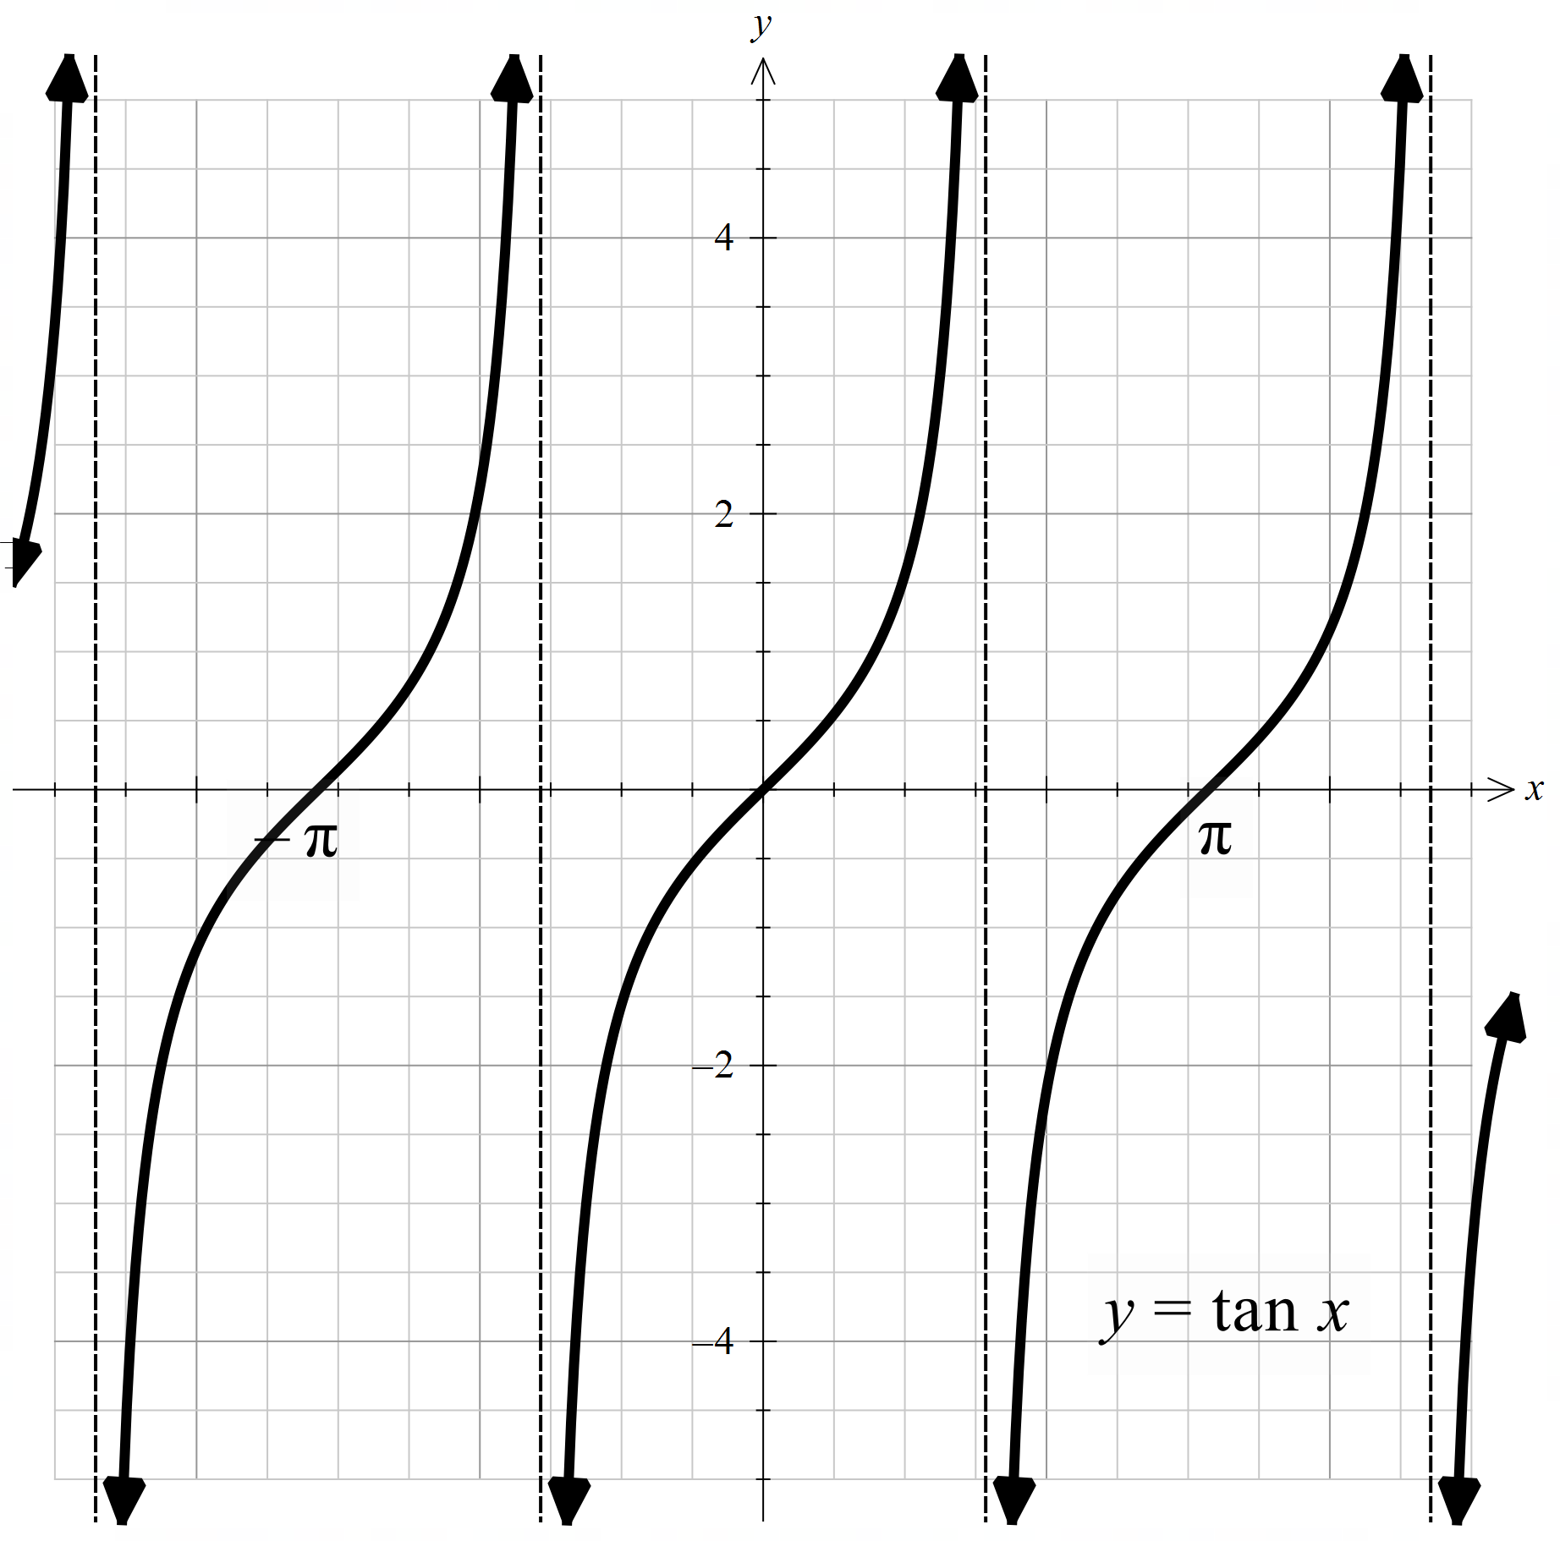

Appendix B

Four quadrant notes
Example 1  Find $\frac{dy}{dx}$ when $x=π$ if $y=x^{2}\tan{5x}$.  $$\frac{dy}{dx}=u\frac{dv}{dx}+v\frac{du}{dx} \\ =\boxed{}× \boxed{}+\boxed{{ }}×\boxed{} \\ =\boxed{ { }}+\boxed{ {}}$$  When $x=π$:$$\frac{dy}{dx}=\boxed{ { }}+\boxed{ {}} \\ =\boxed{ { }}+\boxed{ {}} \\ =\boxed{ { }}$$ | Example 2  Find $\frac{dy}{dx}$ when $x=\frac{π}{4}$ if $y=\frac{e^{x}}{\tan{3x}}$.
Things to remember | Example 3

Appendix C

Tangent and normal questions
- Find the equation of the tangent to the curve $y=x\tan{x}$ at $x=\frac{π}{4}$.
- Find the equation of the normal to the curve $y=\tan{3x}$ at $x=\frac{π}{9}$.
- Differentiate $y=\tan{x}$. Find all values of $x$ in the domain $[0, 2π]$ where the gradient of the tangent to the curve equals 1.
- Show that the line $y=2x$ is a tangent to the curve $y=\tan{2x}$ at $(0,0)$.
- The point $P\left(-\frac{π}{4},1\right)$ lies on the curve $y=-\tan{x}$. Show that the normal at $P$ has the equation $y=\frac{1}{2}x+\frac{8+π}{8}$.

Sample solutions

Appendix B – Four quadrant notes
Example 1  Find $\frac{dy}{dx}$ when $x=π$ if $y=x^{2}\tan{5x}$.  $$\frac{dy}{dx}=u\frac{dv}{dx}+v\frac{du}{dx} \\ =x^{2}×5\sec^{2}{5x}+\tan{5x}×2x \\ =5x^{2}\sec^{2}{5x}+2x\tan{5x}$$  When $x=π$:$$\frac{dy}{dx}=5π^{2}\sec^{2}{5π}+2π\tan{5π} \\ =5π^{2}×1+2π×0 \\ =5π^{2}$$ | Example 2  Find $\frac{dy}{dx}$ when $x=\frac{π}{4}$ if $y=\frac{e^{x}}{\tan{3x}}$.  $$\frac{dy}{dx}=\frac{v\frac{du}{dx}-u\frac{dv}{dx}}{v^{2}} \\ =\frac{\tan{3x}×e^{x}-e^{x}×3\sec^{2}{3x}}{\tan^{2}{3x}} \\ = \frac{e^{x}(\tan{3x}-3\sec^{2}{3x})}{\tan^{2}{3x}}$$  When $x=\frac{π}{4}$:$$\frac{dy}{dx}=\frac{e^{\frac{π}{4}}\left(\tan{\frac{3π}{4}}-3\sec^{2}{\frac{3π}{4}}\right)}{\tan^{2}{\frac{3π}{4}}} \\ =\frac{e^{\frac{π}{4}}\left(-1-3×{\left(\sqrt{2}\right)}^{2}\right)}{1^{2}} \\ =-7e^{\frac{π}{4}}$$

Appendix C – tangent and normal questions
- Find the equation of the tangent to the curve $y=x\tan{x}$ at $x=\frac{π}{4}$.
$$y=x\tan{x} \\ y=\frac{π}{4}\tan{\frac{π}{4}} \\ =\frac{π}{4}×1 \\ =\frac{π}{4}$$
Point is $\left(\frac{π}{4},\frac{π}{4}\right)$
$\frac{dy}{dx}=\tan{x}+x\sec^{2}{x}$ (using product rule)
$$\frac{dy}{dx}=\tan{\frac{π}{4}}+\frac{π}{4}\sec^{2}{\frac{π}{4}} \\ =1+\frac{π}{4}×\frac{1}{\cos^{2}{\frac{π}{4}}} \\ =1+\frac{π}{4}×2 \\ =1+\frac{π}{2}$$
Equation of tangent: $y-\frac{π}{4}=\left(1+\frac{π}{2}\right)\left(x-\frac{π}{4}\right)$

- Find the equation of the normal to the curve $y=\tan{3x}$ at $x=\frac{π}{9}$.
$$y=\tan{3x} \\ y=\tan\left(\frac{3π}{9}\right)=\tan{\frac{π}{3}} \\ =\sqrt{3}$$Point is $\left(\frac{π}{9} , \sqrt{3}\right)$
$$\frac{dy}{dx}=\frac{d}{dx}(tan⁡3x)=3{sec⁡}^{2}(3x)$$at $x=\frac{π}{9}$, $3x=3×\frac{π}{9}=\frac{π}{3}$
$$\frac{dy}{dx}=3\sec^{2}{\frac{π}{3}} \\ =3×\frac{1}{\cos^{2}{\frac{π}{3}}} \\ =12$$Gradient of tangent is $12$, so gradient of normal is $-\frac{1}{12}$.
Equation of normal: $y-\sqrt{3}=-\frac{1}{12}\left(x-\frac{π}{9}\right)$
- Differentiate $y=\tan{x}$. Find all values of $x$ in the domain $[0, 2π]$ where the gradient of the tangent to the curve equals 1.
$$y^{'}=\sec^{2}{x}$$
Solve $\sec^{2}{x}=1$:
$$\frac{1}{\cos^{2}{x}}=1 \\ \cos^{2}{x}=1 \\ \cos{x}=±1 \\ x=0, π, 2π$$

- Show that the line $y=2x$ is a tangent to the curve $y=\tan{2x}$ at $(0,0)$.
At $x=0$,
$y=\tan{2×0}=0$
So, the point $(0,0)$ is on the curve.
$$\frac{d}{dx}\tan{2x}=2\sec^{2}{2x}$$
At $x=0$,
$$\frac{dy}{dx}=2\sec^{2}{0} \\ =2$$
The tangent at $(0,0)$ has slope $2$, so equation $y=2x$ is a tangent to the curve $y=\tan{2x}$ at $(0,0)$.

- The point $P\left(-\frac{π}{4},1\right)$ lies on the curve $y=-\tan{x}$. Show that the normal at $P$ has the equation $y=\frac{1}{2}x+\frac{8+π}{8}$.
At $x=-\frac{π}{4}$,
$$y=-\tan\left(-\frac{π}{4}\right) =-(-1)=1$$So, the point$P(-\frac{π}{4},1)$ is on the curve.
$$\frac{d}{dx}\left(-\tan{x}\right)=-\sec^{2}{x}$$
At $x=-\frac{π}{4}$,
$$\frac{dy}{dx}=-\sec^{2}\left(-\frac{π}{4}\right) \\ =-\frac{1}{\cos^{2}\left(-\frac{π}{4}\right)} \\ =-\frac{1}{\cos^{2}{\frac{π}{4}}} \\ =-\frac{1}{{\left(\frac{\sqrt{2}}{2}\right)}^{2}} \\ =-2$$
The tangent at $P(-\frac{π}{4},1)$ has slope $-2$. Hence, the normal at $P(-\frac{π}{4},1)$ has slope $\frac{1}{2}$.
Equation of normal:
$$y-1=\frac{1}{2}\left(x + \frac{π}{4}\right) \\ y-1=\frac{1}{2}x+\frac{1}{2}⋅\frac{π}{4} \\ y-1=\frac{1}{2}x+\frac{π}{8} \\ y=\frac{1}{2}x+\frac{π}{8}+1 \\ y=\frac{1}{2}x+\frac{π}{8}+\frac{8}{8} \\ y=\frac{1}{2}x+\frac{π+8}{8}$$
Shown as required.

References
This resource contains NSW Curriculum and syllabus content. The NSW Curriculum is developed by the NSW Education Standards Authority (NESA). This content is prepared by NESA for and on behalf of the Crown in right of the State of New South Wales. The material is protected by Crown copyright.
Please refer to the NESA Copyright Disclaimer for more information https://www.nsw.gov.au/education-and-training/nesa/copyright.
NESA holds the only official and up-to-date versions of the NSW Curriculum and syllabus documents. Please visit NESA https://www.nsw.gov.au/education-and-training/nesa and NSW Curriculum https://curriculum.nsw.edu.au.
Mathematics Advanced 11–12 Syllabus © NSW Education Standards Authority (NESA) for and on behalf of the Crown in right of the State of New South Wales, 2024.

© State of New South Wales (Department of Education), 2026
The copyright material published in this resource is subject to the Copyright Act 1968 (Cth) and is owned by the NSW Department of Education or, where indicated, by a party other than the NSW Department of Education (third-party material).
Copyright material available in this resource and owned by the NSW Department of Education is licensed under a Creative Commons Attribution 4.0 International (CC BY 4.0) license.

This license allows you to share and adapt the material for any purpose, even commercially.
Attribution should be given to © State of New South Wales (Department of Education), 2026.
Material in this resource not available under a Creative Commons license:
- the NSW Department of Education logo, other logos and trademark-protected material
- material owned by a third party that has been reproduced with permission. You will need to obtain permission from the third party to reuse its material.
Links to third-party material and websites
Please note that the provided (reading/viewing material/list/links/texts) are a suggestion only and implies no endorsement, by the New South Wales Department of Education, of any author, publisher, or book title. School principals and teachers are best placed to assess the suitability of resources that would complement the curriculum and reflect the needs and interests of their students.
If you use the links provided in this document to access a third-party's website, you acknowledge that the terms of use, including licence terms set out on the third-party's website apply to the use which may be made of the materials on that third-party website or where permitted by the Copyright Act 1968 (Cth). The department accepts no responsibility for content on third-party websites.

