Conditional probability
This lesson introduces conditional probability using a real-world context of medical testing. Students develop an understanding of conditional probability through Venn diagrams, two-way tables and tree diagrams, then apply formulas to solve problems.

Learning intentions
- To understand and define conditional probability.
- To be able to use Venn diagrams, two-way tables and tree diagrams to calculate conditional probabilities.

Success criteria
- I can restrict the sample space in a Venn diagram, a two-way table and a tree diagram.
- I can calculate conditional probabilities using provided data.
- I can apply conditional probability to solve real-world problems.

Outcomes
A student:
- develops understanding and fluency in mathematics through exploring and connecting mathematical concepts, choosing and applying mathematical techniques to solve problems, and communicating their thinking and reasoning coherently and clearly MAO-WM-01
- solves problems involving probability in a variety of contexts MAV-11-09

Content

Conditional probability
- Define conditional probability as the probability that an event $A$ occurs given that another event $B$ has already occurred, and use the notation $P(A|B)$
- Examine conditional probability by restricting the sample space and event spaces in a Venn diagram, using a two-way table, a tree diagram and other arrays
- Establish that $P\left(A | B\right)=\frac{|A∩B|}{|B|}$ when all outcomes are equally likely by restricting the sample space and event space, and hence $P\left(A | B\right)=\frac{P(A∩B)}{P(B)}$, provided $|B|≠0$
- Use the formulas for $P(A|B)$ to solve practical problems involving conditional probability
Mathematics Advanced 11–12 Syllabus © NSW Education Standards Authority (NESA) for and on behalf of the Crown in right of the State of New South Wales, 2024.

Table 1: lesson summary
Section | Summary of activity | Teaching strategies | Teaching points
Activating prior knowledge | Students complete Appendix A by filling in missing values in a Venn diagram and two-way table and then calculating probabilities. Use slides 4 and 5 of the PowerPoint Conditional probability to display the question and solution. | Visibly random groups of 3 | Students calculate probabilities from a Venn diagram and two-way table by applying their prior knowledge of subsets, intersections and complementary events.
Connecting learning | Students explore the reliability of allergy test results through a scenario and consider how to assess the accuracy of a test using slides 7–10 and Appendix B. Use slides 11 and 12 to visually model how to restrict a sample space using tables and Venn diagrams. | Pose-Pause-Pounce-Bounce  Notice and wonder  Prompting questions | Students establish that probability helps to determine medical test accuracy and consider what probability calculations would be used.
Releasing responsibility | Use slides 14–24 to establish and use the formulas to calculate conditional probability. | Visibly random groups of 3  Gallery walk  Worked example (Your turn) | Students develop their understanding of conditional probability with tables and diagrams and apply conditional probability formulas.
Independent practice | Students apply conditional probability to calculate medical test accuracy using slides 26–31, Appendix C (in pairs) and Appendix D (individually). | Think-Pair-Share  Worked example  Self-explanation  Notes to future forgetful selves  Turn and talk | Students establish that conditional probability can be used to determine test accuracy. Conditional probability is calculated using formulas.

Activity structure
Please use the associated PowerPoint Conditional probability to display images in this lesson.

Activating prior knowledge
Students complete Appendix A ‘Getting to school’ in visibly random groups of 3 (bit.ly/visiblegroups) on vertical non-permanent surfaces (bit.ly/VNPSstrategy) by filling in the missing values in the Venn diagram and two-way table and then answering the probability questions.
The diagrams with missing values are also on slide 4 of the PowerPoint and can be completed using a class discussion. The solution is on slide 5.
This activity is designed to make connections to students' prior learning by:
- revising Venn diagrams and two-way tables
- reinforcing students’ understanding of subsets, intersections and complementary events
- reviewing students’ skills in calculating probabilities from a Venn diagram and a two-way table.

Connecting learning
- Pose the following scenario to students using slide 7 of the PowerPoint:
Alex is concerned about having a specific allergy because a close relative has it. Alex takes a test for the specific allergy. The test comes back positive. Is it certain that Alex has the allergy?
- Check for understanding by using the Pose-Pause-Pounce-Bounce questioning strategy (PDF 557 KB) (bit.ly/posepausepouncebounce) to discuss the scenario as a class, starting with the question ‘Is it certain that Alex has the allergy?’ Some prompting questions could include:
- How reliable is the test result?
- What factors might influence how we interpret these test results? Examples include family history, presence of any symptoms.
- What factors might influence whether the result is correct? Examples include knowing how accurate the test is, knowing the rate of false positives or false negatives for the test used.
- What could the implications be if the result is not accurate? Examples include needing to complete additional tests and impacts on the patient such as Alex unnecessarily avoiding the allergen.
- Encourage students to discuss their thoughts on the reliability of medical tests. Emphasise the idea that test results can be uncertain and why it might be helpful to know how accurate a test result is.
- Note: language such as ‘false positive’ might arise. This terminology will be explored further in the next activity.
- Display the following two-way table using slide 8 to discuss the 4 possible outcomes following an allergy test and explore the language of ‘true positive’, ‘false positive’, ‘true negative’ and ‘false negative’.
Table 2: allergy test outcomes
 | Has the allergy | Does not have the allergy
Positive test | True positive (TP) | False positive (FP)
Not positive (negative) test | False negative (FN) | True negative (TN)
If required, the video ‘True Positive, False Positive, True Negative, and False Negative’ (2:30) (bit.ly/MedicalTestOutcomes) provides descriptions and examples of the 4 terms.
- Display the two-way table using slide 9. The table presents data from 1000 individuals who took the same allergy test as Alex.
Table 3: allergy test data
 | Allergic (A) | Not allergic (A’) | Totals
Positive test (B) | 18 | 50 | 68
Not positive test (B’) | 2 | 930 | 932
Totals | 20 | 980 | 1000
- Ask students to consider what they notice and wonder (bit.ly/noticewonderstrategy) about the values. Students should also consider which cells of the table could represent Alex’s situation. Some prompting questions to check for understanding could include:
- Would you say this test is accurate?
- Why might additional testing be needed?
- Some things students might notice include there are more false positives than true positives, only 2% of the population has this allergy; for people who have the allergy, most will test positive; some people who do not have the allergy still test positive; for people who do not have the allergy, most will not test positive.
- Some things students might wonder include why the total population is only 1000, why 50 people who do not have the allergy tested positive, why most of the positive test results were for people who do not have the allergy.
- Since Alex has returned a positive test, he could be in the true positive (18) or false positive (50) cells of the table.
- Note: the terminology ‘sensitivity’ and ‘specificity’ will be introduced and explored in the ‘Independent practice’ section below.
- Students complete Appendix B ‘Alex’s allergy test data’ in visibly random groups of 3 on vertical non-permanent surfaces by drawing a Venn diagram to display data from the two-way table. After some time, the solution to the Venn diagram can be modelled using slide 10.
- Pose the following questions to students and use the Pose-Pause-Pounce-Bounce questioning strategy to initiate a class discussion, checking for understanding:
- What does it mean for a test result to be accurate?
- How would we calculate the probability that Alex’s test result is accurate?
The purpose is for students to understand that we are looking for the probability that Alex really does have the allergy since he tested positive.
Lead students to realise that another way to ask this is: ‘Out of the people that return a positive test result, how many have the allergy?’
- In their groups of 3, ask students to consider how they would find the probability that Alex really does have the allergy, given that he tested positive. Encourage students to visually demonstrate their calculations by referring to specific cells in the table and/or sections in the Venn diagram.
- To check for understanding, students are to do a gallery walk (bit.ly/DLSgallerywalk) of each other’s solutions, focusing on the visual representations. Offer students time to return to their groups to reconsider their approach if necessary.
- Facilitate a class discussion, calling on groups to share their approaches with the class using the Pose-Pause-Pounce-Bounce questioning strategy.
Lead students to realise that they need to restrict the sample space to people who tested positive, for example, $|B|$ and restrict the event space to the number of people who tested positive and have the allergy, for example $|A∩B|$.
- Use slides 11–12 to discuss and model restricting the sample space and event space in the two-way table and Venn diagram for Alex’s allergy test data.

Releasing responsibility
- Introduce the definition and notation for ‘conditional probability’ using slides 14–15 of the PowerPoint.
Point to the relevant notation as you read out the words for students to follow along and/or read aloud with you.
- Use the Worked example (Your turn) method (bit.ly/supportingstrategies) on slides 16–17 to guide students through a conditional probability problem using a Venn diagram.
- Display slide 18 and use the self-explanation prompts to demonstrate that a Venn diagram can also represent data as probabilities.
- Progress to slide 19 and use the example and the self-explanation prompts to demonstrate how the previous formula (using the number of elements) relates to the second formula (using probabilities) for conditional probability. Explain that the second formula can be used when only probability data is provided, for example, in a probability tree diagram.
Bring to students’ attention where the second formula is found on the NESA Mathematics Advanced – HSC Reference Sheet.
- Use the Worked example (Your turn) method on slides 20–23 to guide students through a conditional probability problem using a probability tree diagram.
- Pose the following scenario to students using slide 24 and ask them to solve the problem in pairs. After some time, ask a pair to share their solution with the class.
We know that Alex’s relative has the allergy. If they are administered the same test, what is the probability that they test positive?
Consider this as the conditional probability of event $B$ given event $A$: $$P(B|A) = \frac{18}{20} = 0.9 (×100 = 90\%)$$
- Students should complete practice questions from an existing resource to consolidate their understanding of conditional probability and the associated formulas.

Independent practice
- Display slide 26 of the PowerPoint and discuss the content with the class. The slide introduces the terms ‘sensitivity’ and ‘specificity’ in relation to diagnostic testing.
These terms are not included in the syllabus and students will not need to know these terms for the HSC. They are used purely in the context of this lesson.
- Sensitivity: probability that a test will be positive when administered to a person with the condition.
- Specificity: probability that a test will be negative when administered to a person without the condition.
- Using a turn and talk (bit.ly/classroomtalkmoves), ask students to consider the definitions of ‘sensitivity’ and ‘specificity’ to suggest how conditional probability could be used to determine the sensitivity and specificity of a medical diagnostic test.
- Display Alex’s allergy test data again on slide 27. In a Think-Pair-Share (bit.ly/thinkpairsharestrategy), ask students to calculate the sensitivity and specificity for this test.
- Sensitivity: $P\left(B | A\right)=\frac{18}{20} = 0.9 (×100 = 90\%)$ (this was calculated for scenario 2)
- Specificity: $P\left(B^{'} | A^{'}\right)= \frac{930}{980} = 0.949 (×100 = 94.9\%)$
- Use slides 28–29 to display a problem using sensitivity and specificity with the solution partially completed. Use the slide animations to bring up each self-explanation prompt for students to consider in a Think-Pair-Share.
The problem is: consider a different allergy test with a sensitivity of 75% and a specificity of 65%. Assume 2% of the population have this allergy. Show this information in a two-way table and a probability tree diagram.
- In the same pairs, ask students to complete Appendix C ‘Sensitivity and specificity’ by filling in the remaining values in the two-way table and tree diagram to represent the information from the problem. The solution on slides 30–31 can be displayed after some time is given to students.
- Students individually complete Appendix D ‘Diagnosing diabetes’ to consolidate their skills and practise applying the formula $P\left(A | B\right)=\frac{P(A∩B)}{P(B)}$ to solve practical problems involving conditional probability.
- Students are to create notes to their future forgetful selves (bit.ly/notestofutureself) on calculating conditional probability.
- Conclude the lesson with a reflection and discussion. Some prompts could include:
- How might conditional probability help us to interpret medical test results?
- In what situations might a false positive or false negative significantly impact a patient's health decisions?
- What was the most surprising thing you learned about medical testing today?
- In what other real-world situations might conditional probability be useful?

Assessment and differentiation

Suggested opportunities for differentiation
Activating prior knowledge
- The activity can be discussed and completed as a whole class.
- For students requiring support, the probability questions can be edited to use the event descriptions.
Connecting learning
- For students who need support, provide sentence starters for the notice and wonder.
- Use prompts during class discussions with varying levels to challenge and support all students.
Releasing responsibility
- To extend students, you could introduce Bayes’ Theorem (www.mathsisfun.com/data/bayes-theorem).
Independent practice
- A pair could be encouraged to turn and talk to another pair of students if they are having difficulty establishing the link between conditional probability and sensitivity and specificity.
- Challenge students to explore implications of varying population percentages on test accuracy.

Suggested opportunities for assessment
Activating prior knowledge
- When placed in groups of 3, students provide and receive peer feedback on their understanding.
- Students working at vertical non-permanent surfaces means the teacher can assess student progress and provide support where appropriate.
Connecting learning
- Monitor student responses in class discussions to check for understanding with Venn diagrams.
- Appendix B could be used as evidence of student understanding.
Releasing responsibility
- Students have opportunities to contribute to and hear from pair and class discussions – these act as opportunities for self and peer reflection.
Independent practice
- Monitor student responses in class discussions to check for understanding.
- Appendix C and D could be used as evidence of student understanding.
- Review students’ notes to their future forgetful selves for understanding of conditional probability.

Appendix A

Getting to school
- Fill in the missing values in the Venn diagram and two-way table below.
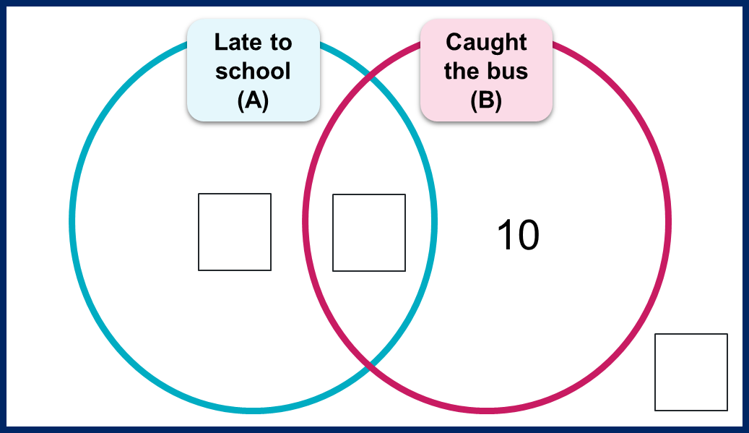
 | Late (A) | Not late (A’) | Totals
Bus (B) |  |  | 14
Not bus (B’)
Totals | 6 |  | 21
- Find the following probabilities:
- $P\left(A\right)$
- $P\left(B'\right)$
- $P\left(B∩A'\right).$

Appendix B

Allergy test data
Draw a Venn diagram in the space below to display the information from the two-way table.
 | Allergic (A) | Not allergic (A’) | Totals
Positive test (B) | 18 | 50 | 68
Not positive test (B’) | 2 | 930 | 932
Totals | 20 | 980 | 1000

Appendix C

Sensitivity and specificity
Consider a different allergy test with a sensitivity of 75% and a specificity of 65%. Assume 2% of the population has this allergy.
Complete the remaining values in the two-way table below and tree diagram.
 | Allergic (A) | Not allergic (A’) | Totals
Positive test (B) | 0.015
Not positive test (B’) |  | 0.637
Totals | 0.02 | 0.98 | 1
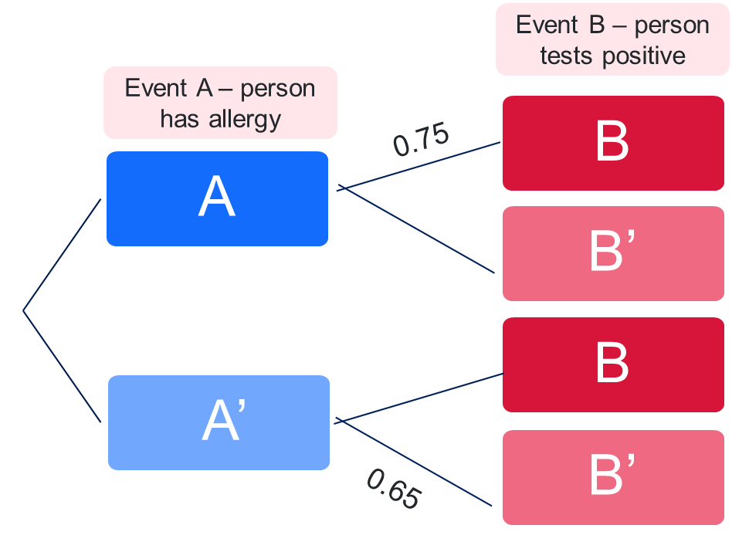

Appendix D

Diagnosing diabetes
To diagnose diabetes, a Fasting Plasma Glucose (FPG) test is used.
The FPG test has sensitivity of 82% and specificity of 89%. Approximately 5% of the Australian population has diabetes.
- Draw a two-way table, Venn diagram or tree diagram to represent this information.
- Calculate the probability that someone who receives a positive FPG test result does have diabetes using the formula $P\left(A | B\right)=\frac{P(A∩B)}{P(B)}$.

Sample solutions

Appendix A – getting to school
- Fill in the missing values in the Venn diagram and two-way table below.
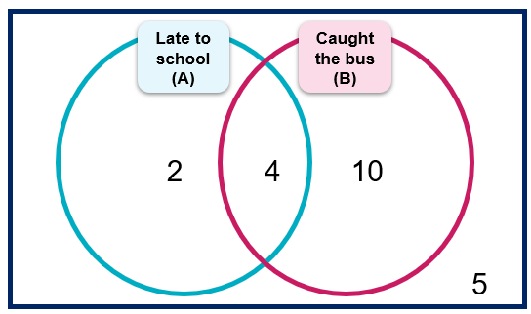
 | Late  (A) | Not late (A’) | Totals
Bus (B) | 4 | 10 | 14
Not bus (B’) | 2 | 5 | 7
Totals | 6 | 15 | 21
- Find the following probabilities:
- $P\left(A\right)=\frac{6}{21}$
- $P\left(B'\right)=\frac{7}{21}$
- $P\left(B∩A'\right)=\frac{10}{21}$

Appendix B – Alex’s allergy test data
Draw a Venn diagram in the space below to display the information from the two-way table.
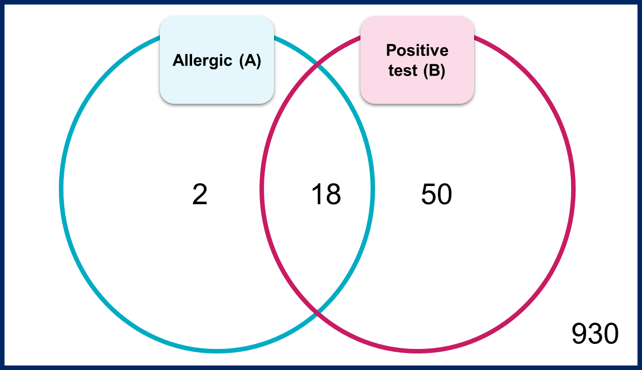

Appendix C – sensitivity and specificity
 | Allergic (A) | Not allergic (A’) | Totals
Positive test (B) | $$0.75×0.02=0.015$$ | $$0.98-0.637=0.343$$ | $$0.015+0.343=0.358$$
Not positive test (B’) | $$0.02-0.015=0.005$$ | $$0.65×0.98=0.637$$ | $$0.005+0.637=0.642$$
Totals | 0.02 | $$1-0.02=0.98$$ | 1
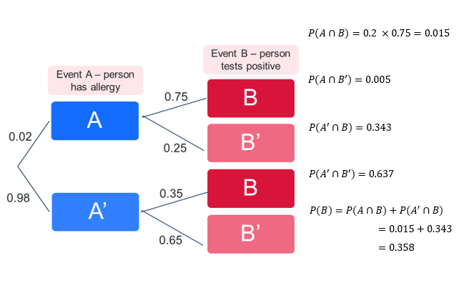

Appendix D – diagnosing diabetes
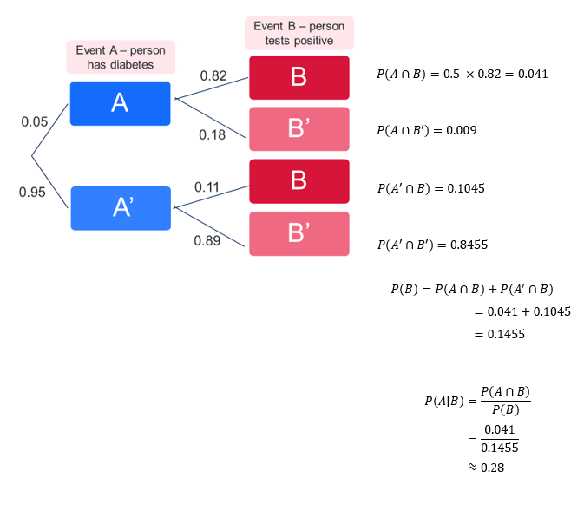

References
This resource contains NSW Curriculum and syllabus content. The NSW Curriculum is developed by the NSW Education Standards Authority. This content is prepared by NESA for and on behalf of the Crown in right of the State of New South Wales. The material is protected by Crown copyright.
Please refer to the NESA Copyright Disclaimer for more information https://educationstandards.nsw.edu.au/wps/portal/nesa/mini-footer/copyright.
NESA holds the only official and up-to-date versions of the NSW Curriculum and syllabus documents. Please visit the NSW Education Standards Authority (NESA) website https://educationstandards.nsw.edu.au/ and the NSW Curriculum website https://curriculum.nsw.edu.au/.
Mathematics Advanced 11–12 Syllabus © NSW Education Standards Authority (NESA) for and on behalf of the Crown in right of the State of New South Wales, 2024.

© State of New South Wales (Department of Education), 2025
The copyright material published in this resource is subject to the Copyright Act 1968 (Cth) and is owned by the NSW Department of Education or, where indicated, by a party other than the NSW Department of Education (third-party material).
Copyright material available in this resource and owned by the NSW Department of Education is licensed under a Creative Commons Attribution 4.0 International (CC BY 4.0) license.

This license allows you to share and adapt the material for any purpose, even commercially.
Attribution should be given to © State of New South Wales (Department of Education), 2025.
Material in this resource not available under a Creative Commons license:
- the NSW Department of Education logo, other logos and trademark-protected material
- material owned by a third party that has been reproduced with permission. You will need to obtain permission from the third party to reuse its material.
Links to third-party material and websites
Please note that the provided (reading/viewing material/list/links/texts) are a suggestion only and implies no endorsement, by the New South Wales Department of Education, of any author, publisher, or book title. School principals and teachers are best placed to assess the suitability of resources that would complement the curriculum and reflect the needs and interests of their students.
If you use the links provided in this document to access a third-party's website, you acknowledge that the terms of use, including licence terms set out on the third-party's website apply to the use which may be made of the materials on that third-party website or where permitted by the Copyright Act 1968 (Cth). The department accepts no responsibility for content on third-party websites.

