Complements
This lesson checks for understanding of probability using practical examples. Students use tree diagrams to solve probability problems and deepen their understanding of the phrase ‘at least’ and complementary events.

Learning intentions
- To understand how to calculate probabilities for events involving the phrase ‘at least’.
- To be able to use the complement rule to solve probability problems.

Success criteria
- I can explain the relationship between an event and its complement.
- I can construct a tree diagram.
- I can perform probability calculations for problems involving the phrase ‘at least’.
- I can apply the complement rule to simplify probability calculations.

Outcomes
A student:
- develops understanding and fluency in mathematics through exploring and connecting mathematical concepts, choosing and applying mathematical techniques to solve problems, and communicating their thinking and reasoning coherently and clearly MAO-WM-01
- solves problems involving probability in a variety of contexts MAV-11-09

Content

Sets and set notation
- Use the notation $\overline{A}, A^{'}\text{or} A^{c}$ to represent the complement of a set $A$ with respect to some universal set $U$

Probability
- Interpret the notation $\overline{A}$ to be the event ‘$A$ does not occur’, interpret $A∩B$ to be the event ‘$A$ and $B$ both occur’, and interpret $A∪B$ to be the event ‘$A$ or $B$ occurs’
- Establish and use the rules $P\left(\overline{A}\right)=1-P(A)$ and $P\left(A∪B\right)=P\left(A\right)+P\left(B\right)-P(A∩B)$
Mathematics Advanced 11–12 Syllabus © NSW Education Standards Authority (NESA) for and on behalf of the Crown in right of the State of New South Wales, 2024.

Table 1: lesson summary
Section | Summary of activity | Teaching strategies | Teaching points
Activating prior knowledge | Use slide 4 of the PowerPoint Complements to display a probability scenario involving gender combinations in a family, where students determine which parents’ wishes are more likely to occur. | Visibly random groups of 3  Vertical non-permanent surfaces | This activity revises tree diagrams and the concept of 'at least', using equally likely outcomes, in preparation for applying these skills to multistage situations where outcomes have different probabilities.
Connecting learning | Use slide 6 to guide students through a weather scenario where they calculate the probability that rain will delay an event by at least one day. Students use tree diagrams and compare different problem-solving strategies. | Visibly random groups of 3  Vertical non-permanent surfaces  Gallery walk  Pose-Pause-Pounce-Bounce | Students should develop the need for a more efficient way to calculate the probability of an event occurring at least once and revise complementary event rules from Stage 4.
Releasing responsibility | Use slides 8–13 to develop the notation and rules of complementary events. Students consolidate their understanding by engaging with Worked examples. Students complete Appendix A and Appendix B. | Worked examples (Your turn)  Four quadrant notes | Students should understand the definition, notation and rules for complements and use the complement rule to solve probability problems.
Independent practice | Use slides 15–21 to illustrate the ‘Approaching questions scaffold’ and for students to work through HSC-style questions. | Visibly random groups of 3  Vertical non-permanent surfaces | Students apply their knowledge of the union and complement rule to solve non-routine problems involving the term ‘at least’ and without replacement.

Activity structure
Please use the associated PowerPoint Complements to display images in this lesson.

Activating prior knowledge
- Assign students to visibly random groups of 3 (bit.ly/visiblegroups) at vertical non-permanent surfaces (bit.ly/VNPSstrategy).
- Provide the class with the scenario below, which can be displayed for students using slide 4 of the PowerPoint.
Melissa and Nick are starting to plan their family and are hoping to have 3 children in the future. They are curious about the possible gender combinations. Melissa would like to have at least one girl and Nick is hoping for at least 2 boys.
- Explain to students that they are to determine which parent’s wishes are more likely to occur. Encourage students to draw a representation and perform probability calculations.
Students may need the phrase ‘at least’ explained to them, prior to completing this activity. Students may have come across this in Stage 5 if they completed some of the Path outcome Probability B MA5-PRO-P-01.
The purpose of this activity is to revise the use of tree diagrams, as well as check for students’ understanding of the phrase ‘at least’, when completing probability problems. This question has been purposefully chosen to have equally likely outcomes, as in the following sections students will apply this understanding to an event where the outcomes are not equally likely.
When completing the problem, students should assume that each child is equally likely to be a boy or a girl.
- Conduct a class discussion where students share their answer. Encourage students to refer to the representation that their group chose to draw and explain the calculations that they used to find the probabilities.
Students should conclude that Melissa’s wishes are more likely to occur, with the $P\left(at least 1 girl\right)=\frac{7}{8}$ compared to Nick’s $P\left(at least 2 boys\right)=\frac{1}{2}$.
- Explain to students that according to the World Health Organisation (WHO), the ratio of male to female births, called the sex ratio, is about 105 to 100 (bit.ly/WorldData-GenderRatio). This means about 51% of births result in a baby boy.
- In their groups of 3, ask students to discuss and consider how this probability might affect their previous answers.
- Conduct a class discussion, selecting non-volunteer students, to share what their group discussed on how changing the probability of a boy to 51% rather than 50% may change their previous answers.

Connecting learning
- Explain to students that they will be analysing a skateboarding event to determine the likelihood of it being delayed due to rain.
- Provide the class with the following scenario, which can be displayed for students using slide 6 of the PowerPoint.
At the Paris 2024 Olympics, the 6-day skateboarding event had to be postponed due to heavy rain, which made conditions unsafe for competitors. Now, partway through the 2026 World Skate Games in Asunción, Paraguay, similar weather concerns are raising fears of another major disruption to the world of competitive skateboarding.
- Outline to students that they will be analysing the weather forecast for the remaining 3 days of the 2026 World Skate Games to determine the chances of the event being postponed by at least one day.
- Use the Pose-Pause-Pounce-Bounce questioning strategy (PDF 557 KB) (bit.ly/posepausepouncebounce) to conduct a class discussion with students to unpack that this means they need to determine the probability that it rains on at least one of the remaining 3 days.
- Animate the slide to display the following weather forecast data for the remaining 3 days of the event.
Table 2: weather forecast
Day | 4 | 5 | 6
Chance of rain | 30% | 90% | 80%
- Assign new visibly random groups of 3 at vertical non-permanent surfaces and explain to students that they are to investigate the chances of the 2026 World Skate Games being delayed by one day. Groups should be encouraged to:
- create a tree diagram representing the remaining 3-day weather forecast
- calculate the probability that it rains on at least one of the remaining 3 days.
- Encourage students to complete a gallery walk (bit.ly/DLSgallerywalk) to compare their own working to other groups.
- Use the Pose-Pause-Pounce-Bounce questioning strategy to conduct a class discussion where groups can share their findings of the probability of the event needing to be postponed. Students should be encouraged to share the approaches that they took to determine the final answer.
A solution has been provided in the ‘Sample solutions’ section of this document.
Some groups may explain that they calculated the probability for each of the 8 possible outcomes, identified which ones included at least one rainy day and then summed the probabilities for those outcomes.
Alternatively, some groups may have observed that only one of the 8 possible outcomes did not include at least one rainy day. These groups might have calculated the probability by subtracting the chance of no rain on the remaining 3 days from 1.
- Continue the class discussion by asking students to consider the relationship between the probability of the event being postponed and the probability of it not being postponed. Remind students that the chances of the event being postponed is determined by the probability that it rains on at least one of the remaining 3 days. Prompting questions could include:
- What is the total probability of the event being postponed by at least one day?
- What is the probability of the event not being postponed by at least one day?
- How are these probabilities related?
- Would it be more efficient to calculate the probability of the event being postponed or not being postponed?
Students should conclude that when calculating probabilities, at times it can be more efficient to use the probability of the complement of the event and subtract this from 1.

Releasing responsibility
- Use slides 8–9 of the PowerPoint to display definitions, notation and rules for the complement of an event. Check for student understanding by using the self-explanation prompts.
Students are familiar with the concept of complementary events from the Stage 4 Probability outcome MAT4-PRO-C-01.
- Use slides 10–13 to model how to use the complement and union rules through the Worked examples (Your turn) method (bit.ly/supportingstrategies). There is an animation on slide 11 to display the self-explanation prompts.
Students have previously established and used the union rule, $P\left(A∪B\right)=P\left(A\right)+P\left(B\right)-P(A∩B)$ in Lesson 4 – intersections and unions of Unit 1 – probability and data.
- In their previous groups of 3, distribute Appendix A ‘Complementary probabilities’ to students and have them shade in the Venn diagrams such that the rule $P(\overline{A)}=1-P(A)$ is true for each case.
- In their groups of 3, have students complete the four quadrant notes to their future forgetful selves (bit.ly/supportingstrategies) from Appendix B ‘Four quadrant notes’.

Independent practice
- Use slide 15 of the PowerPoint to unpack the ‘Approaching questions scaffold’ for students.
The ‘Approaching questions scaffold’ offers students a 4-step framework to work through questions. Each step is accompanied by an icon which corresponds to different aspects of the solution process.
- Establish new visibly random groups of 3 at vertical non-permanent surfaces and display the problem from slide 16 for each group to solve.
- Circulate the room to monitor students' understanding of solving probability problems that include the phrase 'at least', before providing the solution on slide 17 which contains self-explanation prompts.
- Conduct a class discussion, where students share their answers to the self-explanation prompts and discuss the strategies used for each step of the ‘Approaching questions scaffold’.
- In their groups, have students work through Problem 2, from slide 18. The solution is provided on the following slides.
- Have students complete a gallery walk to observe the use of the ‘Approaching questions scaffold’ in other groups’ solutions.

Assessment and differentiation

Suggested opportunities for differentiation
Activating prior knowledge
- Students should be challenged to make connections with prior knowledge they have of tree diagrams and probability.
- Students could be challenged to perform calculations to calculate exactly how much the probabilities will differ when the probability of a boy changes from 50% to 51%.
Connecting learning
- When discussing solutions to the skateboarding event, teachers should encourage students to explain and justify their decisions.
Releasing responsibility
- Appendix A could be completed as a whole class if students need more support to understand the concept of $(\overline{A)}$.
Independent practice
- Students may need the phrase ‘at most’ defined.

Suggested opportunities for assessment
Activating prior knowledge
- When placed in groups of 3, students provide and receive peer feedback on their understanding.
Connecting learning
- Students working at vertical non-permanent surfaces means the teacher can assess student progress and provide support where appropriate.
- Monitor responses in class discussions to check for student understanding of tree diagrams and associated rules of probability.
Releasing responsibility
- Monitor student responses in the ‘Your turn’ section to check for understanding.
Independent practice
- Students will demonstrate their Working mathematically skills in discussions and justifications.

Appendix A

Complementary probabilities
Shade in the Venn diagrams such that they represent the rule $P(\overline{A)}=1-P\left(A\right).$
- 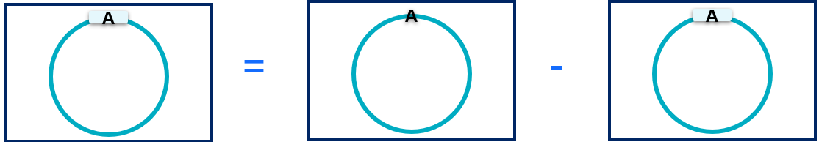
- 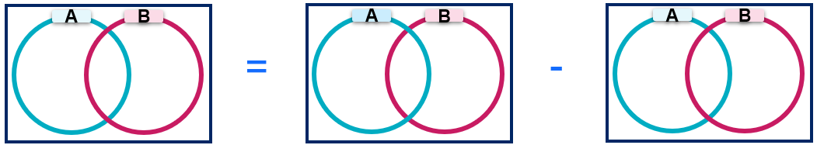
- 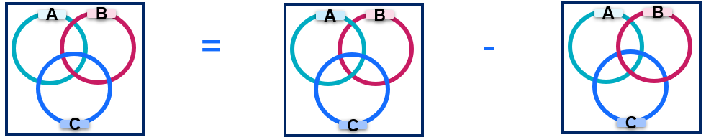

Appendix B

Four quadrant notes
Example 1  A fair dice is rolled twice. What is the probability that neither of the rolls shows a 6?  $$P\left(not rolling a 6 \right)=1-P\left(rolling a 6\right) \\ =1-\left(\frac{5}{6}× \frac{ ⃞ }{ ⃞ }\right) \\ =\frac{ ⃞ }{ ⃞ }$$ | Example 2  A bag contains 4 red marbles, 3 blue marbles and 3 green marbles, making a total of 10 marbles. You randomly draw 2 marbles, one after the other, without replacement.  What is the probability that neither of the 2 marbles you draw is blue?
Things to remember | Example 3

Sample solutions

Connecting learning
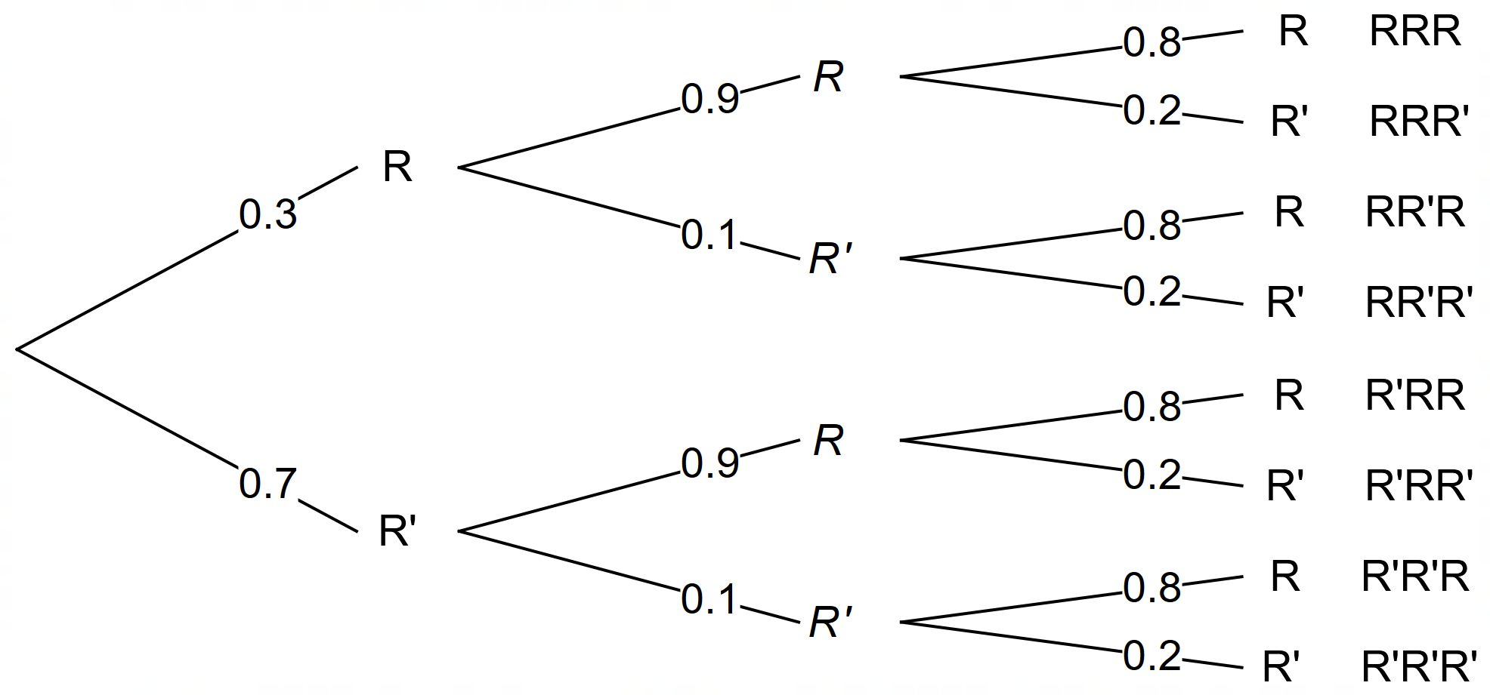
$$P\left(no rain on all 3 days\right)=0.7×0.1×0.2 \\ =0.014$$
$$P\left(at least one of the remaining 3 days\right)=1-0.014 \\ =0.986$$
Therefore, there is a 98.6% chance that it will rain on at least one of the remaining 3 days of the event.

Appendix A – complementary probabilities
- 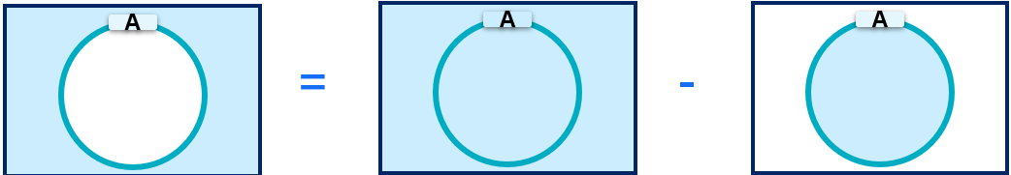
- 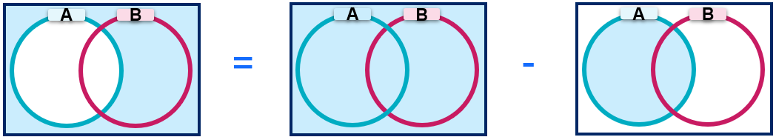
- 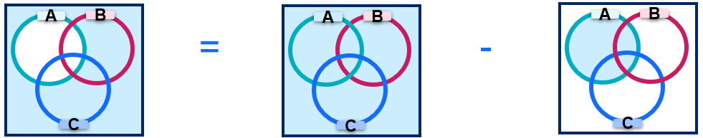

Appendix B – Four quadrant notes
Example 1  A fair dice is rolled twice. What is the probability that neither of the roll shows a 6?  $$P\left(not rolling a 6 \right)=1-P\left(rolling a 6\right) \\ =1-\left(\frac{5}{6}×\frac{5}{6}\right) \\ =\frac{11}{36}$$ | Example 2  A bag contains 4 red marbles, 3 blue marbles and 3 green marbles, making a total of 10 marbles. You randomly draw 2 marbles, one after the other, without replacement.  What is the probability that neither of the 2 marbles you draw is blue?  $$P\left(not blue\right)=1-P(blue) \\ =1-\left(\frac{3}{10}×\frac{2}{9}\right) \\ =\frac{14}{15}$$

References
This resource contains NSW Curriculum and syllabus content. The NSW Curriculum is developed by the NSW Education Standards Authority. This content is prepared by NESA for and on behalf of the Crown in right of the State of New South Wales. The material is protected by Crown copyright.
Please refer to the NESA Copyright Disclaimer for more information https://educationstandards.nsw.edu.au/wps/portal/nesa/mini-footer/copyright.
NESA holds the only official and up-to-date versions of the NSW Curriculum and syllabus documents. Please visit the NSW Education Standards Authority (NESA) website https://educationstandards.nsw.edu.au/ and the NSW Curriculum website https://curriculum.nsw.edu.au/.
Mathematics Advanced 11–12 Syllabus © NSW Education Standards Authority (NESA) for and on behalf of the Crown in right of the State of New South Wales, 2024.

© State of New South Wales (Department of Education), 2025
The copyright material published in this resource is subject to the Copyright Act 1968 (Cth) and is owned by the NSW Department of Education or, where indicated, by a party other than the NSW Department of Education (third-party material).
Copyright material available in this resource and owned by the NSW Department of Education is licensed under a Creative Commons Attribution 4.0 International (CC BY 4.0) license.

This license allows you to share and adapt the material for any purpose, even commercially.
Attribution should be given to © State of New South Wales (Department of Education), 2025.
Material in this resource not available under a Creative Commons license:
- the NSW Department of Education logo, other logos and trademark-protected material
- material owned by a third party that has been reproduced with permission. You will need to obtain permission from the third party to reuse its material.
Links to third-party material and websites
Please note that the provided (reading/viewing material/list/links/texts) are a suggestion only and implies no endorsement, by the New South Wales Department of Education, of any author, publisher, or book title. School principals and teachers are best placed to assess the suitability of resources that would complement the curriculum and reflect the needs and interests of their students.
If you use the links provided in this document to access a third-party's website, you acknowledge that the terms of use, including licence terms set out on the third-party's website apply to the use which may be made of the materials on that third-party website or where permitted by the Copyright Act 1968 (Cth). The department accepts no responsibility for content on third-party websites.

