Tree diagrams and arrays
Students learn about the concepts of tree diagrams and arrays through various real-life scenarios.
Students will need at least one digital device per pair to interact with a dice generator. Alternatively, the teacher can give students 2 dice per pair.

Learning intentions
- To understand how to construct tree diagrams and how they are used to calculate probabilities.
- To know how to construct an array and use it to solve problems.

Success criteria
- I can construct tree diagrams, including weighted probability trees, to represent possible outcomes.
- I can develop an array to solve probability problems.
- I can interpret tree diagrams and arrays to determine probabilities of single and multistage events.
- I can justify my reasoning and apply my understanding of probability to real-world scenarios.

Outcomes
A student:
- develops understanding and fluency in mathematics through exploring and connecting mathematical concepts, choosing and applying mathematical techniques to solve problems, and communicating their thinking and reasoning coherently and MAO-WM-01
- solves problems involving probability in a variety of contexts MAV-11-09

Content

Probability
- Use arrays and tree diagrams to determine the outcomes and probabilities for multistage events
Mathematics Advanced 11–12 Syllabus © NSW Education Standards Authority (NESA) for and on behalf of the Crown in right of the State of New South Wales, 2024.

Table 1: lesson summary
Section | Summary of activity | Teaching strategies | Teaching points
Activating prior knowledge | Use slide 4 of the PowerPoint Tree diagrams and arrays for students to analyse a genetic family tree represented by gummy bears in preparation for creating a tree diagram.  Use slides 5–11 to model for students finding the probability of a child being born with blue eyes from a tree diagram.  Students complete Appendix A. | Notice and wonder  Think-Pair-Share  Worked examples (Your turn) | This activity guides students in constructing tree diagrams for multi-stage events, revising knowledge from Stage 5.
Connecting learning | Use slides 13–19 to model to students a tree diagram problem that requires weighted branches – first looking at an example with replacement and then a question without replacement. | Pose-Pause-Pounce-Bounce  Think-Pair-Share  Visibly random groups of 3  Vertical non-permanent surfaces | Students extend their learning to apply tree diagrams to more complex questions when the outcomes aren’t equally likely.
Releasing responsibility | Students examine the limitations of a tree diagram and create an array for rolling a dice twice.  Use slides 21–22 to play a biased dice game. Students use an array to justify why the game is biased. | Pose-Pause-Pounce-Bounce | The purpose of the activity is to help students understand the limitations of tree diagrams and to introduce arrays as an alternative method for representing probability.
Independent practice | Students apply their knowledge by completing Appendix B to determine the probability that a soccer team will be relegated with 2 games left in the season.  Use slides 24–32 to display the question and solution. | Assessing and advancing questions  Worked examples | This section aims to guide students through a real-world problem, using a structured approach.

Activity structure
Please use the associated PowerPoint Tree diagrams and arrays to display images in this lesson.

Activating prior knowledge
This section involves students creating and determining probabilities using tree diagrams. While tree diagrams are not explicitly mentioned in Stage 5 Core, it is important to note that the Stage 5 Probability A Core outcome MA5-PRO-C-01, implies using tree diagrams and arrays, as demonstrated in NESA’s examples.
- Using slide 4 of the PowerPoint, conduct a class discussion where students share what they notice and wonder (bit.ly/noticewonderstrategy) about the diagram.
Students may notice:
- that the image looks like a family tree made of gummy bears
- that the gummy bears are different colours, possibly representing genetic traits
- that some of the gummy bears in lower generations are mixed colours, suggesting inheritance from both parents
- that the black lines connect parent gummy bears to their offspring.
Students may wonder:
- if the different gummy bear colours are meant to represent traits or characteristics
- how the mixed-colour gummy bears were created
- if this model accurately represents genetic inheritance or if it is just a fun visual
- whether this idea could be used to represent other inherited traits, such as height or eye colour. Others may be curious about what would happen if more generations were added to this gummy bear family tree.
- Check for students’ understanding of genes by asking the class if they know what determines a person’s eye colour, and if they have heard of dominant and recessive traits.
Genes determine how traits are passed from parents to offspring. An allele is a version of a gene. A person inherits one allele from each parent. A dominant allele will show its trait even if only one is present, while a recessive allele only expresses its trait if both copies inherited are recessive. It may be beneficial for students to watch the video ‘Dominant Alleles vs Recessive Alleles’ (2:07) (bit.ly/DominantAllele).
- Using slide 5 of the PowerPoint, have students in a Think-Pair-Share (bit.ly/thinkpairsharestrategy), consider the question:
If one parent has brown eyes with the genotype Bb and the other parent also has brown eyes with the genotype bB, what is the probability their child will have blue eyes?
For this question, the teacher can provide extra context by explaining the following:
Each person’s eye colour is determined by 2 copies of a gene, called their genotype. The gene has 2 versions (alleles): B for brown eyes and b for blue eyes. Brown eyes (B) are dominant over blue eyes (b), which means that a person with one B and one b allele (genotype Bb) will have brown eyes, not blue.
- Model for students how to answer this question using slides 6–11 of the PowerPoint, which shows the construction of a tree diagram to solve the problem using the Worked examples (Your turn) method (bit.ly/supportingstrategies).
- Distribute Appendix A ‘Predicting blood type’, for students to complete as independent practice or small group work.

Connecting learning
Students were exposed to multistage events and tree diagrams in Stage 5, although a review of weighted tree diagrams with and without replacement is included prior to guided practice.
- Using slides 13–17 of the PowerPoint, lead students through the question to determine the probabilities of selecting coloured tennis balls from a bag with a tree diagram.
- Slide 13 aims to gather key information from the question. The teacher could engage students in a Pose-Pause-Pounce-Bounce questioning strategy (PDF 557 KB) (bit.ly/posepausepouncebounce) to check for understanding of ‘What do we know?’ and ‘What do we need to know?’
- On slide 14, check for understanding by selecting a non-volunteer student to present to the class how they can determine the outcomes of each event and the sample space.
- Slide 15 aims to deepen student thinking by highlighting that the tree diagram requires probability weights, as each outcome is not equal. Students can engage in a Think-Pair-Share to discuss the self-explanation prompt.
- Use slides 16 and 17 to model how to notate the probability weights on the tree diagram and answer the question. Self-explanation prompts have been provided.
- By working in visibly random groups of 3 (bit.ly/visiblegroups) on vertical non-permanent surfaces (VNPS) (bit.ly/VNPSstrategy), ask students to consider the question on slide 18 of the PowerPoint.
- Use the Pose-Pause-Pounce-Bounce questioning strategy to prompt students to identify and explain how this question differs from the previous question.
Students should recognise that this question involves items that are not replaced, meaning the probability of selecting a red sock changes if one has already been selected previously.
- Provide students with time to complete their solution in their groups of 3, ensuring that students firstly construct a tree diagram.
- Using slide 19, show students a modelled solution to the question. The teacher can select a non-volunteer student to present to the class why the denominator has changed as the tree diagram progresses along the branches.
- Students should complete practice questions from an existing resource to consolidate their understanding of using tree diagrams to determine the outcomes and probabilities for multistage events, with and without replacement.

Releasing responsibility
- In pairs, ask students to draw a tree diagram that describes the sample space of rolling 2 dice. As they complete this, ask them what they notice and wonder about this activity.
Students should notice that creating a tree diagram becomes challenging with multiple outcomes and may wonder if there is a more efficient or neater way to determine the sample space.
- Use the Pose-Pause-Pounce-Bounce questioning strategy to ask students what other methods they could use to visually represent the sample space of rolling 2 dice.
The teacher should guide this conversation towards creating a table or array to visually represent the sample space.
- In their same pairs, ask students to create an array that visualises the sample space for rolling 2 dice.
- Explain to students that they will now play a game in pairs, using the array they created.
- In each pair, have the students decide who will be Student A and who will be Student B.
- Using slide 21, display the rules to the ‘Dice battle games’, and model how the rules of the game work. Have each pair create a tally to record if Student A or B won.
Search ‘dice roller’ in Google. An applet will appear as shown in Figure 1 below, and by selecting the ‘6’ that is circled in red, you can add a second die. Note, this activity can be completed with physical dice if it is preferred.

Figure 1: dice rolling applet
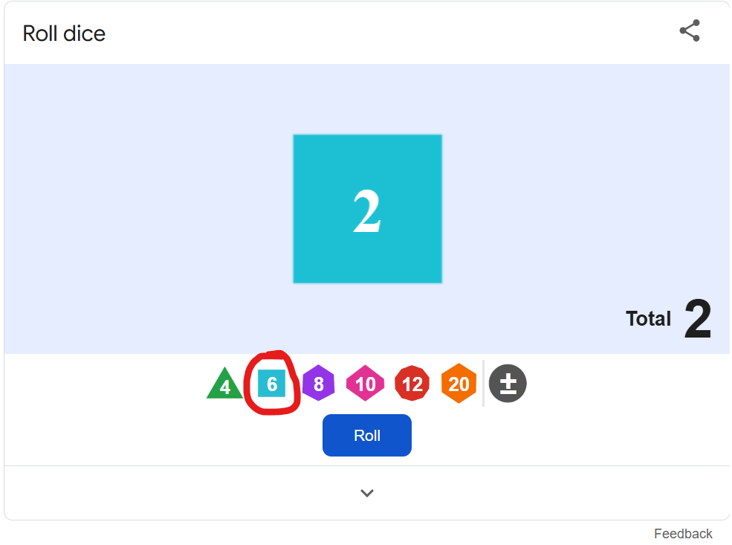
- Have each pair use a dice applet to play 5–10 rounds of the game. On the completion of the game, ask students to consider the tally of who won and ask them what they notice and wonder about the results.
Students should notice that the number of wins by Student A is greater than Student B and wonder if there is a statistical advantage to being Student A.
- Instruct students to complete an array that describes the sample space of this game.
- Using slide 22 and the Pose-Pause-Pounce-Bounce questioning strategy, ask students to justify why Student A should win the dice battle on more occasions than Student B.
The discussion should indicate that Student A has a $\frac{2}{3}$ chance of winning a game compared to Student B’s $\frac{1}{3}$ chance. The teacher could bring up a false counterpoint saying that Student B has more winning numbers (2, 3, 4, 10, 11, 12) compared to Student A’s winning numbers (5, 7, 8, 9).
- Instruct students to return to their pairs and consider what rules they would adjust to make this game fair.
- Conduct a class discussion in which students discuss and justify the adjustments they would make to the game.
- Students are to create notes to their future forgetful selves (bit.ly/notestofutureself) on when it is most appropriate to use either an array or tree diagram to determine the outcomes and probabilities for multistage events.
Encourage students to consider that arrays work best for 2-stage events with equally likely outcomes. The grid format is often easier to construct and interpret than a tree diagram, especially when there are many possible outcomes in each stage.
Tree diagrams, on the other hand, are useful for events with more than 2 stages, or when outcomes are not equally likely or depend on previous stages. The branching structure helps to clearly represent varying probabilities and the sequence of events.

Independent practice
- Use slide 24 of the PowerPoint to unpack the ‘Approaching questions scaffold’ for students.
The ‘Approaching questions scaffold’ offers students a 4-step scaffold to tackle questions. Each step is accompanied by an icon and corresponds to different aspects of the solution process.
- Provide students with Appendix B ‘Will my soccer team not get relegated?’ for students to complete independent, scaffolded practice.
- As students are independently completing Appendix B, ask students assessing and advancing questions (bit.ly/supportingstrategies) to deepen student thinking, gather information or make connections. Some suggestions are provided in the following table.
Table 2: assessing and advancing questions
Assessing questions | Advancing questions
How many points has Dorking Wanderers already earned this season? | What assumptions are we making when we calculate these probabilities? Are they realistic?
How many points do they still need to avoid relegation? | How might you use this probability model to advise the team’s strategy for the last 2 games?
How do you calculate the probability of each possible outcome for a single match? | If Dorking Wanderers win their first match, how does it affect the probability of avoiding relegation?
- Slides 25–32 in the PowerPoint are provided as modelled solutions for students requiring further support with completing Appendix B.
Students may benefit from completing further practice questions to consolidate their understanding of calculating probabilities using both tree diagrams and arrays.

Assessment and differentiation

Suggested opportunities for differentiation
Activating prior knowledge
- Students should be challenged to make connections with prior knowledge.
- Students may benefit from some questions that extend their knowledge and understanding. For example, ‘Calculate $P(not brown)$’.
Connecting learning
- Use of concrete materials may connect the learning and provide a visual representation of a non-replacement problem.
Releasing responsibility
- A pair could be encouraged to turn and talk to another pair if they are finding difficulty with the dice game and determining bias.
- Students can consider the impact of playing the game with different-sided dice or altering the winning numbers.
Independent practice
- Students from non-English speaking backgrounds could be encouraged to analyse the question in their own language.

Suggested opportunities for assessment
Activating prior knowledge
- Monitor responses in class discussions to check for student understanding of constructing and interpreting tree diagrams.
Connecting learning
- Students working at vertical non-permanent surfaces means the teacher can assess student progress and provide support where appropriate.
Releasing responsibility
- Students have opportunities to contribute to and hear from their partner and the class, which act as opportunities for self and peer reflection.
Independent practice
- The teacher could facilitate class discussions and observe students’ reasoning and justification in response to the provided prompts.
- Students will demonstrate their Working mathematically skills in discussions and justifications.

Appendix A

Predicting blood type
The ABO blood type system is controlled by 3 alleles:
- A (dominant)
- B (dominant)
- O (recessive)
Since people inherit one allele from each parent, possible genotypes and blood types are:
- AA or AO = Type A
- BB or BO = Type B
- AB = Type AB (codominant, meaning both A and B are expressed)
- OO = Type O
- Draw a tree diagram to represent a parent who has blood type AB and the other parent who has blood type BO.
- Determine
- $P\left(Type O blood\right)=$
- $P\left(Type A blood\right)=$
- $P(Type A or B blood)=$

Appendix B

Will my soccer team not get relegated?
In soccer, a team will receive 3 points for winning a match, one point for a draw and zero points if they lose. If a team ends the season ranked among the lowest 3, they are moved down to a lower-level competition for the next season.
The Dorking Wanderers play 46 games in a season. Currently, the Dorking Wanderers have won 12 games, drawn 8 and lost 24. To not be ranked among the lowest 3 teams, they need to end the season with at least 48 points.
Big question: based on their current season win, loss and draw statistics, what is the probability that Dorking Wanderers will remain in the competition?
Complete the following to support your calculations:

What do we know? | What do we need to know?
- What are the possible outcomes for the 45th match of the season?
- What is the probability for each of the outcomes of the 45th match?
- Will the probabilities change for the 46th match? Why/why not?

- Construct a diagram to display the sample space of Dorking Wanderers’ last 2 matches.
- Which outcomes on the diagram are required by the Dorking Wanderers to avoid being ranked among the lowest 3 teams?
- Calculate the probability of each of the outcomes listed in part f.
- Solve the big question: What is the probability that Dorking Wanderers will remain in the competition?

Sample solutions

Appendix A – predicting blood type

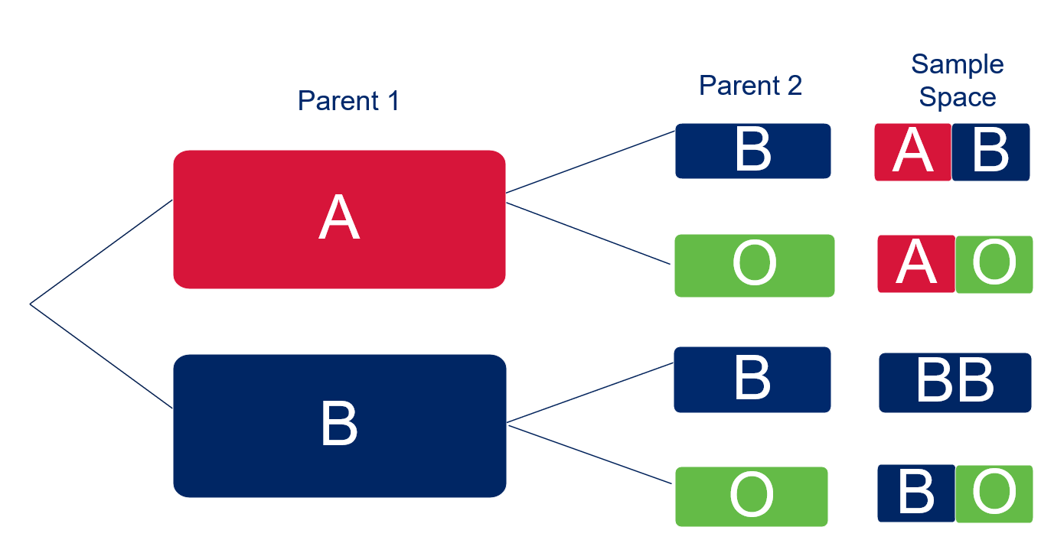

- $P\left(Type O blood\right)=0$
- $P\left(Type A blood\right)=\frac{1}{4}$
- $P(Type A or B blood)=1$

Appendix B – Will my soccer team not get relegated?

What do we know? | What do we need to know?
- 46 games a season  - Win-Lose-Draw  - How to avoid relegation | - Dorking’s current points  - Points required  - Number of remaining games  - Probability of achieving the necessary points
- Win, Lose, Draw
- $P\left(win\right)=\frac{12}{44}$$$P\left(draw\right)=\frac{8}{44} \\ P\left(lose\right)=\frac{24}{44}$$
- No, as we are not removing any event from the set of probabilities.

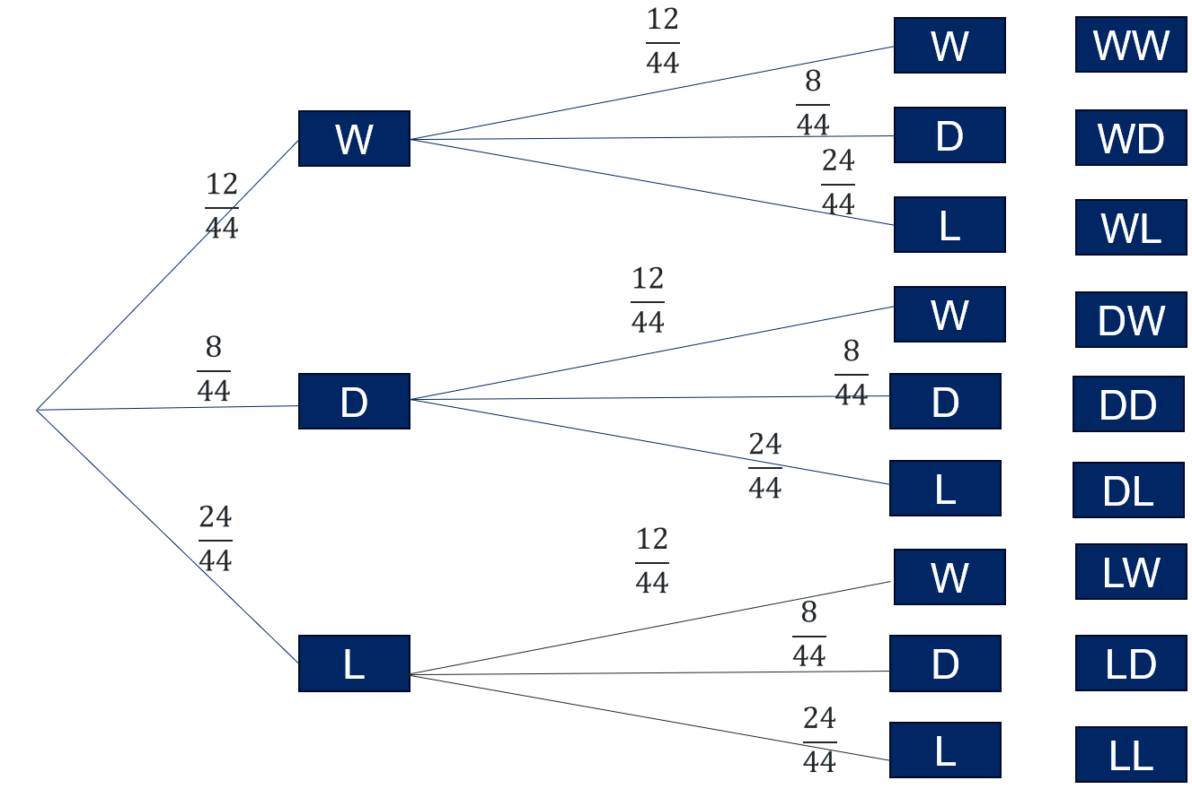
- WW, WD, DW
- $P\left(WW\right)=\frac{12}{44}×\frac{12}{44}=\frac{9}{121}$$$P\left(WD\right)=\frac{12}{44}×\frac{8}{44}=\frac{6}{121} \\ P\left(DW\right)=\frac{8}{44}×\frac{12}{44}=\frac{6}{121}$$
- $P\left(Dorking remain in the competition\right)=\left(\frac{12}{44}×\frac{12}{44}\right)+\left(\frac{12}{44}×\frac{8}{44}\right)+\left(\frac{8}{44}×\frac{12}{44}\right)=\frac{21}{121}$

References
This resource contains NSW Curriculum and syllabus content. The NSW Curriculum is developed by the NSW Education Standards Authority. This content is prepared by NESA for and on behalf of the Crown in right of the State of New South Wales. The material is protected by Crown copyright.
Please refer to the NESA Copyright Disclaimer for more information https://educationstandards.nsw.edu.au/wps/portal/nesa/mini-footer/copyright.
NESA holds the only official and up-to-date versions of the NSW Curriculum and syllabus documents. Please visit the NSW Education Standards Authority (NESA) website https://educationstandards.nsw.edu.au/ and the NSW Curriculum website https://curriculum.nsw.edu.au/.
Mathematics Advanced 11–12 Syllabus © NSW Education Standards Authority (NESA) for and on behalf of the Crown in right of the State of New South Wales, 2024.

© State of New South Wales (Department of Education), 2025
The copyright material published in this resource is subject to the Copyright Act 1968 (Cth) and is owned by the NSW Department of Education or, where indicated, by a party other than the NSW Department of Education (third-party material).
Copyright material available in this resource and owned by the NSW Department of Education is licensed under a Creative Commons Attribution 4.0 International (CC BY 4.0) license.

This license allows you to share and adapt the material for any purpose, even commercially.
Attribution should be given to © State of New South Wales (Department of Education), 2025.
Material in this resource not available under a Creative Commons license:
- the NSW Department of Education logo, other logos and trademark-protected material
- material owned by a third party that has been reproduced with permission. You will need to obtain permission from the third party to reuse its material.
Links to third-party material and websites
Please note that the provided (reading/viewing material/list/links/texts) are a suggestion only and implies no endorsement, by the New South Wales Department of Education, of any author, publisher, or book title. School principals and teachers are best placed to assess the suitability of resources that would complement the curriculum and reflect the needs and interests of their students.
If you use the links provided in this document to access a third-party's website, you acknowledge that the terms of use, including licence terms set out on the third-party's website apply to the use which may be made of the materials on that third-party website or where permitted by the Copyright Act 1968 (Cth). The department accepts no responsibility for content on third-party websites.

